NEURAL ORGANOIDS: A NEW FRONTIER IN NEURODEGENERATIVE DISEASE MODELLING AND DRUG SCREENING.
Arunkumar Subramanian¹, Sabesh S¹, Naraien Karthikeyan S¹, T. Tamilanban^{1*}
¹Department of Pharmacology, SRM College of Pharmacy, SRM Institute of Science and Technology, Kattankulathur, Chengalpattu, Tamil Nadu - 603203, India.

*Corresponding author: Dr. T. Tamilanban,
Associate Prof.,
Dept. of Pharmacology,
SRM College of Pharmacy,
SRM Institute of Science and Technology
India.
tamilant@srmist.edu.in

Abstract:
Neurodegenerative diseases (NDDs) are a group of disorders characterized by nerve cell degeneration, including Alzheimer's, Parkinson's, and Huntington's diseases. Current research relies on animal models and 2D cell cultures, limiting accurate disease replication. However, 3D neural organoids, derived from stem cells, offer exciting prospects for NDD study. Neural organoids closely resemble the developing human brain and have become valuable tools for disease modeling and drug screening. They can differentiate into specific neural cell types and mimic disease-specific protein aggregation. Brain organoids have improved drug screening, assessing drug effects on neural activity, and BBB permeability. Challenges include reproducibility, vascularization, and microglia incorporation. Nevertheless, neural organoids represent a revolutionary approach to NDD research, providing a physiologically relevant model. As technology progresses, neural organoids hold great promise in understanding and discovering drugs for neurodegenerative diseases.

Keywords: 3D – cell culture, Brain organoids, Alzheimer’s disease, Parkinson’s disease.

I. INTRODUCTION
Alzheimer's disease (AD), Lewy bodies dementia, Parkinson's disease (PD), vascular dementia, frontotemporal dementia, Huntington's disease, progressive supranuclear palsy, Creutzfeldt -Jakob disease, motor neuron disease, etc. these diseases are collectively known as neurodegenerative diseases. An instance of a neurodegenerative disease that are caused due to damage of nerve cells over time. Neurodegenerative diseases are hard to observe and incurable. The pathological hallmarks of NDD are represented in fig1 with their locus in human brain. (1)
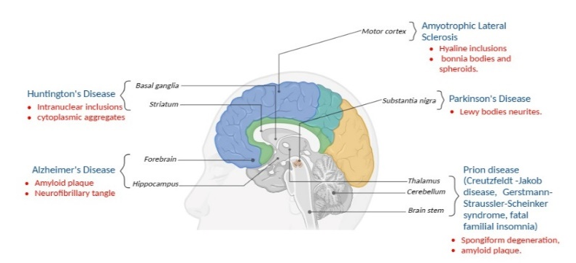
Fig 1: The Pathological hallmarks of NDDs. Various NDDs are mentioned in blue with their possible pathological characteristic features represented in red. Along with above mentioned parts AD, PD & Prion disease also affects the cerebral cortex.

Animal fashions and two-dimensional cultures are presently the number one studies systems for reading neurodegenerative diseases (NDDs). Most neurodegenerative disease fashions make use of two-dimensional (2D) in vitro studies, non-human primate tissue, or human postmortem mind tissue. New possibilities stand up as neuronal culture actions from conventional monolayer (2D) strategies to the advent of 3D organoids. Neural organoids/cerebral organoids/brain organoids are 3D cultures of neuronal cell which are formed by neural aggregates.(2) This chapter discuss about the different protocols of organoids that are developed over the course of evolution of neural organoids and their application in modelling AD and PD.

- BASICS OF BRAIN ORGANOIDS

Human embryonic stem cells (hESC), human induced pluripotent stem cells (hiPSC), and human pluripotent stem cells (hPSC) all have potential to divide, self-renew and differentiate into a vast quantity of different cell types. These capabilities permit present day organoids to locate physiologically essential function of the interest organ by grouping them into cell groups like actual tissue, which results in formation of complex cell cultures.(2) These characters are beneficial for the improvement of personalized medicine and organoid disease models. To recognize 3D culture of neural or cerebral organoids, we need to know about the:
a) Neurosphere: Neural stem cells (NSCs) & neural progenitor cells (NPCs) which are cultured without the use of adherent substrates. One of the first 3D neural approaches is this neurosphere. Individual cells proliferate to shape neutrosphere forming small cellular clusters that is cultured in suspension. (3)
b) Neural aggregates: Pluripotent stem cells also can be used to shape neural aggregates, normally with the aid of embryoid bodies (EBs). Pluripotent stem cells form 3D aggregates of EBs and that resembles an early level of embryonic development. Formation of EBs from colonies of iPS or ESC cultures is very famous as a start line for each centred and spontaneous differentiation techniques now. Neuronal induction-based EB provides a window for NPCs to be generated from ES/iPS cells in neuronal differentiation of CNS. (3)
c) Neural Rosettes: The formation of neural 'rosettes' is a key thing of recognized neural induction strategies. These are systems containing morphologically recognizable NPCs and are notion to symbolize the neural tube. Cells with rosette systems goes through mitosis at the luminal facet of the central lumen. Neural rosettes recapitulate early neurogenesis. NPCs, inside neuronal rosette systems, can eventually develop or differentiate into mature neuronal cells with traits precise to specific cerebral regions. (3)
However, Neurosphere and neuronal aggregates are precious 3D culture strategies which can offer easy solutions for your research. However, they lack other types of brain cells such as neurons and astrocytes and consist only neural stem cells & progenitor cells. To advance the 3D culture model, it is important to create systems that not only include all the important neuronal cell types found in the brain, and organize them in a way that mimics cortical stratification of in vivo brain. 3D brain models, cortical spheroids, and brain organs, generated from human pluripotent stem cells, have been shown to form arranged structures similar to the human brain.
d) Cortical Spheroids: A 3D organoid approach for ES cells become advanced with the aid of using protocol of Eiraku et al. become advanced and named it SFEBq (serum free floating culture of embryoid body-like aggregates with quick reaggregation). This a stepped forward advanced model of SFEB by Watanabe et al. In SFEBq, ES aggregates segregate which shape an epithelium comparable to neuroectoderm. This epithelium then generates cortical neurons that self-prepare in a way comparable to early corticogenesis.(3,4) The culture of 'cortical sphere' become later stronger to illustrate wonderful self-organizing functions of human neocortex formation. Further development become made in Sergiu Paşca's lab. Human cortical spheroids have been studied with the aid of using his Paşca et al. formed from iPS cells. It makes use of no extracellular matrix (ECM) and minimum structural factors. Both deep and superficial cortical neurons are observed in those spheroids. Importantly, neurons are interspersed with dormant astrocytes. These astrocytes are hard to acquire in vitro, play a crucial function in synaptogenesis and are required for full cerebral development. After 2.5 months of development, transcriptional evaluation confirmed that the spheres reflected the human fetal cerebral development in vivo. (1)
e) Cerebral Organoids or Whole-Brain Organoids: No one had made a single neuronal organoid that could represent several distinct brain areas prior to Lancaster and Knoblich's cerebral organoids, or mini-brain models. The culture conditions are embedded in extracellular matrix (ECM) such that it promotes self-organization & self-patterning of cerebral organoids (Corning Matrigel)(5). This ECM fosters the development of large neuroepithelial buds by enhancing the polarization of NPCs. Without the presence of stimulus from exogenous pattern, the buds then spontaneously differentiate into different brain areas. These areas have neuron layers that reflect the human brain development. The organoid specifically for mid brain is further optimized by Lancaster protocol. The utilization of 3D printing to create a spinning miniature bioreactor is an additional breakthrough. As opposed to a standard bioreactor, which needs more volumes and may experience more variability in organoid size and number, this enables autonomous management of the brain organoids in lower volumes.(1)
The unguided method is the process by which the entire brain develops (Lancaster et al.) They focused on improving growth conditions and creating the necessary intrinsic environment for signalling to facilitate autophagy organization by embedded embryonic bodies (EBs) in Matrigel and neuro inducible media used as a culture platform without the use of growth factors. Guided methods are another method for creating specific brain areas, and they work by adding tiny compounds to organoids to drive them in a certain path. As depicted in Fig: 2.
Fig 2: Formation of various types brain organoids from hES/hiPSC through guided and unguided method.

Sequencing of single-cell & transcriptome, and epitranscriptome analysis of multi-period organoids have been used to investigate the capacity of brain organoids to imitate brain development in uterus. The functional maturation and spontaneous firing of neurons created in brain organoids have been demonstrated by electrophysiological recordings and Ca2+ surges. When glutamate receptor agonists and antagonists are applied, the signal-firing frequency change, confirming the glutamatergic neuron's presence. This made a remarkable outbreak in creating disease modelling of neurodegenerative disease. (6)
III. DEVELOPMENT OF BRAIN ORGANOIDS
Stem cell-derived models open up windows for development of many protocols which able to reproduce human brain. Early, in 2D culture system adherent cultures were used in the development of neuronal models. But, regarding replicating the structure of the developing human brain, 2D in vitro systems have a number of drawbacks, including a lack of interactions between one cell and another, neuronal population disorganization, and dubious biological pertinence. Due to the drawbacks of culturing 2D monolayer, efforts were made to develop 3D in vitro model of the human brain that had a more complicated structure and function. Modelling specific brain regions, such as the forebrain, midbrain, cortex, hypothalamus, cerebellum, & retina, may now be made using a number of 3D organoid methods are represented in the given table 1. Brain organoids are combined Recently, fused organoids with a dorsal-ventral pattern and region-specific organoids were developed as models for brain development by three distinct research groups. (3,7)
In 2017, the co-culture of these ventral and dorsal brain organoids in Matrigel by Bagley et al. restored the dorsal-ventral axis, which was supported by the co-expression of the dorso-ventral markers Tbr2 & Nkx2-1. Green fluorescent protein (GFP) reporter immunostaining of the fusion organoids cross section revealed the dorsal-to-ventral cell migration of GABA-producing interneurons. These GABA producing neurons helps in studying the physiology of GABAergic neurons and their role in NDDs (5,8). Other types of cerebral organoids with their CNS region are depicted in Fig: 3.
TABLE 1: PSC derived 3D brain organoids with their patterning factors.
BRAIN REGION | PLURIPOTENT STEM CELL USED | PATTERNING FACTOR FOR ORGANOID | ECM | DIFFRENTIATION DAYS
Dorsal cortex, ventral forebrain, retina, hippocampus, choroid plexus, midbrain-hindbrain boundary | Human ESCs/iPSCs | - | Matrigel | 75 days
Forebrain | Human iPSCs | dorsomorphine, A83–01, WNT3A, CHIR99021, SB-431542 | Matrigel | 120 days
Midbrain | Human iPSCs | LDN-193189, SB-431542, SHH, purmorphamine, FGF-8, CHIR99021 | Matrigel | 120 days
Hypothalamus | Human iPSCs | LDN-193189, SB-431542, 1-Thioglycerol, WNT3A, SHH, purmorphamine | Matrigel | 120 days
Cerebral cortex | Human iPSCs | Dorsomorphin, SB431542, bFGF, EGF | - | 181 days
Neocortex | Human ESCs/iPSCs | SB431542, LDN193189, PD0325901, bFGF, FGF18 | - | 66 days

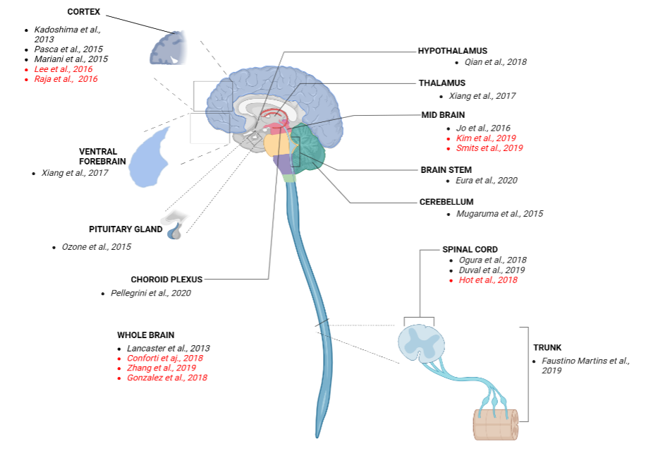
Fig 3: CNS region for which organoid protocols were developed and used in research of NDD. Studies on use of organoid models in NDD research are indicated in red.

IV. MODELLING OF NEURODEGENERATIVE DISEASES USING CEREBRAL ORGANOIDS
Neurodegenerative disease are hard to study under traditional disease modelling techniques and the compartibility of brain organoids for NDD disease modelling and clinical applications are depicted in fig 4.
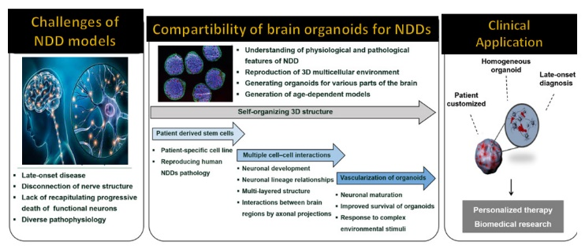
Fig 4: Schematic diagram depicting the suitability of brain organoid from patient cell for modelling NDDs.

Modelling Alzheimer's disease by Brain Organoids from AD Patients: (1,6,9)
AD is a disease that presents late in life (above 65 years of age) and is not associated with the natural aging process. It is responsible for 60%-80% dementia cases with loss of cognitive abilities and memory.(1,10) The accumulation of tau plaques & protein aggregates, and synaptic dysfunction are pathological hallmarks of AD. Human cerebral organoids can effectively mimic key aspects of the human brain compared with cellular and animal models. As a result, several in vitro organ models for AD have been created.
According to Khachaturian (1985), Selkoe (1991), Goedert & Spillantini (2006), AD is a commonly characterized by the deposition of misfolded amyloid Aβ peptides and intracellular nerve fibre disturbances. More than 46.8 million individuals worldwide are affected by AD, resulting in significant cognitive dysfunction and impairment in memory. (Patterson, 2018) (11). By overexpressing APP and PSEN1, in 2014 Choi et al generated a system of 3D culture with human brain stem cells and efficiently detected the combination of β & tau amyloid pathology, showing the 3D culture advantage. Human brain organoids generated from familial AD (fAD) patients show continuous and spontaneous aggregation of Aβ. (12,13)
Compared with the control group, fAD organoids showed significantly more pTau immunoreactivity at the later stage of culture. According to Raja et al. (2016), β- and γ- secretase inhibitors alleviate the induced pathological changes by amyloid Tau & phosphorylation in fAD organoids. Thus, brain organoids could be a versatile tool for testing potential therapeutic agents for NDD. Another recent work demonstrates that herpesvirus-infected 3D brain-like tissues can directly construct a novel AD model, simulating the development of amyloid plaques, glioma, neuritis, and neuropathy. decreased function in the degenerative phase of AD (Cairns et al., 2020).(11,13)
In studying the evolution of AD and the pathogenic mechanisms associated with AD, including gliosis, inflammation, synaptic plasticity, and lipid metabolism, 3D organoids show great promise. This approach could eventually serve as a foundation for identifying Alzheimer's treatment targets and creating new Alzheimer's drug candidates.
Modelling PD by cerebral organoids:(2–4,7,11)
According to Beiske et al, the incidence of PD, a chronic NDD, is 2 per 1000 people. It is characterized by synuclein synthesis and gradual degeneration of dopaminergic neurons, causing tremor, muscle stiffness, slower movements, and postural instability. Parkinson's disease susceptibility is thought to be affected by several genetic variants, including those affecting α-synuclein (SNCA) (Konno et al.), PARK2 (encoding parkin), kinase putative PTEN-induced (PINK1) (Pickrell & Youle,) and Leucinerich repeat kinase 2 (LRRK2). LRRK2 mutations appear to be one of the most common genetic causes of these genes in early- and late-onset Parkinson's disease. In the kinase domain, encoded by exon 41 of LRRK2, a change of glycine to the serine G2019S is commonly observed (Brice, Alcalay et al.; Mortiboys et al.). The intricacy and functionality of the 3D in vivo environment of PD cannot be replicated by 2D culture techniques, but 3D organoid technology has the ability to represent the disease of α -synuclein and cellular maturation.
Midbrain dopaminergic neurons (mDANs) present in human-specific organs of the midbrain are derived from sporadic PD patients with the LRRK2-G2019S mutation, but are reduced in number and magnitude complex compared with controls, consistent with the phenotype of patients with PD (Kordower et al.). To make organic midbrain (MO) generated, Kim et al. used CRISPR-Cas9 technology to insert a heterozygous point mutation LRRK2-G2019S into hiPSCs. The expression of TH, AADC, VMAT2, and DAT, as well as neuronal length of dopaminergic neurons, were all decreased in mutant MO. (2,13)
MOs exhibit additional PD-related clinical markers as increased aggregation and aberrant α-synuclein clearance. Gene expression data showed that the mutant MOs and brain tissue from PD patients were quite similar. The TXNIP is selectively elevated in mutant Mos, and that blocking TXNIP can reduce the LRRK2-induced phenotype in MOs, suggesting that TXNIP may be associated with individuals with PD sporadic with LRRK2 mutations. All of these findings provide important new ideas in pathophysiology of Parkinson’s progression.(1,14)
Expression of the home box transcription factor alpha (early) and the LIM marker tyrosine hydroxylase (late) is altered in MOs generated from individuals with idiopathic PD in addition to sporadic PD (Chlebanowska et al.). The neuromarker genes PTX3, TH, FOXA2 and LMX1A have all been implicated in idiopathic forms of Parkinson's disease. These results imply that MO can be an excellent model for both sporadic and conventional PD (11). The over view of modelling AD& PD with their organoid models are depicted in table 2.
Table 2: NDD modelling using iPSCs derived organoid models with differential markers.
NEURODEGENERATIVE DISEASE | REPLICATED STRUCTURES | ORGANOID MODEL | MARKERS
Alzheimer’s disease | Tuj-I, amyloid-beta, GFAP | neurons and astrocyte with pathological accumulation of amyloid-beta | showing pathological accumulation of amyloid-beta peptides
 | APP duplication; PSEN1 M146I; PSEN1 A264E | cortical organoid | endosome abnormalities; hyperphosphorylated tau protein; amyloid aggregation.
 | LRRK2 dopaminergic neurons | LRRK2-G2019S neuron organoid | three-dimensional midbrain PD organoids to mimic the age induced modelling of PD
Parkinson’s disease | LRRK2 (G2019S) neurons | neuroectodermal spheres | organoids with DARPP32+ neuros
 | dopaminergic neurons, oligodendrocytes and astrocytes | midbrain organoids | midbrain organoids replicate neurotoxin-based PD multiple brain regions
 | dopaminergic neurons | Parkinson’s disease multisystem organoid | organoids with distinct expression profiles of genes associated with synaptic transmission

V. ORGANOID-BASED DRUG SCREENING
A workflow using SFEBs derived from human induced pluripotent stem cells was developed for drug screening. The screening process involves assessing the firing and burst rates of excitatory neurons in the SFEBs using multi-electrode arrays (MEAs) and single-cell high-content imaging (HCI). This method shows consistency and reliability, making SFEBs a potential platform for high-throughput drug screening, especially for cortical organoids with high variation. Although it is a time-consuming approach, it serves as an effective starting point for drug screening. Cerebral / brain organoids, which resemble developing brains in early development, are very sensitive to toxic stress compared to fully developed brains. Therefore, they are an ideal platform for screening neurotoxicity.(13) Using brain organoids, researchers can model early-stage neurotoxicity and assess the effects of various chemicals and potential drugs. This approach offers a valuable alternative to in vivo animal models or cell-based screens and enables the identification of developmentally neurotoxic compounds in the compound library. Successful studies have already identified drugs and heavy metals as developmental neurotoxic substances. The blood-brain barrier (BBB) plays a vital role in drug discovery to treat neurodegenerative diseases (NDDs) due to the high permeability of drugs to the brain. Most of the organoid culture present today is centralised to particular organ or tissue and fails to express the physiological interactions of the tissue or organ with another relevant organ.(15,16) In addition to this human BBB and animal BBB have significantly different functions which makes the translation of human models from animals more difficult. To solve this new BBB chip models have been developed by combining BBB with neural organoid and vascularised cell culture. The drug permeability and interactions at the level of circulation system were stimulated accurately by these models.
Recently, human CNS barrier-forming organoids (CBFOs) derived from the choroid plexus (ChP) have been established. The ChP has two roles, forming protective epithelial BBB and production of cerebrospinal fluid (CSF). CBFOs copies the key features of ChP, producing CSF-like fluid and performing selective permeability, similar to ChP in vivo. Later, CBFOs develops and shows similarities to ChP at the molecular levels of transcriptomics and proteomics. CBFOs can be used in the study of new compounds and their permeability across BBB into the CNS, making them a crucial tool for drug screening related to neurodegenerative diseases. (13,17,18)
However, current organoid-based drug screening approaches have limitations. The amount and quality of the organoids has a significant impact on the efficiency & reproducibility of the screening. Low generation rate limits the size of the organoids, making drug screening difficult. Apart from this, the ability of organoids to accurately simulate their parent organs phenotypes affects the reliability of organoid drug screening. At the systemic level, most organoid models overlook drug interactions with multiple tissues, organs, or systems in vivo, which is particularly important for NDDs due to the presence of the BBB.
- FUTURE OPPORTUNITIES AND CONCLUSION
While cerebral brain organoids are a promising tool for modelling the human brain, they have limitations as an in vitro model. Current methods for organoids focus on early developmental events and do not fully reproduce the patterns and environmental features of an intact embryo. This limits their ability to model disorders & diseases that develop later in foetal development. A major challenge is the lack of vascularization in organoids, which is essential for nutrient supply, gas exchange, and waste disposal in the developing brain. The introduction of vasculature such as mesenchymal cells or iPSC-derived endothelial cells could promote the growth & maturation of organoids beyond the prenatal stage. Another overlooked cell type are microglia, the brain-resident macrophages that play a critical role in brain development and pathogenesis. The incorporation of functional microglia into organoid culture systems could offer additional benefits. Another important consideration is overcoming the limited reproducibility of organoids. Although reproducibility is a challenge in most 3D cell culture models, it is particularly important when using organoids in toxicity screening or high-throughput assays. A potential solution is to use patterning factors to control organoid development, as shown in cortical spheroids. In the future, potential models may include the arrangement of organoids or spheroids that are specific to particular regions, forming intricate and complex tissues. that more closely resemble the developing human brain in vitro, offering improved reproducibility and a greater variety of cell types. Thus, neural organoids culture techniques can be developed further and researches should be made to unlock its true potential.

REFERENCES

1. Bhargava A, Sandoval Castellanos AM, Shah S, Ning K. An insight into the iPSCs-derived two-dimensional culture and three-dimensional organoid models for neurodegenerative disorders. Interface Focus (2022) 12: doi: 10.1098/rsfs.2022.0040
2. Chang Y, Kim J, Park H, Choi H, Kim J. Modelling neurodegenerative diseases with <scp>3D</scp> brain organoids. Biological Reviews (2020) 95:1497–1509. doi: 10.1111/brv.12626
3. Faravelli I, Costamagna G, Tamanini S, Corti S. Back to the origins: Human brain organoids to investigate neurodegeneration. Brain Res (2020) 1727:146561. doi: 10.1016/j.brainres.2019.146561
4. Chang Y, Kim J, Park H, Choi H, Kim J. Modelling neurodegenerative diseases with <scp>3D</scp> brain organoids. Biological Reviews (2020) 95:1497–1509. doi: 10.1111/brv.12626
5. Bang S, Lee S, Choi N, Kim HN. Emerging Brain‐Pathophysiology‐Mimetic Platforms for Studying Neurodegenerative Diseases: Brain Organoids and Brains‐on‐a‐Chip. Adv Healthc Mater (2021) 10:2002119. doi: 10.1002/adhm.202002119
6. Vieira De Sá R, Cañizares Luna M, Pasterkamp RJ. Advances in Central Nervous System Organoids: A Focus on Organoid-Based Models for Motor Neuron Disease. Tissue Eng Part C Methods (2021) 27:213–224. doi: 10.1089/ten.tec.2020.0337
7. Adlakha YK. Human 3D brain organoids: steering the demolecularization of brain and neurological diseases. Cell Death Discov (2023) 9:221. doi: 10.1038/s41420-023-01523-w
8. Grenier K, Kao J, Diamandis P. Three-dimensional modeling of human neurodegeneration: brain organoids coming of age. Mol Psychiatry (2020) 25:254–274. doi: 10.1038/s41380-019-0500-7
9. Bi F-C, Yang X-H, Cheng X-Y, Deng W-B, Guo X-L, Yang H, Wang Y, Li J, Yao Y. Optimization of cerebral organoids: a more qualified model for Alzheimer’s disease research. Transl Neurodegener (2021) 10:27. doi: 10.1186/s40035-021-00252-3
10. Brüll M. Incorporation of stem cell-derived astrocytes into neuronal organoids to allow neuro-glial interactions in toxicological studies. ALTEX (2020) doi: 10.14573/altex.1911111
11. Bordoni M, Rey F, Fantini V, Pansarasa O, Di Giulio AM, Carelli S, Cereda C. From neuronal differentiation of iPSCs to 3D neuro-organoids: Modelling and therapy of neurodegenerative diseases. Int J Mol Sci (2018) 19: doi: 10.3390/ijms19123972
12. Shou Y, Liang F, Xu S, Li X. The Application of Brain Organoids: From Neuronal Development to Neurological Diseases. Front Cell Dev Biol (2020) 8: doi: 10.3389/fcell.2020.579659
13. Ma C, Seong H, Li X, Yu X, Xu S, Li Y. Human Brain Organoid: A Versatile Tool for Modeling Neurodegeneration Diseases and for Drug Screening. Stem Cells Int (2022) 2022:1–20. doi: 10.1155/2022/2150680
14. Wulansari N, Darsono WHW, Woo H-J, Chang M-Y, Kim J, Bae E-J, Sun W, Lee J-H, Cho I-J, Shin H, et al. Neurodevelopmental defects and neurodegenerative phenotypes in human brain organoids carrying Parkinson’s disease-linked DNAJC6 mutations. Sci Adv (2021) 7: doi: 10.1126/sciadv.abb1540
15. Wongtrakoongate P, Pakiranay C, Kitiyanant N. “Toward Understanding Neurodegeneration Using Brain Organoids.,” (2022). p. 91–107 doi: 10.1007/978-3-030-93056-1_5
16. Davenport F, Gallacher J, Kourtzi Z, Koychev I, Matthews PM, Oxtoby NP, Parkes LM, Priesemann V, Rowe JB, Smye SW, et al. Neurodegenerative disease of the brain: a survey of interdisciplinary approaches. J R Soc Interface (2023) 20: doi: 10.1098/rsif.2022.0406
17. Giandomenico SL, Lancaster MA. Probing human brain evolution and development in organoids. Curr Opin Cell Biol (2017) 44:36–43. doi: 10.1016/j.ceb.2017.01.001
18. Li Y, Zeng P-M, Wu J, Luo Z-G. Advances and Applications of Brain Organoids. Neurosci Bull (2023) doi: 10.1007/s12264-023-01065-2

