**Extraction of Bioactive Compounds from Seaweeds and its Applications**

**Sedyaaw P1, Ajay Desai1, Jayappa Koli 2 and Makarand Sharangdhar2**

**---------------------------------------------------------------------------------------------------------------------------------------**

1. **Post Graduate student, College of Fisheries, Shirgaon, Ratnagiri.**
2. **Professor, College of Fisheries, Shirgaon, Ratnagiri.**

**---------------------------------------------------------------------------------------------------------------------------------------**

**Abstract**

The finding of metabolites and biological activity from seaweed has intensely increased over the past three decades. There are several research techniques for creating chemical compounds, but still naturally occurring bioactive molecules in natures are play an important role. Scientists are searching for additional physiologically active compounds. Pharmaceutical industry and researchers are increased attention to the bioactive compounds found in seaweeds that can be used for development of drugs. Seaweeds are receiving scientific attention because of their bioactive compound and several beneficial features, including anti-viral, anti-tumour, anti-inflammatory, and. The key topics covered in this review were chemicals like metabolites, seaweed types, and their characteristics. The primary metabolite and its characteristics are highlighted. Marine seaweeds are a plentiful source of bioactive substances that can be used to enhance health in a variety of food, cosmetic, and medicinal applications. Bioactive substances, including polyphenols, polysaccharides, carotenoids, and fatty acids, have been shown to have bioactivity. Emerging techniques like techniques (Supercritical Fluid Extraction (SFE), Pressurized liquid extraction (PLE), Ultrasound-Assisted Extraction (UAE), Enzyme-assisted extraction (EAE) and Microwave-Assisted Extraction (MAE)have been used for the extraction of these chemicals due to their benefits over traditional techniques. To produce extracts containing the desired bioactive chemicals, each method's process parameters must be tuned.

**Keywords: Seaweeds, Algae, Health, Industry, Extraction**

1. **Introduction**

Seaweed cultivation is a type of marine microalgae that grew by 1.4 percent globally from 34.6 million tonnes in 2019 to 500,000 tonnes in 2020. Seaweed harvests showed major growth in in Southeast Asia and the Republic of Korea in 2020 which include China and Japan. Also, seaweeds are a good source of iodine, fucoidan, fucoxanthin, and phlorotannins and are processed into food additives and supplements (Cai et al., 2021). Microalgae and seaweed are good source of income which account of USD 1.9 billion (58%) from aquatic products made from seaweeds and other algae (FAO 2022). According to the Central Marine Fisheries Research Institute (CMFRI), 342 prospective sites are available for cultivating marine plants and algae in India and has the capacity to generate about 9.7 million tonnes of seaweed annually. ICAR-CMFRI also stated that as of 2022, the world produced 35 million tonnes of seaweed, which consists of various marine plant species and algae, and was valued at about USD 16.5 billion. Moreover, government’s made an allocation of Rs. 640 crores under the Pradhan Mantri Matsya Sampada Yojana (PMMSY) for the promotion of seaweed cultivation, with a goal production of more than 11.2 lakh tonnes by 2025.

Seaweeds or microalgae are rich source of different essential bioactive substances with a variety of biological roles. They are largely used in the food industry, medicines, cosmetics, and other food related industries, and sold commercially. The numerous biological functions associated with the bioactive substances derived from seaweeds have the potential to increase their value for improving health in the food and pharmaceutical sectors. (Merilyn et al., 2022). In recent years, consumers are more and more conscious of the relationship between diet and health, which has led to an increase in their demand for wholesome and functional meals (Granato et al., 2020). According to their primary colours, green, brown, and red algae (Chlorophyta, Phaeophyta, and Rhodophyta, respectively) are typically divided into three groups. Rhodophyta is the phylum of algae with the greatest variety and number of species. These species have large concentrations of carotenoids, including, carotene, fucoxanthin, astaxanthin, and xanthophyll, as well as additional pigments including phycoerythrin, phycocyanin, and allophycocyanin (Maria et al., 2021). Macroalgae have a variety of bioactivities due to the presence of biocompounds, including anti-aging, antioxidant, antibacterial, anti-inflammatory, anti-proliferative, and neuroprotective action (Ana-Marija et al.,2018)

**2.Classification of Seaweeds**

Based on their photosynthetic pigments, seaweeds are classified into three categories: brown (Phaeophyta), green (Chlorophyta), and red (Rhodophyta). There are around 10,000 seaweed species, including about 2000 brown, 1500 green, and 6500 red seaweeds **(**Collins et al., 2016; Gutierrez-Rodriguez et al., 2018).

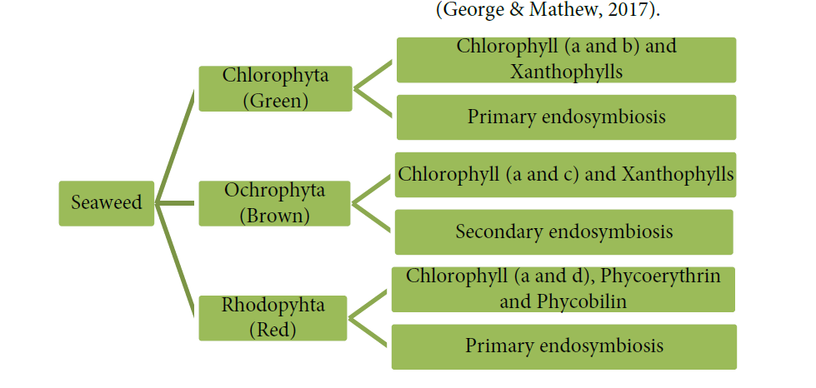

**2.1 Pigments present in seaweeds** **(Yu et al., 2014)**

|  |  |
| --- | --- |
| Green seaweeds | α-, β-, and γ-carotene, chlorophylls a and b, lutein, siphonoxanthin, and siphonein |
| Brown seaweeds | Chlorophylls a, c1, and c2, β-carotene, and fucoxanthin |
| Red seaweeds | Chlorophyll a, r-phycocyanin, allophycocyanin, c-phycoerythrin, α- and β-carotene |

**3. Bioactive compounds obtained from seaweeds (Merilyn et al.,2022)**

**Bioactive compounds and their structure**

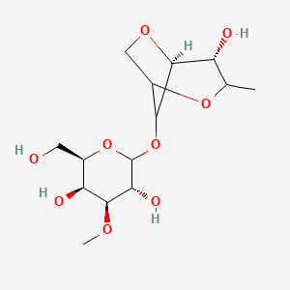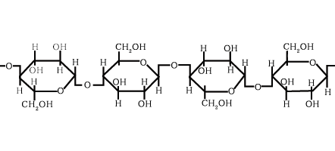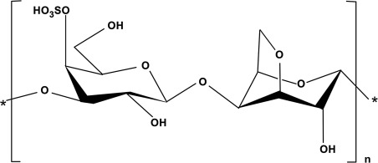

**Figure 1.** structure of Phycocolloids **Figure 2**. structure of Polysaccharide

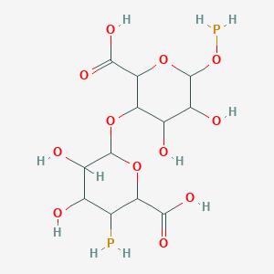

**Figure 3.** structure of Alginate  **Figure 4.** structure of Agar

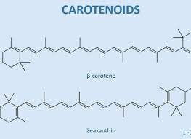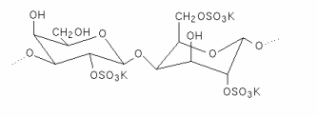

**Figure 5.** structure of Carrageenan **Figure 6 .** structure of Carotenoids

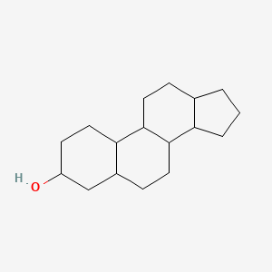

**Figure 7.** structure of Sterols

**Other bioactive compounds and their structure**

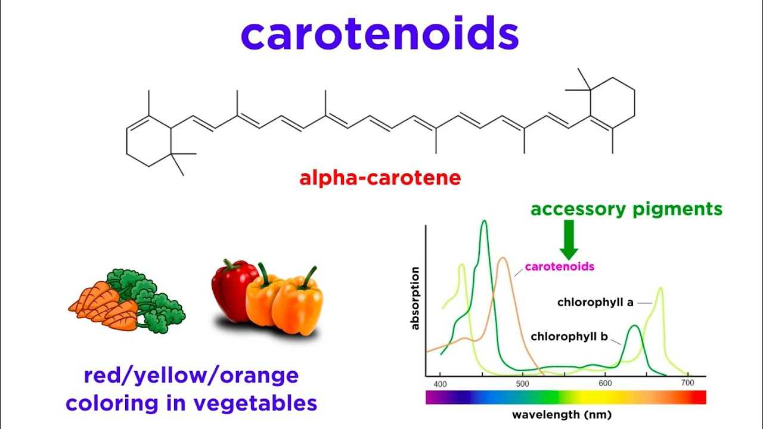

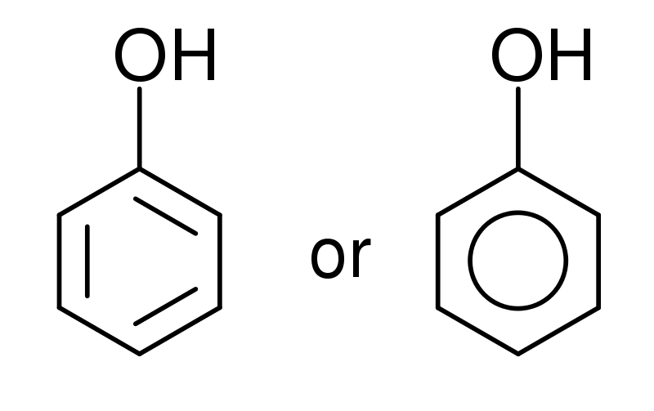

**Figure 1.** structure of Pigments **Figure 2.** structure of Phenolic Compounds

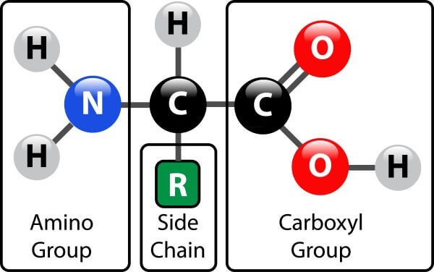

**Figure 3.** structure of *Proteins*

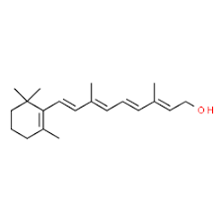

**Figure 4.** structure of *Vitamins*

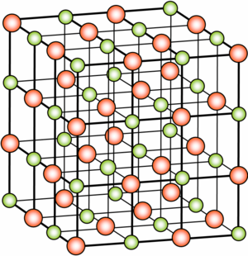

**Figure 5.** structure of *Minerals*

**3.1Phytocolloids**

Seaweed cell wall structural composition is influenced by phytocolloids. They aid in the discovery of the interaction between infections and seaweeds. Phycocolloids are polysaccharides with a high molecular weight made up of several sugar unit repetitions. Alginates, carrageenan, and agar are the three main categories of phycocolloids; they are mostly used in the food and cosmetic industries. (Archana et al., 2014)

**3.2 Polysaccharides**

Polysaccharides are abundant in marine algae, where they are largely found in the cell walls as well as in mycopolysaccharides and storage polysaccharides. Simple sugars or monosaccharides with short chains that are joined together by glycosidic bonds are known as polysaccharides. Ulva, a kind of green seaweed, has a dry weight content of 65% polysaccharide. The amount of cellulose and hemicellulose in the relevant seaweed species ranges from 2% to 10% and 9% of dry weight, respectively. Sulphated galactans, a polymer containing sulfuric acid, are found in chlorophyceae or green algae. (Archana et al., 2014)

**3.3 Alginate**

Brown algae are used to make alginate, which has a significant impact on the food and pharmaceutical industries thanks to its capacity to chelate metal ions and create highly viscous solutions. It is also utilised as a gelling agent in the textile sector. It comes in two forms: acid and salt. It also aids in the prevention of cancer and helps to empty the digestive system. They also possess the ability to absorb substances like cholesterol, which is then removed from the intestine and causes hypolipidemic and hypocholesterolemic reactions. (Archana et al., 2014)

**3.4 Agar**

Agar is a polysaccharide mixture made of agarose and agro pectin that shares structural and functional characteristics with carrageenan. Sulphated polysaccharides called agar are derived from red seaweeds such Gelidium sp. and Gracilaria sp. as well as from the Phaeophyceae family. Due to its ability to gel, emulsify, and have a high viscosity, agar is mostly used in commercial and scientific settings. Agar is a general term for seaweed galactans that contain (1-4)-3, 6-anhydro-L-galactose and (1-3)-D-galactose residues and have up to 6% (w/w) of sulphate esterification. Additionally, it has been demonstrated that agar-oligosaccharide inhibits the enzyme responsible for nitric oxide generation as well as the creation of a pro-inflammatory cytokine (Archana et al., 2014).

**3.5 Carrageenan**

It is a naturally occurring, sulfated galactan that dissolves in water and has an alternate backbone made up of (1-4)-3, 6-anhydro-D-galactose and (1-3)-D-galactose. Different types of carrageenan are as follows :iota (ι)-carrageenan, kappa (κ)- carrageenan, lambda (λ)-carrageenan, although other types of carrageenan are also reported such as μ-carrageenan, ν- carrageenan (Rhein-Knudsen et al., 2017) which is 20% (w/w) and 40% (w/w), is caused by the different kinds of seaweeds and the manner in which they were extracted. Additionally, carrageenan exhibits anti-tumor, anti-viral, anti-coagulant, and immunomodulatory properties, making it a potential pharmaceutical. (Archana et al., 2014)

**3.6 Carotenoids**

The most prevalent pigments are carotenoids, which are present in all algae, higher plants, and photosynthetic microorganisms. They stand in for red, orange, or yellow wavelength photosynthetic pigment. Natural colours known as carotenoids are made from five isoprene carbon units, which are then polymerized by an enzyme to create regular, highly conjugated 40-carbon structures with up to 15 conjugated double bonds. (Archana et al., 2014)

**3.7 Sterols**

Seaweed's nutritional value comes from its sterol content. Sterols predominate in plants, animals, and fungus, with "cholesterol" being the most well-known sterol found in animals. Animal cell membrane fluidity and cellular activity are both influenced by cholesterol, which also serves as a secondary messenger in embryonic signalling. Precursors to steroid hormones and fat-soluble vitamins include cholesterol. According to reports, plant sterols such -sitosterol and fucosterol cause a reduction in the amount of cholesterol present in serum in both human and animal experiments. (Archana et al., 2014)

**Other bioactive compounds**

1. **Pigments**

Due to their antiangiogenic, anticancer, anti-diabetic, anti-inflammatory, antioxidant, and immunomodulatory properties, seaweeds have three types of pigments, namely chlorophyll, carotenoid, and phycobiliproteins, all of which have great potential as ingredients for nutraceuticals and as physiologically active agents. They are also used as food dyes. Chlorophylls are lipid-soluble, greenish pigments that are crucial to seaweed photosynthesis. These three colours exhibit various protein concentrations, spectrum characteristics, and protein shapes (Cherry et al., 2019; Aryee et al., 2018).

**b) Phenolic Compounds**

Catechins, flavonoids, phenolic acids, phlorotannins, tannins, and other phenolic compounds are found in seaweed. As a result, the type and volume of phenolic chemical extraction are significantly influenced by the species of seaweed. Green and red seaweeds are rich in phenolic acids, flavonoids, and borophenols. Phlorotannin and phloroglucinol oligomers make up the majority of the complex polymers found in brown seaweeds (1,3,5-trihydroxy benzene). (Montero et al., 2017; Gomez-Guzman et al., 2018; Cotas et al., 2021).

**c) Proteins**

Species, seasonal cycle, and seasonal fluctuation factors all affect the protein content of seaweed. According to Erna (2011) and Fleurence et al. (2018), it is often greater for red seaweeds (up to 47% of the dry weight), medium for green seaweeds (35% of the dry weight), and lower for brown seaweeds (24% of the dry weight). Since the protein content of seaweeds has been overestimated due to the presence of nonprotein nitrogen, nitrogen-to-protein conversion ratios lower than 6.25, which are frequently used for feed components, have been advised (Makkar et al., 2016). Additionally, seaweeds include important amino acids such as aspartic acid, glycine, alanine, proline, arginine, and glutamic acid (Gullon et al., 2020). (Furuta et al., 2016).

**d) Minerals**

Additionally, seaweeds have a high mineral content (8–40%), including Na, K, Mg, Fe, and other minerals (Cofrades et al., 2017; Lorenzo et al., 2017). The concentration of calcium, which is the most observable mineral, is highest in plant sources. Additionally, they have a lower Na/K ratio than other foods found in typical Western diets, which is beneficial for preserving a healthy cardiovascular system (Circuncisao et al., 2018). Additionally, seaweeds have a high iodine content, thus eating them can help alleviate an iodine shortage (Zava & Zava, 2011).

**e) Vitamins**

Seaweeds are rich in water-soluble vitamins like vitamin C, folic acid, pantothenic acid, niacin, riboflavin, and vitamin B vitamins including vitamin B12, vitamin B6, vitamin B3, vitamin B2, and vitamin B1 as well as fat-soluble vitamins like vitamin A, vitamin D, vitamin E, and provitamin A. (Hentati et al., 2020). However, due to the fact that the vitamin content of seaweeds varies depending on the species, some of them only have a relatively low level (krovankova, 2011). (Hentati et al., 2018; Cherry et al., 2019).

**Table 1.**Bioactive Compounds and their Source(**(Silvia et al 2022)**

|  |  |  |  |  |
| --- | --- | --- | --- | --- |
| **Sr.no** | **Class of Seaweed**  **Bioactive Compounds** | **Principal Source** | **References** | **Year of publication** |
| 1 | Alginate | Brown seaweed  (Laminaria sp.,  Ascophyllum nodosum) | Review of extractions of seaweed hydrocolloids: Properties and applications. | 2018 |
| 2 | Fucoidan | Brown seaweed  (Undaria pinnatifida, Fucus sp.) | A Sulfated Polysaccharides from Brown Algae as Therapeutic Target for Cancer | 2015 |
| 3 | Laminarin | Brown seaweed  (Laminaria sp.) | Extraction, structure and biofunctional activities of laminarin from brown algae | 2015 |
| 4 | Agar | Red seaweed  (Gracilaria sp.) | Algal biotechnology industries and research activities in China. | 2001 |
| 5 | Carrageenan | Red seaweed  (Gigartina sp., Chondrus sp.) | Metabolites from algae with economical impact. | 2007 |
| 6 | Porphyran | Red seaweed  (Porphyra sp.) | Antioxidant and anti-inflammatory activities of porphyran  isolated from discolored nori (Porphyra yezoensis). | 2015 |
| 7 | Ulvan | Green seaweed  (Ulva sp.) | Ulvan from Ulva armoricana (Chlorophyta)  activates the PI3K/Akt signalling pathway via TLR4 to induce intestinal cytokine production. | 2017 |
| 8 | Phlorotannin | Brown seaweed  (Ecklonia sp., Eisenia sp.,  Laminaria sp., Undaria pinnafitida) | Bactericidal activity of phlorotannins from the brown alga  Ecklonia kurome. | 2002 |

**4.Method of extraction**

**4.1. Enzyme-Assisted Extraction (EAE)**

The enzymatic conditions and characteristics of the enzymes are given in Table 2. Ten grams of seaweed powder was weighed into a 2 L reaction vessel and 1 L of corresponding buffer was added. The reaction vessel was connected to an overhead stirrer and placed inside a water bath maintained at optimal temperature needed for the enzyme action. When the optimal temperature has reached, 1 mL (0.1% enzyme) was added to the mixture and stirred at 350 rpm for 20 h in water bath. After the incubation, the enzyme was inactivated by heating at 100 °C for 10 min and cooled in ice. The mixture was centrifuged at 1500×g for 10 min to collect the supernatant. The extract thus obtained was freeze dried, weighed for calculating yield, and reconstituted in a known quantity of water. The extracts were stored at − 86 °C freezer until further use. A water extract was also made in a similar manner for comparison. (Sabeena et al., 2019)

**Table 2.** Optimum conditions and characteristics of enzymes used. (**Source:** Habeebullah et al 2020)

|  |  |  |  |  |
| --- | --- | --- | --- | --- |
| Enzyme | Optimum conditions | | Buffer used | Characteristics |
|  | Temperature | pH |  |  |
| Carbohydrases |  |  |  |  |
| Viscozyme L | 50 °C | 4.5 | 0.1 M acetate buffer | A multi-enzyme complex (containing arabinase, cellulase,  β-glucanase, hemicellulase, and xylanase) |
| AMG 300 L | 60 °C | 4.5 | 0.1 M acetate buffer | Exo-1,4-α-D-glucosidase |
| Celluclast 1.5 L FG | 50 °C | 4.5 | 0.1 M acetate buffer | Cellulase |
| Termamyl 120 L | 60 °C | 6 | 0.1 M phosphate buffer | A heat-stable α-amylase |
| Ultraflo L | 40 °C | 6 | 0.1 M phosphate buffer | A heat-stable multi-β-glucosidase |
| Flavourzyme 500MG | 50 °C | 7 | 0.1 M phosphate buffer | Containing both endoprotease and exopeptidase |
| Alcalase 2.4 L FG | 50 °C | 8 | 0.1 M phosphate buffer | Endopeptidase |
| Neutrase 0.8 L | 50 °C | 8 | 0.1 M phosphate buffer | Metalloendoprotease |

**4.2. Microwave-Assisted Extraction (MAE)**

Milled algae (average particle size<200 μm) were processed by Microwave Assisted Extraction (MAE) using a Microwave reactor Monowave 450 with autosampler Mas 24 (Anton Paar, Austria) for the recovery of high valuable compounds. Dried milled algae and distilled water were added in the microwave vials at a solid liquid ratio of 1:30 (w:w). Preliminary trials were performed to choose the operation conditions taking into account the outcomes achieved in previous works with seaweeds. The first set of samples were heated for a microwave time (tMAE) of 3 min at a wide range of temperatures: 70, 90, 130, 150, 170, 190 °C and the second set of samples were heated for tMAE of 6 min at the same temperatures. Then, both were cooled until 55 °C. Subsequently, the liquid fraction was separated from the solid one by vacuum filtration. The samples were kept in the freezer until further use.

One volume of the liquid fraction obtained by MAE was precipitated with one volume of ethanol (96%, Sigma-Aldrich, USA). The precipitate was separated by filtration if necessary. Then, the recovered biopolymer was dried in an oven at 40 °C. The dried carrageenan was weighed to obtain the yield (g hybrid carrageenan/g dried alga powder). (Elise et al., 2020)

**4.3. Ultrasound-Assisted Extraction (UAE) (Wizi et al. 2022)**

Seaweed-wakame (*Undaria pinnatifida*) samples were cleaned, oven dried and pulverized using a universal disintegrator. Extraction of algae samples was with an ultrasound instrument (ningbo licheng co. Ltd., China) with ultrasound frequency at 25khz. A solvent mixture of 70% ethanol and 30% water (v/v) was for the extraction, which promote effective recovery. Algae sample was cleaned, oven dried and pulverized with a universal disintegrator (yongshi jiupin company, china). To achieve the optimum extraction condition, the algae powder was introduced to the solvent and compounds leached at various temperatures (45°C, 55°C, and 65°C) and times (20 and 30 min) using ultrasound power 70% and 30%. Temperature, ultrasonic power treatment, and time were set for each extraction condition for UAM. Each extraction condition was replicated three times and a thermometer was placed in the mixture to determine temperature. During the UAM extraction the input power was thought to be transformed into heat and dispersed in the medium. The liquor extract was centrifuged at 3000 rpm for 5 min with a tabletop high-speed Bioridge (TG16-WS) centrifuge. To guarantee that all soluble bioactive substances were recovered, the residue was re-extracted.A freeze dryer was used to dry the concentrated extracts .

The yield for each form was calculated using the equation below

Yield% = (Mass of extract / Mass of sample used ) ×100

**4.4. Supercritical fluid extraction (SFE)**

For each extraction, 0.5 g of dried algae biomass was used with a CO2 flow rate of 2 ml/min. Each extraction was carried out for 2 h in triplicate. Extraction conditions based on three factors: temperature (40–60 °C), pressure (100–300 bar) and percentage of ethanol as co-solvent (0–15%). After extraction, the resulting extracts were collected in vials and the residual ethanol was evaporated under vacuum to calculate extraction yield. Then, dried extracts were diluted with ethanol to concentrations from 10 to 20 mg/ml and stored at −20 °C and protected from light until analysis. (Joanna et al., 2016)

**4.5. Pressurized liquid extraction (PLE)**

A pump pushes the solvent in process and extract out once the process is finished. An extraction cell, where the extraction physically takes place. Therefore, it has to be adapted for high pressures and to be equipped with at least two on/off valves to be able to keep the extraction conditions stable. An oven, where the extraction cell is placed so that it can be heated to the desired value (200oc). The PLE instrument may be equipped with heating coils for solvent heating in dynamic extractions. It can also have a nitrogen circuit that helps to vent all the solvent from the lines after extraction. It has to be considered that, given the operating pressures and temperatures usually employed, corrosive-resistant materials have to be used. (Ballesteros et al., 2020)



**Table 3.** Name of Method and Procedure (**Source:** Seaweed extraction process (adapted from Admassu et al. (2018), Kadam et al. (2015), Praveen et al. (2019))

|  |  |  |  |
| --- | --- | --- | --- |
| **Extraction Method** | **Procedure** | **Bioactive Components** | **Author** |
| Enzyme-Assisted  Extraction (EAE) | *Incorporating food-grade enzymes  such as *cellulase, a-amylase, pepsin ,viscozyme, cellucast, termamyl ,ultraflo, carrageenase, agarase, xylanase, kojizyme, neutrase, alcalase, and umamizyme* into seaweeds.  * Degradation of glycosidic bonds  and other internal bonds | *Fucoxanthin  *Lipids  *Phlorotannins  *Phenolic compounds | Admassu et al. (2018), Kadam et al. (2015), Praveen et al. (2019)) |
| Microwave-Assisted  Extraction (MAE) | *Most researched extraction  technique.  *Microwave energy was used to heat  solvent-containing samples.  *Dielectric and total volumetric  heating by microwaves.  *2.45 GHz | *Sulfated polysaccharides,  such as fucoidan, ulvan,  and rhamnan sulfate. | Admassu et al. (2018), Kadam et al. (2015), Praveen et al. (2019)) |
| Ultrasound-Assisted  Extraction (UAE) | *Ultrasonic radiation pressure was  used to generate intense mixing and  agitation, which promotes  Extraction. *Compression and  rarefaction (pressure variation and  cavitation)  *20 kHz  *50-60 kHz | *Polyphenols  * Fucose and uronic acid  * Laminarin  *Phycobiliary proteins  *Taurine  *Antioxidants | Admassu et al. (2018), Kadam et al. (2015), Praveen et al. (2019)) |
| Ultrasound-Assisted  Extraction (UAE) | *Ultrasonic radiation pressure was used to generate intense mixing and agitation, which promotes Extraction. *Compression and  rarefaction (pressure variation and  cavitation)  *20 kHz  *50-60 kHz | *Polyphenols  * Fucose and uronic acid  * Laminarin  *Phycobiliary proteins  *Taurine  *Antioxidants | Admassu et al. (2018), Kadam et al. (2015), Praveen et al. (2019)) |
| Supercritical Fluid  Extraction (SFE)  Pressurized | *The supercritical fluid’s  temperature and pressure are both  greater than the critical point. | *Fatty acids (ω-3)  *Carotenoids,  * Fucoxanthin,  *Fluorotannins  * Volatile compounds  *Polyphenols,  *Cytokinins,  * Auxins, Microelements,  and macro elements | Admassu et al. (2018), Kadam et al. (2015), Praveen et al. (2019)) |

**4. Applications of bioactive compounds from seaweeds**

**4. Industrial purpose**

Brown edible seaweeds serve as the only food supply for the development of lactic acid bacteria. *Himanthalia elongata, Laminaria digitata, and Laminaria saccharina* are three species of edible Irish brown seaweed that were used to study the growth kinetics of lactic acid bacteria (LAB; Lactobacillus plantarum). The findings of this study point to the potential of seaweed fermentation utilising LAB and the potential for the development of a variety of functional meals (Gupta et al., 2011). Seaweed polysaccharides with low molecular weight as prebiotics. Bifidobacterial populations significantly increased in Gelidium seaweed. Seaweeds that produce agar and alginate suggest the possibility for prebiotics Seaweed and pure glucose fermentations produced similar amounts of butanol (Innocenzo et al., 2012).

**4.2. Pharmaceutical**

Many studies use in *vitro* and in *vivo* testing to examine the biological substances of marine species of seaweeds with the aim of analysing their modes of action and utilising them for pharmaceutical purposes. Over the years, research on marine pharmaceuticals has made significant advancements. On this foundation, research continues to advance the field of marine pharmacology, a new area of pharmacy that integrates several academic fields and necessitates a thorough knowledge base. It is essential to confirm the potential of seaweed bioactive components prior to pharmacological studies. It is feasible to have a clear spectrum of the components present in seaweeds, which will be accurately recognised and evaluated, through standardisation and quality control of parameters. The identification, quality, and effectiveness of biological chemicals will be ensured by such research. Examples of pharmacognostic analysis are documented for Sargassum cinereum, Ulva lactuca, and Chaetomorpha antennina. (Lomartire et al., 2022)

**4.3. Nutraceutical**

Several research assessed how adding seaweeds to fish products affected their nutritive, sensory, and textural qualities.After the addition of high quality lipids (long chain n-3 LCPUFAs) and seaweed extracts as natural antioxidants, the sensory quality and lipid oxidation of enriched fish cakes were recently evaluated (Dellarosa, Laghi, Martinsdóttir, Jónsdóttir, & Sveinsdóttir, 2015). It was discovered that adding seaweed extracts in aqueous and ethanol did not have an impact on the products' quality or lipid oxidation. Additionally, none of the samples had an off flavour, and low scores for rancid odour and flavour were reported.

**4.4. Medical**

**Therapeutic properties of seaweed-derived compounds**

**4.4.1Metabolism**

In recent years, a variety of novel diabetic medications have emerged, including insulin mimickers and oral hypoglycemic agents. Type-2 diabetes, which reverses glucose metabolism enzymes, has been demonstrated to be safe and efficient against bioactive substances from seaweed. Alkaloids, flavonoids, carotenoids, polyphenols, and phlorotannins were among the seaweed bioactive that were proven to have a hypoglycemic effect. Fucoxanthin dramatically increases insulin sensitivity and lowers blood glucose levels in diabetic rats, according to Maeda et al findings’ There have been numerous reports of fucoidan from the brown algae Fucus vesiculosus and Ascophyllum nodosum lowering blood glucose levels in an animal model. This study showed that fucoidan, which has a low molecular weight, stimulates the development of beta cells while limiting glucagon output from alpha cells in the reversal of blood sugar. (Abirami et al., 2019)

**4.4.2. Antiviral Activity**

Some sulphated polysaccharides from red algae have reportedly been shown to exhibit antiviral effect against viruses that cause human infection. The two most famous species are Nothogenia fastigiate and Aghardhiella tenera.The most contagious viruses, such as the human immunodeficiency virus or HIV, the herpes simplex viruses types 1, 2, and the respiratory syncytial virus, are tested to see if galactan sulphate (from Aghardhiella tenera) and xylomannan sulphate (from Nothogenia fastigiata) exhibit antiviral activity. When the polysaccharide in these seaweeds adheres to the cell's surface during the initial stage of RNA replication, it becomes active.(Archana et al., 2014)

**4.4.3Anti-Inflammatory Activity**

The 20-carbon polyunsaturated fatty acids such as eicosapentaenoic and docosahexanoic referred to as PUFAS, are abundant in macroalgae, particularly red seaweeds. The two primary metabolites of the oxidative metabolism of C20 PUFAS by seaweeds are prostaglandin and gracilariales. There are two main alternate methods for producing prostaglandins: the first technique employs lipooxygenase, which also acts as archidonic acid in mammalian cells, and the second approach uses fatty acid cyclooxygenase (Archana et al., 2014)

**4.4.4Anti-Thrombic and Anti-Coagulant Activity**

Fucoidan have anti-thrombotic and anti-coagulant properties that are heparin-like in both vivo and in vitro. These properties are mediated by blood coagulation inhibitors like heparin cofactor II or anti-thrombin III. Direct interactions between fucan and thrombin result in anti-coagulant activity, which typically grows with sulphation levels.Ascophyllum nodosum and Fucus vesiculosus both produce sulphated fucan, which has been patented as an anticoagulant (Archana et al., 2014)

**4.4.5Antilipemic, Hypocholesterolaemic Activity**

There are numerous severe illnesses nowadays that are bad for society, including cardiovascular disease, which is mostly brought on by excessive blood pressure and plasma cholesterol levels. Some macroalgae, including alginate, funoran, fucoidan, laminaran, porphyran, and ulvan, have been found to cause hypocholesterolemic and hypolidemic reactions as a result of decreased gut absorption of cholesterol. This is caused by a hypoglycemic reaction and an increase in faecal cholesterol.(Archana et al., 2014)

**4.5.Food industry**

In Hawaii, red macroalgae (Gracilaria spp.) are consumed fresh. Commonly marketed species include G. coronopifolia, G. parvispora, G. salicornia, and G. tikvahiae, however their postharvest life is only around four days (Paul and Chen, 2008). The anti-oxidant and antibacterial phytochemicals found in seaweeds are abundant. Minerals and fibres help to improve the mineral content while lowering the salt concentration. ( Innocenzo et al., 2012)

**4.6. Cosmetics**

**4.6.1Tyrosinase Inhibition Activity of Seaweed**

The enzyme tyrosinase is important for catalysing the formation of the pigment melanin, which gives skin its colour. The abnormal buildup of melanin pigments in the skin is what causes hyperpigmentation. Skin pigmentation is brought on by aberrant melanin synthesis brought on by excessive UV exposure. Natural tyrosinase inhibitors are in high demand as safe and effective skin-whitening agents. Seaweed-based skin-whitening chemicals may therefore be helpful for the cosmetics business. Ishige okamurae Yendo, Endarachne binghamiae, and other seaweed extracts showed tyrosinase inhibitory activity when tested by researchers**.** (Jesumani et al., 2019)

### 4.6.3. Hyaluronidase Inhibition

An enzyme called hyaluronidase breaks down the hyaluronic acid found in the extracellular matrix, speeding up the ageing process of the skin. Hyaluronidase inhibition has only been the subject of a very small number of research. Phlorotannin derivatives from Cystoseira nodicaulis (Withering) M. Roberts, including fucophloroethol, fucodiphloroethol, fucotriphloroethol, 7-phloroeckol, and phlorofucofuroeckol, demonstrated hyaluronidase activity with an IC50 of 0.73 mg/mL and demonstrated that the higher molecular weight Phlorotannin derivatives from Ecklonia kurome Okamura and Eisenia bicyclis (Kjellman) Setchell showed strong inhibition of hyaluronidase.

### 4.6.5. Hyaluronidase

Moisture control is crucial for skincare since it enhances skin texture and condition, making it appear younger and healthier. A. nodosum (Linnaeus) Le Jolis, Cladosiphon okamuranus Tokida, Undaria pinnatifida (Harvey) Suringar, Durvillea antarctica (Chamisso) Hariot, Pediastrum duplex Meyen, and Polysiphonia lanosa extracts (Linnaeus). Tandy demonstrated skin-hydrating qualities and shields against dryness. Because of their high capacity to store water, polysaccharides can be used as humectants and moisturisers in the cosmetics sector. It has been demonstrated that Laminaria japonica Areschoug polysaccharides offer superior hydration and moisturising properties to hyaluronic acid. (Jesumani et al., 2019)

**Table 4 .**Main biological properties and industrial applications of seaweed’s bioactive compounds **(Source:** Silvia et al 2022)

|  |  |  |
| --- | --- | --- |
| **Class of Seaweed**  **Bioactive Compounds** | **Application and Properties** | **Principal Source** |
| Alginate | Used as stabilizer and thickening  agent in food products and medicine | Brown seaweed  (Laminaria sp.,  Ascophyllum nodosum) |
| Fucoidan | Antiproliferative,  Antimicrobial and  Antiviral activity  Anticoagulant activity  Antidiabetic activity | Brown seaweed  (Undaria pinnatifida, Fucus sp.) |
| Laminarin | Used in food industry and  biomedicine because of its  nutraceutical properties;  immunostimulatory, antitumour and  antioxidant activity | Brown seaweed  (Laminaria sp.) |
| Agar | Used in food products and  pharmaceutical field as jellifiers,  stabilisers, thickeners and emulsifiers | Red seaweed  (Gracilaria sp.) |
| Carrageenan | Red seaweed  (Gigartina sp., Chondrus sp.) |
| Porphyran | Anti-inflammatory, antioxidant,  antihyperlipidemic and  anticancer activities | Red seaweed  (Porphyra sp.) |
| Ulvan | Immunostimulatory, antitumoural,  antiviral activities | Green seaweed  (Ulva sp.) |
| Phlorotannin | antimicrobial, antioxidant, antiviral,  anticancer, anti-inflammatory,  antidiabetic properties | Brown seaweed  (Ecklonia sp., Eisenia sp.,  Laminaria sp., Undaria pinnafitida) |

**Conclusion**

seaweeds are regarded as an economically significant biological resource because they contain a variety of bioactive compounds with a variety of biological functions, including different pigments, phenolic compounds, lipids, vitamins, proteins, minerals, polysaccharides, and polyunsaturated fatty acids. Seaweeds are primarily used in the food industry, the pharmaceutical industry, the cosmetics industry, and many other industries. They are commercially offered as fresh and extracts. Despite the fact that seaweeds are mostly safe and healthful, there are still certain hazards associated with them, including exposure to heavy metals, arsenic, and excessive iodine concentrations. Due to the epidemiological study's ongoing inconclusiveness, there is still a paucity of information on this method. Further green extraction methods were used to separate the bioactive components, and the extract's purity was verified by chromatographic analysis. Marine medicines seek to reduce side effects brought on by synthetic substances and produce innovative treatments with natural-source ingredients. Due to the high cost of medications and the poor purchasing power of the populace in places like Africa and Asia, access to vital medicines is currently a luxury that only fewer than 50% of the world's population enjoys. Despite the large number of studies that have been done on the compounds and extracts of seaweeds, more research needs to be done in order to find novel molecules for use in various biotechnological applications, directly and indirectly enhancing human wellbeing.

**References**

1. Abirami, R., Tiwari, U and Rajauria,G.. .Seaweed nutraceuticals and their therapeutic role in disease prevention.Food Science and Human Wellness.8(3):252-263,ISSN 2213-4530, 2019.
2. Amlani, M. & Yetgin, S.. Seaweeds: Bioactive Components and Properties, Potential Risk Factors, Uses, Extraction and Purification Methods . Marine Science and Technology Bulletin , 11 (1) , 9-31 . DOI: 10.33714/masteb.1021121FAO (2022) The State of World Fisheries and Aquaculture.Towards blue transformation. Rome.2022
3. Ballesteros, V., D., Ortega,B.,Camargo,S.,Rodríguez,Varela., P..Pressurized Liquid Extraction of Bioactives. In *Comprehensive Foodomics*; Elsevier: Amsterdam, The Netherlands, 13:754–770. 2020
4. Cikos, A., Jokic, S., Subaric, D and Jerkovic I. Overview on the Application of Modern Methods for the Extraction of Bioactive Compounds from Marine Macroalgae. Marine Drugs.16(10):348.2018
5. CMFRI Annual Report . Central Marine Fisheries Research Institute, Kochi, India.2020-21
6. Collins, K. G., Fitzgerald, G. F., Stanton, C., & Ross, R. P.Looking beyond the terrestrial: The potential of seaweed derived bioactives to treat non-communicable diseases.*Marine Drugs*, *14*(3), 1–31.2016
7. Dellarosa, N., Laghi, L., Martinsdóttir, E., Jónsdóttir, R. and Sveinsdóttir, K. Enrichment of convenience seafood with omega-3 and seaweed extracts: Effect on lipid oxidation. LWT - Food Science and Technology. 62. 746-752.2015
8. Granato, D., Barba, F. J., Kovacevic, D. B., Lorenzo, J. M., Cruz, A. G., & Putnik, P.Functional foods: Product development, technological trends, efficacy testing, and safety. Annual Review of Food Science and Technology, 11:93–118. 2020

# Habeebullah, S., Alagarsamy, S. and Sattari .Enzyme-assisted extraction of bioactive compounds from brown seaweeds and characterization. [Journal of Applied Phycology](https://www.springer.com/journal/10811/).**32**: 615–629 (2020).

1. Innocenzo,. M..Seaweeds for Food and Industrial Applications.Intech Open chapter 7:17–38.2013
2. Jesumani, V., Du, H,. Aslam, M,. Pei, P. and Huang., N. Potential Use of Seaweed Bioactive Compounds in Skincare-A Review. Marine Drugs.17(12):688. 2019
3. Joanna,F., Ibanez, E., Łęska,B.,Miguel.Supercritical fluid extraction as a tool to valorize underexploited freshwater green algae,Algal Research19:237-245.2016
4. Lomartire, S. and Gonçalves,A. An Overview of Potential Seaweed-Derived Bioactive Compounds for Pharmaceutical Applications. Marine Drugs, 20:141.2022
5. Pal, A., Kamthania, M. and Kumar, A.Bioactive Compounds and Properties of Seaweeds—A Review. *Open Access Library Journal*, **1**:1-17. 2014
6. Pappou, S., Dardavila, M., Savvidou, M., Louli, V,, Magoulas, K. and Voutsas, E.Extraction of Bioactive Compounds from Ulva lactuca.Applied. Science. 12: 21-17. 2022
7. Ponthier, E., Dominguez, H. and Torres, M. The microwave assisted extraction sway on the features of antioxidant compounds and gelling biopolymers from Mastocarpus stellatus. Algal Research. 7(3):.32-46.2020
8. Wizi, J., Wang, L., Hou, X., Tao, Y., Ma, B. and Yang, Y. Ultrasound-microwave assisted extraction of natural colorants from sorghum husk with different solvents. Industrial Crops and Products*.*  *120*: 203–213.2018
9. Yu,Xin,K.,Ibrahim, J.Ahmad,R.,Ching, Lee. The major bioactive components of seaweeds and their mosquitocidal potential. Parasitology research.3:113-117. 2014