Chromatography techniques for isolation of phytoconstituents from medicinal plants
Author information
Rustam Ekbbal¹, Mhaveer Singh², Gaurav¹*, Sapna Salar³
¹ Department of Pharmacology, IIMT College of Medical Sciences, IIMT University, O Pocket, Ganga Nagar, Meerut, Uttar Pradesh 250001.
²Pharmacy Academy, IFTM University, Lodhipur Rajput, Delhi Road, Moradabad-244102, Uttar Pradesh, India.
³Department of Pharmaceutical Sciences, Apex University, Jaipur, Rajasthan-302018

Rustam Ekbbal: rustamekbbal@gmail.com
Mhaveer Singh: maahishaalu7@gmail.com
Gaurav: gautamgaurav878@gmail.com
Sapna Salar: sapnasalar50@gmail.com

Dr. Gaurav
Assistant Professor
IIMT College of Medical Sciences,
IIMT University, O Pocket, Ganga Nagar,
Meerut, Uttar Pradesh 250001
Email: gautamgaurav878@gmail.com
Mob. No.: 9760477960
Abstract
Chromatography techniques play a pivotal role in the isolation of phytoconstituents from medicinal plants, facilitating the extraction and purification of bioactive compounds. This abstract review the diverse chromatographic methods employed in the quest for isolating and characterizing phytochemicals with therapeutic potential. Gas chromatography (GC) enables the separation of volatile compounds, while high-performance liquid chromatography (HPLC) offers versatile separation of a wide range of phytoconstituents. Thin-layer chromatography (TLC) provides rapid qualitative analysis and serves as a preliminary step in compound isolation. Preparative chromatography methods, such as flash chromatography and preparative HPLC, are crucial for obtaining larger quantities of pure compounds. Furthermore, liquid chromatography-mass spectrometry (LC-MS) and gas chromatography-mass spectrometry (GC-MS) are indispensable tools for compound identification and structural elucidation, aiding in the characterization of complex phytochemical profiles. The synergy of these chromatographic techniques allows researchers to navigate through the intricate chemical composition of medicinal plants, uncovering valuable bioactive molecules. By harnessing the power of chromatography, the isolation and purification of phytoconstituents become more efficient and accurate, contributing to the advancement of herbal medicine and drug discovery. The constant evolution and integration of chromatography methods with modern technology continue to expand the frontiers of phytochemical research, enhancing our understanding of the therapeutic potential hidden within nature's botanical treasures.
Keywords: Chromatography techniques, Phytoconstituents, Medicinal plants, Isolation, Bioactive compounds, Compound identification

Introduction
Medicinal plants have been an integral part of human healthcare for millennia, offering a vast reservoir of bioactive compounds with therapeutic potential. Within the intricate matrix of plant tissues, a diverse array of phytoconstituents resides, each holding the promise of addressing a wide spectrum of ailments. To harness the medicinal prowess of these botanical treasures, the isolation and purification of phytoconstituents are essential. Chromatography techniques, a family of separation methods, stand as the linchpin of this endeavor, facilitating the extraction of these bioactive compounds with precision and efficiency (Gaurav et al., 2022, 2023b; Khan et al., 2021).
Nature's pharmacopoeia is a vast and intricate tapestry woven by millions of plant species, each harboring a unique chemical signature. In the heart of these botanical riches lie phytoconstituents—secondary metabolites that have evolved as a plant's response to environmental challenges, predators, and pathogens. These compounds encompass a breathtaking diversity, including alkaloids, flavonoids, terpenoids, phenolics, and many others. It is within this chemical diversity that the potential for novel drug discovery and therapeutic innovation resides. While the medicinal potential of phytoconstituents is undeniable, their isolation from the complex matrices of plant tissues is a formidable challenge. The inherent intricacy of medicinal plants necessitates the separation of bioactive compounds from a milieu of non-therapeutic constituents (Gaurav, 2022; Gaurav et al., 2022, 2023b; Gautam, 2022).
Moreover, the sheer scale of phytoconstituents present in even a single plant demands isolation techniques that are not only efficient but also capable of preserving the structural integrity and bioactivity of the compounds in question. Chromatography, a scientific technique that emerged in the early 20th century, is the cornerstone of phytoconstituent isolation. The term "chromatography" itself originates from the Greek words "chroma" (color) and "grapho" (to write), highlighting its initial use in separating plant pigments. Since then, chromatography has evolved into a powerful family of analytical and preparative techniques, each designed to separate complex mixtures into their individual components (Khan et al., 2024, 2022).
Chromatography offers a rich arsenal of approaches, each tailored to specific needs and goals. High-Performance Liquid Chromatography (HPLC), Gas Chromatography (GC), and Thin-Layer Chromatography (TLC) are among the most widely employed techniques in the field of phytoconstituent isolation. High-Performance Liquid Chromatography (HPLC) is a versatile and high-resolution technique frequently used for the separation of complex mixtures. It excels in the identification and quantification of phytoconstituents by exploiting differences in their chemical properties, such as polarity and molecular size. HPLC is well-suited for the analysis of compounds like alkaloids, flavonoids, and polyphenols, often found in medicinal plants. Gas Chromatography (GC) is ideal for separating volatile and semi-volatile compounds. It relies on the vaporization of compounds and their interaction with a stationary phase. GC is particularly useful for isolating essential oils, terpenoids, and other volatile phytoconstituents present in aromatic plants (Gaurav, 2022; Gautam et al., 2023).
Thin-Layer Chromatography (TLC) is a cost-effective and rapid technique for preliminary phytoconstituent screening. It involves the separation of compounds on a thin layer of adsorbent material. TLC serves as an invaluable tool for identifying the presence of specific phytoconstituents in plant extracts. The isolation of phytoconstituents through chromatography opens doors to an array of scientific and practical possibilities. It facilitates the development of novel drugs, herbal formulations, and natural remedies. Phytoconstituents isolated through chromatography are essential for in-depth pharmacological studies, bioactivity assessments, and structure-activity relationship elucidation (Gaurav et al., 2020). Moreover, these techniques play a pivotal role in quality control and standardization of herbal products, ensuring their safety and efficacy. The isolation of phytoconstituents from medicinal plants represents a vital bridge between nature's botanical treasures and modern medicine. Chromatography techniques, with their versatility and precision, are the linchpin of this endeavor, enabling the separation and purification of bioactive compounds with unmatched efficiency. In the pages that follow, we delve into the intricacies of various chromatographic methods, their applications, and the profound impact they have on the exploration of phytoconstituents for healthcare and drug discovery (Gaurav et al., 2023a; Khan et al., 2021; Zahiruddin et al., 2020).
.

Review findings

Chromatography
A technique enables that enables the isolation, purification and identification of the components of a mixture for qualitative and quantitative analysis. The various constituents of the mixture travel at different speeds, causing them to separate. The separation is based on differential partitioning between the mobile and stationary phases.
Based on this approach three components form the basis of the chromatography technique.
- Stationary phase: This phase is always composed of a “solid” phase or “a layer of a liquid adsorbed on the surface a solid support”.
- Mobile phase: This phase is always composed of “liquid” or a “gaseous component.”
- Separated molecules: phytochemicals or chemicals separated on/by stationary phase based on their polarity or molecular integrity
These are special techniques used in the separation of compounds from mixtures based on their size, shape, and charge. The concept of chromatography involves the use of the mobile phase, which is the solvent of extraction and the stationary phase such as silica gel and Sephadex mixed with calcium sulfate as a binder.

Chromatography techniques based on analysis
- Generally, chromatography may be Preparative “to separate the components of a mixture for later use, and is thus a form of purification”
- Analytical chromatography technique is used for identification of components present in smaller amount”. The chromatography method going to be used for the separation of plant constituents can be classified from different points of view are

The most used stationary phase in separation science
- Silica gel is used for parting amino acids, sugars, fatty acids, lipids, and alkaloids.
- Sephadex is applicable in the isolation of proteins and amino acids.
- Aluminum Oxide is useful in the separation of vitamins, carotenes, phenols, steroids, and alkaloids. Cellulose powder is used in the separation of amino acids, food dyes, and alkaloids.
- Celite is applicable in the separation of organic cations and steroids.

The physical state of the phases employed for separation
- If the mobile phase is a gas and the stationary phase
is a solid or liquid, the separation techniques are known as gas-solid chromatography or gas-liquid chromatography (GSC and GLC or often simply GC).
- In liquid chromatography (LC), the mobile phase is a liquid, ranging from a single pure solvent to a multi-component mixture. Supercritical fluid chromatography (SFC) uses a mobile phase (usually CO2) in the supercritical state at high temperature and pressure.

Types of chromatography based on mechanism of separation
In chromatography methods, the stationary phase facilitates separation depends upon four main basic mechanisms of separation are
Basis of shape
  - Column Chromatography: Open column, flash, vacuum
  - Planar Chromatography: TLC, HPTLC, OPLC, Centrifugal TLC
Mode of Separation
  - Adsorption (NPC, LSC): separates molecules based on polarity, least polar eluting first
  - Partition - (RPC, LLC): Separates molecules based on a combination of solubility parameters, partition coefficients, and polarity, most polar eluting first
  - Ion exchange: Separates molecules on basis of molecular charge
  - Size exclusion (GPC, GFC): separation based on molecular size, largest eluting first
  - Affinity: Based on affinity with ligand
Basis of Mobile Phase
  - Liquid Chromatography: LLC, LSC
  - Gas chromatography: GLC, GSC
  - Polarity relationship between the mobile and stationary phases
The separation of phytoconstituents depends upon their polarity and the relation of polarity between the mobile phase and stationary phase.
According to their relation, the stationary phase divides into main two parts.
    - Normal phase: First separation of non-polar compounds
    - Reversed-phase: First separation of polar compounds
Table 1: List of some different sorbents/solid phases used in chromatography
Sorbents | Mechanism | Applications
Silica gels | Adsorption | Amino acids, alkaloids, hydrocarbons, vitamins
Hydrocarbon modified silica | Modified partition | Nonpolar compounds
Cellulose | Partition | Amino acids, nucleotides, carbohydrates
Alumina | Adsorption | Hydrocarbons, alkaloids, food dyes, lipids
Kiselguhrs | Partition | Sugars, fatty acids
Ion-exchange celluloses | Ion-exchange | Nucleic acids, nucleotides
Polyamide | Adsorption  (H-bonding) | Anthocyanin's, aromatic acids, flavonoid

How to start isolation of natural products
To initiate the isolation of natural products, several key considerations must be taken into account. First and foremost, understanding the nature of the compound you aim to isolate is crucial as it guides the approach you should follow. Factors such as solubility, hydrophobicity/hydrophilicity, acid-base properties, charge stability, and size play pivotal roles in determining the isolation strategy. Furthermore, the specific target compound you intend to isolate is of paramount importance. If you are dealing with the isolation of all metabolites from an organism, the aforementioned information becomes less useful, but when dealing with a known compound, consulting existing literature can be invaluable.
In cases where the molecule of interest is unknown and information is scarce, it is advisable to begin by characterizing its nature. For instance, to assess hydrophobicity/hydrophilicity, the sample can be dried and then subjected to solubility testing in various solvents spanning the entire polarity spectrum. Acid-base properties can be determined by adjusting the aqueous solution to different pH levels (e.g., pH 3, 7, and 10) and conducting partitioning experiments to gauge the compound's behavior. Heat stability is another critical aspect, and a heat stability test involving exposure to temperatures of 80-90°C for a duration of 10 minutes can help identify the compound's resilience to thermal stress. Size is yet another parameter to consider, and if dealing with the presence of proteins, they can be effectively eliminated using ultrafiltration membranes.
Moreover, the isolation process should take into account the localization of the bioactive activity within the organism. Different plant parts, such as leaves, stems, roots, or bark, may contain varying concentrations of the target compound, necessitating a tailored approach to maximize yield. Additionally, if the compound of interest is derived from microbial sources, it is essential to determine whether it exists in a free form in the medium or if it is associated with microbial cells, as this information will guide the isolation strategy. In summary, commencing the isolation of natural products requires a systematic understanding of the compound's properties, behavior, and localization, enabling the development of a tailored and effective isolation protocol.

General Isolation Procedure for Natural Products with associated techniques
The isolation process begins from extraction and fraction of plant matrix to get partially purified compound. Later, the yield of partially purified compounds can be accustomed to obtain pure isolated compounds through PTLC/HPLC/CC/CCC. Finally, the extract proceed to determine the chemical identity by using the analytical technique such as IR/MS/NMR etc. the schematic representation of a phytoconstituents from isolation to structure elucidation is summarised in figure

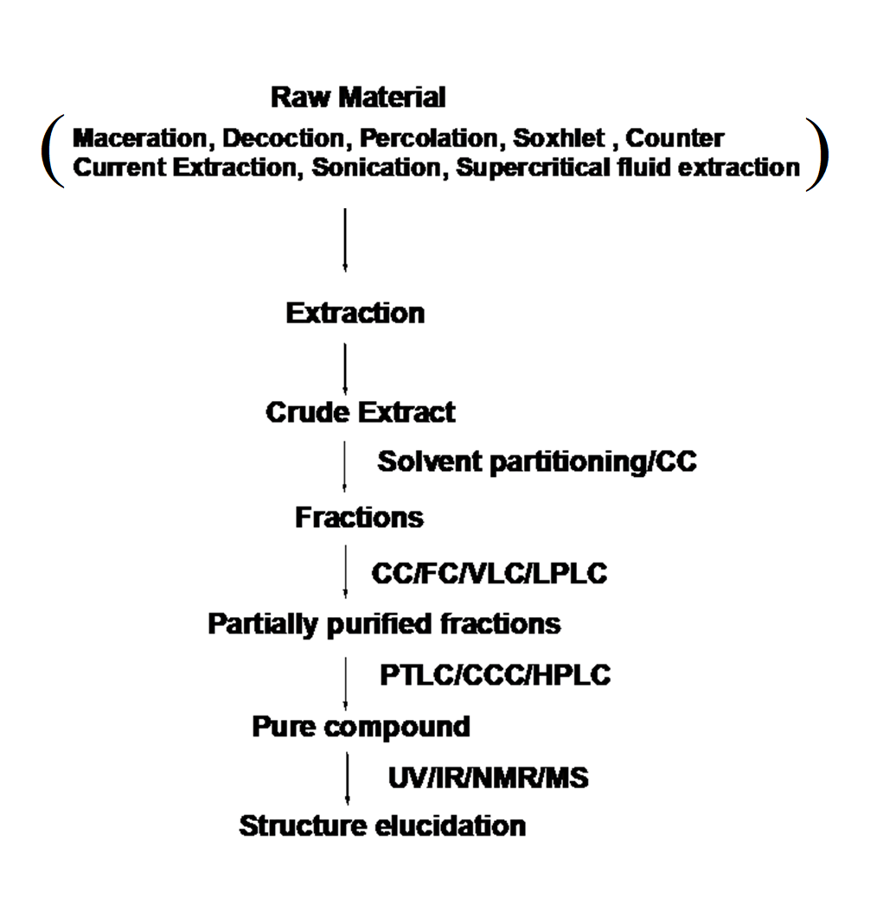
Figure 1: Schematic representation of compound isolation to elucidation with their involved techniques

Type of Chromatography techniques based on separation
Column Chromatography
- Prep Column Chromatography
- Flash Chromatography (FC)
- Vacuum liquid chromatography (VLC)
- Ion Exchange Chromatography
- Gel Chromatography
- Gel Filtration (GFC)
- Gel Permeation (GPC)
Pressure Liquid Chromatography
- Low-Pressure LC
- Medium Pressure LC (MPLC)
- High-Pressure LC (HPLC)
Normal Phase and Reverse Phase Chromatography
Liquid-liquid Chromatography
- Countercurrent Chromatography (CCC)
- Droplet Countercurrent Chromatography (DCCC)
Planar Chromatography
- Prepparative Thin Layer Chromatography (PTLC)
- Centrifugal TLC
- Overpressure layer Chromatography (OPLC)
Gas Chromatography
- Gas-Liquid Chromatography
- Gas-Solid Chromatography

Column chromatography
Column chromatography method used for isolation and purification of a compound from a mixture. Chromatography is able to separate substances based on differential adsorption of compounds to the adsorbent; compounds move through the column at different rates, allowing them to be separated into fractions. According to their relation, the stationary phase divides into main two parts.
- Normal-phase column chromatography
(NP) CC, the sorbent is more polar than the mobile phase and the interaction of polar compounds will be more than non-polar compounds. So it will elute non-polar than polar compounds. NPLC which has a good separation power – plays a very important role, especially in isolation strategies.
- Reversed-phase column chromatography
CC, the stationary phase is less polar than the mobile phase and interaction of non-polar compounds will be more than polar compounds and elute first than non-polar.

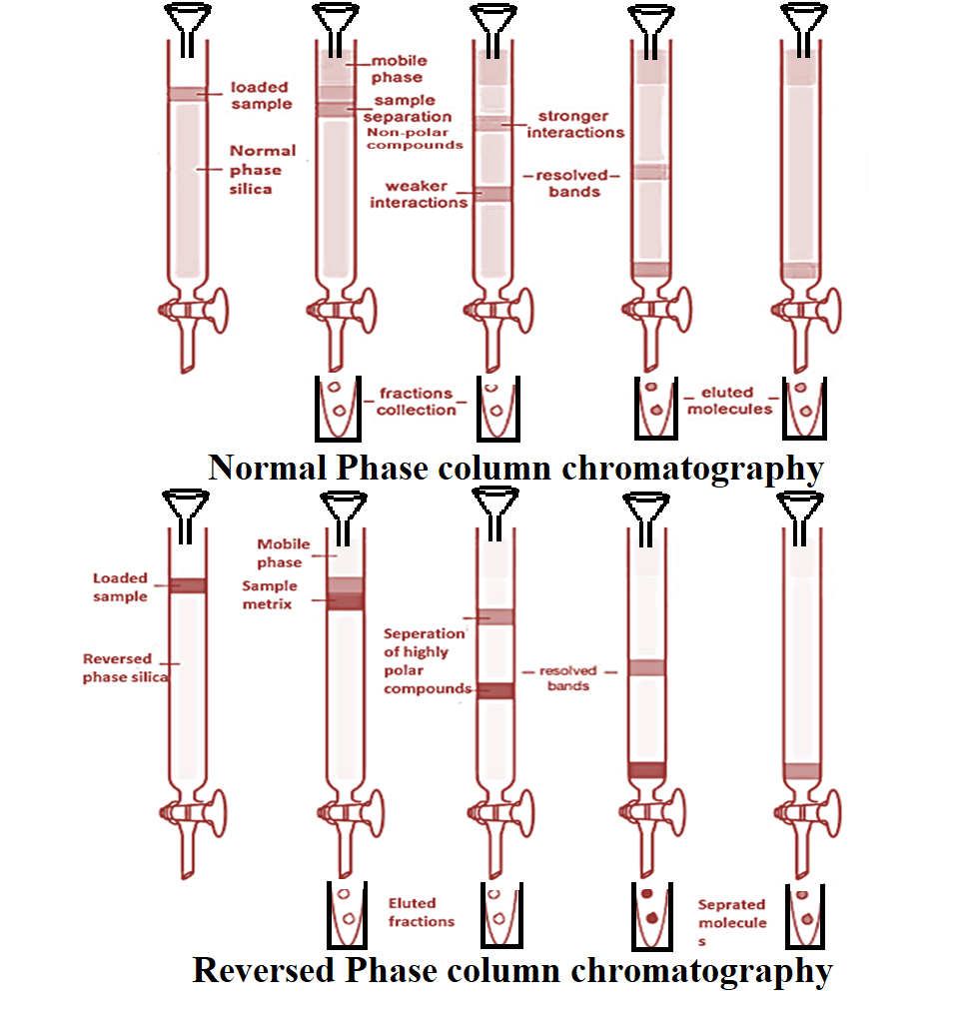
Figure 2: Systematic representation of normal and reversed phase chromatography

Elution Pattern of natural products in column chromatography based on the stationary phase
- Normal Phase
  - Alkanes olefins aromatics organic halogen compounds sulfides ethers nitro compounds esters/aldehydes/ketones alcohols/amines sulfones sulfoxides amides carboxylic acids.
- Reverse Phase
  - Carboxylic acids alcohols/phenols amines ethers/aldehydes ketones organic halogen compounds aliphatics
In RP, readily water-soluble substances are eluted more rapidly than hydrophobic ones. Aq. Solutions can be directly used, gives good separation for polar compounds. No deactivators are required.

Flesh column chromatography
A technique for normal phase purification involves chromatography based on an air pressure-driven hybrid of medium and short column chromatography, specifically optimized for the rapid separation of biomolecules. Unlike traditional gravity-based column chromatography, this method utilizes air pressure to expedite the solvent flow through the column, significantly reducing the chromatography duration, making column preparation and separation possible in less than 10-15 minutes.
This chromatography method relies on a fundamental principle in which a liquid eluent, pressurized with gas (typically nitrogen or compressed air), is swiftly propelled through a short glass column. The column contains an adsorbent material with a defined particle size and a large inner diameter. Silica gel with a particle size range of 40 – 63 μm is commonly used as the stationary phase, although other particle sizes can be employed depending on the specific requirements. For particles smaller than 25 μm, it is advisable to use low-viscosity mobile phases to maintain an adequate flow rate. Typically, gel beds are approximately 15 cm in height, and working pressures range from 1.5 to 2.0 bars. Initially, only unmodified silica was used as the stationary phase, allowing for normal phase chromatography. However, in parallel with the development of High-Performance Liquid Chromatography (HPLC), reversed-phase materials are now increasingly employed in flash column chromatography.
The selection of an appropriate solvent system is crucial. The compound of interest should exhibit a Thin-Layer Chromatography (TLC) Rf value ranging from approximately 0.15 to 0.20 in the chosen solvent system. Binary (two-component) solvent systems are often preferred, with one solvent possessing higher polarity than the other. This choice enables easy adjustments to the average polarity of the eluent. The solvent system's polarity, and thus the elution rates of the compounds to be separated, are determined by the solvent ratio. A higher polarity in the solvent system enhances the elution rate of all compounds. Common binary solvent systems, ranked in order of increasing polarity, include dichloromethane/hexane, ether/hexane, hexane/ethyl acetate, and dichloromethane/methanol. Hexane/ethyl acetate can be safely handled on a laboratory bench, but all other solvents should be used within a fume hood. If the TLC Rf value is approximately 0.2, it is advisable to prepare a volume of solvent approximately five times the volume of the dry silica gel to effectively run the column.
Applications
The separation, isolation, and purification of natural products constitute a critical aspect of various scientific disciplines, finding extensive applications in both pharmaceutical and agricultural industries. This technique serves as an indispensable tool for researchers and professionals seeking to extract and refine bioactive compounds from complex mixtures of natural sources. In pharmaceutical and agricultural sectors, it plays a pivotal role in ensuring the removal of impurities from finished products, thereby enhancing the quality and efficacy of medicines and agricultural formulations. Moreover, one of the most prominent and widely recognized applications of this method lies in the field of drug discovery. Researchers rely on these purification techniques to isolate and characterize potential drug candidates from natural sources, fostering the development of novel therapeutic agents with promising pharmacological properties. Thus, the separation, isolation, and purification of natural products stand at the forefront of scientific and industrial advancements, underpinning advancements in medicine, agriculture, and the broader spectrum of natural product-based innovations.

Vacuum Liquid Chromatography
Vacuum Liquid Chromatography (VLC) is a rapid purification method suitable for both large-scale and small-scale extraction and purification of products from natural resources under vacuum conditions. VLC is particularly valuable for fractionating extracts to isolate specific components based on their polarity or category.
VLC is essentially a preparative thin-layer chromatography (PTLC) technique, wherein separation takes place on TLC-grade silica gel or aluminum oxide. After each fraction, the column is dried, similar to the drying and re-running of PTLC plates to enhance separation. The packed VLC columns can be reused for the same or similar separations by thoroughly washing them with methanol and removing any decomposed polar material or bands from the top of the adsorbent column. Gradient elution is highly effective and can be employed for both small and large mixtures. This apparatus is well-suited for chromatographing extracts from reaction mixtures containing less than 1 g of material. For such small-scale separations, fractions of only 10-15 ml are collected at each polarity step, facilitating comprehensive chromatography. Based on our experience, the silica gel bed layer should not exceed a height of 5 cm for optimal results. For small-scale separations (samples < 100 mg), a column with an internal diameter of 0.5-1.0 cm and a height of 4 cm is suitable. Samples ranging from 0.5-1.0 g require a column approximately 2.5 cm in diameter and 4 cm in height, while samples between 1-10 g for separation benefit from a 5 cm diameter and 5 cm height column. Maintaining a continuous flow of solvent through the VLC column during the process is crucial to prevent drying, which could result in inadequacies.
VLC finds widespread application in the isolation and purification of chemical components from mixtures, including pigments of natural or synthetic origin, at both large and small scales. It is also employed in the identification of "target proteins" with potential therapeutic value. VLC serves industrial and institutional purposes on a large scale for the isolation of therapeutic molecules, making it an invaluable technique in the field of chromatography.

a fast method in order to meet the needs of efficient purification of products from natural resources on both large and small scale under vacuum conditions. It is used for the fractionation of extract to meet desired components as per their polarity/category.

Planner chromatography
Planar chromatography is a distinct branch of chromatography characterized by the use of a flat surface as the stationary phase for separation. One prominent method within this category is paper chromatography.
In paper chromatography, the support material consists of a highly water-saturated layer of cellulose paper. The stationary "liquid phase" is created by the presence of water drops within the pores of a thick filter paper. The mobile phase is composed of a suitable fluid placed in a developing tank. Paper chromatography is classified as a "liquid-liquid" chromatographic technique, and it falls under the umbrella of planar chromatography systems. In this method, a cellulose filter paper serves as the stationary phase where compounds are separated.
Paper chromatography finds various applications in scientific studies, particularly for the identification of unknown organic and inorganic compounds within mixtures. It is also employed in the separation of proteins, isolation of colored pigments, and the sequencing of DNA and RNA molecules. These applications demonstrate the versatility and utility of paper chromatography in diverse research endeavors.

Centrifugal Thin Layer Chromatography
Centrifugal chromatography is a unique form of planar chromatography wherein centrifugal force is generated by the rotation of a support disk, while the mobile phase is consistently supplied at a constant flow rate. As the mobile phase progresses, it carries the sample, resulting in the formation of spherical bands containing separated components. These separated components are subsequently collected from the rotor's edge along with the mobile phase.
Centrifugal chromatography operates by employing circular-shaped paper placed around its center to accelerate the movement of the mobile phase due to the centrifugal force effect. This technique is aptly named "centrifugal chromatography." Scaling up this method to a preparative scale led to the development of the "Chromatotron," which mirrors the operational parameters of centrifugal thin-layer chromatography. Compounds are separated in the direction of solvent flow.
Centrifugal Thin-Layer Chromatography (CTLC) finds widespread use in quality control and standardization processes for herbal products and natural-derived medicines. It is particularly valuable in the separation of compounds belonging to the same group within a plant matrix. These applications underscore the significance of CTLC in ensuring the quality and consistency of herbal and nature-derived remedies.

Thin layer chromatography
Thin-layer chromatography (TLC) is a form of adsorption chromatography where compound separation occurs on a stationary phase, typically silica gel or aluminum oxide, forming a library of compounds at different retardation factors (Rf). The separation of molecules relies on the properties of the silica gel utilized as the stationary phase. Generally, TLC can be categorized into two primary forms:
Preparative thin-layer chromatography is employed for the separation and isolation of compounds on a larger scale. The quantities processed in PTLC typically range from a minimum of 10 mg to 1 gram. In preparative TLC, the materials to be separated are often applied as extended streaks rather than spots within the sample application zone. After the development process, specific components can be retrieved by scraping the sorbent layer from the plate in the region of interest and eluting the separated material from the sorbent using a strong solvent. The recovered material may undergo further purification through TLC or other chromatographic methods. Alternatively, its purity may suffice for identification and structural determination through elemental analysis or spectrometry, for utilization in biological activity or chemical synthesis investigations, or as a standard reference material for comparison with unknown samples.
Although TLC is considered a traditional technique, it remains progressively relevant for the analysis of phytoconstituents and complex compound mixtures extracted from herbal matrices. This enduring relevance is attributed to advancements in instrumentation, automation, the development of new adsorbents and supports, as noted by Shewiyo et al. in 2012. TLC continues to find wide-ranging applications, including the analysis of herbal medicines, dietary supplements, biological and clinical samples, food and beverages, as well as environmental pollutants and chemicals.

High-Performance Thin Layer Chromatography
High-Performance Thin-Layer Chromatography (HPTLC) represents an advanced iteration of instrumental TLC, characterized by the utilization of high-performance adsorbent layers, such as silica gel with finely tuned uniform particles (approximately 5 µm in diameter), in contrast to the 12 µm particles in traditional TLC. HPTLC also incorporates specialized instrumentation, including development chambers, and adheres to standardized methodologies for development, optimization, documentation, and the application of validated methods. This technique serves both qualitative and quantitative purposes in estimating compounds within mixtures, with the quantitative mode operating in a highly optimized and standardized manner.
In HPTLC, samples are automatically spotted onto a TLC plate using an automatic sampler, and the plate is subsequently placed within a saturated TLC chamber for approximately 30 minutes. After drying, the plate is assessed using a UV system or visualizing reagents. To ensure comparability of results across different laboratories and references in the literature, several parameters must be carefully controlled, including the saturation level of the TLC chamber, the composition of the mobile phase, the water content of the silica stationary phase, and more. HPTLC has become an established method with applications in Good Manufacturing Practice (GMP)-compliant quality control of medicinal plants.
Applications of TLC include:
- Phytochemical analysis
- Biomedical analysis
- Quantification of herbal drugs
- Analytical investigations
- Fingerprint analysis

High-performance liquid chromatography
High-Performance Liquid Chromatography (HPLC) is a separation technique that relies on the principles of adsorption to achieve efficient separation. It is well-suited for partitioning both organic and inorganic compounds. In HPLC, the mobile phase comprises a suitable solvent, while the stationary phase consists of solid particles firmly packed together. The separation process commences with the interaction of the compounds within the mixture with the solid particles of the stationary phase.
The HPLC apparatus typically includes components such as a solvent reservoir, sample injector, pressure pump, HPLC column, and a diode detector. The procedure begins with the injection of the mixture to be separated at the bottom of the HPLC column. Simultaneously, an appropriate solvent is introduced into the solvent reservoir. Upon opening the tap, the solvent flows downward, driven by a pressure pump, and mixes with the injected sample. Subsequently, the resulting mixture enters the diode detector, where compound separation occurs. The detector removes waste materials and pumps the final content to processing units for further analysis or collection.
Type of HPLC Columns
 | Particle size | Column ID | Sample Load
Analytical | 3-5 m | 0.3-4.6 mm | ng-mg
Semi-prep | 10 m | 8-10 mm | 1-100 mg
Preparative | 10-30 m | 5-200 mm | Gram scale

An HPLC column consists of a stainless-steel tube that is sealed with fittings on both ends. Steel frits in the end fittings keep the packing material in the column. Analytical columns have inner diameters of 1 - 10 mm and lengths of 25 - 250 mm. They are operated at flow rates of 60 µl - 5.0 ml/min. In preparative chromatography columns with an inside diameter of 200 mm and a length of 600 mm are used. To protect the actual separation column from chemical contamination, a guard column with the same packing material as the separation column is installed (Ujang et al., 2013).
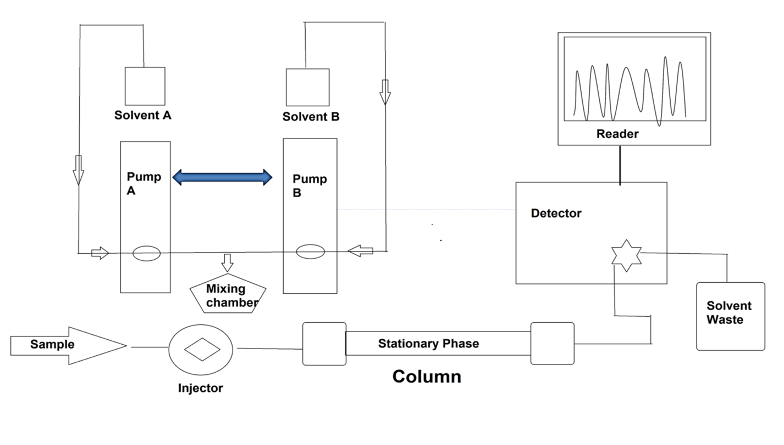
Figure 9: Instrumentation of HPLC
For example, in a study, polyphenols rich fraction was prepared of Tinospora cordifolia, the sample analysis was performed using RP-HPLC. Three major phenols were observed in the sample. The chromatogram of the analyzed sample is depicted as
Application
- Application of HPLC includes isolation, purification, and identification of the components from a complex biological sample, or of similar synthetic chemicals in research institutes and industries.
- Estimation and quantification of vitamins like Vit-D, C, E, etc.
- Assessment of drug in blood samples, determine loss or gain of an allele, quantitate the amount of RNA expressed, and detect a single nucleotide change.
- This technique is also used for the stability study of a drug molecule in the research industry.

Gas chromatography
Gas chromatography (GC) is a well-established analytical technique widely employed in the field of analytical chemistry. It serves the purpose of separating and analyzing compounds, both qualitatively and quantitatively, that can be vaporized without undergoing decomposition. Common applications of GC include assessing the purity of specific substances and segregating the various components within a mixture.
GC relies on a capillary column that capitalizes on factors such as the column's dimensions, the phase properties of different molecules within a mixture, and their relative affinity for the column's stationary phase. These factors facilitate the separation of molecules as the sample traverses the length of the column. Consequently, individual compounds emerge at distinct retention times, which are proportional to their polarity indices. These retention times can be used for precise identification and acquisition purposes. Helium and nitrogen are commonly employed as carrier gases in GC, serving as the mobile phase.
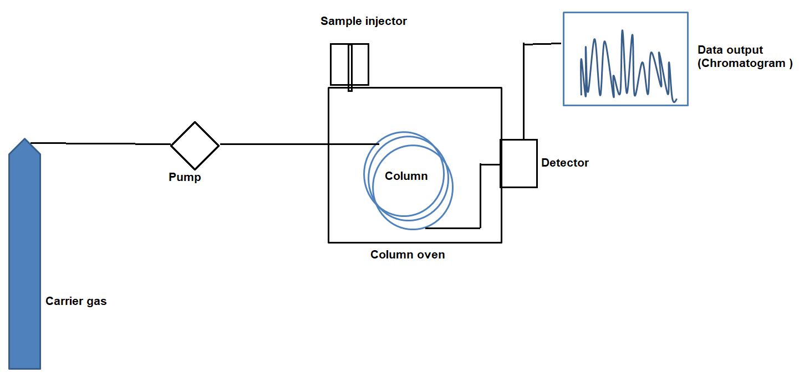
Figure 11: Instrumentation of GC
Advantages
- It is the most precise technique for the analysis of volatile/essential oils
- Qualitative and quantitative estimation of non-polar organic and inorganic compounds
- Assessment of GC in agriculture department for the analysis of pesticides
- Analysis of biological samples
- Analysis of blood sample in forensic science
Disadvantages
- Despite its advantages, the major limitation of GC is that it is restricted to volatile compounds, and the derivatization process is necessary to detect various metabolites which pose difficulties in sample preparation and identification due to multiple additives or derivative products.
- GC analysis of herbal products is usually limited to the essentials oils because of possible degradation of thermo-labile compounds and the requirement of volatile compounds makes GC unsuitable for many herbal compounds

Ion chromatography (IC)/ion-exchange chromatography
Ion-exchange chromatography (IEC) is a crucial component of ion chromatography, a vital analytical technique used for the separation and quantification of ionic compounds. It is one of several ion-based chromatography methods, including ion-partition/interaction and ion-exclusion chromatography. In ion chromatography, stationary phases known as ion exchangers are employed to separate ions or polar molecules based on their affinity for the charged molecules within the stationary phase. This technique is highly versatile, capable of handling a range of substances, from large proteins to small nucleotides and amino acids. Ion chromatography primarily consists of two types: anion-exchange and cation-exchange chromatography.
Cation-exchange chromatography is employed when the molecule of interest carries a positive charge, while anion-exchange chromatography is used when the stationary phase is positively charged, attracting negatively charged molecules.
Ion-exchange chromatography, designed for the separation of compounds with varying charges or ionizability, involves both mobile and stationary phases, similar to other column-based liquid chromatography techniques. The mobile phase comprises an aqueous buffer system into which the mixture to be resolved is introduced. The stationary phase typically consists of an inert organic matrix chemically modified with ionizable functional groups (fixed ions) that can displace oppositely charged ions. Analytes exist in equilibrium between the mobile and stationary phases, creating two possible formats: anion exchange and cation exchange. Exchangeable matrix counter ions encompass protons (H+), hydroxide groups (OH-), singly charged monoatomic ions (Na+, K+, Cl-), doubly charged monoatomic ions (Ca2+, Mg2+), and polyatomic inorganic ions (SO42-, PO43-), as well as organic bases (NR2H+) and acids (COO-). Cations are separated on a cation-exchange resin column, while anions are separated on an anion-exchange resin column. Separation is achieved through the binding of analytes to positively or negatively charged groups fixed on the stationary phase, driven by differences in their net surface charge.
Ion-exchange chromatography has evolved into one of the most essential and widely used liquid chromatographic techniques. It plays a significant role in the separation and purification of charged biomolecules such as proteins, amino acids, and nucleotides, as well as in enhancing the stability and solubility properties of active pharmaceutical drug molecules in research industries. In speciation analysis, it is particularly promising for determining metal and metalloid ions. Some advantages of ion chromatography in cation determinations include simultaneous determination of alkaline and alkaline earth metals and ammonium ions. This technique finds extensive utility in various fields, from analytical chemistry to pharmaceutical research and speciation analysis (Chahardoli et al., 2020; Delatte et al., 2009; Petruczynik et al., 2020).

Size-exclusion chromatography (SEC)
Size exclusion chromatography (SEC), also known as gel-filtration chromatography (GFC) or gel permeation chromatography (GPC) when utilizing organic solvents, is a chromatographic technique employed for the separation of molecules based on their size. The principle behind SEC involves the differentiation in size and geometry of the molecules being separated.
In SEC, a chromatographic column is filled with fine, porous beads made from materials like dextran polymers (Sephadex), agarose (Sepharose), or polyacrylamide. These beads possess specific pore sizes, which serve as indicators of the dimensions of macromolecules. This technique is typically applied to the separation of large molecules or macromolecular complexes, including but not limited to proteins, amino acids, and industrial polymers.

To separate biomolecules in aqueous environments, SEC is commonly known as gel filtration chromatography (GFC), whereas the separation of organic polymers in non-aqueous settings is termed gel permeation chromatography (GPC). The method finds application in the separation and quantification of proteins, amino acids, nucleotides, and large molecular weight drugs. SEC is also employed for both quantitative and qualitative analyses of polydispersity in synthesized polymers, particularly in industries related to polymers and hydrocarbons (Crittenden et al., 2023).
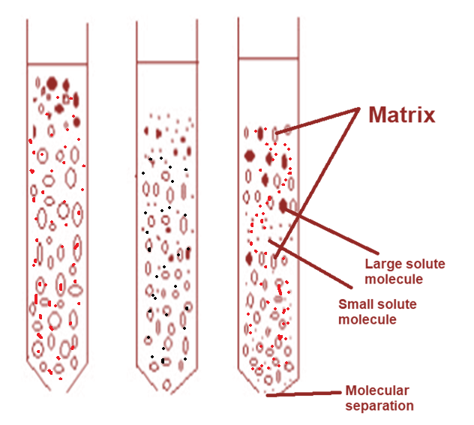
Figure 13: Size-exclusion chromatography (SEC)

Countercurrent chromatography
Countercurrent chromatography is a type of liquid-liquid chromatography that utilizes a liquid stationary phase held in place by centrifugal force. It serves the purpose of separating, identifying, and quantifying the chemical constituents present in a mixture. Countercurrent chromatography encompasses a range of liquid chromatography techniques that employ two immiscible liquid phases without solid support. The partition process occurs within an open column space, where one phase (stationary phase) is retained while the other phase (mobile phase) continuously passes through. In countercurrent chromatography, the separation of molecules is based on their ionic affinity within an applied electric field for chromatographic separation. The dynamic mixing and settling actions enable the separation of components according to their solubility and the selectivity of solvent systems (Lai et al., 2015; Madhukar et al., 2014).
Countercurrent chromatography is employed at both industrial and laboratory scales for the purification of various chemical substances, including proteins, antibiotics, vitamins, natural products, pharmaceuticals, pesticides, and polyaromatic hydrocarbons from environmental samples. It offers the advantage of accommodating chemically complex samples with undissolved particulates.

Conclusion
In conclusion, chromatography techniques stand as indispensable tools in the realm of phytoconstituent isolation from medicinal plants. Their versatility and precision empower researchers to navigate the intricate chemical landscape of these plants, uncovering bioactive compounds that hold significant promise for therapeutic applications. The synergy between various chromatographic methods, coupled with mass spectrometry, has revolutionized our ability to isolate, purify, and elucidate the structures of phytoconstituents. This dynamic interplay between science and nature not only enriches our understanding of traditional herbal remedies but also paves the way for innovative drug discovery and the development of health-enhancing products. Chromatography's role in unraveling nature's pharmacological treasures remains pivotal in shaping the future of natural medicine and healthcare.
Conflict of interest
Authors declare no conflict of interest
Acknowledgement
Authors would like to thank IIMT College of Medical Sciences, IIMT University, O Pocket, Ganga Nagar, Meerut, Uttar Pradesh 250001.

References
Chahardoli, A., Jalilian, F., Memariani, Z., Farzaei, M.H., Shokoohinia, Y., 2020. Analysis of organic acids, in: Recent Advances in Natural Products Analysis. https://doi.org/10.1016/b978-0-12-816455-6.00026-3
Crittenden, C.M., Lanzillotti, M.B., Chen, B., 2023. Top-Down Mass Spectrometry of Synthetic Single Guide Ribonucleic Acids Enabled by Facile Sample Clean-Up. Anal. Chem. https://doi.org/10.1021/acs.analchem.2c03030
Delatte, T.L., Selman, M.H.J., Schluepmann, H., Somsen, G.W., Smeekens, S.C.M., de Jong, G.J., 2009. Determination of trehalose-6-phosphate in Arabidopsis seedlings by successive extractions followed by anion exchange chromatography-mass spectrometry. Anal. Biochem. https://doi.org/10.1016/j.ab.2009.03.003
Gaurav, 2022. GC–MS metabolomics and network pharmacology-based investigation of molecular mechanism of identified metabolites from Tinospora cordifolia (Willd.) miers for the treatment of kidney diseases. Pharmacogn. Mag. 18, 548–558. https://doi.org/10.4103/pm.pm_582_21
Gaurav, Anwar, N., Zahiruddin, S., Ahmad, S., 2023a. TLC-bioautography-MS-based Identification of Antioxidant, α-Amylase and α-Glucosidase Inhibitory Compounds in a Polyherbal Formulation “Sugreen-120.” Pharmacogn. Mag. https://doi.org/10.1177/09731296221145064
Gaurav, Khan, M.U., Basist, P., Zahiruddin, S., Ibrahim, M., Parveen, R., Krishnan, A., Ahmad, S., 2022. Nephroprotective potential of Boerhaavia diffusa and Tinospora cordifolia herbal combination against diclofenac induced nephrotoxicity. South African J. Bot. 000. https://doi.org/10.1016/j.sajb.2022.01.038
Gaurav, Sharma, I., Khan, M.U., Zahiruddin, S., Basist, P., Ahmad, S., 2023b. Multi-Mechanistic and Therapeutic Exploration of Nephroprotective Effect of Traditional Ayurvedic Polyherbal Formulation Using In Silico, In Vitro and In Vivo Approaches. Biomedicines 11. https://doi.org/10.3390/biomedicines11010168
Gaurav, Zahiruddin, S., Parveen, B., Ibrahim, M., Sharma, I., Sharma, S., Sharma, A.K., Parveen, R., Ahmad, S., 2020. TLC-MS bioautography-based identification of free-radical scavenging, α‑amylase, and α‑glucosidase inhibitor compounds of antidiabetic tablet BGR-34. ACS Omega. https://doi.org/10.1021/acsomega.0c02995
Gautam, G., 2022. Network Pharmacology-Based Validation of Traditional Therapeutic Claim of Momordica Charantiain Alleviating Diabetic Nephropathy. J. CAM Res. Prog. 1, 1–10.
Gautam, G., Parveen, R., Ahmad, S., 2023. LC-MS-based Metabolomics of Medicinal Plants, in: Omics Studies of Medicinal Plants. https://doi.org/10.1201/9781003179139-9
Khan, A., Zahiruddin, S., Ibrahim, M., Basist, P., Gaurav, Parveen, R., Umar, S., Ahmad, S., 2021. Thin layer chromatography-mass spectrometry bioautographic identification of free radical scavenging compounds and metabolomic profile of Carica papaya linn. fruit and seeds using high-performance thin-layer chromatography, gas chromatography-mass spectro. Pharmacogn. Mag. https://doi.org/10.4103/pm.pm_326_20
Khan, M.U., Basist, P., Gaurav, Zahiruddin, S., Penumallu, N.R., Ahmad, S., 2024. Ameliorative effect of traditional polyherbal formulation on TNF-α, IL-1β and Caspase-3 expression in kidneys of wistar rats against sodium fluoride induced oxidative stress. J. Ethnopharmacol. https://doi.org/10.1016/j.jep.2023.116900
Khan, M.U., Gaurav, Zahiruddin, S., Basist, P., Krishnan, A., Parveen, R., Ahmad, S., 2022. Nephroprotective potential of Sharbat-e-Bazoori Motadil (sugar-free) in HEK-293 cells and Wistar rats against cisplatin induced nephrotoxicity. J. King Saud Univ. - Sci. 34, 101839. https://doi.org/10.1016/j.jksus.2022.101839
Lai, K.M., Cheng, Y.Y., Tsai, T.H., 2015. Integrated LC-MS/MS analytical systems and physical inspection for the analysis of a botanical herbal preparation. Molecules. https://doi.org/10.3390/molecules200610641
Madhukar, G., Tamboli, E.T., Rabea, P., Ansari, S.H., Abdin, M.Z., Sayeed, A., 2014. Rapid, sensitive, and validated UPLC/Q-TOF-MS method for quantitative determination of vasicine in Adhatoda vasica and its in vitro culture. Pharmacogn. Mag. https://doi.org/10.4103/0973-1296.127375
Petruczynik, A., Wróblewski, K., Wojtanowski, K., Mroczek, T., Juchnowicz, D., Karakuła-Juchnowicz, H., Tuzimski, T., 2020. Comparison of various chromatographic systems for identification of vortioxetine in bulk drug substance, human serum, saliva, and urine samples by HPLC-DAD and LC-QTOF-MS. Molecules. https://doi.org/10.3390/molecules25112483
Ujang, Z.B., Subramaniam, T., Diah, M.M., Wahid, H.B., Abdullah, B.B., Rashid, A.H.B.A., Appleton, D., 2013. Bioguided Fractionation and Purification of Natural Bioactives Obtained from&lt;i&gt;Alpinia conchigera&lt;/i&gt; Water Extract with Melanin Inhibition Activity. J. Biomater. Nanobiotechnol. https://doi.org/10.4236/jbnb.2013.43033
Zahiruddin, S., Basist, P., Parveen, A., Parveen, R., Khan, W., Gaurav, Ahmad, S., 2020. Ashwagandha in brain disorders: A review of recent developments. J. Ethnopharmacol. https://doi.org/10.1016/j.jep.2020.112876

