Synthesis, Structural and EIS studies of La_{2-x}Al_{x}Mo₂O₉ (x=0.2) oxygen ionic conductor
Gyati Tachang Tado
Department of Physics, Dera Natung Govt College, Itanagar, 791111, Arunachal Pradesh, India
E.mail: gyatitachangtado@gmail.com
Abstract
La₂Mo₂O₉ based ionic conductor with partial substitution of Al at La site, La_{2-x}Al_{x}Mo₂O₉ (x=0.2), was synthesized by using conventional solid state reaction technique and characterised by XRD, DSC, Impedance analyser and FTIR. The RT XRD analysis reveals formation of pseudo monoclinic phase with impurity peaks pertaining to Al₂O₃ and La₂Mo₂O₇. It has been observed that the conductivity is enhanced as compared to the parent compound by one order at 600⁰C which is a remarkable result. However, no suppression of phase transition was observed with Al doping.
Keywords solid electrolyte, phase transition, La₂Mo₂O₉, doping, ionic conductivity.
- Introduction
Recently, solid electrolyte has garnered huge attention due to its promising pertinence in solid state ionic devices [1-2]. La₂Mo₂O₉ being the parent compound of LAMOX family is one of the most potential solid electrolytes originally introduced by Lacorre et.al. This compound has been under extensive research since its inception as ionic conductor in the year 2000. It has high anionic conductivity of ~10⁻² S/cm at comparatively lower temperature (800ºC) which is analogous to widely used solid electrolyte YSZ at 1000ºC. It undergoes reversible β-α phase transition from high temperature cubic structure to low temperature monoclinic structure at around 580ºC which deteriorates its conductivity and delimits its application at low temperature [3-5]. To enhance the conductivity, suppress the phase transition and to improve the mechanical stability, rigorous research is underway. Partial substitution being one of the most effective ways to overcome lacuna found in La₂Mo₂O₉ [6]. Here we report, Al doping at La Site of La₂Mo₂O₉ based compound, La_{2-x}Al_{x}Mo₂O₉ (x=0.2), in search of desired result.

- Experimental
  - Synthesis
The specimen was prepared using conventional solid state reaction method.
Firstly, the ingredients were taken maintaining proper stoichiometric ratio. It was grinded under acetone environment in agate mortar for 12hrs initially, then, it was calcined at 500⁰C for 12hrs in muffle furnace. Subsequent, grinding and calcinations were performed at different temperatures. Lastly, it was pelletized and sintered at 950⁰C for 12hrs. The size of the pellet is ~11-13.

  - Characterisation

The powder sample was characterised using a RIGAKU ULTIMA IV X-ray diffractometer employing Cu-Ka radiation (λ=1.54059 Å) at room temperature in the 2θ range from 10º- 80º. The results thus obtained were further analysed by using “Fullprof” software. Average crystallite sizes were estimated using Scherrer’s formula
$L=\frac{kλ}{βcosθ}$ (1)
Where, L is the crystallite size in nm, k is the so-called “Scherrer constant” (k = 0.94), β is full width at half maxima (FWHM) of the diffraction peaks, Ө is obtained from corrected peak position 2Ө and λ represents the wavelength of Cu-Ka radiation ( λ = 1.154059Å).
Differential scanning calorimetric (DSC) measurement was performed by STA 449 F3–NETZSCH at the cooling rate of 5⁰C/min in an argon atmosphere in the temperature range RT-600⁰C.
The Fourier transform infrared (FT-IR) spectrum of the prepared specimen was recorded in transmittance mode on Impact 410 (NICOLET, USA) at room temperature in the wave number region 400-4000 cm⁻¹.
The gold paste was coated on both sides of the pellet for electrical measurements. HIOKI-LCR TESTER IM3536 was used for this study in temperature range RT -750ºC. The results were analysed using EISSA software.

- Results and discussion

  - X-ray diffraction studies

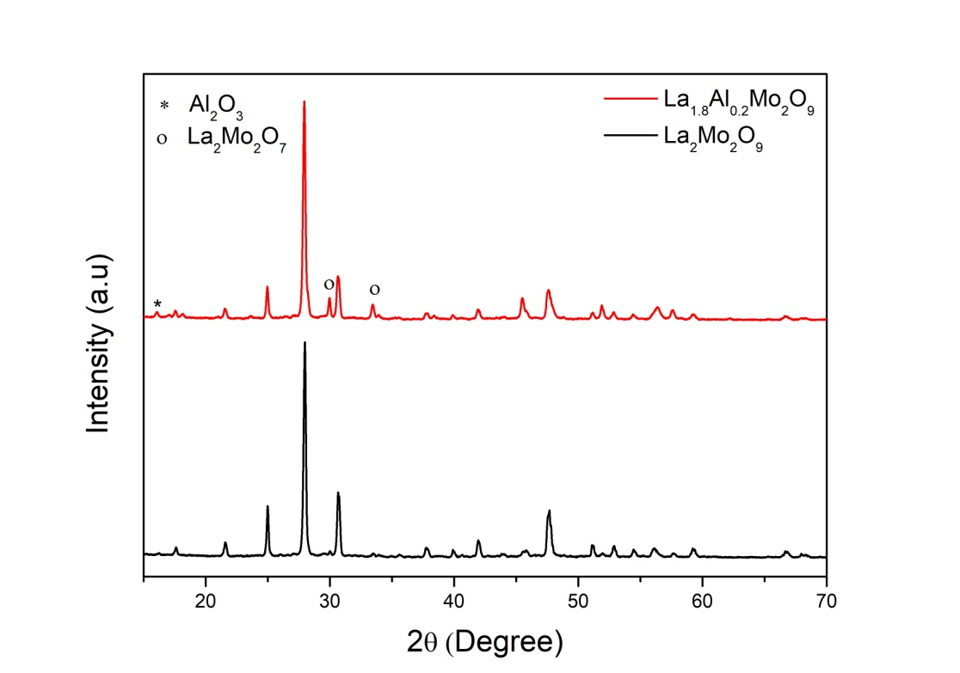

Fig.1 XRD plot of La₂Mo₂O₉ and La_{1.8}AL_{0.2}Mo₂O₉ compound.

The XRD plots of La₂Mo₂O₉ and La_{1.8}AL_{0.2}Mo₂O₉ compound are shown in Fig.1. The Fig. reveals pseudo monoclinic phase formation along with some impurity peaks in the doped compound when compared to the parent compound. Here impurity peaks corresponding to Al₂O₃ and La₂MO₂O₇ (JCPDS card no. 861410 and 841234) are obtained at 2θ=13.45⁰, 29.95⁰ and 33.44⁰. After analysing the parent and doped compound on Fullprof software and by using Scherrer’s formula the cell parameters found are shown in Table 1.
Table 1
The cell parameter, cell volume and crystallite size of the pure and doped La₂Mo₂O_{9.}

Sl.  no. | Specimen | a (Å) | b (Å) | c (Å) | Cell Volume (Å³) | Crystallite size (nm)
1. | La₂Mo₂O₉ | 7.14404 | - | - | 364.61256 | 41.36
2. | La_{1.8}AL_{0.2}Mo₂O₉ | 7.14045 | - | - | 364.06317 | 39.81

  - DSC study

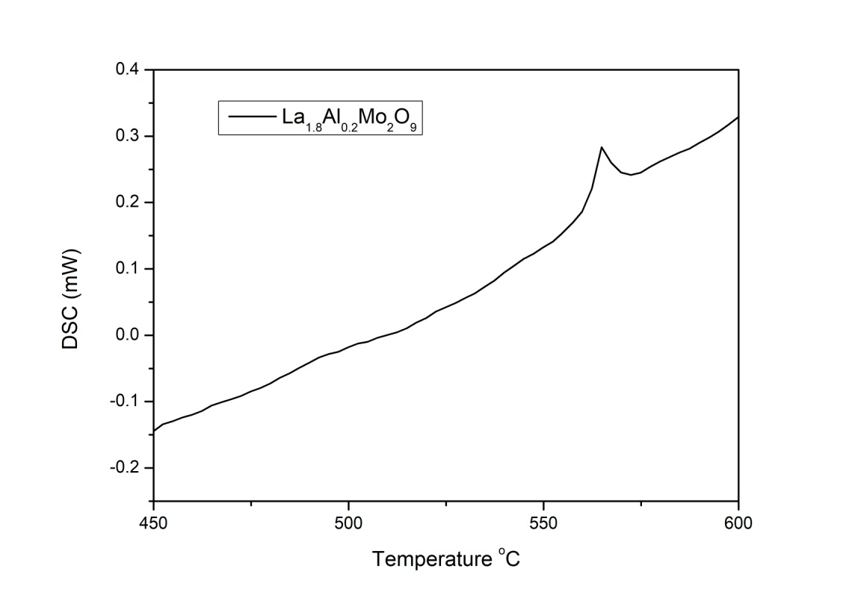
Fig. 2 DSC curve of La_{1.8}AL_{0.2}Mo₂O₉ compound.

The DSC curve of La_{1.8}AL_{0.2}Mo₂O₉ compound is shown in Fig.2. There exists exothermic peak in DSC curve at 564ºC indicating that the doped compound doesn’t suppress the phase transition.

  - FT-IR

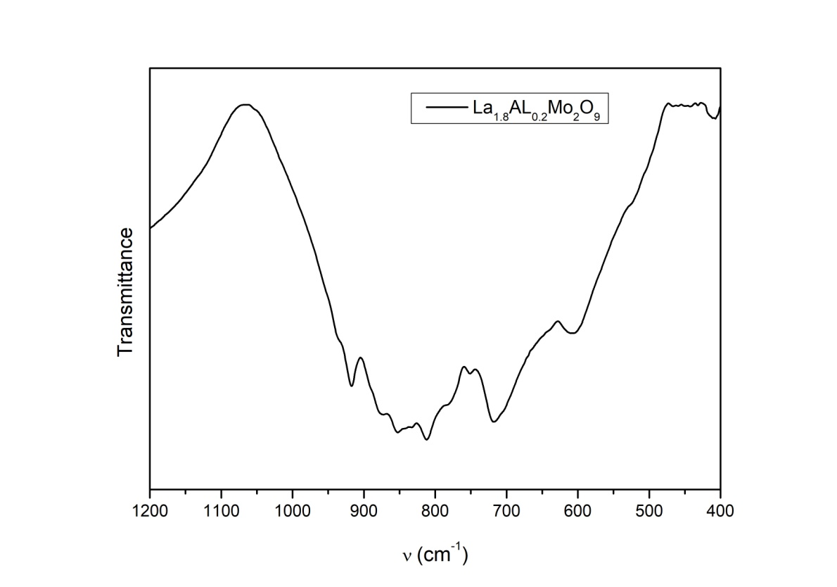

Fig. 3 FT-IR spectrum of La_{1.8}Al_{0.2}Mo₂O₉ compound.
FT-IR spectrum for La_{1.8}Al_{0.2}Mo₂O₉ compound is shown in fig.3. The transmission band in the range ~950 cm⁻¹ – ~600 cm⁻¹ corresponds to Al-O and Mo-O stretching vibration which is in conformity with the result obtained in XRD [7-9]. Bands above 950 cm⁻¹ corresponds to presence of ambient water [7-8].

  - EIS studies

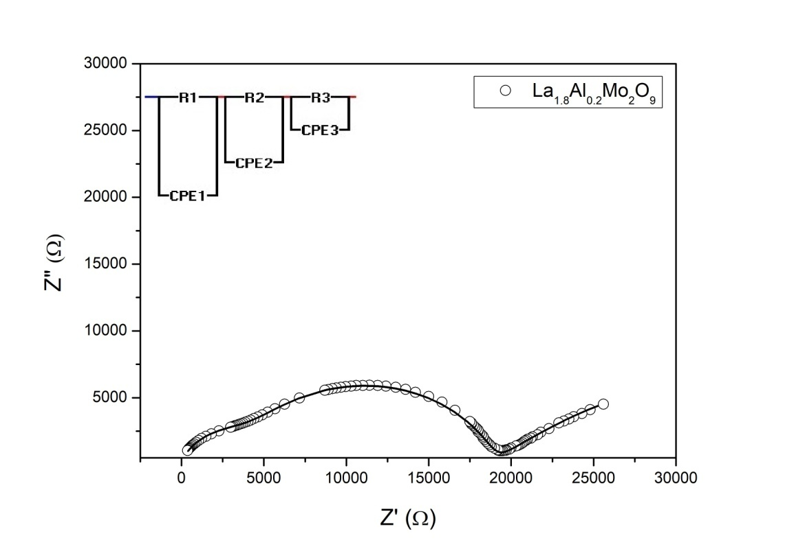

Fig.4 The AC impedance spectrum of La_{1.8}Al_{0.2}Mo₂O₉ compounds at 430ºC. The solid line is the fitted results obtained with equivalent circuit.

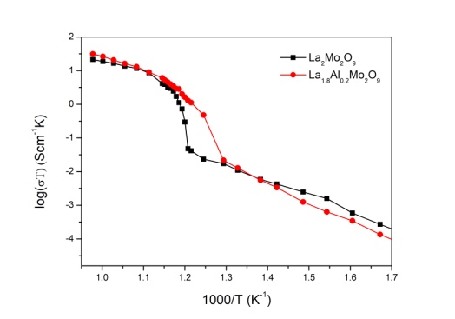

Fig.5 1000/T versus log(σT) of La₂Mo₂O₉ and La_{1.8}Al_{0.2}Mo₂O₉ compounds.
- AC impedance Spectrum of La_{1.8}Al_{0.2}Mo₂O₉ at 430ºC and Arrhenius plot of La₂Mo₂O₉ and La_{1.8}Al_{0.2}Mo₂O₉ compounds are shown in Fig.4 and Fig.5, respectively.
- It is found that the conductivity of doped compound has been enhanced significantly from 500ºC to 750ºC whereas below 500ºC the conductivity is low when compared with parent compound.
- At 600ºC the conductivity of La_{1.8}Al_{0.2}Mo₂O₉ is found to be ~10⁻² Scm⁻¹ which is about one order higher at this intermediate temperature when compared with parent compound which is ~10⁻³ Scm⁻¹.

- Conclusion
The compound La₂Mo₂O₉ and La_{1.8}Al_{0.2}Mo₂O₉ has been synthesized by conventional solid state reaction technique. Partial substitution of Al at La site of La₂Mo₂O₉ doesn’t suppress the β-α phase transition. However, conductivity of La_{1.8}Al_{0.2}Mo₂O₉ is found to be higher than parent material in the temperature region (500ºC < T < 750ºC). At 600ºC the conductivity is about one order higher as compare to the parent compound.
Acknowledgement
I acknowledge FIST facility, Department of Physics, NERIST, provided by DST, New Delhi sanction order no. SB/52/CMP-093/2013 for carrying out XRD and Impedance studies. I also acknowledge CIF, IIT, Guwahati for carrying out DSC and SAIC, Tezpur University for carrying out FT-IR.

REFERENCES:
- Fergus JW, Journal of Power Sources, 162, 30, (2006).
- Skinner S J, Kilner J A, Materials Today, 6 (3), 30, (2003).
- Lacorre P, Goutenoire F, Bohnke O, Retoux R, Laligant Y, Nature 404, 856, (2000).
- Lacorre P, Solid State Sci 2,755, (2000).
- Goutenoire F, Isnard O, Lacorre P, Chem Mater 12, 2575, (2000).
- L. Borah, B. Paik, A. Pandey, Solid State Sciences 14, 387-393, (2012).
- R. A. Rocha and E. N. S. Muccillo, Chem. Mater. 15, 4268-4272, 2003.
- C. Li, X.P. Wang, J.X. Wang, D. Li, Z. Zhuang, Q.F. Fang, Materials Research Bulletin 42, 1077-1084, (2007).
- K. Djebaili, Z. Mekhalif, A. Boumaza, A. Djelloul, Journal of Spectroscopy ,Volume 2015, Article ID 868109, 16 pages.

