CHAPTER NAME - CURRENT TRENDS IN REGENERATIVE
ENDODONTICS THERAPY (RET)

AUTHORS: Dr. K. Sathya Narayanan, Dr. Kurinji Amalavathy. R, Dr. Aravinthan. S Organization Name: Sathyabama Dental College and Hospital, Chennai

CONTENTS:
- Introduction
- Case selection for RET
- Current strategies in RET
- Role of Stem cells in RET
- Effect of Growth Factors in Pulp regeneration
- Scaffolds
- Root canal Irrigants in RET
- Intracanal medicaments in RET
- Protocol for Regenerative Endodontic therapy 10.Outcome assessment
- Advantages and Disadvantages of RET
- Future perspectives in RET 13.Conclusion
- References

INTRODUCTION

The developing dentition is vulnerable to potential risks of pulp necrosis caused by factors such as caries, trauma, and developmental anomalies like Dens evaginatus and invaginatus. Caries, a multifactorial disease, entails the infiltration of bacteria and their by-products into the pulp, triggering inflammation and fibrosis of pulp tissue. In cases where bacteria persist, chronic inflammation may arise, resulting in the necrosis of specific pulp tissue. Prolonged inflammation or recurring insults diminish the pulp's intrinsic capacity for self-repair, ultimately resulting in the spread of necrosis throughout the entire pulp. ⁽²⁾
Dental trauma constitutes another prevalent etiological factor contributing to vitality loss, with a reported incidence of 30% trauma in young permanent teeth. (3) It is well-established that pulp necrosis in immature permanent teeth leads to the cessation of root development. (2) The consequence of arrested root development is reflected in a low crown-root ratio, fragile walls, heightened susceptibility to fractures, and an open apex. Treating an immature tooth with necrotic pulp and an open apex is widely recognized as a challenging task for the dentist. (4) Traditional approaches to treating immature teeth with necrotic pulps have traditionally relied on apexification procedures or the application of apical barriers. ⁽³⁾

Apexification is defined as a technique aimed at inducing a calcified barrier in a root with an open apex or promoting the ongoing apical development of an incomplete root in teeth with necrotic pulp. Historically, an extended course of calcium hydroxide treatment was employed to facilitate apexification in immature teeth with pulpal necrosis, followed by the placement of obturation material, such as gutta-percha, within the root canal system. The clinical success rate of calcium hydroxide treatment ranged from 87% to 100%, with a radiographic success rate of 87% to 93%. Several associated problems are acknowledged in this context.
These include:
- The time required for the formation of the calcified barrier (3-24 months). ⁽⁵⁾
- Multiple appointments needed for reapplication of calcium hydroxide. ⁽⁵⁾
- The effect of long-term application of calcium hydroxide (>30 days) decreases the fracture resistance of root dentin. ⁽⁷⁾
The suggestion posits that the alkalinity of calcium hydroxide leads to a disturbance in the connection between hydroxyapatite crystals and the collagenous network in dentin. This disruption is attributed to neutralization, dissolution, or denaturation of acid proteins and proteoglycans, ultimately resulting in a dentin structure with diminished organic support, rendering the tooth susceptible to cervical fracture. ⁽⁷⁾

Mineral trioxide aggregate (MTA), employed as a root-end filling, presents an alternative material for apexification. Positioned in proximity to periradicular tissues, MTA stimulates the formation of cementum-like hard tissue, offering several advantages over calcium hydroxide apexification. These advantages include a reduction in treatment time and fewer appointments for patients, facilitating prompt tooth restoration. The clinical success rate of MTA ranges from 93% to 100%, with a radiographic success rate of 100%. A systematic review by Cheng Lin et al. reported comparable success rates between calcium hydroxide and MTA. However, both apexification treatments promote further root development, and immature teeth remain susceptible to cervical root fracture.⁽⁸⁾
Root canal therapy preserves millions of teeth each year. Although current treatment modalities demonstrate high success rates for various pulpal conditions, an optimal therapeutic approach may encompass regenerative methods. In this context, diseased or necrotic pulp tissues are removed and replaced with healthy pulp tissue to revitalize teeth. Regenerative endodontics is a developing and captivating field, especially in the treatment of immature teeth with infected root canals. Termed a "paradigm shift," it signifies a transformative approach to handling pulpless young permanent teeth, promoting ongoing root maturation and apical closure. ⁽¹⁰⁾
The idea of regenerating pulpal tissue originated from the seminal studies conducted by Nygaard-Ostby (1961) and Hjortdal (1971). Their investigations focused on the outcomes of induced bleeding through the over-instrumentation of human root canal systems. However, histological examination unveiled tissue repair characterized by elements such as fibroblasts, collagen, and limited vascularity, with no histological indications of regeneration in the pulp-dentin complex. ⁽¹¹⁾
In 1981, Skoglund & Tronstad conducted in vivo studies involving dogs to assess the revascularization potential of ischemic pulp tissue following replantation or auto-transplantation due to avulsion. Their observations revealed instances where some teeth exhibited revascularization of pulp tissue, while others initiated tooth resorption without revascularization. Additionally, the authors noted that a minimal extra-alveolar time could enhance the prognosis for the success of avulsed teeth. ⁽¹²⁾
In 1986, Kling et al. established correlations between particular factors influencing the prognosis of replanted teeth. These factors included the frequency of pulp revascularization in replanted incisors, apical foramen diameter, extra-alveolar time, storage medium, and the postoperative prescription of antimicrobials. The study demonstrated that immature teeth, when kept in favorable extra-alveolar conditions for less than 45 minutes, exhibited an enhanced likelihood of pulp revascularization. ⁽¹³⁾
In 1996, Hoshino and Sato evaluated the influence of root canal disinfection employing a combination of antibiotics, specifically ciprofloxacin and metronidazole. Their intervention effectively eradicated clinical symptoms/signs and apical periodontitis, promoting the thickening of canal walls and achieving apical closure in immature permanent teeth. ⁽¹⁴⁾
In 2001, a novel treatment approach known as "Revascularization" was introduced and initially implemented by Iwaya et al. to address immature teeth with necrotic pulp and apical periodontitis featuring a sinus tract. (15) Subsequently, in 2004, Banchs and Trope presented a revised protocol for a revascularization procedure, asserting that if revascularization is not achieved within three months, conventional treatment is warranted. ⁽¹⁶⁾
The term "Regenerative endodontics" was officially adopted by the American Association of Endodontists (AAE) in 2007, as proposed by Murray et al., inspired by the field of tissue engineering. Regenerative endodontics is precisely defined as "Biologically based procedures designed to replace damaged tooth structures, including dentin and root structures, as well as cells of the pulp-dentine complex" (9). The term Regenerative Endodontic Therapy (RET) specifically refers to treatment aimed at regenerating pulp tissue. In contrast, Regenerative Endodontic Procedures (REPs) encompass various procedures conducted to achieve the regeneration of pulp tissue. The primary objectives of Regenerative Endodontic Procedures (REPs) are to
  - Regenerate pulp-like tissue; ideally, the pulp-dentin complex
  - Regenerates damaged coronal dentin, such as following a carious exposure; and
  - Regenerate resorbed root, cervical or apical dentin. ⁽⁹⁾

In 2008, Huang and Lin proposed the term "Revitalisation" as a substitute for "revascularization" because the regenerated tissues within the root canal space encompassed not only blood vessels but also hard and soft tissues (17). The European Society of Endodontology (ESE) incorporated the term "revitalization" in its position statement in 2016 (18). In the endodontic literature, the terms revascularization, revitalization, and regenerative endodontics are used synonymously and interchangeably ⁽¹⁵⁾
In the majority of regenerative endodontic procedures, practitioners typically induce bleeding from the apical region, allowing the root canal space to be passively filled with a blood clot. Nonetheless, it was only in 2011 that Lovelace and Hargreaves, in a clinical study, presented evidence demonstrating that the influx of apical blood into disinfected root canals coincided with a clinically significant migration of mesenchymal stem cells into the root canal system. ⁽¹⁹⁾
This presentation carried considerable significance in the field of regenerative endodontics, as it established the foundation for stem cell-based procedures. The realization that autogenous stem cells could be introduced into root canals clinically, without the need for ex vivo stem cell expansion, inspired researchers and clinicians to delve into tissue engineering principles. This exploration aimed to enhance treatment protocols and propel the development of the next generation of procedures. ⁽²⁰⁾
The objective of Regenerative Endodontic Procedures (REPs) is to regenerate a fully functional pulp-dentin complex that promotes ongoing root development in immature teeth and prevents or resolves apical periodontitis. The success of regenerative endodontic procedures is predominantly assessed based on the attainment of primary, secondary, and tertiary goals. Regardless of the outcome, it is often advantageous to view REPs as a means for a tooth to serve as a space maintainer until a suitable therapeutic option becomes available. In certain instances, achieving the primary goals alone deems the procedure successful (Figure-1). ⁽²¹⁾
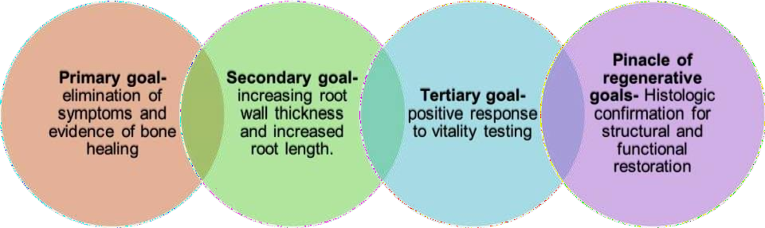
Figure-1: Goals of regenerative endodontic therapy.
Courtesy- Geisler TM. Clinical considerations for regenerative endodontic procedures: Dental Clinics 2012 Jul 1; 56(3):603-26.
The primary goal of Regenerative Endodontic Procedures (REPs) is to histologically confirm the presence of dental pulp with an intact odontoblastic layer and the restoration of a functional pulp (21). Dental pulp, a mesenchymal-derived soft tissue, consists of specialized cells within a collagenous matrix. Comprising 75% water and 25% organic matrix, including Type I and Type III collagen, along with non-collagenous proteins, the tissue houses odontoblasts—post-mitotic cells with unidirectional secretory functions—arranged peripherally and in direct contact with the dentin matrix. This close spatial association between odontoblasts and dentin is commonly referred to as the dentin-pulp complex. Both the structure and biological properties of dentin and pulp are anatomically and physiologically intricate. Recognizing dentin's bioactive nature and its potential to facilitate regenerative processes following injury has generated substantial speculation that the natural biochemical and physiological attributes of the tissue can be harnessed for the development of innovative regenerative treatment modalities ⁽²²⁾
Traditionally, the focus of dentine composition has revolved around the structural aspects of the tissue, characterized by its predominantly collagenous matrix mineralized with hydroxyapatite crystals. Within dentine and predentine, various molecules are recognized to play a crucial role in regulating the regenerative processes of dental tissue. Aside from the mineral phase, the extracellular matrix (ECM) encompasses collagenous and noncollagenous proteins (NCPs) within dentin, proving pivotal in the regenerative context (23). This NCPs component includes bioactive regulatory molecules like Dentine sialoprotein (DSP), Dentin phosphoprotein (DPP), Bone sialoprotein (BSP), Dentine Matrix protein-1 (DMP-1), Osteopontin, and Matrix Extracellular Phosphoglycoprotein (MEPE). This underscores the diverse spectrum of growth factors within the dentine matrix, contributing to the recruitment and expansion of stem cells at the injury site, thereby aiding in tissue regeneration. ⁽²³⁾
Thus, the regeneration approach uses a combination of scaffolds, stem cells, growth factors, tissue engineering, organ tissue culture, transplantation, and tissue grafting. ⁽²⁴⁾ This chapter provides a brief overview of key elements in regenerative endodontics and its current trends.

CASE SELECTION FOR REGENERATIVE ENDODONTIC THERAPY (RET)

According to the “Clinical Considerations for Regenerative Procedure” suggested by AAE, Regenerative Endodontic Therapy is recommended for teeth with necrotic pulp and an immature apex. ⁽¹⁵⁾ Cvek proposed a treatment plan based on stages of root development (Figure 2). ⁽²⁵⁾

  - Stage 1 (less than 1/2 of root formation with open apex),
  - Stage 2 (1/2 root formation with open apex)
  - Stage 3 (2/3 of root development with open apex). The above three are the suitable candidates for RET.
  - Stage 4 (nearly completed root formation with open apex can be managed with either RET or an apical MTA plug and root canal filling because the root canal walls have enough thickness and strength.

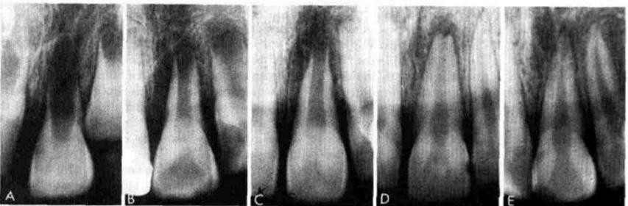

Figure -2; A-D: Immature apex; E- Stage V – Mature apex
Courtesy: Prognosis of nonvital maxillary incisors treated with calcium hydroxide and gutta-percha – A retrospective clinical study –Cvek's et al-Endod Dental Traumatol-1992
Estefan et al reported that younger individual’s age ranges from 9 to 18 years and with preoperative apical diameter of ≥1mm showed greater increase in root thickness, length and root narrowing. ⁽²⁶⁾ Immature permanent teeth with a necrotic pulp requiring post ⁽¹⁵⁾ and primary/deciduous teeth are not suitable candidates for RET. ⁽²⁷⁾ A little evidence is available to support the use of revascularization on avulsed and replanted tooth ⁽²⁸⁾ and no studies in the literature to date have shown revascularization of a tooth in children below 7 years of age. ⁽²⁷⁾

CUURENT STRATEGIES IN REGENERATIVE ENDODONTIC
THERAPY
Various approaches have been developed to engineer new tissues and organs, with nearly all employing a combination of materials with bioactive molecules that stimulate tissue formation or cells cultured in the laboratory. The regenerative strategies for both mature and immature teeth are investigated through two distinct avenues. (29)

CELL BASED APPROACH:
E.g. Ex vivo transplantation of stem cells along with/ without growth factors in scaffolds.

CELL FREE APPROACH:
E.g., Cell homing by molecules that recruit the patient’s endogenous stem cells.
The quartet of regenerative endodontics is Stem cells, Growth factors, Scaffolds, and Disinfection (fig-3), which is a fundamental part interacting with the interplay between the other factors. ⁽²⁰⁾

Figure – 3; Courtesy: Diogenes A, Ruparel NB, Shiloah Y, Hargreaves KM. Regenerative endodontics: a way forward. The Journal of the American Dental Association. 2016 May 1; 147(5):372-80

ROLE OF STEM CELLS IN REGENERATIVE ENDODONTIC THERAPY
Stem cells, also known as "progenitor or precursor" cells, are defined as "clonogenic cells capable of both self-renewal and multi-lineage differentiation" (30). The term "stem cell" was originally introduced in 1868 by German biologist Haeckel and gained scientific usage when proposed by Russian histologist Alexander Maksimov in 1909, further researched by Canadian scientists in the 1960s. The first human embryonic stem cell line was derived in 1998 at the University of Wisconsin-Madison (30). In 1963, hematopoietic stem cells, responsible for generating blood cells, were identified in the bone marrow (31). Subsequently, it was established that the bone marrow is also a primary source for multipotent Mesenchymal Stem Cells (MSCs). Bone Marrow Mesenchymal stem cells (BMMSCs) can differentiate into osteogenic, chondrogenic, adipogenic, myogenic, and neurogenic lineages. MSCs are present in various tissues, including umbilical cord blood, adipose tissue, adult muscle, and dental tissues. They can differentiate into at least three cell lineages, namely osteogenic, chondrogenic, and adipogenic. Under specific conditions in vitro, they can also differentiate into other lineages, such as odontogenic (32). Crisan and colleagues demonstrated that human perivascular cells from various tissues give rise to multi-lineage progenitor cells exhibiting MSC features (33). BMMSCs are identified by their ability to form adherent colonies, morphologically resembling fibroblasts (colony-forming unit – fibroblastic, CFU-F), when cultured at low densities in the presence of media supplemented with mitogenic growth factors or serum. (32)

CLASSIFICATION OF STEM CELLS:
Stem cells are broadly classified as follows (Figure -4). (34)

Based on the origin:
- Embryonic/fetal stem cells
- Adult/Postnatal stem cells

Based on their differentiation potential:
- Totipotent,
- Pluripotent,
- Multipotent, and
- Unipotent
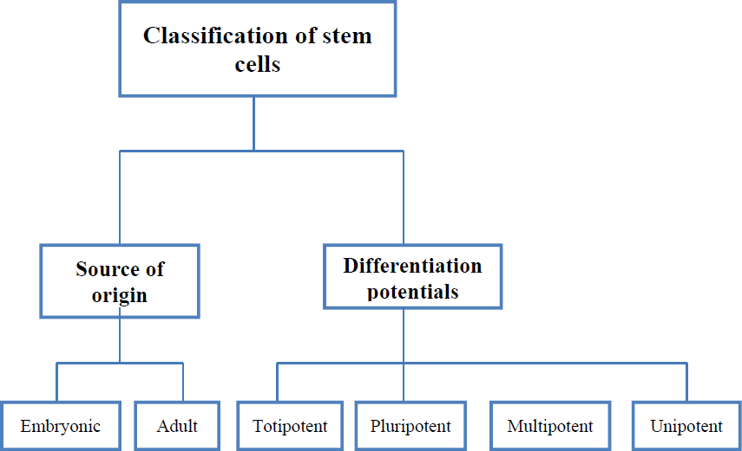
Figure 4: Classification of Stem cells
Courtesy: Multipotent Stem Cell and Current Application-Aligholi Sobhani et al.; Acta Med Iran 2017; 55(1):6- 23.

Following are the sources of stem cells that have been recognized in human dental pulp (35), (36)
- Dental pulp stem cells (DPSCs; Gronthos et al., 2000)
- Stem cells from human exfoliated deciduous teeth (SHED; Miura et al., 2003)
- Stem cells of the apical papilla (SCAP; Sonoyama et al., 2006).
- Periodontal ligament stem cells (PDLSCs; Seo et al., 2004)
- Dental follicle progenitor cells. (Figure-5, 6) (35), (36)
- Induced Pluripotent Stem cells (iPSC)

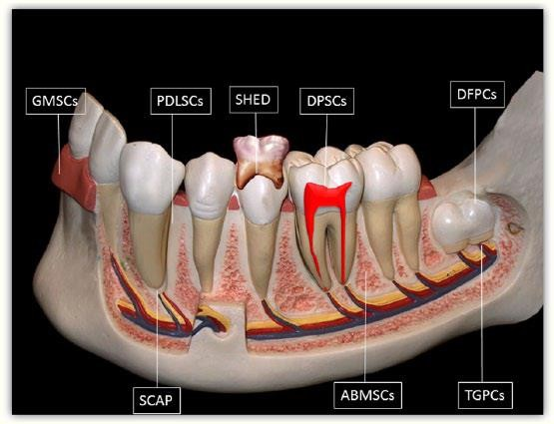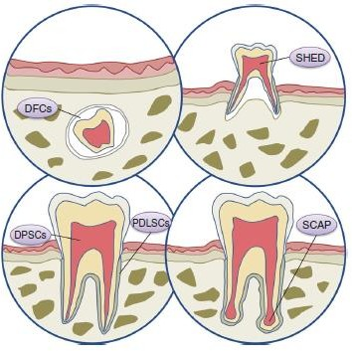

Figure- 5 Figure- 6
Figure 5 & 6: Illustrated in a schematic drawing are potential sources of post-natal stem cells within the oral environment. The cell types include tooth germ progenitor cells (TGPCs), dental follicle stem cells (DFSCs), salivary gland stem cells (SGSCs), stem cells of the apical papilla (SCAP), dental pulp stem cells (DPSCs), stem cells from human exfoliated deciduous teeth (SHED), periodontal ligament stem cells (PDLSCs), bone marrow stem cells (BMSCs), and, as depicted in the insert, oral epithelial stem cells (OESCs) and gingival-derived mesenchymal stem cells (GMSCs).
Figure 5- Courtesy: Chalisserry EP, Nam SY, Park SH, Anil S. Therapeutic potential of dental stem cells. Journal of tissue engineering. 2017 May 20; 8.
Figure 6-Courtesy: Zheng C, Chen J, Liu S, Jin Y. Stem cell-based bone and dental regeneration: a view of microenvironmental modulation. International journal of oral science. 2019 Aug 19; 11(3):1-5.

CHARACTERISTICS OF STEM CELLS:
  - Undifferentiated Embryonic/Adult cells that continuously divide.
  - Self-renewal of the ability to go through numerous cycles of cell division while maintaining the undifferentiated state.
  - They can produce intermediate cells (progenitor/precursor cells- capacity to differentiate into different cell types).
  - Differentiation occurs when stem cells acquire the features of specialized cells. (32)
◆

DENTAL PULP STEM CELLS:
Derived from dental pulp, dental pulp stem cells (DPSCs) constitute the first category of dental stem cells (DSC). In 2000, Gronthos et al. isolated these multipotent stem cells from the pulp tissue of human-impacted third molars through enzymatic digestion, unveiling their characteristic fibroblast-like morphology. (37)
DPSCs are a putative candidate for dental tissue engineering due to (38)

- Easy surgical access to the collection site and very low morbidity after extraction of the dental pulp.
- DPSCs can generate much more typical dentin tissues within a short period than non-dental stem cells.
- Can be safely cryopreserved and recombined with many scaffolds.
- Possess immuno-privilege and anti-inflammatory abilities favourable for the allotransplantation experiments. (38)

IDENTIFICATION OF DPSCs:
Four commonly used stem cell identification techniques are ⁽⁹⁾
- Fluorescent antibody cell sorting: Stem cells can be identified and isolated from mixed cell populations by staining the cells with specific antibody markers and using a flow cytometer.
- Immunomagnetic bead selection.
- Immunohistochemical staining.
- Physiological and histological criteria, including phenotype, proliferation, chemotaxis, mineralizing activity, and differentiation. ⁽⁹⁾

STEM CELLS OF THE APICAL PAPILLA:
In 2006, Sonoyama et al. discovered a unique and distinctive cluster of mesenchymal stem cells located in the apical papilla of immature permanent teeth, designated as stem cells from the apical papilla (SCAP). Histologically, the apical papilla is precisely positioned apical to the epithelial diaphragm, with a cell-rich zone situated between the apical papilla and the pulp (Figure 7). (40)
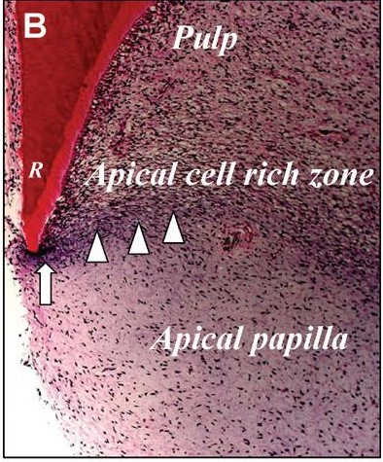
Figure 7- Courtesy: The Hidden Treasure in Apical Papilla: The Potential Role in
Pulp/Dentin Regeneration and Bio Root Engineering - George T.-J. Huang, Sonoyama et al.: (J Endod 2008; 34:645– 651)

Figure 8- Courtesy: Nada OA, El Backly RM. Stem cells from the apical papilla (SCAP) as a tool for endogenous tissue regeneration.
Frontiers in bioengineering and biotechnology. 2018 Jul 24;6:103.
SCAP exhibits distinct characteristics compared to DPSCs, as evaluated through histological, immunohistochemical, cellular, and molecular analyses. SCAP is implicated as the primary source of odontoblasts crucial for the development of root dentin, while DPSCs are presumed to contribute to the generation of replacement odontoblasts. Preserving these stem cells in the treatment of immature teeth may facilitate ongoing root development. The advantageous position of the apical papilla, with collateral circulation, enables its survival even in the presence of pulp necrosis. (39)

ISOLATION OF SCAP:
The apical papilla, along with SCAP, can be easily retrieved following tooth extraction by dissecting the tissue at the tips of developing roots using tweezers. Subsequently, this tissue is fragmented into smaller pieces and subjected to digestion with a combination of collagenase and dispase, following a well-defined protocol, to isolate single-cell suspensions. These isolated cells are then cultured (Figure – 8). (40)
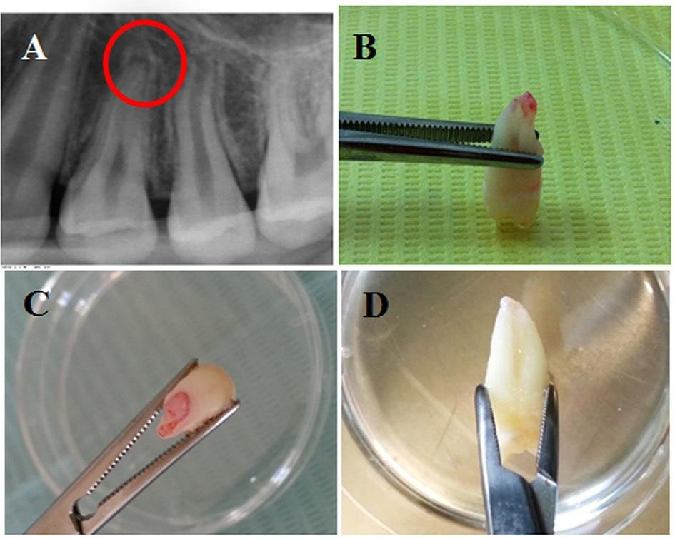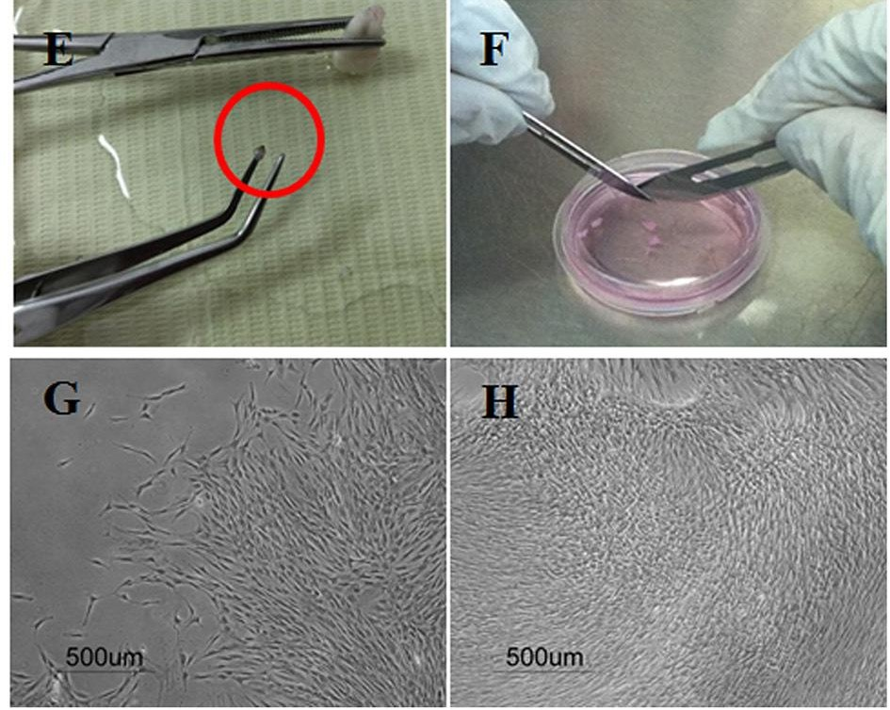
Figure – 8: Isolation of stem cells from the apical papilla showing:
(A) Periapical radiographs of the apical papilla related to the apex of a human premolar

(B–D) Extracted premolars with intact apical papilla

- Apical papilla separated gently using tweezers;

- Scalpel dissection of apical papilla tissue in a cell culture dish with culture medium.

PROPERTIES OF STEM CELLS: (32)
Table - 1
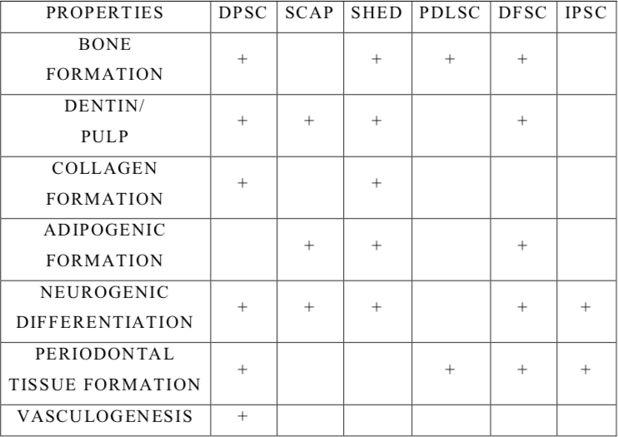

Adapted from- Sedgley CM, Botero TM. Dental stem cells and their sources. Dental Clinics. 2012 Jul 1;56(3):549-61.

EFFECT OF GROWTH FACTORS IN PULP REGENERATION

Growth factors are peptide molecules that transmit signals to regulate cell behavior and activity by interacting with specific receptors on cell surfaces. Various growth factors have been examined for their ability to induce the differentiation of specific mesenchymal stem cell populations into cells resembling odontoblasts. (41)
Growth factors can exert their influence through various mechanisms, including acting on neighboring cells (paracrine functions), the cells producing the growth factor (autocrine function), within the producing cell itself (intracrine function), and between adjacent cells (juxtacrine function). This underscores the intricate control of cellular activities in the body. Despite their presence in only minute concentrations (picogram), growth factors play a potent role in influencing wound healing and repair. (42)

Functions:
- To stimulate the division of neighbouring cells and those infiltrating into the defect, e.g., platelet-derived growth factor (PDGF).
- To stimulate the differentiation of individual cells along a specific pathway, e.g., differentiation factor – Bone Morphogenic protein (BMP).
- To stimulate angiogenesis – Vascular endothelial growth factor (VEGF)
- To serve as chemoattractants for specific cell types. (41)

The growth factors that participate in dental pulp regeneration through two sources, namely: (43)
- Endogenous molecules and
- Exogenous molecules

ENDOGENOUS BIOLOGICAL MOLECULES:
Dentin contains a variety of biological molecules, including growth factors, noncollagenous proteins, and glycosaminoglycans. The growth factors such as
    - Transforming growth factor – β(TGF- β)
      - Bone morphogenic protein (BMP)
      - Growth/differentiation factor(GDF)
    - Platelet-derived growth factor(PDGF)
    - Fibroblast growth factor(FGF)
    - Vascular endothelial growth factor(VEGF)
    - Insulin-like growth factor(IGF) (43)
Non-collagenous proteins in the dentin include
    - Dentin sialoprotein (DSP)
    - Dentin phosphoprotein(DSPP)
    - Dentin matrix protein (DMP)
    - Bone sialoprotein BSP)
    - Osteopontin (OP) (43)
Sulfated glycosaminoglycans
      - Chondroitin sulfates
      - Dermatan sulfates. (43)

Additionally, various critical mobilization factors, including Granulocyte-Colony Stimulating Factor (G-CSF), cytokines such as interleukin (IL)-8, and Fms-like tyrosine kinase-3 (Flt-3) ligand, as well as chemokines like Stromal cell-derived factor-1 (SDF-1) (44), have been identified. These bioactive growth factors become integrated and immobilized within the dentin matrix during dentin mineralization. Given the short half-life of active proteins and growth factors, binding them to extracellular matrix components may be necessary to preserve their bioactivity, protecting them from proteolytic degradation and extending their lifespan. Due to the absence of turnover in the dentin extracellular matrix, regulatory molecules can be reactivated much later in life upon their release from their bonds. In cases of dental caries, bacterial lactate exposes the organic component of dentin, releasing bioactive factors that modify the immune response, cell recruitment, and differentiation. The application of dental materials, namely calcium hydroxide or mineral trioxide aggregate, and self-etching dental adhesives, also releases bioactive factors. (45)

During the execution of regenerative endodontic procedures, organic acids or chelating agents such as EDTA/citric acid are employed to demineralize dentin before the influx of endogenous stem/progenitor cells. This process is designed to liberate the biological cues embedded in the dentin matrix, directing cellular activities towards regeneration (Figure- 9) (45). Apical bleeding is presumed to transport biological molecules to the root canal space, along with stem/progenitor cells, as blood clots contain growth factors derived from blood, such as PDGF, TGF-b, FGF, VEGF, and IGF. These endogenous factors are believed to support the activities of recruited cells and contribute to pulp regeneration. (43)
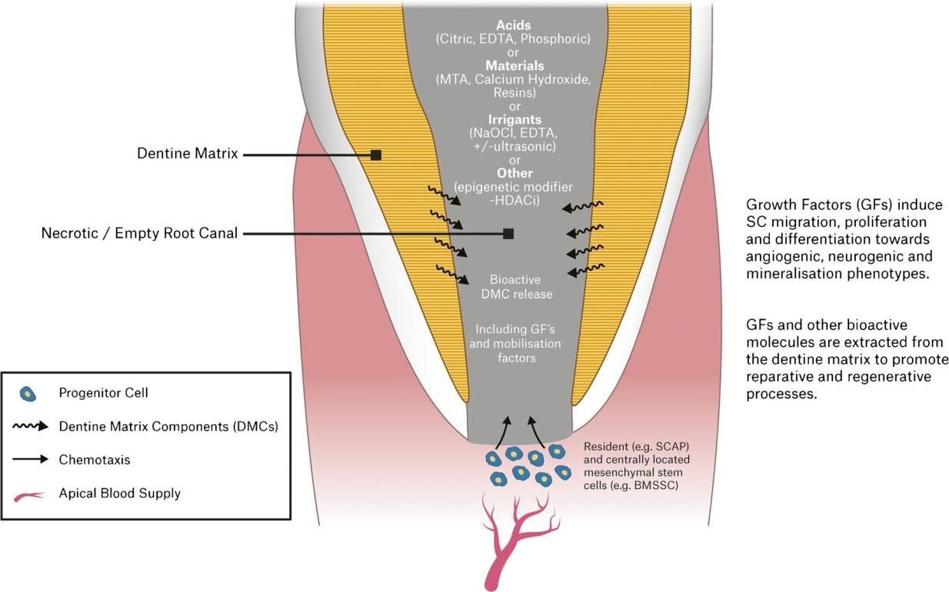
Figure- 9: Schematic drawing representing the influence of dentin matrix components (DMCs) extracted by a range of etchants, irrigants, dental materials, and epigenetic modifying agents (histone deacetylase inhibitors [HDACi]) on the promotion of cell migration, angiogenesis, neurogenesis, mineralization, and regenerative events.
Courtesy: Duncan HF, Kobayashi Y, Shimizu E. Growth factors and cell homing in dental tissue regeneration. Current oral health reports; 2018 Dec 1; 5(4):276-85.

EFFECT OF GROWTH FACTORS IN PULP REGENERATION: (Figure-16)
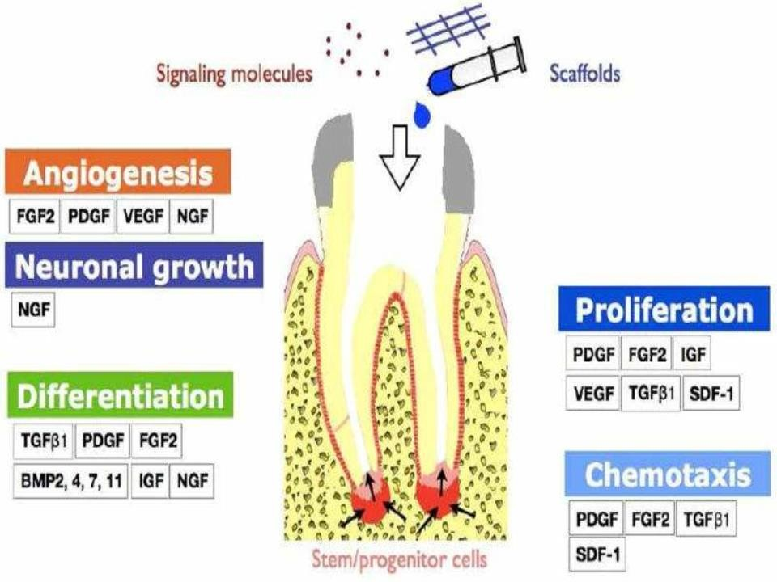
Courtesy: Kim SG, Zhou J, Solomon C, Zheng Y, Suzuki T, Chen M, Song S, Jiang N, Cho S, Mao JJ. Effects of growth factors on dental stem/progenitor cells, Dental Clinics: 2012 Jul 1:56 (3):563-75.

SCAFFOLDS

Scaffolds are three-dimensional (3D) porous stable biomaterials designed in such a manner which will: (46)
- Provide a spatially correct position of cell location.
- Promote cell-biomaterial interactions, cell adhesion, and ECM deposition.
- Permit sufficient transport of nutrients and regulatory factors to allow cell survival, proliferation, and differentiation.
- Biodegrade at a controllable rate that approximates the rate of tissue regeneration.
- Provoke a minimal degree of inflammation or toxicity in vivo. (47)

Besides blood cells, the majority of normal cells in human tissues are anchorage-dependent, residing in a solid matrix known as the extracellular matrix (ECM). The optimal scaffold for engineered tissue should ideally be the ECM of the target tissue in its native state. Laminin, an extracellular matrix protein, plays a role in promoting odontoblast differentiation (47). A recent study by Howard and colleagues highlighted a crucial factor in dental pulp stem cell migration (48). Fibronectin has demonstrated the ability to enhance ameloblast growth and differentiation, while vitronectin provides a structural framework. (49)

Ideal requirements of a scaffold:
- High porosity and adequate pore size facilitate cell seeding and diffusion throughout the whole structure of both cells and nutrients.
- It should allow the effective transport of nutrients, oxygen, and waste.
- Biodegradability is essential since scaffolds need to be absorbed by the surrounding tissues without the necessity of surgical removal.
- The rate at which biodegradation occurs has to coincide with the rate of tissue formation.
- It should be biocompatible.
- Should have adequate physical and mechanical strength. (50)

CLASSIFICATION OF SCAFFOLDS : (46)
- Based on the degradability of matrices
- Based on the form
- Based on the presence or absence of cells
- Based on origin

Table- 2:

Based on the degradability of matrices | Based on forms | Based on the presence or absence of cells
Biodegradable scaffolds | Solid blocks | Cell-free scaffolds
Permanent or biostable scaffolds | Sheets  Porous sponges  Hydrogels (injectable scaffolds) | Scaffolds seeded with stem cells

Table 3:

BASED ON ORIGIN
Biological or natural scaffolds | Artificial or synthetic scaffolds
Platelet-rich plasma | Polymers
Platelet-rich fibrin | Polylactic acid (PLA)
Collagen | Polyglycolic acid (PGA)
Glycosaminoglycans/ hyaluronic acid | Polylactic co glycolic acid ( PLGA)
Demineralized or native dentin matrix | Polyepsiloncaprolactone (PCL)
Blood clot | Bioceramics
Silk | Calcium/ phosphate material
 | Bioactive glasses
 | Glass-ceramics
Adapted from- Gathani KM, Raghavendra SS. Scaffolds in regenerative endodontics: A review. Dent Res J 2016; 13:379-86.

ROOT CANAL IRRIGANTS IN RET:

The removal of bacteria from the root canal system is essential for both pulpal and periapical healing. However, in regenerative endodontic procedures for immature teeth, where mechanical debridement is lacking, reliance is solely on chemical debridement, setting it apart from conventional root canal therapy involving chemo-mechanical debridement of canals. Tissue healing, whether repair or regeneration, takes place in a sterile or highly disinfected microenvironment (51). The host immune defense system aims to stimulate tissue-forming processes without promoting tissue-destructive pro-inflammatory processes. The determination of tissues formed during wound healing is suggested to strongly depend on local parameters such as the dynamics of available constructive cells, the remaining three-dimensional tissue structures, and the degree and chronicity of prior infection. It is crucial to emphasize that the degree and chronicity of prior infection significantly impact wound healing by compromising essential host structures and available constructive cells, including stem/progenitor cells and resident cells from periapical tissues and apical papilla. Long-term infection with large periapical lesions may eliminate the stem cell population near periapical areas, such as stem cells of the apical papilla (SCAP), and mesenchymal cells/progenitor cells from remote sites due to their smaller quantities and slower proliferation compared to resident tissue-forming cells from the periodontal ligament and alveolar. Thus, preventing the migration of these mature resident cells of periodontal origin and promoting the recruitment of stem/progenitor cells at apical tissues for dental pulp-dentin regeneration is crucial. Additionally, the microstructures of root canal dentin, especially dentinal tubules, may be altered by chronic infection, potentially becoming unfavorable for cell attachment and differentiation due to invaded microorganisms. (Figure 10). (51)
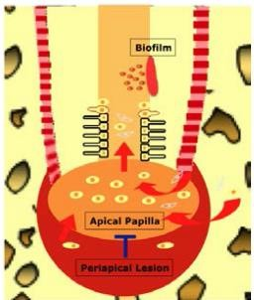
Figure 10: The regeneration of the pulp-dentin complex involves mobilizing stem/progenitor cells from apical tissues, including stem cells of the apical papilla (SCAP), inflamed periapical progenitor cells, periodontal ligament stem cells, and bone marrow mesenchymal stem cells, into the root canals. Prolonged infection can negatively impact the migration and differentiation of these stem/progenitor cells. Mature resident cells of periodontal origin actively engage in tissue healing processes, potentially giving rise to tissues of periodontal origin within the root canal space.
Courtesy: Infection and Pulp Regeneration-Sahng G. Kim; Dent. J. 2016: 4:

SODIUM HYPOCHLORITE:

Sodium hypochlorite (NaOCl) has been employed as a disinfecting agent in the majority of reported cases. NaOCl is an alkaline substance with a pH ranging from 10.9 to 12, possessing several favorable characteristics, including excellent bactericidal efficacy, tissue dissolution capacity, and adequate lubrication for endodontic instruments. The first two advantageous properties are critical for disinfecting immature teeth in regenerative procedures, which typically involve minimal to no mechanical preparation. Despite being a preferred irrigant for achieving maximum disinfection in the root canal, it does impact stem cell survival, attachment, and proliferation. A study by Trevino et al. assessed the survival of stem cells of the apical papilla (SCAPs) cultured in an organotypic root canal model previously irrigated with various combinations of commonly used chemical agents. The study revealed that dentin conditioning with 17% EDTA significantly enhanced SCAP survival, whereas 6% NaOCl had a profound detrimental effect on SCAP survival. Importantly, the use of 17% EDTA after 6% NaOCl mitigates its undesirable effects. (54)
The adverse impacts of NaOCl do not appear to be directly linked to residual NaOCl in the dentinal tubules, causing direct toxicity, as neutralization with sodium thiosulfate (5%) did not reverse this effect. Consequently, NaOCl has a significant influence on dentin, resulting in diminished stem cell survival and differentiation. These effects can be alleviated by using 1.5% NaOCl followed by 17% EDTA. (55)
The American Association of Endodontics (AAE) advocates the application of 20 mL of 1.5% NaOCl with a total exposure time of 5 minutes. The recommendations propose NaOCl disinfection using a technique that minimizes the potential extrusion into the periapical space. Some suggested methods for achieving this goal include using an irrigating needle with a closed-end and side-vents or employing Endovac. Subsequently, irrigation is concluded with saline or C10H16N2O8 (EDTA) (20 mL/canal for 5 min), with the irrigating needle positioned approximately 1 mm coronally from the root end to reduce cytotoxicity to the stem cells in the apical tissues. (56)

ETHYLENE DIAMINE TETRA ACETIC ACID (EDTA):
In 1951, the initial reports documenting the demineralizing effects of EDTA on dental hard tissues were published. Nygaard-Ostby introduced chelators to endodontics in 1957. The EDTA-soluble fraction of demineralized human dentine extracellular matrix contains various growth factors, including transforming growth factor-b1 (TGF-b1), fibroblast growth factor-2 (FGF-2), bone morphogenetic protein-2 (BMP-2), platelet-derived growth factor (PDGF), placenta growth factor (PIGF), and epidermal growth factor (EGF), alongside angiogenic factors such as vascular endothelial growth factor (VEGF). Even at low concentrations, these molecules elicit cellular responses, impacting immune defense, angiogenesis, cell recruitment, proliferation, differentiation, and mineralization.(57)
The demineralizing impact of EDTA is a routine application in root canal treatment. By utilizing EDTA to remove the smear layer after root canal preparation, a more comprehensive disinfection of dentinal tubules is achieved before canal filling. This process has negligible effects on cells in the surrounding tissue. In regenerative endodontic procedures, the initial crucial step is root canal disinfection, a prerequisite for regeneration. Despite NaOCl being crucial for infection control, its effects on cells are undesirable. The subsequent crucial step involves recruiting stem cells from the apical papilla, which are flushed into the canal after initiating bleeding. Pre-treatment of dentine after disinfection and before inducing bleeding may have favorable effects on the behavior of these cells. Galler et al. demonstrated a significantly higher induced cell migration by EDTA compared to other irrigants such as NaOCl and H2O2 after 24hrs and 48hrs of incubation. (58)
In the same study, Galler et al evaluated the cell viability on dentin after pretreating with different irrigating solutions; they found that cell viability on EDTA conditioned dentin is similar to that of untreated dentin disks and statistically higher than other irrigating solutions. (58)
Taweewattanapaisan et al has evaluated the chelating effect of EDTA on dentin contacted blood clot in root canal dentin walls observed a clumping of platelets in EDTA irrigated groups. This may be due to the loss of fibrinogen binding function (Figure- 11). (59)
Furthermore, their findings indicated that the fiber density in the coronal, middle, and apical segments of the root canal did not exhibit a significant difference in each irrigation protocol group. The use of EDTA for 1 minute demonstrated no noteworthy variance in fibrin formation compared to a 5-minute irrigation. This underscores the substantial impact of EDTA on fibrin formation. Post-EDTA irrigation, flushing with Normal Saline Solution (NSS) was observed to enhance fibrin formation by reducing residual EDTA in the root canal. In light of the study's outcomes, the utilization of EDTA followed by NSS did not impact fiber density, but it could potentially influence the quantity of growth factor released from root dentin. The American Association of Endodontics and the European Society of Endodontology recommend that clinicians employ a 17% EDTA solution for 1 minute as a final irrigation step. (56)

Figure-11: A root canal treated with various irrigation protocols at the coronal portion of the root at a magnification of 2500. (A) The NSS group: 20 mL NSS for 5 minutes; (B) the E1N group: 20 mL 17% EDTA for 1 minute followed by 20 mL NSS for 5 minutes; (C) the E5N group: 20 mL 17% EDTA for 5 minutes followed by 20 mL NSS for 5 minutes;
(D) the E1 group: 20 mL 17% EDTA for 1 minute; and (E) the E5 group: 20 mL 17% EDTA for 5 minutes. (D and E) Occasionally, inactivated platelets clumping with a few fibrin fibers were observed (arrows).

Courtesy: Taweewattanapaisan P, Jantarat J, Ounjai P, Janebodin K. The Effects of EDTA on Blood Clot in Regenerative Endodontic Procedures. Journal of endodontics. 2019 Mar 1;45(3):281-6.

INTRACANAL MEDICAMENTS IN RET CALCIUM HYDROXIDE:
Calcium hydroxide is recommended as intracanal medication in Regenerative Endodontic Therapy (RET) due to its robust antimicrobial properties (174), (187). With a high pH ranging from 12.5 to 12.8, calcium hydroxide creates an unfavorable environment for the survival of most bacteria (62). Additionally, it can hydrolyze the lipid moiety of gram-negative bacteria lipopolysaccharide (LPS), leading to the release of free hydroxy fatty acids and the degradation of LPS (63). It's important to note that in RET, calcium hydroxide has been examined for its impact on the survival of stem cells from the apical papilla in vitro, rather than focusing on the elimination of intracanal bacteria in vivo (187) (52). Recent research has indicated that the attachment of human apical cells to root dentin is higher when treated with calcium hydroxide compared to Triple antibiotic paste in vitro. Moreover, water-based calcium hydroxide has been found to marginally increase the levels of Transforming Growth Factor (TGF)-β1 compared to the use of EDTA alone, although this observation did not reach statistical significance (64).

TRIPLE ANTIBIOTIC PASTE: (TAP)

Limited information is available regarding microbial ecology in the canals of immature permanent teeth with infected necrotic pulp. Nagata et al. reported similarities in microbial ecology between the canals of traumatized immature permanent teeth with infected necrotic pulp and those of mature permanent teeth (187). Biofilms were observed on the radicular canal walls, and bacteria infiltrated the dentinal canal tubules of immature permanent teeth with infected necrotic pulp. Antibiotics, also referred to as antimicrobials, are specifically designed to target microbes in infections without affecting the host's normal cells. The use of a topical antimicrobial agent for sterilizing infected root canals was first introduced by Grossman in 1972. Subsequently, Hoshino and Sato et al. employed triple antibiotic paste to sterilize infected root canals in vitro (65) (14). While the mechanism of action and side effects of individual antimicrobial agents are well-described by manufacturers in antimicrobial therapy, the combination of antimicrobial agents, such as triple or double antibiotic paste, raises uncertainties about their mechanisms of action and side effects. It is presumed that combining antimicrobials would prevent polymicrobial infection and yield synergistic effects. (66)

In regenerative endodontic therapy (RET) for immature permanent teeth with infected necrotic pulp, the use of triple antibiotic paste (composed of minocycline, ciprofloxacin, and metronidazole) is recommended as intracanal medication due to its potent antimicrobial activity, effectively eliminating various bacterial species in infected root canals in vitro. The triple antibiotic paste has also undergone testing to assess its impact on the survival of stem cells from the apical papilla in vitro. However, there have been suggestions that a single antibiotic, Augmentin, may be equally effective compared to the triple antibiotic paste in RET. Augmentin has demonstrated the ability to eradicate 100% of microorganisms isolated from infected root canals associated with apical abscesses in vitro. In contrast to other antibiotics that target bacterial protein or DNA synthesis, Augmentin specifically inhibits bacterial cell wall synthesis. Since human cells lack cell walls, Augmentin exclusively affects bacterial cells and does not impact human cells. (67)
Composition and preparation:

According to Hoshino et al antibiotic 3 mix – ratio is 1:1:1 (68)

- Ciprofloxacin- 200mg
- Metronidazole- 400mg
- Minocycline – 100mg

Carrier Macrogol ointment and propylene glycol (MP) ratio: 1:1

PROTOCOL FOR REGENERATIVE ENDODONTIC THERAPY
Factors assessed for the selection of suitable candidates include the stage of root development and the etiology of pulp necrosis. Drawing from classic trauma literature, children with underdeveloped teeth having apical diameters ≥ 1 mm are considered potential candidates for REP. However, a more recent study, which compared successful REP outcomes between young (9–13 years) and older (14–18 years) children, as well as apical diameters (narrow: 0.5–1 mm and broad: ≥ 1 mm), revealed that patients aged 9 to 13 with an apical diameter of ≥ 1 mm exhibited increased success in terms of root length, thickness, and apical diameter. (27) Despite the absence of an apical papilla in mature teeth, inducing bleeding by lacerating periapical tissues in mature teeth among adults resulted in the successful clinical delivery of Mesenchymal stem cells (MSCs) into the root canal system. (69) This influx of MSCs parallels the clinical delivery of MSCs, with the cells also expressing genes associated with stem cell homing, angiogenesis, and odontoblastic differentiation – all critical components for dental pulp regeneration. Another pivotal factor in determining an ideal candidate is the etiology of pulp necrosis, where trauma, when compared to dental anomalies such as dens evaginatus, has demonstrated less-than-ideal clinical outcomes for root development. (70)

HOW DOES REVASCULARIZATION HAPPEN?

Various theories elucidate the revascularization mechanism. In the periapical region of immature teeth, multipotent periodontal cells with significant potential for differentiation into new fibroblasts and cementoblasts are present. Consequently, it has been proposed that the differentiation of cementoblasts and fibroblasts plays a role in augmenting dentinal wall thickness and promoting apical closure. (70) Another hypothesis posits that residual multipotent stem cells from pulp tissue, abundant in young, immature teeth, adhere to dentinal walls, giving rise to odontoblast-like cells and contributing to root-end development. A third possibility involves the infiltration of stem cells from the apical papilla, proliferating within root canals through blood induction from periapical tissues. These cells, characterized by high proliferative capacity, are likely transported into root canals in association with bleeding induced by periapical tissue. (figure-12, 13).(71)

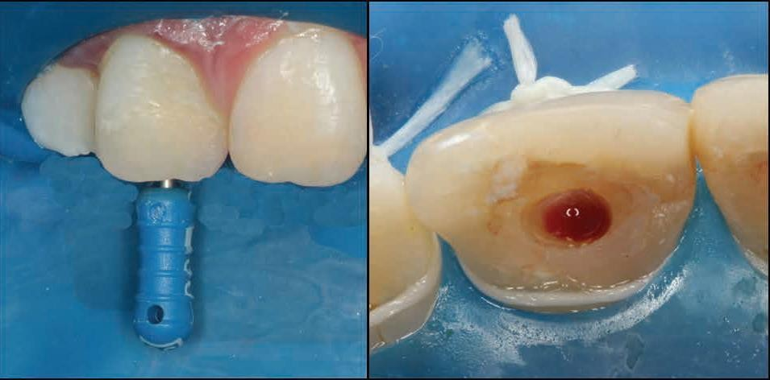

Figure 12: Blood clot stimulation with a manual endodontic file.
(Courtesy: ALBUQUERQUE MT, NAGATA JY, SOARES AD, ZAIA AA. Pulp revascularization: an alternative treatment to the apexification of immature teeth. RGO-Revista Gaúcha de Odontologia. 2014 Dec;62(4):401-10).
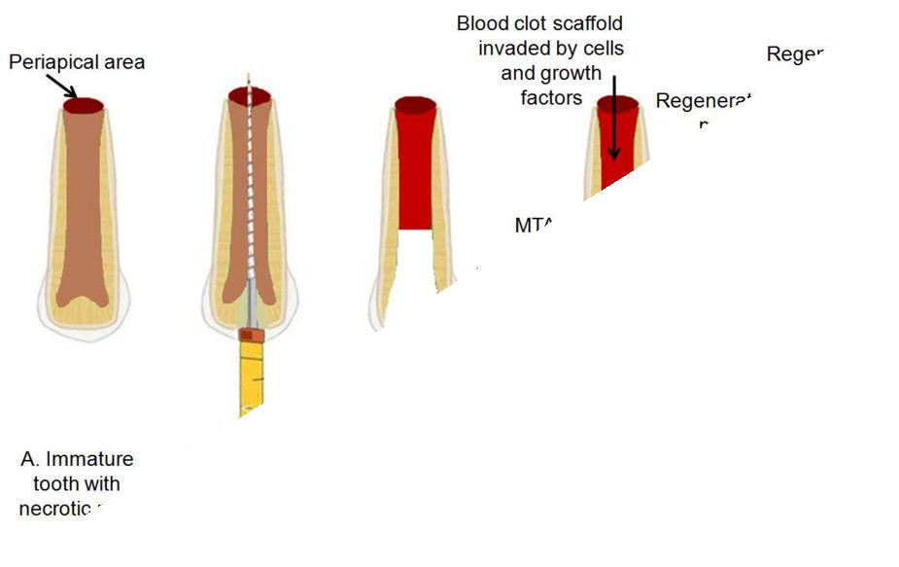

Figure- 13: Diagrammatic representation of root canal revascularization procedure
Courtesy: Bansal R, Jain A, Mittal S, Kumar T, Kaur D. Regenerative endodontics: a road less traveled. Journal of clinical and diagnostic research: JCDR. 2014 Oct;8 (10):ZE20.

LIMITATION OF REVASCULARIZATION:
- Discoloration of teeth due to the use of TAP/grey MTA. ⁽³⁰⁾
- The nature of tissue formed inside is uncertain. ⁽³⁰⁾
- Success rate more in young individuals rather than elderly. ⁽²⁹⁾
- Calcification of canal space is also noted. ⁽²⁹⁾

FACTORS THAT AFFECTING THE REVASCULARIZATION PROCESS:

A comprehensive understanding of these factors is essential for the successful implementation of the treatment procedure. The initial factor pertains to canal disinfection. During the early stages of research, regenerative endodontic treatment for infected pulp tissue was considered unfeasible. The inaugural attempt at regenerative endodontic treatment for an avulsed immature tooth with necrotic yet non-infected pulp yielded success. If the canals are adequately disinfected, and the coronal access is proficiently sealed, regenerative endodontic treatment can proceed similarly to an avulsed tooth. Various types of medications are currently employed for canal disinfection. The second factor revolves around apex diameter. A tooth with an open apex facilitates the migration of mesenchymal stem cells into the root canal space, allowing host cell homing for the formation of new tissue within the root canal. An apical opening of 1.1 mm in diameter or larger proves advantageous, with natural regenerative endodontic treatment occurring in approximately 18% to 34% of teeth with immature roots. The third factor is patient age. Case reports on regenerative endodontic treatment procedures have typically been confined to patients entering adolescence, primarily ranging from 8 to 16 years old. Regenerative endodontic treatment procedures should be avoided for deciduous teeth due to the potential risk of adversely impacting the eruption pattern of permanent teeth. These three factors influencing the outcomes of regenerative endodontic treatment are succinctly summarized .⁽¹⁰⁾ (Figure: 14)

Degree of infection of the canal

Tri-antibiotic paste or Calcium hydroxide is used to disinfect the canal.
  - Irrigants like 1.5% NaOCl and 17% EDTA is
recommended by ADA

Apex diameter
An open apical foramen >1.1 mm is beneficial, Possibility of revascularization increases in approximately 18-34% of teeth with immature roots

Patient age

Recommended age range :8-16 years
    - Revascularization should not be performed on deciduous teeth.

Courtesy: Lin LM, Kahler B. A review of regenerative endodontics: current protocols and
future directions. Journal of Istanbul University Faculty of Dentistry. 2017;51(3 Suppl 1):S41

AAE CLINICAL PROTOCOL FOR RET

In 2016, the American Association of Endodontists (AAE) introduced "Clinical Considerations for a Regenerative Procedure" to provide guidance to clinicians dealing with immature permanent teeth affected by necrotic pulp/apical periodontitis. Nevertheless, the AAE emphasizes that these considerations should be viewed as a singular information source. Acknowledging the rapidly evolving nature of this field, the AAE underscores that "clinicians should also actively review new findings elsewhere as they become available." The establishment of a standardized clinical protocol and rigorous outcome criteria is crucial for Regenerative Endodontic Therapy (RET) from both clinical and research perspectives. (56)

Case Selection:
- A tooth with necrotic pulp and an immature apex.
- Pulp space is not needed for post/core, final restoration.
- Compliant patient/parent.
- Patients were not allergic to medicaments and antibiotics necessary to complete the procedure (ASA 1 or 2).

Informed Consent
- Two (or more) appointments.
- Use of antimicrobial(s).
- Possible adverse effects: staining of crown/root, lack of response to treatment, pain/infection.
- Alternatives: MTA apexification, no treatment, extraction (when deemed non- salvageable).
- Permission to enter information into the AAE database (optional).

First Appointment
- Local anesthesia, dental dam isolation, and access.
- Copious, gentle irrigation with 20ml NaOCl using an irrigation system that minimizes the possibility of extrusion of irrigants into the periapical space (e.g., a needle with a closed-end and side-vents, or Endovac™). Lower concentrations of NaOCl are advised [1.5% NaOCl (20mL/canal, 5 min) and then rinsed with saline or EDTA (20 mL/canal, 5 min), with irrigating needle positioned about 1 mm from root end, to minimize cytotoxicity to stem cells in the apical tissues.
- Dry canals with paper points.
- Place calcium hydroxide or low concentration of triple antibiotic paste. If the triple antibiotic paste is used: 1) consider sealing pulp chamber with a dentin bonding agent [to minimize the risk of staining] and 2) mix 1:1:1 ciprofloxacin: metronidazole: minocycline to a final concentration of 0.1-1.0 mg/ml. Triple antibiotic paste has been associated with tooth discoloration. Double antibiotic paste without minocycline paste or substitution of minocycline for other antibiotics (e.g., clindamycin; amoxicillin; cefaclor) is another possible alternative as root canal disinfectant.
- Deliver into canal system via syringe
- If a triple antibiotic is used, ensure that it remains below CEJ (minimize crown staining).

- Seal with 3-4mm of temporary restorative material such as Cavit™, IRM™, glass ionomer, or another temporary material. Dismiss the patient for 1-4 weeks.
Second Appointment (1-4 weeks after 1st visit)
- Assess response to initial treatment. If there are signs/symptoms of persistent infection, consider additional treatment time with antimicrobial or alternative antimicrobial.
- Anesthesia with 3% mepivacaine without vasoconstrictor, dental dam isolation.
- Copious, gentle irrigation with 20ml of 17% EDTA.
- Dry with paper points.
- Create bleeding into the canal system by over-instrumenting (endo file, endo explorer) (induce by rotating a pre-curved K-file at 2 mm past the apical foramen the entire canal filled with blood to the level of the cementoenamel junction). An alternative to creating a blood clot is the use of platelet-rich plasma (PRP), platelet-rich fibrin (PRF), or autologous fibrin matrix (AFM).
- Stop bleeding at a level that allows for 3-4 mm of restorative material.
- Place a resorbable matrix such as CollaPlug™, Collacote™, and CollaTape™ over the blood clot if necessary and white MTA as capping material.
- A 3–4 mm layer of glass ionomer (e.g., Fuji IX™, GC America, and Alsip, IL) is flowed gently over the capping material and light-cured for 40 s. MTA has been associated with discoloration. Alternatives to MTA (such as bioceramics or tricalcium silicate cement [e.g., Biodentine®, Septodont, and Lancaster, PA, USA]) should be considered in teeth where there is an esthetic concern.

Anterior and Premolar teeth - Consider the use of Collatape / Collaplug and restoring with 3mm of a non-staining restorative material followed by bonding a filled composite to the beveled enamel margin.
Molar teeth or teeth with PFM crown - Consider the use of Collatape / Collaplug and restoring with 3mm of MTA, followed by RMGI, composite, or alloy.

Follow-up
- Clinical and Radiographic exam
- No pain, soft tissue swelling, or sinus tract (often observed between first and second appointments).
- Resolution of apical radiolucency (often observed 6-12 months after treatment)
- Increased root walls (this is generally observed before the apparent increase in root length) often occurs 12-24 months after treatment).
- It increased root length.
- Positive Pulp vitality test response. (56)

  - OUTCOME ASSESSMENT: (Figure: 15)

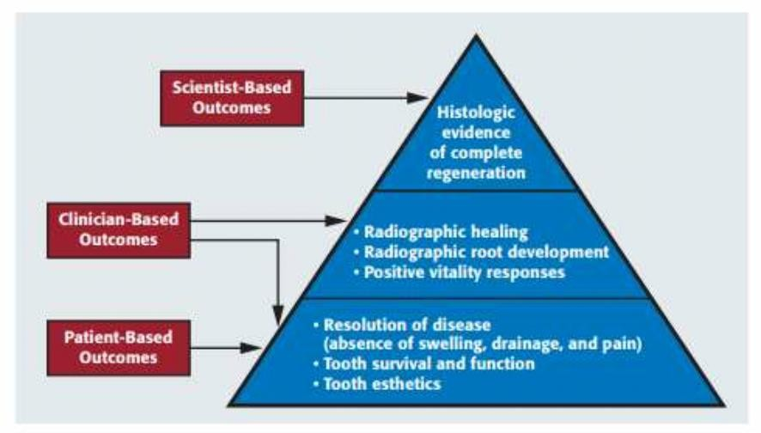

Figure 15- outcome assessment

Courtesy: Diogenes A, Ruparel NB, Shiloah Y, Hargreaves KM. Regenerative endodontics: a way forward. The Journal of the American Dental Association. 2016 May 1;147(5):372-80.

CLINICAL OUTCOMES

Since 2001, many RET clinical studies on human immature permanent teeth with necrotic pulp have been published.(72–75) The American Association of Endodontists clinical considerations for regenerative endodontic procedures define success by three measures:

- Primary goal (essential): The elimination of symptoms and the evidence of bony healing
- Secondary goal (desirable): Increased root wall thickness and increased root length
- Tertiary goal: a positive response to vitality testing. (56)

The primary goal of resolution of the sign/symptom of infection and bone healing is generally achievable. Two recent systematic reviews demonstrated that the primary goal of RET could be reliably achieved with high probabilities (91%-94% of periapical healing). (55,56)

ADVANTAGES AND DISADVANTAGES OF RET

ADVANTAGES:
The main advantages of the regenerative procedure are that
- It allows continued root development. (9)
- It potentially increases the fracture resistance of the tooth by deposition of dentin on the lateral walls. ⁽⁹⁾
- The tooth undergoing for RET procedure was able to regain its nociceptive response on vitality testing. ⁽⁹⁾

DISADVANTAGES:
  - Case selection, Patient compliance and Long term follow up. (76)
  - Technique sensitive. (76)
  - Discoloration of crown due to triple antibiotic paste (i.e., Minocycline) and, calcium silicate cements (MTA or Biodentine). (76)
  - Intracanal calcification (62.1%) after RET is possible. (77)
  - Retreatment of failed RET is difficult due to intracanal calcification. (77)

FUTURE PERSPECTIVES IN REGENERATION OF THE DENTAL
PULP

Only a limited number of instances showcasing successful stem cell therapy have been documented, such as blood reconstitution, corneal regeneration, and skin regeneration. (78) The cell homing strategy in tissue regeneration closely mimics the processes observed in normal tissue wound healing. Following tissue injury, the release of the chemotactic factor stromal cell-derived factor 1 (SDF-1) may act as a signal, directing nearby perivascular stem cells and distant mesenchymal stem cells to the site of tissue damage. Studies advocating for human and animal regenerative endodontics propose that dental pulp regeneration can also be achieved through both cell-based and cell homing approaches. In essence, both cell-free and cell-based methods for pulp tissue regeneration are currently in the preclinical experimentation phase. Nonetheless, looking forward, achieving pulp tissue regeneration appears to be a feasible objective, grounded in the principles of stem cell-based pulp tissue engineering. (78)

CHALLENGES:

    - Although the replacement pulp has the potential to revitalize teeth, it may also become susceptible to further pulp disease and may require retreatment; the implantation of engineered tissue also requires enhanced microbiological control methods required for adequate tissue regeneration. (79)
    - The success of clinical applications of pulp stem cells is limited by the culture conditions and the nature of microenvironment in which the primitive multipotent pulp stem cells are maintained and expanded.
    - To improve the ability of dental pulp constructs to adhere to root canal walls, it seems that the ideal scaffold design is in the same shape as gutta-percha cones. Researchers had used single-canal teeth and cylindrical scaffolds in an attempt to simplify the transplantation process. A more complex root canal anatomy will require more complex scaffolds or the use of more flexible scaffolds to perform regenerative endodontics.
    - Dental pulp tissue constructs adhered more completely to the coronal aspects of the root canal and less completely to the middle and apical aspects. This likely was caused by the increasing complexity of root canal anatomy toward the apex and the physical constraints of the scaffold materials, as well as the placement method. (79)
    - Since most of the tissue-engineered parts have been developed using very potent signal molecules to induce the transformation the growth of the stem cells, a way has to be

found to insure that these transformation and growth will not continue beyond control when implanted.
    - Matching the aging of the implanted tissue-engineered parts with that of the surrounding tissues and organs is a great obstacle too. (79)

CONCLUSION

Regenerative endodontics represents a transformative phase in both biological and clinical endodontics. The advancement of our comprehension of clinical protocols not only seeks to eliminate pulp infection but also endeavors to activate stem cell potential within the canal and release growth factors embedded in the dentine walls. Despite the current protocols yielding repair rather than true regeneration, ongoing research in stem cell-based pulp engineering holds the potential for authentic regeneration and improved treatment outcomes. Regenerative endodontic treatment (RET) leverages tissue engineering technology to regenerate the dentine-pulp complex within the canal space of immature permanent teeth affected by caries or trauma, thereby facilitating the restoration of arrested tooth root development. While RET can effectively eliminate clinical symptoms/signs and resolve apical periodontitis, the predictability of continued root development (thickening of canal walls or apical closure) after RET remains uncertain. In contrast to apexification, RET has the capacity to stimulate ongoing root maturation in immature permanent teeth with necrotic pulp/apical periodontitis. The tissue formed in the canal space post-RET exhibits characteristics of periodontal tissues, including cementum and bone, rather than being pulp-like. Although the vitality of damaged tissue in the canal is restored, the biological function as dental pulp is forfeited after RET. Nevertheless, RET has proven to be successful and reliable in treating immature permanent teeth with necrotic pulp, preserving tooth integrity, normal form, function, and achieving patient-centered outcomes.

REFERENCES:
- Cohen’s Pathways of the Pulp, 11ed (2016).pdf.

- Flanagan TA. What can cause the pulps of immature, permanent teeth with open apices to become necrotic and what treatment options are available for these teeth: Pulp Necrosis Immature Perm Teeth + Treatments. Aust Endod J. 2014 Dec;40(3):95–100.

- Rafter M. Apexification: a review. Dent Traumatol. 2005 Feb;21(1):1–8.

- Aksel H, Serper A. Recent considerations in regenerative endodontic treatment approaches. J Dent Sci. 2014 Sep;9(3):207–13.

- Staffoli S, Plotino G, Nunez Torrijos B, Grande N, Bossù M, Gambarini G, et al. Regenerative Endodontic Procedures Using Contemporary Endodontic Materials. Materials. 2019 Mar 19;12(6):908.

- Lin JC, Lu JX, Zeng Q, Zhao W, Li WQ, Ling JQ. Comparison of mineral trioxide aggregate and calcium hydroxide for apexification of immature permanent teeth: A systematic review and meta-analysis. J Formos Med Assoc. 2016 Jul;115(7):523–30.

- Andreasen JO, Farik B, Munksgaard EC. Long-term calcium hydroxide as a root canal dressing may increase risk of root fracture: Calcium hydroxide and root fracture. Dent Traumatol. 2002 Jun;18(3):134–7.

- ENDODONTICS: Colleagues for Excellence, news letter newsletter, Regenerative Endodontics. AAE org 2013 springer international.

- Murray PE, Garcia-Godoy F, Hargreaves KM. Regenerative Endodontics: A Review of Current Status and a Call for Action. J Endod. 2007 Apr;33(4):377–90.

- Kahler B, Lin LM. A REVIEW OF REGENERATIVE ENDODONTICS: CURRENT PROTOCOLS AND FUTURE DIRECTIONS. J Istanb Univ Fac Dent [Internet]. 2017 Nov 17 [cited 2020 Oct 29];51(0). Available from: http://eor.istanbul.edu.tr/tr/yazi/10- 17096-jiufd-53911-6D004A005100490030006B0071005F007300370077003100

- Nygaard-Östby B, Hjortdal O. Tissue formation in the root canal following pulp removal. Eur J Oral Sci. 1971 Jun;79(3):333–49.

- Skoglund A, Tronstad L. Pulpal changes in replanted and autotransplanted immature teeth of dogs. J Endod. 1981 Jul;7(7):309–16.

- Kling M, Cvek M, Mejare I. Rate and predictability of pulp revascularization in therapeutically reimplanted permanent incisors. Dent Traumatol. 1986 Jun;2(3):83–9.

- Sato I, Ando-Kurihara N, Kota K, Iwaku M, Hoshino E. Sterilization of infected root-canal dentine by topical application of a mixture of ciprofloxacin, metronidazole and minocycline in situ. Int Endod J. 1996 Mar;29(2):118–24.

- Kim SG, Malek M, Sigurdsson A, Lin LM, Kahler B. Regenerative endodontics: a comprehensive review. Int Endod J. 2018 Dec;51(12):1367–88.

- Banchs F, Trope M. Revascularization of Immature Permanent Teeth With Apical Periodontitis: New Treatment Protocol? J Endod. 2004 Apr;30(4):196–200.

- Huang GT, Lin LM. Letter to the editor: Comments on the use of the term “revascularization” to describe. Journal of endodontics. 2008 May 1;34(5):511

- Galler KM, Krastl G, Simon S, Van Gorp G, Meschi N, Vahedi B, et al. European Society of Endodontology position statement: Revitalization procedures. Int Endod J. 2016 Aug;49(8):717–23.

- Lovelace TW, Henry MA, Hargreaves KM, Diogenes A. Evaluation of the Delivery of Mesenchymal Stem Cells into the Root Canal Space of Necrotic Immature Teeth after Clinical Regenerative Endodontic Procedure. J Endod. 2011 Feb;37(2):133–8.

- Diogenes A, Ruparel NB, Shiloah Y, Hargreaves KM. Regenerative endodontics. J Am Dent Assoc. 2016 May;147(5):372–80.

- Geisler TM. Clinical Considerations for Regenerative Endodontic Procedures. Dent Clin North Am. 2012 Jul;56(3):603–26.

- Hashemi-Beni B, Khoroushi M, Foroughi MR, Karbasi S, Khademi AA. Tissue engineering: Dentin – pulp complex regeneration approaches (A review). Tissue Cell. 2017 Oct;49(5):552–64.

- Smith AJ, Scheven BA, Takahashi Y, Ferracane JL, Shelton RM, Cooper PR. Dentine as a bioactive extracellular matrix. Arch Oral Biol. 2012 Feb;57(2):109–21.

- Murray PE. Constructs and Scaffolds Employed to Regenerate Dental Tissue. Dent Clin North Am. 2012 Jul;56(3):577–88.

- Cvek M. Prognosis of luxated non-vital maxillary incisors treated with calcium hydroxide and filled with gutta-percha. A retrospective clinical study. Dent Traumatol. 1992;8(2):45– 55.

- Estefan BS, El Batouty KM, Nagy MM, Diogenes A. Influence of Age and Apical Diameter on the Success of Endodontic Regeneration Procedures. J Endod. 2016 Nov;42(11):1620–5.

- Garcia-Godoy F, Murray PE. Recommendations for using regenerative endodontic procedures in permanent immature traumatized teeth: Regenerative endodontic procedures. Dent Traumatol. 2012 Feb;28(1):33–41.

- Priya M H, Tambakad PB, Naidu J. Pulp and Periodontal Regeneration of an Avulsed Permanent Mature Incisor Using Platelet-rich Plasma after Delayed Replantation: A 12- month Clinical Case Study. J Endod. 2016 Jan;42(1):66–71.

- He L, Zhong J, Gong Q, Cheng B, Kim SG, Ling J, et al. Regenerative Endodontics by Cell Homing. Dent Clin North Am. 2017 Jan;61(1):143–59.

- Jain A, Bansal R. Current overview on dental stem cells applications in regenerative dentistry. J Nat Sci Biol Med. 2015;6(1):29.

- Caplan AI. Mesenchymal stem cells. J Orthop Res. 1991 Sep;9(5):641–50.

- Sedgley CM, Botero TM. Dental Stem Cells and Their Sources. Dent Clin North Am. 2012 Jul;56(3):549–61.

- Crisan M, Yap S, Casteilla L, Chen CW, Corselli M, Park TS, et al. A Perivascular Origin for Mesenchymal Stem Cells in Multiple Human Organs. Cell Stem Cell. 2008 Sep;3(3):301–13.

- Sobhani A, Khanlarkhani N, Baazm M, Mohammadzadeh F, Najafi A, Aval FS. Multipotent Stem Cell and Current Application. :18.

- Chalisserry EP, Nam SY, Park SH, Anil S. Therapeutic potential of dental stem cells. J Tissue Eng. 2017 Jan;8:204173141770253.

- Zheng C, Chen J, Liu S, Jin Y. Stem cell-based bone and dental regeneration: a view of microenvironmental modulation. Int J Oral Sci. 2019 Sep;11(3):23.

- Gronthos S, Mankani M, Brahim J, Robey PG, Shi S. Postnatal human dental pulp stem cells (DPSCs) in vitro and invivo. Proc Natl Acad Sci. 2000 Dec 5;97(25):13625–30.

- Yan M, Yu Y, Zhang G, Tang C, Yu J. A Journey from Dental Pulp Stem Cells to a Bio- tooth. Stem Cell Rev Rep. 2011 Mar;7(1):161–71.

- Huang GTJ, Sonoyama W, Liu Y, Liu H, Wang S, Shi S. The Hidden Treasure in Apical Papilla: The Potential Role in Pulp/Dentin Regeneration and BioRoot Engineering. J Endod. 2008 Jun;34(6):645–51.

- Nada OA, El Backly RM. Stem Cells From the Apical Papilla (SCAP) as a Tool for Endogenous Tissue Regeneration. Front Bioeng Biotechnol. 2018 Jul 24;6:103.

- Basrani B, editor. Endodontic Irrigation: Chemical disinfection of the root canal system [Internet]. Cham: Springer International Publishing; 2015 [cited 2020 Nov 4]. Available from: http://link.springer.com/10.1007/978-3-319-16456-4

- Steed DL. THE ROLE OF GROWTH FACTORS IN WOUND HEALING. :12.

- Kim SG. Biological Molecules for the Regeneration of the Pulp-Dentin Complex. Dent Clin North Am. 2017 Jan;61(1):127–41.

- Duncan HF, Kobayashi Y, Shimizu E. Growth Factors and Cell Homing in Dental Tissue Regeneration. Curr Oral Health Rep. 2018 Dec;5(4):276–85.

- Galler KM, Buchalla W, Hiller KA, Federlin M, Eidt A, Schiefersteiner M, et al. Influence of Root Canal Disinfectants on Growth Factor Release from Dentin. J Endod. 2015 Mar;41(3):363–8.

- Gathani KM, Raghavendra SS. Scaffolds in regenerative endodontics: A review. Dent Res J. 2016;13(5):8.

- Kim SG, Solomon C, Zheng Y, Mo C, Song S, Jiang N, et al. Effects of Growth Factors on Dental Stem/ProgenitorCells. 2014;14.

- Howard C, Murray PE, Namerow KN. Dental Pulp Stem Cell Migration. J Endod. 2010 Dec;36(12):1963–6.

- Tabata MJ, Matsumura T, Fujii T, Abe M, Kurisu K. Fibronectin Accelerates the Growth and Differentiation of Ameloblast Lineage Cells In Vitro. J Histochem Cytochem. 2003 Dec;51(12):1673–9.

- Mahajan A , Mahajan B, Manish Gupta M, Agarwal S, Singh N, Singh C. Regenerative endodontics. I J Pre Clin Dent Res 2015; 2(1):54-58.

- Kim S. Infection and Pulp Regeneration. Dent J. 2016 Mar 10;4(1):4.

- Kahler B, Chugal N, Lin L. Alkaline Materials and Regenerative Endodontics: A Review. Materials. 2017 Dec 5;10(12):1389.

- Diogenes AR, Ruparel NB, Teixeira FB, Hargreaves KM. Translational Science in Disinfection for Regenerative Endodontics. J Endod. 2014 Apr;40(4):S52–7.

- Trevino EG, Patwardhan AN, Henry MA, Perry G, Dybdal-Hargreaves N, Hargreaves KM, et al. Effect of Irrigants on the Survival of Human Stem Cells of the Apical Papilla in a Platelet-rich Plasma Scaffold in Human Root Tips. J Endod. 2011 Aug;37(8):1109–15.

- Martin DE, De Almeida JFA, Henry MA, Khaing ZZ, Schmidt CE, Teixeira FB, et al. Concentration-dependent Effect of Sodium Hypochlorite on Stem Cells of Apical Papilla Survival and Differentiation. J Endod. 2014 Jan;40(1):51–5.

- Endodontics AA of. AAE Clinical Considerations for a Regenerative Procedure. 2018;

- Roberts-Clark DJ, Smith AJ. Angiogenic growth factors in human dentine matrix. Arch Oral Biol. 2000 Nov;45(11):1013–6.

- Galler KM, Widbiller M, Buchalla W, Eidt A, Hiller KA, Hoffer PC, et al. EDTA conditioning of dentine promotes adhesion, migration and differentiation of dental pulp stem cells. Int Endod J. 2016 Jun;49(6):581–90.

- Taweewattanapaisan P, Jantarat J, Ounjai P, Janebodin K. The Effects of EDTA on Blood Clot in Regenerative Endodontic Procedures. 2019;45(3):6.

- Essner MD, Javed A, Eleazer PD. Effect of sodium hypochlorite on human pulp cells: an in vitro study. Oral Surg Oral Med Oral Pathol Oral Radiol Endodontology. 2011 Nov;112(5):662–6.

- Siqueira JF, Lopes HP. Mechanisms of antimicrobial activity of calcium hydroxide: a critical review. Int Endod J. 1999 Sep;32(5):361–9.

- Mohammadi Z, Dummer PMH. Properties and applications of calcium hydroxide in endodontics and dental traumatology: Calcium hydroxide in endodontics and dental traumatology. Int Endod J. 2011 Aug;44(8):697–730.

- Safavi K, Nichols F. Effect of calcium hydroxide on bacterial lipopolysaccharide. J Endod. 1993 Feb;19(2):76–8.

- Dds PK. Attachment Ability of Human Apical Papilla Cells to Root Dentin Surfaces Treated with Either 3Mix or Calcium Hydroxide. 2015;6.

- Kakoli P, Nandakumar R, Romberg E, Arola D, Fouad AF. The Effect of Age on Bacterial Penetration of Radicular Dentin. 2009;35(1):4.

- Rybak MJ, McGrath BJ. Combination Antimicrobial Therapy for Bacterial Infections: Guidelines for the Clinician. Drugs. 1996 Sep;52(3):390–405.

- Baumgartner JC, Xia T. Antibiotic Susceptibility of Bacteria Associated with Endodontic Abscesses. 2003;29(1):4.

- Makandar S, Noorani T. Triple antibiotic paste––Challenging intracanal medicament: A systematic review. J Int Oral Health. 2020;12(3):189.

- He L, Kim SG, Gong Q, Zhong J, Wang S, Zhou X, et al. Regenerative Endodontics for Adult Patients. J Endod. 2017 Sep;43(9):S57–64.

- Ramezanali F, Aryanezhad S, Mohammadian F, Dibaji F, Kharazifard J. In Vitro Microleakage of Mineral Trioxide Aggregate, Calcium- Enriched Mixture Cement and Biodentine Intra-Orifice Barriers. :5.

- Bansal R. Regenerative Endodontics: A Road Less Travelled. J Clin Diagn Res [Internet]. 2014 [cited 2020 Oct 29]; Available from: http://jcdr.net/article_fulltext.asp?issn=0973- 709x&year=2014&volume=8&issue=10&page=ZE20&issn=0973-709x&id=5034

- Nivedhitha MS, Jacob B, Ranganath A. Concentrated Growth Factor: A Novel Platelet Concentrate for Revascularization of Immature Permanent Teeth—A Report of Two Cases. Case Rep Dent [Internet]. 2020 Aug 15 [cited 2020 Nov 9];2020. Available from: https://www.ncbi.nlm.nih.gov/pmc/articles/PMC7448214/

- Panda S, Mishra L, Arbildo-Vega HI, Lapinska B, Lukomska-Szymanska M, Khijmatgar S, et al. Effectiveness of Autologous Platelet Concentrates in Management of Young Immature Necrotic Permanent Teeth—A Systematic Review and Meta-Analysis. Cells [Internet]. 2020 Oct 7 [cited 2020 Nov 9];9(10). Available from: https://www.ncbi.nlm.nih.gov/pmc/articles/PMC7600252/

- Silva MHC, Campos CN, Coelho MS. Revascularization of an Immature Tooth with Apical Periodontitis Using Calcium Hydroxide: A 3-year Follow-up. Open Dent J. 2015 Dec 31;9:482–5.

- Ajram J, Khalil I, Gergi R, Zogheib C. Management of an Immature Necrotic Permanent Molar with Apical Periodontitis Treated by Regenerative Endodontic Protocol Using Calcium Hydroxide and MM-MTA: A Case Report with Two Years Follow Up. Dent J [Internet]. 2019 Jan 1 [cited 2020 Nov 9];7(1). Available from: https://www.ncbi.nlm.nih.gov/pmc/articles/PMC6473881/

- Nosrat A, Homayounfar N, Oloomi K. Drawbacks and Unfavorable Outcomes of Regenerative Endodontic Treatments of Necrotic Immature Teeth: A Literature Review and Report of a Case. J Endod. 2012 Oct;38(10):1428–34.

- Song M, Cao Y, Shin SJ, Shon WJ, Chugal N, Kim RH, et al. Revascularization-associated Intracanal Calcification: Assessment of Prevalence and Contributing Factors. J Endod. 2017 Dec;43(12):2025–33.

- Gong T, Heng BC, Lo ECM, Zhang C. Current Advance and Future Prospects of Tissue Engineering Approach to Dentin/Pulp Regenerative Therapy. Stem Cells Int. :13.

- Moussa DG, Aparicio C. Present and future of tissue engineering scaffolds for dentin‐pulp complex regeneration. J Tissue Eng Regen Med. 2018 Dec 17;term.2769.

