A FUTURE PERSPECTIVE ON NANOTECHNOLOGY TRENDS
Abinash Patra¹, Haragouri Mishra^{1*}, K Shyam Sundar Rao¹, Shyama Sundar Sahu¹
¹ School of Pharmacy, Centurion University of Technology and Management, Odisha, India
* Corresponding author email id- haragourimishra@gmail.com

Abstract
Nanotechnology has emerged as a groundbreaking field with vast potential for transforming various industries and enhancing human lives. This chapter presents a future perspective on nanotechnology trends, highlighting key areas of development, potential applications, and challenges that lie ahead. The future holds immense promise in several key areas. Firstly, nanomedicine is poised to revolutionize healthcare by enabling targeted drug delivery, early disease detection, and personalized treatments. Nanoscale sensors and diagnostics offer unprecedented capabilities for monitoring health parameters and detecting diseases at their earliest stages. Furthermore, nanorobotics and nano-surgery hold the potential for precise, minimally invasive procedures and targeted therapies. In the energy sector, nanotechnology offers solutions for sustainable power generation, energy storage, and efficient utilization. Nanomaterials can enhance the performance of solar cells, enable high-capacity batteries and supercapacitors, and improve energy conversion and storage devices. It promises advancements in water purification and environmental remediation through the development of efficient filtration systems and nanoscale catalysts. Nanoelectronics, such as carbon nanotubes and graphene-based transistors, offer potential solutions to address the challenges faced by the industry. The integration of nanophotonic and nanomagnetic could revolutionize data storage, communication, and processing technologies. Despite the immense potential, several challenges must be addressed to realize the full benefits of nanotechnology. Issues related to safety, toxicity, and ethical considerations demand attention. Standardization and regulation frameworks need to be developed to ensure the responsible and sustainable implementation of nanotechnology. Additionally, investment in research and development, multidisciplinary collaborations, and education and training programs are crucial to fostering innovation and nurturing a skilled workforce.

Keywords: Nanoscale sensors, Nanotechnology, nanotubes, supercapacitors, solar cells

INTRODUCTION:
Nanotechnology, the science and engineering of manipulating materials at the atomic and molecular scale, has already made significant strides in various fields, from medicine to electronics [11]. As we delve further into the future, the potential of nanotechnology becomes even more apparent. Futuristic trends in nanotechnology are poised to reshape industries, revolutionize healthcare, and solve complex environmental challenges [1]. By harnessing the unique properties of materials at the nanoscale, researchers and innovators are paving the way for remarkable advancements that were once confined to the realm of science fiction [2]. In this exploration of the futuristic trends in nanotechnology, we will delve into the transformative possibilities that await us, from nanomedicine and energy applications to nanorobotics and self-healing materials. These trends hold the promise of not only enhancing our lives but also addressing global challenges in unprecedented ways [5]. Join us as we embark on a journey into the exciting world of futuristic nanotechnology and discover the incredible potential it holds for the future [21].
BENEFITS OF ADVANCED NANO TECHNOLOGY:
The benefits of advanced nano technology are extensive and have the potential to revolutionize multiple industries. Here are some key benefits:
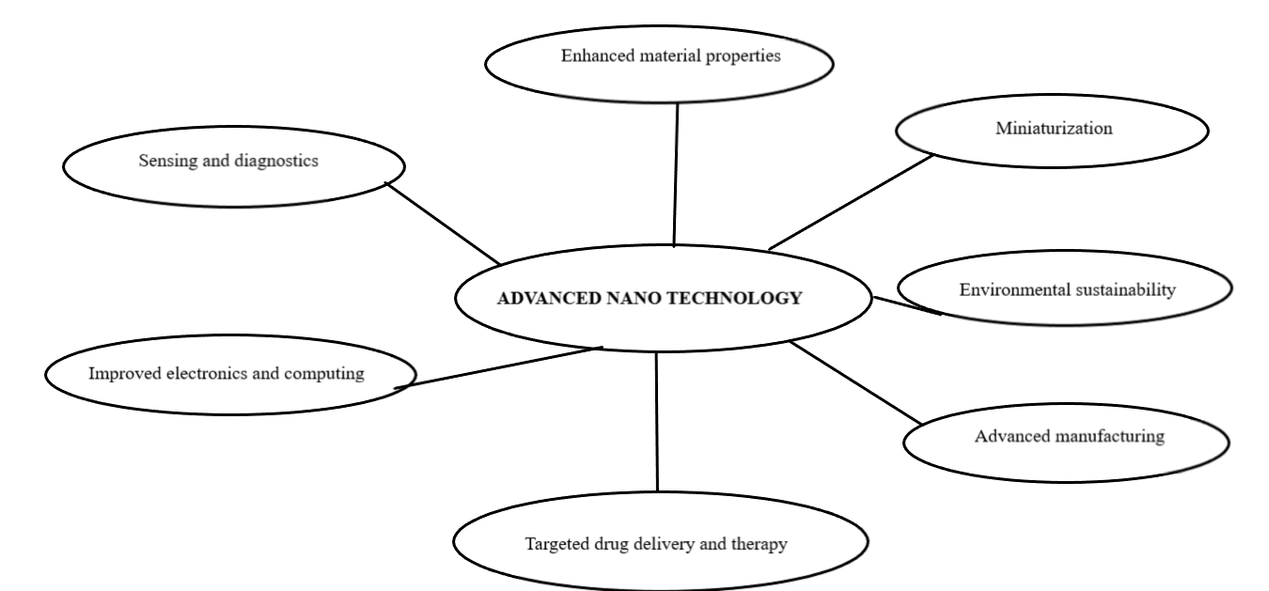

1. Enhanced material properties
2. Miniaturization
3. Targeted drug delivery and therapy
4. Environmental sustainability
5. Improved electronics and computing
6. Sensing and diagnostics
7. Advanced manufacturing

- Enhanced material properties: Nano technology enables the design and engineering of materials with improved properties and functionalities. By manipulating the structure and composition at the nanoscale, materials can exhibit enhanced strength, conductivity, optical properties, and chemical reactivity [1]. This opens up opportunities for developing lightweight yet durable materials, efficient energy storage devices, and high-performance coatings, among others.
- Miniaturization: Nano technology allows for miniaturization of devices and systems, leading to smaller, more compact, and portable products [2]. This is especially significant in the electronics industry, where shrinking the size of components enables the development of smaller and more powerful devices such as smartphones, wearables, and medical implants.
- Targeted drug delivery and therapy: Nano technology has revolutionized the field of medicine by enabling targeted drug delivery and therapy. Nanoparticles can be engineered to carry drugs and specifically target affected cells or tissues, increasing the efficacy of treatment while minimizing side effects [1]. Additionally, nano-sized sensors can monitor physiological parameters and provide real-time feedback, leading to personalized and optimized healthcare.
- Environmental sustainability: Advanced nano technology offers promising solutions for environmental sustainability[16]. Nanomaterials can be used to develop efficient catalysts for renewable energy generation, highly selective filters for water purification, and sensors for environmental monitoring. Additionally, nanotechnology can enable energy-efficient manufacturing processes and reduce waste generation.
- Improved electronics and computing: The advancements in nano technology have a significant impact on electronics and computing. Nanoscale materials, such as carbon nanotubes and graphene, have unique electrical properties that can lead to faster and more energy-efficient electronic devices. Moreover, nanotechnology is instrumental in developing next-generation memory storage, quantum computing, and flexible electronics.
- Sensing and diagnostics: Nano technology enables the development of highly sensitive and selective sensors for a wide range of applications. Nano sensors can detect and monitor minute changes in physical and chemical parameters, leading to advancements in fields such as environmental monitoring, healthcare diagnostics, and food safety [3].
- Advanced manufacturing: Nano technology plays a vital role in advancing manufacturing processes. Nanoscale fabrication techniques, such as nanolithography and self-assembly, enable precise control over the production of nanostructures and nanodevices. This paves the way for the development of new materials, components, and manufacturing methods, contributing to improved efficiency and productivity.
NANOTECH FUTURE TRENDS:
Nanotechnology has captured the imaginations of scientists, innovators, and futurists alike for its potential to manipulate matter on an atomic and molecular level [6]. There is no doubt that nanotechnology will have an enormous impact on the way we live in the near future, as it has the ability to create and control materials and devices at the nanoscale [8]. We can see a thriving landscape of opportunities to reshape industries, propel scientific advancements and solve pressing problems that are facing the world as we look to the future of nanotechnology. As we look to the future, the landscape of nanotechnology is full of exciting potential, brimming with exciting possibilities [2].
Several cutting-edge technologies are convergent with visionary thinking and cutting-edge research in nanotechnology. As a result of these trends, transformative applications once considered science fiction are now possible because of the inherent properties and behaviours of nanoscale materials [3]. Nanotechnology has vast potential in areas such as medicine, energy, electronics, and environmental sustainability. The use of nanotechnology in medicine can lead to a personalized and targeted treatment. In the future, diseases will be detected and diagnosed at their earliest stages by highly sensitive Nano sensors, and drugs will be delivered precisely to affected cells by nanorobots, reducing side effects as much as possible [4]. Millions of people could benefit from such advancements by improving their outcomes and quality of life.
Renewable energy generation and storage are possible with nanotechnology in the energy sector. Solar panels could be highly efficient with nano-engineered materials since they could capture and convert sunlight in a way that has never been seen before [5]. In electric vehicles and portable electronics, nanomaterials could also improve battery life and speed of charging. A significant impact on the electronics industry is also expected as a result of nanotechnology. Future trends in nanoelectronics may lead to ultra-miniaturized devices that are more energy-efficient and have higher computational power [7]. A quantum computer could perform calculations at speeds currently unimaginable, or flexible and wearable electronics that seamlessly connect to our lives [11].
The use of nanotechnology in environmental remediation has also been demonstrated to be very promising. Nanomaterials can remove pollutants and toxins from air and water using powerful catalysts. Monitoring environmental parameters in real-time, using nanosensors, provides valuable information for resource management that is both effective and sustainable. The possibilities provided by nanotechnology seem unlimited as we look to the future.[10]
Our understanding of the world is being transformed as we enter into a new era in which materials behave differently, devices become smarter and more efficient, and where our understanding of the world changes [8]. Embracing and exploring the futuristic trends in nanotechnology takes us on a journey that will push the boundaries of scientific knowledge and unlock a world full of awe-inspiring advances in the future when we embrace and explore the nanotechnology trends of the future [9].
Overall A number of futuristic trends are emerging in nanotechnology as it is an industry that is rapidly evolving, and they have tremendous potential in a wide range of industries and applications. In order to keep up with the latest trends in nanotechnology, here is a list of some of their key aspects,

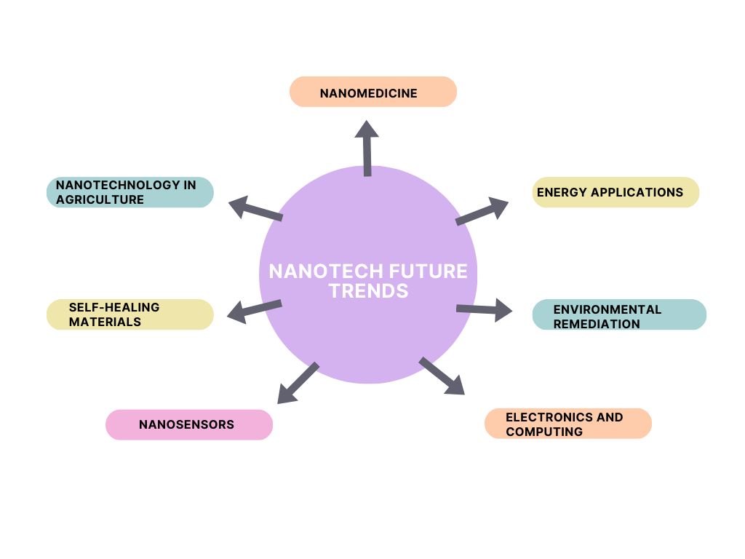

- Nanomedicine
- Energy applications
- Environmental remediation
- Electronics and computing
- Nanosensors
- Self-healing materials
- Nanotechnology in agriculture

- NANOMEDICINE
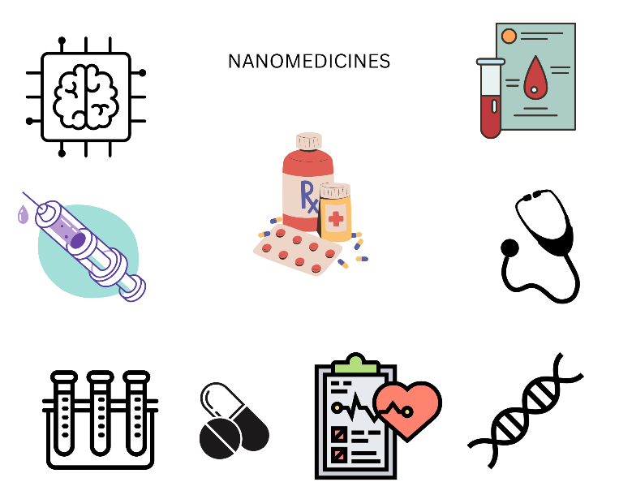

Futuristic trends in nanomedicine hold immense promise for revolutionizing healthcare and transforming the way we diagnose, treat, and prevent diseases. Nanotechnology, with its ability to manipulate materials at the nanoscale, offers unprecedented opportunities to enhance drug delivery, imaging, diagnostics, and regenerative medicine [1]. Here are some of the key futuristic trends in nanomedicine:

- Targeted drug delivery: Nanoparticles can be designed and functionalized to selectively deliver therapeutic agents to specific cells, tissues, or organs in the body [26]. By encapsulating drugs within nanoparticles, they can evade degradation and clearance, allowing for prolonged circulation and targeted release at the desired site. This approach minimizes systemic side effects and maximizes therapeutic efficacy, potentially revolutionizing the treatment of diseases such as cancer, cardiovascular conditions, and neurological disorders [28].
- Theranostics: Nanomedicine enables the integration of therapy and diagnostics into a single system known as theragnostic. Nanoparticles can be engineered to carry both therapeutic agents and imaging agents, enabling simultaneous drug delivery and real-time monitoring of treatment response [3]. This approach allows for personalized medicine, where treatment can be adjusted based on the patient's individual characteristics and disease progression [11].

- Image-guided interventions: Nanotechnology offers the potential for highly precise and targeted image-guided interventions. Nanoparticles can be designed to enhance imaging modalities such as magnetic resonance imaging (MRI), computed tomography (CT), and positron emission tomography (PET) [14]. These imaging agents enable accurate visualization of diseased tissues, facilitating precise surgical procedures and interventions.
- Regenerative medicine: Nanotechnology plays a critical role in regenerative medicine by providing scaffolds and nanomaterial-based platforms that mimic the native environment of cells and tissues [25]. Nanomaterials can guide and stimulate cellular behavior, promoting tissue regeneration and repair. These holds promise for regenerating damaged organs, enhancing wound healing, and treating degenerative conditions.
- Biosensors and diagnostics: Nanotechnology enables the development of highly sensitive biosensors for rapid and accurate disease detection. Nanoscale materials, such as quantum dots and gold nanoparticles, can be used to detect specific biomarkers or pathogens in biological samples [25]. These Nano sensors offer the potential for early disease diagnosis, monitoring treatment response, and detecting infectious agents with high specificity and sensitivity [16].
- Nano-enabled gene and cell therapies: Nanomedicine facilitates the delivery of nucleic acids and therapeutic genes to target cells, enabling precise manipulation of genetic material. Nanoparticles can protect nucleic acids from degradation and efficiently deliver them to the desired cells, offering potential breakthroughs in gene therapy, gene editing, and cell-based therapies [15].
- Nanorobotics in medicine: The integration of nanotechnology and robotics leads to the development of nanorobots or nanobots that can navigate through the body to perform targeted tasks. These tiny robots could deliver drugs, perform minimally invasive surgeries, and even repair damaged tissues at the cellular level [17]. Nanorobotics holds immense potential for highly precise and minimally invasive medical interventions.
- Artificial intelligence (AI) integration: The integration of nanomedicine with AI holds the potential to revolutionize diagnostics, treatment planning, and drug discovery. AI algorithms can analyse vast amounts of patient data, nanoparticle behaviour, and molecular interactions to provide personalized treatment recommendations [16]. This synergy between nanomedicine and AI can accelerate the development of targeted therapies and improve patient outcomes [29].
- Nano-robotic surgeries: Nanorobots with precise control and manoeuvrability can perform intricate surgeries at the cellular level [33]. These nanobots can navigate through complex anatomical structures, deliver therapeutics directly to affected areas, and perform delicate procedures with minimal invasiveness [11]. Nano-robotic surgeries offer the potential for faster recovery times, reduced scarring, and improved surgical outcomes [26].
- Wearable nanotechnology: Nanosensors and nanomaterials integrated into wearable devices can continuously monitor vital signs, biomarkers, and other health indicators [11]. These wearable nanotechnologies can provide real-time feedback on an individual's health status, enabling early detection of diseases and proactive management of health conditions.
- Nanoparticle-based vaccines: Nanotechnology can enhance the effectiveness of vaccines by encapsulating antigens within nanoparticles. These nanoparticle-based vaccines can improve immune system activation, enhance vaccine stability, and enable targeted delivery to specific immune cells [14]. This trend holds promise for the development of highly effective and targeted vaccines against infectious diseases and cancers [28].
- Nanoscale tissue engineering: Nanotechnology offers new avenues for tissue engineering and organ regeneration. By manipulating nanoscale materials and structures, researchers can create biomimetic scaffolds that closely resemble the native tissues. These scaffolds promote cell adhesion, growth, and tissue regeneration, ultimately leading to the development of functional organs and tissues for transplantation [21].
- Nanoparticle-based imaging agents: Advanced nanoparticle-based imaging agents can provide unprecedented visualization of biological structures at high resolution. These imaging agents, such as quantum dots and superparamagnetic nanoparticles, offer improved contrast, sensitivity, and multiplexing capabilities [3]. This trend facilitates earlier and more accurate disease diagnosis, leading to timely interventions and improved patient outcomes.
- Nanotechnology-enabled drug discovery: Nanotechnology plays a vital role in accelerating the drug discovery process. By using nanoscale drug delivery systems and high-throughput screening methods, researchers can efficiently screen and evaluate a vast number of potential drug candidates. Nanotechnology enables targeted and controlled delivery of these drugs, improving their efficacy and reducing side effects [1].
- Nano-based bio scaffolds for tissue regeneration: Nanoengineered bio scaffolds can provide a template for tissue regeneration and guide the growth of new cells [3]. These scaffolds mimic the natural extracellular matrix, promoting cell adhesion, proliferation, and differentiation. By incorporating bioactive molecules and signalling cues, nanoscale bio scaffolds facilitate the regeneration of complex tissues and organs.

There are a number of futuristic trends in nanomedicine that give us a glimpse into the future in which diseases will be treated with astounding precision, diagnostics will be faster and more accurate, and the promise of regenerative therapies will be realized in the desire to restore damaged tissues and organs [1]. Nanotechnology is advancing at a rapid pace in the healthcare sector, and this is resulting in incredible advancements which will lead to transformative breakthroughs in the near future. Nanotechnology is being used to develop treatments and diagnostic tools that are more precise, less invasive, and more effective than traditional methods [3]. This technology is also being used to create advanced materials for implantable medical devices and tissue engineering. Additionally, nanotechnology is being used to create drug delivery systems that target specific cells in the body [25].

- ENERGY APPLICATIONS
Nanoparticles have shown tremendous potential in various energy applications, offering enhanced efficiency, improved performance, and novel functionalities. Here are some energy-related applications of nanoparticles:

- Solar energy conversion: Nanoparticles play a crucial role in improving the efficiency of solar energy conversion. Semiconductor nanoparticles, such as quantum dots, can be tailored to absorb specific wavelengths of light, maximizing the utilization of solar energy [4]. These nanoparticles can be incorporated into solar cells to enhance light absorption, increase charge carrier generation, and improve overall energy conversion efficiency [32].
- Energy storage: Nanoparticles have revolutionized energy storage technologies, particularly in the development of batteries and supercapacitors. Nanomaterials, such as nanowires, nanotubes, and nanoparticles, enable higher energy and power densities, faster charging rates, and improved cycling stability [5]. By manipulating the size, shape, and composition of nanoparticles, researchers can optimize the electrochemical properties and overcome limitations of traditional energy storage devices.
- Fuel cells: Nanoparticles are utilized in fuel cell technologies to improve their performance and durability. Nanocatalysts, consisting of nanoparticles with high surface areas and controlled surface structures, can significantly enhance the efficiency of electrochemical reactions involved in fuel cells [10]. These nanoparticles enable faster reaction kinetics, reduce the need for expensive catalyst materials, and increase the longevity of fuel cell systems.
- Hydrogen production and storage: Nanoparticles are being explored for efficient hydrogen production and storage. Metal nanoparticles, such as platinum and palladium, can serve as catalysts for hydrogen generation through various methods like water splitting and reforming of hydrocarbons. Additionally, nanoparticles can be used to store hydrogen by adsorption or absorption, offering potential solutions for safe and compact hydrogen storage systems [11].
- Energy-efficient lighting: Nanoparticles are used in advanced lighting technologies, such as light-emitting diodes (LEDs). Quantum dots, for example, can be employed as nanoscale light emitters, producing bright and efficient light across a wide range of colors. By using nanoparticles, LED lighting can achieve higher colour accuracy, energy efficiency, and improved longevity compared to traditional lighting technologies [32].
- Thermoelectric materials: Nanoparticles have the potential to enhance the efficiency of thermoelectric devices that convert waste heat into electricity. By manipulating the size, structure, and composition of nanoparticles, researchers can optimize the thermal conductivity and electrical conductivity of thermoelectric materials, improving their conversion efficiency [19].
- Smart windows and coatings: Nanoparticles are used in smart windows and coatings to control the transmission and absorption of light and heat. Nanoparticles embedded in thin films or coatings can selectively block or allow certain wavelengths of light, enabling the regulation of temperature and energy efficiency in buildings [16]. This technology reduces the reliance on mechanical heating and cooling systems, leading to energy savings.

These energy applications of nanoparticles demonstrate their significant contributions to enhancing energy conversion, storage, and efficiency [19]. As nanotechnology continues to advance, researchers are exploring novel nanoparticle-based materials and systems that hold great promise for addressing global energy challenges and driving sustainable energy solutions.

- ENVIRONMENTAL REMEDIATION
Environmental remediation using nanotechnology is indeed a futuristic trend with great potential. Nanotechnology involves the manipulation and control of matter at the nanoscale, which is the scale of atoms and molecules [5]. This technology offers numerous possibilities for addressing environmental challenges in a more efficient and precise manner. Here are a few ways nanotechnology can be applied to environmental remediation:
- Water purification: Nanomaterials such as carbon nanotubes, graphene oxide, and nanoparticles can be used to remove pollutants from water sources [18]. These materials have high surface area-to-volume ratios, allowing them to adsorb contaminants like heavy metals, organic compounds, and pathogens more effectively [5]. Nanofillers and nanomembranes can also be designed to selectively filter out pollutants while allowing clean water to pass through.
- Air pollution control: Nanoparticles can be utilized in air filtration systems to capture and remove harmful pollutants such as particulate matter, volatile organic compounds (VOCs), and nitrogen oxides [6]. Nanomaterials with catalytic properties, like titanium dioxide, can be integrated into paints and coatings to help break down air pollutants when exposed to light.
- Soil remediation: Nano remediation techniques involve the use of nanoparticles to treat contaminated soil and groundwater [14]. These nanoparticles can help degrade or immobilize pollutants, such as heavy metals and organic compounds, through chemical reactions or physical adsorption. Additionally, nanosensors can be employed to monitor and assess the effectiveness of soil remediation efforts [7].
- Environmental monitoring: Nanotechnology can enhance environmental monitoring by developing highly sensitive and selective nano sensors. These sensors can detect and quantify various pollutants, including heavy metals, pesticides, and toxins, in real-time and at extremely low concentrations [9]. This enables early detection of contamination and facilitates prompt remediation actions.
- Energy and resource efficiency: Nanotechnology can contribute to sustainable practices by improving energy and resource efficiency [20]. For example, nanomaterials can enhance the performance of solar cells, making them more efficient at converting sunlight into electricity [11]. Nano catalysts can also enhance the efficiency of industrial processes, reducing energy consumption and waste generation.
It's important to note that while nanotechnology offers promising solutions, there are also concerns regarding the potential environmental and health impacts of engineered nanoparticles. Therefore, the responsible development and regulation of nanotechnology are crucial to ensure its safe and sustainable implementation in environmental remediation.
- ELECTRONICS AND COMPUTING
Electronics and computing are key areas where nanotechnology is driving futuristic trends. Nanotechnology has the potential to revolutionize electronic devices and computing systems by enabling smaller, faster, and more energy-efficient components. Here are some ways nanotechnology is shaping the future of electronics and computing:
- Nanoscale transistors: Traditional silicon-based transistors are reaching their physical limits, but nanotechnology offers alternatives. Nanoscale transistors, such as carbon nanotube transistors and graphene transistors, hold promise for overcoming the limitations of traditional transistors [3]. These nanoscale devices can provide higher performance, reduced power consumption, and enhanced integration density, enabling the development of more powerful and efficient electronic devices [31].
- Nanoelectronics: Nanotechnology enables the fabrication of nanoscale electronic components and circuits. Nanoscale materials, such as quantum dots and nanowires, exhibit unique electrical and optical properties that can be harnessed for novel electronic devices [5]. For example, quantum dot-based displays offer brighter and more energy-efficient screens, while nanowires can be used to create flexible and transparent electronics.
- Molecular electronics: Molecular electronics involves the use of individual molecules as electronic components. Nanotechnology allows for precise manipulation and assembly of molecules to create functional circuits [10]. This field holds promise for ultra-dense storage devices, faster processors, and highly efficient energy harvesting systems.
- Nanophononics: Nanophotonics combines nanotechnology and photonics to manipulate and control light at the nanoscale. This technology can lead to the development of faster and more efficient optical communication systems, high-resolution imaging devices, and advanced sensors [31]. Nanoscale plasmonic structures, photonic crystals, and nanowires are examples of nanophotonic components that enable the miniaturization and integration of optical devices.
- Quantum computing: Nanotechnology plays a crucial role in advancing quantum computing. Quantum computers leverage the unique properties of quantum systems, such as superposition and entanglement, to perform computations beyond the capabilities of classical computers. Nanoscale structures, such as quantum dots and superconducting qubits, serve as the building blocks for quantum processors [11].
- Flexible and wearable electronics: Nanotechnology enables the development of flexible and stretchable electronics. Nanoscale materials, such as carbon nanotubes and nanowires, can be incorporated into flexible substrates to create wearable devices with advanced functionality [18]. These devices can be used for healthcare monitoring, smart textiles, flexible displays, and more [11].

It's important to note that while nanotechnology offers exciting opportunities in electronics and computing, there are still technical challenges and manufacturing complexities that need to be overcome for widespread implementation [20]. However, ongoing research and development in nanotechnology are paving the way for the realization of these futuristic trends.
- Nanosensors
Nanosensors are indeed a futuristic trend in nanotechnology with exciting potential across various fields. Nanosensors are miniaturized devices that can detect and measure physical, chemical, or biological properties at the nanoscale [3]. Here are some ways nanosensors are shaping the future:
- Healthcare and diagnostics: Nanosensors hold great promise for healthcare applications. They can be used for early disease detection, monitoring of biomarkers, and point-of-care diagnostics. Nanosensors can detect specific molecules, proteins, or genetic materials associated with diseases, providing rapid and sensitive diagnostic information [11]. They can also enable real-time monitoring of physiological parameters within the body, facilitating personalized and proactive healthcare.
- Environmental monitoring: Nanosensors play a crucial role in environmental monitoring by detecting and quantifying pollutants, toxins, and hazardous substances in air, water, and soil. These sensors can provide real-time data on environmental quality and help in early detection of pollution events. Nanosensors can be deployed in networks or integrated with wearable devices to enable widespread and continuous monitoring, contributing to environmental protection and public health [13].
- Food safety and quality control: Nanosensors can enhance food safety and quality control measures. They can detect contaminants, pathogens, and spoilage indicators in food products, ensuring their safety and freshness [22]. Nanosensors can also monitor important parameters like temperature, humidity, and gas composition during food storage and transportation, preventing spoilage and optimizing food preservation methods.
- Smart and connected systems: Nanosensors are integral to the development of smart and connected systems, such as smart homes, smart cities, and the Internet of Things (IoT) [25] . They can monitor and collect data on various parameters, enabling real-time control and optimization of systems. For example, nanosensors embedded in buildings can monitor energy consumption, air quality, and occupancy, leading to more efficient resource utilization and improved living conditions.
- Aerospace and defence applications: Nanosensors find applications in aerospace and defense sectors. They can be used for monitoring structural integrity, detecting chemical or biological agents, and enhancing situational awareness [3]. Nanosensors can provide real-time feedback on aircraft components, detect trace amounts of explosives or hazardous materials, and enable advanced surveillance and reconnaissance systems.
- Wearable and implantable devices: Nanosensors are crucial components of wearable and implantable devices. They can monitor vital signs, track physical activity, and detect anomalies in health conditions [11]. Nanosensors integrated into clothing, accessories, or even embedded within the human body can provide personalized health monitoring and enable early intervention in medical emergencies [25].
Nanosensors offer advantages such as high sensitivity, selectivity, miniaturization, and compatibility with different materials and surfaces. However, challenges remain, including power supply, signal processing, and data management. Continued research and development in nano sensor technology are essential to overcome these challenges and fully realize their potential in the future.
- SELF-HEALING MATERIALS
Self-healing materials are indeed a futuristic trend in nanotechnology that has the potential to revolutionize various industries [4]. These materials have the ability to repair damage or restore their functionality without external intervention, mimicking the healing process observed in living organisms. Here's how self-healing materials are shaping the future:
- Structural materials: Self-healing materials can enhance the durability and lifespan of structural components in industries such as construction, aerospace, and automotive. For example, self-healing polymers can automatically repair small cracks or damage caused by stress, fatigue, or impact, reducing maintenance costs and improving safety [5].
- Electronics and coatings: Self-healing materials can improve the reliability and performance of electronic devices and protective coatings. Electronic circuits and conductive coatings can be designed with self-healing capabilities, allowing them to repair minor damages or restore conductivity [6]. Self-healing coatings on surfaces, such as metals or ceramics, can protect against corrosion, scratches, and wear, increasing the longevity of the materials.
- Energy storage and conversion: Self-healing materials hold promise for enhancing the efficiency and lifespan of energy storage systems, such as batteries and fuel cells. Self-healing polymers can repair internal damage, such as electrode degradation or electrolyte leakage, thus extending the lifetime and improving the overall performance of these devices [9].
- Biomedical applications: Self-healing materials have potential applications in the biomedical field. For instance, self-healing hydrogels can be used as scaffolds for tissue engineering, promoting the regeneration of damaged tissues or organs [10]. Self-healing properties in medical implants or prosthetics can improve their lifespan and functionality.
- Environmental applications: Self-healing materials can also contribute to environmental sustainability. For instance, self-healing membranes can be used for water filtration systems, preventing leakage and extending the lifespan of the filters [11]. Self-healing materials in pipelines or storage tanks can minimize the risk of leaks and environmental contamination.
- Wearable and flexible electronics: Self-healing materials can enable the development of wearable and flexible electronics that can withstand mechanical stress and deformation [14]. These materials can self-repair minor damages, maintaining the functionality and integrity of electronic devices integrated into fabrics, wearable sensors, or flexible displays.
The development of self-healing materials involves incorporating healing agents, such as microcapsules or vascular networks, into the material matrix [10]. Upon damage, these agents are released and react to repair the material. Challenges in this field include scalability, optimizing healing efficiency, and integrating self-healing mechanisms into complex structures [11]. Ongoing research and advancements in nanotechnology are driving the development of self-healing materials and expanding their potential applications in the future.

- NANOTECHNOLOGY IN AGRICULTURE
Nanotechnology holds significant potential for revolutionizing agriculture and addressing key challenges in the food production system [2]. It offers innovative solutions for enhancing crop productivity, improving resource efficiency, and ensuring sustainable agricultural practices. Here are some ways nanotechnology is being applied in agriculture:
- Precision agriculture: Nanosensors and nanodevices enable real-time monitoring and precise measurement of soil conditions, nutrient levels, and plant health. These sensors can provide accurate data on temperature, moisture, pH levels, and nutrient concentrations, allowing farmers to optimize irrigation, fertilization, and pest management practices. This leads to more efficient resource utilization, reduced environmental impact, and improved crop yields [2].
- Crop protection: Nanotechnology offers new avenues for crop protection and pest management. Nano pesticides and nanoencapsulation of agrochemicals enable targeted and controlled delivery of crop protection agents, reducing their environmental impact and minimizing chemical exposure. Nanomaterials can also be used as barriers or coatings to protect plants from pests, pathogens, and environmental stressors.
- Nano fertilizers: Nanotechnology enables the development of nanoscale fertilizers that improve nutrient uptake, enhance nutrient efficiency, and reduce fertilizer runoff. Nano-based delivery systems can encapsulate and release nutrients in a controlled manner, ensuring their availability to plants when needed [6]. This results in reduced fertilizer waste, improved nutrient utilization, and minimized environmental pollution.
- Seed enhancement: Nanocoating and nanoscale treatments can improve seed quality, viability, and performance. Nanomaterials can be used to enhance seed germination, protect seeds from pathogens and environmental stressors, and improve seedling establishment [2]. This can contribute to better crop establishment, higher yield potential, and increased resilience to challenging growing conditions [11].
- Post-harvest management: Nanotechnology offers solutions for extending the shelf life of harvested crops and reducing post-harvest losses. Nano-based packaging materials can provide better barrier properties, moisture control, and antimicrobial properties to preserve the freshness and quality of agricultural products [12]. Nanosensors integrated into packaging can also monitor and indicate the freshness or spoilage of perishable items.
- Soil remediation: Nanomaterials can be employed for soil remediation, helping to clean up contaminated soils and improve their fertility [2]. Nanoparticles can be used to remove heavy metals, pesticides, and other pollutants from soil, reducing their bioavailability and toxicity. Nano remediation techniques offer potential for sustainable soil management and restoration of degraded lands [22].
It's important to ensure the responsible and safe use of nanotechnology in agriculture, considering the potential environmental and health impacts. Proper regulation, risk assessment, and adherence to ethical and sustainability considerations are essential for its widespread implementation. Ongoing research and collaboration between scientists, farmers, and policymakers are driving the development and adoption of nanotechnology in agriculture to address global food security challenges.

CONCLUSION:
The future of nanotechnology holds tremendous promise and potential. From environmental remediation to electronics, computing, nanorobotics, nanosensors, self-healing materials, and agriculture, nanotechnology is poised to reshape industries and address pressing global challenges. As advancements continue, we can anticipate more efficient and sustainable solutions, improved healthcare outcomes, enhanced resource utilization, and increased productivity. However, it is crucial to proceed with responsible research, ethical considerations, and regulatory frameworks to ensure the safe and beneficial integration of nanotechnology into our daily lives. With ongoing collaboration and innovation, the futuristic trends in nanotechnology have the capacity to transform our world for the better.
REFERENCE
- Wang, X., Wu, C., Liu, S., & Peng, D. (2022). Combinatorial therapeutic strategies for enhanced delivery of therapeutics to brain cancer cells through nanocarriers: current trends and future perspectives. Drug Delivery, 29(1), 1370-1383. https://doi.org/10.1080/10717544.2022.2069881
- Chausali, N., Saxena, J., & Prasad, R. (2022). Recent trends in nanotechnology applications of bio-based packaging. Journal of Agriculture and Food Research, 7, 100257. https://doi.org/10.1016/j.jafr.2021.100257
- Allouzi, M. M. A., Allouzi, S., Al-Salaheen, B., Khoo, K. S., Rajendran, S., Sankaran, R., ... & Show, P. L. (2022). Current advances and future trend of nanotechnology as microalgae-based biosensor. Biochemical Engineering Journal, 108653. https://doi.org/10.1016/j.bej.2022.108653
- Pushparaj, K., Liu, W. C., Meyyazhagan, A., Orlacchio, A., Pappusamy, M., Vadivalagan, C., ... & Balasubramanian, B. (2022). Nano-from nature to nurture: A comprehensive review on facets, trends, perspectives and sustainability of nanotechnology in the food sector. Energy, 240, 122732. https://doi.org/10.1016/j.energy.2021.122732
- Leong, K. W., Wang, Y., Ni, M., Pan, W., Luo, S., & Leung, D. Y. (2022). Rechargeable Zn-air batteries: Recent trends and future perspectives. Renewable and Sustainable Energy Reviews, 154, 111771. https://doi.org/10.1016/j.rser.2021.111771
- Shah, M. A., Pirzada, B. M., Price, G., Shibiru, A. L., & Qurashi, A. (2022). Applications of nanotechnology in smart textile industry: A critical review. Journal of Advanced Research. https://doi.org/10.1016/j.jare.2022.01.008
- Govarthanan, M., Manikandan, S., Subbaiya, R., Krishnan, R. Y., Srinivasan, S., Karmegam, N., & Kim, W. (2022). Emerging trends and nanotechnology advances for sustainable biogas production from lignocellulosic waste biomass: a critical review. Fuel, 312, 122928. https://doi.org/10.1016/j.fuel.2021.122928
- Puttasiddaiah, R., Lakshminarayana, R., Somashekar, N. L., Gupta, V. K., Inbaraj, B. S., Usmani, Z., ... & Sharma, M. (2022). Advances in Nanofabrication Technology for Nutraceuticals: New Insights and Future Trends. Bioengineering, 9(9), 478. https://doi.org/10.3390/bioengineering9090478
- Govarthanan, M., Manikandan, S., Subbaiya, R., Krishnan, R. Y., Srinivasan, S., Karmegam, N., & Kim, W. (2022). Emerging trends and nanotechnology advances for sustainable biogas production from lignocellulosic waste biomass: a critical review. Fuel, 312, 122928. https://doi.org/10.1016/j.fuel.2021.122928
- Puttasiddaiah, R., Lakshminarayana, R., Somashekar, N. L., Gupta, V. K., Inbaraj, B. S., Usmani, Z., ... & Sharma, M. (2022). Advances in Nanofabrication Technology for Nutraceuticals: New Insights and Future Trends. Bioengineering, 9(9), 478. https://doi.org/10.3390/bioengineering9090478
- Pereira, L., Ismail, G., & Abomohra, A. (2023). Algal biotechnology: Current trends and nanotechnology prospective. Frontiers in Marine Science, 10, 1181665. https://doi.org/10.3389/fmars.2023.1181665
- Verma, K. K., Song, X. P., Joshi, A., Tian, D. D., Rajput, V. D., Singh, M., ... & Li, Y. R. (2022). Recent trends in nano-fertilizers for sustainable agriculture under climate change for global food security. Nanomaterials, 12(1), 173. https://doi.org/10.3390/nano12010173
- Ha, K. H., Huh, H., Li, Z., & Lu, N. (2022). Soft capacitive pressure sensors: trends, challenges, and perspectives. ACS nano, 16(3), 3442-3448. https://doi.org/10.1021/acsnano.2c00308
- Azharuddin, M., Zhu, G. H., Sengupta, A., Hinkula, J., Slater, N. K., & Patra, H. K. (2022). Nano toolbox in immune modulation and nanovaccines. Trends in Biotechnology. https://doi.org/10.1016/j.tibtech.2022.03.011
- Jayusman, P. A., Nasruddin, N. S., Mahamad Apandi, N. I., Ibrahim, N., & Budin, S. B. (2022). Therapeutic potential of polyphenol and nanoparticles mediated delivery in periodontal inflammation: A review of current trends and future perspectives. Frontiers in Pharmacology, 13, 847702. https://doi.org/10.3389/fphar.2022.847702
- Singh, B. P., Aluko, R. E., Hati, S., & Solanki, D. (2022). Bioactive peptides in the management of lifestyle-related diseases: Current trends and future perspectives. Critical reviews in food science and nutrition, 62(17), 4593-4606. https://doi.org/10.1080/10408398.2021.1877109
- Ahmed, M. W., Haque, M. A., Mohibbullah, M., Khan, M. S. I., Islam, M. A., Mondal, M. H. T., & Ahmmed, R. (2022). A review on active packaging for quality and safety of foods: Current trends, applications, prospects and challenges. Food Packaging and Shelf Life, 33, 100913. https://doi.org/10.1016/j.fpsl.2022.100913
- Chadha, U., Bhardwaj, P., Selvaraj, S. K., Arasu, K., Praveena, S., Pavan, A., ... & Paramasivam, V. (2022). Current trends and future perspectives of nanomaterials in food packaging application. Journal of Nanomaterials, 2022, 1-32. https://doi.org/10.1155/2022/2745416
- Kumar, A., Hasan, M., Mangaraj, S., Pravitha, M., Verma, D. K., & Srivastav, P. P. (2022). Trends in edible packaging films and its prospective future in food: a review. Applied Food Research, 100118. https://doi.org/10.1016/j.afres.2022.100118
- Coats, J. P., Cochereau, R., Dinu, I. A., Messmer, D., Sciortino, F., & Palivan, C. G. (2023). Trends in the Synthesis of Polymer Nano‐and Microscale Materials for Bio‐Related Applications. Macromolecular Bioscience, 2200474. https://doi.org/10.1002/mabi.202200474
- Kumar, A., Hasan, M., Mangaraj, S., Pravitha, M., Verma, D. K., & Srivastav, P. P. (2022). Trends in edible packaging films and its prospective future in food: a review. Applied Food Research, 100118. https://doi.org/10.1016/j.afres.2022.100118
- Romero-Resendiz, L., El-Tahawy, M., Zhang, T., Rossi, M. C., Marulanda-Cardona, D. M., Yang, T., ... & Zhu, Y. T. (2022). Heterostructured stainless steel: Properties, current trends, and future perspectives. Materials Science and Engineering: R: Reports, 150, 100691. https://doi.org/10.1016/j.mser.2022.100691
- Tyagi, P. K., Kumar, R., & Said, Z. (2022). Recent advances on the role of nanomaterials for improving the performance of photovoltaic thermal systems: Trends, challenges and prospective. Nano Energy, 93, 106834. https://doi.org/10.1016/j.nanoen.2021.106834
- Sahoo, M., Panigrahi, C., Vishwakarma, S., & Kumar, J. (2022). A review on nanotechnology: applications in food industry, future opportunities, challenges and potential risks. Journal of Nanotechnology and Nanomaterials, 3(1), 28-33. DOI: https://doi.org/10.33696/Nanotechnol.3.029
- Ehsan, M., Waheed, A., Ullah, A., Kazmi, A., Ali, A., Raja, N. I., ... & Li, H. (2022). Plant-Based Bimetallic Silver-Zinc Oxide Nanoparticles: A Comprehensive Perspective of Synthesis, Biomedical Applications, and Future Trends. BioMed Research International, 2022. https://doi.org/10.1155/2022/1215183
- Tsiaka, T., Kritsi, E., Tsiantas, K., Christodoulou, P., Sinanoglou, V. J., & Zoumpoulakis, P. (2022). Design and development of novel nutraceuticals: Current trends and methodologies. Nutraceuticals, 2(2), 71-90. https://doi.org/10.3390/nutraceuticals2020006
- Nitschke, M., & Marangon, C. A. (2022). Microbial surfactants in nanotechnology: recent trends and applications. Critical Reviews in Biotechnology, 42(2), 294-310. https://doi.org/10.1080/07388551.2021.1933890
- Bajpayee, N., Vijayakanth, T., Rencus‐Lazar, S., Dasgupta, S., Desai, A. V., Jain, R., ... & Misra, R. (2023). Exploring helical peptides and foldamers for the design of metal helix frameworks: current trends and future perspectives. Angewandte Chemie, 135(6), e202214583. https://doi.org/10.1002/ange.202214583
- Hetta, H. F., Ramadan, Y. N., Al-Harbi, A. I., A. Ahmed, E., Battah, B., Abd Ellah, N. H., ... & Donadu, M. G. (2023). Nanotechnology as a promising approach to combat multidrug resistant bacteria: a comprehensive review and future perspectives. Biomedicines, 11(2), 413. https://doi.org/10.3390/biomedicines11020413
- Fahmy, H. A., & Farag, M. A. (2022). Ongoing and potential novel trends of pomegranate fruit peel; a comprehensive review of its health benefits and future perspectives as nutraceutical. Journal of Food Biochemistry, 46(1), e14024. https://doi.org/10.1111/jfbc.14024
- Yang, Y., & Jiao, P. (2023). Nanomaterials and nanotechnology for biomedical soft robots. Materials Today Advances, 17, 100338. https://doi.org/10.1016/j.mtadv.2022.100338
- Narisetty, V., Parhi, P., Mohan, B., Hazeena, S. H., Kumar, A. N., Gullon, B., ... & Binod, P. (2022). Valorization of renewable resources to functional oligosaccharides: Recent trends and future prospective. Bioresource Technology, 346, 126590. https://doi.org/10.1016/j.biortech.2021.126590
- Dubey, S. K., Dey, A., Singhvi, G., Pandey, M. M., Singh, V., & Kesharwani, P. (2022). Emerging trends of nanotechnology in advanced cosmetics. Colloids and Surfaces B: Biointerfaces, 112440. https://doi.org/10.1016/j.colsurfb.2022.112440

