BIO SYNTHESIS OF ZINC OXIDE NANOPARTICLES USING AEGLE MARMELOS LEAF EXTRACT AND EVALUATION OF ITS ANTIBACTERIAL ACTIVITY

L.V. Chaudhari¹ Government Vidharbh Institute Of Science And Humanities Amravati,Amravati.
Department of Chemistry, Amravati (India)
- mail mangeshfate1994@gmail.com
Dr. D.P.Gulwade² Government Vidharbh Institute Of Science And Humanities Amravati,Amravati
Department of Chemistry,Amravati (India)
E-mail dpgulwade@gmail.com

Abstract
A green blend of zinc oxide nanoparticles (ZnO NPs) utilizing plant extricates gives an eco-accommodating and promising substitute for ordinary synthetic amalgamation techniques. The current review centers around creating nano-sized ZnO particles by involving zinc acetic acid derivation as a forerunner particle and leaf concentrate of Aegle Marmelos as a decreasing and covering specialist. The morphology and underlying properties of these ZnO NPs were described by UV- (UV-Vis) Spectrophotometry, X-Ray Diffraction (XRD) examination, Scanning Electron Microscopy (SEM), and Fourier-Transform Infrared (FT-IR) Spectroscopy. The nanoparticles have a particle size of 51.17 nm and were in the hexagonal wurtzite stage which was conformed by XRD examination. furthermore, SEM examination confirmed that the nanoparticles were unpredictably spherical. The antibacterial properties of the nanoparticle against Staphylococcus aureus and Escherichia coli.This technique for amalgamation of ZnO NPs from Aegle marmelos is straightforward, eco accommodating, savvy, and helpful and, hence, is supposed to have applications in bio-remediation, drug conveyances, catalysis, and other clinical fields.
Keywords: Zinc oxide nanoparticles; Aegle marmelos; leaf extract; green synthesis; antibacterial activity.
I. Introduction
Nanoparticles display better physical, synthetic as well as natural properties than their mass partners due to which they have acquired a huge interest in the examination field (1). A portion of these properties incorporates better biocompatibility, UV-obstructing properties, retention of sun-based radiations, lower liquefying focuses, capacity to frame suspensions, superparamagnetism in attractive materials, simple dissemination at raised temperatures, and better electrical conductivity (2). This has expanded research on the union that permits beneficial control of the size and shapes at the nanoscale for different modern, natural, substance, organic, and clinical applications. A portion of these applications incorporates medication and quality conveyance utilizing nanoconjugates, tissue designing, bio-detecting, bio-marking, use as antimicrobial specialists, identification of microbes, hyperthermia growth obliteration, bone recovery because of relocation, multiplication, and grip capacities, clinical imaging, phagokinetic studies, a union of nanocomposites, nanomedicines, nanoceramics and nanopolymers (3,4). Ionic metal oxide nanoparticles, especially zinc oxide nanoparticles have encouraged a lot of interest because of their wide assortment of physical and synthetic properties and furthermore their antimicrobial properties (5-10). Among the metal oxide nanoparticles, ZnO nanoparticles have charmed analysts because of their expansive range of antibacterial action and effectively tuneable compound ways of behaving. ZnO NPs have likely executions as bacteriostatic specialists, covering specialists, ZnO-covered carbon nanotubes (CNTs), ZnO nanowires, bio-imaging, and furthermore in catalysis, medication and quality conveyance frameworks and beauty care products (11,12). ZnO NPs display a few unique trademark properties like high photocatalytic movement, brilliant warm and synthetic solidness, and UV sifting, hostile to destructive and radiance properties (13). In this review, plant leaf concentrates of Aegle marmelos having wonderful restorative properties are utilized as surface balancing out specialists for the 'green combination of ZnO NPs having antibacterial properties. The underlying properties of the combined NPs have likewise been dissected utilizing standard portrayal tests.
II. Materials and Methods
A. Preparation of extract
New leaves of Aegle marmelos were gathered and washed completely with running faucet water followed by refined water. The leaves were air-dried and squashed utilizing a sterile pestle and mortar. These squashed leaves (10 g) in 100 mL of refined water blended for 2 hr on an attractive stirrer with a hot plate. The concentrate was sifted in a different cone-shaped flagon.
B. Preparation of ZnO NPs
50 mL of 0.01 M zinc acetic acid derivation arrangement was ready to which 10 mL of the got plant separate was added. This combination was blended for 3-4 hours at 800 rpm and 60˚C utilizing an attractive stirrer until the shade of the combination was bit by bit different from white to light yellow. Add sodium hydroxide dropwise with steady mixing. Subsequent to mixing, the arrangement was centrifuged at 5000 rpm for 5 min. The supernatant was disposed of and the pellet got was washed and dried in a hot air broiler for 2 days at 80˚C. The dried pellet was gathered in an example bottle and utilized for portrayal.

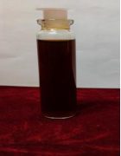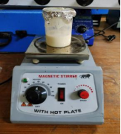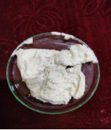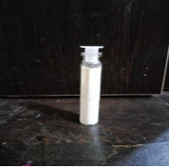
(i) (ii) (iii) (iv) (v)
(Fig 1) (i) Aegle marmelos leaves extract. (ii) stirring at hot plate (iii) After centrifugation. (iv) transferred in petry dish. (v) ZnO powder.
III. Results and Discussions
A. UV-Visible Spectral Analysis
The ingestion spectra of ZnO NPs were recorded utilizing a twofold pillar UV-Vis Spectrophotometer Fig 2. The assimilation range for the example was kept in the scope of 200-800 nm. The retention greatest was gotten at 350 nm which affirms the amalgamation of ZnO nanoparticles. The band hole, energy was determined utilizing condition Eg = 1240/λeV and viewed as 3.54 for ZnO nanoparticles combined from utilizing Aegle marmelos leaves separate.
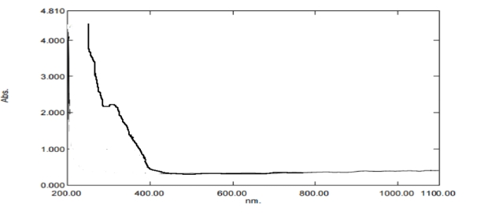
(Fig 2) UV-Vis spectrum of synthesized ZnO NPs
B. Fourier Transform Infrared (FT-IR) Spectroscopy
FT-IR Spectroscopy was utilized to recognize the synthetic bonds present in the blended NPs. An FT-IR Spectrometer working in the percent conveyance (%T) mode at a goal of 4000-400 cm-1 was utilized to get the IR range. The presence of ZnO NPs is demonstrated by the assimilation top at 460.99 cm-1 because of the extending vibrations of Zn-O. The other synthetic bonds present in the nanoparticle are portrayed in the chart Fig.3. The wide stretch of the ingestion band at 3319.49 cm-1 compares to the O-H extending of liquor or phenolics from the plant separately. The ingestion at 2922.16 cm-1 is ascribed to C-H extending from the aliphatic functional group from the phytochemicals. Different pinnacles are portrayed compared to the next functional groups present in the phytochemicals from the plant separate. The presence of unmistakable tops from the phytochemicals prompts the end that the phytochemicals effectively go about as covering specialists for the ZnO NPs. These phytochemicals associate with the outer layer of the NPs and help in their adjustment. Comparable outcomes have additionally been recently detailed where ZnO NPs have been orchestrated utilizing Solanum torvum L. (14) and Bauhinia tomentosa (9) leaf extracts.
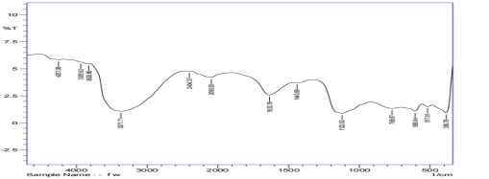
( Fig 3) FT-IR Spectra of synthesized ZnO NPs
C. X-Ray Diffraction (XRD) Analysis
XRD range of the orchestrated NPs was gotten for 2θ qualities going from 20-90˚ utilizing an X-Ray Diffractometer at λ=1.5406 A˚. The unmistakable pinnacles were seen at 2θ qualities with cross-section planes at 32.714o (100), 34.491˚(002), 35.85˚(101), 45.61˚(102), 59.57˚(110), 62.78˚(103), 68.77˚(112), 69.89˚(201)Fig.4.The sharp diffraction tops got show a decent level of crystallinity of the NPs. The shortfall of other conspicuous diffraction tops other than those credited to those of the NPs demonstrates the great level of virtue of the orchestrated ZnO NPs (15). The crystallite size of the NPs was determined as 27.43 nm which was gotten utilizing the Debye-Scherrer formula.
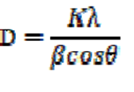
where k is a consistent equivalent to 0.90, λ is the frequency of the occurrence of X-beam, β is the FWHM in radians, D is the crystallite size and θ is the Bragg's point in radians. As per past writing, a crystallite size of under 100 nm produces expanded diffraction tops on account of NPs since such particles have extremely less equal diffraction planes. Top widening is a typical peculiarity in little crystallite-sized NPs and this crystallite size determined is the proportion of the littlest exact locales or reasonably diffracting spaces present in the singular gem. Molecule size is the absolute size of the molecule including every one of the precious stones (16).

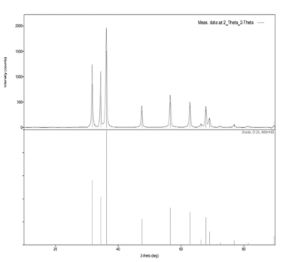
(Fig 4) XRD Spectrum of synthesized ZnO NPs
D. Antibacterial activity
The antibacterial activity of synthesized zinc oxide nanoparticles against pathogenic microbes was shown in Table 1. The zone of inhibition increases with concentrations of 25, 50, and 100 µg/ml. The highest zone of inhibition was observed at 100 µg/ml with Escherichia coli, and Staphylococcus aureus.

Table 1: Zone of inhibition (mm) at different concentrations of ZnO nanoparticles

Sr. No. | Name of bacterial species | 25 µg/ml | 50 µg/ml | 100 µg/ml | Control 10 µg/ml
1 | Staphylococcus aureus | 3 mm | 5 mm | 8 mm | 9 mm
2 | Escherichia coli | 2 mm | 4 mm | 7 mm | 10 mm

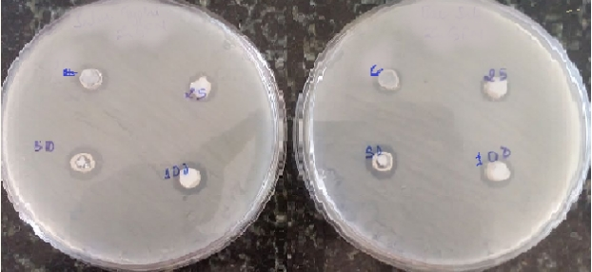
(Fig 5) Antibacterial activity of ZnO nanoparticles.
E. Scanning Electron Microscope (SEM) analysis
The outer morphology of the blended NPs was analyzed utilizing SEM. The SEM picture Fig 5 uncovered that a large portion of the blended NPs were spherical. the NPs cooperate with one another through Van der Waals communications which makes them come somewhat near one another, prompting accumulation. This total of NPs likewise influences their security. A comparable collection impact has likewise been seen in past writing where ZnO NPs have been blended utilizing Cardiospermum halicacabum leaf extracts (17).
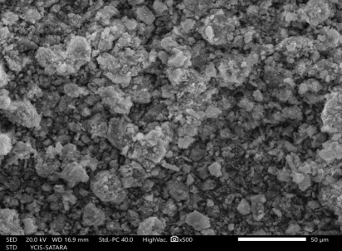
(Fig 6) SEM image of the synthesized ZnO NPs
IV. Coclusion
The biosynthesis of zinc oxide nanoparticles utilizing leaf extract of Aegle marmelos ends up being a practical and eco-accommodating strategy for the blend of nanoparticles. The blended zinc oxide nanoparticles were portrayed utilizing UV-Vis Spectrophotometer, FT-IR, XRD, and SEM. SEM examination showed that the nanoparticles are spherical. FT-IR examination shows that the peak at 460.99 cm-1 is the trademark retention of the zinc oxide (Zn-O) bond which confirms the development of zinc oxide nanoparticles. XRD examination confirms the development of nanoparticles with a crystallite size of 27.43nm and in the hexagonal wurtzite stage which is the structure with the most elevated steadiness of zinc oxide at surrounding conditions. The counter-bacterial property of the orchestrated nanoparticles against Escherichia coli and Staphylococcus aureus. The nanoparticles blended utilizing this technique are supposed to have greater applications in bioremediation, catalysis, drug conveyance frameworks, and other clinical fields.
Acknowledgments
The creator might want to thank the Public authority Vidharbh Organization of Science and Humanities, Amravati. for giving the contraption and lab to do the examination work.
References
[1] F.J. Heiligtag, M. Niederberger, The fascinating world of nanoparticle research, Mater. Today. 16 (2013) 262–271. doi:https://doi.org/10.1016/j.mattod.2013.07.004.
[2] I. Khan, K. Saeed, I. Khan, Nanoparticles : Properties , applications and toxicities, Arab. J. Chem. (2017). doi:10.1016/j.arabjc.2017.05.011.
[3] O. V Salata, Applications of nanoparticles in biology and medicine, J. Nanobiotechnology. 2 (2004) 3. doi:10.1186/1477-3155-2-3.
[4] S. Hasan, A Review on Nanoparticles : Their Synthesis and Types, Res. J. Recent Sci. Res . J . Recent . Sci . Uttar Pradesh ( Lucknow Campus ). 4 (2014) 1–3.
doi:10.3233/978-1-61499-057-4-57.
[5] N. Matinise, X.G. Fuku, K. Kaviyarasu, N. Mayedwa, M. Maaza, ZnO nanoparticles via Moringa oleifera green synthesis: Physical properties & mechanism of formation, Appl. Surf. Sci. 406 (2017) 339–347. doi:https://doi.org/10.1016/j.apsusc.2017.01.219.
[6] M.A. Chougule, S. Sen, V.B. Patil, Facile and efficient route for preparation of polypyrrole-ZnO nanocomposites: Microstructural, optical, and charge transport
properties, J. Appl. Polym. Sci. 125 (2012) E541–E547. doi:10.1002/app.36475.
[7] A. Hatamie, A. Khan, M. Golabi, A.P.F. Turner, V. Beni, W.C. Mak, A. Sadollahkhani, H. Alnoor, B. Zargar, S. Bano, O. Nur, M. Willander, Zinc Oxide NanostructureModified Textile and Its Application to Biosensing, Photocatalysis, and as Antibacterial Material, Langmuir. 31 (2015) 10913–10921. doi:10.1021/acs.langmuir.5b02341.
[8] B.A. Çakır, L. Budama, Ö. Topel, N. Hoda, Synthesis of ZnO nanoparticles using PS-bPAA reverse micelle cores for UV protective, self-cleaning and antibacterial textile applications, Colloids Surfaces A Physicochem. Eng. Asp. 414 (2012) 132–139. doi:https://doi.org/10.1016/j.colsurfa.2012.08.015.
[9] G. Sharmila, C. Muthukumaran, K. Sandiya, S. Santhiya, R.S. Pradeep, N.M. Kumar, N. Suriyanarayanan, M. Thirumarimurugan, Biosynthesis, characterization, and antibacterial activity of zinc oxide nanoparticles derived from Bauhinia tomentosa leaf extract, J. 17 Nanostructure Chem. 8 (2018) 293–299. doi:10.1007/s40097-018-0271-8.
[10] M. Ramesh, M. Anbuvannan, G. Viruthagiri, Green synthesis of ZnO nanoparticles using Solanum nigrum leaf extract and their antibacterial activity, Spectrochim. Acta Part A Mol. Biomol. Spectrosc. 136 (2015) 864–870. doi:https://doi.org/10.1016/j.saa.2014.09.105. [20] A. B. Djurišić, X. Chen, Y. Leung, A.M.C. Ng, ZnO nanostructures: Growth, properties and applications, 2012. doi:10.1039/C2JM15548F.
[11] A. B. Djurišić, X. Chen, Y. Leung, A.M.C. Ng, ZnO nanostructures: Growth, properties and applications, 2012. doi:10.1039/C2JM15548F.
[12] A. Król, P. Pomastowski, K. Rafińska, V. Railean-Plugaru, B. Buszewski, Zinc oxide nanoparticles: Synthesis, antiseptic activity and toxicity mechanism, Adv. Colloid Interface Sci. 249 (2017) 37–52. doi:https://doi.org/10.1016/j.cis.2017.07.033.
[13] S.S. Kumar, P. Venkateswarlu, V.R. Rao, G.N. Rao, Synthesis, characterization and optical properties of zinc oxide nanoparticles, Int. Nano Lett. 3 (2013) 30.
doi:10.1186/2228-5326-3-30.
- K.M. Ezealisiji, X. Siwe-Noundou, B. Maduelosi, N. Nwachukwu, R.W.M. Krause, Green synthesis of zinc oxide nanoparticles using Solanum torvum (L) leaf extract and evaluation of the toxicological profile of the ZnO nanoparticles–hydrogel composite in Wistar albino rats, Int. Nano Lett. 9 (2019) 99–107. doi:10.1007/s40089-018-0263-1.
- [15] S. Hajiashrafi, N. Motakef-Kazemi, Green synthesis of zinc oxide nanoparticles using parsley extract, Nanomedicine Res. J. 3 (2018) 44–50. doi:10.22034/nmrj.2018.01.007.
[16] E. PURUSHOTHAM, N.G. KRISHNA, X-ray determination of crystallite size and effect of lattice strain on Debye–Waller factors of platinum nano powders, Bull. Mater. Sci. 36 (2013) 973–976. doi:10.1007/s12034-013-0553-1.
[17] K. Nithya, S. Kalyanasundharam, Effect of chemically synthesis compared to biosynthesized ZnO nanoparticles using aqueous extract of C. halicacabum and their
antibacterial activity, OpenNano. 4 (2019) 100024.

