Measuring Volatility of Indian Stock Market by using GARCH Models.
Dr. Priyanka Ghosh
Assistant Professor
Kristu Jayanti College (Autonomous)
Orchid id: 0009-0002-5161-6027
Email id: priyanka.g@kristujayanti.com

ABSTRACT
This paper has examined the volatility of Indian Stock Market by using various ARCH & GARCH models. The researchers have considered more than 10 years data to measure the volatility. The researcher has considered monthly closing price of BSE-Sensex to measure the volatility in belief that it will represent the volatility of Indian Stock Market. The data analysis has been done with help of E-Views Software. An ADF test has been conducted to find out the stationarity of the data. The considered time period had experienced with various incidents like Covid-19 Pandemic, Russia-Ukraine War etc. However, the shocks from the news have taken time to normalize in the stock market. Under ARCH model the volatility of BSE Sensex estimated at 0.081162. The sizes of the parameter α and β will ascertain the volatility in the time series. The results of co-efficient indicates that the news in the stock market will remain insistent in future periods.
Keywords: Volatility, Stock Market, Augmented Dickey Fuller Test, Monthly Returns, ARCH and GARCH Models.
- INTRODUCTION
Stock Market, the backbone of any countries economy is also experiencing volatility. Volatility is the risk which is associated with stock market because of various reason. If the value of a security will change fiercely in any either directions will be known as elevated volatility. The investors in stock market are considering volatility to predict the price movements of share market. The financial institutions are using various measuring tools to quantify volatility in stock market.
Volatility always cite as the amount of uncertainty or risk which is related to the amount of changes in the value of security. The price of a stock with high volatility can move to either direction with shorter period of time. Whereas the price of the stock with less or minimum volatility does not change greatly and it aims to be more steady. Volatility of an asset can be measured based on historical prices as well as historical returns. On the other way, volatility can also be measured for the shorter time period with the help of mean returns of an asset. The Autoregressive Conditional Heteroscedasticity, mostly known as ARCH model was initiated by Engel in 1982 is the most popular tool to estimate the volatility. Usually, Volatility can be calculated with the help of variance and standard deviation as:
V = σ√T
Where,
V= Volatilty
σ = Standard Deviations of returns of a specific stock
T= No. of Time periods considered
The previous research states that volatility will be at higher level if the market trend is downward, whereas volatility level will be lower if the market trend is upward which is name as asymmetric volatility. According to Daly (2011), the fluctuations may affect the investment decisions, consumption pattern of investors and also the variables related to macro-economy of a country. The return on stock market has certain characteristics which are (i) each and every security in the market is belonging to a volatility cluster and the volatility will change to a certain level in either way, (ii) volatility in stock market is continuous, (iii) volatility will move within certain range in either way, (iv) volatility will change in accordance with price changes of the security which is also known as leverage effect.
A. An Overview of Indian Stock Market:
There are two stock exchanges in India: Bombay Stock Exchange and National Stock Exchange. The first and largest stock market in India is Bombay Stock Exchange which was established in1875 by Native Share and Stock Broker’s Association. More than 6000 scripts are being listed in BSE which made BSE one of the largest stock exchanges worldwide. As Asia’s first stock exchange BSE has introduced a trading platform for small and medium enterprise equities. BSE is providing various capital market services including clearing the transactions, settlement of trading etc. India’s largest financial market the National Stock Exchange was incorporated in 1992. The NSE had electronic financial market which is holding 4th rank worldwide in terms of equity trading volume. The NSE had launched two branches as wholesale debt market and cash market. Presently NSE allows trading not only in wholesale debt, equity and derivative markets but foreign investors can also invest in exchange through Exchange Traded Funds (ETF). As on August, 2022, the total market capitalization of NSE is US$ 3.4 trillion. In NSE 50 scripts are being listed which are all covered 12 sectors in Indian economy. The NSE is one of the premier stock market where companies can list their stocks and the advance system of NSE also promotes the transparency and settlement process in trading of stocks.
- REVIEW OF LITERATURE
Table 1: Various Literature Review on Generalized Auto Regressive Conditional Heteroskedasticity (GARCH) and its outcomes:
Researchers | Considered Data | Applied Models | Research Results
Bekaert and Wu | Daily Stock Return | ARCH, GARCH | ARCH and GARCH Model are efficient in estimating the volatility but it is not successfully assessing the leverage effect in market
Alberg et al. | Daily Returns of Stocks in Tel Aviv Stock Exchange in Israel (TASE) from October, 1992 to May, 2005. | GARCH, EGARCH, APGARCH | Investors can use GARCH model for effective estimation and also EGARCH model is more efficient in predicting volatility as compared to other models.
Bora & Adhikary | Historical Prices of Nifty from 2015-2019 | GARCH, EGARCH, TGARCH | GARCH, EGARCH, TGARCH Models have predicted volatility of Nifty effectively.
Olowe | Daily returns of stocks from January, 2004 to March, 2009. | EGARCH-in-Mean Model | The researchers had considered Nigerian Stock Exchange to predict volatility. The study found that there is a relation between stock return and volatility.
Gizard & Omran | 79 companies listed in Cairo and Alexandria Stock Exchange | GARCH Model | The considered information’s have very less effect on stock volatility. The researchers also suspected speculations in market during their study.
Neokosmidis | Dow Jones, Nasdaq, NYSE, S&P 500 from March, 2003 to March, 2009 | ARCH, GARCH (1,1), EGARCH | EGARCH Model has effectively predicted the volatility of the stock market. It also being estimated that high volatility can be experienced in future time period after the estimation period.
Tripathy & Alana | Daily NSE index returns considering Open, High, Low, Close (OHLC) values | EWMA, GARCH Model, Volatility Index (VIX), Extreme Value Model | GARCH Model and VIX model has given best result. Whereas Extreme Value Model failed to deliver result because of limited data.
Fama | Daily Stock Returns | Time Series | Time Series had been used to estimate the volatility of stock.
Engle | Daily Stock Returns | ARCH, GARCH | Initiated the Autoregressive Conditional Heteroscedasticity Model to calculate volatility. Estimated the volatility level of stock market by using ARCH and GARCH Model.
Nelson | Daily Stock Returns | GARCH, EGARCH | Applied expansions of GARCH Model to estimate the leverage effect. Used EGARCH Model to estimate the conditional volatility based on logarithm in the stock market.
Zakoian | Daily Stock Returns | GARCH, TGARCH | Developed a new concept of GARCH Model known as Threshold GARCH Model. This model is more efficient in estimating volatility.
Joshi | Daily Closing prices of Stocks from January, 2005 to May, 2009 | ARCH-LM, GARCH (1,1), Non Linear Test-BDS Test | Estimating more volatility in Indian Stock Market.
Chang et al. | Taiwan Stock Exchange, S&P 500, Nasdaq from January, 2000 to January, 2004 | Glosten-Jagannathan-Runkle GARCH (GJR-GARCH)(1,1) | There is a significant volatility has been observed in Taiwan Stock Exchange, US Spot Index, US Index Future.
Srinivasan P | Closing value of Sensex from 1st January, 1996 to 29th January, 2010 | GARCH | Symmetric GARCH Model will forecast volatility more efficiently than Asymmetric GARCH
Chen | New York, London, Tokyo, Hong Kong, Shanghai Stock Exchange | VAR, VEC, GARCH, Granger Casualty Test | These considered stock market has periodic breakdown which has created investment opportunity for the investors.
Rao | Daily Stock Returns from February, 2003 to January, 2006 of Arabian Gulf Cooperation Council Equity Market | MGARCH, VAR | Significant volatility is existing in these stock market.
Young et al. | Daily Returns of Japanese Stock Exchange from 1994 to 2007 | Multi-variate GARCH Model (BEKK-GARCH) | The abrupt news in the Japanese currency market had created volatility in the Japanese Stock Market which has effected most of the industries.

- RESEARCH METHODOLOGY
- Objectives of the Study:
- Estimation of existence of volatility in Indian Stock Market with the help of GARCH Model.
- Limitations of the Study:
- The study based on 10 years data of BSE Sensex.
- The study does not consider the intraday volatility.
- Theoretical Modelling of Volatility:
There are several models which are being used for ascertaining volatility like Autoregressive Conditional Heteroscedastic (ARCH) model developed by Engel in 1982, the Generalized ARCH model introduced by Bollerslev in 1986, the Integrated GARCH (1990) and the Exponential GARCH model coined by Nelson (1991), Threshold ARCH (TARCH) model, Simple Asymmetric ARCH model (1990) Non-linear ARCH model etc.
- Data Source:
This present research work is based on Monthly Closing Price of BSE-Sensex from January, 2012 to November, 2022. The entire data has been collected from the Website of Bombay Stock Exchange which is Secondary in Nature. The researcher has considered BSE-Sensex to measure the volatility in belief that it will represent the volatility of Indian Stock Market.
- Analytical Tools:
Augmented Dickey Fuller (ADF) Test, The Autoregressive Conditionally Heteroscedastic Model (ARCH) and GARCH Family Models have been applied to measure the volatility of considered data. The analysis data has been done with the help of E-Views software.
Volatility is being estimated based on Monthly Closing Price of BSE-Sensex.
- Hypothesis:
H₀= The considered data does not have stationarity.
H_{a}: The considered data does have stationarity.
- Stationarity Test:
To examine the stationarity of the data, unit root test has been carried out on the considered data. The Augmented Dickey Fuller Test has been performed on the considered data.
- Tools to measure Volatility:
To estimate the volatility in Indian Stock ARCH and GARCH Model has been used.
The Autoregressive Conditionally Heteroscedastic Model is another model for the variance of time series. It is being widely used to forecast the possible changes along with volatility. This model is being used to describe the variance over a period but most of the time the ARCH model has been used to quantify the volatility during the shorter time span where variations are more.
The Model ARCH has been developed in the context of solving economic and finance problems. This model has been developed to quantify the variation/changes in the price of the assets/stocks/investments. The ARCH model can be used for any time series where the variations are existing.
- The Model of Volatility:
r_{t}=E(rt/ψt−1)+εt; εt~N(0,σ2t)……………………..(1)
Where εt is return on stock market and ψt is the set of information for a specific time period.
The equation 1 can be written as:
r_{t}=μ_{t}+ε_{t} …………………………………………....(2)
Where μ_{t} = E(rt/ψt−1) is the conditional mean of the data, rt is the information for the timeline t-1.
- Symmetric GARCH Model:
In this model the conditional variances depend on underlying assets. The most popular Symmetric GARCH models include Generalized Autoregressive Conditional Heteroscedasticity and Generalized Autoregressive Conditional Heteroscedasticity in mean.
- The GARCH Model:
The GARCH model is the basic Symmetric model which has been developed by Bollerslev. The model is considering conditional lag periods along with past squared residual which has been framed as:
σ₌α₀₊Ʃα_{i}є²…………………………………………(3)
Where α₀ is the constant term, α₁, α₂,…,α_{q} are known as the parameters or coefficient of ARCH model and β₁, β₂,…… β_{p} are known as the parameters or coefficients of GARCH model.
Again, q, p = These are known as the respective orders of ARCH and GARCH model.
- GARCH-in-Mean (GARCH-M) Models:
The GARCH-Mean model is another symmetric model which has been developed by Engle et. Al in 1987. According to the researchers, in every financial market volatility is expected and the return of any security may depend on its volatility. The researchers also concluded that many of the time the volatility or risk of any security may be atoned by high return on the stock.
- Asymmetric GARCH Model:
Engle and Ng (1993) had coined the model Asymmetric GARCH Model. According to the researchers the volatility of financial markets mainly depends on favorable and unfavorable news which will be having great impact on the security market. A leverage effect also can be experienced in any financial market. Leverage effect arises when the volatility of a stock will decrease as the return on the stock increases and vice-a-versa.
- Exponential GARCH (EGARCH) Model:
The Exponential GARCH Model has been coined by Nelson in 1991. This model is being designed to concede asymmetric effect between positive and negative stock return.
- Simple Asymmetric ARCH Model:
The Simple Asymmetric ARCH Model has been developed by Granger Engel in 1990 which is extension of EGARCH, TGARCH, and GJR-TGARCH model. These models are helping inn ascertaining the asymmetric volatility process which is known as “Leverage Effects”. These models are also explaining the relationship between volatility and return.

- DATA ANALYSIS
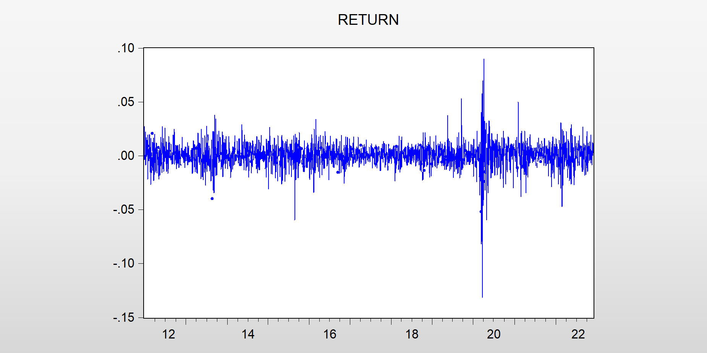
Fig 1: Return of BSE-Sensex
The above chart is showing the daily return of BSE-Sensex. The daily return series of BSE-Sensex has been stable with an average return of almost zero. The data also shows that the volatility of the considered data has also changed over time.
The test for stationarity has been carried out and the below showed that the Probability value of ADF are less than 0.05. It means that the index return series during the considered period are stationary. Hence, the null hypothesis has been rejected.
Table 2: Unit Root Test:
Value | ADF
t-statistics | 53.8264
Probability | 0.000215
Critical Value
1% | 3.4320
5% | -2.862176
10% | -2.567152
The above table is showing the result of Unit Root test using ADF of the considered data. The above table shows that the probability value of ADF is lesser than 0.05 which concludes that the considered data of the time series for the entire study period is stationary. The ADF in above table reported the critical value at 1% confidence level is 3.4320 which resulted the presence of unit root in the data and hence the null hypothesis has been rejected.

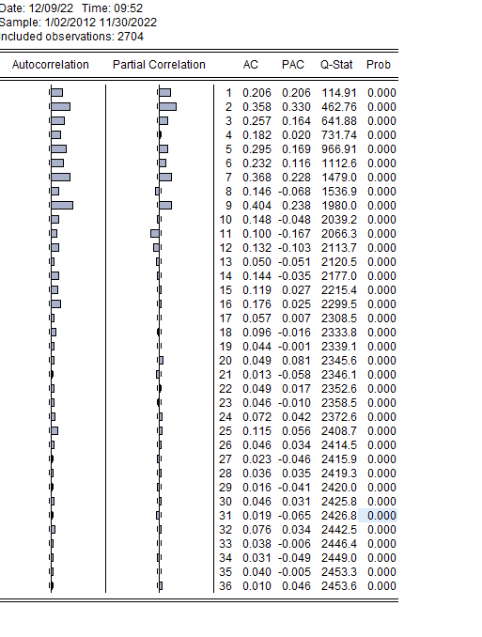
Fig 3: Autocorrelation & Partial Correlation
After confirming the volatility cluster with the considered data and stationarity with the help of ADF, the research mainly focusing on determining the volatility rate of Indian Stock Market. During the study the researcher al so tried to find out best fitted ARCH and GARCH Model.
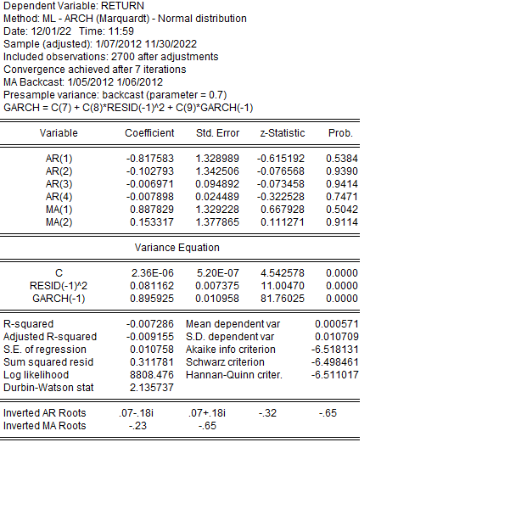

Fig 4: Results of ARCH Models

The above table is showing the estimated value of volatility under ARCH model. The larger value of β proves that the market has reacted according with the types of news. The data has been considered from January, 2012 to November, 2022. This time period had experienced with various incidents like Covid-19 Pandemic, Russia-Ukraine War etc. However, the shocks from the news has taken time to normalize in the stock market. Under ARCH model the volatility of BSE Sensex estimated at 0.081162.
On the other way the coefficient represents the impact of past news on the Stock Market. The above also shows the result of Z test of the considered data. The table resulted that ARCH Model (4) is ascertaining the volatility in Indian Stock Market more efficiently. The analysis resembles that the volatility in the market is more sensitive. It also resulted that the volatility is more incessant. The sizes of the parameter α and β will ascertain the volatility in the time series. The results of co-efficient indicates that the news in the stock market will remain insistent in future periods.
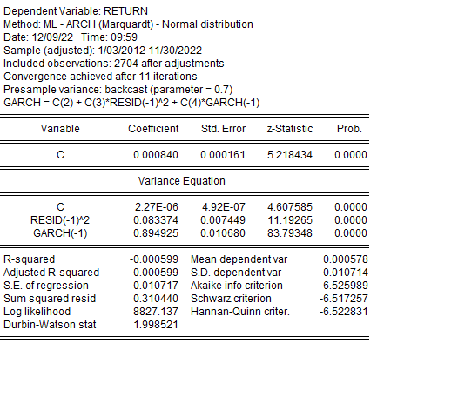
Fig 5: Result of GARCH Model

The above table is showing the estimated value of volatility under GARCH Model. The GARCH (1,1) Model is helping in estimating volatility in stock market. the above table shows that the co-efficient value of the considered data is positive which indicates that volatility do exist in stock market and the stock market reacts according to the variety of news.
- SCOPE FOR THE FURTHER STUDY
The main objective of the study is to measuring the volatility in Indian Stock Market and to explore whether any asymmetric volatility do exist in its return or not. The researcher also tried to find out the asymmetric volatility in Indian Stock market as well as the relationship between the risk and return. The main limitation of this study is the researcher did not consider intraday volatility for the research. The present study is mainly focusing on measuring the volatility; hence a study can also be conducted in future on comparing the volatility of Indian Stock Market with other stock exchanges of developing as well as developed countries.
- CONCLUSION
The main objective of this study is to measure the volatility in BSE Sensex with the help of ARCH and GARCH Model. The data is secondary in nature and it has been collected from BSE website. For this study the data has been considered for 10 years 11 months from January, 2012 to November, 2022. The researcher has considered monthly closing price of BSE Sensex to measure the volatility. The ARCH and GARCH model have been applied after conducting ADF test of unit root. The ADF test has resulted that the considered data has stationarity. The considered time period had experienced with various incidents like Covid-19 Pandemic, Russia-Ukraine War etc. However, the shocks from the news have taken time to normalize in the stock market. Under ARCH model the volatility of BSE Sensex estimated at 0.081162. The sizes of the parameter α and β will ascertain the volatility in the time series. The results of co-efficient indicates that the news in the stock market will remain insistent in future periods.
REFERENCES
[1] Adhikary, B. B. (2019). Indian Stock Market Volatility using GARCH Models: A Case Study of NSE. Seventeenth AIMS International Conference on Management, (pp. 1501-1506).
[2] Engle, R. (1982). Utoregressive Conditional Heteroscedasticity with Estimates of the Variance of United Kingdom Inflation. Econometrica, 50, 987-1007.
[3] Sujata, K. a. (2018). Modelling Stock Return Volatility in India. Munich Personal RePEc Archive, 1-21.
[4] Srinivasan, P. (2010). Forecasting Stock Market Volatility of Bse-30 Index Using Garch Models. Asia-Pacific Journal of Management Research and Innovation, 6(3), 47-60.
[5] Dima Alberg, H. S. (2008). Estimating stock market volatility using asymmetric GARCH Models. Applied Financial Economics, 1201-1208.
[6] Fama, E. F. (1970). Efficient Capital Markets: A Review of Theory and Empirical Work. The Journal of Finance, 383-417.
[7] Geert Bekaert, G. W. (January, 2000). Asymmetric Volatility and Risk in Equity Markets. The Review of Financial Studies, 1-42.
[8] Joshi, P. (2011). Return and Volatility Spillovers Among Asian Stock Markets. SAGE Journals.
[9] Modelling Stock Return Volatility in India. (2018). Munich Personal RePEc Archive, 1-21.
[10] Neokosmidis, I. (2009). Econometric Analysis of realized Volatility: Evidence of Financial Crisis.
[11] Olowe, R. A. (2009). Stock Return, Volatility & the Global Financial Crisis in an Emerging Market: The Nigerian Case. International Review of Business Research Papers, 426-447.
[12] Trilochan Tripathy, L. A.-A. (2010). Suitability of Volatility Models for Forecasting Stock Market Returns: A Study on the Indian National Stock Exchange. American Journal of Applied Sciences, 1487-1494.
[13] Weixian Cai, J. C. (2015). Forecasting Chinese Stock Market Volatility With Economic Variables. Emerging Markets Finance and Trade.

