Soil quality and Agroforestry

Varsha Pandey
Assistant Professor, Department of Soil Science
School of Agricultural Sciences, GD Goenka University, Sohna Road, Gurugram - 122103, Haryana, India
Rini Labanya
Faculty of Agriculture,
Sri Sri University, Cuttack - 754006,
Odisha, India

varshapandey.p93@gmail.com

ABSTRACT
Soil is a dynamic natural body and forms the basis of agricultural and natural plant communities. It performs multiple functions and soil quality is defined as the "capacity of the soil to function". Soil quality can be viewed in two ways as inherent properties of a soil and as the dynamic nature of soils as influenced by climate, human use, management, and land use systems. Agroforestry refers to a land use system where woody perennial are integrated with the agricultural crops and animal farming to create multiple benefits from all. There are economical, ecological, and biological interactions among the different components of agroforestry. Among the multiple benefits of agroforestry system, one of them is positive impact on the soil quality. Agroforestry practices improves soil aggregation and infiltration rate, increases soil organic carbon level, available nutrients status in soil and enhances soil biodiversity. The higher contribution of biomass through above and belowground inputs adds carbon and nutrients to the soil following the processes of decomposition and mineralization. Moreover, the increase in the litter layer from the trees, shrubs and palms, etc. protects the soil surface from erosion, which prevents loss of soil nutrients and fertility. Trees also act as a wind break and shelter belts, providing physical barrier to the wind flow. Therefore, agroforestry-based land use systems add significantly to soil quality and improve production and ecological stability, contributing towards sustainable agriculture and environmental protection.
.

Keywords—soil quality; agroforestry.

INTRODUCTION

Soil, a part of land, is a dynamic natural body developed because of pedogenic processes through weathering of rocks, consisting of mineral and organic constituents, possessing definite chemical, physical, minerological and biological properties, having a variable depth over the surface of the earth, and providing a medium for plant growth [1]. According to the FAO, “Soil is a natural body consisting of layers (soil horizons) that are composed of weathered minerals, organic matter, air and water and provides a natural medium for growth of plants”. Soil microbiologists define soil as a polis i.e., society or community which is governed by soil microorganisms.
Soil is considered the most important production factor for crops as it acts as a reservoir of water and nutrients and therefore provides support to plants. The mineral particles in the soil contain nutrients which are released slowly for plant uptake; organic matter and humus content in soil vary and results from the decomposition of biomass and pore spaces between the soil particles is filled with air or water. Besides providing a physical medium for plant growth, soil is considered a living system which is vital for production of food and fibre for human needs and for maintaining the ecosystem services on which life depends. Due to interaction of physical, chemical, biological and anthropogenic processes that operate with different intensities in soil, soils are characterised by high degree of variability [2]. These properties in turn influences the nature and properties of soil.
Soil is known as the soul of infinite life because of multiple functions it performs. The soil function describes what the soil does. These functions are termed as the ecosystem services which are provided by soil resources. Soil is a major component in the ecosystem. The 7 key functions of soil integrate into one or more ecosystem services (Figure 1)
According to Seybold et al. (1998) [3] soil functions to
- Sustain plant, animal life and productivity.
- Cycle nutrients and carbon within the earth’s biosphere.
- Regulate and partition water and solute flow.
- Filter, buffer and detoxify organic and inorganic materials including municipal, industrial by-products and atmospheric deposition.
- Provide physical stability and support for plants or socioeconomic structures or protection for archaeological treasures associated with human habitation.

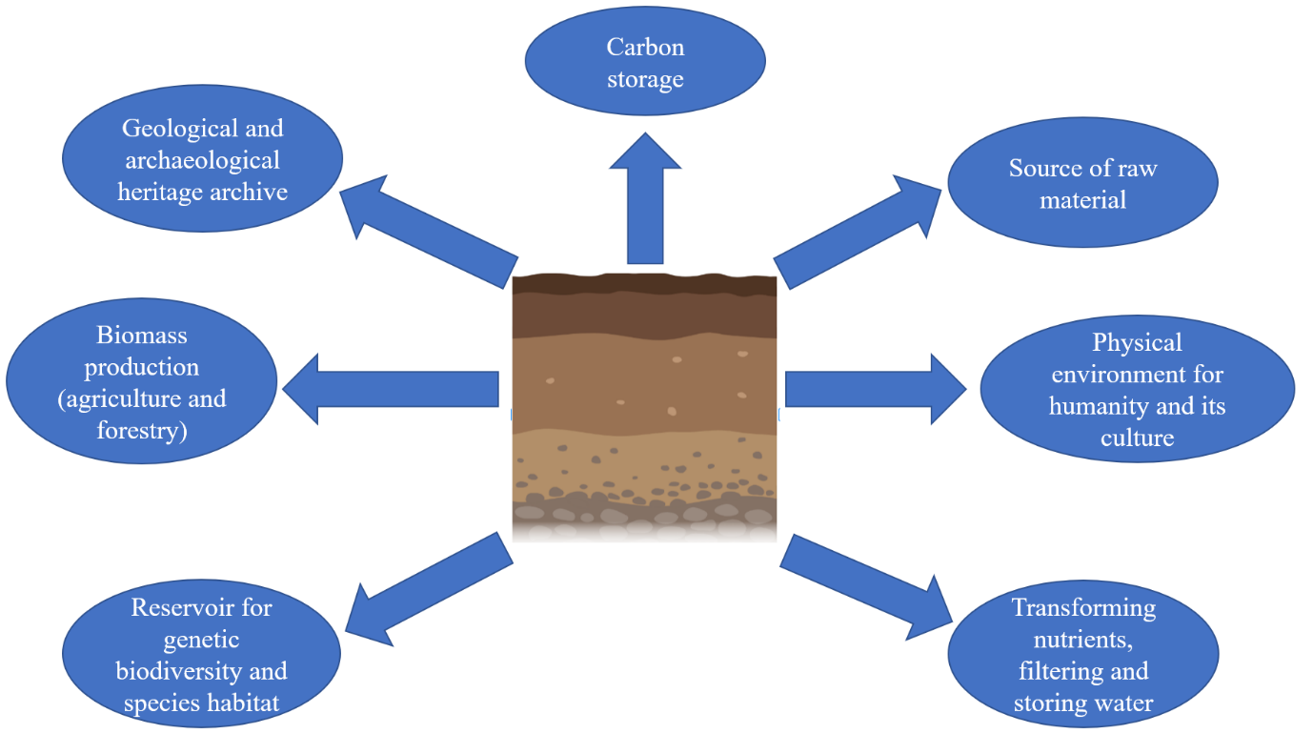
Figure 1: The 7 key functions of soil.
Soil is one of the key natural resources and its fertility is an integrated effect of management of several soil properties that determine crop productivity and sustainability. Soil fertility is related to the inherent ability of soil to supply nutrients in adequate amount and balanced proportion. Good and fertile soil not only produces better crop yield, but also maintains environmental quality and consequently plant, animal and human health. Unfortunately, with the advancement of agriculture, soil is being degraded at a very alarming rate by water and wind erosion, desertification, and salinization because of its misuse and adoption of improper farming practices. There is a considerable decline in soil fertility because of continuous growing of crops one after another without giving much consideration to the nutrient requirement of the crops grown. Therefore, there is a need to develop criteria to evaluate soil fertility and to take corrective measures to improve it. The ultimate purpose of evaluating soil fertility is not only to achieve high biological activity, aggregate stability or other soil properties but also to protect and improve long-term agricultural productivity, water health, and habitats of all the living organisms including people [4].

SOIL QUALITY

A. What is soil quality?

The concept of soil quality was introduced by Warkentin and Fletcher (1977) [5] in context with input allocation to increase the production of food and fiber. Many researchers have proposed several definitions for soil quality from the early 1990s. According to Karlen, Gardner and Rosek (1998) [6], soil quality is defined as the “ability of a specific kind of soil to function within its natural ecosystem boundaries to support plant and animal productivity, maintain or enhance water or air quality, and provide support to human health and habitation”. Soil quality is also defined by some scientists as the "fitness for use", and by others as the "capacity of the soil to function". In literature, there are many definitions of soil quality, and every definition focuses on soil functions.
Soil functions vary depending on the interest of the observer. For a land manager, it is the ability to enhance soil productivity and ultimately sustain crop yield. To a farmer, soil quality is viewed as soil health. For conservationists, it means to sustain soil resources and at the same time protecting the environment while for consumers, it is linked with production of healthy and at the same time inexpensive food products. For an environmentalist, it is the capacity of soil to maintain biodiversity, water quality and nutrient cycling [7]. With reference to national context, soil quality provides a foundation for national policy to protect our environment.
Soil health and soil quality are often used interchangeably in the scientific literature, term soil quality is preferred by scientists and soil health by producers [8]. USDA defines soil health as ‘‘the continued capacity of the soil to function as a vital living ecosystem that sustains plants, animals and humans’’. Soil health is a dynamic soil property that changes in short term, and it is considered as the state of soil at a particular time whereas soil quality is equivalent to intrinsic or static soil property and considered as the soil usefulness for a particular purpose over a long-time scale [9]. The concepts of soil quality and soil health are highly contentious within the soil science community. Soil quality is used in relation to soil functions, whereas soil health represents soil as a ﬁnite non-renewable and dynamic living resource. Soil quality considers those attributes of soil that may be inﬂuenced by management practices and have the capability to enhance or diminish the soil health.

B. Inherent and dynamic soil quality

Soil quality can be viewed in two ways as inherent properties of a soil and as the dynamic nature of soils as influenced by climate, human use and management [10]. A soil which is formed because of the factors of soil formation - climate, topography, vegetation, parent material, and time describes inherent properties of soil [11]. Each soil, therefore, has an innate capacity to function. In the National Cooperative Soil Survey Program, soil qualities are defined as inherent characteristics or properties of a soil, such as texture, slope, structure, and soil color [12]. The second view of soil quality relates to the dynamic nature of soils as influenced by human use and management. For example, organic matter and nutrients content of soil. This view of soil quality requires a reference condition for each kind of soil with which changes in soil condition are compared and is currently the focal point for the term "soil quality". (Figure 2).
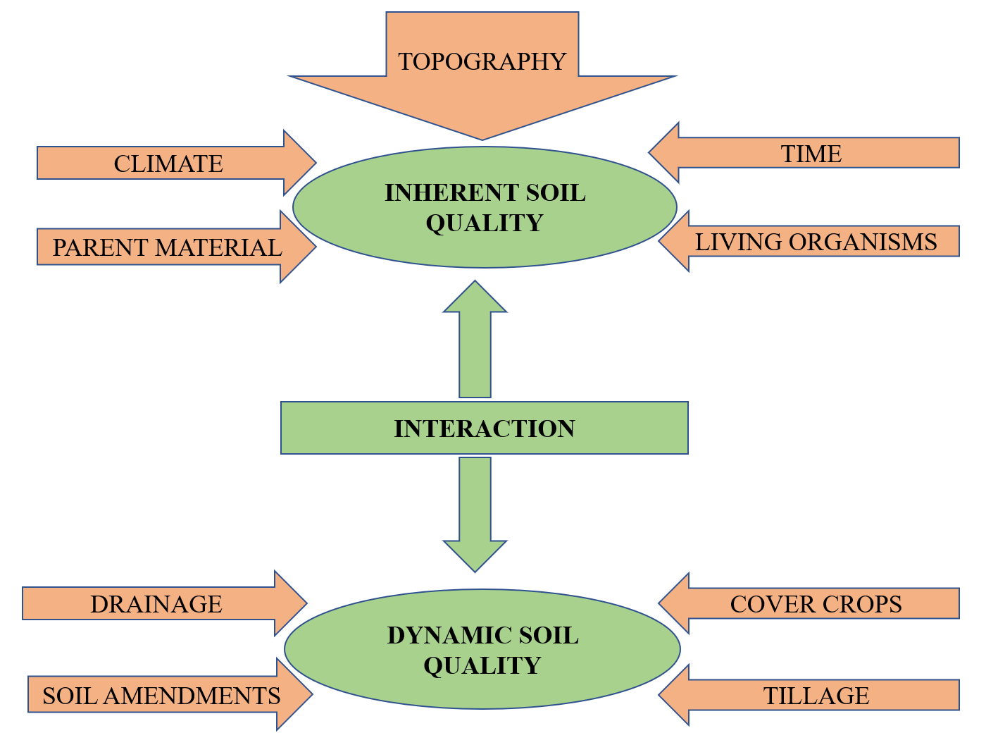
Figure 2: Inherent and dynamic features of soil quality.

C. Assessment of soil quality

We have already seen that soil quality is linked with soil functions. But these soil functions are difficult to quantify and cannot be measured directly or precisely. Thus, assessment of soil quality is done indirectly by assessing some soil quality indicators which are broad and flexible [13]. Soil chemical, physical and biological properties are essential to assess soil quality. For assessment of soil quality soil properties are usually linked to soil functions. A valid soil quality index would combine data from different soil properties and will show whether any land use or management practice would have the desired results for productivity, environmental protection, and health [14].
Thus, the capacity of soil to function can be measured by soil physical, chemical and biological properties known as soil quality indicators (SQIs). SQI is needed to be developed in such a way that they –
- Integrate physical, chemical and biological attributes of soil.
- Apply under diverse field conditions.
- Complement either existing databases or easily measurable data and
- Respond to land use management practices, climate, and human factors [15].
Selecting appropriate indicators is the foundation of soil health assessment (Table 1). The chosen soil quality indicators should be easy to measure and at the same time be able to show any type of problems that exist in the soil. In the field or under lab conditions, soil quality cannot be measured directly. Since, it is a complex functional concept, but it can be estimated with the help of soil parameters or indicators. A mathematical or statistical framework was put forward in early 1990s to estimate soil quality index (SQI). The status of soil and its quality is reflected by integrating soil quality indicators into a single index value based on the combination of several soil properties [16]. Conceptual linkages between soil quality indicators and critical functions are used to compute soil quality indices (Table 2).

Table 1: Some of the commonly used soil quality indicators
Physical attributes | Chemical attributes | Biological attributes
- Soil texture  - Bulk density  - Porosity  - Water holding capacity  - Soil structure (aggregate stability)  - Water holding capacity  - Soil depth  - Hydraulic conductivity  - Infilteration  - Penetration depth  - Penetration resistance | - Soil pH  - EC  - Organic carbon  - Available macronutrients and micronutrients  - CEC  - Labile C and N  - Total and available N  - Available P and K  - Sodicity and salinity  - Heavy metals | - Microbial biomass C and N  - Soil enzymatic activities  - Soil respiration  - Earthworms  - N– mineralisation
Source: Vasu et al. (2020) [17]

Table 2: Conceptual linkages between soil quality indicators and critical functions used to compute soil quality indices.
Soil functions | Soil quality indicators
Biological productivity | Texture, depth of soil
Regulating and partitioning water | Infiltration and bulk density, water-holding capacity, aggregate stability
Filtering and buffering | Soil organic matter, pH
Storing and cycling nutrients | Extractable N, P and K, microbial biomass C and N, potentially mineralizable N
Supporting socioeconomic structures | Structure, mineralogy.
Source: Karlen, Andrews and Doran (2001) [18]

Given below are the three common methods of computation of soil quality index [19] –

1. Simple additive SQI
It is estimated following the method given by Amacher, Neil and Perry (2007) [16]. In this approach, based on literature review, soil parameters are given threshold values. The individual index values are then summed up to obtain a total SQI [20].
$$\sum{ S}QI=\sum{Indiviual soil parameter index values}$$
SQI (%) = (total SQI / Maximum possible total SQI for properties measured) x 100

2. Weighted additive SQI
In this approach, soil parameters are first assigned unitless score ranging from 0 to 1 by employing linear scoring functions [21]. Soil parameters are then divided into groups based on three mathematical algorithm functions:
(a) ‘more is better’ (upper asymptotic sigmoid curve)
(b) ‘less is better’ (lower asymptotic sigmoid curve), and
(c) ‘optimum’ (Gaussian function) [22]
Various soil indicators are arranged in different order depending on whether higher or lower value of a parameter is desirable with respect to soil function. For “higher is better” category, such as organic carbon and available nutrients, each observation of the selected indicator is divided by the highest value so that the highest value would be scored as 1. For “less is better” category, such as bulk density, the lowest value is divided by each data value so as the lowest value received a score as 1. For ‘optimum’ parameters such as pH, are scored as “higher is better” up to a threshold value (e.g., pH 7.2) and then scored as “lower is better” above that threshold value [23].
The transformation of an indicator value to a score is achieved with the help of a scoring function (Table 3). The shape of the curve is decided by their critical values [24]. The critical values include lower threshold limit (LT), upper threshold limit (UT) and baseline (A) values. Upper threshold values are the level where soil property values score equals one or when the soil property is at an optimum level and lower threshold values is the level where soil property values score equals zero or when the soil is so much degraded that plant growth almost ceases. Baseline values are soil property values where the scoring function equals 0.50. It may not be the midpoint between the two threshold values [25]. The measured values of various soil parameters are then transformed to linear and non-linear scores based on linear or non-linear scoring functions. The numerical weights are assigned to each soil function based on their importance in fulfilling the major aim of maintaining soil quality [19].
Weighted soil quality index (WSQI) -

$$WSQI=\frac{1}{n} \sum_{i=1}^{n}{Wi*Si}$$

Where,
Wi = weight assigned to the i ^{th} indicator
Si = linear or non-linear score of the i ^{th} indicator
n = number of indicators included in the index [26].

Table 3: Scoring function of chosen soil quality indicators
Indicator | Scoring curve | Lower threshold (LT) | Upper threshold (UT) | Baseline (A) | Slope at baseline (b)
Bulk density (mg m⁻³) | Less is better | 1.20 | 2.10 | 1.45 | -8.00
Water holding capacity (%) | More is better | 40 | 80 | 60 | 0.350
Hydraulic conductivity (cm h⁻¹) | More is better | 0.25 | 1.0 | 0.625 | 10.5
Soil organic carbon (g kg⁻¹) | More is better | 0 | 12.9 | 6.40 | 0.75
Available N (mg kg⁻¹) | More is better | 0 | 178.5 | 89.2 | 0.04
Available P (mg kg⁻¹) | More is better | 11.16 | 44.64 | 27.9 | 0.425
DTPA Zn (mg kg⁻¹) | More is better | Rice – 0  Wheat- 0.2 | 1.5  6.9 | 0.75  0.9 | 4.00  1.25
DTPA Cu (mg kg⁻¹) | More is better | 0.150 | 0.533 | 1.70 | 4.00
MBC (mg kg⁻¹) | More is better | 75 | 700 | 300 | 0.033
DHA (ug TPF g⁻¹ h⁻¹) | More is better | 0 | 1.5 | 0.75 | 5.5
Soil respiration (ug CO₂ g⁻¹ h⁻¹) | More is better | 20 | 250 | 135 | 0.055
Metabolic quotient | Less is better | 0.16 | 1.42 | 0.79 | -7.5
Source: Bhaduri et al. (2014) [24]

3. Statistically modeled SQI
Principal component analysis (PCA) is a commonly used and widely accepted method for selection of MDS. In this method of SQI, a statistics-based model is used using principal component analysis (PCA). The basic idea of the PCA is to reduce the indicator load, without losing important information and minimum data set (MDS) is used to reduce the dimensionality of the data set [27]. Several minimum data sets of Soil Quality Index have been proposed. Initially, the selection of minimum datasets was based on expert opinion. Subsequently, statistical data reduction by multivariate techniques such as principal component analysis (PCA) was used [28]. The schematic diagram for the computation of SQI using PCA is given in Figure 3.
The transformed scores are then multiplied by the weightage factors and then finally added to derive SQI.
SQI (PCA) = Ʃ Weight × individual soil parameter score

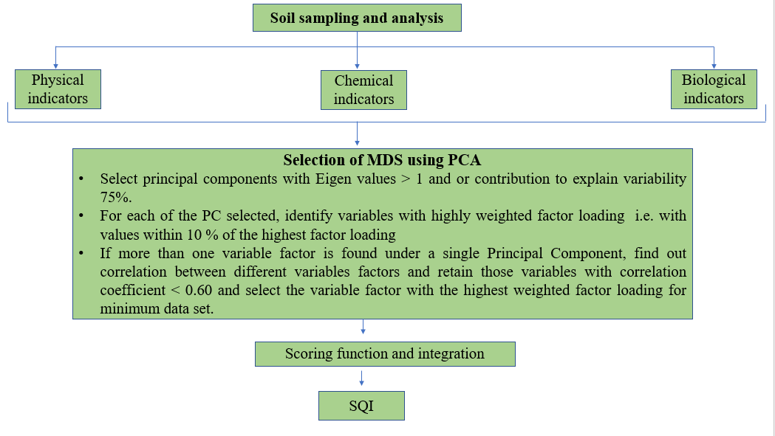
Fig. 3: Schematic diagram for calculation of Soil Quality Index using PCA.

Agroforestry

A. What is agroforestry?

Agroforestry is defined as a dynamic, ecologically based, natural resources management system that, through the integration of trees on farms and in the agricultural landscape, diversifies and sustains production for increased social, economic, and environmental benefits for land users at all levels [29]. It is a collective name for land use systems where woody perennials such as trees, shrubs or palms are used on the same land management unit as the agricultural crops and/ or animals in the form of spatial arrangement or temporal sequence. In agroforestry systems, there are both ecological and economical interactions between the different components and provide economic, sociocultural and environmental benefits. Particularly, agroforestry is crucial to the rural people and smallholder farmers as it is beneficial for food supply, income and health of people. Agroforestry based land use systems can contribute towards ecosystem functions of soil by the following ways [30]
- Maintain soil organic matter status and biological activity of soil.
- Improve nutrient cycling and nutrient use efficiency.
- Improve water use efficiency of soil.
- Restore degraded land and eroded land.
- Climate change mitigation through carbon sequestration.
- Improvement in air and water quality.
- Make use of marginal lands.
B. Role of agroforestry system in influencing soil quality

Forests contribute to formation of soil through physical, chemical, and biological weathering of parent rock and through addition of leaf litter and its subsequent decomposition. Thus, contributing towards soil fertility. The various processes by which trees can improve soil quality is broadly divided into four categories
- Increased input
- Reduction of losses
- Improvement in soil physical and chemical properties
- Improvement in biological properties of soil
These processes by which agroforestry-based systems improve soil quality have been listed in Table 4 and Figure 4.
Soil organic carbon is considered as the heart of the soil and is the source of carbon and energy for soil microbes. Therefore, influences soil biodiversity and associated soil biological functions. Incorporation of trees in different land use systems enhances the soil organic matter content by adding litter and living biomass in both above and belowground surface which improves soil fertility. In a soil-plant system, plant nutrients are in a continuous and dynamic transfer state. Nutrients in the soil are taken up by plants and used for various metabolic activities. These nutrients are then returned to the soil as litter falls naturally or as pruning or may be through root senescence. These different plant parts are decomposed by microbial activities and released into the soil, which are then available for plant uptake. Nutrient cycling has been defined as continuous transfer of nutrients that are already present within a soil-plant system such as farmer’s field [31]. Broadly, nutrient cycling involves continuous transfer of nutrients between different components of the ecosystem and involves various processes such as weathering of rocks, release of nutrients, activity of soil biota and nutrient transformation in the soil plant atmosphere continnum. Agroforestry based systems fall between the two “extremes” of nutrient cycling system. These “extremes” include “closed” nutrient cycling systems with relatively less or little loss or gain of actively cycling nutrients and high turnover rate of nutrients within the system like natural forest ecosystems representing a self-sustaining nutrient cycling system. The other extreme is “open” or “leaky” nutrient cycling system with high nutrients losses like agricultural systems [32]. Thus, Agroforestry based land use system plays major role in affecting soil fertility and overall soil quality.

Table 4: Processes by which agroforestry-based systems improve soil quality.
Increased input  - Carbon fixation via photosynthesis  - Adding to soil N by nitrogen fixation  - Nutrient uptake from deeper layers of soil  - Exudation of certain growth promoting substances by the root rhizosphere | Reduction of losses  - Protection of soil from erosion  - Recycling nutrients which would otherwise be lost by leaching.  - Reduction of rate of organic matter decomposition by shading effect.
Improvement in soil physical and  chemical properties  - Improvement in soil moisture retention capacity, soil structure, soil porosity, permeability, infiltration rate  - Roots break down compact layers of soil  - Litter cover by tree canopy provides shading effect and regulates extremes of soil temperature.  - Enhance organic matter content of soil, ultimately increasing available nutrients for plants.  - Extensive lateral root system of trees scavenges soil nutrients and redistribute them.  - Reduction of soil acidity, basicity or sodicity. | Improvement in biological properties  of soil  - Higher microbial enzymatic activity due above and below ground litter cover and root exudates.  - Higher amount of soil microbial biomass C, N and P due to addition of varying quantity of organic matter input through litter fall.  - Availability of carbonaceous materials and substrates by decomposing litter fall of trees such as amino acids, sugar or organic acids supply carbon and energy to soil microbes.  - Positive effect on soil fauna.

During the lifecycle of a tree, branches, leaves, and twigs fall as litter contributing to soil organic matter after its decomposition. Also, the tree biomass can be used as a mulch. This reduces the erosive effect of the rainfall on soil surface. Root system of trees also stabilize the soil surface, reducing impact of rain drop and decreasing the intensity of erosion. Litter cover also have an added advantage of suppressing the weed growth. Many trees of the genera Acacia, Calliandra, Mimosa, Dalbergia, Erythrina can fix atmospheric nitrogen through symbiotic relationship with bacteria and fungus. Some of the important nitrogen fixing plant species along with the amount of N₂ fixed is given in Table 5. These nitrogen fixing trees are the key constituents in many natural ecosystems in the world. Besides N-fixation, the litter from these trees adds nitrogen to the soil after decomposition of litter.
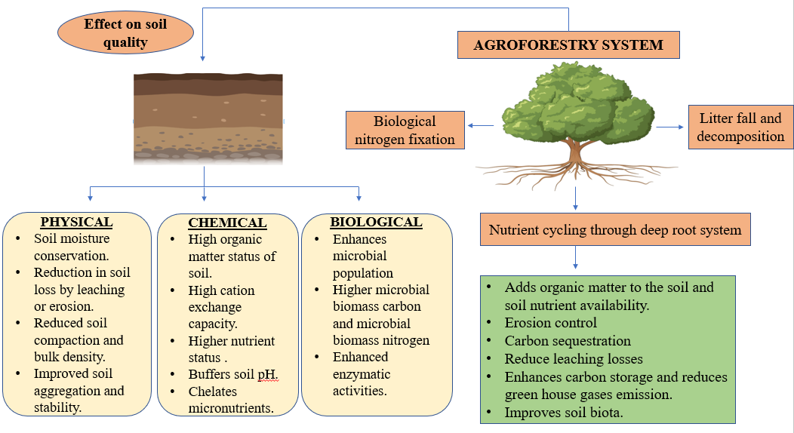Fig. 4: Effect of Agroforestry based systems on soil quality.
Agroforestry based land use systems can also help prevent land degradation and soil erosion while allowing the use of land to produce crops and livestock on a sustainable basis. Due to mismanagement of the natural resources, sustainability of these resources has been threatened. Trees play a great role in the conservation of these natural resources. The long root system of tree species binds the soil surface and controls soil erosion losses caused due to wind and water. The vegetation also acts as a barrier for soil erosion processes. It also improves soil moisture by retaining the rainfall in the field (Table 6).

Table 5: Important N₂ fixing plant species.
Plant | Botanical name | Family | Nitrogen fixed (kg N ha⁻¹yr⁻¹)
Black wattle | Acacia mearnsii | Mimosoideae | 200
Silver wattle | Acacia dealbata | Mimosoideae | 12-32
Gum Arabic tree | Acacia nilotica | Mimosoideae | 40-100
Beef wood, Saru | Casurina equisetifolia | Casuarinaceae | 60-110
Erythrina | Erythrina poeppigiana | Pipilionaceae | 60
Apple ring, Areca | Gliricidia sepium | Fabaceae | 13
Inga | Inga jincicuil | Mimosoideae | 34-50
Subabul | Leucaena leucocephala | Mimosoideae | 100-500
Indian alder | Alnus nepalensis | Betulaceae | 29-117
Horse bean | Vicia faba | Fabaceae | 68-88
Source: Sarvade et al. (2019) [33]
Table 6: In-situ retention of rainfall under different land use systems.
Land use | Mean Slope (%) | Conservation measures | Annual rainfall Retained (%)
Agriculture-Fodder | 32.0 | Contour bunds + bench terraces | 98.53-99.77
Forestry | 38.0 | Vegetation | 92.79-98.27
Agro forestry | 33.0 | Tree + Crop/herb/grass | 96.83-99.52
Agriculture-Food | 32.1 | Contour trench + bench terraces | 0.00-98.68
Agri-horti-silvi pastoral | 32.4 | Contour bunds, bench & half-moon terraces | 98.27-99.99
Horticulture | 41.8 | Contour bunds, bench & half-moon terraces | 96.18-99.75
Natural fallow | 32.4 | Natural vegetation | Trace to 98.46
Sources: Bundela (2007) [34] and Sarvade et al. (2019) [33]

IV. Case study: Assessing soil quality under agroforestry-based land use systems.

The arrangements, activities and inputs people undertake in a certain land cover type to produce, change or maintain it is known as the land use [35]. One of the major concerns in environmental degradation and world climate change is the shift from forests to rangeland and agriculture lands. Land use systems have a major effect on soil properties depending on crop rotation, nutrient amendments and tillage practices employed and over time, this can either result in soil quality improvement, soil quality degradation or being maintained. Changes in the land use systems and different management practices affect the soil structure, soil organic carbon content and nutrient reserve thus affecting soil quality. To sustain agricultural productivity, maintenance and improvement of soil quality is necessary.
An experiment was conducted by Sharma (2011) [36] to study the effect of ten-year-old land use systems on soil quality. Different systems selected for study were Agri horticultural system, agroforestry system, pastoral system and arable land. The chemical soil quality index was evaluated to observe the effect of soil’s physico-chemical properties on its quality. The weighted mean values of the various parameters were transformed using linear scoring method. The results of the study indicated that the Agroforestry system proved superior in terms of maintaining higher soil quality index in comparison to other land use systems. The lowest soil quality was in arable land, which is continuously under agriculture. Litter falls from the trees (Acacia auriculiformis) consisting of dead and falling leaves and twigs branches added organic matter to the soil. Biological nitrogen fixation by the tree legumes was an added advantage. Efficient cycling and nutrient mining from the sub surface layer and solubilization of nutrients through secretion of root exudates also improved the fertility of soil. Also, the root system of the trees reduced the nutrient losses through runoff and sedimentation (Table 7).
Another study was conducted by Pandey (2018) [37] to assess soil health under different land use systems in a Mollisol. Samples were collected from the field crops, horticultural crops, agroforestry crops and fallow land. Analysis of samples was done for various physico-chemical and biological properties and ultimately soil health index was evaluated using simple additive method. Soil health index varied from 69 to 83 percent under different land use systems (Figure 5). It was highest under eucalyptus + turmeric system which was followed by poplar + turmeric system and lowest under fallow (uncultivated land) system. The superiority of agroforestry-based land use system was attributed to the dense canopy which led to more nutrient accretion and minimised the loss of nutrients by leaching.

 | Physico chemical properties |  |  |  | Exchangeable nutrients |  |  |  | Total nutrients |  |  |  |  |  | Total micronutrients |  |  |  |  | CSQI
 | pH | EC | OC | CEC | Ca | Mg | Na | K | N | P | K | Ca | Mg | Cu |  | Mn | Zn | Fe
Agri horticultural system | 5.4 | 0.04 | 8.0 | 12.7 | 5.36 | 3.84 | 0.18 | 0.18 | 531.3 | 673.6 | 4.57 | 13.4 | 4.64 | 16.0 |  | 136 | 37.2 | 13.6 | 0.86
Agroforestry system | 7.5 | 0.11 | 9.6 | 13.7 | 5.86 | 4.71 | 0.18 | 0.23 | 565.0 | 787.3 | 4.60 | 14.0 | 5.22 | 17.4 |  | 160 | 40.2 | 13.8 | 0.92
Pastoral system | 6.8 | 0.07 | 8.1 | 9.2 | 4.50 | 2.83 | 0.16 | 0.16 | 607.5 | 880.0 | 4.38 | 11.51 | 5.14 | 10.5 |  | 99 | 36.7 | 12.31 | 0.80
Arable land | 6.4 | 0.04 | 3.7 | 10.8 | 7.44 | 2.46 | 0.21 | 0.21 | 483.7 | 473.5 | 4.64 | 4.4 | 4.51 | 9.7 |  | 104 | 35.0 | 1.7 | 0.76
Table 7: Weighted means of soil quality parameters and chemical soil quality index (CSQI) under different land use systems.
Source: Sharma (2011) [36]

Source: Pandey (2018) [37]
Fig.5: Soil health index (%) under different land use system in a Mollisol.

It also provided congenial conditions for microbial growth. Forest based system was also found to have more organic carbon status due to more litter falling from the trees.
The generalized influence of trees on the soil quality has been summarized in Table 8.

Table 8: Influence of agroforestry-based land use systems on soil quality.
Agroforestry based system | Soil properties | Effect on soil quality | References
Effect of Prosopis cineraria, Dalbergia sissoo, Acacia leucophloea and Acacia nilotica on soil biological characteristics in an Entisol at farmers’ field in Jaipur district, Rajasthan. | Soil biological activity in terms of microbial biomass C, N and P, dehydrogenase activity and alkaline phosphatase activity | Enhanced biological activity in agroforestry-based systems and amongst trees, P. cineraria-based system brought maximum and significant improvement in soil biological activity. | Yadav et al. (2011) [38]
Oil palm and Cacao based agroforestry systems in Brazil | Above and below ground carbon stock and their distribution | Greater aboveground carbon (litter and living biomass) in oil palm + Cacao than in oil palm + herbaceous system | Ramos et al. (2018) [39]
Silvopastoral systems composed of grazed open prairies with isolated trees in Nicaragua | C, N and P stock as well as microbial respiration | Higher C and N stocks under the canopy and area receiving litterfall than in the open prairie. | Hoosbeek et al. (2018) [40]
Agroforestry systems and a maize-wheat rotation in a semi-arid area in India | Water stable aggregates (WSA) and dry stable aggregates (DSA) in soil organic carbon storage. | SOC levels in both WSA and DSA types were greater under the poplar-based and guava-based agroforestry systems when compared with sole cropping. | Dhaliwal et al. (2018) [41]
Faidherbia albida intercropped with maize in Zambia | Effect of canopy and leaf litter on soil microbial communities and nitrogen mineralization | Litter inputs from Faidherbia albida could supply more than 18 kg N ha⁻¹ year⁻¹ and increased the microbial diversity. | Yengwe et al. (2018) [42]
Poplar-based agroforestry system and rice–wheat, maize-wheat and cotton-wheat rotation farmlands in India. | Comparison of P availability and speciation among various land uses | Contrasting P speciation with greater organic P and lower inorganic P as well as higher SOC content under agroforestry compared to other conventional land uses. | Prakash et al. (2018) [43]
Soil samples were collected from three different land use systems i.e., forests, croplands (agricultural practices was being followed for more than 50-60 years and converted lands (converted from forests to croplands over 15-20 years). | Different soil quality indicators were assessed (Soil texture, Soil CEC, exchangeable Al, pH, EC, soil total carbon, soil organic carbon, nutrient status of soil, density fractionation of soil, soil aggregation parameters, Microbial biomass C, Microbial quotient and Fluorescein Di-Acetate) and soil quality index (SQI) was computed to allot a single value per soil. | Presence of highest soil carbon pool, greater aggregation and maximum microbial dynamics was observed in forest soils due to continuous addition of organic matter and no disturbances. Best soil quality was indicated under forest soils followed by soils of converted lands and crop lands. | De et al. (2022) [44]

V. Hierarchical relationship of soil quality to agricultural sustainability

Soil has certain physical, chemical and biological indicators and soil quality integrates the effects of these dynamic attributes. Soil quality is interrelated with environmental quality, which is a broad term including air, water and soil quality. High quality soils performs its functions effectively, which are needed for optimum plant growth. Each function of soil directly influences environmental quality. Since air and water quality are also affected by the condition of soil resources therefore, environmental quality is further affected by soil quality (Figure 6) [23;45].
The National Research Council (NRC) in their book on soil and water quality [46] stated that "protecting soil quality, like protecting air and water quality, should be a fundamental goal of national policy." They linked soil quality to water quality and suggested that enhancement of soil quality should be the first step toward increasing water quality.
Agricultural sustainability is defined as the “ability of crop production systems to continuously produce food without degradation to the environment” [47]. A sustainable production system usually enhances the soil quality. Warkentin and Fletcher in 1977 [5] proposed the concept of soil quality as a measure of agricultural sustainability. Soil quality is also used as an indicator of environmental quality and agricultural sustainability [48-49].
Selection of soil quality indicators is governed by the goal of ecosystem management and if achieving sustainability is the goal of agroecosystem management then soil quality will constitute one component within a nested agroecosystem sustainability hierarchy.

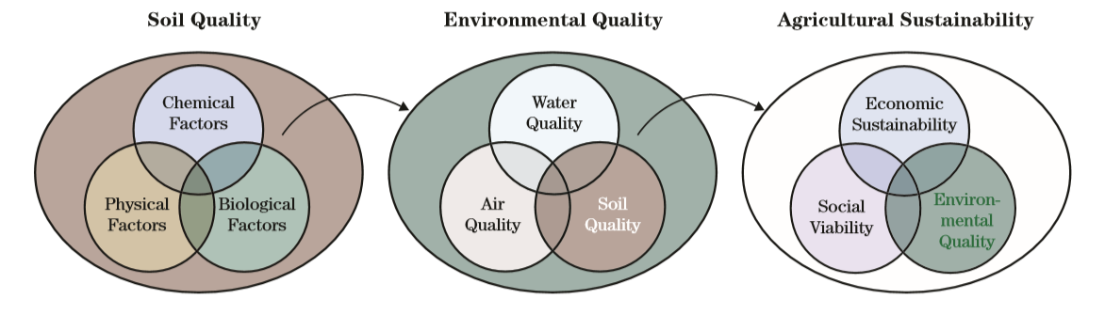Source: Andrews et al. (2002) [50]
Fig.6. Hierarchical relationship of soil quality to agricultural sustainability

VI. Methods for improving soil quality.

- Enhancement of organic matter: the most important way to maintain or improve soil quality is addition of new organic matter every year. Addition of organic matter improves soil aggregation, soil structure, enhances water and nutrient holding capacity of soil, protects soil from erosion, compaction and supports microbial growth by providing carbon source to the microbial community. Regular addition of organic matter in the soil, includes applying manures, composts, leaving crop residues in the soil, growing cover crops, optimum nutrient and water management practices, using low or minimum tillage systems, mulching and crop rotation with high root biomass plants (Figure 7).
- Reduction in intensity of tillage: tillage is the mechanical manipulation of soil to loosen surface soil, control weeds, pests and create conditions suitable for crop growth. But excessive tillage may break up the soil structure, lead to loss of organic matter by speeding up its decomposition, cause compaction and also enhances the chances of erosion.
- Maintenance of ground cover: covering soil surface protects it from erosion damage, provides habitat for soil organisms, improves soil moisture retention, reduces evaporation losses and use of crop residues as a ground cover can additionally add organic matter to the soil and provides food source for soil organisms.
- Diversification of cropping system: Different plants have difference in rooting pattern. Diversification of cropping system can, therefore, help in reducing weed pressure, disease incidence and can help in pest management.

Fig. 7. Principles of conservation agriculture

- Efficient management of pests and nutrients: excessive use of pesticides and chemical fertilizers can lead to soil quality degradation and environmental pollution over a period. Therefore, efficient management of pests and nutrients should be done by applying nutrient sources in the right dose and right place. Soil testing should be necessary part of nutrient management strategy as it will prevent excess or under usage of chemicals which will adversely affect soil quality. The usage of chemicals should be kept minimum by integrating its use with organic sources.
- Prevention of soil compaction: soil compaction leads to reduction of soil porosity, hinder root growth and impact soil organisms. Try to minimize soil compaction caused by heavy machinery, equipment or repeated traffic. [51;17].

VII. Conclusion

The effect of agroforestry-based land use systems on soil quality varies with soil, climate, management practices and the type of crop. Overall, we can conclude that agroforestry practices help in improvement of soil and increase in its organic matter content in the form of surface litter or soil carbon. The litter produced by trees also helps in maintaining soil biodiversity which has a positive effect on soil fertility. Agroforestry systems also plays an important role in carbon sequestration, thus reducing greenhouse gas emissions to reduce climate change and ultimately achieving sustainable development goals.

REFERENCES

[1] Velayutham, M. and Bhattacharyya, T. 2000. Soil resource management. Natural Resource Management for Agricultural Production in India. Ed. Yadav, J.S.P. and G.B. Singh, International Conference on Managing Natural Resources for Sustainables Agricultural Production in the 21st Century.
[2] Goovaerts, P. 1998. Geostatistical tools for characterizing the spatial variability of microbiological and physico-chemical soil properties. Biol. Fertil. Soil. 27, 315–334.
[3] Seybold, C.A., Mausbach, M. J. Karlen, D.L. and Rogers, H.H. 1998. Quantification of soil quality. In Soil Processes and the Carbon Cycle.
[4] USDA, 2006. Soil quality institute. Natural resources conservation service. http://soils.usda.gov/sqi/.
[5] Warkentin, B. P. and Fletcher, H. F. 1977. Soil quality for intensive agriculture. In: Proceedings of international seminar on soil environ and fertilizer management in intensive agriculture, Society for Science of Soil and Manure – National Institute of Agricultural Science, Tokyo, 594–598.
[6] Karlen, D.L., Gardner, J.C. and Rosek, M.J. 1998. A soil quality framework for evaluating the impact of CRP. Journal of Production Agriculture 11: 56-60.
[7] Shukla, M. K., Lal, R. and Ebinger, M. 2006. Determining soil quality indicators by factor analysis. Soil & Tillage Research 87: 194–204.
[8] Harris, R.F. and Bezdicek, D. F. 1994. Descriptive aspects of soil quality/health. In: Defining Soil quality for a Sustainable Environment (J.W.Doran, D.C. Coleman, D.F. Bezdicek and B.A. Stewart, Eds). Soil Science Society of America, Special Publication. No. 35, Madison, Wisconsin. pp 23-35.
[9] Goswami, N.N. 2006. Soil and its quality vis-à-vis sustainability and society: some random thoughts. In Proceedings of International Conference on Soil, Water and Environmental Quality – Issues and Strategies, held during January 28 to February 1, 2005, at New Delhi, organized by Indian Society of Soil Science.
[10] Pierce, F.J. and Larson, W.E. 1993. Developing criteria to evaluate sustainable land management. In Proceedings of the 8th International Soil Management Workshop: Utilization of Soil Survey Information for Sustainable Land Use. J.M. Kimble, ed. USDA SCS, National Soil Survey Center, Lincoln, NE.
[11] Jenny, H. 1941. Factors of Soil Formation. McGraw-Hill, New York, 281 pp.
[12] Soil Survey Division Staff, 1993. Soil Survey Manual. U.S. Dept. Agric. Handbk No. 18, U.S. Govt. Print. Office, Washington, D.C. 437 pp.
[13] Andrews, S.S., Karlen, D.L. and Cambardella, C.A. 2004. The soil management assessment framework: a quantitative soil quality evaluation method. Soil Science Society of America Journal 68: 1945–1962.
[14] Chaudhary, J., Mandal, U. K. and Sharma, K. L. 2005. Assessing Soil Quality Under Long Term Rice-Based Cropping System. Communications in Soil Science and Plant Analysis 36: 1141–1161.
[15] Doran, J.W. and Parkin, T.B. 1994. Defining and assessing soil quality. In: Doran, J.W., Coleman, D.C., Bezdicek, D.F., Stewart, B.A. (Eds.), Defining Soil Quality for a Sustainable Environment. SSSA, Madison, WI, 3–21.
[16] Amacher, M. C., O’Neil, K. P. and Perry, C. H. 2007. Soil vital signs: a new soil quality index (SQI) for assessing forest soil health. Research Paper. RMRS-RP-65 www.Fort Collins, CO: U.S. Department of Agriculture, Forest Service, Rocky Mountain Research Station.
[17] Vasu, D., Tiwary, P. Chandran, P. and Singh, S. K. 2020. Soil Quality for Sustainable Agriculture Nutrient Dynamics for Sustainable Crop Production In book: Nutrient Dynamics for Sustainable Crop Production, 41-66. Doi 10.1007/978-981-13-8660-2_2.
[18] Karlen, D.L., Andrews, S. S. and Doran, J.W. 2001. Soil Quality: Current Concepts and Applications. Advances in Agronomy 74.
[19] Mukherjee, A. and Lal, R. 2014. Comparison of Soil Quality Index Using Three Methods. PLOS ONE 9(8).
[20] Michael, A. C., O’Neil, Katherine P Perry and Charles, H. 2007. Soil vital signs: A new Soil Quality Index (SQI) for assessing forest soil health. Res. Pap. RMRS-RP65WWW. Fort Collins, CO: U.S. Department of Agriculture, Forest Service, Rocky Mountain Research Station. 12 p.
[21] Triantafyllidis, V., Kosma, A. K. C. and Patakas, A. 2018. An Assessment of the Soil Quality Index in a Mediterranean Agro Ecosystem. Emirates Journal of Food and Agriculture 30(12): 1042-1050.
[22] Karlen, D. L. and Stott, D. E. 1994. A framework for evaluating physical and chemical indicators of soil quality. In: Doran JW, Coleman DC, Bezdicek DF, Stewart BA, editors. Defining soil quality for a sustainable environment. Madison, WI: Soil Science Society of America. 53–72.
[23] Andrews, S.S., Karlen, D.L. and Mitchell, J.P. 2002. A comparison of soil quality indexing methods for vegetable production systems in Northern California. Agriculture, Ecosystems & Environment 90:25-45.
[24] Bhaduri, D., Purakayastha, T. J. Patra, A. K. and Chakraborty, D. 2014. Evaluating soil quality under a long-term integrated tillage– water–nutrient experiment with intensive rice–wheat rotation in a semi-arid Inceptisol. Environmental Monitoring and Assessment 186:2535–2547.
[25] Liebig, M. A., Varvel, G. and Doran, J. 2001. A simple performance-based index for assessing multiple agroecosystem functions. Agronomy Journal 93: 313–318.
[26] Sinha, N. K., Chopra, U. K. and Singh, A. K. 2014. Cropping System Effects on Soil Quality For Three Agro-Ecosystems In India. Experimental Agriculture 50 (3): 321–342.
[27] Armenise, E., Redmile-Gorden, M. A. Stellacci, A. M. Ciccarese, A. and Rubino, P. 2013. Developing a soil quality index to compare soil fitness for agricultural use under different managements in the Mediterranean environment. Soil and Tillage Research 130:91–98.
[28] Lima, A.C.R., Brussaard, L. Totola, M. R. Hoogmoed, W.B. and de Goede, R.G.M. 2013. A functional evaluation of three indicator sets for assessing soil quality. Applied Soil Ecology 64, 194–200.
[29] Mead, D.J. 2004. Agroforestry. Forests and Forest Plants Vol 1. EOLSS Publishers, Oxford UK, pp. 324–355 Encyclopedia of life science systems.
[30] Young, A. 2003. Agroforestry for Soil Management (2nd ed.). CAB International, Wallingford, UK.
[31] Buresh, R.J. and Tian, G. 1997. Soil improvement by trees in sub-Saharan Africa. Agrofor. Syst. 38, 51–76.
[32] Nair, P.K.R., Kang, B.T. and Kass, D.B.L. 1995 Nutrient cycling and soil erosion control in agroforestry system. In Agriculture and Environment: Bridging Food production in Developing Countries. American Society of Agronomy. Madison, USA, pp. 117-138.
[33] Sarvade, S., Gautam, D.S., Upadhyay, V.V., Sahu, R. K., Shrivastava, A. K., Kaushal, R., Singh, R. and Yewale, A.G. 2019. Agroforestry and Soil Health: An Overview. In book: Agroforestry for Climate Resilience and Rural Livelihood (pp.275-297) Publisher: Scientific Publisher.
[34] Bundela, D. S. 2007 Water Management in Northeast India - Some Case Studies. Kaledhonkar et al (Eds). CSSRI, Karnal, India. pp. 40-46.
[35] Di Gregorio, A. and Jansen, L.J.M. 1998. Land Cover Classification System (LCCS): Classification Concepts and User Manual. For software version 1.0. GCP/RAF/287/ITA Africover – East Africa Project in cooperation with AGLS and SDRN. Nairobi, Rome.
[36] Sharma, K.L. 2011. Effect of Agroforestry Systems on Soil Quality-Monitoring Assesment.122-132. http://www.crida.in/DRM1-Winter%20School/KLS.pdf.
[37] Pandey, V. 2018. Assessment of soil health under different land use systems in a Mollisol. PhD diss. G. B. Pant University of Agriculture and Technology.
[38] Yadav, R. S., Yadav, B. L., Chhipa, B. R., Dhyani, S. K. and Ram, M. 2011. Soil biological properties under different tree based traditional agroforestry systems in a semi-arid region of Rajasthan, India. Agroforestry Systems 81:195–202.
[39] Ramos, Helen & Vasconcelos, Steel & Kato, Osvaldo & Castellani, Debora. 2018. Above- and belowground carbon stocks of two organic, agroforestry-based oil palm production systems in eastern Amazonia. Agroforestry Systems 92(2): 1-17.
[40] Hoosbeek, M.R., Remme, R.P. and Rusch, G.M. 2018. Trees enhance soil carbon sequestration and nutrient cycling in a silvopastoral system in south-western Nicaragua. Agrofor Syst. https://doi.org/10.1007/s10457-016-0049-2.
[41] Dhaliwal, J., Kukal, S.S. and Sharma, S. 2018. Soil organic carbon stock in relation to aggregate size and stability under tree-based cropping systems in Typic Ustochrepts. Agrofor Syst. https://doi.org/10.1007/s10457-017-0103-8.
[42] Yengwe, J., Amalia, O., Lungu, O. I. and Neve, S. D. 2018. Quantifying nutrient deposition and yield levels of maize (Zea mays) under Faidherbia albida agroforestry system in Zambia. European Journal of Agronomy 99:148-155.
[43] Prakash, D., Benbi, D.K. and Saroa, G.S. 2018. Land-use effects on phosphorus fractions in Indo-Gangetic alluvial soils. Agroforestry Systems 92: 437-448.
[44] De, P., Deb, S., Deb, D., Chakraborty, S., Santra, P. and Dutta P. et al. 2022. Soil quality under different land uses in eastern India: Evaluation by using soil indicators and quality index. PLoS ONE 17(9): e0275062. https://doi.org/10.1371/journal. pone.0275062.
[45] Soil Quality Technical Note No. 10. 2008. Soil Quality Physical Indicators: Selecting Dynamic Soil Properties to Assess Soil Function.
[46] National Research Council, 1993. Soil and Water Quality: An Agenda for Agriculture. Nationai Academy Press, Washington, D.C., 516 pp.
[47] Sharma, K. L. and Mandal, B. 2009. Soil quality and its relevance for sustainable agriculture. Journal of Indian Society of Soil Science 57:572–586.
[48] Bünemann, E. K., Bongiorno, G. Bai, Z. Creamer, R. E. Deyn, G. N. Goede, R. D. Fleskens, L. Geissen, V. Kuyper, T. W. Mädera, P. et al. 2018. Soil quality – a critical review. Soil Biology and Biochemistry 120:105–125.
[49] Herrick, J. E. 2000. Soil quality: an indicator of sustainable land management. Applied Soil Ecology 15:75–83.
[50] Andrews, S. S., Mitchell, J. P. Mancinelli, R. Karlen, D. L. and Hartz, T. K. 2002. On Farm Assessment of Soil Quality in California’s Central Valley. Agronomy Journal 94: 12–23.
[51] Chauhan, A. and Mittu, B. 2015. Soil Health - An Issue of Concern for Environment and Agriculture. Journal of Bioremediation and Biodegradation 6:286. doi:10.4172/2155-6199.1000286.

