Unlocking the Environmental Degradation by Fast Fashion Industry, and it’s Bioremedation.

Inshith Kaur
Independent Scholar
Rourkela, India
Inshith123@gmail.com

ABSTRACT
Climate changes in 2023 has not been unnoticed throughout the world. The major crisis is water, be it’s scarcity or floods- Melting Glaciers, reduction of clean water and sea level rise has led to increase in groundwater which has degraded the soil quality and quantity in certain regions which produce specific crops to sustain the natives and economic distress in India. Fast Fashion Industry is seeing higher growth because of peoples unsatisfied need for buy clothes, they find beautiful and have seen on people in Social Media has been pilling most wardrobe than reuse or further it’s degradation process or how it impacts the environment to produce the material.
Clothes bought are specifically made up of polyester and nylon are later discarded inappropriately, led up to the water bodies as well as these clothes are used as landfills which harms the soils microbiome and the production leads to more carbon emission in air has increased temperature. Certain Bioremediation techniques, which differs with respect of dye used and the quality of effluent released by the nature they are discussed as methods which are used by major countries for survival of farmers, citizen and environment.

Keywords—Fast fashion Industry; Bioremediation; Environmental impact; SWOT analysis.

INTRODUCTION

Fast Fashion means clothes that are moving from famous designers runway to the nearby store, this gives an advantage to most people by (1) creating contents online about a specific cloth design as seen among the most tik tok, instagram and youtube creators (2) how the specific polyester material look good of people all the size (3) benefiting the stores that provide online services and cheap price duplicated copy of the branded designer clothes. The profitability to the manufacturers and retailers have increased and quick delivery providers are main reason that enable people to go with the trend that lasts up to in between a couple of week to 2 months.
Recently in Fast Fashion industry are highly responsible for 20% of global wastewater production, at present a person is seen to purchase up to 35% of his salary every month which would not be worn more than five times after the purchase. Only 12%-14% of the material is recycled, and rest dumped into to environment. Textile dyes can be lost nearly in hundred thousand tons in nearby water bodies and 90 million tons of water are attributed annually to dye production and their application and 90 million tons of water are attributed annually to dye production and their application. In fast fashion industry materials dye making is responsible for up to 20 % pollution of water bodies. Almost 700 varieties of dye are produced in India and these dyes are direct dye, acid dye and reactive dye and it intermediates up to 80% of these are used by Indian textile companies. In one of the case study, ecological and toxicological problems due to the discharge of wastewaters from Sanganer textile industries in local drainage of Rajasthan has reported high concentration of heavy metal in the area like Cu, Cd, Zn, Pb, Ni, etc. Dyes used in these fashion industries are carcinogenic in nature and leads to urinary bladder cancer, liver cancer and many more. Nature has been and excellent provider of different variant of colors but they have low affinity to the fibers used these days and after a wash the color washes out and the material of the cloth is considered cheap and less usage after one wash. But there are small companies trying to be back in sustainability game. Certain new methods are used to degrade dyes such as photo catalysts, enzymatic decolourization, electrochemical oxidation and use of certain fungus and it’s enzymes is discussed briefly. A survey was conducted and collective summary of how fast fashion trends are influencing textile industry to produce mass clothes that goes out of fashion in a few months, are then thrown and cycle carries on without a thought of how climate change is reposed in the environment.

FAST FASHION INDUSTRY IN INDIA
China, India, Pakistan and Vietnam are the major traditional giants in the fast fashion industry-manufacturing products and it’s machineries. India is one of the world’s largest manufacturers and exporter of textiles products and it has invested in more spinning and weaving equipment second to china. China has been more efficient in it’s machinery and availability of underage or women labors at low cost. Shein was the largest cross-border e-commerce site for fast fashion in China, second to H&M, Zara, Adidas and forever2 but however, after Covid-19 India banned Shein and started supporting “Made in India” -Atmanirbhar- Shein suffered quite a billion loss. Through Chinas cheap prices, variety of sizes and fast fashion trend became easy and other homegrown companies took it’s place and lead to certain impacts in environment. In 2023, the industry continues to contribute immensely to the exchequer – 4% to global trade in textiles and apparel, 2% to the GDP (approx. $70 billion), and constitutes 7% of industry output in terms of value. It is also one of the primary sources of employment to include women, in rural India. India has more than 3,400 textile mills and an installed capacity of more than 50 million spindles and 842,000 rotors. The growth of technical textiles in India has gained momentum in the past five years, growing at a 9-10% per annum.

- Types of textile produced in India
India is the largest producer of Cotton and Jute, second producer of Silk and fiber after China. But in 2022 and continuing 2023 as Indian cotton prices continue to be costlier against the international market, cotton yarn exports have taken a major hit to touch historic lows with 59% decline in the first half of Fall Year 23 as compared to the year-ago period. Jute is a natural, strong, versatile fiber, which is also known as “Golden Fiber due to it’s golden-brown color. It has been used for centuries to create rope, twine, mats, sacks, and other useful items. It is also used to make carpets, upholstery, and other fabrics. The Jute industry produces a variety of products that are 100% biodegradable, and recyclable and therefore eco-friendly. India is renowned for it’s exquisite silk production, this industry is highly beneficial for the country, providing employment to 9.76 million people in both rural and semi-urban areas and being one of the largest foreign exchange earners. India produces and exports a wide variety of silk products, including raw silk, natural silk yarn, fabrics & made-ups, ready-made garments, silk waste, and handloom products, during 2021-22 export value of US$ 248.56 million, a 25.3% rise from the previous year. Similarly, in some textile we see a decline due to amid scarce rainfall for the crops to grow and use by country and then further use as an export of certain valuable materials.

- Fast Fashion industry observed in the past few years
Fashion is one sector where the consumerism has expanded substantially in recent 10 years. Fast fashion has grown increasingly common; clothing is created in shorter timescales, with new patterns emerging every few days to meet demand for the newest trends, however this comes at the expense of greater consumption of natural resources and waste production in tones. It is estimated that 20 new clothing are created per person each year, and we are purchasing 60% more than we did in 2010. Each clothing is worn for a shorter period of time before being discarded in appropriately.
Let’s for instance take the western industry and environment as an example, the rise in fast fashion has led to an unsustainable turnover of clothing in our wardrobes, for example in the UK approximately 1 million tons of household textiles are thrown away annually. Textiles have an environmentally significant impact across their lifecycle and reducing this impact is a priority for the UK government. They have a substantial carbon footprint during production and use, and are expensive to dispose of a cloth material. The reuse of clothing saves an estimated 29 kg CO₂e (carbon dioxide equivalent) per kilo of clothing compared to recycling, and 33 kg CO₂e compared to disposal. In a global economy increasingly dominated by resource politic, multinational producers of clothing are also having to think about manufacturing in the future with increasingly scarce resources as water specifically.
In India, the staggering statistics of the quantity of clothes that end up in landfills is not news—in fact, what is new information is that landfills are brimming with so much urban waste: we are talking about Panipat, a city from north India, a place where yours, mine and everyone else’s clothes end up, we have discarded them from our wardrobe. The place is severely affected by the problem of landfills being filled up with discarded clothes. However, in past years, the place is being filled up with so much of discarded clothes, that the land is falling short. That by 2050, India is reportedly going to need a landfill that's the size of it’s capital, New Delhi (claimed by a joint report of Assocham and accounting firm PwC). In a linear fashion model, it's estimated that 73 per cent of all our clothes end up in landfill for various reasons like the lack of collection systems and ineffective redistribution. There are no large-scale solutions available to recycle blended yarns at the moment.
The Fashion industry in India is one of the most important and most polluting industries in terms of consumption and generation of huge amounts of wastewater, fuel and diverse group of chemicals such as dyes. To operate different processes such as resizing, scouring, bleaching, dyeing and printing of fabric, a vast amount of water is used and waste is generated. The main issue of effluent from textile industries with environmental problems is the elevation of biochemical oxygen demand (BOD), chemical oxygen demand (COD), pH, suspended solids in water bodies. Industrial wastes and effluents containing heavy metals such as vanadium, molybdenum, zinc, nickel, mercury, lead, copper, chromium, cadmium, and arsenic are being released in the vicinity of the industrial areas nearby. The polluted water causes harms such as painful skin disease, diarrhea, food poisoning, and gastrointestinal problems in the short-term, and serious health implications such as respiratory problems when toxic materials accumulate in the body in the long-term.

- The environmental impact of the Fast Fashion industry
The fast fashion industry is also reacting to these social changes and is trying to win buyers with green labels-environmental conscious company. But it makes a little difference or is fast fashion still one of the dirtiest industries in the world. When taken a closer look at the various stages in the fashion material production cycles the environmental impact of fast fashion industry is discussed:
- OVER-CONSUMPTION
- HIGH USAGE OF RAW MATERIAL
- WATER POLLUTION
- GARBAGE

OVER-CONSUMPTION: Everyone is aware of buying clothes or possessing clothes more than required. Despite standing in front of an overflowing wardrobe, we still can’t find anything to wear for a lunch or dinner outside with friends we try 2 clothes at maximum. It has been found in many research that a staggering 40 % of our wardrobes is rarely or never worn. Due to constantly changing trends and new collections in the shops, our own clothes quickly go out of fashion and we get the impression that we need something new again. The offer of constantly new collections is huge: Between 2000 and 2014 the production of new clothing has doubled, and in 2014 for the first time the eye-watering mark of 100 billion newly produced garments was hit. This huge growth in the past two decades is partly due to big fashion chains that have increased their offering from two collections per year at that is five times or more new trending garments every year.
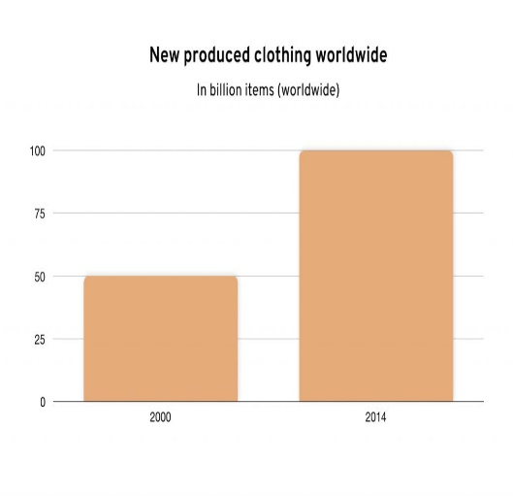
Source: Greenpeace. (2017): “Konsumkollaps durch Fast Fashion

WASTE OF RAW MATERIALS
But it is not only the high consumption and huge production volume that are to blame for the negative impact the fashion industry has on the planet. The environmental impact begins with the cultivation of the materials used to make clothes – either natural fibers, chemical fibers or a mixture of both
Natural fibers- In the case of natural fibers, we speak of materials such as cotton, silk or wool. The most frequently processed natural fiber is cotton at least 28% blend in all clothing material, which is grown in about 80 countries around the world. The main problem in the cultivation of cotton is the high water consumption used in cultivation. For example, 1 kg of conventional cotton needs about 11,000 liters of water. In addition, pesticides and insecticides are used in most cotton fields and two-thirds of the cotton grown is genetically modified. Cotton can also be grown more sustainably and without the use of pesticides: however, this “organic cotton” also consumes a lot of water and is sometimes harvested in developing countries under questionable working conditions. Read a previous article in our blog to find out more about the advantages and disadvantages of organic cotton.
Chemical fibers- Almost 60 % of clothing produced is made from synthetic materials – mainly polyester, polyamide (nylon and perlon), polyacrylic and elastane. The most commonly used synthetic material is polyester. Polyester consists of polyethylene terephthalate (PET), of which the basic materials are petroleum, hard coal, limestone and natural gas. It is said that the production of polyester alone requires 98 million tons of crude petroleum every year. Hence, it currently corresponds to about 1 % of the oil produced worldwide. And the trend is rising. If the fashion industry keeps increasing with such drastic demands, consumption could rise to 300 million tons of oil by 2050, and would be responsible for 26 % of human CO2 emissions by 2050. Currently this figure is 10%, which is more than all international flights and sea shipments together (5 %). Overall, the production of polyester (= 6 kg CO2 per T-Shirt) emits three times more CO2 than the production of cotton (= 2 kg CO2 per T-Shirt). “The fashion industry is responsible for 10 % of the global CO2 emissions. This is more than the global air- shipping traffic combined”
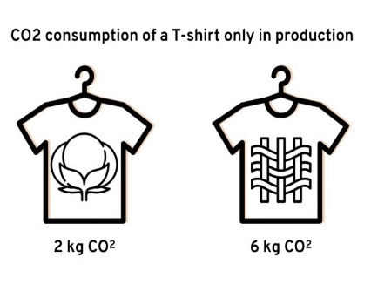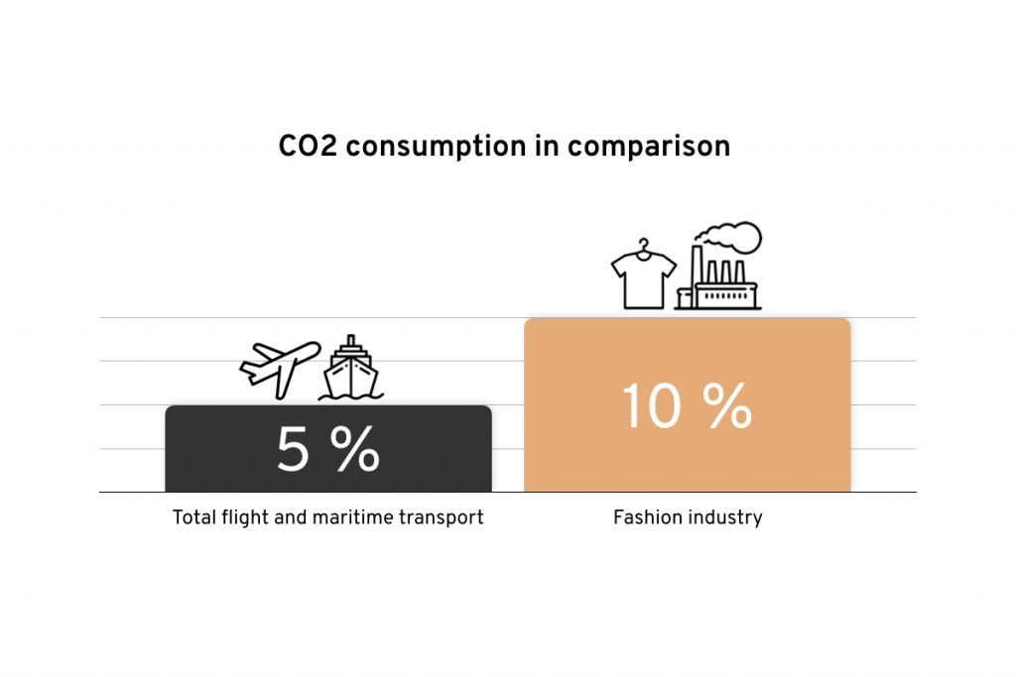
Source: Fokus Online 2019. Sources: Ellen Macarthur Foundation. 2017.

WATER POLLUTION: Water pollution due to micro plastics, its tiny plastic particles that arises from both commercial product development and the breakdown of larger plastics. But it is not only the production of chemical fibers that is harmful to the environment. Another problem of synthetic materials is that they are very hard to biodegrade using living organisms. Most serious consequences of this microfiber ends up in the oceans and inland waters. The fashion industry contributes to 35% of the micro plastics in the sea and is the main source of micro plastics in the oceans. The process of micro plastics being generated even from households are that polyester clothing is washed, tiny fibers are detached. Thus this end up as micro plastics in the wastewater and consequently also in the rivers and oceans. These absolutely non-biodegradable micro plastics so micro plastics are causing problem to the human ecosystem. As long as animals absorb micro plastics through their food, micro plastics will also get into our food-system and thus into our bodies.

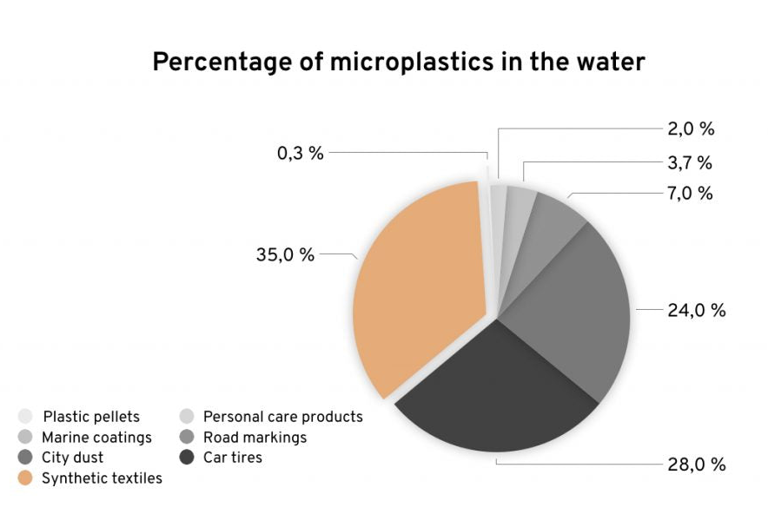
Source: IUCN. (2017). Primary Micro plastics in the ocean.
The fashion industry majorly is responsible for polluting fresh water with chemicals which are far more dangerous. These chemicals that are used to dye textiles end up in rivers as wastewater without any kind of filtering or recycling, especially in developing countries. The reason is that filter systems, which are designed to stop the chemicals, are often an asset of cost production facilities in developing. So many factories depend on their customers to buy n bulk, however these illegal activities, exploiting nature and its work-force to an extend that is further not going to stop any soon. However it’s a fact that these chemicals can also be life-threatening for animals, plants, and local communities.
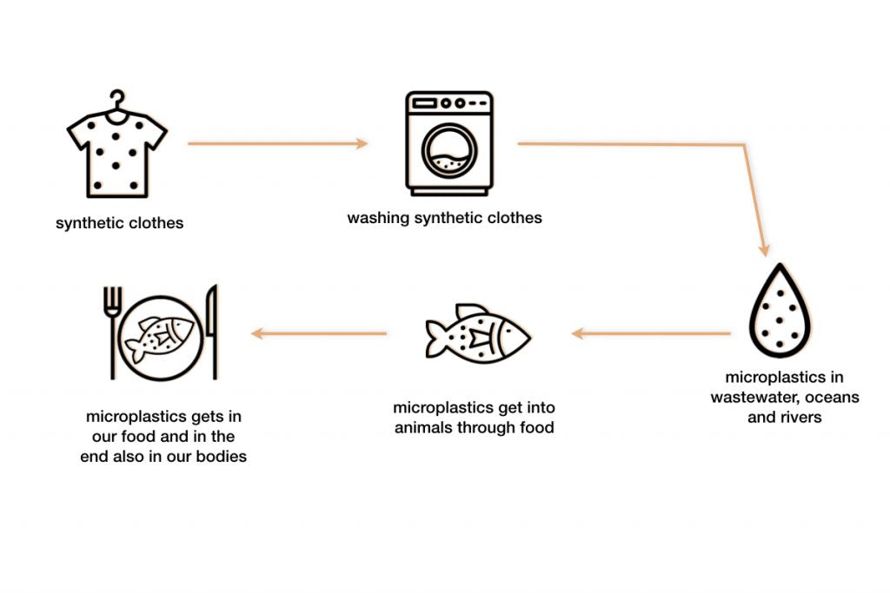
Source: IntechOpen. 2017.

GARBAGE: As it is understood that the fashion industry is produces more than thrice times more clothing than in 2000, because of an increase in consumption, not all garments that are produced are sold. These non-sold garments even from the fashion giants are uninformed to where they are or how they are stored or degraded. As per the trust insiders that almost 20% of the garment collection are non-sold. It is assumed that most of the clothes are burned resulting in significant CO₂ emissions. And it’s stated information that 70 % of all clothes sold end up in residual waste sooner or later and only 1 % can be fully recycled.
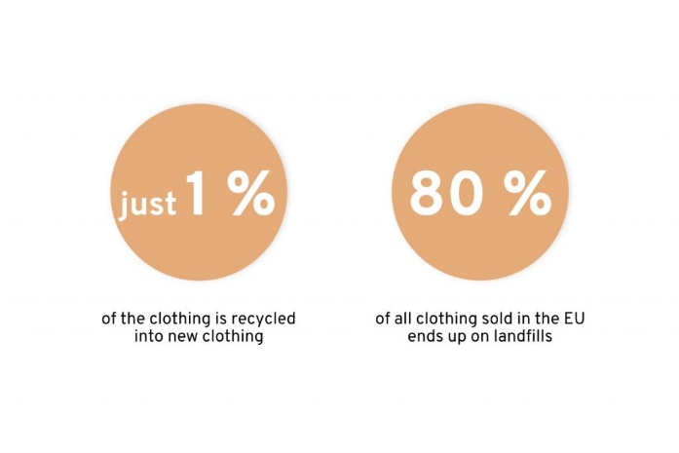
Source: Business of Fashion in 2018

BIOREMEDIATION IN FAST FASHION INDUSTRY

Bioremediation is an ecologically sound and state of the art technique that employs natural biological processes to completely eliminate toxic contaminants. Any process that uses microorganisms, fungi, green plants or their enzymes to return the natural environment altered by contaminants to it’s original condition.

- Materials used by the Fast Fashion industry
Dyes used in fashion industry are classified as azo, diazo, cationic, basic, anthraquione and metal complex based, depending on the nature of their chemical structure. There are more than 100,000 commercially available dyes with over 7 times 105 tons of dyestuff produced annually. Around 8000 chemical products associated with the dyeing process. Chemical structure of the dyes was resistant to fading on exposure to light, water and many chemicals. Color was one of the most obvious indicators of water pollution and discharge of highly colored synthetic dye effluents can damage the receiving water bodies. Colored wastewaters associated with the reactive azo dye constitute approximately 30% of the total dye market.
Many such dyes are known to be carcinogens, such as benzamine and other aromatic components all of which might be reformed as a result of microbial metabolism. It has been already well documented that azo and nitro-compounds were reduced in the sediment and intestinal environment, resulting in the regeneration of the parent toxic amines this compound was not readily removed by typical microbial based waste treatment processes.

- Bioremediation Techniques
Physical and Chemical methods encompass of flocculation, electrochemistry, ozonation, bleaching, membrane filtration, irradiation and adsorption of activated carbon are commonly used for the treatment of industrial effluents. Different and complicated molecular structures of dyes makes effluent difficult to be treated by conventional physical and chemical process such as coagulation, precipitation, adsorption by activated charcoal, oxidation by advanced oxidation process, ionizing radiation, ultra filtration and heterologous photocatlytic treatment. These methods are expensive, less efficient and limited application generating wastes which are difficult to dispose. Typical techniques include the classical methods such as adsorption, coagulation, filtration and sedimentation. Although all these techniques were very versatile and useful, they all end up in producing a secondary waste product which needs to be tackled further. Traditional physical and chemical treatments applied for the purification of dyeing wastewater include adsorption with inorganic (mainly, activated carbon materials) and organic supports, coagulation by lime, aluminum or iron salts, filtration and ion exchange.

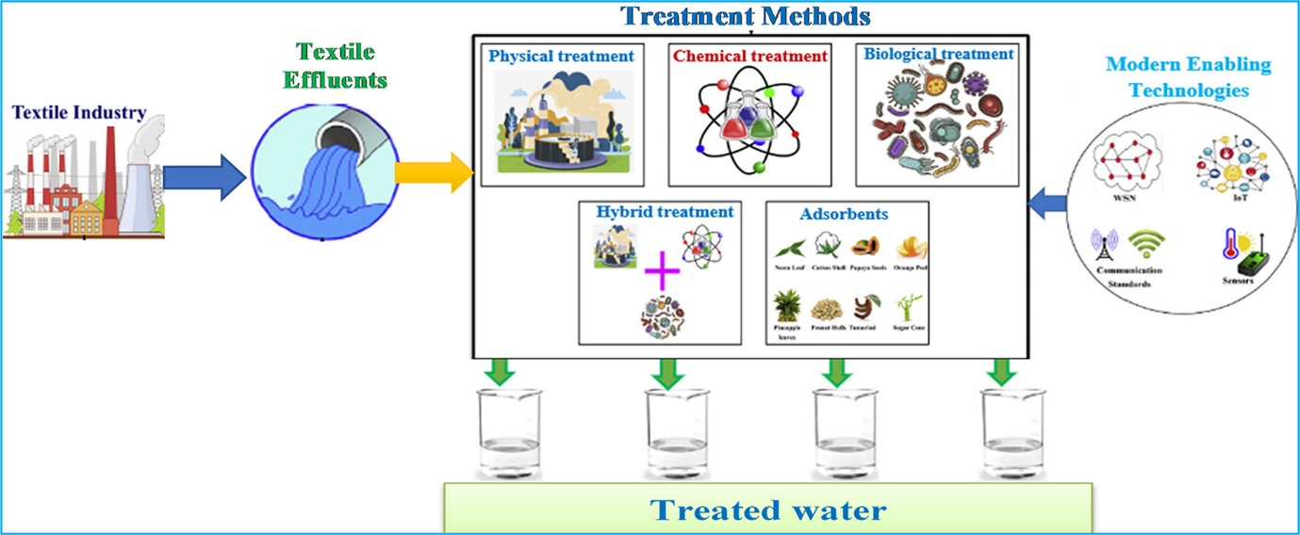

These procedures direct effective decolorization but their application was restricted due to formation of sludge or by the need to regularly regenerate the adsorbent materials. Use of these methods was not completely accepted at present because they are quite expensive and have many operational problems. The main drawback in the implementation of aforementioned techniques was impossible due to high cost, low efficiency and inapplicability to a wide variety of dyes. Other techniques involve chemical oxidation using sodium hypochlorite to remove the color. However, releasing a lot of aromatic amines is carcinogenic otherwise these toxic compounds subsequently aggravate the problem.

SWOT ANALYSIS
SWOT (strengths, weaknesses, opportunities, and threats) analysis is a framework used to evaluate a proposal or certain characteristics of a plan, and to develop strategic planning. SWOT analysis assesses internal and external factors, as well as current and future potential. The framework is considered a powerful support for decision-making because it enables an organization to uncover opportunities for success that were previously unarticulated. It also highlights threats before they become overly burdensome.

Elements of a SWOT analysis
The end result of a SWOT analysis shows characteristics, these are certain elements of it.
Strengths: good communication skills, on time for shifts, handles customers well, gets along well with all departments, physical strength, good availability.
Weaknesses: takes long smoke breaks, has low technical skill, very prone to spending time chatting.
Opportunities: storefront worker, greeting customers and assisting them to find products, helping keep customers satisfied, assisting customer’s post-purchase and ensuring buying confidence, stocking shelves.
Threats: occasionally missing time during peak business due to breaks, sometimes too much time spent per customer post-sale, too much time in interdepartmental chat.

- SWOT Analysis on Fast Fashion Industry
The fashion industry is divided into the creative and sales functions, that is, design and production on one side and sales and distribution on the other.
STRENGTH: Fast Fashion Industry does help grow the small companies or homegrown companies. Most people buy for more than Rs 5000 every month. Even just a Made in India Brand seen by people on social media can sky rocket the sale of this Industry. Fast Fashion Industry and social media are hand to hand partners, just gifting clothes to influencer helps they sell more than enough to build a company in the nearest time. And with time gaining the trust of customers the Brand is highlighted and at the peak of the marketing.
Hence, To take advantage of the opportunities, the report recommends the fast fashion companies to enhance their business presence in the e-commerce sector through investments and initiatives taken towards the development of advanced technological solutions to integrate physical stores and the online marketplace or platform, focus on the development and launch of web stores to increase the accessibility and convenience towards the customer, focus on expanding it’s business and operational presence through strategic agreements and plans to expand and establish stores and manufacturing facilities in developing regions, and companies can also focus on growth via strategic acquisitions.

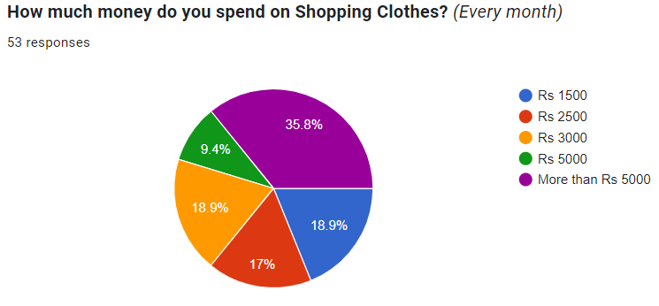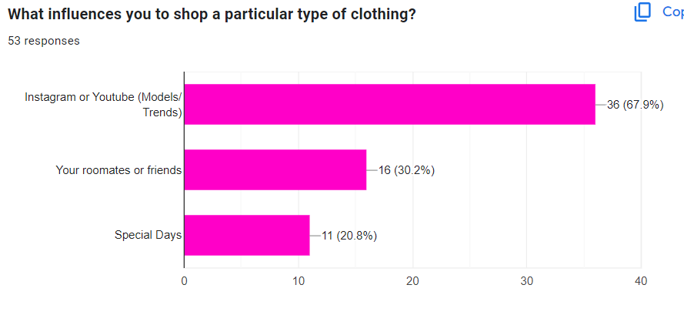

Weakness: People buy more than once a week when they have a wardrobe as well as placed the bags filled with a year old clothes in hidden areas so as to minimalize the spread of clothes but also they weak these clothes so less it’s possible to say a person does not weak a cloth they recently bought more than 5 times in a year. And this just leads to wastage of material when there are people who do not have options as much as the better half of the group. However, not paying fair living wages to workers, poor working conditions, child labor, and environmental destruction from hazardous chemicals, plastic-derived materials, and increasing amounts of water pollution and textile waste.
Most fast fashion brands are dropping tremendous amounts of new products every week, promoting over-consumption. As a result tons of textile is thrown away, creating a lot of waste. Polyester is one of the most popular fabrics derived from fossil fuels, and it is non-biodegradable, so it can stay in landfills for more than 200 years.
Even natural materials such as cotton can be harmful to the environment since they require enormous amounts of water and pesticides. Furthermore, fast fashion brands use toxic and dangerous chemicals that pollute the environment and are hazardous for workers, and the communities around the factory.

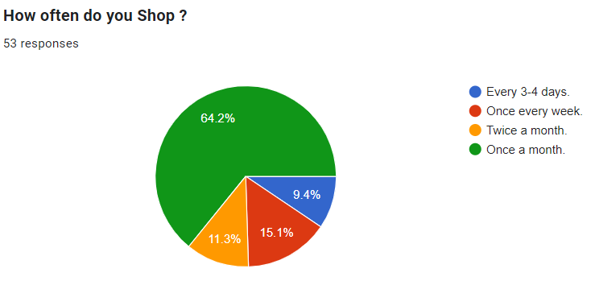
Opportunities: Growth in the historic period resulted from a rise in foreign direct investments, emerging markets growth, growth in media development, and technology developments.
Factors that negatively affected growth in the historic period were lack of resources, reductions in free trade, and increasing inventory levels. Going forward, increasing adoption of trendy clothes by the growing youth population, increasing penetration of social media, growing demand for sportswear and performance wear, and low-cost production will drive the growth.
Factors that could hinder the growth of the fast fashion market in the future include increasing transparency of poor working conditions, negative environmental impact, counterfeit products, limited cotton production, and the impact of COVID-19.
The fast fashion market is segmented by gender into males and females clothing. The female market was the largest segment of the fast fashion market segmented by type, accounting for 60.3% of the total in 2020. Going forward, the female segment is expected to be the fastest-growing segment in the fast fashion market, at a CAGR of 20.3% during 2020-2025.

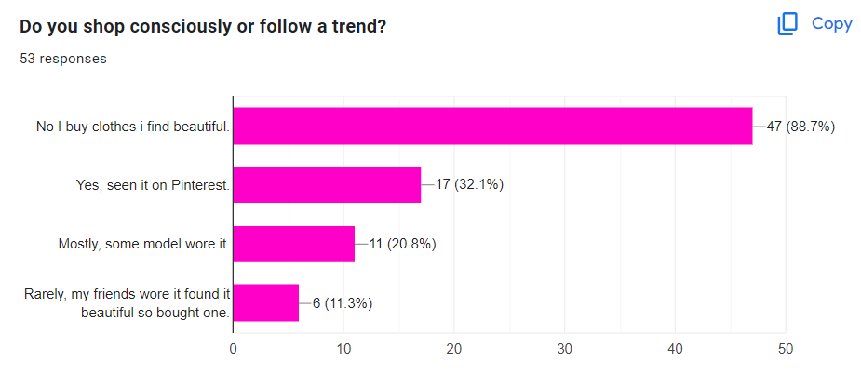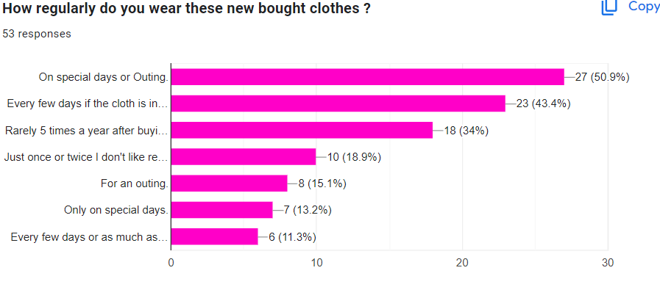

Threat: The common threats that is to be faced by fashion industries in coming future.
Raw material Cost: When it comes to fashion industry, it is based upon the linear model with raw materials with the concept of take, make and waste. The main thing is the raw materials needed for the fashion industries are finite or limited, that when times comes the availability of raw materials will be none. For example, water which is the root for all raw materials needed. Large quantity of water is required for producing fabrics and more of it is usage is in the agriculture of cotton. Scientists have predicted that water consumption needs will exceed supply by 40 percent in 2030 and as a result the cost of raw materials will also boost making it more difficult for fashion to sustain the future environmental situations. Unless technology can more capably recycle used clothes, and gather needed material, current consumption rates are not workable.
Labor Problems: In addition to the inadequate raw materials availability, Fashion industry mainly relies on cheap workers which will become very less due to extreme climate variations. The laborers would have shifted or temporarily relocated to new livelihood making it very difficult to find laborers. The Organization for Economic Co-operation and Development (OECD), recently found that mainly 4 countries which are largest manufacturers of fashion products in the world are in the subject affected by raising sea levels which may cause extreme weather conditions affecting the fashion industry.
Transport: Logistics and transportation industries also faces uncertain future due to the availability of oil resources. Due to the environment disruption oil fields cannot be accessed easily and the cost of extracting oil increases along with the price if oil which make transport very expensive which in turn fashion industry.
Higher regulation: The unavailability of resources like water and oil means the regulation will play an increasing role in manufacturing products such as cotton.
Consumer Sentiment: By 2020, millennial will be the most plentiful demographic in the global labour force, which means fashion businesses must now outfit to their predictions, rather than those of generation X. Millennial steadily identify sustainability as a reason that impacts their purchasing ways. But while a third of millennial say they are more possible to buy from companies that are aware of social responsibilities which means only a tiny proportion of all consumers are willing to pay more for a sustainable product in future. It is about linking our business operations and our sustainability goals how we source, how we manufacture, how selling of products are handled as well as ensuring that sustainability factor adds to the business value.
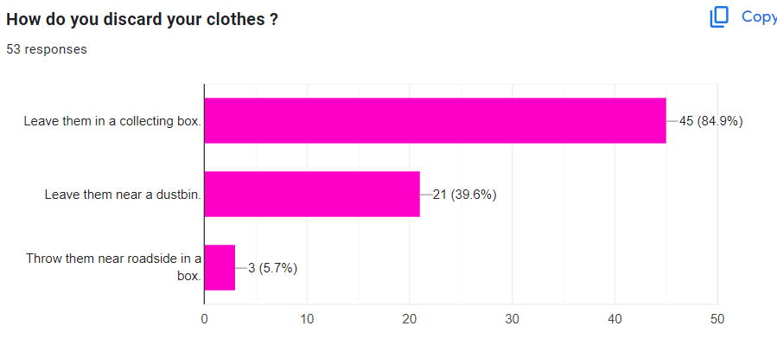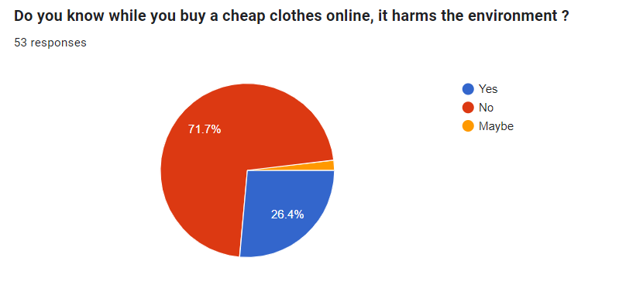
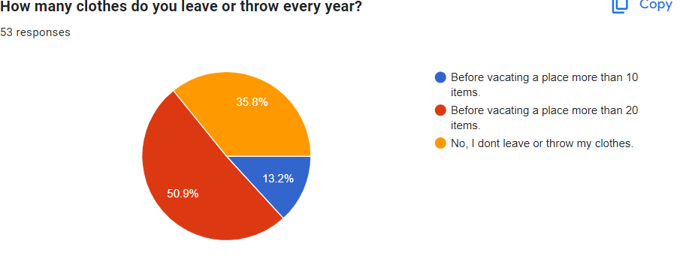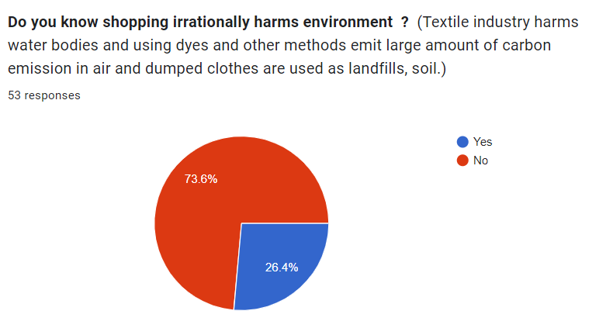

SUMMARY
The environment is the center of all life forms and the way these seasons are dealing with the altered timeline and disruption is plenty rain scarcity which help or destroys production of crops, as well as the flood in certain area that has destroyed the soil and it microbiome. The production of dye in an industry is equal to the carbon emission of a flight through the globe travel. Additionally the cloth material breaks micro plastics which are then consumed and led up ahead to food chain contribute to altered metabolism in even lower part of food chain to higher up the food web. And as for Bioremediation using the first process of decolorizing the clothing material and then certain physical chemical and biological microbes are used to recycle only 1% of cloth after so many process.
In fast fashion Industry there has been a five times the cloth produced than back in 2010 which is drastic, even the fast access through delivery from runways to esteemed designer’s to the cheap low quality clothing from mostly manufactured in Asia has caught an eye from around the globe. Even new business due to low labor charges and overtime work without consciousness of environment in regard to resources has polluted the environment and impacted in a way which is carcinogenic. Thus even buying a costly product buy a cotton based product than a polyester based material. And recycle the cloths such as using them as tile scrubs or donating it to people in need, specifically when it’s winter season. Thus the consciousness of buying a cloth which is necessarily needed and is worn most of the time is even helping the environment.
A survey has been performed and it’s result in form of pie chart and bar graph is shown as to how a human is addicted to virtual shopping or spending more than half of its salary than required.

REFERENCE
- Broadhead R, Craeye L, Callewaert C. The Future of Functional Clothing for an Improved Skin and Textile Microbiome Relationship. Microorganisms. 2021 May 31;9(6):1192. doi: 10.3390/microorganisms9061192. PMID: 34073029; PMCID: PMC8226598.
- Scheibel T. Spider silks: recombinant synthesis, assembly, spinning, and engineering of synthetic proteins. Microb Cell Fact. 2004 Nov 16;3(1):14. doi: 10.1186/1475-2859-3-14. PMID: 15546497; PMCID: PMC534800.
- klilu Azanaw, Bantamlak Birlie, Bayu Teshome, Muluken Jemberie:Textile effluent treatment methods and eco-friendly resolution of textile wastewater,Case Studies in Chemical and Environmental Engineering,Volume 6,2022,100230,ISSN 2666-0164
- Bhatia, D., Sharma, N.R., Kanwar, R. et al. Physicochemical assessment of industrial textile effluents of Punjab (India). Appl Water Sci 8, 83 (2018). https://doi.org/10.1007/s13201-018-0728-4
- Ramachandran, Palanivelan & Sundaram, Rajakumar & Palaniyappan, Jayanthi & Munusamy, Ayyasamy. (2013). Potential process implicated in bioremediation of textile effluents: A review. Advances in Applied Science Research. 4. 131-145
- Sakamoto, M.; Ahmed, T.; Begum, S.; Huq, H. Water Pollution and the Textile Industry in Bangladesh: Flawed Corporate Practices or Restrictive Opportunities? Sustainability 2019, 11, 1951. https://doi.org/10.3390/su11071951
- Anwer, H., Mahmood, A., Lee, J. et al. Photocatalysts for degradation of dyes in industrial effluents: Opportunities and challenges. Nano Res. 12, 955–972 (2019). https://doi.org/10.1007/s12274-019-2287-0
- Degradation of Anthraquinone Dyes from Effluents: A Review Focusing on Enzymatic Dye Degradation with Industrial Potential. Eleni Routoula and Siddharth V. Patwardhan, Environmental Science & Technology 2020 54 (2), 647-664 DOI: 10.1021/acs.est.9b03737
- Noman M, Shahid M, Ahmed T, Niazi MBK, Hussain S, Song F, Manzoor I. Use of biogenic copper nanoparticles synthesized from a native Escherichia sp. as photocatalysts for azo dye degradation and treatment of textile effluents. Environ Pollut. 2020 Feb;257:113514. doi: 10.1016/j.envpol.2019.113514. Epub 2019 Oct 31. PMID: 31706778.
- Research on the Business Strategy and Deficiency of the Fast Fashion Industry to Enhance Development - a Case Study of Shein. https://doi.org/10.2991/978-94-6463-036-7_268
- Perspectives regarding the organizational culture within the Romanian textile industry DOI: 10.35530/IT.071.01.1778 Anaerobic treatment of textile effluents: A review Wouter Delée, Cliona O'Neill, Freda R. Hawkes, Helena M. Pinheiro First published: 04 May 1999 https://doi.org/10.1002/(SICI)1097-4660(199812)73:4<323::AID-JCTB976>3.0.CO;2-S
- Piera Centobelli, Stefano Abbate, Simon Peter Nadeem, Jose Arturo Garza-Reyes, Slowing the fast fashion industry: An all-round perspective,Current Opinion in Green and Sustainable Chemistry,Volume 38,2022,100684,ISSN 2452-2236,https://doi.org/10.1016/j.cogsc.2022.1006

