FOREIGN TRAVELERS’ PERCEPTIONS OF INDIAN CUISINE IN 5 STAR HOTEL AND STEPS TAKEN TO CONSERVE WATER.

Majhar Hussain
Student, School of Hospitality & Tourism,
Galgotias University, Greater Noida

Prof. (Dr.) Vikas Singh
Professor, School of Hospitality & Tourism
Galgotias University, Greater Noida

Prof. (Dr.) Rajiv Mishra
Dean, School of Hospitality and Tourism
Galgotias University, Greater Noida

ABSTRACT

The first task of this survey is to determine the popularity of Indian cuisine, Continental cuisine dishes are more popular than Indian cuisine dishes. We should understand consumer misconceptions about Indian Cuisine dishes, The objective of the study is to identify the dishes and the ingredients of Indian cuisine. For a better understanding of Indian cuisine, this topic I have chosen. The misconception about Indian cuisine can be eradicated by comparing this cuisine to another cuisine of different regions. Many people do not have proper knowledge about the variety of dishes that comes under Indian cuisine. People don’t know the ingredients, tastes, and flavours of the dishes. As we all know about Indian cuisine dishes like dal makhani, assorted Indian bread, rice, mixed vegetables, biryani, butter chicken, jeera rice, etc. So, researching this is more important than others A structured questionnaire was prepared, and this research shows that it is not only delicious but also healthy, rice, pulses, spices, curry powder, ghee, mustard oil and seasonal vegetables are widely used in the preparation of dishes. The study will remove misconceptions about Indian cuisine & awareness programs should be raised and put Indian foods in menu cards by doing menu engineering to aware consumers of Indian cuisine. This leaves a lot of opportunities for future entrepreneurs to enter in food business of Indian cuisine, they should work more on the marketing of all state’s popular dishes by improving the menu.

Keywords: Indian cuisine, dishes, misconception, spices, varieties, rice, business, region, culture, influence, menu, people, traveller, etc.

I. Introduction

Indian food is very popular, yet very misunderstood. The country’s cuisine is always hot and spicy, greasy, rice and greasy, so it is easy to think it's unhealthy and bad for dieters. You may even get the impression that it is hard and time taking. But all of these are myths. Prefer the rest of the world, Indian cuisine is different. You will look for flavourful recipes, complicated dishes that take so much time and dishes that can be made in an hour. No curry powder is needed. Do not rely on hearsay or popular ideas. Dive in and discover for yourself the wonderful world of Indian foods. A trip you will never regret. Indian cuisine has held an important position, especially in the West, due to It is influenced by globalization and other factors such as immigration, the availability of recipes on the Internet, and increased tourism activity. Chicken has become a British national dish from tikka masala to the many Indian recipes served on various international flights, Indian food has secured its place on the new global menu. It has evolved and is inextricably linked to culture, history and geography. Dietary habits have also evolved based on various religious practices. Certainly, Ayurveda, the renowned Indian system of authentic medicine has had a strong influence on many Indian recipes and eating habits. The cultivation and availability of different types of spices and their extensive use in many recipes Usage has always been an important feature of Indian cuisine. It has undergone many new changes to accommodate. New research results in the field of nutrition claim that many ingredients in Indian cuisine have superior health benefits and many people around the world are enjoying the taste of Indian recipes. Indian cuisine will become more and more popular in the future.
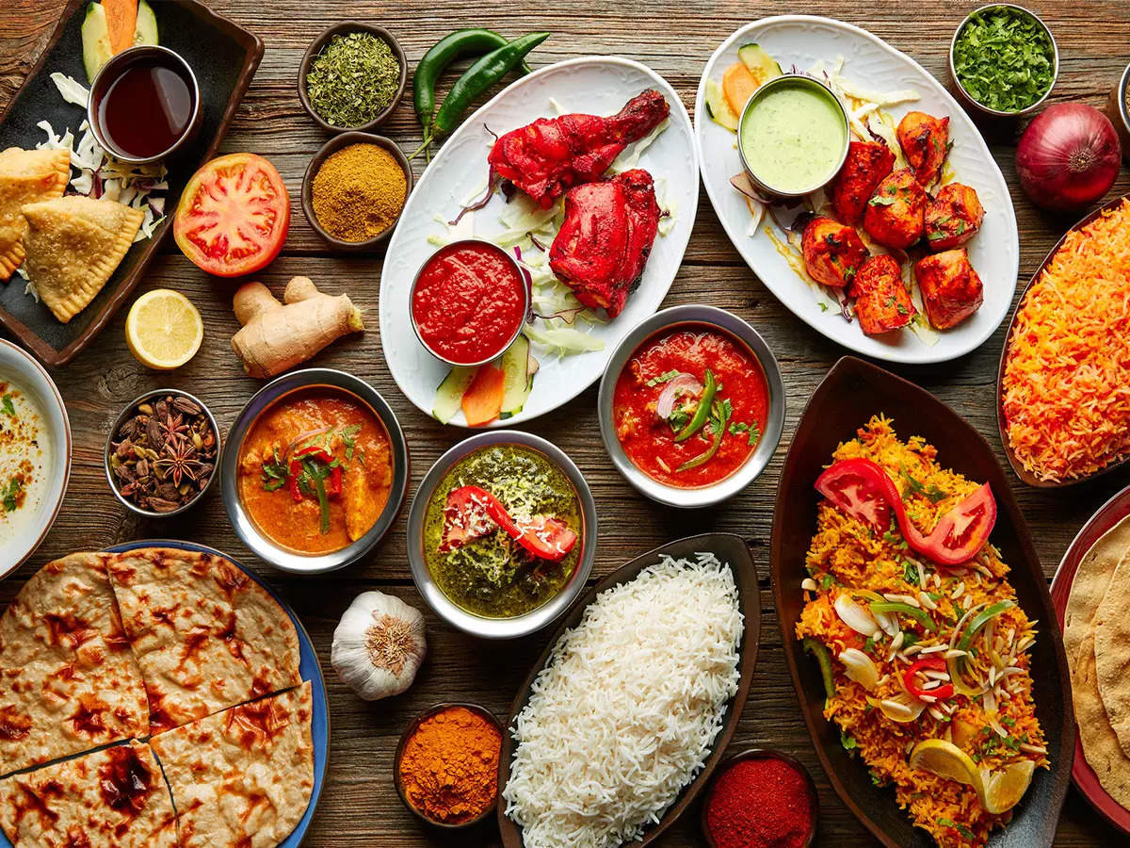
Fig.1.1
(This pic is showing various types of Indian food)
1.1: Steps were taken by a 5-star hotel to conserve the water
Every year, World Water Day highlights the importance of water in our lives and how we can manage every water resource.
There are 7 steps taken by a 5-star hotel to save water;
Step 1: - Establishing a water management plan
Step 2: - Create a plan for each location
Step 3: - Manage and reduce water use
Step 4: - Training staff
Step 5: - Maintaining proper functioning facilities
Step 6: - optimizing the use of the system
Step 7: - Raising awareness among customers

1.2: Indian Food Basics
You don’t know a lot about Indian food, especially if you've only eaten at restaurants. Indian cuisine has evolved over thousands of years. It is the ultimate symbol of Indian culture's ability to absorb other influences and assert itself. Indian cuisine has honed the delicate and sometimes complex art of blending spices to perfection. Indian cuisine is perhaps most beautifully presented with fresh vegetables and fruits prepared in a variety of ways to preserve freshness and nutrition. Traditional Indian cuisine mostly uses fresh ingredients and prepares our food from scratch. That means less preservatives and healthier food. Indian cuisine uses spices such as turmeric, ginger, garlic and green chillies, all of which have medicinal and healing properties. The traditional Indian diet contains all the elements necessary for a balanced diet, including carbohydrates, proteins, fats, and fibre.

1.3: Myth: Indian food is all hot and spicy
It is not true that Indian food is always hot and spicy. Spices are used in Indian cuisine, but not the spices make the food spicy. Chillies (which add spiciness to the dish) are a matter of taste and can be omitted in most recipes.

1.4: Myth: All Indian Food is Fatty and Unhealthy
Secondly, not all Indian dishes contain 10 (or 3, 4, 5) different spices. Over the years, culinary evolution has produced dishes in which the main ingredient is beautifully complemented by just one key spice.
Again, this is incorrect and would be like saying that all Italian food contains pasta, or that Chinese food contains soya sauces. I want to put it in Prepare a dish with 6 tablespoons of oil, or 2 tablespoons if you prefer. Indian cuisine, like any other cuisine, has decadent and "sinful" dishes.
From a health standpoint, you may be surprised at the diversity of Indian vegetables that are part of Indian cuisine. Many recipes also include medicinal and healing spices such as turmeric, ginger, garlic, and green chillies. Apply different cooking methods to these elements, many delicious foods are good for the body as well.
Most of the best Indian chefs recommend using fresh ingredients and cooking from scratch. This is the traditional route, and while it may seem time-consuming, it does not leave your body exposed to the preservatives found in packaged, ready-to-eat foods.

1.5: Myth: All Indian Food is Rich and Diet-Busting
Eating healthy Indian food is all about your choices. No one can force you to eat more chocolate than you want. Given how tempting they are, says Easy is hard to do!
1.6: Myth: All Indian food is difficult to cook
Many Indian dishes are easier to make than you think. Discover recipes for some of our most popular yet easy-to-make dishes like tandoori chicken and marble paneer (peas and cottage cheese). These are just a few examples of Indian dishes that are delicious, quick, and easy to prepare.
1.7: Myth: All Indian food contains curry powder
"Curry" is synonymous with Indian cuisine, and "curry powder" is considered the main ingredient in any dish. This could not be further from the truth. Curry powder is not found in authentic Indian cuisine. This is the English arrangement. But there is one more must-have spice mix.
The main ingredient in Indian cuisine is a blend of spices collectively known as garam masala. It is added to some dishes along with other spices to enhance its taste and aroma. Although the basic ingredients used are the same, each household has its proportions, so the results often vary from household to household. The list carries over to the dishes that use it. If you are new to Indian cooking, making your own is intimidating, but all you need is an Indian curry recipe and a good cup of coffee or seasoning.
1.8: Objective of the study
The purpose of this survey is to:
- To identify the various perceptions about Indian cuisine among travellers visiting 5-star hotels.
- To identify the richness of Indian cuisine in different aspects like – Taste, Flavour, and Health concepts.
- To remove misconceptions, about Indian cuisine among travelers visiting in 5-star hotel.
1.9: Sample of the study
The study aims to collect information on perceptions of Indian cuisine among travellers visiting Delhi-NCR.
1.10: limitations of the study
This study cannot be definitive due to its limited sample of travellers visiting 5-star hotels. To collect more information actual about it should be circulated on the worldwide platform for surveying. However, people feel lazy while feeling the survey questions. As we all know, we are always on the phone but it seems that they are less interested in filling out the survey which causes an error in collecting actual data. They may be filled out this survey without reading it, in a hurry, or not having proper knowledge about the survey due to the busy demanding nature of the environment and I also do not have knowledge about creating a proper questionnaire for this.

II: Literature Review
(Chhabra, et al., 2013) examine this study of how Indian Restaurant Debate and Project Authenticity Outside India visited markers in their hotel/eatery experience. He says that online advertising content for North Indian cuisine in the United States uses predefined Authenticity criteria and pre-registration authenticity features. (Antani & Mahapatra, 2022) reiterates that, a socio-historical overview of Indian cuisine and its development. As a complete analysis of various documents, in this research, she focuses on her four eras, each of which had a significant and lasting impact on Indian foods.
(Mukherjee, et al.,2013) have described in this study Asian Indian immigrant perspectives surrounding dietary identifying Targeted interventions for the prevention of diabetes and cardiovascular disease. Their findings include the influence of religion in the responses of respondents in India, the risk of cultural change in American relations, conflict with the next generation first, and a lens that includes both "native" and "host" reveals the reinterpretation of health-related knowledge through a hybrid context.
(Sei, Y.,1998) says in this study that, India has its culinary history. Many Indian curries are watery. Most of the liquid is with rice or chapattis. Dal, sambar and rasam are also watery soups. Tomatoes brought to India by the British are often used in Indian cooking.
(Mandal,2020) discussed the localization of Indian cuisine and its impact on customer satisfaction in Taiwan. His three aspects of Indian cuisine were explained. First, let me explain how Indian food is distributed in Taiwan. Second, how Indian food is taken care of and served to local customers. The third dimension represents local customers' perception and satisfaction with Indian Cuisine. It has been observed that the authenticity of Indian cuisine has been greatly diminished to attract locals to the business.
(D’Gama,2010) discussed in this study on the growing number of local Indian restaurants is a testament to the growing Indian food popularity in Australia. In this exploratory qualitative study, restaurant menu representations of his diverse Indian cuisines in Perth. Mostly he focuses on reliability issues
As discussed in this study Indian cuisine is one of the most diverse in the world and is characterized by its delicate and sophisticated use of a variety of spices, vegetables, grains, and fruits grown throughout India. Include a variety of cuisines and cooking methods that reflect the diverse demographics of the ethnically diverse Indian subcontinent. India's religious beliefs and culture have influenced the development of its cuisine over the years. Vegetarianism is widespread among many Hindu, Buddhist, and Jain people.
(Formo,1971) discusses devoted to various oilseed crops. Peanuts are the most important oilseeds, but sesame, canola, mustard, flax, and castor beans are also well-grown and classified as important oilseeds in Indian statistics. Cottonseed and rice bran are gaining momentum as sources of vegetable oils, and various indigenous seeds such as neem, mowa, kusum and sal are touted as sources of non-edible fats for soap making.
(Nilesh, 2019) have focused this research on, there are many variations of Indian cuisine using the same ingredients. India has a wide variety of traditional dishes. All thanks to local spices, herbs, vegetables, and fruits. In this article, he has developed a method to recommend Indian food recipes based on available ingredients and preferred dishes.
(Preez & Govender, 2020) says it is said that India can attract foreign tourists with its mystery, but other considerations come into play when it comes to the Indian diaspora as potential travellers. This study uses forced and free migration in South Africa as an example and quantifies these links and identifies free diaspora tourism products. Recommendation for future research is presented.

III. Research Methodology

3.1: INTRODUCTION
This analysis is a detailed survey located in 5-star hotels. 59 travellers who visit 5-star hotels the survey was conducted from January to May. stratification table Samples were selected as a method of publication and questionnaires were distributed. 59 copies (79.3% male students, 20.7% female students) out of a total of 100 copies.
3.2: RESEARCH DESIGN:
The examination configuration is an end-all strategy determining the strategies and methods for assortment and investigating the required data. It is a structure that designs the activity for the exploration project, just as to manage us in taking care of issues. Because of the high number of respondents who expressed interest, we used a quantitative study to guide this research centre. and where proof is assessed, and speculations are created. As a quantitative report, analysts need to appropriate the poll to respondents to make an end. Information is gathered by utilizing structure, easy-going examination structure and even-handed Results, and less specialist notice is included. What is more, the examination covered a more extensive populace in this way the quantitative technique is more appropriate instead of the subjective strategy where a little example is utilized and includes meet. Along these lines, it will be additional tedious.
3.3 DATA COLLECTION METHODS:
Differentiation of knowledge is an important part of research. Incompatible information may affect test results and ultimately lead to inaccurate results. Data can be described in terms of quantities or terms returned by the variables. Data can be numbers, pictures, words, pictures, facts or ideas. Data cannot be found and must be truncated to important data to extract information from the data. There are many ways to interpret data. Information is generally divided into basic information and additional information.

3.3:1 Primary data collection: First information is noticed or gathered straightforwardly from direct insight. It alludes to that information which is gathered for a particular reason from the field of request and is unique in nature and is more solid, bona fide a goal. For the venture essential information was gathered basically through study strategy, utilizing the apparatus poll. Subsequently, it is legitimacy is more prominent than auxiliary information.
3.3:2 Secondary data collection: Collecting secondary data is data collected from sources that are effectively classified in each model. Information about the situation is used, but the analyst does not see it as expected. When writing research papers for any exam, rely on secondary data, usually from books, Google, research papers, notebooks, and notebooks to expand on the facts of project research.
IV: Data Analysis and Interpretation
Data was collected from a survey conducted among foreign travellers visiting 5-star hotels. I surveyed 100 people in 5-star hotels. I only received 59 surveys. I mentioned above, there are many questions such as age, occupation, and gender, as well as the demographic information I mentioned. Then I focused on the main myth about Indian cuisine among foreign travellers visit in Delhi NCR, such as, it’s saying that Indian food is unhealthy and fatty, it’s said that most Indian dishes are made with curry powder, and is Indian food very costly for foreign travellers visit in a 5-star hotel. Below is my comment on information collected by foreign tourists visiting 5-star hotels.
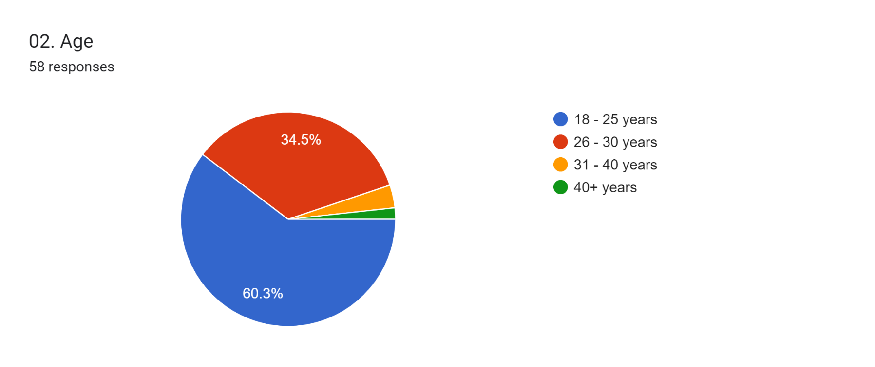
As the graph represents, 60.3% of Travelers aged 18-25
34.5% of travellers are aged 26-30.

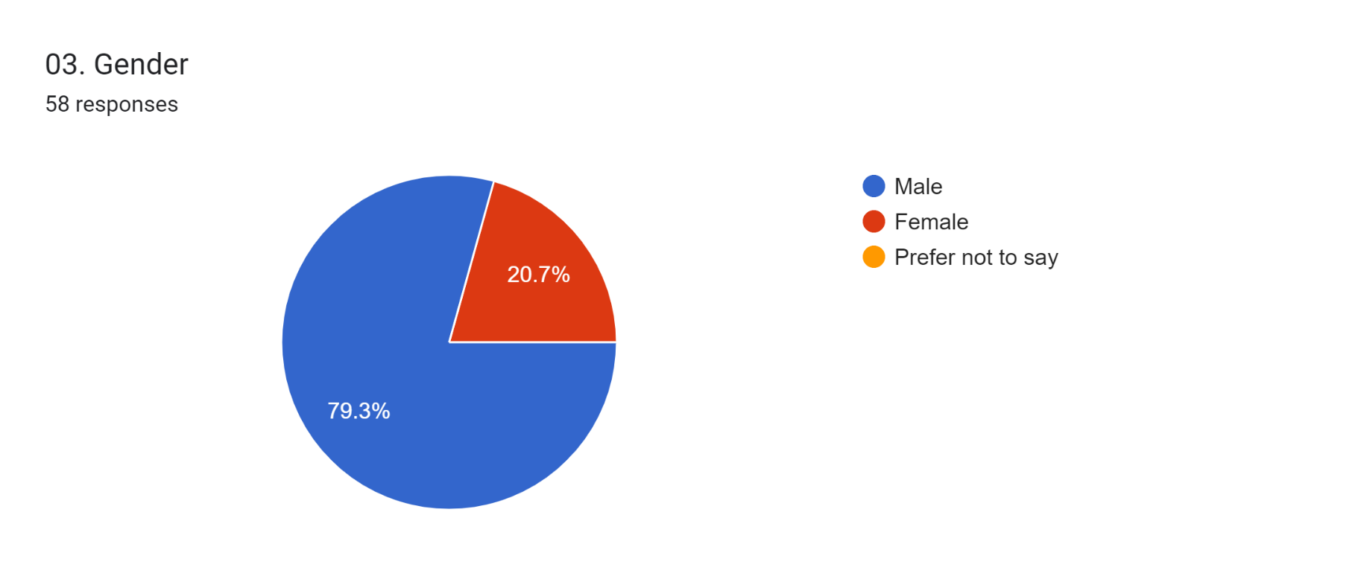
As shown, women are 20.7% and men 79.3%.
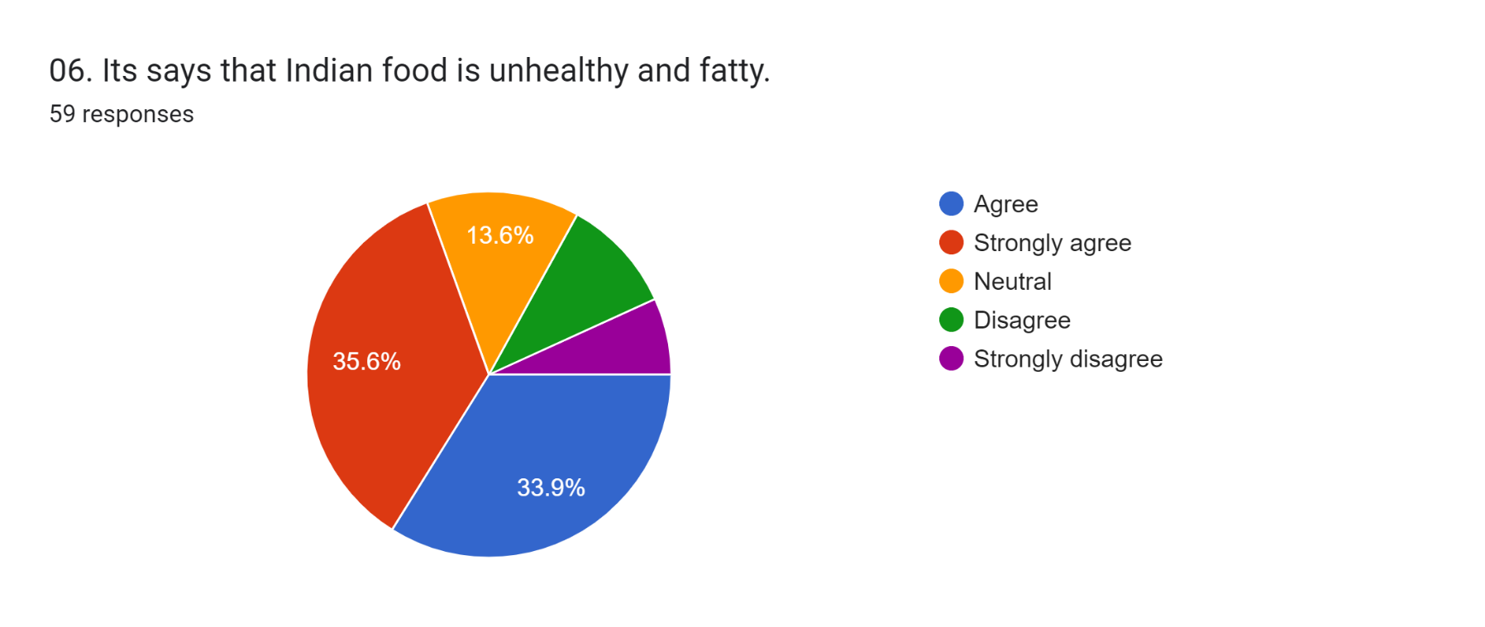
As per the graph, there are 33.9% of travellers agree that Indian foods are unhealthy and fatty, 35.6% of travellers are strongly agreeing with that, and the rest 13.6% are neutral.
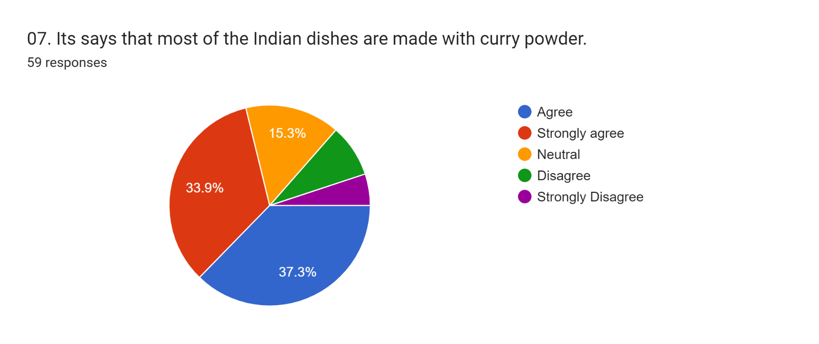
As per the graph, there are 37.3% of travellers agree that Indian dishes are made with curry powder, 33.9% of travellers are strongly agreeing with that, and the rest 15.3% are neutral.
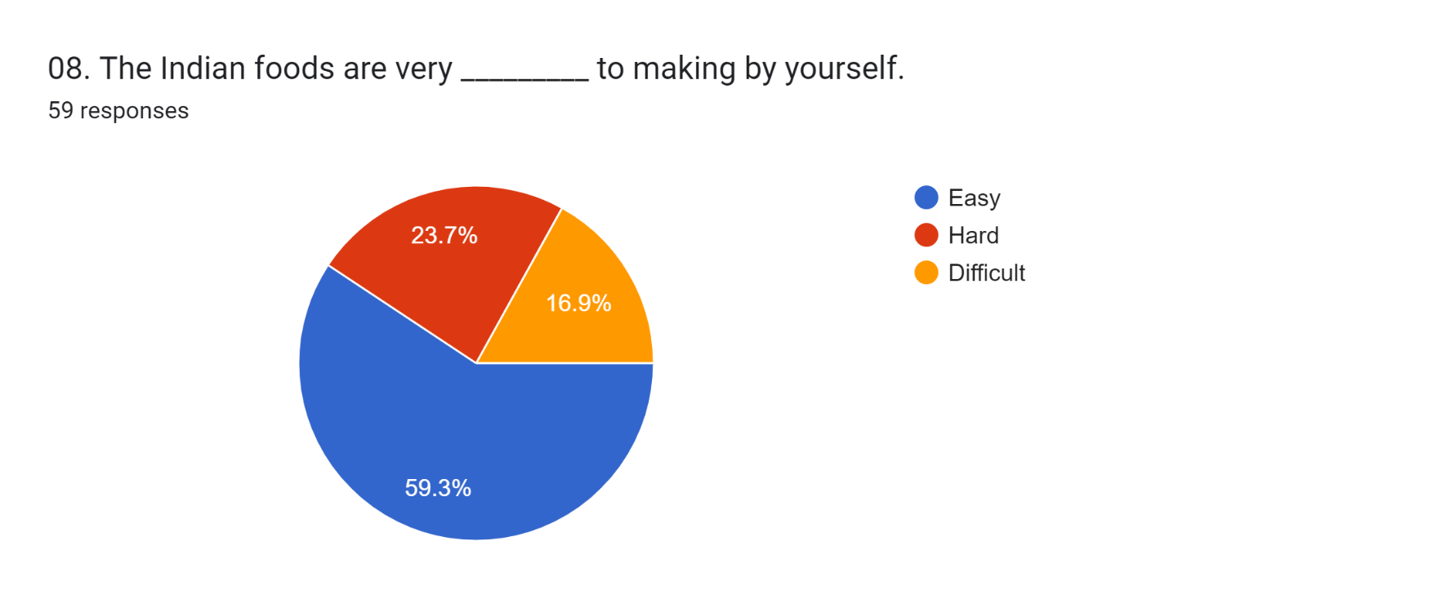
In this pictorial representation, the travellers were asked, if the preparation of Indian foods is easy, hard, or difficult.
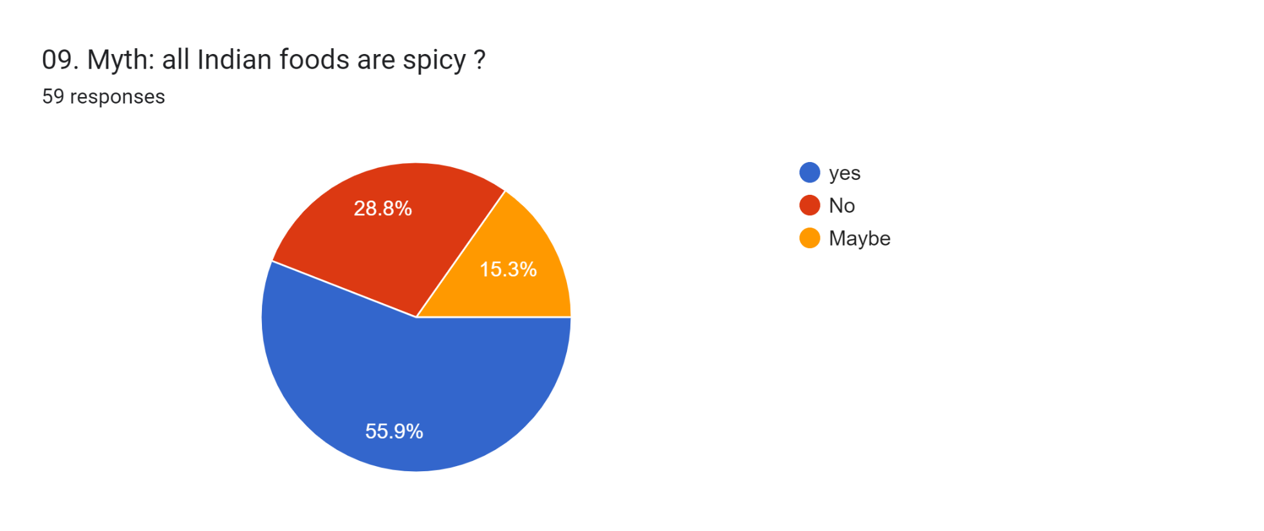
As the graph represents, 55.9% of travellers say that there is a misconception about Indian foods that all Indian food is spicy, 28.8% of travellers said No, and 15.3% of travellers’ say It can be spicy or it can’t be spicy.

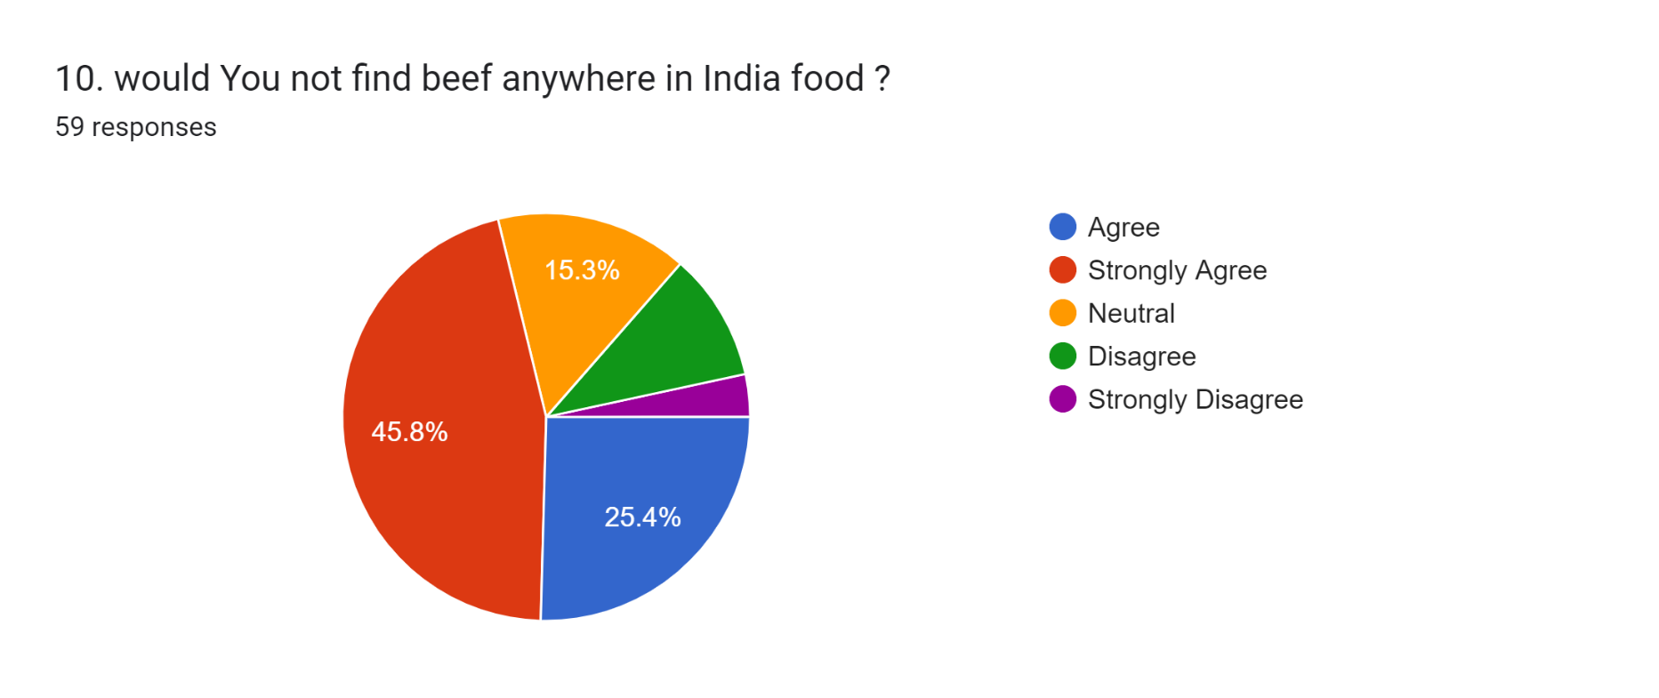
As the graph represents, 25.4% of people agree that you would not find beef anywhere in Indian food, and 45.8% of travellers strongly agreed with that. 15.3% have Neutral.

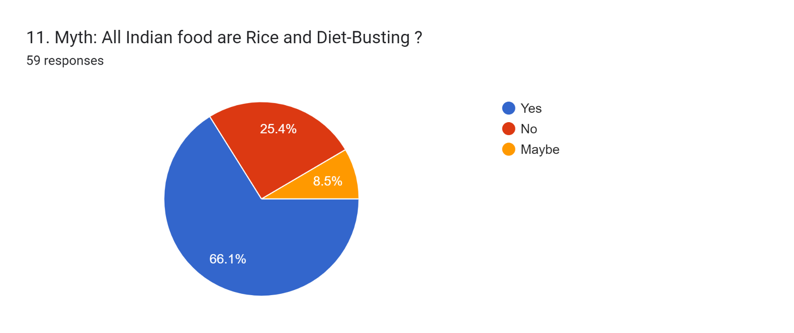
As the graph represents, 66.1% of travellers are agreeing with this Misconception. 25.4% do not agree. 8.5% of travellers are agreeing but are not sure.

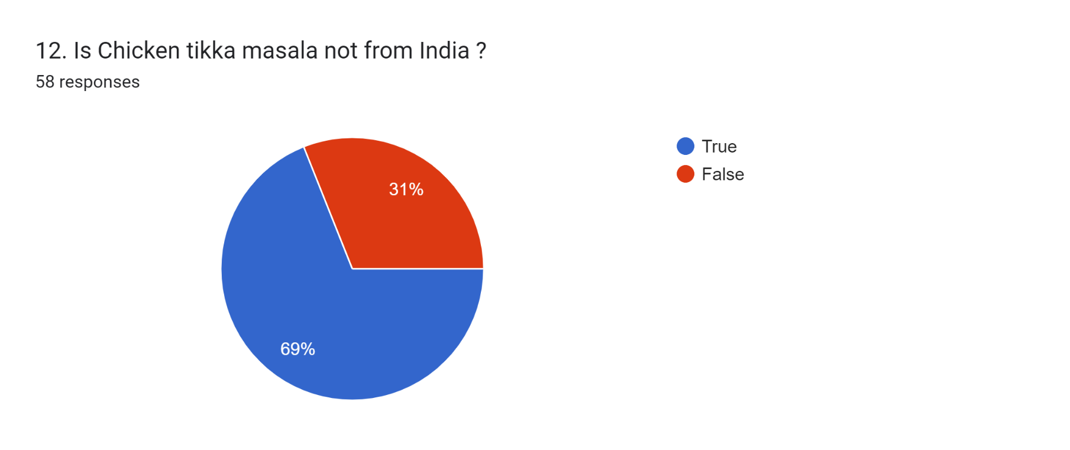
As the graph represents, 69% of travellers said that chicken tikka masala is not from India. 31% of people said it is from India.
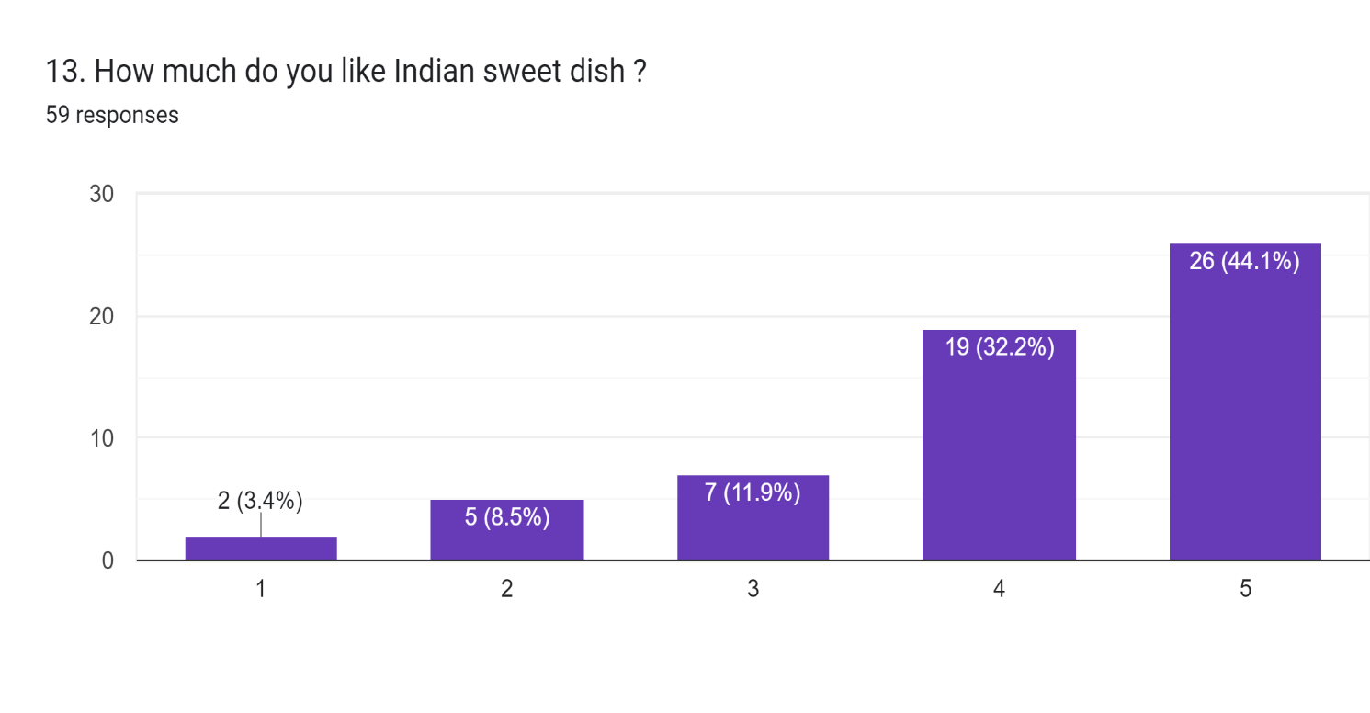
As per the graph, 3.4% of travellers do not like Indian sweet dishes. 8.5% of travellers have given 2 ratings out of 5. 11.9% of travellers have a few Indian sweets. 32.2% have like. 44.1% of travellers’ have so much like Indian sweet dishes.

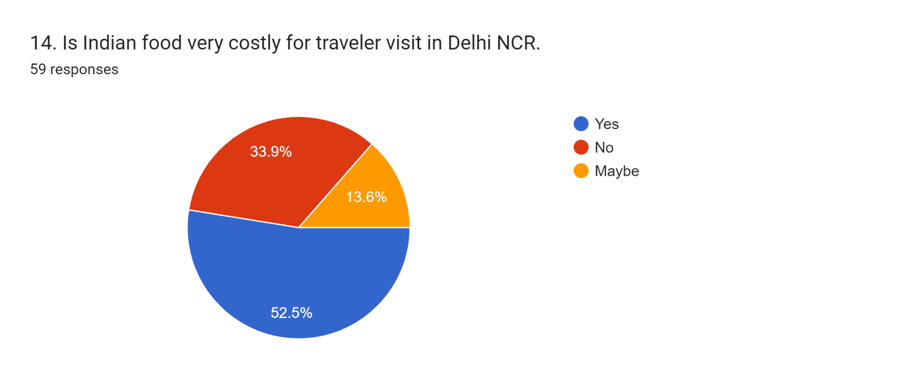
In this pictorial representation, I asked travellers, if Indian foods are very costly. And here is the result.
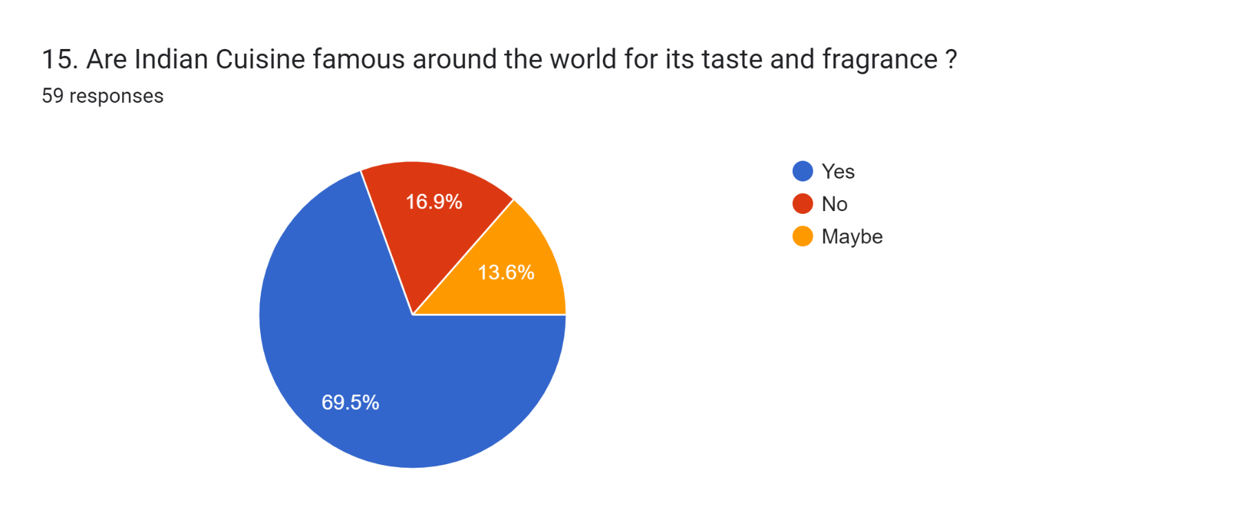

As per the graph, 69.5% of travellers’ said Indian cuisine is famous around the world. 16.9% of travellers have said no it is not famous. And the rest 13.6% have said maybe it’s famous or not.
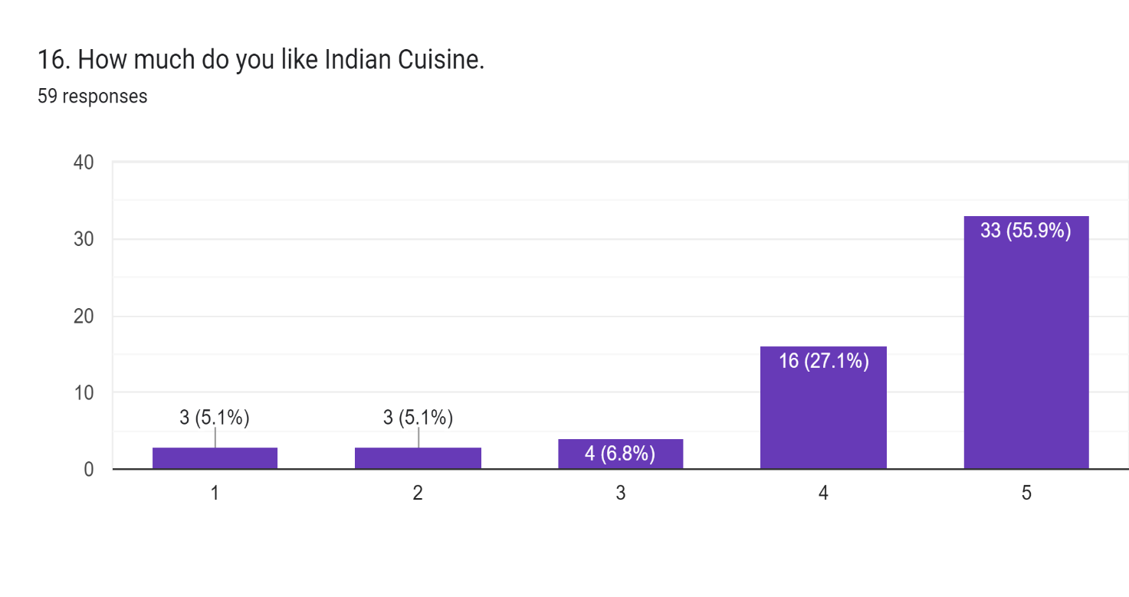

As per the graph, 5.1% of travellers do not like Indian cuisine. 5.1% of travellers have given a 2 rating out of 5. 6.8% of travellers have a little bit of Indian cuisine. 27.1% have like. 55.9% of travellers have so much like Indian sweet dishes.

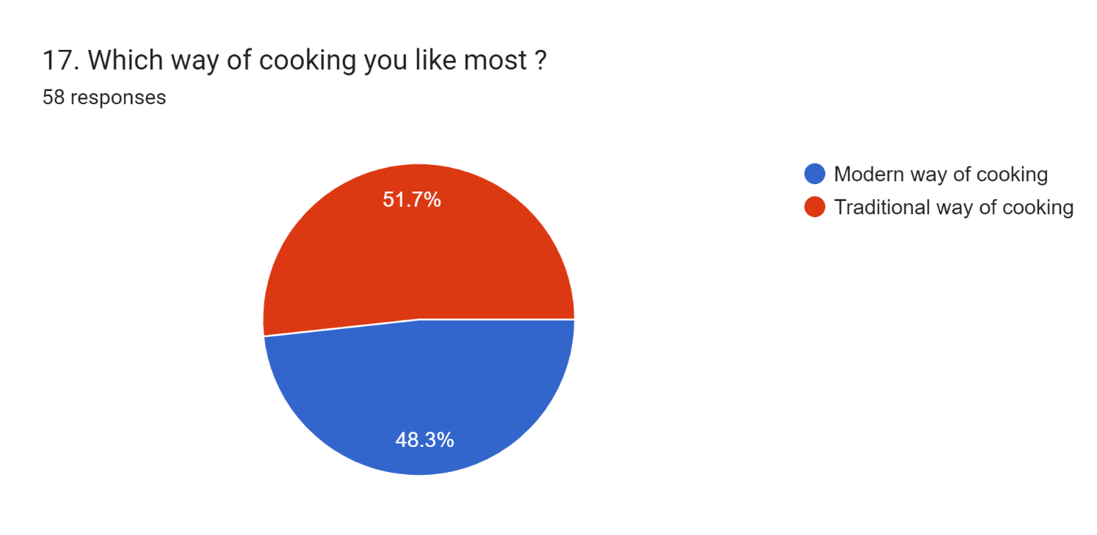

As per the graph, 48.3% of travellers’ have liked the modern way of cooking in India. 51.7% of travellers liked the traditional way of cooking.

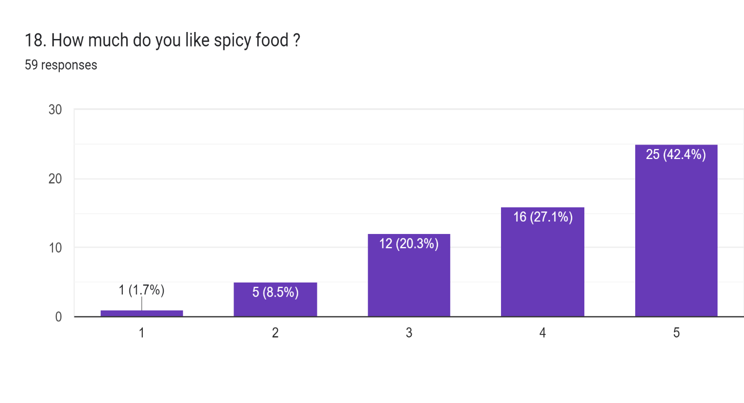

As per the graph, 1.7% of travellers do not like spicy food. 8.5% of travellers have given a 2 rating out of 5. 20.3% of travellers have a little bit of spicy food. 27.1% have like. 42.4% of travellers have so much like spicy foods.

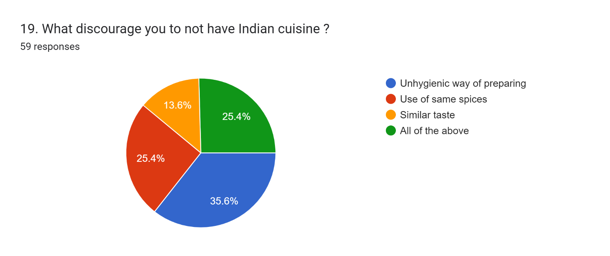
When I asked to the travellers what discourages you do not have Indian cuisine then, 35.6% said the Unhygienic way of preparing food. 25.4% said due to the Use of the same spices in every food. 13.6% said due to similar taste. And 25.4% said due to All of the above.
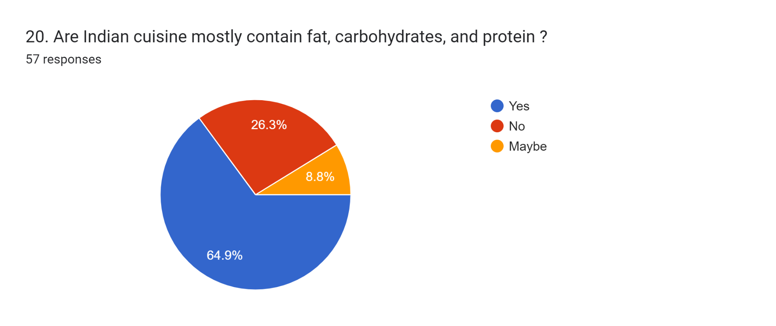
As the graph represents, 64.9% of travellers’ have agreed that Indian cuisine contains fat, carbohydrates, and protein. 26.3% have not agreed. 8.8% of travellers’ have agreed but are not sure.

V: Conclusion

This study was conducted on myths about Indian cuisine among travellers visit in 5-star hotels. 59 travellers (79.3% male travellers, 20.7% female travellers)
This paper provides knowledge about Indian foods to travellers who visit a 5-star hotel. It has only listed 5 major perceptions about Indian cuisine, among the travelers who visit in 5-star hotel. In this study, there is a lot you do not know about Indian food, especially if you have only eaten in a restaurant. Indian cuisine has evolved over thousands of years. It is the ultimate symbol of Indian culture's ability to absorb other influences and assert itself. Indian cuisine masters the subtle and sometimes complex art of perfectly blending spices. Indian cuisine is perhaps most beautifully presented with fresh vegetables and fruits prepared in a variety of ways to preserve freshness and nutritional value. Traditional Indian cuisine mostly uses fresh ingredients and prepares food from scratch. The traditional Indian diet contains all the elements necessary for a balanced diet, including carbohydrates, proteins, fats and fibre.
Indian cuisine is one of the most famous cuisines in the world. This dish is highly appreciated not only in the country of India, as well as the general public in the regions of North America, Europe, Australia and Africa.
Indian cuisine is famous in Southeast Asia due to its strong historical influence on the national cuisine of the region. The influence of Indian cuisine on Malaysian cooking styles dates back to the 19th century. The spread of vegetarianism to other parts of Asia is often linked to the Buddhist practices of ancient India. Indian cuisine is also popular in the Arab world due to its similarities and influences with Arab cuisine. Curry is a popular dish in East Africa, introduced by Indian immigrants during the colonial era. Indian immigrants brought the cuisine to South Africa in the 19th century.

Reference
Chhabra, D., Lee, W., Zhao, S., & Scott, K. (2013). Marketing of ethnic food experiences: Authentication analysis of Indian cuisine abroad. Journal of Heritage Tourism, 8(2-3), 145-157.
Jain, A., & Bagler, G. (2015). Spices form the basis of food pairing in Indian cuisine. arXiv preprint arXiv:1502.03815.
Antani, V., & Mahapatra, S. (2022). Evolution of Indian cuisine: a socio-historical review. Journal of Ethnic Foods, 9(1), 15.
Mann, S. K., Roberts, L. R., & Montgomery, S. (2017). Conflicting cultural values, gender role attitudes, and acculturation: Exploring the context of reproductive and mental health of Asian-Indian immigrant women in the US. Issues in mental health nursing, 38(4), 301-309.
Jain, A., & Bagler, G. (2018). Culinary evolution models for Indian cuisines. Physica A: Statistical Mechanics and its Applications, 503, 170-176.
Mandal, A., & Tsai, Y. H. (2020). TASTE OF INDIA: A CASE STUDY OF INDIAN CUISINE IN TAIWAN. International Journal of Organizational Innovation, 13(2).
Ravindran, A., Jayashree, E., & Anees, K. (2022). Post-harvest processing, chemistry and culinary applications of major spices used in south Indian cuisines. The Pharma Innovation Journal, 11(2), 2429-2441.
SELVAMANI, M. K. Role of Indian Cuisine in International Culinary.
Espinet, R. (1994). Indian Cuisine. The Massachusetts Review, 35(3/4), 563-573.

Formo, M. W. (1971). The oilseed industry of India—potential for food use of proteins. Journal of the American Oil Chemists' Society, 48(10), 619-624.

Dalal, J., Murzello, F., Kadam, S., & Patade, S. (2020, April). A Review: Recommendation System of Indian Cuisine Recipes Using Content-Based Approach. In Proceedings of the 3rd International Conference on Advances in Science & Technology (ICAST).
Dubey, K. G. (2010). The Indian cuisine. PHI Learning Pvt. Ltd.

Mangalassary, S. (2016). Indian cuisine—the cultural connection. Indigenous Culture, Education and Globalization: Critical Perspectives from Asia, 119-134.

