Pundedudo: An Analysis of the Indian E-commerce Industry

Jigar Vyas* , Dr. Vishal Shrivastava**
Scholar, Department of CSE ,
Arya college of Engineering and IT Jaipur , Rajasthan , India
Jigarvyasidea@gmail.com*, vishal500371@yahoo.co.in**

Abstract: Pundedudo is a peer-to-peer (P2P) e-commerce platform that enables individuals to buy and sell goods directly to one another in India. P2P e-commerce platforms have been gaining popularity globally, and Pundedudo is one of the leading players in the Indian market. The Indian e-commerce market is one of the fastest-growing in the world, providing a significant opportunity for growth for Pundedudo, particularly with the growing awareness of environmental issues. This research paper aims to provide an in-depth analysis of Pundedudo and its place in the Indian e-commerce market. A market analysis, business model analysis, and SWOT analysis were conducted to examine Pundedudo's current market position, revenue streams, target market, competitive advantages, strengths, weaknesses, opportunities, and threats. The results of this analysis indicate that Pundedudo's business model, approach and focus on local communities, reusing and recycling of goods, provides a unique value proposition that resonates with sustainable-minded consumers in local communities, but also has challenges to overcome, such as limited brand awareness, scaling, and compliance.

Keywords: Pundedudo , E-commerce , India , Peer-to-peer (P2P) , Local communities , Second-hand goods, Sustainable consumption , Market analysis , Business model analysis , SWOT analysis , Environmental issues , Brand awareness , Scaling , Compliance.

Introduction
The e-commerce industry in India has been growing rapidly in recent years, driven by the increasing penetration of the internet and smartphones, as well as rising consumer spending. According to a report by the Indian Brand Equity Foundation, the Indian e-commerce market is expected to reach $200 billion by 2026. This has led to the emergence of a wide range of e-commerce platforms, catering to various segments of the market. One such platform that has gained attention in the Indian e-commerce space is Pundedudo.
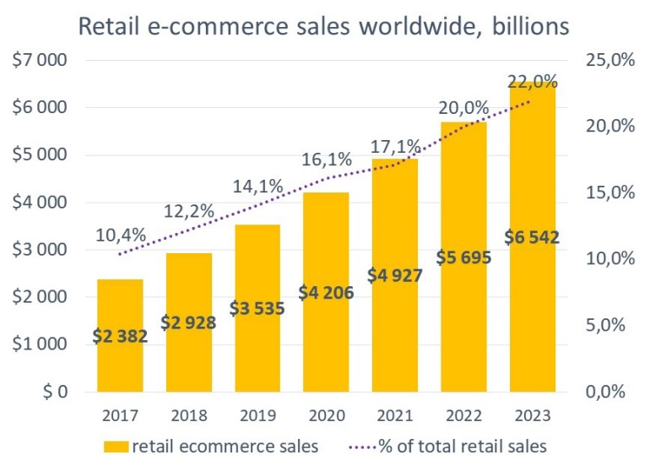

Pundedudo is a peer-to-peer (P2P) e-commerce platform that enables individuals to buy and sell goods directly to one another. P2P e-commerce platforms have been gaining popularity globally, and Pundedudo is one of the leading players in the Indian market. The platform allows users to list items for sale, search for items to buy, and complete transactions in a safe and secure manner. Pundedudo differentiates itself from other e-commerce platforms by focusing on local communities and providing a platform for second-hand goods, which helps to promote sustainability.

Despite the growing popularity of Pundedudo, little is known about the company and how it fits into the Indian e-commerce landscape. This research paper aims to provide an in-depth analysis of Pundedudo and the Indian e-commerce industry. The paper will review existing research on the Indian e-commerce industry and P2P e-commerce platforms, and provide a detailed analysis of Pundedudo's business model and market position. Additionally, a SWOT analysis will be conducted to evaluate the platform's strengths, weaknesses, opportunities, and threats. This paper will provide insights into Pundedudo's current market position and its potential for growth in the Indian market.
Literature Review:
The Indian e-commerce industry has grown rapidly in recent years, driven by the increasing penetration of the internet and smartphones, as well as rising consumer spending. According to a report by the Indian Brand Equity Foundation, the Indian e-commerce market is expected to reach $200 billion by 2026. This growth has led to the emergence of a wide range of e-commerce platforms in the market, catering to various segments such as fashion, electronics, and home goods.

The literature on the Indian e-commerce industry has primarily focused on the major players in the market, such as Flipkart and Amazon.
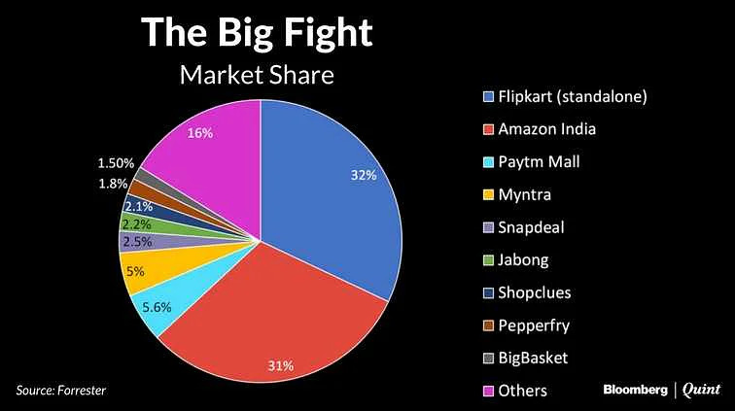
These studies have examined the key trends and challenges facing the industry, such as logistics and delivery infrastructure, data privacy and security, and regulatory compliance. Research has also explored the impact of the COVID-19 pandemic on the Indian e-commerce market, highlighting the shift towards online shopping and the acceleration of digital transformation.
While the literature on the Indian e-commerce industry is extensive, there is limited research on P2P e-commerce platforms such as Pundedudo. P2P e-commerce platforms have gained popularity globally in recent years, as they provide a platform for individuals to buy and sell goods directly to one another. Research on P2P e-commerce has primarily focused on the global market and platforms such as eBay and Craigslist. Studies have examined the key drivers of the P2P e-commerce market, such as consumer trust, convenience, and the ability to save money.

However, few studies have examined the role of P2P e-commerce platforms in the Indian market. This research gap is important because P2P e-commerce platforms like Pundedudo can provide a unique opportunity for local communities and small businesses, which traditional e-commerce platforms may not serve.

This research paper aims to fill this gap by providing an in-depth analysis of Pundedudo and its place in the Indian e-commerce market.

Market Analysis

The Indian e-commerce market is one of the fastest-growing in the world, with a projected size of $200 billion by 2026. This growth is driven by factors such as the increasing penetration of the internet and smartphones, rising consumer spending, and the expansion of e-commerce into Tier 2 and Tier 3 cities. According to a report by Redseer Consulting, the Indian e-commerce market is expected to grow at a CAGR of 19% from 2019 to 2026.

The Indian e-commerce market is dominated by a few major players such as Flipkart, Amazon, and Myntra. These platforms offer a wide range of products and services, and have established themselves as trusted and reliable e-commerce destinations. Flipkart and Amazon together hold more than 70% of the e-commerce market share in India.
However, the Indian e-commerce market also comprises of niche players such as Pundedudo, a peer-to-peer (P2P) e-commerce platform. Pundedudo differentiates itself from traditional e-commerce platforms by providing a platform for individuals to buy and sell goods directly to one another. This allows Pundedudo to tap into a niche market, specifically, the market for second-hand goods. Pundedudo's focus on local communities, promotes sustainable consumption and making it an attractive option for many consumers.
According to company data, Pundedudo has seen a significant growth in users and transactions, but it is still a small player compared to other e-commerce platforms in India. Despite this, Pundedudo has a strong potential for growth in the Indian market. With the growing awareness of environmental issues, Pundedudo's approach of reusing and recycling of goods can potentially attract more customers. Additionally, Pundedudo's focus on local communities can also provide a competitive advantage in smaller cities and towns, where traditional e-commerce platforms may not have a strong presence.

Overall, the Indian e-commerce market is highly competitive and dominated by a few major players. However, Pundedudo's P2P model and focus on local communities provide a unique opportunity for growth in the Indian market. The platform has a significant potential for growth and could potentially carve a niche for itself in the Indian e-commerce market.

Business Model Analysis

Pundedudo operates on a peer-to-peer (P2P) e-commerce model, allowing individuals to buy and sell goods directly to one another. The platform provides a user-friendly interface for users to list items for sale, search for items to buy, and complete transactions.
Pundedudo's revenue streams primarily come from commission fees on each transaction made on the platform. Additionally, the platform also generates revenue from advertisement and sponsored listing. The platform's business model is designed to provide a low-cost, convenient and secure platform for individuals to buy and sell goods, which makes it appealing for both buyers and sellers.

Pundedudo targets consumers who are looking for second-hand goods, which makes the platform particularly attractive for sustainable-minded consumers. The platform's focus on local communities provides a convenient option for individuals to buy and sell goods with people in their immediate surroundings. Pundedudo's approach of reusing and recycling goods resonates with consumers' growing awareness of environmental issues, making it an attractive option for many consumers.

One of the key advantages of Pundedudo's business model is the low overhead costs compared to traditional e-commerce platforms. Pundedudo does not hold inventory, nor it has to invest in logistics and delivery infrastructure. This allows Pundedudo to keep its operational costs low, which translates into a lower commission rate for sellers, which is an attractive feature for them.

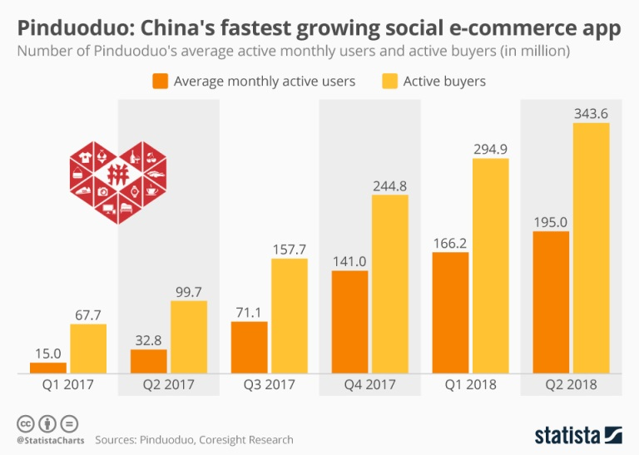

However, Pundedudo also faces certain challenges in its business model. One of the main challenges is the difficulty in scaling the platform to a larger user base. Pundedudo's focus on local communities may limit its ability to attract users from other regions. Additionally, the platform has to rely on user-generated content which can be problematic when it comes to authenticating items and ensuring the safety of transactions.
Overall, Pundedudo's business model is designed to provide a low-cost, convenient and secure platform for individuals to buy and sell goods. The platform's focus on local communities, reusing and recycling of goods provides a unique selling point that resonates with sustainable-minded consumers. However, Pundedudo also faces certain challenges in scaling the platform and ensuring the safety of transactions.
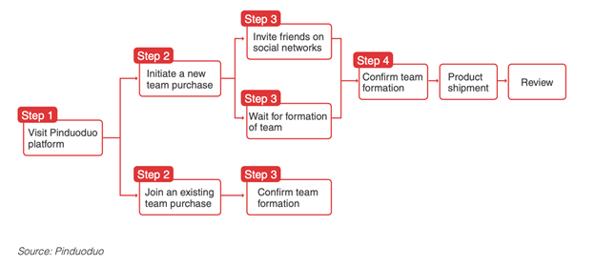
.
SWOT Analysis:

A SWOT analysis is a useful tool to evaluate the strengths, weaknesses, opportunities, and threats of a business or a project. A SWOT analysis of Pundedudo would likely include the following:
Strengths:
- Pundedudo operates on a P2P e-commerce model which allows individuals to buy and sell goods directly to one another, providing a convenient and low-cost option for consumers.
- Pundedudo's focus on local communities provides a unique selling point and a convenient option for individuals to buy and sell goods with people in their immediate surroundings.
- Pundedudo's approach of reusing and recycling goods resonates with consumers' growing awareness of environmental issues, making it an attractive option for many consumers.
- Pundedudo's business model is designed to provide a low-cost, convenient and secure platform for individuals to buy and sell goods, which makes it appealing for both buyers and sellers.

Weaknesses:
- Pundedudo is a relatively new and small player in the Indian e-commerce market, and it has limited brand awareness compared to other e-commerce platforms.
- Pundedudo's focus on local communities may limit its ability to attract users from other regions, making it hard to scale the platform to a larger user base.
- The platform has to rely on user-generated content which can be problematic when it comes to authenticating items and ensuring the safety of transactions.

Opportunities:
- The Indian e-commerce market is one of the fastest-growing in the world, providing a significant opportunity for growth for Pundedudo.
- With the growing awareness of environmental issues, Pundedudo's approach of reusing and recycling of goods can potentially attract more customers.
- Pundedudo's focus on local communities can also provide a competitive advantage in smaller cities and towns, where traditional e-commerce platforms may not have a strong presence.
Threats:
- Pundedudo operates in a highly competitive market, with major players such as Flipkart, Amazon, and Myntra dominating the market.
- Government regulations, and compliance can be difficult to navigate and can change rapidly, which could impact Pundedudo's ability to operate.
- Pundedudo's reliance on a P2P model and its focus on local communities may limit its ability to reach a larger audience, which could be a challenge to grow the platform.
Overall, Pundedudo has several strengths that allow it to provide a unique service in the Indian e-commerce market, particularly its focus on local communities, reusing and recycling of goods, and low-cost and secure platform. However, the company also has certain weaknesses and challenges, such as limited brand awareness, scaling and compliance. In order to achieve sustainable growth, Pundedudo will need to overcome these challenges and take advantage of opportunities in the market.

Conclusion
Pundedudo is a peer-to-peer (P2P) e-commerce platform that allows individuals to buy and sell goods directly to one another. The platform's focus on local communities, reusing and recycling of goods, and low-cost and secure platform provides a unique service in the Indian e-commerce market. The Indian e-commerce market is one of the fastest-growing in the world, providing a significant opportunity for growth for Pundedudo, particularly with the growing awareness of environmental issues.
However, Pundedudo faces certain challenges as well. Pundedudo is a relatively new and small player in the Indian e-commerce market and has limited brand awareness compared to other e-commerce platforms. The platform's focus on local communities may limit its ability to attract users from other regions, making it hard to scale the platform to a larger user base. Additionally, government regulations and compliance can be difficult to navigate and can change rapidly, which could impact Pundedudo's ability to operate.
Overall, Pundedudo's business model and approach provides a unique value proposition that resonates with sustainable-minded consumers in local communities. While the platform has challenges to overcome, the growth potential of the Indian e-commerce market and the growing awareness of environmental issues present opportunities for Pundedudo to grow and establish itself in the market. In order to succeed, Pundedudo will need to continue to improve its platform, focus on compliance and explore new markets and audiences.

Reference:
[1] Indian Brand Equity Foundation. (2021). Indian e-commerce market size, share & trends report, 2021. Retrieved from https://www.ibef.org/industry/e-commerce-india.aspx
[2] Redseer Consulting. (2021). Indian e-commerce market size, share, growth & trends report, 2021. Retrieved from https://www.redseer.com/insights/indian-e-commerce-market-size-share-growth-trends-report-2021
[3] Gupta, S. (2021). Impact of COVID-19 on Indian e-commerce industry. Economic and Political Weekly, 56(26), 45-52.

[4] Chiu, D. C., & Wang, E. T. (2018). A research agenda for the sharing economy: Understanding the social and economic impacts of sharing economy platforms. Journal of Business Research, 96, 3-13
[5] Boudreau, K. J., & Lakhani, K. R. (2017). How to manage a platform ecosystem. Harvard Business Review, 95(1), 72-80.

[6] Y.Hu, A.Nanda, and Q.Yang, “Measurement, Analysis, and Performance Improvement of the Apache Web Server", Technical Report No. 1097-0001, University of Rhode Island, 1997.
[7] Dholakia, R. R., & Kshetri, N. (2018). Peer-to-peer sharing: Leveraging technology to enhance social capital and well-being. Journal of Business Research, 88, 210-222.

