THE IMPACT OF COVID-19 ON MYANMAR TOURISM

NAY MYO HTUN
2nd Year, MA Economics, JAIN (Deemed-to-be University)
Bengaluru, India
Naymyohtun197@gmail.com

ABSTRACT

COVID-19 spread all over the world. Almost all the business sectors of the world are affected by this global pandemic. Tourism sector is not a single industry, but it is connected with many other industries directly or indirectly. Tourism sector is important for Myanmar because this sector contributes GDP for the country. This research paper points out the tourism sector of Myanmar and the impact of COVID-19 on tourism sector. In this paper, the difference between the number of international visitors and impacts on Myanmar Tourism sector are mentioned. This research paper gave the recommendations to rescue the tourism sector.
Keywords: Tourism, economy, COVID-19

- INTRODUCTION

Myanmar is known as the Golden Land for its glittering pagodas and other tourist destinations, situated in Southeast Asia. Myanmar is also the developing country and attempts to develop every sector and tourism is also one of the developing sectors in Myanmar. Myanmar also possess great tourist potential and attractions. Although the tourism sector has been developed by the military governments since 1992, the number of visitors to Myanmar was small compared to the neighbours. After the junta has transferred the power to the civilian government in 2011, the tourism sector gradually increased. Tourism sector has been promoted by advocacy groups as a method of providing economic benefit to Myanmar civilians and during the civilian government has been continuously promoting the tourism sector.
The novel coronavirus or COVID-19 occurred in December 2019 in Wuhan, People Republic of China. All the sectors throughout the world are affected by this COVID-19. People cancelled the trips, flights and hotel bookings and postponed the events. The travel restrictions of the international, regional and local immediately affected national economics, including tourism systems. The first case of COVID-19 in Myanmar occurred in Myanmar on March 23, 2020. The government imposed travel restrictions: international travel, domestic tourism and closing borders. And air transport, cruises, public transport, café, restaurants, conventions, festivals, meetings, culture and sport events are also prohibited to operate because of COVID-19. Although other sectors are trying to recover the damages or losses through online, the tourist destinations have to be still closed. So, it impacted on the tourism sector of Myanmar.

- Research Questions
- How did Tourism sector impact on Myanmar economy?
- How did COVID-19 impact on Myanmar Tourism?
- How did COVID-19 impact on foreign tourists’ arrival?

- Objectives
The objectives of the paper are
- To analyze the impact of COVID-19 on Myanmar Tourism and
- To promote Myanmar tourism in new normal.

- LITERATURE REVIEW

The word “tour” came from Old French “tor, tourn” which is a turn, trick, round, from “torner, tourner "to turn" and sense of "a continued ramble or excursion" is from 1640s. (Harper, n.d.)
The UNWTO defines Tourism is a social, cultural and economic phenomenon which entails the movement of people to countries or places outside their usual environment for personal or business/ professional purposes. These people are called visitors (which may be either tourists or excursionists; residents or non-residents) and tourism has to do with their activities, some of which involve tourism expenditure. (UNWTO)
Tourism is one of the world’s fastest growing industries and also the source of foreign exchange and employment when it closely linked to the social, economic, and environmental well-being of many countries, especially developing countries, like Myanmar. Tourism sector is one of the SDGs, Decent Work and Economic Growth according to United Nations, Department of Economic and Social Affairs. (United Nations, Department of Economic and Social Affairs)
In the work “The impact of COVID-19 on tourism sector in India” by Jaipuria (2021), the authors mentioned the three objectives which are predicting the number of foreign tourist arrivals, particularly in India using ANN model, analysing the impact of COVID-19 on tourism in terms of loss and gain in FEE, and suggesting the appropriate theoretical and managerial implications. The authors used Artificial Neural Network (ANN) model to predict the impact of the epidemic outbreak COVID-19 on India’s foreign tourists’ arrival and the loss of Foreign Exchange Earnings (FEE) considering the exchange rate and tourists’ number. And monthly data of foreign tourists’ arrival from different countries to India from 30th April 1989 to 31st March 2020 (369 months) are used in that paper. The data in that paper are obtained from the Centre for Monitoring Indian Economy and the monthly foreign exchange earnings from tourism are collected from January 1993 to March 2020. This study had significant theoretical and managerial implications. The total contribution of travel and tourism to India’s GDP from 2018 is USD 247.37 billion, and 2019 is USD 268.29 billion. The predicted employment loss in the travel and tourism industry due to COVID19 in India is 9 million. In this study, the authors predicted the number of foreign tourists and its impact on the generated FEE. From the study, the major theoretical implication exhibited is that if the policies in the tourism sector are not restructured, then the FEE will fall below USD 1790.53 million and maybe entirely lost to the economy. If it is managed at some level, then the FEE value will be at least USD 13351.07 million. (Jaipuria, 2021)
Lee-Peng Foo (2021) in the study “The impact of COVID-19 on tourism industry in Malaysia” pointed out a brief overview of the COVID-19 pandemic and the impacts on Malaysia’s tourism industry and the economic stimulus package. The authors used the secondary data from the government websites and WHO. This study pointed out the impact on airlines, hotel businesses. For the impact of hotel businesses, workers in the hotel industry in Kuala Lumpur have been the worst hit by the COVID-19. According to this study, from a sample size of 17,826 workers, 542 workers, equivalent to 3%, had been laid off and 3641 (20%) workers had been asked to take unpaid leave and 2880 (16%) workers had faced pay cuts. And this study also mentioned Malaysia’s economic stimulus package which is expected to assist the tourism industry to sustain throughout this challenging period. (Lee-Peng Foo, 2021)
In the study “Tourism recovery strategy against COVID-19 pandemic”, Shih-Shuo Yeh (2021) pointed out Disaster Management, Interdisciplinary Approaches and recent outbreak of pandemic. This paper uses a qualitative research method to examine the TCDM during the current crisis. Interviews were conducted and transcribed. The text-based data was analyzed by using SPSS modeler 14.1. The data in this paper are primary data and also secondary data. This paper mentioned the effect of COVID-19 on a wide range of tourism-related businesses, some of them suffered the loss of customers which may cause unemployment. (Shih-Shuo Yeh, 2021)
There are types and many forms based on the purpose of visit in tourism. Types of tourism can be categorized into international and domestic tourism. When the people visit foreign countries, it can be called international tourism. Under international tourism, there are two types: inbound tourism and outbound tourism. If tourists of outside origin enter a particular country or travelling outside their host/ native country to another country, is called inbound tourism for the country where they visit. For example, a tourist of Indian origin travels to Myanmar; it is inbound tourism for Myanmar. When the tourists travel to a foreign country, it is the outbound tourism for his/her own country. And domestic tourism is the tourism activity of the people within their own country.

- Background of Myanmar
There is a country in Southeast Asia known as the Golden Land called MYANMAR (formerly known as Burma). Myanmar is one of the last countries of Asia to be revealed to the travelling the world and the largest country in mainland Southeast Asia. It is located between the two powerful countries, China and India and also border with those countries and also with Bangladesh, Laos and Thailand. Myanmar has the total area of 677,000 square kilometers. The population of the country is estimated at 51.14 million according to 2019 Inter- Censual Survey Provisional Result.
On January 4, 1948, Myanmar got its independence. In 1962, there was a military coup by General Ne Win. Myanmar followed the Socialism but with Burmese Way to Socialism by 1974 Constitution. In 1988, the military formed State Law and Order Restoration Council led by General Saw Maung. The country’s name was also changed from Burma to Myanmar in 1989. In 1992, the Chair of that council was succeeded by Senior General Than Shwe. He abolished that council and substituted with new council called State Peace and Development Council in the same year. According to 2008 constitution, the General Election was held in November, 2010 and Thein Sein Government assumed constitutional executive authority on March 30, 2011. In 2012 by-election, the National League for Democracy led by Aung San Suu Kyi who is the democracy icon in Myanmar won 43 out of 45 seats in the parliament. In 2015 general election, the NLD won the election and the NLD government took the office on April 1, 2016. The next term parliament election was held in 2020. In that election, the NLD also won a majority of seats in both legislative chambers but the military seized the power on February 1, 2021 before the new term parliament started. Many political leaders were detained including President Win Myint and Aung San Suu Kyi. And Vice Pres. Myint Swe became acting president. So, the people widely condemned the coup on the international stage, and also there was opposition to the military coup within Myanmar as citizens held large protests and engaged in acts of civil disobedience.

- Background of Myanmar tourism
The country has many colourful and exciting festivals nearly each month among them are, Thingyan Water Festival, Naga New Year and so on. For most international visitors, as the three main arrival points, there are the three International Airports of Yangon, Mandalay and Nay Pyi Taw. There are also internal flights with many domestic centers easily reached by air. Roads connecting the major centers are also good with the quality varies. There are also the rail system and services a large area of the country with the main routes being between Yangon and Mandalay, Kalaw, Pyin Oo Lwin and Hispaw. Geographically, the country is divided into two large regions- Lower Myanmar (Coastal region) and Upper Myanmar (Interior Region). The interior plains and the delta region of the Ayeyarwaddy River are extremely fertile providing rich soil for the paddy fields, which play a huge role in the country’s economy. The northwest and southwest coasts are dotted with islands and beautiful beaches. At higher elevations the weather is cooler, the central region has lesser rainfall and the rainy season lasts from the mid May to the mid October, but overall the visitors can visit all year round. Tourism sector is one of the promoted sectors of Myanmar Investment Commission (MIC).

- COVID-19 situation in the world
According to United Nations, Coronavirus disease (COVID-19) is an infection disease caused by the SARS-CoV-2 virus. Most people who virus infected will experience mild to moderate respiratory illness and recover without requiring special treatment, but some become seriously ill and require medical treatment. Anyone can be sick with COVID-19 and become seriously ill or die at any age. The COVID-19 was first identified from an outbreak in Wuhan City, Hubei Province of China in early December 2019. And it infected other countries in the world and also changed the virus version step by step. As of October 5, 2022, the total number of infected cases in the world is 616,427,419 and total death is 6,528,557. The ten most infected countries in the world are as shown in table 1.

Table 1 Ten Most COVID-19 Infected Countries in the world
Country | Total Cases | Total Deaths
United States of America | 95,150,745 | 1,048,634
India | 44,601,934 | 528,733
Brazil | 34,684,529 | 686,371
France | 34,533,358 | 151,695
Germany | 33,519,761 | 150,192
Republic of Korea | 24,882,894 | 28,544
The United Kingdom | 23,672,855 | 190,317
Italy | 22,602,840 | 177,257
Japan | 21,385,662 | 45,083
Russian Federation | 21,118,629 | 387,779
Source: World Health Organization (as of Oct 5, 2022)
The percentages of the total cases of these countries among the global total cases are following below.

Fig. 1. Percentage of infected cases of top most infected countries.
Source: World Health Organization

The total cases in ASEAN are as shown in figure 2.

Fig. 2. Cases of ASEAN Countries (as of Oct 5, 2022).
Source: World Health Organization
In this figure 2, among ten ASEAN countries, the infected cases in Vietnam are the highest, Indonesia is the second highest and Cambodia is the lowest.

- METHODOLOGY

The data used in this research paper is based on the secondary data. This study is followed by several articles, newspapers, websites and the data from the government ministries, UN World Tourism organization and World Health Organization. In this paper, to know the impact of COVID-19 on tourism sector of Myanmar, the data of the time period for three threes (2019-2021) before COVID-19 and during COVID which is related with tourism sector of Myanmar is used.

- DATA ANALYSIS

Myanmar is known as the Golden Land and also one of the best places to visit not only in ASEAN but also in Asia because of its attracted antiques, customs, traditions and also old Buddhist Pagodas. Myanmar tourism is very potential after the transition period of Myanmar in 2011. From that time, many tourists visited Myanmar. Unexpectedly, there was the COVID-19 pandemic on March 23, 2020. Tourist visa to Myanmar was suspended by the government of Myanmar since that time.

- Restrictions by the Government of Myanmar during COVID-19
Since the COVID-19 pandemic started in Wuhan of China, with a view of preventing importation and spread of COVID-19, the Government of the Republic of the Union of Myanmar is obliged to take additional precautionary measures to control and limit the risk that travellers from all countries may pose to the populations in Myanmar. The government formed the National-Level Central Committee for COVID-19 Prevention in 2020. When there was COVID-19 pandemic started in Myanmar on 23 March, 2020. Since at that time, Ministry of Foreign Affairs of Myanmar issued the announcement that the Myanmar Government temporarily suspends issuance of Visa on Arrival and e-visa for all countries. And the restriction was extended many times till 31 March 2022 as in table 2.

Table 2 Dates for the temporary visa suspension
No. | Issuing Date | Starting Date for effective | Until Date for effective
1 | 24-Mar-20 | 25-Mar-20 | 25-Apr-20
2 | 25-Apr-20 | 26-Apr-20 | 15-May-20
3 | 15-May-20 | 16-May-20 | 31-May-20
4 | 1-Jun-20 | 1-Jun-20 | 15-Jun-20
5 | 15-Jun-20 | 16-Jun-20 | 30-Jun-20
6 | 28-Jun-20 | 1-Jul-20 | 31-Jul-20
7 | 3-Jul-20 | 1-Aug-20 | 15-Aug-20
8 | 28-Jul-20 | 16-Aug-20 | 31-Aug-20
9 | 29-Aug-20 | 1-Sep-20 | 30-Sep-20
10 | 28-Sep-20 | 1-Oct-20 | 31-Oct-20
11 | 27-Oct-20 | 1-Nov-20 | 30-Nov-20
12 | 29-Nov-20 | 1-Dec-20 | 15-Dec-20
13 | 15-Dec-20 | 16-Dec-20 | 31-Dec-20
14 | 30-Dec-20 | 1-Jan-21 | 31-Jan-21
15 | 30-Jan-21 | 1-Feb-21 | 28-Feb-21
16 | 26-Feb-21 | 1-Mar-21 | 31-Mar-21
17 | 31-Mar-21 | 1-Apr-21 | 30-Apr-21
18 | 30-Apr-21 | 1-May-21 | 31-May-21
19 | 31-May-21 | 1-Jun-21 | 30-Jun-21
20 | 30-Jun-21 | 1-Jul-21 | 31-Jul-21
21 | 30-Jul-21 | 1-Aug-21 | 31-Aug-21
22 | 31-Aug-21 | 1-Sep-21 | 30-Sep-21
23 | 1-Oct-21 | 1-Oct-21 | 31-Oct-21
24 | 1-Nov-21 | 1-Nov-21 | 30-Nov-21
25 | 30-Nov-21 | 1-Dec-21 | 31-Dec-21
26 | 1-Jan-22 | 1-Jan-21 | 31-Jan-22
27 | 31-Jan-22 | 1-Feb-22 | 28-Feb-22
28 | 1-Mar-22 | 1-Mar-22 | 31-Mar-22
Source: Ministry of Foreign Affairs of Myanmar

According to table 2, the Myanmar government imposed restriction on visa to Myanmar since there was COVID-19 in Myanmar. Due to the visa restrictions, no visitors came and it started impacting the tourism sector of Myanmar. Although there was military coup in Myanmar on February 1, 2021, the military regime so-called State Administrative Council (SAC) by themselves continued extension the restriction till 31 March, 2022. After April 1, 2022, visas were reissued again.

- Tourist situation in Myanmar (2019-2021)
Due to COVID-19 situation and the restrictions by the governments of the world, there was a huge impact on tourism sector of the countries. Myanmar is also one of the countries which faced the impact of COVID-19 on tourism sector. Before the impacts of COVID-19 are discussed, the tourism situation in Myanmar needed to know. We can see the total number of international visitor arrivals to Myanmar by Entry Points (2019-2021) in table 3.

Table 3 International Visitor Arrivals to Myanmar by Entry Points (2019-2021)
Entry Points/Year | 2019 | 2020 | 2021
International Airports | 1,792,353 | 330,373 | 18,558
Cruises (By Sea) | 8,701 | 1,113 | 818
Land Borders (Visa) | 129,371 | 40,415 | -
Land Borders (EP, BP, TBP) | 2,433,676 | 531,442 | 111,571
Total | 4,364,101 | 903,343 | 130,947
Percentage (+) Increase, (-) Decrease | (+)23% | (-)79% | (-)86%
Source: Department of Immigration
According to table 3, the number of international visitors from the International Airports in 2019 is the highest and in 2021 is the lowest among three years, from the cruises in 2019 is the highest and in 2021 is the lowest, from Land Borders (Visa) in 2019 is the highest and in 2021 is the lowest (not issuing no visa) and from Land Borders (EP, BP, TBP) in 2019 is the highest and in 2021 is the lowest. We can see the comparison of International Visitor Arrivals to Myanmar by Entry Points (2019-2021) in figure 3.

Fig. 3. Comparison of International Visitor Arrivals to Myanmar by Entry Points (2019-2021).
Source: Myanmar Tourism Statistics 2019, 2020 and 2021

We can see the visa type before COVID-19 in 2019, during COVID-19 in 2020 and till 2021 in table 4.

Table 4 Types of Visa (2019-2021)
Types of Visa/ Year | 2019 | 2020 | 2021
Tourist | 1,078,011 | 185,202 | -
Business | 281,879 | 74,285 | 12,533
Others | 3,004,211 | 643,856 | 118,414
Total | 4,364,101 | 903,343 | 130,947
Source: Myanmar Tourism Statistics 2019, 2020 and 2021

Fig. 4. Type of Visa in 2019.
Source: Myanmar Tourism Statistics 2019

Fig. 5. Type of Visa in 2020.
Source: Myanmar Tourism Statistics 2020

Fig. 6. Type of Visa in 2021.
Source: Myanmar Tourism Statistics 2021
According to the figure 4, the number of other visas is the highest (68.84%), tourist visa is the second highest with 24.70% and the business visa is the lowest with 6.46%. Like figure 4 for types of visa in 2019, figure 5 points out the number of other visa is the highest (71.3%), the tourist visa is the second highest with 20.5% and the business visa is the lowest with 8.2%. Figure 6 shows that the number of other visa is also the highest with 90.43%, the business visa is the second highest with 9.57% and the tourist visa is the lowest with 0% in 2021. We can see the comparison of tourist visa to Myanmar in these three years (2019-2021) in figure 7.

Fig. 7. Comparison of tourist visa to Myanmar in these three years (2019-2021)
Source: Myanmar Tourism Statistics 2019, 2020 and 2021

According to figure 7, the number of all visas is gradually decreasing, especially for tourist visa with no issued visa in 2021. For the tourist visa, the number of the visa in 2020 decreased nearly 80% compared to 2019 and also decreased 100% in 2021 compared to 2020. Among the visa, we can see the number of visitor arrivals by Nationality (2019 - 2021) as shown in table 5.
Table 5 Number of visitor arrivals by Nationality (2019 - 2021)
No. | Country/Region | 2019 | 2020 | 2021
North America (Total) |  | 77,817 | 17,765 | 691
1 | U.S.A | 66,757 | 15,030 | 614
2 | Canada | 11,060 | 2,735 | 77
Other Americas (Total) |  | 10,227 | 2,721 | 68
West Europe (Total) |  | 184,016 | 55,767 | 1,248
1 | France | 42,608 | 15,520 | 360
2 | U.K. | 33,857 | 9,317 | 300
3 | Germany | 29,447 | 9,052 | 83
4 | Italy | 19,121 | 5,794 | 77
5 | Switzerland | 9,287 | 2,877 | 93
6 | Netherlands | 9,600 | 2,648 | 77
7 | Belgium | 5,733 | 1,972 | 20
8 | Austria | 3,729 | 1,658 | 17
9 | Spain | 13,689 | 2,182 | 52
10 | Others | 16,965 | 4,747 | 169
East Europe (Total) |  | 18,649 | 7,267 | 873
1 | Russia | 5,259 | 2,094 | 594
2 | Others | 13,390 | 5,173 | 279
Africa (Total) |  | 4,490 | 1,384 | 192
Middle East (Total) |  | 6,006 | 1,890 | 152
Asia (Total) |  | 1,599,186 | 278,293 | 15,910
1 | China | 749,719 | 110,468 | 8,241
2 | Thailand | 273,157 | 58,931 | 1,150
3 | Korea | 111,794 | 19,363 | 1,080
4 | Japan | 125,706 | 26,100 | 1,171
5 | Singapore | 57,890 | 8,762 | 217
6 | Vietnam | 52,567 | 9,825 | 182
7 | India | 48,400 | 11,514 | 1,454
8 | Malaysia | 44,203 | 8,497 | 981
9 | Taiwan | 39,374 | 7,306 | 186
10 | Hong Kong SAR | 32,005 | 4,393 | 42
11 | Macau SAR | 3,352 | 388 | 2
12 | Philippines | 17,398 | 3,311 | 233
13 | Others | 43,621 | 9,435 | 971
Oceania (Total) |  | 30,034 | 6,814 | 242
1 | Australia | 25,867 | 5,952 | 195
2 | New Zealand | 4,000 | 822 | 35
3 | Others | 167 | 40 | 12
Total |  | 1,930,445 | 371,901 | 19,376
Source: Myanmar Tourism Statistics 2019, 2020 and 2021

Figure 8 and 9 show that the difference of the number of visitor arrivals between 2019 & 2020, and 2020 & 2021.

Fig. 8. Difference of the number of visitor arrivals between 2019 & 2020.
Source: Myanmar Tourism Statistics 2019, 2020 and 2021

Fig. 9. Difference of the number of visitor arrivals between 2020 & 2021.
Source: Myanmar Tourism Statistics 2019, 2020 and 2021
According to figure 8, the difference of the number of visitor arrivals from Austria is the lowest with -56% and from Russia is the second lowest with -60% and from Others of East Europe is the third lowest with -61% whilst from Macau SAR is the highest with 88%, from Hong Kong SAR is the second highest with -86% and from China and Singapore are the third highest with -85%. According to figure 9, the difference of the number of visitor arrivals from Others of Oceania is the lowest with -70% and from Russia is the second lowest with -72% and from Africa is the third lowest with -86% whilst from Germany, Italy, Belgium, Austria, Hong Kong SAR and Macau SAR are the highest with -99%.
We can also see the number of visitor arrivals from ASEAN countries (2019-2021) as shown in table 6.
Table 6 Number of Visitor Arrivals from ASEAN countries
Country/ Year | 2019 | 2020 | 2021
Brunei Darussalam | 454 | 77 | 13
Cambodia | 7,879 | 1,802 | 26
Indonesia | 15,558 | 3,653 | 486
Lao PDR | 2,783 | 505 | 6
Malaysia | 44,203 | 8,497 | 981
Philippines | 17,398 | 3,311 | 233
Singapore | 57,890 | 8,762 | 217
Thailand | 273,157 | 58,931 | 1,150
Vietnam | 52,567 | 9,825 | 182
Total | 471,889 | 95,363 | 3,294
Source: Myanmar Tourism Statistics 2019, 2020 and 2021

Fig. 10. Number of visitor arrivals from ASEAN Countries (2019-2021).
Source: Myanmar Tourism Statistics 2019, 2020 and 2021
According to figure 10, in 2019, the number of visitor arrivals from Thailand is the highest and from Brunei Darussalam is the lowest. In 2020, the number of visitor arrivals from Thailand is also the highest and from Brunei Darussalam is the lowest and in 2021, from Thailand is also the highest and from Lao PDR is the lowest. During these three years (2019-2021), the visitor arrivals from ASEAN countries are decreasing year by year because of COVID-19 and in 2021, the numbers of the visitor arrivals are the lowest. Let’s see the
Visitor Arrivals, Expenditure, and Length of Stay (2019-2021) in table 7.
Table 7 Visitor Arrivals, Expenditure, and Length of Stay (2019-2021)
Year | 2019 | 2020 | 2021
Tourist Arrivals | 4,364,101 | 903,343 | 130,947
Total Expenditure (US$ in million) | 2,818.753 | 544.613 | 30.231
Average Expenditure per day (US$) | 108 | 108 | 108
Average Length of Stay (Night) | 6 | 6 | 6
Source: Ministry of Hotels and Tourism & Department of Immigration
Note: Total Expenditures of 2020 and 2021 are expressed based on the 2019 survey data

Fig. 11. Comparison of Total Expenditure and Average Expenditure per day of three years.
Source: Myanmar Tourism Statistics 2019, 2020 and 2021
In figure 11, it shows that before COVID-19 in 2019, the total expenditure is the highest with US$ 2818.753 million among three years (2019-2021). Due to COVID-19 pandemic and also the government restriction for temporarily visa suspension, no tourists came during COVID-19 crisis in Myanmar from 2020-2021. So, the total expenditure in 2021 is the lowest with US$ 30.231 million. Although the total expenditure by visitor was being decreased, the average expenditure per day is the same in these three years (2019-2021) with US$ 108 each year. After knowing the tourism sector in Myanmar, the impacts of COVID-19 on tourism sector will be discussed next section.

- Impacts of COVID-19 on Tourism Sector
Due to COVID-19, there are many impacts on tourism sector in any country which gets the revenue from tourism sector. The impacts can generally be divided into three types:
- Economic impact
- Social impact
- Environmental impact

Impacts of COVID-19 on Tourism sector

Economic

GDP

Income

Foreign Exchange Earns

Employment

BoP

Social

Cultural

Social influence on community

Environment

Positive impact

Negative impact
- Economic Impact
- GDP
The GDP of the countries in the world fall down because of the COVID-19. We can compare the World’s GDP before COVID-19 and during COVID-19 as in figure 12.

Fig. 12. COVID-19 Impact on World’s GDP
Source: World Bank
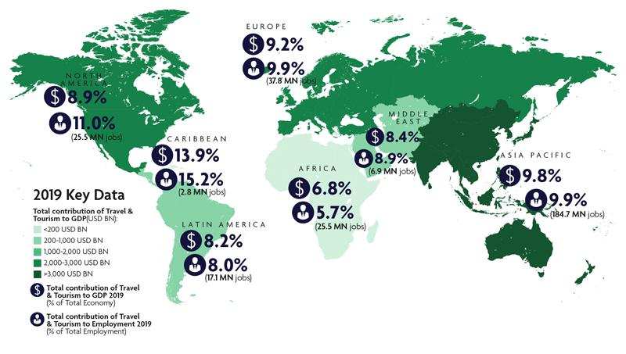
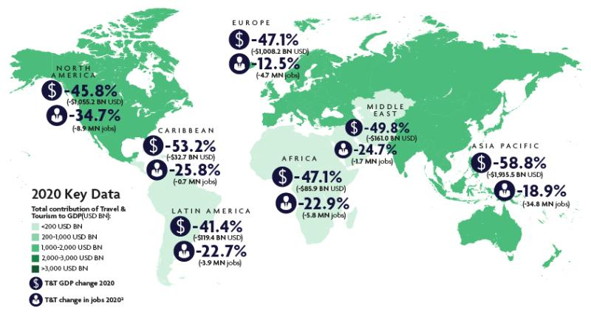
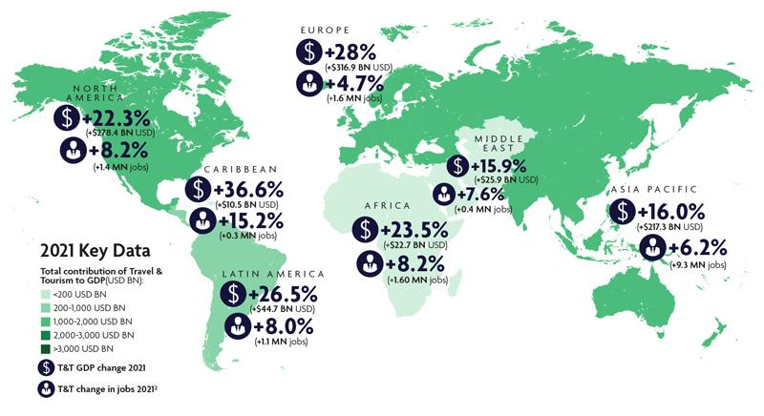
Fig. 13.Total Contributions of Travel & Tourism to GDP (2019-2021)
Source: WTTC
- Employment
The World Travel and Tourism Council (WTTC) forecast that up to 75 million jobs are at risk in this sector. In fact, a far higher share of low-skilled immigrants, women and students are employed in tourism compared to the total non-financial business economy. (Paola Maniga, 2020)

- Environment
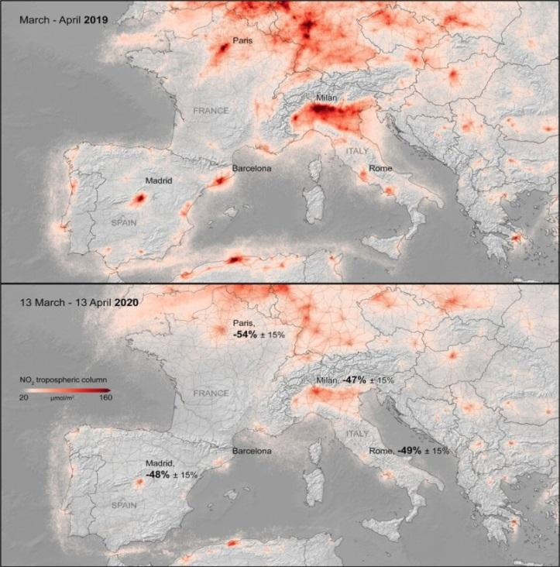
Fig. 14. Comparison of the NO₂ concentration between 2019 and 2020
Source: European Space Agency(ESA), 2020.
According to the figure 14, we can see the NO₂ concentration decreased in 2020 because people stayed at home.

- Impacts of COVID-19 on Tourism Sector in Myanmar

Fig. 15. GDP and Unemployment in Myanmar (2019-2021)
Source: World Bank
According to the figure 15, the GDP and Unemployment rate in Myanmar is the lowest during 2020, the COVID-19 period. According to Socio-economic welfare policies. Myanmar developed the COVID-19 Economic Relief Plan in April 2020 to mitigate the economic impact of COVID-19. Through the plan, the Myanmar government has established a COVID-19 fund to provide loans to small and medium enterprises, provided cash and one-time food assistance to certain vulnerable groups, and implemented a range of other measures for economic recovery.

- FINDINGS

According to the data analysis, International Visitor Arrivals to Myanmar by Entry Points during three years (2019-2021), in 2020 is the lowest because of COVID-19. Myanmar government also restricted the visa in 2020 so the number of visa issued by Myanmar government is the lowest in 2020. The difference in percentage of International visitor arrival between these three years has gradually decreased. For the visitors from ASEAN, the number of the visitors decreased and the visitors from Lao PDR was the lowest. There are many impacts on Myanmar Tourism, especially unemployment rate in tourism sector and foreign reserve from tourism and even impact on the GDP. There was a limitation of data so the other researchers can continue with this paper.

- RECOMMENDATIONS

As the recommendations, the government cannot restrict the visa for so long. So, the government should allow the borders and also commercial flights. In inbound tourism, the government should open the few tourist spots not only for the local people but also for the international visitors. And also should educate to follow the health precautions and social distancing. To develop the tourism, should promote offers and discounts. If another pandemic will be become, the government should plan for the relief plan for every sector.

- CONCLUSION
Tourism has always been an integral part of any economy, and no crisis demonstrated this better than COVID-19. Myanmar government increasingly realised that Tourism must be given a seat at the table to ensure a full and swift recovery. Indeed, governments have witnessed how tourism affects more than just jobs in the sector; it affects people’s livelihoods, community development, the environment, wildlife, and the overall economy. So, the government made many plans for many sectors, tourism sector is one of them. In new normal, the government should promote tourism sector more than before.

APPENDIX

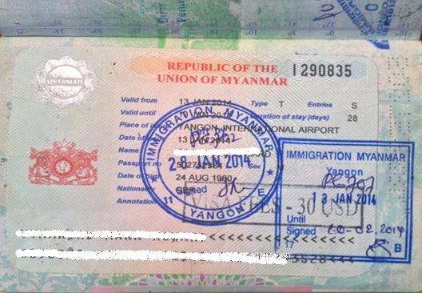
Appendix 1. Myanmar Tourist Visa sample
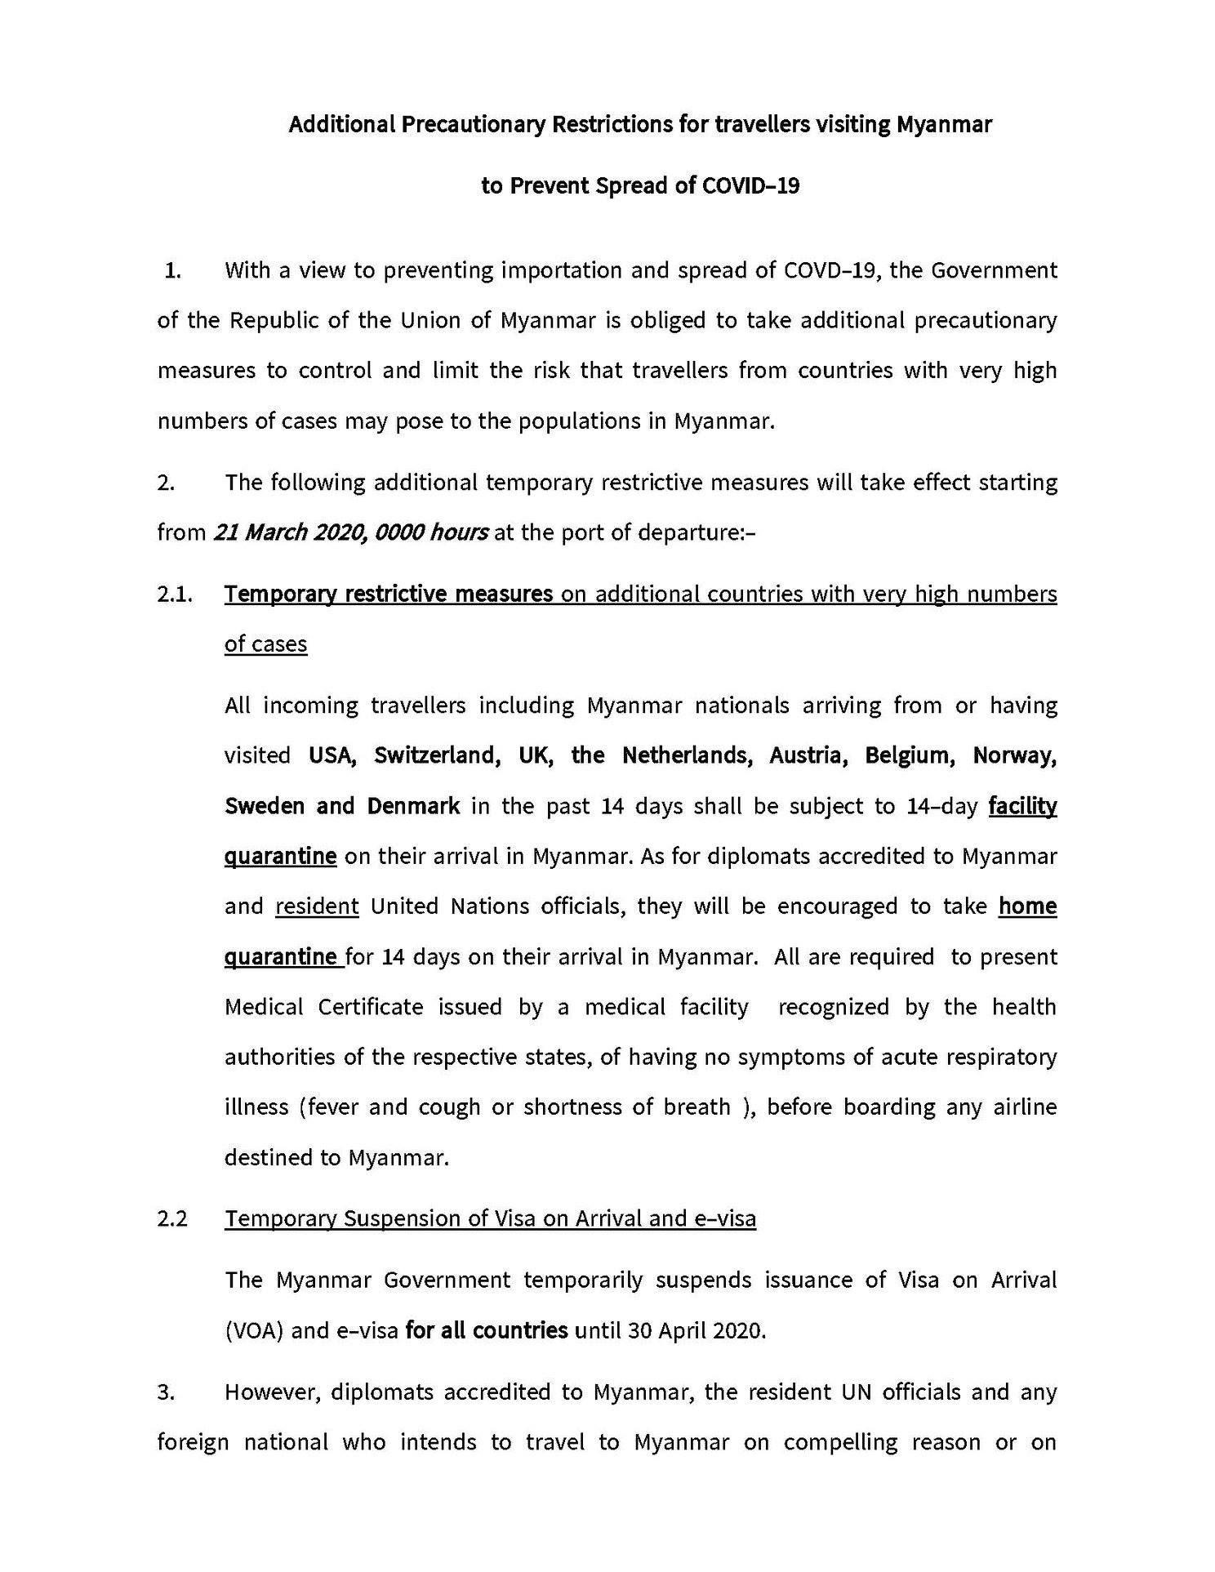
Appendix 2. The announcement for Additional Precautionary Restrictions for COVID-19
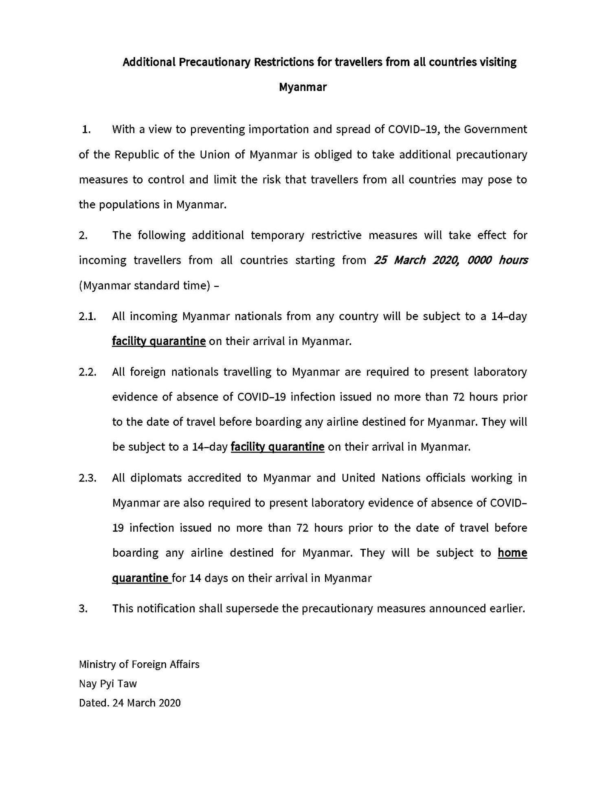
Appendix 3. The announcement for Additional Precautionary Restrictions for COVID-19

REFERENCES

[1] COVID-19 tourism relief plan. Retrieved from https://tourism.gov.mm/wp-content/uploads/2020/06/COVID-19-Tourism-Relief-Plan.pdf
[2] Department of Economic and Social Affairs of United Nations. Sustainable tourism. Retrieved from https://sdgs.un.org/topics/sustainable-tourism
[3] Department of Immigration, Ministry of Immigration and Population of Myanmar
[4] Harper, D. (n.d.). Etymology of tourism. Online Etymology Dictionary. Retrieved from https://www.etymonline.com/word/tourism
[5] Htun, N. M. & Habeeb, M. (2022). Public Budgeting in Myanmar During Five Years (2016-2021). JNANA CHILUME-2022 (5th Annual Series National Conference), 21-42.
[6] Lee-Peng Foo, Mui-Yin Chin, Kim-Leng Tan & Kit-Teng Phuah (2021) The impact of COVID-19 on tourism industry in Malaysia, Current Issues in Tourism, 24:19, 2735-2739, DOI: 10.1080/13683500.2020.1777951
[7] Ministry of Immigration and Population of Myanmar Website. Retrieved from https://www.mip.gov.mm
[8] Ministry of Foreign Affairs of Myanmar Official Facebook Page. Retrieved from https://www.facebook.com/mofamyanmar
[9] Ministry of Foreign Affairs of Myanmar Website. Retrieved from https:// www.mofa.gov.mm
[10] Ministry of Hotel and Tourism of Myanmar Website. Retrieved from https://tourism.gov.mm/
[11] Ministry of Hotel and Tourism of Myanmar Website. About Myanmar. Retrieved from https://tourism.gov.mm/about-myanmar/
[12] Ministry of Hotel and Tourism of Myanmar Website. Policies of Ministry of Hotel and Tourism. Retrieved from https://tourism.gov.mm/policies/
[13] Myanmar Policy Response to COVID-19. Retrieved from https://centerforpolicyimpact.org/wp-content/uploads/sites/18/2020/10/Myanmar-National-Response-to-COVID_19.pdf
[14] Myanmar Tourism Statistics 2019. Retrieved from https://tourism.gov.mm/wp-content/uploads/2020/05/Myanmar-Tourism-Statisitcs-2019-1.pdf
[15] Myanmar Tourism Statistics 2020. Retrieved from https://drive.google.com/file/d/1j8hdoATIGpu7S7pcJtmF52lft-cINCjJ/view
[16] Myanmar Tourism Statistics 2021. Retrieved from https://tourism.gov.mm/wp-content/uploads/2022/06/Myanmar-Toursim-Flyer-2022-01-Final-converted.pdf
[17] Myanmar Tourism Strategic Recovery Roadmap 2021-2025. Retrieved from https://chintravel.com.mm/wp-content/uploads/2020/12/MYANMAR%20TOURISM%20STRATEGIC%20RECOVERY%20ROADMAP%2023.10.20.pdf
[18] MYANMAR TOURISM STRATEGIC RECOVERY ROADMAP 2021_2025 Detailed analysis and action plan. Retrieved from https://tourism.gov.mm/wp-content/uploads/2022/06/MYANMAR-TOURISM-STRATEGIC-RECOVERY-ROADMAP-23.10.20-4.pdf
[19] Sanjita Jaipuria, Ratri Parida & Pritee Ray (2021) The impact of COVID-19 on tourism sector in India, Tourism Recreation Research, 46:2, 245-260, DOI: 10.1080/02508281.2020.1846971. Retrieved from https://doi.org/10.1080/02508281.2020.1846971
[20] Shih-Shuo Yeh (2021) Tourism recovery strategy against COVID-19 pandemic, Tourism Recreation Research, 46:2, 188-194, DOI: 10.1080/02508281.2020.1805933
[21] Sultana, S., Islam, T. & Islam, M. (2020). Impact of Covid-19 Pandemic on Top Tourist Destinations in the World. Journal of Tourism, Hospitality and Sports. 50, 2020. 41-50.
[22] Tourism notes. Tourism. Retrieved from https://tourismnotes.com/travel-tourism/
[23] UNWTO Website. Glossary of Tourism Terms. Retrieved from https://www.unwto.org/glossary-tourism-terms
[24] World Health Organization Website. Retrieved from https://www.who.int/
[25] World Health Organization. Coronavirus Disease (COVID-19). Retrieved from https://www.who.int/health-topics/coronavirus#tab=tab_1
[26] World Travel and Tourism Council. Economic Impact Reports. Retrieved from https://wttc.org/research/economic-impact
[27] Photo of Myanmar Visa Sample. Retrieved from https://allpointseast.com/blog/tour-info/burma-myanmar/burma-myanmar-visas/

