Mobility and immobility

Rehana Quasar (Msc Community Health Nursing) Tutor College of nursing Govt. Medical College, Srinagar ahmadzaynrehana@ gmail.com, 7051528918

BODY MECHANICS:
- BODY MECHANICS :is the utilization of correct muscles to complete a task safely and efficiently, without undue strain on any muscle or joint. It is the efficient use of body as a machine and as a means for locomotion
Purposes of body mechanics
- To avoid stress and strain on the musculoskeletal system .
- It promotes proper physiological function of the body .
- It minimizes the expenditure of the energy .
- It helps in maintaining balance of the body without strain .
- To prevent kyphosis,lordosis,scoliosis and other deformities.
- It contributes to one’s beauty.
Principles of body mechanics :
- Maintain good posture in all activity by avoiding twisting the body, turn your whole body, face the area in which you are working.
- It is easier to slide, pull, or roll an object than to lift it .it helps to reduce the energy needed to raise the weight .
- Movements should be smooth and co-ordinated rather than jerky to prevent injury.
- Use strongest and longest muscles to perform tasks which require physical effort.
- Keep the object as close as possible to your body when lifting,moving or carrying them.
- Keep the work at a comfortable height to avoid excessive bending at the waist.
- Keep your body in good physical condition to reduce the chance of injury.
- Place the feet apart to provide a wide base of support and better balance.
- Get help if the object feels too heavy to lift.
- Flex the joints(knees and hips) to come close to the object instead of bending back.
- Keep work close to the body
- Use the weight of the body to pull or push an object by keeping the body above the object.
General instructions in moving and lifting patients :
- Plan the movement of the patient ahead of time and be sure the path is clear.
- Face the direction in which the movement will be made, to avoid twisting of the vertebral column.
- Place the feet comfortably apart to provide a wide base of support.
- Flex the knees and hip joints but keep the trunk as vertical as possible.
- Keep the patient as close to the body as possible.
- Avoiding jerking and twisting during the lift.
- Heavy patients should be moved in bed by sliding them rather than lifting them.
- Assistance should be requested when lifting or moving heavy patients.
- The height of the bed should be adjusted to a height that permits the nurse to keep her back as erect as possible when moving the patient in bed.
- The patient is moved to the edge of the bed before he is lifted from the bed.this helps the nurse to keep her trunk more erect.
- When moving a patient by more than one person,each worker assumes the responsibility for supporting one of the patient’s body sections.the areas to be supported are,
- 1.head,shoulders and chest
- 2.hips
- 3.thighs and ankles
- In order to co-ordinate the movements of the workers and to maintain the patient’s body in correct alignment throughout,the leader gives the signal by counting 1,2,3.etc.during each count a particular procedure is carried out by the workers .
- Unless contraindicated,encourage the patient to use his abilities as much as possible.
- Observe the patient for symptoms of orthostatic hypotension such as fainting,dizziness,sweating etc .
- Do not support the patient under his armpits,since injury to major nerves and blood vessels may occur.
- Always lock the wheels of bed and stretcher prior to transferring a patient to increase marimum static friction between the wheels and the floor.
Factors affecting body alignment and mobility :
- Growth and development. In adolescence growth spurts may result in awkwardness that can be manifested in posture.
- As age advances,muscle tone and bone density decrease, joints loose flexibility reaction time slows and bone mass decreases..
- Congenital problems
- Eg:
- hip dysplasia,
- spina bifida,
- cerebral palsy .
- Neuromuscular deficits
- Eg: muscular dystrophy,Parkinson’s disease,multiple sclerosis are progressive that impairs the ability of nervous system to control muscular movements and coordination.
- Musculoskeletal
- deficits:eg:
- osteoporosis,
- rheumatoid arthritis.
Chronic health problems:
- These conditions often decrease mobility because such disorders limit the oxygen and nutrients delivered to the muscle contraction and movements
Trauma:
- Injury to joints,tendons,ligaments,muscles or bones affects body alignment and mobility.
- Affective disorders
- Eg:depression and catatonic states result in limited mobility,not because of physical impairment but due to lack of desire to move.
Nutrition:
- Both under and over nutrition can influence body alignment and mobility.
- poorly nourished people may have weakness and fatigue.
- vitamin D deficiency causes bone deformity during growth.
- inadequate calcium intake increases the risk of osteoporosis
- Therapeutic modalities
- Eg :restrictive devices such as cast, splint may be used to immobilize certain areas of body to promote healing.
Personal values and attitudes:
- Choice of physical activity or type of exercises may influence by values.

Mobility: Normal movement may be considered as a skill acquired through learning (or development) for the purpose of achieving the most efficient and economical movement or performance of a given task and is specific to the individual.

Basic elements
- Movements are normally goal directed.
- Mobility is necessary for all aspects of life.
- As we become less mobile in later stages of life results into health problems.
- Factors that contribute to immobility especially in hospital including long stay in hospital.
Alignment

- Alignment refers to how the head, sholders, spine, hips knees and ankles relate and line up with each other.
- Proper alignment of the body puts less stress on the spine and helps to have good posture.
- Helps to optimize on being able to stand or move .
- Helps to stay active and prevent broken bones and disability.
- Helps to limit the amount exercises of kyphosis ,or forward curve o the upper back
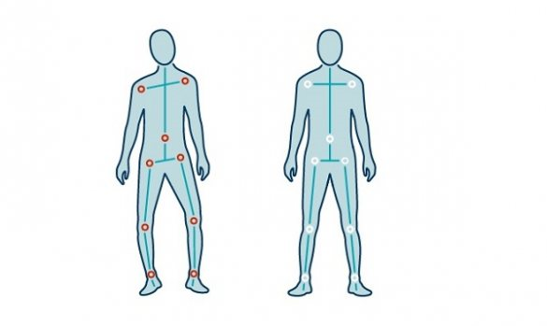
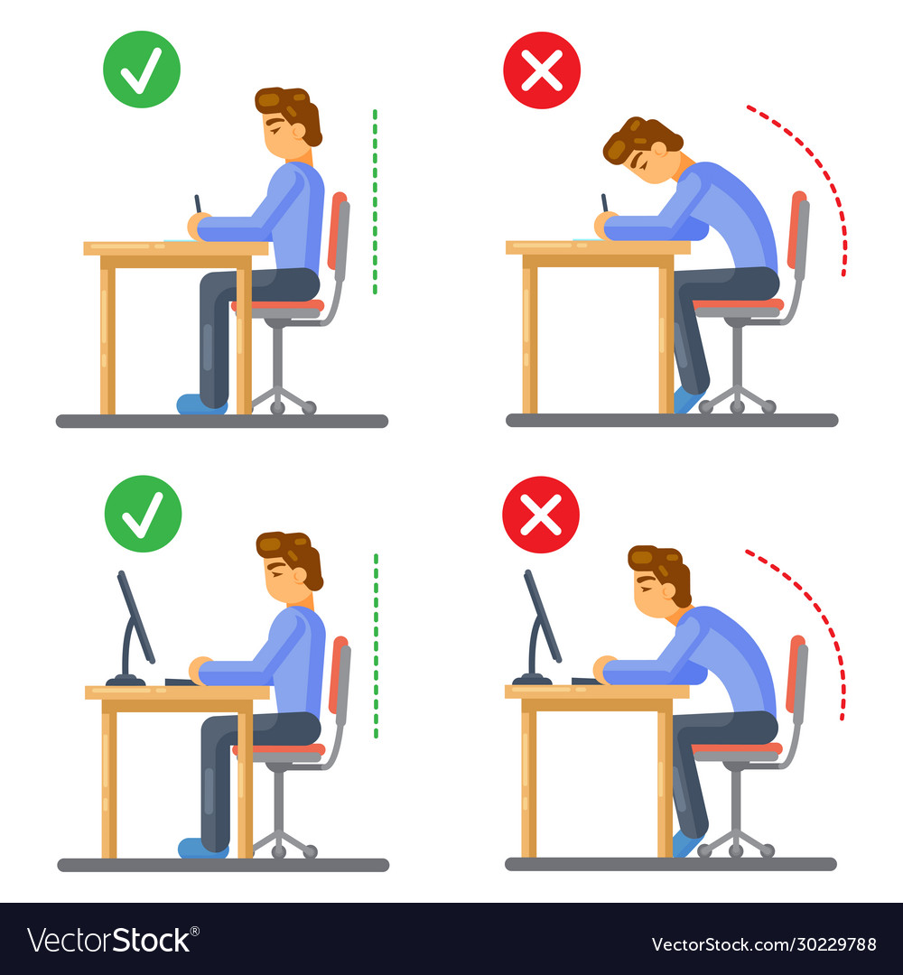

POSTURE

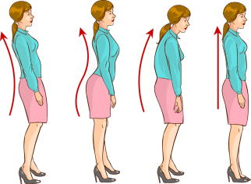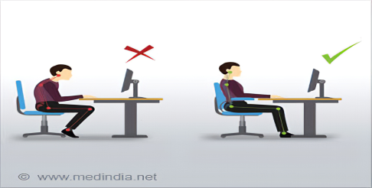
- It is defined as a position or arrested movement .It considers the position of the body and its relationship to whatever is supporting it(eg chair ,floor a table that’s being leaned on).
- Mobility Is the term used for movement which is a complex process that requires coordination between musculoskeletal and nervous systems .
Mobility:
Mobility is essential for activities of daily living. Many functions of the body depend upon mobility.
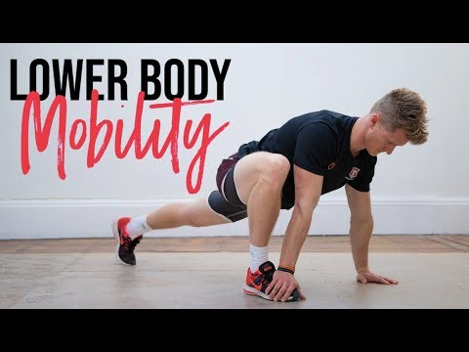

JOINT Mobility
- It is affected by genetics age and disease process. And how physically active we are in our life time .
- Some joints has a wide range of movement.
- Shoulder joint is a ball and socket joint as well as hip joint.
- Some joints are saddle joints in hand with limited flexibility compared to ball and socket .
Centre of gravity (COG) 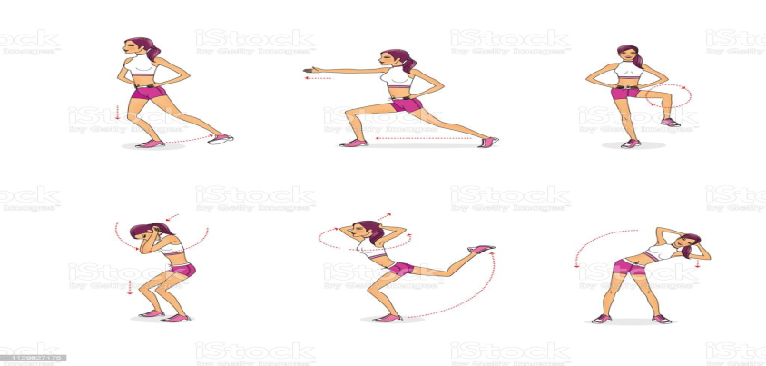
- Centre of gravity (COG) of the human body is a hypothetical point around which the force of gravity appears to act . Lies approximately near to the second sacral vertebra.
Co-ordinated movement
- It is influenced by cerebral cortex, which initiates voluntary movement and cerebrum in back of head is in charge of coordinating motor activity and the basal ganglia maintain posture as well.
Changes in Co-ordinated movement
- Decreased strength
- Slowed reaction time
- Loss of flexibility
- Faculty posture
- Impaired balance

Balance
- Balance is the ability to maintain the body’s center of mass over its base of support. A properly functioning balance system allows humans to see clearly while moving, identify orientation with respect to gravity, determine direction and speed of movement, and make automatic postural adjustments to maintain posture and stability in various conditions and activities. Maintaining balance depends on information received by the brain from the eyes, muscles and joints, and vestibular organs in the inner ear. When this system is disrupted by damage to one or more components through injury, disease, or the aging process you may experience impaired balance accompanied by other symptoms such as dizziness, vertigo, vision problems, nausea, fatigue, and concentration difficulties.

Maintance of normal body alignment and activity.
- Body alignment refers to the arrangements of joints, tendons, ligaments and muscles while in a standing, sitting or lying positions. In a correctly aligned body, a line passes through specific parts while in standing position, these points can be seen from the side and back view .
- 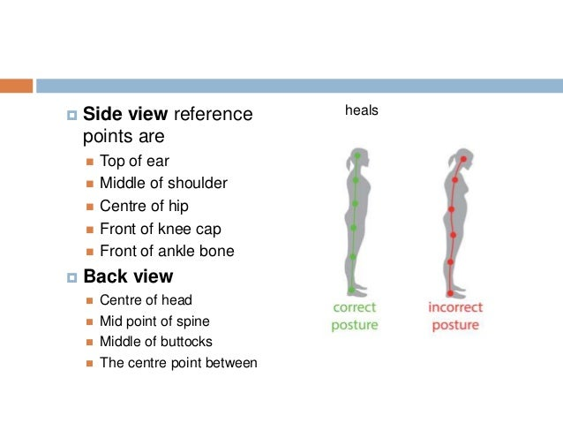
Importance.
- Permits optimal musculoskeletal balance and operation
- Promotes optimal physiologic functioning Deviation may result:
- Chronic poor posture
- Trauma
- Muscle damage or nerve dysfunction
- Pain ,fatigue, and a persons mental and emotional status may also influenced.
Standing: The head is erect and midline . Posteriorly, The shoulder and hips are straight and parallel
The vertebral column is straight .Laterlly : The spinal curves are aligned a reversed s pattern . Abdomen is comfortably tucked in and the knees and angles are slightly flexed . The arms hangs comfortably at the sides .Feet are slightly flexed to achieve a base of support and the toes are pointed forward
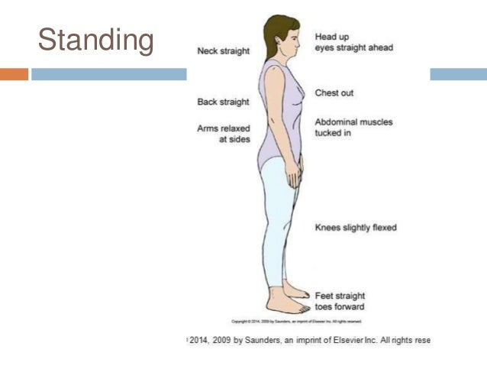
Sitting
- The head is erect, the neck and vertebral column are in straight alignment .
- The body weight is evenly distributed on the buttocks and thighs .
- The thighs are parallel and in horizontal plane .
- Both feet are supported on the floor and the ankles are comfortably flexed .
- A 2.5-5 cm space is maintained between the edge of the seat and the popliteal space on the posterior surface of the knees .
- The clients forearms are supported on the arm rest, in the lap or on the table in front of the chair .
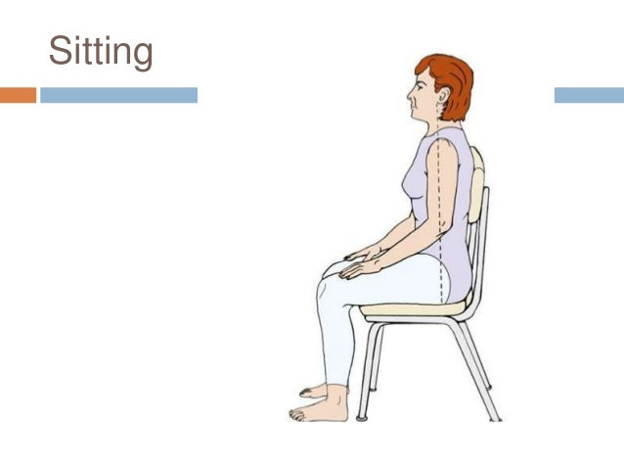
Climbing stairs: Use the stairs for exercise and to help with your bone density, but only if your healthcare provider says it’s safe for you. Build up gradually with this exercise.
- Keep your head high, chin in, shoulder blades slightly pinched together and abdomen gently pulled in.
- Keep your feet pointed straight ahead, not to one side.
- Your knees should face forward. Keep your knees slightly bent.
- Instead of putting one foot directly in front of the other, keep your feet a few inches apart, lined up under the hip on the same side.
- For safety, hold the rail while going up and down but try to avoid pulling yourself up by the railing.Be especially cautious going downstairs.
- A fall down the stairs could cause severe injuries.
- Use the stairs for exercise and to help with your bone density, but only if your healthcare provider says it’s safe for you.
- Build up gradually with this exercise.Keep your head high, chin in, shoulder blades slightly pinched together and abdomen gently pulled in.
- Keep your feet pointed straight ahead, not to one side.
- Your knees should face forward. Keep your knees slightly bent.Instead of putting one foot directly in front of the other, keep your feet a few inches apart, lined up under the hip on the same side.
- For safety, hold the rail while going up and down but try to avoid pulling yourself up by the railing. Be especially cautious going downstairs.
- A fall down the stairs could cause severe injuries
- .Use the stairs for exercise and to help with your bone density, but only if your healthcare provider says it’s safe for you.
- Build up gradually with this exercise.
- Keep your head high, chin in, shoulder blades slightly pinched together and abdomen gently pulled in.
- Keep your feet pointed straight ahead, not to one side.
- Your knees should face forward. Keep your knees slightly bent.
- Instead of putting one foot directly in front of the other, keep your feet a few inches apart, lined up under the hip on the same side.
- For safety, hold the rail while going up and down but try to avoid pulling yourself up by the railing. Be especially cautious going downstairs.
- A fall down the stairs could cause severe injuries.
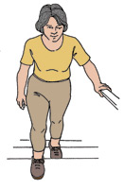
Bending and turning

- Keep your feet flat and about shoulder-width apart from one another.
- Let both upper arms touch your ribs on the sides, unless you’re using one hand for support.
- As you bend, keep your back upright and straight and your shoulder blades pinched together.
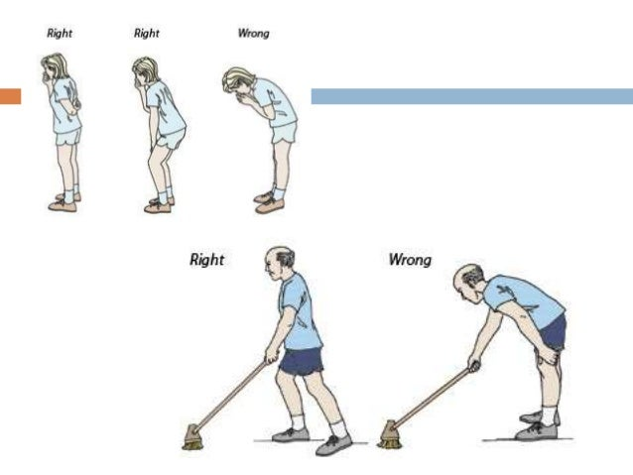
- Bend only at the knees and hips. Do not bend over at the waist since this will put your upper back into a rounded position which can cause broken bones in the spine.
- Even when standing to brush your teeth or to wash the dishes, try not to bend over at the waist. Instead, bend at the knees and hips while keeping your back straight.
When changing the direction you’re facing, move your feet with your body. Do not twist the spine. Pivot on your heels or toes with your knees slightly bent. Keep nose, knees, and toes pointing in the same direction.

Lifting and carrying.

- Don’t lift or carry objects, packages or babies weighing more than 10 pounds.
- If you are unsure about how much you can lift, check with your healthcare provider, especially a physical therapist.
- If you do pick up a heavy object, never bend way over so that your back is parallel to the ground. This places a great deal of strain on your back.
- To lift an object off the floor, first kneel on one knee. Place one hand on a table or stable chair for support if you need it. Bring the object close to your body at waist level. Gently pull your abdomen in to support your back and breathe out when you are lifting an object or straightening up.
- Do not hold your breath.
- Stand using your leg and thigh muscles.
- When carrying groceries, ask to have your bags packed lightly.
- Divide heavy items into separate bags.
- Always hold bags close to your body.
- Try to balance the load by carrying the same amount in each hand.
- When unpacking, place bags on a chair or table rather than on a high counter or floor. This prevents unnecessary lifting and twisting of the spine..
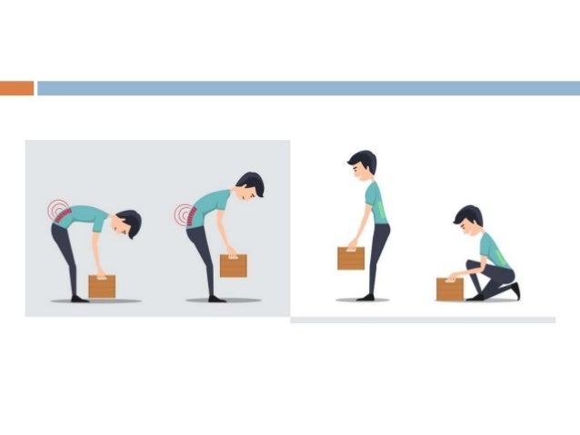
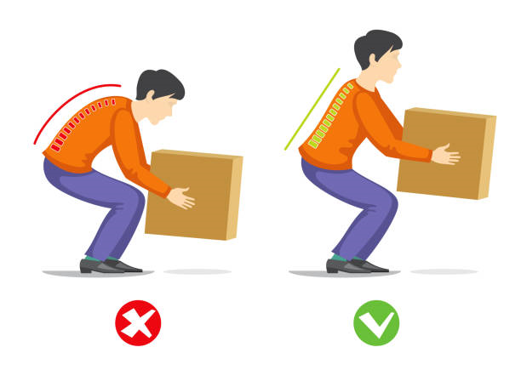
Pulling and Pushing.

- Stand close to the object .Place yourself in proper body alignment
- Tense muscles and prepare for movement
- Hold the object close to the body near the centre of gravity
- Lean towards the object. Push away from utilizing body weight to add force Pulling
- Lean away from the object to pull it towards you
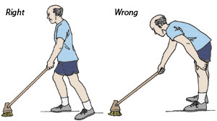

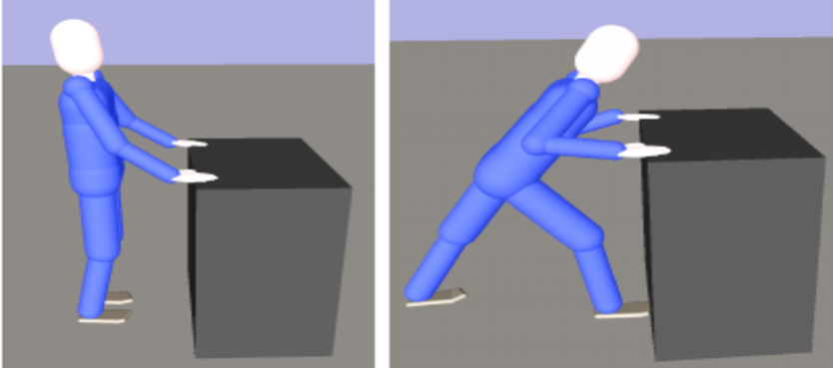

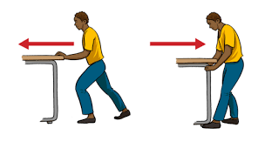

Reaching:

- To get an object above head level

- Stand directly in front of and close to the object
- Avoid twisting or stretching
- Use a stool or ladder for high objects
- Maintain a good balance and a film base of support
- Keep one foot forward
- Keep the back straight
- Reach with both hands
- Before moving the objects, be sure that it is not too large or to heavy

Coughing and sneezing

- Develop the habit of supporting your back with one hand when ever you cough or sneeze.
- Place your hand behind your back or your thigh .this protects the spine from injury caused by a sudden bend forward.

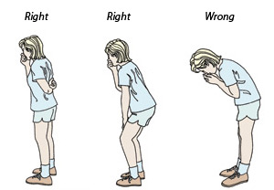
Getting into bed

- First sit down on the side of the bed .
- Lean toward the head of the bed while supporting body with both hands.
- Then lie down on your side, bringing both feet up on to the bed at the same time.
- Keep the knees bent and arms in fornt of you. then roll onto your back in one motion .
- Pull your abdomen in as you roll to support your back and help prevent twisting.
- Keep nose ,knees and toes pointing in the same direction .
- Don’t lift your head and upper back to move in bed .this puts a great deal of strain on your spine and could cause broken bones
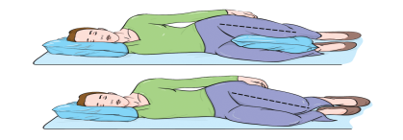

Lying down and getting out of bed

- When lying on your side in bed ,use one pillow between your knees and under your head to keep your spine aligned and increase your comfort.
- When lying on your back in bed ,use one or two pillows under your knees and under your head.
- Try to avoidusing extra pillows.
- When getting out of the bed reverse the steps you used to get into the bed.
- Keep both arms in front of you.
- Pull your abdomen in and breathe as you roll onto your side.
- Keep your abdomen pulled in and use your hands raise your upper body as you carefully place your legs over the side of the bed in one motion.
- Sit on the edge of the bed for a moment or two before you stand up.
- When on your back , never lift your head and upper back to sit up in bed or get out of bed.
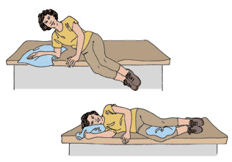

Range Of Motion Exercises
The movement of a joint to the extent possible without causing pain.
Range of motion exercise helps to prevent contractures and joint stiffness by moving the entire patients joints.
Purposes:
• Promote and maintain joint mobility
• Prevent contractures and shortening of muscles and tendons .
• Increase circulation to extremities.
• Facilitate comfort for the patient.
To restore coordination .
Contraindications To ROM
• Any illness/disorder where increased use of energy or increased circulation is hazardous.
- Heart and respiratory diseases. Example: Myocardial infarction.
- Connective tissue disorder. Example: swollen, inflamed joints.
Types Of ROM Exercises
• Active ROM exercises – Exercises the client is able to perform independently.
• Passive ROM exercises – Exercises performed for the client by someone else.
• Active assisted ROM exercises – Performed by a client with some assistance. Client can move a limb partially through its ROM, but needs help completing the ROM.
Guidelines For Performing ROM Exercises
Plan when ROM exercise should be done. Plan the type of exercise .
Start with the head and move down, always do bilaterally
Do not grasp the joint directly
Do not grasp fingernail or toenail.
Be sure to support the distal and proximal end of the limbs
Important joints – thumb, hip, knee, ankle
Move joint through movement 5 times/session
Return body part to normal anatomical position
Move each joint through full range of motion
Move to point of resistance not pain
Allow for rest periods whenever required
Avoid friction LIFT body part don’t drag
Note drastic change in vital signs, extreme fatigue.
Should not disrupt the healing process
Warm water relaxes the muscles and joints, bathing is an ideal time to perform ROM.
Evaluation of patient in terms of fatigue ,pain ,discomfort and joint mobility.
Record keeping : ROM is often placed on a flow sheet. If it is not available then nurses notes are used for documentation.
Patient Preparation
Explain and steps and advantages of ROM exercises.
Remove all restrictive clothing, linen, splint, and dressings.
Drape appropriately
Raise the bed to comfortable height.
Position the patient comfortably- preferably supine position.
Procedure :
Wash hands thoroughly
Support the extremity or the part to be moved above and below joint .
Do not hold the joint.
Move joint through full range of motion .
Perform all movements smoothly and slowly
If pain or strong resistance is present do not force movement.
Perform each movement three times during exercise periods per day.
Exercise period may incorporated to an activity such as bed bath.
Move all joints of the body during the exercise period.
After care.
When exercise is completed ,adjust the patient to the comfortable position.
Place side rails properly to promote safety.
Wash hands thoroughly.
Record the procedure in nurses’ record sheet.

Joint movements :
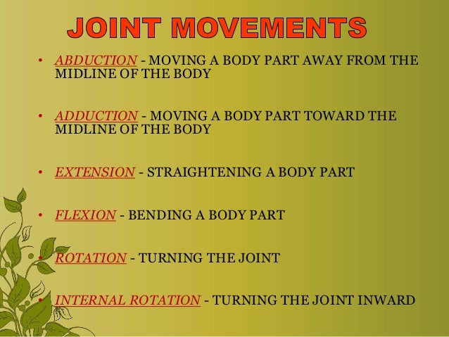
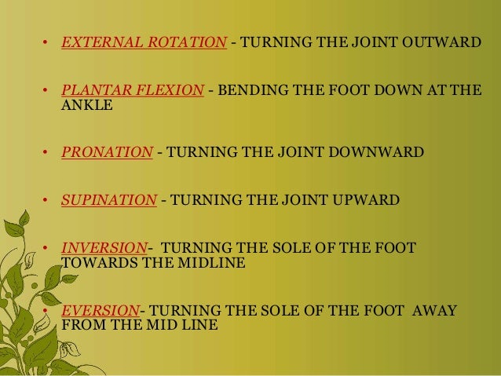
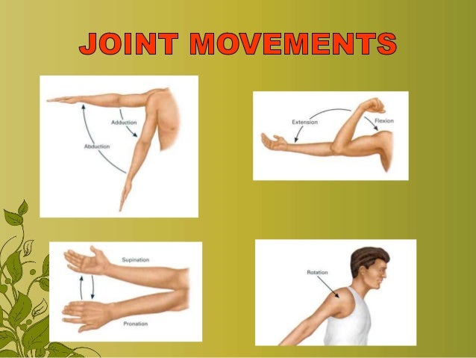
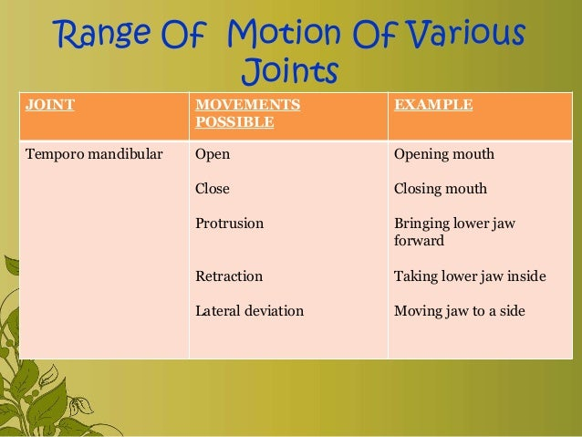
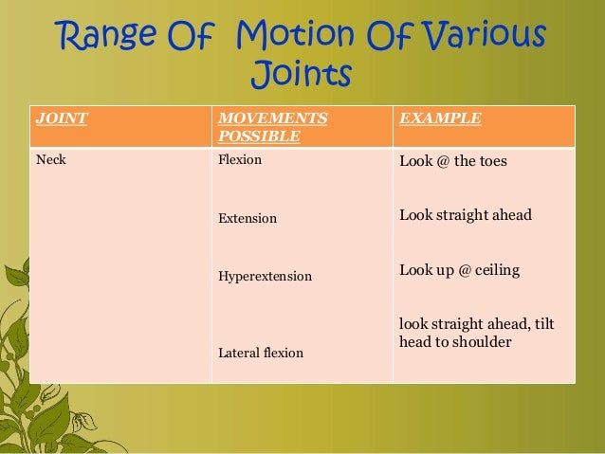
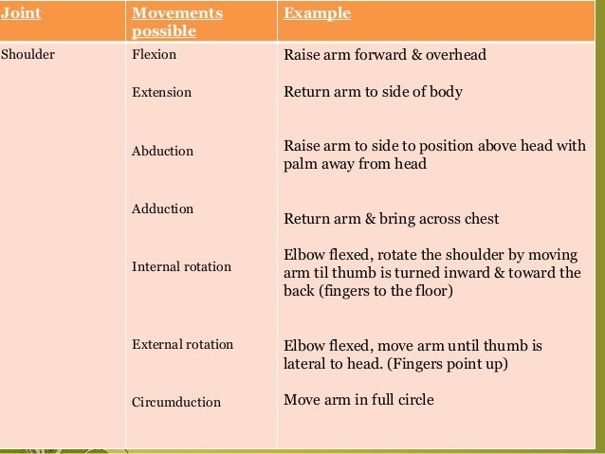
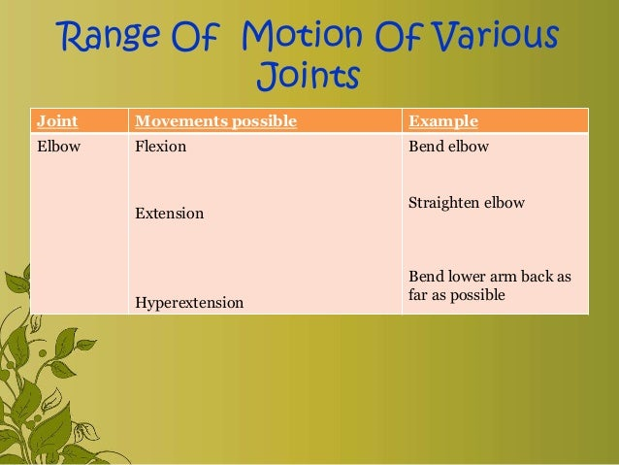

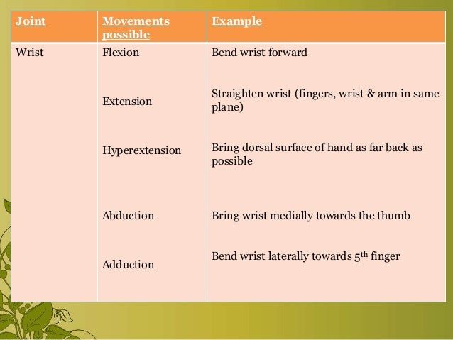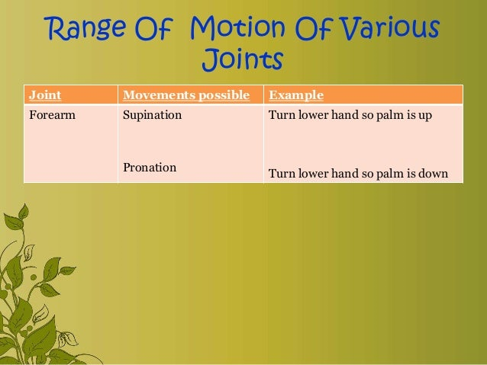

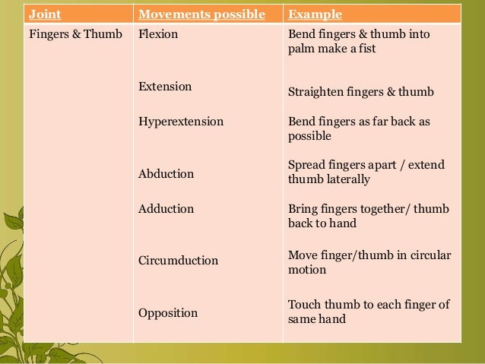
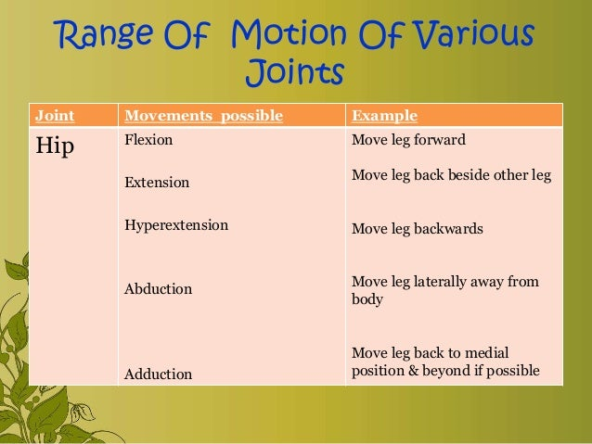
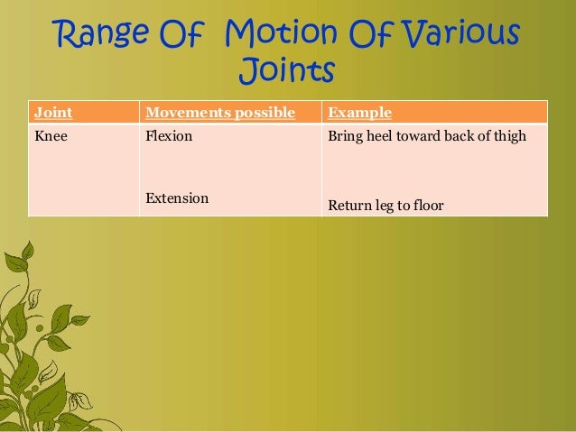

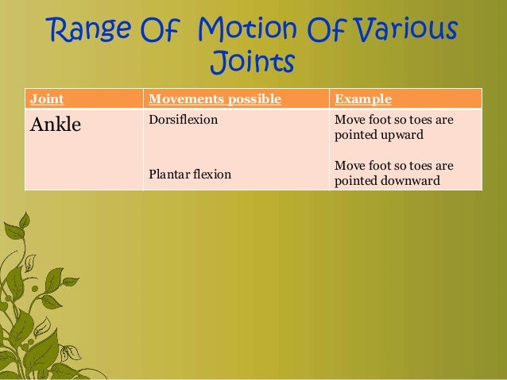
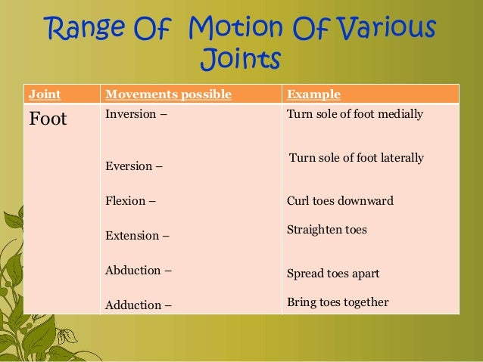

Nursing process for mobility
Nursing assessment
Nurse incorporates comprehensive nursing history and physical assessment skills to acquire patient data about the mobility and activity status .
- history taking : interview patient regarding:
- Daily activity level, endurance ,exercise routine
- Mobility problems.
- Physical and mental health status that affect mobility.
- External factors affecting mobility.
- Exercise routine.
- Physical assessment :
- General ease of movement and gait. Alignment ,joint structure and function
- Muscle mass, tone and strength
- Endurance
Nursing diagnosis
- Nursing diagnosis specially focusing on mobility disorders include:-
- Activity intolerance related to fatigue /generalized weakness/exertional discomfort as evidenced by exertional dyspnea, shortness of breath, weak pulse.
- Impaired transfer mobility related to pain /musculoskeletal impairment (fracture, arthritis ) as evidenced by physical inability to move, limited ROM
3. Risk of injury related to altered sensation, unsteady gait as evidenced by un co-ordinated posture and confusion .
4. Risk of constipation related to decreased mobility as evidenced by passing fewer stools ,having hard stools and decreased bowel movements .
5. Self care deficit related to weakness and impaired mobility as evidenced by inability to perform ADL.
6. Risk for ineffective peripheral tissue perfusion related to sedentary lifestyle.

- Outcome
- The patient will:
- Demonstrate correct body alignment .
- Demonstrate full range of joint mobility.
- Be free of contractures
- Show signs of adequate venous return
- Identify personal benefits of regular exercises .
- Demonstrate the adequate muscle mass ,tone and strength to perform functional ADL.
INTERVENTIONS
- The use of body mechanics and safe patient handling and movement strategies are essential in nursing care of patients with mobility alterations
1. Application of principles of body mechanics to prevent injury to self and patient.
- Nurses carry ,lift, pull, push and move objects and patients routinely in the course of their work or shift .executing these actions correctly is essential to avoid musculoskeletal strains and injuries to nurses.
- Nurse must fallow the principles of body mechanics to prevent injury.
- 2. Ensuring safe patient handling and movement:-
- Safe patient handling and transfer involves the use of patients mobility assessment tools, algorithms for patient handling decisions and proper use of patient handling devices.
- Bedridden patients require assistance in movement. Keep the patient in good alignment and protect the patient from injury while moved.
- 3 safe patient transfer
- Assess the patient
- Assess the patients ability to assist with the planned movement .
- Assess the patients ability to understand instructions and cooperate with staff to achieve the movement.
- During the patient transferring task ,if any care giver is required to lift more than 35 lb of patient weight ,consider the patient to be fully dependent and use assistive devices for transfer.
- Ensure that enough staff is available while transferring the patient.
- Remove any obstacles that may make moving and lifting in convenient.
- Decide which equipment to use .
- Plan the whole activity carefully
- Explain to the patient what you plan to do.
- If patient is in pain administer the analgesic sufficiently in advance of the patient transfer .
- Elevate the bed as necessary so that you are working at a height that is comfortable and safe for you.
- Always lock the wheels of the bed ,wheel chair or stretcher so that they don't slide while moving the patient.
- Be sure the patient is in good alignment .
- Support the patients body properly.
- Avoid friction on patients skin during moving. Use friction reduction devices when ever possible.
- Use mechanical devices such as lifts ,slides transfer chairs or gait belts for moving the patient.
- Move your body and patients in a smooth ,rhythmic motion. Jerky movements tend to put extra strain on muscles and joints .
- 4 equipments and assistive devices.
- Equipments and assistive devices
- 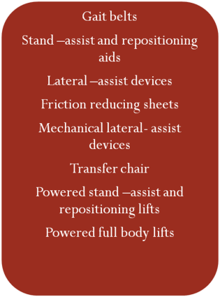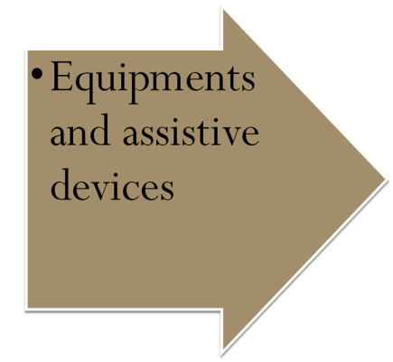
- Many devices and equipments are available to aid in transferring ,repositioning and lifting patients.
- It is important to use the right equipment and appropriate devices based on patient assessment and desired movement.
1) Gait belts 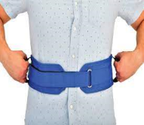
- A gait belt is an assistive device used for transferring the patients and assisting with ambulation.
- Gait belt ,which often has handles is placed around patients waist and secured by Velcro fasteners .
- Do not uses gait belts on patients with abdominal and spinal injuries.
2) Stand –assist and repositioning aids 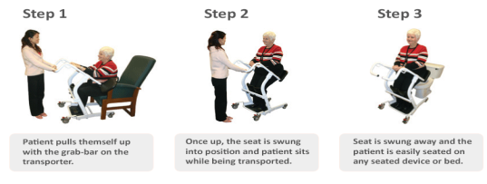
- Many patients require minimal assistance to standup, with an appropriate support to grasp, patients can lift themselves.
- Many types of devices can be freestanding or attached to the bed or wheel chair .other aids have full bar to assist the patient to stand ,and a seat unfold under the patient .after the patient sits on the seat, the device can be wheeled to the chair ,toilet, shower, or bed.

3) LATERAL ASSIST DEVICES
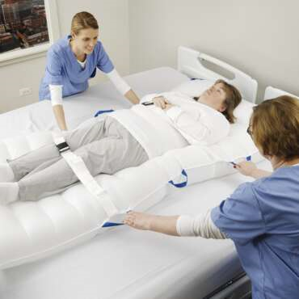
- Lateral assist devices decrease patient- surface friction during side to side transfers. Roller boards, transfer boards, slide boards, inflatable mattresses, and friction reducing lateral assist devices are examples of these devices which make transfer safer and more comfortable for the patient. For example, an inflatable lateral device is a flexible mattress that is placed under patient.
4) Mechanical lateral assist devices
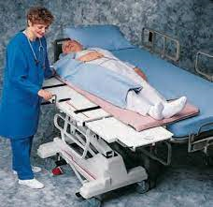
- Mechanical lateral assist devices include specialized stretchers and eradicate the need to slide the patient manually. Some devices are motorized, whereas others use a hand crank.
- The device is then returned to the stretcher, effectively moving the patient without any pulling by staff members.
5) FRICTION REDUCING SHEETS
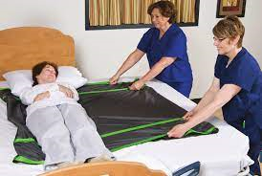
- Friction reducing sheets can be used under patients to prevent skin shearing when moving patients in bed and when assisting with lateral transfers.
- There use decreases friction and the force required to move patients.

6) TRANSFER CHAIRS
- These are helpful with patients who have no weight bearing capacity, cannot follow directions, and / or unable to cooperate.
- The back of the chair bent back, and the leg supports elevate to form a stretcher configuration, eliminating the need for lifting the patient.
7) POWDERED STAND ASSIST AND REPOSITIONING LIFTS
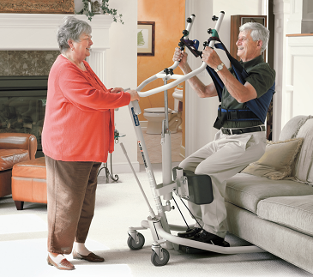
- This equipment can be used with patients who can bear weight on at least one leg, can follow directions, are cooperative.
- A simple sling is placed around the patients back and under the arms.
- Some equipment comes with breathable slings that can remain under the patient, reducing the risk for the nurse in turning the patient to position the sling.
8) POWERED FULL BODY LIFTS
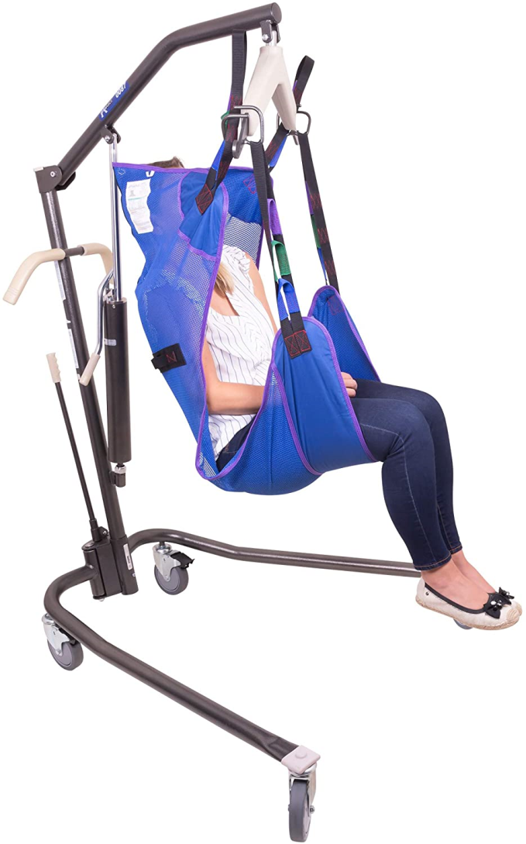
- These devices are used for patients who cannot bear any weight to move them out of bed, into and out of a chair, and to commode or stretcher.
- A full body sling is placed under the patients body including head and torso, then the sling is attached to lift.
- Some of these slings are made to stay under the patient to reduce strain on the staff during placement.
References:
1. Kathwal Jyoti . Text Book of Nursing Foundation for B.sc nuring students . Vision health sciences ,edition ist 2021 page no 413-452.
2. celement I . Text Book of Nursing Foundation. Jay pee publication , 1st edition 2022 ,page no: 446-483.
3. pandey Susma.. AvaniOke . Nair Neena: Principles and procedures of nursing foundation.volume 1,2nd edition.
4)
https://www.nursetogether.com › ... › Nursing Diagnoses cited on 25/6/2023
5)
Nurseslabs , https://nurseslabs.com › ... › Nursing Diagnosis cited on 23/6/2023

