Review of Various Application of IOT Using Machine learning

Dr. Ajay Lala
Department of Computer Science & Engineering
Gyan Ganga College of Technology, Jabalpur
Jabalpur, India
ajaylala@ggits.org

Prof. Kamaljeet Singh Kalsi
Department of Computer Science & Engineering Gyan Ganga College of Technology, Jabalpur
Jabalpur, India
kamaljeetsingh@ggct.co.in

ABSTRACT
Now that the Internet of Things (IoT) is growing swiftly, a wide range of applications are being created by both academia and business. Machine learning allows millions of machines to collaborate in order to extract customer preferences from individual user-generated data. Machine learning is also essential in the IoT sector to manage the massive volume of data generated by those machines. Automated systems using actions deduced statistically can supplement or replace manual processes in critical activities. These applications of intelligent machine learning will be the main emphasis of this paper. Machine learning for IOT can be used to forecast future trends, spot anomalies, and improve intelligence by ingesting picture, video, and voice data. By examining vast amounts of IoT data, machine learning can assist explain the underlying patterns in that data.
Keywords—Internet of Things; Machine Learning; Smart Devices (key words)

INTRODUCTION

For decades, there has been an increasing trend towards the expansion of the current Internet to include all linked devices (commonly referred to as "Things") and their digital representations. As a result, a large range of potentially unique goods, services, and applications will be developed in a number of industries, including smart housing, smart logistics, and smart environmental monitoring. Thanks to the cooperation of academics, industry, and standards bodies in various communities, including telecommunication, health insurance firms, semantic Web, and informatics, this field of study has recently gained a lot of interest as well as a lot of financing. As a result, many venture capitalists follow the crowd.
For a long time, common systems have lacked flexibility because they were only ever designed for particular purposes. This suggests that a system cannot be dynamically or flexibly altered while it is in use. Platforms for applications, products, and services that can gather, exchange, store, access, and share data from the real world are necessary for the IoT initiative currently under way—or, more generally, the future of the Internet—especially when it comes to cross-border communication. A wide range of businesses, including smart homes, green energy, smart retail, smart health, and customized end-user applications, will now have new opportunities as a result.
Machine learning is a key component of Software AG’s Complicity low-code, self-service IoT platform. The platform comes ready to go with the tools you need for fast results: device connectivity and management, application enablement and integration, as well as streaming analytics, machine learning, and machine learning model deployment. The platform is available on the cloud, on-premises and/or at the edge. Uniquely with Complicity IoT, standalone, edge-only solutions are also supported. The data models that are run of the mill of conventional data analytics are often static and of restricted use in tending to quick changing and unstructured information. With regards to IoT, it’s frequently important to distinguish connections between many sensor sources of info and outside components that are quickly creating a great many data points. While conventional data analytics would require a model based on past information and master assessment to build up a connection between the factors, machine learning begins with the result factors (e.g. sparing vitality) and after that naturally searches for indicator factors and their associations.
Machine learning is generally useful when you know what you need but are unsure of the crucial informational aspects that will influence your decision. You then specify the goal(s) for the machine learning algorithm, and it subsequently "learns" from the data which components are crucial for achieving that goal. Machine learning uses a variety of statistics to produce valuable insights that organizations can use to improve bureaucracy, lower costs, make services more sophisticated for customers, or establish new business models. The fact is that most institutions may obtain a significant portion of those advantages through conventional data analytics without the need for more sophisticated machine learning tools.

Clarifying facts is a strong suit of conventional information analytics. You could create analyses or simulations of contemporary events, bringing useful information to the organization. Records analytics may help to compare and fine-tune goals, enable wiser choice making, and then provide the method for monitoring achievement over time. By and large, machine learning is useful when you know what you need but are unsure of how to find the right information sources to provide that requirement. The machine learning method is therefore supplied by you, and it then "learns" from the data what components are essential for achieving that goal.

The ability to predict outcomes is quite helpful in a mechanical setting. Machine mastering calculations can "understand" what is typical for the machine and occasionally identify when something odd is about to emerge by drawing data from special sensors in or on machines. Knowing when a system requires protection is unbelievably important, saving thousands of dollars in expenses. Businesses actually employ machine learning and anticipate above 90% accuracy even though machines will require renovation, which will result in significant cost savings. In reality, gadget learning programmes are a part of our daily lives for all of us. Machine learning is used by both Netflix and Amazon to understand our preferences and provide the customer with a better experience. This could include offering you the gadgets you want or making sensible suggestions for shows and flicks. As a result, machine learning in the IoT may also play a significant role in shaping our circumstances to fit our personalities. The Nest Thermostat is a fantastic example; it uses machine learning to understand how to take into account your preferences for heating and cooling, ensuring that the house is at the ideal temperature when you get home from work or when you get up in the morning. Figure 1 depicts many IOT applications using machine learning.

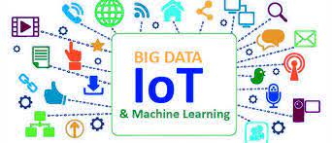

Figure 1- Application of IOT Using Machine Learning

RELATED WORK

Over the past ten years, applications based on smartphones, sensors, and actuators have grown increasingly sophisticated, enabling device connection and the completion of more difficult tasks. The number of network devices has surpassed the number of people on the planet [1] and has been growing exponentially ever since. In the era of the Internet of Things (IoT), virtually every device is connected to a local network or the internet, including smartphones, built-in systems, wireless sensors, and other gadgets. Numerous new applications have been developed for various mobile and remote platforms as a result of the expansion of the Internet of Things (IoT), which includes smartphones [2], sensor networks [3], sensors unique aerial vehicles (UAV) [4,5], cognitively smart systems [6], and others. With an increase in the number of such devices, the amount of data obtained from them frequently rises. Agriculture Automation For the objective of increasing the effectiveness of the agriculture industry, IOT and machine learning are being used. In India, agriculture is essential to the growth of the food industry. The Internet of Things (IoT) represents a turning point in technological development. According to the modern interpretation of the industrial revolution, 4.0[7], we have a finite number of resources, and how they are used—whether it's the use of water or the use of minerals from ores—all have an indirect impact on our daily existence. Prices[8] have been growing as a result of the scarce supply of resources and rising consumption, thus their sustainable use is required. Similar to this, every loss at any level in farming—where we must feed a big number of consumers—proves to be a significant loss to the economy and to the consumer as well[9]. Additionally, there aren't enough research findings in this area. The primary goal is to introduce IoT and machine-assisted farming to India in order to expand farmers, researchers, and the government's use of AI and machine learning on a technical level[10].

CASE STUDY OF IOT APPLICATIONS USING MACHINE LEARNING

The Internet of Things (IoT) and machine learning (ML) have broad applications in many facets of life, including healthcare. The traditional approaches to patient services reduced as a result of the internet's quick expansion and improvement, and were replaced by electronic healthcare systems. The most cutting-edge environment for medical devices is provided to patients and medical professionals through the usage of IoT technology. Machine learning and IoT devices are useful in a variety of classifications, from remote monitoring of the contemporary climate to mechanical mechanization.

An Overview of Machine Learning

Another one of our contemporary technologies for transformation is machine learning. Machine learning is the application of algorithms that can learn from the data. The availability of inexpensive computing power and vast data are driving forces behind machine learning development. The foundation of machine learning is past machine observations. An algorithm is created. Simplified, machine learning is frequently derived from data. The goal of master learning is to identify patterns in the data and apply such patterns to practical tasks. A broad multidisciplinary technique called machine learning that focuses on statistics, algebra, data collection, data processing, etc. Through data training, machine learning (ML), a core approach to artificial intelligence, harvests information. Since it's at the tree's base and we're directing robots to go there in this study.
Machine learning is classified into the following groups as seen in Figure 2
A. Supervised Learning.
B. Unsupervised Learning.
C. Reinforcement Learning

Figure 2 Classification of Machine Learning

Internet of Things (IOT)
Physical devices that are embedded with sensors, software, and other technologies to transfer data and communicate among the devices through the Internet are referred to as such. Examples include mobile phones, personal computers, home appliances, and many more electronic gadgets.
For Example: consider mobile phones, sensors, smart watches, and air conditioners.

Industrial Internet of Things (IIOT)
It is described as using the internet of things in industrial applications and sectors. The IIOT refers to inter-connected sensors and other networked devices together with computer's industrial mainly used in manufacturing.
For example: Amazon warehouse, smart robotics, Air bus etc.

Comparison o IOT and IIOT
Generally, IoT focuses on consumer convenience. Whereas IIoT focuses on return on investment (ROI) so that businesses benefit the most from implementing IIoT. If IoT and IIoT are compared with respect to complexity, cost and requirements , following points can be made.

They are described below.
Cost
Basically IoT and IIoT depend on hardware such as sensors, internet connections and embedded systems.
But IoT is less expensive than IIoT, because the precision required by the IoT devices are less than IIoT devices.
IIoT uses more sophisticated devices for more precision, Because IIoT operates in critical areas of business such as manufacturing, machinery monitoring etc..
Complexity
IIoT applications are more advanced than IoT applications. as technological advancements increase, so does the complexity.
Thus IIoT applications are more complex than IoT applications.
Requirements
IoT end requirement is the consumer convenience and IIoT end requirement is the ROI or return on investment.
IoT focuses on managing home appliances which increase consumer convenience by saving resources such as electricity.
IIoT focuses on critical systems such as health care, aerospace, factory machinery automation and connecting machines and people together along with data analytics.
IIoT wants the uptime to be higher and downtime of business operations to be lesser.

Differences
The major differences between IIoT and IoT are as follows −
IIOT | IOT
It is defined as the application of the internet of things in industrial applications and sectors. | It is defined as physical devices such as mobile phones, computers, home appliances, and many other electrical equipment that are embedded with sensors, software, and other technologies that allow them to exchange data and communicate with one another over the Internet.
Examples include Amazon's warehouse, smart robotics, and Airbus. | Air conditioners, sensors, smart watches, mobile phones, and other devices are examples.
IIoT deals with large scale networks | IoT deals with small scale network
Offers remote on site programming | Offers easy off site programming
To protect the data it requires robust security | IoT requires identity and privacy
Long life cycle | Short product life cycle
High reliable | Less reliable

Machine Learning in IoT
IoT allows for the connectivity, communication, and massive daily data collection of connected devices. IoT devices may also be designed to perform certain tasks in many applications depending on established criteria or feedback from the Future Internet 2019, 11, 94 5 of 23 collected data. Human interaction is necessary to analyse the gathered data, extract useful data, and develop intelligent applications. IoT devices must be autonomous in addition to being able to collect data and communicate with other devices. They must be able to make decisions based on context and draw conclusions from the material they have gathered. Due to this need, the term "Cognitive IoT" (CIoT) was coined. Additionally, intelligent IoT devices that can build smart applications with automatic resource management, communication, and network operation are required. It is possible to significantly enhance apps or the infrastructure itself by implementing ML algorithms in an IoT infrastructure. ML can be used for offline or online data analysis and decision making, as well as for network optimisation, congestion avoidance, and resource allocation optimisation. Additionally, as the number of devices rises, so does the volume of data being gathered. In IoT applications, dealing with "big data" is a typical occurrence. Regular databases are inadequate for handling big data. The large volume of structured and unstructured data requires specialised infrastructure as well as specialised methodologies for analysis. There are many ML algorithms like “Ensemble”, or Artificial Neural Networks (ANN) that can help dealing efficiently with big data, and they will be discussed in the following sections.
Following are the various IOT applications in different streams using Machine Learning Concepts:-

Smart agriculture system
The development and application of Smart Agriculture technologies based on IoT and Machine Learning is altering the agricultural sector by not only enhancing crop output but also making it more cost effective. In recent years, the agriculture sector has seen a structural upheaval, as evidenced by price increases and influenced by population expansion and urbanisation. There is no doubt that the government must invest in agriculture in order for it to thrive. The globe appears to be making technological advances, and it is vital to achieve reasonable advances in agriculture as well. According to the World Bank, if global population growth continues, food consumption would increase by 50% by 2050. Indeed, the effects of drastic changes in climatic conditions have reduced crop yield by more than a quarter. To achieve quality and volume crop production, there must be an emphasis on the adoption of smart technologies in agriculture. The integration of IoT and Machine Learning can undoubtedly assist to reduce costs while also expanding production scale through the collecting of time series data from sensors. There are some aspects that are critical in crop productivity. The influence of these factors accounts for over 51% of crop production.
These factors include precipitation, temperature, humidity, and moisture and pH concentration.

- Precipitation is all of the water that falls from the atmosphere as rain, dew, or snow. Rain is one of the most essential factors influencing a location's vegetation. Rice, tea, and coffee are cultivated in areas with heavy and evenly distributed rainfall, whereas millet and sorghum are grown in areas with less rainfall.
- Temperature Temperatures between 15 and 40 degrees Celsius are excellent for most crops, resulting in maximum production. The temperature of an area is strongly reliant on its proximity to the equator. The temperature has a strong influence on crop growth and productivity.
3. Humidity is another significant factor influencing crop productivity. The water content present in the form of vapours is referred to as humidity. In fact, most crops prefer relative humidity levels of 45-60%, with only a few crops performing well at humidity levels of 75% or more. Pests and diseases are also more likely in humid environments.
4. Concentration of PH The pH concentration of the soil is critical to the good quality production of crops. Soils with pH levels ranging from 6.5-7 are ideal for agricultural growth. Low pH soils are hazardous to plants because of the high concentrations of iron and aluminium, and it also interferes with the plant's access to other nutrients.
Agriculture is the most important and vital occupation in India, as it balances both food requirements for humanity and produces essential raw materials for numerous businesses. Innovative farming practises are gradually increasing crop output, making it more profitable and reducing irrigation waste. The suggested model is a smart irrigation system that forecasts crop water needs using a machine learning algorithm. Moisture, temperature, and humidity are the three most important characteristics to consider when determining the amount of water needed in any agricultural area. This system, which consists of temperature, humidity, and moisture sensors distributed in an agricultural field, delivers data via a microprocessor, resulting in the development of an IoT device with cloud connectivity. To anticipate results efficiently, the decision tree method, an efficient machine learning algorithm, is used to data observed from the field. The results of the decision tree algorithm are provided to farmers by email alert, allowing them to make more informed decisions about water supply.

Agriculture is one of India's most important industries for economic development. Farmers in the traditional agricultural industry appear to be suffering from a variety of issues, including insufficient crop growth and insufficient weather conditions. The real-time readings from sensors, combined with the application of Machine Learning Algorithms, will not only assist farmers in making informed decisions about which crop to grow in a specific region, but will also recommend fertilisers based on various factors such as soil condition, climatic conditions, and so on. Furthermore, of the various machine-learning algorithms used, XGBoost appears to provide the best results, with 99.31% accuracy on recommendations. These IoT and ML-based advice will undoubtedly help farmers understand more about the many elements that will assist them in minimising expenses and making strategic decisions. This results in a scalable and dependable solution that will affect millions of Indians.

Digital Supply chain
Today, IoT and supply chain go hand in hand, and logistics tracking is one of the most common Internet of Things sectors. Supply chain management is hard and high-stakes – when something goes wrong, the consequences sometimes influence entire industries. IoT supply chain technology can assist managers in monitoring logistics and, eventually, preventing bottlenecks in vital supply chain networks from manufacture to transportation and delivery.
Every firm wants to satisfy product delivery deadlines and quarterly sales targets, and well-managed supply chains are essential investments in that direction. Beyond that, bottlenecks in important supply chains (such as medications, essential minerals, semiconductors, and large-capacity batteries) can damage local, national, and global economies.
When logistics partners use IoT in supply chain management, they can collect and use data for better inventory management, transportation, and incident response. These capabilities pave the way for the use of machine learning models to develop advanced, responsive supply management solutions that foresee bottlenecks, save time and money, and accelerate incident response, as seen in figure-3.

Figure 3- Digital Supply Chain

Today, supply chains around the world are struggling to meet rising demand, with many of the problems being caused by "worker shortages and a lack of key components and raw materials." While the COVID-19 pandemic has undoubtedly exacerbated these ongoing issues, it is more likely to have highlighted underlying issues rather than the root cause.
Deploying IoT devices across the supply chain provides visibility and data collecting, from manufacturing plant floors to transportation and distribution centre inventory systems. Connecting these devices to IoT device management platforms centralises visibility and provides real-time insights where they are most needed. Furthermore, businesses can use machine learning to create smart supply chain IoT that maximises supply chain efficiency.
For Example-
- Agriculture, the Internet of Things and the Supply Chain
The agricultural sector can help us comprehend the impact of the internet on supply chain strategies. Agriculture is one of the most difficult industries to manage and support in the global supply chain. Farms, ranches, and commercial fisheries provide perishable raw materials that must be processed, packaged, and sent globally as soon as possible.
Each of these operations need to:
1) monitor, maintain and repair specialized equipment,
2) keep track of fluctuating demand and market prices,
3) schedule and fulfill orders and
4) assess agricultural yields often affected by external factors.
b. IoT help prevent bottlenecks in agricultural supply chains
IoT devices can collect operational data, allowing agricultural warehouses to automate inventory management and issue alarms when supplies are running low. Vehicles transporting perishable food require particular temperature controls and must meet Food Safety Modernization Act (FSMA) criteria – IoT systems can transmit alarms when container conditions do not meet prescribed parameters.
When supplies are limited or delivery are time-sensitive, preventing food loss can save money and prevent unnecessary spoilage. Remote monitoring of smart agricultural machines allows for more efficient and cost-effective equipment maintenance and repair.

- Preventing Food Shortages with Smart Supply Chain IoT
Using IoT in distribution and agricultural inventory management to reduce waste can also help to limit food shortages. Food loss is estimated to harm 24% of agricultural products throughout the postharvest phase of the supply chain, according to researchers. As seen in Figure 4, IoT and device management platforms now offer a promising alternative for overcoming global food shortages and making the agricultural supply chain more sustainable.

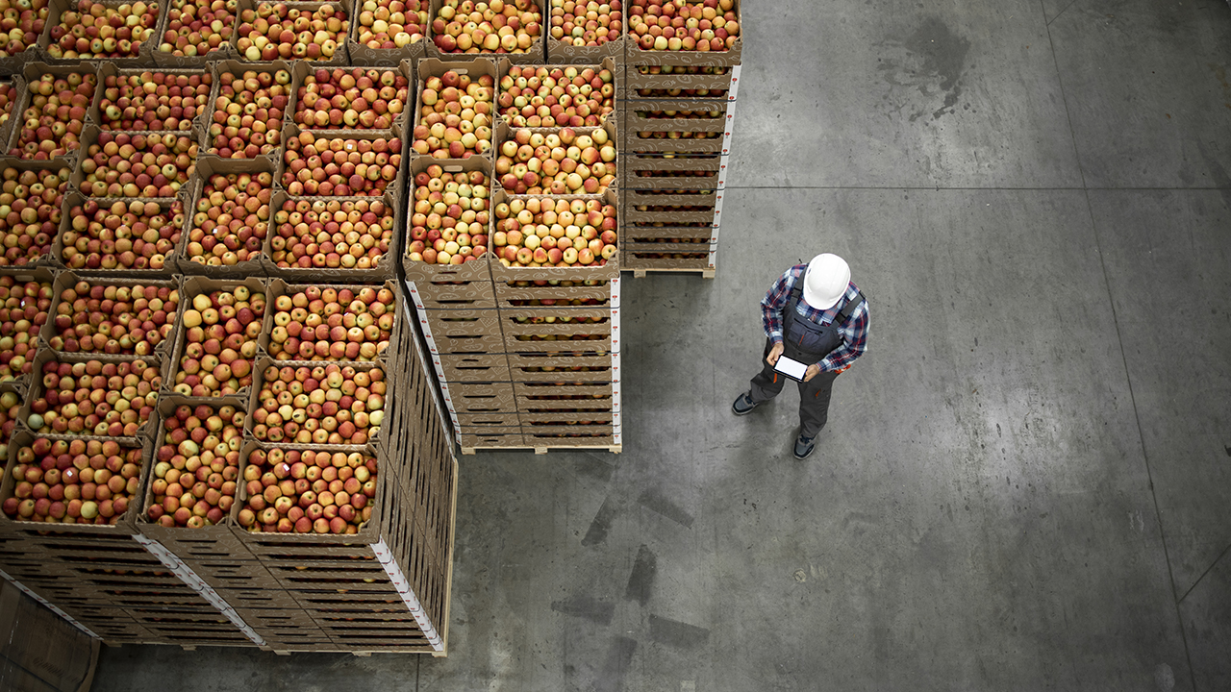

Figure 4- Food Shortages with Smart Supply Chain IoT

IoT in Logistics and Inventory Management
Inventory management is a critical tool for optimising and operationalizing every aspect of the supply chain using IoT devices. These systems ensure that raw materials, finished goods, and deliveries are delivered from producers to distributors, warehouses, and end-users and customers.

Asset management is critical in supply chain management and cannot be overstated. Distributors and transportation businesses would be unable to assure the proper operation of their complicated supply chain networks if they did not have trustworthy inventory data. However, when demand exceeds supply, today's networks struggle to respond quickly.

IoT Supports Inventory Management using machine learning
  - Smart distribution centers and warehouses can reduce inventory management errors and keep accurate counts of raw materials and products.
  - Using IoT for warehouse management means inventory data is updated in real time, tracking availability and limiting orders that can’t be fulfilled.
  - Businesses can deploy machine learning models that learn from recurring patterns in IoT device data, optimizing processes and preventing avoidable shortages.
  - Retail Inventory and the Christmas Season-During the 2022 holiday season, 82% of retail executives had concerns about shortages, and 55% have prepared to shift to secondary suppliers. Traditional inventory management could make this process difficult to execute quickly enough to meet the season’s high demand. Using IoT technology, retail stores could instantly submit orders to distribution centers as soon as their inventory hit a minimum threshold.
Machine Learning and IoT in the Supply Chain
  - As we’ve already touched on, the growing prevalence of IoT devices provides an exciting opportunity to apply machine learning to build responsive supply chains. IoT and machine learning use cases often overlap, and these technologies are connected in many ways:
  - Both provide value through real-time data collection, often for industrial, logistics, technology, energy and other sectors.
  - IoT devices provide a way to collect that information, while machine learning models process that data, providing insights those organizations can act on.
The value organizations get from using IoT and machine learning technology can depend on having access to the low latency, high-bandwidth connections that 5G networks provide.
- Data collected from IoT devices and platforms often requires processing through machine learning models for meaningful results and insights to be gleaned.
Machine Learning Can Reduce Supply Chain Bottlenecks
Machine learning may leverage IoT data to predict rising demand and supply shortfalls as the global agriculture, manufacturing, logistics, and transportation industries improve and integrate their IoT software and services. These capabilities facilitate faster decision-making, whether as part of an automated, integrated system or by providing alarms requiring human action.
1.Helps Predict Future Bottlenecks
Machine learning is a powerful tool that organisations may employ to solve their most critical operational problems; machine learning programmes can process massive amounts of data, detect patterns, and utilise those insights to forecast what will happen next.
These applications, when applied to supply chain management, provide responsive supply chains that forecast and avert future bottlenecks.
The advantages of responsive supply chains (built with machine learning) include:
- Cutting logistics and transportation costs with shipping routes that maximize flexibility in case of an emergency.
- Predictive maintenance and repair schedules for valuable equipment.
- Real-time decision-making to prevent geographic supply shortages based on data from multiple systems.
- Monitoring that helps make sense of massive amounts of data from thousands (or even millions) of IoT devices across the supply chain.
2. Reduce Costs and Response Time
Effective machine learning models can compile data shared across systems and derive insights using information from multiple sources. In supply chains, being able to make data-driven decisions based on retail or customer inventory, production timelines from manufacturing plants, shipment tracking information and even more.
Integrated into IoT applications and platforms, machine learning can help decrease long-term costs for supply chain management and — if something does go wrong — reduce response times by:
- Using logistics data to plan cost-effective shipping routes while meeting delivery targets.
- Quickly adjusting orders and deliveries to new supply chain conditions, such as blocked routes, supply shortages or fluctuating market prices.
- Applying predictive analytics to plan suitable alternative routes in case of unplanned but foreseeable roadblocks (e.g., weather, port congestion, staff shortages).
3. Asset Management and Maintenance
Machine learning and IoT technologies can also be used to improve how agriculture, manufacturing, distribution, and logistics organisations maintain and repair their equipment.

Because certain segments of the supply chain are almost always operational, equipment failures or unplanned downtime can be costly. Machine learning and artificial intelligence (AI) serve important predictive maintenance requirements, allowing organisations to discover elements that can lead to failure, automate service calls, and address issues before they cause downtime.
Organizations across the supply chain can use machine learning applications to:
- Process thousands of data points to monitor and assess equipment performance.
- Reduce equipment downtime by scheduling maintenance work and repairs during times predicted to have lower demand or traffic.
- Monitor, adjust or respond to equipment or environmental conditions that fall outside safe operational parameters, preventing equipment failure or workplace injuries.
4.Transparent Monitoring
IoT devices can assist organisations in gathering on-site data that they have never had access to before — but the volume, variety, and speed with which data is generated sometimes makes it impossible to use that information before it becomes obsolete.

Machine learning gives organisations real-time visibility into their equipment, distribution networks, inventory, and other systems.

Machine learning applications can help process massive amounts of data and distill it all down to what’s important now, what’s likely to happen next and what steps to take based on that insight.
- This level of visibility gives organizations the ability to respond to changes quickly and share real-time information with supply chain vendors, partners and customers.
- Multiple organizations can use connected systems that rely on machine learning-based IoT applications to better respond to direct and indirect impacts on their productivity.
- Transparent monitoring not only supports supply chain management on an organizational level but can also improve its function across an entire industry as shown in figure 5.

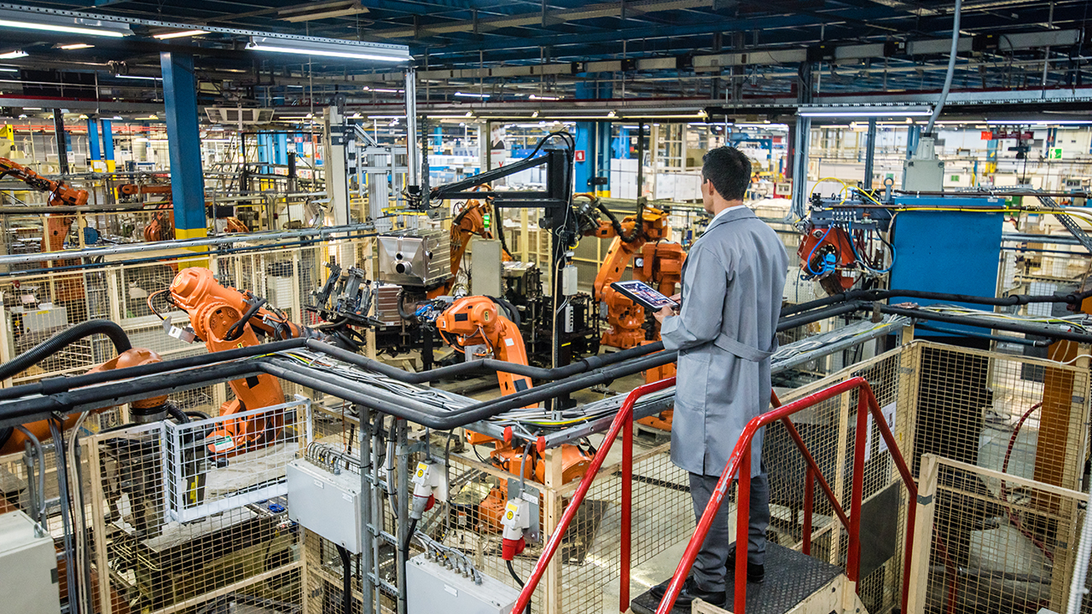

Figure 5- IOT and Machine learning in Industries

Health-care assistance

Health prediction systems assist hospitals in reassigning outpatients to less congested treatment facilities as soon as possible. They increase the number of people who receive proper medical care. A health prediction system addresses the prevalent issue of unexpected changes in hospital patient flows. Many hospitals' demand for healthcare services is fueled by emergency occurrences such as ambulance arrivals during natural catastrophes and motor vehicle accidents, as well as routine outpatient demand. Hospitals that lack real-time data on patient flow frequently struggle to meet demand, but nearby institutions may have fewer patients. The Internet of Things (IoT) connects virtual computers and actual objects to facilitate communication. It provides real-time information collecting via revolutionary microprocessor chips.

Environmental Conditions Monitoring

Environmental monitoring is a potential economic topic because it is a major contributor to the employment market and food production. Farmers are having difficulty lowering water usage and developing the optimal irrigation schedules due to the discontinuous monsoon and fluctuating weather conditions for improving crop production and soil fertility. In Agriculture, IoT-based decision making provides real-time insight into meteorological factors based on cost-effective sensor data collecting and cognitive processing, which eliminates human labour and saves time. Machine Learning and other ever-improving technologies have paved the road for discovering and adapting changes in crop design and irrigation patterns that take into consideration a multidimensional large variety of weather data to effectively predict climate conditions suited for crop irrigation.

Security and Surveillance Systems

In today's world, video surveillance is quite vital. It can be of tremendous use in decreasing crime and monitoring the status of facilities. Human variables such as fatigue, time efficiency, and human resources limit the performance of the video surveillance system. It would benefit everyone if completely automated video surveillance equipment were used to do the job. The automation of the video surveillance system is still unsatisfactory in many ways, including detector accuracy, bandwidth consumption, storage utilisation, and so on. This scientific study is primarily concerned with a video surveillance system that employs Convolutional Neural Networks (CNN), IoT, and the cloud. The system is comprised of many nodes, each of which is comprised of a microprocessor (Raspberry Pi) and a camera. The nodes communicate with one another using client and server architecture. The nodes can detect humans by utilising a pretraining MobileNetv2-SSDLite model and the Common Objects in Context (COCO) dataset, and the collected video will be streamed to the main node (just one node will connect with the cloud). In addition, the main node will notify the security staff through SMS of the discovery of people.

REFERENCES

[1] Swan, M. Sensor mania! the internet of things, wearable computing, objective metrics, and the quantified self 2.0. J. Sens. Actuator Netw. 2012, 1, 217–253.
[2] Cai, C.; Hu, M.; Cao, D.; Ma, X.; Li, Q.; Liu, J. Self-deployable indoor localization with acoustic-enabled IoT devices exploiting participatory sensing. IEEE Internet Things J. 2019, 6, 5297–5311.
[3] Wang, C.; Lin, H.; Jiang, H. CANS: Towards congestion-adaptive and small stretch emergency navigation with wireless sensor networks. IEEE Trans. Mob. Comput. 2015, 15, 1077–1089.
[4] Hu, M.; Liu, W.; Peng, K.; Ma, X.; Cheng, W.; Liu, J.; Li, B. Joint routing and scheduling for vehicle-assisted multidrone surveillance. IEEE Internet Things J. 2018, 6, 1781–1790.
[5] Hu, M.; Liu,W.; Lu, J.; Fu, R.; Peng, K.; Ma, X.; Liu, J. On the joint design of routing and scheduling for vehicle-assisted multi-UAV inspection. Future Gener. Comput. Syst. 2019, 94, 214–223.
[6] Chen, M.; Herrera, F.; Hwang, K. Cognitive computing: Architecture, technologies and intelligent applications. IEEE Access 2018,6, 19774–19783.
[7] S.R. Juhi Reshma, Anitha S. Pillai from book Proceedings of the Eighth International Conference on Soft Computing and Pattern Recognition (pp.602-613)
[8] Abhishek L, Rishi Barath B International Journal of Innovative Technology and Exploring Engineering (IJITEE) ISSN: 2278-3075, Volume-8 Issue-8 June, 2019
[9] Prof. K. A. Patil, Prof. N. R. Kale “A Model for Smart Agriculture Using IoT” IEEE | December 2016.
[10] Agraj Aher, Janhavi Kasar, Palasha Ahuja, Varsha Jadhav International Research Journal of Engineering and Technology (IRJET) Volume: 05 Issue: 03 | Mar-2018
[11]SK Tiwari, DS Rajput, S Sharma, SG Neogi, A Mishra,”Cloud Virtual Image Security for Medical Data Processing”,Mathematical Modeling and Soft Computing in Epidemiology, 317-345, 2020.
[12]Tiwari, S.K., Neogi S. G., Shakya H.K., Mishra A.,Devaraju T., “ Design and Implementation of a Virtualization Security Technique for Cloud Computing”, Computer Integrated Manufacturing Systems, 28(12), 114–123,2022.
[13] Tiwari, S.K., Neogi S. G., Mishra A. Securing Virtual Images in Cloud Environment”, Mathematical Statistician and Engineering Applications, 71(4), 7871–7882,2023.
[14] Tiwari, S.K., Neogi, S.G., Mishra, A. (2023). Design and Implementation of Security Enhancement for Trusted Cloud Computing. In: Kumar, A., Mozar, S., Haase, J. (eds) Advances in Cognitive Science and Communications. ICCCE 2022.Cognitive Science and Technology.Springer, Singapore.
[15].Tiwari,S.K. Sao,N., Kushwaha, A.,Book Title “Fundamental of Machine Learning”,lambert Publication,ISBN: 9789391265335, Oct. 2022.

