EXPERIMENTAL STUDY ON STRENGTH ANALYSIS OF FLY ASH CEMENT BLOCKS WITH BANANA FIBRE AND SUGARCANE BAGASSE WITH ADMIXTURE
DR.S.BHAGAVATHIPERUMAL¹, B.POORNIMA², K.PRIYADHARSHINI³ AND P.SHARVAANI⁴
¹Head Of Department, Department of Civil Engineering, Sairam Engineering College, Chennai – 600044, T.N., India
^{2,3,4}Research scholars, Department of Civil Engineering, Sri Sairam Engineering College, Chennai-600044,T.N., India
Correspondence should be addressed to Dr.S.Bhagavathi Perumal;drsbperumal@gmail.com;9442893339

^{ABSTRACT}
Increasing concern about the global warming, primarily due to deforestation has led to ban on use of clay brick by government in building construction. Subsequently, a large action plan for the development use of fly ash bricks substitute has resulted in creation of more awareness about the use of fly ash-based materials. Fly ash cement blocks are unconventional bricks manufactured from industrial waste such as fly ash, cement, sand/stone dust. This material is widely used because it has several benefits such as more durable, energy-efficient, low maintenance, affordability, fire-resistance, excellent thermal mass and also versatile. This research was conducted to determine the strength of the concrete after adding banana fibre and sugarcane bagasse. Agricultural waste material can help to increase the strength of concrete. The source of natural fibre is found in the plant and they 3are readily environmentally friendly and cheap. In addition, natural fibre has an excellent potential to improve the performance of concrete. In this study compressive strength test was conducted to know the strength of concrete with two different proportions of fibre. A total of 6 cubes with 15cm x 15cm x15cm were used to determine the strength of the concrete using banana fibre. All these specimens are cured for 7 days, 14 days and 28 days using water curing method. The materials used in this study are banana fibre,sugarcane bagasse, cement, manufactured sand, fly ash and water.

INTRODUCTION
FLY ASH
Fly ash is a finely divided residue resulting from the combustion of ground or powdered bituminous coal or sub bituminous coal (lignite) and transported by the flues gases of boiler fired by pulverized coal or lignite. Fly ash is a waste by-product material that must be disposed of or recycled. It consists mainly of spherical glassy particle ranging from 1 to 150 µm in diameter, of which the bulk passes through a 45- µm sieve.
CLASS C FLY ASH:
Fly ash produced from the burning of younger lignite or sub-bituminous coal, in addition to having pozzolanic properties, also has some self-cementing properties. In the presence of water, Class C fly ash will harden and gain strength over time. Class C fly ash generally contains more than 20% lime (Cao). Unlike Class F, self-cementing Class C fly ash does not require any activator. Alkali and sulphate (SO4) contents are generally higher in Class C fly ashes.

CLASS F FLY ASH:
The burning of harder, older anthracite and bituminous coal typically produces Class F fly ash. This fly ash is pozzolanic in nature, and contains less than 10% lime (Cao). Possessing pozzolanic properties, the glassy silica and alumina of Class F fly ash requires a cementing agent, such as Portland cement, quicklime, or hydrated lime, with the presence of water in order to react and produce cementitious compounds. Alternatively, in addition of chemical activator such as sodium silicate (water glass) to Class F ash can lead to the formation of geo-polymer.
BANANA FIBRE
Banana as a natural fibre has inherent advantage like silky lustre, high tensile strength, low extensibility, considerable heat and fire resistance and long staple lengths. Banana fibre can be used in many different areas, and has been receiving increasing attention from industry. Their interests focus not only on the traditional uses of banana fibre, but also on the production of other value-added products such as pulp, paper, geo-textiles, composites and home textiles etc.

SUGARCANE BAGASSE
The fibre possesses moderate amount of elastic recovery at 50% of breaking extension. The torsional rigidity of fibres is quiet high ranging between 95 dyne-cm² and 330 dyne-cm², indicating that the fibre has high rigidity to twisting and is not suitable for making yarn.
ADVANTAGES OF USING FIBRE IN FLY ASH CEMENT BLOCKS:
- Fibre-reinforced fly ash cement blocks has more tensile strength when compared to non-reinforced blocks.
- It increases the durability of the cement block.
- It reduces the crack growth and increases the impact strength.
- Fibre-reinforced concrete improves resistance against freezing and thawing.
- Reinforcing concrete with fibre increases fatigue strength.

APPLICATIONS OF BANANA FIBRE
Inthe recent past, banana fibres had a very limited applications and was primarily used for making items like ropes, mats and some other composite materials. With the increasing environmental awareness and growing importance of eco-friendly fabrics, banana fibre has also been recognized for all its good qualities and now its applications are increasing in other fields too such as apparel garment, home furnishing, bags, curtains etc.
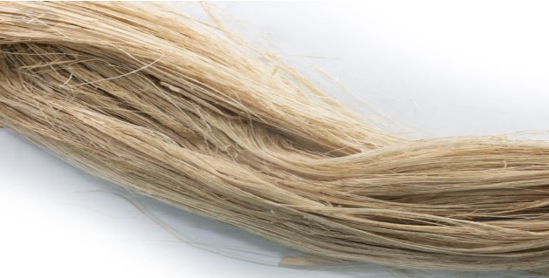
Fig. 1. Banana fibre
APPLICATIONS OF SUGARCANE BAGASSE
Sugarcane bagasse is typically used for producing heat and electricity in sugar mills, but can also be used as cattle feed and for manufacturing disposable food containers. It is mainly used as a fuel in the sugarcane industry to satisfy its own requirements. Now we are applying the use of banana fibre and sugarcane bagasse in the field of construction.

METODOLOGY
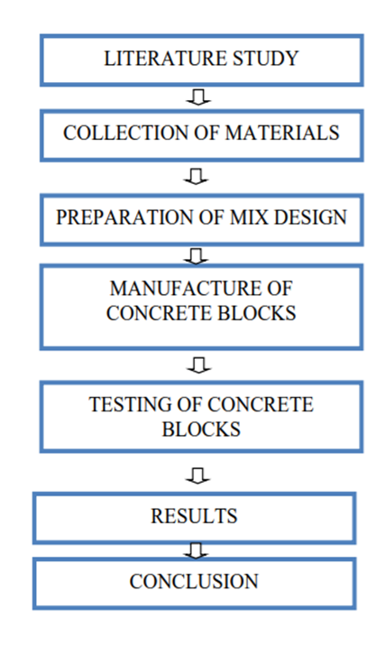
Fig.2. Methodology
MATERIAL TESTING
The materials such as cement, fine aggregate, fly ash, banana fibre sugarcane bagasse and admixture which is used in concrete mix is tested. The test taken for cement is consistency and setting time of cement, for fine aggregate is specific gravity and fineness modulus test.
MIX DESIGN
Mix design has been calculated by using the coal provisions is 10262-2019 and the result for the test is taken in the material testing such as water absorption, fineness modulus, specific gravity, setting time, consistency etc.
CASTING
After calculating the mix proportion, the concrete is prepared using the material cement, fly ash, banana fibre, and fine aggregate along with the required water content (determined from water cement ratio). The mould is prepared and properly fabricated. Then the concrete is casted in the prepared mould as layer by layer with compaction.
CURING
After the final setting time of concrete is completed, then the mould which is casted is demoulded. After the removal of mould, the concrete specimen is immersed in the curing tank for attaining the strength.

TESTING OF SPECIMENS
The test for concrete is classified as two types are fresh concrete test and hardened concrete test. The hardened concrete tests are compressive strength test and tensile strength test. This hardened concrete test shall be taken for 7 days, 14 days and 28 days curing respectively
CEMENT
PROPERTIES OF CEMENT
Cement is a fine powder used for bonding between components of concrete. In this project the cement would be Ordinary Portland cement (OPC) of 53 grade. Cement should be stored in proper place to avoid formation of floc.
The cement used was subjected to various field tests like:
- The cement used had no floc.
- After throwing in water, it floated on water for some time before sinking.
- After immersing our hand in cement, it gave us cool feeling.
- The cement was easily passing through 90-micron sieve.
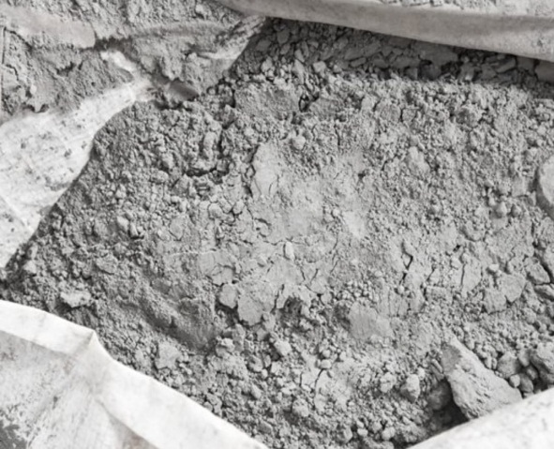

Fig.3. cement

MANUFACTURED SAND
Manufactured sand(M-Sand) is a substitute of river sand for concrete construction. Manufactured sand is produced from hard granite stone by crushing.
M-Sand is an alternative for river sand. Due to fast growing construction industry, the demand for sand has increased tremendously, causing deficiency of suitable river sand in most part of the world.
Due to the depletion of good quality river sand for the use of construction, the use of M-Sand has increased. Another reason for use of M-Sand is its availability and transportation cost.
Since manufactured sand can be crushed from hard granite rocks, it can be readily available at the nearby place, reducing the cost of transportation from far-off river sand bed.
PROPERTIES OF M-SAND
It is used as a filler material to fill the gap i.e., porosity of concrete is reduced. It also has high tensile strength that results from its fine-grained structure.
- Specific gravity-2.5
- Water absorption-0.6%
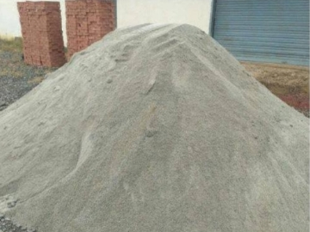
Fig.4. manufactured sand
BANANA FIBRE
Banana fibres are obtained manually scrapping them from the banana sheath of the harvested pseudo stems and then cut into different sizes. To deal with the durability shortcomings associated with organic substances that are found in natural fibres, such as waxes, lignin and pectin. Fibres were first treated by immersion in 5% sodium hydroxide solution for 60 minutes at room temperature. Thereafter, fibres were thoroughly washed with tap water for a minimum of 10 minutes to remove the hemicellulose, lignin and wax surrounding the cellulose. This process is known to exposes cellulose and increase surface roughness of the fibres, as well as improving their interfacial bonding strength.
3.2.4.1. CHEMICAL PROPERTIES OF BANANA FIBRE
- Cellulose: 63-64%
- Hemi cellulose: 6-9%
- Lignin: 5-10%
3.2PHYSICAL PROPERTIES OF BANANA FIBRE
- Density: 1350 kg/m³ Tensile strength: 56 MPa
- Elongation at break: 2.60%
- Young’s modulus: 3.5 MPa
- Fineness:17.15
- Moisture content: 11%
SUGARCANE BAGASSE
- It is a dry pulpy fibrous material that remains after crushing sugarcane to extract their juice. It is used as a biofuel for production of heat, energy, and electricity, and in the manufacture of pulp and building materials.
- PROPERTIES OF SUGARCANE BAGASSE
- The he fibre has highfibre possesses moderate amount of elastic recovery at 50% of breaking extension. The torsional rigidity of fibres is quiet high ranging between 95 dyne-cm² and 330 dyne-cm², indicating that t rigidity to twisting and is not suitable for making yarn.
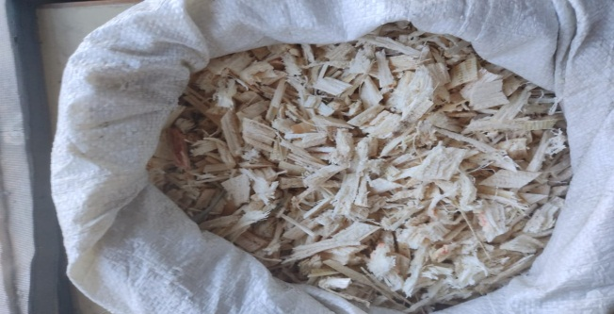
ADMIXTURE (CONPLAST WL)
DAYS | SPECIMEN 1  N/MM² | SPECIMEN 2  N/MM² | SPECIMEN 3  N/MM²
7 | 17.16 | 17.37 | 17.67
14 | 20.71 | 21.88 | 21.98
28 | 26.45 | 26.57 | 26.89
It is a dark brown liquid based on lignosulphonates which mixes readily with water and therefore disperses evenly. It waterproofs by improving the quality of the concrete or mortar. It reduces the water demand for required workability and minimises segregation and bleeding.
PROPERTIES OF ADMIXTURE
- Compatibility- Can be used with all types of cements, including pozzolanic but not high alumina cement.
- Permeability to water- Less than 15% as compared to 50% maximum allowable under IS:2645 compared to control sample.
- Setting time- No significant effect on setting time of concrete or mortar.
- Workability- Improves workability at reduced water cement ratio.

- RESULT OF THE EXPERIMENT 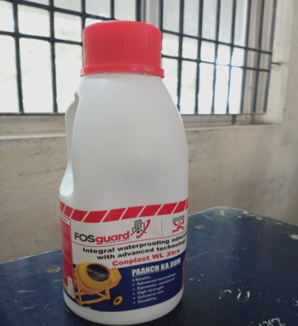

COMPRESSIVE STRENGTH
The samples which are submerged in fresh water for the following 7, 14, 28 days testing and the samples are kept in dry with the goal that the water is depleted well to improve the interpretations. The compressive strength calculates by using formula Fc = P/A F c = Compressive strength N/mm 2 P = Ultimate load KN A = Loaded area mm 2
COMPARISON
1.COMPRESSIVE STRENGTH USING BANANA FIBRE

Specimen 1 = 7.5% banana fibre
Specimen 2 = 10% banana fibre
Specimen 3 = 15% banana fibre

7th day compressive strength using banana fibre

14th day compressive strength banana fibre

28th day compressive strength using banana fibre

Compressive strength comparison using banana fibre
2.COMPRESSIVE STRENGTH USING BANANA FIBRE AND SUGARCANE BAGASSE
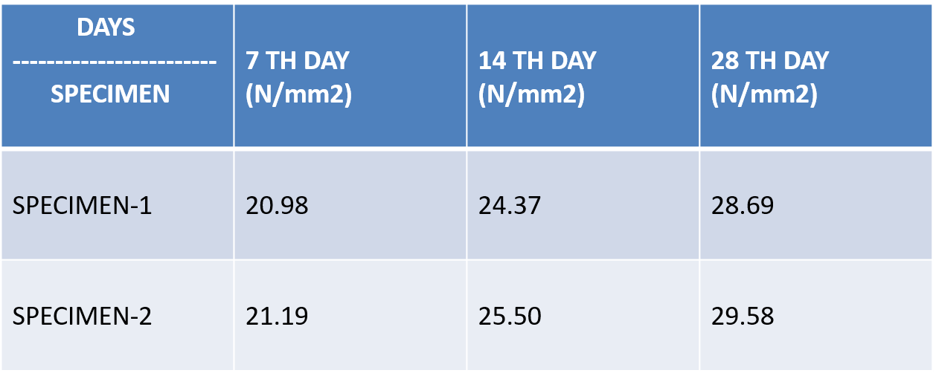ss
Specimen 1 = 5% banana fibre and 5% sugarcane bagasse
Specimen 2 = 7% banana fibre and 3% sugarcane bagasse

7thday compressive strength using banana fibre and sugarcane bagasse

14th day compressive strength using banana fibre and sugarcane bagasse

28th day compressive strength using banana fibre and sugarcane bagasse

Compressive strength comparison using banana fibre and sugarcane bagasse

Comparison of nominal, fly ash cement blocks using banana fibre andfly ash cement blocks using both banana fibre and sugarcane bagasse
CONCLUSION
This study was conducted with the aim to learn the properties of fly ash cememt blocks with banana fibre and sugarcane bagasse and its use as a construction material as building blocks. Fibre reinforced fly ash cement blocks has more tensile strength when compared to non fibre reinforced blocks. It increases the durability of the cement blocks. It reduces the crack growth and increase the impact strength. It improves resistance against freezing and thawing. It also increases fatigue strength. It is heat resistant. It helps in preventing overuse of natural resources for construction. From the experimental study results it is found that fly ash blocks with both banana fibre and sugarcane bagasse has more strength than fly ash cement blocks with only banana fibre and also nominal concrete blocks.
REFERENCES
[1] AeslinaBinti, Abdul Kadir, Ahmad Shayuti, and Bin Abdul Rahim (2014) ‘An Overview of Sludge Utilization into Fired Clay Brick’, International Journal of Environmental, Chemical, Ecological, Geological and Geophysical Engineering, Vol.8, No.8, pp.567-571.
[2] Agrawal, S.K. watile, R.K. mohata, P.V. and makwan, S.C. (2013) ‘Utilization of Textile Apparel Waste in Clay Brick’, International Journal of Advanced Research in Engineering and Technology (IJART), Vol.4, No.7, pp. 48-52.
[3] Angeline Swarna, M. and Venkatakrishnaiah, R. (2014) ‘Manufacturing of Bricks Using Tannery Effluent Sludge’, International Journal of Recent Development in Engineering and Technology, Vol.3, Issue.4, pp.33-36.
[4] Badr El-Din Hegazy, E. HananFouad, A. and Ahmed Hassanain, M. (2012) ‘Brick ManWater Treatment Sludge and Rice Husk Ash’, Australian Journal of Basic and Applied Sciences, Vol.6, No.3, pp.453-461.
[5] Balasubramanian, J. Sabumon, P.C. John Lazar, U. and Ilangovan, R. (2006) ‘Reuse of Textile Effluent Treatment Plant Sludge in Building Materials’, Waste Management, Vol.26, pp.22-28.
[6]https://publons.com/researcher/AAF-3416-2019/
[7]https://publons.com/researcher/32253383/bhagavathiperumal-s/
[8]https://www.scopus.com/authid/detail.uri?authorId=36806710000
[9]https://scholar.google.com/citations?hl=en&user=ATzEacAAAAJ
[10]https://orchid.org/0000-0002-7868-7901

