RECENT INTRACANAL MEDICAMENTS IN ROOT CANAL TREATMENT

Dr. Surya Dahiya¹, Dr. Swati Chhabra², Dr. Simran Virdy³
1.Reader,Deptt of Conservative Dentistry and Endodontics, Maharishi Markendeshwar College of dental sciences and research, Mullana, Haryana.
2.Lecturer, Deptt of Conservative Dentistry and Endodontics, Maharishi Markendeshwar College of dental sciences and research, Mullana, Haryana.
3.PG Student, Deptt of Conservative Dentistry and Endodontics, Maharishi Markendeshwar College of dental sciences and research, Mullana, Haryana.

Abstract
The role of bacteria in root canal system infection has been repeatedly demonstrated over time. The root canals and periapical tissues contain a variety of kinds of bacteria, including aerobic, facultative anaerobes, and anaerobic bacteria. In order for endodontic therapy to be successful, the microbial burden must be kept to a minimum and must not be allowed to recolonize the canal system. The thorough application of irrigants and intracanal medications is essential to the disinfection process. In between appointments, intracanal medications effectively remove pathogens. Therefore, it is essential to comprehend the aspects that influence an intracanal medication's effect as well as the factors that assist in selecting the appropriate one based on the case.
Keywords- Intracanal medicament, Chlorhexidine, Calcium hydroxide, Natural medicament, Nanoparticles

Introduction-

Pulpal or periapical tissues' inflammation and/or infection cannot be overlooked. Depending on the diagnosis, root canal therapy may be the line of treatment for such conditions.¹
When treatment can't be finished in a single appointment, intracanal medications are typically advised due to the possibility that intracanal bacteria may continue to survive and often multiply in the meantime. Kawashima et al. define intracanal medicament as the temporary insertion of medications with favorable biocompatibility within root canals with the aim of preventing bacterial coronal invasion.²
Inter-appointment antimicrobial treatment works by preventing bacterial growth, eliminating any remaining bacteria, and reducing the entry of microorganisms through a leaky restoration.²
Since it is well established that primary cause of pulp as well as periapical pathosis is microorganisms, intracanal medicament is important as infection, necrosis, and apical periodontitis develop if they infiltrate the root canal.³
Due to its broad spectrum of activity against numerous endodontic infections, which is believed to be primarily caused by its high alkalinity inducing bacterial cell membrane breakdown, calcium hydroxide has traditionally been the preferred intracanal medication. However, some bacteria, including Candida albicans and Enterococcus faecalis, appear to be resistant to calcium hydroxide.⁴
As a result, chlorhexidine was developed as an intracanal antibacterial agent. For endodontic irrigants and dressings, different amounts of chlorhexidine gluconate solutions have been suggested.⁴
The field of herbal medicaments has experienced exponential expansion in recent years due to their natural origins, ease of availability, efficacy, safety, and lack of adverse effects.⁴
Advanced technologies are also being explored for disinfecting root canals, including photoactivated disinfection, ultrasonics, ozone, endox lasers, and electrochemically activated water.⁵ No medication appears to be perfect, despite competing claims, and their use varies greatly in clinical dentistry practice.²
The effectiveness of intracanal medications has come into question with the rise of single visit endodontic treatment, which does not employ them. The clinical outcomes of single- and multiple-visit endodontics are relatively comparable, according to a number of reports. However, an intracanal medication is strongly advised if multiple visit treatment is chosen.²

Between endodontic sessions, long-acting intracanal medications are used to stop bacterial inflammation⁵
Microbiology Of Pulp-

Complex microbial flora can be found in loose collections in root canal lumen or as thick aggregation (biofilms) attached to dentinal walls in infected root canals. A variety of periapical reactions associated with the root canal microbes might happen as a result of the interaction between root canal microbes and the development of periapical lesions. These reactions can include granulomas, epithelial proliferation, cysts, acute periapical abscess/cellulitis, chronic periapical inflammation, persistent suppurative periapical inflammation, periapical osteo-myelitis, periapical osteosclerosis, and periapical osteoitis.⁴
Primary infection, which is one that existed before any intervention, progresses over time and depth from a predominately facultative, Gram-positive bacteria flora to one that is almost entirely anaerobic and predominately Gram-negative.
Teeth with apical periodontitis commonly contain strains from the genera Tannerella, Dialister, Fusobacterium, Prevotella, Porphyromonas, Peptostreptococcus, or Treponema.
Additionally, infections caused by other microbes, such as Actinomyces/Arachnia, Eubacterium, Veillonella, and Streptococci, frequently happen.
It has been demonstrated that the microorganisms in secondary root canal infections, or retreatment cases, which happen during or after treatment, are very different from those in original apical periodontitis. Enterococci, Streptococci, or Anaerobic Cocci are frequently found in retreatment instances.⁶
Rationale Of Use-
Medicaments may be utilized in endodontic therapy in order to:
- Help eliminate bacteria
- Reduce inflammation (and thereby reduce pain)
- Induce healing of calcified tissues
- Help eliminate apical exudate
- Control inflammatory root resorption
- Prevent contamination between appointments⁷
- To dry persistently wet or the weeping canals ³
- Enhancing Anesthesia⁵
- To render root canal contents inert
- To neutralize tissue debris
- To act as a barrier against leakage from an inter appointment dressing in symptomatic cases.³

Ideal Properties of Intracanal Medicaments-
(By Louis I Grossman, Endodontic Practice,10th edition)
An ideal intracanal medicament should-
- Be an effective germicide and fungicide.
- Be non-irritating.
- Remain stable in solution.
- Have a prolonged antimicrobial effect.
- Be active in presence of blood, serum, and protein derivatives of tissue.
- Have low surface tension.
- Not interfere with the repair of periapical tissues.
- Not stain tooth structure.
- Be capable of being inactivated or neutralized in a culture medium.
- Not induce cell-mediated immune response.
- Have no deleterious effect on vital tissues.
- Not alter the physiologic activities of the host tissues.
- Have good penetrating ability to be effective in the dentinal tubules.
- Reduce pain.
- Induce healing and hard tissue formation.
- Eliminate apical exudates.
- Control inflammatory root resorption.
- Have reasonable shelf life.
- Be readily available.
- Be inexpensive.
Commonly Used Medicaments-
- Phenol
One of the first antiseptics was phenol, which Lord Lister brought into medicine around 1867.
Because of its capacity to penetrate and destroy bacterial cell walls, phenol has an antibacterial effect via precipitating protoplasmic protein.
Since it is equally hazardous to living tissues just as it is to bacteria, its activity can be described as cytocidal as opposed to bactericidal. Its impact is less direct at lower doses or in certain of its changed forms because it impairs vital enzyme systems rather than precipitating protoplasm to trigger cell death.⁸
- Eugenol
Despite being categorized as a type of essential oil, eugenol shares a chemical affinity with phenolic chemicals.
It produces certain anodyne effects when used in small amounts. Despite being among irritating compounds, it is more efficient and less irritating as an antiseptic than phenol. As a result of its hemolytic activity, when it comes into contact with blood, blood cells are disrupted and blood pigments are released, which stain dentin. It works well as an antimicrobial against a wide range of microorganisms present within an infected root canal. Its activity is more bacteriostatic than bactericidal at therapeutic concentrations. Because of insolubility within water, serum it requires coming in contact with microbes in order to be effective.⁹
- Iodophores
Iodophores are organic iodine solutions that make excellent root canal cleaning tools due to their low surface tension. They are iodine-and-a solubilizing substance or carrier complexes that serve as reservoirs of active free iodine.⁸
Iodine tincture (5% diluted in alcohol) & iodine potassium iodide (2% iodine, 4% w/w potassium iodide, 94% distilled water) are the two most frequently used dental preparations. Using the first solution, endodontic surgery fields are cleaned; while the second, can be used as an intracanal medication.⁴
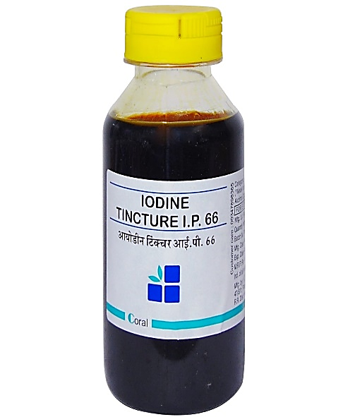
A B
Figure no. 1: (A) Iodine tincture (B) Iodine potassium iodide solution
- Chlorhexidine
In 1953, chlorhexidine (CHX) was initially sold as an antiseptic cream in the United Kingdom. It continues to be used for general disinfecting purposes since 1957. It is frequently used as a medication and endodontic irrigant. As a salt, CHX is stable and is a base. The most popular oral formulation, CHX gluconate, is in water and easily produces electrically positive CHX constituent at physiological pH.¹⁰
The effects of CHX might be bacteriostatic or bactericidal, depending on the concentration.⁴
Small molecular weight chemicals leak out at low concentrations, having a bacteriostatic effect.¹¹ It exerts a bactericidal effect at higher doses because of coagulation or precipitation of cytoplasm, which is probably brought on by protein cross-linking.¹²
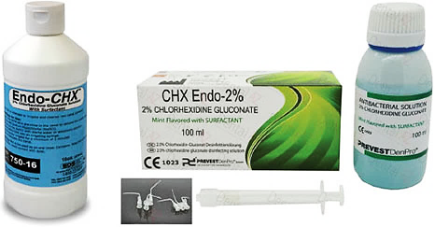
Figure no. 2 : Chlorhexidine preparations
- Calcium hydroxide
The first mention of calcium hydroxide's use in dentistry dates back to Nygren 1838, but Hermann introduced the compound as Calxyl in 1920.¹³
Its high pH (12.5–12.8), which limits bacterial growth and survival because the majority of bacteria can't survive at pH 11 or above 7, is what causes the bactericidal effects. Additionally, lipopolysaccharide and other bacterial metabolites are detoxified and denatured by calcium hydroxide. The mechanism underlying this activity may be connected to calcium hydroxide's antibacterial characteristics, capillary contraction, and creation of the apical plug. Calcium hydroxide is claimed to be effective in reducing inflammatory exudates in the periapical region.¹⁴
The dissipation of hydroxyl ions within an aqueous environment is linked to the antimicrobial activity of calcium hydroxide.¹⁵
- Ledermix paste
Schroeder and Triadan developed the glucocorticoid antibiotic compound in 1960. In Ledermix paste, the antibiotic part was included to make up for any potential corticoid-induced decline in the host immunological response.⁴
Initially, chloramphenicol was used; however, demeclocycline-HCl was eventually substituted as the antibiotic. Today's Ledermix paste contains a corticosteroid called triamcinolone acetonide (around a conc. 1%) and a tetracycline antibiotic called demeclocycline HCI (around a conc. of 3.2%) in a polyethylene glycol base.⁴
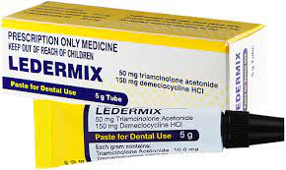
Figure no. 3: Ledermix paste
- Triple Antibiotic Paste
Combination of metronidazole, ciprofloxacin and minocycline that could be effective in killing bacteria in the deep layers of root canal in dentin.¹⁶
Gram-negative, gram-positive, as well as anaerobic bacteria are all susceptible to TAP, and this combination has the potential to be efficient against odontogenic pathogens. Because of the discolouration that minocycline causes, cefaclor has recently taken the place of minocycline.¹⁷
Natural Intracanal Medicaments-
- Propolis
It is made up of pollen (5–10%), essential oils & wax (30–50%), and resin and balsams (50–70%). Other components include phenols, aromatic compounds, minerals, amino acids, vitamins A, B complex, & E, as well as the bioflavonoid (vitamin P), a highly active biochemical substance. Its main biologically active ingredients appear to include flavonoids, caffeic acid, aromatic acids, diterpenic acids, and phenolic compounds. It is not as efficient against gram-negative microbes like Salmonella and is more efficient against gram positive bacteria, especially Staphylococcus aureus.⁴
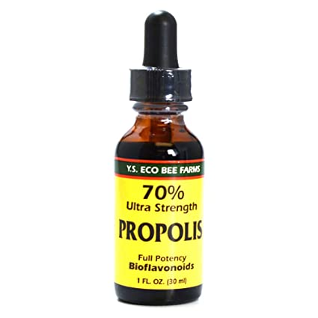
Figure no. 4 : Propolis solution
- Honey
The presence of "Inhibine," a component of honey that Lavie et al. detected as hydrogen peroxide in 1963, is a popular antimicrobial agent, and its negative effects when added alone are not noticeable with honey because the latter sequesters as well as inactivates the free ion that catalyzes the generation of oxygen free radicals created by hydrogen peroxide.⁴
- Azadirachta Indica
It is referred to as the Indian Margosa Tree. It has been demonstrated that this medicine works well against Candida albicans and E. faecalis. It could be used as a substitute to sodium hypochlorite in root canal irrigation due to its antibacterial and antioxidant qualities.⁴
- Arctium Lappa
Sterols, tannins, polyacetylene with sulfur, volatile fatty acids, and polysaccharides are all present in Artium lappa. Arctium Lappa may be used as a root canal medication since research has shown that its ingredients are highly effective against a wide range of microorganisms, including Candida albicans, Staphylococcus aureus, Pseudomonas aeruginosa, and E. faecalis.³
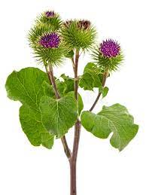
Figure no. 5 : Arctium lappa

- Ricinus Communis
Ricinoleic acid, oleic acid, linoleic acid, -Linolenic acid, stearic acid, palmitic acid, and dihydroxystearic acid are the components of Ricinus communis. Castor oil and its derivatives can be utilized as root canal irrigant and an intracanal medication because of the high proportion of ricinoleic acid residues present in them.¹
- Casearia Sylvestris
Phospholipase A2 inhibitors, which lessen the acute phase of the inflammatory process and lengthen the regenerative phase, are abundant in the alcohol-based extract of Casearia Sylvestris.⁴ It might develop into a respectable substitute for an intracanal medication used briefly.¹
- Curcuma Longa
By preventing the dynamics of FtsZ assembly in the Z-ring, a polyphenolic substance called curcumin effectively prevents bacterial cell multiplication.⁴ The antibacterial action of curcumin has been demonstrated to be strong against a variety of pathogenic bacteria, including enterococcus.³
- Ocimum Sanctum
The eugenol as well as linoleic acid content of tulsi, as well as the suppression of the cyclooxygenase and lipoxygenase pathways for arachidonic acid metabolism, are credited with the herb's anti-inflammatory properties. Excellent antibacterial properties of the essential oil extract from Ocimum sanctum increase with concentration.¹
- Allium Sativum
The antimicrobial effectiveness is a result of its capacity to prevent the formation of toxins and the expression of pathogenesis-related enzymes. Allicin, the main component of garlic, is a well-known antibacterial agent and induces immunological processes. The bacterial cell membrane and cell wall are negatively impacted by allicin.¹
- Aloe Vera
The two active components of aloe vera are aloin and aloe-emodin. The inclusion of anthraquinones, which prevent the growth of S. pyogenes and E. faecalis, explains why it is effective against these two bacteria.³
- Green Tea
Green tea polyphenols (GTP) have a high antioxidant content, function as an anticariogenic, and have anti-inflammatory properties. Its ability to block bacterial DNA gyrase enzymes by attaching to ATP binding sites of ATPB subunit is what gives it its antibacterial properties.³
Recent Advancements-
- Antibiotic Containing Scaffolds:
Using polymer-based electro spinning scaffolds containing antibiotics, comparable to Novamin, which contains calcium, sodium, and phosphosilicate and aids in bone regeneration, it is possible to create a biologically safe antibiotic drug delivery method. According to the type of polymer utilized, the drug release method might be either quick, intermediate, or delayed. According to Bottino MC et al., electro spun nanocomposite fibrous material can be used to accelerate root development and regeneration of pulp-dentin complex.¹⁸
- Medicated Gutta-Percha:
Gutta percha that has been impregnated with tetracycline (TGP) serves as an antibacterial reservoir and has the ability to diffuse onto the material's surface, which prevents bacterial colonization on gutta percha as well as within root canals. TGP has been recommended as a final obturating substance in addition to an inter-appointment intracanal medication ^{19,20,21}
- Bioactive Glass
Research is needed to determine whether bioactive glass may be used as an intracanal medication. It might serve as an interappointment dressing substitute for calcium hydroxide.⁴
- Photo-activated disinfection:
This procedure uses photoactive dye activated by subjecting it to a certain light source while being in the presence of oxygen. First demonstrated by Oscar Raab, who documented the fatal effects of acridine hydrochloride upon Paramecia caudatum, photodynamic treatment (PDT) is a method for inactivating microorganisms.²²
Figure no. 6: PAD mechanism
- Endox
It is a device that aids in improving the effectiveness of root canal therapy and streamlining the process by first enabling the location of apex of root canal followed by facilitating the vaporization of pulp tissue with a subsequent decrease in the amount of bacteria present in the canal system by raising temperature, following the use of high frequency current (600 kHz) for one-tenth of a second.²³
- Odontopaste
Odontopaste, a root canal paste with a zinc oxide base containing 5% clindamycin hydrochloride with 1% triamcinolone acetonide, was introduced in February 2008. This antibiotic has bacteriostatic properties and serves as a temporary dressing to stop bacterial overgrowth within root canal. Triamcinolone acetonide, a form of steroid, can also briefly lessen inflammation along with postoperative pain.²⁴
- Ozone
Ozone can promote angiogenesis and has potent antibacterial and debriding properties. In dentistry, ozone is applied as a gas, in ozonated water, and in ozonated oils. Aldehyde, unsaturated fatty acid, as well as hydrogen peroxide may all contribute to the ozonized oil's antimicrobial properties. As an oxidant, hydrogen peroxide can damage DNA, oxidize enzymes, and destroy the functionality of a bacterial cytoplasmic membrane.²⁵
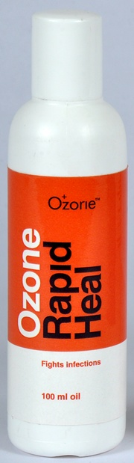
Figure no. 7: Ozonated oil

- Antimicrobial Peptides
Antibacterial peptides (AMPs), which have a high antibacterial effectiveness, good biocompatibility, and limited bacterial resistance, are prospective substitutes for conventional intracanal medications. The majority of AMPs are cationic oligopeptides that are either created computationally or from natural sources such bacteria, fungi, plants or animals.²⁶
- Nanoparticles
Use of nanoparticles, including as metal, polymeric, and ceramic nanoparticles, is another successful intracanal medicament. In order to increase the antibacterial effectiveness of calcium hydroxide, these nanoparticles are frequently added to the calcium hydroxide paste.
Due to broad-spectrum antibacterial action, silver nanoparticle (AgNP) is one of the most researched metal nanoparticles for use against E. faecalis. Copper nanoparticles (CuNP), selenium nanoparticles (SeNP), and zinc oxide nanoparticles (ZnONP) are further antibacterial metal nanoparticles. Chitosan nanoparticles are an example of a polymeric nanoparticle that can be used as a direct antibacterial agent or even as biodegradable nanocarrier containing antimicrobial medicines.²⁶
Conclusion-
Intracanal medication make a significant contribution to cleaning the canal. The outcome of the treatment depends on how much the microbial load is reduced by using irrigants and medications together. One must consider the features, benefits, and drawbacks of a medicament before selecting it.¹
It is obvious that the primary goal of administering these medications is to clean the root canal system in preparation for the insertion of an obturating material that is acceptable to biologically. Furthermore, it is wise to recognize that endodontic infections are managed by the use of local antibacterial dressings and irrigation in root canals as a part of concerted effort. If there are issues with the quality of certain other components of the treatment, they alone cannot ensure success.²
References-
- Nasim I, Hemmanur S. Intracanal Medicaments-A Review of Literature. Int J Dent Oral Sci. 2021 ;8(05):2643-8.
- Kumar A, Tamanna S, Iftekhar H. Intracanal medicaments–Their use in modern endodontics: A narrative review. J Oral Res Rev. 2019;11(2):89-94.
- Tomer A. Intracanal medicaments - a review. Int J Med Sci Diag Res. 2020 ;4(7):48-51.
- Darshan v, Bal S.C.B., Kumari A. Intracanal Antiseptic Medicaments. Book Rivers. 2022.Print.
- Pal H, Sarkar A, Das L, Saha S, Sarkar S. Application of Intracanal Medicaments: A Review. IOSR J Dent Med Sci. 2019;18(1):14-21
- Chong BS. Harty’s Endodontics in Clinical Practice. 6th ed. London, England: Churchill Livingstone; 2016.Print.
- Abbott PV. Medicaments: aids to success in endodontics. Part 1. A review of the literature. Aust dent j. 1990;35(5):438-48.
- Grossman L. Endodontic Practice. 10th edition. Bombay: Varghesese Publishing House;1998;247-259.
- Torneck CD. Therapeutic armamentarium. In: Clark's dentistry. Harcourt Brace & Co, Mosby; 1-21.
- Neil A Baker, Paul D Eleazer, Robert. E, Samuel Seltzer. Scanning electron microscopic study of the efficacy of various intracanal irrigants. J Endodon. 1975; 1:127-37.
- Vasudeva A, Sinha DJ, Tyagi SP, Singh NN, Garg P, Upadhyay D. Disinfection of dentinal tubules with 2% Chlorhexidine gel, Calcium hydroxide and herbal intracanal medicaments against Enterococcus faecalis: An in-vitro study. Singapore dent J. 2017; 38:39-44.
- Sinha DJ, Jaiswal N, Vasudeva A, Garg P, Tyagi SP, Chandra P. Comparative evaluation of the effect of chlorhexidine and Aloe barbadensis Miller (Aloe vera) on dentin stabilization using shear bond testing. J conserv dent. 2016 Sep;19(5):406-9.
- Gokturk H, Bayram E, Bayram HM, Aslan T, Ustun Y. Effect of double antibiotic and calcium hydroxide pastes on dislodgement resistance of an epoxy resin-based and two calcium silicate-based root canal sealers. Clin Oral Investig. 2017; 21:1277-82
- Kawashima N, Wadachi R, Suda H, Yeng T, Parashos P. Root canal medicaments. Int dent J. 2009;59(1):5-11.
- Kurian B, Swapna DV, Nadig RR, Ranjini MA, Rashmi K, Bolar SR. et al. Efficacy of calcium hydroxide, mushroom, and aloe vera as an intracanal medicament against enterococcus faecalis: an in vitro study. Endodon. 2016;28(2):137-142.
- Shrestha S, Mala K. Evaluation of sealing ability of a root canal sealer with various antibiotic additives: An in vitro study. J Interdiscip Dent. 2013; 3:21-4.
- Hoshino E, Kurihara-Ando N, Sato I, Uematsu H, Sato M, Kota K et al. In-vitro antibacterial susceptibility of bacteria taken from infected root dentine to a mixture of ciprofloxacin, metronidazole and minocycline. Int Endod J. 1996; 29:125-30.
- Reichal P, Anjaneyulu K, Arivarasu L. Antibiotics as Root Canal Medicaments-A Review of Literature. PalArch's J Arch Egypt/Egyptol. 2020 Nov 28;17(7):661-73.
- Martin H, Martin TR. Iodoform gutta percha: MGP, a new endodontic paradigm. Dent Today. 1999; 18:76-81.
- Martin H. Antibiotic/Medicated Gutta Percha Point. US Patent 6,602,516; 2003.
- Emre B, Tayfun A, Mustafa S. The antimicrobial and antifungal efficacy of tetracycline integrated gutta percha. Ind J Dent Res 2008; 19:112-5.
- Hargreaves K.M., Cohen S. Pathways of the pulp. 10th edition. Mosby Elsevier,2011: 245-282.
- Turner SR, Love RM, Lyons KM. An in‐vitro investigation of the antibacterial effect of nisin in root canals and canal wall radicular dentine. Int Endod J. 2004;37(10):664-71.
- Topcuoglu HS, Arslan H, Akcay M, Saygili G, Cakici F, Topcuoglu G. The effect of medicaments used in endodontic regeneration technique on the dislocation resistance of mineral trioxide aggregate to root canal dentin. J Endod. 2014; 40:2041-4.
- Reddy KS, Prasad SD, Sirisha PD, Prashanth V. Evaluation of Antimicrobial Efficacy of Ozonated Sesame Oil, Calcium Hydroxide and their Combination as Intracanal Medicament against Candida Albicans: An in-vitro study. Adv Hum Biol. 2015;5(2):78-87.
- Ordinola‐Zapata R, Noblett WC, Perez‐Ron A, Ye Z, Vera J. Present status and future directions of intracanal medicaments. Int Endod J. 2022;55(Suppl 3):613-36.

