Nanocellulose: A fascinating, multifunctional and sustainable biomaterial
Shubhangi P. Patil¹*, Rajendra R. Tayade², Aniruddha B. Patil³
¹Department of Chemistry, The Institute of Science, Mumbai, 400032, India
²Department of Chemistry, Institute of Science, Nagpur – 440008, India
³Department of chemistry, Maharshi Dayanand College, Parel, Mumbai, Maharashtra 400012, India
Corresponding Author: ¹Shubhangi P. Patil* E-mail ID: shubhangi.patil@iscm.ac.in, 919004941343

ABSTRACT
Nanocellulose is a remarkable natural polymer that is prevalent on the planet. It demonstrates incredible properties to meet contemporary needs for sustainability, biodegradability, diverse functionality, tuneable chemistry, and renewability. Nanocellulose may be extracted chemically or mechanically from a variety of natural sources, such as rice husk and sugarcane bagasse. This chapter discusses numerous cellulose sources, nanocellulose types and extraction procedures. In this study, we concentrated on modification of nanocelllose to impart or improve certain specifications to the material based on its application. With several current research examples, we show the application of nanocellulose. We cover nanocellulose applicability in packaging, bio-medical, environmental amoliaration, energy harvesting, and electronics. Finally, we provide a critical viewpoint on the use of nanocellulose in the context of innovative, eco - friendly and sustainable materials.
Keywords: Nanocellulose, tuneable chemistry, Surface modification, applicability
I. INTRODUCTION
A. Need of a natural polymer:cellulose
On this planet, every ecosystem including the human ecology is harmoniously moulded by nature. Nature uses creation and abolition as a means of preserving the harmony of each ecosystem. Then safety, comfort, and luxury are products of human evolution. The human race's journey from the stone age to the age of technology was spectacular and now we are here with almost all of our accomplishments; along with pollution, damaged ecosystems, and global warming. One of the main causes of nature's balance being upset is the usage of synthetic materials that persist in the environment after years of use. One of the biggest problems is the degradation of synthetic polymers, since it affects directly or indirectly all ecosystems and upsets the natural order [1]. As a result, cellulose, a natural polymer has drawn the attention of numerous experts in recent years. Cellulose is a plentiful, widely accessible, renewable, and biodegradable natural polymer. It is the substance that produces the most on earth. Hence, it comes under the lens of curiosity for many researchers [2].
B. Chemistry of Cellulose
With the chemical formula (C6H10O5)n, cellulose is an organic substance. Anhydroglucose units (AGUs) are a semicrystalline polycarbohydrate that make up cellulose and are joined by β-1,4-glycosidic linkages where as shown in figure.1. Each repeating unit in this linkage contain three hydroxyl groups from which one is primary alcohol and other two are secondary alcohols. These hydroxyl groups are responsible for intramolecular as well as intermolecular hydrogen bonding. Due to the hydroxyls' equatorial orientation, the AGU is capable of forming internal hydrogen bonds, such as those between the hydrogen atom in a unit's C-3 hydroxyl group and an oxygen atom in a nearby unit's ring. Increased stiffness of cellulose chains is a result of internal hydrogen bonds that prevent the glucopyranosic rings from freely rotating around the chemical glycoside bonds [3]. Crystallites are the rigid, strong, and highly organised cellulose constituents that are inaccessible to water and some chemical reactions due to a robust system of intra- and intermolecular hydrogen bonds. The increased hydrophilicity and accessibility of cellulose materials, on the other hand, is caused by extremely weak hydrogen bonds in noncrystalline amorphous domains. Because of this cellulose's structural chemistry, it is a variable substance[3], [4].
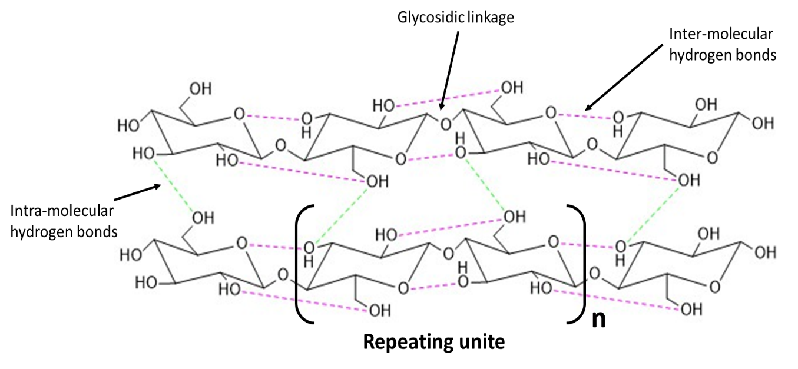

Figure.1 Chemical structure of Cellulose
C. Sources
Plant cell walls typically consist of cellulose, hemicellulose, and lignin, with lignin accounting for around 10-25 % of the total weight and being the substance that gives the cell wall its rigidity and strength. Cellulose and hemicellulose, the latter two components, make up 35–50% and 20–35% respectively of the material in cell walls [5]. Depending on the amount of cellulose available in a specific material, a variety of plant-based materials, including sugarcane bagasse, rice straw, wheat straw, bamboo, rice husk, maize straw, sunflower stalks, cotton stalks, and many more can be used as a source for cellulose extraction [3], [5], [6]. Some algae, such as ulva lactuca can be utilised as a feedstock for the extraction of cellulose. Another source of cellulose is found in the marine invertebrate group known as tunicates, which belongs to the Tunicata subphylum. Tunicate cellulose beats plant-based cellulose in terms of molecular weight, mechanical properties, capacity to store water, permeability, and thermal stability. Tunicate cellulose has a high degree of crystallinity (85–100%), however because it comes from animals, it cannot be regarded as a good source. The majority of bacteria in natural environments create extracellular polysaccharides, such cellulose, which surround the cells in protective envelopes [7], [8]. Numerous kinds of bacteria, including Acetobacter, Sarcina ventriculi, and Agrobacterium, are sources of cellulose. In comparison to other sources, bacterial cellulose is distinguished by its excellent purity, strength, moldability, and improved water holding capacity.

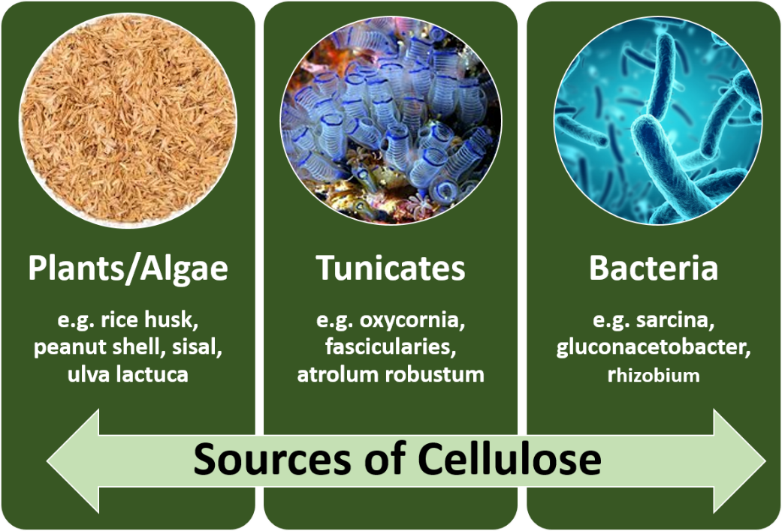
Figure.2 Various sources of Cellulose

D. Sustainability and classification of Nanocellulose
Nanocellulose (NC) is a cellulose that has a diameter of less than 100 nm in one dimension and a length of a few micrometres. Due to its nanoform, this light-weight NC has unique properties such a high surface area to volume ratio, better mechanical strength and stiffness, crystallinity and variable surface chemistry in addition to being nontoxic and biodegradable. As a result, it is becoming a versatile and effective material that is sustainable, which will have a big impact on the commercial sector [9] .
Based on its synthesis and structural characteristics, nanocellulose can be divided into cellulose nanofibre (CNF), cellulose nanocrystal (CNC), and bacterial nanocellulose (BNC). As seen in figure 2[10]–[12], CNF has a long, threadlike structure that resembles a jigsaw made up of numerous threads. As seen in the figure.1, the hydroxyl group of one molecule and the oxygen atom of another molecule form an intermolecular hydrogen bond, which stabilises this structure. CNC have a bean-like short and highly crystalline structure as shown in figure.3 with a rectangular cross section [13], [14]. The material source, the amount of time and concentration required for acid hydrolysis, and the temperature all affect the structure of CNF and CNC. CNF and CNC are prepared using a top-to-bottom strategy, while BNC is prepared using a bottom-to-top strategy. Bacteria such as acetobacter use simple culture techniques to synthesise BNC, allowing for low-cost, environmentally responsible small- and large-scale production. BNC has great purity, crystallinity, and a high degree of polymerization because it is produced as a pure cellulose without the contaminants of hemicellulose and lignin found in plants [15].
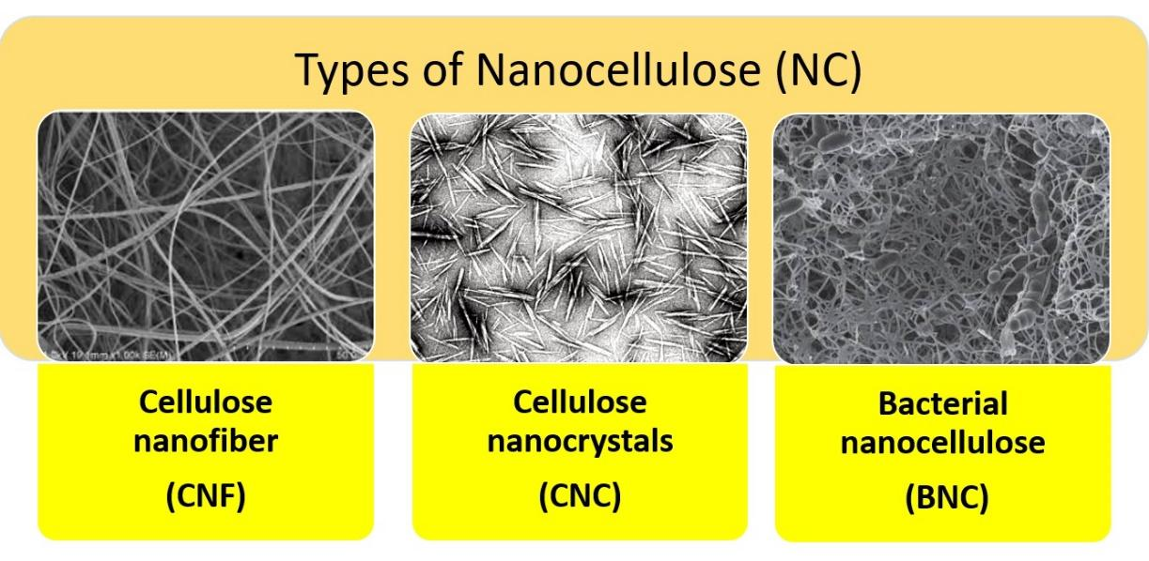
Figure.3 Classification of nanocellulose Adapted with permission [10,11,12]. Copyright 2019, Elsevier and Creative Commons Attribution-Non Commercial-Share Alike 4.0 International CC BY-NC-SA 4.0

II. EXTRACTION OF NANOCELLULOSE
A. Chemical Treatment
We have already spoken about the many sources of nanocellulose, so now let's look at how CNC and CNF are created using various techniques, including chemical and mechanical treatment for nanocellulose isolation.In this method, the amorphous regions which include hemicellulose and lignin are removed to yield pure cellulose, which is subsequently acid hydrolyzed to create nanocellulose from cellulose. As seen in the figure.4 chosen cellulosic feedstocks, such as rice husk, maize husk, and sugarcane bagasse is washed in an alkaline solution containing 2-4% NaOH before being treated with acetic acid or HCl [16]. Amorphous lignin and hemicellulose are eliminated during this process, which is classified as delignification. The next stage is bleaching, which involves exposing the alkali-treated material to 2 to 6% H₂O₂ or sodium chlorite in an acidic environment for 3 hrs. We obtain pure, white, and crystalline cellulose after removing any leftover amorphous areas or other contaminants during this process. This crystalline cellulose is then subjected to acid hydrolysis using 63 wt% H₂SO₄[17]–[19]. The cellulosic chain breaks down during this process and by following ultrasonication and numerous centrifugation cycles in water, we obtain nanocellulose suspension as shown in Figure.4. The majority of the time, CNC is created during acid hydrolysis; however, CNF can occasionally be created as well. According to numerous researchers, the chemical treatment method has many variants. Other alkali reagents, such as potassium hydroxide (KOH), Ca(OH)₂ (calcium hydroxide), NH₃ or sodium carbonate, can be used for delignification. Other concentrated acids, such as HCl, HNO₃, and H₃PO₄ can be employed while following the acid hydrolysis process. It is also known to use citric acid, oxalic acid, and maleic acid for the same purpose[20]–[22].
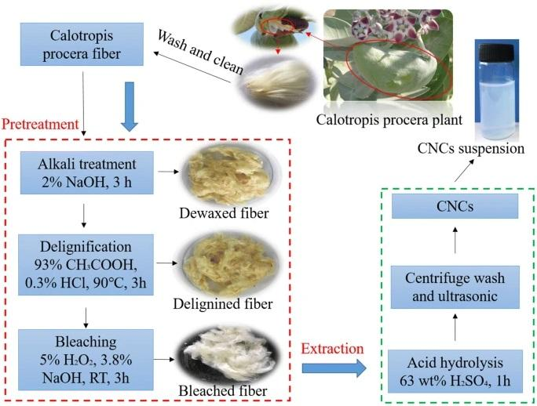
Figure 4. Chemical treatment for the isolation of nanocellulose. Adapted
with permission from [14] Copyright © 2019, Springer Nature

B. Mechanical Treatment
Nanocellulose can be mechanically extracted from its source utilising techniques such microfluidization, high pressure homogenization, ultrasonication, and micogrinding. Pure cellulose is forced through a very small nozzle under high pressure in the high-pressure homogenization (HPH) as shown in figure 5.b, a process that was first used to recover NC from wood pulp in 1983[23]. The two primary causes of CNF generation are high pressure and nozzle diameter. The problem with this procedure is that fibres can clog, so the solution is to slice the fibres at the microscopic level before running them through the HPH. For the isolation of nanocellulose, microfluidizers (figure 5.a) function similarly to HPH. Intensifier pumps are used in microfluidizers to increase pressure, and the interaction chamber is used to defibrillate fibres by applying shear and impact forces to colliding streams. Multiple passes through the micro-fluidizer increase the surface area of the fibres and also have an impact on their size and structure[23]–[25].
Another process for producing nanocellulose is called microgrinding (figure 5.c), in which the cellulose is passed through two overlaid spinning stones, one of which is stationary and the other rotating. In order to break down the hydrogen bond and cell wall structure of fibres and transform cellulose pulp into nanoscale fibres or occasionally crystals, this mechanism generates shear forces. The fibrillation process that occurs during stone friction produces heat, which aids in raising the solid content and evaporating water content. Increasing the number of grinding cycles has an impact on the size and surface area of the nanocellulose. Small vacuum bubbles in the medium are created by the high-intensity ultrasonic pulses used in ultrasonication (figure 5.d). The high-pressure cycle is characterised by the bubbles collapsing when they reach their saturation point. For the purpose of producing nanocellulose, the caviation method generates oscillating power[23], [25], [26]. The best fabrillation results from a combination of temperature, time, and high power. However, the fact that these mechanical processes need a lot of energy is their main drawback. As a result, it is challenging to use these technologies for large-scale synthesis.
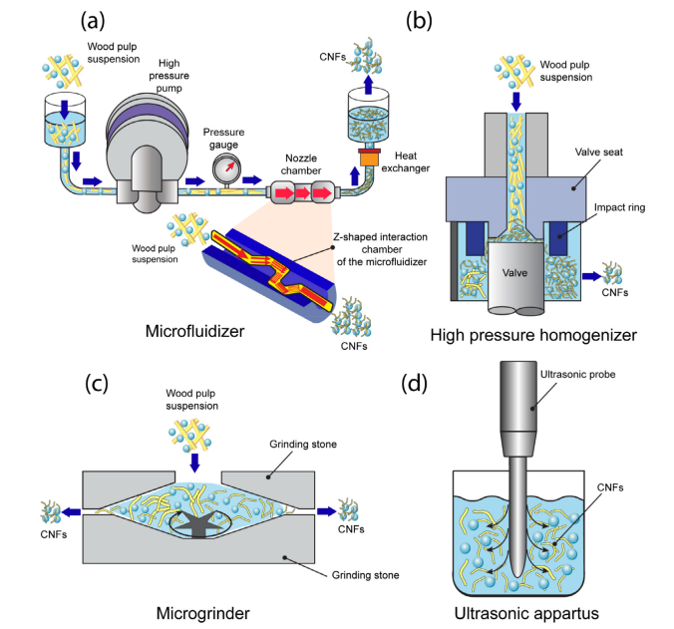
Figure.5 different mechanical techniques for the isolation of nanocellulose. Adapted
with permission [21] © 2021 Elsevier
III. TAILORING OF NANOCELLULOSE
As we have already mentioned, nanocellulose offers unique properties such as strong mechanical strength, a high surface area to volume ratio, crystallinity, and changing surface chemistry. Nanocellulose is a flexible material whose properties can be tailored to change in accordance with the requirements of the primary application due to its active hydroxyl groups, high surface area, and hydrophilic nature. By changing the hydroxyl group into another functional group or necessary moiety, this flexible material can be transformed into the required material for a specific application[20]. Because of its strength and surface area, it can serve as an excellent reinforcing agent for different nanocomposites. Nanocellulose, a naturally occurring polymer, can graft with other polymers to enhance its characteristics [4]. Nanocellulose can also be used as a pickering agent for the creation of stable emulsions or serums, with the hydrophilic or hydrophobic nature of the material being adjusted in accordance with the application's needs[27]. Numerous methods were reported for customising nanocellulose are shown in Figure 6[15].
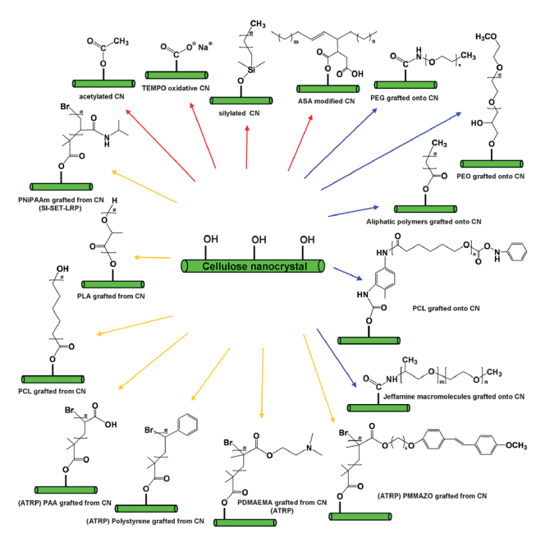
Figure.6 Tailoring of nanocellulose by different methods. Adapted with permission [13] @ RSC Pub
A. Surface modification through hydroxyl group
The hydroxyl functional group in nanocellulose makes it mostly hydrophilic in nature. The functionalization of these nanomaterials produces molecules with tailored chemical properties as well as active ionic surfaces, hydrophobicity, enhanced rheological nature, flexibility, and sorption capacity.
During the process of extracting nanocellulose, concentrated H₂SO₄ (sulfuric acid) is used for hydrolysis which causes half-esters to be generated from the NC's hydroxyl groups and resulting in stable colloidal suspensions. The surface has negatively charged sulphate groups that generates a negative electrostatic layer which enhances the environment for repelling particles and enhance the dispersion of NC and also increases the material's thermal stability. Furthermore, it is reported that use of NaIO₄ (periodate) and NaHSO₃ (bisulfite) in sulfonation process results in the generation of NC with a diameter range of 10–60 nm. One of the methods for converting the primary alcoholic group (-CH₂OH) of NC at the C6 alcoholic position into carboxylic acid (-COOH), which gives the substance hydrophobicity, is TEMPO (2,2,6,6-tetramethylpiperidine-1-oxyl) mediated oxidation of nanocellulose. Another approach that increases the likelihood of producing more nanoscale materials with a diameter of 5–10 nm is carboxymethylation, which is used to increase the negative charge repulsion on nanocellulosic surfaces[4], [23]. The hydroxyl group (-OH) is changed into the carboxymethyl group(-O-CH₂OH) during this procedure. The hydrogel that resulted from this functionalization likely possessed oxygen barrier capability. The dehydration process, which improves the crystallinity of the material, is favoured by the modification of nanocellulose by an inorganic ester, which produces phosphate and sulphate esters that liberate the phosphoric and sulphuric acids. Other agents, including POCl₃ (phosphorus oxychloride), P₂O₅ (phosphorus pentoxide), H₃PO₄ (phosphoric acid), and organophosphates, are used in this functionalization of NC. The hydrophobicity and crystallinity of the material were enhanced through acetylation of nanocellulose using acetic anhydride and acetic acid with perchloric acid as the catalyst. Silylation of nanocellulose with (CH₃)₂SiHCl (dimethylchlorosilane) and C₃H₈O(isopropyl) improved the flexibility and rheological properties[4], [6]. The isocyanate (R-NCO) and hydroxyl (-OH) groups of nanocellulose interact during the functionalization process using the urethanization method, forming covalent bonds in the process. Using n-octadecyl isocyanate (C₁₉H₃₇NO), which increases the hydrophobicity of nanocellulose, Siqueira et al. reported surface functionalization of CNCs and CNFs[28].
B. Nanocomposites
Nanocomposites are multiphase materials with minimum one phase is in nanoscale (1-100 nm) at least in one dimension. Nanocellulose is highly sought after for many industrial applications because of its special qualities, which make it an effective reinforcing material for nanocomposites. In general, stresses like impact, tensile, elongation or compression causes cracking or breaking of composites which are brittle in nature. Nanocellulose is a viable contender to address this problem since it can create a robust network of reinforcing nanofibres or nanocrystals throughout the composite material, absorbing stresses and boosting material strength. Therefore, nanocellulose can raise the material's critical point of stress tolerance[17], [23]. A three-dimensional network is generated when nanocellulose is combined with polymer matrix above the critical reinforcing concentration; this network is thought to be what gives composites their mechanical rigidity. Nanocellulose has been extensively used as a reinforcement material for numerous polymers, including polyethylene, polypropylene, and polystyrene[24], [29]. In these instances, researchers noticed an improvement in other mechanical characteristics along with an increase in rubbery modulus. Numerous research teams also study cellulose nanocomposite materials along with natural rubber, synthetic rubbers, polyester, polyurethane and epoxy resins[24].
One of the key areas for research is nanocomposites made of nanocellulose and metallic nanoparticles. As metallic dispersion phases in bio-nanocomposites with nanocellulose, a variety of metal nanoparticles including Ag, Au, Pt, Pd, Co, and Ni, have been described[30]. There are numerous uses for these composites in the fields of electronics, biomedicine and packaging. It has also been reported that nanocellulose nanocomposites with other metal organic frameworks and 2D materials, such as graphene, mxenes, and borophene, have a wide range of applications[31], [32].
C. Pickering emulsion
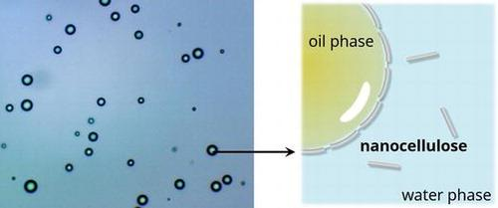
Figure.7 Pickering emulsion stabilized by nanocellulose. Adapted
with permission [31] copywrite @ 2022 Informa UK Limited
Emulsions are created by dispersing or combining two or more immiscible liquids with high energy such as sonicating, homogenising, stirring, or a straightforward handshake approach, which causes the dispersion of droplets in a continuous phase. Emulsions can either be oil-in-water (o/w), where oil droplets are spread in a continuous water phase, water-in-oil (w/o), where water droplets are dispersed in a continuous oil phase, or water-in-water (w/w), which is generated when immiscible salutes are present in water[33]. Emulsions have a wide range of uses since they are utilised in a variety of products, including food, adhesives, firefighting agents, cosmetics, and pharmaceuticals. In the case of emulsions, stability is crucial and a key factor. When evaluating the droplet size of emulsions, an ideal emulsion is stable, consistent, and does not change considerably over time. Phase separtion, droplet coalesence, sedimentation, and creaming are all effects of an unstable emulsion that lead to the emulsion's demise [33], [34].
In pickering emulsions, solid particles are used to stabilise the oil-water interface and this interface acts as a barrier for droplet coalescence as shown in Figure.7 [33]. The energy required to remove these solid particles is far higher than the thermal energy of the emulsion phase; hence, desorption of these solid particles from the interface is not possible, which leads to the formation of stable emulsions. Due to its structure, hydrophilic and green nature, customizable surface chemistry; nanocellulose has attracted interest in the last few years for use as a pickering stabiliser[33]. It has been reported that different modifications to nanocellulose have produced stable pickering emulsions. For instance, the hydrophilic nature of NC can be changed by polymer grafting to hydrophobic, which aids in stabilising the emulsions. By eliminating the anionic sulphate half ester group from CNC, the surface charge density can be altered, increasing CNC's ability to adsorb on two-phase interfaces. Stable pickering agents are created by adding a carboxylate group through the rapid oxidation of CNC and silylating CNF with chlorodimethyl isopropylsilane[27], [35], [36].
D. Polymer Grafting
Grafting mode, which improves the material's physico-chemical properties, can increase the applicability of nanocellulosic material. More elasticity, heat resistance, ion exchange capabilities, stability, and sorbent characteristics are present on the graphed nanocellulosic surfaces[23]. Due to its superior mechanical and biocompatible qualities and low degradability, grafted NC have been employed for surgical repair applications. There are three ways to graft with polymeric materials: to, from, and through. The "grafting to" method involves combining the nanocellulose's active hydroxyl group with another polymeric substance, such as polylactic acid or polystyrene[37]. As opposed to grafting from route NC, which is triggered by an initiator-formed monomer before being grafted via the surface. Grafting through, also known as the macromonomer method which involves joining one polymer with another through side chain linkage. Since CNF is a long chain polymer with a nanometer-wide width, it is typically employed for grafting modification. There have been reports of CNF grafting with PVA, starch, polyurthanes, acrylic acid, acrylonitrile, and glycidyl methacrylate. Grafted nanocellulose polymers are the improved, sustainable, and greener version of polymers as compared to synthetic polymers[5], [23], [29], [37].

IV. APPLICATIONS OF NANOCELLULOSE
Nanocellulose is a special bio-based material with a distinctive surface chemistry that is both unique and tuneable. It also has good mechanical, thermal, and optical properties that make it suitable for a wide range of applications in fields such as packaging, biomedicine, environmental improvement, energy harvesting, and electronics as shown in figure.8[38]
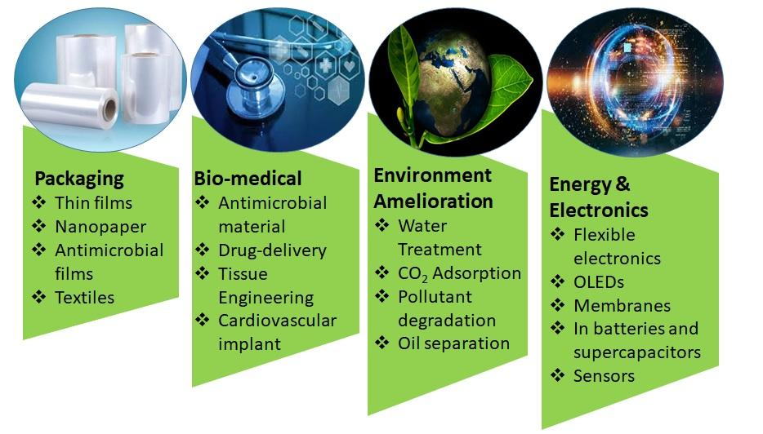

Figure.8 Applications of nanocellulose in various field
A. Packaging
Packing material is more than simply packaging; it may be justified for reducing the degradation of food and drink, cosmetics, healthcare, and other consumer products owing to physical, biochemical, and microbiological reasons[18]. Packaging also has anticorrosive and fire-retardant characteristics. They should also provide an adequate barrier against air, water vapour, oil, and bacteria. Since of its nanoscale dimension, nanocellulose has the potential to replace synthetic polymers in the packaging field because it can behave as a barrier for water and gases[39]. With its appropriate modifications, nanocellulose gives various benefits to textiles, including reduced weight with high strength and increased filler content. Because of its multifunctionality and cross-linking nature, various studies have found that CNCs tensile strength improves dramatically, reaching nearly nine times that of steel. Several studies have been published in which nanocellulose was combined with other materials such as polylactic acid, agar, carboxymethyl guar, polyvinyl alcohol, polyacrylamide, polypyrole and polyaniline to form packaging films with good mechanical strength as well as water and gas barrier potential[22], [40]. Zwitterion films made of poly sulfobetaine methacrylate and nanocellulose were successfully produced as an antibacterial film for food packaging. Various researchers claim antimicrobial packaging films based on nanocellulose and illustrate their experiment for apples, oranges, bananas, and avocadoes; these films also extend the material's shelf life[41], [42]. Some cellulosic materials also limit or reduce the enzymatic reactivity of food, such as sliced apples. Antimicrobial nanocellulosic films are frequently employed in the biomedical field for wound dressing and healing. This packaging is also being researched for the packing of important instruments, materials, and in rare situations for vital organs[30], [43].
B. Bio-medical field
Management of infectious diseases is a constant challenge for the medical community. After the pandemic COVID19 outbreak, everyone is on high alert and concerned about this, not just in the medical and research fields but also at the grassroots level. Nanonocellulose has the potential to be developed into an antibacterial material for use in a variety of applications[18]. Nanocellulose is made bacteriostatic and biocompatible by being functionalized with various moieties like aldehyde, quaternary ammonium, and metallic nonoparticles (Zn, Ag, and Cu). Additionally, nanocellulose functions as a pharmaceutical excipient to compact drug-loaded matrices into tablets for oral medication[40], [44]. For some specific tablets, CNF are reported to provide a stronger encapsulation, and CNC with cyclodextrin work together to form hydrogel, which regulates the drug's release kinetics. For hydrophobic solid drug nanoparticles, nanocellulose also serves as a drug pool with sockets[45].
Nanocellulose is a promising material having the necessary properties for the creation of suitable biomaterials used in tissue engineering. Recent research has examined BNC tubes for the replacement of blood vessels from many angles including cell attachment, hemodynamic analysis, microcirculatory assessment, coagulation, and proliferation. Since nanocellulose is being researched for numerous tissue engineering applications, including the replacement of soft tissues, the replacement of the nucleus pulposus, tissue regeneration and repair, wound healing, the restoration of skin tissue, and the renewal and repair of bone tissue, it can be said that nanocellulose is a material that is on the rise in tissue engineering[44], [46]. Due to its nanodimensions and strength, crystalline NC has been studied in relation to cardiovascular disease. As a result, a new class of biomaterial for tiny replacement vascular grafts has been created using nanocrystalline cellulose as a reinforcing material for a biocompatible matrix like fibrin[22], [26], [47].
C. Energy and Electronics
CNFs can be used to create flexible, mechanically strong, and transparent films with low charge transfer efficiency, making them a possible contender for flexible electronics. Some recent research has claimed that nanocellulose material is used to make a variety of electronic gadgets. Microwave devices consisting of gallium arsenide and nanocellulose are more durable and environmentally benign. On a substrate made of nanocellulose, metal-oxide semiconductor circuits and functional electronics capable of operating at frequencies up to 5 kHz can be built. The flexible organic field-effect transistors (OFETs) used in cellulose nanopaper are yet another example of flexible electronics. Another area where cellulose nanoparticles have proven to work well as substrates is in printed electronics. Over the past few years, researchers as well as electronics manufacturers have been interested in using CNFs as substrates for light-emitting diodes and screens. Nanocomposite made up of wood-based cellulose nanofibers are reported successfully fabricating an organic light-emitting diode (OLED) devices.
Additionally, nanocellulose is utilised as a solid-ion conducting electrolyte, as a separator membrane in lithium ion batteries, for energy storage in battery electrodes, and for energy harvesting in solar cells[48]. According to several research findings, cellulosic materials perform better in energy storage devices than traditional materials. According to Jabbour et al., flexible electrodes made of graphite and cellulose microfibres had a conductivity of roughly 0.3 S/cm, which was much lower than that of reference electrodes[49], [50]. Cellulose nanofibres have the potential to take the role of thermoplastic polymer films as membrane separators for Li-ion batteries. It has been shown that cellulose nanomaterials may function as a component in supercapacitor systems. Numerous studies have used nanocellulose as parts of the electrodes in electrochemical capacitors, which store energy by quickly charging and discharging at the interface between an electrode and an electrolyte[48]. Another instance is the development of a very porous electrode structure by Liew et al. using cellulose nanocrystals covered with a thin polypyrrole layer[51]. They discovered that the cellulose nanocomposite had a high capacitance (256 F/g) and quick charge/discharge, which they credited to the composite's porous three-dimensional structure. Using the triboelectric effect, which transforms mechanical energy into electricity, it has been demonstrated that cellulose nanocomposites including CNCs and polydimethylsiloxane are capable of energy harvesting[48], [49], [52].
Nanocellulose and its various composites have also been used as sensors and stimuli-sensitive functional materials, notably in biomedical field. The CNC suspension's emission spectra changed with pH, and the ratio of intensity at several wavelengths exhibited distinct transitions as a function of pH. In conjunction with a cellulose membrane, peptide-modified CNCs might be employed as a biosensor wound dressing to detect a damaging protease[53]. In another case, pyrene-modified CNCs were shown to be extremely selective to detecting Fe³⁺ with strong discrimination between Fe²⁺ and Fe³⁺ revealing that nanocellulosic materials have the potential to be used as chemical sensors. As a result, there is no limit for nanocellulosic materials in the field of electronics since they touch practically every nook and cranny of the electronic sector, from energy storage to sensors[44], [52], [53].
D. Environment Amelioration
There have been reports of the use of nanocellulose, as well as a variety of its composites and surface-modified moieties, for cleaning up oil contamination in the environment as well as for purifying the air and water and degrading harmful contaminants. The ability to adjust for the required pore size, mechanical strength, water flux, hydrophilicity, adsorption capacity, and operating pressure makes NC based membranes effective for the purification of water[24]. According to Jebali et al., the removal of humic and fulvic acids from waste water that are generated from biomass using amino group modified NC has been described[54]. The degradation of dye is investigated in modified nanocellulose and its different composites. When nanocellulose membranes are modified with nanocatalysts like palldium or silver, the interaction between contaminants and the catalytic material is improved, automatically increasing the activity of the catalyst while purifying the water. CNF extracted from cladophora algae forms an 80–120 nm-sized filter that is effective at capturing viruses like swine influenza. Improved adsorption ability for metallic pollutants like Cu²⁺ and Fe³⁺ is present in nanocellulose functionalized with 1,2,3,4-butanetetracarboxylic acid. Another technique to increase the sorption capacity of nanocellulose is phosphorylation[24], [43], [55].
According to a WHO report, nine out of ten people breathe air that is more polluted than acceptable levels, and the mortality curve associated with air pollution is rising steadily. Metal organic frameworks (MOF) and cellulose nanocomposite combine to produce hybrid membranes with excellent CO₂ absorption. Bacterial cellulose with amino functionalization for CO₂ adsorption has also been described. For the adsorption of CO₂, several Zeolitic imidazolate frameworks (ZIFs) hybrid with nanocellulose outperform standalone candidates. CelloMOFs exhibits a synergistic impact that allows both candidates to function more effectively as an aerogel and thin film membrane[9], [24], [43]. Oil spills can have a long-lasting negative impact on marine life and take months to clean up, which could have a devastating influence on the aquatic ecosystem. The NC material can be applied to the removal of oil spills with various modification like silylation of nanocellulose makes it hydrophobic and possess sorption capacity for oils[56]. Nanocellulose composites based on ZIFs are also being investigated for the separation of oils such as cyclohexane, n-decane, petroleum, n-octane, and heptane, which exhibit great flux and high oil purity[57], [58]. As a result, it can be concluded that nanocellulose is a viable option for the sustenance of nature, which is solely taken from nature.
V. CONCLUSION
The scope, flexibility, and extent of modern nanocellulose research have witnessed the relevance of nanocellulose over the last decade. Materials discoveries impact practically every aspect of current research trends such as energy, environment, and bio-medical. This paper highlighted the underlying chemistry of cellulose by emphasising its multifunctional character as a result of hydroxyl groups and hydrogen bonding. We also summarise nanocellulose's resources, kinds, extraction processes, surface modifications, and applications. Despite significant advances in creating nanocellulose into sustainable and useful materials, several obstacles remain in terms of processability and performance.
Initiatives in this area need a thorough understanding of the nature of cellulose and nanocellulose interactions. Attempts to preserve the intricate structure of nanocellulose after separation are extremely desirable, but they are far from succeeding. To ease separation and open up new applications, a fresh understanding regarding the natural assembly of nanocellulose is required. This necessitates the development of low-cost, environmentally friendly techniques that make complete use of every characteristic embedded in nanocellulose's key components.

References
[1] K. Heise et al., “Nanocellulose: Recent Fundamental Advances and Emerging Biological and Biomimicking Applications,” Advanced Materials, vol. 33, no. 3, p. 2004349, Jan. 2021, doi: 10.1002/adma.202004349.
[2] M. T. Islam, M. M. Alam, A. Patrucco, A. Montarsolo, and M. Zoccola, “Preparation of Nanocellulose: A Review,” aatcc j res, vol. 1, no. 5, pp. 17–23, Sep. 2014, doi: 10.14504/ajr.1.5.3.
[3] “BOOk 1 Handbook of nanocellulose and cellulose nanocomposites. Volume 1-Wiley VCH (2017).pdf.”
[4] K. Wieszczycka, K. Staszak, M. J. Woźniak-Budych, J. Litowczenko, B. M. Maciejewska, and S. Jurga, “Surface functionalization – The way for advanced applications of smart materials,” Coordination Chemistry Reviews, vol. 436, p. 213846, Jun. 2021, doi: 10.1016/j.ccr.2021.213846.
[5] D. Tahir et al., “Sources, Chemical Functionalization, and Commercial Applications of Nanocellulose and Nanocellulose-Based Composites: A Review,” Polymers, vol. 14, no. 21, p. 4468, Oct. 2022, doi: 10.3390/polym14214468.
[6] B. Thomas et al., “Nanocellulose, a Versatile Green Platform: From Biosources to Materials and Their Applications,” Chem. Rev., vol. 118, no. 24, pp. 11575–11625, Dec. 2018, doi: 10.1021/acs.chemrev.7b00627.
[7] P. Phanthong, P. Reubroycharoen, X. Hao, G. Xu, A. Abudula, and G. Guan, “Nanocellulose: Extraction and application,” Carbon Resources Conversion, vol. 1, no. 1, pp. 32–43, Apr. 2018, doi: 10.1016/j.crcon.2018.05.004.
[8] M. Nasir, R. Hashim, O. Sulaiman, and M. Asim, “Nanocellulose,” in Cellulose-Reinforced Nanofibre Composites, Elsevier, 2017, pp. 261–276. doi: 10.1016/B978-0-08-100957-4.00011-5.
[9] K. Dhali, M. Ghasemlou, F. Daver, P. Cass, and B. Adhikari, “A review of nanocellulose as a new material towards environmental sustainability,” Science of The Total Environment, vol. 775, p. 145871, Jun. 2021, doi: 10.1016/j.scitotenv.2021.145871.
[10] D. A. Gopakumar, V. Arumughan, D. Pasquini, S.-Y. (Ben) Leu, A. K. H.P.S., and S. Thomas, “Nanocellulose-Based Membranes for Water Purification,” in Nanoscale Materials in Water Purification, Elsevier, 2019, pp. 59–85. doi: 10.1016/B978-0-12-813926-4.00004-5.
[11] J. Y. Park, S. W. Han, and I. H. Lee, “Preparation of Electrospun Porous Ethyl Cellulose Fiber by THF/DMAc Binary Solvent System,” p. 7.
[12] F. Barja, “Bacterial nanocellulose production and biomedical applications,” J Biomed Res, vol. 35, no. 4, p. 310, 2021, doi: 10.7555/JBR.35.20210036.
[13] D. A. Gopakumar, V. Arumughan, D. Pasquini, S.-Y. (Ben) Leu, A. K. H.P.S., and S. Thomas, “Nanocellulose-Based Membranes for Water Purification,” in Nanoscale Materials in Water Purification, Elsevier, 2019, pp. 59–85. doi: 10.1016/B978-0-12-813926-4.00004-5.
[14] J. Y. Park, S. W. Han, and I. H. Lee, “Preparation of Electrospun Porous Ethyl Cellulose Fiber by THF/DMAc Binary Solvent System,” p. 7.
[15] N. Lin, J. Huang, and A. Dufresne, “Preparation, properties and applications of polysaccharide nanocrystals in advanced functional nanomaterials: a review,” Nanoscale, vol. 4, no. 11, p. 3274, 2012, doi: 10.1039/c2nr30260h.
[16] K. Song, X. Zhu, W. Zhu, and X. Li, “Preparation and characterization of cellulose nanocrystal extracted from Calotropis procera biomass,” Bioresour. Bioprocess., vol. 6, no. 1, p. 45, Dec. 2019, doi: 10.1186/s40643-019-0279-z.
[17] A. Dufresne, Nanocellulose: from nature to high performance tailored materials. Berlin: De Gruyter, 2012.
[18] D. Tahir et al., “Sources, Chemical Functionalization, and Commercial Applications of Nanocellulose and Nanocellulose-Based Composites: A Review,” Polymers, vol. 14, no. 21, p. 4468, Oct. 2022, doi: 10.3390/polym14214468.
[19] V. Thakur, A. Guleria, S. Kumar, S. Sharma, and K. Singh, “Recent advances in nanocellulose processing, functionalization and applications: a review,” Mater. Adv., vol. 2, no. 6, pp. 1872–1895, 2021, doi: 10.1039/D1MA00049G.
[20] V. Thakur, A. Guleria, S. Kumar, S. Sharma, and K. Singh, “Recent advances in nanocellulose processing, functionalization and applications: a review,” Mater. Adv., vol. 2, no. 6, pp. 1872–1895, 2021, doi: 10.1039/D1MA00049G.
[21] P. Phanthong, P. Reubroycharoen, X. Hao, G. Xu, A. Abudula, and G. Guan, “Nanocellulose: Extraction and application,” Carbon Resources Conversion, vol. 1, no. 1, pp. 32–43, Apr. 2018, doi: 10.1016/j.crcon.2018.05.004.
[22] D. Trache et al., “Nanocellulose: From Fundamentals to Advanced Applications,” Front. Chem., vol. 8, p. 392, May 2020, doi: 10.3389/fchem.2020.00392.
[23] M. Ghasemlou, F. Daver, E. P. Ivanova, Y. Habibi, and B. Adhikari, “Surface modifications of nanocellulose: From synthesis to high-performance nanocomposites,” Progress in Polymer Science, vol. 119, p. 101418, Aug. 2021, doi: 10.1016/j.progpolymsci.2021.101418.
[24] H. N. Abdelhamid and A. P. Mathew, “Cellulose–metal organic frameworks (CelloMOFs) hybrid materials and their multifaceted Applications: A review,” Coordination Chemistry Reviews, vol. 451, p. 214263, Jan. 2022, doi: 10.1016/j.ccr.2021.214263.
[25] M. T. Islam, M. M. Alam, A. Patrucco, A. Montarsolo, and M. Zoccola, “Preparation of Nanocellulose: A Review,” aatcc j res, vol. 1, no. 5, pp. 17–23, Sep. 2014, doi: 10.14504/ajr.1.5.3.
[26] K. Heise et al., “Nanocellulose: Recent Fundamental Advances and Emerging Biological and Biomimicking Applications,” Advanced Materials, vol. 33, no. 3, p. 2004349, Jan. 2021, doi: 10.1002/adma.202004349.
[27] A. G. de Souza, R. R. Ferreira, E. S. F. Aguilar, L. Zanata, and D. dos S. Rosa, “Cinnamon Essential Oil Nanocellulose-Based Pickering Emulsions: Processing Parameters Effect on Their Formation, Stabilization, and Antimicrobial Activity,” Polysaccharides, vol. 2, no. 3, pp. 608–625, Aug. 2021, doi: 10.3390/polysaccharides2030037.
[28] G. Siqueira, H. Abdillahi, J. Bras, and A. Dufresne, “High reinforcing capability cellulose nanocrystals extracted from Syngonanthus nitens (Capim Dourado),” Cellulose, vol. 17, no. 2, pp. 289–298, Apr. 2010, doi: 10.1007/s10570-009-9384-z.
[29] S. C. Agwuncha, C. G. Anusionwu, S. J. Owonubi, E. R. Sadiku, U. A. Busuguma, and I. D. Ibrahim, “Extraction of Cellulose Nanofibers and Their Eco/Friendly Polymer Composites,” in Sustainable Polymer Composites and Nanocomposites, Inamuddin, S. Thomas, R. Kumar Mishra, and A. M. Asiri, Eds., Cham: Springer International Publishing, 2019, pp. 37–64. doi: 10.1007/978-3-030-05399-4_2.
[30] M. Oprea and D. M. Panaitescu, “Nanocellulose Hybrids with Metal Oxides Nanoparticles for Biomedical Applications,” Molecules, vol. 25, no. 18, p. 4045, Sep. 2020, doi: 10.3390/molecules25184045.
[31] Y. Li et al., “Nanocellulose as green dispersant for two-dimensional energy materials,” Nano Energy, vol. 13, pp. 346–354, Apr. 2015, doi: 10.1016/j.nanoen.2015.02.015.
[32] B. Thomas et al., “Nanocellulose, a Versatile Green Platform: From Biosources to Materials and Their Applications,” Chem. Rev., vol. 118, no. 24, pp. 11575–11625, Dec. 2018, doi: 10.1021/acs.chemrev.7b00627.
[33] S. Fujisawa, E. Togawa, and K. Kuroda, “Nanocellulose-stabilized Pickering emulsions and their applications,” Science and Technology of Advanced Materials, vol. 18, no. 1, pp. 959–971, Dec. 2017, doi: 10.1080/14686996.2017.1401423.
[34] M. M. González, C. Blanco-Tirado, and M. Y. Combariza, “Nanocellulose as an inhibitor of water-in-crude oil emulsion formation,” Fuel, vol. 264, p. 116830, Mar. 2020, doi: 10.1016/j.fuel.2019.116830.
[35] S. A. Kedzior, V. A. Gabriel, M. A. Dubé, and E. D. Cranston, “Nanocellulose in Emulsions and Heterogeneous Water‐Based Polymer Systems: A Review,” Adv. Mater., vol. 33, no. 28, p. 2002404, Jul. 2021, doi: 10.1002/adma.202002404.
[36] A. A. Wardana, A. Koga, F. Tanaka, and F. Tanaka, “Antifungal features and properties of chitosan/sandalwood oil Pickering emulsion coating stabilized by appropriate cellulose nanofiber dosage for fresh fruit application,” Sci Rep, vol. 11, no. 1, p. 18412, Dec. 2021, doi: 10.1038/s41598-021-98074-w.
[37] K. Spence, Y. Habibi, and A. Dufresne, “Nanocellulose-Based Composites,” in Cellulose Fibers: Bio- and Nano-Polymer Composites, S. Kalia, B. S. Kaith, and I. Kaur, Eds., Berlin, Heidelberg: Springer Berlin Heidelberg, 2011, pp. 179–213. doi: 10.1007/978-3-642-17370-7_7.
[38] N. Lin, J. Huang, and A. Dufresne, “Preparation, properties and applications of polysaccharide nanocrystals in advanced functional nanomaterials: a review,” Nanoscale, vol. 4, no. 11, p. 3274, 2012, doi: 10.1039/c2nr30260h.
[39] C. G. Perdani and S. Gunawan, “A short review: Nanocellulose for smart biodegradable packaging in the food industry,” IOP Conf. Ser.: Earth Environ. Sci., vol. 924, no. 1, p. 012032, Nov. 2021, doi: 10.1088/1755-1315/924/1/012032.
[40] V. B. Lunardi et al., “Nanocelluloses: Sources, Pretreatment, Isolations, Modification, and Its Application as the Drug Carriers,” Polymers, vol. 13, no. 13, p. 2052, Jun. 2021, doi: 10.3390/polym13132052.
[41] M.-N. Efthymiou et al., “Development of biodegradable films using sunflower protein isolates and bacterial nanocellulose as innovative food packaging materials for fresh fruit preservation,” Sci Rep, vol. 12, no. 1, p. 6935, Apr. 2022, doi: 10.1038/s41598-022-10913-6.
[42] A. Ferrer, L. Pal, and M. Hubbe, “Nanocellulose in packaging: Advances in barrier layer technologies,” Industrial Crops and Products, vol. 95, pp. 574–582, Jan. 2017, doi: 10.1016/j.indcrop.2016.11.012.
[43] P. Thomas et al., “Comprehensive review on nanocellulose: Recent developments, challenges and future prospects,” Journal of the Mechanical Behavior of Biomedical Materials, vol. 110, p. 103884, Oct. 2020, doi: 10.1016/j.jmbbm.2020.103884.
[44] S. Das, B. Ghosh, and K. Sarkar, “Nanocellulose as sustainable biomaterials for drug delivery,” Sensors International, vol. 3, p. 100135, 2022, doi: 10.1016/j.sintl.2021.100135.
[45] H. N. Abdelhamid and A. P. Mathew, “Cellulose-Based Nanomaterials Advance Biomedicine: A Review,” IJMS, vol. 23, no. 10, p. 5405, May 2022, doi: 10.3390/ijms23105405.
[46] A. Vikulina, D. Voronin, R. Fakhrullin, V. Vinokurov, and D. Volodkin, “Naturally derived nano- and micro-drug delivery vehicles: halloysite, vaterite and nanocellulose,” New J. Chem., vol. 44, no. 15, pp. 5638–5655, 2020, doi: 10.1039/C9NJ06470B.
[47] A. H. Bhat, Y. K. Dasan, I. Khan, H. Soleimani, and A. Usmani, “Application of nanocrystalline cellulose,” in Cellulose-Reinforced Nanofibre Composites, Elsevier, 2017, pp. 215–240. doi: 10.1016/B978-0-08-100957-4.00009-7.
[48] O. A. T. Dias, S. Konar, A. L. Leão, W. Yang, J. Tjong, and M. Sain, “Current State of Applications of Nanocellulose in Flexible Energy and Electronic Devices,” Front. Chem., vol. 8, p. 420, May 2020, doi: 10.3389/fchem.2020.00420.
[49] B. Yao, J. Zhang, T. Kou, Y. Song, T. Liu, and Y. Li, “Paper-Based Electrodes for Flexible Energy Storage Devices,” Adv. Sci., vol. 4, no. 7, p. 1700107, Jul. 2017, doi: 10.1002/advs.201700107.
[50] “Highly conductive graphite/carbon fiber/cellulose composite papers”, doi: http://dx.doi.org/10.1016/j.compscitech.2012.01.006.
[51] X. Wu, “Conductive Cellulose Nanocrystals for Electrochemical Applications,” p. 210.
[52] R. Sabo, A. Yermakov, C. T. Law, and R. Elhajjar, “Nanocellulose-Enabled Electronics, Energy Harvesting Devices, Smart Materials and Sensors: A Review,” j renew mater, vol. 4, no. 5, pp. 297–312, Oct. 2016, doi: 10.7569/JRM.2016.634114.
[53] V. Gabrielli and M. Frasconi, “Cellulose-Based Functional Materials for Sensing,” Chemosensors, vol. 10, no. 9, p. 352, Aug. 2022, doi: 10.3390/chemosensors10090352.
[54] A. Jebali et al., “Adsorption of humic acid by amine-modified nanocellulose: an experimental and simulation study,” Int. J. Environ. Sci. Technol., vol. 12, no. 1, pp. 45–52, Jan. 2015, doi: 10.1007/s13762-014-0659-z.
[55] K. Dhali, M. Ghasemlou, F. Daver, P. Cass, and B. Adhikari, “A review of nanocellulose as a new material towards environmental sustainability,” Science of The Total Environment, vol. 775, p. 145871, Jun. 2021, doi: 10.1016/j.scitotenv.2021.145871.
[56] X. Wang et al., “Application of Nanocellulose in Oilfield Chemistry,” ACS Omega, vol. 6, no. 32, pp. 20833–20845, Aug. 2021, doi: 10.1021/acsomega.1c02095.
[57] S. Fürtauer, M. Hassan, A. Elsherbiny, S. A. Gabal, S. Mehanny, and H. Abushammala, “Current Status of Cellulosic and Nanocellulosic Materials for Oil Spill Cleanup,” Polymers, vol. 13, no. 16, p. 2739, Aug. 2021, doi: 10.3390/polym13162739.
[58] S. Mehanny, A. Kuzmin, and A. Elsherbiny, “Nanocellulosic Materials for Oil Spill,” p. 8.

