VEHICLE OVER SPEED DETECTION USING ARDUINO

¹B Siva Kumar Reddy,
Professor, Dept. of ECE,
CMR Engineering College,Hyderabad, Telangana-501401, India
Bsivakumar100@gmail.com

²Samala Sudhakar, ³S.Swathi, ⁴V.Ganesh, ⁵M.NagaRakshitha, ⁶R.Krishna
²Assistant Professor, ^{3,4,5,6} Student, Dept. of ECE,
CMR Engineering College, Hyderabad, Telangana-501401, India
26sudhaswathi@gmail.com

ABSTRACT

The goal of the work is to develop a system that will allow drivers to be alerted when their cars go over the speed limit. This will help reduce the risk of accidents and promote road safety. The system will use a device that will detect the speed of vehicles moving on roads. In the past, there were various ideas for detecting excessive driving. Many of these systems require a lot of effort and human intervention to be successful. In this project, we are developing a system that will detect the presence of over speeding cars. This will help prevent road accidents by determining the speed limit at the location where the vehicles are moving. The system will also display the time it takes for the vehicle to reach its destination on an LCD screen.
Keywords- Arduino, speed sensor, display unit, buzzer.

INTRODUCTION

Road accidents are a common occurrence all across the world. The most common cause of these collisions is rash driving. In 2001, over 4,74,084 accidents were reported in India. Unfortunately, there are no effective measures to control the traffic in the country. In order to prevent these types of accidents, the government should introduce technology that can monitor the speed of moving vehicles.This system is time-consuming and can't be relied on by people due to the traffic. It doesn't need human intervention, and it can be used to save a lot of time by determining a vehicle's speed. It displays the vehicle's speed and its details on a display screen, which an alarm will be generated if it exceeds the stated speed.
Car Speed Measurement Device with Over Speed Indicator using arduino [4] and IR sensor [5]. We can be placed this device beside the road. Which can measure the vehicle speed automatically and show the vehicle speed on a display. This device has one more feature, when any vehicle crosses the speed limit then it indicates by a red light. A pair of sensors is set up on a road. These are equipped with an IR receiver and transmitter. They are placed at a predetermined distance from each other.
The system uses the time that it has collected to calculate the speed of the car and display it on a seven segment display. It first takes the required time for the car to move from one point to another. This method is carried out through the use of an IT receiver and transmitter pair. A microcontroller is used to process the data and determine the required travel time for a vehicle from one point to another. It displays this information on an LCD display. If a vehicle is detected traveling over the speed limit, a buzzer will sound to alert the user.

Car overspeed detection is a vital aspect of road safety systems aimed at preventing accidents and promoting responsible driving behavior. With the increasing number of vehicles on the roads, monitoring and controlling vehicle speeds have become essential for reducing accidents and ensuring public safety. Car overspeed detection systems utilize various technologies to measure the speed of vehicles and detect when they exceed the prescribed speed limits. These systems are typically integrated into traffic management systems, law enforcement operations, and intelligent transportation systems. The most common technology used for car overspeed detection is radar based sensors [9]. These devices use radio waves to measure how long it takes for an object to bounce back after it has been hit. By analyzing the frequency shift of the returned waves, the system can accurately calculate the speed of the vehicle.Radar-based systems are effective in detecting overspeeding vehicles in real-time and can cover a wide area. Another technology used for overspeed detection is LIDAR [10] [ (Light Detection and Ranging). A type of radar known as LIDAR uses laser beams to determine the speed and distance of objects moving in its path. This method works by measuring how long it takes for the beams to reflect back onto the sensor. A vehicle's speed can be obtained by using this type of system. The motivation behind car overspeed detection using Arduino can be attributed to several factors:
1. Safety: Speeding is a major cause of accidents on roads. By detecting and monitoring the speed of vehicles, particularly in areas with speed limits, the system aims to promote road safety and reduce the likelihood of accidents.
2.Law Enforcement: Overspeeding is a traffic violation in many jurisdictions. Implementing an overspeed detection system helps law enforcement agencies in monitoring and enforcing speed limits, leading to better compliance with traffic regulations.
3.Traffic Management: Overspeeding can disrupt the flow of traffic and increase congestion on roads. By detecting vehicles that exceed speed limits, traffic management authorities can take appropriate measures to address the issue, such as adjusting traffic signals, implementing speed calming measures, or deploying additional resources for monitoring.
4. Data Collection and Analysis:A speed detection system can collect data on a wide variety of factors, such as traffic patterns and trends. It can then be used to identify areas where overspeeding is prevalent and implement targeted interventions to reduce the risk of accidents.
5.Public Awareness and Education: By visibly displaying the detected speed to drivers, the system can raise awareness about their speed and encourage self-regulation. This serves as a reminder for drivers to adhere to speed limits and drive responsibly.
6.Cost-Effective Solution: Arduino, being an open-source hardware platform, offers a relatively low-cost and accessible option for developing an overspeed detection system. This makes it an attractive choice for individuals, organizations, or communities looking to implement such a system without significant financial investment.
Overall, the motivation behind car overspeed detection using Arduino revolves around enhancing road safety, enforcing traffic regulations, optimizing traffic flow, collecting data for analysis, raising public awareness, and providing a cost-effective solution for speed monitoring.

- RESEARCH METHODOLOGY

Research methodology for car overspeed detection involves a systematic approach to investigate, develop, and evaluate methods to detect and manage instances of vehicles exceeding speed limits. Here's a step-by-step guide to help you outline the research methodology:
1. Define the Research Objectives:
Clearly articulate the goals of your research. For example, you might want to develop a real-time overspeed detection system for vehicles to improve road safety.
2. Literature Review:
A comprehensive review of the literature is necessary to identify the various limitations and advantages of overspeed detection technologies. It will also help you develop effective strategies for addressing these issues..
3. Research Design:
Choose an appropriate research design that fits your objectives. For this type of research, experimental or observational studies could be applicable.
4. Data Collection:
You should choose the data sources that you'll use for your study. This can include data from GPS devices, cameras installed on roads, and speed sensors.
5.Data Preprocessing:
Ensure the quality of the data by preprocessing it. Doing so will remove noise and handle missing values.
6. Feature Selection/Extraction:
Identify relevant features from the data that will help in overspeed detection. These features could include speed, acceleration, time of day, weather conditions, road type, etc.
7. Algorithm Selection:
For overspeed detection, choose the appropriate statistical or machine learning techniques. These include clustering, decision trees, random forests, support vector machines, and neural networks.
8. Model Training and Evaluation:
The data should be split into testing and training sets. The former should be used to train your chosen models, while the latter should be used to evaluate their performance.
9. Parameter Tuning:
If you are using machine learning models, optimize hyperparameters to improve their performance.
10. Real-world Testing:
Implement your overspeed detection system in real-world conditions to assess its effectiveness in a practical setting. Monitor its performance and gather feedback.
11. Comparison with Existing Methods:
Compare the performance of your overspeed detection system with existing methods to evaluate its superiority, if applicable.
12. Ethical Considerations:
Address any ethical concerns related to data privacy and potential biases in the system's functioning.
13. Result Analysis and Interpretation:
Analyse the results of your experiments, discuss the findings, and interpret the implications of your research.
14.Conclusion and Recommendations:
Summarize your research, restate the key findings, and provide recommendations for further improvements or future research directions.
15. Documentation and Publication:
Document your research methodology, results, and conclusions thoroughly. If the research yields significant results, consider publishing your findings in relevant conferences or journals.
Remember, the specific steps and methodologies will depend on the complexity of the overspeed detection system you aim to develop and the available resources at your disposal. Always ensure the accuracy and reliability of your research methodology for meaningful and impactful results.

- SYSTEM MODEL

Here is a brief explanation of the block diagram shown in Figure 1 of the car over speed detector using arduino
The working principle of car overspeed detection using Arduino involves several steps and components. Hereis a general overview of how such a system can be implemented:
1.Speed Sensor: A speed sensor is required to measure the speed of the vehicle. This can be done using various sensors, such as a Hall effect sensor, a magnetic sensor, or an optical sensor. The sensor is typically placed near the rotating part of the vehicle, such as the wheel, to detect its speed.
2.Arduino Microcontroller: An Arduino board is used as the central processing unit to control the system. The speed sensor is connected to the Arduino board, allowing it to receive signals from the sensor.
3.Calibration: Before the overspeed detection system can accurately measure overspeed, it needs to be calibrated. This involves determining the maximum allowable speed limit for a particular road or area.
4.Speed Calculation: The speed sensor of the vehicle sends signals to the Arduino board, which then calculates the vehicle's current speed based on the time it takes for the wheels to rotate.
5.Speed Comparison:The speed limit is compared with the calculated speed. If the speed exceeds it, it means that the vehicle is overspeeding.
6.Visual or Audible Alert: Once overspeeding is detected, the Arduino board triggers an alert mechanism to notify the driver. This can be done using visual indicators, such as LED lights, or audible alarms, such as a buzzer or speaker.
7.Data Logging and Display (Optional): If desired, the Arduino board can also log overspeed events, recording details such as the time, date, and location of each instance. This data can be stored on an external storage device or displayed on an LCD screen for monitoring and analysis purposes.
The implementation details of an overspeed detection system can vary depending on its requirements and design. For instance, the alert mechanisms, sensors, and calibration process can be customized.
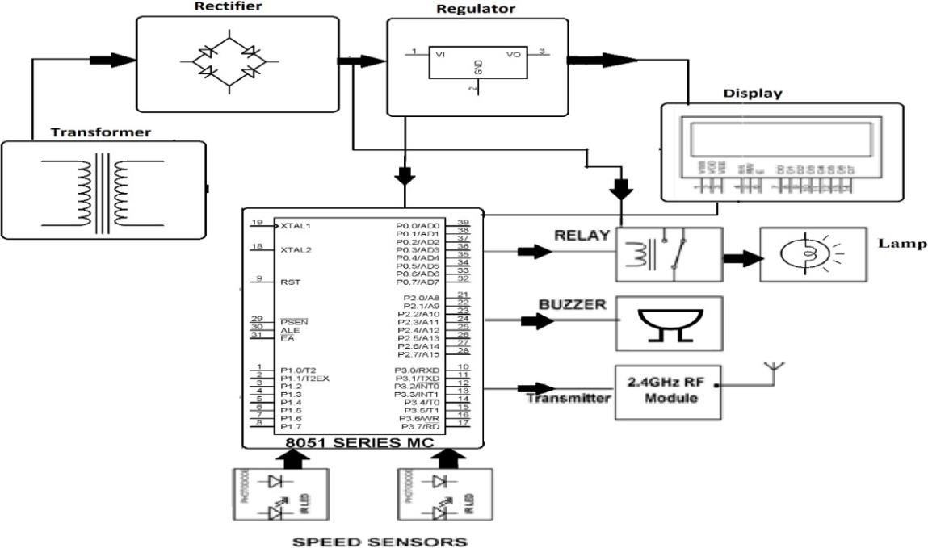

Fig 1.Block diagram

- RESULTS AND DISSCUISIONS

Figure 2 shows the ideal mode of the proposed system, in which the LCD shows the blank screen. The Figure 3 shows the "NORMAL SPEED" when its speed is less than 60 kilometers per hour. Car over speed detection, in this project if speed of the car is greater than 50km per hour then the sensor detects the speed of the car and buzzer alerts andit displays the message "Car Overspeed" and also shows the vehicle's speed as shown in Figure 4.

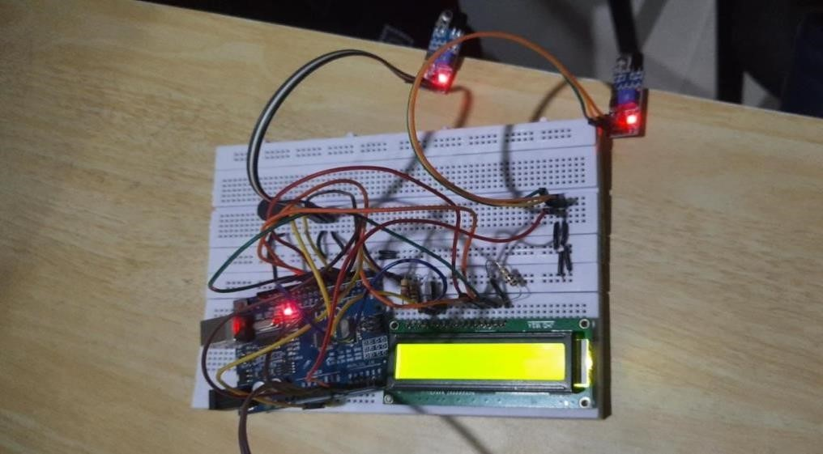

Figure 2. System in Ideal mode

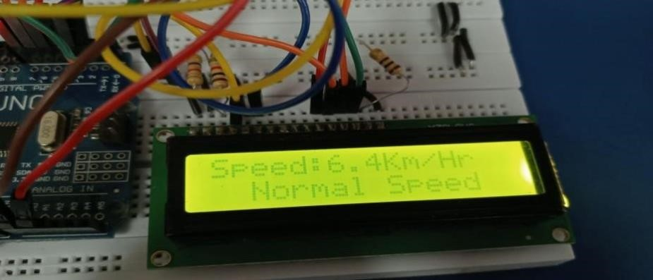

Figure 3. System shows Normal mode

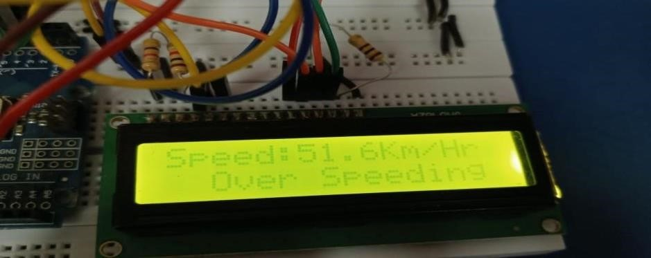

Figure 4. System shows the Over speed mode

CONCLUSION
The system uses an LCD display to record the vehicle's speed and informs the user if it exceeds the speed limit. A buzzer is also generated to alert the user if the vehicle is about to go over the speed limit. These systems play a vital role in preventing road accidents by monitoring the approaching vehicle's speed. These systems utilize advanced technologies such as radar, lidar, or GPS to accurately measure and monitor vehicle speeds. By detecting vehicles that exceed the speed limits, these systems provide real-time alerts and warnings to both drivers and authorities, encouraging them to adhere to the speed regulations and avoid potential hazards. In summary, car overspeed detection systems provide a proactive approach to address the issue of speeding on roads. By combining technology, enforcement, and data-driven decision- making, these systems promote compliance, enhance law enforcement efforts, and contribute to overall road safety. Ultimately, their implementation helps save lives, prevent injuries, and create a more secure transportation system for all road users.

REFERENCES
[1]Weinstein, Ron. "RFID: a technical overview and its application to the enterprise." IT professional 7.3 (2005): 27-33.
[2]Takeda, A., et al. "41.1: A super‐high image quality multi‐domain vertical alignment LCD by new rubbing‐less technology." SID Symposium Digest of Technical Papers. Vol. 29. No. 1. Oxford, UK: Blackwell Publishing Ltd, 1998.
[3]Tyson, John J., Katherine C. Chen, and Bela Novak. "Sniffers, buzzers, toggles and blinkers: dynamics of regulatory and signaling pathways in the cell." Current opinion in cell biology 15.2 (2003): 221-231.
[4] Banzi, Massimo, and Michael Shiloh. Getting started with Arduino. Maker Media, Inc., 2022.
[5] Budzier, Helmut, and Gerald Gerlach. Thermal infrared sensors: theory, optimisation and practice. John Wiley & Sons, 2011.
[6] Reddy, Bathula Siva Kumar. "Experimental validation of non-orthogonal multiple access (NOMA) technique using software defined radio." Wireless Personal Communications 116.4 (2021): 3599-3612.
[7] Reddy, B. Siva Kumar, et al. "Design and Implementation of Novel FPGA Based LFSR for IOT and Smart Applications." 2022 IEEE International Women in Engineering (WIE) Conference on Electrical and Computer Engineering (WIECON-ECE). IEEE, 2022.
[8]Ghugardare, Rakhi P., et al. "Optical character recognition system for seven segment display images of measuring instruments." TENCON 2009-2009 IEEE Region 10 Conference. IEEE, 2009.
[9] Mercuri, Marco, et al. "Vital-sign monitoring and spatial tracking of multiple people using a contactless radar-based sensor." Nature Electronics 2.6 (2019): 252-262.
[10] Liu, Xiaoye. "Airborne LiDAR for DEM generation: some critical issues." Progress in physical geography 32.1 (2008): 31-49.

