"Precision Medicine: Unleashing the Future of Healthcare"

Introduction:
The linkages between biohacking, the pharmaceutical business, genetic medicine, and the chances for diagnosis in the future are examined in this intriguing and instructive chapter. Through the prism of precision medicine, we investigate how these fields are going to impact healthcare in the future. Come along as we set out on a discovery expedition to explore the revolutionary discoveries and improvements that are changing the way we approach diagnosis and treatment.

Genomic Medicine: A Paradigm Shift in Healthcare
Genomic medicine is a rapidly growing field that involves the use of genomic information to improve patient care. It is an interdisciplinary medical specialty that has rapidly grown since the completion of the Human Genome Project. Genomic medicine investigates how a person's biological information can be used to improve their clinical care and health outcomes. It is a multidisciplinary field that involves the use of genomic information to identify biomarkers that can reflect the expression, function, or regulation of genes. In this, we will explore some of the subtopics of genomic medicine, including human genetic variation, the economics of genomic medicine, access to genomic medicine, implementation science approach to genomic medicine, clinical genomics, and public health genomics. We will also discuss some of the implications of genomic medicine for health policy.
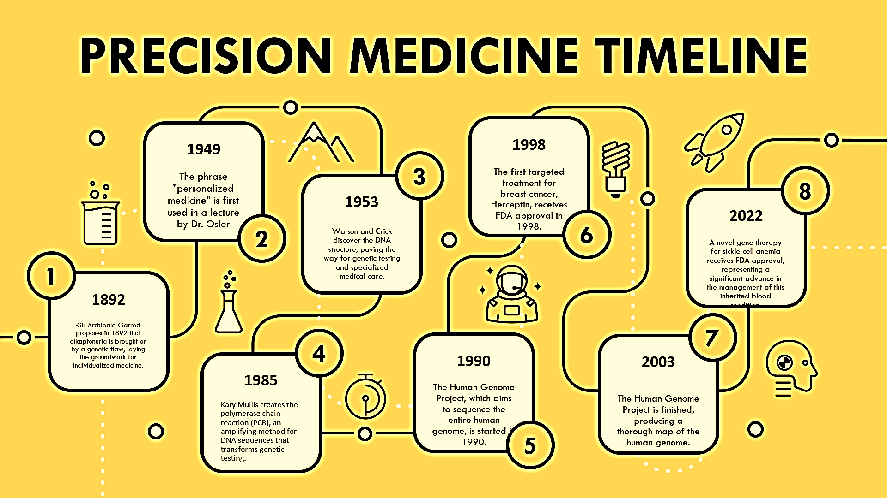
human genetic variation
Human genetic variation refers to the differences in DNA sequence within the genome of individuals in populations. Genetic variations can take many forms, including single nucleotide changes or substitutions, tandem repeats, insertions and deletions (indels), copy number variations (CNVs), and more. Single nucleotide polymorphisms (SNPs) are the most common type of genetic variation, occurring with a frequency of approximately 1 in every 400 bases of DNA sequence . Research in genetic variations is drawing much attention and effort from the genetics community, as evident from the initiation of the 1000 Genomes Project, which aims to construct the most detailed map of genetic variations in the human genome . The non-SNP genetic variations certainly have the potential of becoming the next generation genetic markers in human genetic and disease gene mapping studies However, there are issues and problems in categorizing genetic variations into distinct groups, and a clear consensus in defining genetic variations has not been reached.
The study of human genetic variation has important implications for medicine, particularly in the areas of pharmacogenomics and precision medicine. Pharmacogenomics is the study of how genetic variations influence an individual's response to drugs. Genetic variations can affect the metabolism, transport, and target of drugs, leading to differences in drug efficacy and toxicity . Precision medicine is an approach to patient care that takes into account individual variability in genes, environment, and lifestyle for each person. By understanding an individual's genetic variations, healthcare providers can tailor treatments to the specific needs of each patient, leading to improved outcomes .
Economics of genomic medicine,
The economics of genomic medicine is a complex topic that involves the cost-effectiveness of genomic testing and the impact of genomic medicine on healthcare delivery. The use of genomic information in medicine has the potential to make genetic diagnosis of disease a more efficient and cost-effective process, by reducing genetic testing to a single analysis, which then informs individuals throughout life. However, the cost of genomic testing and the infrastructure required to support it can be a barrier to its widespread adoption.
Despite these challenges, the potential economic benefits of genomic medicine are significant. Genomically informed restoration of health and consequent earning capacity can lead to personal economic benefits. Higher precision in risk identification reduces health costs for an individual and the healthcare system by avoiding adverse reactions and unnecessary treatments . The impact of genomic medicine on the national economy is also significant. Genomic information and its application to technical developments, medical research, and healthcare will have a major impact on the national economy
In addition to the economic benefits, the use of genomic information in medicine has important implications for healthcare delivery. The integration of genomic information into clinical care has the potential to improve patient outcomes and reduce healthcare costs by enabling more targeted and personalized treatments

Access to genomic medicine
Access to genomic medicine is an important topic that involves ensuring equitable access to genomic medicine, including the role of health systems in delivering genomic medicine and ways in which providers can make genomic medicine more accessible to underserved populations.
Content | Description
Definition of Genomic Medicine | Genomic medicine is explained as a field that uses genetic information to guide diagnostic and treatment decisions.
 | It aims to understand how an individual's unique genetic makeup influences their health and disease risk.
Advancements in Genomic Medicine | Recent advancements in genomic medicine, including new sequencing technologies, have revolutionized the field.
 | These advancements have enabled faster and more accurate diagnosis, personalized treatments, and precision medicine.
Electronic Health Records and Genomic Medicine | The readiness of electronic health records for genomic medicine is discussed, along with challenges that need to be addressed.
 | Integrating genomic data into electronic health records is essential for leveraging genetic information in clinical settings.
Content Types in Genomic Medicine | Various content types in genomic medicine, such as research articles, figures, and tables, play a crucial role in communicating research findings and promoting knowledge dissemination within the scientific community.
Continuing Education in Genomic Medicine | Continuing education in genomic medicine is emphasized, as staying updated with evolving genetic technologies is critical for healthcare professionals to provide high-quality care and make informed decisions for patients.
 | Topics such as bioinformatics, interpretation of genetic data, and ethical considerations are essential for readiness to practice genomic medicine.
Impact of Genomic Medicine | The potential impact of genomic medicine on healthcare is highlighted, particularly in rare diseases, pharmacogenetics, and cancer. Genomic insights offer targeted therapies, early detection, and personalized treatments, improving patient outcomes.
Challenges in Genomic Medicine | Challenges in genomic medicine, such as ensuring comprehensive education in foundational concepts and practical skills, are mentioned.
 | Addressing these challenges is essential to maximize the benefits of genomic medicine and improve patient care.

One of the main challenges in accessing genomic medicine is the cost of genomic testing and the infrastructure required to support it. The cost of genomic testing can be a barrier to its widespread adoption, particularly for underserved populations who may not have access to the necessary resources .In addition, there are ethical, legal, and social concerns associated with the use of genomic information, which can further complicate access to genomic medicine
To address these challenges, there is a need for increased education and awareness about genomic medicine among healthcare providers and the general public. This can help to reduce the stigma associated with genomic testing and increase the demand for genomic medicine services
In addition, there is a need for increased funding for research and development in genomic medicine, particularly in the areas of pharmacogenomics and precision medicine
Another important aspect of improving access to genomic medicine is the role of health systems in delivering genomic medicine. Health systems can play a critical role in ensuring equitable access to genomic medicine by providing education and training to healthcare providers, developing policies and guidelines for the use of genomic information in clinical care, and investing in the necessary infrastructure to support genomic testing and analysis
There are also opportunities for healthcare providers to make genomic medicine more accessible to underserved populations. This can include developing culturally appropriate educational materials, partnering with community organizations to provide outreach and education, and offering genetic counselling services to help patients understand the implications of genomic testing

Implementation science approach to genomic medicine

Implementation science is the study of methods to promote the adoption and integration of evidence-based practices, interventions, and policies into routine practice, and to improve the quality and effectiveness of health services
In the context of genomic medicine, implementation science can accelerate the translation of basic and clinical genomic research findings by assessing how healthcare professionals and organizations behave and then applying that knowledge to the process of changing routine clinical practice . Implementation science can be incorporated into multiple translational phases of research to promote the integration of genomics into real-world practice settings
However, it remains unclear to what extent translational research in genomic medicine includes implementation science approaches. There is a need for further research to identify the degree to which implementation science is present in genomic medicine research and to fill the gaps in the field to ensure the population benefit of genomic medicine. The incorporation of rigorous implementation science methods grounded in theory and practice can help to improve the adoption and integration of genomic medicine into routine clinical practice
Clinical genomics.
Clinical genomics is a field of study that deals with the influence of differences in the genome on our health and the development of new medications based on genomic information . It is a multidisciplinary field that involves the use of genomic information to identify biomarkers that can reflect the expression, function, or regulation of genes
The use of clinical genomics has important implications for medicine, particularly in the areas of pharmacogenomics and precision medicine. Pharmacogenomics is the study of how genetic variations influence an individual's response to drugs. Genetic variations can affect the metabolism, transport, and target of drugs, leading to differences in drug efficacy and toxicity
Precision medicine is an approach to patient care that takes into account individual variability in genes, environment, and lifestyle for each person. By understanding an individual's genetic variations, healthcare providers can tailor treatments to the specific needs of each patient, leading to improved outcomes .
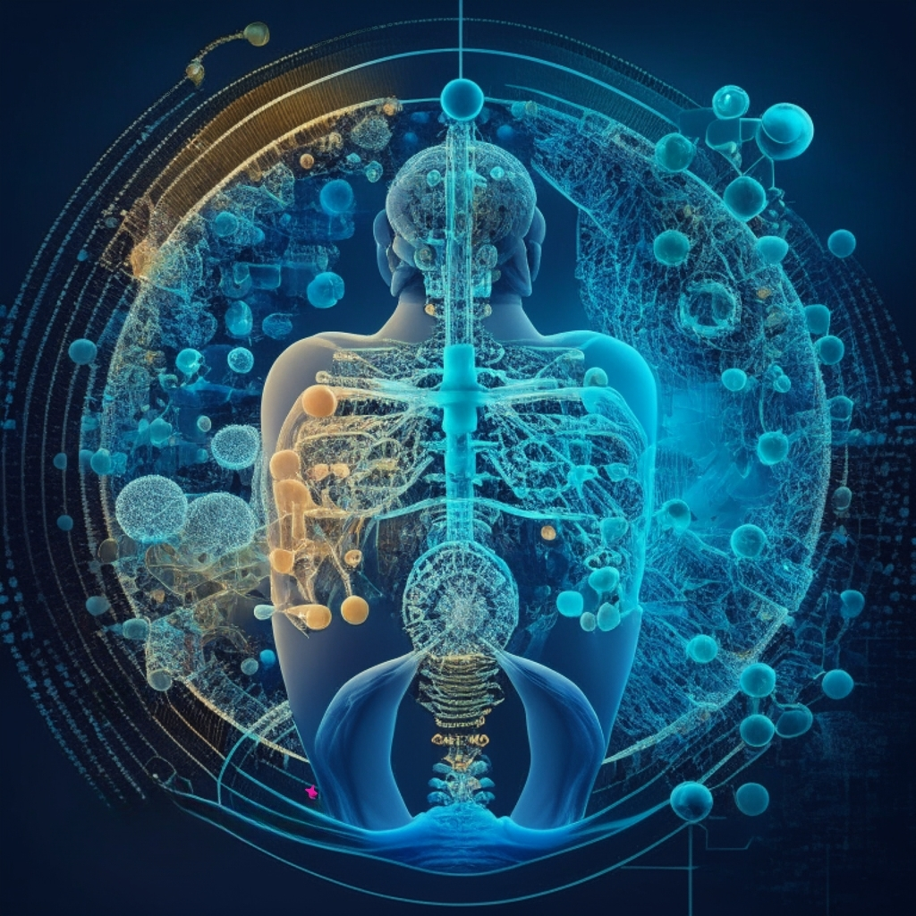
The use of clinical genomics has also led to the development of new approaches to therapeutic development, health care delivery, and population health management . For example, the use of genomic information can help to identify individuals who are at increased risk for certain diseases, allowing for earlier intervention and prevention
However, there are challenges associated with the use of clinical genomics, including the cost of genomic testing and the infrastructure required to support it . In addition, there are ethical, legal, and social concerns associated with the use of genomic information, which can further complicate the use of clinical genomics
Public health genomics.
Public health genomics is an emerging field that assesses the impact of genes and their interaction with behaviour, diet, and the environment on the population's health . It is the application of advances in human genetics and molecular biotechnology to improve public health and prevent disease
Public health genomics focuses on effective and responsible translation of genomic science into population health benefits.The use of genomic information in public health has important implications for health policy. Genomic technologies have been at the leading edge of applications in clinical medicine and have the potential to revolutionize public health .The use of genomic information in public health can help to identify individuals who are at increased risk for certain diseases, allowing for earlier intervention and prevention .
Implications of genomic medicine for health policy.
One of the main challenges in using genomic information in public health is the ethical, legal, and social concerns associated with the use of genomic information. These concerns can include issues related to privacy, confidentiality, and discrimination . In addition, there is a need for increased education and awareness about genomic medicine among healthcare providers and the general public to reduce the stigma associated with genomic testing and increase the demand for genomic medicine service. To address these challenges, there is a need for increased funding for research and development in public health genomics, particularly in the areas of pharmacogenomics and precision medicine
In addition, there is a need for the development of policies and guidelines for the use of genomic information in public health, as well as the necessary infrastructure to support genomic testing and analysis .The use of public health genomics has important implications for precision public health, which is an emerging multidisciplinary field that uses genomics, big data, and machine learning/artificial intelligence to predict health risks and outcomes and to improve health at the population level . Precision public health has the potential to transform public health by enabling more targeted and personalized interventions, leading to improved health outcomes and reduced healthcare costs.
Public health genomics is an important area of study in genomic medicine. The use of genomic information in public health has the potential to improve population health and prevent disease. However, there are challenges associated with the use of genomic information, including ethical, legal, and social concerns. Further research is needed to fully understand the implications of public health genomics for health policy and to develop effective strategies for incorporating this information into public health practice.

Biohacking: Empowering Individuals in the Pursuit of Health
Biohacking, also known as human augmentation or human enhancement, is a practice that involves individuals taking a personalized approach to their health and wellness in order to optimize their physical and cognitive performance. It combines scientific approaches to diet, exercise, and lifestyle changes with the use of technology and self-experimentation to enhance bodily functions and cognitive abilities.
The concept of biohacking revolves around the idea of self-improvement and optimization, with individuals seeking to maximize their potential through experimentation and the use of technology. It encompasses various practices, including tracking and analysing personal health data, making incremental changes to the body, diet, and lifestyle, and utilizing technology to enhance performance. The origins of biohacking can be traced back to the convergence of several factors, including advancements in technology, the rise of citizen science, and the increasing interest in personalized health and wellness.
The availability of wearable devices, such as fitness trackers and smartwatches, has provided individuals with the means to monitor and track various health metrics in real-time .
This, coupled with the accessibility of information and the ability to connect with like-minded individuals through online communities, has contributed to the growth and popularity of biohacking . Biohacking practices can range from relatively safe and common practices, such as intermittent fasting and using wearable technology, to more experimental and less common practices, such as blood transfusions and genetic modifications.
It is important to note that while some biohacking practices can be beneficial, others may carry potential health risks and should be approached with caution.

TYPES OF BIOHACKING

How biohacking aligns with the Precision Medicine
Aspect | Biohacking | Precision Medicine
Definition | The term "biohacking" describes a popular movement where people experiment on themselves to improve their health and well-being using technology and scientific knowledge. | Precision medicine is a new medical strategy that involves customising medical therapies based on a patient's particular genetic make-up, way of life, and clinical data to produce the best therapeutic results.
Approach | Personalized optimization is the goal of biohacking, which is motivated by people' own decisions and activities. | The development of individualised methods is based on substantial clinical research, data analysis, and best practises.
Genetic Emphasis | Individual genetic variances are highlighted by biohacking, which concentrates on comprehending and utilising genetic data for the improvement of one's health and performance. | The use of genetic profiles to inform treatment choices and forecast disease risks are all important components of precision medicine.
Therapeutic Goals | Enhancing general well-being, maximising physical and mental performance, and promoting lifespan are the main objectives of biohacking. | Precision medicine offers customised therapies based on the unique features of each patient in an effort to increase therapeutic effectiveness, safety, and results.
Integration of Data | In order to make well-informed judgments about health interventions, biohacking frequently combines self-collected data from lifestyle, dietary, and biometric sources. | In order to create a thorough patient profile, precision medicine entails the integration of several datasets, including genetic, clinical, environmental, and lifestyle data.
Personal Empowerment | By empowering people to actively participate in their health decisions, biohacking empowers people to take charge of their wellbeing. | By include patients in the decision-making process, giving them access to individualised treatment alternatives, and educating them about their options, precision medicine empowers patients.
Customization | Biohacking is characterised by customization, with treatments made to fit each person's tastes and objectives in order to achieve personal optimum. | In precision medicine, where therapies are individualised based on genetic, clinical, and lifestyle characteristics, a patient-centric approach is guaranteed, customization is a fundamental concept.
Disease Prevention | The focus of biohacking is on proactive lifestyle changes that improve general health and sickness prevention. | In order to allow preventative measures, precision medicine focuses on early illness identification and management, identifying risk factors based on genetic susceptibilities.

Future Prospects of Diagnosing: Unlocking New Frontiers
Medical condition diagnosis is a discipline that is constantly evolving due to technological breakthroughs and novel methods. The ability to identify illnesses more accurately in the future will allow for earlier identification, individualised treatment programmes, and more accurate evaluations. With an emphasis on the use of artificial intelligence (AI), nanotechnology, and other upcoming technologies, we will examine the fascinating potential that lie ahead in the field of diagnosis in this introduction.
AI may be applied in a variety of areas to advance human welfare and development, including the clinical sphere, where it can help medical practitioners with diagnosis, identifying disease features, therapy, prognosis, prevalence, and research.
Currently, there are five uses for AI:
- Assessing disease severity
- Predicting treatment efficacy
- Preventing complications
- Assistive technology
- Analysing enormous data
AI/ML can be used in liquid biopsy for cancer detection, identify disease causing genomic variants, to predict future variants of existing pathogens genome, and to improve gene editing process and tools by means of deep learning (a form of AI).
Rare Diseases
Rare diseases are a condition with low prevalence and that affects a small number of the population compared with other prevalent diseases. Classical diagnosis of such diseases is time consuming, challenging and in some cases misdiagnosed especially if the patient presents with atypical symptoms and these conditions have a large phenotypic spectrum.
Use of AI
Data driven architecture can be utilised for storing patient details and also enables the collection, integration and analysis of various data sources such as Electronic Health Records, scientific documents, literatures for phenotyping rare conditions. Many types of AI tools are used in the healthcare system for diagnosis of rare diseases. One such AI tool is computer vision. Computer vision is a field of artificial intelligence that enables computer systems to derive information from digital images such as x-rays and other visual inputs by acquiring, processing, analysing and understanding digital images.
NLP [Natural Language Processing]
Natural Language Processing is a branch of AI concerned with the interaction between human and computer language. It is used to extract information from unstructured free texts such as clinical notes, patient narratives. It helps physicians to identify specific phenotypic traits, medical information, and the genetic condition of a patient. Since
NLP can process vast amounts of textual data; it can be combined with data-driven architecture to enhance the efficiency of phenotyping by reducing manual efforts and accelerates the potential diagnosis process. The technique can also be used to analyse vast amounts of scientific documents, literature, analyse case reports, research documents, genetic markers for accurate diagnosis and for designing a personalized treatment plan.
.NLP in healthcare is an interdisciplinary field which utilises the applications of NLP in the medical sector. This can also be used in clinical trials, EHRs, literatures, information extraction process, machine learning based text mining and medical knowledge graph construction.
Therefore, leveraging this technology helps the patients to reduce Diagnostic delay, financial burden to provide early interventions and appropriate therapy to improve their quality of life and better health outcome.
Advances in cancer diagnosis
Cancer has been one of the most dreadful diseases, affecting millions of people worldwide. The diagnosis and treatment are a challenge for clinicians. Recent advancement of non-invasive methods of diagnosis (CTCs), cancer associated mutations, cell free DNA , micro RNA, in biological fluids such as blood, CSF, urine. CTCs are initially shed by primary tumors that accounts for the development of metastatic tumors. Circulating tumour DNA from extravascular vesicles are membrane bound that consist of nucleic acid proteins, circulating cell free RNA, small RNA etc. This provides comprehensive data for pathologists regarding primary and metastasized tumors. CTCs not only work as an indicator of tumor but also for assessing treatment response where lower count represents better survival.
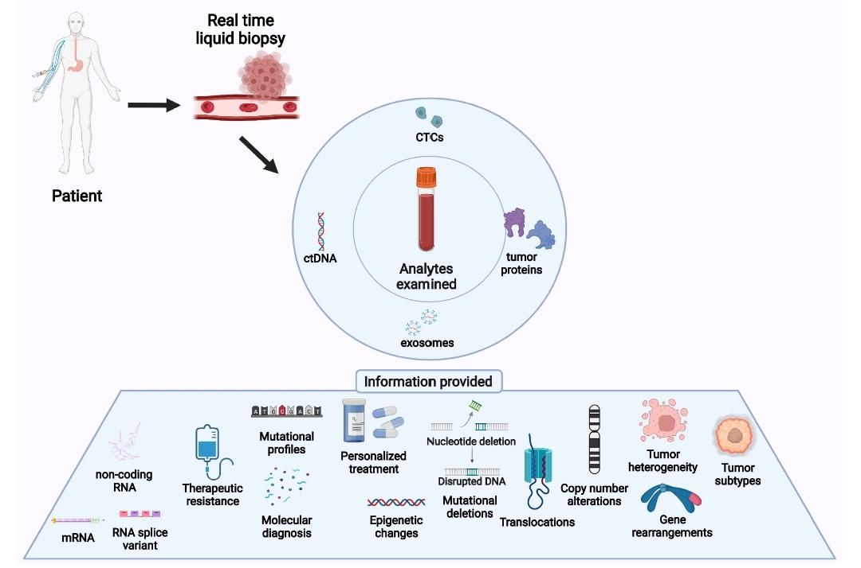
Figure: Entities analyzed in liquid biopsies and their application. The various analytes isolated from blood in LBs provide a wide variety of information regarding tumors. Each analyte has a specific application in tumor diagnosis, monitoring, and treatment.

EPISPOT (Epithelial ImmunoSPOT) assay uses membrane bound antibodies against epithelial cell adhesion molecules (EpCAM or CD326) on tumor cells to detect viable CTCs. Another test is Adna test which incorporates polymerase chain reaction (PCR) to detect tumor specific mRNA transcripts.
This provides accurate information about tumour characteristics and early detection compared to traditional tissue biopsies. Thereby significantly enhancing patient outcome and potentially helps in preventing cancer from advancing to later stages.
Liquid biopsy can also be used in treatment monitoring by analysing tumour heterogeneity, genetic alterations and to find therapeutic targets to prompt treatment response providing tailored therapy and helps in periodic monitoring to detect emergence of drug resistance or treatment resistance for adapting new treatment regimens and timely treatment modifications to improve patient outcome and reduces unnecessary procedures.
Moreover, advances in AI/ML are being leveraged to expand algorithms for accurate interpretation of complex data generated by liquid biopsy.
MI detection
Myocardial Infarction also called as heart attack is caused due to decreased blood flow to the myocardium of heart leading to sudden death. Road accidents due to emergency medical conditions such as MI in drivers are increasing overtime. Researchers are developing wearable real time MI detection systems for road safety.
The device can be a smart watch or a chest strap that utilizes advanced sensors interlaced within them and analyses the sensory data via AI/ML algorithms which monitors vital signs of blood pressure, heart rate, ECG signals to detect abnormal signs of heart attack.
Healthcare Department | Future Aspects of Diagnosing
Cardiology | Advanced wearable devices for continuous heart monitoring
 | AI-based algorithms for early detection of heart diseases
 | Genomic testing to identify genetic risks for heart conditions

 | Non-invasive imaging techniques for precise diagnosis
Oncology | Liquid biopsies for early cancer detection and monitoring
 | Personalized cancer vaccines tailored to individual genomes
 | AI-driven predictive analytics for treatment outcomes

 | Nanotechnology for targeted drug delivery
Neurology | Brain-computer interfaces for improved diagnosis
 | Genomic profiling for personalized treatment plans
 | Biomarkers for early detection of neurodegenerative diseases

 | Virtual reality-based diagnostic tools for neurological conditions
Rheumatology | Advanced imaging techniques for accurate joint assessment
 | Biomarker-based tests for early detection of autoimmune diseases
 | AI-powered algorithms for predicting disease progression

 | Precision therapies targeting specific immune system components
Gastroenterology | Non-invasive methods for diagnosing gastrointestinal diseases
 | Genomic testing for personalized treatment regimens
 | AI-driven analysis of gut microbiome for disease association

 | Wireless capsule endoscopy for comprehensive intestinal examination
Pulmonology | AI-powered lung function tests for early disease detection
 | Genomic profiling for targeted therapies in lung diseases
 | Wearable devices for continuous respiratory monitoring

Virtual reality-based pulmonary simulations for training

Upon detection of abnormality the device sends warning alerts as auditory signals, visual signals, and high vibration patterns. Furthermore, this also informs the emergency medical services along with the driver's location for immediate medical assistance.
The device can also be integrated with vehicle systems by connecting to the vehicle’s onboard computer to collect additional information of driving pattern, steering wheel movement and to monitor driver’s condition such as head position, eye movement, posture and gestures to provide timely warning of any possible cardiac events.
The data collected from the device can also be analysed by the physicians to identify possible risks, aggregating factors and implement targeted interventions. To prevent unauthorised access the device adheres to privacy and strict security.
Recent trends in prenatal testing and screening
Prenatal testing and screening or used to identify genetic birth defects in foetus. The major advancement is the development of non-invasive prenatal testing (NIPT) employing bioinformatics and epigenetics involves testing for common chromosomal abnormalities such as Edwards syndrome by analysing cell free DNA present in maternal blood. High resolution analysis of foetal nucleated RBC and trophoblasts in maternal circulation also helps to detect abnormalities.
Recent trends have paved a way for expanded screening panels which unlike traditional screening, focuses on a broad range of genetic conditions including single gene defects, intellectual disabilities thereby enabling the clinicians to recognise potential risks and offer management strategies.
Advances in single cell genomics enables the analysis of fetal cells from maternal circulation individual fetal cells can be obtained from maternal circulation and the fetal DNA can be studied for the detection of chromosomal abnormalities by analysing the fetal genome at higher resolution increases the accuracy and can be helpful in the detection of micro delusion syndrome. Fetal cells can be separated from maternal blood by silicon based nano structured micro fluidic platform which is a micro fluid device which has antibody coatings that binds to corresponding antigens on the surface of circulating fetal nucleated RBC.

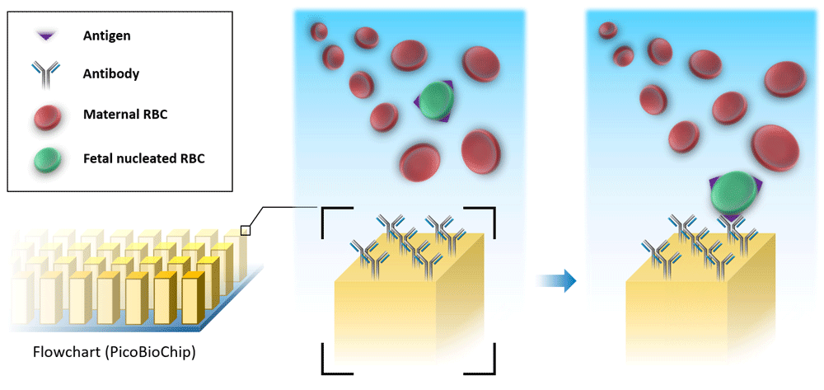

Figure: Scheme of silicon-based nanostructured microfluidic platform (Cell Reveal™).

Placenta is very important for the normal fetal development during pregnancy. DNA methylation is a crucial factor that epigenetically regulates functioning and development of placenta by gene activation or repression, splicing regulation etc. Abnormality in the DNA methylation process of placenta may lead to formation of abnormal genes which thereby affects the fetal development. DNA methylation status can be determined by treating the DNA with sodium bisulfite leads to the formation of unmethylated cytosine. Since different tissues exhibit variations in the methylation process, bisulfite sequencing differentiates fetal derived cfDNA from tumor derived cfDNA. Methy-pipe is a bioinformatics software for data preprocessing, sequence alignment and downstream methylation which is used for whole genome bisulfite sequencing data analysis. FEMER (fetal methylome reconstructor) can be helpful to obtain a high resolution view of placental methylome which is challenging incase of methy-pipe.

Prenatal ultrasound diagnosis plays an important role during pregnancy. Repeated ultrasound diagnosis helps to detect congenital abnormalities in the growing foetus. However, factors such as foetal mobility abdominal wall thickness of the pregnant mother etc makes ultrasound challenging on gradual implementation of deep learning into this ultrasound diagnosis not only helps to minimise time and manual workload but also helps in appropriate diagnosis of foetal growth abnormalities, measurements of head circumference, gestational age and weight assessment enables to target minimising foetal mortality and morbidity rates.
Dermal tattoo diagnostics
Tattoos are a kind of body art imprinted on skin. Innovations in the medical field have paved the way to colorimetric dermal tattoos as a biosensor that involves change in its characteristics due to alterations in the biomarkers such as pH, uric acid, temperature, glucose which can be read by naked eyes. These quantitative changes in biomarkers can be detected for 4 days thus can be helpful in monitoring long-term conditions.
The traditional tattoo inks can be replaced with colorimetric sensing reagents and the biosensors are formed under stratum corneum thereby providing a strong physical barrier against contamination of sweat and other external factors.
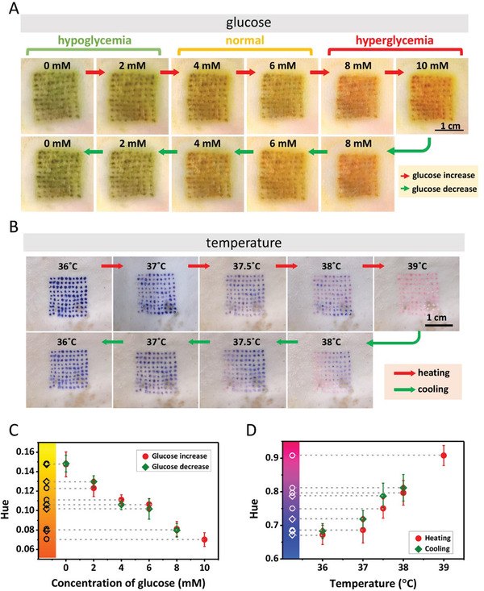
Uniform reading can be obtained by fabricating dermal tattoo with microneedle patch.
Detections of glucose and body temperature ex vivo using colorimetric dermal tattoo biosensors. A) Detection of glucose ex vivo, in the range of increasing glucose concentration (≈0–10 mm) (upper row) and decreasing glucose concentration (≈10–0 mm) (lower row). B) Detection of temperature ex vivo, during heating (≈36–39 °C) (upper row) and cooling (≈39–36 °C) (lower row). C, D) The Hue values extracted from the images in (A) and (B) as a function of glucose concentration (C) and temperature (D).
Molecular diagnostics
Molecular diagnostics is a combination of techniques that involves analysis of DNA, RNA and proteins to identify disease. It includes PCR, Real-time polymerase chain reaction, multiplex polymerase chain reaction, ELISA, immunoassay, genetic testing, whole-exome sequencing, DNA microarray etc.
dPCR digital polymerase chain reaction is highly sensitive and can be used to detect low levels of pathogen targets and minor mutations. Used for quantification of low microorganisms content such as HIV (Human Immunodeficiency Virus), HRV(Human Rhinovirus). The technique performs absolute quantification of the target genes where the amplification reactions are divided into thousand sectors by using microarrays, microplates into separate compartments. Based on the fluorescence threshold, the droplets generated are identified as positive and negative whose ratio helps to calculate target gene content. To attain accurate quantification, proper threshold setting is very important as this can be affected by many factors such as length of probe, primer factors, sample's quality and quantity.
HRM (High Resolution Melting) is a new molecular diagnostic technique which is based on differences in the melting point of different ds-DNA. The method is rapid, economical for genotyping and species detection. Pathogens are identified by monitoring changes in the shape of the melting curve by using fluorescent probes. This method showed high sensitivity and specificity in the detection of Candida spp., Aspergillus spp. and Cryptococcus spp. thus facilitating early diagnosis.
Microarray analysis has gained prominence in prenatal genetic testing. This technique allows for the detection of chromosomal abnormalities and the identification of sub microscopic deletions or duplications in the foetal genome.
Microarray analysis provides a higher resolution compared to traditional karyotyping, enabling the detection of smaller genetic imbalances associated with developmental disorders. It has become an integral part of the diagnostic workup for individuals with congenital anomalies detected during prenatal ultrasound.
Whole -Exome Sequencing (WES): Exome is part of the genome consisting of exons. WES is a genomic technique of sequencing protein coding regions of the gene. This can analyse any abnormalities and detect the presence of mutations in genetic impairments.
Fig WES and impact of its genetic consequences on human public health. Variant calling of the WES data is applied for various purposes in different disorders: diagnosis (prenatal diagnosis: PND, preimplementation genetic diagnosis: PGD and mutation detection in heterogeneous diseases such as hearing loss using selected genes for faster diagnosis), screening procedures and research. Consequently, WES benefits for treatment and management of patients, gene discovery, SNP detection for drug effects and finding disease mechanisms and gene networks.

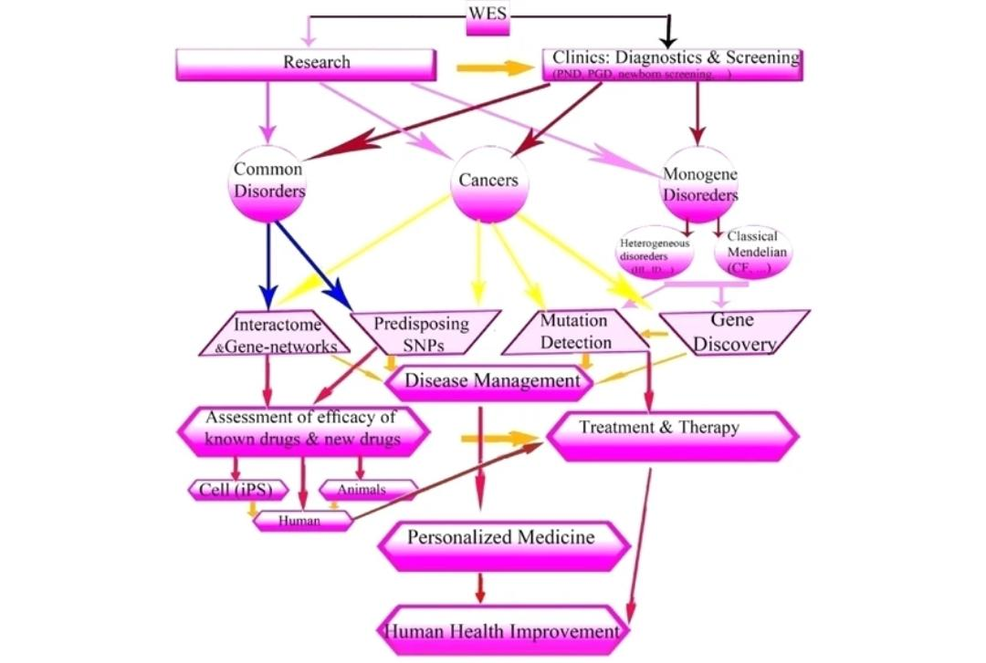
Fig WES and impact of its genetic consequences on human public health. Variant calling of the WES data is applied for various purposes in different disorders: diagnosis (prenatal diagnosis: PND, preimplementation genetic diagnosis: PGD and mutation detection in heterogeneous diseases such as hearing loss using selected genes for faster diagnosis), screening procedures and research. Consequently, WES benefits for treatment and management of patients, gene discovery, SNP detection for drug effects and finding disease mechanisms and gene networks.
Biosensing is a new molecular diagnostic that enables the combination of target biomarker and ionic conductivity materials to generate signals that can be detected by optical or electrochemical sensors. An example is the use of photoelectric biosensing of the genome for diagnosis and quantitative analysis of infectious diseases. Further studies revealed the use of such biosensors in identifying mycobacterial proteins and interferons in early detection of tuberculosis.
Fluorescence in situ hybridization (FISH) detects specific nucleic acid sequence in a cell can be combined with flow cytometry to detect in thousands of cells separately. Hence integrating their use in bacterial identification, monitoring pathogen growth, detecting infected cell growth, gene expression etc.
In cases of secondary antibiotic resistance due to empirical treatment before the test results, molecular diagnostics produces quicker results compared to classical tests thereby timely screening and detection of resistance makes the method an integral part of diagnosis.
Combining the studies of pharmacogenomics and precision medicine with molecular diagnostics paves way for a new era in the healthcare system.
Precision medicine and Metabolomics
Metabolomics is a scientific study of metabolites (end products of biological processes) in our body which includes amino acids, carbohydrates, lipids, bile acids etc. It was found that disease states alters the metabolite status that can be used to understand physiology of the disease and can be used as biomarkers for disease identification.
According to National Institutes of Health, Biomarker can be defined as “a characteristic that is objectively measured and evaluated as an indicator of normal biological processes, pathogenic processes, or pharmacologic responses to a therapeutic intervention”. Body fluids such as blood, lymph, urine, saliva may contain biomarkers which can be analysed to detect specific diseased conditions. In this emerging era of technology, medical diagnosis can be made accurate and accelerate detection of biomarkers for precise treatment by integrating with artificial intelligence/machine learning.
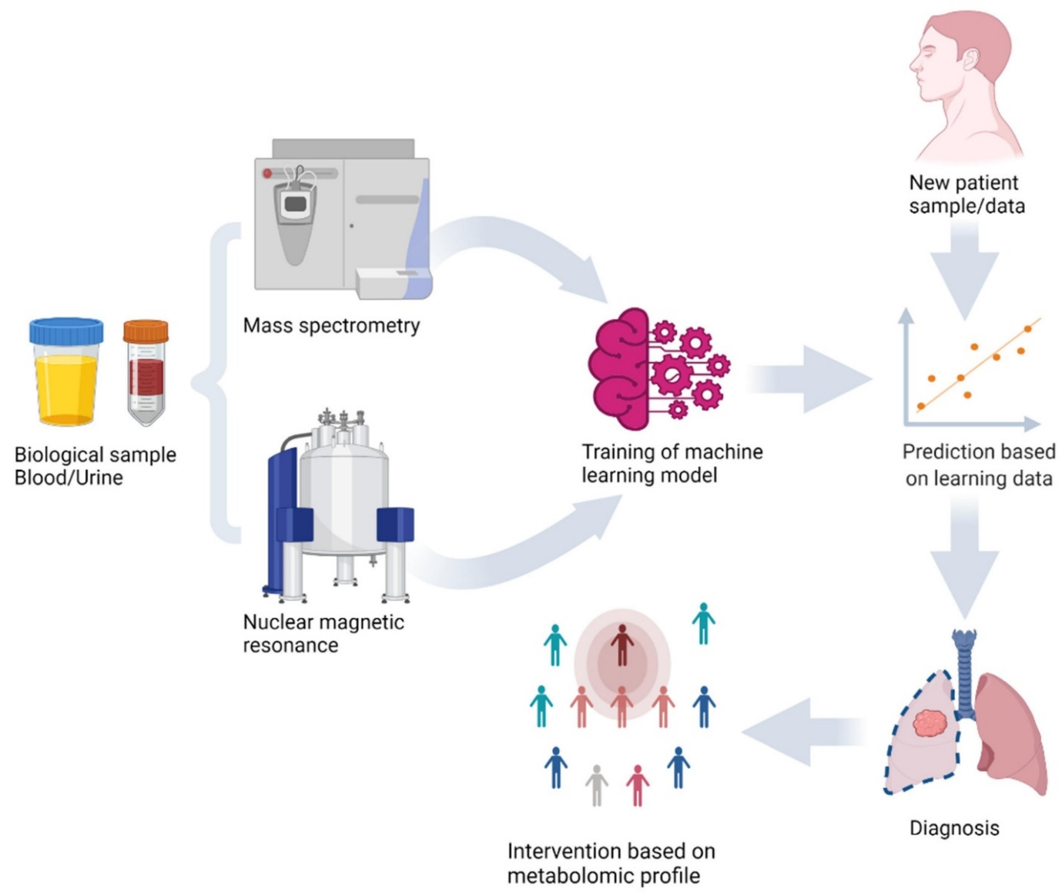
Figure: Machine learning model training and prediction of new sample using metabolomics analysis of biological samples with mass spectrometry and nuclear magnetic resonance.
Metabolomics focuses on identification and quantification of metabolites in the physiological fluids and provides details of metabolic status, treatment responses, monitoring disease progression and alterations of metabolites during diseased conditions such as metabolic disorders, cardiovascular diseases, cancer etc. Thereby helping the physicians to analyse the metabolomic profile for choosing optimal therapeutic options and drug dosage regimen to minimise unwanted adverse effects.
Nuclear magnetic resonance (NMR) and mass spectroscopy (MS) based technology can be used to analyse the samples. NMR has better reproducibility than MS technology but the sensitivity is lower and requires large sample size hence MS based metabolomic technology is widely used in clinical research.
MS-based techniques are used for in-vitro detection, Imaging Mass Spectrometry (IMS) involves in-vitro and in-vivo detection and visualization of metabolites. This is used to analyse spatial distribution of endogenous metabolites in the tissue. Matrix assisted laser desorption ionization (MALDI) IMS is currently the most common commercial IMS mode for an wider metabolite coverage and faster scans. This technique has been combined with MRI (Magnetic Resonance Imaging) in colon cancer diagnosis.
Pharmacometabolomics is the new branch of metabolomics that studies the efficacy of drug therapy by identifying the biomarkers associated with specific organ’s response to the treatment, further helps to plan an effective dosage regimen as a part of Therapeutic Drug Monitoring (TDM) and to monitor body’s response to drug, external factors, drug interactions and toxicity of the drugs.
However the requirement of robust bioinformatic tools and sophisticated analytical techniques for data interpretation and complexity of data reproducibility issues and other important issues, integration with other technologies poses limitations in the metabolomics technology.

The Role of Pharmaceutical Industry in Precision Medicine

One of the sectors with the quickest rate of growth worldwide is the pharmaceutical sector, which demands ongoing innovation. The pharmaceutical industry has been incorporating precision medicine in their drug development pipeline to generate unprecedented insight into the genetics of human disease and a wealth of novel drug targets and biomarkers. However , there are unique challenges in the precision medicine pipeline, including ethical considerations, regulatory challenges, and limitations of current technologies. Despite these challenges, precision medicine holds immense promise as a facilitator of more targeted therapies and a healthier society.
.Pharmaceuticals still face a number of obstacles that must be overcome in order to succeed and compete in a market that is continually changing despite their expansion. Recent data portray a clear image of the pharmaceutical industry, highlighting both its influence and its difficulties.
Industry forecasts predict that by 2023, global pharmaceutical sales would surpass $1.5 trillion, reflecting the rising need for healthcare solutions globally.
By examining present patterns and future projections in the pharmaceuticals industry, the pharmaceutical business is anticipated to witness a transition from traditional sales positions to medical affairs responsibilities in 2023. Real-world evidence, the revolution in organs-on-a-chip, and health economics research are examples of emerging trends. Synthetic data and AI-based medications are gaining popularity, and health sciences firms will increasingly value the human touch. The worldwide pharmaceutical industry saw strong growth, increasing slightly from 2021 to 2022 to reach 1.48 trillion US dollars.

Conclusion
Finally, "Converging Horizons" displays a breathtaking work of art that alters the face of healthcare. The complex relationships between biohacking, the pharmaceutical business, genetic medicine, and future diagnostics paint an alluring picture of individualised treatment, tailored medicines, and ground-breaking developments. It is clear that this synergistic interaction is changing medicine as we know it as we stand at the beginning of this revolutionary age.
Biohacking's emergence in the healthcare industry demonstrates a dynamic trend toward individualised therapy. Biohacking encourages patients to actively participate in their health journey by embracing unique genetic differences and utilising cutting-edge technology, transforming them into partners rather than passive recipients of treatment. This recently formed cooperation opens the way to painstakingly individualised treatments and therapies that take into account the distinctive genetic profiles of each individual.
Using genomic medicine, we can decipher the secrets contained in our DNA. It may be possible to create medicines that specifically target genetic abnormalities and weaknesses as we learn more about the complex genetic tapestry that makes up each of us. This emphasis on precision medicines has encouraged the pharmaceutical industry to engage in research and development, leading to a wide range of drugs that target the root of illnesses with previously unheard-of precision and efficacy.
GENOMIC MEDICINE
BIOHACKING
FUTURE PROSPECTS OF DIAGNOSIS
PHARMACEUTICAL INDUSTRY
EFFECTIVE
PATIENT OUTCOME
After being mesmerised by these genomic insights, the pharmaceutical sector uncovers an extended canvas in the form of genetic data. Collaborations between genetic researchers and medication developers produce a rhythm that pinpoints possible therapeutic targets with unmatched accuracy. Clinical trials take on a remarkable quality when they are painstakingly planned with genetically stratified patient cohorts, ensuring that the appropriate medications are delivered to the right people at the right time.
Looking ahead, diagnostics stands out as a brilliant work of innovation that will change the course of the combat against illnesses. New opportunities for early identification and intervention are made possible by technological breakthroughs, pointing the way to a healthy future. Genetic testing at the point of treatment and liquid biopsies shines as rays of hope because they can detect illnesses before they show symptoms. Artificial intelligence (AI)-driven diagnostic algorithms provide a web of information, giving doctors predictive analytics to enable quick treatments and stop illnesses before they start.
Even said, we must not lose sight of the fact that this path involves constant ethical reflection and critical thought as we awe at this expanding piece of art. In addition to their brilliance, these interconnected worlds are beautiful because of the obligation to uphold ethical and scientific standards. As we advance, it is crucial to protect patient privacy, make sure that precision medicines are available and affordable, and understand the ethical issues around the use of genetic data.
"Converging Horizons" is a monument to human inventiveness, compassion, and a common goal for a better world in the vast tapestry of healthcare. The ability to change the fundamental nature of healthcare itself is contained inside this linked canvas, which is a living, breathing expression of hope and development. It urges us to imagine, create, and work together.

References
- Ku, C. S., Loy, E. Y., Salim, A., Pawitan, Y., & Chia, K. S. (2010). The discovery of human genetic variations and their use as disease markers: past, present and future. Journal of human genetics, 55(7), 403-415.
- Pollex, R. L., & Hegele, R. A. (2007). Copy number variation in the human genome and its implications for cardiovascular disease. Circulation, 115(24), 3130-3138.
- Brown, S. M., Hay, J. G., & Ostrer, H. (2008). Essentials of medical genomics. John Wiley & Sons.
- Mattick, J. S., Dziadek, M. A., Terrill, B. N., Kaplan, W., Spigelman, A. D., Bowling, F. G., & Dinger, M. E. (2014). The impact of genomics on the future of medicine and health. Medical Journal of Australia, 201(1), 17-20.
- https://www.med.unc.edu/ppmh/education/past-educational-offerings/explorations-in-genomic-medicine-research/
- Roth, S. C. (2019). What is genomic medicine?. Journal of the Medical Library Association: JMLA, 107(3), 442.
- https://nap.nationalacademies.org/read/25277/chapter/2#5
- National Academies of Sciences, Engineering, and Medicine. (2018). Understanding disparities in access to genomic medicine: proceedings of a workshop. National Academies Press.
- Bauer, M. S., Damschroder, L., Hagedorn, H., Smith, J., & Kilbourne, A. M. (2015). An introduction to implementation science for the non-specialist. BMC psychology, 3(1), 1-12.
- National Academies of Sciences, Engineering, and Medicine. (2016). Applying an implementation science approach to genomic medicine: workshop summary.
- Roberts, M. C., Clyne, M., Kennedy, A. E., Chambers, D. A., & Khoury, M. J. (2019). The current state of funded NIH grants in implementation science in genomic medicine: a portfolio analysis. Genetics in Medicine, 21(5), 1218-1223.
- Implementation science and genomic medicine in action: A case study. Posted on September 18, 2019 by Mindy Clyne, Division of Cancer Control and Population Sciences, National Cancer Institute, Rockville, Maryland, and Muin J. Khoury, Office of Public Health Genomics, Centers for Disease Control and Prevention, Atlanta, Georgia [https://blogs.cdc.gov/genomics/2019/09/18/implementation-science-2/]
- https://www.sciencedirect.com/topics/biochemistry-genetics-and-molecular-biology/clinical-genomics
- https://www.nationalgeographic.com/science/article/partner-content-genomics-health-care
- Mattick, J. S., Dziadek, M. A., Terrill, B. N., Kaplan, W., Spigelman, A. D., Bowling, F. G., & Dinger, M. E. (2014). The impact of genomics on the future of medicine and health. Medical Journal of Australia, 201(1), 17-20..
- Public health genomics. (2023, June 21). In Wikipedia. https://en.wikipedia.org/wiki/Public_health_genomics
- Khoury, M. J., Bowen, M. S., Clyne, M., Dotson, W. D., Gwinn, M. L., Green, R. F., ... & Yu, W. (2018). From public health genomics to precision public health: a 20-year journey. Genetics in Medicine, 20(6), 574-582.
- Khoury, M. J., & Holt, K. E. (2021). The impact of genomics on precision public health: beyond the pandemic. Genome medicine, 13(1), 67.
- https://www.med.unc.edu/ppmh/education/past-educational-offerings/explorations-in-genomic-medicine-research/
- https://orzuv.life/blog/precision-medicine-personalizing-healthcare-for-better-patient-outcomes
- Statista – The Statistics Portal. (n.d.). Statista. https://www.statista.com/aboutus/our-research-commitment/285/matej-mikulic
- Melissa Pistilli. (2023, July 10). Runner. https://investingnews.com/author/melissa-pestilli. Using Artificial Intelligence to Diagnose Rare Genetic Diseases - National Gaucher Foundation
- Parikh, J. R., Genetti, C. A., Aykanat, A., Brownstein, C. A., Schmitz-Abe, K., Danowski, M., Quitadomo, A., Madden, J. A., Yacoubian, C., Gain, R., Williams, T., Meskell, M., Brown, A., Frith, A., Rockowitz, S., Sliz, P., Agrawal, P. B., Defay, T., McDonagh, P., Reynders, J., … Beggs, A. H. (2021). A data-driven architecture using natural language processing to improve phenotyping efficiency and accelerate genetic diagnoses of rare disorders. HGG advances, 2(3), 100035. https://doi.org/10.1016/j.xhgg.2021.100035
- Lone, S. N., Nisar, S., Masoodi, T., Singh, M., Rizwan, A., Hashem, S., El-Rifai, W., Bedognetti, D., Batra, S. K., Haris, M., Bhat, A. A., & Macha, M. A. (2022). Liquid biopsy: a step closer to transform diagnosis, prognosis and future of cancer treatments. Molecular cancer, 21(1), 79. https://doi.org/10.1186/s12943-022-01543-7
- Mass spectrometry-based metabolomics in health and medical science: a systematic review. Xi-wu Zhang, Qiu-han Li, Zuo-di Xu, Jin-jin Dou (2020). RSC Advances.
- https://www.tomorrow.bio/post/what-is-biohacking-an-overview-of-the-growing-trend-2023-05-4450116062-biohacking
- https://www.forbes.com/sites/bernardmarr/2021/02/26/whats-biohacking-all-you-need-to-know-about-the-latest-health-craze/?sh=24a218845d76
- https://www.medicalnewstoday.com/articles/biohacking
- https://www.cell.com/trends/biotechnology/fulltext/S0167-7799(18)30078-7
- https://www.cell.com/trends/biotechnology/fulltext/S0167-7799(18)30078-7
- Chowdhury, Muhammad & Alzoubi, Khawla & Khandakar, Amith & Khalifa, Ridab & Abouhasera, Rayaan & Koubaa, Sirine & Ahmed, Rashid & Hasan, Anwarul. (2019). Wearable Real-Time Heart Attack Detection and Warning System to Reduce Road Accidents. Sensors. 19. 2780. 10.3390/s19122780.
- Pös, O., Budiš, J., & Szemes, T. (2019). Recent trends in prenatal genetic screening and testing. F1000Research, 8, F1000 Faculty Rev-764. https://doi.org/10.12688/f1000research.16837.1
- Xiao, S., Zhang, J., Zhu, Y., Zhang, Z., Cao, H., Xie, M., & Zhang, L. (2023). Application and Progress of Artificial Intelligence in Fetal Ultrasound. Journal of clinical medicine, 12(9), 3298. https://doi.org/10.3390/jcm12093298
- He, R., Liu, H., Fang, T., Niu, Y., Zhang, H., Han, F., Gao, B., Li, F., & Xu, F. (2021). A Colorimetric Dermal Tattoo Biosensor Fabricated by Microneedle Patch for Multiplexed Detection of Health-Related Biomarkers. Advanced science (Weinheim, Baden-Wurttemberg, Germany), 8(24), e2103030. https://doi.org/10.1002/advs.202103030
- Liu, Q., Jin, X., Cheng, J., Zhou, H., Zhang, Y., & Dai, Y. (2023). Advances in the application of molecular diagnostic techniques for the detection of infectious disease pathogens (Review). Molecular medicine reports, 27(5), 104. https://doi.org/10.3892/mmr.2023.12991
- Rabbani, B., Tekin, M. & Mahdieh, N. The promise of whole-exome sequencing in medical genetics. J Hum Genet 59, 5–15 (2014). https://doi.org/10.1038/jhg.2013.114
- Hao, T., Huang, Z., Liang, L., Weng, H., & Tang, B. (2021). Health Natural Language Processing: Methodology Development and Applications. JMIR medical informatics, 9(10), e23898. https://doi.org/10.2196/23898
- Barberis, E., Khoso, S., Sica, A., Falasca, M., Gennari, A., Dondero, F., Afantitis, A., and Manfredi, M. 2022. “Precision Medicine Approaches with Metabolomics and Artificial Intelligence.” International Journal of Molecular Sciences 23 (19) (September 24): 11269. doi:10.3390/ijms231911269. http://dx.doi.org/10.3390/ijms231911269.
- Clish C. B. (2015). Metabolomics: an emerging but powerful tool for precision medicine. Cold Spring Harbor molecular case studies, 1(1), a000588. https://doi.org/10.1101/mcs.a000588

