A review on: - Role of Ginger (Zingiber officinale) treatment against Prostate cancer
Sanjib Kumar Mohanty¹ , Yashaswi Nayak¹
1. Department of Zoology, Centurion University of Technology and Management, Bhubaneswar.
210506182002@cutm.ac.in¹, yashaswi.nayak@cutm.ac.in¹,
Abstract:-
The aim of the article is to describe the extraction process and how the bioactive compounds present inside the ginger reduces the effect of cancer and play a role in anticancer activity. PC-3 and LNcAP cancer cells are taken for investigation. Both in vitro and in vivo experiments shows the anticancer activity of the Zingiber officinale extracts. Numerous bioactive compounds were separated and noted by using different extraction procedures and their anticancer activities were tested later on PC-3 and LNcAP cancer cells by in silico analysis or by molecular docking of the plant contents against the cancerous cells. Historical background of ginger species clearly depicts the anticarcinogenic contents that reduces the effects of prostate cancer in the ancient times till to date. Ethanol concentrates of eight species (Amommum cardamomum, C. longa, C. mangga, C. xanthorrhiza, Zingiber aromaticum, Z, officinale, Z. cassumunar) showed a solid inhibitory impact on the development of the malignancy cells. Ginger (Zingiber officinale Roscoe) is a superb wellspring of a few bioactive phenolics, including non-unpredictable impactful mixtures like gingerols, paradols, shogaols and gingerones. Ginger has been known to show calming, cell reinforcement and antiproliferative exercises, demonstrating its promising job as a chemopreventive specialist. Here, we show that entire ginger concentrate (GE) applies critical development inhibitory and passing inductory impacts in a range of prostate disease cells. To the most amazing aspect our insight, this is the primary report to exhibit the in vitro and in vivo anticancer movement of entire ginger extract for the administration of prostate disease.
Keywords: Bioactive, Ethanol, Prostate cancer, Zingiber officinale Roscoe
1. Introduction:-
Public health systems are facing a great threat in the most developed as well as in the under developed countries due to the uncontrollable growth of various deadly diseases over the past decades, commonly one of which includes cancers, which is portrayed as one of the difficult situations as its leading to a syndrome like situation which is neither curable nor preventable. (Briss et al.,2004). This deadly cancer is being referred to as one of the most noticeable, prevalent, mortality causing and costly disease due to the hazard it causes irrespective of any gender or age. It is for a cause that this disease is considered as one of the most tremendously health damaging disease as it ranks 2nd in the most devastating and morbidities causal disease worldwide (Valery et al.,2018). Uncontrolled cell division and growth is the reason that leads to its growth and spread from a single zone to its metastasising to various body portions which is a reason for threat of its rapid growth that further leads to its change from being a localised cancer to a metastasised cancer. Despite various progresses made in by various on cologists and scientists the main cause of cancer deaths are due to the heterogeneity in its pattern of disease spread as well as the various complications like mental stress, physical pain, physical distress, society unacceptance leading to fear development further leading to various psychological disorders combined with its various side effects (Boehmer et al.,2001). This widespread disease seems to be one of the major concerns which has innumerable factors leading to such condition is the lifestyle and environ mental changes which is one of the major risk factors that are causing to the further worsening of the condition more and more (Ambrosone et al., 2004). Ginger has higher concentrations of phenethyl isothiocyanate, a substance that has demonstrated anticancer activity in several disease cell lines. It prevents the growth of PC-3, a PC cell line that is orthotopically administered into mice, from happening. (Xiao et al., 2006). According to a recent assessment, the use of elective medicine, particularly for chronic or acute illnesses or severe conditions, has increased dramatically. (Crains et al.,2001). According to a study, 83% of 453 cancer patients used at least one optional drug. Many of these improvements are naturally occurring in the United States. (Hosseini et al.,, 2001). Species belonging to the Zingiberaceae family of plants have been used for therapeutic, curative, and culinary purposes for a very long time, especially in Asian regions. In studies using creature theories, many spices and tastes, especially those from the Zingiberaceae family, proved to offer useful protection against degenerative diseases like cancers. (Milner et al., 2012;). A few members of the family have been found to engage in cancer prevention, cancer mitigation, and cancer preventive exercises. (Haleagrahara et al.,2010). The phytochemicals (carotenoids, polyphenolics, anthocyanins, alkaloids, N and S compounds) found in foods that are cultivated in the ground have been shown to target various neoplastic phases to reduce overall disease risk. Garlic, ginger, turmeric, cruciferous vegetables (broccoli, brussel sprouts, cabbage), grape seed extracts, and over 35 other plant-based foods have been identified by the NCI as being effective in preventing malignant development.. Ginger, also known as Zingiber officinale Roscoe, is a common and widely used zest. Numerous synthetic components, such as terpenes, polysaccharides, lipids, natural acids, and crude filaments are abundant in it. The majority of ginger's phenolic components, such as gingerols and shogaols, are responsible for its medicinal benefits.. Studies taken together have shown that ginger provides a variety of natural benefits, such as anti-cancer, relaxing, antibacterial, anti-cancer, neuroprotective, cardiovascular defensive, respiratory defensive, anti-obesity, antidiabetic, anti-nausea, and antiemetic properties. (Shukla et al.,2007).
2. Historical Background of Ginger:-
Zingiber officinal Roscoe is a member of the Zingiberaceae family (Tewtrakul et al.,2007) and the genus Zingiber. Because of the protrusions on the rhizome, English botanist William Roscoe (1753- 1831) gave it the name Zingiber, which was taken from the sanskrit word “singabera,” which meaning horn-shaped (Ibrahim et al., 2006). Southeastern Asia is the region where ginger originates, and it has long been prized for its fragrance, culinary, and therapeutic properties, as evidenced by References in old Chinese, Indian, and Middle Eastern publications. It is 5 to 15mm in diameter, 1.5 to 6meters broad, and 2cm thick, and can be yellowish, beige, or reddish depending on the assortment (López et al.,2018). In the 10th century, ginger's curative properties were acknowledged throughout Germany, France, and England.. One pound of ginger was reportedly worth nearly as much as a pound of sheep throughout the thirteenth and fourteenth centuries in England, according to documents. In addition to being a potent anti-irritant, ginger was employed by eclectic physicians in the middle of the nineteenth century to cause sweat, reduce cravings, and avoid sickness. An essential part of Ayurveda, the traditional medicine of India.. (Moghaddasi et al.,2012).

3. Taxonomical Classification:-
Kingdom | Plantae
Phylum | Tracheophyta
Class | Liliopsida
Order | Zingeberales
Family | Zingeberaceae
Genus | Zingiber
Species | officinale

Table 1:- Shows the Taxonomical Clasification of Ginger (Zingiber officinale),Ginger is used fresh, in some kind of a new glue, or dried, together in fine powder, all over the world as a zest, flavouring specialist, embellishment, medicinal, as well as food ingredient. Although the types of new and dried ginger are somewhat different, new ginger can be substituted for dried ground ginger. The scent of ginger is entering and sweet-smelling. Ginger is called as “Adrak” (local name) in the subcontinent like India and Pakistan and is a fundamental element of numerous dishes (Kizhakkayil et al.,2011).
4. Nutritional composition of Ginger:-
4.1 Chemical composition:-
Depending on the climatic conditions, composition of ginger varies from place to place. Ginger includes around half carbohydrates, 9% protein including whey proteins, 6-8 percent unsaturated fats and natural oils, 3-6 percent detritus, and 3-6 percent rough fiber (on a dry matter basis)( Natarajan et al.,1972). Protein and fat content in African ginger assortments range between 5.98 and 3.72 grammes per 100 grammes (Bhat et al.,2013). In ginger, there are both soluble and insoluble strands. Ginger contains important micronutrients such as potassium, magnesium, copper, manganese, and silicon. Manganese and potassium are two minerals that aid in the healing of wounds, construct protection from sickness and ensure the coating of heart, veins and urinary entries. Silicon promotes clear glow, scalp, enamel, and cuticles, as well as aiding collagen production. Ginger rhizome also contains a small amount of nutrients A, E, and a few measures of B-nutrients, as well as nutrient C (Ei et al., 2010).

4.2 Phytochemical composition:-
Ginger is made up of over 60+ different ingredients (Ogbuewu et al.,2014). Oleoresin, a phytochemicals are found in the ginger rhizome, which plays an important role in preparation of fundamental oil and gum. The structure of the fundamental oil differs from the components like terpenes, hydrocarbons present in other species of ginger. Ginger is the basic phenolic compound, and when it degrades, it produces shogaols, zingerone, and paradol. Zingerone and shogaols can be found in small amounts in fresh ginger and in larger amounts in dried or extricated ginger. Ginger contains an extraordinary gathering of mixtures called diasyleheptanoids, which include gingerenone. In addition, ginger contains a little amount of curcumin. It does, however, contain trace amounts of alkaloids, saponins, carotenoids, flavonoids, steroids, and cardinolides (Kubra et al.,2012).
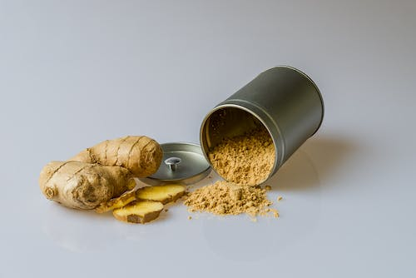
Figure1:- Shows the identified image of Ginger (Zingiber officinale)
4.3 Bioactive components of Ginger:-
Ginger has a lot of active ingredients such as polyphenols and terpenoid chemicals. Gingerols, shogaols, and paradols are the phenolic chemicals found in ginger. Gingerols, such as 6-gingerol, 8-gingerol, and 10-gingerol, are the primary polyphenols in young ginger. Gingerols can be converted to comparable shogaols through heat treatment or long-term storage. Shogaols can be converted to paradols after hydrogenation. In addition to quercetin, zingerone, gingerenone-A, and 6-dehydrogingerdione, ginger has a plethora of other phenolic chemicals. A few terpene segments found in ginger, such as bisabolene, curcumene, zingiberene, farnesene, and -sesquiphellandrene, are thought to constitute the major constituents of ginger basic oils. Moreover, ginger contains polysaccharides, lipids, natural acids, and crude filaments (Ma et al., 2021).

5. Ginger as an Antioxidant:-
It has been realized from the previous studies that overproduction of free extremists, like receptive oxygen species (ROS), has a significant impact in the advancement of numerous persistent illnesses. An assortment of characteristic items have cell reinforcement potential, like vegetables, organic products, palatable blossoms, cereal grains, therapeutic plants, and natural mixtures(Kikuzaki et al.,1993). A few investigations have discovered that ginger likewise has high cancer prevention agent movement. The cell reinforcement movement of ginger has been assessed in vitro by means of ferric decreasing cancer prevention agent power (FRAP), 2, 2-diphenyl-1-picrylhydrazyl (DPPH), and 2, 2’-azinobis-(3-ethylbenzothiazoline-6-sulfonic corrosive) (ABTS) strategies. The outcomes uncovered that dried ginger showed the most grounded cancer prevention agent (Ghasemzadeh et al., 2010). A small portion of the dried ginger powder contains polyphenols which shows anti-cancer activity and also prevent movement of FRAP, oxygen to cell. Also, the kind of extraction dissolvable could affect the cell reinforcement action of ginger (Maizura et al.,2011). An ethanolic concentrate of ginger showed high Trolox-identical cancer prevention agent limit and ferric-diminishing capacity, and a watery concentrate of ginger displayed solid free revolutionary searching movement and chelating capacity (Ali et al.,2018). Ginger concentrate could decrease the creation of ROS in human fibrosarcoma cells with H2O2-instigated oxidative pressure. Now scientists are focusing on rodent model for heart homogenates. Ginger concentrate diminished the substance of malondialdehyde (MDA), which was identified with lipid peroxidation. Ginger and its bioactive mixtures, (for example, 6-shogaol) shows cell reinforcement movement by means of the atomic factor erythroid 2-related factor 2 (Nrf2) flagging pathway (Gundala et al.,2014).
6. Cytotoxicity:-
Malignant growth is said to be the leading cause of death, with over 9.6 million cases reported in 2018. A few examination works have exhibited that normal items, for example, products of the soil plants have shown anticancer action. Ginger has recently been studied for its anticancer potential in the treatment of several cancers, including breast, gynecological, gastrointestinal, as well as prostate cancers (Powell et al.,2018). The possible systems of activity include the restraint of multiplication and the acceptance of apoptosis in malignant growth. Ginger's cytotoxic effects and hidden systems in prostate cancer were studied in vitro and in vivo conditions. By downregulating the protein articulation of multidrug opposition-related protein 1 (MRP1) and glutathione-S-transferase (GST), it was observed that 6-gingerol, 10-gingerol, 6-shogaol, and 10-shogaol had a chemopreventive impact on human rectal cancerous growth cells. Parallel mixtures of ginger phytochemicals, such as 6-gingerol, 8-gingerol, 10-gingerol, and 6-shogaol, also inhibited the proliferation of PC-3 prostate cancer cells synergistically (Salehi et al.,2019). A ginger concentration had a 2.4-fold better inhibitory effect on tumor growth than a mixture of 6-shogaol, 6-gingerol, 8-gingerol, and 10-gingerol. Furthermore, 6-shogaol may be more important between 6-gingerol as well as 6-paradol for reducing cellular endurance but also triggering apoptotic in both human and animal prostate cancer cells. It operated mostly by masking the sign transducer but rather by the regulator of record 3 (STAT3) as well as NF-B flagging (Hatzoglou et al.,2005). It also reduced cyclin D1, survivin, c-Myc, and B-cell lymphoma 2 (Bcl-2) expression and improved Bax articulation. Trial contemplates have shown that ginger can forestall and treat a few kinds of malignant growth, like colorectal, prostate, bosom, cervical, liver, and pancreatic disease. The activation of apoptosis and the inhibition of malignancy cell growth are the most common anticancer components (Aziz et al.,2021).

7. Prostate Cancer:-
WCRF studies which is the world cancer research fund studies done by american studies for cancer research studies have shown that the approximately 18 million cancer cases were reported around the world and that cancer was a great burden which was worsening day by day in this 21st century as well as the major factors leading to this was to the unhealthy survival done by the people worldwide and Among the numerously diagnosed types of cancer the lung prostate and breast cancers were seen to be the most common cancers that lead to around 12.3 percent of the total number of the reported cases of the year 2018. In 2012, worldwide assessments of new malignant growth cases were 14.1 million, while 8.2 million passings happened because of malignancy (Haas et al.,2008). Nonetheless, in more created nations prostate malignancy in men and cellular breakdown in the lungs in ladies are the main sources of disease. Prostate cancer mostly affects the elderly men. In addition to that, black men are much prone to prostate cancer than white men. The people suffering from the prostate cancer develops a tumor in the prostate gland which slowly spreads throughout the body. The vast majority of prostate tumors are adenocarcinomas that start from the organs in the prostate. Others are ductal adenocarcinoma, temporary cell (urothelial) malignant growth, squamous cell disease, carcinoid, little cell disease, sarcomas, and sarcomatoid malignant growth (Rawla et al.,2019).
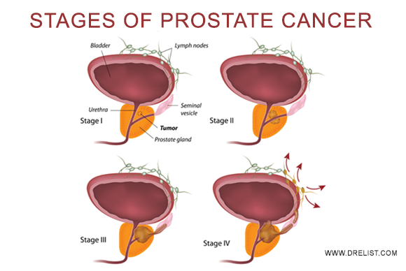
Figure 2:- It shows that there are 4 different stages by which a human affected by Prostate cancer (Rawla et al.,2019)
7.1 Epidemics of Prostate Cancer:-
7.1.1. Data Source
The source of the data mentioned in this article has been referred from the GLOBOCAN, the Surveillance, Epidemiology and End Results (SEER) program of the National Cancer Institute (NCI) of the United States, as well as research papers related to prostate cancer. GLOBOCAN 2012 project started by the International Agency for Research on Cancer (IARC), World Health Organization (WHO) is a data set that provides evaluations of occurrence, mortality, and 5-year predominance of all significant kinds of malignant growths. All these data have been collected from the population-based cancer registries (PBCRs) in 184 countries (Jones et al.,2011).
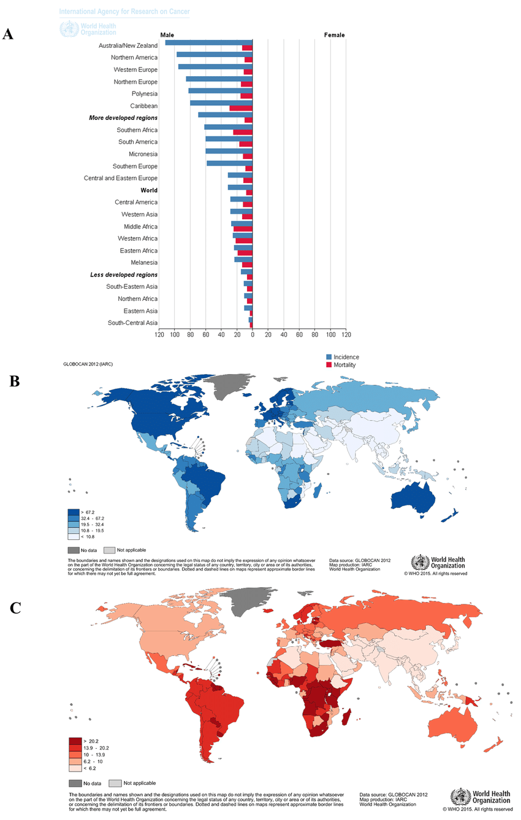
Figure 3:- This global data shows the worldwide affected by Prostate cancer(Jones et al.,2011)
7.1.2. Incidence of prostate cancer
Prostate Cancer is the second most known cancer found in every man worldwide, which accounts for 15% of cancer cases (Bashir et al. 2015). In 2012, 1.1 million new instances of prostate malignant growth were reported. In the created nations, having just 17% of the world's male populace, it is the most now and again analyzed disease in men (Pall et al., 2015). Indeed, in agricultural nations, prostate malignancy is the fourth most pervasive disease among men. This variety in frequency in created as opposed to agricultural nations could be ascribed to the utilization of various strategies for prostate-specific antigen (PSA) testing for finding. There was a quick ascent in rate in the created nations after the 1990s when PSA testing was presented (Caffo et al., 2015). The test distinguishes even the inert, moderately developing, asymptomatic tumors, consequently inflating the noticed disease rate in created nations. Thusly, in agricultural nations where PSA testing isn't being utilized as broadly, the rate of prostate malignancy is low (Rebbeck et al.,2013)

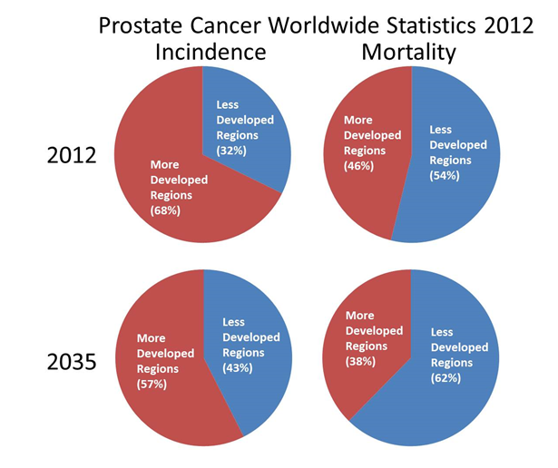
Figure 4:- It shows the the world wide statics of Prostate cancer in 2035 (Caffo et al., 2015)

7.1.3. Mortality:-
Prostate disease is the fifth driving reason for death across the world. In 2012, there were 307,000 passings (6.6% of complete passings in men) worldwide because of prostate malignant growth. The most minimal death rate was accounted for in South-Central Asia, where 2.9 passings happen per 100,000. The death rate in Asia was reliable with the low frequency of prostate malignancy on the mainland. In locales with the most elevated frequency, like Australia, New Zealand, the United States, furthermore, northern and western Europe, the quantity of passings was moderately low, with death paces of 12.9, 9.8, 14.5, and 10.7, individually. The passing rates have diminished in these locales (Wong et al,2016). The fundamental purpose behind this decrease is the early location and improved treatment offices). The difference in the occurrence of prostate malignant growth in created and nonindustrial nations isn't seen for mortality, as PSA screening has more impact on occurrence and less on mortality (Schröder et al.,2012). Higher mortality is found in dark populaces when contrasted with Caucasians and Asians (Ferlay et al., 2013). In America, the most noteworthy prostate-specific mortality was in California (3,380 for each 100,000), concordant with the high-frequency rate in this state. In Florida, Texas, and New York, where the frequency was likewise very high, death rates were individually 2,170, 1,660, and 1,760 for each 100,000. Passings because of prostate disease were shockingly high in Illinois (1,190 for each 100,000), Pennsylvania (1,370 for each 100,000), and Ohio (1,200 for every 100,000), where the rate was lower contrasted with California (8,820; 10,930, and 8,690 for every 100,000 individually) (Potosky et al.,2001).
7.2 Danger factors associated with prostate Cancer:
Danger elements can be extensively separated into two classifications, modifiable and non-modifiable. Non-modifiable danger factors incorporate quality transformations and single nucleotide polymorphisms. Mutation of the gene, Single Nucleotide Polymorphisms (SNPs), race, and agility while modifiable risk factors include environmental and lifestyle risk factors (Cuzick et al., 2014). Age, race/identity, and family ancestry are the most grounded hazard factors related to the improvement of prostate malignant growth (Center et al., 2012). Different elements like SNPs in specific qualities and way of life factors (like smoking, drinking, and so forth) are being investigated for their relationship with this bleak infection. Certain changes have been identified to be firmly associated with the danger of creating prostate malignant growth. Dietary propensities and a stationary way of life have to been found to add to the danger of creating prostate malignant growth (Kerns et al.,2010).

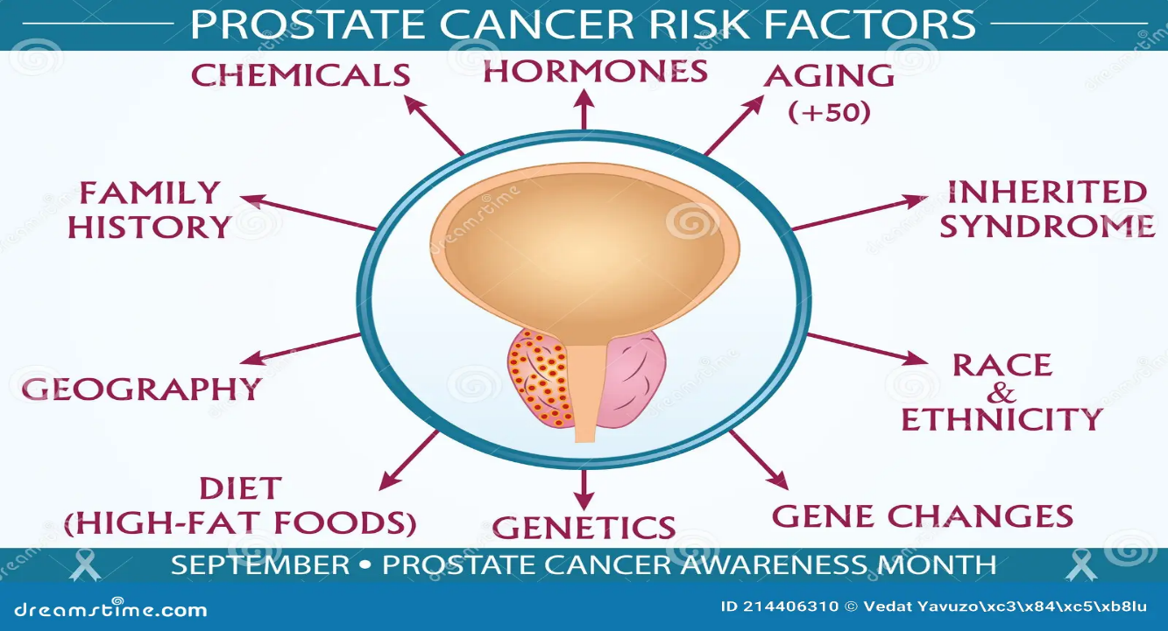
Figure5:- It shows there are various types of risk factors are playing an important role
For causing prostate cancer
7.3 Relation Between Age and prostate Cancer
The danger of creating prostate malignant growth is straightforwardly corresponding to age. Over 80% of all malignant growths are analyzed in men more than 65 years old. It is normal that in Asian nations, where the occurrence of prostate malignancy is the most minimal on the planet, the future will increment particularly sooner rather than later (Bechis et al., 2011). Therefore, the weight of prostate malignancy is required to increment in these districts (Baade et al., 2013). The prostate malignancy rate shows a sharp increment for a long time past 55 years. In any case, as PSA testing turned out to be more normal and individuals turned out to be more mindful, middle age at finding dropped from 72 in 1986 to 66 in 2011. Moreover, it was discovered that prostate diseases that were created at a more youthful age acted all the more forcefully. It is imperative to refer to youthful age prostate disease, which is defined as prostate malignant growth recognized in men under 55 years old. For more youthful men (Sakr et al.,1993).
7.4 Heredity Genetics factors of cancer:-
The overall danger of creating prostate malignant growth is higher among men with an influenced first-degree relative. Indeed, family ancestry is the most grounded hazard factor for the improvement of prostate malignant growth among every one of the racial and ethnic gatherings (Bratt et al.,2002). of the multitude of men influenced with prostate malignancy, around 10–15% have a positive family ancestry. Besides, the danger of creating prostate malignancy is significantly higher for men under 65 years old than those more noteworthy than 65 years old, having a positive family history of prostate malignant growth, just as in men who have more than one first-degree relative with prostate disease. Numerous investigations likewise report a higher danger if the influenced relative is the sibling than if it is the dad, which focuses on the likelihood that the hereditary segment is X-connected or recessive (Carter et al., 2004). Clinically, the solitary contrast between innate and non-genetic types of prostate malignancy is the early age (~6–7 years) finding on account of innate prostate disease (Schaid, 2004).
7.5 Mutated Genes:-
There is a strong correlation between developing prostate cancer and variants of the allele that is found at the loci (8q24 and 17q21) of black men (Schumacher et al., 2018). Different investigations have detailed a relationship somewhere in the range of BRCA1 and BRCA2 changes and the danger of prostate malignancy in men. These changes are likewise known to expand the danger of creating bosom disease in ladies a few overlay. BRCA1 is present at the loci 17q21 and encodes a protein that regulates the cell cycle progression. BRCA2 lies on locus 13q12 and can prompt about a 5-to 7-crease increment in relative danger, particularly at a youthful age (≤ 65 years), and is additionally connected with more forceful malignancies (Armenia et al.,2018). Be that as it may, BRCA2 transformations are moreover only from time to time found in men having a positive family background of prostate malignant growth. Because of the low recurrence of the event of BRCA1 and BRCA2 changes in the populace, they clarify a little percentage of genetic prostate malignant growths (Mao et al 2011).
8. Extraction of ginger by different extraction methods:-
8.1 Super-Critical CO2 Extraction(SFE):-
The supercritical liquid extractions (SFE) have been carried out on the pilot-scale gear depicted in the diagram below. The pilot unit includes a carbon-dioxide high-pressure siphon (Maximator-G35), a CO2 capacity chamber (C1), specific semi (HE1, HE2), an electronic framework enabling quantify the Emissions stream, and two glass detachment vessels (VS1, VS2) (Ilmabol TGI Boro 3.3). The super-critical liquid extractions were carried out in a Waters distillation apparatus with a capacity of 500 mL, a diameter of 6.3 cm, and a height of 19 cm. The conditions that were investigated were resolved by past works range to acquire the unstable concentrates utilizing the SFE approach: four unique pressing factors. At 40 °C, with a 1000 g.h-1 CO2 stream rate and 0.2 kilograms of ginger rhizome, 80, 90, 100, and 110 bar) at 40 °C ( Junior et al., 2020).
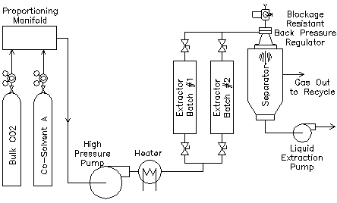
Figure 6: Supercritical extraction experimental apparatus : C – CO2 cylinder, HE – heat exchanger, CV – check valve, P1 – CO2 high pressure pump, EV – extraction vessel, T – temperature transmitter, P – pressure transmitter, VS – separation vessel, MFT – mass flow transmitter, SV – Shutoff valve(( Junior et al., 2020).
8.2. Steam Distillation:-
The steam refining extractions were carried out on pilot-scale equipment, as shown in the schematic diagram below. The apparatus includes a heater (B1) with both a dissolvable (water) volume of 10 L and even a force wellspring of two kilowatts, as well as level sensors (upper and lower), which estimate pressing factors and temperature. A similar plant material was exposed to the procedure indicated in the example ready for the steam refining measure. The ginger mass, in this case, was 2000 g, and the extraction vessel used (EV1) seems to have a 9.4 Litre capacity, a 31.3 mm thickness, and a 19.3 meters long breadth. Three separate greatest pressing variables were used to lead the extractions (1, 2, and 3 bar) (Machado et al., 2022)
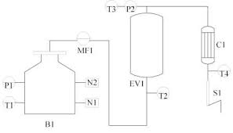
Figure 7: Steam distillation apparatus : B – boiler, EV– extraction vessel, C– condenser, S– separator, T– temperature transmitter, P– pressure transmitter, MF– flow measure, N– level switch(Machado et al., 2022
8.3. Hydrodistillation:-
This hydrodistillation interaction has been accomplished using the example that was recently simple for 24 hours at 30 degrees Celsius to be handled more quickly. The cycle entails placing 50 g of both the prepared samples in a 100 mL cup and connecting it to a Soxhlet extraction mechanical assembly. Every cup gets warmed with a warming cover until it is hot, at which point the produced steam appears at the condenser, which is connected to a constantly flowing water stream, the fume is consolidated, as well as the oil obtained is removed by thickness comparison with solution. (Garcez et al., 2020).

8.4. Soxhelet Extraction Method:-
20 gram of the new ginger root was pounded. At that point, 100ml of supreme ethanol dissolvable (Merck, Germany) was added into the jar along with the ginger root. The interaction was led at 78.4°C for 12 hours, with 5-6 warmth cycles in a warming mantle (MTOP, Republic of Korea) for 60 minutes.( Nguyen et al., 2019).
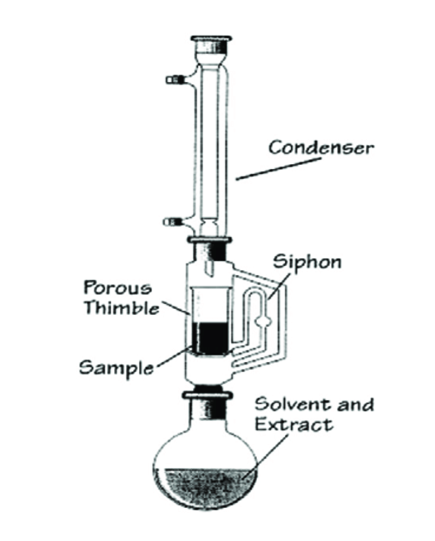

Figure 8:- shows the i:-Condenser, ii: siphon, iii: Solvent and extract, iv:- Porus thimble( Nguyen et al., 2019).

9. Isolation of components from ginger (Zingiber officinale) and their Biological Activity:-
9.1 Gingerol([6]-Gingerol; [8]-Gisngerol; [10]-Gingerol):-
Gingerol, also known as [6]-gingerol, is a phenolic phytoconstituents molecule present in red ginger which activates the tongue’s zest receptors. Although gingerol is atomically related to a pungent crystal compound of capsicum called capsaicin and a chemical irritant compound called piperine, both of which are alkaloids, the bioactive routes are distinct. It’s most typically found like a powerful yellowish lubricant throughout the callus cultures, but it can also be seen as a close to the bottom transparent strong. This chemical compound mainly discovered in the Zingiberaceae family, which includes all members of the Zingiberaceae family (Ahmad et al.,2022).
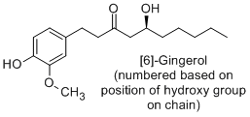
Figure 9:- Structure of “Gingerol([6]-Gingerol; [8]-Gisngerol; [10]-Gingerol” from Ginger (Zingeber officianale) (Ahmad et al.,2022).
9.2 Shogaol([6]-Shogaol; [8]-Shogaol; [10]-Shogaol):-
Shogaols were significant parts of ginger equivalent in manufactured development to one of the phytocompounds like gingerol. Mostly notable of get-together is shogaol. Similar to gingerone it is conveyed when ginger is dried conditions or cooked conditions. The Japanese term Shogaol is derived for the ginger. When contrasted with other sharp mixtures, shogaol is tolerably more impactful than piperine, however not as much as capsaicin. There are 4 types of shogaols namely that is [4]-Shogaol, [8]-shogaol, [10]-shogaol, and [12]-shogaol all together comprise the gathering shogaols. Methylated shogaols, such as methyl [6]-shogaol and methyl [8]-shogaol, are also found in ginger cultivars. Shogaols, a ginger compound, are strangely framed while storing or through excessive heat, most likely due to a parchedness response of the gingerols. The ratio of gingerols to shogaols is occasionally used as a gauge of item quality. It is confirmed by pale yellow liquid when ginger extracted by 1 H and 13C NMR (Connell et al., 1969).
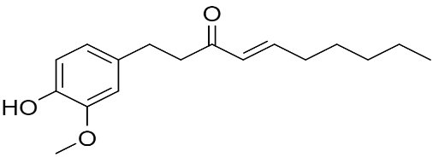
Figure 10:- Structure of “Shogaol([6]-Shogaol; [8]-Shogaol; [10]-Shogaol” from Ginger (Zingeber officianale) (Connell et al., 1969).

9.3 [6]-Parado:-
Paradol is the dynamic flavor constituent of the seeds of Guinea pepper. It is additionally found in ginger. Paradol has been found to have cancer prevention agent and antitumor advancing impacts in a mouse model. Compound 7 from ginger concentrate is a light yellow fluid. It was clarified as 6- paradol by 1 H NMR and 13C NMR, and affirmed by contrasting and writing information (Ezzat et al.,2018)
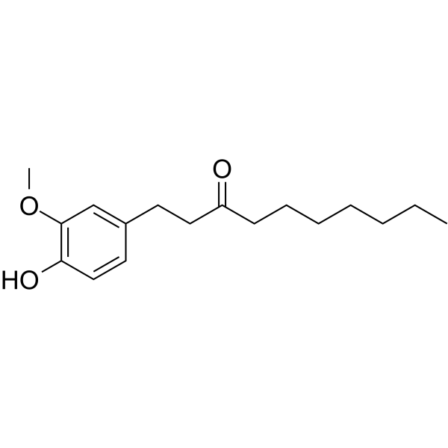
Figure 11:- Structure of “[6]-Parado” derived from Ginger (Zingeber officianale) Ezzat et al.,2018)
9.4 1-dehydro-6-gingerdione:-
Compound 8 from ginger concentrate is yellow precious stone. It was explained as 1- dehydro-6-gingerdione by 1 H NMR and 13C NMR, and affirmed by contrasting and writing information (Salehi et al.,2019)
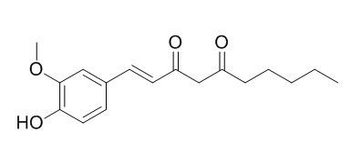
Figure 12:- Structure of “1-dehydro-6-gingerdione” derived from Ginger (Zingeber officianale)
10. Ginger root - A Blessing to Cure the Prostate Cancer
Ginger is the supernatural occurrence fix. The British Journal of Nutrition distributed the consequences of an American examination as of late in which ginger concentrate (zingiber officinale) murdered human prostate disease cells while solid prostate cells didn't kick the bucket. The outcomes happened at a day-by-day portion of 100 mg of ginger concentrate per kg of body weight (in light of a man weighing 150 pounds this is equivalent to around 550 mg removed each day). In eight weeks, the ginger concentrate cut prostate tumor development into equal parts (Karna et al.,2012).
The analysts have assessed that 100 grams of new ginger eaten day by day will offer similar outcomes. As a malignancy champion, ginger has calming, cancer prevention agents and antiproliferative impacts upon tumors making ginger a promising chemopreventive specialist. Entire ginger concentrate holds critical development inhibitory and passing industry impacts in a range of malignancy cells by interfering with disease cell cycle movement, weakening disease multiplication, and adjusting apoptosis. In any case, in particular, ginger doesn't have any poisonousness in ordinary, quickly isolating tissues like the gut and bone marrow. Ginger taken orally can forestall or mitigate queasiness coming about because of chemotherapy, movement disorder, pregnancy, and medical procedure. Not exclusively can ginger root fix malignant growth, but it is a characteristic solution for nausea from moving around, queasiness, acid reflux, tooting, colic, touchy entrail disorder, loss of craving, chills, helpless course, feminine issues, dyspepsia, acid reflux, heartburn, and numerous other gastrointestinal issues. Ginger root is likewise incredible mitigating for joint issues and is demonstrated for joint inflammation, fevers, migraines, toothaches, hacks, bronchitis, osteoarthritis, rheumatoid joint inflammation, tendonitis, elevated cholesterol, and circulatory strain furthermore, can likewise forestall inner blood clumps (Brahmbhatt et al.,2013).
Ginger is even an enemy of viral and makes a warming cold and influenza cure. ginger concentrate (GE) applies huge development inhibitory and passing inductor impacts in a range of prostate malignant growth cells. Exhaustive investigations have affirmed that GE bothered cell-cycle movement, disabled conceptive limit, balanced cell-cycle, and apoptosis administrative particles, and actuated a caspase-driven, mitochondrially interceded apoptosis in human prostate malignant growth cells. Surprisingly, everyday oral taking care of 100 mg/ kg body weight of GE restrained the development and movement of PC-3 xenografts by around 56 % in bare mice, as appeared by estimations of tumor volume. Tumor tissue from GE-treated mice showed decreased expansion list and boundless apoptosis contrasted and controls, as dictated by immunoblotting and immunohistochemical techniques. In particular, GE didn't apply any distinguishable harmfulness in typical, quickly isolating tissues like gut and bone marrow. The most amazing aspect of our insight, this is the primary report to exhibit the in vitro and in vivo anticancer action of entire GE for the administration of prostate malignant growth (Saha et al., 2014)
11. Antioxidant Property of Ginger on Prostate Cancer
In a meta-investigation taking a gander at various phytochemical impacts on prostate disease, two explicit examinations utilizing mice noticed [6]-gingerol intensifies instigated apoptosis in malignant growth cells by meddling with the mitochondrial film. Instruments connected to the disruption of the G1 stage proteins to block the propagation of malignant growth cells were also discovered, which is also a linked benefit of other key anticancer investigations. Protein disruption appears to be the basic route through which gingerol phytochemicals follow up on sick cells (Karna et al.,2012).
In a study, the anti-cancer activity of [6]-paradol and [6]-gingerol was analyzed by looking at the cell components linked to mouse skin cancer and focusing on the activator proteins linked to tumor initiation. Gingerol inhibited the transformation of normal cells into cancer cells by inhibiting AP-1 proteins, and when the illness was present, paradol pushed apoptosis due to its cytotoxic effect. In cancer cells, [6]-gingerol exhibits cell cycle arrest, and necrotic activity, including metaphor cell flagging signal corruption. Gingerol was shown to inhibit cell division by interfering with the interpretation of Conditions, which are required for copying mostly during the G1 and G2 phases of embryonic development. To speed up apoptosis, Cytochrome C is released first from mitochondria, halting ATP production and having to leave worthless mitochondria. Cytochrome C gathers an apoptosome, which activates Nf - κb pathway and initiates a killer Β - catenin course, successfully splitting Genetic code into the nucleosomes and progressing apoptosis. [6]-Gingerol also inhibits anti-apoptotic Bcl-2 protein mostly on the exterior of mitochondria, thereby leading to enhanced pro-apoptotic Bcl-2 proteins to initiate cell death. Malignancy cells have a lot of development chemical stimulator polypeptides, which are communicated by contaminant flagging pathways. The Akt protein can't bind with some of its PH regions if PI-3-Kinase isn't phosphorylated, effectively suppressing the downstream signal. A two-fold negative cell flagging strategy to enhance apoptosis by putting The right proteins linked to bashing proteins, which prevents them from advancing cell development (Saha et al., 2014).

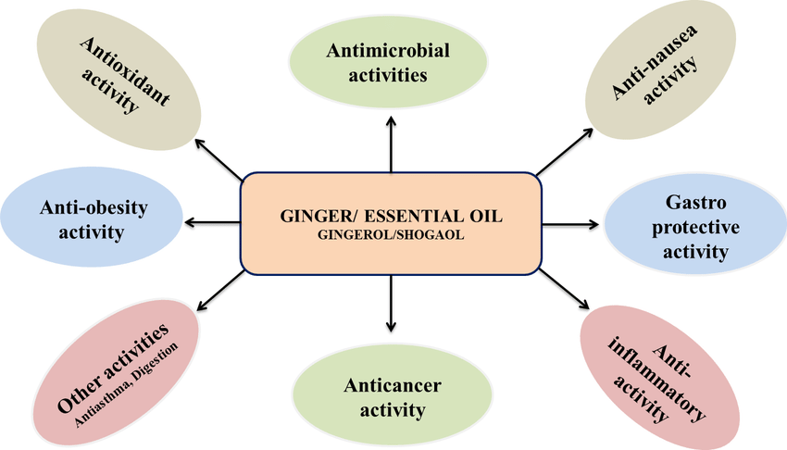
Figure 13:- shows the Essential oil of ginger (Zingiber officinale ) shows other activities
12. In silico study of ginger extract and consequences for prostate cancer
Ginger concentrate and capsaicin are utilized as phytochemical drugs. These parts can influence the development of prostate malignancy and reduction its pace of advancement without influencing the typical cells contrasting with current chemotherapy drugs. What's more, though the more reasonable atomic structure, will bring about more medications that are powerful. The point of this examination is to foresee the limiting of capsaicin, 6-gingerol, and 6-shogaol to the over-communicated androgen receptor (NR3C4) utilizing an in silico model. The docking examination was performed utilizing SCIGRESS 3.0 programming. The outcomes showed that capsaicin and 6-gingerol have close benefits of restricting energy, while 6-shogaol takes generally higher worth, 6-shogaol having the most grounded restricting energy (≈ – 181 kcal/mol) to the dynamic destinations of NR3C4. The 6-shogaol can set up 8 hydrogen bonds with NR3C4 receptors (Mohamad et al.,2019).
Accordingly, 6-shogaol can be created as a productive therapy for prostate disease. Prostate disease is an exceptionally sluggish developing malignant growth furthermore, shows side effects chiefly in its late stage. In any case, when prostate malignancy begins to develop, it rapidly spreads into the entire body. The prostate malignant growth appears to be brought about by the adjustment in the cell DNA. The DNA changes can be all things considered acquired from a parent or can be incited during an individual's lifetime. The prostate disease can be treated in its beginning phases with excellent possibilities for endurance. The ginger concentrate is an amazing wellspring of a few bioactive phenolics, including non unpredictable mixtures like gingerols, shogaols, parasols furthermore, and zingerone. Ginger has been known to show mitigating, cell reinforcement, and antiproliferative exercises, showing its promising job as a chemopreventive specialist. Here, we are keen on prostate disease treatment utilizing two ginger concentrate compounds (6-gingerol and 6-shogaol), which have been demonstrated to influence the development of prostate disease with the least side impacts when contrasted with different medicines. It was seen that 6-gingerol has actuated portion and time-subordinate hindrance of cell suitability in pancreatic malignancy cells. 6-shogaol is a phytochemical compound found in ginger and can be compared with the structure of 6-gingerol. It can only be used for human consumption when it is dried or cooked. Shogaols are relics framed during capacity or by abundance heat, presumably made by a lack of hydration response of all types of gingerols. The extent of shogaols to gingerols on occasion is taken as an indication of thing quality. 6-shogaol represses mouse and human prostate malignant growth cells in culture, joined by acceptance of apoptosis. 6-shogaol has movement and biochemical properties that make it a possible regular chemopreventive specialist in prostate malignancy with low harmfulness (Saha et al.,2014).
The androgen receptor, in any case, called NR3C4 (nuclear receptor subfamily 3), is a kind of nuclear receptor that is incited by the restricting of the androgenic synthetics, for instance, testosterone from the cytoplasm which is moved into the center. The primary capacity of NR3C4 is as a DNA-restricting record factor that manages the quality articulation. Additionally, the androgen-managed qualities are basic for the turn of events and upkeep of the male sexual aggregate. Over formation of androgen could be recognized in streaming tumor cells of metastatic prostate infection patients. The androgen receptor is significant for restorative objectives in prostate disease and in this way, numerous inhibitors should have been created. SCIGRESS 3.0 is a subatomic demonstrating programming suite that can dock the ligands into dynamic destinations to a wide range of atomic frameworks utilizing straight scaling semi-exact quantum strategies for protein improvement and ligand docking. It empowers specialists to study and configuration wide scope of sub-atomic frameworks. Its potential work is an information-based methodology from structure data of known protein-ligand buildings contained in the Protein Data Bank. Has been exhibited a huge relationship between's trial-restricting affinities and their processed score for assorted protein-ligand buildings (Mohamad et al.,2019).

13. Animal model study in Prostate Cancer
Mouse Models in Prostate Cancer Research: Mouse models serve as valuable tools in preclinical research to study disease progression, therapeutic interventions, and underlying mechanisms. In the context of prostate cancer, mouse models allow researchers to mimic the disease's development, assess treatment responses, and investigate molecular pathways. These models enable the investigation of ginger and its bioactive components on prostate cancer initiation, growth, metastasis, and response to treatment. By manipulating variables such as dosage, treatment duration, and specific genetic alterations, mouse models provide crucial insights into ginger's therapeutic potential against prostate cancer (Pienta et al.,2008).
Ginger's Effects on Prostate Cancer in Mouse Models, recent Studies using mouse models have shed light on the potential of ginger in prostate cancer prevention and treatment. Ginger and its bioactive constituents, including gingerols, shogaols, and paradols, have shown anti-cancer effects in various preclinical models. In mouse models of prostate cancer, ginger supplementation has been found to inhibit tumor growth, reduce tumor size, and decrease tumor incidence. These effects are attributed to ginger's ability to modulate multiple cellular pathways involved in prostate cancer, such as inflammation, oxidative stress, apoptosis, and angiogenesis (Choi et al., 2013).
Ginger's anti-cancer effects in prostate cancer mouse models are mediated through diverse mechanisms. Ginger and its bioactive compounds have been shown to possess antioxidant properties, reducing oxidative stress and DNA damage. Ginger also exhibits anti-inflammatory effects by inhibiting pro-inflammatory signaling pathways and reducing the production of inflammatory mediators. Moreover, ginger modulates apoptosis-related proteins, leading to increased programmed cell death in prostate cancer cells. Additionally, ginger has been found to inhibit angiogenesis, the formation of new blood vessels crucial for tumor growth, through the suppression of vascular endothelial growth factor (VEGF) signaling (Park et al.,2014).
14. Conclusion
Ginger root is notable for its potassium and manganese content. Potassium is fundamental for keeping up ordinary blood flow, muscle, and nerve work, while manganese assimilates useful nutrients and minerals. Ginger contains nutrients A, C, and E, beta-carotene, and zinc, all solid cell reinforcements that shield the prostate from destructive free revolutionaries. Free extremists accelerate tissue maturing and malignant growth advancement. Nutrient C and zinc invigorate the insusceptible framework and shield the body from contamination and irritation. Ginger is fruitful in hindering 5-lipoxygenase, a protein that propels harm improvement. It diminishes the peril of harmful development and even assists in the withdrawal of tumors in the prostate. In different examinations, ginger has been set out to impact prostate danger cells by Crippling the improvement of harmful development cells, Disturbing the improvement example of harm cells, Controlling ordinarily conveyed combinations to trigger the collapse of cells, Executing off threat cells by cutting off energy creation and stimulating the appearance of synthetic compounds that different illness cells. Only ginger must not be used in the treatment of prostate cancer. Everything has a good side and a bad side, when taken at an excess level the impact that shows in our body is bad while in an adequate amount, it shows good. It is now a question that the developing world may ever able to get through this all dangerous diseases

REFERNCES
1. Briss, P., Rimer, B., Reilley, B., Coates, R. C., Lee, N. C., Mullen, P., ... & Task Force on Community Preventive Services. (2004). Promoting informed decisions about cancer screening in communities and healthcare systems. American journal of preventive medicine, 26(1), 67-80.
2. Valery, P. C., Laversanne, M., Clark, P. J., Petrick, J. L., McGlynn, K. A., & Bray, F. (2018). Projections of primary liver cancer to 2030 in 30 countries worldwide. Hepatology, 67(2), 600-611.
3. Boehmer, U., & Clark, J. A. (2001). Communication about prostate cancer between men and their wives. Journal of family practice, 50(3), 226-226.
4. Ambrosone, C. B., McCann, S. E., Freudenheim, J. L., Marshall, J. R., Zhang, Y., & Shields, P. G. (2004). Breast cancer risk in premenopausal women is inversely associated with consumption of broccoli, a source of isothiocyanates, but is not modified by GST genotype. The Journal of nutrition, 134(5), 1134-1138.
5. Xiao, D., Lew, K. L., Kim, Y. A., Zeng, Y., Hahm, E. R., Dhir, R., & Singh, S. V. (2006). Diallyl trisulfide suppresses growth of PC-3 human prostate cancer xenograft in vivo in association with Bax and Bak induction. Clinical Cancer Research, 12(22), 6836-6843.
6. Cairns, P., Esteller, M., Herman, J. G., Schoenberg, M., Jeronimo, C., Sanchez-Cespedes, M., ... & Sidransky, D. (2001). Molecular detection of prostate cancer in urine by GSTP1 hypermethylation. Clinical cancer research, 7(9), 2727-2730.
7. Hosseini, F. S., Karimabad, M. N., Hajizadeh, M. R., Khoshdel, A., Falahati-Pour, S. K., Mirzaei, M. R., ... & Mahmoodi, M. (2019). Evaluating of induction of apoptosis by Cornus mass L. extract in the gastric carcinoma cell line (AGS). Asian Pacific journal of cancer prevention: APJCP, 20(1), 123.
8. Kaefer, C. M., & Milner, J. A. (2012). Herbs and spices in cancer prevention and treatment.
9. Shukla, Y., & Singh, M. (2007). Cancer preventive properties of ginger: a brief review. Food and chemical toxicology, 45(5), 683-690.
10. Haleagrahara, N., Jackie, T., Chakravarthi, S., Rao, M., & Kulur, A. (2010). Protective effect of Etlingera elatior (torch ginger) extract on lead acetate-induced hepatotoxicity in rats. The Journal of toxicological sciences, 35(5), 663-671.
11. Tewtrakul, S., & Subhadhirasakul, S. (2007). Anti-allergic activity of some selected plants in the Zingiberaceae family. Journal of ethnopharmacology, 109(3), 535-538.
12. Ibrahim, K. A. (2006). Extraction of essential oils from ginger rhizome using steam distillation method (Doctoral dissertation, KUKTEM).
13. López-Sampson, A., & Page, T. (2018). History of use and trade of agarwood. Economic botany, 72(1), 107-129.
14. Moghaddasi, M. S., & Kashani, H. H. (2012). Ginger (Zingiber officinale): A review. Journal of Medicinal Plants Research, 6(26), 4255-4258.
15. Kizhakkayil, J., & Sasikumar, B. (2011). Diversity, characterization and utilization of ginger: a review. Plant Genetic Resources, 9(3), 464-477.
16. Natarajan, C. P., Bai, R. P., Krishnamurthy, M. N., Raghavan, B., Shankaracharya, N. B., Kuppuswamy, S., ... & Lewis, Y. S. (1972). Chemical composition of ginger varieties and dehydration studies on ginger. Journal of food science and technology, 9(3), 120-124.
17. Bhatt, N., Waly, M. I., Essa, M. M., & Ali, A. (2013). Ginger: A functional herb. Food as Medicine, 1, 51-71.
18. El-Ghorab, A. H., Nauman, M., Anjum, F. M., Hussain, S., & Nadeem, M. (2010). A comparative study on chemical composition and antioxidant activity of ginger (Zingiber officinale) and cumin (Cuminum cyminum). Journal of agricultural and food chemistry, 58(14), 8231-8237.
19. Ogbuewu, I. P., Jiwuba, P. D., Ezeokeke, C. T., Uchegbu, M. C., Okoli, I. C., & Iloeje, M. U. (2014). Evaluation of phytochemical and nutritional composition of ginger rhizome powder. International Journal of agriculture and rural development, 17(1), 1663-1670.
20. Kubra, I. R., & Rao, L. J. (2012). Effect of microwave drying on the phytochemical composition of volatiles of ginger. International journal of food science & technology, 47(1), 53-60.
21. Ma, R. H., Ni, Z. J., Zhu, Y. Y., Thakur, K., Zhang, F., Zhang, Y. Y., ... & Wei, Z. J. (2021). A recent update on the multifaceted health benefits associated with ginger and its bioactive components. Food & Function, 12(2), 519-542.
22. Kikuzaki, H., & Nakatani, N. (1993). Antioxidant effects of some ginger constituents. Journal of food science, 58(6), 1407-1410.
23. Ghasemzadeh, A., Jaafar, H. Z., & Rahmat, A. (2010). Antioxidant activities, total phenolics and flavonoids content in two varieties of Malaysia young ginger (Zingiber officinale Roscoe). Molecules, 15(6), 4324-4333.
24. Maizura, M., Aminah, A., & Wan Aida, W. M. (2011). Total phenolic content and antioxidant activity of kesum (Polygonum minus), ginger (Zingiber officinale) and turmeric (Curcuma longa) extract. International Food Research Journal, 18(2).
25. Ali, A. M. A., El-Nour, M. E. M., & Yagi, S. M. (2018). Total phenolic and flavonoid contents and antioxidant activity of ginger (Zingiber officinale Rosc.) rhizome, callus and callus treated with some elicitors. Journal of genetic engineering and biotechnology, 16(2), 677-682.
26. Gundala, S. R., Mukkavilli, R., Yang, C., Yadav, P., Tandon, V., Vangala, S., ... & Aneja, R. (2014). Enterohepatic recirculation of bioactive ginger phytochemicals is associated with enhanced tumor growth-inhibitory activity of ginger extract. Carcinogenesis, 35(6), 1320-1329.
27. Powell Gray, B., Kelly, L., Ahrens, D. P., Barry, A. P., Kratschmer, C., Levy, M., & Sullenger, B. A. (2018). Tunable cytotoxic aptamer–drug conjugates for the treatment of prostate cancer. Proceedings of the National Academy of Sciences, 115(18), 4761-4766.
28. Salehi, B., Fokou, P. V. T., Yamthe, L. R. T., Tali, B. T., Adetunji, C. O., Rahavian, A., ... & Sharifi-Rad, J. (2019). Phytochemicals in prostate cancer: from bioactive molecules to upcoming therapeutic agents. Nutrients, 11(7), 1483.
29. Hatzoglou, A., Kampa, M., Kogia, C., Charalampopoulos, I., Theodoropoulos, P. A., Anezinis, P., ... & Castanas, E. (2005). Membrane androgen receptor activation induces apoptotic regression of human prostate cancer cells in vitro and in vivo. The Journal of Clinical Endocrinology & Metabolism, 90(2), 893-903.
30. Aziz, M. A., Sarwar, M. S., Akter, T., Uddin, M. S., Xun, S., Zhu, Y., ... & Hongjie, Z. (2021). Polyphenolic molecules targeting STAT3 pathway for the treatment of cancer. Life Sciences, 268, 118999.
31. Haas, G. P., Delongchamps, N., Brawley, O. W., Wang, C. Y., & de la Roza, G. (2008). The worldwide epidemiology of prostate cancer: perspectives from autopsy studies. The Canadian journal of urology, 15(1), 3866.
32. Rawla, P. (2019). Epidemiology of prostate cancer. World journal of oncology, 10(2), 63.
33. Jones, J. S. (2011). Radiorecurrent prostate cancer: an emerging and largely mismanaged epidemic. European urology, 60(3), 411-412.
34. Bashir, M. N. (2015). Epidemiology of prostate cancer. Asian Pacific journal of cancer prevention, 16(13), 5137-5141.
35. Pal, S. K., He, M., Wilson, T., Liu, X., Zhang, K., Carmichael, C., ... & Jones, J. O. (2015). Detection and phenotyping of circulating tumor cells in high-risk localized prostate cancer. Clinical genitourinary cancer, 13(2), 130-136.
36. Ferlay, J., Steliarova-Foucher, E., Lortet-Tieulent, J., Rosso, S., Coebergh, J. W. W., Comber, H., ... & Bray, F. (2013). Cancer incidence and mortality patterns in Europe: estimates for 40 countries in 2012. European journal of cancer, 49(6), 1374-1403.
37. Caffo, O., De Giorgi, U., Fratino, L., Alesini, D., Zagonel, V., Facchini, G., ... & Galligioni, E. (2015). Clinical outcomes of castration-resistant prostate cancer treatments administered as third or fourth line following failure of docetaxel and other second-line treatment: results of an Italian multicentre study. European urology, 68(1), 147-153.
38. Rebbeck, T. R., Devesa, S. S., Chang, B. L., Bunker, C. H., Cheng, I., Cooney, K., ... & Zeigler-Johnson, C. M. (2013). Global patterns of prostate cancer incidence, aggressiveness, and mortality in men of african descent. Prostate cancer, 2013.
39. Wong, M. C., Goggins, W. B., Wang, H. H., Fung, F. D., Leung, C., Wong, S. Y., ... & Sung, J. J. (2016). Global incidence and mortality for prostate cancer: analysis of temporal patterns and trends in 36 countries. European urology, 70(5), 862-874.
40. Schröder, F. H., Hugosson, J., Roobol, M. J., Tammela, T. L., Ciatto, S., Nelen, V., ... & Auvinen, A. (2012). Prostate-cancer mortality at 11 years of follow-up. New England Journal of Medicine, 366(11), 981-990.
41. Potosky, A. L., Feuer, E. J., & Levin, D. L. (2001). Impact of screening on incidence and mortality of prostate cancer in the United States. Epidemiologic reviews, 23(1), 181-186.
42. Cuzick, J., Thorat, M. A., Andriole, G., Brawley, O. W., Brown, P. H., Culig, Z., ... & Wolk, A. (2014). Prevention and early detection of prostate cancer. The lancet oncology, 15(11), e484-e492.
43. Center, M. M., Jemal, A., Lortet-Tieulent, J., Ward, E., Ferlay, J., Brawley, O., & Bray, F. (2012). International variation in prostate cancer incidence and mortality rates. European urology, 61(6), 1079-1092.
44. Kerns, S. L., Ostrer, H., Stock, R., Li, W., Moore, J., Pearlman, A., ... & Rosenstein, B. S. (2010). Genome-wide association study to identify single nucleotide polymorphisms (SNPs) associated with the development of erectile dysfunction in African-American men after radiotherapy for prostate cancer. International Journal of Radiation Oncology* Biology* Physics, 78(5), 1292-1300.
45. Bechis, S. K., Carroll, P. R., & Cooperberg, M. R. (2011). Impact of age at diagnosis on prostate cancer treatment and survival. Journal of Clinical Oncology, 29(2), 235.
46. Baade, P. D., Youlden, D. R., Cramb, S. M., Dunn, J., & Gardiner, R. A. (2013). Epidemiology of prostate cancer in the Asia-Pacific region. Prostate international, 1(2), 47-58.
47. Sakr, W. A., Haas, G. P., Cassin, B. F., Pontes, J. E., & Crissman, J. D. (1993). The frequency of carcinoma and intraepithelial neoplasia of the prostate in young male patients. The Journal of urology, 150(2), 379-385.
48. Bratt, O. (2002). Hereditary prostate cancer: clinical aspects. The Journal of urology, 168(3), 906-913.
49. Carter, B. S., Bova, G. S., Beaty, T. H., Steinberg, G. D., Childs, B., Isaacs, W. B., & Walsh, P. C. (1993). Hereditary prostate cancer: epidemiologic and clinical features. The Journal of urology, 150(3), 797-802.
50. Schaid, D. J. (2004). The complex genetic epidemiology of prostate cancer. Human molecular genetics, 13(suppl_1), R103-R121.
51. Schumacher, F. R., Al Olama, A. A., Berndt, S. I., Benlloch, S., Ahmed, M., Saunders, E. J., ... & Castelao, J. E. (2018). Association analyses of more than 140,000 men identify 63 new prostate cancer susceptibility loci. Nature genetics, 50(7), 928-936.
52. Armenia, J., Wankowicz, S. A., Liu, D., Gao, J., Kundra, R., Reznik, E., ... & Van Allen, E. M. (2018). The long tail of oncogenic drivers in prostate cancer. Nature genetics, 50(5), 645-651.
53. Mao, X., Boyd, L. K., Yáñez-Muñoz, R. J., Chaplin, T., Xue, L., Lin, D., ... & Lu, Y. J. (2011). Chromosome rearrangement associated inactivation of tumour suppressor genes in prostate cancer. American journal of cancer research, 1(5), 604.
54. Souza Junior, E. T. D., Siqueira, L. M., Almeida, R. N., Lucas, A. M., Silva, C. G. F. D., Cassel, E., & Vargas, R. M. F. (2020). Comparison of different extraction techniques of Zingiber officinale essential oil. Brazilian Archives of Biology and Technology, 63, e20190213.
55. Machado, C. A., Oliveira, F. O., de Andrade, M. A., Hodel, K. V. S., Lepikson, H., & Machado, B. A. S. (2022). Steam distillation for essential oil extraction: An evaluation of technological advances based on an analysis of patent documents. Sustainability, 14(12), 7119.
56. Garcez, J. J., da Silva, C. G. F., Lucas, A. M., Fianco, A. L., Almeida, R. N., Cassel, E., & Vargas, R. M. F. (2020). Evaluation of different extraction techniques in the processing of Anethum graveolens L. seeds for phytochemicals recovery. Journal of Applied Research on Medicinal and Aromatic Plants, 18, 100263.
57. Le, X. D., Nguyen, M. C., Vu, D. H., Pham, M. Q., Pham, Q. L., Nguyen, Q. T., ... & Tran, Q. T. (2019). Optimization of microwave-assisted extraction of total phenolic and total flavonoid contents from fruits of Docynia indica (Wall.) Decne. using response surface methodology. Processes, 7(8), 485.
58. Ahmad, N., Qamar, M., Yuan, Y., Nazir, Y., Wilairatana, P., & Mubarak, M. S. (2022). Dietary polyphenols: Extraction, identification, bioavailability, and role for prevention and treatment of colorectal and prostate cancers. Molecules, 27(9), 2831.
59. Connell, D. W., & Sutherland, M. D. (1969). A re-examination of gingerol, shogaol, and zingerone, the pungent principles of ginger (Zingiber officinale Roscoe). Australian journal of chemistry, 22(5), 1033-1043.
60. Ezzat, S. M., Ezzat, M. I., Okba, M. M., Menze, E. T., & Abdel-Naim, A. B. (2018). The hidden mechanism beyond ginger (Zingiber officinale Rosc.) potent in vivo and in vitro anti-inflammatory activity. Journal of ethnopharmacology, 214, 113-123.
61. Salehi, B., Fokou, P. V. T., Yamthe, L. R. T., Tali, B. T., Adetunji, C. O., Rahavian, A., ... & Sharifi-Rad, J. (2019). Phytochemicals in prostate cancer: from bioactive molecules to upcoming therapeutic agents. Nutrients, 11(7), 1483.
62. Karna, P., Chagani, S., Gundala, S. R., Rida, P. C., Asif, G., Sharma, V., ... & Aneja, R. (2012). Benefits of whole ginger extract in prostate cancer. British journal of nutrition, 107(4), 473-484.
63. Brahmbhatt, M., Gundala, S. R., Asif, G., Shamsi, S. A., & Aneja, R. (2013). Ginger phytochemicals exhibit synergy to inhibit prostate cancer cell proliferation. Nutrition and cancer, 65(2), 263-272.
64. Saha, A., Blando, J., Silver, E., Beltran, L., Sessler, J., & DiGiovanni, J. (2014). 6-Shogaol from dried ginger inhibits growth of prostate cancer cells both in vitro and in vivo through inhibition of STAT3 and NF-κB signaling. Cancer prevention research, 7(6), 627-638.
65. Mohamad, E. A. (2019). In silico study of ginger extract and capsaicin effects on prostate cancer. Romanian Journal of Biophysics, 29(3).
66. Pienta, K. J., Abate‐Shen, C., Agus, D. B., Attar, R. M., Chung, L. W., Greenberg, N. M., ... & Vessella, R. L. (2008). The current state of preclinical prostate cancer animal models. The Prostate, 68(6), 629-639.
67. Choi, Y. Y., Kim, M. H., Hong, J., Kim, S. H., & Yang, W. M. (2013). Dried ginger (Zingiber officinalis) inhibits inflammation in a lipopolysaccharide-induced mouse model. Evidence-based Complementary and Alternative Medicine, 2013.
68. Park, G. H., Park, J. H., Song, H. M., Eo, H. J., Kim, M. K., Lee, J. W., ... & Jeong, J. B. (2014). Anti-cancer activity of Ginger (Zingiber officinale) leaf through the expression of activating transcription factor 3 in human colorectal cancer cells. BMC complementary and alternative medicine, 14, 1-8.

