RECENT TRENDS TO DETECT ENDODONTIC MICROBES

AUTHORS: Dr K SATHYA NARAYANAN, Dr ANGEL MARIYAM JOHN, Dr NEELA SHIVA TARUN

ORGANIZATION NAME: SATHYABAMA DENTAL COLLEGE AND HOSPITAL, CHENNAI

CONTENTS

Introduction

Traditional methods

Limitations of culturing methods

Molecular biology technique

DNA- DNA hybridization

Fluorescence in situ hybridization

Advantages and disadvantages of molecular methods

Conclusion

References

INTRODUCTION
Multispecies biofilms are the major form of bacterial organization in infected root canals. In these structures, different bacterial species are near one another and interact with other species. A groundbreaking study conducted by Ricucci and Siqueira in 2010 revealed the previously undisclosed prevalence of biofilms and their connection to various manifestations of apical periodontitis. Traditionally, the exploration of the endodontic microbiota relied on the microbiologic culture method. Unfortunately, not all microorganisms can be successfully grown in artificial laboratory conditions due to our limited understanding of their nutritional and physiological requirements. (1)
To overcome the limitations associated with cultivation, molecular biology-based tools and techniques have emerged, significantly enhancing our ability to provide a more accurate representation of the microbial world without the need for growing microorganisms in culture. Pyrosequencing technology and fingerprinting methods like denaturing gradient gel electrophoresis (DGGE) and terminal restriction fragment length polymorphism (T-RFLP) enable the analysis of bacterial community structures. Fluorescence in situ hybridization (FISH) is capable of quantifying specific species and providing insights into their spatial distribution within tissues. Additionally, variations in PCR technology can be employed for microbial strain typing. (2)

METHODS FOR BACTERIAL IDENTIFICATION

Over the years, advancements in microscopy, including transmission electron microscopy and scanning electron microscopy, along with innovative techniques in molecular biology, have been developed to provide a comprehensive insight into the microbial composition of the root canal flora. These emerging methods have the potential to enhance or potentially reshape our future understanding of the natural history and intricate nature of the root canal flora, as discussed in the work of Woo et al. in 2008. (3)

EVOLUTION OF ENDODONTIC MICROBIOLOGY RESEARCH

ACROSS FIVE GENERATIONS.
- Initial research on apical periodontitis concentrated on culture-dependent methods, providing a wealth of knowledge and identifying an array of cultivable species.

- The primary checkerboard assay and succeeding molecular methods were introduced in second-generation studies. The evidence from the first generation was confirmed and strengthened by these closed-ended, species-specific approaches, which also allowed for the inclusion of several hard-to-culture species among possible endodontic pathogens.

- Third-generation study used open-ended, able to examine a wider spectrum of bacterial variety inside endodontic infections molecular tools such as PCR-cloning-sequencing and T-RFLP. This approach revealed previously unknown and uncharacterized bacteria in addition to cultivable species.

- Species-specific molecular approaches, such as PCR, microarrays, and reverse-capture checkerboard assays, were employed in fourth-generation investigations.(4)

CULTURE-BASED ANALYSIS

Providing microorganisms with the nutrients they require and optimum physicochemical conditions, including temperature, moisture, environment, salt concentration, and PH, is the process of culture. (5)

The steps involved in culture-based studies are;
    - Sample collection and transport,
    - Dispersion
    - Dilution
    - Cultivation
    - Isolation
    - Identification
    - identified based on multiple phenotype-based aspects
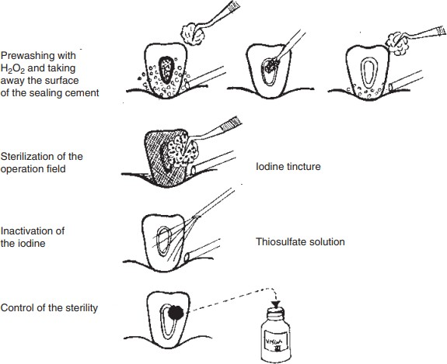
Endodontic samples are collected and transported to the laboratory in a viability-preserving, non-supportive, anaerobic medium. Followed by dispersing the sample using various techniques, diluting, and cultivating it in suitable culture media. Then the identification of microbes is made using various methods like gram-staining, gas-liquid chromatography, gel electrophoresis, fluorescence under ultraviolet light, microscopic techniques, etc.(6)
FIGURE 1: Drawing showing the main steps in the preparation and sterilization of the operation field before entering the root canal. (Drawing by Mrs Gunilla Hjort.)
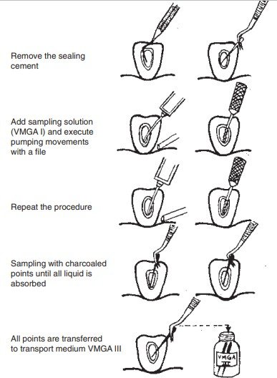
Microbiological sampling from the root canal. (Drawing by Mrs Gunilla Hjort.)

LABORATORY CONSIDERATIONS

The objectives are;

  - To identify the presence of viable bacteria in the sample

  - To determine the bacterial genus or species present in the sample

  - To obtain a semi-quantitative measure of the bacterial load

Liquid media are mostly preferred in laboratories. One of the advantages of using liquid media is that it allows the growth of fastidious and dormant microbe cells. There is no need for extra equipment for the anaerobic bacteria to grow, if tubes are filled with nitrogen gas during inoculation. If bacterial inoculation is done under anaerobic conditions and the bottom part of the tube is filled with bacteria, the tubes are capped tightly (rubber stopper), and the medium itself will ascertain anaerobic conditions even for the most oxygen-sensitive bacterial species. Solid media (brucella agar plate, blood agar plate) to complement the liquid media, separate aerobic incubation, and anaerobic incubation jars are used to disclose the diverse microbial species and for the quantification of microbes grown in the liquid media. Further biochemical tests, selective media, or gram staining should be carried out to identify microbial species and genera. (7)
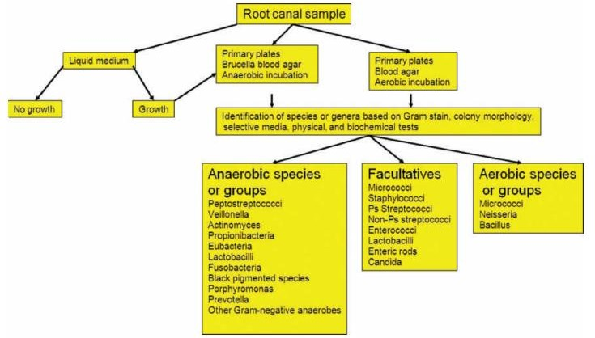
FIGURE 3: The methods used in the Laboratory of Oral Microbiology at Goteborg University when analyzing root canal samples

Culture media detect both cultivable and as-yet-uncultivated species and strains. High specificity and accurate identification of strains with ambiguous or aberrant phenotypic behavior is an advantage of culture media. It has high sensitivity and detects species directly in clinical samples. Culture media is found rapid and most assays take no more than minutes to a few hours to identify a microbial species. There is no need for carefully controlled anaerobic conditions during sampling and transportation. Culture media can be used during antimicrobial treatment. The samples can be stored frozen for later analysis. The DNA can be transported easily between laboratories while using culture media.(8)

LIMITATIONS
Cultural media have several limitations. These include the inability to culture numerous existing bacterial species, limited success in recovering viable bacteria, low sensitivity, and a reliance on the microbiologist's experience for specificity. The isolation of anaerobic bacteria demands significant expertise and specialized equipment, and the identification of most anaerobes can be a time-consuming process, often taking several days to weeks. Additionally, the method of sample transport plays a crucial role in the process. The sample requires immediate processing. It is costly and time-consuming.
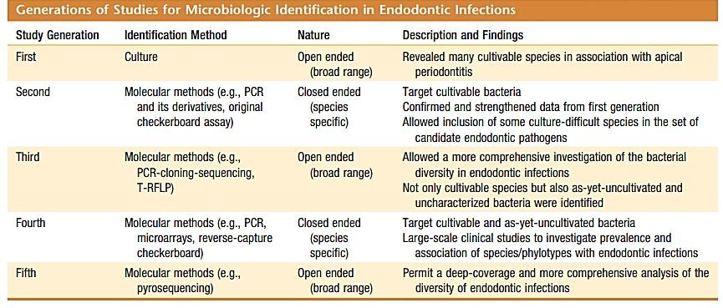

MOLECULAR METHODS

According to Woese's theory from 2000 (9) and Wade's discussion from four years later (10) on characteristic genes specific to various bacterial species, molecular methods for microbial identification depend on their ability to identify these genes. The 16S and 23S rRNA genes are mainly employed in molecular biology procedures among these technologies. Small subunit rRNA genes can be used to identify microbes and have a number of benefits. These genes are present in all organisms without exception, are long enough to supply a wealth of information, and are small enough to allow for simple sequencing, particularly with the development of automated DNA sequencers. As a result, they offer a soli1). Therefore, the 18S rRNA gene and the 16S rRNA gene (or 16S rDNA) of bacteria and foundation for establishing phylogenetic relationships, as first noted by Woese in 1987(9)

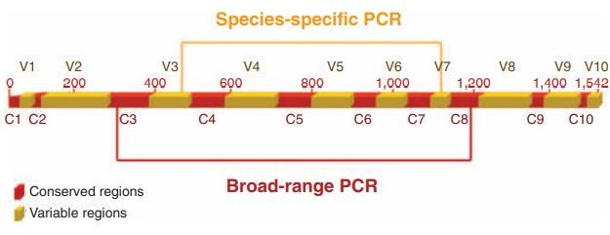
FIGURE 4: The 16S rRNA gene is depicted schematically (rDNA). Variable regions, denoted by areas in yellow, contain details about the genus and the species. In species-specific assays, primers created using these regions are used. The gene's conserved regions are indicated by red areas. Broad-range ammunition uses primers created for these areas.

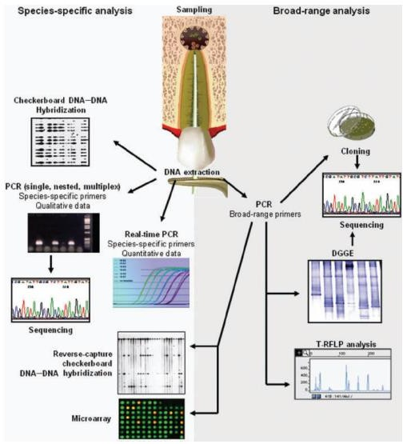
FIGURE 5: Methods from molecular biology used to study endodontic infections. The type of analysis to be done will determine which technique is chosen.

PCR- POLYMERASE CHAIN REACTION

The introduction of PCR (Polymerase Chain Reaction) by Kary Mullis in 1983 (10) ADDIN marked a groundbreaking moment in the field of molecular biology. In today's era, it has become possible to extract genes from any organism, facilitating genome sequencing studies. PCR has the remarkable ability to amplify even a single copy of a gene into millions to billions of copies. The fundamental steps involved in PCR are as follows:

When the hydrogen bonds holding the DNA strands together are broken, the target DNA, which serves as the template, is exposed to denaturation (melting) at high temperatures, causing the separation of the two single strands of DNA.

The primers, which are two brief oligonucleotides, bind to complementary sequences on the target DNA's opposing strands. The boundaries of the DNA segment that will be amplified are defined by these primers.

A heat-resistant DNA polymerase enzyme creates a complementary second strand of fresh DNA. Deoxyribonucleoside triphosphates (dNTPs) are used in excess to perform this synthesis as the primers are prolonged.

In every successive cycle, all previously produced DNA products operate as templates for fresh rounds of primer extension reactions. The DNA products are exponentially amplified as a result of this iterative process.
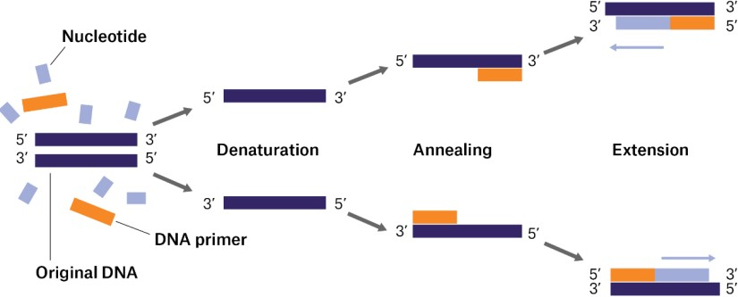

FIGURE 6: Steps involved in PCR technique

Various methods are available to confirm the successful generation of the desired PCR product, with agarose gel electrophoresis being the most commonly employed technique.

AGAROSE GEL ELECTROPHORESIS
This method involves placing a small amount of the PCR reaction sample onto an agarose gel and applying an electrical gradient through a buffer solution. The dimension of the PCR products affects how they travel along the gel as they migrate. Shorter migration distances occur as a result of larger products encountering greater resistance within the gel matrix. DNA ladder digests containing DNA fragments of known sizes are performed alongside the samples as molecular size standards in order to determine the size of the PCR results. Usually, ethidium bromide staining followed by ultraviolet light exposure is used to see the gel. When chosen primers are effective, a PCR product of a particular size is produced. Therefore, the existence of a band matching the anticipated.
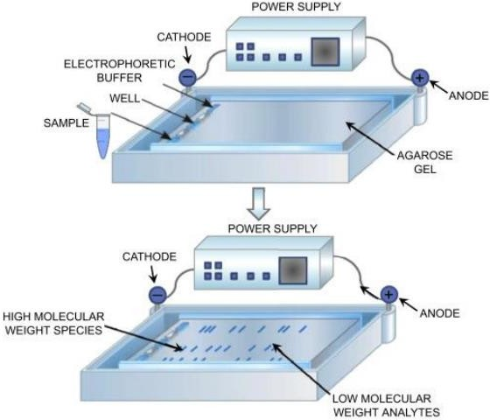
FIGURE 7: Agarose gel electrophoresis system

The identification of PCR products can be verified using a number of techniques:

- PCR product sequencing involves determining the PCR product with certainty by pinpointing its precise genetic sequence. a particular oligonucleotide probe is hybridized to a region inside the PCR product between the priming sites.

ii. Amplifying the PCR product for additional examination.
The technique known as restriction fragment length polymorphism (RFLP) involves cleaving the PCR product with a known restriction enzyme that slashes a particular sequence within the product.

PCR AND ITS DERIVATIVES:

- SPECIES-SPECIFIC PCR

The 16S rRNA gene's variable sections are employed by the widely used PCR technique to identify and create primers that are particular to different bacterial species. Primers that can identify nearly all cultivable and yet-to-be-cultivated oral species have been developed using public datasets that contained 16S rRNA gene sequences from different oral bacteria.
Analyzing the size of the PCR result, which should match the predicted size, is a common technique used in agarose gel electrophoresis to verify the existence of the target species. The use of a touchdown process can increase test specificity. In this method, the initial PCR cycle's annealing temperature is set higher than the estimated melting temperature (Tm) of the primers. In subsequent cycles, the annealing temperature is gradually reduced until it reaches the Tm or slightly below, which can help prevent nonspecific amplification. This technique is valuable for minimizing false positives. These methods collectively ensure the accuracy and specificity of PCR-based assays for identifying microbial species. The unintended amplification of extraneous DNA fragments may include fragments that are not part of the target rRNA genes or those that do not possess the correct sizes, as highlighted by Don et al. in 1991. (11)

MULTIPLEX PCR
In 2003, James et al.(12) introduced a technique known as multiplex PCR for the identification of GM soybeans. Multiplex PCR is a method that employs multiple primer pairs in a single reaction to amplify several sequences simultaneously, a departure from common assays that typically detect only one species at a time. (13) This approach enables the simultaneous detection of various unique target sequences within a clinical specimen. Multiplex PCR assays offer advantages such as reduced time and cost compared to sequential detection methods.
However, it's crucial to design primers meticulously for multiplex assays. They should have similar annealing temperatures and should not exhibit complementarity with one another to ensure accurate and reliable results. (2)

- NESTED PCR
Nested PCR (nPCR) is a traditional PCR technique that uses two successive amplification stages to focus on a particular DNA region. Initially, the desired region in the first reaction is amplified using an outer primer pair. The results of the first amplification round are then used as templates for the second amplification cycle, which makes use of an internal primer pair. A shorter amplified fragment is created as a result of the internal primer set's internal binding to the first-round products. Haqqi et al. first introduced this approach in 1988. (16).

Nested PCR is praised for its great sensitivity, which allows it to identify target DNA even at far lower quantities than traditional PCR can. However, this technique involves a lot of amplification cycles, which can complicate the process. Additionally, it frequently shows less background interference from eukaryotic DNA and other bacterial DNA sections, which can sometimes make it difficult to distinguish from the target DNA. According to Siqueira Jr. and Rocas in 2005, one significant disadvantage of the nested-PCR methodology is the increased potential of contamination during the transfer of the first-round amplification results to a different reaction tube.(2)

REVERSE TRANSCRIPTASE-PCR
An approach called reverse transcriptase-PCR (RT-PCR) is made for amplifying RNA targets. The reverse transcriptase enzyme, which can produce a complementary DNA (cDNA) strand from an RNA template, is used to do this. A two-step process is routinely used in many RT-PCR tests. Reverse transcriptase turns RNA into single-stranded cDNA in the initial stage. The complementary strand of cDNA is produced in the second stage using DNA polymerase, PCR primers, and nucleotides. Similar to traditional PCR, this double-stranded DNA can be utilized as a template for amplification once it has been created.
This two-step process can be simplified into a one-step method by directly utilizing RNA as the template. In this modified approach, an enzyme with both reverse transcriptase and DNA polymerase activities is employed, such as the enzyme found in the bacterium Thermus thermophilus (2, 17).

QUANTITATIVE PCR
Three different assays, most probable number (MPN)-PCR, competitive PCR, and real-time PCR, can be used to perform quantitative PCR (Q-PCR). Real-time PCR is one of them and has become very popular, mainly because it is a high-throughput technology and provides better accuracy and precision than the other Q-PCR techniques. Additionally, it does away with the necessity for post-PCR adjustments, lowering the possibility of contamination
- REAL-TIME PCR
Recently, a number of commercially available devices have been created that use the PCR process to detect the presence of a target in a relatively short amount of time, often between 30 and 120 minutes. This is frequently known as "real-time" PCR. Real-time PCR detects DNA synthesis indirectly, which is proportional to the fluorescence released. A fluorimeter connected with the PCR thermocycler detects the fluorescence inside a closed tube format. High sample throughput, multiplexing capabilities, target DNA measurement, and real-time amplification process monitoring are just a few benefits of this technique.
For microbiological identification, real-time PCR is often employed, and it entails the real-time detection of PCR products using fluorescently tagged probes. These probes may include:
  - SYBR Green
  - TaqMan probe
  - Molecular beacon
Real-time PCR assays are versatile, allowing for the quantification of individual target species as well as the determination of the total bacterial load in clinical samples.(14)

SYBR GREEN
The simplest and most cost-effective version of RT-PCR is the SYBR Green assay. This approach employs a fluorescent dye that binds to double-stranded DNA. As the extension step proceeds, the dye attaches to the increasing amount of newly formed double-stranded DNA. Any unbound dye in the solution emits minimal fluorescence.

Although the SYBR Green assay is highly sensitive, it does come with certain limitations in terms of specificity. This is because the dye binds to all double-stranded DNA present in the sample, and occasionally, the formation of primer dimers can result in inaccurate readings.

.

TAQMAN METHOD
The addition of a labeled oligonucleotide probe into the primers is another method used in RT-PCR. A unique 20–30 base long oligonucleotide sequence that exactly matches a sequence found between the two primers must be designed for this technique, also known as the TaqMan probe assay. The reporter fluorescent dye at the TaqMan probe's 5' end and the quencher dye at the 3' end efficiently block the reporter dye's emission spectrum. No signal is produced as long as the probe is undamaged and attached to its target. However, the Taq DNA polymerase enzyme cleaves the TaqMan probe during the real-time PCR extension step, causing the reporter dye to detach from the quencher and increase fluorescence emission.
Regarding specificity, quantitatively, and sensitivity for the detection of oral bacteria, Maeda et al. (2003)(15) found no discernible difference between TaqMan and SYBR Green chemistry. SYBR Green test protocols are typically easier to follow and less expensive than TaqMan methods.

MOLECULAR BEACONS

Molecular beacons, single-stranded oligonucleotides with a distinctive stem-and-loop structure, are used in a different real-time PCR test. The loop sequence in this structure forms the stem and is flanked by brief complementary arms that are complementary to a particular target sequence. The oligonucleotide has a fluorophore attached to one end and a quencher molecule attached to the other.

Molecular beacons take on a hairpin-like structure in their unbound state when in a solution, with the stem maintaining the arms close together. The dye's fluorescence is effectively muted by this configuration. The two ends of the molecular beacon, however, split apart when it connects to its target sequence. As a result, a detectable signal is created when the excited fluorophore releases its energy as light. According to Klara Abravaya in 2011 (17), this change from quenched to emitting light enables the identification of the target sequence.

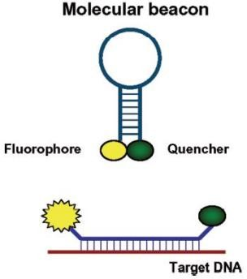
FIGURE 8: Representative image: Single-stranded, fluorophore-labeled nucleic acid probes known as molecular beacons can produce a fluorescent signal when they are in contact with their target but are dark when they are not.

PCR-BASED MICROBIAL TYPING
One technique that uses PCR technology for clonal study of microorganisms is arbitrarily primed PCR (AP-PCR), also known as random amplified polymorphic DNA. A relatively quick method of determining the relationship between two isolates of the same species is provided by AP-PCR. A single random sequence primer, typically made up of 10 to 20 bases, is utilized in AP-PCR. Despite base-pairing mismatches, this primer can bind to unidentified DNA target locations. It is possible to start priming at sites with imperfect matches by using a random sequence primer under low stringency conditions, enabling a flexible and useful clonal study.
Only when two primers successfully bind in close proximity and in the proper forward and reverse orientations necessary for product production can amplification in an AP-PCR take place. Due to variances in their priming sites, the genetic variants contained in two DNA templates result in distinctive DNA fingerprints. According to studies done by Spiegelman et al. in 2005, when these amplicons are put through electrophoresis, they generate a strain-specific pattern that typically consists of 5 to 15 bands per species. The benefit of AP-PCR is that it can produce extremely specific DNA profiles without the need for prior DNA sequence knowledge. Additionally, primers can be created to specifically target recognized genetic elements, such as recurrent extragenic palindromic sequences (REP-PCR) and enterobacterial repetitive intergenic consensus sequences (ERIC-PCR).

The application of AP-PCR for clonal analysis can be pivotal in determining the degree of relatedness among specific strains within a particular species, especially those strains that may be more closely linked to specific disease signs or symptoms.

Clonal analysis also serves as a valuable tool for tracking the source of microorganisms infecting a particular location. For instance, by comparing bacterial strains obtained from different sites, such as the root canal and the gingival sulcus or other oral areas, it becomes possible to gain insights into the origin of the bacteria within the root canal system. Furthermore, clonal analysis can be used to trace the origin of microorganisms found in a suspected focal disease. This is accomplished by comparing the isolates discovered at the initially infected site with those identified in the suspected original focus of infection, as discussed by Siqueira Jr. and Rocas in 2005 (2).

BROAD RANGE PCR
Multiple fastidious, uncultivated bacterial pathogens have been discovered from various human sites using broad-range PCR. Primers are created for broad-range PCR that are complementary to conserved sections of a specific gene (often the 16S rRNA gene) shared by a variety of bacteria. Almost any bacterial species present in a sample may be identified using broad-range PCR and 16S rRNA gene clone library assembly (Conrads et al., 1997). (16)

Bulk DNA is originally isolated from samples for this kind of PCR. The 16S rRNA gene is then extracted from the bulk DNA using PCR and primers made especially for conserved gene regions. The 16S rRNA gene from practically every bacterial species in the sample is amplified when broad-range primers are used for amplification. The risk of amplifying DNA from microorganisms during PCR amplification is significant. The use of separate rooms for pre- and post-PCR work, UV decontamination of surfaces, the use of high-quality reagents, the implementation of appropriate sampling techniques, and the use of vials for clinical specimens are just a few of the precautions that must be taken in order to minimize this risk. The 16S rRNA gene fragments from almost all of the bacteria in the sample are mixed together when broad-range primers are used for amplification. Direct sequencing of PCR products is not possible in mixed infection cases because the consortium contains mixed products from different species. To fix this, a library of 16S rRNA genes obtained from the sample is created by cloning the amplified products into a plasmid vector and using it to convert Escherichia coli cells. Sequence separation during the cloning procedure makes it possible to characterize each individual by sequencing. Individual sequencing of the cloned genes is followed by submission of the obtained results to databases for identification.

A 16S rRNA gene sequence similarity of 98.5–99% is the generally recognized standard for recognizing a bacterium at the species level. When compared to sequences from known species in databases, a sequence with similarity scores below this cutoff (i.e., below 98.5–99%) raises the possibility that it belongs to a new species. These recently discovered species are frequently classified as uncultivated and unidentified bacterial taxa. According to studies by Drancourt et al. from 2000 and Woo et al. in 2008, an unofficial title is often given in these circumstances. (3,17)

Bulk nucleic acids are extracted directly from samples

↓

16S rDNA isolated via PCR with primers specific for conserved regions of the gene (universal or broad-range primers)

↓

Amplification of 16S rRNA gene

↓

In case of mixed infections, separate sequencing is done

↓

For that, PCR products are cloned into a plasmid vector

↓

Transforms Escherichia coli cells forming a cloning library of 16S rDNA

↓

Submitted for identification of bacterial species to the databases

↓

Sequenced individually

Broad range PCR's similarity method and phylogeny method have both been developed to increase accuracy. This method uses computations to create a phylogenetic tree based on differences in the variable sections of gene sequencing (Leys et al. 2006). (18) Using specialized bioinformatic software, the links between different bacterial phylotypes (or taxa) are examined, and the outcomes are displayed in dendrograms or phylogenetic trees. Even when sequences come from previously uncultivated and uncharacterized bacteria, the 16S rRNA gene can be used to build phylogenetic connections among bacteria.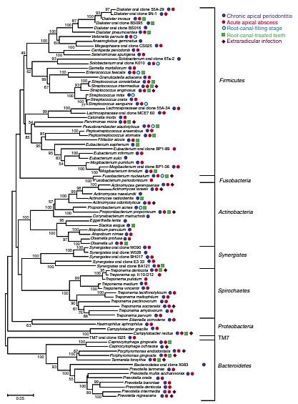
FIGURE 9: Endodontic infections' bacterial diversity as revealed by molecular biology techniques. Phylogenetic tree based on 16S rRNA gene comparisons displaying a number of potential endodontic pathogens, their associated clinical conditions, and the phyla they belong to. Number of nucleotide substitutions per site is indicated by the scale bar.

THE DENATURING GRADIENT GEL ELECTROPHORESIS (DGGE)

The DGGE technique is a genetic fingerprinting method used to assess the diversity of microbial species within various ecosystems and gain insights into the behavior of microbial communities over time. This approach relies on the electrophoresis of PCR-amplified gene fragments, typically 16S rRNA, within polyacrylamide gels that contain an increasing gradient of DNA denaturants, typically a mixture of urea and formamide.

As PCR products migrate through the gel, they encounter varying concentration gradients of denaturants. At specific points within the gel, the DNA may partially or fully denature. Partial denaturation leads to a significant reduction in the electrophoretic mobility of the DNA molecules. Different molecules with distinct sequences exhibit varying melting behaviors, causing them to halt migration at different positions within the gel. The position in the gel where DNA strands melt is determined by their nucleotide sequence and composition. Visualization of DNA bands in DGGE can be achieved using various methods such as ethidium bromide, SYBR Green, or silver staining (Chakraborty et al., 2014) (22).

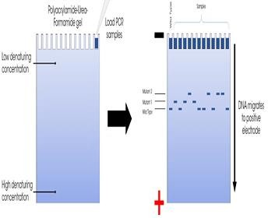

FIGURE 10: Denaturing Gradient Gel Electrophoresis
- In DGGE, multiple samples can be analyzed concurrently, so that it helps to verify differences in microbial populations and the efficacy of various antimicrobials before and after their usage at various sites. Specific bands can also be excised from the gels, re-amplified, and sequenced to allow microbial identification. Temperature Gradient Gel Electrophoresis (TGGE) also uses the same principle as DGGE, except for the fact that the gradient is temperature rather than chemical denaturants.

- TERMINAL RESTRICTION FRAGMENT LENGTH POLYMORPHISM
Another technique used for the analysis of diverse microbial communities is Terminal Restriction Fragment Length Polymorphism (T-RFLP), which assesses the size variation of terminal restriction fragments derived from a PCR-amplified marker. The process begins with PCR, which amplifies the 16S rRNA gene from various species within the sample. One of the PCR primers is tagged with a fluorescent dye. Subsequently, the PCR-amplified products undergo digestion with restriction enzymes, yielding fluorescently labeled terminal fragments of varying lengths. These fragments are then separated using high-resolution sequencing gel electrophoresis within an automated DNA sequencer, allowing for the determination of both the size and intensity of terminally labeled restriction fragments (T-RF), thereby generating a characteristic profile (23).

The electrophoretogram serves as a representation of the microbial community's profile, depicted as a series of peaks differing in migration distance. In such a profile, size is plotted on the horizontal axis, while intensity is represented on the vertical axis. In theory, each T-RF corresponds to a single species. Robust databases are available for 16S rRNA gene sequences and can be employed to identify all T-RFs predicted from known sequences, considering a specific set of primers and restriction enzymes. The prediction of T-RF lengths involves locating the restriction site nearest to where the labeled primer attaches and counting the number of nucleotides in between. Typically, the use of multiple restriction enzymes (typically four or five) is necessary to ensure reliable identification, as distinct species may produce the same T-RF when only one enzyme is employed (Chakraborty et al., 2014; Fouad, 2009) (22, 24).

THE DNA-DNA HYBRIDIZATION ASSAY

DNA-DNA hybridization methodology involves the pairing of complementary bases between two single-stranded DNA molecules. These DNA probes are typically marked with various indicators, such as enzymes, radioactive isotopes, or chemiluminescent reporters, allowing them to bind to their corresponding nucleic acid sequences, creating a new double-stranded molecule. The labeled duplex can then be detected and examined.

Whole genomic DNA or oligonucleotides can be used to make DNA-DNA hybridization probes. Because different species share some sequences, whole genome probes are more likely to interact with non-target bacteria. On the other hand, oligonucleotide probes created using particular gene signature sequences (such as the 16S rRNA gene) typically offer more specificity. The precise hybridization temperatures may be calculated using the known probe sequence, and mismatches are tolerated less because of the weaker binding between the short probe and the target sequence. As expanded in the work of Cho and Tiedje in 2001, oligonucleotide probes can also be designed to identify previously uncultivated bacteria. They can also be used to distinguish between closely related species or subspecies.(19)

The checkerboard DNA-DNA hybridization approach was developed by Socransky et al. (1994) (23, 25). It allows several DNA samples to be hybridized simultaneously against a large number of entire genomic DNA or 16S rDNA-based oligonucleotide probes that have been digoxigenin-labeled on a single support membrane. With the use of this technique, numerous bacterial species can be identified simultaneously in one or more clinical samples. It is very useful in in-depth epidemiological studies.

Checkerboard DNA–DNA hybridization-

The checkerboard method, developed by Socransky et al. in 1994 (25), revolutionized the hybridization of a large number of DNA samples against a large number of entire genomic DNA probes on a single support membrane. This ground-breaking method made it easier to identify several bacterial species in one or more clinical samples.

DNA from the samples is extracted, denaturized, and attached to a membrane as part of the process. The membrane is then placed at a 90-degree angle on a Mini-blotter device. Whole genomic DNA probes that have been digoxigenin-labeled are placed onto individual Mini-blotter lanes. These DNA probes are conjugated with antibodies linked to alkaline phosphatase, and the results of the hybridization are seen through chemo-fluorescence or chemiluminescence. When a spot appears on the membrane where two lanes meet, the probe and sample have successfully hybridized. The amount of DNA from the target species present in the sample directly correlates with the intensity of this area..

A modified version of the checkerboard method was proposed by Paster et al. in 1998 (26), referred to as the PCR-based reverse-capture checkerboard hybridization methodology. It is termed "reverse capture" because, unlike the original method, the probe is first fixed onto the membrane in this modified approach. This altered approach offers heightened specificity due to the use of oligonucleotide probes. Additionally, oligonucleotide probes can be designed to detect both cultivable and previously uncultivated bacteria, whereas the original method utilizing whole genomic probes can only identify cultivable species.

In vitro bacterial culture, which was required in the original checkerboard strategy to create complete genome probes, is no longer necessary with the reverse-capture technique. This technique uses a Mini-blot device to place up to 30 reverse-capture oligonucleotide probes targeting distinct sections of the 16S rRNA gene in different horizontal lanes on a nylon membrane. These probes are made with a polythymidine tail that is attached to the membrane and cross-linked, making the probe available for hybridization. A primer that has been digoxigenin-labeled is used in the PCR process to amplify the 16S rRNA gene that has been isolated from clinical samples. A Mini-blotter equipment is used to perform hybridizations in vertical channels using up to 45 samples of digoxigenin-labeled PCR amplicons. Subsequently, the hybridization signals are detected using chemo-fluorescence or chemiluminescence techniques, as detailed in the work by Siqueira Jr. and Rocas in 2005 (2).

DNA MICROARRAYS

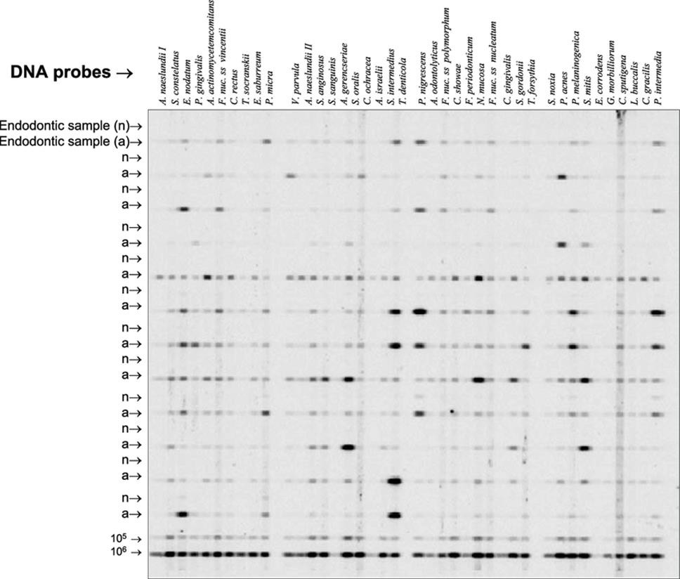
Schena et al.(20) first introduced this technique in 1995. The assay is a condensed form of the checkerboard hybridization assay. It is used to identify the target from the clinical sample and comprises of a high-density matrix of DNA probes printed on a glass slide. Targets will be placed to an array with fluorescence and those that hybridize with complementary probes will be found using a reporter molecule of some sort. For imaging and analysis, sophisticated computer software programs use a high-resolution laser scanner. (21)

The Human Oral Microbe Identification Microarray is a DNA microarray technology used to identify oral microbial species. Using PCR, this technique can also be employed for more accurate detection and identification.
FIGURE 11: DNA microarrays

By using this method, a single hybridization approach can provide results as to the presence and levels of 200 target species/phylotypes at a time (Siqueira & Rocas, 2005; Smoot et al., 2005). (2,22)

FLUORESCENCE IN SITU HYBRIDIZATION

Fluorescence in situ hybridization (FISH) is a technique that employs specially designed fluorescent probes directed at ribosomal RNA (rRNA) sequences. It is used in conjunction with fluorescence microscopy to directly identify intact microbial cells in clinical specimens within their natural habitat (30). FISH offers several noteworthy advantages, as it not only enables the identification of microorganisms but also provides valuable information about their morphology, quantity, community structure, and spatial relationships (31). Additionally, the versatility of FISH lies in its ability to use custom-designed oligonucleotide probes, enabling the detection of both cultivable species and previously uncultivated phylotypes (32).

In the FISH procedure, microbial cells are initially fixed and then subjected to hybridization with the rRNA-directed probes on a glass slide. These probes are relatively short, typically consisting of 15 to 25 base pairs, and they are covalently labeled with a fluorescent dye at one end. Following thorough washing steps to eliminate any unbound probes, the cells are visualized using either a conventional epifluorescence microscope or a confocal laser scanning microscope. Multiple species-specific probes, each labeled with a unique fluorescent tag, can be employed simultaneously to distinguish between different microbial species.

Advantages of Molecular Genetic Methods

Here are some key advantages of using molecular methods for microbial detection and identification, as discussed by Siqueira and Rocas in 2005:(2)

• Identification of Culturable and Non-Culturable Species: Molecular techniques have the capability to identify both microorganisms that can be grown in the lab and those that cannot.
• Improved Precision: They provide higher specificity and more accurate identification, especially for microbial strains with unclear phenotypic characteristics.
• Direct Detection in Clinical Samples: These methods can directly find microbial species in clinical samples without the need for cultivation, saving time and delivering swift results.
• Enhanced Sensitivity: Molecular methods are extremely sensitive, enabling the detection of even very low concentrations of microorganisms.
• Time-Efficiency: They are quicker and less time-consuming compared to traditional culture-based methods.
• Swift Diagnosis: Molecular techniques enable rapid diagnosis, which is especially crucial for life-threatening diseases or those caused by slow-growing microorganisms.
• No Need for Anaerobic Control: Unlike culture-based methods, molecular techniques don't require carefully controlled anaerobic conditions during sampling and transportation, preventing the loss of viability in delicate anaerobic bacteria and other fragile microorganisms.
• Applicability During Treatment: They can be utilized during antimicrobial therapy to monitor its effectiveness.
• Suitable for Epidemiological Investigations: In epidemiological studies that involve a large number of samples, molecular methods allow for sample storage and batch analysis.

These advantages collectively make molecular methods a valuable tool in microbiological research and clinical diagnostics.

Limitations of PCR-derived technologies

- Here are some key considerations and challenges associated with PCR assays for microbial identification, as outlined by Siqueira and Rocas in 2005(2)
Quantitative Limitations: Many PCR assays used for identification provide qualitative outcomes, indicating whether the target microorganism is present or absent in the sample, without quantifying its abundance. Quantitative results can be obtained using real-time PCR assays.
• Limited Target Detection: PCR assays typically focus on detecting one or a few specific species (or a limited set) at a time. In contrast, broad-range PCR analysis can provide information about the identity of nearly all species within a microbial community.
• Challenges in Detecting Unexpected Species: PCR assays are often designed to detect predetermined target species and may not recognize unexpected or unanticipated species. Broad-range PCR assays can help overcome this limitation by offering a more comprehensive view.
• Potential Biases and Challenges: Broad-range PCR analyses can be influenced by various factors, including biases in sample homogenization, preferential DNA amplification, and differences in DNA extraction methods, which can introduce variability in results.
• Issues with Certain Microorganism Types: Microorganisms with robust cell walls, such as fungi, can be difficult to lyse, requiring additional steps to effectively release DNA.
• Risk of False Positives: False-positive results can occur due to the unintended amplification of contaminant DNA. It is crucial to take rigorous precautions to prevent contamination, including measures to avoid the carryover of amplification products.
• Potential for False Negatives: False negatives may arise due to the presence of enzyme inhibitors or nucleases in clinical samples, which can disrupt the amplification process and degrade DNA templates. Additionally, analyzing small sample volumes can increase the likelihood of false negatives, especially when the target species is present in low quantities.

These considerations underscore the importance of careful experimental design, rigorous quality control measures, and an understanding of the limitations and challenges associated with PCR-based microbial identification.

CONCLUSION
The critical role of bacteria in the development of pulpal and peri-radicular diseases is widely acknowledged. Their presence within the root canal system or periapical tissues can substantially impact the success of endodontic treatments. In cases of primary endodontic issues, the root canal environment provides a rich source of peptides and amino acids, nourishing the bacterial population inside the root canal system. However, when root canals are well-filled, most, if not all, of the necrotic pulp tissue remnants are removed. Therefore, clinicians must have a comprehensive understanding of the intricate nature of polymicrobial endodontic infections and recognize the importance of eliminating the source of infection through endodontic treatment or tooth extraction.

Endodontic biofilms, which are communities of microorganisms, are well-protected within the root canals of teeth and present challenges in terms of access and elimination. A practical approach for real-time detection and analysis of these biofilms involves making use of the inherent fluorescence of porphyrins and other bacterial metabolites. Utilizing visible red light as the excitation source is preferred for this purpose.

An effective strategy for removing biofilms likely involves a combination of various technologies discussed in this review. This may encompass improved methods for mechanically eradicating biofilms through instrumentation and irrigation fluids, as well as enhanced chemical treatments and more efficient biocides capable of deactivating microorganisms. The goal is to reduce reliance on conventional antibiotics and instead emphasize antimicrobial approaches that are less susceptible to the development of resistance.

Recent advancements in root canal disinfection, driven by new technology and insights from recent research, offer promise for enhancing the capacity to disinfect the root canal system. These developments mark a significant progression in the field of endodontics.

REFERENCES
1. Ricucci D, Siqueira JF, Bate AL, Pitt Ford TR. Histologic Investigation of Root Canal–treated Teeth with Apical Periodontitis: A Retrospective Study from Twenty-four Patients. J Endod. 2009 Apr;35(4):493–502.
2. Siqueirajr J, Rocas I. Exploiting Molecular Methods to Explore Endodontic Infections: Part 1—Current Molecular Technologies for Microbiological Diagnosis. J Endod. 2005 Jun;31(6):411–23.
3. Woo PCY, Lau SKP, Teng JLL, Tse H, Yuen KY. Then and now: use of 16S rDNA gene sequencing for bacterial identification and discovery of novel bacteria in clinical microbiology laboratories. Clin Microbiol Infect. 2008 Oct;14(10):908–34.
4. Solution of Pulp Tissue by Chemical Agents | Semantic Scholar [Internet]. [cited 2023 Sep 23]. Available from: https://www.semanticscholar.org/paper/Solution-of-Pulp-Tissue-by-Chemical-Agents-Grossman-Meiman/512085e0e3931bc73369a84fa7a3eadc8314edb1
5. Slots J. Rapid identification of important periodontal microorganisms by cultivation. Oral Microbiol Immunol. 1986 Feb;1(1):48–55.
6. Keijser BJF, Zaura E, Huse SM, Van Der Vossen JMBM, Schuren FHJ, Montijn RC, et al. Pyrosequencing analysis of the Oral Microflora of healthy adults. J Dent Res. 2008 Nov;87(11):1016–20.
7. Fouad AF, Rivera EM, Walton RE. Penicillin as a supplement in resolving the localized acute apical abscess. Oral Surg Oral Med Oral Pathol Oral Radiol Endodontology. 1996 May;81(5):590–5.
8. Engelkirk PG, Duben-Engelkirk JL, Burton GRW. Burton’s microbiology for the health sciences. 9th ed. Philadelphia: Wolters Kluwer Health/Lippincott Williams & Wilkins; 2011. 433 p.
9. Woese CR. Bacterial evolution. Microbiol Rev. 1987 Jun;51(2):221–71.
10. Mullis K, Faloona F, Scharf S, Saiki R, Horn G, Erlich H. Specific Enzymatic Amplification of DNA In Vitro: The Polymerase Chain Reaction. Cold Spring Harb Symp Quant Biol. 1986 Jan 1;51(0):263–73.
11. Don RH, Cox PT, Wainwright BJ, Baker K, Mattick JS. ‘Touchdown’ PCR to circumvent spurious priming during gene amplification. Nucleic Acids Res. 1991;19(14):4008–4008.
12. James D, Schmidt A mary, Wall E, Green M, Masri S. Reliable Detection and Identification of Genetically Modified Maize, Soybean, and Canola by Multiplex PCR Analysis. J Agric Food Chem. 2003 Sep 1;51(20):5829–34.
13. Chamberlain JS, Gibbs RA, Rainer JE, Nguyen PN, Thomas C. Deletion screening of the Duchenne muscular dystrophy locus via multiplex DNA amplification. Nucleic Acids Res. 1988;16(23):11141–56.
14. Abravaya K, Huff J, Marshall R, Merchant B, Mullen C, Schneider G, et al. Molecular Beacons as Diagnostic Tools: Technology and Applications. Clin Chem Lab Med [Internet]. 2003 Jan 25 [cited 2023 Sep 23];41(4). Available from: https://www.degruyter.com/document/doi/10.1515/CCLM.2003.070/html
15. Maeda H, Fujimoto C, Haruki Y, Maeda T, Kokeguchi S, Petelin M, et al. Quantitative real-time PCR using TaqMan and SYBR Green for Actinobacillus actinomycetemcomitans , Porphyromonas gingivalis , Prevotella intermedia , tetQ gene and total bacteria. FEMS Immunol Med Microbiol. 2003 Oct;39(1):81–6.
16. Conrads G, Gharbia SE, Gulabivala K, Lampert F, Shah HN. The use of a 16S rDNA directed PCR for the detection of endodontopathogenic Bacteria. J Endod. 1997 Jul;23(7):433–8.
17. Drancourt M, Bollet C, Carlioz A, Martelin R, Gayral JP, Raoult D. 16S Ribosomal DNA Sequence Analysis of a Large Collection of Environmental and Clinical Unidentifiable Bacterial Isolates. J Clin Microbiol. 2000 Oct;38(10):3623–30.
18. Kumar PS, Leys EJ, Bryk JM, Martinez FJ, Moeschberger ML, Griffen AL. Changes in Periodontal Health Status Are Associated with Bacterial Community Shifts as Assessed by Quantitative 16S Cloning and Sequencing. J Clin Microbiol. 2006 Oct;44(10):3665–73.
19. Cho JC, Tiedje JM. Bacterial Species Determination from DNA-DNA Hybridization by Using Genome Fragments and DNA Microarrays. Appl Environ Microbiol. 2001 Aug;67(8):3677–82.
20. Schena M, Shalon D, Davis RW, Brown PO. Quantitative Monitoring of Gene Expression Patterns with a Complementary DNA Microarray. Science. 1995 Oct 20;270(5235):467–70.
21. Clarke JD, Zhu T. Microarray analysis of the transcriptome as a stepping stone towards understanding biological systems: practical considerations and perspectives. Plant J. 2006 Feb;45(4):630–50.
22. Smoot LM, Smoot JC, Smidt H, Noble PA, Könneke M, McMurry ZA, et al. DNA Microarrays as Salivary Diagnostic Tools for Characterizing the Oral Cavity’s Microbial Community. Adv Dent Res. 2005 Jun;18(1):6–11.

