Electrical and Magnetic properties of the Praseodymium doped multiferroic composites.

Hage Doley*
Dera Natung Govt. College, Itanagar, Arunachal Pradesh, India – 791113

*Corresponding author: hagedoley@gmail.com

Abstract

In this study Solid solution of (Ba₅PrTi₃V₇O₃₀)_{1-x}(BiFeO₃)_{x} for different values of x is fabricated using a high-temperature solid-state reaction technique. Basic crystal qualities are analyzed using XRD (X-Ray Diffractogram). For x = 0.5, the crystal structure of the composite is Tetragonal. From SEM (SEM: JOEL-IT300) study it is found that there is an emergence of columnar shape grains as the content of BiFeO₃ increases in the composite. Electrical properties such as Dielectric constant and loss tangent at various frequencies (4Hz-1000Hz) and at wide temperature ranges (RT-500°C) are measured using an Impedance analyzer (HIOKI-IM3536). All the sample was found to have ferroelectric characters and as BiFeO₃ content increases the dielectric constant was found to decrease and the loss tangent increased. Magnetic measurement is done using PPMS (Physical Property Measurement System) Vibrating Sample Magnetometer (VSM) at a temperature range (of 10-350K). B-H hysteresis loop was detected at room temperature. It was found that the dielectric characteristic and magnetic property of solid solution improves when it is mixed with a ferroelectric material.

Keywords: Dielectric Constant, Loss tangent, Magnetization, VSM.

1. Introduction
Multiferroic materials and/or magneto-electric materials have multiform properties in the single phase i.e., they may exhibit both magnetic and electric order in a single phase. The characteristics of having spontaneous electrical and magnetic order have a wide range of probable applications as sensors [1], spintronic devices, data storage media, actuators, dual storage devices (electrical and magnetic polarization can be used for storing data as RAM) and multiple state storage/memories. It has been found that the magnetically ordered state is good for storing data but controlling the states of magnetic fields for application is complicated. However, the electric voltage is much easier to be controlled at the microscopic level; hence device, where the magnetic state is being controlled electrically, has more utility. In such devices, electric voltages switch the ferroelectric state which in turn switches the magnetic state.
There exist only very few single-phase multiferroics at room temperature. It is because ferroelectric materials by nature are polarized and insulators whereas magnetic materials are mostly found to be conducting in nature. In addition to that leakages of impurities or atoms in material severely weaken the ferroelectric properties even if the material is an insulator.
Bismuth ferrite (BiFeO₃) is one such kind of multi-ferroelectric material. It has a non-centrosymmetric rhombohedral distorted perovskite structure [2,3] with an R3c space group [4]. It exhibits complex magnetic behaviour due to magnetic interactions among Fe³⁺ ion and its Bi ion mediated by oxygen surroundings.
S. Chandarak et al. [5] studied dielectric properties of ferroelectrics mixed with Bismuth Ferrite composite i.e. (BaTiO₃)_{x}(BiFeO₃)_{1-x}and found that the dielectric characteristics significantly improve with the addition of BaTiO₃; the increase in values of dielectric constant is because of giant-dielectric characters which are due to the multivalent states effect of Fe ion and as BaTiO₃ content increases; ceramic density grain packing improves; also BaTiO₃-BiFeO₃ ceramics shows giant-dielectric like property identical to that of BiFeO₃.
Nalwa et al. studied the rare earth-doped Bismuth Ferrite and found that there is an increase in the remnant polarization in the rare earth BiFeO₃ sample but also associated with high conductivity [6].
In our earlier work, we mixed Tb-doped vanadate ferroelectrics with Bismuth Ferrite and found that there is an enhanced magnetization [7] in the composite along with a decrease in electrical conductivity [8] of the BiFeO₃ sample. In our present study, we aim to mix Pr-doped vanadate ferroelectrics with BiFeO₃ to fabricate a solid solution of (Ba₅PrTi₃V₇O₃₀)_{1-x}(BiFeO₃)_{x} composite for different values of x and study the electric and magnetic properties of the material.

2. Materials and methods

Solid state reaction technique is used to prepare a (Ba₅PrTi₃V₇O₃₀)_{1-x}(BiFeO₃)_{x} composite. The required material is mixed at appropriate proportion and calcined at temperature 750 (at a rate of 1$℃/$min) for about 12 h. Polyvinyl Butyral is put in small an amount as a binder into the processed powder then using die pressed by 7 tons to fabricate a pellet having dimensions ~2 mm thickness and ~13 mm diameter. Samples are sintered at 800 for 6 h and then cooled by 2/min. Crystalline phase formation is analyzed by X-ray powder diffraction with Cu-K_{α} radiation ($λ$ = 1.5405 Å) within the Bragg’s angles range (10< θ< 60) having a rate of scanning 3/min. The morphology of the sample is studied by SEM (JOEL-IT300). Processed samples are made electrodes by finely polishing and applying a paste of silver on the top and bottom surfaces. The dielectric characteristics are studied by HIOKI-IM3536 (Impedance Analyzer). Magnetic measurements were carried out with a vibrating sample magnetometer in Physical Property Measurement System (Quantum Design, San Diego, USA) at low temperatures (10-350K). Hysteresis (B-H) curves are measured at normal temperature (300K).

3. Results and Discussion

3.1 Structural studies

Using X’perthighscore software the lattice parameters are obtained. The crystal system is more Orthorhombic in nature as can be seen in Table 1. However, as x increases further there is a shift in the structure. When x = 0.5, (i.e., 50% of BiFeO₃) crystal structure of the sample is Tetragonal. The change in the structure of the addition of BiFeO₃ may be due to the distortion in oxygen octahedra caused by mechanical stress caused by the addition of BiFeO₃. For x = 0.7, (i.e. 70% of BiFeO₃) the crystal structure of the solid solution is Rhombohedral which is similar in structure to x = 1(i.e. pure BiFeO₃ is Rhombohedral) [9].

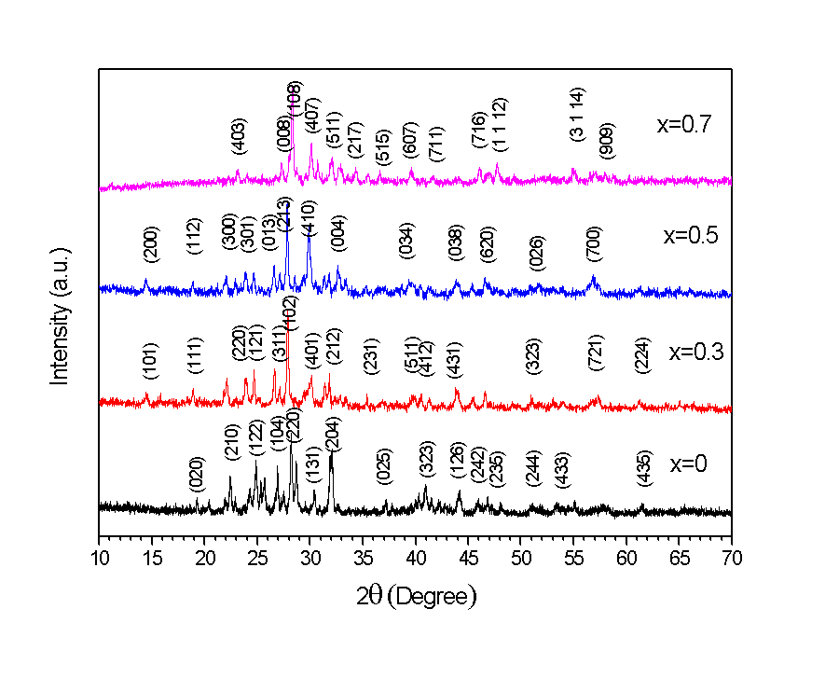
Figure 1 XRD pattern for (Ba₅PrTi₃V₇O₃₀)_{1-x}(BiFeO₃)_{x}

Table 1 Lattice parameters (in Å), volume (Å³), Structure and Grain Size (in μm) for
(Ba₅PrTi₃V₇O₃₀)_{1-x}(BiFeO₃)_{x}

 | a | b | c | V | Structure | SEM grain size (in μm)
x=0 | 8.81 | 9.20 | 14.26 | 1157.41 | Orthorhombic | $\sim$~ 0.75
x=0.3 | 17.47 | 4.41 | 25.39 | 1957.56 | Orthorhombic | ~ 3.63
x=0.5 | 12.10 | 12.10 | 11.09 | 1625.72 | Tetragonal | $\sim$~ 2.27
x=0.7 | 12.54 | 6.58 | 6.58 | 1196.20 | Rhombohedral | $\sim$~ 2.10

3.2 Microstructural studies
SEM micrographs of (Ba₅PrTi₃V₇O₃₀)_{1-x}(BiFeO₃)_{x} for x= 0, 0.3, 0.5 and 0.7 is shown in Figure 2 (a-d). The grain growth is found to be more or less complete. The grain size is determined using the linear intercept method as shown in Table 1. It was found that as the BiFeO₃ content increases, columnar shape grains start appearing because of the loss of Bismuth Oxide (Bi₂O₃) when the temperature is high. The presence of porosity may be because of the presence of some impure phases of BiFeO₃.

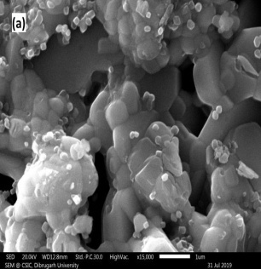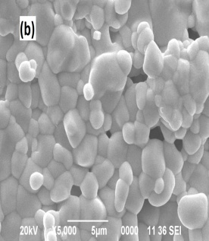
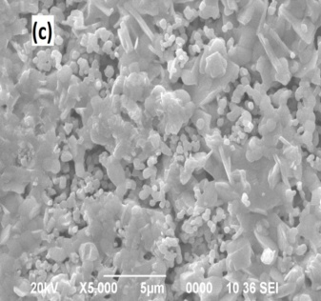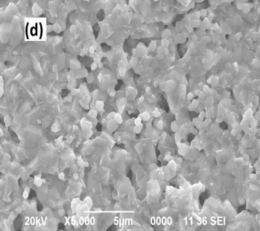

Figure 2 SEM images of (Ba₅PrTi₃V₇O₃₀)_{1-x}(BiFeO₃) _{x} for x = 0, 0.3, 0.5, 0.7

3.3 Dielectric studies
From Figure 3, it can be seen that for (Ba₅PrTi₃V₇O₃₀)_{1-x}(BiFeO₃)_{x} at normal temp, in the frequency range from 4Hz to 10kHz, the $ε_{r}$ decreases with an increase in frequency which is as expected of any characteristic dielectric materials. It was found that with an increase in the content of BiFeO₃ the value of the dielectric constant decreases for any given value of frequency. It may be due to the presence of conducting metallic ions such as Fe ion in the composite resulting in an increase in conductivity and hence a decrease in dielectric constant.

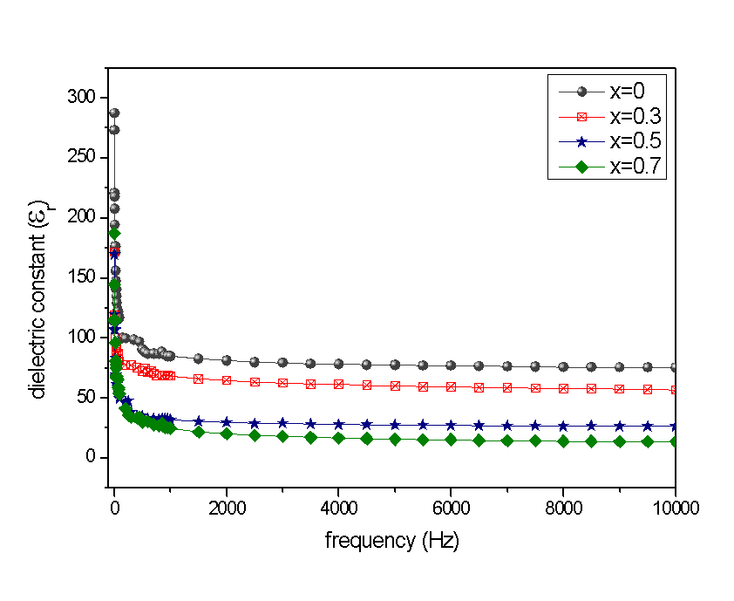
Figure 3 Frequency variation of Ɛ_{r} for (Ba₅PrTi₃V₇O₃₀)_{1-x}(BiFeO₃)_{x} in RT.
From Figure 4 it can be seen that for (Ba₅PrTi₃V₇O₃₀)_{1-x}(BiFeO₃)_{x} at normal temp. at the frequency range from 4Hz to 10kHz, there is a decrease in tangent loss (tanδ) which is also expected for characteristic dielectric materials. With the increase in the content of BiFeO₃ tangent loss also increases for any given value of frequency which may be because of the presence of Fe ions in BiFeO₃ resulting in semiconducting nature.
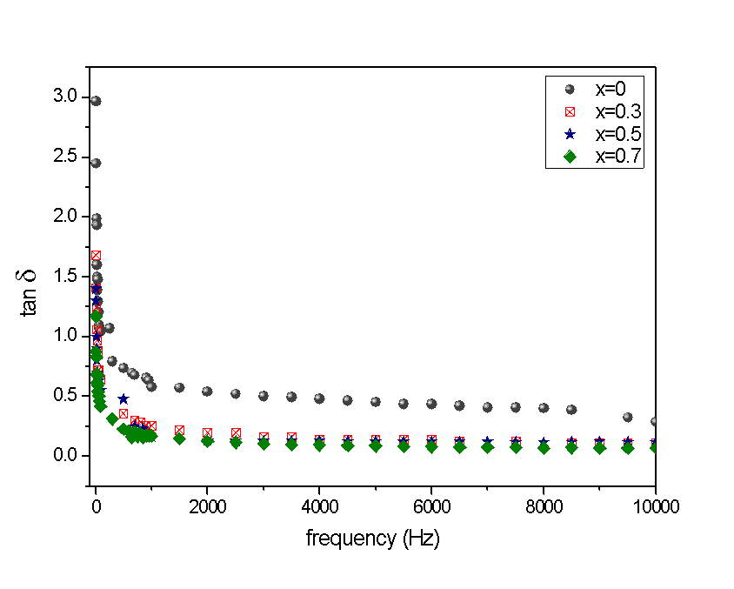
Figure 4 Frequency variation of tanδ of (Ba₅PrTi₃V₇O₃₀)_{1-x}(BiFeO₃)_{x} at RT.

For (Ba₅PrTi₃V₇O₃₀)_{1-x}(BiFeO₃)_{x} at temperature range (RT- 500 ) for a particular frequency of 1kHz with the rise in temperature the value of dielectric constant also increases and after attaining the peak (at transition temperature T_{C}) it decreases as shown in Figure 5. It may be because of the contribution of dipole orientation of charges and long-range migration effect. With further increases in temperature, it is found that the relative dielectric constant rises rapidly. It may be due to the reason that at high temperatures there is the creation and dominance of space charge polarization.
At transition temperature pure ferroelectric material (i.e., Ba₅PrTi₃V₇O₃₀) has a dielectric constant ($ε_{max}$) ~377 which decreases with the addition of semiconducting nature material i.e., BiFeO₃. At room temperature, the dielectric constant of the pure ferroelectric is more than any of the other mixed composites. However, at a much higher temperature, the relative dielectric constant keeps on increasing at an exponential rate whereas, for pure ferroelectric material, it decreases. The exponential increase of dielectric constant at high temperatures may be due to the breaking up of Fe-O-Fe chains due to thermal agitation.
Also, the introduction of Ba₅PrTi₃V₇O₃₀ having orthorhombic TB phase into Rhombohedral perovskite phase BiFeO₃ results in stabilization of perovskite phase and formation of morphotropic phase boundary (MBP) causing a decrease in the electrical conductivity of BiFeO₃ and hence a good ferroelectric material.
Thus, the dielectric characteristic of BiFeO₃ is enhanced when it is mixed with a ferroelectric material such as Ba₅PrTi₃V₇O₃₀.
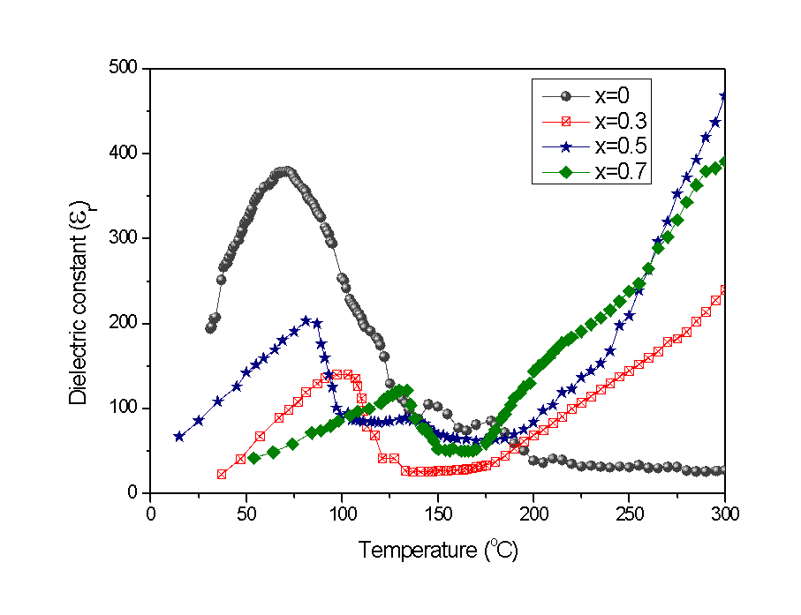
Figure 5 Variation of Ɛ_{r}$ε_{r}$ with temp for (Ba₅PrTi₃V₇O₃₀)_{1-x}(BiFeO₃)_{x} at 1kHz.
For (Ba₅PrTi₃V₇O₃₀)_{1-x}(BiFeO₃)_{x} at 1kHz in the temperature range (RT- 500) it can be seen from Figure 6 that with an increase in temperature there is very little change in loss tangent (tan δ) for pure ferroelectric whereas for a mixed composite loss tangent (tan δ) rises sharply with increase in temperature.
A sharp rise in temperature at high temperatures with the addition of BiFeO₃ may be due to the predominance of Fe ions resulting from the breaking of the Fe-O-Fe bond resulting in cascading conductivity effect and hence a high loss tangent (tan δ).
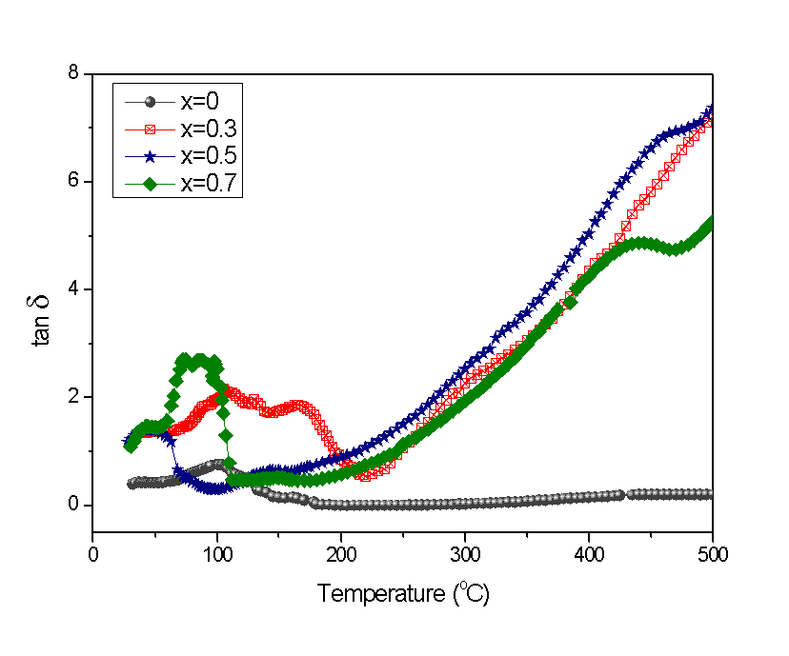
Figure 6 Plot of tanδ$δ$ vs temperature for (Ba₅PrTi₃V₇O₃₀)_{1-x}(BiFeO₃)_{x}.

Table 2 Dielectric properties for (Ba₅PrTi₃V₇O₃₀)_{1-x}(BiFeO₃)_{x} at 1kHz.

(Ba₅PrTi₃V₇O₃₀)_{1-x}(BiFeO₃)_{x} | $$ε_{RT}$$ | $$ε_{max}$$ | tan δ_{RT} | tan δ_{max} | T_{c}($℃$ )
x= 0 | 194 | 377 | 0.38 | 0.76 | 70
x=0.3 | 86 | 205 | 1.07 | 1.39 | 84
x= 0.5 | 22 | 141 | 0.59 | 2.19 | 99
x= 0.7 | 31 | 121 | 1.02 | 2.74 | 129

3.4 Magnetization studies
From B-H hysteresis curves of BiFeO₃ as shown in Figure 7 it can be seen that there is no saturation of Magnetization even on application of a high magnetic field indicating characteristic anti-ferromagnetic behaviour [10]. It can be seen from Table 3 that BiFeO₃ has low B_{r} ~ 8.506810⁻⁴ emu/g and H_{c} ~ -65 Oe suggesting weak ferromagnetic nature [11]. The occurrence of a hysteresis loop may be due to canted Fe-O-Fe chains ensuing weak spontaneous magnetic moments. Non-saturation of magnetization and low magnetic moment may be because of uncompensated antiferromagnetic character.
Figure 7 B-H hysteresis curves for BiFeO₃ at Normal Temperature.

From the B-H hysteresis curve of (Ba₅PrTi₃V₇O₃₀)_{1-x}(BiFeO₃)_{x} for x = 0, 0.3, 0.5 and 0.7 at the normal temperature as shown in Figure 8. As BiFeO₃ is introduced into the solid solution the loop starts appearing. Coercivity (H_{c} = -1206 Oe) maximum for x=0.7 and Retentivity (B_{r}= 118.4 10⁻⁴ emu/g) was found to be maximum for x=0.3 as can be seen from Table 3. When the Rhombohedral perovskite structured BiFeO₃ is mixed with the Orthorhombic TB- structured Ba₅PrTi₃V₇O₃₀ there is mechanical stress resulting in distortion of antiferromagnetic order of Fe-O-Fe chains of BiFeO₃ and introduction of diamagnetic Ti⁴⁺ into sites of perovskite phase of BiFeO₃ results into dilution of the concentration of paramagnetic Fe³⁺ ions causing the development of weak ferromagnetism. Pure Ba₅PrTi₃V₇O₃₀ (i.e., x = 0), has paramagnetic characteristics.

Figure 8 B-H hysteresis curves for (Ba₅PrTi₃V₇O₃₀)_{1-x}(BiFeO₃)_{x} at normal temperature.

Table 3 Magnetic parameters obtained for (Ba₅PrTi₃V₇O₃₀)_{1-x}(BiFeO₃)_{x} at RT.
(Ba₅PrTi₃V₇O₃₀)_{1-x}(BiFeO₃)_{x} | H_{c} (Oe) | B_{r}(10⁻⁴emu/g)
x=0.3 | -964.596 | 118.4
x=0.5 | -1223.92 | 1.4918
x=0.7 | -1527 | 18.00
x=1 | -65 | 8.5068

4. Conclusion
The introduction of Ba₅PrTi₃V₇O₃₀ into BiFeO₃ introduces a change in crystal systems which might have stabilized the perovskite phase and resulted in the formation of morphotropic phase boundary (MBP) causing a change in the electric properties of BiFeO₃ (electric conductivity decreases hence better ferroelectric material). The magnetic properties also improve with enhanced remnant magnetization which might be due to dilution in the concentration of paramagnetic Fe³⁺ ions and breaking of antiferromagnetic order resulting in weak ferromagnetic material.
Thus, the dielectric characteristic and magnetic property of BiFeO₃ improve when it is mixed with a ferroelectric material i.e., Ba₅PrTi₃V₇O₃₀.

References

- Eerenstein W, Mathur ND, Scott JF. Multiferroic and magnetoelectric materials. nature. 2006 Aug; 442(7104):759-65.
- Andres J, Simões AZ, Aguiar EC, Gonzalez AH, Longo E, Varela JA. Strain behavior of lanthanum modified BiFeO3 thin films prepared via soft chemical method.
- Kubel F, Schmid H. Structure of a ferroelectric and ferroelastic monodomain crystal of the perovskite BiFeO3. Acta Crystallographica Section B: Structural Science. 1990 Dec 1;46(6):698-702.
- Michel C, Moreau JM, Achenbach GD, Gerson R, James WJ. The atomic structure of BiFeO3. Solid State Communications. 1969 May 1;7(9):701-4.
- Chandarak S, Ngamjarurojana A, Srilomsak S, Laoratanakul P, Rujirawat S, Yimnirun R. Dielectric properties of BaTiO3-modified BiFeO3 ceramics. Ferroelectrics. 2010 Nov 2;410(1):75-81.
- Nalwa KS, Garg A, Upadhyaya A. Effect of samarium doping on the properties of solid-state synthesized multiferroic bismuth ferrite. Materials Letters. 2008 Mar 15;62(6-7):878-81.
- Doley H, Swain PK, Panigrahi A, Tado GT. Structural and ferroelectric properties in the solid solution (Ba5TbTi3V7O30) x (BiFeO3) 1-x. Ferroelectrics. 2020 Nov 17;568(1):104-11.
- Doley H, Swain PK, Panigrahi A. Modulating the magnetic properties of BiFeO3 by addition of Ba5TbTi3V7O30. Processing and Application of Ceramics. 2020;14(4):277-81.
- Moreau JM, Michel C, Gerson R, James WJ. Ferroelectric BiFeO3 X-ray and neutron diffraction study. Journal of Physics and Chemistry of Solids. 1971 Jan 1;32(6):1315-20.
- Rout J, Choudhary RN, Sharma HB, Shannigrahi SR. Effect of co-substitutions (Ca–Mn) on structural, electrical and magnetic characteristics of bismuth ferrite. Ceramics International. 2015 Aug 1;41(7):9078-87.
- Rout J, Choudhary RN, Shannigrahi SR, Sharma HB. Structural, Electrical, and Magnetic Properties of Mechanosynthesized (1− x) BiFeO3-xBaMnO3 (0≤ x≤ 0.15) Multiferroic System. Journal of Electronic Materials. 2015 Oct;44(10):3811-8.

