An innovative method of using trash debris to minimize product costs was investigated during an examination of the technological characteristics of a hybrid nano-composite made of an aluminum matrix.

Seshappa A¹
¹Department of Mechanical Engineering, Vardhaman College of Engineering, Hyderabad-501218, India.
Email:eshurambollimi@gmail.com

Subbaratnam B³
¹Department of Mechanical Engineering, nijamabad institute of Technology , T.S -413423, India.

Prasanna P²
¹ Department of Mechanical Engineering, Jawaharlal Nehru Technological University Hyderabad, College of Engineering, Hyderabad-500 085, India.

ABSTRACT
Plenty of aluminum composites made of the metal matrix are highly regarded over innovative complementary properties like illumination mass, increased performance, and coefficient of thermal extension, and their actual applications span the aerospace sector, military services, automobiles aerobic activity teaching apparatus, and electronics industries. Aerospace manufacturers make extensive use of the practical Al 7075 alloy for structural mechanism gradual improvement. In this preliminary study, Al-7075 was strengthened using the swirl transmission technique amidst increasing 2, 4, 6, and 8 affect support in terms of privilege to Al2O3 and 3 affect support in terms of proportional representation of SiC, and of solid waste (PKSA) that was both natural and synthetic. Test specimens for rigidity, the elongation impact, and wear are all set up in line with worldwide norms. After the casting process is complete, Al-HMC may be successfully added to aluminum by a swirl gearbox approach employing up to 8% of silicon carbide and the aluminium oxide residue. This AL-HMC had greater rigidity and tensile strength when Al203 and SiC residues were absorbed into the material. Wear and frictional strength are diminished when AMC deposits of Al203, SiC, and solid waste (PKSA) accumulate. When the Al203, SiC, and solid waste (PKSA) percentages in the MMC are drastically raised, the collision intensity fluctuation becomes negligible. Combining the L9 Array with Different DOE Methods This study establishes several WEDM process settings to enhance minimum surface roughness in addition to MRR for Al7075, Al203, SiC, and solid waste (PKSA). Increases in surface roughness and the percentage of Al203, SiC, and solid waste (PKSA) pilot must have been independently responsible for the observed decrease in MRR. To produce HMMC of Al 7075 with Al203, SiC, and solid waste (PKSA) at different weight percentages, the study's results were utilized to choose the quickest as well as most accurate WEDM Process settings.

Keywords—HMMC, Swirl Transmits Method, Stiffness, Tensile, Collision And Wear Tests, SEM, Wedm And (L9) Array.

INTRODUCTION

Metal Matrix Composite
In addition to combining and acquiring attractive different items like ceramics and metals, propose extending into naughty materials such as metal matrix composite (MMC) resources. A stronger Exact value of robust component parts underneath manufacturing metal matrix conception structure containing elements accelerated materials survives within the center of ceramic and matrix alloy reinforcement when the two are used together. Materials were selected for their useful properties, such as increased efficiency, the ability to bend under pressure and heat, but sometimes encapsulating less stiffness, and the existence of rigid in addition to resistant, while sensitive, in certain ceramics. In terms of mechanical properties, aluminium, and silicon carbide couldn't be more different. Their respective Young's modules are 70 GPa and 400 GPa, while their respective coefficients of thermal expansion are 24 106/°C and 35 600 MPa. Were metal matrix composites(T6 conditioned A6061/SiC/17p) with adequate yielding performance as well as Young's modulus values of 510 MPa and 96.6 GPa retained as a consequence of integrating listed ingredients[1]. These qualities have the potential to be enhanced further via an increased comprehension of the structure of the comparative quantity and the allocation regarding each element for a compound as well as the circumstances of dispensation. The Wire Electrical Discharge Machining (WEDM) technique is one of several mechanisms practises. It is one of the most flexible approaches for complex as well as intricate geometries, and it is the best suited manufacturing practices with difficulty structures made of composite materials. However, as a result of the efforts of researchers to categorise a variety of metal matrix composites via the process of wire electro discharge machining, very little laborious work has been completed[2]. The tool materials used in Wire Electro Discharge machining procedures are often constructed of brass or copper, and the wire diameters range anywhere from 0.1 to 0.25 millimeters. Although there's no physical interaction across the workpieces-work while the wire's tool during this process, sparks are still generated between the material of the workpieces along with the tool with the assistance of dielectric fluid. These sparks are constantly provided throughout the machine's operating location, and the operation of machining has been finished because of the high spark generation [3,4]. During the machining process, there is no pressure nor friction formed among that tool and the work materials because of the way the process is designed. The production of dies, tools, gauges, and fixtures often makes use of this process. There are a lot of extremely complicated process parameters involved in wire EDM, and they all rely on the material of the work piece, the dielectric fluid, and how well the machining is going. Because even little changes may have a significant impact on machining performance, the task of selecting the appropriate process parameters for form, surface roughness, and material removal rate can be challenging for a research scholar or an engineer [4]. examine the distinct characteristics of materials, such as High Modulus Matrix Composites (HMMCs), in relation to their suitability for component manufacturing using electrical discharge machining. Furthermore, the investigation seeks to determine the influence of various machining parameters on achieving a superior surface quality over a large surface area [5] discuss the characteristics of composite materials consisting of multiple phases, particularly focusing on the elongated structure of certain phases. Additionally, it highlights the influence of weight fraction or volume ratios on the composite materials, where the presence of reinforced hard materials within the matrix can either enhance the toughness or weaken the composites. These effects are dependent on the quantity and quality of the metal matrix composites (MMCs) [6]. availability and affordability of particulate reinforcements are notable advantages. The inclusion of a cast, specifically, is an essential element for enhancing the functionality of metal matrix composites in the present area. Expenditure reductions may be attained by the use of cost-effective measures such as enhancing the component parts at a lower cost, using streamlined multipart manufacturing processes, and leveraging increased automation capabilities. The selection of stir casting as the preferred method has been made. Particulate reinforcements exhibit a lower cost and greater availability. Stir casting has been identified as a very cost-effective processing technology [7].
The industry is experiencing significant demand for innovative geometric product designs and machining of hard materials. This is particularly driven by the introduction of automation for the modernization of existing processes and the increasing demands of new industries. These industries prioritise high productivity and quality of elements, while simultaneously aiming to reduce processing time and costs. Consequently, enhancing the machining characteristics of a designated metal matrix composite for a certain component is of utmost importance, along with achieving a high level of surface smoothness and overall quality [8].

Aluminum Stand Metal Matrix Composite
Alloys associated with aluminium have constantly established themselves as the preferred metal matrix material (MMM) for the progression of Metal Matrix Composites (MMCs). This development is primarily distinguished by its extensive selection of high-end residences, offered at a cost that is deemed affordable and commensurate with market standards. Several attractive characteristics of Aluminium metal matrix composites (MMCs) include heightened specific stiffness and strength, improved elevated thermal properties (in comparison to metallic constituents), along with a specified heat capacity and thermal expansion. Aluminium metal matrix composites (AMMCs) are being utilised in various industries such as electronic heat sinks, aerospace manufacturing, astrophysical sheet layers with receiver reflector, automotive impel streak fins, and components for detonation steam engines and diesel engines. These composites possess versatile properties that make them suitable for a wide range of applications. The majority of employment reports within the field of journalism have mostly centred on aluminium and its many elements, including Al7075, Al6061, A357, A359, Al2618, and Al2214. Table 1 presents the spectrometric assessments of the Al 7075 work material conducted in the current study. The increasing likelihood of heightened exposure and economic detriment resulting from the use of Aluminium metal matrix composites (AMMCs) using Al-7075 alloy as a template has spurred ongoing research efforts. The process of manufacturing required the incorporation of reinforcing materials into a metal matrix, which included the melting of the matrix material. A very elevated temperature is necessary for this approach. Stir casting is a widely used traditional manufacturing technique that exhibits typical versatility, making it particularly well-suited for the fabrication of metal matrix composites (MMCs). Figure 1 illustrates the configuration of the stir-casting setup, including the implementation of a stirring rod, and the selection of stainless steel as the impeller material, attributed to its improved thermal stability at high temperatures [9, 10].

TABLE: 1. Al 7075 alloy composition by spectrometric examination
Element | Chromium | Copper | Ferrite | Magnesium | Manganese | Silicon | Zinc | Titanium | Aluminum
Content | 0.8 | 1.35 | 0.3 | 2.21 | 0.08 | 0.4 | 5.67 | 0.06 | Balance

Swir Casting Technique
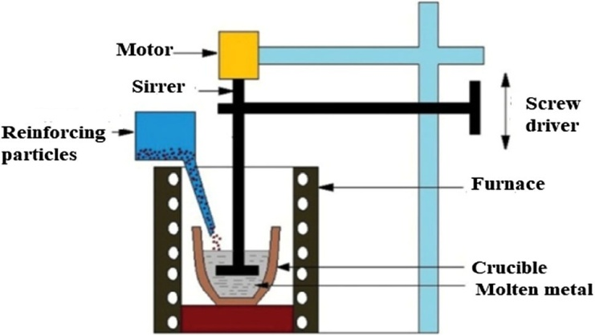
A detachable stage (little fibers, porcelain materials) is combined by turn to liquid-defined existing conditions metals with motorised magnificence in the process of swirl casting, which is a technique of manufacturing amalgamated materials that takes place in a liquor state. Whenever a liquid amalgamated substance of MMC is communicated, it is possible that is could also represent taken out of action by a talent for making metal that is predictable. In the following facial look, Swirl Casting stands out as a unique option. There is a potential of non-absolutely standardised homogeneous combination of transmit in the comfortable of detachable segment live limited (30 percent in terms of volume some time less than the established value). The resultant mixture now has vapour filaments that are quite thin. There is a potential for there to be major separation extraordinary of the detachable segment in the dissimilarity brought about by the concentration of the matrix segment and standing apart. One example of a motorised blender that may be used in a swirl casting system is shown in Figure 1. The method is really simple and does not cost too much.
Figure: 1. Swirl casting set up

EXPERIMENTAL DETAILS

The investigation employed the swirl casting technique to craft a composite substance, central to the study. Specifically, the study utilized an Al 7075 matrix material, which served as the foundation. This matrix material was fortified with reinforcing components, including silicon carbide boasting a granule size of 200 lattices. This additive amalgamation also featured aluminum oxide, contributing fine-grained solid debris known as PSPK. The process entailed several steps. Initially, casting took place, producing a base material with the desired properties. Subsequently, machining transpired on a Wire Electrical Discharge Machining (WEDM) platform, leveraging a brass wire with a diameter of 0.25 mm as the pivotal tool element. This machining process led to the creation of Metal Matrix Composites (MMCs) in the dimensions of 100 x 100 x 10 mm, accomplished through the intricate stir casting method.
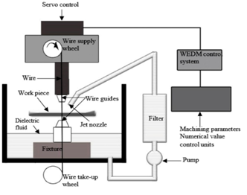
Figure: 2 Wedm Set Up
The innovative aspect of this process lay in the choice of dielectric medium employed to stimulate the sparking phenomenon between the tool and the workpieces. In this scenario, water served as the dielectric medium. This selection introduced a unique element to the machining equation, enhancing the precision and effectiveness of the WEDM process. For a clearer understanding of the setup, Figure 2 provides a schematic representation of the WEDM arrangement. This diagram elucidates the positioning and interaction of the components, shedding light on the intricacies of the process. In conclusion, the swirl casting method, paired with the strategic selection of materials and processes, facilitated the creation of intricate MMCs with noteworthy dimensions and properties.
Table 2 lists all the different variables that may be adjusted throughout the process; from there, we'll use a design-of-experiments (DOE) using an orthogonal array of L9 to tweak the other four variables, pulse-off time included. Nanoscale components are cut, and the sample pieces' surfaces are then honed using emery paper of varied grits to get the desired effect. Using disc polishing equipment, we were able to obtain a mirror quality on both the sample work pieces and the alumina suspension with velvet fabric. Microstructures are created via optical and scanning electron microscopes (SEMs). Samples of composites may be etched using Keller's reagent. After microstructure images have been collected, the samples are subjected to a Vickers hardness test using a 50-gram weight to determine the level of toughness. A Mitutoyo surface area roughness tester was used to evaluate the quality of the EDM-machined surface's finish [11, 12].
Table: 2.Wedm Process Parameters
Levels | Process parameters
 | Pulse on time  (TON) | Pulse off time  (TOFF) | Voltage GAP  (V) | Wire feed rate  (F)
1 | 5 | 9 | 55 | 6
2 | 7 | 7 | 75 | 8
3 | 9 | 5 | 95 | 10

RESULTS AND DISCUSSIONS

Hardness Test
Employing the swirl casting method, the hardness of Aluminum Matrix Metal Composite (ALMMC) was augmented by introducing Al2O3/SiC/PKSA at weight percentages of 2-4%, 4-6%, and 6-8%. The resultant composite's collective hardness distribution is elucidated in Figure 3.a, presenting a clear depiction of hardness changes across different reinforcement concentrations. Notably, the graph unmistakably showcases a substantial upsurge in hardness corresponding to higher Al2O3 and SiC solid waste of PKSA contents in the composite. This experiment underscores the effectiveness of the swirl casting technique in tailoring material properties by manipulating reinforcement levels, consequently influencing the mechanical performance of the ALMMC.
TABLE: 3.Test results of Hardness, tensile, Impact, wear
Sample | Avg. Hardness (VHN) | Avg. Tensile Strength (Mpa) | Avg. Impact Strength(J) | Avg. Wear rate
Al 7075,2% Al2O3 /SiC/PKSA | 178 | 194 | 2.8 | 410
Al 7075,4% Al2O3 /SiC/PKSA | 184 | 224 | 4.2 | 400
Al 7075,6% Al2O3 /SiC/PKSA | 192 | 310 | 5.6 | 312
Al 7075,8% Al2O3 /SiC/PKSA | 199 | 340 | 9.6 | 288

Tensile Test
Tensile tests are carried out laying on a tensometer, with wt% of 2, 4, 6, and 8 wt% Al2O3/SiC/PKSA reinforcement in the composite. The results of these tests are shown in Table 3, which presents the results of the tests in the standard form. It would seem that the addition of wt% Al2O3/SiC/PKSA to ALMMC for the purpose of reinforcing the addition of wt% Al2O3/SiC/PKSA also results in an improvement in the material's tensile strength. Figure 3.b demonstrates the potential for an enhancement to be made that will result in an increased gain of Al2O3/SiC/PKSA weight percent in the matrix.

Impact Test
Figure 3.c indicates that when the produced composite toughness of the material improves, so does the weight percent of reinforcements such as Al2O3/SiC/PKSA. In this research endeavour, we introduced 8 weight percent of Al2O3/SiC/PKSA, which exhibits strong impact strength in the ALMMC. If more reinforcements are put in the ALMMC by employing swirl casting, it includes with the intention of boosting the composite material's toughness. The fact that the fractured test specimen passed both the Izod and the tensile tests lends credence to the ductile nature of the break. The variation in specimen toughness that results from changing the weight % of Al2O3/SiC/PKSA in composites.

Wear Test
Wear testing is performed on the chosen or sample specimens using a pin on disc test setup. The results of the testing are recorded. In figure 3.d, a larger degree of decrease occurs when a lower weight percent of Al2O3/SiC/PKSA is added to Al 7075 as reinforcements. On the other hand, a lower wear rate occurs when a higher weight percent of Al2O3/SiC/PKSA is added to Al 7075 as reinforcements. This is due to the fact that a weight percent of graphite contains a self-lubricating feature.

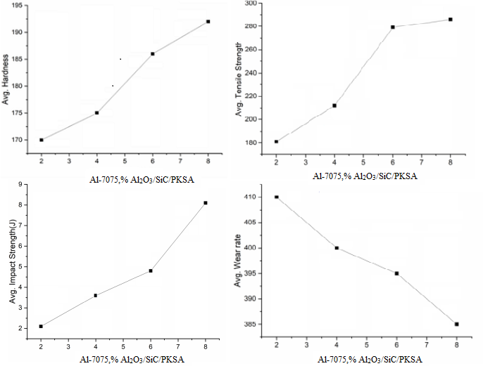

Figure: 3. (A) Plot Of Hardness V/S Al₂O₃/SiC/PKSA Wt % (B) Plot of Tensile Strength V/S Al₂O₃/SiC/PKSA Wt %
(C) Impact Strength V/S Al₂O₃/SiC/PKSA Wt% (D). Wear V/S Wt% Al₂O₃/SiC/PSPK Wt %

Machining Performance Effect With Machining Parameters
The input process parameters as well as the experimental results of MRR and Ra are shown in Table 4, which can be found here. The work being done right now is responsible for controlling four parameters: gap voltage, pulse-on time, pulse-off time, and wire feed. During the process of precision machining, the performance of the machine was affected by a variety of process parameters. The values that may be assigned to each parameter fall into one of many predetermined categories[13,14].
TABLE: 4. process parameters also investigational reactions of Material removal rate and Surface Roughness
Ex. No | Input Process parameters |  |  |  | Output Responses MRR(mm3/min) |  |  |  | Surface Roughness(Ra)
 | Pulse on time  (TON) | Pulse off time  (TOFF) | Voltage GAP  (V) | Wire feed rate  (F) | Al 7075,  2% Al2O3  /SiC/  PKSA | Al 7075,  4% Al2O3  /SiC/  PKSA | Al 7075,  6% Al2O3  /SiC/  PKSA | Al 7075,  8% Al2O3  /SiC/  PKSA | Al 7075,  2% Al2O3  /SiC/  PKSA | Al 7075,  4% Al2O3 /SiC/  PKSA | Al 7075,  6% Al2O3 /SiC/  PKSA | Al 7075,  8% Al2O3  /SiC/  PKSA
1 | 5 | 9 | 55 | 6 | 24.52 | 23.98 | 24.15 | 25.85 | 0.62 | 0.98 | 1.65 | 1.69
2 | 5 | 7 | 75 | 8 | 18.12 | 20.24 | 21.72 | 21.98 | 1.32 | 1.62 | 1.71 | 1.82
3 | 5 | 5 | 95 | 10 | 16.28 | 20.52 | 17.68 | 17.96 | 1.41 | 1.62 | 1.44 | 1.48
4 | 7 | 9 | 75 | 10 | 19.12 | 22.45 | 21.23 | 21.85 | 1.62 | 1.32 | 1.65 | 1.85
5 | 7 | 7 | 95 | 6 | 18.58 | 16.25 | 14.56 | 14.92 | 1.12 | 1.22 | 1.56 | 1.67
6 | 7 | 5 | 55 | 8 | 33.24 | 28.21 | 21.28 | 21.62 | 1.25 | 1.76 | 1.75 | 1.85
7 | 9 | 9 | 95 | 8 | 18.54 | 21.15 | 15.28 | 15.21 | 1.44 | 1.68 | 1.85 | 1.92
8 | 9 | 7 | 55 | 6 | 29.51 | 28.04 | 22.38 | 22.68 | 0.94 | 1.52 | 1.18 | 1.38
9 | 9 | 5 | 75 | 10 | 19.02 | 21.45 | 21.12 | 21.54 | 1.02 | 1.12 | 1.32 | 1.62

Material Removal Rate (MRR)
The output reactions of the average Material Removal Rate (MRR) investigational values headed for exist at 20.97, 20.87, 18.70, and 18.15 mm3/min, respectively, as shown in Fig. 4a-d. The average Material Removal Rate (MRR) of the Al-7075 metal matrix composites is practically headed within the support of 2 percent, 4 percent, 6 percent, and 8 wt percent Al2O3 SiC/PSPK. In metal matrix composites (MMCs), it was revealed that lowering the material removal rate (MRR) may be accomplished by increasing the weight proportion of Al2O3/SiC/PKSA. The MRR has the ability to soften the Al2O3/SiC/PKSA particles found within the MMCs. Reinforcements and Al2O3 both contribute to a reduction in MRR because to their high heat conductivity and stiffness, respectively. According to the findings of this study, MRR valves may often be recognised by an increase in pulse-on time. This is because an increase in pulse-on time indicates that a spark has occurred during the WEDM process. Greater pulse-on time deals with ejections, pulse through increases in concentration, and the development of deep lowest point on work pieces material as well as higher material[15,16].
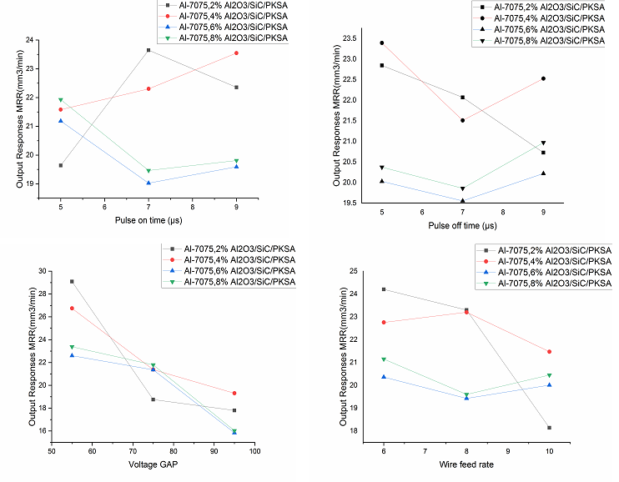
Figure: 4. Material Removal Rate Response Graphs

Surface Roughness (Ra)
Figure 5a-d displays the output responses of the Surface roughness study conducted on Al-7075 with Al2O3/SiC/PKSA. These responses are comprised of 2%, 4%, 6%, and 8% weight of the reinforcing particles, respectively. The level of average surface roughness is shown in figures 5a through 5d. As can be observed in figures 5a-d, the surface roughness has an average value of 1.31m. The surface roughness valve is improved by using the appropriate amount of Al-7075 in conjunction with 2%, 4%, 6%, and 8% wt of Al2O3/SiC/PKSA. The resulting PKSA values for these valves are 1.21, 1.28, 1.32, and 1.42m. As can be observed in figures 5a through 5d, the weight percentage of reinforcement is growing in MMCs. It was found that the surface roughness was becoming rougher over time as a direct consequence of the inclusion of hard particles in MMCs as a reinforcement. Because of the spark that was created when the tool and the work components came into contact with one another during the WEDM process, it was also revealed that the surface roughness reduced as the pulse-on time was increased. Surface roughness will rise proportionally with an increase in the pulse-off time. Ejections may be controlled with a longer pulse-on time. pulse through provides deep lowest point on the work components concentration creates increases material likewise higher[17].
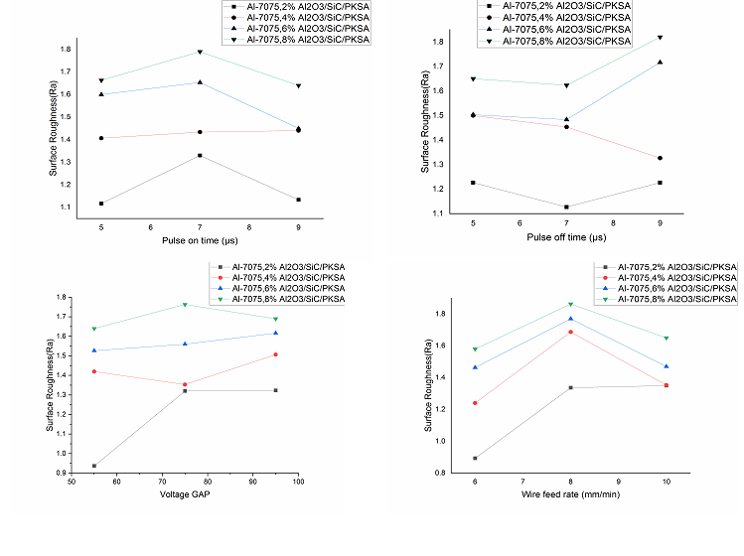
Figure: 5 Surface Roughness Response Graphs

SEM and Microstructure Analysis
The relationship reinforcing subdivision allocation of Al2O3/SiC/PKSA is shown in Figure 6 (a-d), along with its qualities that are associated in the direction that the scanning electron microscope (SEM) aids. Since the Al₂O₃/SiC/PKSA subdivision allocations are consistent across the test specimens, the SEM parallels may be understood without a problem. Using an electron beam with a high intensity and a raster scan pattern, investigate the specimen's microstructure at the location where the tensile test piece broke. 6th picture, the microstructure of a, b, and c demonstrates strengthening in the matrix the microstructure by using the optical microscope to achieve magnifications of 300 X reveals for higher dispersion. The number of reinforcement particles rises as the weight percent of Al2O3/SiC/PKSA in the matrix increases, while the amount of space between the reinforcement particles decreases. In agglomerations of certain Al2O3/SiC/PKSA Al matrices, the existence of a refusal sign may be uncovered.
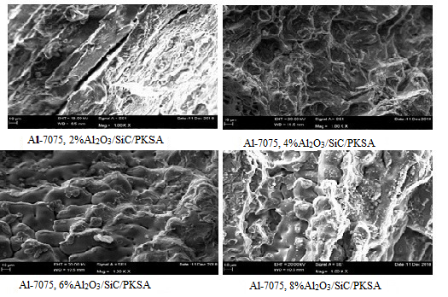
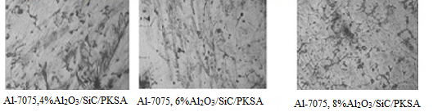
Figure: 6. SEM and Microstructure

CONCLUSIONS

WEDM (wire cut electric discharge machining) was used to analyse Al-7075/ Al2O3/SiC/PKSA that was generated using the liquid-state technique with 2%, 4%, 6%, and 8% weight. Material Removal Rate and Surface Roughness were also taken into consideration during this investigation. The observations have been summed up and are provided below.
- In order to manufacture an Al-7075/ Al2O3/SiC/PKSA metal matrix composite in a manner that is both efficient and cost-effective, a typical stir casting method is used.
- Composite materials comprised of Al-7075/ Al2O3/SiC/PKSA showed a greater hardness valve when compared to non-reinforced Al-7075 in terms of the comparison.
- The SEM and microstructure data indicated that Al2O3/SiC/PKSA particles were distributed in a regular manner across the Al-7075.
- The pulse-off time with the voltage gap between the tool and the workpieces is the basic process parameter for the MRR trail through wire feed. This is the minimum valve required for this process.
- In addition to the Al2O3/SiC/PKSA reinforcements that are included in Al-7075, the pace at which material is being removed is steadily reducing.
- Since WEDM is able to machine composite materials that are difficult to cut, surface roughness valve increases the weight percent of reinforcements added in Al-7075, but material removal rate has no influence on the weight percent of reinforcements added in MMCs.

REFERENCES

- Introduction to Composite Materials, F.C. Campbell, Structural Composite Materials http://machinedesign.com/article/metal-matrix-composites-1115, Nov- 15, 2010
- Pradeep K. Rohatgi (1993) Metal-matrix Composites, Defence Science Journal, Vol 43(4) , pp 323-349.
- N.G. Patil, P.K. Brahmankar, D.G. Thakur, On the effects of wire electrode and ceramic volume fraction in wire electrical discharge machining of ceramic particulate reinforced aluminum matrix composites. Proceedings CIRP 42, 286–291 (2016)
- J. Zhao, J.C. Jie, C. Fei, C. Hang, T. Li, Z. Cao, Effect of immersion Ni plating on interface microstructure and mechanical properties of Al/Cu bimetal. Trans. Nonferrous Met. Soc. China 24, 1659–1665 (2014)
- H.K. Garg, K. Verma, A. Manna, R. Kumar, Hybrid Metal Matrix Composites and a further improvement in their machinability—a review. Int. J. Latest Res. Sci. Technol. 1(1), 36–44 (2012)
- K.B. Vijay, S. Dharminder, S. Puneet, Research work on composite epoxy matrix and Ep polyester-reinforced material. Int. J. Eng. Res. Technol. 2(1), 1–20 (2013)
- B.S. Yigezu, P.K. Jha, M.M. Mahapatra, The key attributes of synthesizing ceramic particulate reinforced Al-based matrix composites through stir casting process: a review. Mater. Manuf. Processes 28(9), 969–979 (2013)
- Y.C. Shin, C. Dandekar, in Mechanics and modeling of Chip Formation in Machining of MMC, ed. by J.P. Davim, Machining of Metal Matrix Composites (Springer-Verlag London Limited, 2012) https://doi.org/10.1007/978-0-85729-938-3-1
- B.C. Kandpala, J. Kumar, H. Singh, Machining of aluminum metal matrix composites with electrical discharge machining—a review. Mater. Today Proc. 2, 1665–1671 (2015)
- A. Kumar, D.K. Bagal, K.P. Maity, Numerical modeling of wire electrical discharge machining of super alloy Inconel 718. Proc. Eng. 97, 1512–1523 (2014)
- S. Prashanth, R.B. Veeresha, S.M. Shashidhara, U.S. Mallikarjun, A.G. Shiva siddaramaiah, A study on machining characteristics of Al6061-SiC metal matrix composite through wire—cut electro discharge machining. Mater. Today Proc. 4(10), 10779–10785 (2017)
- Y. Pachaury, P. Tandon, An overview of electric discharge machining of ceramics and ceramic-based composites. J. Manuf. Process. 25, 369–390 (2017)
- S. Mohanty, B.C. Routara, A review on machining of metal matrix composites using nano-particle mixed dielectric in electro- discharge machining. Int. J. Automot. Mech. Eng. 13(2), 3518–3539 (2016)
- G. Talla, D.K. Sahoo, S. Gangopadhyay, C.K. Biswas, Modeling and multi-objective optimization of powder mixed electric dis- charge machining process of aluminum/alumina metal matrix composite. Eng. Sci. Technol. Int. J. 18, 369–373 (2015)
- P. Sivaprakasam, P. Hariharan, S. Gowri, Optimization of micro- WEDM process of aluminum matrix composite (A413-B4C): a response surface approach. Mater. Manuf. Process. 28, 1340–1347 (2013)
- P. Shandilya, P.K. Jain, N.K. Jain, Prediction of surface rough- ness during wire electrical discharge machining of SiCp/6061 Al metal matrix composite. Int. J. Ind. Syst. Eng. 12(3), 301–315 (2012)
- H. Singh, H. Kumar, Review on wire electrical discharge machining (WEDM) of aluminum matrix composites. Int. J. Mech. Product. Eng., ISSN: 2320-2092 3(10) (2015).
- Michael Oluwatosin Bodunrin, Kenneth Kanayo, Alaneme Lesley Heath Chown(2015), Aluminium matrix hybrid composites: a review of reinforcement philosophies; mechanical, corrosion and tribological characteristics, Journal of materials research and technology, vol 4(4) Dec 2015, pp 434-445.
- H. Warren, Hunt, Darrell R. Herling (2004), Text book, Aluminium Metal Matrix Composites, Advanced Materials and Processes http://www.science.org.au/nova/059/059key.htm
- Yoshiro.Iwai, Hidetomo.Yonede, and Tomomi.Honda, (1995), “Sliding wear behaviour of SiC whisker reinforced aluminum composite”, wear 181-183, pp.594-602.
- Rupa Dasgupta (2010) The Stretch, Limit and Path Forward for Particle Rein-forced Metal Matrix Composites of 7075 Al-Alloys. Scientific research Engineering, vol 2, pp 237-256
- Zeynep TAŞLIÇUKUR, Gözde S. ALTUĞ, Şeyda POLAT (2012) “Characterization of microstructure and fracture behavior of GG20 and GG25 cast iron materials used in valves” metal vol 5 pp 23-25
- Sidney H.Avner. (1986); Introduction to physical metallurgy, McGraw-Hill.]
- N. Mahathaninwonga, T. Plookphola, J. Wannasina, S. Wisutmethangoonb(2012) T6 heat reatment of rheocasting 7075 Al alloy ,Materials Science and Engineering Volume 532, Pages 91–99]
- S.M. Bayazida, , , H. Farhangia, H. Asgharzadehb, L. Radanc, A. Ghahramania, A. Mirhajib Effect of cyclic solution treatment on microstructure and mechanical properties of friction stir welded 7075 Al alloy , Materials Science and Engineering, Volume 649, Pages 293–300
- Siavash gholami, esmaeil emadoddin, mohammad tajally, ehsan borhani(2015) Friction stir processing of 7075 Al alloy and subsequent aging treatment , Transactions of Nonferrous Metals Society of China, Volume 25(9) Pages 2847–2855
- Jin-feng l, zhuo-wei peng, chao-xing li, zhi-qiang jia, wenjing chen zi-qiao zheng (2008) Mechanical properties, corrosion behaviors and microstructures of 7075 aluminium alloy with various aging treatments ,Transactions of Non-ferrous Metals Society of China, Volume 18(4), Pages 755–762

