Comprehensive Study of Sugar Oxidation with Cr (VI) Oxidants
Ashish Tomar^{1*}, Unik Arora¹
¹Department of Chemistry, Meerut College, 250001 Meerut (U.P.), India
E-mail: ashisht.chemistry@mcm.ac.in, dr.ashishtomar1983@gmail.com
ORCID iD: - Ashish Tomar (https://orcid.org/0000-0002-1316-0359)
Unik Arora (https://orcid.org/0009-0009-2099-3541)

ABSTRACT

This chapter thoroughly explores how sugars react with different Cr (VI) oxidants. It probe into the details of the reaction kinetics and mechanisms, shedding light on the complex processes. Various factors affecting the rate and pathways of these reactions are also discussed.

Keywords- Oxidation, Kinetics, Mechanism, Sugar, Cr (VI) oxidants.

I. INTRODUCTION

Physical organic chemistry is a vital field focusing on the principles of organic reactions. It explores diverse reaction types, highlighting creative mechanistic investigation technique. The study of chemical phenomena involves thermodynamics, addressing equilibrium, and chemical kinetics, focusing on the rate of change under non-equilibrium conditions. These methods are interconnected, with thermodynamics providing the foundational driving potential for chemical kinetics (1).
In inorganic chemistry, oxidation is the process when electron are lost or the oxidation number goes up. In organic chemistry, applying these definitions is challenging due to indirect electron transfers and issues with oxidation numbers. Oxidation reactions in organic chemistry are categorized into five groups based on bond changes: elimination of hydrogen, cleavage of carbon-carbon bonds, and substituting hydrogen with oxygen, introducing oxygen to the substrate, and combining molecules through oxidation.
Carbohydrates, encompassing sugars, are versatile naturally occurring substances that serve multiple functions, with their oxidation products assuming a pivotal role as intermediates in synthesizing complex molecules. Moreover, these products often exhibit diverse biological activities, highlighting their significance in chemical and biological processes (2).
However, reducing sugars could affect chromium chemistry due to their reducing properties. The year 1798 marked the discovery of chromium by French chemist Vanquelin (3). Chromium, found in the periodic table (group VI-B), has an electron arrangement in its lowest energy state represented as [Ar] 3d⁵ 4s¹. Remarkably, it stands out as one of the most commonly found heavy metals, ranking 21st position among the Earth crust’s abundant elements (4). Chromium metal exhibits stable oxidation states of Cr (II), Cr (III), and Cr (VI), while Cr (IV) and Cr (V), which are unstable in water, transform into Cr (III) and Cr (VI). Cr (VI) serves as an oxidant in various reactions(5). Chromates or dichromates containing hexavalent chromium (Cr (VI)) are typically known for their low solubility in most organic solvents while readily soluble in water (6). The oxidation process involving Cr (VI) is complex, influenced by various factors such as solvent, substrate structure, temperature, and pH of the reaction medium, making it challenging to comprehensively study from a mechanistic perspective (2). Researchers are keenly studying the intermediate stages involving Cr (V) and Cr (IV) that arise during the reduction of Cr (VI). The focus is driven by their crucial role in understanding the mechanisms behind cancers caused by exposure to chromium (7).

II. CHROMIUM (VI) BASED OXIDANTS

Over the last few decades, Chromium (VI) complexes have emerged as fascinating transition metal complexes, capturing considerable interest. These compounds have been extensively investigated since the inception of organic chemistry, owing to their catalytic and oxidizing properties. Nowadays, there has been a notable interest among researchers in oxidation processes, particularly selective and environmentally friendly reagents involving Cr (VI).

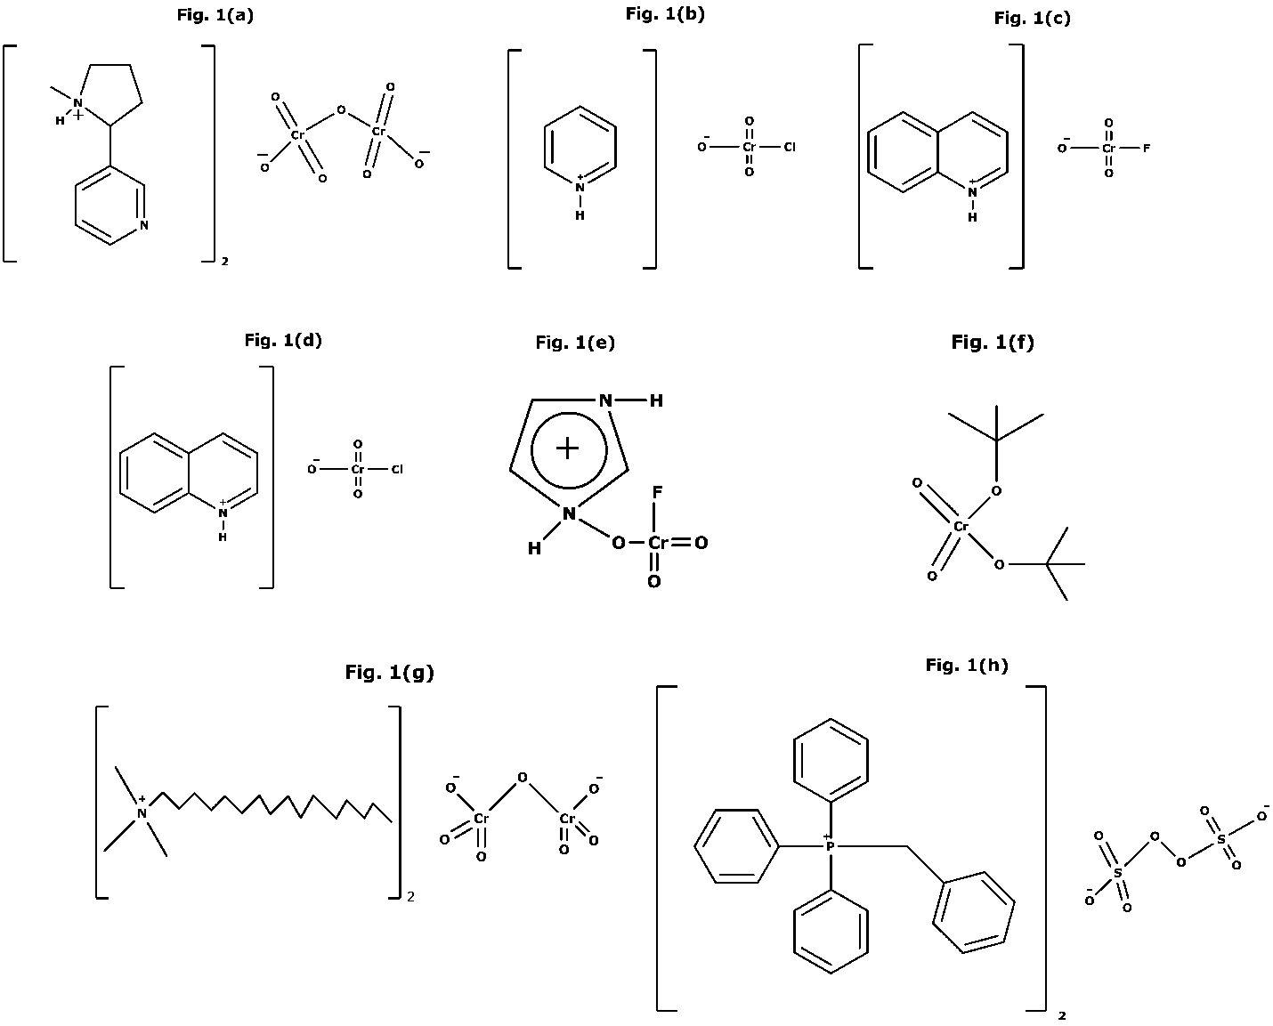
Fig. 1(a). Structure of Nicotinium dichromate, 1(b). Piperidinium chlorochromate, 1(c). Quinolinium Fluorochromate, 1(d). Quinolinium Chlorochromate 1(e). Imidazolium Fluorochromate, 1(f). Ditertiary Butyl Chromate, 1(g). Cetyltrimethylammonium dichromate, 1(h). Benzyltriphenylphosphonium peroxydisulphate
The main theme of this exploration revolves around the utilization of Cr (VI) in oxidizing organic compounds, involving its transition to lower oxidation states. By employing various oxidants like Nicotinium dichromate, Piperidinium chlorochromate, Quinolinium Fluorochromate, Quinolinium Chlorochromate, Imidazolium Fluorochromate, Ditertiary Butyl Chromate, Cetyltrimethylammonium dichromate, Benzyltriphenylphosphonium peroxydisulphate etc., the reported hazardous Cr (VI) transforms into environmentally benign and non-toxic Cr (III) (Fig. 1 (a) – 1(h)) (5,8–12).

III. REDUCING SUGAR

All monosaccharides are reducing sugars due to their free aldehyde or ketone groups. Disaccharides can be reducing or non-reducing based on free anomeric carbons. The aldehyde functional group in reducing sugars allows them to participate in reactions like Tollen’s and Benedict’s tests. These sugars are crucial in Maillard's reaction during cooking and are used to assess the quality of food products such as wine, juice, and sugarcane (13). In aqueous solution, reducing sugars can be found in various forms, including acyclic aldehyde or ketones, α- and β- pyranose, and furanose versions of the associated hydrates (Fig. 2 (a) & 2(b)). The rate and the pathway of the oxidation reaction depend on the nature of sugar, the oxidizing agent, and the pH of the solution (2).

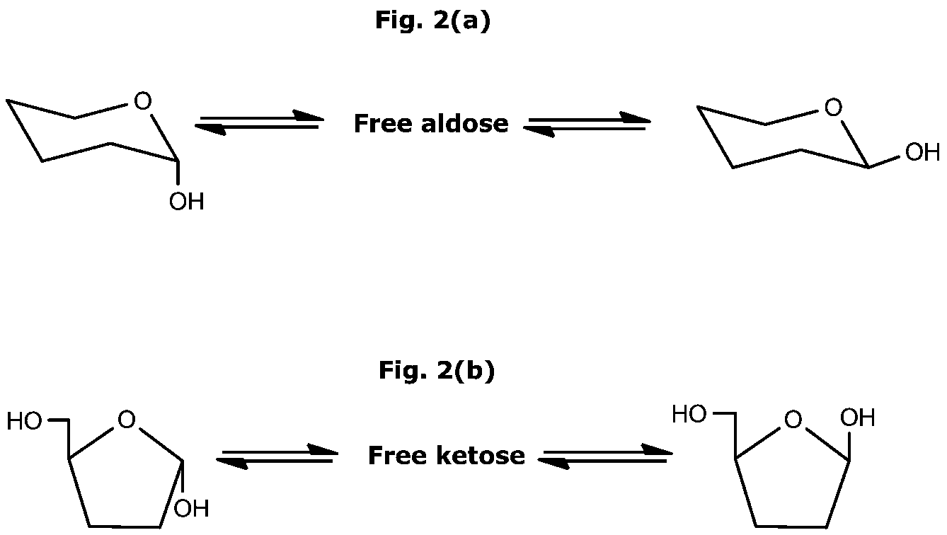
β-Furanose
α- Pyranose
β- Pyranose
α- Furanose

Fig. 2(a). Interconversion of α- Pyranose into β- Pyranose, 2(b). Interconversion of α- Furanose into β- Furanose via open-chain forms in an aqueous medium.

IV. OXIDATION OF REDUCING SUGARS

Cr (VI) oxides and oxyacids exhibit strong oxidizing properties. In case of Cr (VI) based oxidation, chromic esters are supposed as potential intermediates, undergoing decomposition by eliminating the proton linked to the carbon bonded to oxygen. Two mechanisms have been considered for this proton elimination process, with an additional proposition involving coordination complex formation (14). The formed complex is theorized to undergo decomposition, generating radical species that undergo further oxidation to yield distinct product (15).
In this section, numerous chromium (VI) reagents and methodologies have been suggested and thoroughly documented. Tetramethylammonium chlorochromate (TEACC) serves as a versatile reagent, demonstrating efficiency and selectivity in oxidizing organic substrate, such as crotonaldehyde in acetic acid medium (Fig. 3) (16).

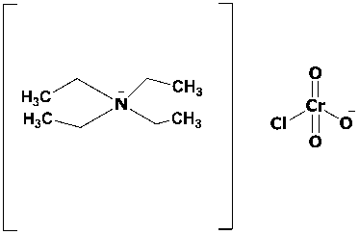
Fig. 3. Structure of TEACC
In separate studies, this reagent was used to investigate the rate of some sugars oxidation. Arabinose and formic acid resulted from D-galactose, D-glucose, and D-mannose oxidation, while D-fructose produced D-erythrose and glycolic acid. Consistent kinetics showed unit-order dependence on the concentration of both TEACC, and sugars. The reaction rates enhanced from hydrogen ions, and a hydride ion elimination was proposed (17–20). A study investigated the oxidation of certain sugars like glucose and galactose in acetic acid medium using Quinolinium fluorochromate (QFC) (Scheme 1) (Fig. 1(c)). The reaction exhibited 1:1 stoichiometry ratio and followed unit-order kinetics for sugar and QFC. Perchloric acid catalyzed the reaction, with a unit-order dependence on concentration of hydrogen ions. Notably, oxidation rate decreased as the medium’s dielectric constant increased, while changes in ionic strength did not significantly affect the reaction rate (21).
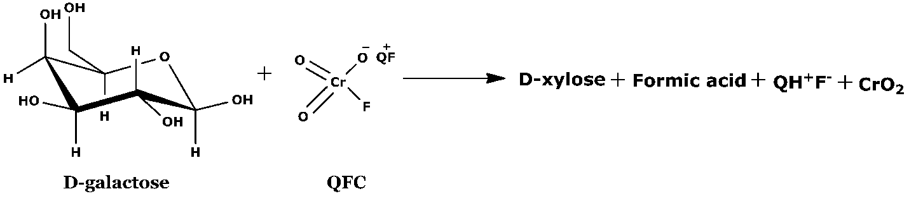
Scheme 1. Oxidation of D-galactose by Quinolinium Fluorochromate (QFC)
An alike kinetics of some monosaccharides oxidation using Quinolinium chlorochromate (QCC) (Fig. 1(d)) was conducted in an aqueous acetic acid medium at unchanged ionic strength. The process depicted unit-order dependence regarding [QCC], and [Substrate] (Scheme 2). Perchloric acid was the main source of H⁺ ion in the reaction, and exhibited unit order dependence on [H⁺]. Significantly, the process involved a direct transfer of hydride ions, causing the specific breakage of the carbon-carbon bond in the substance and the formation of the resulting products (22).
Scheme 2. L-arabinose oxidation by Quinolinium Chlorochromate (QCC)
Further, the oxidation kinetics of some monosaccharides in aqueous perchloric acid using pyridinium fluorochromates (PFC) and pyridinium chlorochromates (PCC) (Fig. 4) have been conducted (Fig. 4). Each reaction exhibited unit-order kinetics concerning the concentration of Oxidant, Sugars, and hydrogen ions. In case of PFC, the proposed pathway involves transfer of hydride ions. In contrast, PCC-induced oxidation follows two pathways: one involves C-H bond cleavage through hydride ion transfer, while the other involves carbon-carbon bond cleavage via a cyclic chromate ester (23,24).
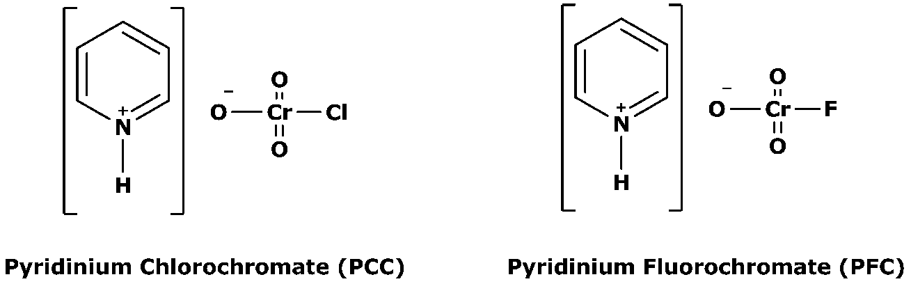
Fig. 4. Structure of Pyridinium Chlorochromate (PCC) & Pyridinium Fluorochromate (PFC)

V. MICELLAR MEDIA AND Cr (VI) REDUCTION

This section discusses how aqueous micellar media, or micro-heterogeneous systems, can affect the oxidation pathways of reducing sugars involving Cr (VI) Oxidant.
In micellar system, studying electron transfer can help us understand how electron move, similar to their transport in biological processes (25). The way electrons react in these systems is connected to how chromium behaves in living systems. Further, it was observed that the use of surfactants in the reaction process have an impact on rates, yields, and products.

A. Surfactants
Surfactants, like sodium dodecyl sulfate (SDS) and cetyltrimethylammonium bromide (CTAB), have both hydrophobic and hydrophilic parts. Anionic surfactants have sulfate or sulfonate groups, while cationic surfactants have quaternary ammonium salt or pyridinium groups. Non-ionic surfactants often contain polyoxyethylene residues (26,27).
In an aqueous solution, surfactants show hydrophobic interactions, leading to spontaneous aggregation into thermodynamically stable colloidal particles. The self-assembly of colloidal particles depend upon various factors. When surfactants are in low concentration, they act like regular solutes. However, when their concentration surpasses a certain point (Critical Micelle Concentration or CMC), they start forming micelles (26–29).

Cooperative model
Berezin’s model

Kinetic models for micellar effects

Menger–Portnoy model
Pseudo-phase ion-exchange model

Scheme 3. Different kinetic models for micellar effects

The aggregation of hydrocarbon chains occurs due to the hydrophobic interactions between them (29). Micelle enlargement is hindered by factors like hydration, electrostatic repulsion, steric effects, and entropy losses (27,29). Micelles stay evenly spread throughout the water, forming a pseudo-phase. Micelle-surfactant interconversion is reversible, allowing micelle destruction below the CMC. The CMC is influenced by temperature, hydrocarbon chain length, and chemical composition. Aqueous micelles show diverse forms, sharing a common structure of hydrophilic groups outward and hydrocarbon ends inward (25–30).

B. Oxidation of sugars in micellar media
A study investigated micellar effects on D-xylose oxidation by Cr (VI) (31). SDS and Triton X-100 surfactants did not alter rate law or mechanism but increased rate constant with concentration. The effect was attributed to reactant partitioning between aqueous and micellar pseudo-phases. SDS exhibited ion-dipole interaction; Triton X-100 displayed hydrogen bonding. Acid-catalyzed reactions involved hydrogen ions in the phase containing micelles. NH₄⁺, Li⁺, and Na⁺ ions hindered SDS micellar catalysis, considered with the other reports on salt-induced inhibition (32–34).
A similar study was conducted to explore the micellar effects on the oxidation of reducing sugar by Cr (VI), both catalyzed and uncatalyzed by picolinic acid (35–37). The rate law was unaffected by surfactants. SDS catalyzed both paths, while cetylpyridinium chloride (CPC) inhibit them. For picolinic acid catalyzed path, a Cr (VI)-picolinic acid complex again formed a complex with substrate before redox decomposition. The inhibition by CPC implied that the primary active oxidant was predominantly present in the aqueous phase. SDS catalysis suggested that the reactions occurred in both phases. The observed micellar effect was explained by examining rate data using the Menger-Portnoy and cooperative models (25).
A room temperature method for Cr (VI) oxidation of lactose to lactobionic acid was developed by taking some derivatives of piconilic acid as promoters in acidic medium (4,38). SDS and Triton X-100 surfactants enhanced the rate, while CPC hinders it.
A study explored oxidation reaction of D-galactose with Cr (VI) in aqueous micellar medium with a 2,2’-Bipyridine catalyst (39). The Cr (VI)-bpy complex served as the effective oxidizing agent, forming D-galactonic acid. The process involved a pre-equilibrium step where Cr (III)-bpy complex supported the formation of Cr (VI)-bpy complex, which is then reduced to Cr (III)-bpy complex.
VI. METAL IONS AND THE Cr (VI) OXIDATION

This section discusses the impact of adding metal ions on the oxidation kinetics and mechanistic pathways of reducing sugars involving Cr (VI) oxidant.
A study was conducted to understand that how Mn²⁺ influences the rate at which D-ribose oxidizes in perchloric acid (40). The findings showed that the rate relies on both the concentration of the oxidizing agent and D-ribose in a first-order manner. The order with respect to the concentration of hydrogen ions is slightly less than two. At low [Oxidant], Mn (II) catalyzes the process, following a first-order pathway for each of the reactant. However, at high [Oxidant], Mn (II) inhibits the reaction by trapping Cr (IV) intermediate. Mn (III) has been confirmed as an intermediate when Mn (II) is present.
A study was conducted to explore the oxidative reaction of D-galactose with Cr (VI) in HClO₄ under different conditions, with and without the presence of Ce (IV) and Mn (II) (41). The reaction revealed a unit-order dependence on both the concentration of D-galactose and hydrogen ions. Ce (IV) inhibits the process, suggesting Cr (IV) formation, while Mn (II) catalyzes the oxidation, with the D-galactose-Mn (II) complex acting as an active oxidant in a ternary chromate ester pathway, undergoing acid-catalyzed redox decomposition.
A study explored the kinetic data of D-fructose and L-sorbose oxidations by Cr (VI) and vanadium (V) in perchloric acid (42). Rate constants increased with added perchloric acid and sodium perchlorate. Changing the Medium from H₂O to D₂O affected Cr (VI) rates, not vanadium (V) rates. Chromium (VI) oxidations lacked the formation of intermediate-complex, while vanadium (V) oxidations revealed a 1:1 intermediate complex formation with ketoses.

VII. MICROWAVE ASSISTED OXIDATION OF CARBOHYDRATES

The utilization of microwave irradiation is gaining popularity as a heating method, progressively replacing conventional approaches due to its proven cleanliness, cost-effectiveness, and convenience. Frequently, it yields higher outputs and leads to shorter reaction durations (43). This section discusses various applications of microwave-assisted oxidation in the context of carbohydrates with Cr (VI)-based oxidants.
A study introduced the microwave-assisted oxidation of organic compounds, including carbohydrates and polycyclic arenes, using cetyltrimethyl ammonium chlorochromate (Scheme 4) (4,44).

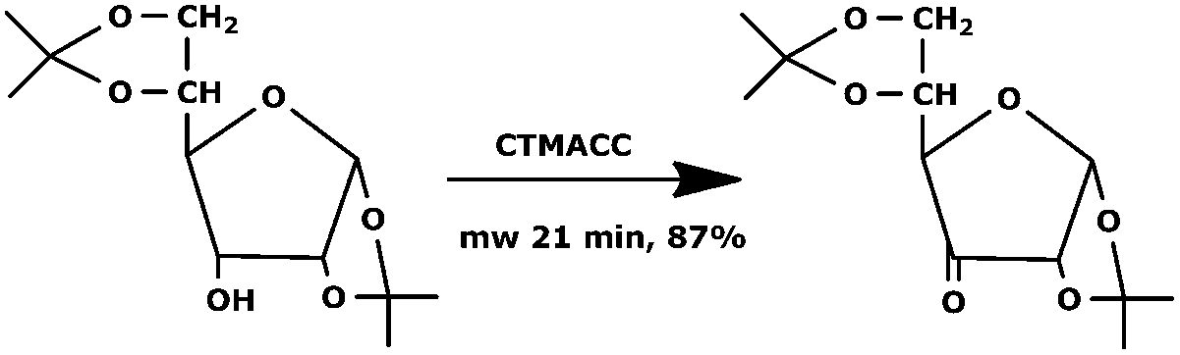
Scheme 4. Microwave assisted oxidation of carbohydrates
A study was aimed to utilize microwave irradiation for the oxidation of 1,2:5,6-di-O-cyclohexylidene-α-glucofuranose in dry CH₂Cl₂ with pyridinium chlorochromate (PCC) (Scheme 5) (43,45). Interestingly, the process yielded ketone within 10 minutes, contrasting with a 4-hour duration without microwave irradiation.

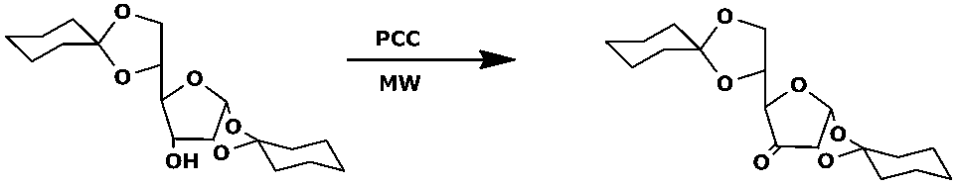

Scheme 5. Microwave assisted oxidation of 1,2:5,6-di-O-cyclohexylidene-α-glucofuranose

VIII. FACTORS EFFECTING OXIDATION

The oxidation reaction involving Cr (VI) are complex processes, influenced by various factors such as dielectric constant, ionic strength, catalyst, and temperature. Therefore, studying them from a mechanistic standpoint is challenging. In this section, certain factors are deliberated.

A. Temperature
The reaction rate consistently rises with temperature, regardless of the reaction’s endothermic or exothermic nature, due to an increased number of activated molecules. Generally, a ten-degree temperature increase doubles the rate of reaction. The rate expression, in the form of Arrhenius equation, demonstrates that while reactant concentrations and reaction order remain unaffected, the rate constant is temperature-dependent. Experimentally, activation energy is determined using both Arrhenius and Eyring equations (expression I & II) (46–48).
(I)
$$k=A e^{-\frac{E_{a}}{RT}}$$
$$k_{2}=K_{t}\frac{K_{b}T}{h} e^{-\frac{{ΔG}^{‡}}{RT}}$$
B. Catalyst
(II)
Certain substances have an activating effect that serves as a unique catalytic force on reactants. Catalysis speeds up reactions using a catalyst, lowering activation energy (49). In contrast to reagents, catalysts are not consumed and may participate in multiple transformations. In this chapter, various metal ions and surfactants (SDS) were introduced as catalysts; anionic surfactants sometimes slowed the reaction rates.

C. Ionic Strength
The reaction rates are affected by the formation of activated complex, which is influenced by the ionic strength (I). This parameter represents the electric field strength in the solution based on Bronsted and Bjerrum’s theory (expression (III)).
(III)
$$\log{k= \log{k_{0}+1.018Z_{A}Z_{B}\sqrt{I}}}$$
In a context of a reaction with ions A and B, characterized by ion valencies Z_{A} and Z_{B}, and rate constants k and k₀ with and without an added electrolyte respectively. A linear relationship is expected when plotting log k against I^{1/2} ((49,50). If Z_{A}Z_{B} have similar signs, the rate increases with positive slope, and if they differ, the rate decreases with a negative slope as ionic strength rises. When one of the involved reactant is neutral, the reaction remains unaffected by variations in ionic strength (49).

D. Dielectric constant of reaction medium
To investigate the role of medium’s dielectric constant on reaction rates, various solvents like acetic acid and acetonitrile, at different percentages, are commonly used. The equation presented below depicts how the dielectric constant (D) influences the rate constant of a reaction involving two ions:
(IV)
$$\log{\frac{k}{k_{0}}}= \frac{{-Z}_{A}Z_{B}e^{2}N}{4πε_{0}d_{AB}D}$$

This equation reveals that a plot of log k against (1/Dielectric constant) yields a straight line, where –Z_{A}Z_{B}e²N/4πε₀d_{AB} represents the slope.(49,51,52).

IX. Conclusions

The field of synthetic organic chemistry has evolved significantly, demanding innovative approaches and reagents for the total synthesis of complex molecules. Among various classes of organic reactions, oxidation holds a pivotal role in modern organic chemistry. Cr (VI) compounds, extensively studied for oxidizing various reducing sugars, have become integral in organic synthesis. While these compounds exhibit significant potential in transitioning metal compounds, their biological properties remain largely unexplored. Future research should focus on investigating the biological properties of existing Cr (VI) complexes and developing new complexes with enhanced features. This chapter highlights the notable progress made in using Cr (VI) reagents and suggests for further exploration of their applications in organic synthesis. Encouraging additional research on Cr (VI) oxidation is essential, given its biological significance, open the way for new advancement in this critical area of study.

X. References
1. Latha T. Kinetics of Oxidation of Alanine by N-chlorobenzamide in Aqueous Acetic Medium. Int Res J Manag Sociol Humanit. 2018;9(7):44–72.
2. Singh JV, Awasthi A, Dipti, Tomar A, Singh D. Kinetics and Mechanism of Oxidation of Reducing Sugars: A Review. Asian J Chem. 2013;25(2):595–611.
3. Shanker A, Cervantes C, Lozatavera H, Avudainayagam S. Chromium toxicity in plants. Environ Int. 2005 Jul;31(5):739–53.
4. Katre SD. Recent Advances in the Oxidation Reactions of Organic Compounds using Chromium (VI) Reagents. Res J Chem Environ. 2020 Jan;24(1):130–51.
5. Chaudhuri MK, Chettri SK, Lyndem S, Paul PC, Srinivas P. Quinolinium Fluorochromate (QFC), C ₉ H ₇ NH[CrO ₃ F]: An Improved Cr(VI)-Oxidant for Organic Substrates. Bull Chem Soc Jpn. 1994 Jul;67(7):1894–8.
6. Anna L. Rowbotham, Leonard S. Levy,. Chromium in the Environment: An Evaluation of Exposure of the Uk General Population and Possible Adverse Health Effects. J Toxicol Environ Health Part B. 2000 Jul;3(3):145–78.
7. Costa M. Toxicity and Carcinogenicity of Cr(VI) in Animal Models and Humans. Crit Rev Toxicol. 1997 Jan;27(5):431–42.
8. Roldan F, Gonzalez A, Palomo C. Nicotinium dichromate: a new cheap reagent for high-yielding large-scale oxidation of carbohydrates. Carbohydr Res. 1986 Jun;149(1):C1–4.
9. Chimatadar SA, Koujalagi SB, Nandibewoor ST. A kinetic and mechanistic study of thallium(I) oxidation by quinolinium dichromate (QDC), a new oxidant. Transit Met Chem. 2002;27(7):704–11.
10. Pandurangan A, Rajlcumar GA, Arabindoo B, Murugesan V. Imidazolium fluorochromate (IFC): A new, mild, stable and selective chromium(VI) oxidant. Indian J Chem. 1999 Jan;38B:99–100.
11. Chromium Oxidations in Organic Chemistry. Cham: Springer International Publishing;
12. Patel S, Mishra BK. Oxidation of Cholesterol by a Biomimetic Oxidant, Cetyltrimethylammonium Dichromate. J Org Chem. 2006 Apr 1;71(9):3522–6.
13. Bruice PY. Organic chemistry. Eighth edition, global edition. Harlow: Pearson; 2017. 1336 p.
14. Smith M, March J. March’s advanced organic chemistry: reactions, mechanisms, and structure. 6th ed. Hoboken (N.J.): J. Wiley &sons; 2007.
15. Rahman M, Rocek J. Chromium(IV) oxidation of primary and secondary alcohols. J Am Chem Soc. 1971 Oct;93(21):5455–62.
16. Dipti, Tomar A, Kumar A. Kinetic and mechanistic studies of the oxidation of crotonaldehyde by tetraethylammonium chlorochromate in aqueous acetic acid medium. Oxid Commun. 2012 Jan;35(3):569–76.
17. Tomar A, Kumar A. Kinetic and Mechanistic Study of the Oxidation of D-Galactose by Tetraethylammonium Chlorochromate in Aqueous Acetic Acid Medium. Asian J Chem. 2006 Jul;18(4):3053.
18. Tomar A, Kumar A. Kinetics and mechanism of oxidation of D-glucose by tetraethylammonium chlorochromate in aqueous acetic acid. Oxid Commun. 2007 Jan;30(1):88–96.
19. Tomar A, Kumar A. Kinetic and Mechanistic Study of the Oxidation of D-mannose by Tetraethylammonium Chlorochromate in Aqueous Acetic Acid Medium. Asian J Chem. 2006;18(4):3073–80.
20. Tomar A, Kumar A. Kinetics and mechanism of oxidation of D-fructose by tetraethylammonium chlorochromate in aqueous acetic acid. J Indian Chem Soc. 2006 Nov 30;83:1153–7.
21. Dhage SD, Hallale SN, Patwari SB. Kinetic and Mechanistic Study of Oxidation of D-galactose and Dglucose by Quinolinium Fluorochromate in Aqueous Acetic Acid. Int J Univers Print. 2018 Mar;4(2):66–73.
22. Singh JV, Tomar A. Oxidation Kinetics of L-Arabinose with Quinolinium Chlorochromate. Asian J Chem. 2018;30(5):1027–30.
23. Varadarajan R, Dhar R. Kinetics and Mechanism of Oxidation of D-glucose with Pyridinium Fluorochromate (PFC). Indian J Chem. 1986 May;25A:474–5.
24. Dhar RK. Kinetics of oxidation of some monosaccharides by pyridinium chlorochromate (PCC). Indian J Chem. 1992 Feb;31A:97–101.
25. Das AK. Micellar effect on the kinetics and mechanism of chromium(VI) oxidation of organic substrates. Coord Chem Rev. 2004 Jan;248(1–2):81–99.
26. Berezin IV, Martinek K, Yatsimirskii AK. Physicochemical Foundations of Micellar Catalysis. Russ Chem Rev. 1973 Oct 31;42(10):787–802.
27. Myers D. Surfaces, interfaces, and colloids: principles and applications. 2. ed. New York Weinheim: Wiley-VCH; 1999. 501 p.
28. Chapman D. The Hydrophobic Effect: Formation of Micelles and Biological Membranes (2nd Edition). Biochem Soc Trans. 1981 Feb 1;9(1):178–178.
29. Tanford C. The hydrophobic effect: formation of micelles and biological membranes. 2. ed. New York: Wiley; 1980. 233 p. (A Wiley-Interscience publication).
30. Simmons B, Agarwal V, McPherson G, John V, Bose A. Small Angle Neutron Scattering Study of Mixed AOT + Lecithin Reverse Micelles. Langmuir. 2002 Oct 1;18(22):8345–9.
31. Kabir-ud-Din, Morshed AMA, Khan Z. Micellar Effects on the Chromium(VI) Oxidation of d (+)-Xylose. Inorg React Mech. 2002 Jan;3(4):255–66.
32. Bunton CA, Cerichelli G. Micellar effects upon electron transfer from ferrocenes. Int J Chem Kinet. 1980 Aug;12(8):519–33.
33. Rafiquee ZA, Shah RA, Ud-Din K, Khan Z. Kinetics of the interaction of Cd(II)-histidine complex with ninhydrin in absence and presence of cationic and anionic micelles. Int J Chem Kinet. 1997;29(2):131–8.
34. Mishra S, Panigrahi AK, Sinha BK. Acid-catalysed Hydrolysis of Methyl Acetate in Micellar Phase. J Indian Chem Soc. 1997 May;74:408–10.
35. Das AK, Mondal SK, Kar D, Das M. Micellar Effect on Chromium(VI) Oxidation of D-Glucose in the Presence and Absence of Picolinic Acid in Aqueous Media: A Kinetic Study. Bioinorg React Mech [Internet]. 2001 Jan 1 [cited 2023 Nov 14];3(1). Available from: https://www.degruyter.com/document/doi/10.1515/irm-2001-0107/html
36. Das AK, Roy A, Saha B, Mohanty RK, Das M. Micellar effect on the reaction of chromium(VI) oxidation ofD-fructose in the presence and absence of picolinic acid in aqueous media: a kinetic study. J Phys Org Chem. 2001 Jun;14(6):333–42.
37. Saha B, Das M, Mohanty RK, Das AK. Micellar Effect on the Reaction of Chromium(VI) Oxidation of L-Sorbose in the Presence and Absence of Picolinic Acid in Aqueous Acid Media: A Kinetic Study. J Chin Chem Soc. 2004 Apr;51(2):399–408.
38. Malik S, Ghosh A, Mukherjee K, Saha B. Combination of Best Promoter and Micellar Catalyst for Cr(VI) Oxidation of Lactose to Lactobionic Acid in Aqueous Medium at Room Temperature. Tenside Surfactants Deterg. 2014 Jul 15;51(4):325–32.
39. Bayen R, Das AK. Kinetics and Mechanism of Oxidation of D-Galactose by Chromium(VI) in Presence of 2,2’-Bipyridine Catalyst in Aqueous Micellar Media. Open Catal J. 2009 Apr 28;2(1):71–8.
40. Perez-Benito JF, Arias C, Rodriguez RM, Ros M. Kinetics and mechanism of the reduction of chromium(VI) by D-ribose. New J Chem. 1998;22(12):1445–51.
41. Manhas MS, Kumar P, Hashmi AA, Khan Z. Influence of cerium(IV) and manganese(II) on the oxidation of D-galactose by chromium(VI) in the presence of HClO4. Kinet Catal. 2009 Jan;50(1):82–7.
42. Sen Gupta KK, Nath Basu S, Sen Gupta S. Kinetics and mechanism of oxidation of d-fructose and l-sorbose by chromium(VI) and vanadium(V) in perchloric acid medium. Carbohydr Res. 1981 Nov;97(1):1–9.
43. Corsaro A, Chiacchio U, Pistara V, Romeo G. Microwave-assisted Chemistry of Carbohydrates. Curr Org Chem. 2004 Apr 1;8(6):511–38.
44. Mathur S, Yadav MB, Devra V. Oxidation of Lysine by Chromium (vi) in Acid Perchlorate Medium : A Kinetic Study. Int J Chem Sci. 2015;13(2):641–9.
45. Pagnotta M, Pooley CLF, Gurland B, Choi M. Microwave activation of the mutarotation of α‐ D ‐glucose: An example of an interinsic microwave effect. J Phys Org Chem. 1993 Jul;6(7):407–11.
46. Laidler KJ, Meiser JH, Sanctuary BC. Physical chemistry. 4th ed. Boston: Houghton Mifflin; 2003. 1060 p.
47. Glasstone S, Laidler KJ, Eyring H. The Theory of Rate Processes. New York: McGraw-Hill; 1941.
48. Espenson JH. Chemical kinetics and reaction mechanisms. 2nd ed. repr. New York [etc.]: McGraw-Hill Custom Publishing; 2007.
49. Jain B, Negi R, Singh AK. Oxidative behavior of N-bromophthalimide for organic compounds: a review. SN Appl Sci. 2019 Jan;1(1):98.
50. Puttaswamy, Vaz N, Rajenahally Vgowda J. Mechanistic Investigations of Oxidation of Some Dipeptides by SodiumN-chloro-p-toluenesulfonamide in Alkaline Medium:A Kinetic Study. Chin J Chem. 2008 Mar;26(3):536–42.
51. Rangappa KS, Anitha N, Nikath MA, Rai KML, Gowda NMM. Oxidation of Uronic Acids by Manganese(iii) Sulfate in Acid Solution: a Kinetic and Mechanistic Study. Synth React Inorg Met-Org Chem. 2001 May 31;31(5):713–23.
52. Singh AK, Negi R, Jain B, Katre Y, Singh SP, Sharma VK. Pd(II) Catalyzed Oxidative Degradation of Paracetamol by Chloramine-T in Acidic and Alkaline Media. Ind Eng Chem Res. 2011 Jul 20;50(14):8407–19.

