Nanotechnology Applications In Various fields
1.Dr.B.VIJAYALAKSHMI, ECE Department AU GVP College Of Engineering for Women Visakhapatnam, Andhra Pradesh  bvl@gvpcew.ac | 2.S.PRAVEEN  ECE department ,GVPCEW,AU  GVP College Of Engineering for Women  Visakhapatnam, Andhra Pradesh ddychinnu655@gmail.com | 3.Dr..V.RADHIKA  ECE Department, Pragati Engineering College(A), Surampalem, Affiliated to JNTUK, Kakinada. Andhra Pradesh.  radhika.v@pagati.ac.in

ABSTRACT- There is an enormous growth in the way we have lived over the past 75 years. Furthermore, work was transformed by two miniature discoveries. One is that using semiconductor transistor and the other one miniaturisation of VLSI microchip have revolutionized modern inventions extremely since their development. In the 1939s, they have been getting smaller and smaller. In this paper introduces contemporary trends in nanotechnology then its applications besides future scope as well as addresses the progress of our country in this emerging field.

KEY WORDS-Nano technology ,biomedical,
Nano technogy application

1.INTRODUCTION

The world is shrinking. There’s a deep and relatively unexplored world beyond what human eyes can see. The microscopic world is truly alien and truly fascinating. Delving further than the microscopic scale and exploring the potentials of working at a nanoscopic level i.e., a billion times smaller than the average scale we work at today leads to nanotechnology.

II.OVERVIEW OF NANOTECHNOLOGY

Nanotechnology means any technology on a nanoscale that has applications in the real world .yesterday’s science fiction is today’s science. We are now expanding our capabilities in every area of science, chemistry, biology, physics, and engineering. The rapid pace of technological change is clearly visible, but much of what you may not see, the exceedingly small physical components of change called .nanotechnologies, are catalysing the revolution .It is an emerging science which is expected to have strong future developments.
Although it is hard to predict what will happen to nanotechnology in next 100 years, we know that nanotechnology will be a powerful tool of science and technology in the future.

III.NANOTECHNOLOGY APPLICATIONS
Invisible particles that fight cancer cells, faster microprocessors that consume energy, batteries that last 10 times longer or solar panels that yield twice as much energy. These are just some of the many applications of nanotechnology, a discipline with all the ingredients to turn into the next industrial revolution.
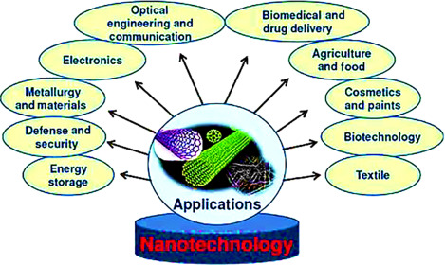
Fig 1.Applications of nanotechnology in various domains
A) SUSTAINABLEENERGY APPLICATION
The difficulty of meeting the world’s energy demand is compounded by the growing need to protect our environment. Many scientists are looking into ways to develop clean, affordable, and renewable energy sources, along with means to reduce energy consumption and lessen toxicity burdens on the environment. Prototype solar panels incorporating nanotechnology are more efficient than standard designs in converting sunlight to electricity, promising inexpensive solar power in the future. Nanotechnology is already being used in numerous kinds of batteries that are less flammable, quicker-charging, more efficient, lighter weight and that have a higher power density and hold electrical charge longer.
B)BIO MEDICINE
Nanotechnology is already heavily incorporated into medical tools knowledge and therapies are already widely in use. Nanomedicine is the application of nanotechnology in medicine. It’s used for disease prevention diagnosis and treatment. Nanoparticles can encapsulate or otherwise help to deliver medication directly to cancer cells and minimize the risk of damage to healthy tissue. This could ultimately change the way cancer is currently treated and dramatically reduce the toxic effects of chemotherapy. Suffice to say, researchers are working on it. The increased capabilities of imaging diagnostic tools enabled by nanotechnology are also paving the way for increased success rates for many different therapies.
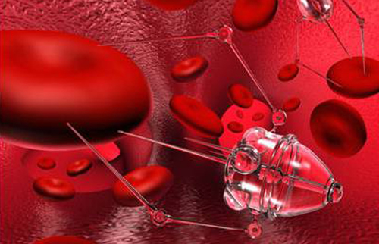
Fig 2. Application of nanotechnology in biomedicine
Nanobots in fact hold the potential to address many health problems beside cancer such as unblocking blood vessels in hard-to-reach areas taking biopsies or measuring the level of certain chemicals in otherwise inaccessible areas of the body. In the field of medical, nanorobotics holds considerable promise for advancing medical progress. Nanotechnology sounds like a solid solution to many modern medical and technological issues.
C)POSSIBILITIES IN BIG DATA
In this age of information technology, there is a huge increase in electronic data, which has produced the urgent need to effectively manage this data, spot the patterns and alert us to the problems without missing critical information. For instance, big data from traffic sensors to help manage congestions and avoid accidents, prevent crimes by using statistics to more effectively allocate police resources, to name a few. Nanotechnology plays an important role here by allowing the creation of ultra-dense memory that can store huge amounts of this data. At the same time, it’s giving them the motivation to create super-effective algorithms for handling, scrambling and conveying information without compromising its dependability.
Fig 3. Application of nanotechnology in big data
D)WATER TREATMENT
Nanotechnology really has the potential to do great things for the conservation of our planet and the human race. The availability of fresh drinking water is an increasingly pressing issue that can be linked back to population growth, urban mitigation pollution and the fast effects of events associated with climate change. Nanotechnology holds the power and promise to not only detect pollutants but to filtrate and purify the magnetic interactions between ultra-small specks of dust. Similarly, the development nanoparticles that can purify water pollutants which cost less than the process of pumping it out of the ground for treatment also holds a great promise. Basically, getting clean water is a huge problem and nanotechnology can help solve it to a very great extent.
E) ELECTRONICS
Nanotechnology has been pivotal in advancing computing and electronics leading to faster and smaller, smarter and more portable systems and products. It is now considered completely normal for a computer to be carried with one hand while just 40 years ago a computer infinitely slower was the size of a room. This has been made possible through the miniaturization of the world of microprocessors. For example transistors, the switches that enable all modern computing have reduced drastically in the briefest amount of time from roughly 250 nanometres size in 2000 to just a single nanometre in 2016. This revolution in transistors size may soon enable the memory for an entire computer to be stored in a single tiny chip increasingly faster systems have also been made possible using nanoscale magnetic tunnel junctions that can quickly and effectively save data during a system shutdown. It’s expected that using magnetic Random Access Memory (RAM) with these nanoscale junction’s computers will soon be able to almost instantly flexible, bendable, foldable, and stretchable. In normal terms they are really small and super bendy. Nanotechnology is a definite answer to a digital world that is focused on becoming smaller and more efficient.
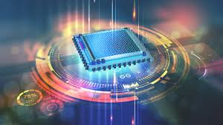

Fig 4.Application of nanotechnology in electronics

IV..DISTRIBUTION OF NANOTECHNOLOGY APPLICATIONS IN VARIOUS SECTORS

As it makes things smaller, it has more impact in our lives; such is the beauty of nanotechnology. If we can master this technology, however, then we have the opportunity to improve not just electronics but all sorts of areas of modern life.

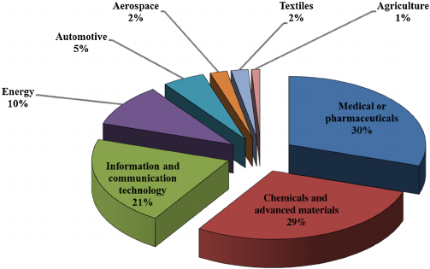
Fig 5.% Distribution of nanotechnology applications in various sectors
A )INDIA AND NANOTECHNOLGY
Efforts to promote research in nanotechnology in India began early in the millennium. The “Nanoscience and Technology Initiative” started with a funding of Rs. 60 crores. In 2007, the government launched a 5-year program called Nano Mission with wider objectives and larger funding of USD 250 million. The funding spanned multiple areas like basic research in nanotechnology, human resources development, infrastructure development and international collaboration. Multiple institutions like Department on Information Technology, Defence Researchand Development Organisation, Council of Scientific and Industrial Research and Department of Biotechnology provided the funding to researchers, scholars and projects. National Centres for Nanofabrication and Nanoelectronics were started in Indian Institute of Science, Bangalore and Indian Institute of Technology, Mumbai.
The efforts have paid off well. India published over 23000 papers in nanoscience in the past 5 years. In 2013, India ranked third in the number of papers published, behind onlyChina and USA. But there is lot of room for improvement. The amount India spends on nanotechnology research is still just a fraction of the research spending of countries like Japan, USA, France and China.
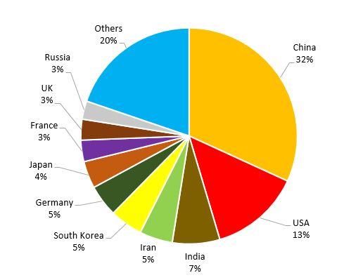
Fig 6. No of nanotechnology articles published by various countries
V.FUTURE OF NANOTECHNOLOGY
Nanotechnology has now gone well beyond the scope of science fiction stories. Nanotechnologies are now mainly interested in the composition of materials, but their potential applications go far beyond. Nanotechnology has seen a prosperous growth; it is well used and can be fundamental in the near future. It has caused a positive impact on life in the sectors of medicine, food, energy that could change our lives which makes it worthy of a science fiction story. Nanotechnology is often referred to as "the future technology" that can solve many problems. Some even talk about a nanotechnology revolution. Nanotechnology definitely brings tremendous benefits and potential, but the fact that even the youngest technology has its dangers, and much less explored, should be well known to

VI.CONCLUSION
Nanotechnology has the potential to revolutionize our lives. This is because it presents almost unlimited potential to make remarkable changes in virtually all fields ranging from medicine, computer technology, construction, environmental remediation, food industry, to new energy sources.Despite presenting many potential benefits in many areas, nanotechnology of today is still in its infancy as just a few projects have been commercialized. Many are yet to undergo full lifecycle assessment. The number of nanotechnology innovations continues to rise. However, the same cannot be said of research about their potential effects on environment and biological systems.As the world readily adapts to this new technology wave, concomitant effort should be directed to the understanding of their possible impacts. This is essential to ensure that nanomaterials do not become the new hazard of 21st century. The long-long term sustainability of this new technology may depend on the establishment of its risks.
VII.REFERENCES
[1] Pene F, Merlat A, Vabret A, et al. Coronavirus 229E-related pneumonia in immunocompromised patients. Clin Infect Dis.2003;37(7):929932.doi:10.1086
[2] Vijgen L, Keyaerts E, Moes E, Maes P, Duson G, Van Ranst M. Development of one-step, real-time, quantitative reverse transcriptase PCR assays for absolute quantitation of human coronaviruses OC43 and 229E. J Clin Microbiol. 2005;43(11):54525456.doi:10.1128/JCM.43.11.5452-5456.2005
[3] Arias LS, Pessan JP, Vieira APM, Lima TMT, Delbem ACB, Monteiro DR. Iron oxide nanoparticles for biomedical applications: a perspective on synthesis, drugs, antimicrobial activity, and toxicity. Antibiotics (Basel). 2018;7(2). doi:10.3390/antibiotics7020046
[4] Abo-Zeid Y, Williams GR. The potential anti-infective applications of metal oxide nanoparticles: a systematic review. Wiley Interdiscip Rev Nanomed Nanobiotechnol. 2020;12(2):e1592. doi:10.1002/wnan.1592
[5] Coyne DW. Ferumoxytol for treatment of iron deficiency anemia in patients with chronic kidney disease. Expert Opin Pharmacother. 2009;10(15):2563–2568. doi:10.1517/14656560903224998
[6] Ahamed M, Alhadlaq HA, Alam J, Khan MA, Ali D, Alarafi S. Iron oxide nanoparticle-induced oxidative stress and genotoxicity in human skin epithelial and lung epithelial cell lines. Curr Pharm Des. 2013;19(37):66816690.doi:10.2174/138161281131937001
[7] Ahamed M, Alhadlaq HA, Khan MAM, Akhtar MJ. Selective killing of cancer cells by iron oxide nanoparticles mediated through reactive oxygen species via p53 pathway. J Nanopart Res. 2013;15(1).doi:10.1007/s11051-012-12256
[8] Rab S, Afjal A, Javaid M, Haleem A, Vaishya R. An update on the global vaccine development for coronavirus. Diabetes2020;14(6):20532055.doi:10.1016/j.dsx.2020.10.023

