Profit Maximization in Cloud Computing Using Metaheuristic Algorithms

Dr.N.Chandramouli

Asst. Professor, Department of CSE

Vaageswari College of Engineering

Warangal,Telangana,India

[@gmail.com](mailto:naveensmitha@gmail.com)

Dr.V. Bapuji

Professor, Department of Computer Science

Vaageswari College of Engineering

Karimnagar,Telangana,India

[bapuji.vala@gmail.com](mailto:bapuji.vala@gmail.com)

ABSTRACT

Computing may be converted into a process that includes space, oxygen, electricity and nourishment as every other life product. In this situation the consumer accesses anything without disrupting the hosting location. Cloud infrastructure is the most prominent platform that aims to fulfill the idea of "computing services any time anywhere." The main aim of this chapter is commoditizing the computer services managed on distributed environments. Most of the enterprises often strive to optimize the income and reduce costs. Although IT is the essential requirement of any small business but it is not simple for them to develop and manage infrastructure. In this case, Cloud emerged with a solution to reserve the computing services.

Cloud computing is a model for allowing omnipresent, easy, on-demand network access to a shared pool of configurable data resources ( e.g. networks , servers , storage, applications and services) that can be easily distributed and published with minimal management or service provider interaction. Cloud industry development has carried with some desirable circumstances for the submission of significant work-flow applications on a scale. Specifically, Infrastructure as a Service (IaaS) creates a readily usable, adaptable and flexible framework for bringing such systems together.

Keywords—Cloud Computing; Virtual Machine; ASO-PSO; QoS; OLPSO-CS.

# INTRODUCTION

IaaS vendors provide the ability to submit low-cost job processes without needing to own the base by renting virtualized services or Virtual Machines (VMs). This helps work processes to be quickly packaged and sent. It empowers the work process administration frameworks to enter a virtually endless pool of VMs that can be accessed and discharged flexibly and are paid for any use assumption at a fee. For some period, the usage of a job method tool should be calibrated in terms of the existing client needs.

Datacenters operate as "cloud service providers," which has computer infrastructure that provides customers with numerous types of organized and effective administration. A wide variety of IT institutions like Google's Facebook , Amazon, EBay, Oracle, Microsoft, SalesForce and others own their data centers and offer cloud administrators pay-as-you-go. There are two cloud deployment types, i.e. proprietary and public, which is used in the business framework.

A public cloud is built to provide numbers of anonymous users who use similar cloud services to cloud administrations. For example, public cloud management is interested in Google's cloud (app engine) at whatever time or anywhere. Despite what might be expected, an internal usage of a unit entity is dedicated to a private cloud. Taken into consideration, Google Cloud utilizes Map Reduce, GFS, and Big Data as an integral part of its private cloud infrastructure, so these services are only available within the organization. Google uses private cloud to provide, web development, dashboard configuration, software, media distribution, and social collaboration for public cloud administration.

**2. CLOUD DEFINITION**

Foster defined cloud is a large-scale distributed computing paradigm that is driven by economies of scale, in which a pool of abstracted virtualized, dynamically-scalable, managed computing power, storage, platforms, and services are delivered on demand to external customers over Internet.

**3. CLOUD BASICS**

Cloud computing provides a variety of computing resources with the "pay as you go" governance concept across network and usually offers a broad range of software services. Now this overall cost of IT can be reduced by having different cloud platform services available. Cloud computing consists of five core features, three types of service and four modes of implementation. Multi-tenancy, flexible, service oriented, Service Level Agreement (SLA) based, virtualized, self-healing and backup are the essential characteristics. The basic services cloud computing provides are Infrastructure as a Service (IaaS), Software as a Service (SaaS), &Platform as a Service (PaaS). Four basic cloud deployment models are Private Cloud, Public Cloud, Hybrid Cloud, and Community Cloud. The central cloud computing system is often seen as a structured model in Figure 1

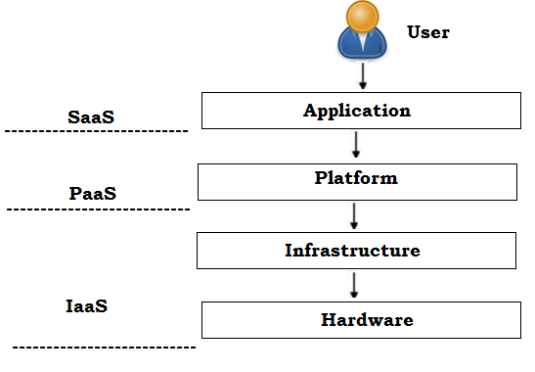

Figure 1. Layered model of cloud computing

Cloud computing has three main abstraction layers like system layer containing virtual machine of a server (IaaS), platform layer possessing Operating System ( OS) of a server (PaaS) and application layer having web application (SaaS). Cloud computing as well offers various computing services based on SLA between customer and provider. IaaS provides the customer, full control over the rented infrastructures i.e., it can be seen as the computing system of the company itself which is not operated by them. It also is called Utility Computing; this system requires the computing resources without spending in it, just like electricity and water. Microsoft, Rackspace, IBM are some of the IaaS providers.

The main concept of IaaS cloud service is that, it extends the IT resources of the organization. The large organization generates the raw computing power without any capital investment. IaaS is a foundation on which cloud computing is built and helps to build SaaS and PaaS layers on top of it. Capabilities provided to the customer are development, storage networks and other essential computing resources where consumers can implement their applications.

Server provides both software and hardware to an organization in a desired format. The easiest form is an email for an agency. SaaS opportunities grow up as it provides the computing resources to corporate, medium sized and large scale enterprises. Amazon, Google, Microsoft, SalesForce are few sources for SaaS providers. It also supports the user to function in a multitenant climate, by combining the evidence from various applications on the server. This also requires the customer to access the services of vendors operating on a cloud network which does not require the company to manage the underlying infrastructure. PaaS is a cloud-based application the customer will get from, a further variety of software tools they need to use. Unlike IaaS and SaaS it also offers pay as you go function.

PaaS provides the possibility to build and change the programs. The SaaS distribution platform is an addition. This allows the customer to deploy their software with complete hardware, running and production climate. Several sources for PaaS vendors include Google App Engine, Salesforce.com, and Microsoft Azure

Personal cloud is known as External Private Cloud (on site) and Virtual Private Cloud Hosted (hosted and operated by third parties). Personal cloud is alluded to as an organization-only computing network. The proprietary cloud services can only be used by the organization’s representatives. Private cloud is not a simple concept of providing the cloud service to the general public. This is more stable than public cloud. Private cloud’s principal downside is its heavy spending in resources. All cloud resources open to the general population are offered via Public cloud.

Cloud services are offered as a service with pay-per usage charge over the network. Public cloud provider maintains the network and shares services so it can be rendered available to the general public or even to large organizations. The key benefits of the digital cloud include low overhead, improved monetary gain, scalability, seamless connectivity, automated downloading and storage for data and devices. The main drawback of the public cloud is lack of data protection.

Hybrid cloud is made of public and private clouds. This blends the anonymity (flexibility) and public cloud (versatility) advantages. It provides cost and flexible public cloud advantages and facets of private cloud security control. This reduced capital expenditure, enhanced resource allocation; server-bursting assistance and network efficiency are the advantages of hybrid cloud. Portability of services is the main feature of the hybrid cloud.

Community cloud resides between private and public cloud with respect to customer target set. It was like a private cloud but more companies are supplied with infrastructure and resources rather than a single organization. Early investment in capital is cheaper than private cloud but higher than in the public cloud. The following benefits come from cloud computing:

* **Supports reduced IT Cost:** System and software upgrades are easier, with reduced power consumption.
* **Scalability:** Scale up or down storage and operation needs depending on the situation.
* **Flexibility:** One can connect to virtual office quickly and easily, while on offsite.
* **Collaboration:** Easy to collaborate with employees, contractors and third parties in cloud computing.
* **Automatic Updates:** Up-to-date version of software, server upgrade and computer processing power upgrade can be done easily.
* **Business Continuity:** Even in the case of natural disaster, business can be continued as data and systems are protected and backed up by the cloud provider.

**4. VIRTUALIZATION**

Shared resources are accessed via a framework virtualization when using cloud environment. Virtualization provides a logical name to each physical resource, which includes a reference to the physical resources when several requests are made by the customer.

Virtualization provides essential elements for the development of the computing environment which means that by mapping VM to PM more effectively, then it achieves capital. Virtualization lets the improvements constantly follow the exponential change in demand and computational demands and allows it immediate due to the dynamic shift in the mapping technique.

Virtualization has made the most significant variations in data center technology through the use of a set of methods and tools that support the data center management dynamic environment. This has been the most important application for allowing cloud implementation technologies. It abstracted the infrastructure’s essential entities (such as storage, processing, network, control, and I / O) that offer the cloud consumer the illusion that every resource is available at the end of the user that is handled through virtualization technology.

Virtualization is also a rational term for the digital capital. This essentially allows various computing resources to be generated and obtained. This framework is called virtual, because it provides client-requested simulation environment. Cloud computing environment implements various types of virtualization. The extensive tree is illustrated in figure 2

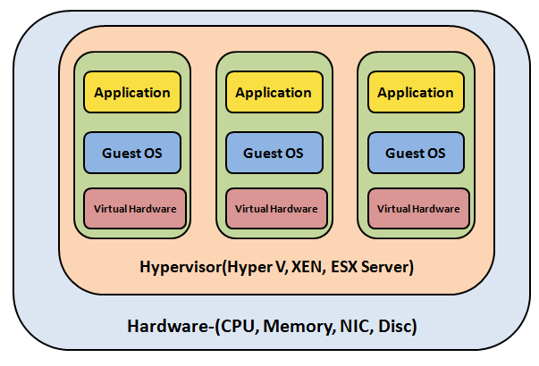

Figure 2. Layered Virtualization Technology Architecture

Virtualization technology essentially renders the cloud customer usable from various computer environments. The most common virtualization method used in IaaS is the virtualization of the hardware. The virtualization includes the user experience and framework as provided by the operating system.

Computer virtualization provides for specific device specifications to be rendered accessible on top of the same system stack. These stacks have virtual machine instances within, operating in the setting that offers total isolation to each other.

High-performance computing servers may have several instances of VM, providing an ability to provide a updated stack of applications on request. It is the fundamental strategy that helps cloud storage systems, such as Right Scale, Microsoft, VCloud, Amazon EC2, among others, to deploy virtual resources on request. Mutually with server and network virtualization and device virtualization, the IT system simulation development choice complements**.**

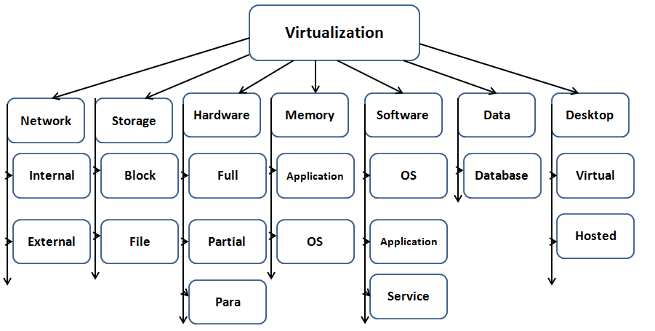

Figure 3. Types of Virtualization on different level

The definition and property in hardware and software that provides this elasticity asmeeting the requirements to essential patterns of mobility

* V2V: Virtual to Virtual
* V2P: Virtual to Physical
* C2C: Cloud to Cloud
* C2D: Cloud to Datacenter
* P2P: Physical to Physical
* D2C: Datacenter to Cloud
* D2D: Datacenter to Datacenter
* P2V: Physical to Virtual

**Network virtualization**

The network virtualization is used to abstract the network component from the end user. The different network devices are virtually available at the user side and used to monitor the entire network from the single network management software console. It controls the routers, switches, bandwidth and other components through a single interface of network administrator. It is extremely useful in the cloud environment, where there is demand of user is unpredictable and there is a rapid change in the market so the CSP cannot manage it physically. The change is so dynamic that need of client cannot be satisfied in a physical manner.

**Storage Virtualization**

In this type of virtualization physical storage is abstracted as virtual storage or virtual disc. It combined different network storage into single storage so that it pretends like single storage. The storage virtualization is implemented on block and file level. It is implemented through software tools and the major reasons to implement the storage virtualization are;

1. It provides optimum utilization of storage in the heterogeneous cloud environment.

2. It provides the enhanced availability of storage and downtime of storage can be estimated to improve the

Performance.

3. It supports the better utilization of storage device and hot swapping in case of any issues.

**Hardware Virtualization**

Hardware virtualization is a creation of virtual hardware through virtualization technology like OS and computer component. This technology was introduced by AMD and Intel for the abstraction of hardware. There are three types of hardware virtualization

**Full Virtualization:** It provides full hardware simulation environment to run the guest applications in an unmodified guest OS.

**Partial Virtualization:** It this virtualization unmodified software runs on the guests modified OS.

**Para Virtualization:** In this hardware virtualization entire application needs a modification to run on the guest OS.

**Memory Virtualization**

In this virtualization the part of the memory is amalgamated into one virtual disk available for the storage. There are many OS who are using such technology to provide the part of its hard disk as a RAM to extend it and it helps to run the large/heavy applications in cloud. There are two types of control provided by this virtualization technology i.e. application level and OS level. An application level is used to control the memory utilization through application and application can access the memory block directly while in OS level memory block is controlled through OS and it manages the entire memory management program.

**Software Virtualization**

The dynamic change in the business environment demand the same level of changes in the software used to run the business. It generates the compatibility issue in the IT infrastructure. The maintenance of such software application is such a tedious task. Software virtualization gives the solution of this problem. In this part of virtualization an instance of software is maintained by CSP. The CSP provides necessary service and support of upgrade, install and customize the software. It works on three levels on the system such as Operating System, Application and Service Level

**Data Virtualization**

It is an important entity for which cloud services are being used by the companies. The unstructured database is used, administrated and modified for the business purposes. The data can be accessed any time without following any compatible structure. The data virtualization makes it available any time with the desired format. It may be accessed by any machine with the level of authentication. The database structure must be so flexible so that no compatibility and loss issues should be generated while accessing the data by different client through different modes.

**Desktop Virtualization**

Desktop provides an interface to interact the directly to the services provided by the cloud. There may be different devices where user wants to use the cloud services. The desktop virtualization provides the availability of users interface everywhere in the same way as user customizes it. If the loss of device occurs then also there will not be any loss of data. The user can get the same desktop through the login from the new device. There are two types of desktop virtualization

**Virtual:** In this desktop virtualization a virtual desktop is available at guest machine. There are various VM to serve the virtual desktop. It is automatically updated and available through the client‘s login without machine dependency.

**Hosted:** It is virtualization every client is associated to the individual VM hosted in the different data center.

**5. HYPERVISORS**

The base level of virtualization is Virtual Machine Manager (VMM) or the hypervisor, it makes the bare machine virtualize. It creates the environment in which the base operating system runs and help the applications virtualizes so that availability of the services can be achieved. The hypervisor controls the host processor and other hardware component to run the multiple operating systems on the single machine.

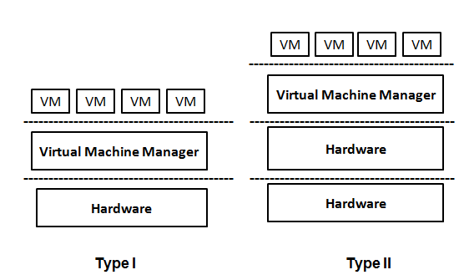

Figure 4. Types of Hypervisors

**Type-I Hypervisor**

It directly runs on the system hardware and available on bare metal level. It contains kernel driver and runs the different VM over it. So no operating systems interaction is required to run the applications. It allow the machine virtualize at the hardware level so this kind of type I hypervisor is called the native VM.

**Type-II Hypervisor**

This type of hypervisor requires the host OS to perform virtualization and its facilities. The purpose is that other operating systems run like an application software over host OS as depicted in figure 1.5.1there are different hypervisors are available for different platforms. VMM are: Containers, Parallels Desktop for Mac, KVM for Linux, VMWare Fusion, Microsoft Hyper V, VMware Workstation6.0, Wind River Simics, Virtual Server 2005 R2, and Server. Hyper-V is a hypervisor for windows platforms and Xen (used by AWS) hypervisor is used for Linux OS.

**6. PROFIT MAXIMIZATION**

Cloud service provider's main aim is to get more income and profit on investment. Cloud infrastructure provisioning is a difficult problem because the user's demands differ from time to time. In order, the cloud provider has a set number of capacity, the capacity are underutilized during valley hours, while the customer request can be denied in peak hours. Because customer expectations differ widely, the cloud provider has to handle and provide the services to fulfill client needs. Provided that a private server has a limited number of capital, infrastructure provisioning plays a significant role for user loyalty in cloud computing. At the same period, a service provider income is always an essential consideration to remember, to grow in the service sector. Often known as the cloud union, federated cloud is the process of linking several service services, handling complex shifts in customer demands and coordinating the load between services. The cloud union addresses the above pitfalls, enabling the service provider to license its services to certain vendors and even to outsource services actively from other vendors according to the difference in demand

**7. PROPOSED SYSTEM**

Compared to the physical system, VMs have many advantages, such as high availability, scalability, quick recovery backup, fast cloning and storage, etc. Server consolidation is the main advantage when using VM. This achieves consumption of 50 percent to 80 percent relative to traditional computer. At the same time it enjoys a high degree of security as VMs are completely segregated.

Modern VMs are emulated from the underlying infrastructure with the aid of hypervisor as shown in Figure.5at the top of the host OS. VMs are often produced for their applications with their own Software, with their own memory storage system drives and daemons. Because VM has its own OS, there are also limitations on the amount of VMs to be virtualized. It is also called virtualization depending on the Hardware Level, or Hypervisor, as it is entirely controlled by the hypervisor. Since VM requires hypervisor, footprint is bulky for Random Access Memory (RAM) and data. But VM's are known to be strong and expensive. Because two operating systems, namely host OS and guest OS, reside in the VM architecture, there is a two-level resource allocation and scheduling that renders a VM heavy and also sluggish in design.

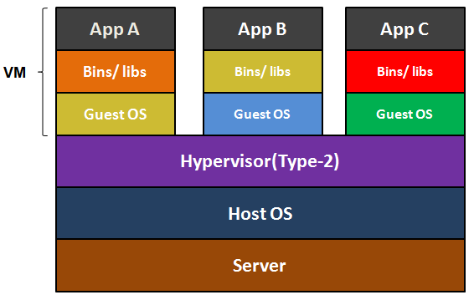

Figure 5. VM Virtualization

VM initialization period takes a few minutes as it relies on the hypervisor. Using hypervisor like Xen, Hyper-V etc., VM operates on the actual computer above. On every new program is updated, virtualization will be redone by using VM.

**8. PROFIT MAXIMIZATION USING ACO-PSO HYBRID ALGORITHM**

For cloud computing a service provider’s benefit implies strong capital spending profits. If the user's expectations exceed the cloud provider's usable services, otherwise the benefit would be important. Because the cloud provider has a limited number of space, the vendor needs to make use of the services from other different clouds as the customer demand differs dramatically from time to time. To increase the benefit, careful coordination of tasks to the resources should be done. Many meta-heuristic algorithms are required to plan the assignments to the necessary tools. Various heuristic algorithms are implemented and evaluated to maximize profit and meet the demands of users QoS requirements.

**Particle Swarm Optimization Algorithm**

Particle Swarm Optimization (PSO) algorithm is a stochastic population-based optimization established by **Kennedy et al . (1995),** motivated by the bird flocking or fish schooling social behavior. This algorithm is well adapted for both local (exploitation) and regional (exploration) queries. In PSO finding paths of the particle changes based on the whole particle's self-flying experience and social-flying experience. The effective learning mechanism varies from other evolutionary algorithms. The principal advantages of PSO are simple concept, easy to perform and computationally efficient.

**ACO-PSO Hybrid Algorithm**

The ACOPSO hybrid algorithm is introduced to incorporate the advantages of ACO and PSO algorithms. To observe that the benefit relies on the optimal usage of resources in the hybrid cloud setting, the suggested hybrid algorithm play significant role in arranging activities with the resources available. The proposed hybrid algorithm is being applied in this work to plan the function for the specific VMs in the private cloudAs well as public cloud to optimize the service provider’s benefit and increase the CPU and energy utilization efficiency and QoS guaranteed for the user.

**9. ORTHOGONAL LEARNING BASED PSO (OLPSO) ALGORITHM**

In PSO each particle utilizes its historical best experience through linear summation. Such a learning strategy is easy to use, but is inefficient when searching in complex problem spaces.But OLPSO can utilize previous search (experience) more efficiently. The OL strategy can guide particles to fly in better directions by constructing a much promising and efficient exemplar. The OL is applied to both global and local versions of PSO, yielding the OLPSO-G and OLPSO-L algorithms. The OLPSO significantly improves the performance of PSO.

**10. CUCKOO SEARCH (CS) ALGORITHM**

According to the CS algorithm, an initial set of nests, which represent the solutions, are randomly generated. These solutions are then updated over multiple generations. The process of updating an individual solution is as follows; a random nest is chosen, and a new solution is generated by random walking from this previous solution. This new solution can then replace a different randomly chosen solution if it has a fitness value better than the original. After this possible replacement of a solution, all of the nests are ranked by fitness and the worst fraction of the nests is replaced with random solutions. This combination of mechanisms allows the solutions to search locally and globally at the same time for the optimal solution. It is the best algorithm for scheduling the resources in cloud computing.

**11. ENHANCED PROFIT BY OLPSO-CS APPROACH**

Recently suggested ACO-PSO hybrid algorithm, is used in the first part of the research work to increase the cloud provider's benefit and also to obtain improved CPU and resource use. Throughout the ACO method, it is challenging to adjust the likelihood of judgment on increasing iteration and theoretical study too. Convergence is assured but in this method the level of convergence is unpredictable.

In PSO convergence speed is equally lower and does not guarantee the solution. Because both the ACO and PSO algorithms trap into local optima, the other meta-heuristic algorithms can be combined to further maximize cloud provider benefit. To further maximize the benefit, a novel hybrid algorithm composed of Orthogonal Learning Particle Swarm Optimization (OLPSO) and Cuckoo Search (CS) is suggested. This OLPSO-CS hybrid algorithm provides a greater return than the ACO-PSO solution previously suggested.

**12 PROPOSED WORK:**

**PROPOSED OLPSO-CS HYBRID ALGORITHM**

Using the hybridization of Orthogonal Learning Particle Swarm Optimization (OLPSO) and Cuckoo Search (CS) in this segment, a revolutionary resource allocation approach is effectively envisaged to solve the scheduling problem. Several investigations have marked off various techniques for the effective allocation and scheduling of resources in the cloud; however, the time-honored scheduling techniques grounded in the statistical concept have displayed clear short comings. Therefore, artificial intelligence technologies are used for mission- or resource-related scheduling procedures nowadays, the crucial reason for the same being the elimination of the conventional prediction approaches' unnecessary restrictions. The Particle swarm optimization is, in this regard, a population-based optimization method for many complex optimization problems that yield superior performance. The convergence of OLPSO and Cuckoo quest has opened the way for improved global quest and local search joint effect.

**OLPSO-CS Based Scheduling Approach**

While the basic PSO is commonly used in the fields of research and engineering, its robustness is far from adequate, which reflects the potential to effectively solve problems of divergent characteristics. Alternatively, trapping those sticky issues in to local optima is simple. Typically each particle uses the linear summation to leverageits strongest historical background along with that of the community.

The associated research strategy is simple to employ, but it is inefficient when searching takes place in the challenging space of the problem. As a consequence, PSO is begun an OL technique to find more positive results. In fact, the cuckoo quest algorithm is used elegantly to boost the scheduling process.

**Pseudo code of the hybridization of OLPSO-CS**

A step involved in the OLPSO-CS-based scheduling approach is described as follows:

*1. Start*

*2. Initialize the constraints*

*3. Initialize the population arbitrarily*

*4. Initialize position and velocity of each particle*

*5. Estimate the fitness function for each*

*6. Evaluate the personal best Pi*

*7. Compute the neighborhood best Pn*

*8. Estimate the guidance vector Po*

*9. The particles are updated by the cuckoo search operator*

*10. If stopping condition is not met, update velocity and position of each particle, and*

*go to step (5), otherwise output the resources allocated to each task*

**Flow chart of OLPSO-CS**

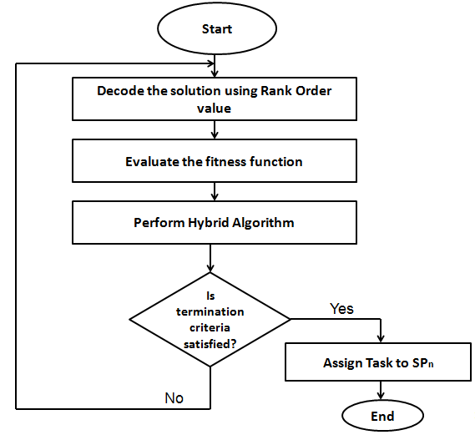

Profit Maximization

Figure 5. Shows the average profit for 50 tasks. Profit of proposed OLPSO-CS is lesser than ACO-PSO algorithm for 50 tasks on account of its reduced CPU utilization rate.

|  |  |  |
| --- | --- | --- |
| ALGORITHMS | 50 TASKS  (PROFIT IN LAKHS) | 100 TASKS  (PROFIT IN LAKHS) |
| CS | 11 | 20 |
| OLPSO | 16 | 31 |
| ACO-PSO | 21 | 40 |
| OLPSO-CS | 18 | 44 |

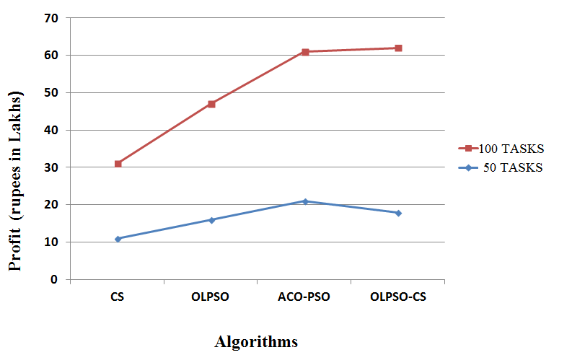

Figure 6. Average profit for 50 & 100 tasks

Figure 5 and Figure 6 represents average profit for 100 and 1000 tasks respectively. From the results obtained, it is clear that profit of the proposed hybrid algorithm is superior to other algorithms including ACOPSO hybrid algorithm for larger size tasks. Hence proposed hybrid algorithm is well suited for handling fluctuating user demands.

|  |  |
| --- | --- |
| ALGORITHMS | 1000 TASKS  (PROFIT IN LAKHS) |
| CS | 198 |
| OLPSO | 304 |
| ACO-PSO | 376 |
| OLPSO-CS | 433 |

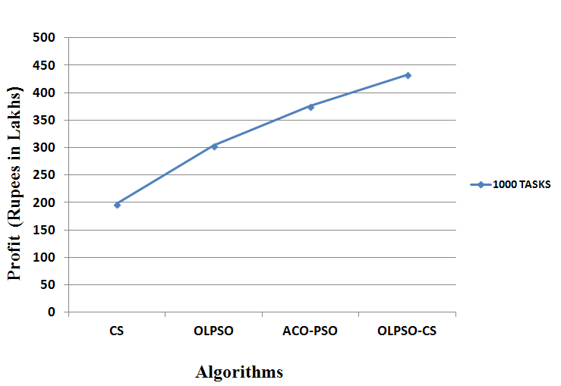

Figure 7. Average profit for 1000 tasks

**13. RUNTIME**

Average runtime of all techniques for 50 and 100 tasks, and 1000 tasks is shown in Figure 7 and Figure 8 respectively. Runtime of proposed hybrid approach is higher than OLPSO and CS algorithms and but lesser than ACO-PSO hybrid approach for all size of tasks, as its searching procedure aims for efficient task scheduling. Results obtained clearly indicates that deadline constrained task scheduling is well achieved by this proposed OLPSO-CS hybrid algorithm to ensure the user QoS requirements. Also time complexity of the proposed hybrid approach is reduced compared to previously proposed ACO-PSO hybrid technique, leading to the increased convergence rate.

|  |  |  |
| --- | --- | --- |
| ALGORITHMS | 50 TASKS(Runtime in ms) | 100 TASKS(Runtime in ms) |
| CS | 10 | 20 |
| OLPSO | 9 | 18 |
| ACO-PSO | 31 | 58 |
| OLPSO-CS | 18 | 32 |

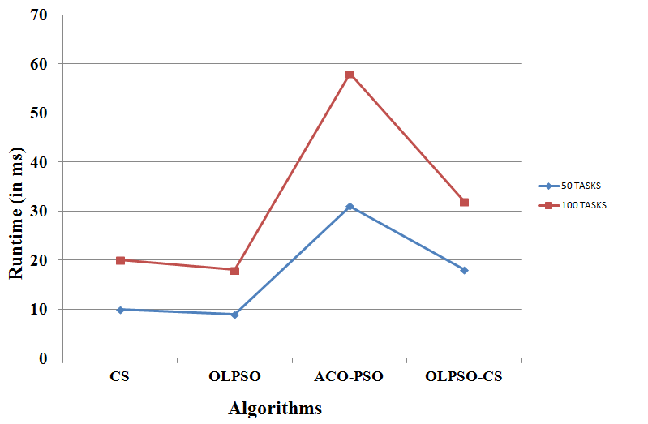

Figure 8. Average runtime for 50 and 100 tasks

|  |  |
| --- | --- |
| ALGORITHMS | 1000 TASKS(Runtime in ms) |
| CS | 198 |
| OLPSO | 182 |
| ACO-PSO | 583 |
| OLPSO-CS | 324 |

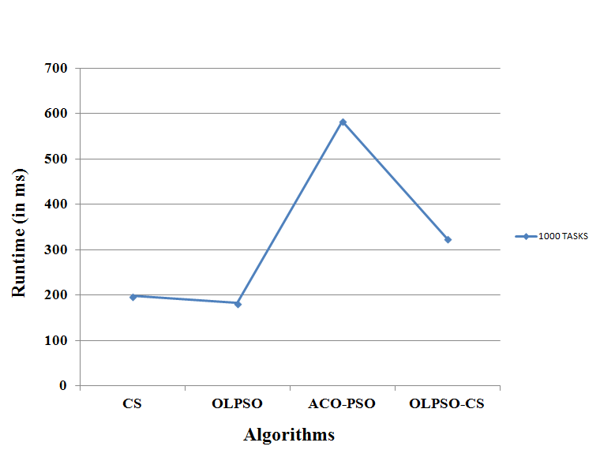

Figure 9. Average runtime for 1000 tasks

**UTILIZATION RATE**

CPU utilization rate and memory utilization rate of private cloud are discussed here.

**(a) CPU Utilization Rate**

As profit of private cloud mainly depends on the effective consumption of its own resources like CPU and memory, assessment of CPU utilization rate is necessary.CPU utilization rate is calculated using the equation. Figure 10 shows the CPU utilization rate of all techniques for 50,100 and1000 tasks. On account of reduced CPU utilization rate of private cloud for 50 tasks by the proposed algorithm, profit is decreased. Similarly, proposed OLPSO-CSapproach produces more financial gains than ACO-PSO hybrid algorithm and other techniques, as it make higher rates of CPU utilization for 100 and 1000tasks.



Figure 10. CPU Utilization Rate

**(b) Memory Utilization Rate**

Like CPU, memory is also an important resource to be considered for evaluating the profit of private cloud. Memory utilization rate is estimated using the same equation (10), for all size of tasks and arrived results of CS, OLPSO, ACO-PSO and OLPSOCS are compared. Figure 4.14 shows memory utilization rate of all approaches for 50,100 and 1000 tasks. Here also, proposed hybrid algorithm outperforms all other approaches, producing maximum profit for private cloud. On the other hand, proposed algorithm is well geared to build up the swarm continuously so as to arrive at an enhanced solution.



Figure 11. Memory Utilization Rate

**14. SUMMARY**

The term cloud computing was first coined, the simple idea behind that would lower cost with the interim or short term needs of the consumer. The cloud service providers usually attempt to maximize their profits from such standards and allow them to offer competitive price. This is mostly occurs due to the productivity and profitability gain through technological investments. As per complex user demands, the ACO-PSO hybrid algorithm is applied for job scheduling. It is not efficiently work out. In order to enhance the profits for service providers a meta-heuristic hybrid algorithm OLPSO-CS is proposed. The proposed hybrid algorithm is applied on private cloud services. This algorithm provides predictable cost outlay and provides a steady stream of income for the service provider and a vision of increased earnings and cost reduction in a foreseeable future

**REFERENCES:**

[1]. A. A. Pirzada and C. Mcdonald, *“Trust Establishment in Pure Ad Hoc Networks,”* *Wireless Personal Communications*, vol. 37, no. 1-2, pp. 139-168, Apr. 2006.

[2]. D. Gambetta’ *“Can we trust trust?,”* in D. Gambetta, editor, *Trust: Making and Breaking Cooperative Relations*, chapter 13, pages 213.237. Department of Sociology, University of Oxford, electronic edition, 2000.

[3]. M. Blaze, J. Feigenbaum, and J. Lacy, *“Decentralized trust management,” in Security and Privacy, 1996. Proceedings.,” IEEE Symposium on*, 1996, pp. 164–173, 1996.

[4]. S. Marsh, “*Formalizing Trust as a Computational Concept*,” PhD thesis, University of Stirling, Uk, 1994.

[5]. A.Rajaram and Dr.S.Palaniswami *“A Trust-Based Cross-Layer Security Protocol for Mobile Ad hoc Networks,”* in (IJCSIS) International Journal of Computer Science and Information Security, Vol. 6, No. 1, 2009.

[6]. P. Michiardi, *“Core: a collaborative reputation mechanism to enforce node cooperation in mobile ad hoc networks,”* *Proceedings of the IFIP TC6/TC11 Sixth*, pp. 107–121, 2002.

[7]. Y. L. Sun, Z. Han, W. Yu, and K. J. R. Liu, *“Attacks on trust evaluation in distributed networks,”* in *Information Sciences and Systems, 40th Annual Conference* , pp. 1461–1466, 2006.

[8]. S. D. Kamvar, M. T. Schlosser, and H. Garcia-Molina, *“The eigen trust algorithm for reputation management in p2p networks,”* in *Proceedings of the 12th international conference on World Wide Web*, pp. 640–651, 2003.

[9]. Reddy DS, Bapuji V, Govardhan A, et al. Sybil attack detection technique using session key certificate in vehicular ad hoc networks. In: 2017 international conference on algorithms, methodology, models and applications in emerging technologies (ICAMMAET), Chennai, India, 16–18 February 2017, pp.1–5. New York: IEEE

[10]. P. Velloso, R. Laufer, D. D. O. Cunha, O. C. Duarte, and G. Pujolle, *“Trust management in mobile ad hoc networks using a scalable maturity-based model,”* *IEEE Transactions on Network and Service Management*, vol. 7, no. 3, pp. 172-185, Sep. 2010.

[11]. A. Patwardhan, J.Parker, M.Iorga, A. Joshi, T.Karygiannis and Y.Yesha “*Threshold-based Intrusion Detection in Ad hoc Networks and Secure AODV*” Elsevier Science Publishers B. V., Ad Hoc Networks Journal (ADHOCNET), June 2008.

[12]. Tarag Fahad and Robert Askwith *“A Node Misbehaviour Detection Mechanism for Mobile Ad-hoc Networks*”, in proceedings of the 7th Annual PostGraduate Symposium on The Convergence of Telecommunications, Networking and Broadcasting, June 2006.

[13]. Ernesto Jiménez Caballero*,“Vulnerabilities of Intrusion Detection Systems in Mobile Ad-hoc Networks - The routing problem”,* 2006*.*

[14]. Yanchao Zhang, Wenjing Lou, Wei Liu, and Yuguang Fang*, “A secure incentive protocol for mobile ad hoc networks”,* Wireless Networks(WINET), vol 13, No. 5, October 2007.

[15]. Liu, Kejun Deng, Jing Varshney, Pramod K. Balakrishnan and Kashyap “*An Acknowledgment-based Approach for the Detection of Routing Misbehavior in MANETs*”, IEEE Transactions on Mobile Computing, May 2007.

[16]. Afzal, Biswas, Jong-bin Koh,Raza, Gunhee Lee and Dong-kyoo Kim, *"RSRP: A Robust Secure Routing Protocol for Mobile Ad Hoc Networks",* in proceedings of IEEE Conference on Wireless Communications and Networking, pp.2313-2318, April 2008.

[17]. Bhalaji, Sivaramkrishnan, Sinchan Banerjee, Sundar, and Shanmugam, *"Trust Enhanced Dynamic Source Routing Protocol for Ad hoc Networks*", in proceedings of World Academy of Science, Engineering and Technology, Vol. 36, pp.1373-1378, December 2008.

[18]. Meka, Virendra, and Upadhyaya*, "Trust based routing decisions in mobile ad-hoc networks*" in Proceedings of the Workshop on Secure Knowledge Management, 2006.

[19]. Muhammad Mahmudul Islam, Ronald Pose and Carlo Kopp, *"A Link Layer Security Protocol for Suburban Ad-Hoc Networks",* in proceedings of Australian Telecommunication Networks and Applications Conference, December 2004.

[20]. Shiqun Li, Tieyan Li, Xinkai Wang, Jianying Zhou and Kefei Chen *"Efficient Link Layer Security Scheme for Wireless Sensor Networks",* Journal of Information And Computational Science, Vol.4, No.2,pp. 553-567, June 2007.

[21]. Chin-Yang Henry Tseng, *“Distributed Intrusion Detection Models for Mobile Ad Hoc Networks,”* University of California at Davis Davis, CA, USA, 2006.

[22]. M. R. Prasad, R. L. Naik and V. Bapuji, "Cloud computing: Research issues and implications", *Int. J. Cloud Comput. Services Sci.*, vol. 2, no. 2, pp. 134, Jan. 2013.

[23]. Reddy DS, Bapuji V, Govardhan A, et al. Sybil attack detection technique using session key certificate in vehicular ad hoc networks. In: 2017 international conference on algorithms, methodology, models and applications in emerging technologies (ICAMMAET), Chennai, India, 16–18 February 2017, pp.1–5. New York: IEEE

[24]. Haifeng Yu et al, “*Defense against Sybil Attacks via Social Networks*”, SIGCOMM 2006, Pisa, Italy, September, 2006