Influence of Injection Timing (IT) on the Performance and Emission Characteristics of a Diesel Engine Operated on Dual-Fuel Mode.

Sushrut S. Halewadimath  Department of Mechanical Engineering,  K.L.E. Institute of Technology, Hubballi-27, Karnataka, India.  Email ID: sushrutsh@kleit.ac.in | Shrinivas Timmanagoudar  Department of Mechanical Engineering,  K.L.E. Institute of Technology, Hubballi-27, Karnataka, India.  Email ID: shrinivasnt@kleit.ac.in | Sucheet M. Gogeri  Department of Mechanical  Engineering,  K.L.E. Institute of Technology, Hubballi-27, Karnataka, India.  Email ID: sucheet@kleit.ac.in | N. R. Banapurmath  Department of  Mechanical Engineering,  K.L.E. Technological University, BVB Campus, Hubballi-31, Karnataka, India;  Email ID: nr_banapurmath@kletech.ac.in | Anand K Joshi  Department of Mechanical Engineering,  Presidency University Bengaluru Karnataka, India.  Email ID: anandkjoshi.mech@gmail.com

ABSTRACT
In present scenario fossil fuels are getting depleted, in addition to this dependency and price are increasing. A time may come in future there might have no fossil fuel left. Hence we need to make use of alternate fuels, in order to make a better future. Therefore renewable fuels can be predominantly used as fuel for transportation and power generation applications. In view of this background, effect of injection timing (IT) on the performance, combustion and emission characteristics have been investigated in a single cylinder, four stroke water cooled direct injection (DI) compression ignition (CI) engine operated on dual fuel mode using Neem Oil methyl ester (NeOME) and producer gas induction. In the present experimental investigation, an effort has been made to enhance the performance of a dual fuel engine utilizing different IT (19º to 31º in step of 4º ) was optimized. Results of investigation on NeOME-producer gas operation showed increased brake thermal efficiency with reduced emission levels at 27^{O} before top dead center (bTDC).

Keywords: Neem Oil Methyl Ester (NOME), Injection, power generation, Dual fuel engine.

INTRODUCTION

The fuels are used in several sectors like Automobiles, Industries, Power plants, Power generation engines(generator) to produce a power for further application. Beside these problems the researchers are found that during next 30 to 40 years there will complete depletion of fossils fuels and no fuel left to run vehicles or machines and now at present conditions are showing that there is continuously increasing of fossil fuel price and also usage parallel [1,2,3,4].
In the rural areas farmers use fuels in power generation purpose which produces gases like CO, NO_{x}, sulphur oxides, particulate matters etc., which are harmful for the environment, animal life and human life. The use of biofuel as alternative fuel has a more advantages. The biofuels may be alcohol, vegetable oil etc.,[5,6,11] The using of biofuels reduces the environment pollution and dependence on fuels. The CO₂ produced from burning of bio fuel does not much affect the environment. The CO₂ produced from burning of biofuels forms the complete cycle of CO₂ .Hence we can use alternate fuels like neem oil, rice bran oil, methane etc. in dual combustion engine to generate electricity using producer gas produced from agricultural wastes and bio wastes.[7]

In the present work neem oil as bio fuel which is produced by transesterification process, and biogas is produced by gasification method using wood, to conduct experiment on duel fuel engine. Duel fuel engine is a engine that uses a two fuels for the production of power. Neem oil is used as a primary fuel and producer gas as a secondary fuel to get a high efficiency from engine[12]. As neem trees are abundantly available and it is highly growing plantation in our country. As per the present calculation the growth is higher, which we get 60% of dry fruit of which constitutes 40%, kernel 17%of seed. It is said that there will be no diseases where there are more neem trees. [8,9,10]

2. Materials and Methods

In the present work NeOME and Producer gas derived from neem biomass (PG-NeOEM) have been used as injected and inducted fuels respectively. Properties of NeOME and PG-NeOEM are presented in Table 1.

Table 1. Properties of fuels used
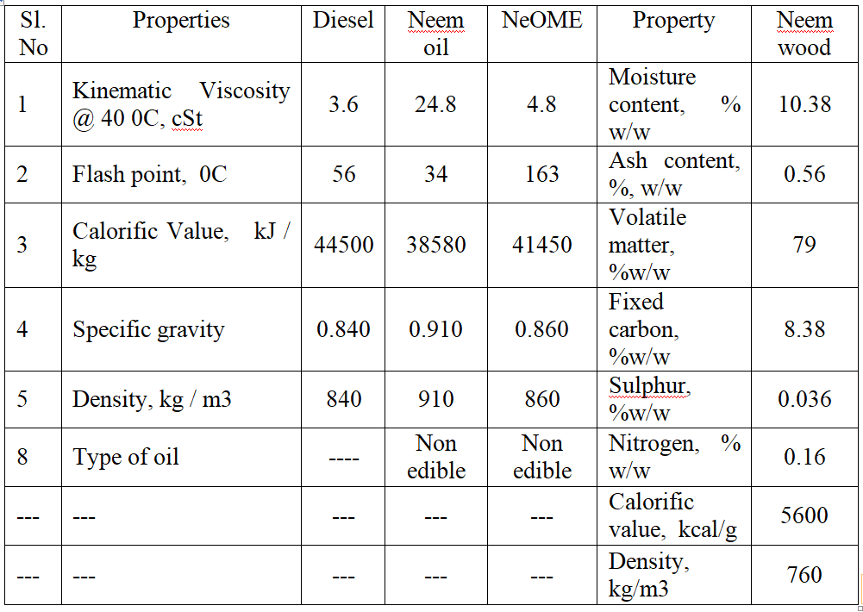

3. Experimental set-up and methodology
Diesel engine was coupled to the down draft gasifier and was operated on dual-fuel mode under various engine loads at 1500 rpm. Diesel engine mainly involves, downdraft gasifier; cooling-cleaning system, flow meters and other accessories as shown in Figure 1. The engine has eddy current dynamometer used for engine loading. The complete specification of both diesel engine and gasifier is presented in Table 2 and 3.During experimentation; data generated are recorded in the data acquisition system. Calibrated venturimeter was used to measure PG flow rate, (digital). Similarly, burette and single tube manometers are used to measure air and pilot fuel flow rate. Piezoelectric transducer was used to measure in-cylinder pressure, and mounted to the cylinder head. In-cylinder pressure was recorded for every crank angle and stored in a data acquisition system. Diesel engine had a conventional mechanical fuel injection (CMFI) system. It has 3 holes, and each hole has 0.3 mm diameter. Injector for the NeOME–PG operations, Manufacturer specified static IT and IOPas 23ºbTDC and 205 bar respectively.
IT was varied from 19ºbTDC to 31ºbTDC in steps of 3º. Exhaust gas emissions were recorded with Hartridge smoke meter and five-gas analyzer after periodic calibration and steady state conditions.
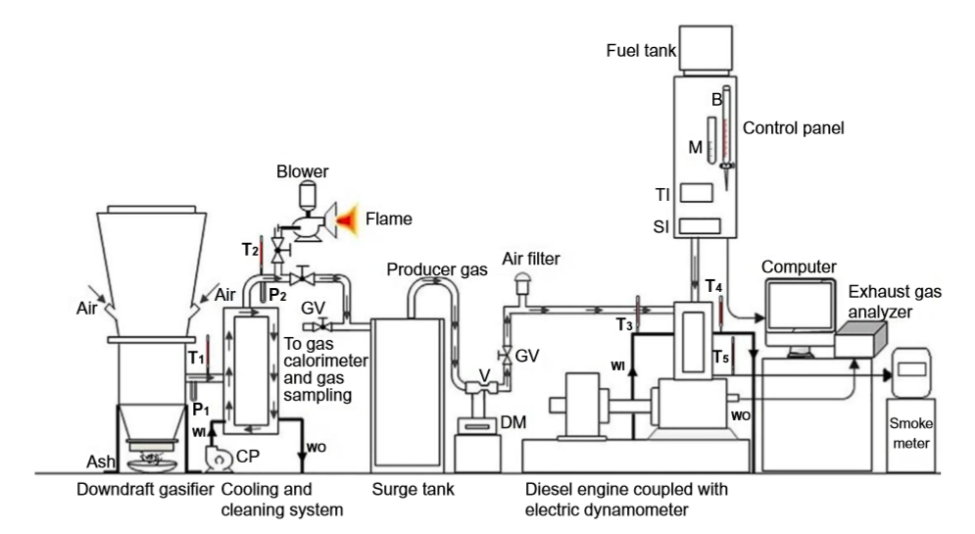
Figure 1. Experimental Test Rig
Table 2. Specifications of engine

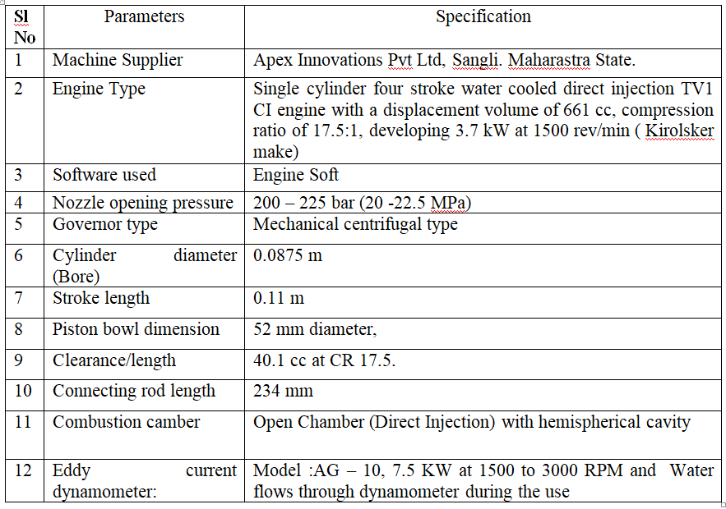

Table 3.Specification of the downdraft gasifier
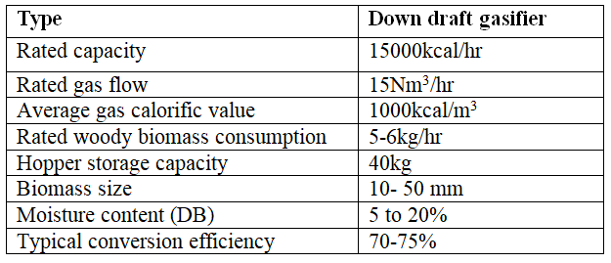

3.1 Uncertainty analysis
During experiment while measuring parameter the uncertainties are most common due to random and systematic errors. Table 4. Gives list of uncertainties in the calculated parameters.
Table 4. The uncertainties in the calculated parameters
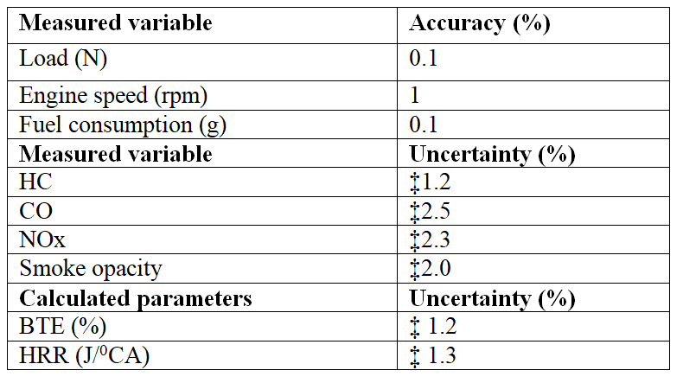
4.0 Results and discussions
During experimentation, IT has been optimized in terms of enhanced performance, combustion emission characteristics while PG flow rate and engine speed were maintained constant. A suitable carburetor was used to ensure air–gas mixture at stoichiometric ratio.

4.1 Effect of Injection Timing:
For a single cylinder diesel engine fuelled with producer gas and neem oil methyl ester. The basic emission characteristics and performance is tested with varied injection timing(19°,23º and 27º bTDC). Variable load test was conducted at rated speed of 1500 rpm and with selected compression ratio of 17.5 and an injector opening pressure of 205bar for each load air flow rate, fuel flow rate, exhaust gas temperature, HC, CO, smoke, and NOx emissions are recorded. A 3-hole injector of 0.3 mm diameter orifice are selected for studies. Based on results optimum injection timing was determined for selected fuel combination.

4.2 Effect of injection timing on brake thermal efficiency

From fig. 2 brake thermal efficiency values of NeOME along with producer gas as dual fuel is lower compared to diesel tested for 3 injection timings. For the same output power, the fuel consumption is high and low energy is attributed due to which there is decrease in brake thermal efficiency. The viscosity of NeOME is high but formation of mixture is poor compared to diesel. The brake thermal efficiency of NeOME and diesel are 16.5 % and 18 % at 27º bTDC. By advancing the injection timing by 4 o there is increase in brake thermal efficiency. Therefore, for NeOME the observed brake thermal efficiency values were 15.5% and 16 % at 19º bTDC and 23º bTDC. The brake thermal efficiency values of optimum injection timing for NeOME were 27º bTDC.

Figure 2.IT vs. Break Thermal Efficiency

4.3 Effect of injection timing on smoke capacity:
From fig. 3 smoke emission for both fuel decreases with advanced Injection timing. Improper Air-fuel ratio and improper mixing, the combustion is incomplete when injection timing is advanced to 27º bDTC from 19º bTDC, the fuel injection occurs at low temperature and pressure in cylinder due to this the smoke level falls. This results in increase of Injection delay and lower smoke The smoke emission with NeOME is found to be minimum for 27º bTDC for advanced injection timing. NeOME smoke emissions were 68HSU,65,60 with injection timings 19º,23º and 27º bTDC at 80% load.

Figure 10.IT vs. Smoke Opacity
4.4 Effect of injection timing on HC and CO emissions:
The lean mixture during delay period and under mixing of fuel coming out of fuel injector nozzle at low velocity is the reason for hydrocarbon emissions in diesel engines. For 19º, 23º and 27º bTDC injection timings the hydrocarbon emission values of NeOME at 80% load were 68ppm, 65ppm and 62ppm. One of the toxic by-product with incomplete combustion is carbon monoxide. For all injection timings the CO is increased at higher loads and decreased at part loads. At 19º, 23º and 27º bTDC injection timings the amount of CO is 0.52%, 0.48% and 0.45% for NeOME at 80% load. As compared to other injection timings of 19º and 23º bTDC lowest CO levels were found at the optimum injection timing 27º bTDC. Fig (11 & 12) shows that effect of injection timing on HC and CO emissions.

Figure 11.IT vs. HC emissions

Figure 12.IT vs. CO emissions
4.5 Effect of injection timing on NOx emission:

In general, there is substantial reduction in NOx emissions for retarded injection timings. The combustion process is retards as Injection timing retards. The Concentration levels of NOx were found to be lower at lower peak temperatures. For Injection timings of 23º,27º bTDC NOx levels were higher and also due to higher ignition delay leads to sharp premixed heat release. With operation of NeOME, NOx emissions were higher at injection timing of 31º bTDC compared to 19º, 23 º and 27º bTDC. It is concluded that 19º bTDC injection timing is optimum for home based on the results. Fig (13) shows the effect of Injection timing of NOx emissions.

Figure 13.IT vs. NOx emissions
.
Conclusion:

From the experimental observation the combustion efficiency is found to be less compared to the diesel fuel but by advancing the Injection timing the performance is improved. Favourable results are found by varying Injection timing from 19º to 31º bTDC. Hence for diesel engines NeOME can be used as an alternate fuel.

Refereance

[1] Kamalapur, G. D., & Udaykumar, R. Y. (2010). “Electrification in rural areas of India and consideration of SHS”. 2010 5th International Conference on Industrial and Information Systems. doi:10.1109/iciinfs.2010.5578635
[2] Adrian N. Zomers. March (2003). “The Challenge of Rural Electrification Energy for Sustainable
Development” 7(1):69-76 DOI: 10.1016/S0973-0826(08)60349-X

[3] Neem Abas Kalair. March (2015). “ Review of Fossil fuels and Future Energy Technologies” Futures 69 DOI: 10.1016/j.futures.2015.03.003
[4] Michael Hoel , Snorre Kvernodokk. February (1996). “Depletion of fossil fuels and the impacts of global warming” Resource and Energy Economics 18(2):115-136 DOI: 10.1016/0928-7655(96)00005-X
[5] Manieniyan V, M. Thambidurai, R. Selvakumar. December (2009). “Study On Energy Crises And The Future Of Fossils Fuels”. DOI: 10.13140/2.1.2234.3689 Conference: Proceedings of SHEE 2009
[6] A.G. Chmielewski. January(2005). “Environmental Effects of Fossil Fuel combustion”
[7] Abulaziz Atabani (A.E.Atabani). January(2013). “Alternate Fuels Research Progress”
[8] S. Rostami, B. Ghobadian, M. Kiani Deh Kiani. December (2014). “Effect of Injection timing on the Performance of a Diesel Engine using Biodiesel Blends”. International Journal of Automotive and Mechanical Engineering 10(1):1945-1958 DOI:10.15282/ijame.10.2014.12.0163
[9] Srinath Pai, Ashath Shettigara, Dr. Abdul sharief, Dr. Shreeprakash B. May (2016) “Effect of Injection Timing performance and emission of a direct injection diesel engine fuelled with Simarouba biodiesel blend”. Conference: TWO DAY NATIONAL CONFERENCE ON “Advances in Mechanical Engineering Sciences” (NCAMES-2016) At: SRINIVAS INSTITUTE OF TECHNOLOGY in Association with SEVENTH SENSE RESEARCH GROUP, Mangalore Volume: 1
[10] Emad A. Shalaby. March (2013). “Biofuel; sources, Extraction and Determination” DOI: 10.5772/51943 In book: Liquid, Gaseous and Solid Biofuels - Conversion Techniques
[11] Federcia Perera. December (2017 ). “Pollution From Fossil-Fuel combustion is the Leading Environmental Threat to Global” Pediatric Health and Equity: Solutions Exist International Journal of Environmental Research and Public Health 15(1):16 DOI: 10.3390/ijerph15010016 .lLicense CC BY
[12] Md. Hasan Ali, Mohammad Mashud, Md Rowsonozzaman Rukibul Hossain Ahmad. December (2013). “Biodiesel From Neem Oil as an Alternate Fuel For Diesel Engine” Procedia Engineering 56:625–630 DOI: 10.1016/j.proeng.2013.03.169 .License CC BY-NC-ND 3.0

