Crypto-Microbiology: Decoding Cryptic Microbial
Interactions in the Dark Web

Shruti Awasthi¹, Lahar Khandelwal¹, Archana Nalinan¹,
Disha Maheshwari¹, Chethana V Chalapathy²*
Garden City University, Bangalore
shruti.awasthi@gardencity.university,archnanalinan@gmail.com, laharkhandelwal@gmail.com , maheshwaridisha8@gmail.com ,.
* Corresponding author. Tel: +91 78998 49374, chethana.v@gardencity.university
- Assistant Professor, Department of Life Sciences, Garden City University, Bangalore
- Ar, Department of Life Sciences, Garden City University, Bangalore
- Assistant Professor, Department of Life Sciences, Garden City University, Bangalore

1. Introduction
In the vast realm of the internet, where information flows freely and connections between individuals are made effortlessly, lies a concealed underworld known as the Dark Web. This hidden network of encrypted websites and anonymous communication channels has become a breeding ground for illegal activities, serving as a haven for cybercrime, illicit trade, and underground communities. However, beyond the malevolent activities that typically define the Dark Web, there exists a lesser-known domain that harbors a diverse ecosystem of cryptic microbial interactions (Bradbury D et al., 2014).
1.1 Unveiling the Hidden World of Cryptic Microbial Interactions
Cryptic microbial interactions refer to the covert relationships established between microorganisms within the Dark Web's clandestine corners. The internet's anonymity and the encrypted nature of the Dark Web offer an environment where these microscopic organisms can thrive, undetected and understudied. Here, microorganisms engage in complex networks of symbiotic, parasitic, or competitive relationships, forming intricate webs of interaction that remain largely unexplored (Liu C et al., 2020). For example, within the Dark Web's microbial ecosystem, certain bacteria may establish mutualistic relationships with each other, exchanging vital resources or signals to enhance their survival.
1.2 Significance of Decoding Cryptic Microbial Interactions
Cryptographic microbial interactions are crucial for microbiology, ecology, and cybersecurity as they reveal dynamics, mechanisms, and resilience in hostile environments. Understanding these webs can lead to therapeutic strategies and ecosystem management. This chapter explores cryptic microbial interactions on the Dark Web, analyzing diverse communities, composition, structure, and potential applications in medicine, agriculture, and environmental management. It addresses challenges and ethical considerations, including privacy and cybersecurity. The chapter aims to improve microbial ecology, advance knowledge of hidden environments, and unlock untapped potential (Pierce EC et al., 2022).
2. Defining Cryptic Microbial Interactions
Cryptic microbial interactions refer to the intricate and often covert exchanges that occur between microorganisms in diverse ecological settings. These interactions are characterized by their elusiveness and the difficulty of observing or deciphering them using conventional microbiological techniques. The emergence of the dark web, with its clandestine networks and hidden platforms, has provided an intriguing backdrop for investigating cryptic microbial interactions, giving rise to the field of crypto-microbiology (Francke W et al., 2005).
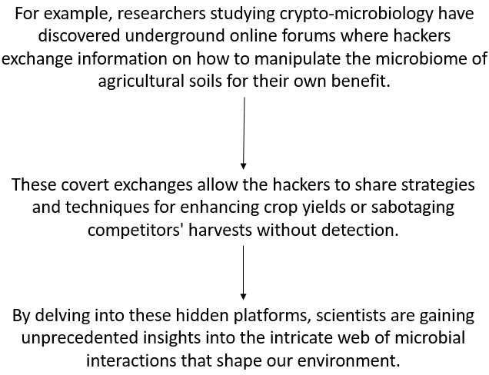
Figure 1: Example of cryptic microbial interactions
2.1 Understanding Cryptic Interactions in Microbial Ecology
Microbial ecology studies the complex relationships between microorganisms and their environment, focusing on cryptic interactions that evade direct detection and analysis (Schauder S et al., 2001). These interactions include chemical signaling, molecular communication, and quorum sensing. These covert strategies influence ecosystem dynamics and community structure, allowing bacteria to coordinate actions and form complex social networks. Understanding these hidden interactions is crucial for uncovering the intricacies of microbial life (Savoia D et al., 2012).
2.2 Types and Examples of Cryptic Microbial Interactions
Cryptoctic microbial interactions involve various forms, each with its own implications for microbial ecology. Common examples include chemical signals production and sensing, which enable microbes to communicate and coordinate their behavior. Cheating in microbial cooperation occurs when microbes exploit others' cooperative behavior without contributing to the collective benefit (Guimera R et al., 2005). This can have significant consequences for the stability and functioning of microbial communities. Cryptoctic interactions can also involve the production of antimicrobial compounds or the development of resistance mechanisms. Microbes may engage in chemical warfare, releasing antimicrobial substances to suppress competitors or defend territory. In response, other microbes develop resistance mechanisms, leading to an ongoing arms race within microbial communities (Reuter JA et al., 2015).
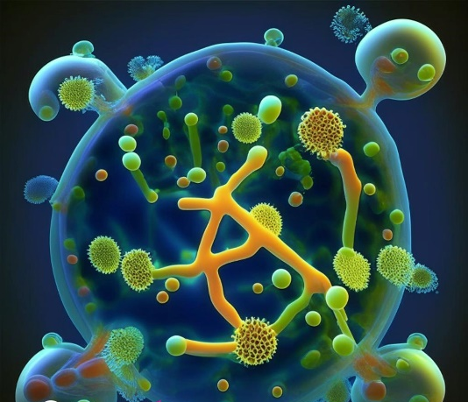
Figure 2: Autoinducers detected by neighboring microbes, enabling collective behaviors
2.3 Challenges in Studying Cryptic Microbial Interactions
Crypto-microbiology faces challenges due to its hidden nature and complexity. Observing interactions is challenging due to microscopic scales, transient nature, and real-time monitoring (Dickson RP et al., 2014). Deciphering intricate molecular mechanisms requires a multidisciplinary approach involving microbiology, molecular biology, bioinformatics, and computational modeling. Advancements in technology, such as high-throughput sequencing, metagenomics, and imaging techniques, offer promising avenues for understanding cryptic interactions within microbial communities (Hugenholtz P et al., 2008).
3. Experimental Approaches for Unravelling Cryptic Interactions
3.1 Culture-Independent Techniques for Detection
Traditionally, studying microbial interactions relied on culturing microorganisms in the laboratory, which often fails to capture the complexity of microbial communities, especially those involved in cryptic interactions (Bashiardes S et al., 2016). Culture-independent techniques, such as metagenomics, have emerged as powerful tools for detecting and characterizing hidden microbial interactions. Metagenomics helps identify genes present in a sample, allowing researchers to compare gene profiles across different samples, reducing potential interactions and metabolic pathways within the community (Liu C et al., 2021).
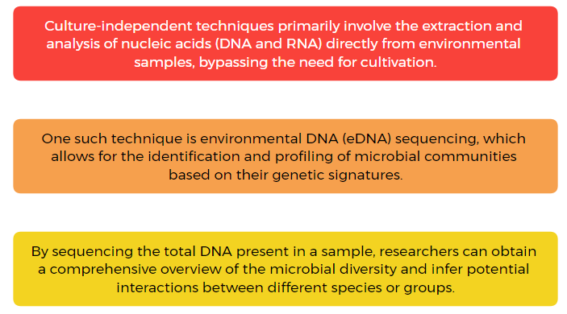
Figure 3: Culture-Independent Technique
3.2 Metagenomics and Meta transcriptomics
Metagenomics and meta transcriptomics are two techniques that revolutionize microbial ecology by studying unculturable microorganisms and their interactions. Metagenomics involves sequencing DNA from environmental samples and reconstructing their genomes, allowing researchers to infer potential interactions like syntrophic relationships and metabolic exchanges (Hu P et al., 2016). Meta transcriptomics analyzes microbial gene expression within a community, identifying genes involved in cryptic interactions. Combining these techniques provides a comprehensive understanding of the microbial community's genetic potential and functional activities, shedding light on cryptic interactions within the dark web of microbial ecology (Reece A et al., 2016).
3.3 Single-Cell Analysis and Microfluidics
Single-cell analysis techniques enable studying individual cell-level microbial interactions, uncovering intricate details of cryptic interactions (Waters CM et al., 2005). Single-cell genomics and microfluidics provide insights into genetic makeup and interactions, revealing novel microbial lineages and rare taxa. Combining these techniques with microfluidics allows for high-throughput analysis and manipulation of microorganisms, enabling unprecedented resolution in cryptic microbial interactions. This combination enables identification of individual cells involved in specific interactions, characterization of gene expression patterns, and visualization of spatial organization within the community (Whiteley M et al., 2017).
We now have a better understanding of the complexity and diversity of microbial communities in the digital age thanks to experimental methods like culture-independent techniques, metagenomics, meta transcriptomics, single-cell analysis, and microfluidics.
4. Chemical Signaling in Cryptic Interactions
4.1 Quorum Sensing and Signaling Molecules
In the clandestine realm of microbial interactions within the dark web, chemical signaling plays a pivotal role in facilitating cryptic communication. Microorganisms can respond to changes in population density by using signaling molecules thanks to a mechanism called quorum sensing. When the population reaches a certain threshold, this process, like in a biofilm, enables bacteria to modify their behavior and produce sticky molecules. Microbes produce and release signaling molecules like autoinducers that serve as molecular messengers and help the community survive and thrive in their secret environment (Whiteley M et al., 2017).
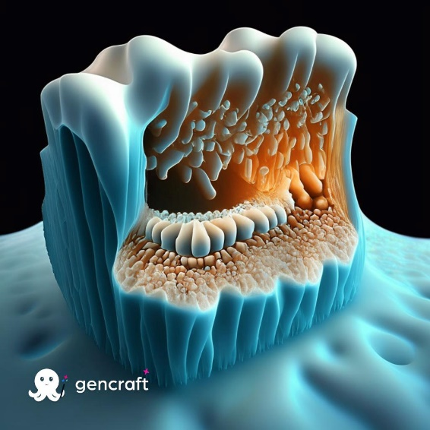
Figure 4: A biofilm of bacteria coating a surface, such as the lining of your teeth, quorum sensing allows the population to collectively adjust their behaviors.
4.2 Cryptic Communication and Quorum Quenching
While quorum sensing is an essential tool for microbial communities, the dark web harbors a distinct realm of cryptic communication. Cryptic communication refers to the exchange of information among microorganisms that occurs without the detection of traditional quorum sensing molecules. In this covert domain, microorganisms have evolved alternative signaling strategies to remain undetected and communicate subversively (Grandclément C et al., 2016).
Quorum quenching is a cryptic communication phenomenon where microorganisms disrupt or inhibit signaling pathways, giving them a competitive advantage. For example, Pseudomonas aeruginosa uses lactonase enzyme to degrade signaling molecules, preventing virulence factors activation and enabling colonization and infection in specific niches.

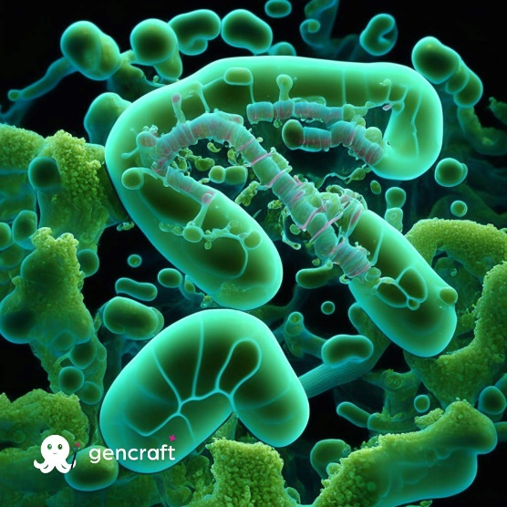
Figure 5: Pseudomonas aeruginosa use a lactonase enzyme to degrade signaling molecules

4.3 Role of Cryptic Signaling in Microbial Communities
The dynamics and behavior of microbial communities on the dark web are significantly impacted by cryptic signaling. Complex symbiotic relationships, competitions, and alliances are driven by these covert interactions. In order to overcome the particular difficulties posed by the encrypted environment, microbial communities adapt, creating intricate webs of interdependence and niche-specific communities. The development of specialized ecosystems within the depths of the dark web is also aided by cryptic signaling (Uroz S et al., 2009). The study of cryptic signaling in microbial communities, which reveals evolutionary dynamics and offers potential applications, is known as crypto-microbiology. This information may have implications for biotechnology and cybersecurity, opening up new opportunities for utilizing mysterious microbial interactions (Shi Y et al., 2017).
5. Covert Cooperative Behaviors
The dark web, with its clandestine nature and encrypted communication channels, has become a breeding ground for a variety of cryptic microbial interactions. In this chapter, we delve into the fascinating world of crypto-microbiology, focusing on the deciphering of these enigmatic cooperative behaviors that occur within this hidden realm. Specifically, we explore mutualistic symbioses, synergistic interactions, metabolic cooperation, and cryptic cooperation in antibiotic production (Shi Y et al., 2017).
5.1 Mutualistic Symbioses in the Dark Web
Within the dark web ecosystem, microbial organisms have evolved to form mutualistic symbioses, where different species interact in a mutually beneficial manner. These partnerships can involve the exchange of resources, protection from threats, or even enhanced survival in hostile environments. The encrypted environment of the dark web provides a unique setting for the establishment of such covert collaborations (Shank EA et al., 2009).
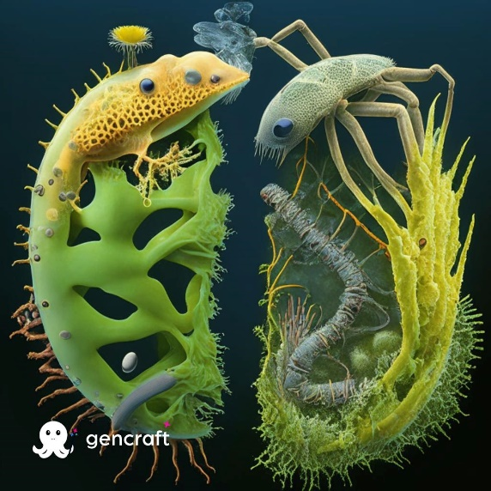
Figure 6: Mutualistic Symbioses
5.2 Synergistic Interactions and Metabolic Cooperation
In the dark web, microbial entities with complementary abilities frequently interact and cooperate metabolically in order to be more effective and successful. By sharing enzymatic processes and exchanging metabolites, these interactions enable organisms to take advantage of resources that would otherwise be inaccessible to them. In crypto-microbiology, botnet-based ransomware attacks take advantage of this symbiotic relationship to deploy cyberthreats quickly and covertly (Ankitha S et al., 2019).
5.3 Cryptic Cooperation in Antibiotic Production
A hidden economy that engages in illegal activities like the sale and distribution of illegal drugs is the dark web. To produce and spread antibiotics, crypto-microbes have created cryptic cooperation mechanisms, giving the participating organisms a survival advantage. These groups collaborate genetically to produce antibiotics, which enables them to create powerful antibiotics that evade detection (Moran NA et al., 2005). Their combined strength enables them to more effectively take on competing microbial populations and ensure their survival in this intensely hostile environment. In the dark web, covert cooperative behaviors between microbial organisms thrive through mutualistic symbioses, synergistic interactions, and covert cooperation in the production of antibiotics, providing a unique platform for the study of crypto-microbiology.
6. Hidden Antagonistic Interactions
Cryptic microbial interactions, concealed within the depths of the Dark Web, have unveiled a clandestine world of hidden antagonistic behaviors. In this section, we delve into the enigmatic realm of cryptic competition, antibiotic warfare, predation, and the cryptic interactions found within host-pathogen relationships. These covert interactions shed light on the intricate dynamics of microbial communities and their impact on various ecological systems (Liao WH et al., 2010).
6.1 Cryptic Competition and Antibiotic Warfare
Cryptographic microbial communities that compete for resources and dominance on the Dark Web employ strategies like antibiotic warfare. A wide variety of microbial weapons, such as antibiotic resistance genes, virulence factors, and metabolic pathways, are revealed by these cryptic interactions. The spread of these genetic components without authorization poses a serious risk to the public's health, emphasizing the need for better monitoring and defenses (Schink B et al., 2002).
Figure 7: A group of hackers infiltrating a dark web marketplace specifically dedicated to trading antimicrobial resistance genes.
6.2 Predation and Cryptic Interactions in Food Webs
In the secret ecosystem of microbial predators and prey known as the Dark Web, predatory microorganisms interact covertly with unaware prey. The structure and dynamics of microbial communities in various ecological niches are greatly impacted by this cryptic predation. The diversity and composition of these communities are shaped by the selective pressure of predatory microorganisms, which also drives the evolution of cryptic defenses and counterstrategies. Our understanding of ecosystem functioning and the delicate balance of nature is aided by knowing these hidden dynamics (Sarsan S et al., 2021).
6.3 Cryptic Interactions in Host-Pathogen Relationships
The Dark Web is a digital environment where covert colonization and cunning immune evasion tactics are common in host-pathogen interactions (Agany DD et al., 2020). Cybercriminals and researchers delve into this shadowy realm to learn more about immune evasion mechanisms, pathogenic novelties, and virulence factors. This information improves our comprehension of infectious diseases and provides guidance for the creation of specialized treatments and interventions. The exchange of sensitive information on the Dark Web sheds light on the precarious equilibrium between microbial invaders and their hosts (Demars A et al., 2019).
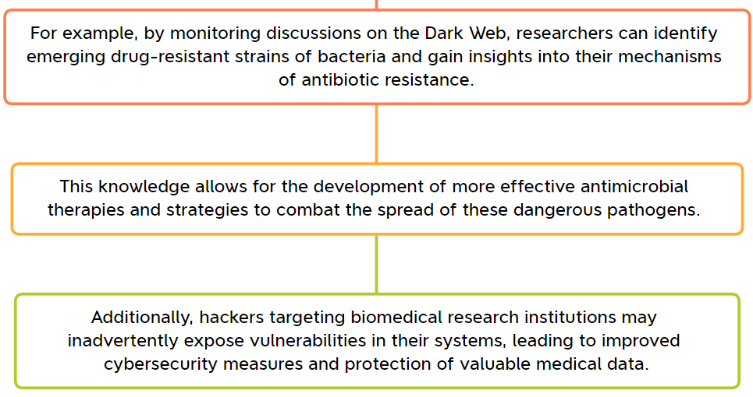
Figure 8: Host-Pathogen Relationships
A novel viewpoint on microbial interactions, such as antibiotic warfare, predation dynamics, and host-pathogen interactions, is offered by the Dark Web. We can better understand the web of life and unravel microbial ecology by investigating and analyzing these interactions.
7. Ecological Consequences of Cryptic Interactions
7.1 Impact on Microbial Community Structure and Dynamics
Crypto-Microbiology investigates the complex web of shadowy connections that characterizes microbial communities on the Dark Web. These interactions, which are frequently shrouded in mystery, have important ecological repercussions. Through covert communication and network formation, microorganisms can adapt to their niches and change the structure of microbial communities. Cryptic microbial interactions are influenced by resource availability, environmental factors, and competitive environments. The makeup of the microbial community can be quickly altered by clever alliances within the Dark Web ecosystem, potentially giving some members of the community an advantage over rivals or marginalizing others (Kinnison MT et al., 2015).
7.2 Influence on Ecosystem Functioning and Stability
Cryptographic interactions have an effect on the microbial community structure, ecosystem stability, and operation. The metabolic interactions and information flow that power critical processes like nutrient cycling, energy transmission, and organic compound degradation make up the Dark Web ecosystem. While covert collaborations encourage efficient resource utilisation and the breakdown of resistant compounds, secret competition modifies resource distribution and availability. The cycling of nutrients can become unbalanced, energy flows can be hampered, and resilience can be reduced as a result of disruption or modification of cryptic interactions. For an understanding of the underlying mechanisms governing ecosystem processes in the dark web, it is essential to understand and decode these hidden interactions (Cosetta CM et al., 2019).
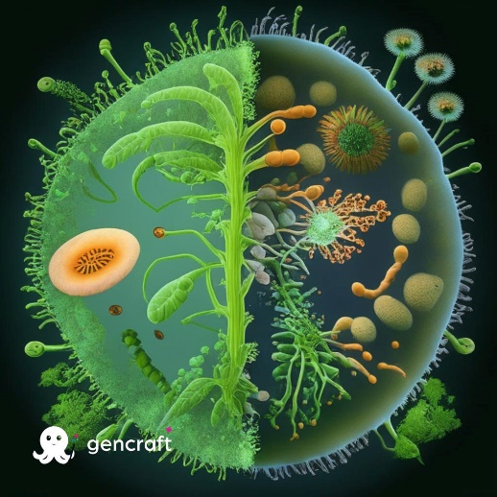
Figure 9: Mutualistic relationship between a nitrogen-fixing bacteria and plants. They form symbiotic associations with plants by converting atmospheric nitrogen into a usable form for plants.
7.3 Role of Cryptic Interactions in Biogeochemical Cycling
Microbes participate in the biogeochemical cycling that involves the transformation and transfer of essential elements that occurs in the ecosystem of the Dark Web. These microorganisms support the biogeochemical cycles of the planet by dissolving complex organic matter, releasing essential nutrients, and incorporating them into microbial biomass. By being recycled back into the environment, these nutrients are made available to other organisms (Millette NC et al., 2018). Crypto cryptic interactions have a big impact on how toxins and xenobiotics are transformed and cycled through the Dark Web.
Degradation and detoxification of harmful substances are made possible by covert interactions between specialised microbial species, minimising the negative environmental effects of illegal activity. The creation of long-term management and cleanup strategies for contaminated areas in both the real and virtual worlds can be aided by an understanding of the fundamental mechanisms governing biogeochemical cycling (Hug LA et al., 2018).
The complex and enigmatic world of microbial life within the Dark Web is revealed by crypto-microbiology, which has an impact on ecosystem stability, functioning, and biogeochemical cycling. These interactions have an impact on the dynamics and structure of microbial communities and are crucial for biogeochemical cycling.
8. Evolutionary Significance of Cryptic Interactions
8.1 Coevolution and the Cryptic Arms Race
In the intricate world of microbial interactions, cryptic interactions hold extraordinary evolutionary significance. The mutual adaptation and evolution of interacting species in response to one another's influence is known as coevolution. Coevolution is exemplified by the cryptic arms race, in which microorganisms constantly adapt and change to outsmart and outmaneuver one another. Due to the cryptic nature of these interactions, which involve covert communication or competition, a never-ending cycle of one-upmanship develops. In covert arms races, microbes frequently use a variety of tactics to gain the upper hand, including creating covert signals, creating camouflage, or undermining metabolic processes (Gupta A et al., 2022).

Figure 10: Example of covert arms race
8.2 Cryptic Interactions and Microbial Evolutionary Strategies
For microorganisms to survive and thrive in their ecological niches, cryptographic interactions are crucial for their evolutionary strategies. These interactions involve coexistence, competition, and cooperation and give rise to a variety of strategies, including diversification, symbiotic relationships, niche specialization, and coexistence. While diversification enables microorganisms to increase their metabolic capacity, phenotypic traits, or genetic repertoire, niche specialization enables them to exploit particular resources or avoid competition. Mutualistic, commensal, or parasitic interactions, which benefit from benefits like resource sharing, protection from predators, and improved survival in harsh environments, are also driven by cryptic interactions. These symbiotic interactions help the participating microorganisms succeed in their overall mission (Yoshida T et al., 2007).
8.3 Implications for Microbial Adaptation and Diversification
Cryptoctic interactions have a significant impact on microbial adaptation and diversification, influencing the course of their evolutionary development, the emergence of numerous species, and their ability to endure in a fast-paced, hostile environment. The study of these interactions has wide-ranging effects on industries like agriculture, medicine, and environmental sciences. Developing targeted treatments for infectious diseases can benefit from understanding the cryptic tactics of pathogenic microbes, and agricultural ecosystems can boost crop productivity and disease resistance. The intricate web of microbial communities and their functions in ecosystem functioning are further illuminated by the study of cryptic interactions. Understanding the ways in which microorganisms interact can help us better understand the resilience, stability, and functionality of microbial ecosystems, which in turn can help us better comprehend larger ecological systems (Scanlan PD et al., 2019).

Figure 11: Example for Microbial Adaptation and Diversification
In conclusion, the evolutionary significance of cryptic interactions lies in their ability to drive coevolution, shape microbial evolutionary strategies, and foster microbial adaptation and diversification. Exploring the hidden world of microbial interactions on the dark web provides a unique lens through which we can unravel the intricate tapestry of life at the microscopic level, offering valuable insights into the dynamics of microbial evolution and its implications for our world.
9. Applications of Understanding Cryptic Interactions
9.1 Biotechnological Potential and Synthetic Biology
Cryptoctic microbial interactions hold immense potential in biotechnology and synthetic biology. These interactions involve complex communication networks and biochemical exchanges between microorganisms, which are often unexplored. Understanding these interactions can uncover novel pathways, enzymes, and genetic elements with various applications.
For example, biofuels and industrial chemicals production can benefit from utilizing unique metabolic capabilities of microorganisms involved in cryptic interactions. By optimizing microbial consortia and engineering synthetic systems, researchers can efficiently convert renewable resources into valuable products. Synthetic biologists can also use their knowledge of cryptic microbial interactions to design and construct new genetic circuits and organisms. This information can be used to develop novel genetic tools, synthetic gene networks, and programmable cellular systems for various applications, including biosensors, bioremediation agents, and targeted gene therapies (Qian X et al., 2020).
Figure 12: Biofuels and industrial chemicals production site
9.2 Biocontrol and Microbial Manipulation
In biocontrol and microbial manipulation, cryptotic microbial interactions are essential. Understanding these interactions enables the identification of important players in the control of disease, nutrient cycling, and ecological stability. Understanding these interactions in agriculture can help in the development of biocontrol methods, the targeting of plant pathogens, the reduction of pesticide use, and the promotion of sustainable practices. Deciphering cryptic interactions in environmental microbiology can aid in ecosystem preservation and restoration. Microbes are crucial for the cycling of nutrients, the reduction of pollution, and the overall health of ecosystems. Scientists can engineer microbial communities or introduce particular species to enhance contaminants degradation, restore ecological balance, and improve environmental quality by unravelling these complexities (Cosetta CM et al., 2019).
9.3 Therapeutic Approaches and Drug Development
Drug development and therapeutics hold great promise for cryptic microbial interactions. Different bioactive substances, including antibiotics, antifungals, and anticancer agents, are produced by microorganisms. Unlocking these interactions can help researchers discover new bioactive substances and better understand the processes that lead to their synthesis and control. By finding new antimicrobial agents, improving production techniques, and creating plans to combat antibiotic resistance, this knowledge can be used to create novel therapeutic approaches. The complex interactions between the human microbiome and pathogenic microorganisms can also be better understood by studying cryptic interactions, which can help identify potential therapeutic targets. With the help of this knowledge, new medications, probiotics, and microbiome-based treatments can be created that control microbial interactions to improve health and treat diseases (Scott DE et al., 2016).
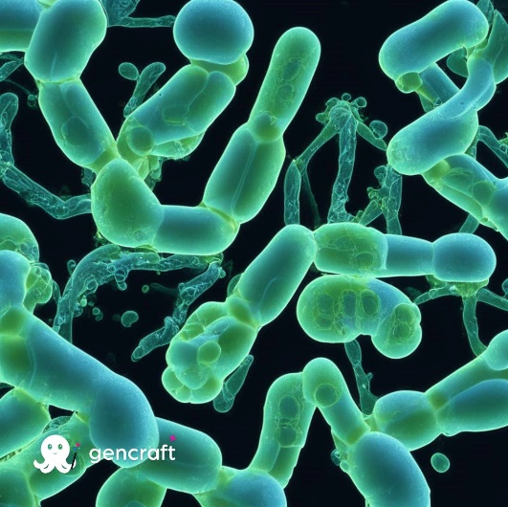
Figure 13: A bacterium producing a compound capable of inhibiting the growth of antibiotic-resistant superbugs
In summary, understanding cryptic microbial interactions has diverse applications in biotechnology, synthetic biology, biocontrol, microbial manipulation, and drug development. The insights gained from decoding these interactions can drive innovation, lead to the development of sustainable practices, and provide novel solutions to various challenges in agriculture, the environment, and human health.
10. Conclusion and Future Directions
10.1 Summary of Key Findings on Cryptic Microbial Interactions
The world of crypto-microbiology is examined in this chapter, along with its implications for the broader study of microbiology, as well as the hidden dynamics of microbial communities are revealed. Communities can cross geographical boundaries and interact in novel ways thanks to the dark web, which acts as an incubator for covert microbial exchanges. The dark web's anonymity and decentralization enable the spread of genetic information, promoting the emergence of distinctive microbial consortia with potentially ground-breaking functionalities. Blockchain technology and cryptocurrencies make it easier for microbes to collaborate and transact, which poses a serious risk to biosecurity.
The exploration of novel microbial interactions and the sharing of knowledge are made possible by hidden online forums and marketplaces, which create an ideal environment for the discovery of novel microbial species and their functional characteristics. The results highlight the need for increased regulation and vigilance to counter the threats posed by the microbial ecosystem of the dark web. To monitor and stop illegal activities related to crypto-microbiology, law enforcement, scientific communities, and cybersecurity experts must work closely together. The study also highlights the significance of educating the general public about the risks of unrestricted microbial exchanges and creating effective biosecurity controls for the internet.
10.2 Future Directions and Challenges in Crypto-Microbiology
The study of crypto-microbiology has revealed a number of problems and areas that require more research. Effective surveillance requires cutting-edge methods for finding and tracking microbial agents on the dark web. It is possible to identify illegal activity and potential biosecurity threats by integrating artificial intelligence and machine learning algorithms. Complex genomic data from the dark web needs to be mined and analyzed using sophisticated bioinformatics and data analysis pipelines. Designing efficient legal measures to stop illegal trade, ensure biosecurity, and safeguard public health requires cooperation between governments and international organizations. Ethics matters a lot because it's important to weigh the advantages of scientific research against any potential risks. Researchers and policymakers can navigate this complex environment with the help of established guidelines and ethical frameworks.
10.3 Implications for Microbial Ecology and Beyond
A rapidly developing field, crypto-microbiology has important implications for microbial ecology and related fields. Understanding the complex interactions and resiliency mechanisms of microorganisms on the dark web can shed light on more general ecological processes. Understanding evolutionary dynamics, biotechnological uses, and one-health strategies are part of this. Investigating microbial interactions on the dark web helps us better understand the forces that lead to microbial adaptation and diversification, which in turn advances our knowledge of microbial evolution and speciation. Crypto microbiology’s unique microbial consortia and functional properties have important ramifications for biotechnology, enabling the creation of bioactive substances, enzymes, and other beneficial bioproducts. Understanding how these systems are interconnected is essential for reducing the risks posed by newly emerging infectious diseases and antimicrobial resistance. In conclusion, the study of crypto-microbiology is a brand-new, rapidly developing field with enormous potential for advancement and application in science. It's crucial to address the issues raised by this covert ecosystem and responsibly navigate its moral ramifications. Future developments in this enigmatic field of crypto-microbiology will be made possible by embracing multidisciplinary collaboration and taking advantage of technological advancements.
References
Bradbury D. Unveiling the dark web. Network security. 2014 Apr 1;2014(4):14-7.
Liu C, Kakeya H. Cryptic Chemical Communication: Secondary Metabolic Responses Revealed by Microbial Co‐culture. Chemistry–An Asian Journal. 2020 Feb 3;15(3):327-37.
Pierce EC, Dutton RJ. Putting microbial interactions back into community contexts. Current Opinion in Microbiology. 2022 Feb 1;65:56-63.
Francke W, Dettner K. Chemical signalling in beetles. The Chemistry of Pheromones and Other Semiochemicals II: -/-. 2005:85-166.
Schauder S, Shokat K, Surette MG, Bassler BL. The LuxS family of bacterial autoinducers: biosynthesis of a novel quorum‐sensing signal molecule. Molecular microbiology. 2001 Jul;41(2):463-76.
Savoia D. Plant-derived antimicrobial compounds: alternatives to antibiotics. Future microbiology. 2012 Aug;7(8):979-90.
Guimera R, Nunes Amaral LA. Functional cartography of complex metabolic networks. nature. 2005 Feb 24;433(7028):895-900.
Reuter JA, Spacek DV, Snyder MP. High-throughput sequencing technologies. Molecular cell. 2015 May 21;58(4):586-97.
Bashan A, Gibson TE, Friedman J, Carey VJ, Weiss ST, Hohmann EL, Liu YY. Universality of human microbial dynamics. Nature. 2016 Jun 9;534(7606):259-62.
Dickson RP, Erb-Downward JR, Prescott HC, Martinez FJ, Curtis JL, Lama VN, Huffnagle GB. Analysis of culture-dependent versus culture-independent techniques for identification of bacteria in clinically obtained bronchoalveolar lavage fluid. Journal of clinical microbiology. 2014 Oct;52(10):3605-13.
Hugenholtz P, Tyson GW. Metagenomics. Nature. 2008 Sep 25;455(7212):481-3.
Bashiardes S, Zilberman-Schapira G, Elinav E. Use of metatranscriptomics in microbiome research. Bioinformatics and biology insights. 2016 Jan;10:BBI-S34610.
Liu C, Ren L, Yan B, Luo L, Zhang J, Awasthi MK. Electron transfer and mechanism of energy production among syntrophic bacteria during acidogenic fermentation: A review. Bioresource technology. 2021 Mar 1;323:124637.
Reece A, Xia B, Jiang Z, Noren B, McBride R, Oakey J. Microfluidic techniques for high throughput single cell analysis. Current opinion in biotechnology. 2016 Aug 1;40:90-6.
Hu P, Zhang W, Xin H, Deng G. Single cell isolation and analysis. Frontiers in cell and developmental biology. 2016 Oct 25;4:116.
Waters CM, Bassler BL. Quorum sensing: cell-to-cell communication in bacteria. Annu. Rev. Cell Dev. Biol.. 2005 Nov 10;21:319-46.
Whiteley M, Diggle SP, Greenberg EP. Progress in and promise of bacterial quorum sensing research. Nature. 2017 Nov 16;551(7680):313-20.
Grandclément C, Tannières M, Moréra S, Dessaux Y, Faure D. Quorum quenching: role in nature and applied developments. FEMS microbiology reviews. 2016 Jan 1;40(1):86-116.
Uroz S, Dessaux Y, Oger P. Quorum sensing and quorum quenching: the yin and yang of bacterial communication. ChemBioChem. 2009 Jan 26;10(2):205-16.
Shi Y, Pan C, Wang K, Chen X, Wu X, Chen CT, Wu B. Synthetic multispecies microbial communities reveals shifts in secondary metabolism and facilitates cryptic natural product discovery. Environmental Microbiology. 2017 Sep;19(9):3606-18.
Shank EA, Kolter R. New developments in microbial interspecies signaling. Current opinion in microbiology. 2009 Apr 1;12(2):205-14.
Ankitha S, Basri S. The effect of relational selling on life insurance decision making in India. International Journal of Bank Marketing. 2019 Sep 10;37(7):1505-24.
Moran NA, Degnan PH, Santos SR, Dunbar HE, Ochman H. The players in a mutualistic symbiosis: insects, bacteria, viruses, and virulence genes. Proceedings of the National Academy of Sciences. 2005 Nov 22;102(47):16919-26.
Liao WH, Chang CC. Peer to peer botnet detection using data mining scheme. In2010 international conference on internet technology and applications 2010 Aug 20 (pp. 1-4). IEEE.
Schink B. Synergistic interactions in the microbial world. Antonie Van Leeuwenhoek. 2002 Dec;81:257-61.
Sarsan S, Pandiyan A, Rodhe AV, Jagavati S. Synergistic interactions among microbial communities. Microbes in Microbial Communities: Ecological and Applied Perspectives. 2021:1-37.
Agany DD, Pietri JE, Gnimpieba EZ. Assessment of vector-host-pathogen relationships using data mining and machine learning. Computational and Structural Biotechnology Journal. 2020 Jan 1;18:1704-21
Demars A, Lison A, Machelart A, Van Vyve M, Potemberg G, Vanderwinden JM, De Bolle X, Letesson JJ, Muraille E. Route of infection strongly impacts the host-pathogen relationship. Frontiers in immunology. 2019 Jul 11;10:1589.
Kinnison MT, Hairston Jr NG, Hendry AP. Cryptic eco‐evolutionary dynamics. Annals of the New York Academy of Sciences. 2015 Dec;1360(1):120-44.
Cosetta CM, Wolfe BE. Causes and consequences of biotic interactions within microbiomes. Current opinion in microbiology. 2019 Aug 1;50:35-41.
Millette NC, Grosse J, Johnson WM, Jungbluth MJ, Suter EA. Hidden in plain sight: The importance of cryptic interactions in marine plankton. Limnology and Oceanography Letters. 2018 Aug;3(4):341-56.
Hug LA, Co R. It takes a village: microbial communities thrive through interactions and metabolic handoffs. MSystems. 2018 Apr 24;3(2):10-128.
Gupta A, Peng S, Leung CY, Borin JM, Medina SJ, Weitz JS, Meyer JR. Leapfrog dynamics in phage‐bacteria coevolution revealed by joint analysis of cross‐infection phenotypes and whole genome sequencing. Ecology letters. 2022 Apr;25(4):876-88.
Yoshida T, Ellner SP, Jones LE, Bohannan BJ, Lenski RE, Hairston Jr NG. Cryptic population dynamics: rapid evolution masks trophic interactions. PLoS biology. 2007 Sep;5(9):e235.
Scanlan PD. Microbial evolution and ecological opportunity in the gut environment. Proceedings of the Royal Society B. 2019 Nov 20;286(1915):20191964.
Qian X, Chen L, Sui Y, Chen C, Zhang W, Zhou J, Dong W, Jiang M, Xin F, Ochsenreither K. Biotechnological potential and applications of microbial consortia. Biotechnology advances. 2020 May 1;40:107500.
Scott DE, Bayly AR, Abell C, Skidmore J. Small molecules, big targets: drug discovery faces the protein–protein interaction challenge. Nature Reviews Drug Discovery. 2016 Aug;15(8):533-50.

