EVALUATION OF DIURETIC EFFECTS OF METHANOLIC ROOT EXTRACT OF MIRABILIS JALAPA IN RODENT MODELS

Ganga Raju M, N V L Suvarchala Reddy V, Madhavi P, Ramya N

Department of Pharmacology

Gokaraju Rangaraju college of Pharmacy

Hyderabad, India.

ABSTRACT

In-silico docking experiments and pharmacokinetic studies for bioactive components were conducted to assess the diuretic activity of the methanolic root extract of Mirabilis jalapa in animal models. The roots of Mirabilis jalapa have diuretic, antioxidant, hepatoprotective, anti-inflammatory, anti-noniceptive, cytotoxic, antispasmodic, antihelmintic, anti-microbial, antibacterial, antifungal, and antiviral properties. They also have anti-microbial, antibacterial, antifungal, and antiviral properties. The dried powder from the Mirabilis jalapa roots is extracted by soxhlation with methanol. Distilled water, a common medication (furosemide 20 mg/kg), and two separate doses (200 and 400 mg/kg) of methanolic extract were administered to Wistar rats. By assessing variables such the frequency of urination, urine volume, electrolyte concentration, and pH of the urine, diuretic activity was assessed. The process of diuresis was described using electrolyte indices. In addition, the phytochemicals included in the plant extracts were subjected to a qualitative and quantitative study. The phytochemical components found in the roots of Mirabilis jalapa include flavonoids, terpenoids, phenols, steroids, and carbohydrates. In the diuretic activity study, rats were split into four groups: control, extract (200 and 400 mg/kg, bd.wt, p.o.) and furosemide (20 mg/kg, bd.wt, i.p.). Significantly more salt and potassium were excreted in the urine as well as a rise in output compared to the control group. Flavonoid components have good binding affinities and bioavailability in contrast to standard, according to in-silico docking research. From the above results showed that methanolic root extract of Mirabilis jalapa possess diuretic activity.

Keywords: Mirabilis jalapa, diuretic activity, furosemide, Molecular docking, Schrondinger.

- INTRODUCTION

Diuretics are medications that enhance urine production and aid in eliminating excess salt and water from the body. They do this by preventing sodium and water from reabsorbing in various nephron-related structures, leading to excretion from the body. Clinically beneficial diuretics also speed up the excretion of an accompanying anion, typically Cl-, as well as Na (natriuresis). By lowering the total body Nacl content, diuretics are typically used in clinical settings to decrease extracellular fluid volume (edema). Diuretics are used to treat a variety of illnesses, including hypertension, glaucoma, and other clinical problems. They are also used to address edema linked to cardiovascular, renal, and endocrine issues [1]. Hypertension: Generally speaking, diuretics work by making the kidneys excrete more salt and water from the body. This causes a decrease in plasma volume and the volume of blood inside the arteries, which lessens the "pushing" on the artery walls and, as a result, lowers blood pressure. The glomerular filtration rate (GFR) and renal perfusion can both be improved in oliguric renal insufficiency by using loop diuretics to induce diuresis. In electrolyte disorders, diuretics can be administered in a number of circumstances where dyselectrolytemia is present. In hyperkalemic situations, they can increase potassium excretion (loop diuretics, thiazides), increase calcium excretion (loop diuretics), or slow down calcium excretion (thiazides) in hypercalcemic states. Acetazolamide can promote the excretion of bicarbonate, while loop diuretics can encourage the excretion of hydrogen ions [2].
The blooming plant Mirabilis Jalapa, also referred to as "four o'clock," is a member of the Nyctaginaceae family and normally grows to a height and breadth of between 0.6 and 0.9 meters. The blooms are arranged in threes and encircled by five green bracelets. They are available in a range of hues, including yellow, crimson, white, and variegated. The Mirabilis jalapa can be found in its native tropical South America's southern and warm western regions, as well as occasionally in the cooler northern parts [3]. Alkaloids, flavonoids, phenols, steroids, triterpenes, glycosides, tannins, saponins, and lignin are all active components found in M. jalapa roots. There are also small amounts of resin, trigonelline, oxymethylanthraquinone, and a carbohydrate that, when hydrolyzed, produces galactose and arabinose. There are an additional eleven phytoconstituents in roots, including flazin, 4'-hydroxy-2,3-dihydroflavone-7-beta-D-glucopyranoside, daucosterol, gingerglycolipid-A, 3,4-dihydroxybenzaldehyde, P-hydroxybenzaldehyde, -sitosterol, and daucosterol. The roots of Mirabilis jalapa exhibit diuretic, antioxidant, hepatoprotective, anti-inflammatory, anti-noniceptive, cytotoxic, antispasmodic, antihelmintic, anti-microbial, antibacterial, antifungal, and antiviral properties [4]. They are also anti-helmintic and anti-inflammtory. The roots of Mirabilis jalapa are used as a treatment for kidney stones, and the tuber from the gall bladder, known as chyluria, is given in very small doses to treat piles. In the current work, molecular docking experiments were used to examine diuretic efficacy as well as the binding affinity of plant-derived phytochemicals.

- MATERIALS AND METHODS

- Plant collection and drying:
The roots of Mirabilis jalapa were procured in the month of October from Hyderabad, Telangana, and were verified by a botanist from Osmania University. The roots are ground into a coarse powder in a mixer grinder after being shade-dried for 14 days. The material was either kept or removed for the extraction process.

- Preparation of extract:
The Mirabilis Jalapa roots had been dried. The powder was then extracted with methanol using the soxhlation method.

Soxhlet Extraction:
The extractor body of a soxhlet system for continuous extraction is connected to a side tube and a siphon tube. 500 g of the plant's powder are placed either directly in the Soxhlet device or in a thimble of filter paper. To prevent the solvent from bumping, fresh activated porcelain bits are put to the flask's spherical bottom. Before being heated, the solvent (methanol) is allowed to flow. After being heated to reflux, the solvent goes up a distillation arm and into the chamber containing the thimble of solid. Warm solvent slowly fills the compartment with the solid substance and begins to dissolve it. The Soxhlet chamber is drained into a flask using a siphon when it is almost full. Days of this cycle are repeated, and by utilizing a rotary evaporator to remove surplus solvent, the desired chemical is concentrated [5].

- Preliminary phytochemical screening
According to the procedure, the extract was submitted to preliminary phytochemical analysis in order to detect different phytoconstituents in plant roots [6].

- Acute toxicity testing:
An investigation of the acute toxicity of a methanolic extract of Mirabilis jalapa roots was conducted. Organization for Economic Cooperation and Development (OECD) guidelines were followed in conducting the study. The up-and-down procedure (OECD guidelines-425) is used to assess the acute oral toxicity. Throughout the investigation, a variety of physical and behavioral traits were seen. Other factors, such as food and water intake, were also tracked.
Principle of limit test:
A maximum of 5 animals are used in the limit test, which is a sequential test. 2000 mg/kg or, more atypically, 5000 mg/kg may be utilized as the test dose.

- Experimental protocol
- Animal procurement:
Wistar albino mice (about 20 to 25 g) and albino rats (approximately 200–250 g) were purchased from Albino research, Hyderabad. The current investigation was conducted in an animal facility at Gokaraju Rangaraju College of Pharmacy in Bachupally, Hyderabad, India, that has received CPCSEA approval. (1175/Po/Re/S/08/CPCSEA).
- Animal housing:
The animals were kept in poly acrylic cages with a maximum of six animals per cage and a cycle of 12 hours of light and 12 hours of darkness. Rats have unlimited access to a conventional food and unlimited water. Before the trial began, the mice were given a week to become accustomed to the lab setting. The Committee for the Purpose of Control and Supervision of Experiments on Animals issued criteria for the care and upkeep of the animals, and these were followed.

- Evaluation of diuretic activity:
- Diuretic model:
For the investigation, male Albino rats will be employed. All animals aside from the control group get two doses of the methanolic extract of Mirabilis jalapa and Furosemide (20 mg/kg, i.p.) over the course of seven days. The animals will be kept at a controlled temperature of 22–25 °C in metabolic cages (1 per cage), which are specifically made to separate urine and faeces. The amount of urine collected, and its pH level will be tested after six hours. Animals won't have access to food or water during this time. Body weight, total urine volume, and the amounts of Na+ and K+ will be monitored using a flame fluorimeter over the course of the 7-day trial [7]. The treatment groups are split up in accordance with table 1 supplied.

Table 1: Treatment groups of diuretic model

GROUPS | TREATMENT
Group-I | Control (Normal saline)
Group-II | Furosemide (20 mg/kg, bd.wt., i.p)
Group-III | MEMJ (200 mg/kg, bd.wt., p.o.)
Group-IV | MEMJ (400 mg/kg, bd.wt., p.o.)

- Molecular Docking studies:
By inserting a molecule (ligand) into the preferred binding site of the target specific region of the DNA/protein (receptor) primarily in a noncovalent manner, molecular docking is an appealing scaffold to understand drug biomolecular interactions for rational drug design and discovery as well as in the mechanistic study. The binding energy, free energy, and stability of complexes can be suggested using the information gleaned through the docking procedure. Currently, docking approaches are used to anticipate the ligand-receptor complex's tentative binding characteristics. A type of bioinformatics modeling called molecular docking involves the interactions of two or more molecules to produce a stable adduct. It makes predictions about the three-dimensional structure of any complex based on the binding characteristics of the ligand and target [8].

- Protein-ligand interactions:
The binding orientations of drug candidates to their protein targets are predicted by docking stimulations. For creating docking simulation studies, Glide 5.6 (Schrodinger Inc.) was employed. Docking simulations were run on the Intel ® Core TM i7 CPU 860 @GHz; 12.0 GB RAM; and 1 TB Hard disk of the Dell Precision T-1500 workstation. Maestro 9.1 was used to display interactions between proteins and ligands.
- Ligand preparation
The Maestro 9.1 workspace was used to import the Chem Draw 8.0-created 2D ligand (8.mol), which was then exported as *.mae files. Using the OPLS2005 force field approach, the energy of the ligands (in *.Mae format) was optimized (RMSD 0.30 A). The combine_Sd file was used to store the energy-optimized structures.
- Protein preparation:
The cytosolic phospholipase inhibitor's x-ray crystallized structure (PDB ID: 1O86) was obtained from the RCSB protein bank. Polar and non-polar hydrogen bonds were added, and all of the bonds in the protein structure were allocated. All of the water molecules above 5 A, cofactors, hetero groups, ligands other than metal ions, and cofactors were eliminated. At pH 70.4, ionization states for the co-crystallized ligand were produced. The energy of chain A has been reduced using the OPLS2005 force field (RMSD 0.3A ).
- Receptor grid generation:
On the basis of the centroid ligand, a receptor grid was created with a scaling factor of 1 and a partial cut of charge of 0.25.
- Ligand docking and scoring:
Flexible glide-ligand docking in the XP additional precision mode promoted protein ligand interactions. Docking was possible close to the co-crystallized ligand's 20 A. The compounds docked were evaluated in terms of glide score (G score) and based on their affinity with the protein.
- Visualization and analysis:
The Maestro 9.1 workspace was used to display the resulting docking poses. To understand the binding interactions between ligands and proteins, the hydrogen bonding and hydrophobic interactions were shown. To determine their strength, the distance between interacting groups of ligands and proteins was also shown. The glide score formula was used to select the best docked structures. The more favourable the binding, the lower the glide score. Additionally, the various ligand receptor interactions were investigated as well as the docked ligand poses.

III. RESULTS AND DISCUSSION

- Preparation of methanolic extract of roots of Mirabilis jalapa (MEMJ)
The roots of Mirabilis jalapa were soxhlated to produce a methanolic extract.
% of yield obtained $\frac{Amount of extract obtained}{total amount of powder used}$ × 100
The formula below was used to determine the % yield of the methanolic extract.
% Yield of extract = 35.8/235 ×100 = 15.23 % w/w

- Preliminary phytochemical analysis
The Mirabilis jalapa showed positive results for phenolic chemicals, alkaloids, sterols, saponins, flavonoids, triterpenoids, and carbohydrates in a phytochemical screening.

- Acute toxicity studies:
The harmful effects of a methanolic extract of the roots of Mirabilis jalapa at a concentration of 2000 mg/kg were investigated in an acute toxicity investigation. Up to 2000 mg/kg body weight, the animal showed no evidence of toxicity or mortality. Various morphological and behavioural traits were seen throughout the investigation. Other factors, such as food and water intake, were also tracked. Even after 14 days of observation, it was discovered that all the animals were secure. The extract was therefore determined to be safe up to 2000 mg/kg bd. wt. One tenth and one fifth of the doses were chosen for the study based on the findings.

- In vivo diuretic activity
Mirabilis jalapa roots were examined for their potential diuretic properties using a methanolic extract, and the results are shown in table 2 and figure 1.

Table 2: Effect of Furosemide and MEMJ on urine parameters

Groups | Treatment | Urine pH | Urine volume (mL)
I | Control (Normal diet) | 5.65±0.1 | 6.17±0.10
II | MEMJ (200 g/kg) | 7.9±0.2** | 10.2±0.19**
III | MEMJ (400 mg/kg) | 8.4±0.16^{**a} | 12.3±0.45**
IV | Furosemide (20 mg/kg) | 8.1±0.16** | 17. 01±0.40^{*a}

The mean SEM of the values was used (n=6). ANOVA was used for statistical analysis, and Dunnett's test was used to compare the results to the control and standard. Values that are statistically significant are shown as control group (**p0.01, *p0.05) and standard (a=p0.05).
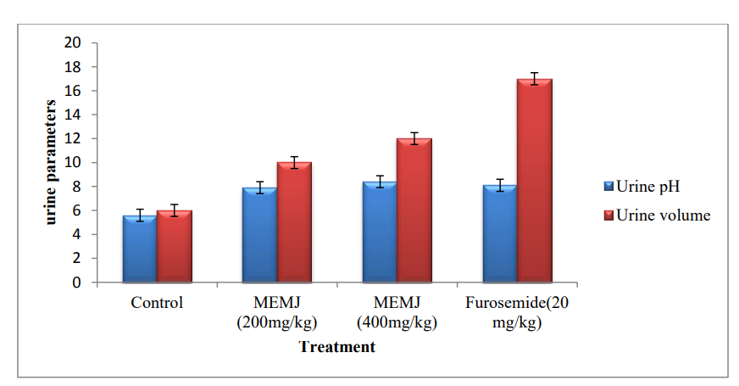
Figure 1: Effect of MEMJ on urine parameters
In comparison to the normal control group, the reference diuretic (furosemide) considerably increased urine production (17.010.40) and pH (8.10.16). Both the 200mg/kg and 400mg/kg doses of MEMJ administered to the treated groups caused a considerable rise in urine volume and PH, though less so than was seen with the reference medication.

- Effect of MEMJ on electrolyte concentration
Table 3 and Figure 2 show that the MEMJ reduced the increase in electrolyte excretions found with furosemide at doses of 200 mg/kg and 400 mg/kg (1430.5to 3.010.08 and (1570.5to 3.320.14), respectively).
Table 3: Effect of Furosemide and MEMJ on electrolyte concentration

Groups | Treatment | Sodium excretion (mmol/L) | Potassium excretion (mmol/L)
I | Control (Normal diet) | 136±0.9 | 2.2±0.3
II | MEMJ (200 mg/kg, bd.wt., p.o.) | 143±0.5** | 3.01±0.08**
III | MEMJ (400 mg/kg, bd.wt., p.o.) | 157±0.5** | 3.32±0.14**
IV | Furosemide (20 mg/kg, bd.wt., i.p) | 161±0.8^{**a} | 3.32±0.03^{**a}

The mean SEM of the values was used (n=6). ANOVA was used for statistical analysis, and Dunnett's test was used to compare the results to the control and standard. Values that are statistically significant are shown as control group (**p0.01) and standard (a=p0.01).

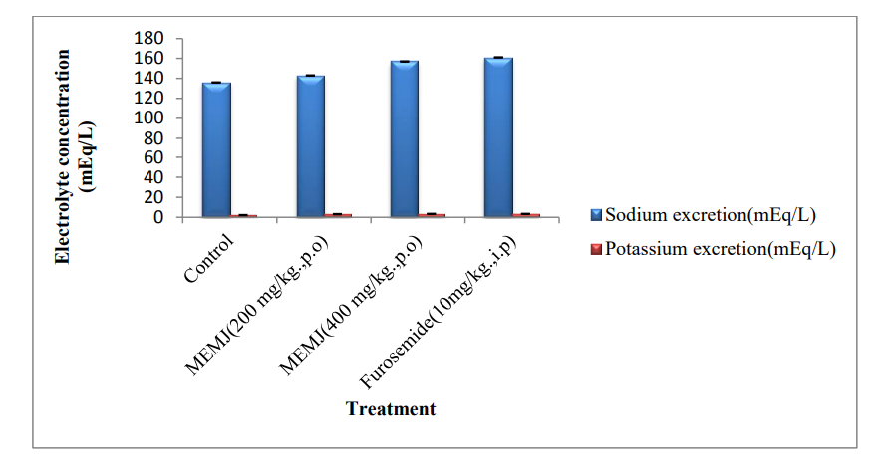
Figure 2: Effect of MEMJ on electrolyte concentration

The roots of Mirabilis jalapa are used to manage dysuria (as a diuretic), according to ethnopharmacological research, however its diuretic effect has not been scientifically proved. In order to treat patients who are unable to urinate, this study demonstrates the diuretic and natriuretic effects of methanolic extract from the roots of Mirabilis jalapa. The phytochemical components found in the roots of Mirabilis jalapa include flavonoids, terpenoids, phenols, steroids, and carbohydrates.
Previous research has demonstrated the several methods by which phytochemicals exert their diuretic and natriuretic effects. Alkaloids, for instance, can block carbonic anhydrase, increase renal blood flow by widening renal afferent arteries, and possibly prevent the tubules from reabsorbing water and salts. On the other hand, renal tubule carbonic anhydrase is inhibited by flavonoids and phenols [9,10]. Due to their inhibition of the angiotensin converting enzyme (ACE), increased bioavailability of bradykinin, prostacyclin, and nitric oxide, or inhibition of Na/K- ATPase, they induce diuresis. By encouraging the dilatation of afferent arterioles, adenosine A1 receptor antagonists can either directly alter Na absorption in the proximal tubule or indirectly promote diuresis and Na excretion [11,12]. Because flavonoids are naturally occurring antagonist ligands for A1 adenosine receptors, it is known that the activity of these receptor antagonists is linked to diuretic activity [13]. Reabsorbing 60–70% of the salt and water removed by the PCT is done so by adenosine A1 receptors [14]. Therefore, A1 adenosine receptor antagonists enhance renal blood flow, induce natriuresis, and diuresis while controlling glomerular filtration rate via vasodilating renal afferent arteries. Additionally, phenols, flavonoids, and alkaloids have the ability to block carbonic anhydrase. In PCT, salt reabsorption and pH regulation are both influenced by the enzyme carbonic anhydrase [15].

- Molecular docking studies

Chain B was initially removed from the protein after it had been obtained from the PDB. The water molecules in both chains are eliminated. There was a reduction in energy. Later, chemdraw-created molecules were translated to mol format, and ligprep was developed. The structures were docked against 1O86 protein B after grid creation. Results of the Schrodinger XP- docking Some of our compounds have strong binding ability to the ACE inhibitor protein (PDB ID: 1O86), which is shown in figures 3,4,5,6, and 7. This is according to XP docking.

Figure 3: Hydrogen bonding interactions of Silymarin with PDB ID: 1O86Silymarin (total score -6.70) by hydrophobic interactions with Tyr 520, GLN 281, lys 511, GLU 384
Figure 4: Hydrogen bonding interactions of Atorvastatin with PDB ID: 1O86 Atorvastatin (total score -5.42) by hydrophobic interactions with Arg-522

Figure 5: Hydrogen bonding interactions of Flazin with PDB ID: 1O86 Flazin (total score -7.10) by hydrophobic interactions with His-387, ASN-66, Tyr-360

Figure 6 : Hydrogen bonding interactions of Mirabijalone-A with PDB ID: 1O86 Mirabijalone-A (total score -8.80) by hydrophobic interactions with ASN-66, GLU-143, ALA-356, GLU-384
Figure 7 : Hydrogen bonding interactions of 4-hydroxy 2,3-dihydroflavone 7-β-D glycopyranoside with PDB ID: 1O86 4-hydroxy-2,3-dihydroflavone-7-β-D-glycopyranoside (total score -8.82) by hydrophobic interactions with ASN-70, GLU-384, ALA-356.

- CONCLUSION

The current study shows that the roots of Mirabilis jalapa's methanolic extract have diuretic properties, increasing urine volume and electrolyte (sodium and potassium) excretion. The methanolic extract's diuretic response was comparable to that of the reference medication (furosemide), pointing to a shared mode of action. Flazin and 4-hydroxy2,3-dihydroflavone7-Dglycopyranoside displayed favourable docking scores with better interactions with receptors, according to a study on bioactive active chemicals. It is important to further isolate the bioactive substances and understand how they work.

REFERENCES
- Arumugham VB, Shahin MH. Therapeutic Uses of Diuretic Agents. [Updated 2023 May 29]. In: StatPearls [Internet]. Treasure Island (FL): StatPearls Publishing; 2023 Jan. Available from: https://www.ncbi.nlm.nih.gov/books/NBK557838/
- Ramesh B. Nidavani, Mahalakshmi AM. An Ethnopharmacological review of Four o’ clock flower plant (mirabilis jalapa). Journal of biological& scientific opinion. 2014;2 (6):344-348.
- Khandelwal K.R.(2008) Practical pharmacognosy.
- Nath LR, Manjunath KP, Savadi RV, Akki KS. Pharmacognostical and phytochemical studies of Mirabilis jalapa Linn leaves, Phcog Journal. 2009; 1(2): 111-115.
- Suvarchala Reddy NVL, Kusuma Priyanka AY and Raghavendra NM. Isolation and Characterization of triterpenoids from bark of Syzygium alternifolium (Wight) Walp. Annals of Phytomedicine. 2012; 1(2): 45-51.
- Suvarchala Reddy NVL, Anjani M, Ganga Raju M. Evaluation of nephroprotective activity of methanolic extract of Illicium verum hooks fruits in rodents. Asian Journal of Pharmacy and Pharmacology. 2019; 5(1): 159-164.
- Suvarchala Reddy NVL, Alekhya B, Ganga Raju M. Evaluation of the Diuretic activity of the Methanolic Extract of Bougainvillea Spectabilis. Research Journal of Pharmacognosy and Phytochemistry. 2019; 11(1): 38-41.
- Ganga Raju M, Srilakshmi S and Suvarchala Reddy NVL. Anti-inflammatory, in-silico docking and ADME analysis of some isolated compounds of Tagetes erecta flower heads. International Journal of Pharmaceutical Sciences and Research. 2020; 11(3): 1358-1366.
- Karioti A, Carta F, Supuran T. An update on natural products with carbonic anhydrase inhibitory activity. Curr Pharm Des. 2016; 22(12):1570–1591.
- Melendez-Camargo ME, Contreras-León I, Silva-Torres R. Diuretic effect of alkaloids fraction extracted from Selaginella lepidophylla (Hook. et Grev.) spring. Bol Latinoam Caribe Plantas Med Aromát. 2014;13(1):92–99.
- Aditama R, Mujahidin D, Syah YM, Hertadi R. Docking and molecular dynamics simulation of carbonic anhydrase II inhibitors from phenolic and flavonoid group. Procedia Chem. 2015;16:357–364.
- Ekinci D, Karagoz L, Ekinci D, Senturk M, Supuran CT. Carbonic anhydrase inhibitors: in vitro inhibition of α isoforms (hCA I, hCA II, bCA III, hCA IV) by flavonoids. J Enzyme Inhib Med Chem. 2013;28(2):283–288.
- Huyut Z, Beydemir Ş, Gülçin İ. Inhibitory effects of some phenolic compounds on the activities of carbonic anhydrase: from in vivo to ex vivo. J Enzyme Inhib Med Chem. 2016;31(6):1234–1240.
- Ghosh D, Scheepens A. Vascular action of polyphenols. Mol Nutr Food Res. 2009;53(3):322–331.
- Perez-Vizcaino F, Duarte J, Jimenez R, Santos-Buelga C, Osuna A. Antihypertensive effects of the flavonoid quercetin. Pharmacol Rep. 2009;61(1):67–75.

