Transforming Manufacturing: The Power of IoT in Shaping the Future

Vamsi Sravanth Mahendrada
PG Student,
School of CS & IS
Presidency University
Bengaluru, India

Dr. Jagdish H Godihal
Professor-CIV and Deputy Dean -Academic Research
School of Engineering
Presidency University
Bengaluru, India

Abstract:
This book chapter presents a comprehensive exploration of the Internet of Things (IoT) and its profound impact on the manufacturing industry. The chapter begins by defining IoT in the manufacturing context, elucidating the concept of interconnected devices and sensors that collect and exchange data. It delves into the wide-ranging applications of IoT in manufacturing, encompassing smart factories, predictive maintenance, inventory management, supply chain optimization, quality control, and product lifecycle management. Emphasizing the immense benefits brought forth by IoT technologies, the chapter underscores improved operational efficiency, cost reduction, real-time monitoring and analytics, enhanced productivity, and better decision-making as some of the key advantages. Moreover, the chapter sheds light on the challenges associated with implementing IoT in manufacturing, such as data security, interoperability, legacy infrastructure, and the need for skilled professionals. To provide practical insights, real-world case studies are presented, showcasing successful IoT implementations and the valuable lessons learned from them. Looking ahead, the chapter explores future trends and implications, including the integration of edge computing, artificial intelligence, machine learning, and sustainability practices within the manufacturing domain. In conclusion, this book chapter offers a unique perspective on the transformative role of IoT in shaping the future of manufacturing, fostering innovation, and cultivating a highly connected and efficient industry.
Keywords— Internet of Things (IoT), Smart Manufacturing, Sensor Networks, Predictive Maintenance, Decision-Making Processes, Green Manufacturing.

Introduction:
The manufacturing sector is experiencing a substantial revolution, propelled by the progress made in information technologies. Among these technologies, the IoT has emerged as a pivotal force, revolutionizing traditional manufacturing practices and paving the way for a new era of smart manufacturing. The IoT, characterized by its interconnected devices and sensors, facilitates the gathering, sharing, and examination of extensive data volumes. This empowers manufacturers with instantaneous insights and unparalleled operational control [1].
The primary objective of this book chapter is to offer an all-encompassing overview of the IoT within the manufacturing industry, exploring its definition, applications, benefits, implementation challenges, and future implications. By understanding the role of IoT in manufacturing, readers will gain insights into how this technology is reshaping the industry and driving innovation across various domains.
Firstly, defining IoT in the manufacturing context, highlighting its core elements of interconnected devices and sensor networks are discussed then delve into the fundamental concept of IoT, where physical objects are equipped with sensors, actuators, and connectivity, allowing them to establish communication and interaction among themselves as well as with humans. This interconnectedness forms the foundation for a highly automated, intelligent, and data-driven manufacturing ecosystem [2][3].
Next, we explore the diverse applications of IoT. From the establishment of smart factories that leverage IoT to optimize production processes and enhance efficiency, to the implementation of predictive maintenance systems that proactively identify and address equipment failures, IoT is transforming every aspect of the manufacturing value chain. We also delve into areas such as inventory management, supply chain optimization, quality control, and product lifecycle management, showcasing how IoT is revolutionizing traditional practices and unlocking new opportunities for manufacturers [4][6].
The benefits of IoT in manufacturing are immense and far-reaching. Improved operational efficiency, cost reduction, real-time monitoring and analytics, enhanced productivity, and informed decision-making are just a few of the advantages that IoT technologies bring to the table. By harnessing the power of IoT, manufacturers can streamline their operations, minimize downtime, optimize resource utilization, and deliver higher-quality products to meet the ever-evolving demands of the market [7].
However, alongside the promise of IoT, there are implementation challenges that must be addressed. Data security and privacy concerns, interoperability between different systems, integration with existing legacy infrastructure, and the need for skilled professionals are some of the hurdles that manufacturers face when adopting IoT. We delve into these challenges, providing insights and strategies to mitigate potential risks and ensure successful IoT implementation [8][9].
To provide practical insights, we present real-world case studies that showcase successful IoT implementations in manufacturing. These case studies highlight the outcomes, benefits, and lessons learned from diverse industries, demonstrating the transformative power of IoT in improving efficiency, enabling predictive maintenance, optimizing supply chains, and enhancing overall productivity [10][21].
Looking ahead, we explore the future trends and implications of IoT in manufacturing. The convergence of IoT with emerging technologies such as edge computing, AI, machine learning (ML), and sustainability practices promises to further enhance the capabilities of IoT in the manufacturing domain. We discuss how these advancements will shape the future of manufacturing, enabling intelligent decision-making, autonomous processes, and sustainable practices [12][13].
- Definition of IoT in Manufacturing
Internet of Things represents a transformative paradigm that combines physical objects and digital technologies to create interconnected ecosystems. IoT in manufacturing involves integrating devices, sensors, and machines within the production environment, enabling real-time data collection, exchange, and analysis.
1.1 Understanding IoT in the Manufacturing Context
In the context of manufacturing, the Internet of Things (IoT) refers to the network of interconnected devices and systems that collect, exchange, and analyze data to enhance various aspects of the manufacturing process. IoT in manufacturing enables the integration of physical objects, such as machines, sensors, and actuators, with digital technologies, facilitating optimization, real-time monitoring, and control of production processes.
The application of IoT in manufacturing brings about a transformative shift, revolutionizing traditional manufacturing into what is known as "smart manufacturing" or "Industry 4.0." It empowers manufacturers with unprecedented capabilities to improve operational efficiency, productivity, and quality, leading to cost savings and competitive advantages.
1.2 Interconnected Devices and Sensor Networks
At the core of IoT in manufacturing are interconnected devices and sensor networks. These devices, equipped with sensors and actuators, facilitate the acquisition of live data from the shop floor, production lines, and other manufacturing operations. The data collected can range from environmental conditions, machine performance, and energy consumption, to quality parameters.
These devices communicate with each other and with centralized systems through wired or wireless connections, forming a network that enables seamless data exchange and collaboration. This interconnectedness facilitates the integration of data from multiple sources, enabling a holistic view of the manufacturing process [14].

1.3 Data Collection, Exchange, and Integration
Data lies at the heart of IoT in manufacturing. By means of sensor networks and interconnected devices, an extensive volume of data is gathered from diverse origins throughout the manufacturing ecosystem. This data encompasses real-time production data, metrics pertaining to equipment performance, quality evaluations, information regarding the supply chain, and feedback from customers.
The collected data is exchanged and integrated to enable comprehensive insights and actionable intelligence. Advanced analytics techniques, such as data fusion, ML & AI, are applied to process and analyze the data, extracting valuable patterns, trends, and correlations. These insights drive informed decision-making, predictive maintenance, process optimization, and product quality improvements [15]. Figure 1 depicts the process of collecting, exchanging and integrating data in IoT-enabled manufacturing.
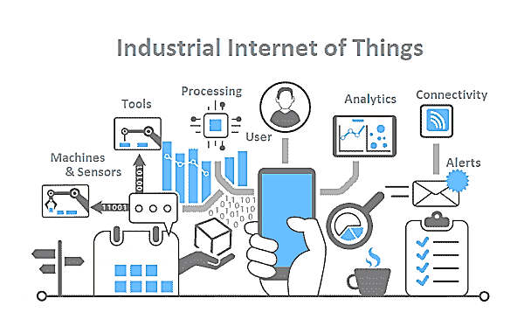
Fig 1: Integration, collection, and exchange of data
By leveraging interconnected devices, sensor networks, and effective data collection, exchange, and integration, IoT in manufacturing enables a new era of intelligent and data-driven operations. The integration of physical and digital realms empowers manufacturers to optimize their processes, enhance decision-making, and achieve higher levels of efficiency, productivity, and quality.
- Applications of IoT in Manufacturing
In this section, we will discuss some of the applications of IoT in manufacturing like Smart Factories, Industrial Automation, Predictive Maintenance, Equipment Monitoring, supply chain, quality control and worker safety etc.
2.1 Smart Factories and Industrial Automation
IoT plays a crucial role in the advancement of smart factories & industrial automation. By integrating IoT technologies, manufacturers can create highly connected and automated production environments. Sensors embedded in machines, equipment, and production lines enable real-time data capture, monitoring, and control. This enables seamless coordination between different processes, optimizing production efficiency and reducing downtime [5]. Figure 2 illustrates the production in a smart factory.

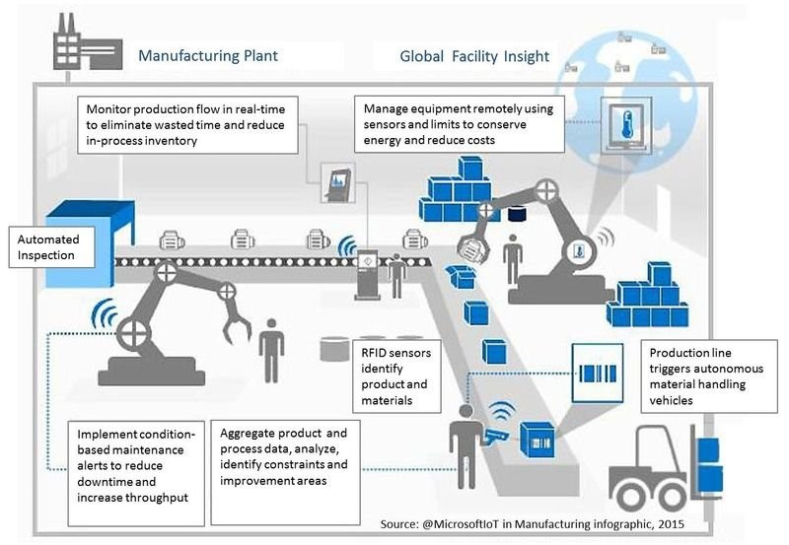
Fig 2: Production in Smart Factory
2.2 Predictive Maintenance and Equipment Monitoring
Predictive maintenance is a critical application of Internet of things (IoT) in manufacturing. By utilizing IoT-enabled sensors & data analytics, manufacturers can actively monitor the real-time performance of their equipment. This enables the detection of anomalies, identification of potential faults, and prediction of maintenance requirements. By addressing maintenance needs proactively, manufacturers can reduce equipment downtime, extend equipment lifespan, and optimize maintenance schedules [16].
2.3 Inventory Management and Supply Chain Optimization
IoT offers significant improvements in inventory management and supply chain optimization. By implementing IoT technologies, manufacturers can monitor inventory levels, track products in real-time, and automate inventory replenishment. This enables better inventory control, reduced stockouts, and improved supply chain visibility. IoT also facilitates the optimization of logistics and transportation, enabling efficient routing, shipment tracking, and demand forecasting [17]. Figure 3 demonstrates the product flow and information within an IoT-enabled supply chain.
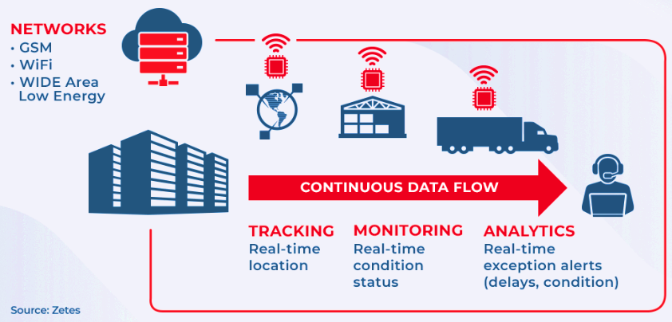
Fig 3: IoT-enabled supply chain
2.4 Quality Control and Defect Detection
IoT-based solutions enhance quality control and defect detection processes in manufacturing. By leveraging sensors, manufacturers have the capability to gather real-time data on various product quality parameters, detect deviations from quality standards, and identify potential defects. This enables early intervention, reducing waste, improving product quality, and minimizing the risk of faulty products reaching the market. IoT also facilitates automated inspection and testing processes, ensuring consistent quality across production batches.
2.5 Product Lifecycle Management and Tracking
IoT enables enhanced product lifecycle management (PLM) by providing real-time visibility and traceability throughout the product's journey. IoT sensors embedded in products allow manufacturers to track their location, monitor usage patterns, and gather data on product performance. This information aids in product design improvements, warranty management, and customer support. Additionally, IoT facilitates end-to-end traceability, enabling quick identification and resolution of issues related to product recalls or non-compliance [18]. Figure 4 illustrates the product lifecycle management process in IoT-enabled manufacturing.
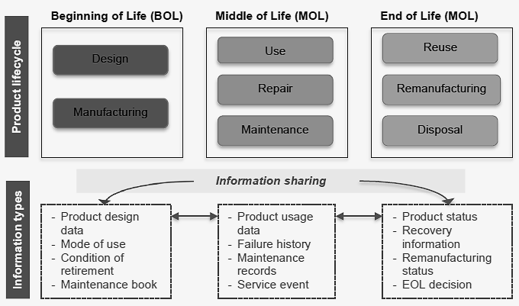
Fig 4: PLM and information Sharing (Yoo M-J et al.)
2.6 Worker Safety and Environmental Monitoring
IoT technologies contribute to ensuring worker safety and monitoring environmental conditions in manufacturing facilities. IoT sensors can detect hazardous situations, monitor air quality, temperature, and humidity levels, and provide real-time alerts to mitigate potential risks. Additionally, wearable IoT devices can track worker movements, fatigue levels, and exposure to hazardous substances, promoting a safer work environment. IoT also aids in environmental monitoring and compliance by monitoring energy consumption, emissions, and waste management.
With the help of IoT in manufacturing, organizations can unlock numerous benefits, including improved operational efficiency, enhanced productivity, optimized supply chain management, and better product quality. These applications empower manufacturers to transform their processes, gain real-time insights, and make data-driven decisions for sustainable growth.
- Benefits of IoT in Manufacturing
The implementation of IoT in manufacturing brings a multitude of benefits, including improved operational efficiency, real-time monitoring and analytics, enhanced productivity, streamlined decision-making, and increased customer satisfaction. By harnessing the power of IoT technologies, manufacturers can gain a competitive edge in today's dynamic and data-driven business landscape.
3.1 Improved Operational Efficiency and Cost Reduction
IoT brings significant benefits to manufacturing operations by improving operational efficiency and reducing costs. By integrating IoT devices and sensors into production processes, manufacturers can gather real-time data on equipment performance, energy consumption, and workflow. This data enables proactive maintenance, optimized resource allocation, and streamlined operations. Through predictive analytics and machine learning algorithms, IoT systems can identify bottlenecks, optimize production schedules, and minimize downtime. These improvements lead to increased productivity, reduced waste, and lower operational costs.
3.2 Real-Time Monitoring, Analytics, and Insights
IoT enables real-time monitoring and analytics in manufacturing, providing valuable insights for decision-making. Through the continuous collection and analysis of data from IoT devices and sensors, manufacturers can gain real-time visibility into production processes, supply chain activities, and equipment performance. This data-driven approach allows for immediate identification of issues, proactive problem-solving, and continuous improvement. With advanced analytical approaches such as ML &AI, IoT systems can generate actionable insights, optimize production parameters, and predict maintenance needs, resulting in improved operational effectiveness and agility.
3.3 Enhanced Productivity and Resource Utilization
IoT technology drives enhanced productivity and resource utilization in manufacturing. Through real-time data capture and analysis, manufacturers can optimize production workflows, identify process inefficiencies, and implement targeted improvements. Automating mundane processes with IoT-enabled equipment reduces human error and frees up labor for higher-value activities. Additionally, IoT devices can monitor resource usage, such as energy, water, and raw materials, allowing for more efficient allocation and conservation. The result is increased productivity, reduced waste, and improved resource utilization, leading to cost savings and sustainability benefits.
3.4 Streamlined Decision-Making Processes
IoT makes it easier to make educated decisions by supplying real-time and accurate data for manufacturing processes. With IoT-enabled systems, manufacturers can access data on production status, supply chain performance, and customer demand in real-time. This allows for quicker response times, adaptive decision-making, and improved customer satisfaction. IoT analytics tools can process vast amounts of data to identify patterns, trends, and anomalies, enabling proactive decision-making and risk mitigation. The ability to make data-driven decisions based on real-time insights leads to improved operational agility, competitive advantage, and customer-centricity.

3.5 Customer Satisfaction and Product Customization
IoT contributes to improved customer satisfaction and product customization capabilities in manufacturing. Through IoT-connected products, manufacturers can gather data on product usage, performance, and customer preferences. This data can inform product design improvements, personalized offerings, and tailored customer experiences. By leveraging IoT-enabled technologies, such as remote monitoring and predictive maintenance, manufacturers can provide proactive customer support, minimizing product downtime and enhancing overall satisfaction. Furthermore, IoT facilitates the integration of customer feedback into the product development process, enabling iterative improvements and increased customer engagement.
Incorporating IoT into manufacturing operations brings numerous benefits, including improved operational efficiency, real-time monitoring and analytics, enhanced productivity, streamlined decision-making, and increased customer satisfaction. By harnessing the power of IoT technologies, In the dynamic and data-driven business environment of today, manufacturers can acquire a competitive advantage.
- IoT Implementation Challenges in Manufacturing
Implementing IoT in manufacturing comes with challenges like data security, interoperability, retrofitting legacy infrastructure, and addressing the need for a skilled workforce. Overcoming these hurdles is essential to fully harness the potential of IoT technologies and drive successful digital transformation in the manufacturing industry.
4.1 Data Security and Privacy Concerns
Problems with data security and privacy arise when IoT is implemented in the manufacturing sector. The security, integrity, and availability of data must be ensured in light of the enormous volume of data being gathered through interconnected devices and sensors. Manufacturers must set up strong security measures to guard against cyber-attacks, unauthorized access, and data breaches. Encryption, authentication mechanisms, and secure communication protocols are essential components of a comprehensive IoT security framework [19]. Additionally, manufacturers must also integrate privacy measures and get user consent for data collection and processing in order to comply with data protection laws like the General Data Protection Regulation (GDPR).
4.2 Interoperability and Integration of Systems
Interoperability and integration of diverse systems pose challenges when implementing IoT in manufacturing. Manufacturers often have a mix of legacy systems, equipment, and software programs that require seamless data interchange and communication. Interoperability standards and protocols are essential for assuring the connectivity and compatibility of IoT devices, sensors, and platforms. Additionally, data integration and aggregation from various sources require data mapping, transformation, and consolidation. Integration frameworks and middleware solutions can facilitate the smooth exchange of data between different systems, enabling a unified view of operations.
4.3 Legacy Infrastructure and Retrofitting
The presence of legacy infrastructure in manufacturing facilities presents challenges for IoT implementation. Many existing machines, equipment, and production lines may lack built-in connectivity and IoT capabilities. Retrofitting these assets with IoT sensors and devices can be complex and require careful planning, considering factors such as compatibility, cost-effectiveness, and minimal disruption to ongoing operations. Integration with legacy systems and protocols may also pose technical challenges. Manufacturers need to assess the feasibility and benefits of retrofitting existing infrastructure and consider strategies for gradual modernization and phased implementation.
4.4 Skilled Workforce and Training Needs
The implementation of IoT in manufacturing requires a skilled workforce with expertise in IoT technologies, data analytics, cybersecurity, and system integration. Training existing employees or hiring new talent with the necessary skills can be a challenge for manufacturers. The rapidly evolving nature of IoT technologies necessitates ongoing training and upskilling initiatives to keep the workforce updated with the latest advancements. Collaborations with academic institutions, industry certifications, and internal training initiatives can fill the skills gap and guarantee a skilled workforce capable of efficiently managing and maintaining IoT systems.
The successful implementation of IoT in manufacturing requires overcoming challenges related to data security and privacy, interoperability and integration, retrofitting legacy infrastructure, and addressing workforce skills. By understanding and addressing these challenges, manufacturers can fully realize IoT technology’s potential to drive innovation, efficiency, and competitiveness in the manufacturing industry.
- Case Studies
Some of the case studies for predictive maintenance, operational optimization and efficiency, cost reduction, improved customer satisfaction, product quality.
Case study 1
Hitachi Construction Machinery (HCM) is a major manufacturer in the construction, mining, and forestry industries. They faced a challenge in collecting operational data from their customers' equipment located in remote and harsh environments. To address this, HCM sought a connectivity partner with asset management experience, a flexible business model, and reliable global connectivity. They found a suitable solution in Telenor Connexion.
HCM partnered with Telenor Connexion to establish a global network of their heavy machines using managed connectivity. The machines are equipped with M2M modules containing 2G/3G SIMs and sensors, allowing data collection and transmission for analysis and action.
The collaboration resulted in the development of ConSite, a web-based system that provides real-time monitoring of various machine parameters such as location, movement, hours of operation, fuel consumption, and power usage. ConSite helps HCM's clients by identifying potential issues, optimizing machine performance, and minimizing administrative downtime.
ConSite also enables the automatic alerting of local operators and service crews if maintenance is required. By promptly addressing maintenance needs, serious damage and downtime can be avoided, which is particularly crucial in remote areas where sending out parts and service teams can be costly.
The data gathered by ConSite helps HCM's customers in effectively utilizing and servicing their machines, resulting in increased operational effectiveness, a reduction in time and expenses. Additionally, the insights provided by ConSite allow customers to better plan for and optimize their operations in any location.
In conclusion, the partnership between HCM and Telenor Connexion, along with the implementation of ConSite, has enabled efficient monitoring and management of HCM's heavy machines worldwide. The solution provides valuable data for operational optimization, cost reduction, and improved customer satisfaction.
Case Study 2
In 2019, Derek Mak founded 99Bridges with a mission to utilize technology and promote a circular economy. The company aims to drive innovation in recycling, reusing, refilling, repurposing, reducing, and renewing, challenging consumer habits that harm the environment.
By promoting the usage of reusable shopping bags, 99Bridges initially targets the problem of single-use plastic bags. Their Mosaic solution, being tested by retailers like Walmart, Target, and CVS Health, offers "smart bags" that can be borrowed for a refundable fee. Users who continue to reuse the bags receive rewards points through a mobile app.
To support their reusable bag initiative, 99Bridges chose an infrastructure using RFID chips in the bags. IoT controllers connected to sensors and scanners at store checkouts track bag borrowing, returns, and reuse. They selected Cisco Catalyst IR1100 Rugged Series Routers for their reliability, compact form factor, and edge computing capabilities.
99Bridges utilizes Cisco IoT Operations Dashboard and Secure Equipment Access to monitor and maintain their network and devices. This allows remote checking of IoT controller status and facilitates troubleshooting. The company aims to provide retailers with a comprehensive view of their equipment and gain insights into the movement of smart bags across various locations.
Collecting data on consumers' recycling and shopping habits is a valuable aspect of 99Bridges' strategy. This data helps refine engagement strategies and enables personalized promotions. Derek continues to advance 99Bridges' mission one step at a time, emphasizing the importance of sustainable practices. The Mosaic solution is referred to as the Reusable-OS for a sustainable future [20].
Case study 3
SRF Limited is a multi-business organization and top producer of technical fabrics, fluorochemicals, packaging films & specialty chemicals, embarked on an IoT-enabled digital transformation journey to improve product quality and optimize processes. They partnered with Altizon and implemented the Datonis IoT platform in four of their connected plants across India.
The focus of the case study is on the dipping process in the manufacturing of technical textiles. SRF aimed to generate actionable insights from the data collected from their OT-IT data lake, with the ultimate objective of obtaining specified fuel consumption & predictive quality. To assist them in achieving these goals, they looked for an industrial IoT partner with the necessary technical skills.
To evaluate impact and make plans, the leadership team of SRF uses a project selection procedure with a payback duration of roughly 1.5 years. They began by implementing one use case in one plant, then following a successful implementation, they extended to other plants. They anticipated using predictive analytics, insights into specific fuel use, and process optimization to reduce rework and waste of raw materials from their cooperation with Altizon.
The Datonis IoT suite was implemented by Altizon, with Datonis Edge running in a fail-safe configuration inside the SRF network. The cloud was used for the deployment of the Datonis IoT platform and MInt (Machine Intelligence). Integration with dependent systems such as ERP and QMS was achieved using the Datonis IoT API.
The deployment of Altizon's solution allowed SRF to gain real-time insights and correlations between process parameters and quality defects. They were able to optimize specific fuel consumption and reduce wastage. Unified view of the data was made possible by the integration of the OT infrastructure with the ERP and QMS, enabling better decision-making.
SRF Limited's partnership with Altizon and they have been able to use real-time data for process optimization, predictive quality, and targeted fuel consumption thanks to the Datonis IoT platform. They have made significant strides in their IoT-enabled digital transformation journey, driving improvements in product quality and operational efficiency [21].
6. Future Trends and Implications
The future of IoT in manufacturing holds promise with trends like edge computing, AI integration, blockchain, and digital twins driving innovation. These advancements will optimize processes, enhance decision-making, and foster sustainable practices, shaping a highly connected and efficient industry.
6.1 Edge Computing and IoT at the Edge
Edge computing has become a promising trend in the industrial sector as a result of the proliferation of IoT devices and the requirement for real-time data processing. It involves processing and analyzing data at or close to the location where it is generated, which reduces latency and speeds up response times. This trend enables manufacturers to make faster decisions, optimize operations, and reduce the dependency on cloud infrastructure.
6.2 Machine Learning & Artificial Intelligence Integration
The integration of machine learning (ML) & artificial intelligence (AI) with IoT in manufacturing holds tremendous potential for enhancing operations and enabling predictive capabilities. Algorithms of AI and machine learning may examine enormous volumes of data gathered from IoT devices to identify patterns, make predictions, and optimize processes. This integration enables manufacturers to automate decision-making, improve product quality, and reduce downtime through predictive maintenance.
6.3 Blockchain and Distributed Ledger Technologies
Blockchain technology offers secure and transparent data management, making it applicable in various manufacturing processes, such as supply chain management, product traceability, and warranty tracking. By utilizing blockchain and distributed ledger technologies, manufacturers can enhance data integrity, improve trust among stakeholders, and streamline transactions.
6.4 Cyber-Physical Systems & Digital Twins
The concept of cyber-physical systems (CPS) & digital twins has gained significant attention in the manufacturing industry. CPS involves the integration of physical components with digital systems, enabling the monitoring, regulation, and optimization of production processes in real time. Digital twins, on the other hand, are virtual replicas of physical assets, allowing manufacturers to undertake predictive maintenance, analyze performance data, and simulate and optimize processes.
6.5 Sustainability and Green Manufacturing
The drive for sustainable and environmentally friendly manufacturing practices has become increasingly important. IoT technologies can contribute to green manufacturing by enabling energy-efficient operations, waste reduction, and environmental monitoring. By collecting and analyzing real-time data, manufacturers can identify areas for improvement, optimize resource usage, and minimize their ecological footprint.
Conclusion
This book chapter has provided a comprehensive exploration of the Internet of Things (IoT) and its profound effect on the manufacturing industry. We have examined the definition of IoT in the manufacturing context, emphasizing interconnected devices and sensor networks that enable real-time data collection, exchange, and analysis. The applications of IoT in manufacturing have been extensively explored, showcasing its transformative potential in areas such as smart factories, predictive maintenance, inventory management, supply chain optimization, quality control, and product lifecycle management.
Throughout the chapter, we have highlighted the immense benefits that IoT technologies bring to the manufacturing industry, including improved operational efficiency, cost reduction, real-time monitoring and analytics, enhanced productivity, and informed decision-making. These benefits empower manufacturers to streamline their processes, optimize resource utilization, and deliver higher-quality products to meet the ever-evolving demands of the market.
However, we have also acknowledged the challenges associated with implementing IoT in manufacturing, such as data security, interoperability, legacy infrastructure, and the need for a skilled workforce. To achieve a successful IoT implementation, manufacturers must confront these issues head-on and create solid strategies.
Real-world case studies have been presented to provide practical insights into successful IoT implementations in manufacturing, demonstrating the tangible outcomes and valuable lessons learned from diverse industries. These case studies underscore the transformative power of IoT in improving efficiency, enabling predictive maintenance, optimizing supply chains, and enhancing overall productivity.
Looking ahead, we have explored future trends and implications, highlighting the integration of edge computing, artificial intelligence, machine learning, blockchain, cyber-physical systems, digital twins, and sustainability practices within the manufacturing domain. These advancements hold the potential to further enhance the capabilities of IoT, enabling intelligent decision-making, autonomous processes, and sustainable practices.
References
[1] Gubbi, J., Buyya, R., Marusic, S., & Palaniswami, M. (2013). Internet of Things (IoT): A vision, architectural elements, and future directions. Future Generation Computer Systems, 29(7), 1645–1660. doi:10.1016/j.future.2013.01.010
[2] Atzori, L., Iera, A., & Morabito, G. (2010). The Internet of Things: A survey. Computer Networks, 54(15), 2787–2805. doi:10.1016/j.comnet.2010.05.010
[3] Kusiak, A. (2017). Smart manufacturing must embrace big data. Nature, 544(7648), 23–25. doi:10.1038/544023a
[4] Lee, J., Bagheri, B., & Kao, H.-A. (2015). A Cyber-Physical Systems architecture for Industry 4.0-based manufacturing systems. Manufacturing Letters, 3, 18–23. doi:10.1016/j.mfglet.2014.12.001
[5] Wang, S., Wan, J., Zhang, D., Li, D., & Zhang, C. (2016). Towards smart factory for industry 4.0: a self-organized multi-agent system with big data-based feedback and coordination. Computer Networks, 101, 158–168. doi:10.1016/j.comnet.2015.12.017
[6] Xu, Li & He, Wu & Li, Shancang. (2014). Internet of Things in Industries: A Survey. IEEE Transactions on Industrial Informatics. 10. 2233-2243. 10.1109/TII.2014.2300753.
[7] Rathore, M. M., Ahmad, A., Paul, A., & Rho, S. (2016). Urban planning and building smart cities based on the Internet of Things using Big Data analytics. Computer Networks, 101, 63–80. doi:10.1016/j.comnet.2015.12.023
[8] Evans, P & Annunziata, Marco. (2012). Industrial Internet: Pushing the boundaries of minds and machines. General Electric.
[9] Perera, Charith & Liu, Chi Harold & Jayawardena, Srimal. (2015). The Emerging Internet of Things Marketplace From an Industrial Perspective: A Survey. IEEE Transactions On Emerging Topics In Computing. 3. 10.1109/TETC.2015.2390034.
[10] Henzel, R., & Herzwurm, G. (2018). Cloud Manufacturing: A state-of-the-art survey of current issues. Procedia CIRP, 72, 947–952. doi:10.1016/j.procir.2018.03.055
[11] Xu H, Yu W, Griffith D, Golmie N. (2018). A Survey on Industrial Internet of Things: A Cyber-Physical Systems Perspective. IEEE Access. doi: 10.1109/access.2018.2884906. PMID: 35531371; PMCID: PMC9074819.
[12] Jan, B., Farman, H., Khan, M., Imran, M., Islam, I. U., Ahmad, A., … Jeon, G. (2017). Deep learning in big data Analytics: A comparative study. Computers & Electrical Engineering. doi:10.1016/j.compeleceng.2017.12.009
[13] Li, Shancang & Xu, Li & Zhao, Shanshan. (2018). 5G Internet of Things: A survey. Journal of Industrial Information Integration. 10. 10.1016/j.jii.2018.01.005.
[14] Landaluce H, Arjona L, Perallos A, Falcone F, Angulo I, Muralter F. (2020). A Review of IoT Sensing Applications and Challenges Using RFID and Wireless Sensor Networks. Sensors; 20(9):2495. https://doi.org/10.3390/s20092495
[15] Saqlain M, Piao M, Shim Y, Lee JY. (2019). Framework of an IoT-based Industrial Data Management for Smart Manufacturing. Journal of Sensor and Actuator Networks; 8(2):25. https://doi.org/10.3390/jsan8020025
[16] Au-Yong, Cheong Peng & Ali, Azlan & Ahmad, Faizah. (2014). Predictive Maintenance: Monitoring Tools and Equipment. The Malaysian Surveyor. 49. 6-11.
[17] Doborjginidze, Giorgi & Petriashvili, Lily & Inaishvili, Mariam. (2021). Optimization of Inventory Management in the Supply Chain. Journal of Communication and Computer. 16. 10.17265/1548-7709/2021.01.001.
[18] Yoo M-J, Grozel C, Kiritsis D. Closed-Loop Lifecycle Management of Service and Product in the Internet of Things: Semantic Framework for Knowledge Integration. Sensors. 2016; 16(7):1053. https://doi.org/10.3390/s16071053
[19] Acharya, Vadiraja & Hegde, Vinay. (2020). Security Frameworks for Internet of Things Systems - A Comprehensive Survey. 339-345. 10.1109/ICSSIT48917.2020.9214127.
[20] Angela Murphy (2021). 99Bridges uses industrial IoT to power sustainability. Cisco blogs. https://blogs.cisco.com/internet-of-things/99bridges-uses-industrial-iot-to-power-sustainability
[21] https://altizon.com/srf-chemicals-case-study/

