BLOCKCHAIN AND ARTIFICIAL INTELLIGENCE FOR INTERNET OF THINGS

Author: Abi K, Deepika J, Yogesh J
M.Sc. Computer Science and Technology
SRM Arts and Science College, Kattankulathur.

ABSTRACT
This article explores the convergence of two cutting-edge technologies: blockchain and artificial intelligence (AI). Blockchain technology is a decentralized and secure system that has gained attention for its potential to revolutionize various industries. It is a distributed and immutable digital ledger that records transactions or information across a network of computers in a transparent and tamper-proof manner. AI, on the other hand, is a field of technology focused on creating machines and systems that can mimic human cognitive functions. It involves developing algorithms and models that enable computers to process data, recognize patterns, and make decisions in ways that simulate human intelligence. The article delves into the synergistic relationship between these two technologies, highlighting their potential to reshape industries ranging from finance to healthcare. However, it also acknowledges the challenges and ethical concerns associated with their implementation. Overall, the article presents a comprehensive overview of the convergence of blockchain and AI, exploring their potential to transform the digital landscape.
INTRODUCTION

BLOCKCHAIN
Block chain technology is a decentralized and secure system that has gained significant attention for its potential to revolutionize various industries. At its core, a blockchain is a distributed and immutable digital ledger that records transactions or information across a network of computers in a transparent and tamper-proof manner. Each block in the chain contains a timestamped record of transactions, and once added, the blocks cannot be altered without consensus from the network participants.

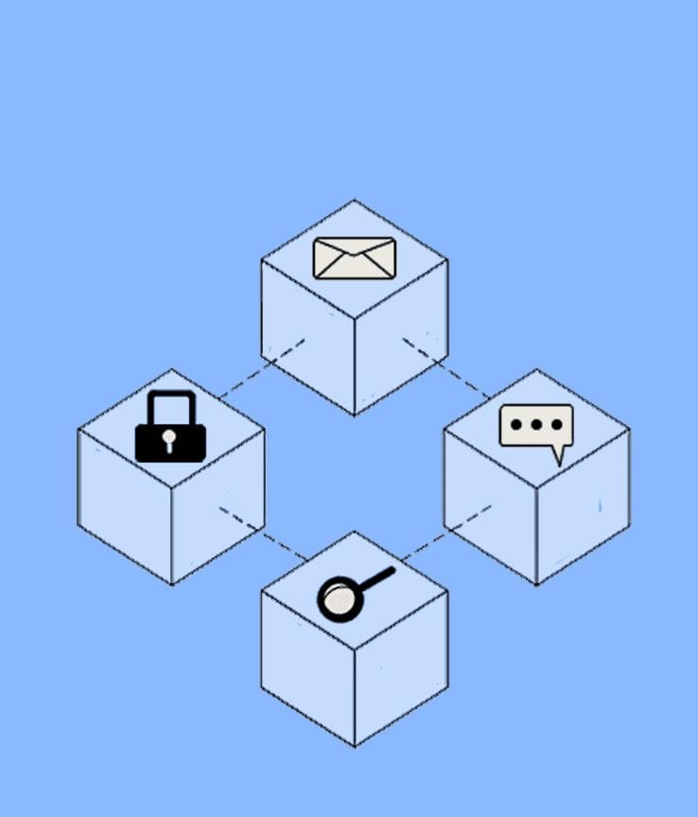
- One of the key features of blockchain is its transparency and security. Because data is stored across multiple nodes in the network, it becomes extremely difficult for any single entity to manipulate the information, enhancing trust and accountability. This has led to its widespread use in financial applications like cryptocurrencies, with Bitcoin being the most well-known example.
- Blockchain technology extends beyond finance. It has applications in supply chain management, where it can trace the origins and journey of products, ensuring authenticity and ethical sourcing. Smart contracts are another innovation enabled by blockchain, allowing self-executing contracts with predefined conditions and automatic enforcement.
However, blockchain is not without challenges. Its energy consumption, especially for proof-of-work-based cryptocurrencies, has raised concerns about environmental impact. Scalability and interoperability issues also need to be addressed for widespread adoption.

ARTIFICIAL INTELLIGENCE
Artificial Intelligence (AI) is a transformative field of technology focused on creating machines and systems that can mimic human cognitive functions. Over the years, AI has evolved from theoretical concepts to practical applications that are shaping various industries. The core principle of AI involves developing algorithms and models that enable computers to process data, recognize patterns, and make decisions in ways that simulate human intelligence.
AI encompasses several subfields, with machine learning being a prominent one. Machine learning involves training algorithms on vast datasets to improve their performance over time. Neural networks, a subset of machine learning, are inspired by the human brain's structure and have enabled breakthroughs in tasks like image and speech recognition.
Natural Language Processing (NLP) is another critical area of AI, allowing computers to understand, interpret, and generate human language. This has led to advancements in chatbots, language translation, and sentiment analysis.
While AI offers remarkable potential, it also raises ethical concerns. Issues related to bias in AI systems, data privacy, and the potential for job displacement due to automation are subjects of ongoing debate.

Converging Pathways: Exploring the Synergy of Blockchain and AI:

This abstract delves into the synergistic relationship between two cutting-edge technologies: blockchain and artificial intelligence (AI). Deep learning models, rooted in intricate neural networks mimicking human cognition, have demonstrated their prowess in pattern recognition, prediction, and decision-making. On the other hand, blockchain networks offer a transparent, decentralized economic settlement layer, fostering immutable data storage and trust-minimized digital interactions.
The amalgamation of blockchain and AI holds the promise of intelligent automated decision-making systems, rooted in immutable data, capable of triggering real-world outcomes. This integration could birth novel business models, enhance operational efficiency, automate tasks, bolster data security, and imbue AI-driven smart contracts with unprecedented transparency and trust.
Yet, the implications reach beyond business, spanning into education, healthcare, energy, social impact, agriculture, and urban planning. Through the fusion of AI's analytical prowess and blockchain's decentralized security, these technologies could empower data-driven decision-making and resource management across diverse sectors. This abstract envisions a future where the convergence of AI and blockchain reshapes industries, fosters innovation, and facilitates efficient, transparent resource allocation for societal advancement.
Various use cases and potential synergies between AI (Artificial Intelligence) and blockchain technology:

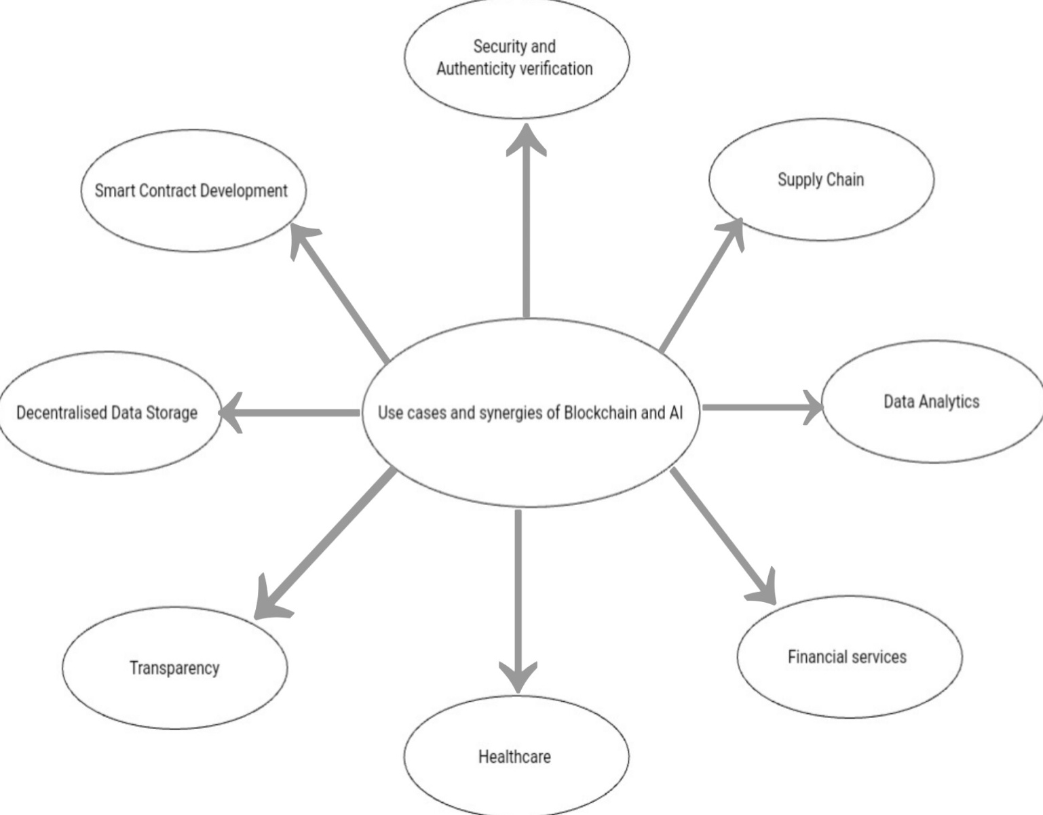

SECURITY:
Combining AI and blockchain can enhance security by deploying AI systems with built-in safeguards, enforced by tamper-proof decentralized infrastructure. Decentralized systems are more resilient against attacks due to their distributed nature.

SUPPLY CHAIN:
AI models within blockchain-based smart contracts can automate tasks like inventory management and order execution. This integration can improve transparency, reduce fraud, and optimize supply chain processes, even aiding disaster relief efforts.

AUTHENTICITY VERIFICATION:
The blend of AI's creative capabilities and blockchain's cryptographic validation can help verify the authenticity of media content. Blockchain can timestamp content and validate its origin, combating misinformation and fostering content trust.

DATA ANALYTICS:
Blockchain's secure data provenance can be utilized for large-scale data analytics. AI models can analyze on-chain data, extract trends, and provide insights for informed decision-making.

FINANCIAL SERVICES:
AI can leverage decentralized finance (DeFi) for executing financial actions without intermediaries. The composability of blockchain applications allows for complex financial transactions with transparency and security.

HEALTHCARE:
Blockchain's secure data storage combined with AI analysis can lead to accurate diagnoses, personalized treatment plans, and enhanced privacy in healthcare data management.

TRANSPARENCY:
Blockchain's transparent nature can address the opacity of complex AI models. By recording decision-making patterns on the blockchain, AI models can provide more integrity and transparency in their outputs.

DECENTRALISED DATA STORAGE:
Blockchain-based storage solutions like File coin and IPFS can safeguard training data integrity and confidentiality, benefiting AI systems.

SMART CONTRACT DEVELOPMENT:
AI-assisted development tools can boost the productivity of smart contract developers. AI-powered APIs can enable the creation of innovative Web3 applications.
Overall, the integration of AI and blockchain has the potential to revolutionize various sectors by enhancing security, transparency, efficiency, and trust in diverse applications.

The integration of AI and blockchain technology holds great promise across various industries, but several challenges must be addressed to fully unlock their potential. Some of these challenges include:

DATA COLLECTION AND INTEROPERABILITY:
AI models require diverse datasets, which can be challenging to gather due to privacy concerns and the need to connect different datasets. Interoperability between various blockchain networks and AI platforms is crucial to ensure seamless data exchange and compatibility between these technologies.

STANDARDS AND CONNECTIVITY :
Establishing standards is essential to facilitate connectivity between AI and blockchain systems. Common protocols and interfaces need to be developed to ensure smooth interactions and data sharing.

DATA PRIVACY:
The integration of AI and blockchain can raise new privacy concerns. Existing data privacy frameworks may need to be updated to address these challenges and ensure that user privacy is protected while leveraging the benefits of both technologies.

USER AWARENESS AND EDUCATION:
Public awareness of AI and blockchain remains limited. Educating the public about the potential benefits, risks, and considerations associated with these technologies can build trust and foster greater acceptance of their integration.

REGULATORY AND ETHICAL CONSIDERATIONS :
Regulatory frameworks need to evolve to accommodate the unique challenges posed by the convergence of AI and blockchain. Addressing ethical concerns, such as bias in AI models and the potential misuse of blockchain for nefarious purposes, is important.

TECHNICAL COMPLEXITY:
Implementing and managing AI on blockchain can be technically complex. Addressing scalability, efficiency, and performance issues while maintaining security is crucial.

RESOURCE REQUIREMENTS :
AI and blockchain technologies can be resource-intensive. Ensuring efficient resource utilization, especially in decentralized systems, is a consideration.

LACK OF STANDARDIZATION:
The absence of standardized approaches for combining AI and blockchain can lead to fragmentation and hinder widespread adoption..
Despite these challenges, addressing them can lead to a future where AI and blockchain work harmoniously, enhancing data security, privacy, transparency, and efficiency across various sectors.
INTERNET OF THINGS
IoT describes physical items that have been connected to the internet and have sensors.Smart gadgets allow data to be collected by sensors, processed internally, and transmitted to other internet-connected devices.
Blockchain integration with IoT
Blockchain was initially utilised for cryptocurrencies and financial transactions, where all nodes in the network execute and store transactions. Following that, blockchain is used by many industries due to its great advantages. IoT systems is one of these domains. Numerous IoT applications can benefit greatly from combining blockchain with IoT . As it is appropriate for IoT applications like healthcare, smart homes, smart cities, smart transportation, and others, the blockchain is decentralised and trustless in the meantime.
It is not simple to integrate blockchain technology into an IoT system. The first and critical step is to identify the blockchain platform that will be utilised to connect the IoT with blockchain technology.
Technology convergence:
IoT, Blockchain, and AI/ML are combining in a way that creates a powerful synergy that is the actual strength of the digital transformation. Organisations may take advantage of the new technologies' seamless integration to build connected, intelligent ecosystems. IoT devices, for instance, can produce enormous volumes of data that can be safely shared and stored using blockchain technology. The useful insights that AI/ML algorithms can then uncover from this data will facilitate reasoned decision-making and continual development.
Industry-specific effects:
IoT, blockchain, and AI/ML technology convergence is revolutionising a wide range of sectors. Organisations are utilising these technologies to streamline operations, improve customer experiences, and spur innovation in a variety of industries, including healthcare, manufacturing, finance, and logistics.
CONCLUSION
Innovations like blockchain, IoT, and AI provide significant advantages in terms of security, transparency, immutability, privacy, and the automation of corporate processes. However, when blockchain, IoT, and AI are coupled, the impact of these advancements is even greater. We contend that these breakthroughs will eventually combine, propelling the industry's digitization. IoT, blockchain, and AI/ML technology convergence is leading the way in accelerating digital transformation. Organisations that embrace this potent mix can open up new possibilities, improve operational effectiveness, and offer customers revolutionary experiences. Organisations can stay competitive in the digital age and create a future where success is driven by connectivity, trust, and intelligence by leveraging the seamless integration of these technologies.

REFERENCES:
1.Sandner P, Gross J and Richter R (2020) Convergence of Blockchain, IoT, and AI. Front. Blockchain 3:522600. doi: 10.3389/fbloc.2020.522600
2. Ruonan Wang et al.
3.Saima Khan, Omprakash Mangde
4.Ruonan Wang et al.
5.Boar, C., Holden, H., Wadsworth, A. (2020): Impending arrival — a sequel to the survey on central bank digital currency, BIS Paper №107.
6.Liu, M., Yu, R., Teng, Y., Leung, V., Song, M. (2019). Performance Optimization for Blockchain-Enabled Industrial Internet of Things (IIoT) Systems: A Deep Reinforcement Learning Approach. IEEE Transactions on Industrial Informatics.
7.Yin, H. H. S., Langenheldt, K., Harlev, M., Mukkamala, R. R., Vatrapu, R. (2019). Regulating Cryptocurrencies: A Supervised Machine Learning Approach to De-Anonymizing the Bitcoin Blockchain. Journal of Management Information Systems, 36(1), 37–73

