Nursing As a Profession
Rehana Quasar (Msc Community Health Nursing) Tutor College of nursing Govt. Medical College, Srinagar ahmadzaynrehana@ gmail.com, 7051528918

INTRODUCTION

Any profession that needs advanced training and usually involves mental rather than physical work, like teaching, engineering, especially medicine and law“ So, nursing is a profession because is based on knowledge and training

Definition:
“The unique function of the nurse is to assist the individual, sick or well, in the performance of those activities contributing to health or its recovery (or to peaceful death) that he would perform unaided if he had the necessary strength, will or knowledge.”
—Virginia Henderson

“Nursing consists of autonomous and collaborative care of individuals of all ages, families, groups and communities, sick or well and in all settings. It includes the promotion of health, the prevention of illness, and the care of ill, disabled and dying people.”
World Health Organization “WHO
NURSING ASPECTS
Spiritual: When an individual is physically unwell, the belief system, religious/spiritual rituals and practices are challenged. Nurse do provide spiritual care and while doing so she encourages patient to keep the faith and helps to perform the routine or rituals related to spiritual beliefs of the patient. Purpose is to provide a support to patient and help to cope up with illness, loss or grief or pain.
Emotional; Emotional care includes acceptance of the patient as an individual being empathetic and compassionate towards the individual in sickness, loss or grief or pain. Nurse need to be emotionally stable and possess emotional intelligence to provide effective care.
Social: Social care is related to the interpersonal relationships patient has and empowering the patient to maintain them in a healthy way is providing social care. Nurse need to be free from personal prejudices and bias in order to incapacitate the patient for better understanding of others’ mind set so that empathetic approach is developed and conflict resolution occurs.
Physical: Physical care is the most important and responsible for disturbance of other dimensions of health. Patients are mainly focused on the physical (bodily) sickness, due to which the other aspects are affected therefore nurse provides care catering to all the aspects leading to provision of holistic care.

CONCEPTS OF NURSING
Fair and justice | The delivery of care should be impartial regardless of physical and psychological condition of individual, their age, gender, race, belief and status in society
Respect | Respect fundamental human rights while providing health care to individual.
Therapeutic | Build a helping relationship with the patient, his family and society.
Collaboration | Ability to walk independently and in collaboration with the multidisciplinary team in view of developing her skills and professional knowledge.
Judicious | Timely and thoughtful implementation of health policies.
Evidence based practice | Participate in research-based nursing and evaluation of research to propose evidence-based practices
Patient autonomy | Respect the rights of patient to accept and refuse the treatment
Informed practices | Disseminate appropriate information to patients and his family members about health status, investigations and procedures done, diagnosis, treatment and prognosis of patient

NURSING METAPARADIGM
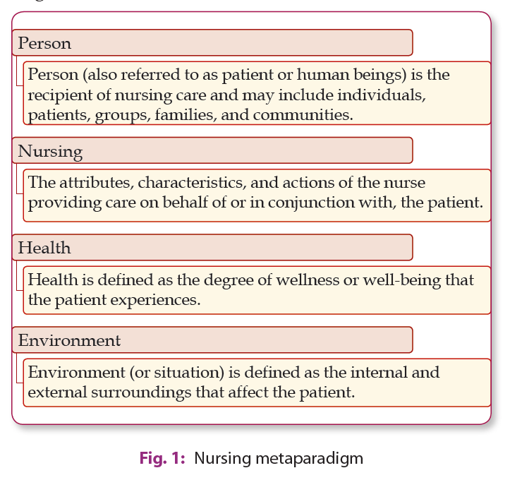

NURSING PHILOSOHY :
- Nursing philosophy is related to our thoughts that what we perceive as true regarding the nature of the nursing profession and provide a basis for nursing activities.
- Nursing is considered as ’profession of charity’. It covers following aspects
PHILOSOPHY OF NURSING BARRIERS
- Spiritual:-. It emphasises on development of a sense of meaning, purpose, and hope for the person in their daily life experience. Spiritual interventions involve spiritual rituals that facilitates the person to connect to God by using meditation or prayer.
- Moral: Understanding of moral principles and actions lead the nurses to study ethics. Nurse has to fallow the right conduct in different situations of daily life, based on moral character, adequate understanding and application of moral standards.
- Intellectual: Nurse should be intellectually sound. Nursing education should give training in memory development, communication skills, acting reasonably, judging wisely, strengthening and expansion of capacity.
- Emotional needs: Nurse must be able to function as emotionally strong personality in order to relate with the public .
- Physical: Nurse should have knowledge, ability and skills to guide and assist others in carrying out their physical activities. Nurse must have knowledge of, how to keep well and improve health.
- Social: Nursing is linked to social group , where nursing is carried out. Nursing professionals devote their life for patient care under social culture irrespective of color, creed, cost ,religion etc . It depends on art and science, which form the position, intellectual fitness and showing abilities of the individual nurse, to help individuals, debilitated or well, to meet their wellbeing needs in clinical way.
- Other Barrier:
CHARACTERISTICS OF NURSING PRACTICE
Respects the diversity
Nursing care respects the different cultural diversity to meet the individualized needs of the patient, family and group or community.

COORDINATION
The nurses establish coordination with the heath care team and address the needs of the patients and achieve the goals to deliver the quality health care.
SYSTEMATIC AND SCIENTIFIC APPROACH
Nurses use nursing process (cognitive skills and evidence-based practice) to make diagnosis, identify objectives, plan and implement and evaluate the care. Critical thinking underlines each step of nursing process.
HEALING ENVIRONMENT
Nursing practice is a strong link between the professional work and environment to provide optimal level of health care services and to achieve optimal outcomes.
CONTINUUM OF CARE
Professional nurse provides hospital or community based specialized care to the patients experiencing health problems.
Interpersonal relationship.
It is a process of interacting with the patients that focuses on advancing their physical and emotional well-being. With proper communication, the nurse understands the response of the patient that is good to patient’s mental and physical health. Therapeutic communication is the backbone of the nursing.
PHYSICAL AND BIOLOGICAL INTERVENTIONS
Nursing involves delivering or assisting in various psychical and biological interventions such as medications, surgery and direct physical care (personal hygiene, nutrition, sleep, etc) of the patients having illness.
PSYCHOSOCIAL INTERVENTIONS
It includes psychological interventions, such as cognitive behavioral therapy, family therapy, milieu therapy and psychodynamic approaches. These interventions are used by the nurses to alleviate the psychological problems

SPIRITUAL therapy
It helps to developing a sense of exisistence , goal , and hope for the patients in their life experience.
THERAPEUTIC RELATIONSHIP
The basic component of nursing care involve interpersonal relations and interactions between nurses and patients.
EMPATHETIC NURSING
It is the core of nursing where nurse try to Understand patient’s perspective. Empathy reinforces a positive psychological and enhances patient’s sense of importance.
SUPPORTIVE CARE
therapeutic relationships between nurse and patient need to have positive support. Minor activities, such as sitting with the patients or reading the newspaper together can improve the quality of support provided. Therapeutic touch is induces comfort and console the patients.
LEGAL AND ETHICAL PARAMETERS
Professional nursing takes place in legal and ethical boundaries. Nurse must have clear sense of professional ethics, one's own values that helps her to be honest and committed nursing professional
SCOPE OF NURSING PRACTICE
The scope of nursing practice range from roles, functions, responsibilities, and activities that registered nurses are licensed to perform. Nursing practice is accomplished through the following:
1) EXPANDED ROLES OF NURSES
- Home care Nursing
- Institutional nursing
- School health nursing
- Geriatic nursing
- Industrial nursing
- Nurse educator
- Nurse epidemiologist
- Rehabilitation nurse
- Military nursing
- Diaster nursing
- Nurse researcher Nurse enterrpreneur
EXTENDED ROLES OF NURSES
- Certified Registered Nurse Anaesthetist
- Nurse Practitioner
- Psychiatric Nurse Practitioner
- Adult Nurse Practitioner
- Paediatric Nurse Practitioner
- Nurse Midwife Practitioner
- Oncology Nurse Practitioner
- Nurse Informatics Specialist
- Registered Nurse Lawyer
FACTORS AFFECTING SCOPE OF NURSING PRACTICE
- Issues and Challenges - Issues such as kind infrastructure, co-morbidity illness, cost of treatment, availability of resources and manpower, community awareness, stigma etc. are the important factors affecting the role and functions of a nurse .
- Practice Trends -Trends such as deinstitutionalization, integrated and continuity of services, holistic aspects of care, Use of information technology, Evidence Based Practice and pandemic such as COVID 19 has broaden the role and functions of the nurses
- Professional Practice Standard and Quality of Care- These standards identify the competency requirements for a nurse to practice and guide them to functions according to the expected norms
- Personal Characteristics of a Nurse - Interest, altruism, professional competencies, emotional wellbeing, values and many personal characteristics of a nurse influences their roles and functions.

FUNCTIONS OF A NURSE
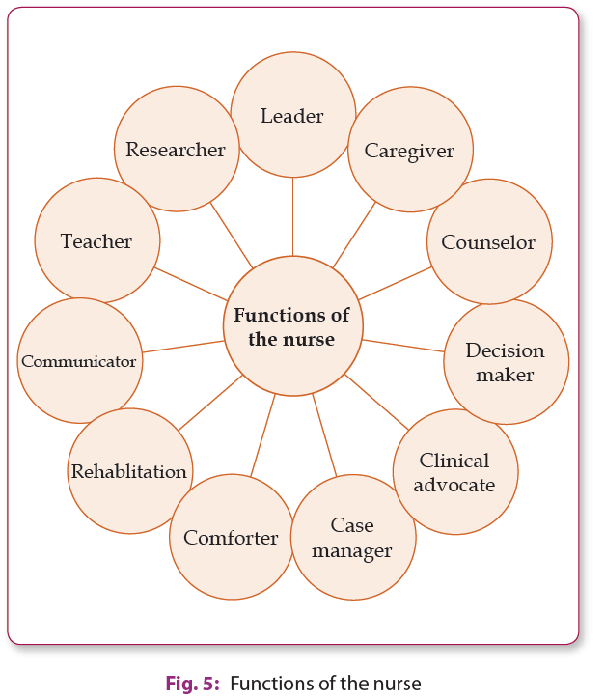
QUALITIES OF NURSE
The qualities of nurse are as :

1. Caring:

Nurses help the patient physically and psychologically and provide the direct care related to patient welfare.

2. Communication Skills
Use of effective therapeutic interpersonal communications skills is important to recognize problems of a client and his family.

3. Empathy
By practicing empathy, nurses are more likely to treat their patients as “people” and focus on a person-centered care approach, rather than strictly following routine guidelines.

4 . Problem Solving Skills
Problem solving skills are important to nursing, as nurses should have critical thinking skills to address the problems of patient.

5. Stamina
As nursing is over whelmed with lot of pressure due to lack of proper nurse patient ratio and other. Therefore an effective managing skill is important that helps a nurse to cope and improve her occupational role . This skill impacts nurses, their coworkers, and the patients. Having enough stamina is the most important qualities of a nurse.
6. Respect
Nurses should have respect for people and ethics .they should maintain confidentiality of different cultures, traditions and wish of the patient

7. Critical Thinking
It is important skill to become competent nurse utilizing knowledge and practice especially in stress situation .it also is helpful to develop a leadership quality and to enhance professional and personal growth..

8. Time Management
Effective time management is one of the essential quality of nursing professional .With this a nurse can manage the patients and other activities in an appropriate manner and benefit her own life and her occupation.

9. Leadership.

Being a leader is a great job as it focuses on overall development of a patient care ,nursing education and nursing administration..

References
- Kozier & Erb's Fundamentals of Nursing, concepts, process and practice , (10th Edition). Tenth Edition
- Audrey Berman and, Shirlee Snyder. 2016.
- Potter, P. A., Perry, A. G., Hall, A., & Stockert, P. A. (2017). Fundamentals of nursing. Ninth edition. St. Louis, Mo.: Mosby Elsevier.
- Barbara Kozier - Fundamentals of Nursing ed. Fourth Addison Wesley Canada 1991
- Textbook of Foundation of Nursing" by Jyoti Kathwal
- Alisha Cornell, Natalie Vaughn, February 25, 2020, Cited On 12/7/2023

Internet
1.https://www.who.int/news-room/campaigns/year-of-the-nurse-and-the-midwife- 2020 2.https://www.icn.ch/ 3.www.un.org 4.https://archive.org/account/login 5.https://theweek.com/audio/623296/brief-history-florence-nightingale-founder- modern-nursing 6.https://www.icn.ch/nursing-policy/nursing-definitions 7.https://www.ukessays.com/ 8. https://www.nursingschoolhub.com/history-nursing/ 9. https://www.nursingtimes.net/

