Pulsed Electric Field: A Promising Technique for Future Food Processing

Mehul Chudasama
Department of Dairy and Food Technology
Parul Institute of Technology, Parul University,
Vadodara, India
mehul.chudasama29347@paruluniversity.ac.in

Manish Tiwari
Department of Dairy and Food Technology
Parul Institute of Technology, Parul University,
Vadodara, India
manish.tiwari28589@paruluniversity.ac.in

Jyotirmoy Goyary
Department of Dairy and Food Technology
Parul Institute of Technology, Parul University,
Vadodara, India
jyotirmoy.goyary29350@paruluniversity.ac.in
Abstract
Pulsed Electric Field (PEF) technology is a promising technique for future food processing. It involves applying short pulses of high-voltage electric fields to food products, resulting in microbial inactivation and quality improvement. PEF offers a non-thermal alternative to traditional methods, such as pasteurization, while preserving the sensory and nutritional attributes of food. It has demonstrated efficacy against various microorganisms and can be applied to liquids, semi-solids, and solids. PEF not only controls microbial growth but also enhances food quality by facilitating compound extraction and improving texture. Although challenges exist, ongoing advancements are addressing them and expanding the application of PEF in the food industry. PEF holds significant potential as an energy-efficient and environmentally friendly processing technique for producing high-quality, minimally processed foods.

Keywords- Pulsed Electric Field; microbial inactivation; pasteurization alternative; non-thermal processing

I. Introduction
Pulsed Electric Fields (PEF) is a non-thermal method of food preservation that employs short pulses of electrical current to deactivate microorganisms, while minimizing the impact on food quality. The primary objective of PEF technology is to deliver high-quality food to consumers. With regards to food quality, PEF technology is considered superior to conventional heat treatment techniques as it mitigates or substantially reduces undesirable alterations in sensory and physical attributes of food. PEF technology exhibits advantages over heat treatment by effectively eliminating microbes while better preserving the original color, taste, texture, and nutritional composition of unprocessed foods. The application of PEF involves subjecting a liquid or semi-solid food product positioned between two electrodes to high voltage pulses. The majority of PEF studies have concentrated on examining the impact of PEF treatment on the inactivation of microorganisms in various liquid foods such as milk, milk products, egg products, juices, among others.

A. History
Heinz Doevenspeck, a German engineer, conducted groundbreaking experiments on the application of pulsed electric fields (PEF) for food processing. In 1960, he obtained a patent (Doevenspeck 1960), describing the use of PEF for cell disruption in food materials, specifically to enhance phase separation (Doevenspeck 1961). As early as 1961, an industrial-scale plant capable of processing up to 2500 kg/h of beef, pork, and fish waste materials was established in a fat smeltery in Germany. Doevenspeck, working as a consulting engineer, explored potential applications of the PEF technique and collaborated with Münch, the technical director for animal material processing at Krupp Maschinentechnik, in 1985. Recognizing the potential of the technology, Krupp Maschinentechnik sought alternative processing methods for cell disintegration and improved phase separation of fish slurry in a screw press following the restrictions on perchloroethylene use for fat extraction (Sitzmann 2006). Subsequently, in consultation with Doevenspeck, a working group comprising Münch, Sitzmann, and other colleagues developed the ELCRACK® and ELSTERIL® processes (Sitzmann and Münch 1988; Sitzmann and Münch 1989). In 1986, a pilot plant for ELSTERIL® was developed, featuring a high voltage pulse generator capable of producing peak voltages of 15 kV at a repetition rate of 22 Hz. The storage capacity of the plant ranged from 0.5 to 5 µF, and an ignitron was employed to discharge the stored electrical energy (Grahl 1994). Multiple treatment chambers, including both batch and continuous systems, were designed with two parallel plate carbon electrodes. The electrode gap options were 0.5 or 1.2 cm, and a flow rate of 165 l/h was utilized (Grahl 1994). In collaboration with FMC Europe in 1990, no adverse effects on the quality of orange juice were observed during testing. However, following issues with the initial industrial unit, financial support from Krupp was significantly reduced. Sitzmann, undeterred, continued his work in the field of PEF applications by establishing his own businesses, DWS and Nafutec GmbH, thereafter (Anonymous 1995; Sitzmann 1995).

B. Principle
The fundamental principle of PEF technology involves administering short pulses of high-intensity electric fields, typically ranging from microseconds to milliseconds in duration, with intensities on the order of 10-80 kV/cm.
Processing time = Number of pulses ⨯ Pulse duration
The PEF process involves the delivery of pulsed electrical currents to a food product positioned between a pair of electrodes within a chamber, typically at room temperature. The distance between the electrodes is referred to as the treatment gap of the PEF chamber. By applying a high voltage, an electric field is generated, leading to the inactivation of microorganisms. Various types of electrical pulses, such as exponentially decaying, square wave, bipolar, or oscillatory pulses, can be utilized. The application of electric fields can be performed at ambient, sub-ambient, or slightly above ambient temperatures. Following the treatment, the food is aseptically packaged and stored under refrigeration. The conductivity of the food, attributed to the presence of ions, enables the transfer of electrical current throughout the liquid. As a result, charged molecules within the food facilitate the flow of electrical current to all parts of the liquid (Zhang et al., 1995).

C. How does PEF inactivate microorganisms?
PEF treatment has a lethal impact on various types of vegetative bacteria, molds, and yeasts. Ongoing research is exploring the effectiveness of PEF inactivating spores in combination with heat or other methods. The mechanism behind PEF involves the application of a series of short, high-voltage pulses, which disrupt the cell membranes of vegetative microorganisms in liquid media. This disruption occurs through the expansion of existing pores (electroporation) or the creation of new ones. The formation of pores can be reversible or irreversible depending on factors such as the intensity of the electric field, the duration of the pulses, and the number of pulses (Figure 1). As a result of PEF treatment, the membranes of microorganism cells become permeable to small molecules, leading to swelling and eventual rupture of the cell membrane.
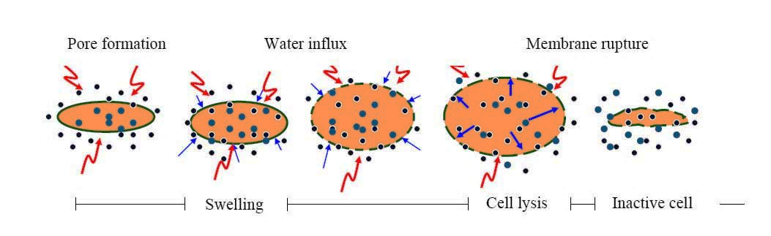
Figure 1 – Electroporation of cell

II. PEF Components:

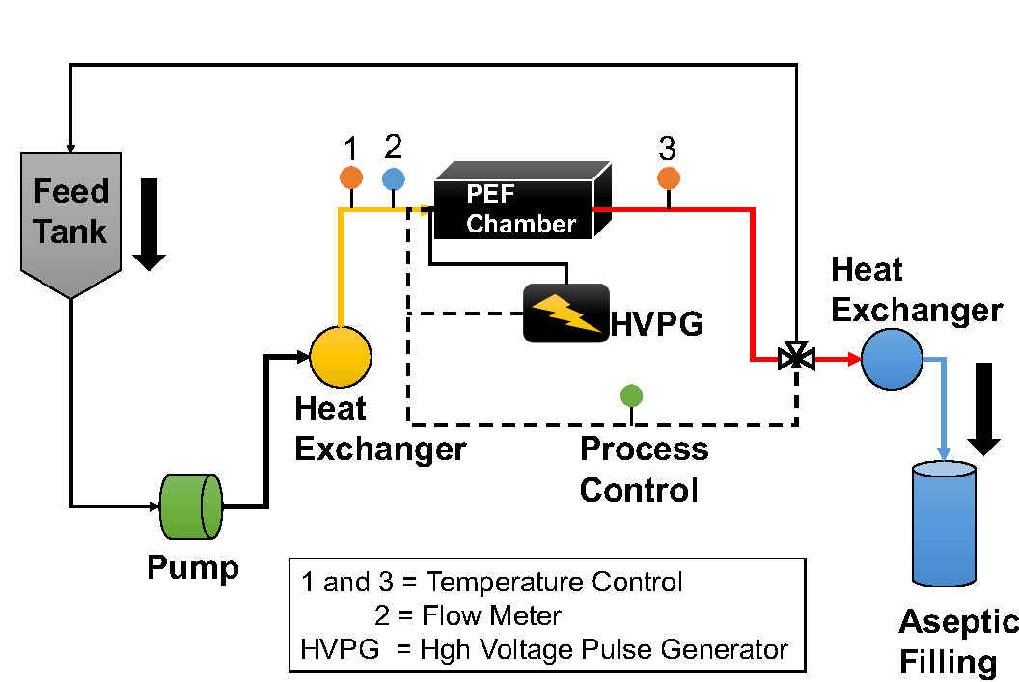
A simple Pulsed Electric Field setup consists of,
Figure 2 – Flow diagram of continuous Pulsed Electric Field system

1. High Voltage Pulse Generator
It provides electrical pulses of desired voltage, shape and duration.

2. A Treatment Chamber
The treatment chamber utilized in PEF applications comprises a minimum of two electrodes separated by an insulating region, within which the food products undergo treatment. One electrode is connected to the voltage source while the other is grounded. Various electrode materials can be employed, such as carbon, gold, platinum, metal oxide, carbon-brass, or commonly used stainless steel electrodes. The electrodes are held in fixed positions by insulating materials, which also form the chamber that contains the food being processed. Insulator materials commonly utilized include polythene, polypropylene, nylon, polysulfone, Plexiglas, and PVC.

Figure 3 - Continuous PEF treatment chambers: (1) parallel plate, (2) coaxial, and (3) co-linear configuration (Source: Toepfl et al., 2005).

3. Control System:
It consists two major devices are an oscilloscope and a temperature probe. The oscilloscope measures the voltage across the treatment chamber and shows the output voltage shape.

A. PEF parameters to be consider:

- Field strength: Field strength refers to the intensity of the electric field applied during PEF treatment. It is typically measured in kilovolts per centimeter (kV/cm). Higher field strengths result in greater disruption of cell membranes, leading to improved microbial inactivation and increased extraction efficiency.
- Pulse length: Pulse length represents the duration of each individual electric pulse applied during PEF treatment. It is usually measured in microseconds (µs). Longer pulse lengths allow for more energy to be transferred to the food product, leading to increased microbial inactivation. However, excessively long pulses may cause excessive heating and undesirable effects on food quality.
- Number of pulses: The number of pulses refers to the total count of electric pulses applied to the food product during the PEF treatment. Increasing the number of pulses can enhance microbial inactivation, but an optimal range must be determined to prevent excessive energy transfer and unwanted effects.
- Start temperature: Start temperature refers to the initial temperature of the food product before the PEF treatment begins. It influences the overall effectiveness of the treatment since higher temperatures can increase the electrical conductivity of the food, resulting in better energy transfer and enhanced microbial inactivation.
- End temperature: End temperature represents the final temperature of the food product after the PEF treatment. The temperature change during PEF treatment depends on factors such as energy input, product characteristics, and treatment time. It is important to monitor and control the end temperature to avoid thermal effects that may negatively impact food quality.
- Treatment chamber: The treatment chamber is the physical space where the PEF treatment takes place. It consists of electrodes through which the electric pulses are applied to the food product. The design of the treatment chamber affects the distribution and uniformity of the electric field, which in turn influences the treatment efficacy.
- Volume: Volume refers to the quantity or size of the food product being treated within the PEF system. It is important to consider the volume to ensure consistent treatment throughout the batch and to determine appropriate process parameters for efficient microbial inactivation.
- Treatment gap: The treatment gap represents the distance between the electrodes in the PEF treatment chamber. It determines the electric field strength and uniformity within the food product. An optimal treatment gap should be chosen to ensure efficient energy transfer and uniform treatment.
- Flow rate: Flow rate refers to the rate at which the food product is passed through the treatment chamber during PEF treatment. It is typically measured in liters per hour (L/h) or any other suitable unit. The flow rate affects the residence time and the treatment intensity experienced by the food product, which has implications for microbial inactivation and quality preservation.
- Residence time: Residence time is the duration for which the food product remains within the treatment chamber during PEF treatment. It is calculated by dividing the volume of the food product by the flow rate. The residence time influences the extent of microbial inactivation and the energy delivered to the food product.

B. Microbial parameters:
- Type of Microorganism: Different microorganisms have varying levels of resistance to PEF treatment. Factors such as the species, strain, age, and physiological state of microorganisms can influence their susceptibility to PEF. Generally, PEF has been found to be effective against a wide range of microorganisms, including bacteria, yeasts, molds, and some viruses. Common foodborne pathogens like Escherichia coli, Salmonella spp., Listeria monocytogenes, and Campylobacter jejuni have been studied regarding their response to PEF treatment. These bacteria can cause foodborne illnesses, and PEF has been found effective in reducing their populations. Various spoilage-causing yeasts and molds, such as Saccharomyces cerevisiae, Candida spp., and Aspergillus spp., have also been targeted with PEF treatment. PEF can inhibit their growth and extend the shelf life of products prone to fungal spoilage, such as fruit juices and dairy products.
- Medium Composition: The composition of the surrounding medium or food matrix can affect microbial inactivation by PEF. Factors such as pH, ionic strength, and the presence of certain compounds (e.g., sugars, salts, proteins) can influence the sensitivity of microorganisms to PEF treatment. Acidic conditions, such as those found in fruit juices, can enhance the microbial inactivation achieved by PEF. Acidic environments make bacteria more vulnerable, and therefore PEF treatment can lead to significant reductions in populations of acid-tolerant pathogens like E. coli O157:H7 and Salmonella spp. Some microorganisms, particularly yeasts, exhibit increased resistance to PEF in high-sugar environments. For instance, the spoilage yeast Zygosaccharomyces bailii can be more resilient in high-sugar solutions, thus requiring higher PEF treatment parameters for effective inactivation.
- Oxygen Concentration: The presence or absence of oxygen can impact the effectiveness of PEF treatment. Some microorganisms are more resistant to PEF in anaerobic conditions compared to aerobic conditions. Oxygen can potentially react with reactive oxygen species generated during PEF treatment, leading to enhanced microbial inactivation.
- Time of Incubation: After PEF treatment, microorganisms may require a certain period of time to exhibit the full extent of inactivation. This is referred to as the incubation or post-treatment holding time. During this time, damaged cells may continue to lose viability, and sub-lethally injured cells may die off. The duration of the incubation period can vary depending on the specific microorganism and processing conditions.

C. Product parameters:
- Conductivity: The electrical conductivity of the product being treated can influence the efficiency and effectiveness of PEF treatment. It is a measure of how well a substance conducts electric current. Higher conductivity can result in increased energy transfer and potentially higher microbial inactivation. Fruit juices, such as orange juice or apple juice, typically have a higher conductivity due to their natural sugars and electrolyte content. Higher conductivity in fruit juices can enhance the effectiveness of PEF treatment for microbial reduction. Dairy products like milk or yogurt have relatively lower conductivity. However, the addition of electrolytes or salts can increase the conductivity, thereby improving the efficiency of PEF treatment for microbial control.
- Composition: The overall composition of the product can impact the response of microorganisms to PEF treatment. Different components present in the product matrix can affect the efficacy of microbial inactivation. Solid foods with complex compositions, such as meat or vegetables, contain structural barriers that can shield microorganisms from the electric field. The presence of cellular structures, fibrous materials, or protective layers can influence the effectiveness of PEF treatment in penetrating and inactivating microorganisms. Liquid products with simpler compositions, such as clear juices or liquid dairy products, offer fewer barriers to the electric field, allowing for better penetration and microbial inactivation.
- Ionic Strength: The concentration of ions in the product, often referred to as ionic strength, can impact the efficacy of PEF treatment. Ionic strength affects the electrical conductivity and the ability of electric fields to disrupt microorganisms. Foods preserved in brines or solutions with high salt concentrations have increased ionic strength. Higher ionic strength can enhance the effectiveness of PEF treatment for microbial control, especially against salt-tolerant microorganisms like Staphylococcus aureus or Vibrio parahaemolyticus. Foods with low salt content, such as fresh fruits or low-sodium products, have lower ionic strength. Lower ionic strength may require higher PEF treatment parameters to achieve comparable microbial reductions.
- pH: The acidity or alkalinity of the product, as measured by pH, can influence microbial inactivation by PEF. pH affects the electrical conductivity and the stability of microorganisms. Acidic foods, such as citrus juices or pickled vegetables with low pH values, can enhance the efficacy of PEF treatment. Lower pH creates an environment that is more conducive to microbial inactivation. Foods with neutral or alkaline pH, such as milk or plant-based beverages, may require higher PEF treatment parameters to achieve significant microbial reductions due to reduced electrical conductivity and increased microbial stability.
- Water Activity: Water activity (aw) is a measure of the availability of water for microbial growth. It affects the resistance of microorganisms to PEF treatment. Dry or dehydrated products, such as dried fruits or jerky, have low water activity. Microorganisms in low-water activity foods may exhibit increased resistance to PEF treatment, requiring higher treatment parameters for effective inactivation. Moist or high-moisture products, like fresh produce or sauces, have high water activity. Microorganisms in high-water activity foods are generally more susceptible to PEF treatment, making it more effective for microbial control.

III. Applications
Pulsed Electric Field (PEF) technology offers a viable alternative for food preservation without the need for traditional heat treatments. Its effectiveness has been demonstrated in various food products, including juices, milk, yogurt, soups, and liquid eggs, for purposes such as pasteurization. However, it is important to note that PEF processing is limited to food products that do not contain air bubbles and possess low electrical conductivity.
- Fruit Juices
- Milk
- Yogurt
- Soups
- Liquid Eggs
- Extraction of Sugar
- Extraction of Oils
- Extraction of other cellular compounds
- Reduction of solid waste (sludge) from waste water
- Enhance Drying (Heat & Mass Transfer)
- Modification of Enzyme Activity
- Preservation of solid & semi-solid foods

Table 1: Microbial inactivation in some food products by use of PEF:

Food | PEF system | Treatment condition | Log reduction | Source
Skim Milk | Batch parallel plate | 30 kV/cm, 1500 pulses per second | < 1.5 | Beveridge et al., 2002
 | - | 41 kV/cm. 2.5 μs, 10-63 pulses per second | 2.3 – 4.5 | Dutreux et al., 2000
 | Batch parallel plate | 50 kV/cm, 62 μs, < 30 °C | 2.5 | Cortesea et al., 2011
Liquid Eggs | Coaxial | 36 kV/cm, 37 °C | 6 | Martin-Belloso, et al., 1997
Orange Juice | - | 28 kV/cm, 75 μs, 55 °C | 3.79 |  | Gurtler et al., 2010
 | - | 40 kV/cm. 100 μs. 56 °C | 6.3 |  | McNamee et al., 2010
Apple Juice | Bench scale OSU 4-H model  (Ohio University) | 36 kV/cm,1-10 μs,  400, 600, 800 pulses per second | 3.5  4.5  6 |  | Charles-Rodriguez et al., 2007

6. Advantages:
- Requires less treatment time & temperature
- Potential of substitute for conventional heat pasteurization
- Pasteurize liquid food products
- Increase shelf life and maintain food safety
- Minimally processed foods
- Fresh quality
- Higher nutritional value
- Colour and flavour retention
- Inactivates vegetative micro-organisms including yeasts, spoilage micro-organisms and pathogens
- 4-6 log reduction of micro-organisms
- Increase in fruit juice and oil extraction yield

7. Disadvantages:
- Expensive
- Still under research and development
- Less commercial units available
- The method of inactivation is still theoretical
- Not suitable for solid foods
- Electrode lifetime
- Foods containing air bubbles can cause spark inside treatment chamber
- Not possible to use in foods with higher or variable electrical conductivity

8. Conclusion:
The application of PEF for food preservation holds significant potential in maintaining high-quality products at lower temperatures and shorter processing times, thus preserving their fresh-like characteristics and nutritional value. However, the development of reliable, industrial-scale equipment capable of generating high-intensity electric field pulses remains a challenge for engineers. The availability of such pulse generation systems is crucial for the widespread adoption and implementation of PEF treatment in the food industry. Additionally, there is a need to enhance the uniformity of treatment intensity distribution through optimization of PEF processes. Ongoing research on pulsed electric fields technology is being conducted worldwide. While promising results have been obtained in laboratory and pilot plant settings, further comprehensive studies are necessary to develop PEF solutions suitable for commercial-scale applications.

References:
Anonymous (1995). Kalt erwischt. Wirtschaftswoche (12), 119-123.

Beveridge, J. R., Macgregor, S. J., Marsili, L., Anderson, J. G., Rowan, N. J., & Farish, O. (2002). Comparison of the effectiveness of biphase and monophase rectangular pulses for the inactivation of microorganisms using pulsed electric fields. IEEE Transactions on Plasma Science, (30), 1525–1531.

Charles-Rodriguez, A. V., Nevarez-Moorillon, G. V., Zhang, Q. H., & Ortega-Rivas, E. (2007). Comparison of thermal processing and pulsed electric fields treatment in pasteurization of apple juice. Food and Bioproducts Processing, (85), 93–97.

Cortesea, P., Dellacasaa, G., Gemmea, R., Bonettab, S., Bonettab, S., Carrarob, E., Pizzichemic, M. (2011). A Pulsed Electric Field (PEF) bench static system to study bacteria inactivation. Nuclear Physics B (Proc. Suppl.), (215), 162–164.

Doevenspeck, H. (1960). Verfahren und Vorrichtung zur Gewinnung der einzelnen Phasen aus dispersen Systemen.German Patent, DE 1237541

Doevenspeck, H. (1961). Influencing cells and cell walls by electrostatic impulses. Fleischwirtschaft 13(12):968- 987.

Dutreux, N., Notermans, S., Wijtes, T., Gongora- Nieto, M. M., BarbosaCanovas, G. V., & Swanson, B. G. (2000). Pulsed electric fields inactivation of attached and free-living Escherichia coli and Listeria innocua under several conditions. International Journal of Food Microbiology, (54), 91–98.

Grahl, T. (1994). Abtöten von Mikroorganismen mit Hilfe elektrischer Hochspannungsimpulse. Hamburg, TU Hamburg-Harburg, Germany.

Gurtler, J. B., Rivera, R. B., Zhang, H. Q., & Geveke, D. J. (2010). Selection of surrogate bacteria in place of E. coli O157:H7 and Salmonella typhimurium for pulsed electric field treatment of orange juice. International Journal of Food Microbiology, (139), 1–8.

Martin-Belloso, O., Vega-Mercado, H., Qin, B. L., Chang, F. J., BarbosaCanovas, G. V., & Swanson, B. G. (1997). Inactivation of Escherichia coli suspended in liquid egg using pulsed electric fields. Journal of Food Processing and Preservation, (21), 193–208.

Mcnamee, C., Noci, F., Cronin, D. A., Lyng, J. G., Morgan, D., J., & Scannell, A. G. M. (2010). PEF based hurdle strategy to control Pichia fermentans, listeria innocua and Escherichia coli k12 in orange juice. International Journal of Food Microbiology, (138), 13–18.

Sitzmann, W. and Münch, E.-W. (1988). ELCRACK® und ELSTERIL® - Zwei neue Verfahren zur gezielten Beeinflussung von Phasengrenzflächen. GVC Fachausschuss, Brussel, Belgium.

Sitzmann, W. and Münch, E.-W. (1989). Elektrische Verfahren zur Keimabtötung. Die Ernährungsindustrie 6: 54-58.

Sitzmann, W. (1995). High voltage pulse techniques. New methods for food preservation. G. W. Gould. London, Graham & Hill.

Sitzmann, W. (2006). Technologieentwicklung der Elektroporation. Personal communication.

Toepfl, S. Heinz, V., Knorr, D. (2005). Overview of Pulsed Electric Field Processing for Food. In “Emerging Technologies in Food Processing” ed. Sun, Da-Wen. Elseveir Academic Press, San Diego, California, USA, pp. 69.

Zhang, Q., Barbosa-Cánovas, G. V. and Swanson, B. G. (1995). Engineering aspects of pulsed electric field pasteurization. Journal of Food Engineering (25): 261-281.

