Smart Hydroponics: Advancing Towards Futuristic Sustainable Agriculture
Rhea Sharma
Amity Institute of Biotechnology
Amity University
Noida, Uttar Pradesh

*Dr. Mahjabin
Assistant Professor
Amity Institute of Biotechnology
Amity University
Noida, Uttar Pradesh
maslam@amity.edu
Dr. Yuvraj Yadav
Assistant Professor
School Of Agriculture Studies
Geeta University
Panipat, Haryana

ABSTRACT
Hydroponics has witnessed significant advancements over the past few years, with ongoing research and technological innovations leading to increased crop yield, improved resource efficiency, and enhanced automation. Advanced monitoring and control systems, utilizing Internet of Things (IoT) and artificial intelligence (AI), allow for precise nutrient delivery, optimal lighting, and real-time data analysis, optimizing plant growth. Furthermore, vertical farming and rooftop hydroponics have gained traction, enabling the utilization of urban spaces efficiently and reducing transportation-related carbon emissions. Hydroponics, a revolutionary soilless farming technique, has emerged as a promising solution to address global food security and environmental challenges. This abstract explores the future trends of hydroponics by analysing recent advancements, identifying potential challenges, and highlighting sustainable solutions.
Keywords--- hydroponics; vertical farming; genetic diversity; Internet of Things (IoT); artificial intelligence; urban food security

  - INTRODUCTION
In addition to being productive, hydroponics culture is perhaps the most intensive method of crop production in today's emerging agriculture industries. It is primarily used in developed and developing countries to produce food, and over time, the cost of cultivation decreases because it does not require large spaces, laborers, or smart agriculture technologies to monitor the performance of the crop. Due to its ability to make optimum use of finite resources like time and space, hydroponic farming has a tremendous potential to lessen the risks these problems represent to our agricultural system.[1]
One of the main advantages of hydroponic farming is the ability to grow crops in nearly ideal circumstances utilizing controlled environment agriculture (CEA) technologies. Hydroponically and indoor-grown crops can be cultivated anywhere at any time of the year, regardless of the climate, the availability of arable land, or the condition of the soil. [2]
There is a great deal of promise for hydroponic farming to lessen the risks these problems present to our agricultural system. One of the main advantages of hydroponic farming is the ability to grow crops in nearly ideal circumstances utilizing controlled environment agriculture (CEA) technologies. No matter where on the planet, at any time of the year, crops can be grown hydroponically and inside, regardless of the climate, availability of arable land, or soil quality. For regions with severe droughts and poor soil quality, such as sub-Saharan Africa where availability of leafy green vegetables is frequently constrained, hydroponic farming has the potential to supply fresh, regional cuisine.
Table 1: Difference between Hydroponics and Conventional Farming
HYDROPONICS | CONVENTIONAL FARMING
Higher yield | Less yield
Less space | More space
Less water | Requires high amount of irrigation water
High nutrient use efficiency | Less nutrient use efficiency
Sustainable farming | Not sustainable
Seasonally agonistic | Not seasonally agonistic
Climate proof | Venerable

  - HYDROPONICS SYSTEM TYPES
There are several different types of hydroponics systems available based on how simple they are to put up; seven of them are frequently used commercially. These are the systems:
- Wick System
Wick systems are the most basic types of hydroponic systems because they don't require aerators, pumps, or power. The plants are grown directly on an absorbent material like perlite or vermiculite. The plant is covered with nylon wicks before being submerged in the nutritional solution. Small herbs and plants that require relatively little water are grown in this setup.
- Deep Water Culture
A straightforward hydroponic method called a "deep water culture system" submerges the plant right into the nutrient solution. This method pumps oxygen into the nutritive medium using a diffuser or air stone. The best feature of this technique is that plant roots are in close contact with the nutrient media, facilitating easy nutrient absorption by plants and promoting rapid growth. Regardless of the size of the facility, the system is appropriate.
- Nutrient Film Technology
The nutrients are supplied at the base of the crop using this system, which is used to grow high value crops like lettuce. The nutrients are circulated through tubes arranged side by side in rows and connected to a central reservoir tank of nutrient solutions. To increase the effectiveness of resource usage in this system, the slope, length, and flow rates are set appropriately. [3]
- Flood and Drain (Ebb and Flow)
In this system, electricity and water pumps with timers are needed to circulate nutrient solution. Plants are grown in beds made of growth mediums like rock wool or perlite, and timers and monitors are used to prevent the solution from overflowing. The water automatically drains out of the bed and is recirculated back through the pump when the optimal nutrient solution is circulated. The technique works for both root and leafy crops.
- Drip System
Drip systems can be quite effective because their system configuration can be altered according on the type of crops grown. The nutritional solutions are pumped to the plant's roots using pumps and tiny tubes; drip emitters are installed at the ends of each tube to control the amount of solutions circulated, and flow may be adjusted according to the needs of the plant. Any type of crop can be cultivated in this system because it is flexible enough to be changed according to the plants.
- Dutch Bucket System
Because they are grown in buckets connected to tubes or drip emitters that deliver the solution directly in drips at the base of the plant, this system is practical for growing vines and larger plants. Typically, 2-3 plants are placed in lines in a bucket fitted with delivery tubes; it is especially suitable for fruits and vegetables.
- Vertical Hydroponics System
Numerous plants can be arranged in a single tower when the plants are grown in stacks or towers, which decreases the amount of space needed. The plants are all fed with nutrients using the same system of delivery tubes. Growing plants in greenhouse buildings is practical since it requires 99 percent less area or land and effectively conserves 90 percent of the irrigation water. Because the crops are grown in secure structures, there are little infestations of pests and diseases.
  - MANAGEMENT OF NUTRIENTS
- Essential Nutrients
Without 17 key nutrients, plants cannot operate properly. These nutrients are necessary for the progression of processes essential to plant growth and development. Magnesium, for instance, is an essential part of chlorophyll. Chlorophyll is a pigment that is used to absorb the light energy required for photosynthesis. The majority of plants are green because they reflect green wavelengths as well. The core of the chlorophyll molecule is magnesium.
The two main categories of essential nutrients are macronutrients and micronutrients. Both macronutrients and micronutrients are critical for the development and growth of plants. Macronutrients include calcium, magnesium, phosphorus, potassium, sulfur, oxygen, and nitrogen. Iron, manganese, zinc, boron, molybdenum, chlorine, copper, and nickel are examples of micronutrients. The quantity needed by plants determines the distinction between macro- and micronutrients. More of the macronutrients are needed than the micronutrients.[4]
Air and water provide carbon, hydrogen, and oxygen to plants. In hydroponics, the remaining nutrients are obtained from the soil or from nutrient solutions or aggregate media.
- pH
It is impossible to talk about plant nutrition without taking pH into account. The pH of the water used to create nutrient solutions and irrigate plants is our main concern in hydroponics. In terms of the availability of nutrients to plants, pH is a measurement of the relative acidity or hydrogen ion concentration. On a scale of 0 to 14, where 0 is the most acidic, 7 is neutral, and 14 is the most alkaline, it is measured. Each unit on the logarithmic scale corresponds to a 10-fold change. This translates to big changes in pH for minor changes in values. A value of seven, for instance, is 100 times higher than five and ten times higher than six.
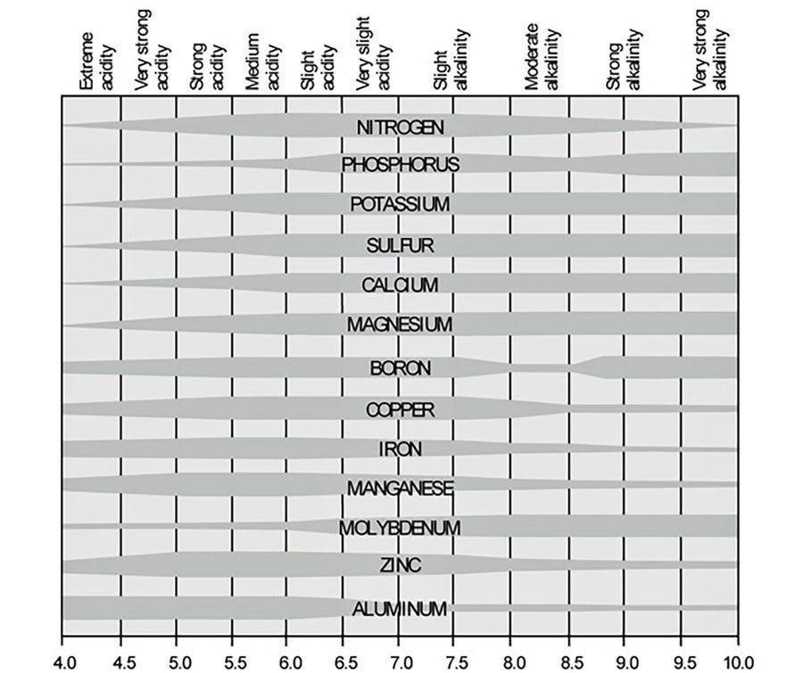
Figure 1: Chart shows the relationship between nutrient availability and pH
- Conduction of electricity
The term "EC" stands for "Electrical Conductivity," and it is used in hydroponics to assess the density of nutrients in water. While examining your water's pH level informs you of the balance of nutrients, EC provides information on the quantity of nutrients present.
Due to the absence of minerals, pure water has no electrical conductivity. Water can conduct electricity once minerals (i.e., in the form of liquid nutrition) have been added to it because of the dissolved salts. By measuring electrical conductivity (EC), which increases with salt concentration, you may determine how much nutrition is present in the water. Milli Siemens per centimeter (mS/cm) is a unit of measurement for the EC level.
It is essential to maintain the proper EC level for healthy plant growth because both an inadequate and excessive supply of nutrients can be harmful to plants. Inadequate nutrient availability can result in stunted growth and low yields, whereas an excess of nutrients can poison plants and harm their roots.
- Maintenance
We'll start by talking about pH and EC readings. You should keep an eye on your nutrient solution more regularly when your system is still quite new. Test your nutrient solution regularly or more frequently in the beginning. You will have a better "feel" for your system as it becomes more established, and you can lower the testing frequency as a result. You eventually reduce your testing to once every few days. The only exception to this is when you add extra nutrient solution to your reservoir; in order to maintain constant levels, you must test pH and EC levels each time you add nutrient solution. Smaller hydroponic systems require more regular testing because the EC and pH will fluctuate more noticeably with the addition of nutrients and water evaporation. You have a few options for testing your pH and EC, including an electronic meter, test strips, and drop test kits.
Create distinct columns in your log to record each pH and EC reading, along with the day the readings were taken. When you reach a stable level in your system, you should observe little volatility. Each time you test TDS, temperature, or humidity, follow the same steps. Again, they should be pretty stable; if there is a substantial fluctuation in a reading, there may be a problem with your hydroponic system or fertilizer reservoir.
Unless you alter your lighting schedule, the photoperiod data you log will remain constant. Your plants' photoperiod will alter in accordance with their stage of development so you can provide the right amount of lighting at each step.
  - FUTURE OF HYDROPONICS
    - Potential of Vertical Farming and Controlled Environment Agriculture
The vertical farming concept was put forth with the intention of "building upwards" more agricultural area. In other words, by erecting a high-rise building with multiple stories on the same plot of land, the effective arable area for crops can be enhanced.
Utilizing a single, tall glasshouse with numerous crop racks placed vertically is one strategy. It is an expansion of the hydroponic farming method used in greenhouses and deals with issues related to the usage of soils, such as the need for fertilizers, pesticides, and herbicides. Due to proximity to the user, transportation expenses can be minimized, year-round production can be planned based on demand, and plant-growing conditions can be fine-tuned to maximize yield by adjusting temperature, humidity, and lighting conditions.
Because there is less evaporation and gray water is recycled, indoor farming in a controlled atmosphere uses a lot less water than outside farming. Due to these characteristics, its widespread acceptance is anticipated to start in small, highly urbanized nations like Israel, Japan, and the Netherlands as well as desert and drought-stricken regions like various sections of the Middle East and Africa. Where there is a large demand for CGG food in nations that struggle with severe pollution and soil depletion, like areas of China, vertical farming is especially appealing. [5]
All-year-round crop production, higher yields (by a factor of six or more depending on the crop), avoidance of droughts, floods, and pests, water recycling, ecosystem restoration, reduction of pathogens, provision of energy to the grid through methane generation from compost, reduction in use of fossil fuels (no tractors, farm machinery, or shipping), and creation of new jobs are just a few of the reasons why vertical farming could be very alluring to policy makers. In the context of space exploration, the closed environment might also be applicable to other planetary habitats.

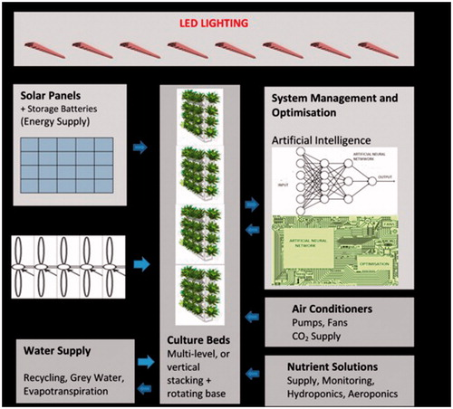
Figure 2: Components of a vertical farm and their interactions.
    - Integration of AI and Machine Learning
The manner that crops are grown and handled has been completely transformed by the application of AI (Artificial Intelligence) and machine learning in hydroponics. Hydroponic systems may be automated, tracked, and controlled with extreme precision using AI and machine learning algorithms, which boosts production and sustainability.
The creation of intelligent sensors and monitoring systems is one of the main uses of AI and machine learning in hydroponics. The sensors track a number of variables, including temperature, humidity, light intensity, pH levels, and nutrient concentrations. Real-time data processing by AI algorithms enables producers to make well-informed judgments and take the appropriate steps to improve plant development circumstances.
Predictive analytics for hydroponics heavily rely on machine learning methods. Machine learning models can produce precise predictions and suggestions by examining previous data on crop growth, environmental factors, and nutrient levels. This knowledge aids growers in making the best decisions possible about things like nutrient dosing, irrigation schedules, and lighting conditions, maximizing crop yields and reducing resource waste.
Remote hydroponic setup monitoring and control are also made possible by AI-powered devices. On their mobile devices, growers may access real-time data and alarms, enabling them to monitor and change system parameters even while they are not on the field. By spotting trends and anomalies in the data, machine learning algorithms can provide early warnings for potential problems like nutrient deficits, illnesses, or pests. By allowing for prompt interventions, this proactive strategy lowers crop losses and boosts the effectiveness of the entire system. [6]
Furthermore, AI and machine learning have aided in the creation of complex agricultural growth models. To simulate and forecast crop behavior, these models take into account a variety of environmental variables, plant features, and growth stages. Growers may explore and perfect their hydroponic systems without having to go through a lot of trial and error by modeling various scenarios and optimizing growth factors. As a result, hydroponic farming operations become more profitable by saving time and resources.
It is crucial to remember that hydroponics' use of AI and machine learning is still in its infancy. These technologies and their uses in hydroponic farming will be further developed through ongoing research and development as well as practical application, opening the door for more effective, sustainable, and fruitful agricultural systems.
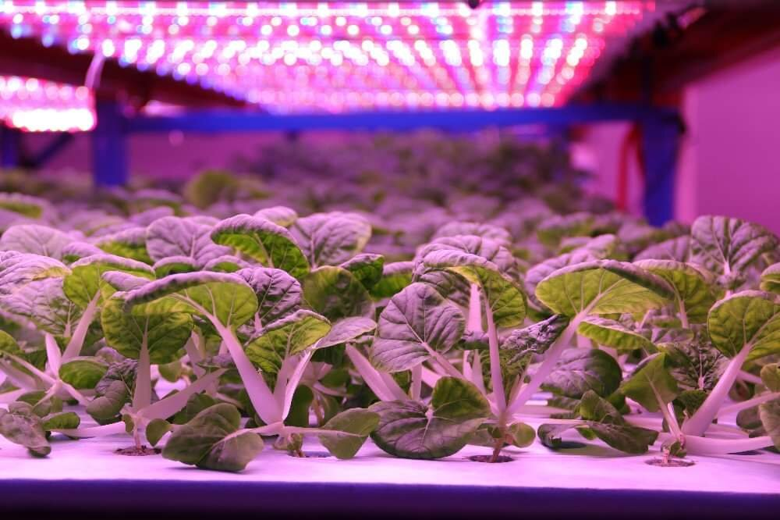
Figure 3: Plants receiving energy from LED lighting.
    - Nutrient Management Innovation
A more precise and focused administration of nutrients will be possible because to developments in sensor technology and data processing. Plant health indicators, nutrient levels, and ambient variables will all be continuously monitored by sensors integrated into the hydroponic system. Real-time AI algorithms will process this data, enabling dynamic fertilizer distribution modifications, optimizing plant growth, and reducing waste. Systems for integrated nutrient sensing will give plants immediate input on the availability and uptake of nutrients. By fine-tuning nutritional formulations and dosing regimens, this information will ensure adequate nutrient ratios and prevent toxicities or deficiencies. [7]
It will be prioritized more in future hydroponic systems to shut the loop on nutrient recycling. The development of effective techniques for collecting, handling, and recycling nutrient solutions will be pursued. With less fertilizer waste and less dependency on outside resources, hydroponics is more ecologically friendly and environmentally sustainable.
Innovative nutrient distribution methods will be influenced by natural systems. To improve nutrient uptake effectiveness and overall plant health, ideas such root zone microbiome manipulation, bioactive chemicals, and symbiotic interactions will be investigated. The smooth connectivity and data sharing between numerous components would be made possible by the integration of hydroponic systems with IoT technology. Real-time monitoring, control, and optimization of nutrient distribution will be made possible by IoT-enabled devices and AI algorithms, increasing productivity and efficiency. [11]
    - Genetic Engineering and Crop Improvement
An exciting future development in hydroponics is the use of genetic engineering and crop modification, which has the potential to increase crop features, boost yields, and solve a number of agricultural problems.
The deliberate change of an organism's genetic makeup through biotechnology methods is known as genetic engineering. Genetic engineering can be used in the context of hydroponics to enhance plant properties necessary for hydroponic production, such as nutrient uptake effectiveness, disease resistance, and environmental adaptability. With the help of this technique, certain genes from other organisms can be inserted into plants' genomes or altered to produce desired effects. [8]
Growth rates and crop yields can be accelerated by genetic engineering by improving a plant's capacity to absorb and utilize nutrients from the hydroponic solution. Crops grown hydroponically can be given disease-resistant genes, which lowers the likelihood of pathogen outbreaks and reduces the need for chemical pesticides.
Genetic engineering has improved crop performance in difficult growing conditions by conferring resistance to various environmental stresses, such as high salinity or extreme temperatures, and can be used to increase the nutritional value of crops grown in hydroponic systems by increasing the levels of vital nutrients like vitamins, minerals, and antioxidants. Alternatively, genetically modified crops with improved resource use efficiency can flourish in hydroponic systems with less water and nutrient inputs, making them more sustainable.
The potential for crop enhancement in hydroponics will dramatically increase if genetic engineering and biotechnology advances continue. Researchers are constantly experimenting with new methods, such as genome editing tools like CRISPR-Cas9, which allow for targeted and precise alterations to plant genomes. [9]
Additionally, continuing genetic engineering research strives to maximize the potential of hydroponic non-traditional crops. These crops can be modified to survive in different hydroponic conditions by modifying certain qualities, expanding the variety of crops that can be effectively produced using this technique.
    - Integration of Hydroponics with other Agriculture Practices
A symbiotic system called aquaponics combines hydroponics and aquaculture (fish farming). In these systems, hydroponically grown plants are fertilized with nutrient-rich water from fish tanks while the plants clean the fish's drinking water. This integrated strategy improves resource efficiency and nutrient cycling, resulting in a closed-loop system that uses fewer resources and produces less waste. [10]
Interest in fusing hydroponics with organic agricultural practices is rising as the market for organic produce continues to expand. The development of organic hydroponic systems, which supply consumers with pesticide-free, ecologically friendly produce, can be facilitated by innovations in the formulation of organic nutrients and sustainable business methods.
The creation of hybrid farming techniques that combine aspects of hydroponics and conventional soil-based farming may be a trend in the future. For example, combining hydroponics with greenhouse or open-field farming can create more controlled growth environments, lengthen growing seasons, and increase crop output overall.
In deteriorated or nutrient-depleted locations, hydroponics can be utilized as a method to encourage soil restoration and conservation. Growing cover crops or particular hydroponic plants with deep root systems can enhance soil structure, reduce erosion, and restore nutrient levels. Opportunities for nutrient cycling and a circular economy can be created by combining hydroponics with other agricultural techniques. garbage that is nutrient-rich from one system can be used as inputs for another, lowering the requirement for outside inputs and generating less garbage.
With the help of hydroponics, it is possible to create controlled, ideal growing conditions for a variety of plant species with various environmental needs. Farmers can increase their resistance to pests, illnesses, and climate change by using a variety of crops in hydroponic systems.
Research and innovation in the area will probably increase as a result of interactions between hydroponics and other agricultural techniques. New growth methods, crop types, and sustainable farming approaches will be developed through cooperation between conventional farming methods and hydroponic technology.

  - DISCUSSION
The future of hydroponics offers an enticing vision for the future of agriculture, to sum up. Hydroponics is emerging as a practical and sustainable alternative to fulfill the rising demand for food as we grapple with issues like the expanding global population, climate change, and the scarcity of arable land. Hydroponic systems are expected to undergo a revolution as a result of the integration of cutting-edge technologies like AI, machine learning, and IoT, which will improve fertilizer supply, automate procedures, and use resources more effectively.
The ability of hydroponics to grow a variety of crops, including unusual and specialist types, presents tremendous opportunities for agricultural adaptation and innovation. Growers may respond to individual crop needs, generate higher yields, and produce nutrient-rich foods by fine-tuning nutrient formulas and growth conditions.
In the future of hydroponics, urban agriculture and vertical farming will become increasingly important. By reducing travel times and increasing access to fresh fruit for nearby populations, these approaches bring farming closer to urban areas. Hybrid systems that integrate hydroponics into conventional agriculture can boost output, lengthen growing seasons, and encourage cooperation across various agricultural practices.
The advancement of hydroponics will be fueled by research and innovation. New and improved growing methods, cutting-edge crop varieties, and ground-breaking technology will continue to push the limits of hydroponics.

REFERENCES
- Payen FT, Evans DL, Falagán N, Hardman CA, Kourmpetli S, Liu L, et al. How Much Food Can We Grow in Urban Areas? Food Production and Crop Yields of Urban Agriculture: A Meta-Analysis. Earth’s Future. 2022;10(8):1–22. https://doi.org/10.1029/2022EF002748
- Ezzahoui I, Abdelouahid RA, Taji K, Marzak A. Hydroponic and Aquaponic Farming: Comparative Study Based on Internet of things IoT technologies. Procedia Computer Science. 2021;191:499-504. https://doi.org/10.1016/j.procs.2021.07.064
- Ammar AK. Hydroponics System.
- Bugbee B. Nutrient management in recirculating hydroponic culture. South Pacific Soilless Culture Conference-SPSCC 648 2003 Feb 10 (pp. 99-112).
- Despommier D. The vertical farm: feeding the world in the 21st century. Macmillan; 2010 Oct 12.
- Lowe M, Qin R, Mao X. A review on machine learning, artificial intelligence, and smart technology in water treatment and monitoring. Water. 2022 Apr 24;14(9):1384.
- Chowdhury M, Jang BE, Kabir MS, Kim YJ, Na KD, Park SB, Chung SO. Factors affecting the accuracy and precision of ion-selective electrodes for hydroponic nutrient supply systems. InInternational Symposium on Advanced Technologies and Management for Innovative Greenhouses: GreenSys2019 1296 2019 Jun 16 (pp. 997-1004).
- Kahl G, Winter P. Plant genetic engineering for crop improvement. World Journal of Microbiology and Biotechnology. 1995 Jul;11:449-60.
- Sami A, Xue Z, Tazein S, Arshad A, He Zhu Z, Ping Chen Y, Hong Y, Tian Zhu X, Jin Zhou K. CRISPR–Cas9-based genetic engineering for crop improvement under drought stress. Bioengineered. 2021 Jan 1;12(1):5814-29.
- Diver S, Rinehart L. Aquaponics-Integration of hydroponics with aquaculture. Attra; 2000 Nov.
- Srinidhi HK, Shreenidhi HS, Vishnu GS. Smart Hydroponics system integrating with IoT and Machine learning algorithm. In2020 International Conference on Recent Trends on Electronics, Information, Communication & Technology (RTEICT) 2020 Nov 12 (pp. 261-264). IEEE.

