Thermal processing of palm weevil (Rhynchophorus phoenicis) larvae and effect on the minerals, vitamins and sensory attributes

Olusegun Ayodele Olaoye^{1*}, Nkeiruka Lilian Nwanagba¹, Anna Ngozi Agiriga², Josephine Chigbolum Ohuche³, Ann Chinyere Nwachukwu¹ and Ekefre Charles Ekong¹

¹ Department of Food Science and Technology, Michael Okpara University of Agriculture, Umudike, Abia State, Nigeria

² Department .of Food Science and Technology, Federal University Oye-Ekiti, Nigeria

³ Department of Microbiology and Brewing, Nnamdi Azikiwe University, Awka, Anambra State

* Author for correspondence, Email: olaayosegun@yahoo.com

Abstract
Palm weevil (Rhynchophorus phoenicis) larvae serve as edible food sources in Nigeria. In this study, the effect of frying and roasting on the quality characteristics of the larvae was investigated. Rhynchophorus phoenicis larvae were processed by frying and roasting methods, and the products were analyzed for minerals, vitamins and sensory attributes. Frying was carried out for 2, 5 and 7 min, and roasting 5, 10 and 15 min. The physical properties of the processed larvae were also determined. The average weight (g) of the fresh larvae was 25.43 while a range of between 22.12 and 22.48 was obtained for the fried and roasted samples. Length ranged from 4.15 to 5.0, and width from 2.11 to 3.21. The fried samples had higher crude fibres and crude proteins than their roasted counterparts. A similar observation was noted for mineral contents, with the fried samples having higher values of calcium, sodium, potassium, magnesium, phosphorus, iron and zinc than the roasted samples. Values ranging from 133.66 and 162.15 µg/100g of vitamin A were obtained for the fried larvae samples, while vitamin C ranged from 7.62 and 9.61 mg/100g. The vitamins (A, C and E) were generally higher in the fried larvae samples than in roasted counterparts. Result of the sensory evaluation revealed that among the processed larvae samples, the sample fried for 2 min had highest scores of 6.55, 6.75, 6.80 and 6.70 in the attributes of appearance, aroma, texture, and overall acceptability; making it more acceptable to panelists than others. It was concluded that adoption of frying technique in the processing of Rhynchophorus phoenicis larvae had an advantage over roasting, as it enhanced the crude proteins and ash contents of the palm weevil larvae. Also, vitamins C and E was more abundant in the fried than roasted samples.
Keywords: Rhynchophorus phoenicis larvae, frying and roasting, physical properties, mineral contents, vitamins, sensory evaluation

Introduction
The larva of Rhynchophorus phoenicis, a Coleoptera of Curculionidae family is used as traditional food in several African countries, including Nigeria, where it is commonly found. In these countries, it serves as delicious meal. The high cost of animal protein has directed interest towards several insects as potential sources of proteins for humans. Among the insects species, R. phoénicis larvae are considered the major sources of dietary lipids and proteins. They are consumed world wide, especially in developing and under developed countries where consumption of animal protein may be limited because of economic, social, cultural or religious
Factors (Womeni et al., 2012).
There is a growing concern over worldwide malnutrition largely among the low-income
groups found in rural areas and the slums of cities. However, there are many underused food sources already in existence that could be exploited to ameliorate this nutritional deficiency, one of which is edible insects (Okunowo et al., 2017). Edible insects have a long history in the nutrition of man– in some cases eaten as emergency food, as staple food or as a delicacy. In Africa, Asia and Latin America for example, insects are eaten and used to prepare many delicacies (Van-Huis et al. 2013). Information is scarce about the actual number of insect species consumed by humans worldwide; however, at the last count 2037 species of insects have been reported as food for humans. Reports have shown that many of the edible insects contain satisfactory amount of nutrients (protein, carbohydrate, fatty acids and minerals) required by humans (Rumpold and Schlüter 2013).
As people continue to discriminate more on the type and sources of foods on the grounds of increasing health concerns and nutritional awareness, indigenous food sources such as the palm weevil (Rhynchophorus phoenicis) would become popular as alternative to red meat and chicken egg. Research into the advancement of production volume of Rhynchophorus phoenicis may therefore help improve economies, if global and industrial demands are created. Edible insects are traditional foods all over the world and are highly nutritious.. Notable examples of these insects are Rhynchophorus phoenicis, termites, Macroterms nigeriense, erina forda, variegated grasshopper etc (Okoli et al., 2019).
The present study was therefore carried out to determine the effect of processing, frying and roasting, on the minerals, vitamins and sensory attributes of palm weevil (Rhynchophorus phoenicis) larvae, with the aim of advising consumers of the best method of processing in order to optimize its inherent nutritional potential.

Materials and methods
Source of raw materials

Life larvae of palm weevil (Rhynchophorus phoenicis) were obtained from Idemiri North Local Government Area of Anambra State, Nigeria (Figure 1). They were placed in aerated plastic buckets and transported to the Food Microbiology laboratory in the Department of Food Science and Technology, Michael Okpara University of Agriculture, Abia State, Nigeria, for processing. Certain aspects of the processing were also carried out in the central laboratory of National Root Crops Research Institute, Umudike, Abia State, Nigeria

Preliminary processes in the handling of the palm weevil (Rhynchophorus phoenicis) larvae

Prior to the main processing of frying and roasting, the palm weevil larvae were sorted to remove the dead ones, dirt and other debris including the feeds. Subsequently, they were washed in excessive running tap water to get rid of mud, sand and other extraneous materials. The life weevil larvae were then dropped inside boiling water for 1-2 min in order to kill them; they were then drained of water and hung on bamboo barbecue skewers, with two palm weevil larvae per skewer.

Frying of palm weevil (Rhynchophorus phoenicis) larvae

Frying of the palm weevil larvae (already hung on bamboo skewers) was done in vegetable oil (Kings, Nigeria) in frying pans over low burning fire at temperature of 90±2ºC for different time intervals of 2, 5 and 7 min. Fried palm weevil larvae were then drained of oil and allowed to cool, after which samples were taken for analyses.

Roasting of palm weevil (Rhynchophorus phoenicis) larvae

Roasting of the palm weevil larvae (already hung on bamboo skewers) was done over charcoal grill at temperature of 95±2ºC for different time intervals of 5, 10 and 15 min. The larvae were turned intermittently during roasting to prevent burning or charring (Okaka, 2005). After roasting, palm weevil larvae were allowed cool to room temperature, after which samples were taken for analyses.

Determination of the physical properties of the fresh, fried and roasted palm weevil (Rhynchophorus phoenicis) larvae

The physical properties (weight, length and widths) of the fresh, fried and roasted palm weevil larvae were determined. The weight was measured using analytical balance (Make, Country??), while calipers was used for measuring lengths and widths.

Determination of the proximate composition of the fresh, fried and roasted palm weevil (Rhynchophorus phoenicis) larvae

The proximate composition including moisture, ash, fat, and protein contents of the ogiri samples were determined using the methods of Association of Official Analytical Chemists (AOAC 2005). Carbohydrate was determined by difference.

Determination of the mineral contents of the fresh, fried and roasted palm weevil (Rhynchophorus phoenicis) larvae

The methods of Saura-Calixto et al. (1983) and Bonire et al. (1990) were used for the determination of mineral contents in the gari samples. Potassium and sodium were determined by digesting the ash of the samples with perchloric acid and nitric acid, and then taking the readings on Jenway digital flame photometer (spectronic20). Phosphorus was determined by vanado-molybdate colorimetric method. Calcium, magnesium, cupper, iron and zinc were determined spectrophotometrically by using Buck 200 atomic absorption spectrophotometer (Buck Scientific, Norwalk) and compared with absorption of standards of the minerals.

Determination of the vitamin contents of the fresh, fried and roasted palm weevil (Rhynchophorus phoenicis) larvae

Vitamins A, C and E in the fresh, fried and roasted palm weevil larvae were determined according to the methods of AOAC (2005).

Sensory evaluation of the fried and roasted palm weevil (Rhynchophorus phoenicis) larvae

The fried and roasted palm weevil larvae samples were subjected to sensory evaluation for the attributes of appearance, aroma, taste, texture, crunchiness and overall acceptability. A semi trained twenty member panel was used and scores were allocated to the attributes based on a 9-point hedonic scale ranging from 1 (dislike extremely) to 9 (like extremely). The data collected were subjected to statistical analysis to determine possible differences among samples.

Statistical analysis

Data, which depended the different palm weevil larvae samples, were analyzed according to a completely randomized design with three replicates. Data were subjected to variance analyses and differences between means were evaluated by Duncan’s multiple range test using SPSS statistic programme, version 10.01 (SPSS 1999). Significant differences were expressed at p < 0.05.

Results and discussion
In the present investigation, fresh palm weevil (Rhynchophorus phoenicis) larvae (Figure 1) were processed by frying and roasting (Figures 2 and 3). The physical characteristics of the fresh and processed larvae samples are presented in Table 1. The average weight (g) of the fresh larvae was 25.43 while a range of between 22.12 and 22.48 was obtained for the fried and roasted samples, with roasted samples having lower weights than their fried counterparts. Weights of both roasted and fried palm weevil larvae decreased with longer periods of roasting and frying. This was expected as heat treatments have would remove moisture from the larvae; the longer the treatment, the more moisture is removed. An average length of 5.13 cm was recorded for fresh larvae between 4.15 and 5.0; and 4.40 and 4.83 were observed for roasted and fried samples respectively. The fresh larvae of palm weevil also recorded the highest value of 3.50 cm. Lowest value of 2.11 and 3.03 were observed for larvae samples roasted for 15 minutes, and fried for 7 minutes respectively; while highest values of 2.74 and 3.03 were recorded for respective samples roasted for 5 minutes and fried for 2 minutes. The values lengths and widths obtained for the larvae samples are similar to those reported by Okoli el al. (2019), who obtained between 4.83 and 5.27 cm for lengths, and 2.11 and 3.5 cm for widths. The weights reported by the authors however differ from those obtained in the present study, possibly due to difference in varieties and species of the palm weevil (Rhynchophorus phoenicis) larvae used in the two studies. Frying and roasting for longer periods were observed to have proportional effect on the lengths and widths of the larvae samples.
Table 2 shows the results of the proximate composition (%) of the roasted and fried palm weevil larvae, along with that of fresh samples prior to processing. Moisture content was highest (34.04) in the fresh sample while lower values were recorded for roasted samples than their fried counterparts. Among the processed larvae samples, the lowest value, 24.02, was obtained for larvae sample roasted for 15 minutes, and the highest, 31.01, for sample fried for 2 minutes. Roasting as a method of processing was noted to have higher and significant effect (p < 0.05) on moisture in the larvae samples than frying processing technique, resulting in lower moisture contents in the roasted product than fried counterpart. Result of the crude proteins (%) showed that frying technique had a profound positive effect on the larvae samples, as higher values (25 and above) were recorded for fried samples than the roasted counterparts. The highest value of 25.11 was recorded for sample fried for 2 minutes while the lowest value of 23.01 was obtained for sample roasted for 15 minutes. Values of the crude proteins generally indicate that roasting and frying processes are of better advantage when carried out at minimal duration of time than longer periods, as losses were noticeable with longer periods of processing. Crude fat contents were higher in the fried larvae samples, and this could obviously be due to the use of vegetable oil during the frying process, which may have contributed to the increase in the fat contents. The range of values recorded in this study corresponds to the figure (25.01%) reported in a previous investigation by Womeni et al. (2012) on Rhynchophorus phoenicis larvae. In another similar report, Okunowo et al. (2017) recorded crude protein and crude fat contents of 24.43 and 33.25 respectively, and this further corroborates the values obtained in the present study.
Ash contents of the Rhynchophorus phoenicis larvae were between 4.79 and 5.35, with the fresh sample recording the lowest value. The roasted larvae samples had a range of 5.09 and 5.23; the sample roasted for 5 minutes recorded the lowest value while the highest value was observed for sample roasted for 15 minutes. Furthermore, the fried samples had ash contents of between 5.10 and 5.35, with the sample fried for 2 minutes having the lowest value. The ash contents recorked in the present study compare favourably with those reported in previous investigations. Some of the other researchers who reported values similar to those obtained in this study include Okaraonye and Ikewuchi (2008), Elemo et al. (2011) and Ehounou et al. (2019). The carbohydrate contents of the larvae samples generally ranged between 10.45 and 17.39, the fresh sample having the highest value while the lowest was recorded for the sample fried for 7 minutes.
Results of the mineral analysis (%) of the Rhynchophorus phoenicis larvae samples are presented in Table 3. Calcium content of 49.82 was recorded as the highest value for larvae sample fried for 7 minutes while 33.06 was the lowest value for that roasted for 15 minutes. Sodium ranged from the lowest value 50.73 (for the fresh sample) and 71.42 for sample fried for 15 minutes. A similar trend was observed for potassium, magnesium, iron and phosphorus, with the sample fried for 7 minutes having the highest values of 913.59, 44.21, 19.96 and 442.53 respectively. In a study reported by Ehounou et al. (2019), a value of 56.49 was obtained for sodium in processed Rhynchophorus phoenicis larvae, and this is similar to those recorded in the present study.
Analysis of the vitamins in the Rhynchophorus phoenicis larvae samples (Table 4), revealed that vitamin A (µg/100g) ranged from 107.92 and 216.02, the highest value was recorded for the fresh sample and the lowest for the sample roasted for 15 minutes. Vitamin A was higher in samples fried for 2 and 5 minutes than others, with the exception of the fresh sample. The vitamin C (mg/100g) was highest in the fresh sample, having a value of 10.51. Higher values, which ranged between 7.62 and 9.61, were recorded for the fried samples than their roasted counterparts of 2.02 and 7.33. Value of 1.22 was obtained for the fresh sample as the highest vitamin E content (mg/100g) of the larvae samples, while the lowest value (0.74) was recorded for sample roasted for 15 minutes. Fried larvae samples recorded higher contents of vitamin E than other processed samples. In a similar study, Okunowo et al. (2017) also carried out vitamin analysis on Rhynchophorus phoenicis larvae, and comparison of the results with those obtained in the present study suggests slight variations, which may be due to possible difference in the species used in the studies.
The mean scores obtained from the sensory evaluation of the roasted and fried palm weevil larvae are shown in Table 5. The sample fried for 2 minutes had the highest mean score of 6.55 in the sensory attribute of appearance, followed by sample roasted for 10 minutes with a mean score of 6.40 while sample roasted for 5 minutes recorded the lowest score. In the attribute of aroma, sample fried for 2 minutes also had the highest score, 6.75, while the lowest score was recorded for sample roasted for 10 minutes. However, sample roasted for 15 minutes recorded the highest value (6.65) in the attribute of taste, followed by the sample roasted for 5 minutes having a mean score of 6.60. Mean scores ranged from 5.30 and 6.80, with samples fried for 2 and 5 minutes having the highest and lowest scores respectively. The highest score of 5.95 was obtained in the attribute of crunchiness for sample fried for 5 minutes, while sample roasted for 5 minutes recorded the lowest score (5.25). The overall acceptability evaluation by the sensory panelists of the larvae samples indicates that fried samples had higher scores than their roasted counterparts, with sample fried for 2 minutes having the highest score, followed by that fried for 5 and 7 minutes respectively.
In conclusion, the result of this study suggests that adoption of frying technique in the processing of Rhynchophorus phoenicis larvae had an advantage over roasting, as it enhanced the crude proteins and ash contents of the palm weevil larvae. Also higher values were recorded for larvae sample fried for 5 minutes than the roasted counterparts. Furthermore, result indicates that vitamins C and E was more abundant in the fried than roasted samples, suggesting that frying technique may be preferable than roasting as a method of processing of Rhynchophorus phoenicis larvae, due to the enhanced quantities of the vitamins in the fried samples. The fried samples were also preferable than their roasted counterparts in most of the sensory attributes evaluated in this study.

References
Okaka, J. C. (2005). Basic processing of grain, cereals and legumes in handling, storage and processing of plant foods. OCJ Academic Publishers, Enugu. Pp. 240-285.
AOAC (2005). Official methods of analysis, 18th edn. Association of Official Analytical Chemists, Washington, DC. ISBN 0-935584-77-3

Saura-Calixto, F., Canellas, J., & Soler, L. (1983). Dietary fibre components of the nitrogen free extract of almond kernels. Journal of Science Food Agriculture, 36, 1419-1422.

Bonire, J.J., Jalil, N.S.N., & Lori, J.A. (1990). Sodium and potassium content of two cultivars of white yam (Dioscorea rotundata) and their source soils. Journal of Science of Food Agriculture, 53, 271-274.

Okoli, I.C., W.B. Olodi, I.P. Ogbuewu, N.O. Aladi and C.G. Okoli (2019). Nutrient Composition of African Palm Grub (Rhynchophorus phoenicis) Larvae Harvested from Raphia Palm Trunk in the Niger-delta Swamps of Nigeria. Asian Journal of Biological Science, 12(2): 284-290

Womeni, H.M., Tiencheu, B., Linder, M., Nabayo, E.M.C., Tenyang, N., Mbiapo, F.C., Villeneuve, P., FannI, J., and Parmentier, M. (2012). Nutritional value and effect of cooking, drying and storage process on some functional properties of Rhynchophorus phoenicis

Elemo, B.O., Elemo, G.N., Makinde, M.A., and Erukainure, O.L. (2011). Chemical evaluation of African palm weevil, Rhychophorus phoenicis, larvae as a food source. Journal of Insect Science, 11: 1-6

Okaraonye, C.C. and Ikewuchi, J.C. (2008). Rhynchophorus phoenicis (F) larvae meal: Nutritional value and health implications. Journal of Biological Sciences, 8(9): 1221-1225

Ehounou, G.P., Ouali-N’goran, S.M., Soro, D. and Bedikou, M.E. (2019). Nutrient contributions of Rhynchophorus phoenicis Fabricius, 1801 (Coleoptera: Curculionidae), very appreciated larvae in Côte d’Ivoire compared with beef (N'Dama breed) and thon (Thunnus thynnus).
International Journal of Biological and Chemical Sciences, 13(4): 2092-2103

Okunowo, W.O., Olagboye, A.M., Afolabi, L.O. and Oyedeji, A.O. (2017). Nutritional value of Rhynchophorus phoenicis (f.) larvae, an edible insect in Nigeria. African Entomology, 25(1): 156–163.

Van-Huis, A., Van-Itterbeeck, J., Klunder, H., Mertens, E., Halloran, A., Muir, G. and Vantomme, P. 2013. Edible Insects: Future Prospects for Food and Feed Security. FAO Forestry Paper 171.

Rumpold, B.A. & SchlüteR, O.K. 2013. Potential and challenges of insects as an innovative source for food and feed production. Innovative Food Science & Emerging Technologies 17: 1–11.

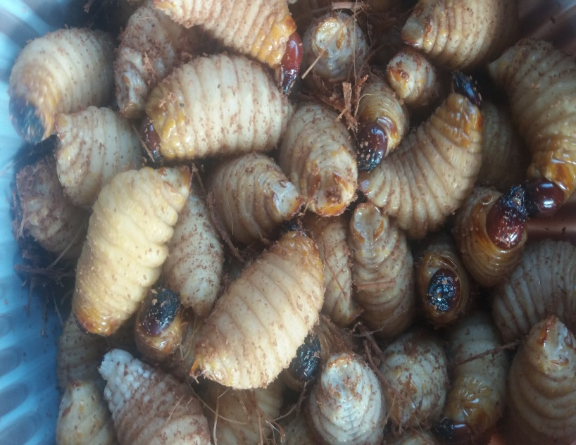

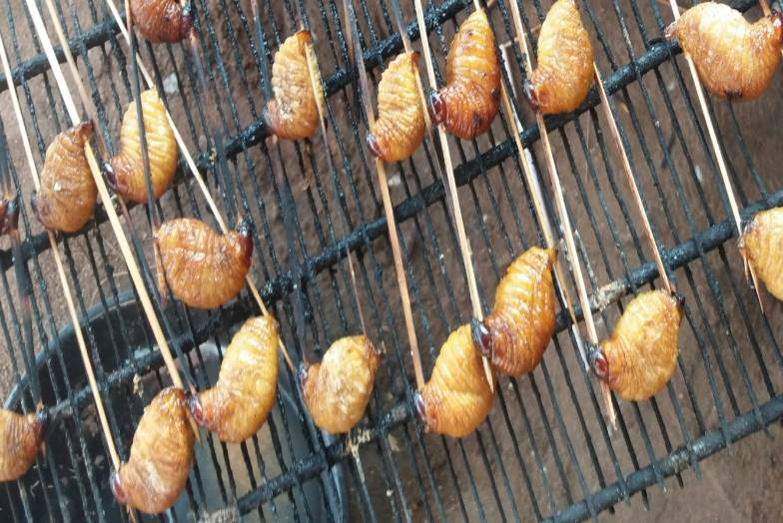
Figure 1. Fresh edible palm weevil larva
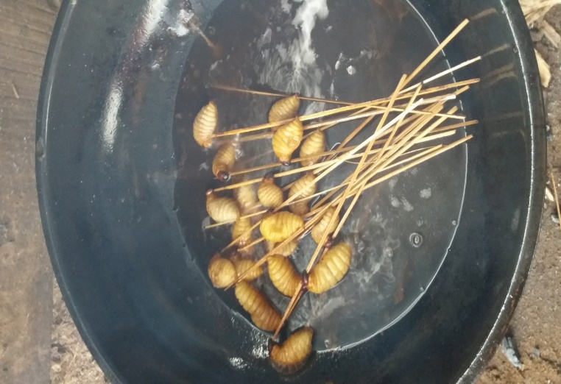

B
A

Figure 2. Fried (A) and roasted (B) palm weevil (Rhynchophorus phoenicis) larvae

Table 1. Physical properties of roasted and fried edible palm weevil (Rhynchophorus phoenicis) larvae

Sample | Weight (g) | Length (cm) | Width (cm)
Fresh | 25.43^{ab}±0.24 | 5.13ª±0.04 | 3.50ª±0.14
Roasted
5 min | 22.21^{bcd}±0.01 | 5.00^{b}±0.00 | 2.74^{d}±0.02
10 min | 22.12^{cd}±0.03 | 4.63^{d}±0.04 | 2.41e±0.01
15 min  Fried | 22.01^{d}±0.01 | 4.15^{f}±0.01 | 2.11^{f}±0.01
2 min | 22.32^{abc}±0.03 | 4.83^{c}±0.04 | 3.21^{b}±0.01
5 min | 22.41^{ab}±0.01 | 4.63^{d}±0.04 | 3.11^{bc}±0.01
7 min | 22.48ª±0.01 | 4.40e±0.00 | 3.03^{c}±0.01

Values are means of duplicate determinations; Means in the same column with different superscripts are significantly different (p < 0.05)

Table 2. Proximate composition of roasted and fried Rhynchophorus phoenicis larvae

Samples | Moisture Content  (%) | Crude Protein  (%) | Fat Content  (%) | Ash Content  (%) | Carbohydrate Content  (%)
Fresh | 34.04ª±0.00 | 24.14^{d}±0.01 | 19.63^{g}±0.01 | 4.79^{g}±0.00 | 17.39^{c}±0.01
Roasted  5 min | 29.23^{d}±0.01 | 24.10e±0.00 | 22.03^{f}±0.00 | 5.04^{f}±0.00 | 19.60^{b}±0.01
10 min | 29.02e±0.01 | 23.50^{f}±0.00 | 25.02e±0.01 | 5.20^{d}±0.01 | 17.27^{d}±0.01
15 min | 24.02^{g}±0.01 | 23.01^{g}±0.01 | 27.52^{d}±0.00 | 5.23^{c}±0.00 | 20.02ª±0.00
Fried  2 min | 31.01^{b}±0.00 | 25.11ª±0.01 | 28.35^{c}±0.00 | 5.10e±0.01 | 10.45^{g}±0.00
5 min | 30.18^{c}±0.00 | 25.02^{b}±0.00 | 29.07^{b}±0.00 | 5.25^{b}±0.01 | 10.50^{f}±0.00
7 min | 28.44^{f}±0.00 | 25.00^{c}±0.00 | 30.01ª±0.01 | 5.35ª±0.01 | 11.23e±0.00
Values are means of duplicate determinations; Means in the same column with different superscripts are significantly different (p < 0.05)

Table 3. Mineral contents of roasted and fried Rhynchophorus phoenicis larvae

Sample | Calcium mg/100g | Sodium mg/100g | Potassium mg/100g | Magnesium mg/100g | Iron  mg/100g | Phosphorus mg/100g | Zinc mg/100g | Copper mg/100g
Fresh | 38.65^{b}±6.35 | 50.73^{g}±0.02 | 780.62^{g}±0.01 | 29.72^{g}±0.03 | 16.33^{f}±0.01 | 390.14^{g}±0.04 | 4.45^{f}±0.04 | 0.09^{g}±0.01
Roasted
5 min | 36.28^{b}±0.01 | 54.21^{f}±0.01 | 823.33^{f}±0.02 | 33.15^{f}±0.02 | 18.32e±0.03 | 391.62^{f}±0.03 | 5.81e±0.01 | 0.28^{c}±0.01
10 min | 34.61^{b}±0.03 | 56.78e±0.02 | 840.05e±0.04 | 37.27^{d}±0.03 | 19.43^{d}±0.02 | 401.82e±0.03 | 5.93^{d}±0.01 | 0.48^{b}±0.01
15 min | 33.06^{b}±0.03 | 59.32^{d}±0.02 | 883.45^{c}±0.04 | 41.72^{b}±0.02 | 19.92ª±0.01 | 411.17^{d}±0.04 | 6.12^{b}±0.01 | 0.62ª±0.01
Fried
2 min | 46.22ª±0.02 | 66.82^{c}±0.01 | 860.65^{d}±0.04 | 36.43e±0.01 | 19.63^{c}±0.01 | 430.74^{c}±0.03 | 5.91^{d}±0.01 | 0.13^{f}±0.01
5 min | 48.15ª±0.02 | 69.72^{b}±0.03 | 891.44^{b}±0.01 | 40.76^{c}±0.03 | 19.83^{b}±0.02 | 439.62^{b}±0.02 | 6.08^{c}±0.01 | 0.18e±0.01
7 min | 49.82ª±0.02 | 71.42ª±0.01 | 913.59ª±0.01 | 44.21ª±0.01 | 19.96ª±0.01 | 442.53ª±0.02 | 6.22ª±0.01 | 0.25^{d}±0.01
Values are means of duplicate determinations; Means in the same column with different superscripts are significantly different (p < 0.05)

Table 4. Vitamin contents of fresh, roasted and fried Rhynchophorus phoenicis larvae

Sample | Vitamin A  (µg/100g) | Vitamin C  (mg/100g) | Vitamin E (mg/100g)
Fresh  Roasted | 216.02ª±0.02 | 10.51ª±0.01 | 1.22ª±0.01
5 min | 141.86^{d}±0.02 | 7.33e±0.02 | 1.05^{c}±0.01
10 min | 126.02^{f}±0.01 | 4.76^{f}±0.04 | 0.91e±0.01
15 min  Fried | 107.92^{g}±0.01 | 2.02^{g}±0.01 | 0.74^{f}±0.01
2 min | 162.15^{b}±0.01 | 9.61^{b}±0.01 | 1.18^{b}±0.01
5 min | 143.23^{c}±0.01 | 9.04^{c}±0.01 | 1.04^{c}±0.01
7 min | 133.66e±0.02 | 7.62^{d}±0.01 | 0.96^{d}±0.01
Values are means of duplicate determinations; Means in the same column with different superscripts are significantly different (p < 0.05)

Table 5. Mean scores of sensory evaluation of roasted and fried Rhynchophorus phoenicis larvae
Sample | PT  (min) | Appearance | Aroma | Taste | Texture | Crunchiness | OA
Fried | 2 | 6.55ª±1.76 | 6.75ª±2.36 | 5.45ª±1.64 | 6.80ª±1.36 | 5.40ª±2.16 | 6.70ª±2.08
Fried | 5 | 5.80ª±2.09 | 5.60^{ab}±1.90 | 6.10ª±2.49 | 5.30^{b}±1.98 | 5.95ª±1.82 | 6.50ª±2.40
Fried | 7 | 5.95ª±2.09 | 5.70^{ab}±1.90 | 5.65ª±2.13 | 5.55^{ab}±1.50 | 5.90ª±2.05 | 6.40ª±1.82
Roasted | 5 | 5.25ª±2.73 | 5.60^{ab}±2.28 | 6.60ª±2.48 | 5.85^{ab}±2.28 | 5.25ª±2.07 | 5.80ª±2.46
Roasted | 10 | 6.40ª±2.09 | 5.20^{b}±1.77 | 6.25ª±2.40 | 5.45^{ab}±2.35 | 5.65ª±2.32 | 5.80ª±2.02
Roasted | 15 | 5.35ª±2.32 | 5.90^{ab}±2.15 | 6.65ª±2.46 | 6.00^{ab}±1.95 | 5.80ª±2.17 | 6.05ª±2.04

PT, processing time; OA, overall acceptability; Values are means of duplicate determinations; Means in the same column with different superscripts are significantly different (p < 0.05)

