Implementation of a Floating Wetland as a degree to improve the efficiency of a Wastewater Treatment Plant by an IoT-based, Open-channel Ultrasonic Flow meter

Harshavardhana, Research Scholar, School of Engineering, Department of Civil Engineering, Presidency University, Bengaluru, India, Harshavardhana.20223CIV0005@presidencyuniversity.in

Dr. Jagdish. H. Godihal, Professor,

School of Engineering, Department of Civil Engineering, Presidency University, Bengaluru, India, drjagdishgodihal@presidencyuniversity.in

ABSTRACT

Pollution levels vary in a significant portion of the world's water sources. The Floating Treatment Wetland (FTW) is a method utilized for the cleansing and rehabilitation of water sources. It has been extensively researched and implemented in various locations as an eco-friendly alternative. The history and recent developments of the FTW are explored in this article through the examination of diverse literary works published in the last decade. Simultaneously, we are researching the effectiveness of FTW in purifying domestic wastewater and eliminating harmful substances. The write-up presents captivating information about employing loT for controlling the pace of item placement in relation to design, material supply, and production approach. Valuable guidance and suggestions on enhancing the design and effectiveness of contaminant treatment using a loT -based flowmeter will be offered through this information. Additionally, the article provides a fair assessment of the disadvantages associated with employing temporary staff. Effective technological progressions, including aeration, the addition of beneficial substances or bacteria for waste decomposition, and the implementation of combined technologies (hybrid FTWs), were briefly outlined. This paper points to executing a floating wetland as a degree to progress the productivity of wastewater treatment by an IoT-based, open-channel ultrasonic flow meter and a solar cell with an inverter to screen ceaseless flow rate observing and exact flow estimation.

Keywords—Wastewater, Floating wetland, bacteria, flow meter, IOT

# INTRODUCTION

The water demand for the current populace is calculated based on a standard rate of 135lpcd. In this manner, in case there's a shortage of supply and the assortment isn't nonstop, it isn't sufficient to meet the current demand. Agriculturists within the city may confront water shortages and have been known to exploit sewer lines and grey/rainwater for water systems. If the city does not have a formal wastewater reuse arrangement, at that point the city can restrain the utilization of drinking water for recreational exercises to a few degrees and reuse the treated wastewater from the water. wastewater from a wastewater treatment plant [1]. The floating wetlands comprise a suspended framework planted with wetland plants. This makes favorable conditions for microorganisms and plants to prepare supplements. Floating wetlands work by empowering the sedimentation and bioremediation of suspended silt, granular and broken-up supplements, and pollutants, and by channeling water through the root mass [2]. suspended. Wetlands (FTWs) or islands are little man-made stages that permit these developing aquatic plants to develop in waters that are regular as well profound for them.

Their roots spread over floating islands and into the water, making thick root columns with a bounty of the surface region. Not as it were do plants assimilate supplements and contaminants themselves, but plant roots and floating island fabric give an adequate surface for microscopic organisms to develop, shaping a disgusting biofilm. The biofilm is where most of the supplement take-up and breakdown takes put within the FTW framework [3]. The potential components giving the treatment are known, but the precise commitments are questionable. It is believed that plant roots have a significant impact on the treatment of floating wetland systems. The reason for this is that the extensive root system beneath the floating mat enables water to flow through it. Roots discharge proteins, create broad biofilms and advance coagulation [4]. The instruments of supplement evacuation are transformation and assimilation by bacteria and plants, digestion, and assimilation in natural and inorganic dregs, and change to gas by dissipation. Sea-going plants, both on the surface and within the water, assimilate and evacuate these components from the sediment and water column into plant matter or their biomass. Other forms that will be vital incorporate plant uptake of supplements and metals at collection, improvement of hypoxic conditions within the water column underneath drifting mats, and advancement of microbial forms such as diminishment nitrate, advancing the statement and authority of contaminants within the silt bowl. This module can be utilized in existing water bodies or streams or a purpose-built pond. Since they can be utilized in existing bodies of water, they are especially reasonable where space is constrained for a built-in treatment wetland or additionally measured treatment framework [5].

# METHODOLOGY

## **Overview**

Setting up an expansive root volume is basic to framework execution. The specified root length is ordinarily 0.4 to 0.8 m. A few roots are up to 1.5 m tall. The least water profundity of 0.8 to 1.5 m ought to be kept up to anticipate macrophyte roots from connecting to the substrate. The anchorage must permit the tangle to drift up and down with the water level to anticipate the macrophyte vegetation from being submerged or roots clinging to the benthic substrate [6]. Floating wetlands require standard water to preserve vegetation and plant determination ought to consolidate neighborhood local species. Floating wetlands ought to be found to handle most inflows and not cause brief circuits with an adequate 3–5-day retention period required for deposition and microbial action [7]. The methodology basically involved in setting up the floating wetland involves four stages as depicted in **figure 1 and** the flow mechanism of the floating wetland is depicted in **Figure:2.**

**Figure 1: Methodology adopted**

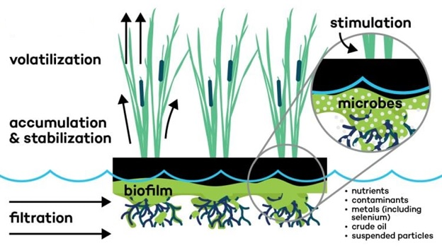

**Figure 2: Mechanism of Floating Wetland**

## **Relevancy and limitations**

Contaminant expulsion rates shift by area and sort of water being treated. Other variables such as stacking rate, contaminant concentration, silt estimate, and temperature will influence removal effectiveness [8]. Floating treatment frameworks are appropriate for lakes, lakes, and slow-moving water bodies. Even though they can withstand fluctuations in stream rate and water profundity, these changes diminish treatment proficiency.

## **Site selection**

Floating wetlands can be placed in already existing waterways or ponds, or a specially made pond. To be effective, these should be positioned in regions with slow-moving water that maintains a constant flow. Floating wetlands can be severely affected, and their protection becomes challenging due to significant alterations in water levels or the presence of swiftly flowing water. The presence of fast-moving water or changes in water level can have a detrimental impact on floating wetlands and complicate the efforts to safeguard them. Floating wetlands are vulnerable to damage and protection measures become difficult when water levels fluctuate or when there is an increased flow of water.

## **Sizing**

The size of the floating wetland can be determined by evaluating factors such as water volume, holding capacity, and desired water duration. Staying in a hydraulic system for a longer period of 3-5 days helps in removing more nitrogen compared to a shorter stay. To help remove nitrates from the pond, the floating wetland should cover a good amount of the water's surface, between 10% and 50%. It is suggested to put a cover over the pond/lake to have the right lack of oxygen conditions. Floating wetlands are usually built-in separate pieces and can be made bigger if they need to be to clean up the water or lagoon.

# DESIGN, FABRICATION, AND PROCUREMENT

The floating mat or matrix needs to be arranged in a way that allows the water in need of treatment to interact with the plant roots. To achieve this, it is important to ensure an even distribution of water throughout the floating wetlands, which should be completely submerged.8-15 meters to prevent the consumption of plant roots[4], For this very purpose, the flow meter is a device that measures how much fluid is flowing. It has an application that uses the Internet of Things (IoT) for monitoring the flow constantly and accurately. To ensure the flowmeter works correctly, it should be installed in a structure called a Parshall flume. Sometimes, the flowmeter gives inconsistent readings or reads zero in the data collection device. This might be caused by changes in the power supply at the sewage treatment plant site. To fix this, we need to investigate the current connection between the control panel room and the Parshall flume, as well as the backup power system.

Floating wetlands in specific locations may require nets or other protective measures to prevent plants from being damaged by birds. The bank can be connected to the floating mats employing wires. These wires let the mats go up and down when the water level changes. The strength of the anchoring should be sufficient to handle fluctuations. The relevant fabrication materials procurement (not limited to) are depicted in **Figure: 3 and Figure: 4.**

## **Procurement of the relevant floating wetland fabricaton fabrication materials (not limited to)**

1. Materials

i. 4” diameter PVC pipe

ii. 4” 90° bends

iii. Solvent glue for fixing the pipes

iv. Plastic mesh

v. Coir

vi. Plants for wetlands

vii. Rope for anchoring

2. Transportation of the required materials for the fabrication of floating wetlands to the STP **(Figure: 5)**

3. Fabrication and erection of floating wetlands of the desired target area in Sq.m **(Figure: 6)**

4. Ensuring the floating wetlands are anchored to the banks of the pond **(Figure:7)**

5. Training the staff in charge at the STP site on the fabrication and erecting of floating wetlands.

6. Training/orientation on the maintenance of the floating wetlands.

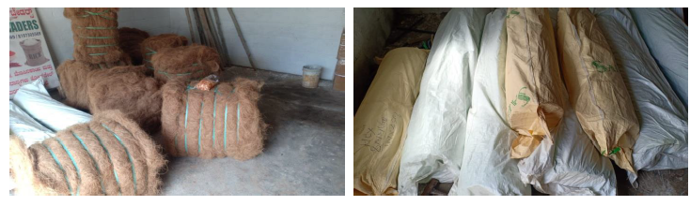

**Figure 3: Procurement of materials (Coir, PVC pipes)**

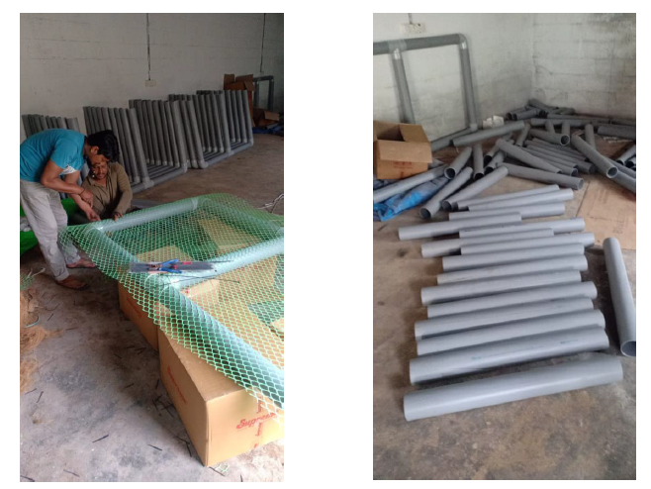

**Figure 4: Fabrication of the wetland module**

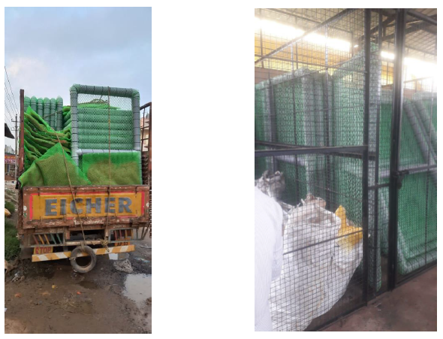

**Figure 5: Transportation of Fabricated wetland**



**Figure 6: Installed floating wetland in pond** *(source: Maturation Pond, STP Chikkaballapur, karnataka)*

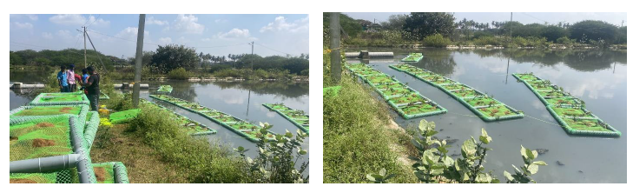

**Figure 7: Floating wetland with anchorage**

## **Procurement of Ultrasonic IoT based Transmitter Open Channel**

The flow meter needs to be installed with a solar battery and inverter at STP. This is to make sure we can monitor the flow continuously and measure the flow rate accurately

## **Time for Establishment**

Plant formation takes from 30 days to 12 months, depending on location and weather conditions [9].

## **Time for Establishment Operation and maintenance**

The lowest standards are needed for operation. Some buildings might have a pump system that needs electricity. Keep an eye on the health of plants, including their roots, and make sure to get rid of weeds and bugs. Sometimes it is necessary to cut down or trim trees, especially if the goal is to remove phosphorus from the treatment system [10]. Solid particles that have sunk in the water under the floating wetland need to be taken out regularly to make sure there is enough space to keep the sediment and to get rid of any harmful substances that may be in the sediment. Treatment wetlands can be transported and relocated by operators .

# CONCLUSIONS

* The genuine benefit of floating wetlands will depend on site-specific conditions and venture targets and ought to be considered in connection to other treatment frameworks or administration mediations.
* The arrangement is to reuse the treated wastewater from the treatment plant for non-mobile purposes. In case the current treatment productivity of the plant is underneath standard, and the yield wastewater contaminates the downstream environment, nature-based innovation with the assistance of the Web of Things will be a made strides technique, feasible and inexpensive to improve wastewater quality for reuse
* Floating wetlands can make strides in stormwater runoff quality and watershed supplement administration, as well as treat wastewater and other industrial contaminants

##### REFERENCES

1. Boonsong, K and Chansiri, “Domestic Wastewater Treatment using Vetiver Grass Cultivated with Floating Platform Technique”, Assumption University, Journal of Technology. 12(2), Oct 2008, pp: 73-80,
2. Barco, A., and Maurizio Borin,“Treatment performances of floating wetlands: A decade of studies in North Italy, Ecological Engineering”, Volume 158, 2020
3. Borne, “Floating Treatment Wetland To Treat Stormwater Runoff", Silverdale Pond”, New Zealand, Interim report No.2, Department of Civil & Environmental Engineering, University of Auckland
4. Borne, K., Fassman-Beck, E., Winston, R., Hunt and W.anner, C, “Implementation and maintenance of floating treatment wetlands for urban stormwater management”, J. Environ. Eng, 04015030.
5. Borne, KE, Fassman, EA, and Tanner CC, 2013, “Floating treatment wetland retrofit to improve stormwater pond performance for suspended solids, copper and zinc, Ecological Engineering, Volume 54,2013, pp:173– 182.
6. Headley, TR, and Tanner CC, “Application of Floating Wetlands for Enhanced Stormwater Treatment: A Review, Auckland Regional Council Technical Publication No. 324,November 2006
7. Abbas Z, Arooj F, Ali S, Zaheer IE, Rizwan M, Riaz MA, “ Phytoremediation of landfill leachate waste contaminants through floating bed technique using water hyacinth and water lettuce”. Int J Phytoremediat ,Volume 21, 2019, PP:1356–1367.
8. Afzal M et al, “ Floating treatment wetlands as a suitable option for large-scale wastewater treatment”, Nat Sustain, Volume 2, 2019, pp:863–871.
9. Borne KE, “ Floating treatment wetland influences on the fate and removal performance of phosphorus in stormwater retention ponds”, Ecol Eng, Volume 69, pp:76–82
10. Borne KE, Fassman-Beck EA, Winston RJ, Hunt WF, Tanner CC, “ Implementation and maintenance of floating treatment wetlands for urban stormwater management”, J Environ Eng, Volume 141, pp:345-351