REMOTE-CONTROLLED IRRIGATION SYSTEM

N.Ansgar Mary, T.M.Angelin Monisha Sharean
Assistant Professor
Department of Information Technology
St.Xavier’s Catholic College of Engineering
Chunkankadai, India- 629003

ABSTRACT
Water is vital for the growth of plants. Watering the plants is done by the irrigation process. Irrigation is the practice of supplying controlled amounts of water to land to grow crops, landscape plants and lawns. The main objective of this system is that it doesn’t need human intervention. This system aims at fulfilling water requirements of the crops, by monitoring the soil moisture using soil moisture sensor and other environmental parameters such as humidity and temperature using DHT11 sensor. It also helps in water conservation by providing water to the plants in gardens depending on their water requirements without going into the field for watering the plants. This irrigation system will reduce manpower, save time and enhance effectiveness at minimal cost. The feature of an animal detector is also added in case of animal movement onto the field and the notification of animal detection will be sent to the farmer by the warning message using the Blynk app which is also an IOT app.
Keywords— IOT, DHT11 sensor, Blynk app, Arduino IDE, Soil Moisture sensor, NodeMCU

INTRODUCTION

Water is an essential need for living things and agriculture is the largest consumer of freshwater in the world with 70% consumption. Therefore, smart irrigation systems are essential to meet future demands for reducing water consumption and manpower. The irrigation system is essential for crop yield, as over-irrigation and under-irrigation can lead to decreased productivity and power and water wastage. Precision irrigation reduces power and water wastage while increasing productivity. The traditional irrigation systems used in earlier years are Check Basin Method, Furrow Irrigation Method, Strip Irrigation Method and Basin Irrigation Method. These methods use groundwater sources and canals to deliver water to their fields, ensuring proper seed germination, higher yield of harvests and faster crop production growth. Farmers in India use these methods to ensure proper seed germination, higher yield of harvests and faster crop production growth. Modern methods are cheaper, but not as efficient due to human or animal labor and uneven distribution of water. IoT provides a strong means of monitoring various processes and real-time data transparency creates clearer visibility for improvement technology. In agriculture, IoT makes monitoring and management of micro-climate conditions a reality, which in turn increases production. For plants, the devices using IoT technology can sense the soil moisture level of the soil. This prevents wasting a precious resource and increases soil fertility.
Smart irrigation methods reduce outdoor water use by irrigating based on plant water needs. This technology can be used to create a smart controller by adding a sensor to an existing irrigation timer. It uses weather and soil moisture data to determine the irrigation needs of the landscape. Smart irrigation systems are important for water conservation in agriculture, this advancement could play a critical role in reducing water usage. Agriculture and farming techniques are also linked with IoT and automation, to make the whole process much more effective and efficient. Irrigation systems have been identified as positive contributors towards optimized irrigation systems that could improve the use of continuous research and development aimed at improving the sustainability of operations and cost reduction. We can make every drop of water count at your facility to improve the irrigation method.
Since irrigation is important to yield good quality crops in the seasonal or non-seasonal period, we can use modern agriculture. A smart irrigation system is one of the greatest ways for increasing output in the shortest amount of time. To a large extent, this smart irrigation system is developed and entirely automated to reduce agricultural labor. And one of the advantages is that it is very simple for users or farmers to grasp the notion of IoT and sensors for smart irrigation. Animal detection plays a very important role in the agricultural field. Applications which are very important are preventing crops from harming animals, knowing locomotive behaviors of animals and many more. Animal detection due to a wide range of real-world applications. Various animal detection methods and warning systems are used for indicating the presence of animals on the roads or residential areas and farming fields. This project added a feature of an animal detector in case of animal movement onto the field. An animal detection system detects the presence of animals and issues a warning.

LITERATURE SURVEY

Sensor Based Irrigation
Smart irrigation is implemented by using sensors [1]. Here the rain gun is attached with a pipe that is then connected to the water pump and the other end of the pipe is near to the root of the plant. The signal will be sent through the microcontroller when opening and closing of the valve is done. The procedure is done by watering the root of the plant drop by drop using a rain gun. The valve will be closed according to the moisture level. The microcontroller will send the signal to the mobile according to the sensor level which activates the buzzer to indicate the valve is open or not. The two mobiles are connected using GSM. The GSM and microcontroller are connected using MAX232.
Other smart irrigation system is implemented by Data analysis methods [2]. By sensors and integrated circuits, it records physiological conditions such as temperature, humidity, light density and soil moisture. It controls various irrigation management practices by measuring various agricultural parameters such as soil moisture, soil pH, humidity and temperature. These systems allow farmers to monitor and control their fields using easy-to-use mobile applications. The portable WSN is used here. Wireless satellites, mobile phones, sensors, Internet-based communications and microcontrollers record ecological parameters. The knowledge obtained from the sensors is transferred directly to the cloud servers using the Internet of Things technology.

Microcontroller Based Irrigation
In the ATMEGA 328 microcontroller-based irrigation system [3] the interrupt signal is sent to the motor and is programmed to receive input signals indicating the varying moisture condition of the soil via the sensing arrangement. Temperature and humidity sensors are connected to the internal ports of the microcontroller via a comparator. When there is a change in temperature and humidity in the environment, these sensors sense the change and send an interrupt signal to the microcontroller, causing the motor to turn on. A buzzer is also used to indicate that the pump is on. The project is intended to function as an irrigation system, with the pump/motor turning on and off based on the moisture content of the soil. This is accomplished by employing an op-amp as a comparator that serves as a bridge between the sensing arrangement and the microcontroller.
IoT based smart irrigation system install sensors for each plant in order to determine the soil's condition [4]. In order to supply water, each plant also needs a water pump. Blynk application on a smartphone is required, as well as hardware implementation that can detect the condition of the plant using the DHT11 sensor and moisture level detector is also required. It monitors the ambient air with a capacitive humidity sensor and a thermistor and outputs a digital signal on the data pin. Soil moisture sensors monitor the amount of water in the soil and can be used to calculate how much water is stored in the soil horizon. Soil moisture sensors do not detect water directly in the soil instead they track changes in another soil property that is related to water content in a predictable way.
For the efficient usage of water in smart irrigation system, embedded control system is used [5]. Remote monitoring and control have been introduced due to non-availability of cheap human resources. This system consists of an Arduino board which is used to interface different sensors including ultrasonic sensor, light ambient sensor, humidity sensor, temperature sensor and soil moisture sensor. It also controls a light, solenoid valve, water sprinkler and a cooling fan. The different sensors are used to measure different parameters for switching ON or OFF the relevant motor or fan or light as the case may be. They proposed the use of Embedded control systems for automation. They involved the use of sensors to check the humidity of the soil for switching on the motor when required.
Mobile application is also used to operate the water pump to turn ON/OFF without sensing the soil moisture level pouring the water anywhere with the help of IoT [6]. They will connect the device using Arduino. Arduino is the best part to help to conserve the water within a busy schedule. The node used to connect the system to your smart device controls the water flow from the pump and the shortness of the flow time. Farmers can monitor the process online through the website. Without monitoring the soil moisture levels, it will just pour the water for plants using Arduino. Users can operate the process in mobile applications.
In the smart agriculture model a relay act as an electrically operated switch [7]. The DHT11 detects the water vapor by measuring the electrical resistance between two electrodes. Soil moisture sensors measure the volumetric water content in soil. The valve is controlled by an electric current through a solenoid. It also stores the sensor parameters in real time. This will help the user to analyze the conditions of various parameters in the field anytime anywhere. It can control the motor in the field using humidity, temperature and moisture level. The moisture level of the soil is measured or sensed by the sensors. These values are stored in Arduino Nano to execute the methods. The motor will be turned on and off automatically without human interaction according to the soil moisture levels. The solenoid valve regulates water flow by sensing moisture levels in the soil. For two farms we use two moisture sensors, those are connected to microcontrollers and send moisture levels continuously.

Wireless Sensor Network

. Wireless Sensor Networks are playing an increasingly indispensable role in this system [8]. This irrigation system must contain at least one type of sensor which plays an important role in estimating the amount of water levels in the soil which will be defined by soil moisture sensor values. The sensed parameters such as temperature and humidity will drop if it goes below specific levels. Otherwise, he/she can use a smart irrigation controller that allows irrigation schedules to be automatically adjusted according to weather and soil moisture sensed data. The use of sensors or water pumps equipped with solar panels can help resolve the problem of energy crisis.

A water pipeline is an important structure used to transport potable water over long distances for consumption or irrigation. The wireless sensor network technique is for monitoring the water pipelines. The ZigBee wireless protocols are used for consumption and communication. As a result, in order to address the shortcomings of existing WSNs in terms of energy efficiency, this proposed model includes high-performance information that serves as a platform for WSNs to better support agricultural production.

Solar Renewable Energy
In the smart irrigation the solar powered water pump can also be used with a water flow control using a moisture sensor [22]. Solar energy is the most abundant source in the world. A photovoltaic generation is used here. The solar power will first drive the water pumps to pump water from borewells then driven into a tank. To optimize the use of water, the outlet valve of the tank is regulated using a controller. The moisture sensor is to control the flow rate of water from the tank to the irrigation field. Solar panels are used to pump water from a borewell directly into a ground level storage tank. The valves are controlled using smart algorithms to adjust the flow of water to the fields according to the moisture needs of the soil.
Fuzzy logic, sensors like soil moisture and DHT sensor can also be used to analyze conditions of the soil [22]. They used solar energy to power all the Arduino and the sensors. They use an Arduino microcontroller. These sensors are connected to a control unit which is responsible for controlling as well as monitoring the whole irrigation process and depending upon the weather conditions, a decision will be based on fuzzy logic regarding the need to irrigate the soil.
Another method monitors soil moisture, humidity and temperature levels, pumping water to the field and providing real-time information to the farmer's smartphone to take necessary action [27]. It mainly uses wireless sensors which are placed in the agricultural field to collect data with the real time values, a master controller is embedded to receive and transmit the data the necessary controllers for timely action. The agricultural field is surrounded by electric fencing. Farmhouse and electric fencing is generated by Solar Power generation. The system will power lighting to street lamps and fencing during night time and power will automatically disconnect during day time. The user can completely monitor the activity without the farmer’s interference in the surrounding area.

Machine Learning
Machine learning concepts can also be used with this smart irrigation. For the growth and yield of carrots, a transmitter and receiver circuit to a water pump via an actuator is used [20]. The transmitter circuit was in charge of reading the moisture content of the soil and wirelessly transmitting it to the receiver. Based on the received soil moisture data, the receiver decided whether to turn the pump on or off. It was piloted on a carrot farm, with 16 beds constructed. It was divided into 2 different blocks. The first block consisted of 8 beds which were manually irrigated and the second block was made up of 8 beds which were irrigated by means of machine-to machine communication. M2M is the use of any communication channel, including wired and wireless, to communicate directly between devices.
Sensor node inter-connectivity system can also be used to monitor the field thoroughly [26]. The Internet of Things and machine learning algorithms help to classify and predict the amount of soil, crop type and yield required by the crop. A wireless sensor network field needs to be established throughout the farm or even in the household garden to monitor all the parts of the field. It is based on opensource databases which are available online and Machine Learning algorithms. These solutions are based on microcontrollers such as Raspberry pi 3 and Arduino Mega, choice of microcontroller depends on computing power, price and availability. By using various sensors, the constant difference for water that is appropriate and specific to the type of crop will be analyzed continuously.
The next method uses the science of machine learning and data mining. This system uses various sensors which are used to collect data for real-time analytics on the weather forecast, soil moisture, air temperature, pH and humidity [18]. It is a data analysis process using multiple models and algorithms to train data directly. This method of incorporation of automated data processing, data recording and decision implementing machine learning is a complete ration-based framework. It increases the degree and quality of output. This survey can help farmers gain prior knowledge in order to implement machine learning techniques with irrigation action systems based on their needs and increase productivity.
Edge computing can also be used with IoT for smart irrigation system [28]. The sensors used here are soil moisture sensor, humidity and temperature sensor and light sensor. To make decisions for water requirements the k-nearest algorithm which is based on highly required, not required, highly not required, average required and required. The DHT22 sensor is used for humidity and temperature sensor, the BH1750 sensor is used for light sensor and the HL-69 sensor is used for hygrometer which is used for the humidity of the soil and the soil moisture from the field. It is implemented in Anaconda and it uses an Arduino UNO ATmega328P controller. The microcontroller layer is the perception layer, the edge server is the first processing layer and the GSM SIM808 is the transport layer and the main IoT is the second processing layer.

III. PROPOSED SYSTEM

A. IoT-based irrigation system
The proposed irrigation system fulfills the farmer's requirements. This system is based on the internet of things which achieves its objectives much faster. The irrigation will be done automatically with the real time values of soil moisture of the soil, temperature and humidity of the atmosphere of the plant in this system. It is very easy to use and is user friendly. In the current system, irrigation is done manually by farmers, but in our system, there is no farmer intervention to do the irrigation process instead the irrigation will be done automatically. In the existing system, the irrigation can be done automatically but with only the help of mobile applications using the button present in the application which is to control the motor. The motor controls the water pump to turn on and off so the mobile application gets control over it. But in this system the automatic irrigation process is used. The IoT application Blynk app also used here. First of all, if the soil is dry, the sensor will sense it and give the real time values of the soil moisture to the NODEMCU. The NODEMCU will send the values to both the LCD display and the Blynk app. Both of them will display the values of those sensors.

B. Animal Detection
The special feature called animal detection is used in this system. In this animal detection, the detection will be based on the movement of animals. To detect the animal movement in the field, a PIR sensor is used. The PIR sensor is connected to the microcontroller i.e., NODEMCU. In the existing system there is no notification for the indication of animals, but in this system, we will send a warning message to the farmer in the Blynk app. The warning message is to alert the farmer to indicate there is an animal movement in the field. We also have a buzzer which makes the animals get out of the field by the sound. The PIR sensor will detect the animal’s movement within 10 to 12 meters range. Depending upon the size of the PIR sensor, the distance for the motion detection will be varied. PIR sensor is controlled by the button in the Blynk. The user can use it according to their convenience. To indicate the ON and OFF, the button itself has a name in it. If any animal movement is detected, there will be an indication in the Blynk app by producing a red color button like symbol in it. After a few seconds, the warning message will appear. It also detects the movement of the humans since it is a motion detecting sensor.

IV SYSTEM ARCHITECTURE

Figure 1: Block Diagram

System architecture is a description of a system that includes the mapping of functionality to hardware and software components, the mapping of software architecture to hardware architecture and human interaction with these components. The purpose of system architecture is to define a wide solution based on interrelated and consistent principles, concepts and attributes. The System architecture describes how the system works and interacts with other systems and the outside world.

A. Soil moisture sensor
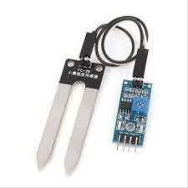
Soil moisture sensors measure or estimate the amount of water that is present in the soil. The soil moisture sensor is used in our project since the water is pumped out using its real time values. The sensor includes a fork-shaped probe with two exposed conductors which is inserted into the soil or wherever the moisture content is to be measured. A fork-shaped probe with two exposed wires acts as a variable resistor whose resistance changes with the moisture content of the soil.
Figure 2: Soil moisture sensor
There are 4 pins in the soil moisture sensor namely Analog Output, Digital Output, VCC and GND. AO (Analog Output) generates analog output voltage proportional to the soil moisture level. DO (Digital Output) indicates whether the soil moisture level is within the limit. VCC supplies power to the sensor and the sensor is powered from 3.3V to 5V. The sensor produces anoutput voltage according to the resistance, by measuring we can determine the soil moisture level. Sensors are placed on the root zone of the field, trees or shrubs directly measure the humidity position in the soil and transmit this data to the control unit. The controller also adjusts the pre-programmed watering schedule as demanded.

B. PIR Sensor
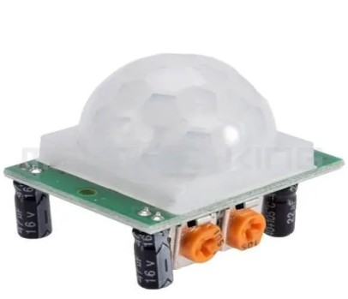
A passive infrared sensor is an electronic sensor that is mostly used in PIR-based motion detectors. PIR sensors enable the detection of animal movement and are also used to detect whether the animal has moved into or out of range of the sensor. PIR sensors allow for motion detection, almost always used to detect if a person has moved into or out of range of the sensor. PIR sensors detect changes in energy levels in the surroundings. PIR sensors can detect animal/human movement within the desired range. PIR sensors are mostly used in PIR-based motion detectors. It is also used in security alarms and automatic lighting applications.
Fig 3: PIR sensor
The PIR sensor consists of 3 pins- Pin 1, Pin 2 and Pin 3. Pin1 corresponds to the drain terminal of the device which is connected to the positive supply of 5V DC. Pin2 corresponds to the source terminal of the device which connects to the ground terminal through a resistor of 100K or 47K and it is the output pin of the sensor. Pin3 will be connected to ground. We can adjust the timing and direction of the pins in the sensor which are available on the side of the sensor. It receives the infrared radiation from the animal body to make an alarm. Any object with temperature is constantly radiating infrared rays to the outside world. Most of its radiant energy is concentrated in the wavelength range of 8 um-12 um.

C.DHT11 Sensor
The DHT-11 Digital Temperature and Humidity Sensor is a basic, very inexpensive digital temperature and humidity sensor. It uses a capacitive humidity sensor and a thermistor to measure the ambient air and spits out a digital signal on the data pin. This sensor is used to detect ambient humidity and temperature, measure soil moisture and also recommends watering the crops at the right time and for a certain period of time. The DHT11 sensor can be used to prevent the motor from ending up, which can shut down the motor after sensing high temperature and thermal value.
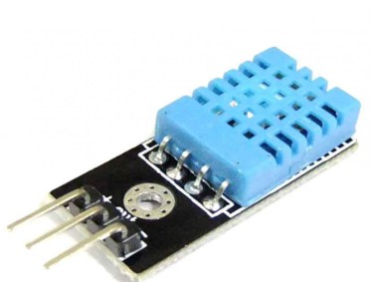
Fig 4: DHT11 sensor

The DHT11 sensor can be purchased either as a sensor or as a module. This sensor is used in a variety of applications such as humidity and temperature measurement in heating, ventilation and air conditioning systems. The DHT11 humidity sensor consists of 4 pins namely VCC, Data Out, Not Connected (NC) and GND. The voltage range for the VCC pin is 3.5V to 5.5V. A 5V supply would be sufficient. The data from the Data Out pin is serial digital data. It is a digital compound temperature & humidity sensor that gives a digital output previously calibrated. This single-chip microcontroller with an 8-bit connection provides quick response and better output quality, thus making it cost-effective. A single bus data format acts as both input/output transmission or two way communication. One single unit of data is 5 Byte (40 Bit). The communication time of transmitting and receiving is a maximum of 3 ms. The power consumption is quite low i.e., supply voltage of about 5V and the maximum current(average) of about 0.5 mA. DHT11 Sensor Humidity sensor is used for sensing the vapors in the air.

D. NodeMCU ESP8266
The NodeMCU also known as Node MicroController Unit is an open source software and hardware development environment that is built around a very inexpensive System-on-a-Chip (SoC) called the ESP8266 (ESP stands for electrostatic precipitator) which is a low-cost WiFi microchip, with built-in TCP/IP networking software.
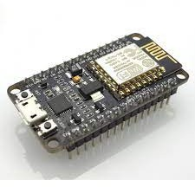

Fig 5: NodeMCU ESP8266

It has the operating voltage of 3.3V and input voltage of 7-12V. It has 16 Digital I/O Pins (DIO) and 1 Analog Input Pins(ADC). Also, there are 1 UARTs, 1 SPIs, 1 I2Cs, Flash Memory which is 4 MB and SRAM which is 64 KB. The NodeMCU Development Board can be easily programmed with Arduino IDE since it is easy to use, it will hardly take 5-10 minutes. All we need is the Arduino IDE, a USB cable and the NodeMCU board itself.
The ESP8266 module enables microcontrollers to connect to 2.4 GHz Wi-Fi and it can also be used with ESP-AT firmware to provide Wi-Fi connectivity to external host MCU. The ESP8266 NodeMCU development board is a real plug-and-play solution for less expensive projects using WiFi, so we are using this in our project.

E. DC motor
A DC motor is an electrical machine that converts electrical energy into mechanical energy. A DC motor consists of a wound armature, commutator, brushes and magnets, all inside a completely enclosed housing. It runs on DC power or AC mains voltage with a rectifier. A DC motor is based on the scenario that when a current-carrying conductor is placed in a magnetic field, it creates a mechanical force. The direction of the force is determined by the left-hand rule.
A DC motor is based on the scenario that when a current-carrying conductor is placed in a magnetic field, it creates a mechanical force. For large electrical applications such as steel mills and electric trains, alternating current (AC) is converted to direct current because the speed and torque characteristics of a DC motor are better than those of an AC motor. In the case of industrial applications, DC motors are as widely used as three-phase induction motors.
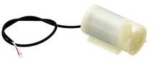
Fig 6: DC motor
The power source is electric and its voltage is 9V. Its flow rate is 80-120 L/H. The outside diameter is 7.5 mm and the aperture is 4.5 mm. Maximum lift is 40 ~ 110 mm and the operating voltage, 6 ~ 9V. This is a low cost, small size submersible pump motor. It can take up to 120 liters per hour with very low current consumption of 220mA. We can just connect the tube pipe to the motor outlet, submerge it in water and power it. Its usage type is domestic. If the soil becomes dry, the sensor senses the moisture level and automatically turns on the DC motor, which acts as a water pump to deliver water to the plant/plot. The direction of the water flow in the pipe is automatically determined by the DC motor, so we use it in our project. The direction of the water flow in the pipe is automatically determined by a DC motor.

Relay
Relay boards are electrically operated switches that open and close circuits by receiving electrical signals from external sources. Relays, which are built into electrical products, work by receiving an electrical signal and sending it to another device by flipping a switch on and off. Relay is electromechanically switch which is operated by a relatively small amount of electric current which can control the switching activity of the large electric current operating devices.
A relay is an electromechanical device that can be used to make or break an electrical connection. Consisting of a flexible moving mechanical part that can be controlled electronically using an electromagnet, basically a relay is like a mechanical switch but you can control it with an electronic signal instead of manually turning it on or off.
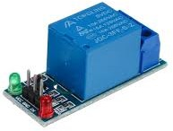
Fig 7: Relay

The relay also has two pins namely normally closed and normally open (NC and NO), the normally closed pin is connected to the armature or common terminal while the normally open pin is left free. Relays, which are built into electrical products, work by receiving an electrical signal and sending it to another device by flipping a switch on and off. When the power is off, COM automatically connects to NC, which is the default state of the relay. The relay will control the flow of water from the pump. The water pump will be connected by a pipe. When the pump is on, it will supply water from the pot through the connected pipe, so we use this in our project.

G. Blynk Application

Blynk is a simple, powerful, no-code app builder that you can prototype and deploy. Blynk's platform empowers small-scale manufacturers of smart home products and agricultural equipment. Blynk app allows you to create stunning interfaces for your projects using various widgets. Blynk is an IoT platform for iOS or Android smartphones used to control Arduino, Raspberry Pi and NodeMCU over the Internet. This software is used to create a graphical interface or human machine interface (HMI) by compiling and providing appropriate addresses with existing widgets. It can control hardware remotely. You can view sensor data, save data, visualize it and do many other cool things.
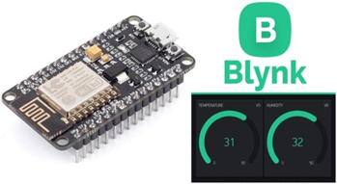

Fig 8: Blynk App

Arduino IDE
The Arduino Integrated Development Environment or Arduino Software (IDE) contains a text editor for writing code, a message area, a text console, a toolbar with buttons for common functions and a series of menus. It connects to the Arduino hardware to upload programs and communicate with them. The IDE application is suitable for different operating systems such as Windows, Mac OS and Linux. It supports the programming languages C and C++. Here, IDE stands for Integrated Development Environment. The program or code written in the Arduino IDE is often called sketching.
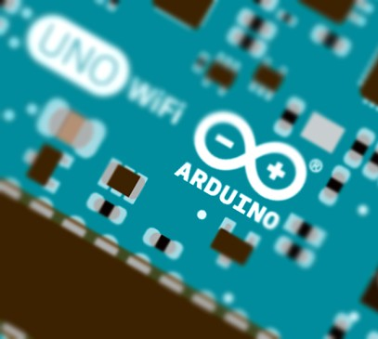

Fig 9: Arduino IDE

V SYSTEM IMPLEMENTATION

Implementation of the system involves determining how the information system will be built, ensuring the operation and use of the information system and also ensuring that the information system meets quality standards. This phase begins after the system is tested and accepted by users. The implementation phase includes user notification, hardware setup, software installation and system integration. System implementation is a set of procedures followed to complete the design in the approved system design document and to test, install and begin using a new or revised Information System. The goals of system implementation are to write, test and document the programs and procedures required by the approved systems design document.

A. Soil moisture and temperature sensing
In this module the moisture content is analyzed in the soil. Soil moisture is the critical parameter in agriculture. If there is a shortage or overabundance of water, plants may die. This refers to the entire quantity of water in the ground’s pores or on its surface. The moisture content of soil depends on such factors as weather, type of land and plants. The temperature of the surrounding and the soil’s humidity is also analyzed here. According to the sensor values, further decisions are taken. It is vital to understand the most effective methods for analyzing soil moisture content.

B. Send the results on NodeMCU
Once the values of temperature, humidity and moisture are generated on the microcontroller r(ESP866). The threshold can also be notified by itself. And if the result of moisture, temperature and humidity goes below the threshold value the pump will automatically turn ON and if the level of the moisture, temperature and humidity increase up to threshold level of field then pumps will automatically turn OFF.

C. Displayed on LCD display
The values which are obtained by the sensors will be conveyed and displayed in the LCD display. It will show the accurate real-time values of soil moisture, temperature and humidity. The Microcontroller will send the real time values of the moisture level of the soil and the humidity of the air. The temperature of the atmosphere will also be analyzed and displayed here. It also displays the indication whether the water pump is ON or OFF and also displays the indication whether the PIR sensor is ON or OFF.

D. Watering using Water pump with the help of DC motor and Relay
Relay module is used as a commander here. It is electromechanically a switch. This module is used to turn off the pipe by the values of the sensor sensed from the plant and the atmosphere. According to the real time values, the relay module will on or off the water using a dc motor which will be submerged inside the water. Anyways, the water will be pumped from the water pump to the soil. It will occur with the help of a relay and dc motor.

E. Detection of Animal
The PIR sensor will detect the movement of the animal if any animal enters into the field. The PIR sensor will detect the animal’s movement within 10 to 12 meters range. The frequency range of the PIR sensor is about 7 Hz to 30 Hz.

F. Mobile Application
The IoT Blynk app is used as a mobile application. In this, we can see the real time values of the temperature, humidity and the soil moisture directly from the field. Also we have a button for turning off and on the water pump. We can also be able to use the button in the app which is for animal detection to use it for the user’s convenience. To indicate the watering process in the app, the app will show the soil moisture level as 0 to water the plants and 99 to stop watering. We can use the button in the app to do so.

VI RESULTS & DISCUSSION

The results section contains a description of the main findings. In the results section, the research results must be presented in a logical sequence without any discrimination or explanation. In the results section the results of the study based on the methodology is reported. The Results section reports the findings of the research without assumptions. It brings all the previous chapters together and allows the reader to see the connections between each part of the research process.
The discussion section explains the results for the reader and provides the significance of the findings. The discussion session examines the results and puts them in the context of general research. The discussion should not repeat the results. The purpose of the discussion section is to explain the importance of the findings to the things that have been known about the research problem being investigated and to explain new views or views that emerged from your research.

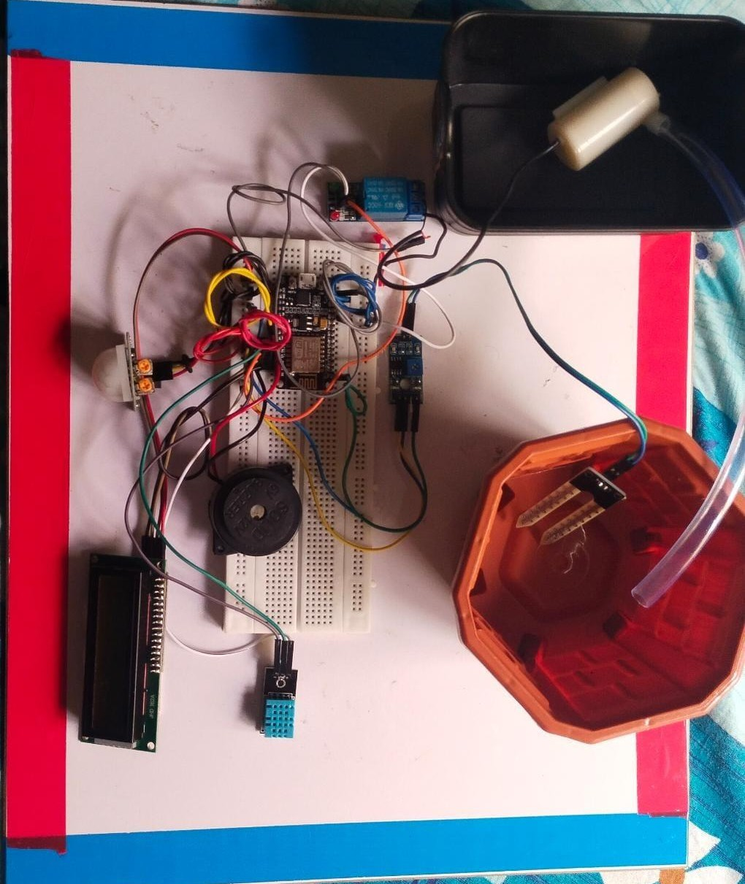
A. Working of Smart Irrigation System

Fig 10: Smart Irrigation system

This is the smart irrigation system which has NODEMCU, DHT11 sensor, LCD display, PIR Sensor, relay module and DC motor.

B. Notification of animal detection

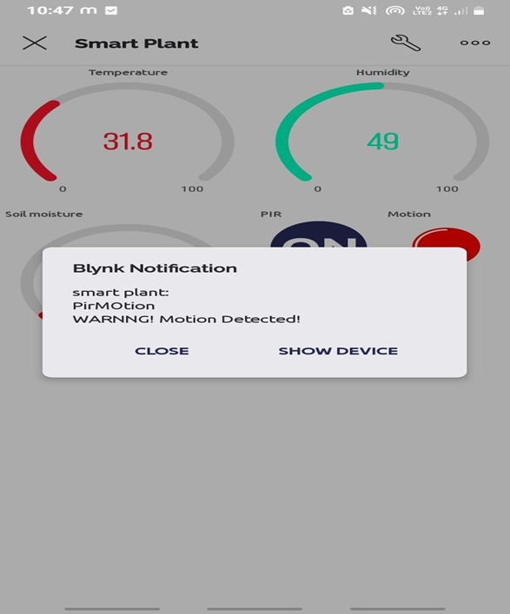

Fig 11: Notification of animal detection

The notification will be sent to the Blynk app if any motion is detected. It will be indicated by the Nodemcu based on the detection of animals.

C. LCD Display
The LCD display will show the temperature, humidity, soil moisture level, PIR sensor indication whether it is on or off and the water pump is on or off.

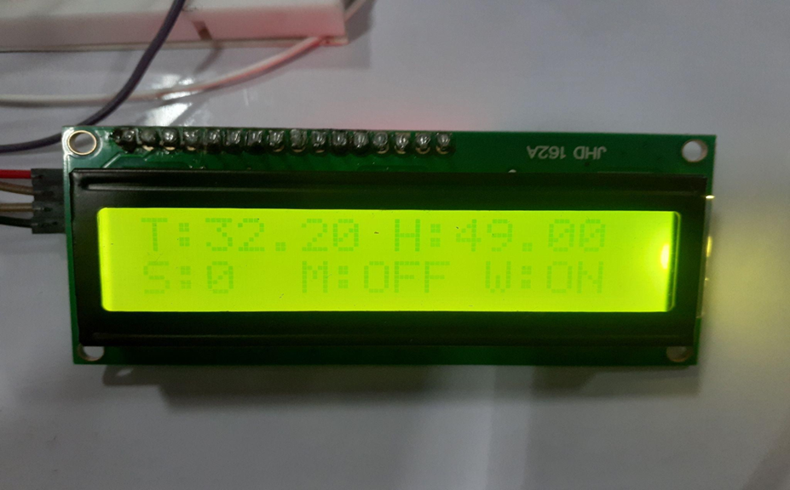

Fig 12: LCD Display

D. PIR Sensor button

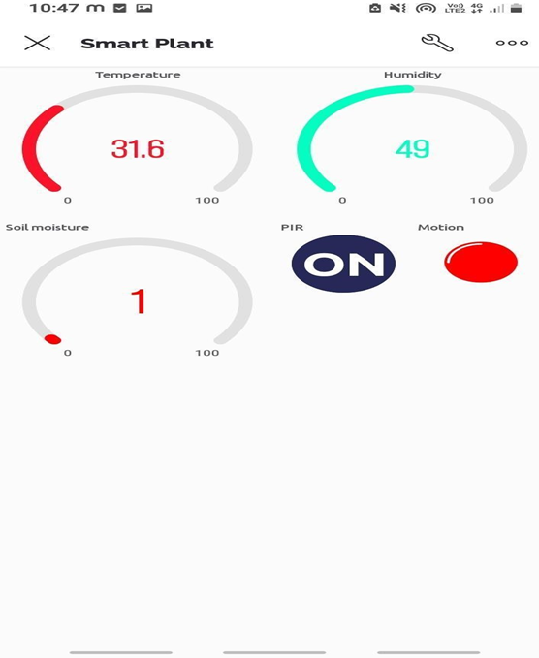

Fig 13: PIR Sensor button

The PIR sensor will indicate the animal detection in the IoT application by the red color button. We can turn on or off by the switch in the IoT application.

VII FUTURE SCOPE & CONCLUSION

A. Future Scope

This system has a wide scope for future development. To keep abstract of technical improvements, the system may be further refined. So, this type of system is improved in further future development. This development is efficient and effective. In the future this work can be upgraded by adding several features on this system to fetch more data from many plants simultaneously. And also, to enhance the working of the animal detection, we will increase the length of the PIR sensor for sensing the animal which is coming far away from the field. Along with the SMS notification, in the future repellent system of Bright light and irritating loud noise can be added which is used simultaneously with an interval of 4 seconds is used upon the animal. The insect removal machine works continuously to better scare the animals.

B. Conclusion

The conclusion of the proposed system is to make the irrigation process easy by doing it automatically and also the system has the additional features of PIR sensor. The system automatically turns on and off the water pump without the intervention of the farmer by sensing the real time values of the temperature and the water content of the soil with the help of DHT11 sensor which is a digital temperature and humidity sensor and soil moisture sensor. The method helps the farmer by working automatically and smartly. It also helps in water conservation by providing water to the plants/gardens depending on their water requirements without going into the field for watering the plants. This irrigation system will reduce the hardship of farmers, save time and enhance effectiveness at relatively minimal cost which is done automatically.

A special feature of animal detection is also added in this work. With the help of the PIR sensor which is also known as passive infrared sensor, animal movement is detected in the field. By the help of this, we can reduce the harm of animals in the field. The notification of animal detection will be sent to the farmer by noting him with the warning message using the Blynk app. The main benefit of using the PIR sensor is that it saves farmer’s time.

REFERENCES

[1]. Mr. Karan Kansara Sensor based Automated Irrigation System with IOT : A Technical Review) International Journal of Computer
Science and Information Technologies, Vol.(6) , 2015, 5331-5333.
[2]. Muhammad Awais,1Weimin Ru,1Weidong Shi,2Muhammad Ajmal,3Saad Uddin,4and Chenchen Liu,Review of Sensor Network-
Based Irrigation Systems Using IoT and Remote Sensing Advances in Meteorology Volume 2020, Article ID 8396164, 14 pages
[3]. Bishnu Deo Kumar1, Prachi Srivastava2, Reetika Agrawal3, Vanya Tiwari4 MICROCONTROLLER BASED AUTOMATIC PLANT
IRRIGATION SYSTEM International Research Journal of Engineering and Technology (IRJET) e-ISSN: 2395 -0056 Volume:04,
Issue: 05 | May -2017
[4]. Darshna, S., et al. "Smart irrigation system." IOSR Journal of Electronics and Communication Engineering (IOSR-JECE) 10.3 (2015):
32-36.
[5]. M. Pyingkodi; K. Thenmozhi; K. Nanthini; M. Karthikeyan; Suresh Palarimath; V. Erajavignesh; G.Bala Ajith Kumar Sensor Based
Smart Agriculture with IoT Technologies: A Review international Conference on Computer Communication and Informatics (ICCCI).
[6]. Fateh Bounnama3 , Belkacem Draoui, Khelifa Benahmed Intelligent Irrigation Management System International Journal of Advanced
Computer Science and Applications, Vol. 9, No. 9.
[7]. Darshna, S., et al. "Smart irrigation system." IOSR Journal of Electronics and Communication Engineering (IOSR-JECE) 10.3 (2015):
32-36.
[8]. Rawal, Srishti. "IoT based smart irrigation system." International Journal of Computer Applications 159.8 (2017): 7-11.
[9]. Tyagi, Apurva, et al. "Smart irrigation system." International Journal for Innovative Research in Science & Technology 3.10 (2017).
[10]. Nawandar, Neha K., and Vishal R. Satpute. "IoT based low cost and intelligent module for smart irrigation system." Computers and
electronics in agriculture 162 (2019): 979-990.
[11]. Leh, Nor Adni Mat, Muhammad Syazwan Ariffuddin Mohd Kamaldin, Zuraida Muhammad, and Nur Atharah Kamarzaman. "Smart
irrigation system using internet of things." In 2019 IEEE 9th International Conference on System Engineering and Technology
(ICSET), pp. 96-101. IEEE, 2019
[12]. Ramachandran, V., R. Ramalakshmi, and Seshadhri Srinivasan. "An automated irrigation system for smart agriculture using the
Internet of Things." In 2018 15th International conference on control, automation, robotics and vision (ICARCV), pp. 210-215. IEEE,
2018.
[13]. Munir, M. Safdar, Imran Sarwar Bajwa, and Sehrish Munawar Cheema. "An intelligent and secure smart watering system using fuzzy
logic and blockchain." Computers & Electrical Engineering 77 (2019): 109-119.
[14]. Oussama, G., et al. "Fast and intelligent irrigation system based on WSN." Computational Intelligence and Neuroscience 2022.
[15]. Kaur, Baltej, et al. "A survey on smart drip irrigation systems." Int. Res. J. Eng. Technol.(IRJET) 3.02 (2016).
[16]. Sharma, Brij Bhushan, and Nagesh Kumar. "IoT-based intelligent irrigation system for paddy crops using an internet-controlled water
pump." International Journal of Agricultural and Environmental Information Systems (IJAEIS) 12.1 (2021): 21-36.
[17]. Boopathy, S., Gokul Anand KR, and N. R. Rajalakshmi. "Smart Irrigation System for Mint Cultivation through Hydroponics Using
IoT." TEST Engineering and Management 83 (2020).
[18]. Vij, Anneketh, et al. "IoT and machine learning approaches for automation of farm irrigation systems." Procedia Computer Science
167 (2020): 1250-1257.
[19]. Liu, Hong Kong. "Agricultural water management based on the Internet of Things and data analysis." Acta Agriculturae Scandinavica,
Section B—Soil & Plant Science 72, no. 1 (2022): 300-311.
[20]. Kponyo, Jerry John, Kwasi Adu-Boahen Opare, AA RAHMAN, and Justice Owusu Agyemang. "An intelligent irrigation system for
rural agriculture." International Journal of Applied Agricultural Sciences 5, no. 3 (2019): 75-81.
[21]. Sudharshan, N., et al. "Renewable energy based smart irrigation system." Procedia Computer Science 165 (2019): 615-623.
[22]. Harishankar, S., et al. "Solar powered smart irrigation system." Advance in electronic and electric engineering 4.4 (2014): 341-346.
[23]. Chate, Bhagyashree K., and J. G. Rana. "Smart irrigation system using Raspberry Pi." International Research Journal of Engineering
and Technology 3.05 (2016): 247-249.
[24].Gunturi, Venkata Naga Rohit. "Micro controller based automatic plant irrigation system." International Journal of Advancements in
Research & Technology 2.4 (2013): 194-198.
[25]. Satriyo, P., I. S. Nasution, and D. V. Della. "Controlled sprinkler irrigation system for agricultural plant cultivation." IOP Conference
Series: Earth and Environmental Science. Vol. 922. No. 1. IOP Publishing, 2021.
[26]. Anbarasi, M., et al. "Smart multi-crop irrigation system using IoT." Int. J. Innov. Technol. Explorer . Eng 8 (2019): 153-156.
[27]. CM, Avinash. "MOBILE INTEGRATED SMART IRRIGATION SYSTEM USING IoT." Journal of Contemporary Issues in Business
and Government 27.3 (2021): 1725-1730.
[28]. Prathipa, R., et al. "LoRa based smart irrigation system for remote areas." International Research Journal of Engineering and
Technology 8 (2021): 160-164.
[29]. Babu, D. Vijendra, et al. "Automatic Irrigation Systems for Efficient usage of Water using Embedded Control Systems." IOP
Conference Series: Materials Science and Engineering. Vol. 993. No. 1. IOP Publishing, 2020.
[30]. Kansara, Karan, et al. "Sensor based automated irrigation system with IoT: A technical review." International Journal of Computer
Science and Information Technologies 6.6 (2015): 5331-5333.
[31]. VinothKumar, V., et al. "Implementation of IoT in smart irrigation systems using arduino processors." International Journal of Civil
Engineering and Technology (IJCIET) (2017).
[32]. Srivastava, Prakhar, Mohit Bajaj, and Ankur Singh Rana. "Overview of ESP8266 Wi-Fi module based smart irrigation system using
IoT." 2018 Fourth International Conference on Advances in Electrical, Electronics, Information, Communication and Bioinformatics
(AEEICB). IEEE, 2018.

