EFFECTS OF MITES INFESTATION ON FOLIAR GALLS
M. Gopi

Assistant Professor & Head,
Department of Plant Biology and Plant Biotechnology, Guru Nanak College (Autonomous), Velachery, Chennai, India.

gopilmk74@gmail.com

Abstract
Plant Galls are externally visible growths which are varied in size and topography .The Cecidophyta (Bacteria, Fungi, algae, seed plants) or Cecidozoa (insects, mites, nematodes worms.) are gall forming agents. The present study is in Kavalur Hills at Thirupatur District, Tamil Nadu, India, Two plants were taken and studied elaborately Acacia caesia W. & A.and Alangium salvifolium (L. f.) Wang. The causative agents of these galls were belonging to mites. Mites may infect any aerial organ of the plant leading to felty outgrowths, witches brooms, pouches and covering growth galls. Phytophagous mites not only damage food crops and fruits but also induce galls on plants. Leaves are more effected than the buds, veins and petioles. These various types of galls have been vividly described and compared, with normal plant organs in the observational part of this research paper.

Key Words :Acacia caesia , Alangium salvifolium , Foliar galls, Mites

Introduction
Man’s knowledge of plant galls dates back to the seventeenth century. Marcello Malpihigi seems to have initiated the scientific inquire of these neo-plastic outgrowths (Gopi, M. 2018). Ceciodology as a separate discipline of biological significance was first founded by Prof. M. S. Mani. . The mouthparts, called chelicera are adapted for piercing, sucking and lacerating (Channabasavanna, 1981). The present study pertains to a preliminary survey of certain mite galls in different parts of Kavalur Hills at Thirupatur District, namely, Acacia caesia, Alangiumsalvifolium and Commiphoracaudata.
Materials and Methods
The plant material being leaves with galls were fixed in FAA (Formalin-Acetic Acid-Alcohol) separately. For morphological study, photographed and interpreted. The host plant was identified with the help of ‘The Plant Book’ by Mabberley (2005) and ‘The Flora of the Presidency of Madras’ by Gamble (1957). The gall causing organism was identified with the help of the previous literature ‘Plant Galls of India’, by Mani (2000). Toludine blue is a polychromatic stain, was used for staining The dye render pink colour to the cellulose walls, blue to the lignified to the lignified to the lignified cells, dark green in to suberin, violet to the mucilage, blue to the protein. Descriptive terms of the anatomical features are as given the standard Anatomy books (Esau, 1964).
Photomicrographs
Photographs of different magnifications were taken with Nikon Labphot-2 microscopic unit.
Observations
1. Acacia caesia W.& A. (Mimosaceae) –

Reported the ‘Caulifourous gall’ - Foliar gall several leaflets of a pinna or entire leaf with almost of leaflets are infested and turned into irregular, tuberculate, highly convoluted irregular mass; the gall, when young is pale green and turns brick red when old; the leaflets lose their identity and get agglomerated into a mass. The gall mass is a fusion of several deformed leaf lets.

Anatomy of Gall– The mite infects the meristematic axillary bud of the plant; the bud consists of apical meristem, leaf primordial and bud scales. The anatomy of the gall is typical leaf. The mites are usually dispersed by wind and when deposited on the young axiallary buds, they feed on the surface cells of the young organs. The feeding stimulus causes proliferation of the epidermal and subepidermalcells, which develop into tuberculate tissue masses provide a conducive domicile for feed and to live.

2. Alangium salvifolium (L. f.) Wang. – leaves were incited by the mite EriophyesalangiiNalea (Acarina). gall epiphyllous, irregularly subglobose, verrucose, sessile, free or sometimes also a few agglomerate, pale yellow or yellowish green pouch gall, with large wide open ostiole on the lower side, gall cavity filled with fine, short, rusty-brown erineum. Size 2 – 15 mm in diameter; distributed in northern coromandal coast.

Results and Discussion
The plant galls of Thirupathur district are induced by agents of diversified taxonomic groups.

Figures

Fig. 1. Acacia caesia W.& A. (Mimosaceae) - ‘Caulifourous gall’
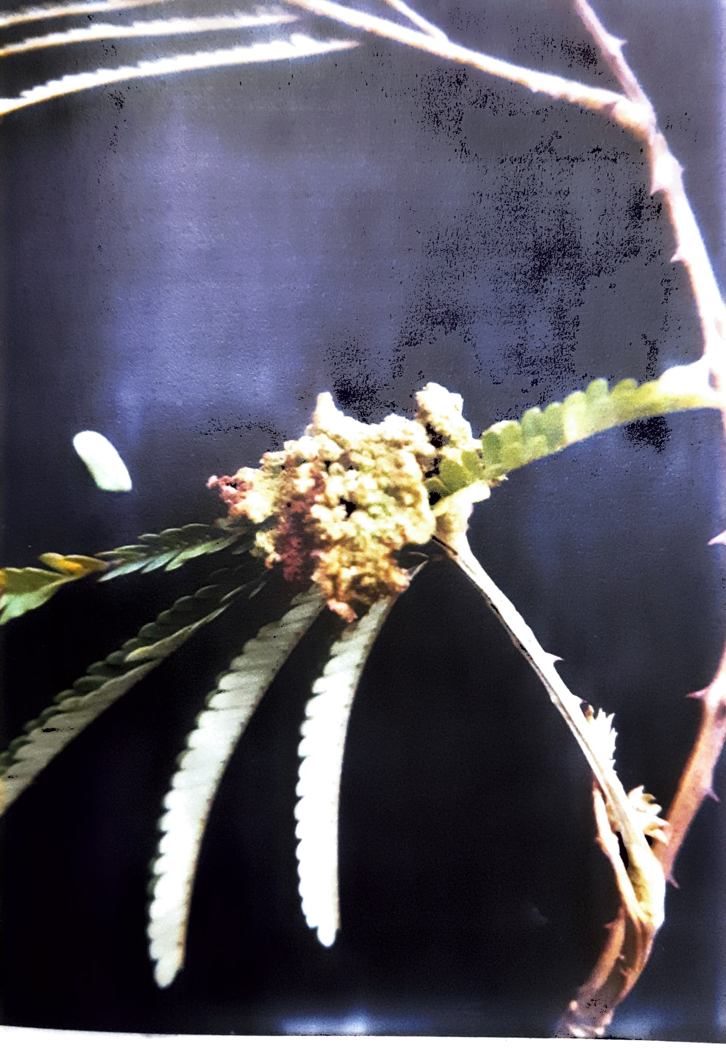
Exomorphic features of normal leaf and Galled leaf
Fig. 2. Acacia caesia W.& A. (Mimosaceae)
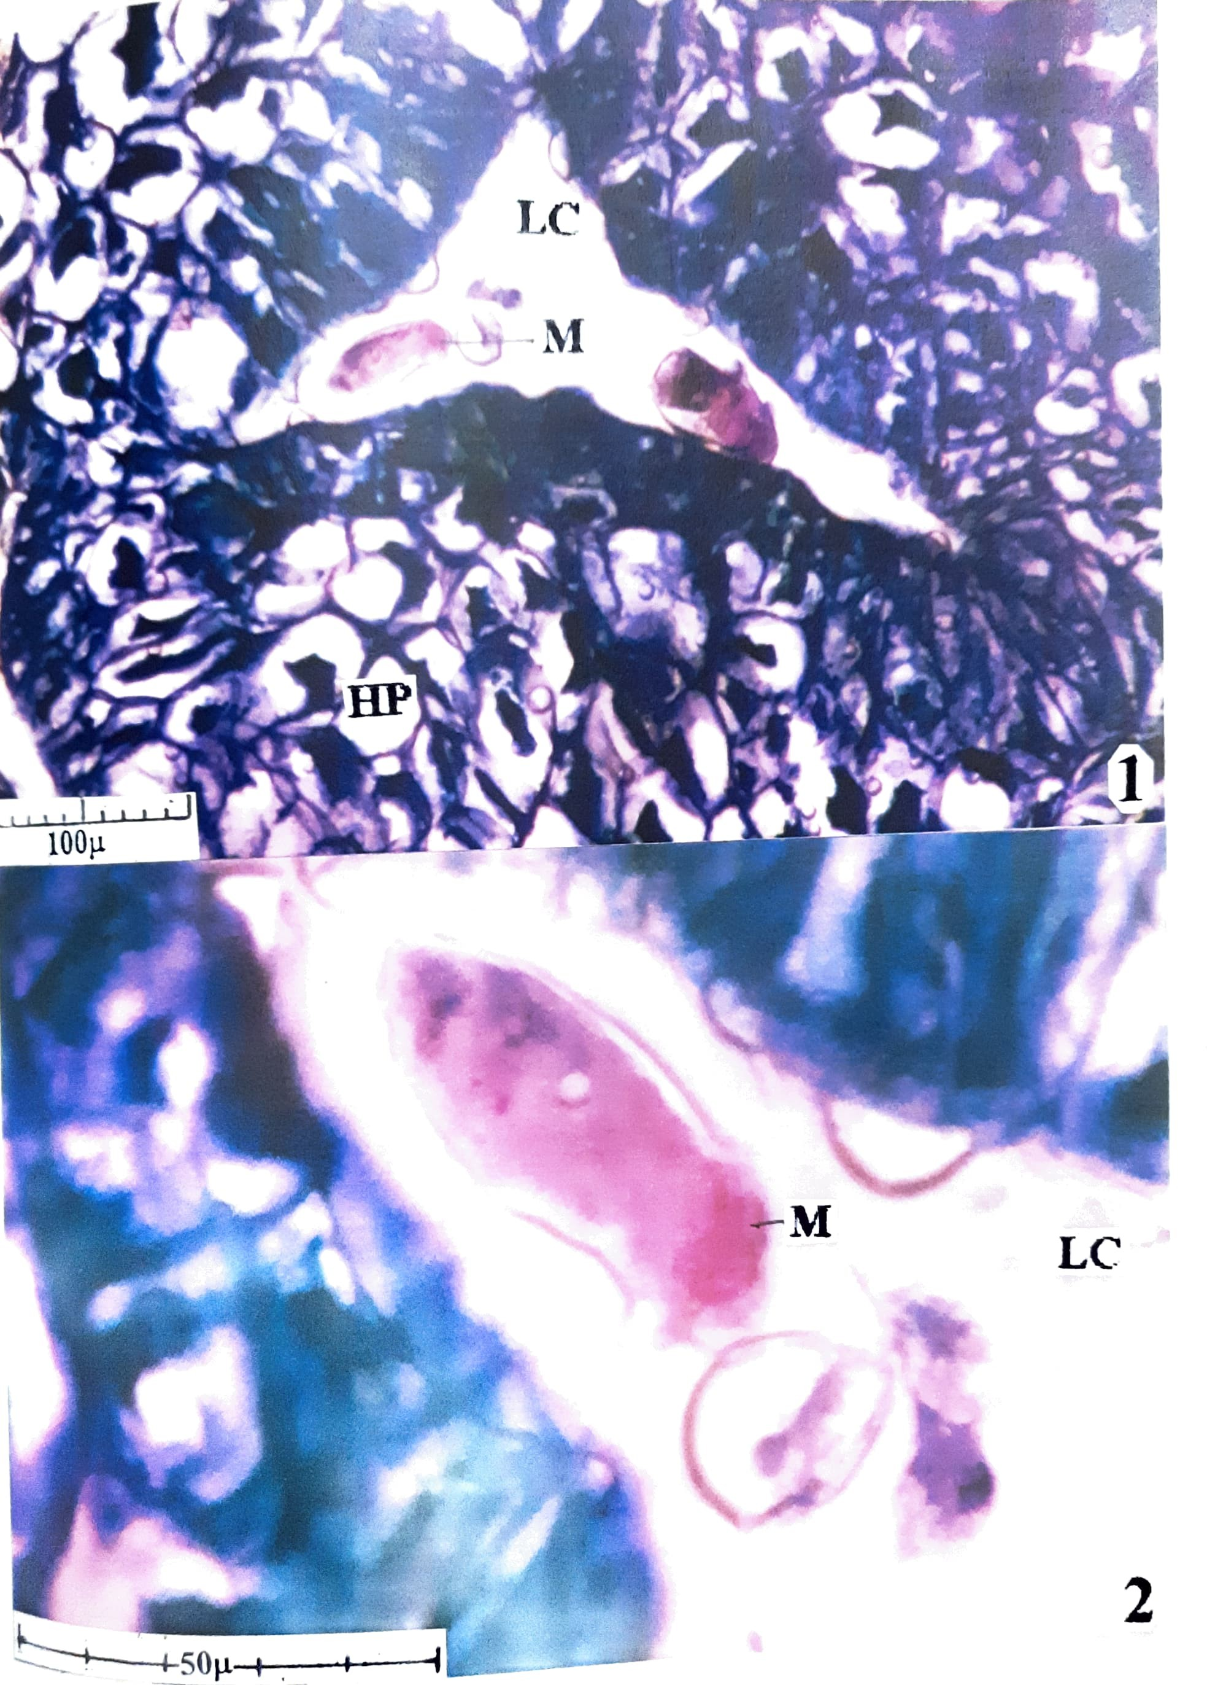
- Transectional view of leaf gall showing gall cavity and hypertrophied parenchyma cells
- Larval cavity magnified showing mites
( HP – Hypertrophied parenchyma; LC – Larval Cavity; M – Mite )

Fig. 3. Alangium salvifolium (L. f.) Wang. – Alangiaceae
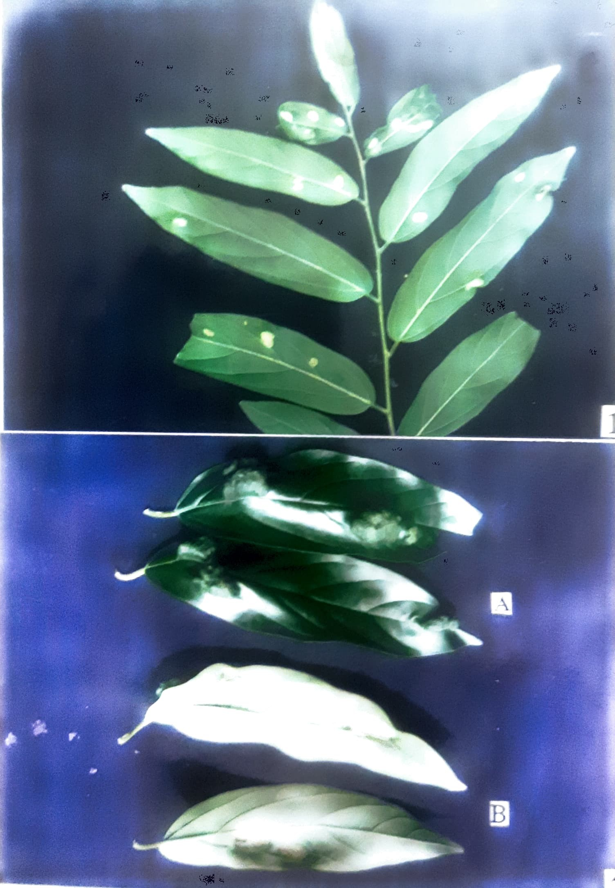
- Exomorphic features of the leaf gall
- Exomorphic fetures of leaf gall – Adaxial view and Abaxial view
( A – Mite Gall; B – Infected Region )

Fig. 4. Alangium salvifolium (L. f.) Wang. – Alangiaceae

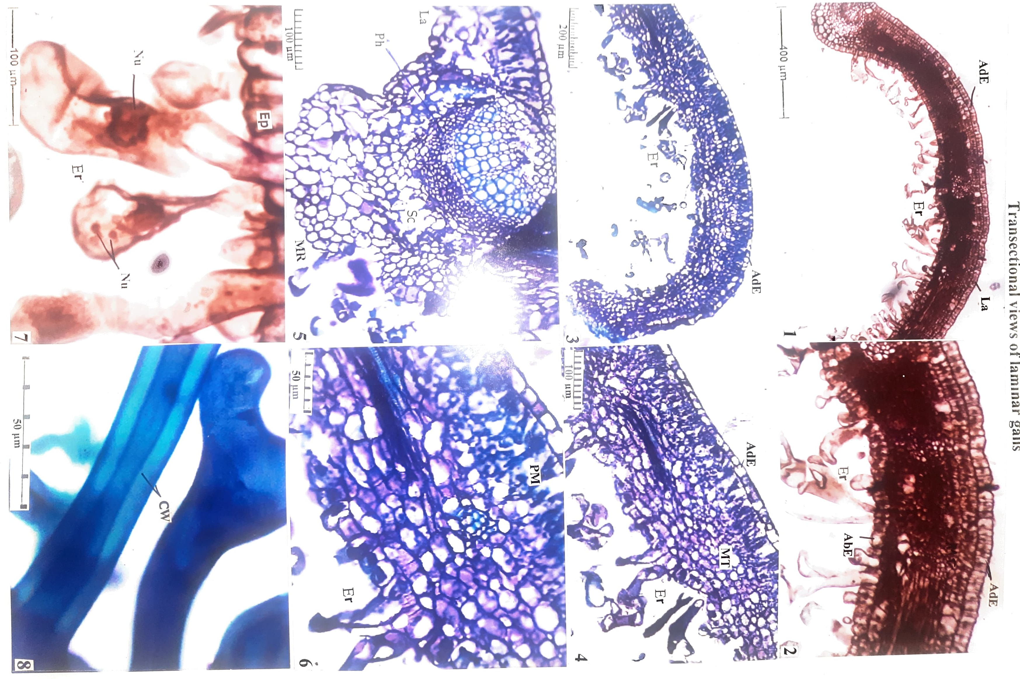
( AdE – Abaxial Epidermis; AdE – Adaxial Epidermis; CW – Cell Wall; Ep – Epidermis; Er – Erineal Hairs; GP – Gall pouch; La – Lamina; MR – Midrib; Nu – Nucleus; Ph – Phloem; PM – Palisade Mesophyll )
References
- Channabasavanna, G. P. 1981. (ed.) Contributions to Acarology in India. Department of Entomology, University of Agricultural Sciences, Bangalore.
- Esau, K, 1964. Plant Anatomy Joyhn Wiley & Sons. New York p. 767.
- Foster, A.S. 1934. The use of tannic acid and iron chloride for staining cell walls in meristematic tissue. Stain Technol. 99: 91 – 92.
- Gamble, J. S. 1957. Flora of the Presidency of Madras, 3 Vol. Botanical Survey of India. Calcutta, India.
- Gopi, M. 2018. Utility of plant galls. Indian Journal of Economics and Development. Vol 6 (10), pp. 1 – 10.
- Gopi, M. 2021. Plant Galls : Hitherto untapped focus on positive approach. Book Chapter entitled ‘Gall-Inducing Arthropods on Forest Trees’. Scientific Publishers. Edited by John Prasanth Jacob. pp. 63 - 76.
- Johanson, D. A. 1940. Plant Microtechnique. McGraw Hill Book company, New York.
- Mabberley, D. J. 2005. The Plant Book. Cambridge University Press.
- Mani, M. S. 2000. Plant Galls of India. Second Edition Oxford & IBH Publishing Co. Pvt. Ltd. New Delhi.

