Advances into Management and Treatment of Breast Cancer
Pushpendra Kumar Rajput, Assistant Professor Department of Paramedical Sciences, Swami Vivekanand Subharti University, Meerut
Vishant Pal, Biochemistry Demonstrator, Department of Paramedical Sciences, Swami Vivekanand Subharti University, Meerut

Abstract
An Overview of Management and Treatment of Breast Cancer is provided in this chapter. With particular focus on the basic cell structure, Causes, sign and symptoms, breast anatomy, types of cancer, diagnosis, treatment and risk factor. Breast Cancer is a prevalent and deadly disease that affects women worldwide. It is a malignant tumor that develops in the breast soft tissue. National Cancer Awareness Day is celebrated on November 7 in India to increase awareness of the condition's importance and promote early detection, treatment, and diagnosis in an effort to slow the rapid spread of cancer. The early warning signs of cancer, we might use the phrase CAUTION. there are two types of types of cancer first, In situ breast cancer (ductal carcinoma in situ or DCIS) is a pre-cancer that starts in a milk duct and has not grown into the rest of the breast tissue and second, invasive (or infiltrating) breast cancer is used to describe any type of breast cancer that has spread (invaded) into the surrounding breast tissue. There are different types of diagnosis techniques of screening breast cancer like mammography, MRI, USG etc. There is many types of treatment or therapy techniques like chemotherapy, Surgery, Radiation therapy etc.
Introduction
Cancer is largely a disease of lifestyle. They comprise factors like age, color, gender, and family history that people cannot change. When cancer is identified in its early stages, it is easier to treat. The key to preventing cancer is early detection and early treatment. Being aware of the body and what is 'normal' for him/her, and reporting symptoms to the doctor, can help the individual to make sure that, if he/she does have cancer, it is diagnosed in an early stage for better and effective treatment
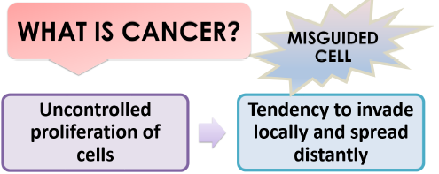
Figure: Image shows definition of cancer

The most common cancer among women is now thought to be breast cancer. There are numerous things that have been recognized as breast cancer risk factors. Some of them include late age at first pregnancy (more than 30 years), having only one kid, and late age at menopause. Additionally recognized as a risk factor is a diet that contains lots of fat. Exercise has been shown to protect against breast cancer. Physical activity has been greatly reduced and the intake of diets high in fat has increased as a result of the abrupt shift to wealthy lifestyle. High fat diets during the pubertal age and obesity in the post menopausal age are risk factors for breast cancer. Breast self-examination by women themselves on a regular basis is an extremely effective way to find breast cancer in its early stages. The chances that breast cancer will be recovered with early cancer detection.
Symptoms and sign of cancer
A person may notice certain warning signs that indicate something is unexpected or distinct from one another. Early cancer symptoms can be quite vague and challenging to diagnose. To help us remember the early warning signs, we might use the phrase CAUTION.
C: A change in bowel habits
A: A wound that won't go away
U: Unusual bleeding from any bodily orifice and unexplained weight
loss
T: Bulging or thickening
I: Discomfort
O: Overt modification of a wart or mole
Nagging cough, shortness of breath, and hoarseness

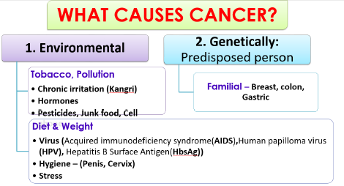
Figure: Image shows causes of cancer.

What is cell
The fundamental structural and functional components of the human body are cells. A human body contains approximately 37.2 trillion cells. Organelles make up a cell. These organelles include the nucleus, which serves as the command and control center of the cell, mitochondria, which is known as the energy source, lysosomes, which serve as the garbage collector for worn-out or damaged cell parts, the golgi apparatus, which uses a mechanism to transport proteins, and endoplasmic reticulum. Reticulum are responsible for producing lipids (fats) and proteins. Cell Membrane is the name of the protective outer layer, and cytoplasm is the term used to describe the jelly-like fluid in which all of these organelles are suspended.
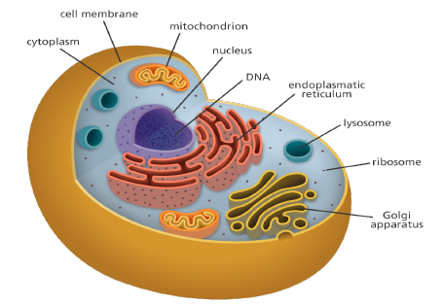
Figure: Image shows Cell.

Cell division and cell death
The life cycle of a cell includes birth, growth, reproduction, and death. The cell further splits into two daughter cells when it reaches the limit of its ability to grow. Cell division is the process in question.
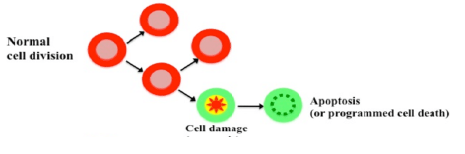
Figure: Image shows cell division and cell death.

New cells of that type T proliferate in their place when damaged or aging cells die. Apoptosis is the name for this mature cell death mechanism.
Cancer cell v/s normal cell
In order to heal damaged tissue or as a result of growth and development (such as during childhood), normal cells expand. A cell's or a group of cells' genes must undergo specific alterations before a tumor can develop. Cancer cells typically develop as a result of a succession of mutations, which alter the genetic sequence. These mutations can either be inherited, or more frequently, they are brought on by carcinogens—substances that cause cancer—in our environment. Some alterations are handled by the body's defense mechanisms. If hazardous external substances such as cigarettes, a high-fat diet, the environment, and/or abnormally fast growth overwhelm them, they become unable to control the development of damaged cells, which is known as a tumor.
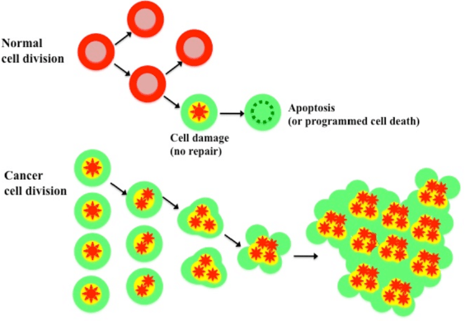
Figure: Image shows cell division and cell death.

Types of tumor
Tumors come in two varieties: benign and malignant. Benign tumors do not penetrate or spread to neighboring tissues. But benign tumors may sometimes be rather big and hefty.
They typically don't grow back after being removed. Malignant tumors, or those that can spread to or infect surrounding tissues, include cancerous tumors. Additionally, when these tumors develop, some cancer cells may separate, move through the blood or lymph system to distant regions of the body, and develop secondary tumors distinct from the first one tumor.
We refer to this process as metastasis.
Metastatic cancer is a type of cancer that has spread from the site of its origin to another location in the body. Metastasis is the process by which cancer cells spread to various organs or tissues inside the body. Additionally, breast cancer can spread to organs like the liver, lungs, and bones that are further removed from the breast. Brain cancer may spread from breast cancer less frequently. Stage IV or metastatic breast cancer is defined as breast cancer that has progressed to a distant site in the body. Even if the cancer has spread, it is still given its original name. For instance, breast cancer that has spread to the lungs is referred to as metastatic breast cancer rather than lung cancer. Breast cancer can be managed or treated, regardless of whether it has spread or how far.
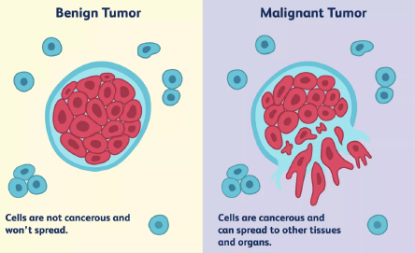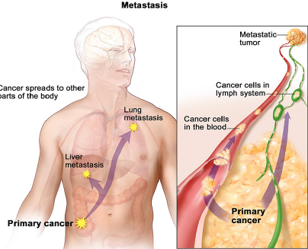
Figure: Image shows benign tumor and malignant tumor & Metastasis.

Risk factor for cancer
Two main classifications can be used to classify cancer risk factors. Modifiable Risk Factors: A person's risk of developing cancer can be affected by their behaviors and environmental exposures. They may theoretically be changed so they are changeable. Example: Alcohol, tobacco, and obesity.
Risk variables that cannot be changed are known as non-modifiable risk factors. Examples include genetics and infections (viruses/microbes).
Breast anatomy
Breast cancer can be invasive or noninvasive. Invasive breast cancer is cancer that spreads into surrounding tissues. Noninvasive breast cancer does not go beyond the milk ducts or lobules in the breast. Most breast cancers start in the ducts, called ductal carcinoma, or in the lobules, called lobular carcinoma. The milk is transported from the lobes to the nipple via tiny ducts that connect the glands, lobules, and lobes. The areola, the darker region that encircles the nipple, contains the nipple in the center. Along with lymphatic and blood veins, the breast is permeable. Cells receive food by blood, while bodily waste is removed by the lymphatic system. The lymph vessels link the small, bean-shaped lymph nodes, helping in the body's defense against infection.
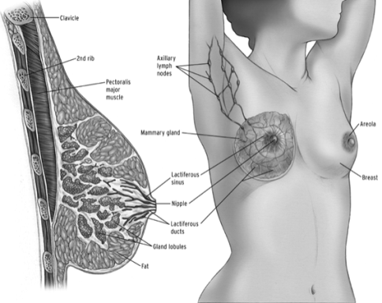
Figure: Image shows Anatomy of Breast.

Mammary Cancer
Breast cancer is a collection of cancerous cells (malignant tumor) that originates from breast cells. Breast cancer is a condition in which tumors are created when aberrant breast cells proliferate uncontrollably.
The tumors have the potential to spread throughout the body and cause death if not treated. The breast's milk ducts and/or milk-producing lobules are where breast cancer cells first appear. The initial form (in situ) doesn't present a danger to life. Breast tissue adjacent may become colonized by cancer cells due to invasion.
Tumors are produced as a result, causing lumps or thickening. Cancers that are invasive can metastatically spread to neighboring lymph nodes or other organs. Metastasis may result in death. Treatment is determined on the patient, the cancer's type, and how far it has spread. Surgery, radiation therapy, and medication are all used in the treatment. Although it can affect both men and women, it mostly affects women. A breast lump or an abnormal mammography are frequently the earliest symptoms of breast cancer. With a range of breast cancer treatments, breast cancer stages can vary from early, treatable breast cancer to metastatic breast cancer.
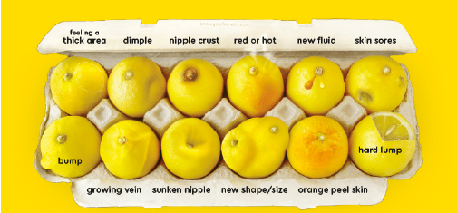
Figure: Image shows abnormal mammogram.

The National Health Mission has offered some recommendations about breast cancer screening. The age range for screening women for breast cancer set by the Indian government is 30-65 years. A medical officer with training will do the clinical breast examination. The target group will be instructed on how to perform a breast self-examination, which they can use as a self-tool to find any abnormalities.
Symptoms and Signs
In the majority of instances, there are no symptoms, however in more advanced stages, following indicators may appear:
A. firm, painless node or lump in the breast or armpit.
b. Swelling and soreness in the breasts.
c. Breast discharge.
d. A change in the breast's size, shape, or appearance, or wrinkling of the breast skin
e. A recently flipped nipple.
f. The skin around the breasts itching, crusting, or scaling.
g. The patient typically has no pain.
h. Having breast lumps does not always indicate the presence of cancer; some lumps develop as a result of cysts or infections.
i. Nipple adjustments
a) Ulceration
b) Pulling back or inverting
c) Uncontrollable discharge
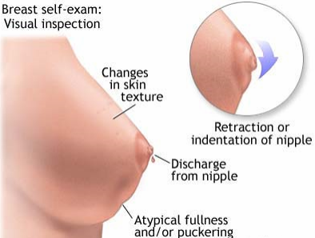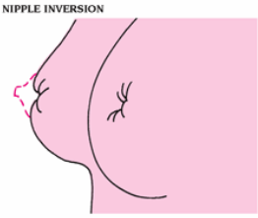
Figure: Image shows Retraction and nipple inversion.

Myths About Breast Cancer
Myth: Teenage girls do not receive Mammary Cancer
Fact: Although it can happen to extremely young women, breast cancer is more likely to affect women over the age of 35.
Myth: Breast cancer always runs in families
Fact: The majority of women with breast cancer are unrelated to anyone who has been diagnosed with them. Only 5–10% of cases have a hereditary component. Even while breast cancer runs in the family, this does not mean that a particular person will develop the disease.

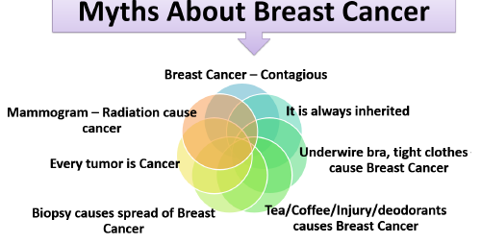
Figure: Image shows Myths about cancer.

Breast cancer types
Invasive or non invasive breast cancer is two types of cancer spread in breast. Breast cancer that has spread to the surrounding tissues is invasive. Breast lobules or milk ducts are the limit of non invasive breast cancer. The majority of breast malignancies, known as ductal carcinoma or lobular carcinoma, begin in the ducts or lobules. When a tumor is removed during a biopsy, a pathologist assesses it is ductal or lobular carcinoma. A pathologist is a medical professional who focuses on analyzing laboratory results and examining cells, tissues, and organs to identify diseases. It is referred to as invasive or infiltrating ductal or lobular carcinoma if the disease has moved outside the duct or lobule and into the surrounding tissue. In situ, which means "in place," is a term for cancer that is solely present in the duct or lobule and is non-invasive. Ductal carcinoma in situ (DCIS) accounts for the majority of in situ breast malignancies. Surgery, radiation therapy, and hormone therapy are frequently used to treat DCIS.
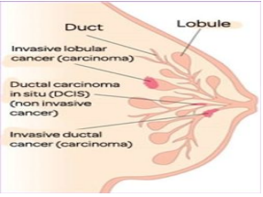
Figure: Image show Invasive and Non- Invasive cancer.
Clinical Breast Examination (CBE):
Both breasts are visually evaluated and palpated in various postures from both sides for the following indications, and if anything suspicious or abnormal is discovered, further study is recommended.
Examining: Any asymmetry in the size and contour of the breasts, changes in the skin, including dimpling, retraction, and ulceration, the level of both nipples, retraction of the nipple(s), and inverted nipples.
Any discharge from the nipple, color of the discharge, lumps, consistency of lumps, swelling in the arm pit (axillary area), above the collar bone (supra clavicular area), and at the base of the neck (infra clavicular area) are all things that can be felt by palpation.
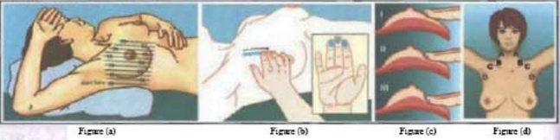
(a) In order to highlight any changes in the breasts, patients should be evaluated while sitting and lying down with their lateral hand overhead. The breast can be centered by placing a small pillow under the shoulder or lower back.
(b) Applying uniform pressure in a vertical strip pattern (Figure a), the finger pads of the middle three fingers should be used to palpate (not compress) the breast in a circular motion.
(c) Pressure on palpation
1. Light pressure for tissue in the superficial layer of the breasts;
2. Medium pressure for the middle layer;
3. and deep pressure for tissue next to the chest wall.
(d) Nodes: A& B - Supra clavicular area; C. Infra clavicular area; D. Axillary area.
Interpretation
Following are some possible interpretations for the CBE results:
1. Negative or normal: No abnormalities upon palpation or ocular inspection.
2. High Risk: According to the screening and care algorithm for breast cancer, benign breast diseases and people with a personal history of breast cancer in the breast or the opposite breast will be placed in the "High Risk Group."
3. Asymmetry is clearly present and can be felt or seen as abnormal. Either probably malignant or probably non-malignant conditions are possible. The patient will be treated in accordance with the screening and management algorithm for breast cancer if there are any discrete hard lumps in the breast, whether or not there are any swellings in the armpit, recent nipple retraction or distortion, skin dimpling or retraction, ulceration, or blood-stained nipple discharge.
Presence of anyone of the signs shall be considered as abnormal.
Probably Malignant | Probably Non Malignant
Discrete hard lump in the breast with or without swelling in the armpit. | Other lumps in the breast
Recent nipple retraction or distortion | Non bloody nipple discharge
Skin dimpling or retraction
Ulceration

Breast Cancer Diagnosis
Breast ultrasound: A device that creates sonograms, or photographs, of specific breast tissues using sound waves.
Diagnostic mammography - Your doctor may recommend a diagnostic mammogram if you have a breast issue, such as lumps, or if a region of the breast seems suspicious on a screening mammogram. This particular X-ray of the breast is more in-depth.
Breast Magnetic Resonance Imaging (MRI): A type of physical examination that involves a magnet and a computer. Areas inside the breast will be captured in fine detail by the MRI scan.
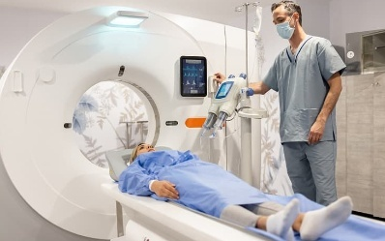
Figure: Image shows Breast magnetic resonance imaging (MRI).
Treatment for Breast Cancer
Doctors specializing in various fields of cancer treatment, such as surgery, radiation oncology, and medical oncology, collaborate with radiologists and pathologists to provide cancer care.
Create an overall treatment plan for a patient that incorporates various sorts of treatments. This is known as a multifunctional team. Other health care professionals on cancer care teams include physician assistants, nurse practitioners, oncology nurses, social workers, pharmacists, genetic counselors, dietitians, therapists, and others. The treatment plan is influenced by the biology and behavior of breast cancer. Some tumors are small but rapidly growing, while others are huge but slowly growing. Treatment options and suggestions are very individualized and are determined by a variety of factors, including:
- The subtype of the tumor, which includes hormone receptor status (ER, PR), HER2 status, and nodal status.
- The cancer's stage
- Age, general health, menopausal status, and preferences of the patient.
- The presence of recognized mutations in hereditary breast cancer genes such as BRCA1 or BRCA2 based on genetic test finding.
The following are the most prevalent therapies for early-stage and locally progressed breast cancer:
a) Surgery;
b) Radiation therapy;
c) Chemotherapy;
d) Hormone therapy;
e) Targeted therapy;
f) Immunotherapy;
g) Neoadjuvant systematic therapy for metastatic breast cancer

Surgery
One of the initial therapies for someone who has been diagnosed with breast cancer that has not progressed throughout the body is frequently surgery to remove the tumor from the breast and/or check the lymph nodes for cancer. The following categories exist:
1. Lumpectomy -This entails the excision of the tumor as well as a thin margin of healthy tissue surrounding it that is cancer-free.
2. Mastectomy – This is when the entire breast is surgically removed. Mastectomies come in a variety of varieties.
Radiation therapy
High-energy x-rays or other particles are used in radiation treatment to kill cancer cells. Radiation oncologists are medical professionals that specialize in administering radiation therapy as a cancer treatment. Radiation therapy comes in a variety of forms:
1. Whole breast irradiation – External beam radiation therapy is used to treat the entire breast in whole breast irradiation.
2. Partial breast irradiation (PBI) is radiation therapy that targets the tumor location specifically rather than the entire breast.
3. Brachytherapy- Radioactive sources are inserted into the tumor during this type of radiation therapy.

Chemotherapy
Chemotherapy is the use of medications to kill cancer cells. Typically, this is done by preventing the cancer cells from proliferating, dividing, and producing new cells. It may be administered before to surgery to minimize the size of a large tumor, facilitate surgery, and/or lower the chance of recurrence. Neoadjuvant chemotherapy is the name for it when it is administered prior to surgery. Additionally, adjuvant chemotherapy, which is administered after surgery to lower the chance of recurrence, may be used.

Hormonal Therapy
Hormonal therapy, commonly known as endocrine therapy, is often advised for persons with ER- or PR-positive breast cancer. Blocking the hormones, either alone or in conjunction with adjuvant or neoadjuvant chemotherapy, can help avoid recurrence and death in these types of cancers since they need hormones to fuel their growth.

Targeted therapy
Targeted therapy is a sort of pharmacological therapy that specifically targets the genes, proteins, or tissue environment that support the growth and survival of the tumour. This form of therapy prevents the development and spread of cancer cells while minimizing harm to healthy cells.

Immunotherapy
Immunotherapy, also called biologic therapy, is designed to boost the body’s natural defenses to fight the cancer. It uses materials made either by the body or in a laboratory to improve, target, or restore immune system function. The following drugs are used for advanced or metastatic breast cancer.

Side Effects
Breast Cancer treatment has many side effects are following-
1. Hair Loss
2. Lymphedema
3. Chemobrain
4. Peripheral neuropathy

References
https://www.cancer.gov/about-cancer/understanding/what-is-cancer
https://www.britannica.com/list/6-cell-organelles
https://www.researchgate.net/figure/Schematic-of-normal-cell-vs-cancer-cell-division-
This-figure-was-redrawn-based-on-the_fig2_307205581
https://www.afro.who.int/news/7-warning-signs-cancer
https://www.webmd.com/cancer/cancer-early-warning-signs#1
https://www.cancer.gov/about-cancer/causes-prevention/risk
cancerindia.org.in › cancer-statistics
https://www.webmd.com/breast-cancer/default.html
https://www.who.int/news-room/fact-sheets/detail/breast-cancer
https://www.moh.gov.sa/en/awarenessplateform/ChronicDisease/Documents/Breast%20Cancer.pdf
https://www.cancer.net/sites/cancer.net/files/asco_answers_guide_breast.pdf
https://www.wbhealth.gov.in/NCD/uploaded_files/all_files/MO_Module_for_PBS_for_NCDs.pdf
https://www.cancer.net/cancer-types/breast-cancer/types-treatment
https://www.cdc.gov/cancer/breast/basic_info/diagnosis.html

