**PHARMACODYNAMICS**

**Rizwan Ahamad1, Asad Ali2, Mohd. Mujeeb3,Abu Safana Biswas4, Mohd Ikhlaq Mir5**

1Department of Pharmacology, School of Pharmaceutical Education and Research, Jamia Hamdard, New Delhi-110062

2Department of Pharmaceutics, School of Pharmaceutical Education and Research, Jamia Hamdard, New Delhi-110062

3Department of Pharmacognosy & Phytochemistry, School of Pharmaceutical Education and Research, Jamia Hamdard, New Delhi-110062

4Department of Pharmacology, JSS College of Pharmacy, Mysore

5Graduate School of Innovative Life Sciences, University of Toyama, Japan

**Abstract**

Pharmacodynamics is a fundamental discipline within the field of pharmacology. The term "it" refers to the concept of pharmacodynamics, which encompasses the physiological and biochemical effects that drugs exert on the human body. This chapter provides a concise and inclusive overview of the pharmacodynamics of drugs and the associations between drugs and biological targets. This text pertains to the fundamental principles underlying the interaction between drugs and receptors. It elucidates key concepts including affinity, efficacy, and the relationships between dose and response. This text elucidates the importance of the receptor, ligand, and dose-response curve. The presence of receptors in the cellular membrane. Receptors are characterized by their glycoprotein composition and possess distinct recognition capabilities. Receptors have the ability to bind with ligands, such as endonuclease and exonuclease molecules, leading to the initiation of biochemical reactions within cells. Ligands can be classified into various categories based on their ability to bind to receptors and the resulting biological responses they elicit. These categories include agonists, partial agonists, inverse agonists, and antagonists. This chapter explores the fundamental principle of pharmacodynamics, specifically focusing on the concepts of dose-response relationships and therapeutic drug monitoring. Healthcare professionals possess the capacity to enhance patient care and facilitate the safe and efficient utilization of medications by applying their expertise.

**Keywords:** Pharmacodynamic, drug-receptor interaction, drug therapy, Therapeutic drug monitoring

1. **Introduction to pharmacodynamics**

Pharmacology refers to study of drugs. The word is a combination of the Greek *Pharmakos* (medicine or drug) and *logos* (study).

Pharmacodynamic is the branch of pharmacology that focuses on understanding how drugs interact with the body and produce their effects. It encompasses the study of drug actions at various levels, including molecular, cellular and systemic levels.

The degree of an organism's reaction as a role in exposure (or dose) to a stressor (often a biochemical) subsequently a dose-response relationship, referred as the exposure-response relationship, describes a particular period of exposure. The Dose-response relationship can be explained by using dose-response curves.

1. **Receptors**

Cell membranes frequently contain receptor-type glycoproteins, which have a particular recognition and binding mechanism for ligands. Some drugs are among these small compounds, which have the ability to 'ligate' themselves to the receptor protein. The receptor protein undergoes conformational changes during the process, thereby initiating a sequence of biochemical reactions within the cell, commonly referred to as "signal transmission."Frequently, these reactions encompass the production of secondary messengers which undergo conversion to biological responses, such as muscle contraction or hormone secretion. Receptors can adjoint with ligands for example neurons, hormones, and growth factors, even if ligands of interest to the prescriber are exogenous molecules (pharmaceuticals). The combination of drug and receptor are generally alterable.

1. **Ligands:**

Drugs are typically thought of as molecules that attach to receptors, and any compounds that do so are typically referred to as ligands (for example, drugs). Typically, a ligand is thought to be minor than a receptor in size. Receptor binding: Clark (1926) originally proposed the idea of drug-receptor binding. Ariens and De Groot (1954) and Stephenson (1956) expanded on Clark's occupancy theory, which later served as the basis for the study of PDs.

**Theory of receptor binding:** The models are built on the basis of receptor binding theory that utilized to characterize the PD connection. According to the classical receptor theory, reversible receptor binding causes a cascade of biochemical and physiological alterations that lead to the drug's apparent effects. The drug achieves its maximum effectiveness when all receptors bind with ligands. According to the Michaelis-Menten equation, drug binding to receptors is essentially the same as drug binding to enzymes.

Michaelis-Menten equation**-**

Bmax x [L]

[L] + Kd

Bound =

Vmax x [S]

[S] + Km

V0 =

Where,

L= concentration of the ligand, S= concentration of the substrate, V0 = initial reaction velocity,

Vmax= maximum rate, L= concentration of the ligand, Kd= dissociation constant, and Km= is the Michaelis-Menten constant of the substrate.

In general, investigations of ligand-receptor binding experiments are commonly conducted utilizing the conventional law of mass action model:

Simple binding reaction (reversible)-

koff





kon

### Where, the reaction apparatuses can effortlessly verbose throughout the medium and [R], [L], and [RL] denoted unrestricted concentration of the receptor, ligand, and receptor-ligand complexes. The association and dissociation rates of the ligand receptor complexare kon and koff respectively. After separation, the receptor and the ligand are presumed to be unchanged.

**Applications of ligand binding models in clinical pharmacology include:**

* Arrangement of interrelating components from various ligands with various binding receptor locations can be explained by ligand binding models.
* Although ligand binding models can be used to describe the dynamics of binding (association and dissociation), it is more typical to talk about binding at equilibrium.
* NTs (such as acetylcholine) and radio-immunoassays can be used in an experimental setting to measure the receptor binding qualities for illness conditions.
* To determine the binding locations of receptors, ligand binding models are helpful during the drug development procedure.
* To show numerous binding positions and receptors at once, ligand binding models are helpful.
* For comparing the attractions of numerous ligands for the similar receptor, ligand binding models are also highly helpful.

**Overview of type of receptor an modes of action:**

|  |  |  |
| --- | --- | --- |
| Drug targets | Description | Examples |
| *Receptors* | | |
| [**Channel-linked receptors**](http://www.guidetopharmacology.org/GRAC/FamilyDisplayForward?familyId=697&familyType=IC) | -Ligands connected toion channel.  -channel is activated  -cell membrane becomes permeable.  -Unlike"voltage-gated" channels, which reciprocate to variations in membrane potential, these channels are "ligand-gated," meaning that receptor interaction activates them. | [Nicotinic acetylcholine receptors](http://www.guidetopharmacology.org/GRAC/FamilyDisplayForward?familyId=76), GABA receptors |
| [**G-Protein coupled receptors**](http://www.guidetopharmacology.org/GRAC/ReceptorFamiliesForward?type=GPCR) | -Signal transduction is facilitated by a group of closely related proteins known as "G proteins,"  -it plays a crucial role in connecting receptor binding to the activation of intracellular enzymes or the opening of ion channels.  -Linked to intracellular effector mechanisms. | [mAch receptors](http://www.guidetopharmacology.org/GRAC/FamilyDisplayForward?familyId=2),  β-[Adrenoceptors](http://www.guidetopharmacology.org/GRAC/FamilyDisplayForward?familyId=4" \t "_blank),  [Dopamine receptors](http://www.guidetopharmacology.org/GRAC/FamilyDisplayForward?familyId=20), and  [5-HT (Serotonin) receptors](http://www.guidetopharmacology.org/GRAC/FamilyDisplayForward?familyId=1) |
| **Kinase-linked receptors** | The linkage between them is a direct association with an intracellular protein kinase, initiating a cascade of phosphorylation events. | [Insulin receptors](http://www.guidetopharmacology.org/GRAC/FamilyDisplayForward?familyId=321) |
| [Nuclear hormone receptors](http://www.guidetopharmacology.org/GRAC/ReceptorFamiliesForward?type=NHR) | Intracellular referred as the 'nuclear receptors’ It may take hours or days for a ligand to bind in order to have a biological effect, but it can also encourage or hinder the creation of new proteins. | [Steroid hormone receptors](http://www.guidetopharmacology.org/GRAC/FamilyDisplayForward?familyId=107&familyType=NHR),  [Thyroid hormone receptors](http://www.guidetopharmacology.org/GRAC/FamilyDisplayForward?familyId=84), and  [Vit. D receptors](http://www.guidetopharmacology.org/GRAC/FamilyDisplayForward?familyId=90) |
| Other targets | | |
| [**Voltage-sensitive ion channels**](http://www.guidetopharmacology.org/GRAC/FamilyDisplayForward?familyId=696&familyType=IC) | A target for medications that can obstacle the channel or otherwise delay with conductance, it is present in excitable tissues. | Local anaesthetics like lidocaine that block Na+ channels |
| [**Enzymes**](http://www.guidetopharmacology.org/GRAC/ReceptorFamiliesForward?type=ENZYME) | Drugs can change  co-factors needed by an  enzyme for effectivity or enzyme active site. Active locations are typically inhibited by competition, while it occasionally happens to be enduring and efficiently unalterable (as in the case with aspirin). | Inhibitors of cyclooxygenase such as aspirin,  Inhibitors of ACE such as enalapril, and xanthine oxidase such as allopurinol |
| [**Transporter proteins**](http://www.guidetopharmacology.org/GRAC/ReceptorFamiliesForward?type=TRANSPORTER) | -The phenomenon of substance exchange, co-transport of multiple substances in the same way, or the active transport of a solo chemical into or out of a cells are all instances of bidirectional movement.  -Pharmaceutical substances have the potential to function as "false substrates," thereby obstructing the movement of the typical biological substrate, or they can influence transporters to hinder their functionality. | SSRIs, such as fluoxetine |
| **Cell adhesion-proteins** | Type-1 membrane glycoproteins function as transmembrane linkers that facilitate the connection between ligands present on the outer surface of the cell and the act in cytoskeleton. These glycoproteins play a crucial role in facilitating cell-cell and cell-matrix adhesion. | Leukocytes have two integrins that are necessary for efficient immune responses. GPCRs of the adhesion class. Cadherins like E-cadherin are necessary for tissue morphogenesis and endothelial cell-cell interaction during embryonic development. |

**Agonist, Antagonists, Partial agonists and Inverse agonist**

Receptor ligands can be differentiated based on their capacity to elicit a biological response upon binding to receptors:

* **Agonist:** A substance which can bind with a receptor, activates it, and triggers a biological reaction is called an agonist. Agonists, specifically a full agonist, exhibits fundamental activity. For example, Morphine effectively emulates the activity of endorphins at opioid receptors, thereby classifying Morphine as an Agonist.
* **Antagonist:** An antagonist is a substance which can bind and block the effectivity of receptor, resulting in the inhibiting to produce any biological response. Acetylcholine (Ach) is inhibited by ex-atropine at the mAChR (muscarinic acetylcholine receptor).
* **Partial agonist:** An agonist that is not accomplished to produce a maximal response referred as a partial agonist. Such as [acebutolol](https://www.sciencedirect.com/topics/pharmacology-toxicology-and-pharmaceutical-science/acebutolol" \o "Learn more about acebutolol from ScienceDirect's AI-generated Topic Pages), [oxprenolol](https://www.sciencedirect.com/topics/pharmacology-toxicology-and-pharmaceutical-science/oxprenolol" \o "Learn more about oxprenolol from ScienceDirect's AI-generated Topic Pages), [pindolol](https://www.sciencedirect.com/topics/pharmacology-toxicology-and-pharmaceutical-science/pindolol" \o "Learn more about pindolol from ScienceDirect's AI-generated Topic Pages), and xamoterol, produce less resting bradycardia.
* **Inverse agonist:** Inverse agonists exert the opposite effect of agonists. For example, Flumazenil elicit an anxiogenic effect at the GABA (Gamma-Aminobutyric Acid) receptor.

**Types of antagonist drugs:**

There are three main types of antagonist drugs-

1. **Competitive Antagonists**

These medications bind to the receptor's binding site and block the natural ligand from binding. A competitive antagonist's form resembles that of the natural ligand. The action of a competitive antagonist can be quiet; however, uncertainty the ordinary ligand's concentration rises. A natural ligand like morphine or heroin cannot attach to the opioid receptor because naloxone, an antagonist that competes with it, is present. The competitive antagonist naltrexone, which is also used to treat opiate addiction, is another excellent illustration.

1. **Non-competitive Antagonists**

An allosteric site, which differs from the actual binding site, is where a non-competitive antagonist binds. The non-competitive antagonist binds to the receptor, changing its conformation (or shape), preventing the normal ligand from binding. Ketamine act as non-competitive antagonist for the NDMA receptor and is used as an anaesthetic. The activity of the non-competitive antagonist cannot be blocked by the amount of agonist existing, which is the distinction between competitive and non-competitive antagonists.

1. **Irreversible Antagonists**

Irreversible antagonists are bind with receptor with strong covalent connections and are incapable to be wash awayor else displace it e.g. Other 1 antagonists are reversible, however phenoxybenzamine is an irreversible antagonist of 1 receptors. The 1 and 2 receptors are both antagonistic by phentolamine. Presynaptic noradrenaline release is increased due to antagonism of presynaptic 2 receptors, which in turn stimulates the heart.

1. **Ion channels**

Protein complexes called ion channels make holes in cell membranes so that ions can pass through their hydrophobic centers. They are a component of the plasma membrane of every cell as well as the membranes lining intracellular organelles. They perform important physiological functions such as establishing and modulation of the electrical signals that underlie muscle contraction and relaxation as well as neuronal signal transmission, releasing neurotransmitters, improving cognition, secreting hormones, transmitting sensory information, and controlling blood pressure and electrolyte balance. Gating, or the mechanical or chemical stimulus that "opens" the channel, is the traditional classification method.

Most of the Na+, K+, Ca2+, and some Cl-channels are voltage-sensitive, but some K+ and Cl-channels, TRP channels, ryanodine receptors, and IP3 receptors are usually voltage-sensitive, and are gated by second messengers, intracellular, or extracellular mediators.

* **Ligand gated ion channels**

Ligand-gated ion channels (LGICs) facilitate the passive ion flux that is operateby the permeant ions' electrochemical gradient. When a particular ligand binds to an orthosteric site or sites, it causes a conformational shift that leads to the conducting state. LGICs can also be gated by the binding of endogenous or exogenous modulators to allosteric sites. Fast synaptic transmission in the neurological system and at the somatic neuromuscular junction is simplified by LGICs.

This class of receptors includes inhibitory, ion-selective GABAA and glycine receptors, excitatory, cation-selective, nAch, 5-HT3, ion-tropic glutamate (NMDA, AMPA, and kainate receptors) and P2X receptors. It also includes acid sensors (proton gates).

**Fear conditioning, memory consolidation, and pain perception include acid sensing ion channels (ASIC). NMDA receptor antagonists primarily inhibit the NMDA glutamate receptor. Examples include the anaesthetic ketamine, the commonly used OTC cough suppressant dextromethorphan, the PCP phencyclidine, and nitrous oxide. By way of CYP2D6, dextromethorphan is converted to the NMDA antagonist dextrorphan. Because of their psychoactive and dissociative properties, several medications in this class are taken recreationally.**

* **Voltage gated ion channels**

Voltage-gated ion channels (VGICs) are essential for the proper operation of excitable cells like neurons and muscle cells because they respond to changes in the local electrical membrane potential. Each of the four main physiological ions (Na+, K+, Ca2+ and Cl-VGICs) has a distinct channel that selects the ion. Every channel type consists of multiple subunits that are encoded by different genes varying subunit combinations have varying voltage dependency and cellular localization in various tissues. Some VGICs, like the CatSper Ca channels, which are solely expressed in the main portion of the sperm tail, are extremely localized.

* **Other ion channels**

**Enzymes:** Proteins known as enzymes serve as catalysts to speed up the transformation of substrates into products. The Nomenclature Committee of the International Union of Biochemistry and Molecular Biology (NC-IUBMB) has created an enzyme categorization system that groups enzymes into six major families:

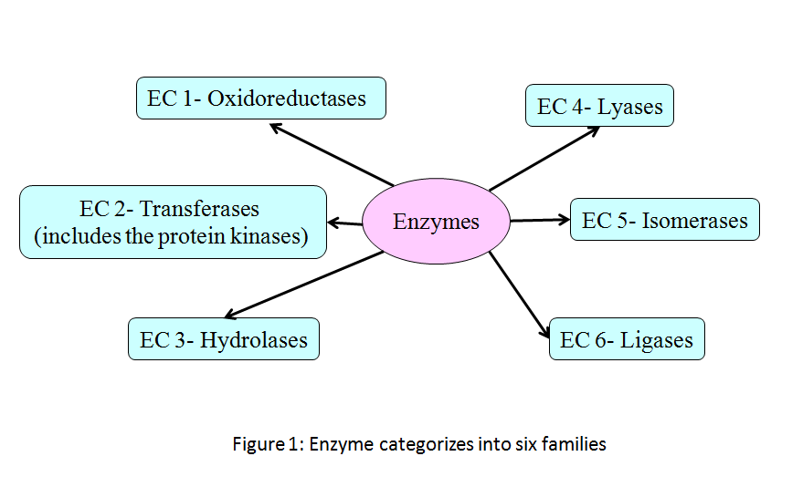

Figure 1: Enzymes categories into six major families

* **Cyclooxygenase inhibitors**

Non-steroidal anti-inflammatory medications (NSAIDs) called cycloxygenase (COX) inhibitors are used in clinical settings to treat fever and pain, including that brought on by headaches, colds, the flu, and arthritis. NSAIDs are sold both over-the-counter (OTC) and via prescription.

COX inhibitors exert their effect one or both of the isozymes, [COX-1](http://www.guidetopharmacology.org/GRAC/ObjectDisplayForward?objectId=1375&familyId=269&familyType=ENZYME) and [COX-2](http://www.guidetopharmacology.org/GRAC/ObjectDisplayForward?objectId=1376&familyId=269&familyType=ENZYME).

COX-1 takes involved in the production of the prostaglandins required for the upkeep and defence of the gastrointestinal tract, whereas COX-2 creates the pro-inflammatory prostaglandins in charge of inflammation and pain.

* **Phosphodiesterase inhibitors**:

The enzymes phosphate deoxidase (PDEs) destroy the second messengers of intracellular adenosine monophosphate (cAMP) and guanosine monophosphate (cGMP). Phosphodiesterases come in a wide variety of subtypes, and the inhibitory profiles of these inhibitors can either be non-specific or selective.

**Selective PDE inhibitors**

* **PDE3 inhibitors:**Cardiovascular drugs, such as Milinone, Enoximone, and Inamilinone, called PDE3 inhibitors, are used to treat congestive heart failure. Selective PDE3 inhibitors include clostazol used to treat sporadic leukemia, and anagrelide used to treat essential thrombocytoma.
* **PDE4 inhibitors:** PDE4 roflumilast and apremilast inhibitors have anti-inflammatory effects and are used to treat inflammatory arthritis, chronic obstructive pulmonary disease (COPD) and asthma, respectively. PDE4 inhibitors inhibit the release of cytokines and other inflammatory signals and have anti-inflammatory effects.
* **PDE5 inhibitors:** PDE5 inhibitors such as Sildenafil, Tadalafil, Vadenafil, and the most recent drug, Avanafil, specifically block PDE5 expressed in soft muscle cells surrounding the blood vessels of the corpus cavernosum and other tissues. PDE5 is a selective cGMP phosphodiesterase. The main purpose of these drugs is to treat erectile dysfunction. Some of these drugs are also effective in treating benign prostate hyperplasia (BPH) and arterial hypertension (PAH).
* **Dihydrofolate reductase inhibitors:** The production of folate (folic acid), required for rapid dividing cells to produce thymine for DNA synthesis, is reduced by dihydrofolate reductase inhibitors (DHFR). For example, antimicrobial drugs such as pyrimamine and proguanil, antibiotic trimethoprim are used to treat UTIs caused by streptococcus pneumoniae, haemophilus influenzae, and PCPs (formerly pneumocystis jirovecii, Pneumocystis carinii).
* **Kinase inhibitors:** Proteins and lipid kinases are essential targets for treating human diseases because abnormal activity is the root cause of cancer, inflammation, diabetes, infectious diseases, cardiovascular disease, etc. Currently, there are more than 35 small molecule protein kinase inhibitors with international human approval.
* **Drug metabolizing enzymes:** In humans, cytochrome P450 enzymes serve as the principal xenobiotic inactivators, responsible for the metabolism of drugs and other substances through Phase I oxidative processes. The mono-oxygenases of the CYP1, CYP2, and CYP3 families are the primary CYP450 enzymes tangled in drug metabolism.CYP3A4 is the most commonly encountered and versatile cytochrome P450 enzyme involved in the process of drug metabolism. The majority of medications are deactivated by CYP3A4, whereas some are bioactivated to create their active molecules. Patients should be informed of the dangers of consuming grapefruit, pomegranate, and other fruit juices while using sensitive medications since these juices block the enzyme CYP3A4.

**Examples of certain CYP450 enzymes process drugs-**

|  |  |
| --- | --- |
| **Enzyme isoform** | **Drug metabolized** |
| [CYP1A2](https://www.guidetopharmacology.org/GRAC/ObjectDisplayForward?objectId=1319) | [caffeine](https://www.guidetopharmacology.org/GRAC/LigandDisplayForward?ligandId=407), and [nicotine](https://www.guidetopharmacology.org/GRAC/LigandDisplayForward?ligandId=2585) |
| [CYP2A6](https://www.guidetopharmacology.org/GRAC/ObjectDisplayForward?objectId=1321) | [5-fluorouracil](https://www.guidetopharmacology.org/GRAC/LigandDisplayForward?ligandId=4789), and coumarin |
| [CYP2B6](https://www.guidetopharmacology.org/GRAC/ObjectDisplayForward?objectId=1324) | [cyclophosphamide](https://www.guidetopharmacology.org/GRAC/LigandDisplayForward?ligandId=7154) and propofol |
| [CYP2C8](https://www.guidetopharmacology.org/GRAC/ObjectDisplayForward?objectId=1325) | [phenytoin](https://www.guidetopharmacology.org/GRAC/LigandDisplayForward?ligandId=2624), [warfarin](https://www.guidetopharmacology.org/GRAC/LigandDisplayForward?ligandId=6853), and [paclitaxel](https://www.guidetopharmacology.org/GRAC/LigandDisplayForward?ligandId=2770) |
| [CYP2C9](https://www.guidetopharmacology.org/GRAC/ObjectDisplayForward?objectId=1326) | NSAIDs, sulfonylureas, and [cabozantinib](https://www.guidetopharmacology.org/GRAC/LigandDisplayForward?tab=summary&ligandId=5887) (less contribution) |
| [CYP2C19](https://www.guidetopharmacology.org/GRAC/FamilyDisplayForward?familyId=262#1328) | [omeprazole](https://www.guidetopharmacology.org/GRAC/LigandDisplayForward?ligandId=4279), [codeine](https://www.guidetopharmacology.org/GRAC/LigandDisplayForward?ligandId=1673), and TCAs |
| [CYP2D6](https://www.guidetopharmacology.org/GRAC/ObjectDisplayForward?objectId=1329) | some antipsychotics(*Ex- risperidone, haloperidol*) and some antiarrythmics (*Ex- flecainide, propafenone*) |
| [CYP2E1](https://www.guidetopharmacology.org/GRAC/ObjectDisplayForward?objectId=1330) | [paracetamol](https://www.guidetopharmacology.org/GRAC/LigandDisplayForward?ligandId=5239), [triazolam](https://www.guidetopharmacology.org/GRAC/LigandDisplayForward?ligandId=7313) and [midazolam](https://www.guidetopharmacology.org/GRAC/LigandDisplayForward?ligandId=3342) |
| [CYP3A4](https://www.guidetopharmacology.org/GRAC/ObjectDisplayForward?objectId=1337) | [erythromycin](https://www.guidetopharmacology.org/GRAC/LigandDisplayForward?ligandId=1456), CCBs (Ex-*[diltiazem](https://www.guidetopharmacology.org/GRAC/LigandDisplayForward?ligandId=2298" \t "_blank), [verapamil](https://www.guidetopharmacology.org/GRAC/LigandDisplayForward?ligandId=2406" \t "_blank), and nifedipine*)  many chemotherapeutics (Ex- *[paclitaxel](https://www.guidetopharmacology.org/GRAC/LigandDisplayForward?ligandId=2770" \t "_blank) and*[*doxorubicin*](https://www.guidetopharmacology.org/GRAC/LigandDisplayForward?ligandId=7069))  some protein kinase inhibitors (Ex-  *[imatinib](https://www.guidetopharmacology.org/GRAC/LigandDisplayForward?ligandId=5687" \t "_blank), and [sunitinib](https://www.guidetopharmacology.org/GRAC/LigandDisplayForward?ligandId=5713" \t "_blank)*)  PDE5 inhibitors (*Ex-* [*sildenafil*](https://www.guidetopharmacology.org/GRAC/LigandDisplayForward?ligandId=4743)*and [tadalafil](https://www.guidetopharmacology.org/GRAC/LigandDisplayForward?ligandId=7299" \t "_blank)*) |

1. **Dose- response relationship:**

Whether an effect is brought on by binding or a chemical reaction depends on how much drugs are present at the location.

Dose-response data are displayed with the dose or dose function (such as log10 dose) on x-axis and the measured effect (response) on the y-axis. When an effect peaks or when things are in a constant state (as during an IV infusion), calculated effects are typically recorded as being at their maximum.

The following characteristics of a hypothetical dose-response curve vary (figure 2)-

• Potency (where the curve is on the dose axis)

• Maximum effectiveness or ceiling effect (highest possible response)

• Slope (variation in reaction with dose);

In the same population, biologic variation—variation in the strength of the reaction among test subjects—occurs as well. It is possible to compare the pharmacologic profiles of different medications by graphing their dose-response curves (figure 3). This knowledge aids in calculating the dosage required to produce the desired result. The dose-response principle, which includes the pharmacokinetics and pharmacodynamics ideas, establishes the dosage and frequency of a medication in a population. A tool for evaluating a drug's effectiveness and safety is the therapeutic index, which is calculated as the ratio of the median effective concentration to the least hazardous concentration. When the dosage of a drug with a low therapeutic index is raised, the risk of toxicity or drug inefficiency rises. The patient-specific factors including age, pregnancy, and organ function (such as estimated GFR) can affect these features since they differ by population and are patient-specific.

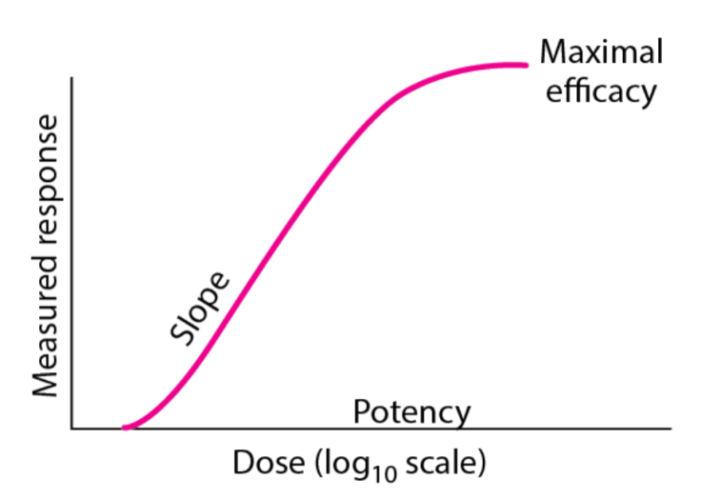

Figure 2: Dose response curve

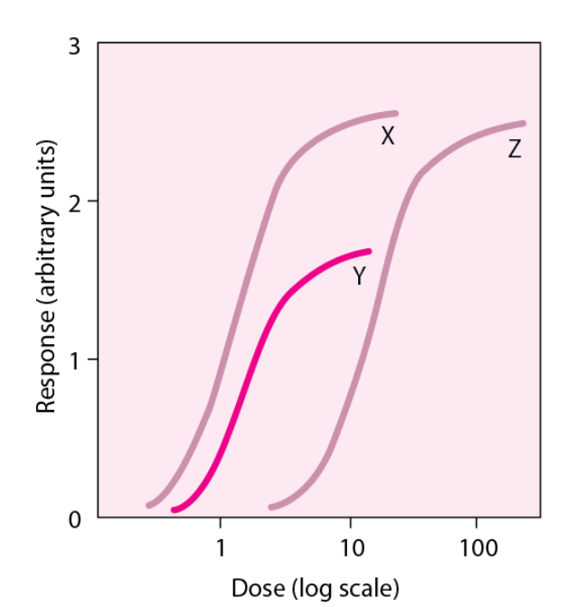

Figure 3: Comparison of dose response curve Drug X is more potent than drugs Y or Z because it has more biologic activity when compared to dosage equivalents. Indicated by their maximum possible response (ceiling effect), drugs X and Z are equally effective. Drug Y has a higher potency than Drug Z, but a lower maximum efficacy.

* **Therapeutic index (TI):** The therapeutic index contrasts the therapeutic efficacy of a therapeutic agent with the amount that results in toxicity or death. The TI in animal study is calculated by separating the minimal effective dose for 50% of the community by the lethal dose of a medicine for 50% of the community.
* **Therapeutic window (or Pharmaceutical window):**

The range of pharmacological dosages that, while remaining within the safety range, can successfully cure disease is known as a medicine's therapeutic window (or pharmaceutical window). The range of pharmaceutical dosages between that which has an effect (effective dose) and that which produces more unintended effects than intended effects. Compared to either the therapeutic index or the protective index, this index is thought to be more trustworthy.

* **Certain Safety Factor:** The fatal dosage to 1% of the community divided by the active dose to 99% of the community is known as the Certain Safety Factor (LD1/ED99). For substances that have both desirable and unpleasant effects, this safety index is superior to the LD50 since it takes into account the extremes of the spectrum, where levels may be required to elicit a reaction in one person but may be fatal in another at the same dose.

**Certain Safety Factor= LD1/ED99**

* **Protective index:** The quantity of a therapeutic agent has a therapeutic impact is compared to the quantity which has a harmful effect. In terms of numbers, it is the result of dividing toxic dose by the therapeutic dose. The toxic dose of a medication for 50% of the population (TD50) separated by the minimal effective dose for 50% of the population (ED50) results in a protective index. The therapeutic index is comparable to the protective index, although the latter is concerned with toxicity (TD50) as opposed to lethality (LD50)

**Protective Index= TD50/ED50**

1. **Therapeutic drug monitoring**

Therapeutic drug monitoring is the process of using assay techniques to measure drug concentrations in plasma and interpreting and applying the concentration data gotten to generate treatment schedules that are both harmless and effective. If executed properly, this strategy allows for the faster and safer attainment of therapeutic drug concentrations than empiric dose increases. Therapeutic monitoring using drug concentration data is valuable when:

* The pharmacologic reaction and plasma concentration exhibit a strong connection. The intensity of pharmacologic effects should rise with plasma concentration throughout at least a small concentration range. We can forecast pharmacologic effects with changing plasma drug concentrations because to this relationship (Figure 4).
* A given dose causes significant inter-subject variability in plasma drug concentrations.
* The medication has a close relationship between its therapeutic and toxic concentrations, or narrow therapeutic index.
* Other straightforward methods, such blood pressure monitoring for antihypertensives, cannot easily assess the drug's desired pharmacologic effects.

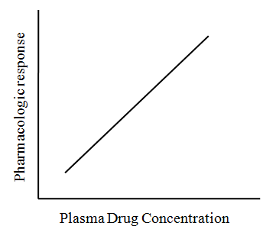

Plasma drug concentration

Figure 4: When plasma drug concentrations and pharmacologic effects are connected, the latter can be utilised to anticipate the former.

Therapeutic drug monitoring has limited utility in the following circumstances:

* The therapeutic plasma concentration range is not clearly defined.
* If metabolite concentrations are not taken into account, the application of plasma drug concentration data to clinical effect is complicated by the synthesis of pharmacologically active metabolites of a drug.
* Both high and unexpectedly low medication concentrations have the latent to reason lethal significances.
* Too high or too low quantities don't have any obvious effects.

**Conclusion**

* Healthcare professionals must possess a comprehensive understanding of pharmacodynamics in order to effectively optimize drug therapy, enhance efficacy, and mitigate adverse effects.
* The fundamental principle of pharmacodynamics, dose-response relationships, and therapeutic drug monitoring. Healthcare providers have the ability to improve patient care and promote the safe and effective utilization of medications through the application of their knowledge.

**Bibiliography:**

1. <https://www.ncbi.nlm.nih.gov/books/NBK554403/>
2. <https://bpspubs.onlinelibrary.wiley.com/doi/abs/10.1111/j.1476-5381.1977.tb07532.x>
3. <https://www.researchgate.net/publication/244874517_Receptors_agonists_and_antagonists>
4. Sharma A, Jusko WJ. Characteristics of indirect pharmacodynamic models and applications to clinical drug responses. Br J Clin Pharmacol. 1998 Mar;45(3):229-39. [[PMC free article](https://www.ncbi.nlm.nih.gov/pmc/articles/PMC1873365/)] [[PubMed](https://pubmed.ncbi.nlm.nih.gov/9517366)]
5. [Drug–Receptor Interactions - Clinical Pharmacology - MSD Manual Professional Edition (msdmanuals.com)](https://www.msdmanuals.com/professional/clinical-pharmacology/pharmacodynamics/drug%E2%80%93receptor-interactions)
6. Berg JM, Tymoczko JL, Stryer L. The Michaelis-Menten model accounts for the kinetic properties of many enzymes. Biochemistry. 2002;5:319-30.