ARTIFICIAL INTELLIGENCE AND BIOINFORMATICS: FUTURISTIC TRENDS IN BIOTECHNOLOGY TO ENSURE FOOD SECURITY
Vividha Sirsat, Dinkar T Deshmukh, Pravin Vishwanathrao Jadhav, Umesh Dnyanewshwar Shinde and Sayali Magar
Biotechnology Centre, Department of Agricultural Botany, Dr. Panjabrao Deshmukh Krishi Vidyapeeth, Akola,Maharashtra, State, India.
Email: vividhasirsat@gmail.com
Abstract
In the revenue-generating sector, agriculture is important. The primary issue among them that is currently gaining attention globally is the technological advancement of agriculture.As a result of the population boom, there is a huge increase in the need for food security. The farmers employment of traditional methods was insufficient to meet these demands. Improved automated techniques were consequently introduced. These innovative techniques supplied the world's food needs while simultaneously giving billions of people access to livelihoods.Therefore, technologies based on artificial intelligence (AI) have been effective in reducing resource consumption, increasing safety and transparency while also increasing food production and quality, and eliminating food waste.Unexpected new possibilities are possible when biotechnology and AI advancements are coupled.For the purpose of finding the genome and the variations within it, which might ultimately be employed to genetically modify crops in the future, bioinformatics and artificial intelligence may be implemented. The agriculture system of today has developed to a new level as a result of AI. Artificial intelligence has improved agricultural surveillance, generation, picking, processing, and commercialization in the actual time. The development of numerous technologically advanced electronic devices that can identify various vital components, such as weed recognition, productivity being identified, crop performance, and variety of others contributed towards the launch of these platforms. When artificial intelligence is implemented in the field of agriculture, socioeconomic values will improve, that may encourage farmers to accept and trust it.
Keywords: Agriculture, Artificial intelligence(AI), Bioinformatics, Technology, Food security.

I. Introduction
A subfield of computer science called artificial intelligence (AI) is primarily focused on automating intelligent behaviour. We can consider this behaviour in all spheres, including that of people, animals, and plants. While some researchers believe that the objective of AI is to create intelligence without taking any human qualities into account, many researchers believe that the purpose of AI is to mimic human cognition. Many other researchers believe that AI should not be judged by an abstract idea of intelligence but rather should be used to develop useful artefacts for human comfort and wants [1].The aim of AI research is to discover ideas concerning knowledge representation, studying, rule-based structures, and search that may be employed to explain different types of intelligence. The study of artificial intelligence has deep roots across many conventional subjects and cannot be found in an empty space. These roots are: Philosophy, Mathematics/Logic, Computing, Cognitive science/ Psychology, Biology/Neuroscience and Evolution. Every organisation now needs to embrace AI approaches in order to continue to be competitive in the market. Numerous organisations prefer to disclose the actual AI methods they employ. In computer science, the gathering of computer scientists had served as the catalyst for the development of artificial intelligence and the development of smart robots has a long history, yet the phrase artificial intelligence defies an explicit meaning, and even determining cognitive ability is tricky. [2,3,4]. This field has been divided into two unique sections in order to comprehend the specific procedures for managing the scientific data: algorithmic learning and advanced learning. The key differences between these terminologies are-
1. Artificial intelligence which at first serves as a generic phrase and a broad discipline, is the construction of smart machines that are suited to performing tasks that would typically require intelligence from individuals, such as acquiring knowledge, resolving issues, and their choices.
2. Algorithmic learning is concerned with instructing digital machines to perform operations requiring particular commands by drawing on trends and conclusions from data.
3. Neural networks made up of computers with numerous levels are used in advance learning to gain knowledge and make predictions. It is in particular helpful for assignments requiring the analysis of large amounts of data, such as those involving the use of spoken linguistics and computation in order to generate between people. chats or the creation of photographic images from spoken languages.
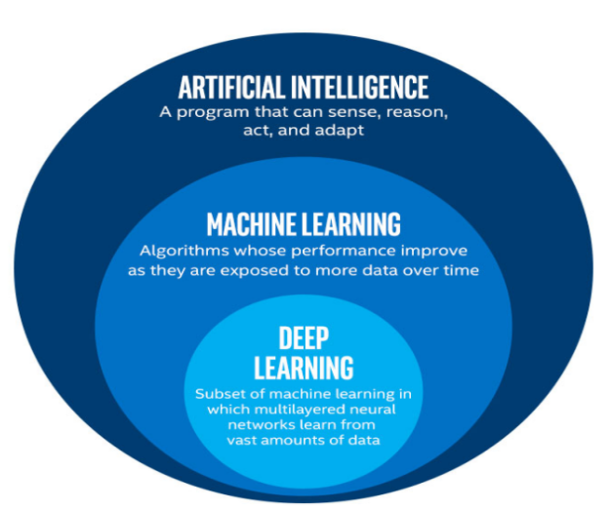
Fig 1. Sub-fields of AI.
Today, AI has been separated under multiple sub-fields that incorporate a wide range of techniques, including the following and are given under fig 1(a).
1. Extraction of information, automatic translation, question-and-answering, and summarization are all examples of natural language processing.
2. Health care solving problems, systems that support decisions, and educational systems are examples of engineering and expert systems.
3. Object verification, picture understanding, smart management, and independent research are all examples of machine vision and robotics.
4. Speech processing consists of the analysis of speech, its production, computerised negotiation, and its user interface.
5. Decision tree modelling and version field intelligence are examples of machine learning
6. Time-series data estimation, categorization, computational genetics, and brain simulation are examples of evolutionary and genetic models.
7. For fuzzy controls, use fuzzy systems.
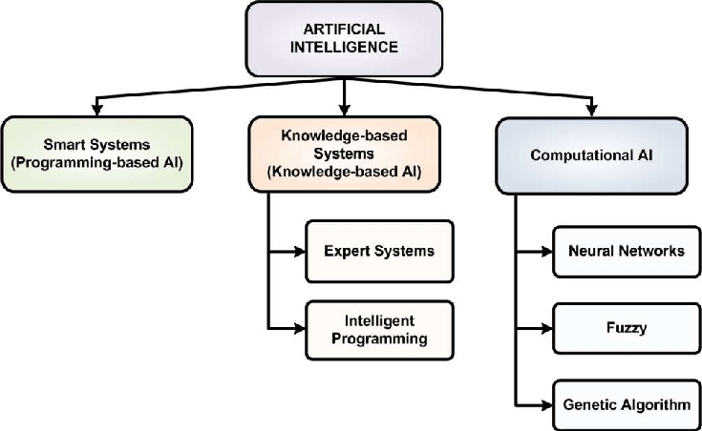
Fig 1(a)Techniques in Artificial Intelligence.
I(a). Artificial intelligence in Agriculture: Overview

Agriculture is crucial for India. The country contains the second-largest area of arable land in the globe, and around half of its population depends on agriculture for a living. India's agricultural system is somehow critical not only for the country but also for the rest of the world because it is an important supplier of goods including rice, wheat, cotton, sugar, and dairy. However, there are significant problems with India's agricultural sector. For India's 1.4 billion people to continue to be fed, crop productivity must increase. Our agricultural systems are disrupted by climate change, while at the same time; unsustainable farming methods contribute significantly to greenhouse gas emissions, water use, and deforestation. Global agricultural and environmental systems are in danger if nothing changes. The access to enough nutritious food to meet human needs is referred to as having "food security[5].Global food insecurity had already been on the rise, primarily as a result of climate change. The effects of worldwide rising on weather patterns include scorching temperatures, prolonged rainfall, and dry spell. Increasing nutritional price tags in 2021 significantly contributed to the estimated thirty thousand thousand individuals in nations with lower incomes encountering food scarcity.. As climate change effects worsen, growers need detailed real-time data to determine exactly how and when to treat their crops. Six factors constitute the structure for nourishment and food security: supply, usage, equilibrium, agency, and durability (fig 2). Brief examples of AI for ensuring food security are :
1. The detection of numerous infectious diseases[6] as well as some non transmissible diseases have all been accomplished by focusing on pathogen control while managing the cultivation of seeds of Solanum tyberosum by using ES system.
2. Synthetic networks made up of computers [7] are employed for examining maize and soybean productivity for the purpose to figure out whether or not the model's accuracy is able to contrast data at various levels using multiple models of independent variables.
3. In order to compare and manage tomatoes that have been harmed by illnesses [8]of fungal diseases, the study used nearly ultraviolet spectrum and a neural network algorithm. By employing a computerized algorithm, between 80 and 96 percent of the tomatoes that were damaged were found.
4. By incorporating different kinds of linear regression and neutral networks, two distinct algorithms[9] have been used to forecast the production rate of the rice crop under various environmental circumstances. The trails were held in several locales. In the meanwhile, the data were gathered and analyzed using two algorithms, and the investigation demonstrated that neutral networks' predictions were more accurate than those of the competition.
5. Fuzzy logic, a theoretical notion in computational artificial intelligence, was used to study how parasites and prey communicate in G. max[10].
6. The two systems effectiveness in weed categorization was assessed for site-dependent herbicide. Thus, for the mapping of weed genera in various crop species, recent methods in knowledge based artificial intelligence and computational intelligence were compared. [11].
7. Additional modifications [12] to the laser machine and the use of computer intelligence to make the equipment even more accurate made it feasible to develop the land.
8. Through the use of computer simulations, these elements may be noticed for particularly setting the harvest [13]. However, for realistic production forecasts in crops, certain AI-related models need their participation in order to assess the other aspects that are important for fluctuating output.
9. For the purpose of identifying pests and illnesses[14]among various crops, a novel computational AI methodology was applied. This model makes use of its expertise and tailors its analysis to the particular crop.
10. Different artificial intelligence techniques were used to examine how P. vulgaris spp. has heightened and maintained its productivity rate [15].
11. Production of dairy products and their byproducts is one of the primary components of today's agricultural sectors, based on dairy science [16]. By introducing novel instruments for maintaining surveillance on it, fresh algorithms have recently been put to use to determine and control the dairy product output.
12. Numerous computational techniques have been used by the food processing industry to preserve and enhance the products while keeping in huge depots [17, 18].
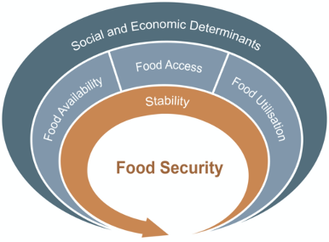
Fig 2. AI for food security.

Since only 4% more land can be converted to cultivation by 2050, the rise in population places more strain on arable land [19]. An increasing population, increasing lifestyles, an inadequate supply of natural resources, worldwide warming up and fluctuations in the environment are thought to have already made ensuring food security more difficult [20]. The vast requirement of the expanding population cannot be adequately satisfied by current cultivating practices. This forces farmers and agricultural enterprises to come up with fresh ideas for raising productivity and cutting waste. Food assurance challenges have gotten worse as a result of a recent upsurge popularity for biofuel produce, which has opened up a new market for food products. To address these issues, a variety of genetic applications have provided numerous opportunities to combine the benefits of components in order biological processes, integrated biology, and massive amounts structured functional genomics initiatives with the introduction of artificial intelligence in the development of technology to improve the methods to determine agricultural results and rates, adaptive sprinkling, forecasting perspectives, farm machines, field and land evaluation, and pathogen diagnostics[21,22]. Additionally, computational biology provides a substantial power on the advancement of the farming sector, agricultural-based enterprises, the application of farmed residues, and improved ecological administration. By giving researchers access to the genomic data, bioinformatics keeps advancing biology significantly as the number of sequencing initiatives rises. [20].

(b) Artificial intelligence in Biotechnology
Biotechnology already makes extensive use of artificial intelligence (AI) to address a range of issues. These includes, pharmacology [23], functional and structural genomics [24, 25], proteomics [26, 27], metabolomics [28], drug discovery [29], drug safety[30]and pharmacogenomics. Large databases are already maintained by biotechnology firms and other medical organisations globally. Drug manufacture, chemical analysis of diverse chemicals, nucleotide sequencing, biocatalyst investigations, and other biological processes with a similar workflow all need substantial support from AI software programmes to proceed quicker along with reduced manual errors. One aspect of the digital transformation process might be the use of novel approaches and innovations to improve technological advancement research and development's effectiveness, reliability, and pace. This approach also makes it possible to create brand-new, disruptive goods and services.
(c) AI: Agricultural biotechnology developments of late
(i) Accelerating the pace of plant breeding with artificial intelligence (AI)
‘Plant omics’ research has seen a technological uptick that has increased the accumulation of complicated datasets.Understanding these intricate datasets' precise meaning is crucial for identifying crop plants that exhibit a particular characteristic.Furthermore, MAS and GWAS approaches thoroughly examine plant genotypes and phenotypes combined with transcriptomics and proteomics studies. Consequently, this part provides important information about artificial intelligence and machine learning in plant breeding. The availability of insightful prototype and persuading algorithms in breeders databases will open up the possibility of using high throughput sequencing artificial intelligence for plant hybrids [31]. For the aim of studying massive biological processes, Intelligence in genetics can additionally include data from the fields of genome research and multi-omics approches characteristics controlling how plants grow and develop in response to triggers from the environment, comprehensive knowledge of genetic design, and demonstrating the site of genes regulating vital economic phenotypes. A summary of the possible use of artificial intelligence to boost plant breeding techniques for quick, accurate, and early genotype/parental combination prediction for varietal development is described in figure 4.
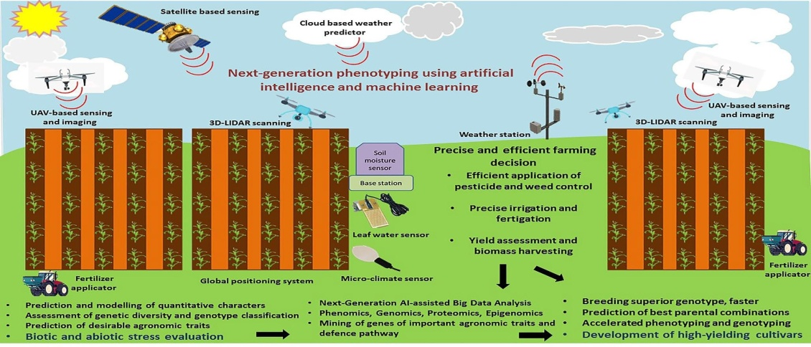
Fig 4. Application of AI in strengthening plant breeding

The agribusiness corporations are introducing self-sufficient micro machines leveraging various prototypes that can carry out ordinary job more quickly and accurately than regular individuals. The data collected by drones is processed and analysed using DL algorithms. ML algorithms assist in monitoring and forecasting a variety of environmental changes, such as weather changes that affect crop productivity. The field of smart agriculture is likewise being greatly impacted by digital revolution [31]. A healthy, nutrient-dense cycle is essential for the effective, fruitful, and long-term production of crops and cattle in agriculture. The emphasis is shifting to improving the nutrient cycle in addition to preserving, such as for regulatory monitoring. Artificial intelligence in farming can assist in addressing the issue of nutrition by adapting management production to a shifting climate. This entails figuring out which crops are more resilient to changes in the climate. The stress physiology of crops impacted by groundwater and inadequate nutrients can be directly addressed by approaches surpassing those now used in agriculture. The phenotypic analysis has become popular in recent decades to get around these problems[32,34,35] It is also possible to apply technologies like biomass estimate, crop type categorization, and soil characteristic mapping to find new crop phenotypes that are more resource-efficient and resilient to climatically unpredictable situations. It is vital that plant breeding initiatives include cover natural defence systems of crops since climate change goes hand in hand with growing pressure from pests and diseases. It is essential that programmes for plant breeding also take into account the natural defence systems of crops, including their wild cousins, because a changing climate goes hand in hand with an increase in the pressure from pests and diseases. Although droughts and other extreme weather conditions, as well as climate change, seriously affect plant health and have a negative impact on food production (yield potential and stability), identification of effective natural defence mechanisms is urgently needed. The development of novel plant types has been sped up by AI technology, from high-throughput genomics and phenomics to sophisticated breeding[36,37]. Marker-assisted selection, genomic selection, and genomic prediction have all seen an increase in the usage of machine learning techniques. To analyse massive data and enhance data interpretation for climate change consequences, new imaging technologies linked with AI are at the crossroads[38]. Therefore, recent advances in plant phenomics have opened the door for precision breeding. Three crucial facets of phenomic data management involve the use of AI: algorithms and software to transform sensory data into phenotypic information; model development to comprehend genotype-phenotype relationships with environmental interactions; and database management to facilitate the sharing of knowledge and resources [39]. The phenotyping of crops using AI has improved crop phenotyping and predictions, according to recent studies. For example:- 1. Wheat and maize have both effectively used AI-assisted high-throughput phenotyping systems to determine the plant growth stage and segmenting plant images [40,41], an increase in plant productivity[42], Oil seed crops as a basis for semantic crop and weed categorization [43] etc.
Therefore, some initiatives have been taken in plant breeding discipline via AI/machine learning to study its traits function. Various successful examples have been setup under table 6.
(ii) AI Advances helping in plant tissue culture -Micro propagation is based on plant tissue culture, which is further dependent on a stem cell's totipotency, or capacity to differentiate into any type of cell. In this procedure, plants are cultivated in containers with culture media made from various explants. Growth promoters and nutrients are included in this in vitro culture. The word "micro propagation" refers to the lesser growth of seedlings when in vitro compared to those in vivo. One of the most important technologies for crop species propagation and breeding is in vitro culture, which allows for a variety of methods which includes shoot multiplication or the creation of plants from cells and tissues through the development of embryos that are somatic or adventitious shoots. Because the specific nutrient requirements of various plant cells and tissues vary depending on the species of plant, improving culture media is a time-consuming process that requires a vast array of media formulations [44]. In this scenario, artificial intelligence models are very helpful in resolving the issue of complicated interactions with many aspects of in vitro culture, which cannot be resolved with an irrational number of treatments and classical statistics. Artificial intelligence models alongwith other systems are broadly employed in different fields of technology and science and have recently been applied to improve different stages of plant regeneration. The usefulness of the application of advanced intelligence technology has been demonstrated in the prediction and optimization of overall segments of mini regenerating parts, in hairy root culture, and optimization of environmental conditions to achieve maximum productivity and efficiency, as well as classification of different regenerating explants.
(d)AI-based crop genome-phenome linking- Modern breeding strategies concentrate on precisely and accurately tying the genotype to the crop phenotype. It is extremely difficult to relate the entirety of the genome's information to high-throughput phenotypes in advanced breeding, which hinders the best use of fieldwork phenotyping and omics. Such resources as crop phenotypic diversity, SNP polymorphisms, GWAS analysis, genome sequence, genomic selection and QTL analysis may all be integrated into the enormous comprehensive database using AI technology. Artificial intelligence (AI) technologies are used to anticipate crop phenotypes using whole genome predictions. New breeding techniques are created using AI-related computation and model training[45,46].
(e) AI and IoT(Internet of things) for crop diseases detection- Due to the numerous pathogens that are prevalent in their environment, crops are very susceptible to various diseases. Most of the mentioned disease pathogens are bacterial or fungal species, while others are viral. The productivity of crops can be reduced by 10% to 95% by illnesses [47]. Hence, early illness detection is essential to prevent severe losses and to cut down on pesticide overuse, which may be harmful to both people and the environment. Most of the time, particularly in poor nations and on small farms, farmers can identify crop illnesses just by looking at their physical signs. This is a tiresome procedure that necessitates extensive treatment time and plant pathology expertise. In order to meet growing consumer demands and reduce the negative environmental effects of chemical inputs on both human health and the environment, researchers are motivated to develop technological proposals for the early identification of crop diseases in a precise, quick, and reliable manner. Both direct and indirect strategies have been suggested to automate the illness identification process. Direct approaches include molecular and serological techniques, which offer precise and direct detection of the pathogens causing the disease[48]. However, these techniques require an extended period to collect, process, and evaluate the samples they need. Optical imaging techniques, in contrast, are among the indirect approaches that can spot diseases and forecast the health of the crop based on multiple variables like morphological shifts and temperature. Some of the most prominent indirect techniques to identify early disease comprise fluorescence and hyperspectral imaging [49]. Despite the fact that hyperspectral captures are a useful data source and provide more information than typical images. Yet, due to their capacity to dependably learn and distinguish visual information, deep learning and transfer learning methods in agriculture have achieved widespread success and produced very promising results throughout the previous decade [50]. The different Artificial Intelligence algorithms/ techniques used in identification of crop diseases are described below in table 1.

Table1. Identification of Crops Diseases by using AI.
Artificial Intelligence models | Crops | Disease identification | References
CNN model via. Deep learning | Cereal crops | Yellow rust | Nigam et al. (2019)[51]
ConvNet (Deep Learning) | Tomato | Leaf Diseases | Belal A.M et al. (2019)[52]
Support Vector Machine, Deep Learning | Corn | Rust, Round Spot, Dwarf Mosaic etc. | Zhang et al.(2018)[53]
Deep Learning | Potato | Black Dot Disease, Scab Patch, Scruf Patch | D. Oppenheim  1†  and G. Shan  D. Oppenheim  1†  and G. Shan  Oppenheim D et al.(2017)[54]
Deep Learning | Rice | Leaf Blight, Rice Blast etc. | Yao Q et al. (2009)[55]

(f) AI in bioinformatics- Beyond all projections, bioinformatics resources have developed breakthrough nutritional genomics biotechnology tools to genetically edit and improve the food supply for an increasing world population. Consequently, bioinformatics may now be utilised to speed up the application of basic research to agriculture. The growth of the agriculture industry, agro-based businesses, the use of agricultural byproducts, and better environmental management all benefit from bioinformatics. Two subfields of bioinfomatics exist i.e., the creation of computational tools and databases, and the use of these tools and databases to produce biological knowledge to comprehend living systems. A large part of effectively analysing agricultural data is bioinformatics because there are many various forms of agricultural data and a large amount of them, making their interpretation challenging. In order to produce stronger disease and pest resistant crops as well as healthier, more drought resistant and more productive livestock, plant genetic resources must be effectively collected, managed, and exploited in bioinformatics. Artificial intelligence is used in bioinformatics to match genetic sequencing, structure of proteins, and gene therapy for clinical studies [57]. Methods based on artificial intelligence can be used to handle a wide range of complicated biological systems challenges. Artificial intelligence is a widely used concept in computational molecular biology and bioinformatics research today [58]. The investigation and prediction of gene or protein structure, pattern recognition analysis, extraction of knowledge from biological data, Prediction of medication development and design Algorithms based on artificial intelligence used to store biological data. Because of the success of AI in bioinformatics, many different biological problems have been solved using algorithms and methodologies such as artificial neural networks, statistical approach, tree-based decisions, cellular automata, combination methods, and algorithms based on genetics [59].
(f)(1)AI in multi-omics: Due to the massive extent of large-scale information multi-omics system biology, which includes programmes, records, and approaches, must be used for multi-omics integration.(fig3). Recently, adopting organized multi-omics integration, it have been possible to comprehensively ingest, highlight, and predict these immense data sets.
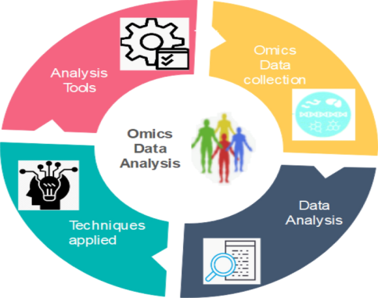

Fig 3. Omics data workflow

In order to uncover the functional links between these data and omics datasets, computational approaches have been extensively implemented. Due to the features of multi-omics data, such as its tremendous scale, excessive dimension, considerable vibration, and large variability, additional applications or programmes must be developed for uncovering discoveries in plant modification. Multi-omics data will be studied in a more scientific and coordinated strategy for faster progress of crops. As omics and other artificial intelligence methods are combined with the use of informatics software to expedite the breeding process, our understanding of agricultural precision breeding will deepen and broaden. By integrating the omics data concurrently and reducing false-positive outcomes we must utilize previous information.
(g) Artificial intelligence in genome editing- The essential difference between genome editing and traditional one is that the former genuinely depends on natural mechanisms. Yet this greatly reduces the unpredictability of the alteration procedure. The majority of GM goods, whether they are crops or livestock, have had a synthetic genetics or a genetic code from another living thing injected into them. For instance, a gene found in insect-resistant maize or cotton developed in a bacterium. A plant is more amenable to change, the less optimum it is. Therefore, genome editing offers an ideal chance for older various types that haven't been mass-produced or commercially developed. By the use of various algorithms of AI technology, it is now able to understand the NDA data more precisely than handled by the humans. A startup is researching strategies that will boost crop yield while tackling sustainability concerns.

II Future of AI/Bioinformatics in agriculture

Precision farming powered by AI will spread more widely in the near future as farmers look to boost yields and save expenses. Early pest and disease detection and targeted treatment will be made possible by machines. Based on information about the weather and the state of the soil, AI will also assist farmers in optimizing irrigation schedules. Early pest and illness detection will be possible thanks to machines, which will also allow for targeted treatment. On the basis of meteorological and soil data, AI will also assist farmers in optimising irrigation schedules. Recently, scientists have started to look into how GBPA (Genome -based precision agriculture) might support farmers all around the world. This method has been shown to increase wheat's ability to withstand drought in a study that was published in the journal Nature Plants in 2019. The study discovered that the adoption of precision farming based on genomics increased crop yields by up to 20%.The application of GBPA to lessen the need for fertilizer is being investigated by other researchers. Researchers showed that utilizing precision farming based on genetics can reduce fertilizer inputs by up to 40% while maintaining yields in an investigation published in the Agronomy Journal. As a result, agriculture may have a substantially smaller negative influence on the environment. Around the world, bioinformatics is revolutionizing farming methods and sustainable agriculture. With the help of this technology, farmers and academics may come up with creative answers to the problems facing agriculture, increasing productivity and durability. We can anticipate seeing even more advancements in environmentally friendly farming and crop production as technology develops.

III Conclusion

Without concerted action to support food security, there is a risk that climate change may cause severe food shortages and widen the wealth and health gap worldwide. The cultivation of better crops could be accelerated thanks to developments in genetics artificial intelligence and bioinformatics, increasing global food security in the face of climate change. The execution of technological ideas is still insufficient despite the fact that the food sector is one of the most significant sectors in many economies around the world. This is primarily because of the non-uniformity of the agricultural systems around the world as well as the small margin of food items that are unsupported towards larger investments, a shortage of skilled staff, and a lack of devices. Before deploying any technology-based solution, it must be thoroughly examined and the investments need to be prioritized in order to prevent loss or a drop in revenues from the introduction of novel methods to maintain the normal operation of the food system. We require more potent processing capabilities, better data collection techniques, and superior algorithms. But if we can overcome these challenges, agriculture's future appears to be very bright.

References

[1] Chowdhary, K. R. (2020). Introducing Artificial Intelligence. Fundamentals of Artificial Intelligence, 1–23. doi:10.1007/978-81-322-3972-7_1

[2]Turing AM. Computing machinery and intelligence. Mind 1950;59(236):433–60. https://doi.org/10.1093/mind/LIX.236.433. [3] Holzinger A, Kickmeier-Rust M, Müller H. Kandinsky patterns as IQ-test for machine learning. Lecture Notes in Computer Science LNCS 11713. Cham:
[4] McCarthy J, Minsky ML, Rochester N, Shannon CE. A proposal for the dartmouth summer research project on artificial intelligence, August 31, 1955. AI Mag 2006; 27(4):12–4. https://doi.org/10.1609/aimag.v27i4.1904
[5] Ejemeyovwi, J.O.; Osabohien, R.; Adeleye, B.N.; De Alwis, T. Household ICT Utilization and Food Security Nexus in Nigeria. Int. J. Food Sci. 2021, 2021, 1–10. [Google Scholar] [CrossRef] [PubMed]
[6] Boyd D. and Sun M. (1994). Prototyping an expert system for diagnosis of potato diseases. Computers and electronics in agriculture. 10(3): 259-267
[7] Kaul M., Hill R.L. and Walthall C. (2005). Artificial neural networks for corn and soybean yield prediction. Agricultural Systems. 85(1): 1-18
[8] Hahn F., Lopez I. and Hernandez G. (2004). Spectral detection and neural network discrimination of Rhizopus stolonifer spores on red tomatoes. Biosystems Engineering. 89(1): 93-99
[9] Ji B., Sun Y., Yang S. and Wan J. (2007). Artificial neural networks for rice yield prediction in mountainous regions. The Journal of Agricultural Science. 145(3): 249
[10] Peixoto M.S., Barros L.C., Bassanezi R.C. and Fernandes O.A. (2015). An approach via fuzzy systems for dynamics and control of the soybean aphid. In 2015 Conference of the International Fuzzy Systems Association and the European Society for Fuzzy Logic and Technology (IFSA-EUSFLAT-15). Atlantis Press
[11] Eddy P., Smith A., Hill B., Peddle D., Coburn C. and Blackshaw R. (2008). Hybrid segmentation–artificial neural network classification of high-resolution hyperspectral imagery for site-specific herbicide management in agriculture. Photogrammetric Engineering & Remote Sensing. 74(10): 1249-1257
[12] Si Y., Liu G., Lin J., Lv Q. and Juan F. (2007). Design of control system of laser leveling machine based on fussy control theory. In International Conference on Computer and Computing Technologies in Agriculture. Springer, Boston, MA. 1121-1127
[13] Zhang J., Wang Y., Li J. and Yang P. (2008). A neural network model for predicting cotton yields. International federation for information processing-publications-ifip. 259: 1321-1322
[14] Kolhe S., Kamal R., Saini H.S. and Gupta G. (2011). A web-based intelligent disease-diagnosis system using a new fuzzy-logic based approach for drawing the inferences in crops. Computers and electronics in agriculture. 76(1): 16-27
[15] Correa A.M., Teodoro P.E., Gonçalves M.C., Barroso L.M.A., Nascimento M., Santos A. and Torres F.E. (2016). Artificial intelligence in the selection of common bean genotypes with high phenotypic stability. Genet. Mol. Res. 15(10.4238)
[16] Yan W.J., Chen X., Akcan O., Lim J. and Yang D. (2015). Big data analytics for empowering milk yield prediction in dairy supply chains. In 2015 IEEE International Conference on Big Data (Big Data). IEEE: 2132-2137
[17]Morimoto T., Suzuki J. and Hashimoto Y. (1997). Optimization of a fuzzy controller for fruit storage using neural networks and genetic algorithms. Engineering Applications of Artificial Intelligence. 10(5): 453-461
[18] Gottschalk K., Nagy L. and Farkas I. (2003). Improved climate control for potato stores by fuzzy controllers. Computers and electronics in agriculture. 40(1-3): 127-140
[19]Ryan, M. (2022) The social and ethical impacts of artificial intelligence in agriculture: mapping the agricultural AI literature. AI & Soc. Published online January 3, 2022. http://doi.org/10.1007/ s00146-021-01377-9
[20] Ujjawal Kumar Singh Kushwaha, Indra Deo, Jai Prakash Jaiswal & Birendra Prasad. Role of Bioinformatics in Crop Improvement. Global Journal of Science Frontier Research: D Agriculture and Veterinary Volume 17 Issue 1 Version 1.0 Year 2017. Online ISSN: 2249-4626 & Print ISSN: 0975-5896
[21] Eli-Chukwu, N.C. (2019) Applications of artificial intelligence in agriculture: a review. Eng. Technol. Appl. Sci. Res. 9, 4377–4383
[22] Smith, M.J. (2019) Getting value from artificial intelligence in agriculture. Anim. Prod. Sci. 60, 46–54
[23] Van der Lee M, Swen JJ. Artificial intelligence in pharmacology research and practice. Clin Transl Sci 2023;16(1):31–6. https://doi.org/10.1111/cts.13431.
[24] Caudai C, Galizia A, Geraci F, et al. AI applications in functional genomics. Comput Struct Biotechnol J 2021;19:5762–90. https://doi.org/10.1016/j. csbj.2021.10.009.
[25] Lin J, Ngiam KY. How data science and AI-based technologies impact genomics. Singap Med J 2023;64(1):59–66. https://doi.org/10.4103/singaporemedj.SMJ- 2021-438
[26] Xiao Q, Zhang F, Xu L, et al. High-throughput proteomics and AI for cancer biomarker discovery. Adv Drug Deliv Rev 2021;176:113844. https://doi.org/ 10.1016/j.addr.2021.113844.
[27]Mund A, Coscia F, Hollandi R, et al. AI-driven Deep Visual Proteomics defines cell identity and heterogeneity. BioRxiv 2021. https://doi.org/10.1101/ 2021.01.25.427969
[28]Petrick LM, Shomron N. AI/ML-driven advances in untargeted metabolomics and exposomics for biomedical applications. Cell Rep Phys Sci 2022;3:7. https://doi. org/10.1016/j.xcrp.2022.100978.
[29]David L, Thakkar A, Mercado R, Engkvist O. Molecular representations in AI-driven drug discovery: a review and practical guide. J Chemin- 2020;12(1):1–22. https:// doi.org/10.1186/s13321-020-00460-5.
[30]Diaw MD, Papelier S, Durand-Salmon A, Felblinger J, Oster J. AI-assisted QT measurements for highly automated drug safety studies. IEEE Trans Biomed Eng 2022. https://doi.org/10.1109/TBME.2022.3221339.
[31]Harfouche A.L., Jacobson D.A., Kainer D., Romero J.C., Harfouche A.H., Mugnozza G.S., Moshelion M., Tuskan G.A., Keurentjes J.J.B., Altman A. Accelerating climate resilient plant breeding by applying next-generation artificialintelligence. TrendsBiotechnol. 2019;37:12171235.doi: 10.1016/j.tibtech.2019.05.007
[32]Holzinger A, Saranti A, Angerschmid A, et al. Digital transformation in smart farm and forest operations needs human-centered ai: challenges and future directions. Sensors 2022;22(8):3043. https://doi.org/10.3390/s22083043
[33]Barnes ML, Breshears DD, Law DJ, et al. Beyond greenness: detecting temporal changes in photosynthetic capacity with hyperspectral reflectance data. PLoS One 2017;12(12):e0189539. https://doi.org/10.1371/journal.pone.0189539
[34]Fiorani F, Schurr U. Future scenarios for plant phenotyping. Annu Rev Plant Biol 2013;64:267–91. https://doi.org/10.1146/annurev-arplant-050312-120137.
[35]Holzinger A, Haibe-Kains B, Jurisica I. Why imaging data alone is not enough: AI-based integration of imaging, omics, and clinical data. Eur J Nucl Med Mol Imaging 2019;46(13):2722–30. https://doi.org/10.1007/s00259-019-04382-9
[36] Esposito S., Carputo D., Cardi T., Tripodi P. Applications and trends of machine learning in genomics and phenomics for next-generationbreeding. Plants. 2020;9:34. doi: 10.3390/plants9010034.
[37]Reinoso-Peláez E.L., Gianola D., González-Recio O. Genome-enabled prediction methods based on machine learning. In: Ahmadi N., Bartholomé J., editors. Genomic Prediction of Complex Traits. Volume 2467. Humana; New York, NY, USA: 2022.
[38] Ribaut J, De Vicente M, Delannay X. Molecular breeding in developing countries: challenges and perspectives. Curr Opin Plant Biol 2010;13(2):213–8. https://doi. org/10.1016/j.pbi.2009.12.011
[39] Nabwire S., Suh H.K., Kim M.S., Baek I., Cho B.K. Review: Application of Artificial Intelligence in Phenomics. Sensors. 2021;21:4363. doi: 10.3390/s21134363.
[40] Sadeghi-Tehran P., Sabermanesh K., Virlet N., Hawkesford M.J. Automated method to determine two critical growth stages of wheat: Heading and flowering. Front. Plant Sci. 2017;8:252. doi: 10.3389/fpls.2017.00252.
[41]Brichet N., Fournier C., Turc O., Strauss O., Artzet S., Pradal C., Welcker C., Tardieu F., Cabrera-Bosquet L. A robot-assisted imaging pipeline for tracking the growths of maize ear and silks in a high-throughput phenotyping platform. Plant Methods. 2017;13:96. doi: 10.1186/s13007-017-0246-7.
[42]Mochida K., Koda S., Inoue K., Hirayama T., Tanaka S., Nishii R., Melgani F. Computer vision-based phenotyping for improvement of plant productivity: A machine learning perspective. GigaScience. 2019;8:giy153. doi: 10.1093/gigascience/giy153.
[43] Abdalla A., Cen H., Wan L., Rashid R., Weng H., Zhou W., He Y. Fine-tuning convolutional neural network with transfer learning for semantic segmentation of ground-level oilseed rape images in a field with high weed pressure. Comput. Electron. Agric. 2019;167:105091. doi: 10.1016/j.compag.2019.105091.
[44] Hesami M, Jones AMP. Application of artificial intelligence models and optimization algorithms in plant cell and tissue culture. Appl Microbiol Biotechnol 2020;104:9449–85. https://doi.org/10.1007/s00253-020-10888-2.
[45]Caudai C., Galizia A., Geraci F., Le Pera L., Morea V., Salerno E., Via A., Colombo T. AI applications in functional genomics. Comput. Struct. Biotechnol. J. 2021;19:5762–5790. doi: 10.1016/j.csbj.2021.10.009.
[46]Wang H., Cimen E., Singh N., Buckler E. Deep learning for plant genomics and crop improvement. Curr. Opin. Plant Biol. 2020;54:34–41
[47] Shirahatti, J.; Patil, R.; Akulwar, P. A survey paper on plant disease identification using machine learning approach. In Proceedings of the 2018 3rd International Conference on Communication and Electronics Systems (ICCES), Coimbatore, India, 15–16 October 2018; pp. 1171–1174.
[48] Lacomme, C.; Holmes, R.; Evans, F. Molecular and serological methods for the diagnosis of viruses in potato tubers. In Plant Pathology; Springer: Berlin/Heidelberg, Germany, 2015; pp. 161–176.
[49] Bauriegel, E.; Herppich, W.B. Hyperspectral and chlorophyll fluorescence imaging for early detection of plant diseases, with special reference to Fusarium spec. infections on wheat. Agriculture 2014, 4, 32–57.
[50]Orchi, H.; Sadik, M.; Khaldoun, M. On Using Artificial Intelligence and the Internet of Things for Crop Disease Detection: A Contemporary Survey. Agriculture 2022, 12, 9. https://doi.org/10.3390/ agriculture12010009
[51] Upadhyaya S, Arora A and Jain R. 2006. Rough set based cluster analysis for soybean disease diagnosis. (In) Proceeding of International Conference on Statistics and Informatics in Agricultural Research, New Delhi, December.
[52] Belal A M Ashqar and Samy S. Abu-Naser. Image-Based Tomato Leaves Diseases Detection Using Deep Learning. International Journal of Engineering Research 2019, 2(12):10-16

[53] Zhang Xihai, Yue Qiao, Fanfeng Meng, Chengguo Fan , Mingming Zhang(2018). Identification of Maize Leaf Diseases Using Improved Deep Convolutional Neural Networks. Digital Object Identifier 10.1109/IEEE ACCESS.2017.Doi Number
[54] Oppenheim D and Shani G. 2017. Potato disease classification using convolution neural networks. Advances in Animal Biosciences 8(2): 244–9.
[55] Yao Q, Guan Z, Zhou Y, Tang J, Hu Y and Yang B. 2009. Application of support vector machine for detecting rice diseases using shape and colour texture features. (In) International Conference on Engineering Computation, IEEE
[57] Su T, Basu M, Toure A (2002) Multi-domain gating network for classification of cancer cells using gene expression data. In: Proceedings of the International Joint Conference on Neural Networks (IJCNN’02), Honolulu, Hawaii, pp 286–289
[58]Shepherd A (1999) Protein secondary structure prediction with neural networks: A tutorial. Available from http://www.biochem.ucl.ac.uk/~shepherd/sspred_tutorial/ss-index.html
[59]Singh, V., & Kumar, A. (Eds.). (2021). Advances in Bioinformatics. doi:10.1007/978-981-33-6191-1

.

