PLANNING OF MOBILITY AND PARKING SERVICES FOR MIT ADT UNIVERSITY CAMPUS, PUNE

Sourabh S. Chougule
Department of Civil Engineering, MIT SOE, Loni Kalbhor, Pune, 412201, Maharashtra, India.
Email: er.sourabhsc@gmail.com
Satish B. Patil
Department of Civil Engineering, MIT SOE, Loni Kalbhor, Pune, 412201, Maharashtra, India.
Email: satish.patil@mituniversity.edu.in
Rajshekhar G. Rathod
Department of Civil Engineering, MIT SOE, Loni Kalbhor, Pune, 412201, Maharashtra, India.
Email: rajshekhar.rathod@mituniversity.edu.in

Abstract
This research study delves into the issues of traffic congestion and parking management within the campus of MIT ADT University in Pune, Maharashtra, India. With the growing population, the study focuses on investigating the causes of congestion and other challenges faced by the campus. To gather relevant data, three surveys were conducted as part of the research project. These surveys included a traffic volume survey, an origin-destination survey, and a parking survey. By collecting data on traffic patterns, parking utilization, and vehicle movement, valuable insights were obtained. This data formed the basis for identifying key issues, such as bottlenecks and inadequate intersection design contributing to traffic congestion, as well as parking difficulties near specific buildings due to limited spaces. The study proposes recommendations to address these concerns, encompassing measures to alleviate bottleneck congestion, implement traffic channelizing techniques, consider lane expansion, improve parking design and management, enhance signage and wayfinding systems, and promote sustainable transportation practices. Regular surveys are suggested to monitor the effectiveness of the implemented solutions. By implementing these recommendations, campus authorities can improve traffic management, reduce congestion, and enhance parking facilities, thus improving the overall campus environment.
Keywords: Traffic Planning, Parking Planning, Traffic Congestion, Bottleneck Congestion, Campus Planning.

INTRODUCTION
Traffic planning and parking management in universities play a crucial role in maintaining efficient transportation systems on campus. With a large number of students, faculty, staff, and visitors commuting to universities daily, it is essential to develop comprehensive strategies to alleviate traffic congestion, provide convenient parking options, and promote sustainable modes of transportation. Effective traffic planning and parking management not only enhance the overall mobility experience but also contribute to the safety and well-being of the university community. Traffic planning in universities involves analyzing traffic patterns, identifying bottlenecks, and developing strategies to improve circulation. It aims to minimize congestion, reduce travel times, enhance safety, and promote sustainable transportation options. Effective traffic planning ensures that students, faculty, and staff can commute to and from the university efficiently, reducing frustration and stress associated with traffic congestion.
Campus roads are vital pathways that connect different facilities and individuals within educational institutions. They provide accessibility to students, faculty, and staff, accommodating both vehicular traffic and pedestrians. Safety measures, wayfinding signage, and efficient design ensure a welcoming and inclusive environment for everyone. Campus roads not only serve a functional purpose but also add to the aesthetic appeal of the institution, fostering creativity and tranquility. Embracing sustainability, some campuses incorporate eco-friendly features, promoting green transportation and environmental stewardship.
Parking on campus is a perennial concern for students, faculty, and staff. It plays a crucial role in ensuring smooth transportation and accessibility within the campus environment. Adequate parking options are essential for accommodating the growing number of commuters, facilitating access to classrooms and offices. However, challenges like limited space, inefficient layouts, and parking fees can create frustrations and barriers to accessibility.
University campuses serve as vibrant hubs of academic activities, with a diverse population of students, faculty, staff, and visitors. The movement of individuals within these campuses is essential for the smooth functioning of academic programs, administrative operations, and social interactions. However, the increasing volume of traffic on campus roads and limited parking facilities present significant challenges that need to be addressed.

METHODOLGY

STUDY AREA – MIT ART, DESIGN AND TECHNOLOGY UNIVERSITY, PUNE
MIT ADT University, formerly known as MIT Art, Design, and Technology University, is a recognized private university in Pune, Maharashtra, India. Established in 2006, the university focuses on art, design, and technology disciplines. It offers diverse undergraduate, postgraduate, and doctoral programs in fields like architecture, engineering, fashion design, fine arts, and management. The university provides state-of-the-art facilities, promoting practical learning and research. Emphasizing hands-on education, it encourages creativity, critical thinking, and problem-solving skills. Collaborations with industry partners, internships, and industry projects prepare students for successful careers. Research and innovation are prioritized, fostering an environment of exploration and discovery. Situated on a picturesque 125-acre campus along the Mula-Mutha River, the university blends nature's tranquility with stunning architecture. With around 15 institutions and over 113 courses, MIT ADT University offers a wide range of opportunities for students in various disciplines.
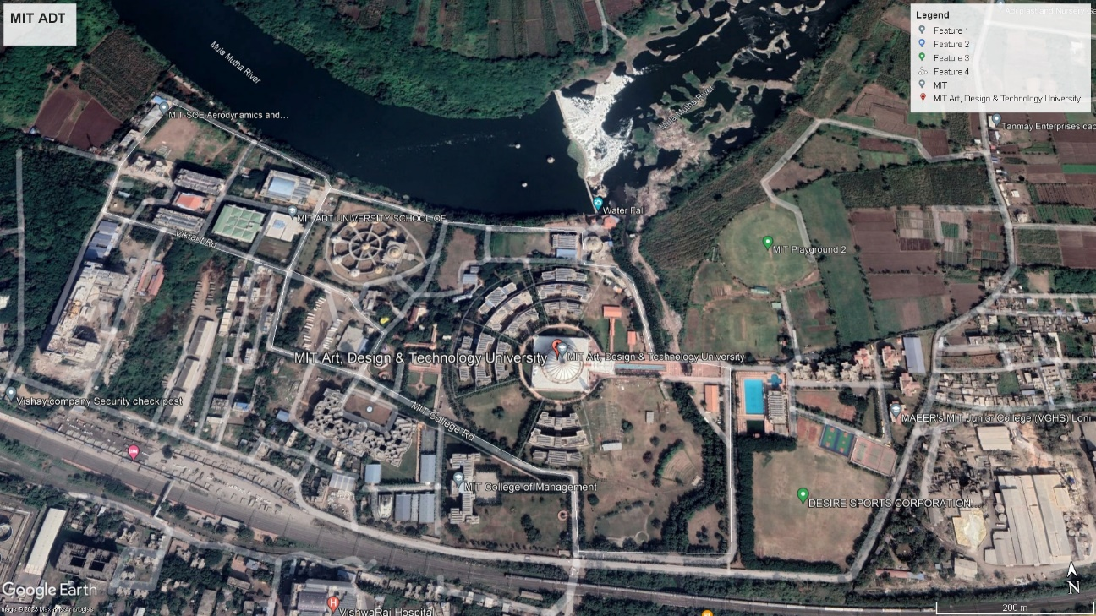
Figure 1 - MIT Art, Design and Technology University

MIT enrolls about more than 5000 students every year. The increasing number of students, faculty, staff, and visitors, coupled with limited space and growing vehicular traffic, has led to significant disruptions in campus mobility and accessibility. Insufficient parking spaces, poor traffic flow, and lack of effective management strategies have resulted in frustration, environmental concerns, and safety hazards. Thus, there is an urgent need to address the following problems in traffic planning and parking management on campus-
- Traffic Congestion and Safety Issues
- Inadequate Parking Infrastructure

DATA COLLECTION
As part of the research project, three surveys were conducted to gather relevant data on traffic patterns and parking utilization. The surveys included a traffic volume survey, an origin-destination survey, and a parking survey. Method adopted for collection of traffic volume is manual counting method while method adopted for origin destination survey and parking inventory survey is via google forms.

TRAFFIC VOLUME SURVEY
The manual method of traffic volume count involves physically observing and recording the number of vehicles passing a specific location over a predetermined period. This process typically includes using manual counting devices like tally counters or clickers, where an observer stands by the roadside and manually clicks the counter each time a vehicle passes. The data collected is then compiled and analyzed to determine the traffic volume at that location during the observation period. Manual traffic volume counting is a labor-intensive process but can be useful for smaller-scale studies or when automated counting methods are not feasible or available.

Table 1 Traffic Volume Survey Template
TRAFFIC VOLUME SURVEY OF CAMPUS
(15 mins) |  | Two Wheeler  (veh) | Three Wheeler  (veh) | Four Wheeler  (veh) | School Bus  (veh) | LCV  (veh) | HCV  (veh) | Cycle  (veh) | Total Vehicles
16-00 | 16-15 | 0 | 0 | 0 | 0 | 0 | 0 | 0 | 0
16-15 | 16-30 | 0 | 0 | 0 | 0 | 0 | 0 | 0 | 0
16-30 | 16-45 | 0 | 0 | 0 | 0 | 0 | 0 | 0 | 0
16-45 | 17-00 | 0 | 0 | 0 | 0 | 0 | 0 | 0 | 0

ONLINE SURVEY
The online survey was conducted using google forms for O-D survey and inventory parking survey. The survey targeted students, faculties and involved questioning them about their mode of transportation, travelling time, parking time and travel time. To ensure a comprehensive survey, the questionnaire was administered during both peak and off-peak times. The primary objective of conducting this survey was to gather details about the travel patterns of commuters. The questions analyzed the data regarding the origin and destination points, no of days commuting to campus, mode of transport, time of arrival and departure, trip duration, parking preferences.

IDENTIFYING PROBLEM
The survey identified the certain problems occurring within the campus and are stated as follows –

BOTTLENECK CONGESTION
A bottleneck refers to a point in a transportation system where the flow of traffic is restricted or constricted, resulting in reduced capacity and slower movement of vehicles. It is a common cause of traffic congestion and can occur in various forms, such as narrow roads, intersections, or areas with heavy pedestrian traffic. Bottlenecks disrupt the smooth flow of traffic, leading to delays, longer travel times, and increased frustration for motorists. Identifying and addressing bottlenecks is crucial for improving traffic flow and reducing congestion.
This type of congestion can be seen within MIT ADT University campus at a point where the stream of flow is hampered due to shortening of road width i.e. 4 lane road merges to 2 lane. The point 1in figure 2 shows the point of bottleneck congestion.

IMPROPER INTERSECTION DESIGN
The intersection near the tuck shop is being considered as improper as there is inadequate lane capacity and lacks turning lanes. The point 2 in fig 2 shows the point of improper intersection.

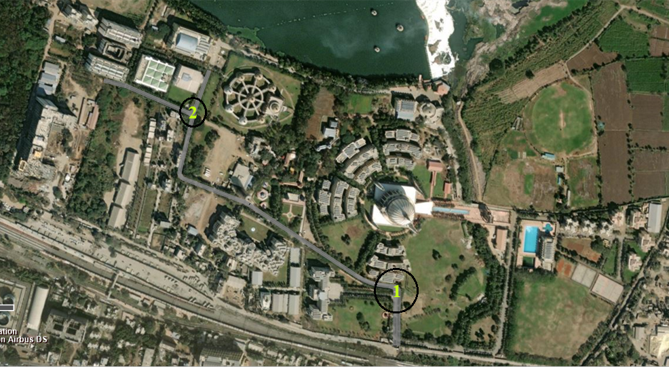
Figure 2 Traffic Congestion Issue within the Campus

PARKING ISSUE
MIT ADT University Campus has well planned parking system surrounding over the 125 Acre. It has in all 20 parking spots, covering all the different schools, sports complex, and cafeteria. The figure 3 gives the information regarding existing parking area within the campus. The increasing population of the college and the rise in the use of private/individual vehicles have posed challenges for parking management on campuses. As more students, faculty, and staff bring their vehicles to campus, the demand for parking spaces often exceeds the available supply. This leads to overcrowded parking lots, increased traffic congestion, and frustration among campus community members. Underground parking areas are particularly susceptible to water intrusion, especially during heavy rainfall or due to water table levels. The IT Building, Design Building, and ISBJ Building are situated in low-lying areas that are particularly susceptible to water accumulation during the rainy season. This poses a significant challenge when it comes to parking, as the presence of standing water in these areas hampers the availability and usability of parking spaces, especially for bicycles. The water tends to collect in these locations, making it nearly impossible to find suitable spots for bike parking. Given this situation, it becomes crucial to implement efficient and targeted parking management measures within these specific areas.

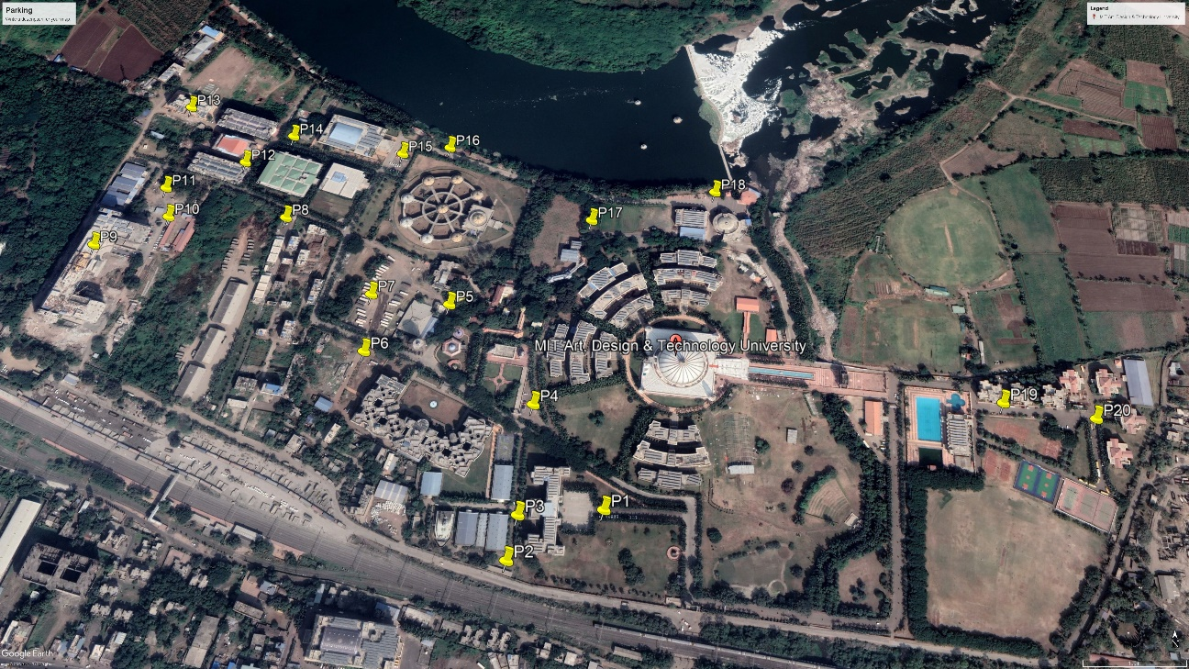
Figure 3 Existing Parking Areas within the Campus

VISSIM SIMULATION
VISSIM, developed by PTV Group, is a sophisticated software transforming traffic simulation and analysis. It is a vital tool for transportation engineers, urban planners, and researchers worldwide, offering a microscopic traffic simulation that models individual vehicles and their interactions with accuracy. This enables a comprehensive analysis of traffic flow, congestion, delays, and performance metrics, aiding in identifying bottlenecks and optimizing traffic operations.
VISSIM excels in modeling and analyzing traffic control elements, including traffic signals, stop signs, and roundabouts, allowing users to optimize signal operations and find effective strategies for traffic flow improvement and safety enhancement.
With a comprehensive set of analysis tools, VISSIM measures traffic flow, travel times, delays, and emissions, presenting results through visually appealing graphs and animations, making interpretation clear and effective.
The software allows users to calibrate and validate their models against real-world traffic data, enhancing the credibility and reliability of simulation results.
VISSIM finds applications in transportation planning, urban design, traffic engineering, and research, contributing to advancements in transportation science. It is widely used in various transportation-related fields for traffic impact assessments, signal optimization, and infrastructure planning.

RESULTS & DISCUSSION

TRAFFIC VOLUME SURVEY DATA
As part of the research project, a traffic volume count survey was conducted on weekdays for one week, from 13th March 2023 to 17th March 2023, between 06:00 am and 08:00 pm. The survey utilized a manual counting method, where students were stationed at the entry gate and used tally counters to record the number of incoming and outgoing vehicles throughout the observation period. The PCU adopted for the research project was from Table 5.2 of the INDO-HCM Manual 2017 – PCU values for undivided roads.

Table 2 Adopted PCU Values
Sr. No. | Vehicle Type | PCU Value
1 | Two Wheeler | 0.20
2 | Three Wheeler | 0.73
3 | Four Wheeler | 1.00
4 | Bus | 3.77
5 | Light Commercial Vehicle | 2.30
6 | Heavy Commercial vehicle | 3.70
7 | Cycle | 0.39

The volume count survey resulted that the peak hour within the campus can be seen twice i.e. one in the morning session and another in the evening session. The morning peak hour accounts to be from 08:30am to 09:30am while the evening peak hour starts from 04:00pm to 05:00pm.

Table 3 Hourly Volume Survey of Incoming Vehicles on Monday (no. of PCU)
Time |  | Passenger Vehicle |  |  | Goods Vehicles
hour |  | Two Wheeler  (PCU) | Three Wheeler  (PCU) | Four Wheeler  (PCU) | School Bus  (PCU) | LCV  (PCU) | HCV  (PCU) | Cycle  (PCU)
06-00 | 07-00 | 3.6 | 0 | 4 | 0 | 0 | 0 | 1.95
07-00 | 08-00 | 24.2 | 5.84 | 20 | 26.39 | 2.3 | 0 | 1.56
08-00 | 09-00 | 132 | 21.9 | 218 | 203.58 | 34.5 | 14.8 | 4.68
09-00 | 10-00 | 229.4 | 51.83 | 216 | 18.85 | 20.7 | 0 | 3.12
10-00 | 11-00 | 75.2 | 21.9 | 76 | 0 | 13.8 | 0 | 1.95
11-00 | 12-00 | 72.6 | 18.98 | 58 | 3.77 | 11.5 | 7.4 | 1.56
12-00 | 13-00 | 42.2 | 10.95 | 63 | 33.93 | 6.9 | 14.8 | 0.39
13-00 | 14-00 | 56.6 | 19.71 | 64 | 41.47 | 6.9 | 0 | 2.73
14-00 | 15-00 | 114.8 | 18.98 | 83 | 33.93 | 11.5 | 3.7 | 1.17
15-00 | 16-00 | 46 | 28.47 | 58 | 18.85 | 9.2 | 3.7 | 0.39
16-00 | 17-00 | 23 | 18.98 | 33 | 37.7 | 9.2 | 11.1 | 0.39
17-00 | 18-00 | 17.6 | 8.03 | 26 | 22.62 | 6.9 | 0 | 0
18-00 | 19-00 | 14 | 5.11 | 12 | 11.31 | 2.3 | 7.4 | 0.78
19-00 | 20-00 | 22 | 4.38 | 6 | 3.77 | 4.6 | 7.4 | 0.78

Table 4 Hourly Volume Survey of Outgoing Vehicles on Monday (no. of PCU)
Time |  | Passenger Vehicle |  |  | Goods Vehicles
hour |  | Two Wheeler  (PCU) | Three Wheeler  (PCU) | Four Wheeler  (PCU) | School Bus  (PCU) | LCV  (PCU) |  | HCV  (PCU) | Cycle  (PCU)
06-00 | 07-00 | 0 | 0 | 0 | 0 |  | 0 | 0 | 0
07-00 | 08-00 | 19.4 | 2.92 | 11 | 3.77 |  | 2.3 | 0 | 1.95
08-00 | 09-00 | 23.6 | 18.25 | 34 | 33.93 |  | 2.3 | 0 | 1.56
09-00 | 10-00 | 19.2 | 50.37 | 39 | 26.39 |  | 0 | 0 | 0.78
10-00 | 11-00 | 31 | 22.63 | 30 | 15.08 |  | 2.3 | 0 | 0
11-00 | 12-00 | 33.2 | 13.14 | 32 | 11.31 |  | 0 | 0 | 1.95
12-00 | 13-00 | 93.8 | 15.33 | 83 | 26.39 |  | 2.3 | 18.5 | 2.34
13-00 | 14-00 | 103.2 | 16.06 | 75 | 11.31 |  | 0 | 0 | 1.17
14-00 | 15-00 | 48.8 | 17.52 | 65 | 45.24 |  | 2.3 | 0 | 0.78
15-00 | 16-00 | 89.8 | 5.84 | 75 | 52.78 |  | 0 | 0 | 0
16-00 | 17-00 | 184.6 | 3.65 | 248 | 131.95 |  | 0 | 0 | 8.19
17-00 | 18-00 | 85.2 | 6.57 | 106 | 30.16 |  | 0 | 0 | 2.73
18-00 | 19-00 | 57.6 | 20.44 | 34 | 0 |  | 4.6 | 3.7 | 3.12
19-00 | 20-00 | 31.2 | 2.92 | 30 | 7.54 |  | 4.6 | 3.7 | 0

The maximum volume estimated is 1113.68 PCU/hr occurring on Friday. The rate of flow refers to the number of vehicles passing through a given point on a roadway within a specific time period. The rate of flow estimated for the maximum volume during peak hour is estimated to be 1711.68 PCU/hr.

Table 5 Rate of flow during peak hour
Traffic flow during peak hour (08-30 am - 09-30 am)
Time |  | PCU | Vehicle | Rate of flow PCU/hr | Rate of flow veh/hr
08-30 | 08-45 | 261.76 | 423 | 1047.04 | 1692
08-45 | 09-00 | 427.92 | 601 | 1711.68 | 2404
09-00 | 09-15 | 243.3 | 586 | 973.2 | 2344
09-15 | 09-30 | 180.7 | 442 | 722.8 | 1768
Total |  | 1113.68 | 2052

Level of Service (LOS) is a concept commonly used in transportation engineering and planning to measure and evaluate the quality of service provided by transportation facilities, such as roads, intersections, and public transportation systems. It is used to assess the operational performance and efficiency of these facilities in terms of traffic flow, capacity, delays, and user experience. As mentioned in table 21.19 practical capacities of Two-way urban roads, the capacity of two lane two way road is 1200 PCU/hr. The peak hour volume is 1113.68 PCU/hr. and thus volume to capacity ratio estimates to be 0.92. Hence the LOS as per the volume to capacity ratio estimated is “E”.

ONLINE SURVEY DATA
The online survey data can be represented as follows-

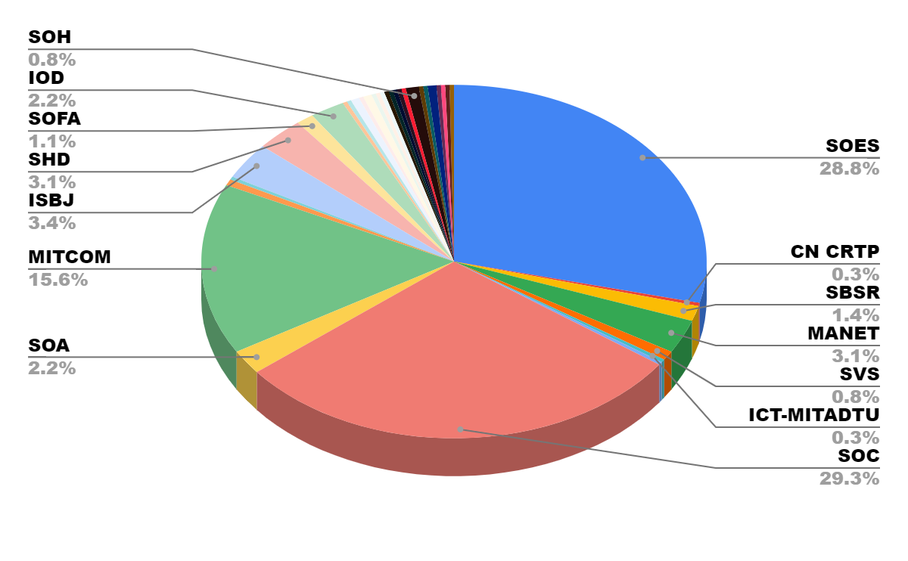
Figure 4 Graphical depiction of the public feedback of their destination
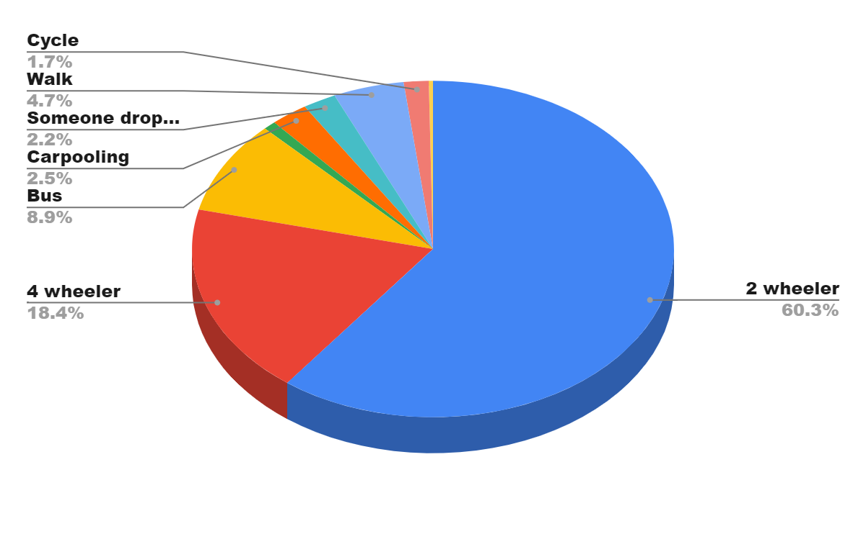
Figure 5 Graphical depiction of modes of transport used by students and faculties
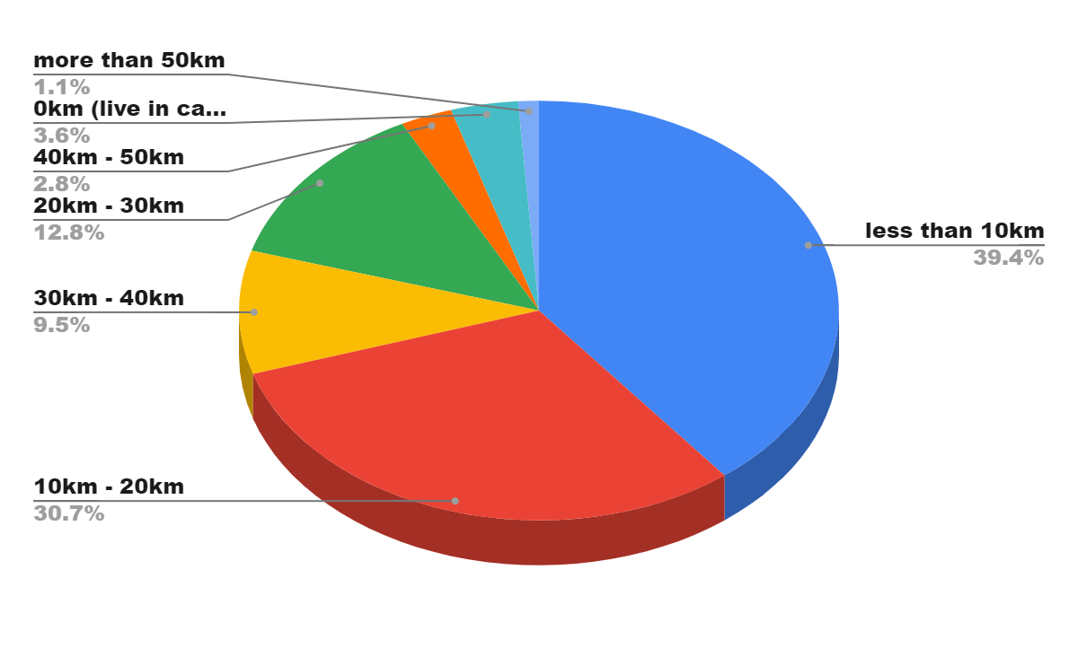
Figure6 Graphical depiction of distance travelled by individual to reach Campus

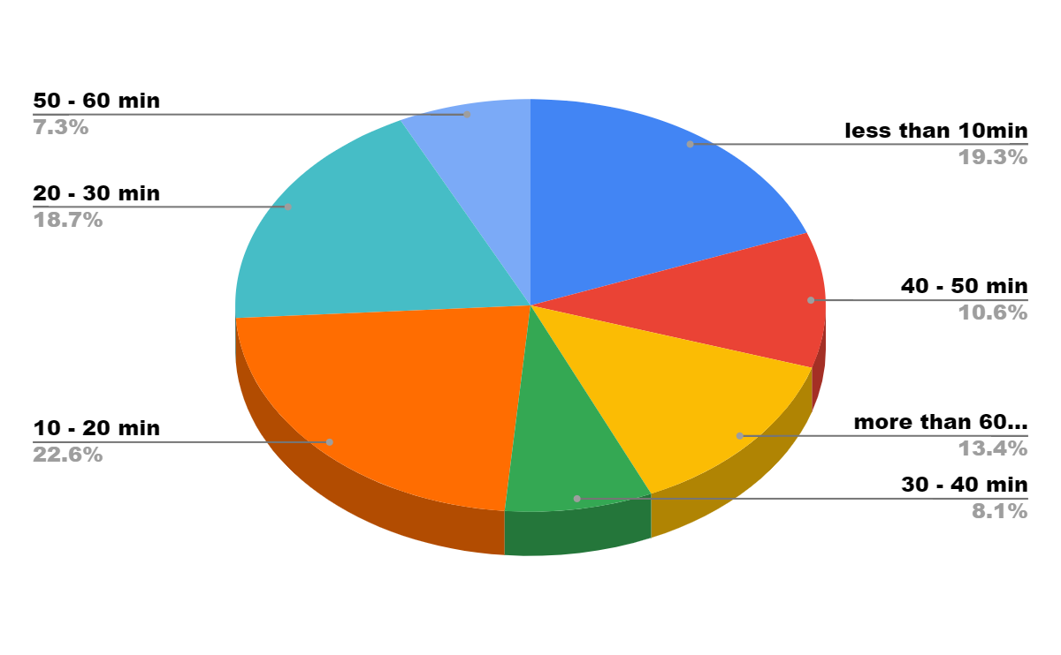
Figure 7 Time required by individual to reach university

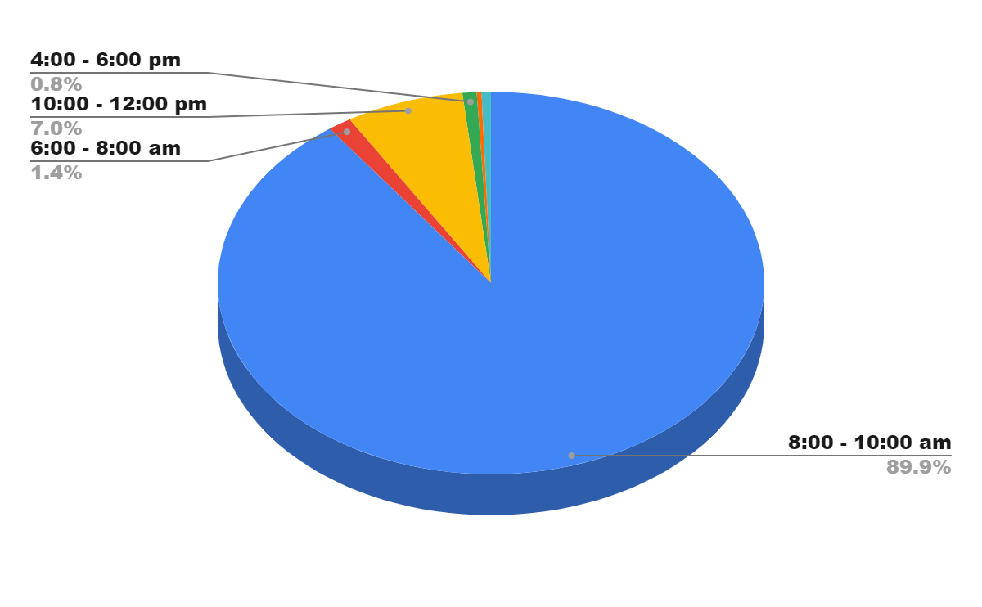
Figure 8 Graph displaying the time of arrival for students, staff, and faculties

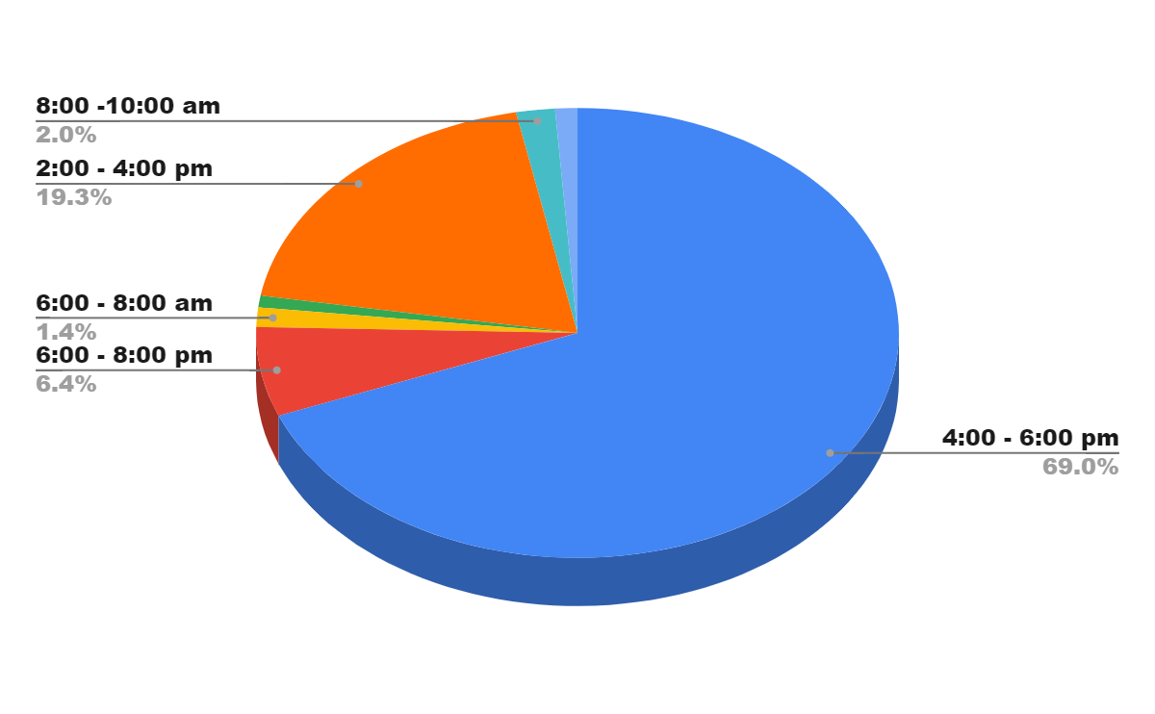
Figure 9 Graph illustrating the time of departure for students, staff, and faculties

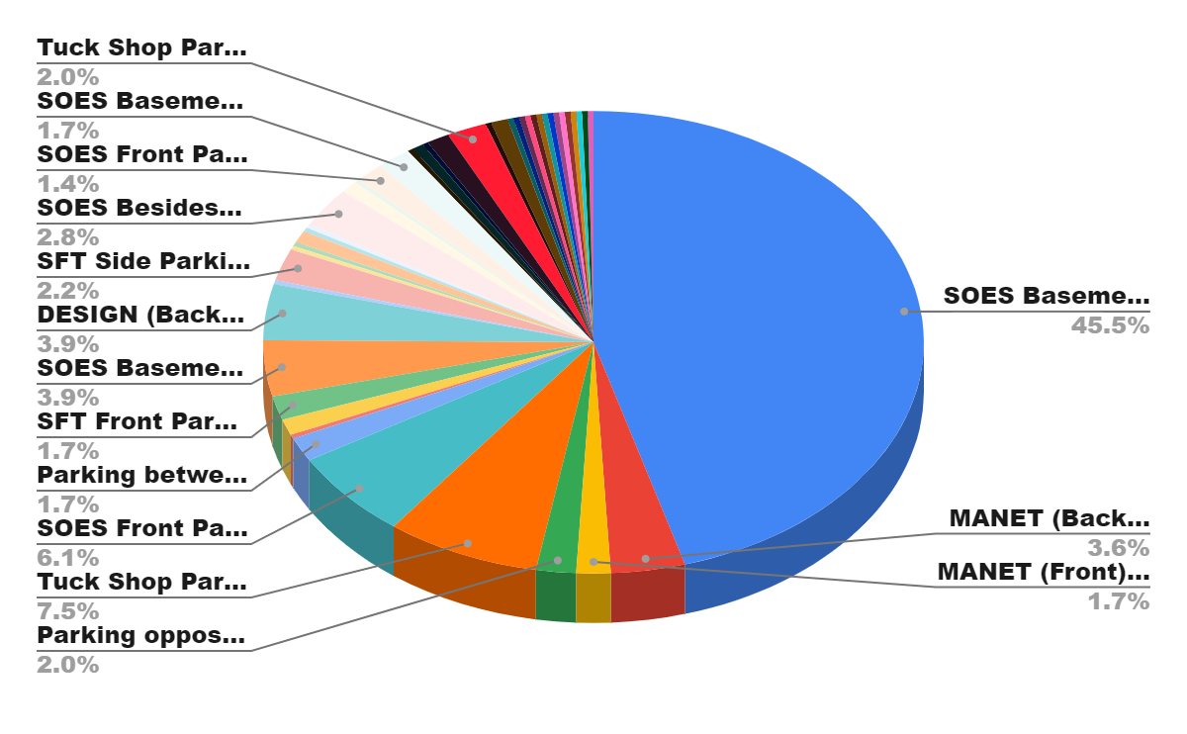
Figure 10 Graphical representation of parking preference

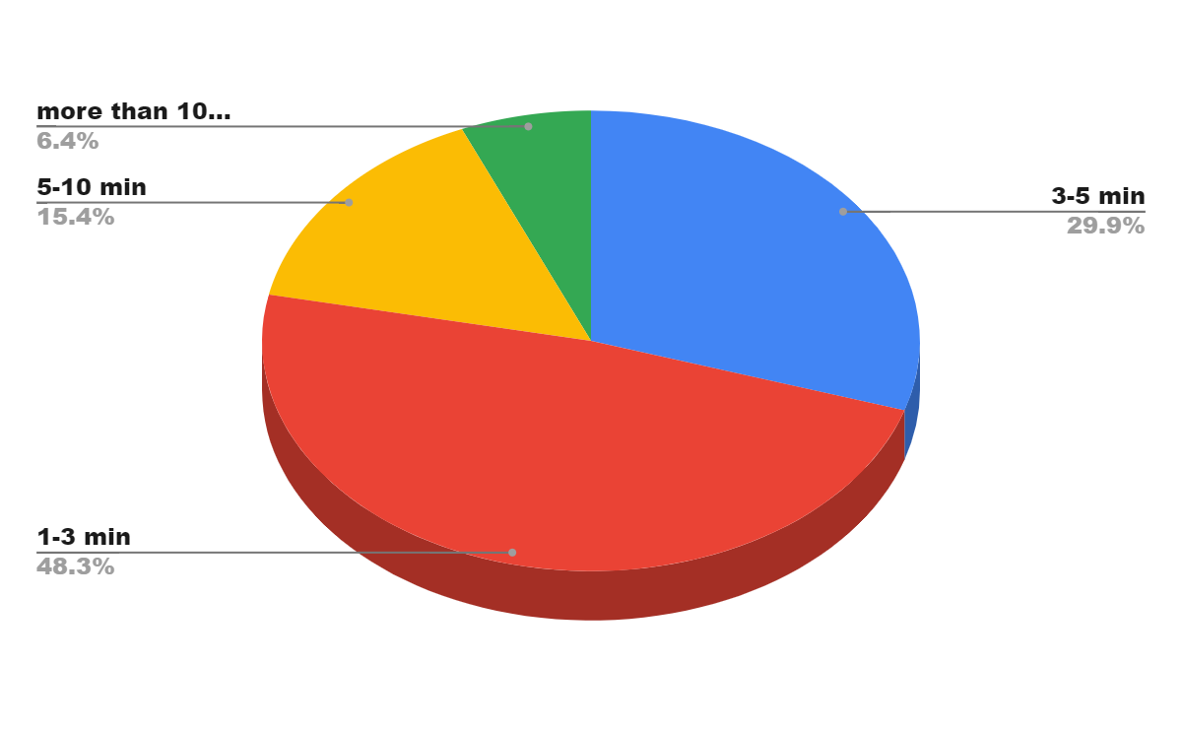
Figure 11 Graphical depiction of time required to find a parking space

PROPOSED SOLUTIONS
MIT ADT University offers a wide range of undergraduate, postgraduate, and doctoral programs across various disciplines. The current growth in admission depicts that the population of the campus has almost doubled and will increase eventually in following years. As MIT ADT University expands and admits more students, it becomes crucial to plan and manage the resources, infrastructure, and facilities effectively. In order to address and tackle above problems following proposals are being suggested.

SOLUTION FOR CONGESTION
Congestion on campus poses numerous challenges that hinder the overall efficiency and experience of students, faculty, and staff. However, by implementing a combination of strategies such as efficient infrastructure planning, alternative transportation promotion, technology integration, thoughtful class scheduling, virtual learning opportunities, and effective communication, campuses can address congestion and create a more sustainable and harmonious environment. By prioritizing the mobility and well-being of the campus community, these initiatives not only enhance efficiency but also contribute to a positive and enriching educational experience for all. Following are the proposals suggested to enhance the traffic flow and mitigate the congestion issue.

TRAFFIC CHANNELIZATION
The objective of this proposal is to minimize traffic congestion by channelizing the traffic through different entry gates based on the destination points within the campus. By utilizing the three entry gates available, namely Main Gate, SOE Gate, and Sports Gate, we aim to optimize the traffic flow and reduce congestion. The strategy of the proposal is to -
- Identify destination points- Determine the primary destination points within the campus that generate significant traffic. In this case, the SOE Building, Design Building, VGS, and Sports Complex have been identified as major destination points.
- Gate allocation- Assign specific gates for the traffic heading towards each destination point. Traffic destined for the SOE Building and Design Building will be directed to use the SOE Gate, while traffic headed to VGS and Sports Complex will be directed to use the Sports Gate. All other students and visitors can use the Main Gate.
- Signage and directions- Install clear signage at strategic locations within the campus to guide drivers and pedestrians towards their intended entry gates based on their destination. This will ensure that everyone is aware of the designated gate for their specific destination.
- Communication and education- Conduct awareness campaigns and communicate the new traffic channelization plan to all students, faculty, staff, and visitors. This can be done through emails, social media, campus announcements, and orientation sessions. Emphasize the importance of following the designated gates to minimize congestion and improve traffic flow.
- Monitoring and enforcement- Regularly monitor the traffic flow at each gate to ensure compliance with the designated routes. Security personnel or traffic marshals can be stationed at each gate to guide and enforce the traffic channelization plan. Any violations or deviations can be addressed with reminders and warnings initially, followed by appropriate disciplinary actions if necessary.
Implementing traffic channelization by utilizing different entry gates based on destination points within the campus can significantly reduce congestion, improve traffic flow, and enhance safety. By effectively communicating the plan, educating stakeholders, and enforcing compliance, the proposed strategy can be successfully implemented and contribute to a more efficient and organized campus transportation system.

Lane Expansion
The road network within the campus is of 2 lane. Only the entry route has 4 lane and all other roads are 2 lane. This cuts the stream of the flow thus hampering the speed of the traffic and formation of queue at the point where 4 lane converts into 2 lane. And so in order to resolve this lane expansion should be done. Two lane roads must be upgraded to three lane. Expanding the two-lane roads to three lanes within the campus can indeed help alleviate traffic congestion and improve the flow of vehicles. By providing an additional lane, it allows for more vehicles to travel simultaneously, reducing the chances of bottlenecks and queues forming at the transition point from four lanes to two lanes.

SOLUTION FOR PARKING ISSUE
The increasing population of the college and the rise in the use of private/individual vehicles have posed challenges for parking management on campuses. As more students, faculty, and staff bring their vehicles to campus, the demand for parking spaces often exceeds the available supply. This can lead to overcrowded parking lots, increased traffic congestion, and frustration among campus community members.
Also parking in low-lying areas becomes difficult as they are prone to water accumulation during the rainy season. This creates a significant obstacle for parking, particularly for bicycles, as the standing water obstructs the availability and usability of parking spaces. The presence of collected water in these areas makes it extremely difficult to find suitable spots for bike parking. To address this issue effectively, it is essential to implement targeted and efficient parking management measures within these specific locations. By employing appropriate strategies such as improved drainage systems, designated parking zones, or alternative parking arrangements, the challenges associated with water pooling can be alleviated. A well-planned parking management plan will optimize the utilization of available spaces, ensuring that parking remains accessible and convenient for all users, even during periods of heavy rainfall.
An elevated parking needs to be constructed in order to address both the issue i.e. inadequate parking area and water intrusion. Elevated or stack parking refers to a parking system where vehicles are vertically stacked on top of each other to maximize the use of available space. It is a solution used in areas where land is limited or expensive, and traditional parking options are impractical. In an elevated parking system, vehicles are parked on multiple levels or platforms, with each level accessible via ramps, lifts, or mechanical systems. The vehicles are typically parked on pallets or platforms that can be raised or lowered to accommodate additional vehicles.

VISSIM SIMULATION
In the project, a network model of real-time traffic was designed and simulated using VISSIM software. The process involved creating a network layout, modeling traffic demand, defining vehicle behavior, configuring traffic control elements, and executing the simulation. The simulation results were then analyzed to evaluate network performance and propose optimization strategies. Various metrics were used to assess traffic flow, delays, and queue lengths. The network model of the proposed solutions were also designed and the simulated to compare the results.

EXISTING NETWORK MODEL
VISSIM's graphical user interface was utilized to accurately design the network layout, reflecting the existing road network of the MIT ADT area. This involved defining road segments, intersections, and other essential traffic infrastructure elements. The traffic volume was modeled based on real-time data, specifying the number of vehicles, their origins, destinations, and routes. The simulation, executed within VISSIM, incorporated the real-time traffic demand, vehicle behavior, and traffic control configurations, effectively simulating individual vehicle movement and interactions within the network to capture the dynamic traffic conditions of the MIT ADT area. The simulation results were meticulously analyzed to evaluate the performance of the existing road network, employing VISSIM's comprehensive analysis tools and metrics to assess traffic flow, travel times, queue lengths, delays, and other relevant performance indicators. Based on these analysis results, areas of congestion or potential bottlenecks within the MIT ADT Campus were accurately identified.

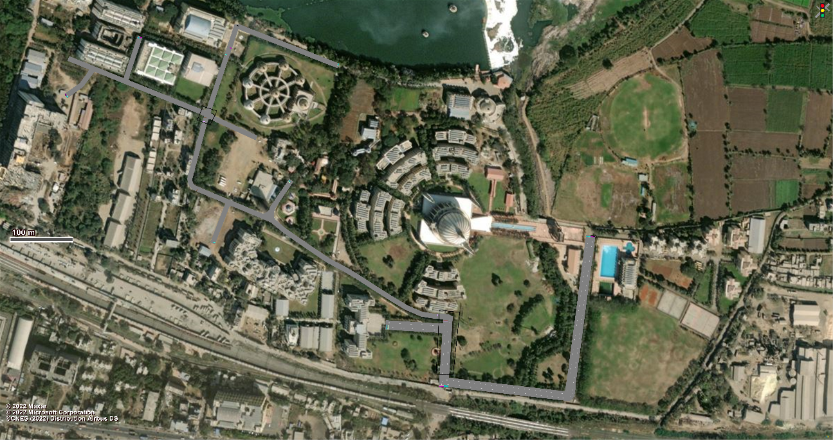
Figure 5 VISSIM Model of Existing Network

TRAFFIC CHANNELIZED NETWORK MODEL
The second model focused on the proposed solution of traffic channelization, specifically addressing the need to manage internal traffic within the network. This involved designing and analyzing additional routes that could be utilized to direct and channelize the flow of vehicles. In the design phase, the network layout was modified to include the newly proposed routes, taking into consideration the existing road infrastructure and traffic patterns. The additional routes were strategically selected to optimize traffic flow, reduce congestion, and enhance the overall efficiency of the network. After incorporating the proposed routes, the model was simulated using VISSIM to assess their effectiveness.

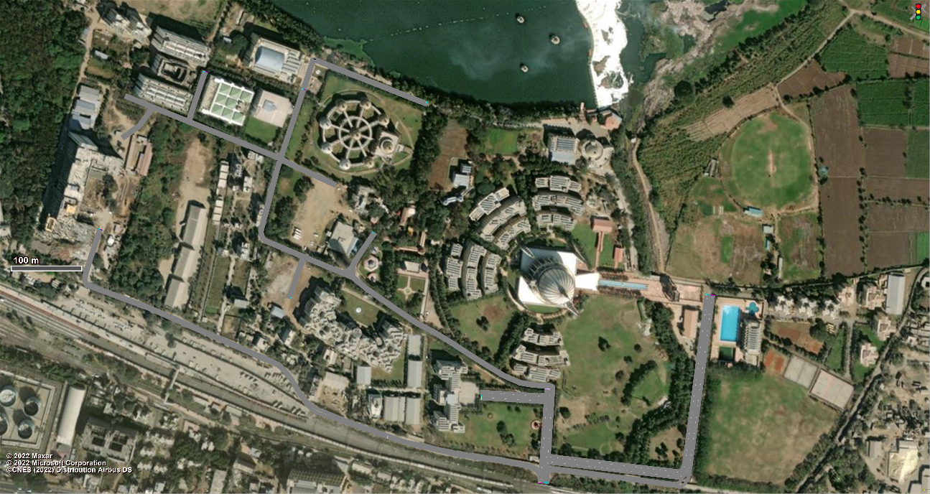
Figure 6 VISSIM Model of Channelized Network

LANE EXPANSION MODEL
The third model focuses on the network design utilizing the solution of lane expansion. It addresses the need to enhance the capacity and efficiency of the network by adding additional lanes to existing road segments. In this model, the network layout is modified to incorporate the proposed lane expansion. Once the lane expansion design is implemented in VISSIM, the model is simulated to evaluate its effectiveness. The simulation considers various factors such as traffic demand, vehicle behavior, and traffic control configurations to replicate real-world conditions accurately. The analysis phase involves evaluating the performance of the network with the added lanes. This analysis provides insights into the effectiveness of the proposed design in improving traffic flow and reducing congestion.

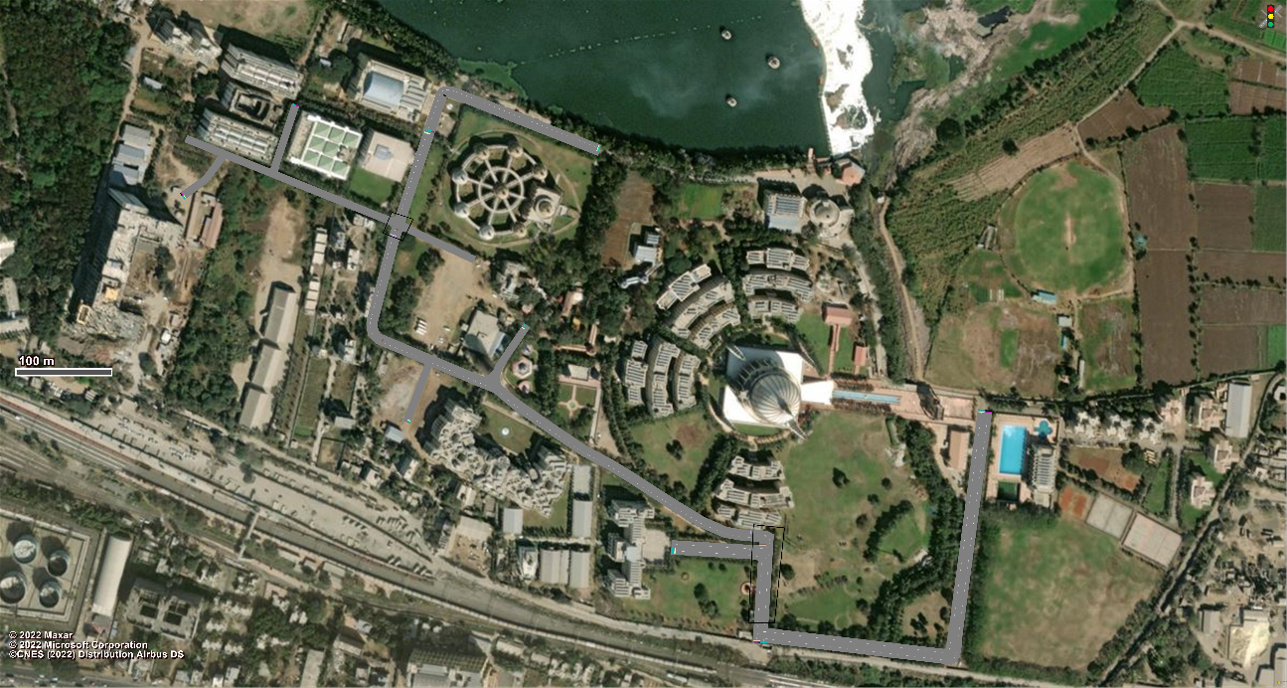
Figure 7 VISSIM Model of Lane Expanded Network

COMPARATIVE ANALYSIS OF VISSIM RESULTS
This section presents a comparative analysis of the results obtained from the VISSIM simulation for three different network models- the existing network model, the channelized network model, and the lane expansion model. The study focuses on evaluating and comparing the outcomes of these models to assess their effectiveness in addressing traffic congestion and improving traffic flow. By analyzing the results obtained from each model, valuable insights can be gained regarding the impact of different design and management strategies on the overall performance of the network.

VEHICLE TRAVEL TIME RESULTS
The following table presents a comparison of travel time required for vehicles to reach a common destination point across three different road networks. The data clearly indicates that implementing channelization measures leads to a noticeable reduction in travel time. However, the most significant reduction in travel time is observed when lane expansion is implemented. This highlights the effectiveness of lane expansion in improving travel efficiency and reducing overall travel time for vehicles.

Table 5.1 Vehicle Travel Time Results of Morning Peak Hour Traffic Simulation
VEHICLE TRAVEL TIME RESULTS
 | EXISTING TRAFFIC |  |  | CHANNELIZED TRAFFIC |  |  | LANE EXPANDED TRAFFIC
VEHICLE TRAVEL TIME MEASUREMENT | NO OF VEHICLES | TRAVEL TIME | DISTANCE TRAVELLED | NO OF VEHICLES | TRAVEL TIME | DISTANCE TRAVELLED | NO OF VEHICLES | TRAVEL TIME | DISTANCE TRAVELLED
MAIN GATE TO MANET | 6 | 25.894 | 180.263 | 5 | 24.794 | 210.945 | 5 | 28.069 | 180.769
MAIN GATE - VGS | 65 | 58.074 | 468.727 | 65 | 59.814 | 489.264 | 69 | 59.399 | 468.729
MAIN GATE - BOI | 9 | 108.328 | 507.260 | 6 | 70.008 | 538.738 | 6 | 63.413 | 507.482
MAIN GATE - FT | 4 | 143.422 | 575.904 | 7 | 68.767 | 596.989 | 5 | 66.032 | 572.307
MAIN GATE - SOE | 98 | 210.190 | 952.162 | 101 | 123.765 | 823.362 | 109 | 131.789 | 955.164
MAIN GATE - ISBJ | 33 | 179.148 | 798.543 | 26 | 110.327 | 830.645 | 32 | 101.745 | 799.803
MAIN GATE - BANDARA | 28 | 209.137 | 1025.609 | 26 | 139.142 | 1052.618 | 32 | 128.739 | 1024.111

To visually demonstrate the effects of the proposed solutions, the graph provided showcases the disparities in vehicle travel time across three different networks. Despite having identical origin and destination points, each network's unique configuration and the implementation of specific improvements result in varying levels of delay for vehicles. This graphical representation serves as a powerful illustration, highlighting the significance of selecting the appropriate solution to effectively minimize delays and optimize the overall flow of traffic.

Figure 8 Vehicle Travel Time Results of Morning Peak Hour Traffic Simulation

DELAY RESULTS
The presented table provides a comprehensive comparison of the delays resulting from congestion in the current stage and the proposed solutions. The data highlights that implementing lane expansion offers the most effective resolution to the congestion issue, while channelization measures can also contribute to reducing delay times.

Table 5.2 Delay Results of Morning Peak Hour Traffic Simulation
DELAY RESULTS
DELAY MEASUREMENT | EXISTING TRAFFIC |  | CHANNELIZED TRAFFIC |  | LANE EXPANDED TRAFFIC
 | VEHICLE DELAY TIME (ALL) | NO OF VEHICLES (ALL) | VEHICLE DELAY TIME (ALL) | NO OF VEHICLES (ALL) | VEHICLE DELAY TIME (ALL) | NO OF VEHICLES (ALL)
MAIN GATE-MANET | 5.9110 | 6 | 0.9526 | 5 | 0.5950 | 5
MAIN GATE-VGS | 0.7674 | 65 | 2.6151 | 65 | 0.5361 | 69
MAIN GATE-BOI | 50.5517 | 9 | 3.9749 | 6 | 5.5074 | 6
MAIN GATE-FT | 72.4324 | 4 | 0.9195 | 7 | 3.5429 | 5
MAIN GATE-SOE | 96.968 | 98 | 25.4889 | 101 | 18.6894 | 109
MAIN GATE-ISBJ | 77.4401 | 33 | 14.2499 | 26 | 5.7751 | 32
MAIN GATE-BANDHARA | 77.4525 | 28 | 17.4479 | 26 | 5.9763 | 32

To visualize the impact of these solutions, the accompanying graph illustrates how vehicle delays vary across three distinct networks. Despite sharing the same origin and destination points, each network's configuration and proposed improvements lead to varying levels of delay for vehicles. This visualization emphasizes the importance of selecting the appropriate solution to minimize delays and optimize traffic flow.

Figure 9 Graph representing Delay Results during Morning Peak Hour

QUEUE RESULTS

Table 5.3 Queue Results
QUEUE LENGTH
 | EXISTING TRAFFIC |  |  | CHANNELIZED TRAFFIC |  |  | LANE EXPANDED TRAFFIC
QUEUE COUNTER | QUEUE LENGTH | QUEUE LENGTH MAXIMUM | QUEUE STOPS | QUEUE LENGTH | QUEUE LENGTH MAXIMUM | QUEUE STOPS | QUEUE LENGTH | QUEUE LENGTH MAXIMUM | QUEUE STOPS
BOTTLENECK POINT | 46.356114 | 112.17274 | 261 | 0.850135 | 48.189985 | 7 | 0 | 0 | 0

The presented table illustrates the queue length resulting from congestion, ranging from a minimum of 46 meters to a maximum of 113 meters. The findings indicate that implementing lane expansion measures can entirely eliminate the formation of queues, while traffic channelization techniques can effectively reduce the queue length by approximately 50 percent. These results highlight the significant impact of proposed solutions in mitigating congestion and improving the flow of vehicles, ultimately leading to a more efficient and smoother traffic experience.

Figure 3.7 Graph showing queue length during morning peak hour

CONCLUSIONS AND RECOMMENDATIONS

CONCLUSIONS
In conclusion, this research study has identified key issues related to traffic congestion and parking management within the campus.
- The research findings clearly indicate that traffic congestion within the campus stems from bottlenecks and inadequate intersection design.
- Effective measures such as traffic channelizing and lane expansion can eliminate traffic congestion.
- The existing internal road has a capacity of 1200PCU/hr, and the volume of traffic currently reaching the road is 1113.68PCU/hr, indicating that the road has reached its maximum capacity. In anticipation of future population growth, it is necessary to expand the lanes in order to increase the road's capacity.
- By maintaining a width of 10m for the internal road, which corresponds to an undivided three-lane configuration, the road's capacity can be increased to 1800PCU/hr, ensuring a continuous flow of traffic.
- The issue of parking is primarily observed near the IT Building, Design Building, and ISBJ Building, where low-profile areas and insufficient parking spaces contribute to the problem.
- Implementing appropriate design and management strategies can effectively address the parking issue.
- Signage promotes travel awareness and facilitates campus navigation, making it easier for drivers to find their way and follow designated routes.
- Incorporating sustainable transportation into campus planning and design can enhance the overall functionality and attractiveness of the campus.

RECOMMENDATIONS
After thorough research and analysis, the following recommendations/proposals have been identified as valuable insights
- Implement measures to address bottleneck congestion and improve intersection design to alleviate traffic congestion within the campus.
- Explore traffic channelizing techniques and consider lane expansion to effectively manage traffic flow and reduce congestion.
- Focus on resolving the parking issue in the vicinity of the IT Building, Design Building, and ISBJ Building by implementing proper design and management strategies.
- Enhance signage and wayfinding systems to provide clear guidance and improve navigation for drivers within the campus.
- Promote sustainable transportation practices by encouraging the use of alternative modes of transportation, such as carpooling, cycling, walking, and public transit. Promoting use of e-cycles for students coming through bus or walking.
- Conduct regular traffic volume surveys and parking surveys to monitor and assess the effectiveness of implemented solutions and make necessary adjustments.
By considering these recommendations/proposals, campus authorities can take informed decisions and implement effective measures to improve traffic management, alleviate congestion, and enhance parking facilities within the campus environment.

ACKNOWLEDGEMENTS
The authors would like to express their gratitude my guide, Prof. Rajshekhar G. Rathod, Assistant Professor and Prof. Sagar K. Sonawane, Assistant Professor of Civil Engineering Department, MIT School of Engineering, Pune for their encouragement during my dissertation work. I am also thankful to Prof. Dr. Satish B. Patil, Head, Civil Engineering Department, MIT School of Engineering, Pune for his support and for giving an immense knowledge about the site and various construction safeties.

REFERENCES
1. Eom, J. K., Stone, J. R. & Ghosh, S. K. Daily Activity Patterns of University Students. J. Urban Plan. Dev. 135, 141–149 (2009).
2. Hamad, K., Htun, P. T. T. & Obaid, L. Characterization of travel behavior at a university campus- A case study of Sharjah University City, UAE. Transp. Res. Interdiscip. Perspect. 12, (2021).
3. Xu, J., Zhang, Z. & Rong, J. The Campus Road Planning and Design Research. Procedia - Soc. Behav. Sci. 43, 579–586 (2012).
4. dell’Olio, L. et al. A methodology based on parking policy to promote sustainable mobility in college campuses. Transp. Policy 80, 148–156 (2019).
5. Mohammed Almatar, K. Traffic congestion patterns in the urban road network- (Dammam metropolitan area). Ain Shams Eng. J. 14, 101886 (2023).
6. Fernandes, P., Sousa, C., Macedo, J. & Coelho, M. C. How to evaluate the extent of mobility strategies in a university campus- An integrated analysis of impacts. Int. J. Sustain. Transp. 14, 120–136 (2019).
7. Obregón Biosca, S. A. College student mobility in emerging countries- Case study on Universidad Autónoma de Querétaro, México. Transp. Res. Interdiscip. Perspect. 6, 100155 (2020).
8. Parmar, J., Das, P. & Dave, S. M. Study on demand and characteristics of parking system in urban areas- A review. J. Traffic Transp. Eng. (English Ed. 7, 111–124 (2020).
9. Min-Allah, N. & Alrashed, S. Smart campus—A sketch. Sustain. Cities Soc. 59, 102231 (2020).
10. Gurbuz, O. & Cheu, R. L. Survey to Explore Behavior, Intelligent Transportation Systems Needs, and Level of Service Expectations for Student Parking at a University Campus. Transp. Res. Rec. 2674, 168–177 (2020).
11. IRC-SP- 73-2018 Manual Of Specifications And Standards For Two Laning Of Highways With Paved Shoulder.
12. IRC- 067-2012 Code of Practice for Road Signs.
13. IRC- 106-1990 Guidelines for Capacity of Urban Roads in Plain Areas.
14. Indian Highway Capacity Manual (Indo-HCM) 2017.
15. Traffic Engineering and Transport Planning by Dr. L. R. Khadiyali.

