AI & ML in Medicine

Rajat Kulshrestha¹, Shruti Awasthi², Rama Chandra Prasad², Sheeja MS², V G Shanmuga Priya²*
¹Student, Department of Life Sciences, Garden City University, Bangalore
²Assistant Professor, Department of Life Sciences, Garden City University, Bangalore
* Corresponding author (Orcid ID : 0000-0002-3897-3591)

“There is a multitude of possibilities when it comes to the use of AI. Artificial Intelligence (AI) will not replace doctors and nurses, you cannot cure by code, you need the human touch, you need the people. But what is possibly going to happen is that while AI is not going to replace doctors, doctors who use AI will replace doctors who do not use it.”
Sangeeta Reddy, Joint Managing Director, Apollo Hospitals
Interview to PTI,14 Feb 2023
The above quoted words portend the change that is looming large on the horizon for all practitioners of modern medicine. The traditional pillars of wisdom guiding the modern-day doctors are soon going to get a fillip from the computational world of data crunching and machine learning, the cardinal practices that enable the incorporation of Artificial Intelligence into all knowledge system. Despite the perceived abstract nature of medical information, making it seemingly impervious to the influence of Artificial Intelligence, the medical data are indeed amenable to the application of machine learning, by replicating the very models that have revolutionized the rest of the knowledge-based systems. There is tremendous potential for AI to change the delivery of patient health care, in both bedside as well as administrative processes.
Wide ongoing research in the field of diagnostic medicine has irrefutably argued that tools based on machine learning have the ability to identify and, distinguish malignant diseases with the same accuracy and precision as experienced radiologists and pathologists, if not better. Not only that, the tools also enable the researchers to intelligently design the protocols of clinical trials, ensuring randomness and blindness, essential for their success. Algorithms are being increasingly written, encoded and being tested for their veracity based upon the huge quantum of Big data generated in the field of medicine. Several facets of patient care can be automated, relieving clinicians from repetitive, mundane, yet vital tasks involved therein, provided there are sufficient safeguards in place.
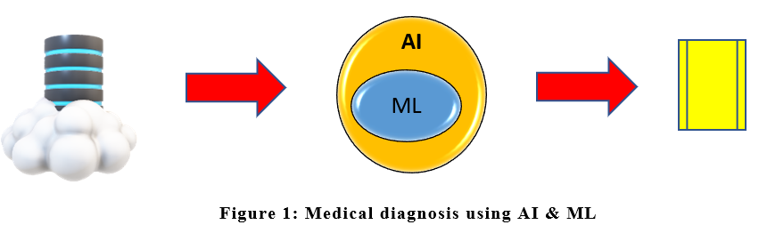
The phrase “Artificial Intelligence” (AI) is often used randomly, with scarce attention to its myriad, laborious, and seemingly esoteric components. The practice of AI is founded on a number of technologies that have been developed since their inception in 1940s at the hands of Alan Turing and his team. The process essentially has been focused on cracking the enemy’s code, except now the enemy is not a hostile nation, but disease.
1.AI TECHNOLOGIES
The technologies that comprise AI are robotics, natural language processing, rule based expert systems, and deep learning. Developing neural networks based upon existing information employs statistical modeling that are put to test so as to assist the practicing clinician in making accurate diagnosis, and planning optimal treatment.
1.1 ROBOTICS
Robotic technology transformed the post war modern world industry by employing machines to carry out repetitive, pre-defined tasks in the chain of operations. These tasks varied from heavy lifting, repositioning and welding to fine assembly of components, and have found their place in hospital settings in form of inventory management, delivering supplies and janitorial tasks in hazardous areas. The mechanics of robotics have been so finetuned that precise surgical operations are being successfully conducted each day all over the world using robotic techniques. Research and collaboration with medical professionals have made these robots intelligent, to the mutual benefit of medicine and industry. Computerization of robotic systems has converted them from unwieldy machines to competent assistants of a trained surgeon. Keyhole surgeries, with minimal blood loss and extremely fine incisions and suturing have resulted in marked reduction of post-operative morbidity to the patients enabling their early return to normal life (George,2018). Robotic surgery has become the norm in prostate, urological, gall bladder, orthopedic, gynecological, and even head and neck surgery in several centres. As further technology refines the operating systems of robots, with predictive capability, the association between the two fields will only strengthen further.
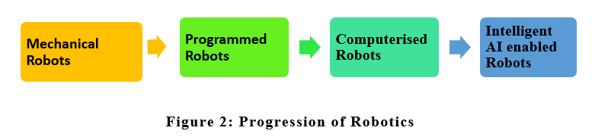
Robotic processes have automated several administrative tasks dovetailed into patient care. Though not strictly incorporating physical robots, these processes empower a computer to take decisions in a human-like manner by integrating the workflow processes and the standard operating procedures governing them. The computer carries out these tasks in a semi-intelligent manner, strictly in accordance with the established rules. These tasks may include billing, Updation of electronic health records, organizing patient data into the hospital database, and retrieving and sharing appropriate information with other stakeholders in the patient care (Sheikh,2021).
1.2 NATURAL LANGUAGE PROCESSING
Natural language processing (NLP) is the ability of a computer program to understand human language as it is spoken and written referred to as natural language. NLP has its roots in the field of linguistics. NLP enables computers to take real-world input, process it, and make sense of it in a way a computer can understand. At some point in processing, the input is converted to code that the computer can understand. Clinical data is often unstructured and text-heavy with several technical terms and need a way to efficiently process it. Most of the information even in electronic format is in natural human language, and until recently, could not be effectively analyze this data. natural language processing has made medical information amenable to computerized processes. NLP in healthcare can precisely deliver significance to the unstructured data, map the appropriate data into structured form in the Electronic Health Record (EHR), convert it into machine-readable format for training other health professionals in a language of their choice, providing valuable insight into the understanding the various aspects of disease, enhance the quality of research and analysis methods, culminating in favourable outcomes for patients (Lee,2018). NLP can also help optimizing the medical images into important insights and reports.
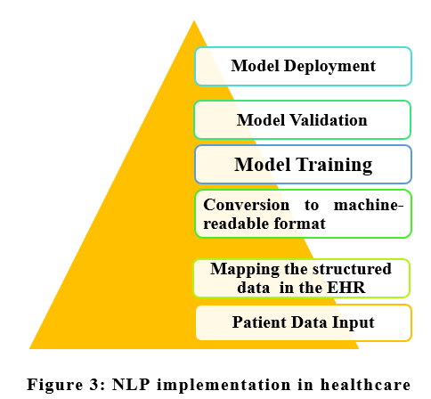

1.3 RULE BASED EXPERT SYSTEMS
An expert system is a computer program for providing the computer the decision-making ability like a human expert. The system helps in decision making for complex problems using both facts and heuristics. It contains the expert knowledge of a specific domain and can solve any complex problem by extracting knowledge from its knowledge base using the reasoning and inference rules according to the user queries. The simplest rules are conditional statements (if a, then do x, else if b, then do y), which acquire complexity when being used to describe a complex problem, and are modelled for all possible outcomes. The first expert system was developed in the year 1970, and was the first successful application of artificial intelligence. In the field of medicine, however, their use in clinical decision making is fairly limited, despite initial promise because the clinical decision making, by nature, is a very complex process (Bizopoulos,2018). Recently it is increasingly being replaced by machine learning.
1.4 MACHINE LEARNING
Machine learning has come to acquire the pride of place in AI technology, having nearly replaced Rule Based Expert Systems. Simply put, machine learning is a technique that attempts to imitate human intelligence by employing statistical methods to process and analyze data and develop models to predict outcomes of future data, without resorting to complex programming. The goal is to understand the structure of the data, and identify patterns and fit theoretical distributions to the data that are well understood. Machine learning often uses iterative approach to learn from data and can therefore be easily automated. Passes are run through the data until a robust pattern is found. One form of machine learning employs supervised learning approach algorithms using labeled examples, such as an input where the desired output is known. The learning algorithm receives a set of inputs along with the corresponding correct outputs, and the algorithm learns by comparing its actual output with correct outputs to find errors. It then modifies the model accordingly. Supervised learning is suitable for applications where historical data predicts likely future events (Peiffer,2019). In healthcare, the obvious application of machine learning can be envisaged through the use of wearable devices and sensors that can use data to assess a patient's health in real time. The information gathered from patterns of past data can help medical experts analyze data to identify trends or red flags that may lead to improved diagnoses and treatment (Jiang,2020).
1.5 NEURAL NETWORKS
Neural networks represent a more complex form of machine learning and were conceptualized in 1943, and imitate the connections within the brain to process data using a set of algorithms. Fundamentally, a neural network receives inputs, and delivers output after assigning probability values called weights to various variables that associate the former with the latter and channels the data through nodes. As more and more data are processed, the model gets trained, adjusting the weights as learning proceeds. Neural networks have been employed to predict disease risk stratification based on patient data (Ismaeel,2017; Ning,2006).
1.6 DEEP LEARNING
Deep Learning is currently the most advanced and most complex technology of Artificial Intelligence. Deep learning is enabled by using big data that by definition is voluminous, unstructured, generated at high speed, is of high value and needs to be verified owing to inherent uncertainties, includes images, videos and speech records, not very different from clinical data, and consequently requires sophisticated computational resources, both in terms of hardware and software along with storage, often cloud-based. Researchers have been working on developing and improving Deep Learning based tools in the field of radio-imaging and histopathology to screen and diagnose malignancies, with ability to detect pathological changes otherwise not discernible by the human eyes (Shankar,2021). Availability of high-end computers and unlimited storage space in cloud has enabled Deep learning to be embedded in Natural Language Processing and previously used Image Analysis tools. It is expensive, and does not offer any explanations for the observations or predictions, but holds far greater promise in healthcare than all other technologies, and can be applied to other technologies, eg. robotics to develop a line of intelligent robots, dedicated to various medical and surgical procedures (Morris,2022).
2. THE NEED FOR AI IN MODERN MEDICINE
The field of medicine has kept pace with the prevailing innovative technologies, and this adaptability has been to the benefit of both physicians and patients. Hence development of AI technologies with healthcare at its centre is as natural a progression as adoption of X Rays, CT and MRI technologies by the medical field. As a matter of fact, these technologies are also amenable to AI. AI in healthcare holds much promise, with its potential to alleviate the physician’s burden and allow them to spend more time with the patients.
2.1 PRINCIPLE OF AI ENABLEMENT OF HEALTHCARE
Timely diagnosis of an ailment, and halting its progression in a patient, if not reverse it altogether is the primary purpose of medical profession. This requires not just the collection of patient data, but also compare it with existing data on the subject, as available in medical literature. Therefore, doctors attempt quick action, armed with reliable, reproducible, recordable and trustworthy data with the sole aim of improving patient’s health. In the broader sense, this also has a significant effect on the lives of mankind around the globe socially and financially. AI in health care will definitely improve from gathering and processing valuable data to develop and train independent models that can be tested repeatedly before adoption into healthcare (Shrivastava,2022).
AI in healthcare modelling replicates the framework standardized by the experience in other fields, as an end-to-end process encompassing the entire gamut of data collection and data processing, in close collaboration between data scientists, IT, and domain experts, i.e., clinicians, through the following steps:
a. Data Collection: Large datasets are an absolute requirement for Deep Learning models to be trained on and produce meaningful results. Lack of availability of right data is the principal limiting factor e.g., Pathologic data from a patient of breast cancer is incomplete unless complemented by radiologic data, as well as data from the clinical examination. For AI to be holistic, data needs to be holistic, even inclusive of ambulatory care or home monitoring programs. Predictive power, the ultimate aim of AI also needs longitudinal data about the efficacy of various treatment protocols and their outcomes. Lack of this data hampers the ability of AI to predict patient outcomes. Hence, clinicians and all care givers should record all patient care data before AI can be expected to provide evidence-based, individualized care plans (de Santiago, 2022).
b. Data Cleansing: The dictum Garbage in-garbage out holds true in AI. Results of AI are invariably dependent on the quality of data used to train the Deep learning model. Data cleansing is thus crucial, and the most laborious step, often consuming up to 80% of the programmers’ time. The clinical data is not only unstructured, but also highly variable, with two physicians using entirely different vocabulary of terms while describing the same patient. Data from different sources needs to be normalized to eliminate noise resulting from such inconsistencies. Standardization of medical vocabulary, with strict formatting can prevent such noise, and eliminate consequent errors in training an algorithm.(https://demigos.com/blog-post/data-aggregation-and-normalization-in-healthcare/)
c. Choosing a model to run cleansed data: Machine learning incorporates a vast number of analytical methods, and the results are heavily dependent on the choice of method. There is a possibility that if four different deep learning models are employed on the same dataset, there would be four different results. Therefore, the data scientist cannot work in isolation, and needs the support of clinicians to understand the fine-print of the dataset, and how it should be configured. In the last decade, there has been a gradual shift from developing a de novo model to deploying the best possible model out of the existing ones (Labarère,2014).
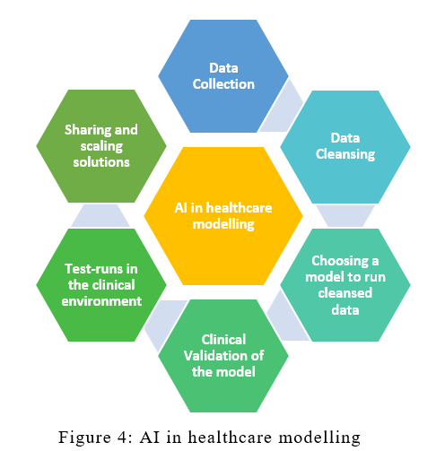
d. Clinical Validation of the model: the chosen model is subjected to testing, and is deployed only after repeated successful testing iterations. Sharing of standardized data across a large number of users, through widespread collaboration, nationally and internationally, empowers the model to become more inclusive, and accounting for the demographic as well as individual disease trends and patterns (Wu,2020; Bibault, 2021).
e. Test-runs in clinical environment: The model needs to be robust and flexible for use in various clinical departments, which use a variety of workflow systems in their operations. Therefore, operationalization of AI cannot be like an electrical switch. The adoption is possible only if clinical experts have been involved right from the start, and there needs to be an in-built scope for inter-operability, which in turn is possible only if established standards are used in individual departments instead of human discretion.
f. Sharing and scaling solutions: Partnership between the hospital, industry experts, IT corporations and startups holds the key to devise, develop and continuously upgrade AI solutions for healthcare, as a single vendor will seldom be able to provide all the answers.
2.2. AI IN DIAGNOSTIC MEDICINE
Ability to make accurate clinical diagnosis takes years of experience, and is often time-consuming, and sometimes costly to the patient. In several fields, the diagnosis is often delayed, with adverse clinical outcome, simply because the patient was unable to get an appointment with the right doctor, if at all. Deep Learning algorithms – have now advanced by leaps and bounds and have enabled automatic diagnosis by identifying patterns characteristic of a disease e.g., early detection of lung cancer or strokes based on CT scans, assessing the risk of sudden cardiac death or other heart diseases based on electrocardiograms and cardiac MRI images, classifying skin lesions in skin images and finding indicators of diabetic retinopathy in eye images. In these fields, algorithms have advanced to a level as good as the experts, in a matter of a fraction of a second, at a very low cost with accuracy and reproducibility in any part of the world. More and more medical literature is now being published citing the efficiency of AI in diagnosing Alzheimer’s disease, cancers, cardiovascular disease, liver disease, tuberculosis and epilepsy (Kaur,2021). As a matter of fact, AI experts were able to develop deep learning models for diagnosis of COVID-19 from chest radiography images that achieved a sensitivity rate of 98%, while having a specificity rate of around 90%, within one year of the reporting of first case of COVID-19.
2.3. AI IN DRUG DEVELOPMENT
Drug development is an arduous, time-consuming, costly process that commences with the identification of targets for intervention and discovering candidate drug molecules that are tested in rigorous animal and human trials before being finally approved for use in clinical setting. AI has been demonstrated to work successfully across each of these stages. AI developers, armed with the enormous amount of scientific data resulting from the advances in understanding of molecular pathways instrumental in the causation of diseases have been able to design models that are able to identify the potential target molecules, and suggest suitable compounds that would interact with the target molecules to halt or even reverse the disease progression. These compounds could be natural or produced by chemical or bioengineering methods. AI can be used to even predict the toxic or allergenic nature of these compounds, thereby rejecting them even before in vivo testing, and providing a list of lead molecules for use in clinical trials. AI algorithms can even provide an early warning system for a clinical trial that is producing ambiguous, inconclusive results – empowering the researchers to intervene earlier, and potentially saving the development of the drug (Paul,2021).
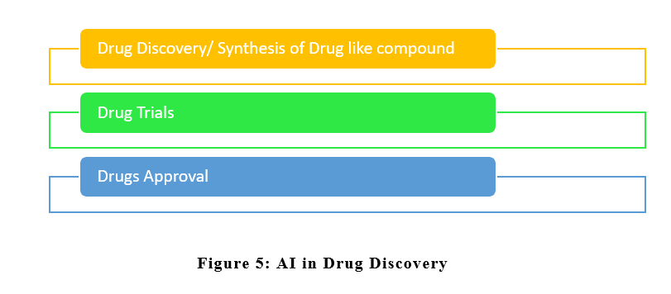
2.4. AI IN PERSONALIZED MEDICINE
Different people respond differently to treatment for the same disease. Better understanding of disease progression through the analysis of patient data can help predict which treatment a patient is most likely to respond to, without any adverse effects. This requires collation of data from each and every patient on almost daily basis integrating health records as well as their lifestyle behavior, recorded through biosensors and wearable devices into one large whole. These elaborate datasets provide vital insight into the mechanistic understanding of chronic diseases and enable earlier intervention. These datasets can only be processed electronically, and this makes it amenable to AI. To emphasize this point, it is pertinent to mention here that a recent Oracle Health Sciences survey revealed that nearly 80% of respondents expected AI to process this information towards guiding individual patients’ treatment. AI allows fast processing of enormous patient data, identify correlation with genetic variation among patient cohorts and develop targeted therapy in the correct doses and treatment schedules, and even address the needs of outliers of clinical trials, the small, specific groups of patients with certain shared characteristics who react differently from majority of the patients (Uddin, 2019).
2.5. AI AND GENE EDITING
The CRISPR/Cas9 system has revolutionized genome editing with precision and in a cost-effective manner. CRISPR/Cas9 technique can be used detect drug targets and carry out genomic analysis of cancer cells. The process involves short guide RNA that target and cleave a specific position in the DNA. Each guide RNA is roughly 20 nucleotides and hundreds of potential guides exist for each target gene and also due to similarity of many genomic regions, the sgRNA can accidentally act upon the wrong gene and cause undesired off-target effects. The collaboration between the computer scientists and biologists is focused on building machine learning tools to provide researchers with an end-to-end system for designing experiments with the CRISPR-Cas9 system – helping researchers select a guide that achieves the intended effect of disabling a particular gene, and reduce mistakes such as cutting the wrong gene (Bhat,2022).
2.6. IMPROVED PATIENT COMPLIANCE
No treatment is of any use unless patient complies with it. Chronic diseases, in particular are often subject to this issue, with poor treatment outcome and increased periods of hospitalization. AI based smartphone applications have been used for assessing and encouraging medication adherence in stroke patients as well as patients with heart disease, and diabetes, with markedly improved clinical outcome (Bates,2021).
2.7. AI AND HOSPITAL ADMINISTRATION
An obvious application of AI in hospital administration is its incorporation into the processes that govern updation, verification and retrieval of information from patient Electronic Health Records (EHR). AI tools can help healthcare providers extract clinically-relevant insights from EHR for research, training and further automation. AI can also enable adoption of digital health by facilitating physicians in recording patient medical information electronically, an otherwise frustrating task in their busy schedules, as the time it taken to record data is time lost with their patients. AI experts are working on developing digital scribes – machine-learning algorithms that can take a conversation between a doctor and patient, deconstruct the text and use it to fill in the relevant information in the patient’s EHR, with the added benefit of standardized data input (Mounikaananthula, 2023). AI is already employed in making appointments through chatbots by many hospitals, with marked reduction in waiting time and preventing crowding in out-patient clinics. ChatGPT, the latest buzzword in the world of Information Technology, deserves to be mentioned here. Despite the sensational news that ChatGPT was able to qualify in the US Medical Licensing Examinations, concerns have arisen with respect to its adoption. ChatGPT has been illustrated to generate patient discharge summary in a short time, as well as simplify radiology reports, factually correct, complete but not completely free from errors.
2.8. AI AND COMMUNITY HEALTH
While most of the information stated above pertains to deployment of AI in diagnostic and therapeutic role, AI tools can aid practitioners of public health through predictive analytics to identify risk factors for disease; and optimization frameworks to target specific at-risk groups in a population. Beneficiaries of focused health campaigns like maternal and reproductive health care, National Tuberculosis Control Programme can be tracked and compliance ensured through AI based apps (SMSala). AI can even be used to detect subtle behavior changes inapparent to the peers, but recordable on wearable devices among soldiers working in stressful environments towards early intervention and suicide and fratricide prevention. The advent of climate change has engendered research into developing machine learning tools to identify and predict climate change-induced illnesses with data obtained from surveys and meteorological surveillance, and guide policy-makers to plan interventions to reduce the impact in vulnerable communities (Sukitsch). AI tools also bear the potential of predicting disease load in a pandemic, as evident from the recent experience with COVID-19 and formulation of policies at regional, national and international level.

3. LIMITATION OF AI IN HEALTHCARE
Like all technologies, AI has its limitations. Apart from the cost in terms of equipment, storage, servers, data processing infrastructure, energy requirement, the integration with medical equipment poses its own challenge. However, the greatest limitation of AI is in it being biased due to the quality of data employed to train the model (Kelly,2019). An AI model is considered biased when it generates an erroneous output due to insufficient or poor model training, and will definitely result in dangerous outcomes. The bias results from training data and includes racial, gender, linguistic and socioeconomic bias. Racial bias was discovered in the dataset of pulse oximetry sensors which did not accurately measure and detect low blood oxygenation in Black and dark-skinned patients, thereby missing serious hypoxemia. An AI algorithm that has not been trained on data from sufficient number of men and women is likely to be error-prone in predicted clinical outcomes in diseases that affect men and women differently. Socioeconomic (SES) bias is reported consequent to data collection primarily from private hospitals that cater only to the rich and affluent. Such a model will result in inequalities in the output for patients with low incomes who may have a higher health risk than people with high incomes. Linguistic bias results mainly from models that use audio data to diagnose diseases such as Alzheimer’s. If not trained with a wide range of accents, the outputs of the models will be biased. Bias cannot be eliminated completely, but can be reduced if the data used to train the model is diverse and reflective of the demographic parameters of the population (Gerke,2019). Even the team of developers should be from multiple backgrounds in order to widen the horizon of the development process.

4. CHALLENGES TO AI IN HEALTHCARE
The greatest challenge to adoption of AI is the reluctance of healthcare personnel, but can be overcome by training. The lack of standardized data available to train models and the lack of regulations pose another set of challenges, as multiple AI service providers compete with each other in marketing their AI tools with unproven efficacy. This may also make patients suspicious towards AI, in addition to their doctors. Most hospitals that cater to the largest proportion of patients may not have the funds to adopt AI, and the legacy systems of the ones that serve the rich and affluent may not be compatible with modern AI tools, preventing interoperability and integration of past data, and necessitating added cost of investment in computing power, and storage capacity, that will be further passed on to the patients. Lack of qualified personnel is yet another challenge, but can be overcome by training and education (Wang,2019). And last, but not the least, the all-pervasive suspicion that adoption of AI means loss of jobs is a challenge that may be laid to rest by the statement quoted at the beginning of this chapter.
5. AI AND STAKEHOLDERS IN HEALTHCARE.
Clinicians, patients, managers, researchers, regulators and industry are the primary stakeholders in the field of healthcare, and they collaborate with the sole aim of improving patient care. The innovation is driven by the ideations of researchers and technical and financial support from the industry. The attitudes of clinicians, patients and hospital administrators are directly linked to the promise, and the success of AI models under development. The onus of driving the investment in AI, however, hinges upon the role of regulators who need to address the needs and fears of the society, and formulate the legal framework that would govern the practice of AI in healthcare, without compromising patient privacy, and ensuring safety and absolute confidentiality of the patient data, fix accountability, and define the ownership of patient data unambiguously. Majority of these concerns have been addressed in the Electronic Health Record policy promulgated by the Government of India, and merit their extension to AI tools intended to be used in healthcare. At present, there are no specific laws in India with regard to regulating AI, ML. The Ministry of Electronics and Information Technology (MEITY) is the executive agency for AI-related strategies in India, and has recently constituted four committees to bring in a policy framework for AI. The Niti Aayog has listed seven AI principles, viz safety and dependability, equality, inclusivity and non-discrimination, privacy and security, transparency, accountability, and the protection and reinforcement of positive human values. These principles are essential for protecting the public interest while simultaneously encouraging innovation through increased trust and adoption. It is hoped that these will guide policy formulation for adoption of AI in healthcare by Ministry of Health and Family Welfare in near future.

6. CONCLUSION
The practitioners of medicine have traditionally been reluctant, if not resistant, towards adoption of new methods and technology, right from the times of Immanuel Semmelweis. Meanwhile, the advancement of science over the centuries has led to the development of techniques and technology-driven instrumentation for the intended use in medical profession through continuous improvement and refinement, often through incremental adoption, and rarely in form of a revolution. The progressive professionals have examined modern tools on their merit and adopted them in order to improve clinical outcomes and benefit their patients. AI promises to be one such able, meritorious, and competent assistant to the sincere, modern but busy physicians that takes over their mundane tasks, and enables them to pay greater attention to direct patient care. This competent assistant can be further promoted to an intelligent one, if the physicians share the valuable clinical data to train and test the assistant, and train themselves to get the most out of their mutual relationship. While AI cannot and should not be used as the sole clinical decision-making tool, it can certainly provide valuable inputs to guide those life-saving decisions. The time has come for both AI and the lay physician to embrace each other for their mutual benefit, and the ultimate benefit of the patients.
REFERENCES
Bates, D. W., Levine, D., Syrowatka, A., Kuznetsova, M., Craig, K. J., Rui, A., Jackson, G. P., & Rhee, K. (2021). The potential of artificial intelligence to improve patient safety: A scoping review. Npj Digital Medicine, 4(1). https://doi.org/10.1038/s41746-021-00423-6
Bhat, A. A., Nisar, S., Mukherjee, S., Saha, N., Yarravarapu, N., Lone, S. N., Masoodi, T., Chauhan, R., Maacha, S., Bagga, P., Dhawan, P., Akil, A. A.-S., El-Rifai, W., Uddin, S., Reddy, R., Singh, M., Macha, M. A., & Haris, M. (2022). Integration of CRISPR/Cas9 with artificial intelligence for improved cancer therapeutics. Journal of Translational Medicine, 20(1). https://doi.org/10.1186/s12967-022-03765-1
Bibault, J.-E., Chang, D. T., & Xing, L. (2020). Development and validation of a model to predict survival in colorectal cancer using a gradient-boosted machine. Gut, 70(5), 884–889. https://doi.org/10.1136/gutjnl-2020-321799
Bizopoulos. P., Koutsouris D., (2019). Deep Learning in Cardiology. IEEE Rev Biomed Eng.
12, pp. 168-193. doi: 10.1109/RBME.2018.2885714. Epub 2018 Dec 10.
PMID: 30530339.
De Santiago, I., & Polanski, L. (2022). Data-driven medicine in the diagnosis and treatment of infertility. Journal of Clinical Medicine, 11(21), 6426. https://doi.org/10.3390/jcm11216426
George, E. I., et al.(2018) “Origins of Robotic Surgery: From Skepticism to Standard of Care.” JSLS : Journal of the Society of Laparoendoscopic Surgeons, 22 (4). https://doi.org/10.4293/jsls.2018.00039.
Gerke, S., Minssen, T., & Cohen, G. (2020). Ethical and legal challenges of artificial intelligence-driven healthcare. Artificial Intelligence in Healthcare, 295–336. https://doi.org/10.1016/b978-0-12-818438-7.00012-5
Isma’eel, H.A. et al. (2017) “Artificial Neural Network-based model enhances risk stratification and reduces non-invasive cardiac stress imaging compared to Diamond–Forrester and morise risk assessment models: A prospective study,” Journal of Nuclear Cardiology, 25(5), pp. 1601–1609. Available at: https://doi.org/10.1007/s12350-017-0823-1.
Jiang, T., Gradus, J.L. and Rosellini, A.J. (2020) “Supervised machine learning: A brief primer,” Behavior Therapy, 51(5), pp. 675–687. Available at: https://doi.org/10.1016/j.beth.2020.05.002.
Kaur, T., Diwakar, A., Kirandeep, Mirpuri P., Tripathi, M., Chandra, P.S., Gandhi, T.K. (2021)
“Artificial Intelligence in Epilepsy”, Neurol India, 69(3), pp. 560-566. doi: 10.4103/0028-
3886.317233. PMID: 34169842.
Kelly, C. J., Karthikesalingam, A., Suleyman, M., Corrado, G., & King, D. (2019). Key challenges for delivering clinical impact with Artificial Intelligence. BMC Medicine, 17(1). https://doi.org/10.1186/s12916-019-1426-2
Labarère, J., Bertrand, R., & Fine, M. J. (2014). How to derive and validate clinical prediction models for use in Intensive Care Medicine. Intensive Care Medicine, 40(4), 513–527. https://doi.org/10.1007/s00134-014-3227-6
Lee, S.H. (2018) “Natural language generation for electronic health records,” npj Digital Medicine, 1(1). Available at: https://doi.org/10.1038/s41746-018-0070-0.
Morris, M.X. et al. (2022) “Deep learning applications in surgery: Current uses and Future Directions,” The American Surgeon, 89(1), pp. 36–42. Available at: https://doi.org/10.1177/00031348221101490.
Mounikaananthula (2023) Artificial Intelligence Innovation: Leading companies in Ophthalmic Imaging System for the healthcare industry, Hospital Management. Available at: https://www.hospitalmanagement.net/data-insights/innovators-ai-ophthalmic-imaging-system-healthcare/ (Accessed: February 23, 2023).
Ning, G. et al. (2006) “Artificial neural network based model for cardiovascular risk stratification in hypertension,” Medical & Biological Engineering & Computing, 44(3), pp. 202–208. Available at: https://doi.org/10.1007/s11517-006-0028-2.
Paul, D., Sanap, G., Shenoy, S., Kalyane, D., Kalia, K., & Tekade, R. K. (2021). Artificial Intelligence in drug discovery and development. Drug Discovery Today, 26(1), 80–93. https://doi.org/10.1016/j.drudis.2020.10.010
Peiffer-Smadja, N. et al. (2020) “Machine Learning for Clinical Decision Support in Infectious Diseases: A narrative review of current applications,” Clinical Microbiology and Infection, 26(5), pp. 584–595. Available at: https://doi.org/10.1016/j.cmi.2019.09.009.
Shankar, K. and Perumal, E. (2020) “A novel hand-crafted with deep learning features based fusion model for covid-19 diagnosis and classification using chest X-ray images,” Complex & Intelligent Systems, 7(3), pp. 1277–1293. Available at: https://doi.org/10.1007/s40747-020-00216-6.
Sheikh, A. et al. (2021) “Health Information Technology and Digital Innovation for National Learning Health and Care Systems,” The Lancet Digital Health, 3(6). Available at: https://doi.org/10.1016/s2589-7500(21)00005-4.
Shrivastava, M., & Kumar, D. (2022). The potential of artificial intelligence in public healthcare industry. Impact of Artificial Intelligence on Organizational Transformation, 349–360. https://doi.org/10.1002/9781119710301.ch20
SMSala. “Fight against Tuberculosis and Infectious Diseases with Artificial Intelligence.” Rising Kashmir, http://risingkashmir.com/fight-against-tuberculosis-and-infectious-diseases-with-artificial-intelligence.
Sukitsch, N. (no date) AI/ML as a tool for climate change and Global Health, LinkedIn. Available at: https://www.linkedin.com/pulse/aiml-tool-climate-change-global-health-nicholas-sukitsch (Accessed: February 23, 2023).
Uddin, M., Wang, Y., & Woodbury-Smith, M. (2019). Artificial Intelligence for precision medicine in Neurodevelopmental Disorders. Npj Digital Medicine, 2(1). https://doi.org/10.1038/s41746-019-0191-0
Wang, F., & Preininger, A. (2019). Ai in health: State of the art, Challenges, and Future Directions. Yearbook of Medical Informatics, 28(01), 016–026. https://doi.org/10.1055/s-0039-1677908
Wu, J. T., Wong, K. C., Gur, Y., Ansari, N., Karargyris, A., Sharma, A., Morris, M., Saboury, B., Ahmad, H., Boyko, O., Syed, A., Jadhav, A., Wang, H., Pillai, A., Kashyap, S., Moradi, M., & Syeda-Mahmood, T. (2020). Comparison of chest radiograph interpretations by artificial intelligence algorithm vs radiology residents. JAMA Network Open, 3(10). https://doi.org/10.1001/jamanetworkopen.2020.22779

