Solar Cells: Types and Applications
Rajveer Kaur
Department of Physics
Guru Nanak College, Sri Muktsar Sahib 152026 (Punjab) India
Email: rjvrbrar05@gmail.com

Abstract:
Solar energy that is obtained from sun is a non renewable source of energy. This energy can be used for variety of purposes. One such purpose is the use of this solar energy by solar cells, which converts this energy into electrical form. Different kinds of materials can used in order to fabricate these solar cells. This chapter will discuss about the improvements that has undertaken in different cells from one generation to another. First generation deals with the silicon based solar cells while second generation solar cell deals with thin films but advancement in technology has led to third generation due to which the efficiency of solar cells has increased by several factors. Third generation solar cells has gained popularity and it is in demand in today’s world. Comparison between different solar cells is also highlighted in this chapter. It also emphasized the applications of these solar cells in domestic and commercial world.
Keywords: Solar Energy, Generation, Cells.
- Introduction

- Sunlight: Source of energy

Sun, which is considered as a star is a source of solar energy. Solar energy is a type of renewable energy that can be harnessed from sunlight and can be converted into some other forms. Sun emits enormous amount of energy in form of electromagnetic radiations which includes visible, infrared and ultraviolet rays. These radiations can then be converted into electricity or heat as per the choice of the user by using latest technological products (Ashok, S. 2023).

Inside the core of the sun, nuclear fusion process takes place. Four hydrogen atom fuse together to form Helium atom and as a result some of the mass is converted into energy. The mass of four hydrogen atoms is 4.03130 a.m.u and mass of one helium atom is 4.00268 a.m.u. The net difference between the masses of these atoms is 0.02862 a.m.u. This small amount of mass is radiated in the form of thermal energy and this energy can keep a 60 watt bulb shine for about 100 years (Spanel Planetarium 2022). There are numerous advantages of this clean energy.

- Renewable and Sustainable: Sun will radiate energy for billions of years and this ensures that this energy has long-term availability as well as sustainability.
- Reduced Pollutants: Solar energy is free from any harmful gases and it is a clean source of energy. Further, it reduces the air pollution level and improves the environmental quality.
- Low Operating Costs: Solar panels required for generation of electricity needs less maintenance and electricity produced by this method can be used for about years.
- Independent Source: Most of the countries do import fossil fuels and dependence on solar energy for variety of applications can reduce vulnerability of disruptions as well as price fluctuations.
- Employment: Addition of new source of energy in present sources will increase employment opportunities in different sectors like research, manufacturing, installation and maintenance.
- Advancement in Technology: Advancements in solar technology have led to increase in efficiency, low maintenance costs, improvement in type of devices being used.
- Low transmission losses: Solar power generation can be localized and as a result energy losses can be minimized.

Although there are plenty of advantages of solar energy but there are disadvantages too. Firstly, during bad climatic conditions it becomes difficult to take benefit from solar energy in terms of its applications. Secondly, the intensity of radiations is not constant throughout the day due to which there might be some fluctuations in the value of current. Thirdly, solar energy is not available during night time. Also, solar power setups are installed by keeping in view the geographical location of the area as ample amount of sunlight is required for generation purpose. Research and development in this field are moving forward to diminish the effect of these disadvantages, making solar energy as a sustainable option (Lakatos et al. 2011; Sharma et al. 2015).

- Solar Cells

Solar cells are composed of semiconductor materials mainly silicon. Electric current is produced when sunlight fall on these cells. This current can be used for many purposes by converting it into suitable form. In order to have high conversion efficiencies, a lot of research activities are going on in the manufacturing process of these solar cells. Solar cells are also known as photovoltaic cells. Collection of tiny solar cells is known as solar panel. These cells are arranged in a definite pattern so that enormous amount of power supply can be obtained. Following is the mechanism that goes on inside the solar cell:
- Holes (p-type) and electrons (n-type) gets generated when sunlight falls on the surface of solar cell.
- Separation of charge carriers, holes and electrons.
- Collection of these carriers on respective electrodes and thus a potential difference gets developed across the junction

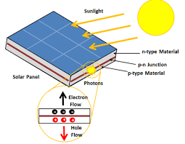
Figure 1: Solar panel
Different kinds of semiconductor materials are employed for designing of solar cells in order to have high efficiency. Now-a-days solar panels that are covered with glass sheets are employed on the roofs for obtaining high powers. Solar cells come in different types and each of them has its own characteristics (Choubey et al. 2012)

- Types of solar cells

In 1839, Alexandre-Edmond Becquerel observed the first photovoltaic cell. Earlier, solar cells were made from thin silicon wafers and sunlight was converted into electricity by using such wafer. In 1946, Russel Ohl invented the first solar cell which was made up of silicon. Now-a-days solar cells works upon the principle of generation of electron and hole in a semiconductor material and such a material has two different layers in it namely p-type and n-type. When photons strike the junction of semiconductor material, electron gains energy and jump to conduction band and thus leaving a hole behind. In such a process, creation of hole and electron give rise to electrical power (Askari et al. 2015).

On the basis of materials used in such a photovoltaic cells, solar cells are classified in different classes as discussed in the following sections.

  - First generation Solar Cells: Wafer based

- Monocrystalline Solar cells: These kinds of cells are made from a single crystal structure. Crochralski method is used in manufacturing process. In this particular kind of process, a big sized ingot is sliced into Si crystals. The resulting bars will be pure in nature. Due to such purity, these solar cells are quite expensive. The efficiency of these cells lies between 17%-18%. The shape of these solar cells is hexagonal or round and hence some empty space is being left when solar panels are constructed from such cells. The life span of such solar cells is of 50 years (Sharma et al. 2015).

- Polycrystalline (Multicrystalline) Solar cells: In this kind of solar cells, silicon is made from multiple crystals. Rods of several silicon crystals are melted and then the molten silicon is poured into square mold. Solar cells made from such kind of process are not identical to each other. These solar cells are affordable but its efficiency is less as compared to monocrystalline solar cells. Efficiency of about 12%-14% is achieved in such a kind of solar cell. These solar cells are squared in shape and hence less empty space is there between the cells (Sharma et al. 2015).

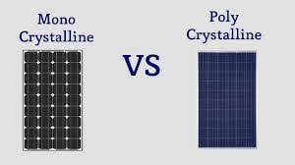

Figure 2. Monocrystalline and Polycrystalline solar panels

  - Second generation Solar Cells: Thin-film Solar cells

Thin-film Solar cells are developed by depositing thin layers of some photovoltaic materials onto a substrate. This substrate can be a glass, metal or plastic. Its advantages include flexibility and lightweight. However, its efficiency is low as compared to crystalline silicon cells. These kinds of solar cells have 1 µm of absorbing layers while silicon wafers have 350 µm of absorbing layers.

Second generation solar cells can be further classified into three types:

- Amorphous Silicon (a-Si) Thin-Film: This kind of solar cell can be manufactured at low temperatures. So, substrates that require less amount of energy can be used. It can be integrated into curved or flexible surfaces. These kinds of solar cells are made by taking a substrate and coating its backside with doped silicon material. The silicon material used here does not have a definite arrangement of atoms. It is not highly structured. Moreover, this kind of solar cell is cheap and is available widely. The reflecting side of these solar cells is dark brown in color and conducting side is silver in color. As per the efficiency is concerned, it has efficiency of 4%-8%. However these can be used in areas where sun shines for just few hours (Sharma et al. 2015).
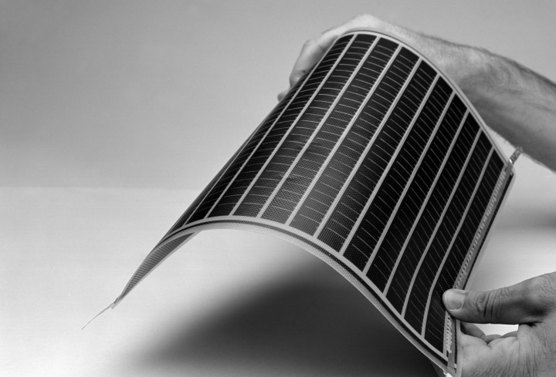
Figure 3: Amorphous Silicon PV modules

- Cadmium Telluride (CdTe) Thin-Film: Band gap CdTe is 1.5 eV. It is direct band gap semiconductor and hence absorption of light is easy. It has high optical absorption coefficient. It is chemically stable. Due to these features, it is one of the most in-demand materials that can be used in designing of such thin-film solar cells. Moreover, CdTe solar cells are more economical as compared to other thin films solar cells. It consists of a p-n hetero junction which contains p-type layer of CdTe layer that matches with window layer made up of n-doped cadmium sulfide. Following are the steps involved in manufacturing process of such a cell:

- A substrate material is chosen such as glass.
- Polycrystalline material is taken from which CdTe solar cells are to be made.
- Deposition method is used in which multiple layers of CdTe is coated on substrate.
Its efficiency lies between 9%-11%. The main disadvantage of such kind of cell is the use of Cadmium in it. Cadmium is a toxic agent. It can accumulate in animals, plants and human bodies. Recycling process of such a material is also expensive (Askari et al. 2015; Sharma et al. 2015).
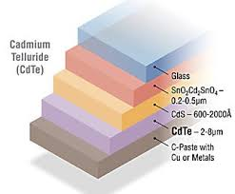
Figure 4. Five layers of CdTe Solar Cell

- Copper Indium Gallium Selenide (CIGS) Thin-Film: Four elements are present in such kind of solar cells namely: Copper, Indium, Gallium and Selenide. These elements are deposited on flexible substrate. The electrodes are formed at back and front surface so that current can be collected. This kind of solar cell has high absorption coefficient so, a much thinner film is required for them. The techniques that are followed during its manufacturing process are sputtering, evaporation, electrochemical coating and electron beam deposition. It is also a direct band gap semiconductor. Its efficiency lies in range of 10%-12%. It has long lifetime (Askari et al. 2015; Sharma et al. 2015)
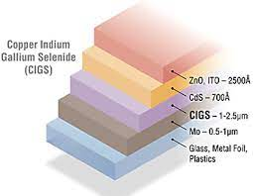
Figure 5. Copper Indium Gallium Selenide Solar cell

  - Third generation Solar Cells: Emerging new technology

Third generation solar cells have been introduced so that conversion efficiency could be increased and cost of the material used should be decreased.

- Nanocrystal Solar cells: These cells are known as quantum dot solar cells (QDSC). Bulk materials like Si, CdTe or CIGS can be replaced by these kinds of solar cells. Quantum dots have tunable band gaps and changing their size can lead to absorb maximum amount of energy. The absorbing photovoltaic materials used in these are from transition metal groups whose size lies in nanocrystal range. Quantum dot material is deployed between hole and electron transport medium as shown in figure. It is known that a silicon solar cell has efficiency range of 30%-33%. As the number of layers in a cell is increased, efficiency factor also gets increased.

Type of cell | Band gap | Efficiency
Two layer cell | 1.64 eV, 0.94 eV | 44%
Three layer cells | 1.83 eV, 1.16 eV, 0.71 eV | 48%
Infinite layer cells | - | 86%

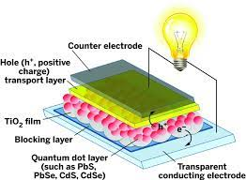

Figure 6. Quantum dot Solar Cell

Main advantages of quantum dot solar cell are:

- Size-based quantum confinement enables us to tune the band gaps and thus optical response can be improved.
- Quantum dots makes possible to generate multiple charge carriers from a single photon.
The only limitation that occurs in such kind of cells is recombination of charge carriers which is the main disadvantage in every solar cell (Rehman et al. 2023)
- Concentrated Solar cells
This is one of the newest technologies that are gaining the popularity in research and development. Here optics is being employed in such a way that large amount of energy is concentrated on small portions. Mirrors and lens are arranged in such a way that sunlight rays could be focused on a small area. The optics behind such a phenomenon is when radiations do fall on those lenses or mirrors; the light gets converged and large amount of heat energy is being produced. It is one of the leading solar cell in solar world. It depends upon the type of lens system that is being used that how much amount of energy is concentrated on particular place.The efficiency in these solar cells is more than 40%. Advantages of these solar cells are quick response time, no moving part and no thermal mass gets involved. It can be made in different sizes (Philipps et al. 2015)
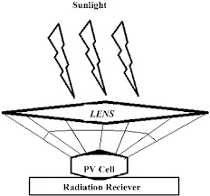
Figure 7. Concentrated Solar Cells
- Dye-sensitized solar cells
DSSCs use a dye-coated semiconductor to absorb light and generate electricity. These are also known as G cells as the first DSSC was made by Michel Gratzel at Swiss Federal Institute of technology. Dye molecules are employed between electrodes. Four components that are involved in these cells are semiconductor electrode, a dye sensitizer, redox mediator and counter electrode. These solar cells are quite attractive, transparent, and low cost and are flexible. Its efficiency is greater than 10%. The only issue that occurs with these cells is when they are exposed to ultraviolet or infrared radiations, dye molecules gets degraded due to which lifetime and stability of these cells gets decreased. However, they can be used in low-light conditions and in some artistic applications due to their translucent properties (Suhaimi et al. 2015)

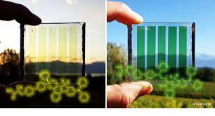
Figure 8. Dye Sensitized Solar Cells
- Organic Solar cells
Organic solar cells use organic materials, such as polymers or small molecules, to generate electricity. They have the potential for low-cost and flexible applications but currently have lower efficiency compared to other types of solar cells. It was invented by Tang et al. at Kodak Research Lab. Yu et al. mixed poly [2-methoxy-5-(2’-ethylhexyloxy)-p-phenylene vinylene] (PPV), C60 and its other derivatives to develop the first polymer solar cell. He obtained high power conversion efficiency. These cells are made up of thin functional layers that are coated on a polymer foil or ribbon. In order to absorb sunlight, different materials can be used like conducting polymers. These kinds of solar cells has opened door for other stretchable solar devices that includes textiles and fabrics (Min, Ho 2016)
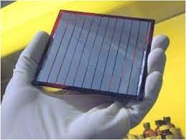
Figure 9. Organic Solar Cells

- Perovskite Solar Cells
Perovskite solar cells are a rapidly emerging technology that uses materials with a perovskite crystal structure. The material used in these cells are class of compounds, ABX₃ where X is a halogen namely I⁻, Br⁻, Cl⁻ and A and B are cations of different size. They are superiors as compared to conventional and thin film based solar cells. In case of conventional solar cells, multiple processing steps are needed and temperature of about 1000º C is generated. Moreover in some cases, vacuum facilities are also required. The conversion efficiency in this case is 31%. They can be made with low-cost manufacturing processes and have shown remarkable efficiency improvements in a short time. However, they are still being developed and face challenges related to stability and durability (Ahn et al. 2015; Tina et al. 2015; Shi et al. 2015)
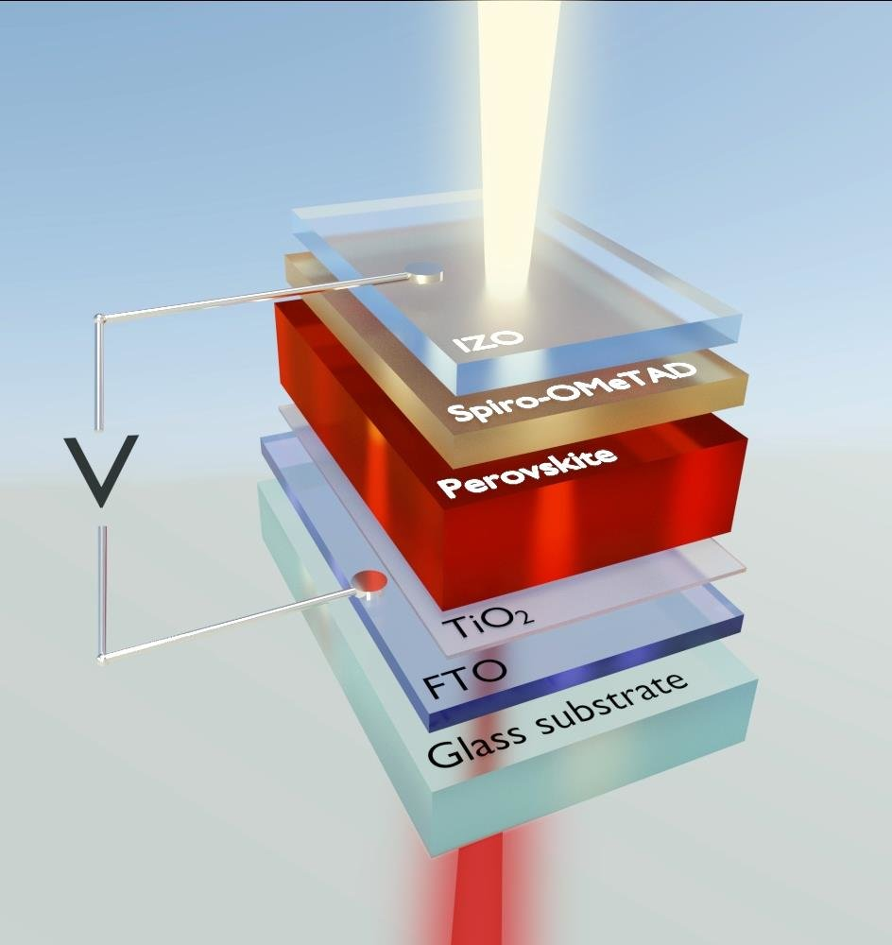
Figure 9. Perovskite Solar Cells

- Tandem Solar Cells
Tandem solar cells combine two or more different types of solar cell materials with complementary absorption spectra in order to increase overall efficiency. For example, one layer may absorb high-energy photons while another absorbs lower-energy ones. The efficiency of solid Si solar cell is almost 25% and its band gap is just 1.1 eV and therefore it can absorb low energy photons. Perovskite band gap can vary from 1.6 eV- 2.3 eV so it can absorb some high energy photons. 4T Tandem solar solar has four terminals. Fabrication of both solar cells is done separately. Both are brought together and placed over each other. Tandem solar cells can be placed on the top while Si based solar cells can be placed at bottom. In case of 2T Tandem solar cells, high class equipment and more considerations are require in order to manufacture it as here only two terminals are required. Firstly, Silicon solar cell is made and then Perovskite layer is being deposited over it. Tandem solar cells are transparent and hence light can easily pass from these to lower Silicon solar cells. This kind of cell can increase the efficiency to even 44%.
Each type of solar cell has its own strengths and weaknesses in terms of efficiency, cost, flexibility, and suitability for various applications. Ongoing research and development are continually pushing the boundaries of solar cell technology to improve efficiency and accessibility (Ašmontas et al 2023).
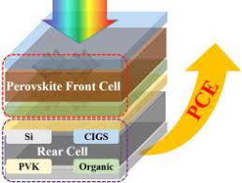
Figure 11. Tandem Solar Cell

- Comparison of solar cells

- In terms of efficiency
Third generation solar cells are more efficient as compared to other generations (Ankur et al. 2019; Sharma et al. 2015)

Graph 1: Comparison of maximum efficiency corresponding to type of solar cell

- In terms of cost effectiveness
First generation is two times more expensive than second and third generation solar cells (Ankur et al. 2019; Sharma et al. 2015).

Graph 2: Comparison of Expensiveness with respect to different generations of solar cells
- Applications of solar cells

- Homes: Solar energy is used at homes for variety of purposes. Photovoltaic cells can be installed on the roof of the house and solar energy can be stored in batteries and can be used for different purposes.

- Commercial Purposes: Solar panels or PV modules can be installed on roofs of buildings and thus electricity can be provided to different offices working under that roof. These cells collect solar energy from sun and convert it into suitable form so that the power can be used for different purposes.

- Power pump: It can be seen that in today’s modernized world, agriculture is based on use of these solar panels. Power pumps can be connected to these solar power supplies so that flow of water can be maintained.

- Swimming pools: It is difficult to keep the water hot in pools during summer season by utilizing minimum power. A solar blanket can be added in the pool so that water can remain hot with energy that can be taken from sunlight. Moreover, solar heating setup can be installed that can have heating panels in order to keep water hot during winters.

- Street lights: Solar energy can be used in street lights. It can store solar energy during day time and this energy is further converted into electrical form during night time for lightening up the lights. This technology is used in many parts of the world so that dependence on fossil fuels for generation of electricity can be reduced.

- Solar Cars: Solar panels can be used in cars. Solar cars can be recharged by using solar light. These absorb sunlight and convert it into electrical energy. This electrical energy is further stored in the batteries that are installed in solar cars so that we can use this energy during night time.

With advancement in technology, the solar cells are being modified so that efficiency could be improved. One such advancement is of carbon nanotubes. It can enhance the light absorption capabilities of cells (Askari Mohammad Bagher et al. 2015).

- Conclusion
In order to meet the high energy demand, solar power generations have been developed. It offers numerous advantages as compared to other forms of energy like fossil fuels and other deposits. Although the methods used in generation of electrical energy is same in every cell but the efficiency factor depends upon the type of material that is being used in a cell. Each kind of material used in a cell has its own advantages and disadvantages. Tandem solar cells can convert maximum solar energy into electrical form. Also, other kinds of cells are economical and viable. However, different considerations are to be considered in choosing a particular cell for different kinds of applications. The research on achieving the efficiency towards maximum percentage is still going on and it is the need of the today’s world.
References:

- Ahn, N., Son, D.-Y., Jang, I.-H., Kang, S.M., Choi, M. and Park, N.-G. (2015). Highly Reproducible Perovskite Solar Cells with Average Efficiency of 18.3% and Best Efficiency of 19.7% Fabricated via Lewis Base Adduct of Lead(II) Iodide. Journal of the American Chemical Society, 137, 8696-8699. http://dx.doi.org/10.1021/jacs.5b04930
- Ankur Kumar Bansal, Dinesh Kumar, Dr. Mukesh Kumar. (2019). A Review Paper on Development in Material Used in Solar Pannel as Solar Cell Material. SSRG International Journal of Mechanical Engineering, vol. 6, no. 6, pp. 35-41, 2019. https://doi.org/10.14445/23488360/IJME-V6I6P107
- Ashok, S. (2023). Solar energy. Encyclopedia Britannica. Available at: https://www.britannica.com/science/solar-energy.
- Askari Mohammad Bagher, Mirzaei Mahmoud Abadi Vahid, Mirhabibi Mohsen. (2015). Types of Solar Cells and Application. American Journal of Optics and Photonics. Vol. 3, No. 5, pp. 94-113. Doi: 10.11648/j.ajop.20150305.17.
- Al-Ezzi, A.S.; Ansari, M.N.M. (2022) Photovoltaic Solar Cells: A Review. Appl. Syst. Innov., 5, 67. https://doi.org/10.3390/asi5040067.
- Ašmontas, S., & Mujahid, M. (2023). Recent Progress in Perovskite Tandem Solar Cells. Nanomaterials, 13(12), 1886. MDPI AG. Retrieved from http://dx.doi.org/10.3390/nano13121886.
- Choubey, P. C., Oudhia, A., & Dewangan, R. (2012). A review: Solar cell current scenario and future trends. Recent Research in Science and Technology, 4(8). Retrieved from https://updatepublishing.com/journal/index.php/rrst/article/view/942.
- Lakatos, Laszlo & Hevessy, G. & Kovács, J. (2011) Advantages and Disadvantages of Solar Energy and Wind-Power Utilization. World Futures. 67. 395-408. DOI: 10.1080/02604020903021776.
- Min, Ho. (2016). A Review on the Organic Solar Cells. Australian Journal of Basic and Applied Sciences. 10. 21-24.
- Philipps, S.P., Bett, A.W., Horowitz, K. and Kurtz, S. (2015). Current Status of Concentrator Photovoltaics (CPV) Technology. Report Version 1.2, Fraunhofer Institute for Solar Energy Systems (NREL).
- Rehman, Fatima & Syed, Iqrar & Khanam, Saira & Ijaz, Sumbel & Mehmood, Haris & Zubair, Muhammad & Massoud, Yehia & Mehmood, Muhammad Qasim. (2023). Fourth Generation Solar Cells: A Review. Energy Advances. DOI: 10.1039/D3YA00179B.
- Sharma, S., Jain, K. and Sharma, A.(2015) Solar Cells: In Research and Applications—A Review. Materials Sciences and Applications, 6, 1145-1155. Doi: 10.4236/msa.2015.612113.
- Shi, D., Zeng, Y. and Shen, W. (2015). Pervoskite/c-Si Tandem Solar Cell with Inverted Nanopyramids: Realizing High Efficiency by Controllable Light Trapping. Scientific Reports, 5, Article No. 16504.
- Spanel Planetarium. (2022). The Sun and Nuclear Fusion. Available at: https://www.wwu.edu/astro101/a101_sun.shtml.
- Suhaimi, S., Shahimin, M.M., Alahmed, Z.A., Chyský, J. and Reshak, A.H. (2015). Materials for Enhanced Dye-Sen-sitized Solar Cell Performance: Electrochemical Application. International Journal of Electrochemical Science, 10, 28- 59.
- Tina Casey. (2015). An Article on Perovskites Will Power New Low-Cost & Highly Efficient Solar Cells. Clean Technical.

