Chapter
Manglicolous Endophytic Fungi as a Source of L-asparaginase

Neema Job, Ashly Augustine, Kottayath Govindan Nevin

Contents
Introduction………………......................................................................................................3
L-asparaginase in cancer therapy.............................................................................................4
L-asparaginase in the Food industry........................................................................................5
Clinically available L-asparaginase.........................................................................................6
Sources of L-asparaginase.......................................................................................................6
L-asparaginase production by marine endophytic fungi.........................................................7
Assay for screening and quantifying L-asparaginase activity in endophytic fungi………….8
Production optimization and purification……………………………………………………9
Enzyme Kinetics……………………………………………………………………………..10
Improving the production by Cloning and expression of L-asparaginase gene………………10
Biocompatibility and anticancer properties of L-asparaginase………………………………11
Conclusion……………………………………………………………………………………13
Acknowledgment……………………………………………………………………………14
References…………………………………………………………………………………14

Job N •Augustine A • K G Nevin (*)
Department of Marine Biosciences, Faculty of Ocean Science and Technology, Kerala University of Fisheries and Ocean Studies, Panangad PO, Kochi-682506, India
Centre for Bioactive Substances from Marine Organisms, Kerala University of Fisheries and Ocean Studies, Panangad PO, Kochi-682506
e-mail: nevinkg@kufos.ac.in
Abstract
Mangroves are considered as a dynamic transition zone between terrestrial and marine habitats. They exhibit high levels of biodiversity along tropical and subtropical coastlines because they coexist with both marine and terrestrial habitats. Since mangrove forests are home to the second-largest group of the marine fungal group, they are always regarded as biodiversity "hotspots." The mycotic inhabitants of mangroves, especially endophytes, are adapted to changing environmental conditions and can withstand a variety of physical and biological stressors, making them promising sources for the recovery of novel bioactive chemicals. Additionally, several mangrove species are useful sources of secondary metabolites with therapeutic benefits. As a result, the pharmaceutical, food, and agricultural industries have recognized extensive potential use for secondary metabolites generated from mangrove endophytic fungus. L-asparaginase is a significant enzyme that is commonly used as an antitumor agent in the treatment of acute lymphoblastic leukaemia (ALL), the most common pediatric cancer. The use of these enzymes as therapeutics selectively differentiates normal cells and promotes apoptosis of only cancerous cells due to their mode of action. The production of L-asparaginase by fungus appears more promising in light of the increased similarity of fungi to humans, which may reduce the likelihood of immunological reactions. In the food industry, asparaginase is also successfully utilized to lower the development of acrylamide in processed meals with high starch contents. To identify asparaginase production, extensive screening and quantification approaches have been developed, however, the majority of them have shown to be more complicated and deficient in established pharmaceutical quality control standards. To get around these restrictions, this review provides information on straightforward screening techniques using a dye-based plate assay on modified Czapek Dox medium with phenol red and bromothymol blue indicators, as well as reasonably simple and accurate colorimetric techniques for enzyme quantification (Nessler method, L-aspartic acid -hydroxamate (AHA), and indo-oxine). It is also worth noting that this method is better suited for assuring accurate and representative asparaginase activity in research. Finding innovative remedies is critical in today's world, where cancer and other terrible diseases are so prevalent. Despite the fact that asparaginase production from medicinal plants has been extensively studied, this review will look at the potential benefits of using marine fungi associated with mangroves as a tool for biotechnological, therapeutic, and industrial applications.
Key words: Endophytic fungi;Mangroves; lymphoblastic leukaemia; L-asparaginase

Introduction
Marine fungi form an ecological group that is either obligate or facultative. Among them, obligate marine fungi are those that grow and sporulate solely in marine water, while facultative marine fungi are those that grow from freshwater or terrestrial milieus and can sporulate in the marine environment under certain physiological variations (Raghukumar 2008). However, about 74,000 fungal species have been estimated so far, with an overall expected global fungal diversity of 1.5 million species. It is expected that the fungal diversity in individual habitats has been considerably underestimated, for example, marine fungi from sediments avoid microscopic detection due to their tendency to form aggregates (Rateb and Ebel 2011).
These marine fungi are mainly important in coastal systems, as decomposers of vascular plants and are also found among the “symbionts”, the “parasites” and the “super parasites”. (Sieburth 1979). The extreme conditions in marine environments, such as a change in pressure, temperatures, salinity, and relative oxygen amount (Raghukumar 2008) induce great challenges. The organisms which live and thrive despite those stresses are expected to produce metabolites that might be of interest to drug prospectors. Therefore, many researchers are interested in bioprospecting the newly emerging group of association, endophytic fungi that are less investigated in the marine field.
Because of their peculiar environment, plant endophytic fungi associated with mangrove plants are of particular interest. Mangroves are halophytes that grow in the intertidal zone of tropical or subtropical climates. Mangrove plants exhibit significant biodiversity along the tropical and subtropical coastlines because they embrace both marine and terrestrial habitats. Furthermore, mangrove forests are regarded as biodiversity "hotspots," as they are home to the second biggest fungal group among marine fungi (Thatoi et al. 2012). The tremendous richness seen in mangrove species emphasizes the relevance of studying these plants as part of a series of studies on fungi connected with marine plants (Kohlmeyer and Volkmann-Kohlmeyer 1991).
Various natural metabolites have been characterized from manglicolous endophytic fungi including antimicrobial, anti-inflammatory, anticancer, antituberculosis, and antimalarial activities (Gunatilaka 2006; Hazalin et al. 2009; Gordien et al. 2010; Elfita et al. 2011; Ahmed et al. 2011; Mohana et al. 2012; Praptiwi et al. 2013; Zhang et al. 2014). In addition to these, endophytes have been identified as a promising source of valuable enzymes with various biotechnological applications (Firáková et al. 2007; Pimentel et al. 2011). They are reported to be producers of hydrolytic and oxidative enzymes; with amylase, cellulase, lipase, chitinase, pectinase, tyrosinase, protease, and ligninase activity (Bonugli-Santos et al. 2015). The role of these extracellular hydrolytic enzymes in litter degradation of tropical plant communities, such as a mangrove community, was studied by Kumaresan and Suryanarayanan (2002). Such knowledge is pertinent, as mangroves are one of the most productive natural ecosystems (Kohlmeyer and Volkmann-Kohlmeyer 1998).
Exploration for enzymes, like asparaginase and tyrosinase has recently augmented due to their medicinal value in the treatment of cancer, Parkinson’s disease, and myocardial disease. Among them, L-asparaginase is the pioneer and largest group of therapeutic enzymes used in cancer treatment especially Acute Lymphoblastic Leukaemia (ALL) and other non-Hodgkin lymphomas (Kumar and Sobha 2012). Currently, L-asparaginase is also used in food manufacturing to reduce the formation of acrylamide in fried and oven-cooked foods. This enzyme is produced by a diverse source of organisms such as plants, animals, and microorganisms including bacteria, fungi, and actinomycetes. As extraction of L-asparaginase from mammalian cells is very challenging and expensive, the best-known source was from bacterial origin chiefly E. coli and Erwinia carotovora. But, in 60% of patients, it ends up with serious clinical complications like hypersensitivity reactions, toxicity, and even death. Moreover, bacterial asparaginases are contaminated with glutaminase, which adds to side effects like hyperglycemia, abnormalities of homeostasis, lipid metabolism, and neurological disorders (Geuenich et al. 1998; Duval et al. 2002; Kumar et al. 2011b). In addition to the presence of glutaminase, concomitant urease leads to hydrolysis of urea in blood and causes toxic reactions, also demands additional purification steps needed to maintain the drug efficacy.
Due to immunogenic complications associated with the currently used microbial sources (E. coli and Erwinia carotovora), there is a requisite to switch to novel natural sources to serve as non-immunogenic and better production sources of L-asparaginase. Recently, endophytic fungi have received much attention because of their ability to produce diverse bioactive enzymes. The main reason for studying endophytic fungi is that they are phylogenetically related to the host and are non-immunogenic. Being eukaryotic their post-translational modifications are the same and considered an unexplored source of novel drugs. As fungal endophytes reside inside the plant body, the stability issues are also tackled and they have been recognized as a repository of novel secondary metabolites. These benefits made endophytic fungi the most reliable and potent source for screening L-asparaginase. It was also found that several species of this ecological group i.e., halophilic mangrove endophytes are an excellent source of L-asparaginase and are considered comparatively safe for the treatment of hypersensitive patients. Thus, in this present scenario, where cancer-like dreadful diseases are so prevalent, the discovery of novel therapeutics is of utmost importance for the treatment. As a result, this review focuses on the enzyme L asparaginase, various preliminary screening methods, quantitative estimation, testing the efficacy and biocompatibility of the enzyme in different cancer cell lines, the possibility of cloning, and its future applications in industrial and medical fields. The potential of a fungal endophyte generated from mangroves to create the novel anticancer medication L-asparaginase is a starting point for further research into its metabolic activity.
L-asparaginase in cancer therapy
L-asparaginase (E.C.3.5.1.1, L-asparagine amidohydrolase) is an enzyme that hydrolyses the free amino acid L-asparagine to L-aspartic acid and ammonia (Goodsell 2005; Verma et al. 2007). Asparagine is a non-essential amino acid in normal healthy cells and has asparagine synthetase located on chromosome no. 7q 21.3 for the synthesis of asparagine from aspartate and glutamine using ATP.
However, certain tumour cells depend on an exogenic source of asparagine for protein synthesis, because they lack or express very low levels of asparagine synthetase. Therefore, exhaustion of asparagine by L-asparaginase leads to the selective death of tumour cells (Broome 1968). L-asparaginase selectively depletes the serum asparagine, which devoid the tumour cells of their only source of asparagine leading to their cell cycle arrest in the G0/G1 phase (Kumar and Sobha 2012; Offman et al. 2011). The free enzyme is intravenously injected to reduce the L-asparagine concentration in blood and thereby, selectively kill the cancer cells. The nutritional stress induced by asparaginase leads to DNA, RNA, and protein biosynthesis inhibition in Acute Lymphoblastic Leukaemia (ALL), acute myeloblastic leukemia (AML), and other asparagine-dependent tumor cells resulting in subsequent apoptosis (Fig. 1).

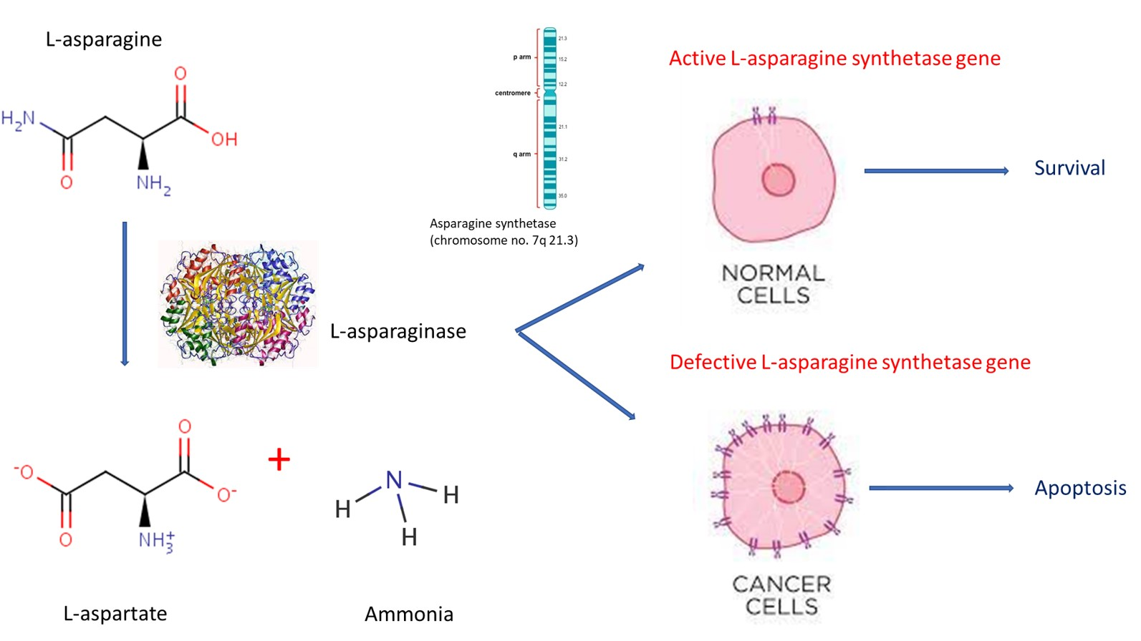
Fig. 1 Functional role of L-asparaginase in normal healthy cells and leukemic cells

L-asparaginase in the Food industry
In the food industry, during baking and frying of starchy foods at high temperatures of about 120 °C, acrylamide, a neurotoxin, is produced as a result of the Maillard reaction. At high temperatures, the alpha-amino group of amino acid asparagine and the carbonyl group of glucose in bread, potato, and other starch foods, reacted to form this carcinogenic acrylamide. As L-asparaginase could convert L-asparagine to aspartate, its ability opens the way to reduce the precursor and reduce the risk of acrylamide formation. Moreover, L-asparaginases are tasteless and odourless, they can be readily incorporated in bread doughs and other baked products to avoid acrylamide formation (Fig. 2). Nowadays L-asparaginases from Aspergillus oryzae and Aspergillus niger are used in the food industry for this purpose (Mottram et al. 2002; Pedreschi et al. 2008; Morales et al. 2008).
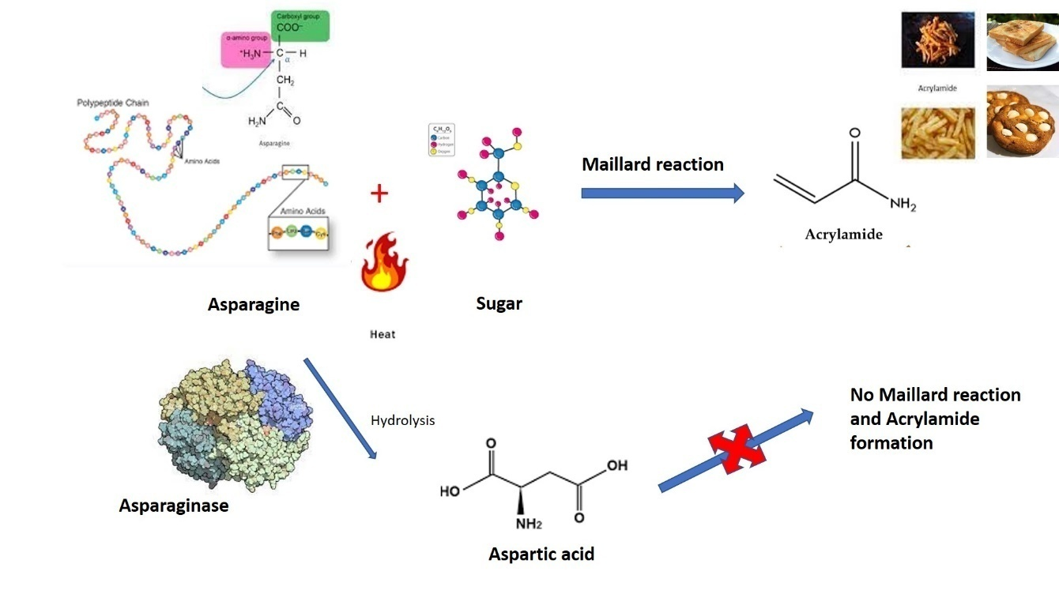

Fig. 2 Mode of action of L-asparaginase in Food industry
Clinically available L-asparaginase
The efficiency of L-asparaginase in the treatment of human leukemic subjects was first successfully validated by Oettgen et al. (1967). Mainly E.coli asparaginases are marketed under commercial names Kidrolase, Elspar, Crasnitin, Leunase, and Asparaginase Medac. A PEGylated enzyme, Oncaspar1 (pegaspargase), is widely used for the treatment of pediatric acute lymphoblastic leukemia and is already in use in the clinic (Kumar and Sobha 2012). Without hindering the antitumor activity, PEGylation successfully modifies the chemical nature of an enzyme with reduced immunogenicity. Asparaginase and PEGylated forms of asparaginase are effective adjuncts for standard chemotherapy (Blain et al. 2002). Recombinant Erwinia asparaginase was also available as Erwinase (Allas et al. 2009).
Sources of L-asparaginase
The presence of L-asparaginase from an animal source like the blood of guinea pig serum was first reported by Clementi (1922). Later Kidd (1953) described the antitumor activity of guinea pig serum against the growth of lymphosarcoma in mice and rats. Broome (1963) was the pioneer in recognising the role of L-asparaginase as an effective constituent for the inhibition of a tumour. Then onwards, this enzyme holds a key role in the treatment of Acute Lymphoblastic Leukaemia (ALL) (Boyse et al. 1967; Alpar and Lewis 1985). This enzyme was also found in tissues of several animals like the liver of rats, tissues of fish, and internal organs of many mammals and birds (Adamson and Fabro 1968; Cooney and Handschumbcher 1970). Similarly, in plants, it is found in Pisum sativum, Glycine max, Oryza sativa, Hordenum vulgareroots, Lupinus, and other species (Konrad et al. 1988; Sieciechowicz and Ireland 1989; Borek and Jaskolski 2001). In the case of microbial origin, the major bacterial source reported were Bacillus subtilis, Corynebacterium glutamicum, Erwinia chrysanthemi, Escherichia coli, Rhodosporidium toruloides, Serratia marcescens, Thermus thermophiles, Vibrio proteus and Zymomonas mobilis(Cedar and Schwartz 1967; Stern et al. 1976; Mesas et al. 1990; Sinha et al. 1991; Ramakrishnan and Joseph 1996; Aghaiypour et al. 2001; Prista and Kyridio 2001; Pinheiro et al. 2001; Kelo et al. 2002; Fisher and Wray 2002; Kotzia and Labrou 2007). In E. coli there are two types of L-asparaginase (L-Asn I and L-Asn II) of which Asn I is cytoplasmic and Asn II is periplasmic. The amido-hydrolytic activity is observed only in ECAII (E.coliasparaginase II). Among actinomycetes, several Streptomyces species (Narayana et al. 2008) were identified with active asparaginase production. Several eukaryotic microorganisms like yeast and filamentous fungi were identified as capable of asparaginase production. Mitosporic fungal species such as Aspergillus terreus, Aspergillus nidulans, Penicillium, Mucor, and Fusarium sp. and the yeast, Candida utilis, also have been reported to produce L-asparaginase that is nontoxic and ensure myelosuppressive and immunosuppressive activity (Ali et al. 1994; Patil et al. 2012).
Correspondingly L-asparaginase isolated from purified Chlamydomonas sp. (Paul 1982), was also identified as the first enzyme to be purified from marine microalgae, with restricted antitumor activity. Asparaginase was even isolated from protozoa, Tetrahymena pyriformis. Though the enzyme is widely distributed, only some of these L-asparaginases possess the anti-neoplastic activity and among the microbial sources, the most commercially notable ones are Escherichia coli, Erwinia carotovora,and Serratia marcescens. In most microorganisms, L- asparaginase is an intracellular enzyme; the prevalence of both periplasmic and cytoplasmic enzymes has been reported (Schwartz et al. 1966). The study on the localization of any enzyme plays a vital role in the development of a suitable bioprocess (Moorthy et al. 2010).
L-asparaginase production by marine endophytic fungi
Endophytic fungi live symptomless in the host plant and the interactions of endophytic fungi with their host leads to the production of a battery of secondary metabolites. L-asparaginase-producing fungal endophytes have been reported on the modified Czapek Dox medium with L-asparagine as a nitrogen source (Jain et al. 2012). Similarly, endophytic fungi from Thai medicinal plants were also evaluated to produce asparaginase (Theantana et al. 2007). Asparaginase-producing endophytic fungi have been isolated from various sources such as soil samples, medicinal plants, and tropical pitcher plants (Patil et al. 2012; Lee et al. 2014). Microorganisms in extreme living conditions like marine environments are expected to yield halophilic proteins and enzymes with modified structures and diverse immunological properties. Due to their immense genetic and biochemical diversity, marine microorganisms are viewed as a novel promising source of enzymes with immense technological applications (Debashish et al. 2005; Zhang and Kim 2012). Studies byThirunavukkarasu et al. in 2011 revealed that apart from the fungal genera like Aspergillus, Penicillium, and Fusarium, several other endophytic fungal species are also good sources of L-asparaginase. The absorptive mode of nutrition in marine endophytic fungi results in the secretion of this enzyme.
Moreover, the L-asparaginase from fungal sources is not always accompanied by glutaminase activity as seen in the case of bacterial sources. The glutaminase activity of asparaginase promotes the irreversible conversion of blood glutamine into glutamate and ammonia. This glutamate reacts with sodium in the blood and results in the formation of monosodium glutamate (Kurtzberg et al. 2003). Glutaminase activity of the asparaginase cumulatively activates side effects in patients (Kravchenko et al. 2008; Ramya et al. 2011). Therefore, the search for glutaminase-free asparaginase from native microorganisms is still a genuine scientific task. Similarly, in addition to all the parameters, the extracellular L-asparaginase secretion also depends on the medium components such as nitrogen and carbon sources and cultural parameters like the initial pH of the culture medium, incubation temperature, inoculum size, and fermentation time. All these factors vary from one organism to another (Bascomb et al. 1975). Solid-state fermentation (SSF) and submerged fermentation (SmF) are in use for the extracellular production of fungal L-asparaginase. Although SSF uses cheap substrates like agricultural wastes, the SmF is preferred since the medium composition is known and can be easily altered to get a considerable yield of quality asparaginase (Warangkar et al. 2009). Biochemical characterization and purification of asparaginase is also a very crucial part of the evaluation of the toxicity of the drug (Kumar and Sobha 2012).
Assay for screening and quantifying L-asparaginase activity in endophytic fungi
Considering the pharmacological and food significance of L-asparaginase, there should be an efficient, sensitive, and reliable quantification method to determine L-asparaginase activity. Although the normal function of asparaginase is to deaminate asparagine into L-aspartic acid (L-Asp) and ammonia (NH₃), it can also catalyze the conversion of aspartic hydroxymateto asparagine, and hydroxylamine, and vice versa (DeGroot and Lichtenstein 1960 a, b; Ehrman et al. 1971).
Primary analysis can be done using Modified Czapek Dox (MCD) medium amended with two different dyes such as 0.009% phenol red and 0.007% bromothymol blue as indicators separately. Different control plates were prepared with NaNO₃, urea, and glutamine as the sole nitrogen source. MCD plates with L-asparagine as an individual nitrogen source were inoculated with test organisms and their colony diameter and zone diameter can be calculated by measuring the diameter of the fungal growth and enzyme production respectively after 7-8 days of incubation. The zone index was calculated as
Zone Index = $Outer zone diameter$
Inner colony diameter

The most common method for L-asparaginase quantification is by measuring the amount of ammonia released during the conversion of asparagine, with a characteristic yellow reaction mixture quantified spectrophotometrically (Meister 1955). The amount of ammonia liberated was calculated using a(NH₄)₂SO₄ as standard. One unit (IU) of L-asparaginase is defined as the amount of enzyme required to catalyse the formation of 1μ mole of ammonia from L-asparagine per minute at ambient temperature and pH. Even though this method exhibits good reproducibility, Nessler’s reagent can give false positive results, when used in complex media, and with contaminants like polymers, esters, salts, surfactants, alcohols, amines, and aldehydes, thereby interfering in the exact quantification and estimation of activity (Miller and Miller 1948). To overcome some of the limitations of the Nessler method, another approach was used, based on the AHA method (L-aspartic acid β-hydroxamate). In the presence of hydroxylamine, L-asparaginase can also convert asparagine into L-aspartic acid β-hydroxamate (AHA), when reacted with ferric chloride (FeCl₃) yielded a brown colouration determined spectrophotometrically (Grossowicz et al. 1950). Yet another common technique uses the hydrolysis of AHA to liberate hydroxylamine, which when reacted with 8-hydroxyquinoline at alkaline pH, resulting in an intensely green-coloured, oxindole dye (indooxine) easily detectable between 705 and 710 nm (Lanvers et al. 2002; Wehner et al. 1992). The enzyme activity was expressed as a nmol substrate formed min-l (mg protein)-l. This aspartyl transferase activity of asparaginase was correlated with the ammonium production determined by nesslerization (Imada et al. 1973).
Other methods include the use of high-performance liquid chromatography (HPLC) that quantify directly the depletion of L-asparagine using an isocratic HPLC fluorescence, thereby overcoming the drawbacks of colourimetric methods (Nath et al. 2009; Gentili et al. 1994). Direct amino acid quantification can also be done using circular dichroism (CD), and electrophoresis assays (Kudryashova and Sukhoverkov 2016; Broome 1968). Additional assays include the measurement of different substrate degradation, like indooxine, L-aspartic acid β-(7-amido-4- methylcoumarin), NADH, 5-diazo-4-oxo-L-norvaline, and the use of conductometry to detect elevation of conductivity in response to the production of L-aspartate and ammonia (Magri et al. 2018; Lanvers et al. 2002; Ylikangas and Monone 2000; Cooney and Handschumacher 1970; Handschumacher et al. 1968; Drainas and Drainas 1985). All protein determinations can be carried out by using the procedure of Bradfords or Lowry method. With the most predictability and accuracy, our goal was to critically highlight different traditionally applied colourimetric assays (Nessler, AHA, and indooxine methods) and the latest methods to estimate and quantify the L-asparaginase activity.
Production optimization and purification
Production of asparaginase may vary considerably depending on the species and is controlled by the constituents of the culture medium (primarily the carbon and nitrogen source), and physical parameters (temperature, pH, agitation, inoculum size, and fermentation period). Each organism varies accordingly in L-asparaginase production; so, optimization of medium components and cultivation parameters is essential in the biological process. Some statistical experimental design helps us to analyse the role of individual factors, establish an interaction between individual factors, and finally calculate performance at the optimum levels obtained. Furthermore, statistical designs are acknowledged to be better than the traditional one-variable-at-a-time method. Plackett-Burman design was widely used and found successful in evaluating and optimising enzyme production (Baskar and Renganathan 2009). Similarly, optimization using Central Composite Design (CCD) and Artificial Neural Network (ANN) associated with genetic algorithms was also employed to optimize the model for maximum asparaginase production (Baskar and Renganathan 2011, 2012). In addition, other types of statistical methods were also employed by the selected studies, to optimize the asparaginase production, such as Simplex mixture design (Dias et al. 2015), Latin square design (LSD) (Baskar and Renganathan 2009a; Baskar et al. 2010), Central composite rotatable design (Mohan Kumar and Manonmani 2013) and Box-Behnken design (Uppuluri et al. 2013). Even though most of the studies often reported induced L-asparaginase production by submerged fermentation (SmF), solid-state fermentation (SSF) was also employed successfully (Dias et al. 2015; Mohan Kumar and Manonmani 2013). Furthermore, different agro-industrial residues such as wheat bran, soybean meal, cottonseed meal, orange peel, groundnut oil, corn flour, oat flour, and sesame oil cake were used as a substrate for L-asparaginase production (Dias et al. 2015; Baskar and Renganathan 2009, 2011; Gurunathan and Sahadevan 2011; Baskar et al. 2010; Huang et al. 2014; Uppuluri et al. 2013)
All the investigated L-asparaginase enzymes displayed a wide molecular weight ranging from 35 to 133 kDa. The enzyme was found as tetramers with identical subunits ranging from 25–65 kDa (Eisele et al. 2011; Huang et al. 2014). Besides the molecular weight, one of the key factors for the successful use of the enzyme includes its high affinity for its substrate asparagine (with a low Km value). Among the selected studies that evaluated enzyme purification, the major steps used for asparaginase purification were solvent precipitation, ion exchange chromatography, size exclusion chromatography, and affinity chromatography (Dutta et al. 2015; Mohan Kumar and Manonmani 2013; Patro et al. 2014; Huang et al. 2014).
Enzyme Kinetics
L-asparaginase enzyme is a tetramer of four identical subunits, a conjugate protein with 37.3% carbohydrate. Various studies reported that metal ions, such as Zn²⁺, Fe²⁺, Cu²⁺, Hg²⁺, and Ni²⁺ potentially inhibited the enzyme activity, while metal chelators like EDTA, CN-, cysteine, etc., enhanced the activity indicating that the enzyme was not a metalloprotein. Its activity was also enhanced in the presence of reduced glutathione but not with dithiothreitol and 2-mercaptoethanol. The catalytic activity of L-asparaginase subtypes is found to be dependent on K⁺ (Bruneau et al. 2006). Various other elements including Cu²⁺, diphosphate, EDTA, Li⁺, and Mg²⁺ have been reported to influence the activity of L-asparaginase, isolated from different sources, directly or indirectly. Carbon sources like glucose and maltose were generally used for enzyme production and were activated by MgCl₂ and repressed by EDTA. A detailed kinetic study involving thermal inactivation for the L-asparaginases at different temperatures can be performed along with other kinetic parameters using the experimental system having varying amounts of the substrate, chelators, and metal ions. The stability of this enzyme at physiological pH, temperature, and with specific substrates helps us to utilize it in future investigations in the food industry and for pharmaceutical applications (Dias et al. 2019).
Improving the production by Cloning and expression of the L-asparaginase gene
L-asparaginase is governed by different molecular elements in different organisms. Though many L-asparaginases have been cloned from bacteria, very few studies have focused on fungal L-asparaginases, which may have fewer adverse side effects when used for the treatment of leukaemia or lymphosarcoma. Here we will be discussing a general strategy for cloning the L-asparaginase gene, its heterologous expression, along with purification, and characterization of the recombinant L-asparaginase.
Based on the conserved amino acid sequences of known L-asparaginase genes, a known sequence will be used for amplification with degenerate forward and reverse primers using genomic DNA from fungal isolates. The 5’and 3’ flanking regions of the fragment can be obtained by rapid amplification of cDNA ends (RACE). The two flanking regions can be then assembled with the core fragment to generate a putative full-length ORF. This L-asparaginase cDNA sequence will be subjected to BLAST analysis. To amplify this region from the genomic DNA, specific primers will be used for the amplification of the gene and the PCR product will be purified and will be ligated with the pMD18-T vector and transformed into E. coli DH5α cells for sequencing. Nucleotide and deduced amino acid sequences will be analyzed using different software packages.
Later the purified PCR product after digestion with suitable restriction enzymes will be subcloned into the pET-28a (+) vector, and transformed into competent E. coli BL21(DE3) cells for protein expression (Fig. 3). The recombinant L-asparaginase will be purified using any specialized tagged column like Ni-IDA (nickel-iminodiacetic acid)/ Ni-NTA nickel-nitrilotriacetic acid) column. The purified enzyme can be migrated on the SDS-polyacrylamide gel to confirm the molecular weight.
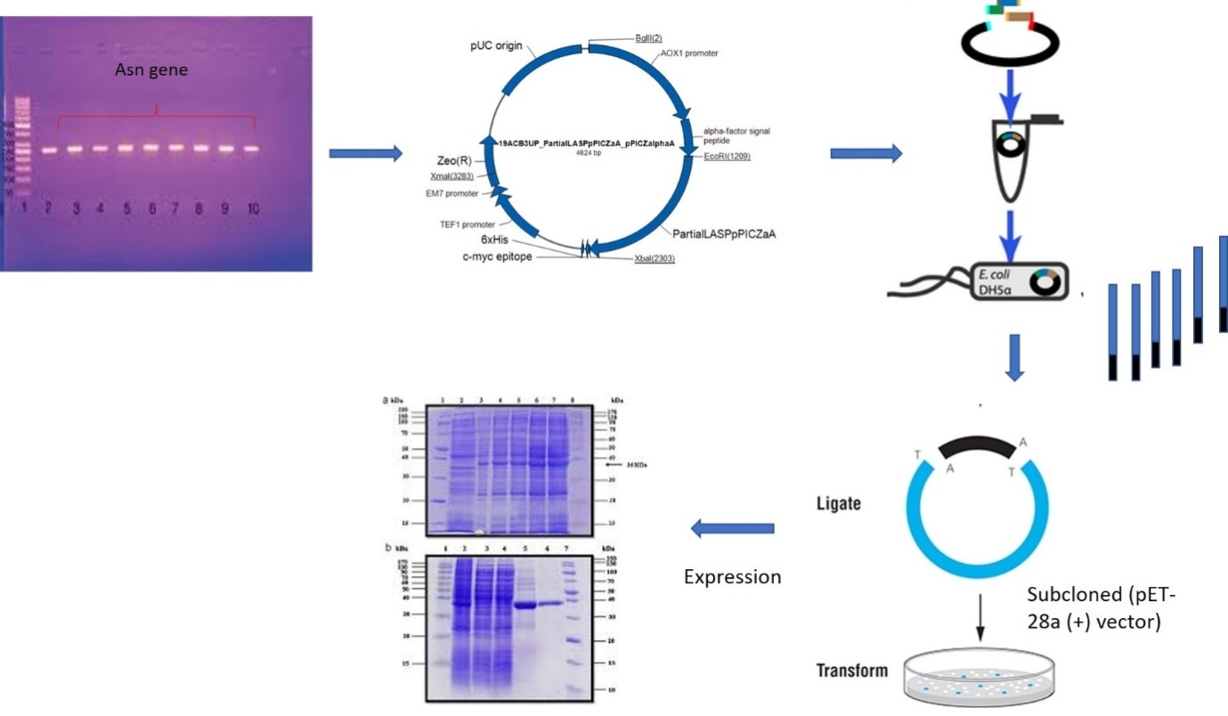
Fig. 3 General overview of cloning and expression of fungal asparaginase gene
Biocompatibility and anticancer properties of L-asparaginase
A toxicological evaluation of asparaginase was performed to investigate the hemolytic effect of purified asparaginase on human blood (erythrocytes). Similarly, the US National Cancer Institute (NCI) started anti-cancer screening support for researchers worldwide in 1955. To establish a new in vitro screen panel, a total of 60 different human tumour cell lines derived from nine cancer types: Lung, Colon, Melanoma, Renal, Ovarian, Brain (CNS), Leukemia, Breast, and Prostate (Boyd and Paull 1995) was used. Cytotoxicity evaluation can be performed using different cell viability assays. Three assays for cell viability were extensively evaluated, which include MTT, XTT, and Sulforhodamine B (SRB) assays.
Furthermore, the purified asparaginases can be tested for their antiproliferative activity against different types of human tumour cells, such as human leukaemia (Huang et al. 2014), hepatocellular carcinoma, breast cancer, and prostate cell lines (Shafei et al. 2015). The relation between the surviving cells and the asparaginase-used concentrations was plotted to get the survival curve of each tumor cell line after treatment with the purified asparaginase. The cytotoxic concentration (MCC50), the concentration required to cause a toxic effect in 50% of intact cells, can be estimated from graphic plots of the dose-response curve for each concentration, using prism software (San Diego, CA, USA). Cell morphology and DNA fragmentation pattern can be used as an initial confirmation for the apoptotic action of L-asparaginase on tumour cells. Gene expression analysis using real-time polymerase chain reaction (RT-PCR) and protein analysis (Western blotting), we can confirm the regulation of proapoptotic and antiapoptotic genes (Fig. 4).
Similarly specific in vitro cell-based assays like flow cytometric cell cycle analysis, topoisomerase inhibition assay, Hoechst 33342 staining, Terminal Deoxynucleotidyl Transferase dUTP Nick End Labelling (TUNEL) assay, Annexin V – Propidium iodide (PI) double staining, Caspase activation analysis, and Immunocytochemistry staining methods can be performed to establish the potential anticancer nature of the enzyme, as cytotoxicity can also be due to necrosis, and it is imperative to prove that the mode of cell lysis is not due to necrosis. Quantitative real-time PCR (qPCR) will be used to analyze the expression pattern of cancer-controlling genes, cell cycle-associated genes, non-caspase protease genes, interferon-induced immune genes, and cytokine-associated immune genes in compound-treated cell lines, which will be compared with untreated control.
Table 1 NCI 60 cell line panel (Boyd and Paull 1995)
Tissue of origin | Cell lines
Lung | NCI-H23, NCI-H522, A549-ATCC, EKVX, NCI-H226, NCI-H332M, H460, H0P62, HOP9
Colon | HT29, HCC-2998, HCT116, SW620, COLO205, HCT15, KM12
Breast | MCF7, MCF7ADRr, MDAMB231, HS578T, MDAMB435, MDN, BT549, T47D
Ovarian | OVCAR3, OVCAR4, OVCAR5, OVCAR8, IGROV1, SKOV3
Leukemia | CCRFCEM, K562, MOLT4, HL60, RPMI8266, SR
Renal | UO31, SN12C, A498, CAKI1, RXF393, 7860, ACHN, TK10
Melanoma | LOXIMVI, MALME3M, SKMEL2, SKMEL5, SKMEL28, M14, UACC62, UACC257
Prostate | PC3, DU145
CNS | SNB19, SNB75, U251, SF268, SF295, SM539

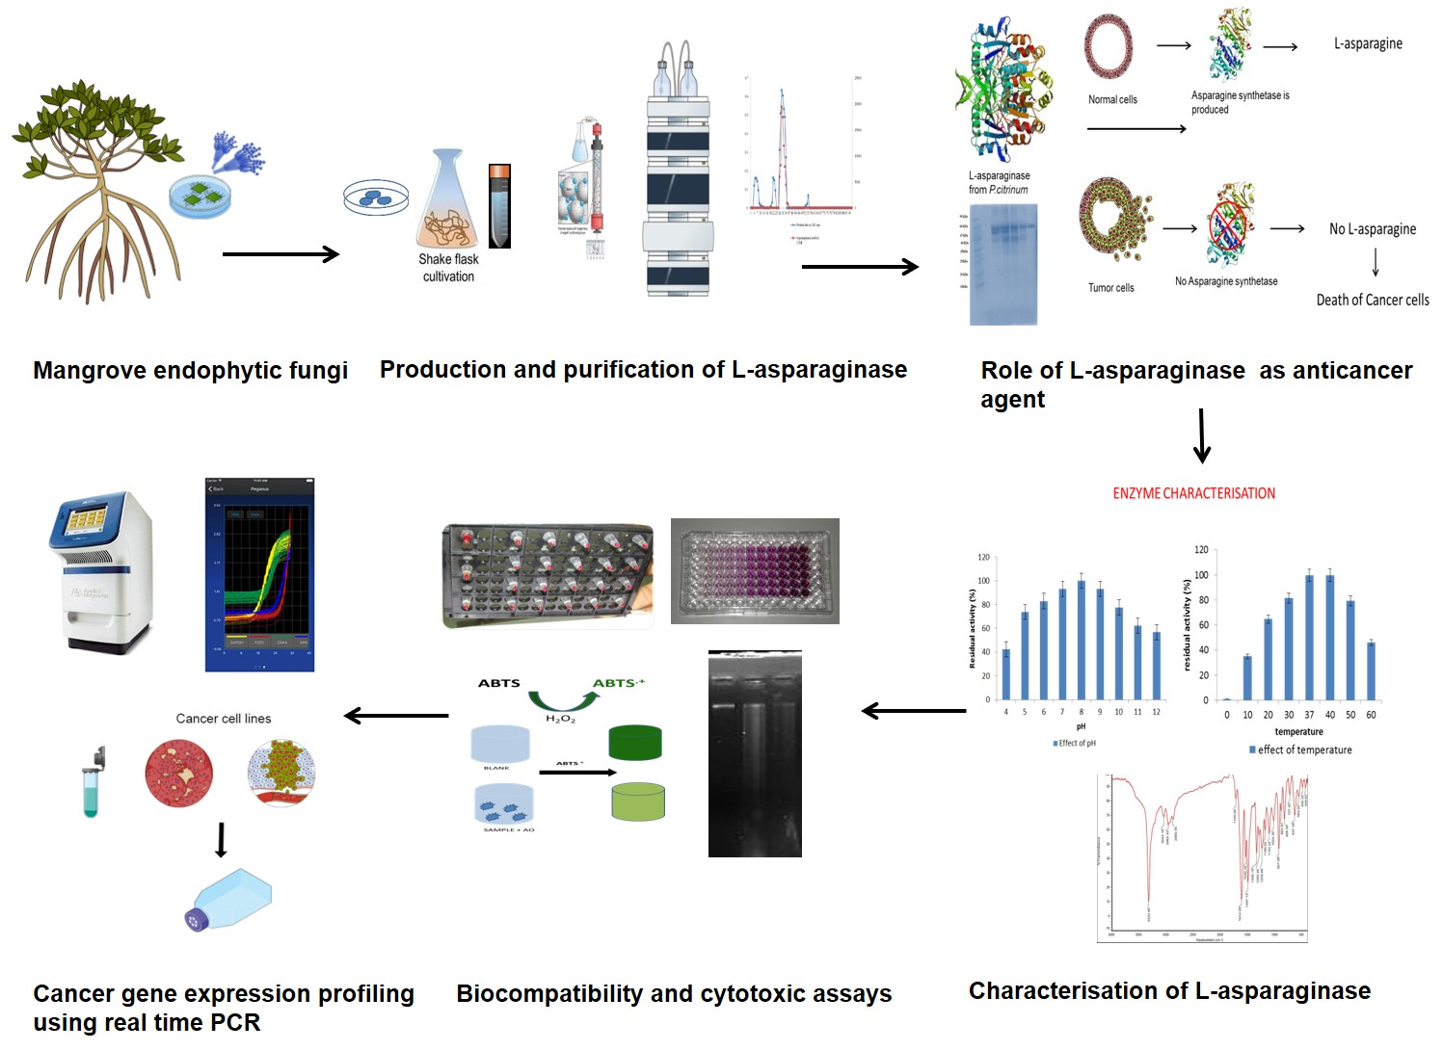
Fig. 4 A general approach for screening, production, purification, and characterization of L-asparaginase from manglicolous endophytic fungi.
Conclusion
In this review, we have presented a general method to screen and characterize the economically relevant enzyme L-asparaginase used both in the clinical and food industry. Due to the deamination property of L-asparaginase, a lot of research has been conducted to show their role in cancer therapy. Besides, this enzyme also benefits the food industry in the elimination of carcinogenic acrylamide. Though these enzymes are widely studied in bacteria, their production in manglicolous endophytic fungi is considered significant as they reduce several side effects and the short life of enzymes in association with their applications. As we are using different screening procedures to select a potent strain that solely produces L-asparaginase enzyme, various undesirable allergic reactions such as hypersensitive effects, and immunogenic complications, of the drug, can be eliminated. L-asparaginase is often found associated with glutaminase, urease, and other contaminants, hence it induces different side effects that can be fatal. This review will give a comprehensive insight and will be a benchmark study that describes the preliminary screening of manglicolous endophytic mycobionts living in extreme environmental conditions as a source of L-asparaginase, its different quantification protocols, media optimization, enzyme kinetics, and purification parameters. To increase the yields of L-asparaginase, genetic engineering and cloning strategies can be made possible to increase the expression rate of this enzyme. To better understand the mode of action of this enzyme as an anticancer source, biocompatibility tests, cell cytotoxicity assays, and various anticancer assays along with the importance of in vitro gene expression analysis of cancer-controlling genes were discussed. Currently, the available strategy was collected and summarized here to initiate a study on L-asparaginase to broaden the scope of cost-effective, non-immunogenic production and application.
Acknowledgment
The authors are thankful to the Directorate of Environment and Climate Change, Government of Kerala, India. We also thank the Faculty of Ocean Studies and Technology, Kerala University of Fisheries and Ocean Studies, India for providing their support.
References
Adamson R H, Fabro S (1968) Antitumor activity and other biologic properties of L-asparaginase (NSC-109229)-a review. Cancer Chemotherapy Reports 52(6): 617-626.
Aghaiypour K, Wlodawer A, Lubkowski J (2001) Structural basis for the activity and substrate specificity of Erwinia chrysanthemi L-asparaginase. Biochemistry 40(19): 5655-5664.
Ahmed I, Hussain H, Schulz B, Draeger S, Padula D, Pescitelli G, Ree V, Krohn K (2011) Three new antimicrobial metabolites from the endophytic fungus Phomopsis sp. Eur J Org Chem 15: 808–812.
Ali S S, Rai V, Soni K, Kulshrestha P (1994) A fungal L-asparaginase with potential antitumor activity. Indian Journal of Microbiology 34: 73-73.
Allas S, Sahakian P, Fichtner I, Abribat T (2009) Pharmacokinetics and Pharmacodynamics in Mice of a Pegylated Recombinant Erwinia chrysanthemi-Derived L-Asparaginase. Blood 114(22): 2033.
Alpar H O, Lewis D A (1985) Therapeutic efficacy of asparaginase encapsulated in intact erythrocytes. Biochemical pharmacology 34(2): 257-261.
Bascomb S, Banks G T, Skarstedt M T, Fleming A, Bettelheim K A, Connors T A (1975) The properties and large-scale production of L-asparaginase from Citrobacter. Microbiology 91(1): 1-16.
Baskar G, Renganathan S (2009) Statistical screening of process variables for the production of L-asparaginase from cornflour by Aspergillus terreus MTCC 1782 in submerged fermentation. Indian J Sci Technol 2(5): 45-48.
Baskar G, Renganathan S (2009a) Production of L-asparaginase from natural substrates by Aspergillus terreus MTCC 1782: Effect of substrate, supplementary nitrogen source and L-asparagine. International Journal of Chemical Reactor Engineering 7(1).
Baskar G, Renganathan S (2011) Statistical and evolutionary optimisation of operating conditions for enhanced production of fungal l-asparaginase. Chemical Papers 65(6): 798-804.
Baskar G, Renganathan S (2012) Optimization of L-asparaginase production by Aspergillus terreus MTCC 1782 using response surface methodology and artificial neural network-linked genetic algorithm. Asia-Pacific Journal of Chemical Engineering 7(2): 212-220.
Baskar G, Sriharini C, Sripriya R, Renganathan S (2010) Statistical screening of supplementary nitrogen source for enhanced production of L-Asparaginase by Aspergillus terreus 1782. Chemical and Biochemical Engineering Quarterly 24(4): 467-472.
Blain F, Tkalec A L, Shao Z, Poulin C, Pedneault M, Gu K, ....., Su H (2002) Expression system for high levels of GAG lyase gene expression and study of the hepA upstream region in Flavobacterium heparinum. Journal of bacteriology 184(12): 3242-3252.
Bonugli-Santos R C, dos Santos Vasconcelos M R, Passarini M R, Vieira G A, Lopes V C, Mainardi P H, ....., Sette L D (2015) Marine-derived fungi: diversity of enzymes and biotechnological applications. Frontiers in microbiology 6: 269.
Borek D, Jaskólski M (2001) Sequence analysis of enzymes with asparaginase activity. Acta Biochimica Polonica 48(4): 893-902.
Boyd M R, Paull K D (1995) Some practical considerations and applications of the National Cancer Institute in vitro anticancer drug discovery screen. Drug development research 34(2): 91-109.
Boyse E A, Old L J, Campbell H A, Mashburn L T (1967) Suppression of murine Leukemias By L-asparaginase: Incidence of sensitivity among leukemias of various types: comparative inhibitory activities of guinea pig serum L-asparaginase and Escherichia coli L-asparaginase. The Journal of experimental medicine 125(1): 17-31.
Broome J D (1963) Evidence that the L-asparaginase of guinea pig serum is responsible for its antilymphoma effects: I. properties of the L-asparaginase of guinea pig serum in relation to those of the antilymphoma substance. The Journal of experimental medicine 118(1): 99-120.
Broome J D (1968) Studies on the mechanism of tumor inhibition by L-asparaginase: effects of the enzyme on asparagine levels in the blood, normal tissues, and 6C3HED lymphomas of mice: differences in asparagine formation and utilization in asparaginase-sensitive and-resistant lymphoma cells. The Journal of experimental medicine 127(6): 1055-1072.
Bruneau L, Chapman R, Marsolais F (2006) Co-occurrence of both L-asparaginase subtypes in Arabidopsis: At3g16150 encodes a K+-dependent L-asparaginase. Planta 224(3): 668-679.
Cedar H, Schwartz J H (1967) Localization of the two L-asparaginases in anaerobically grown Escherichia coli. Journal of Biological Chemistry 242(16): 3753-3755.
Clementi A (1922) Presence of L-asparaginase in animals and its significance. Arch Int Physiol 19: 369-398.
Cooney D A, Handschumacher R E (1970) L-asparaginase and L-asparagine metabolism. Annual review of pharmacology 10(1): 421-440.
De Groot N, Lichtenstein N (1960) The action of mammalian liver enzyme preparations on asparagine and asparagine derivatives. Biochimica et biophysica acta 40: 92-98.
De Groot N, Lichtenstein N (1960) The action of Pseudomonas fluorescens extracts on asparagine and asparagine derivatives. Biochimica et biophysica acta 40: 99-110.
Debashish G, Malay S, Barindra S, Joydeep M (2005) Marine enzymes. Marine Biotechnology I: 189-218.
Dias F F G, de Castro R J S, Ohara A, Nishide T G, Bagagli M P, Sato H H (2015) Simplex centroid mixture design to improve L-asparaginase production in solid-state fermentation using agroindustrial wastes. Biocatalysis and Agricultural Biotechnology 4(4): 528-534.
Dias F F G, Santos Aguilar J G D, Sato H H (2019) l-Asparaginase from Aspergillus spp.: production based on kinetics, thermal stability and biochemical characterization. 3 Biotech 9(7): 1-10.
Drainas D, Drainas C (1985) A conductimetric method for assaying asparaginase activity in Aspergillus nidulans. European journal of biochemistry 151(3): 591-593.
Dutta S., Ghosh, S., &Pramanik, S. (2015). L-asparaginase and L-glutaminase from Aspergillus fumigatus WL002: Production and some physicochemical properties. Applied biochemistry and microbiology, 51(4), 425-431.
Duval M, Suciu S, Ferster A, Rialland X, Nelken B, Lutz P, ....., Philippe N (2002) Comparison of Escherichia coli–asparaginase with Erwinia-asparaginase in the treatment of childhood lymphoid malignancies: results of a randomized European Organisation for Research and Treatment of Cancer- Children's Leukemia Group phase 3 trial. Blood, The Journal of the American Society of Hematology 99(8): 2734-2739.
Ehrman M, Cedar H, Schwartz J H (1971) L-Asparaginase II of Escherichia coli: Studies on the enzymatic mechanism of action. Journal of Biological Chemistry 246(1): 88-94.
Eisele N, Linke D, Bitzer K, Na’amnieh S, Nimtz M, Berger R G (2011) The first characterized asparaginase from a basidiomycete, Flammulinavelutipes. Bioresource technology 102(3): 3316-3321.
Elfita E, Muharni M, Munawar M, Legasari L, Darwati D (2011) Antimalarial compounds from endophytic fungi of Brotowali (Tinasporacrispa L). Indonesian Journal of Chemistry 11(1): 53-58.
Firáková S, ŠturdíkováM, Múčková M (2007) Bioactive secondary metabolites produced by microorganisms associated with plants. Biologia 62(3): 251-257.
Fisher S H, Wray Jr L V (2002)Bacillus subtilis 168 contains two differentially regulated genes encoding L-asparaginase. Journal of Bacteriology 184(8): 2148-2154.
Gentili D, Zucchetti M, Conter V, Masera G, D'Incalci M (1994) Determination of L-asparagine in biological samples in the presence of L-asparaginase. Journal of Chromatography B: Biomedical Sciences and Applications 657(1): 47-52.
Geuenich S, Haberl C, Egger D, Kaspers U, Hültner L, Wilmanns W, Denzlinger C (1998) Induction of leukotriene production by bleomycin and asparaginase in mast cells in vitro and in patients in vivo. Biochemical pharmacology 55(4): 447-453.
Goodsell D S (2005) The Molecular Perspective: l‐Asparaginase. Stem Cells 23(5): 710-711.
Gordien A Y, Gray A I, Ingleby K, Franzblau S G, Seidel V (2010) Activity of Scottish plant, lichen and fungal endophyte extracts against Mycobacterium aurum and Mycobacterium tuberculosis. Phytotherapy Research: An International Journal Devoted to Pharmacological and Toxicological Evaluation of Natural Product Derivatives 24(5): 692-698.
Grossowicz N, Wainfan E, Borek E, Waelsch H (1950) The enzymatic formation of hydroxamic acids from glutamine and asparagine. J Biol Chem 187(1): 111-125.
Gunatilaka A L (2006) Natural products from plant-associated microorganisms: distribution, structural diversity, bioactivity, and implications of their occurrence. Journal of natural products 69(3): 509-526.
Gurunathan B, Sahadevan R (2011) Production of L-asparaginase from natural substrates by Aspergillus terreus MTCC 1782: Optimization of carbon source and operating conditions. International Journal of Chemical Reactor Engineering 9(1).
Handschumacher R E, Bates C J, Chang P K, Andrews A T, Fischer G A (1968) 5-Diazo-4-oxo-L-norvaline: Reactive asparagine analog with biological specificity. Science 161(3836): 62-63.
Hazalin N A, Ramasamy K, Lim S S M, Wahab I A, Cole A L, Abdul Majeed A B (2009) Cytotoxic and antibacterial activities of endophytic fungi isolated from plants at the National Park, Pahang, Malaysia. BMC complementary and alternative medicine 9(1): 1-5.
Huang L, Liu Y, Sun Y, Yan Q, Jiang Z (2014) Biochemical characterization of a novel L-Asparaginase with low glutaminase activity from Rhizomucormiehei and its application in food safety and leukemia treatment. Applied and environmental microbiology 80(5): 1561-1569.
Imada A, Igarasi S, Nakahama K, Isono M (1973) Asparaginase and glutaminase activities of micro-organisms. Microbiology 76(1): 85-99.
Jain R, Zaidi K U, Verma Y, Saxena P (2012) L-asparaginase: A promising enzyme for treatment of acute lymphoblastic leukiemia. People’s Journal of Scientific Research 5(1): 29-35.
Kelo E, Noronkoski T, Stoineva I B, Petkov D D, Mononen I (2002) β-Aspartylpeptides as substrates of L-asparaginases from Escherichia coli and Erwinia chrysanthemi. FEBS letters 528(1-3): 130-132.
Kidd J G (1953) Regression of transplanted lymphomas induced in vivo by means of normal guinea pig serum: I. course of transplanted cancers of various kinds in mice and rats given guinea pig serum, horse serum, or rabbit serum. The Journal of experimental medicine 98(6): 565-582.
Kohlmeyer J, Volkmann-Kohlmeyer B (1991) Illustrated key to the filamentous higher marine fungi.
Kohlmeyer J, Volkmann-Kohlmeyer B (1998) A new marine Xylomyces on Rhizophora from the Caribbean and Hawaii. Fungal Diversity 1: 159-164.
Konrad A S, Kenneth W J, Robert J (1988) The metabolism of asparagine in plants. Phytochemistry 27(3): 663-671.
Kotzia G A, Labrou N E (2007) L-Asparaginase from Erwinia chrysanthemi 3937: cloning, expression and characterization. Journal of biotechnology 127(4): 657-669.
Kravchenko O V, Kislitsin Y A, Popov A N, Nikonov S V, Kuranova I P (2008) Three-dimensional structures of L-asparaginase from Erwinia carotovora complexed with aspartate and glutamate. Acta Crystallographica Section D: Biological Crystallography 64(3): 248-256.
Kudryashova E V, Sukhoverkov K V (2016) “Reagent-free” L-asparaginase activity assay based on CD spectroscopy and conductometry. Analytical and bioanalytical chemistry 408(4): 1183-1189.
Kumar D S, Sobha K (2012) L-asparaginase from microbes: a comprehensive review. Advances in Bioresearch 3(4).
Kumar N M, Ramasamy R, Manonmani H K (2013) Production and optimization of L-asparaginase from Cladosporium sp. using agricultural residues in solid state fermentation. Industrial Crops and Products 43: 150-158.
Kumar S, Dasu V V, Pakshirajan K (2011) Purification and characterization of glutaminase-free L-asparaginase from Pectobacteriumcarotovorum MTCC 1428. Bioresource technology 102(2): 2077-2082.
Kumaresan V, Suryanarayanan T S (2002) Endophyte assemblages in young, mature and senescent leaves of Rhizophora apiculata: evidence for the role of endophytes in mangrove litter degradation. Fungal Diversity 9: 81-91.
Kurtzberg J, Yousem D, Beauchamp N (2003) Cancer Medicine. Holland J, Fries E, Kurtzberg J, editors, American Chemical Society IV: 699-705.
Lanvers C, Pinheiro J P V, Hempel G, Wuerthwein G, Boos J (2002) Analytical validation of a microplate reader-based method for the therapeutic drug monitoring of L-asparaginase in human serum. Analytical biochemistry 309(1): 117-126.
Lee J M, Tan W S, Ting A S (2014) Revealing the antimicrobial and enzymatic potentials of culturable fungal endophytes from tropical pitcher plants (Nepenthes spp.). Mycosphere 5(2): 364-377.
Magri A, Soler M F, Lopes A M, Cilli E M, Barber P S, Pessoa A, Pereira J F (2018) A critical analysis of L-asparaginase activity quantification methods—colorimetric methods versus high-performance liquid chromatography. Analytical and bioanalytical chemistry 410(27): 6985-6990.
Meister A (1955) Glutaminase, Asparaginase and Alpha-keto acid-omega-amidase. Methods in enzymology 2: 380-385.
Mesas J M, Gil J A, Martn, J F (1990) Characterization and partial purification of L-asparaginase from Corynebacterium glutamicum. Microbiology 136(3): 515-519.
Miller G L, Miller E E (1948) Determination of nitrogen in biological materials. Analytical Chemistry 20(5): 481-488.
Mohan Kumar N S, Manonmani H K (2013) Purification, characterization and kinetic properties of extracellular L-asparaginase produced by Cladosporium sp. World Journal of Microbiology and Biotechnology 29(4): 577-587.
Mohana Kumara P, Zuehlke S, Priti V, Ramesha B T, Shweta S, Ravikanth G, ..., Uma Shaanker R (2012) Fusarium proliferatum, an endophytic fungus from Dysoxylumbinectariferum Hook. f, produces rohitukine, a chromane alkaloid possessing anti-cancer activity. Antonie Van Leeuwenhoek 101(2): 323-329.
Moorthy V, Ramalingam A, Sumantha A, Shankaranaya R T (2010) Production, purification and characterization of extracellular L- asparaginase from a soil isolate of Bacillus sp. African J Microbiol Res 4(1): 1862-1867.
Morales F, Capuano E, Fogliano V (2008) Mitigation strategies to reduce acrylamide formation in fried potato products. Annals of the New York Academy of Sciences 1126(1): 89-100.
Mottram D S, Wedzicha B L, Dodson A T (2002) Acrylamide is formed in the Maillard reaction. Nature 419(6906): 448-449.
Narayana K J P, Kumar K G, Vijayalakshmi M (2008) L-asparaginase production by Streptomyces albidoflavus. Indian Journal of Microbiology 48(3): 331-336.
Nath C E, Dallapozza L, Eslick A E, Misra A, Carr D, Earl J W (2009) An isocratic fluorescence HPLC assay for the monitoring of l‐asparaginase activity and l-asparagine depletion in children receiving E. coli l‐asparaginase for the treatment of acute lymphoblastic leukaemia. Biomedical Chromatography 23(2): 152-159.
Oettgen H F, Old L J, Boyse E A, Campbell H A, Philips F S (1967) Clarkson, BD. In Tallal L, Leeper RD, Schwarta MD, Kim JH: Inhibition of Leukemias in Man by L-asparaginase. ACS-NCI Conference on Acute Leukemia and Burkitt's Tumor (Rye 1967), Cancer Res (Vol. 27, p. 2619).
Offman M N, Krol M, Patel N, Krishnan S, Liu J, Saha V, Bates P A (2011) Rational engineering of L-asparaginase reveals importance of dual activity for cancer cell toxicity. Blood, The Journal of the American Society of Hematology 117(5): 1614-1621.
Patil M P, Patil R H, Maheshwari V L (2012) A novel and sensitive agar plug assay for screening of asparaginase-producing endophytic fungi from Aegle marmelos. Acta BiologicaSzegediensis 56(2): 175-177.
Patro K R, Basak U C, Mohapatra A K, Gupta N (2014) Development of new medium composition for end production of L-asparaginase by Aspergillus ﬂavus. Journal of environmental biology 35: 295-300.
Paul J H (1982) Isolation and characterization of a Chlamydomonas L-asparaginase. Biochemical Journal 203(1): 109-115.
Pedreschi F, Kaack K, Granby K (2008) The effect of asparaginase on acrylamide formation in French fries. Food chemistry 109(2): 386-392.
Pimentel M R, Molina G, Dionísio A P, Maróstica Junior M R, Pastore G M (2011) The use of endophytes to obtain bioactive compounds and their application in biotransformation process. Biotechnology research international 2011.
Pinheiro I O, Araujo J M, Ximenes E C P A, Pinto J C S, AlvesT L M (2001) Production of L-asparaginase by Zymomonasmobilisstrain CP4. Biomaterial and Diagnostic BD6: 243-244.
Praptiwi P, Jamal Y, Fathoni A, Nurkanto A, Agusta A (2013) Antibacterial activity of Bisanthraquinone (+)-1, 1’-bislunatin. Microbiology Indonesia 7(4): 4-4.
Prista A A, Kyridio D A (2001) L-asparaginase of Thermus thermophilus: purification, properties and identification of essential amino acids for catalytic activity. Mol Cell Biochem 216: 93-101.
Raghukumar C (2008) Marine fungal biotechnology: an ecological perspective. Fungal Divers. 31, 19–35.
Ramakrishnan M S, Joseph R (1996) Characterization of an extracellular asparaginase of Rhodosporidiumtoruloides CBS14 exhibiting unique physicochemical properties. Canadian Journal of microbiology 42(4): 316-325.
Ramya L N, Doble M, Rekha V P B, Pulicherla K K (2011) In silico engineering of L-asparaginase to have reduced glutaminase side activity for effective treatment of acute lymphoblastic leukemia. Journal of PediatricHematology/Oncology 33(8): 617-621.
Rateb M E, Ebel R (2011) Secondary metabolites of fungi from marine habitats. Natural product reports 28(2): 290-344.
Schwartz J H, Reeves J Y, Broome J D (1966) Two L-asparaginases from E. coli and their action against tumors. Proceedings of the National Academy of Sciences 56(5): 1516-1519.
Shafei M S, El-Refai H A, Mostafa H, El-Refai A M H, El-Beih F M, Easa S M, Gomaa S K (2015) Purification, characterization and kinetic properties of Penicillium cyclopium L-asparaginase: Impact of L-asparaginase on acrylamide content in potato products and its cytotoxic activity. Current trends in biotechnology and pharmacy 9(2): 132-140.
Sieburth J M (1979) Sea microbes: a survey of the habitats, field and laboratory methods, morphology, nutrition, taxonomy, and ecology of marine bacteria, fungi, microalgae, and protozoa.
Sieciechowicz K A, Ireland R J (1989) Isolation and properties of an asparaginase from leaves of Pisum sativum. Phytochemistry 28(9): 2275-2279.
Sinha A M, Manna, S U, Roy S K, Chakrabarty S L (1991) Induction of L-asparaginase synthesis in Vibrio proteus. The Indian Journal of Medical Research 93: 289-292.
Stern M L, Phillips A W, Gottlieb A J (1976) Physical properties of L-asparaginase from Serratia marcescens. Journal of bacteriology 125(2): 719-727.
Thatoi H N, Behera B C, Dangar T K, Mishra R R (2012) Microbial biodiversity in mangrove soils of Bhitarkanika, Odisha, India.
Theantana T, Hyde K D, Lumyong S (2007) Asparaginase production by endophytic fungi isolated from some Thai medicinal plants. Current Applied Science and Technology 7(1-1): 13-18.
Uppuluri K B, Dasari R K V, Sajja V, Jacob A S, Reddy D S R (2013) Optimization of L-asparaginase production by isolated Aspergillus niger C4 from sesame (black) oil cake under SSF using Box–Behnken design in column bioreactor. International Journal of Chemical Reactor Engineering 11(1): 103-109.
Verma N, Kumar K, Kaur G, Anand S (2007) L-asparaginase: a promising chemotherapeutic agent. Critical reviews in biotechnology 27(1): 45-62.
Warangkar S C, Khobragade C N, Dawane B S, Bhosale R B (2009) Effect of dihydropyrimidine derivatives on kinetic parameters of E. carotovora L-asparaginase. Int J BiotechnolAppl 1(1): 05-13.
Wehner A, Harms E, Jennings M P, Beacham I R, Derst C, Bast P, Rohm K H (1992) Site- specific mutagenesis of Escherichia coli asparaginase II: None of the three histidine residues is required for catalysis. European journal of biochemistry 208(2): 475-480.
Ylikangas P, Mononen I (2000) A fluorometric assay for L-asparaginase activity and monitoring of L-asparaginase therapy. Anal Biochem 280(1): 42–5.
Zhang C, Kim S K (2012) Application of marine microbial enzymes in the food and pharmaceutical industries. Advances in food and nutrition research 65: 423-435.
Zhang Q, Zhang J, Yang L, Zhang L, Jiang D, Chen W, Li G (2014) Diversity and biocontrol potential of endophytic fungi in Brassica napus. Biological control 72: 98-108.

