CLIMATE INDUCED URBANIZATION IMPACT ON URBAN FLOOD HAZARD USING GIS AND REMOTE SENSING

V. Sampath Kumar¹, S. Muthusamy² and P. Mohana³*

- Department of Civil Engineering, Sathyabama Institute of Science and Technology, Chennai – 119.
- Assistant Professor, Department of Geology, V.O.C College, Tuticorin
- Centre for Remote Sensing and Geoinformatics, Sathyabama Institute of Science and Technology, Chennai – 119.

ABSTRACT

Flooding is one of the most common natural disasters that afflict people all over the world. It is a serious natural hazard in Velachery that arises every year. Floods in Velachery are distinguished for their unusually huge volume, widespread devastation, and frequency. Velachery suffers from a flood generated by Velachery Lake. The primary cause of flood in that area is the topographic condition, accelerated rate of deforestation, high intensity of rainfall, explosive increase of people, large amount of land use, and so on. Despite the fact that it is an age-old phenomenon in the Velachery lake, the level of destruction inflicted by the flood has expanded dramatically in recent years. It caused massive devastation and irreversible harm to the local inhabitants. It has a negative impact on human life and property, transportation and communication, and so on, resulting in massive economic losses each year. This article discusses the state's considerable economic losses as a result of flooding.
Floods are uncontrollable natural disasters that cause loss of life and property destruction. Flood water must be controlled so that it can be used for a variety of purposes. Remote sensing and GIS (Geographic Information System) techniques can be used to estimate the area and depth of flooding. This study will concentrate on the issue of field investigation in conjunction with GIS to recreate a flood event in order to estimate the flood volume and extent. According to field investigations, the Velachery neighbourhood of Chennai, India, is prone to catastrophic flooding. Through field inquiry in the Velachery area, this study attempts to replicate the flood event of December 3, 2005. The scope of investigation has been limited to Velachery.

Keywords: Flood, Economy, Rainfall, Population.

INTRODUCTION
Urban flood is the important issue at present in Chennai metropolitan area. In this issue we were taken to study about the Velachery area flooded details and to assess the storm water drainage system. By using this system whenever the flood are raised, the local people can open the storm water drain in Velachery.

The people from this areas are never want to temporarily migrate for this issues. In future, the people are live in safe manner like, where the people are residents in non-flooded zone areas. To compare the results of existing and new systems.

Storm water drains are pieces of infrastructure that are used to drain excess rain and ground water from impermeable surfaces such as paved streets, vehicle parks, parking lots, walkways, sidewalks, and roofs. Storm drains come in a variety of sizes, from modest household dry wells to big municipal systems.

Drains collect water from street gutters on most highways, motorways, and other major roads, as well as towns in flood-prone areas and coastal towns with frequent storms. Guttering from houses and buildings can also link to storm drains. Because many storm drainage systems are gravity sewers that discharge untreated storm water into rivers or streams, dumping hazardous material into the drains is unacceptable.

Storm drains are sometimes unable to handle the amount of rain that falls during strong rains or storms. Flooding can occur when drains get clogged. Many regions require interior detention tanks that temporarily collect runoff during heavy rains and restrict outlet flow to the municipal sewer. This decreases the possibility of overflowing the public sewer. Some storm drains mix storm water (rainwater) with sewage, either intentionally or accidently in the case of combined sewers.

Flooding is an unavoidable natural occurrence that occurs from time to time, causing not only harm to natural resources and the environment, but also loss of life, economy, and health. Flooding occurs when the discharge in the channels (natural or manmade) exceeds the carrying capacity. Watershed urbanisation reduces infiltration or increases runoff coefficient, increases peak flow, decreases duration of concentration, and hence increases floods for the same quantity of rainfall. Nowadays, cutting-edge technology in the field of Geographic Information System (GIS) enables for spatial analysis in order to develop flood hazard modelling. GIS is a crucial tool for flood studies since it allows for data acquisition, input, manipulation, transformation, visualisation, combination, query, analysis, modelling, and output. Although numerous flood modelling methodologies are available, this study analyses the flood scenario using firsthand knowledge from flood-affected persons. As a result, the volume of flood water in the area is computed using the high flood level recorded in the field and the GIS-created Digital Elevation Model.

OBJECTIVES
    - Find out the location of man-made storm water drainage
    - To assess the Digital Elevation Model and other topographical features
    - To find out the location for new storm water path or where to improve the existing system
SCOPE
The scope of the project is, to make the flooded zone as non-flooded zone in Velachery
To plan adequate construction of storm water drainage and to avoid flood in residents, commercial, hospitals and institutional buildings.

METHODOLOGY

The methodology is based on the Flood Intensity indicator (Iw), a GIS-based indicator that can be thought of as a trade-off between morphometric indexes and physically based two-dimensional (2D) hydraulic models.

Some popular flood control strategies include the placement of rock beams, rock ripraps, sand bags, the maintenance of normal slopes with vegetation or the use of soil cements on steeper slopes, and the building or expansion of drainage. Dyes, dams, retention basins, and detention are some more options.

The suggested methodology employs the aforementioned Iw index to provide insight into flood variables and processes, taking into account both simple (e.g., local failure of flood defences) and complicated hazard scenarios (e.g., failure or overflowing from one or more river reaches). The methodology synthesizes information on a region's flood vulnerability into graphs and curves based on the strategy chosen. By integrating this information with appropriate damage functions, the flood susceptibility of the area can be easily determined, linking the various flood scenarios with the damage they are predicted to do.. Furthermore, the findings of these analyses can be used to characterize, compare, and rank the susceptibility and vulnerability of various flood-prone locations within a region.

METHODOLOGY
Study Area

Digital Elevation Model

Slope Map

Land Cover Map

Rainfall Data

Overlay Analysis

Flood Map

Possible zones for Storm water Drainage

Flood Inundation

Fig 1: Flow Chart

DESCRIPTION OF STUDY AREA

Velachery is a rapidly rising residential neighbourhood in South West Chennai, a major city in Tamil Nadu, India. Velachery is located at 12° 58' 20" latitude and 80° 13' 35" longitude. It is well-connected by highways and the MRTS (Mass Rapid Transit System) railway network. The majority of the study area is built up, with only a few open spaces. Water becomes stagnant in this wide field as the water table rises.

The study area is located in Chennai, India, and is part of the Velachery Detailed Development Plan (DDP) (Fig 1). The study area contains a variety of land-uses, including residential, commercial, hospital, and institutional use (Industrial use is not permitted inside the study area limit), and the built structure ranges from single-story structures to nine-story complexes with diverse floor-wise uses.
The Pallikaranai wetland is a freshwater marsh near Chennai, India. It is located near to the Bay of Bengal, approximately 20 kilometres (12 miles) south of the city core, and covers an area of 80 square kilometres (31 square miles). Pallikaranai marshland is the city's only surviving wetland habitat and one of South India's few and last remaining natural wetlands. It is one of 94 recognised wetlands under the Government of India's National Wetland Conservation and Management Programme (NWCMP) that was implemented in 1985-86, and one of three in the state of Tamil Nadu, the other two being Point Calimere and Kazhuveli. It is also one of Tamil Nadu's prioritised wetlands. The swamp's geography ensures that some storage is always retained, generating an aquatic habitat. A project on 'Inland Wetlands of India' commissioned by the Ministry of Environment and Forests, Government of India, identified Pallikaranai marsh as one of the country's most significant wetlands. The marsh is home to several rare, endangered, and threatened species and serves as a foraging and breeding habitat for thousands of migrating birds from all over the country. The number of bird species seen in the marsh is substantially greater than at Vedanthangal Bird Sanctuary.

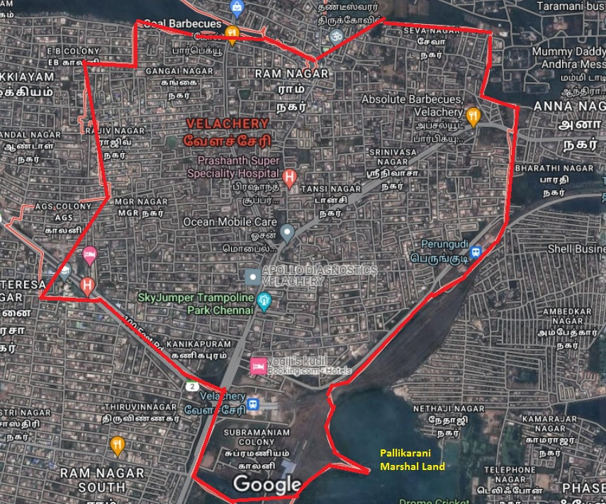

Fig 2: Velachery study area location map (Source: Google Map)

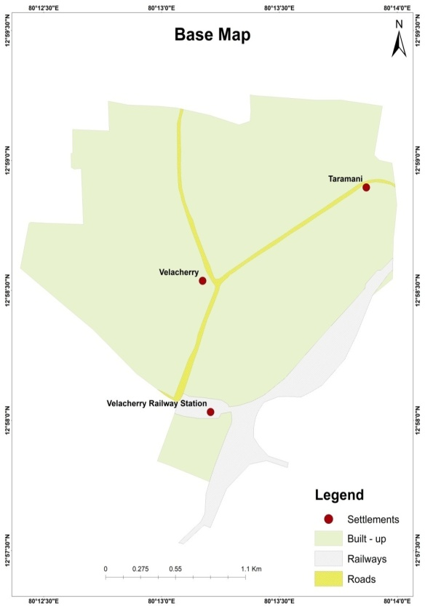

Fig.3: Velachery Base map (Study Area Location)

THEMATIC LAYERS

Digital Elevation Model (DEM)

A satellite imagery model is a three-dimensional visual effects illustration of elevation data used to depict terrain on a planet. DEMs are the the majority general basis for digitally generated relief maps and are frequently used in geographic information systems. It shows in fig (4)

It depicts the Earth's bare ground (bare earth) topographic surface, excluding trees, buildings, and other surface items. DEMs are made using a variety of methods. DEMs from the Shuttle Radar Topography Mission (SRTM) were previously produced primarily from topographic maps.

DEMs are typically created using data obtained using remote sensing techniques, although they can also be created by land surveying. Mappers can create digital elevation models in a variety of ways, but remote sensing is usually used instead of direct survey data. By using satellite we can capture the study area and process into DEM. The below fig. shows the values in meters and satellite is covered the pixel about 30 meters.

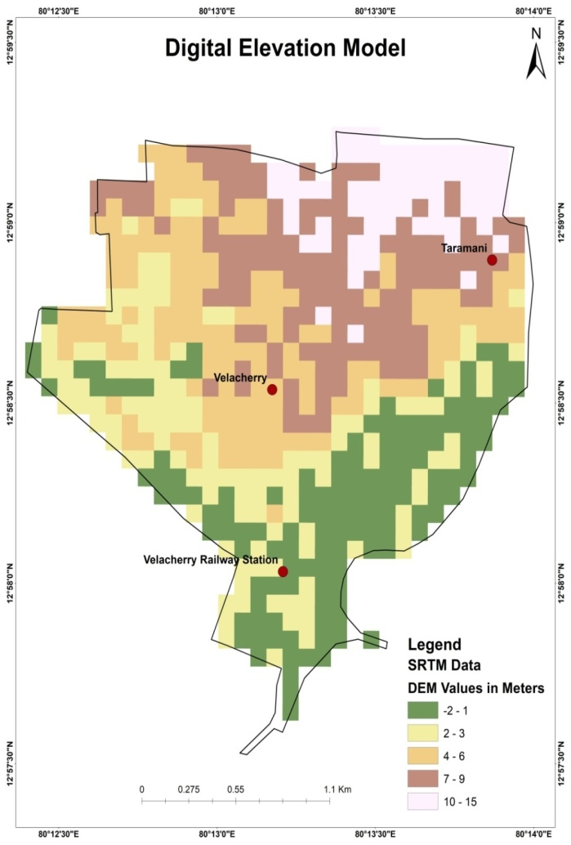
Fig 4: Velachery Digital Elevation Model

Geomorphology
Velachery is largely made up of clay and hard rock. The Velachery lake used to be roughly 250 acres in size, including the old Selliamman and Narasimhar temples on its southern tip. Thousands of acres of marshland called Kazhuveli, south of Velachery, were made up of coarse elephant grass and swamps. Because it permitted rainwater runoff and catchment, the area was also known as Kazhiveli. It contained six natural spring aquifers that refilled the groundwater table. The marshes also served as a haven for both permanent and migratory birds. Due to fast development and encroachment, the wetlands all but vanished in the later decades of the twentieth century. The Pallikaranai wetland is made up of the surviving southern portions of the marshes.

Slope
The rise and fall of the study region land surface is referred to as a slope. By using the ArcGIS software we can identify the land arrangements in the study area in which the flood will inundated.

Land use and Land cover
Water bodies, urban areas, barren land, and woodland make up the majority of the study region.
Rainfall
Rainfall refers to the amount of precipitation in the form of rain that falls to the earth's surface, whether on land or water. It happens when a cloud of air travels over a warm body of water or wet ground.

Slope Map (From ArcGIS Software)

It is a two-dimensional depiction of a surface's gradient. It indicates whether a slope is steep or gentle at any given position. It can be used to identify possible risks, plan construction projects, and do a variety of other things. The slope of the land must be taken into account in order to reduce building costs, reduce risks from natural disasters such as flooding and landslides, and lessen the impact of proposed development on natural resources such as soils, plants, and water systems.

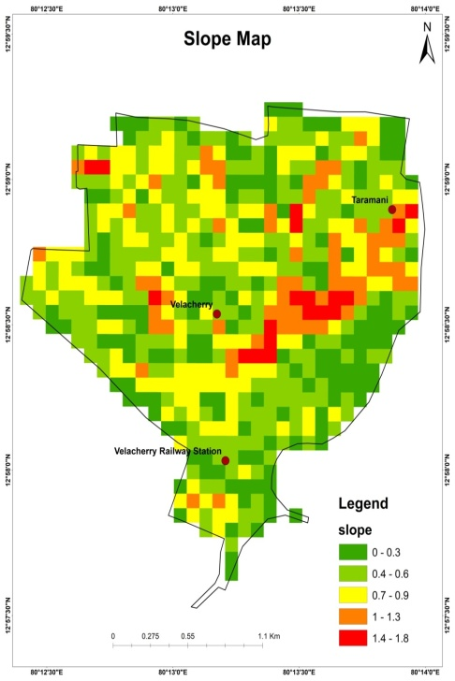

Fig 5: Velachery Slope Map (From ArcGIS Software)

Slope Map (From Satellite)

Slope maps are used to illustrate land relief, however unlike topographic maps, which display altimetry numerically with contour lines or colour bands, slope values correlate to the angle (in degrees) of the Earth's surface.

They quantify the greatest slope of the relief. In a GIS, slope is calculated by comparing a specific point inside a raster to its neighbours. Typically, a point's slope is determined by comparing it to eight of its neighbours, however the exact procedure varies depending on the type of slope analysis sought.
The Slope tool determines the steepness of a raster surface at each cell. The flatter the terrain, the lower the slope value; the steeper the terrain, the greater the slope value.

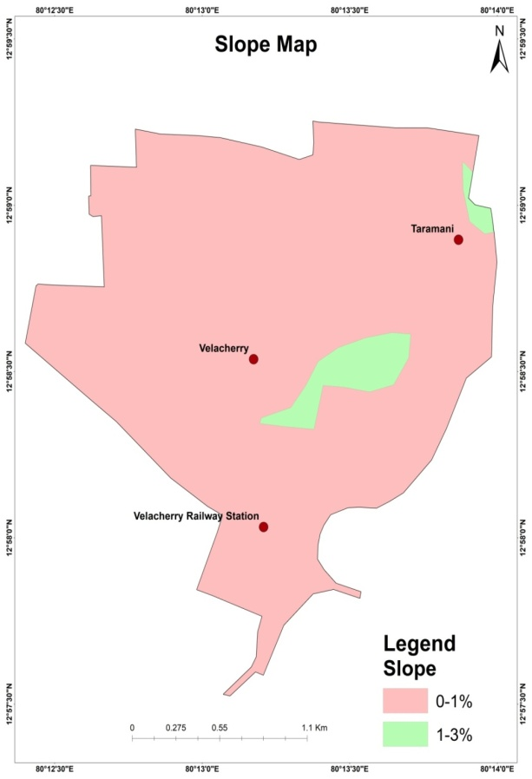

Fig 6: Velachery Slope Map (From Satellite)

Land Cover Map

Land cover maps are useful tools for learning about the Earth's land usage and cover patterns. They contribute to policy development, urban planning, forest and agricultural monitoring, and so forth.
It is a method of classifying present land resources into thematic groups such as forest, water, and paved surfaces. An area's land cover maps give information to help users comprehend the current terrain. Annual data on national spatial databases will allow for the tracking of the temporal dynamics of agricultural ecosystems, forest conversions, surface water bodies, and so on. The systematic mapping of land cover patterns, including change detection, is often accomplished by one of two methods: field survey. Land use and land cover mapping are used to study land utilisation and future land resource planning and management. In the study area, five land use classes have been identified: agricultural crop land, built-up (urban and rural), water body, forest area, and wasteland. One of the most important and common applications of remote sensing is land cover and land use mapping. The physical condition of earth surface characteristics such as forest, grassland, and so on is represented by land cover. Land cover identification offers the baseline from which monitoring operations (change detection) can be undertaken, as well as ground cover information for baseline thematic maps. Land use relates to the function of the land, such as recreation, wildlife habitat, or agriculture.
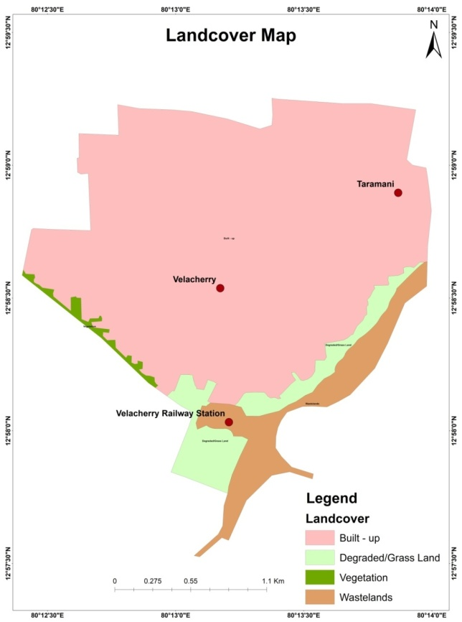

Fig 7: Velachery Land cover map

Settlements Map

Accurately mapping and naming settlements enables tracking and monitoring the progress of activities/interventions/ programmes, etc., Human settlement maps can be used to better understand growth trends, population distribution, resource management, change detection, and a range of other applications that require information about the earth's surface. A dataset containing settlement points or polygons as well as their names for spatially locating, identifying, and visualising settlement characteristics. This map depicts a location where people live. A settlement can be as tiny as a single house in a rural area or as vast as a megacity (a city with a population of more than 10 million people). They give crucial information about towns, such as the name, location of structures, and geographic breadth.
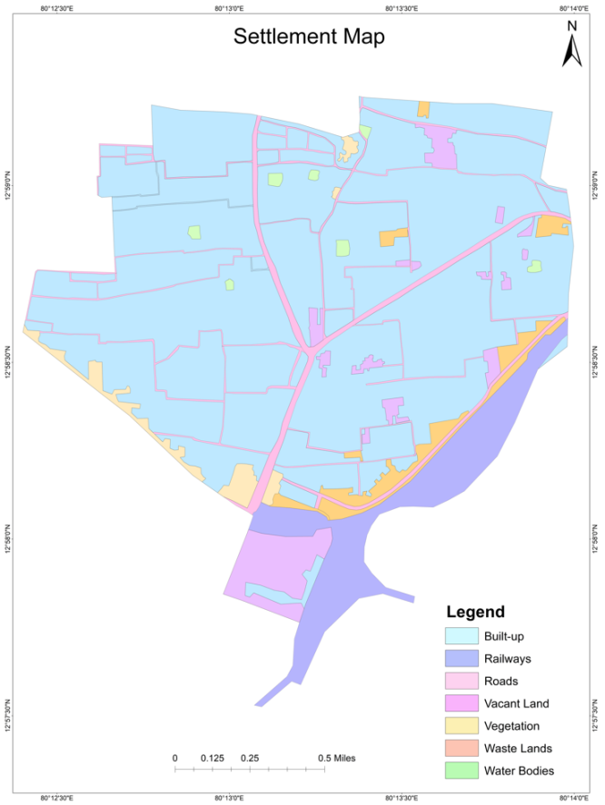
Fig 8: Velachery Settlement map

Rainfall Data

On North East Monsoon rainfall it has rained 635.42mm from 01.10.2021 to 29.11.2021. This is 80% more than 352.6mm (when it is compared to normal rainfall)

The annual rainfall in last 7 years:
Year | North East Monsoon rainfall in Tamil Nadu (mm) | North East Monsoon rainfall in Chennai (mm) | Annual rainfall in Tamil Nadu | Annual rainfall In Chennai
2015 | 518 | 1167 | 1057 | 1610
2016 | 100.6 | 95 | 472 | 789
2017 | 300.6 | 854 | 877 | 1310
2018 | 314.8 | 321 | 768 | 722
2019 | 348 | 417 | 800 | 1006
2020 | 303.8 | 811.5 | 814 | 1343
2021 | 613 | 1121 | 1300 | 1866

Based on survey taken, 2021 has more rained when it is compared from 2015 to 2021. Tamil Nadu and Chennai has more rained 1300mm and 1866mm on last year.

YEAR | SWMS |  |  |  | NEMS |  |  |  |  | WINTER |  |  |  |  | HOT WEATHER |  |  |  |  | ANNUAL RAINFALL
 | Normal | Actual | Deviation | % Variation |  | Normal | Actual | Deviation | % Variation |  | Normal | Actual | Deviation | % Variation |  | Normal | Actual | Deviation | % Variation |  | Normal | Actual | Deviation | % Variation
2003-2004 | 332 | 337 | 5 | 2 |  | 465 | 403 | -62 | -13 |  | 37 | 12 | -26 | -69 |  | 128 | 283 | 155 | 121 |  | 961.8 | 1035 | 7.6 | 8
2004-2005 | 332 | 361 | 29 | 9 |  | 465 | 472 | 8 | 2 |  | 37 | 14 | -23 | -62 |  | 128 | 232 | 103 | 80 |  | 961.8 | 1079 | 12.2 | 12
2005-2006 | 333 | 308 | -25 | -7 |  | 459 | 830 | 371 | 81 |  | 37 | 16 | -21 | -57 |  | 130 | 151 | 21 | 17 |  | 958.5 | 1306 | 36.1 | 36
2006-2007 | 316 | 251 | -65 | -21 |  | 431 | 498 | 66 | 15 |  | 35 | 11 | -24 | -69 |  | 129 | 100 | -29 | -22 |  | 911.6 | 860 | -5.7 | -6
2007-2008 | 316 | 342 | 26 | 8 |  | 431 | 515 | 84 | 20 |  | 35 | 47 | 11 | 32 |  | 129 | 261 | 132 | 102 |  | 911.6 | 1165 | 27.7 | 28
2008-2009 | 288 | 334 | 46 | 16 |  | 431 | 553 | 122 | 28 |  | 35.3 | 7.7 | -28 | -78 |  | 129 | 132 | 3 | 2 |  | 883.1 | 1026 | 142.5 | 16
2009-2010 | 316 | 317 | 1 | 0 |  | 431 | 483 | 52 | 12 |  | 35 | 12 | -23 | -66 |  | 129 | 127 | -2 | -2 |  | 912 | 938 | 26 | 2.9
2010-2011 | 319 | 384 | 64 | 20 |  | 430 | 605 | 175 | 41 |  | 31.3 | 36.3 | 5 | 16 |  | 128 | 140 | 12 | 10 |  | 908.6 | 1165 | 256.5 | 28.2
2011-2012 | 439.1 | 769.6 | 75.3 | 100.4 |  | 789.9 | 835.9 | 5.8 | 38.1 |  | 36.8 | 17 | -53.8 | -53.2 |  | 58.5 | 0.5 | -99.1 | -99.6 |  | 1324.3 | 1623 | 22.6 | 39.3
2012-2013 | 433.9 | 852.7 | 418.8 | 97 |  | 877.3 | 852 | -25.3 | -3 |  | 24.7 | 16.3 | -8.4 | -34 |  | 55.6 | 3.6 | -52 | -94 |  | 1391 | 1724.6 | 333.1 | 24
2013-2014 | 439.1 | 597.6 | 158.5 | 36.07 |  | 789.9 | 463.5 | -326.4 | -41.32 |  | 36.7 | 7.1 | -29.6 | -80.65 |  | 58.8 | 30.5 | -28.3 | -48.37 |  | 1324.5 | 1098.7 | -225.8 | -17.04
2014-2015 | 439.1 | 529.4 | 90.3 | 20.6 |  | 789.9 | 719.6 | -70.3 | -8.9 |  | 36.7 | 14 | -22.7 | -61.9 |  | 58.5 | 59.2 | 0.7 | 1.2 |  | 1324.2 | 1322.2 | -2 | -0.2
2015-2016 | 439.1 | 369.9 | -69.2 | -15.8 |  | 789.9 | 1608.6 | 818.7 | 103.6 |  | 36.7 | 0.5 | -36.2 | -98.6 |  | 58.5 | 198.1 | 139.6 | 278.6 |  | 1324.2 | 2177.1 | 792.9 | 64.4
2016-2017 | 739.1 | 459.9 | 12.9 |  |  | 789.9 | 342.1 | -56.7 |  |  | 36.7 | 4.5 | -81.7 |  |  | 58.5 | 1.8 | -96.9 |  |  | 1324.2 | 844.3 | -36.2

Abbreviations:

SWMS – South West Monsoon Season
NEMS – North East Monsoon Season

Flood Map

Flooding is the most prevalent natural disaster, causing significant loss of life, property, and livelihoods around the world. The problem will only increase as climate change makes extreme weather more common and unpredictable and urbanisation in combination with poor land use planning means people settle in areas with high exposure to floods.

Flood mapping is crucial to flood risk management and risk reduction. Flood mapping helps minimise the loss and damage caused by floods. If you know what areas have high exposure to flood risk you can choose not to build important infrastructure, like hospitals, there. Flood maps also play an important role in risk communication, if people know they live in an area with flood risk they are more likely to seek information on how to protect themselves, and take alerts and warning seriously.

Flood risk mapping is the process of identifying the spatial extent of risk (combining information on likelihood and repercussions). Risk mapping requires combining maps of hazards and vulnerabilities. Flood maps or flood mapping exercises are vital for a range of activities carried out my public, private, and third-sector actors including: to establish and enforce zoning, land use and building standards, when planning and building infrastructure and transportation networks, for flood warning, evacuation and emergency management and planning.
Flood mapping exercises carried out with or by communities can provide useful knowledge and for example identify safe evacuation routes, suitable locations for emergency shelters, and community members who are particularly vulnerable to flooding. In the resources below you can find a range of useful mapping exercises for understanding and mitigating community flood risk.
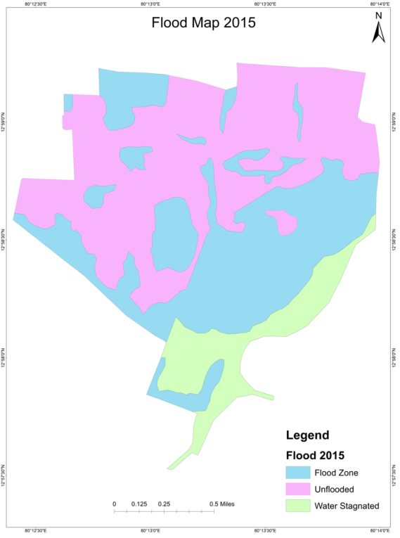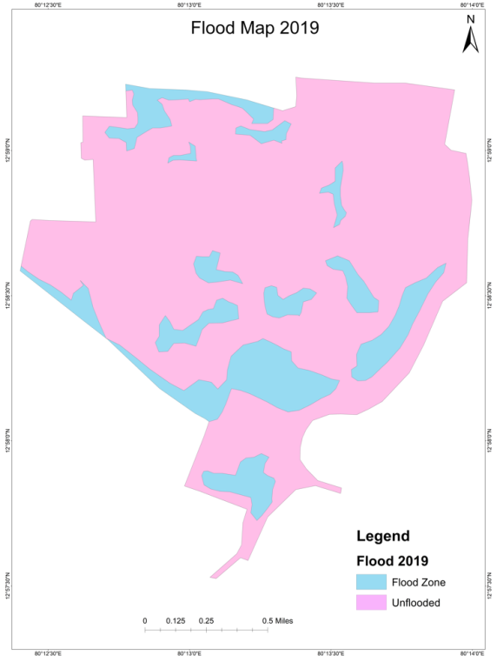
Figure. 10.1Velachery flood map in 2015 Figure 10.2: Velachery flood map in 2019
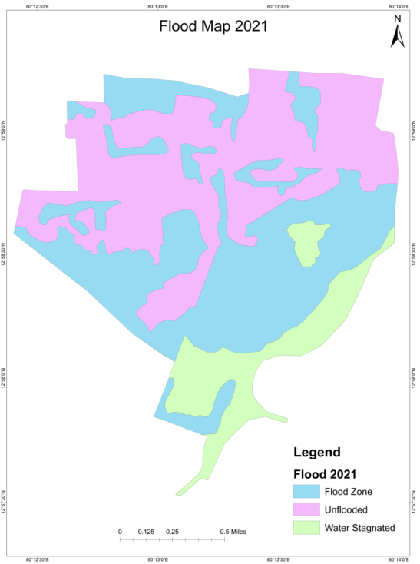
Figure 10.3: Velachery flood map in 2021
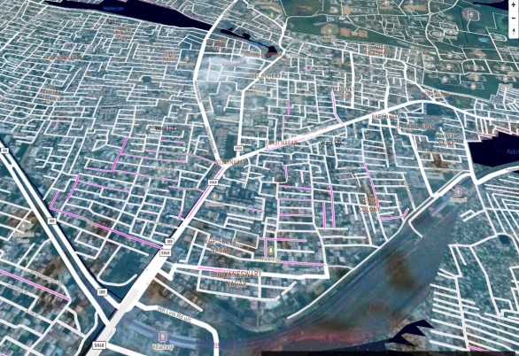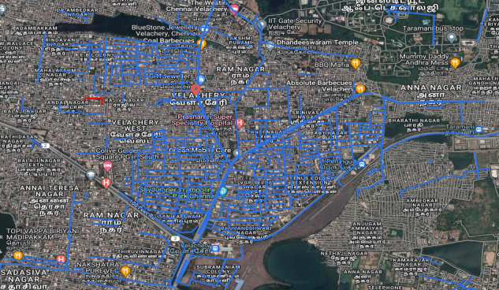
Figure 10.4: Velachery Vulnerable and Inundated areas Figure 10.5: Velachery Flood Map (Source: Chennai Flood Map Satellite View)
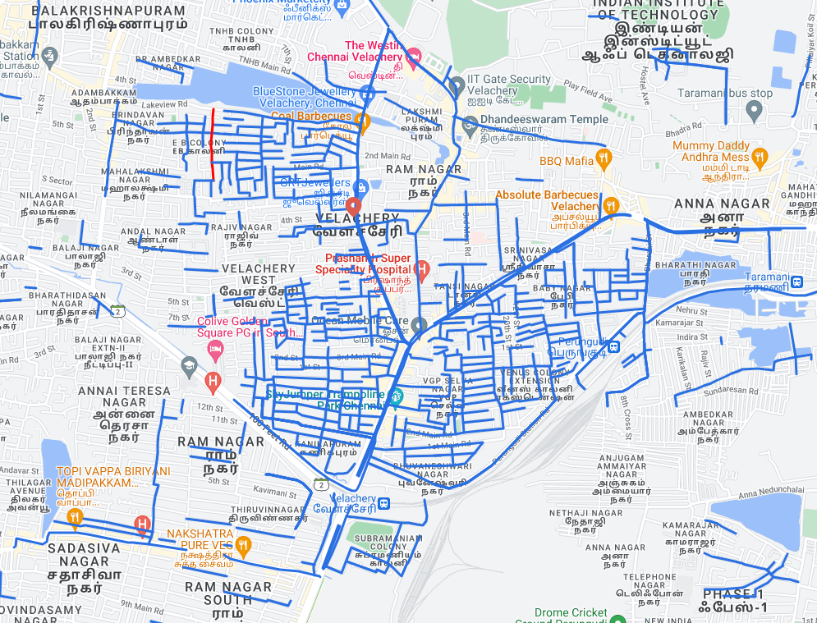
Figure 10.6: Velachery Flood Map (Source: Chennai Flood Map Terrain View)
SUMMARY AND CONCLUSION

The places that are extremely susceptible to floods are found out based on the flood extent and the volume estimate. In this study, the extreme flood events of November 12, 2021 are considered.

Conclusion
The flood-prone area cannot be identified only based on contour data; high flood levels that have been witnessed on the ground must also be taken into account. The information acquired from locals, which may be overstated, is used to calculate the water levels, which is one of the study's weaknesses. Using ALTM (Airborne Laser Terrain Mapping) data allows for the creation of a more precise DEM for analysis. In the Velachery region, areas like Vijaya Nagar, Tansi Nagar, and Baby Nagar are especially vulnerable to flooding. The storm water drainage system has a single outflow point that leads to Pallikaranai Marsh. The flood water from Velachery cannot be carried by the entire waterway. Thus, field research aids in shedding light on actual circumstances and events, providing accurate information for the management of catastrophes like floods. 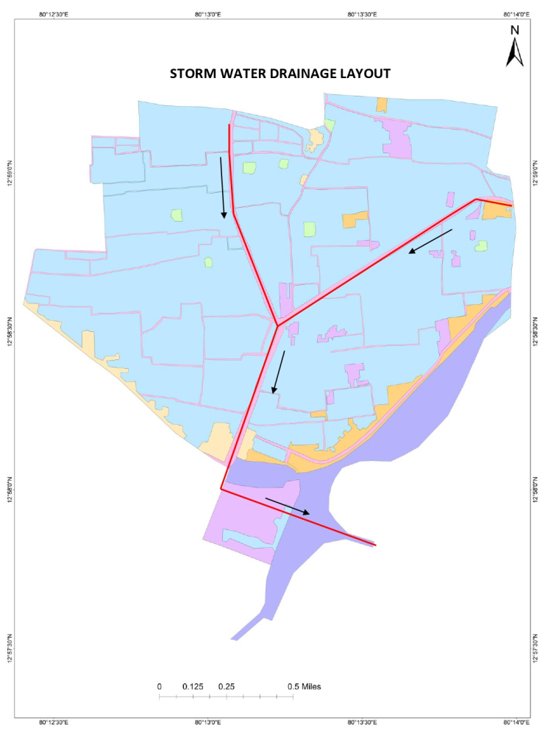
Figure 5.1: Velachery Storm Water Drainage Layout
REFERENCES
1. Md. Monirul Islam, Kiyokazu Ujjies, Tofael Ahamed in 7 January 2022 - Flash flood-induced vulnerability and need assessment of wetlands using GIS, remote sensing and economic models. Remote Sensing Applications: Society and Environment.

2.Jar R.S. Doorga, Leonard Mageri, Ravindra Boojhawon are an International Journal of Disaster Risk Reduction, 19 November, 2021done GIS-based muli-crirtera modelling of flood risk susceptibility in Port Louis, Mauritius: Towards resilent flood management.

3.Daouda Nsangou, Amidou Kpoume, Jules Remy Ndam Ngoupyou are African Scientists, 29 November done Urban flood susceptibility modeling using AHP and GIS approach: case of the Mfoundi watershed at Yaounde in the South-Cameroon plateau.

4.E.C. Chukwuma, C.C. Okonkwo, C.P. Nwachukwu Hliyon, 22 September 2021 a GIS based flood vulnerability modelling of Anambra State using an integrated IVFRN-DEMATEL-ANP model.

5.Hunegnaw Desalegn, Arega Mulu are African Scientists, 5 July 2021 published the Mapping flood inundation areas using GIS and HEC-RAS model at Fetam River, Upper Abay Basin, Ethipoia.

6.Sandeep Samantaray, Sambit Sawan Das, Deba Prakash Satapathy proceedings, 11 December 2021 are Evaluating the appilcations of metaheuristic approaches for flood simulatiuon using GIS. A case study of Baitarani river Basin, India.

7.Felix Ndidi Nkeki, Ehiaguina Innocent Bello, Ishola Ganiy Agbaje are an International Journal of Disaster Risk Reduction, 3 June 2022 published the Flood risk mapping and urban infrastructural susceptibility assessment using a GIS and analytic hierarchial raster fusion approach in the Ona River Basin Nigeria.

