Artificial Intelligence and Intelligent Computing Techniques for Healthcare Decision Support
Dr. Sanjeev Gour,Asst. Professor,Dept. of Computer Science, Medi-Caps University, Indore.

Abstract:
The integration of artificial intelligence (AI) and intelligent computing approaches has led to notable breakthroughs in healthcare decision support systems. This chapter delves into the impact of artificial intelligence (AI) on healthcare decision support systems, offering a comprehensive examination of different AI technologies and their utilization within the healthcare field. In addition, an examination will be conducted on the potential enhancements that can be achieved in patient care, diagnosis, treatment, and the broader domain of healthcare management through the use of these technologies. The main subjects covered in this chapter encompass machine learning methods, natural language processing, expert systems, and their practical applications.
Keywords— Artificial Intelligence (AI), Healthcare decision support systems
Introduction:
A. An Overview of Healthcare Decision Support Systems:
In this Section, we will provide a comprehensive introduction to healthcare decision support systems (HDSS). HDSS are computer-based tools that assist healthcare professionals in making informed decisions on patient care. These systems utilize several technologies, such as artificial intelligence and data
Healthcare decision support systems are a significant invention within the continuously developing healthcare domain. These systems have been specifically developed to aid healthcare professionals and administrators in making well-informed decisions through the utilization of data and technology. The utilization of decision support systems (DSS), commonly referred to as DSS, has garnered considerable attention in response to the urgent demand for healthcare solutions that are more precise, effective, and based on data. The development of these systems can be attributed to the increasing intricacy of healthcare, the proliferation of medical data, and the imperative to optimize patient outcomes.
Healthcare decision support systems serve as the fundamental technological infrastructure of contemporary medicine, equipping healthcare providers with the required resources and knowledge to effectively navigate an ever-evolving healthcare environment. This encompasses the process of making crucial determinations regarding the identification of medical conditions, development of treatment strategies, administration of patient care, and allocation of resources.
B. The Significance of Data-Driven Decision-Making in the Healthcare Sector
The significance of data-driven decision-making in the healthcare industry cannot be exaggerated. The proliferation of medical data sources, including electronic health records (EHRs), patient history, medical imaging, and genetics, presents an unparalleled potential to leverage this extensive knowledge for enhanced healthcare results. Data-driven decision-making is the process of collecting actionable insights from a large volume of information and using them to improve the quality of care, optimize the utilization of resources, and minimize errors.
In a domain characterized by high stakes involving matters of life and death, the utilization of data-driven decision-making not only holds the potential for enhanced efficacy, but more significantly, it presents an opportunity to preserve lives and enhance the holistic welfare of patients. The toolset offered by this system equips healthcare practitioners with a robust array of resources to discern trends, detect potential hazards, and render more precise and prompt judgements. Nevertheless, the extensive quantity and intricate nature of healthcare data require the utilization of sophisticated technology in order to fully exploit its capabilities.
C. The Integration of AI and Intelligent Computing Techniques in Healthcare
The use of artificial intelligence (AI) and intelligent computing techniques signifies a significant transformation in the field of healthcare. Artificial intelligence (AI) is playing a leading role in driving this revolution, thanks to its advanced capabilities in machine learning, natural language processing, and expert systems. Artificial intelligence (AI) algorithms have a notable capacity to acquire knowledge from data, adjust to novel information, and offer previously concealed insights within the extensive healthcare data domain.
The utilization of artificial intelligence (AI) inside healthcare decision support systems is progressively gaining prevalence due to its inherent merits. Intelligent technologies possess the capability to analyze patient information, medical imaging, and clinical literature with an unprecedented scale and speed, beyond the limitations of conventional methods. Artificial intelligence (AI) possesses the capacity to enhance the precision of diagnoses and prognoses, streamline healthcare procedures, and augment patient care by means of discovering correlations, forecasting outcomes, and proposing treatment choices.

Machine Learning Algorithms in Healthcare:
A. Supervised Learning for Diagnosis and Prognosis
Supervised learning, a fundamental component of artificial intelligence, has brought about a significant transformation in the healthcare industry, specifically in the domains of diagnosis and prognosis. Supervised learning involves the training of algorithms using labelled datasets, wherein the input data, such as patient records or medical imaging, is accompanied by known outcomes, such as illness presence or treatment success. This particular sort of learning allows healthcare providers to utilize past patient data in order to make well-informed decisions regarding present and future instances.
Supervised learning models have the capability to analyze various patient data, encompassing symptoms, laboratory test outcomes, and medical imaging, in order to forecast the probability of a specific illness or disease for diagnostic purposes. These models have the capability to aid in the early detection of diseases, suggest supplementary diagnostic testing, and even uncover previously unnoticed risk factors. In the realm of prognosis, the utilization of supervised learning techniques can contribute to the prediction of the probable trajectory of a disease, thereby offering significant and crucial insights that can inform treatment strategies and facilitate effective patient counselling. Through a process of continuous learning and adaptation to novel data, these algorithms progressively improve their predictive accuracy, so assisting healthcare practitioners in providing care that is more precise and tailored to individual patients.
B. Unsupervised Learning for Patient Clustering and Anomaly Detection
The present section focuses on the application of unsupervised learning techniques for the purpose of patient clustering and anomaly detection.
Unsupervised learning methods play a crucial role in the identification and exploration of concealed patterns within extensive healthcare datasets. In this particular methodology, algorithms undertake the analysis of data in the absence of predetermined labels or results. Within the domain of healthcare, the utilization of unsupervised learning techniques is particularly prominent in the areas of patient clustering and anomaly detection.
The process of patient clustering entails the categorization of individuals based on their comparable medical profiles or illnesses, yielding various advantageous outcomes. For example, it can facilitate the segmentation of patient groups to develop tailored treatment programmes, identify cohorts for clinical trials, or support resource allocation efforts. Through the utilization of automated categorization techniques, healthcare providers have the ability to classify patients according to their distinct characteristics and medical histories. This enables the customization of care plans for specific groups, hence enhancing the efficacy and personalization of treatments.
Anomaly detection plays a critical role in the identification of outliers or anomalies within healthcare data. These abnormalities may potentially indicate inaccuracies in the process of data gathering, the identification of fraudulent activities, or even the initial indications of an uncommon medical condition. Unsupervised learning models provide the capability to identify anomalies that deviate from the established patterns, hence urging healthcare practitioners to do more inquiry. The protection of data integrity serves as a critical measure in ensuring both the early identification of issues and the prompt administration of necessary interventions and treatments.
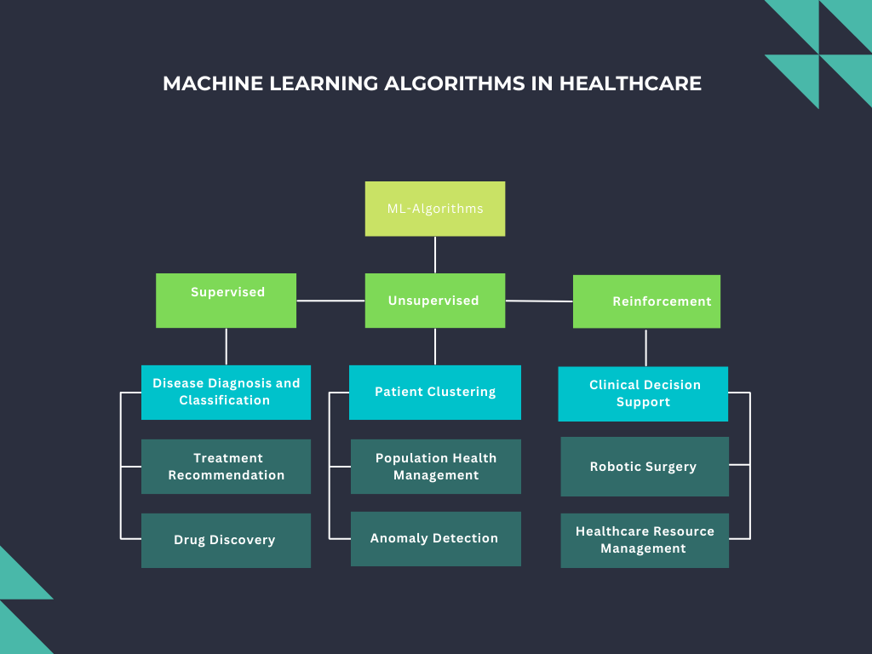
Fig.1: Machine Learning Algorithms in Healthcare

C. Reinforcement Learning for Treatment Optimization
The focus of this section is on the application of reinforcement learning techniques for the purpose of optimizing treatment strategies.
Reinforcement learning, an area of machine learning that facilitates algorithmic learning through interactions with an environment, is becoming recognized as a potent tool for optimizing healthcare treatment regimens. Reinforcement learning models have the capacity to change their activities towards achieving optimal outcomes through the receipt of feedback in the form of rewards or penalties.
In the domain of healthcare, reinforcement learning is being utilized to customize treatment tactics. The aforementioned algorithms possess the capability to suggest treatment regimens that dynamically adjust in accordance with a patient's response, hence enhancing the effectiveness of therapies over a period of time. The use of this dynamic strategy guarantees that interventions are modified in response to the acquisition of novel data, hence enhancing patient outcomes and mitigating the likelihood of unfavorable consequences. Reinforcement learning exhibits significant potential in enhancing the delivery of more efficient and patient-centric care, particularly in domains such as personalized medicine and chronic disease management.
Natural Language Processing (NLP) in healthcare:
A. NLP for Electronic Health Record Analysis
The field of healthcare has witnessed the emergence of Natural Language Processing (NLP) as a transformative technology. NLP facilitates the examination and extraction of important information from the vast quantities of unstructured textual data present in electronic health records (EHRs). Electronic health records (EHRs) serve as valuable warehouses of patient information, encompassing clinical narratives, physician notes, and patient history. Nevertheless, the abundance of information can prove to be daunting for healthcare providers in the absence of sophisticated natural language processing (NLP) capabilities.
Natural Language Processing (NLP) algorithms has the capability to analyses the intricate narrative present in Electronic Health Records (EHRs) and effectively extract significant information such as diagnosis, drugs, procedures, and patient demographics. In addition, these systems include the capability to discern connections among various data points, hence enhancing clinicians' ability to make well-informed recommendations. For example, Natural Language Processing (NLP) has the potential to aid in the identification of patients at high risk, the prediction of illness outcomes, and the enhancement of medical coding precision. The utilization of Natural Language Processing (NLP) in the analysis of Electronic Health Records (EHR) not only improves the effectiveness of healthcare procedures but also facilitates more precise clinical decision-making.

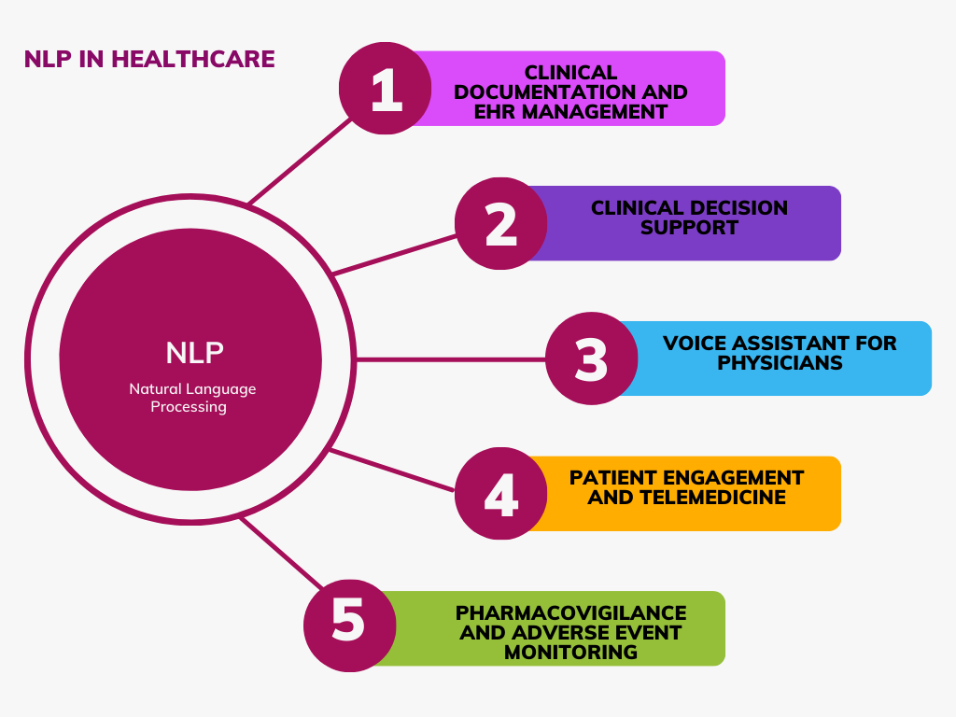
Fig.2: Natural Language Processing (NLP) in healthcare

B. An Analysis of Sentiment in Patient Feedback
In this section, we aim to analyze the sentiment expressed in patient feedback. The objective is to get insights into the overall satisfaction levels of patients and identify any areas of improvement in healthcare services.
In the era of healthcare focused on patient-centered treatment and the prioritization of quality improvement, the collection of patient feedback has emerged as a highly valuable and informative resource. The comprehension and measurement of patient feelings hold significant importance for healthcare organizations aiming to improve the patient experience and the overall standard of service. Sentiment analysis, which is a subfield of natural language processing (NLP), assumes a crucial function in this context.
Sentiment analysis algorithms have been specifically developed to examine patient feedback expressed through various mediums such as online reviews, questionnaires, or comments. These algorithms aim to extract meaningful insights from unstructured textual data. Healthcare practitioners can enhance their comprehension of patient satisfaction, concerns, and opportunities for improvement by discerning the polarity (positive, negative, or neutral) of feedback and distinguishing the exact sentiments conveyed. This data can be utilized to customise services, enhance communication, and facilitate evidence-based modifications in healthcare provision.
For example, sentiment analysis can assist healthcare facilities in identifying concerns pertaining to staff conduct, hygiene standards, waiting durations, or the standard of service delivered. Healthcare facilities are able to enhance their operations by utilising data-driven strategies, which in turn promotes a patient-centric approach and ultimately leads to a greater level of care. Sentiment analysis serves the dual purpose of measuring patient sentiment and enabling healthcare organizations to take appropriate actions based on this information. This ensures that the patient's perspective is acknowledged and considered in the continuous pursuit of enhancing healthcare delivery.

Expert Systems in Medical Diagnosis:
A. Expert Systems and Their Role in Healthcare
Expert systems, which are a subset of artificial intelligence, have had a significant impact on the healthcare sector, bringing about substantial changes. These sophisticated computer systems are specifically engineered to replicate the decision-making abilities of human specialists within a specific field. Expert systems have demonstrated significant value in the healthcare field by offering decision assistance, facilitating the process of making diagnoses, and assisting in the planning of treatments. Expert systems have the capability to integrate the knowledge and expertise of healthcare professionals into a computer programme. This integration allows for the provision of evidence-based recommendations, accurate assessments, and support in intricate clinical decision-making processes.

B. Case-Based Reasoning for Diagnosis
Case-based reasoning (CBR) is a widely recognised and significant implementation of expert systems within the healthcare domain. The CBR methodology is an approach to problem-solving that use previous experiences and instances in order to address novel situations that share similarities. Within the healthcare domain, the utilisation of Case-Based Reasoning (CBR) facilitates the ability of the system to conduct a comparative analysis between the symptoms, medical history, and test outcomes of a given patient and an extensive repository of prior cases. This process entails the identification of resemblances and patterns for the purpose of informing medical decision-making. By establishing connections between the present case and past cases, CBR has the potential to offer healthcare professionals valuable insights in terms of diagnostic possibilities, treatment options, and prognostic indications.
Case-based reasoning (CBR) proves to be highly advantageous in scenarios when healthcare professionals encounter intricate and uncommon instances, or when they must take into account a diverse array of variables and aspects during the diagnostic procedure. Through the utilisation of Case-Based Reasoning (CBR), expert systems have the capability to enhance the accuracy and evidence-based nature of diagnoses. This is achieved by ensuring that a comprehensive repository of medical knowledge and historical cases is easily accessible, hence providing valuable assistance for clinical decision-making processes.

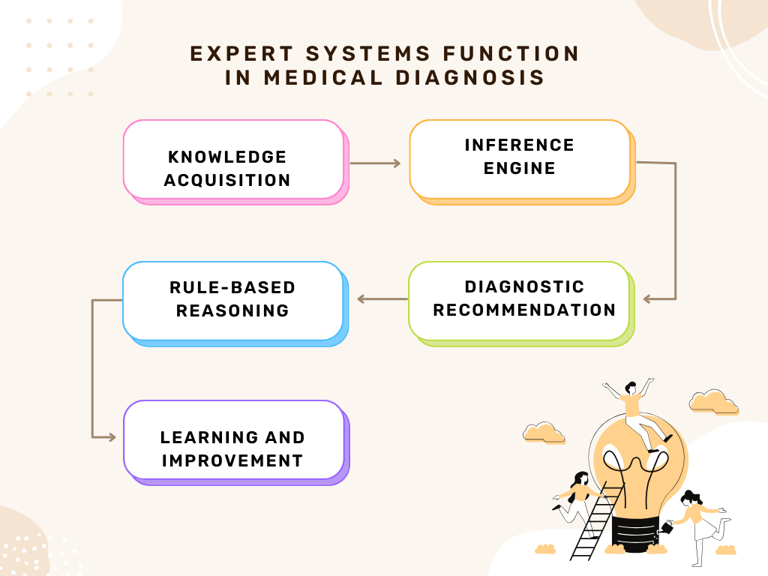
Fig.3: Expert Systems in Medical Diagnosis
C. Rule-Based Expert Systems for Clinical Decision Support
The utilization of rule-based expert systems in the field of clinical decision support has gained significant attention and recognition. These systems are designed to assist healthcare professionals in making informed and accurate decisions by applying a set of predefined rules and knowledge. By using these systems, clinicians can benefit from the expertise
Rule-based expert systems belong to a category of expert systems that function through the application of a predetermined set of rules and logical reasoning to address a specific problem or scenario. Rule-based expert systems are extensively employed in the healthcare domain for the purpose of providing clinical decision assistance. The development of these systems involves the extraction of medical experts' expertise, which is then encoded into a set of "if-then" rules that establish connections between certain conditions and corresponding actions. Upon being presented with patient data, the system proceeds to assess these rules and thereafter generates recommendations that are contingent upon the patient's specific characteristics and the medical information that has been recorded.
In the context of medication management, a rule-based expert system has the capability to integrate recommendations and interactions in order to notify healthcare providers regarding probable drug interactions, allergies, or necessary dosage modifications. These systems have the capability to aid in the selection of suitable treatments, taking into account the presence of comorbidities, and promoting adherence to established best practises.
Rule-based expert systems provide a means of decision-making that is characterised by openness and traceability. This is due to the fact that the rules governing the system can be easily scrutinised and adjusted by domain experts. Consequently, these systems serve as a valuable tool in upholding the utmost standard of care and ensuring patient safety.

Predictive Analytics and Healthcare Outcomes:
A. Predictive Modeling for Patient Outcomes
Predictive modelling, a subfield within the realm of artificial intelligence, is progressively playing a pivotal role in enhancing patient outcomes within the healthcare domain. Through the examination of previous patient data and the identification of recurring patterns, predictive models have the capability to foresee forthcoming health events, provide valuable insights for treatment decisions, and improve the overall quality of patient care. These models utilise a diverse range of data sources, like as electronic health records, medical imaging, genetic information, and patient-reported outcomes, in order to make predictions on many aspects, including illness progression, risk of readmission, and response to treatment. By utilising predictive models to anticipate patient outcomes, healthcare professionals can implement proactive strategies to enhance the quality of care and ultimately enhance patient well-being.
B. Risk Assessment and Prevention Using AI
One of the most appealing uses of artificial intelligence in the healthcare domain pertains to risk assessment and prevention. AI-powered risk assessment models have the capability to analyse extensive datasets in order to identify individuals who are more susceptible to acquiring particular health disorders. This facilitates the implementation of early intervention and prevention efforts. These models take into account a wide range of risk factors, including genetic predisposition, lifestyle decisions, and environmental influences. Artificial intelligence (AI) plays a significant role in mitigating the impact of chronic diseases and fostering a more health-conscious society by effectively identifying individuals at high risk and offering tailored advice for preventive measures.
The application of artificial intelligence (AI) in the field of preventative medicine also encompasses public health. As an illustration, artificial intelligence (AI) has the capability to examine epidemiological data in order to identify instances of disease outbreaks, track the dissemination of infectious diseases, and forecast the requirements for healthcare resources in the midst of pandemics. The implementation of a proactive strategy for risk assessment and prevention not only has the potential to mitigate loss of life, but also has the opportunity to decrease healthcare expenditures and address resource allocation complexities.
C. Data Sources and Challenges in Predictive Analytics
The present study focuses on the examination of data sources and challenges encountered in the field of predictive analytics. This research aims to provide a comprehensive understanding of the various sources from which data is obtained for predictive analytics, as well as the obstacles faced in the process. By exploring these aspects,
The effectiveness of predictive analytics in the healthcare sector is strongly contingent upon the accessibility and reliability of data. Electronic health records (EHRs), medical imaging, patient demographics, and wearable device data are considered indispensable sources for the development and training of predictive models. Nevertheless, there are certain obstacles that need to be confronted in order to fully exploit the capabilities of predictive analytics in the healthcare sector.
One major challenge that persists is the issue of data interoperability. The integration and analysis of healthcare data is often hindered by its compartmentalization across several systems, resulting in a lack of seamlessness. Furthermore, the issue of data privacy and security, especially when it comes to handling sensitive patient data, requires the implementation of strong safeguards to ensure the confidentiality of patients and adherence to regulatory standards.
The importance of data quality and completeness cannot be overstated. The presence of inaccurate or incomplete data has the potential to result in erroneous predictions and impede the efficacy of predictive models. In addition, the ethical problem persists in ensuring that the utilization of predictive analytics is directed towards the enhancement of patient well-being and the improvement of healthcare procedures, rather than solely for the purpose of maximizing financial gains.

Image Analysis and Computer Vision:

A. AI-Driven Image Analysis for Medical Imaging
AI-Driven Image Analysis for Medical Imaging has emerged as a prominent field in the healthcare industry. This innovative approach utilises artificial intelligence (AI) algorithms to analyse medical images, such as X-rays, CT scans, and MRIs. By harnessing the power of AI, healthcare professionals can obtain
Medical imaging has been a fundamental component of healthcare for a significant period of time, facilitating the ability of healthcare professionals to visually examine and identify various medical ailments. The incorporation of artificial intelligence (AI) has greatly enhanced the capabilities of medical imaging, leading to a paradigm shift characterised by improved precision and effectiveness. The utilisation of deep learning algorithms in AI-driven image analysis enables the examination of radiological images, including X-rays, CT scans, MRIs, and ultrasound, with exceptional accuracy and efficiency.
One of the key benefits associated with AI-powered picture analysis is its capacity to identify minor anomalies and patterns that may be imperceptible to human perception. These algorithms have the potential to aid radiologists by identifying and highlighting prospective regions of interest, so limiting the possibility of oversight and offering an additional layer of scrutiny through a virtual examination. Additionally, artificial intelligence (AI) has the potential to enhance the process of interpretation, resulting in quicker turnaround times and, in urgent situations, enabling prompt clinical decision-making.
In the course of our investigation, we will examine distinct instances in which picture analysis powered by artificial intelligence has yielded significant changes, including the timely identification of cancer, the study of neurological illnesses, and the examination of musculoskeletal ailments. In addition, this discourse will address the obstacles and ethical implications associated with the utilisation of artificial intelligence (AI) in the field of medical imaging, emphasising its capacity to fundamentally transform diagnostic precision and the quality of healthcare provided to patients.
B. Early Detection and Diagnosis Using Computer Vision
Computer vision, which is a subfield of artificial intelligence (AI), assumes a critical role in the timely identification and diagnosis of medical conditions within many medical domains. Computer vision algorithms have the ability to automatically evaluate, interpret, and extract significant information from visual data, including medical photos, pathology slides, and dermatological photographs, by imitating the human visual system.
The timely identification of medical conditions is of utmost importance in the field of medicine, as it frequently determines the outcome of therapy and the course of diseases. The capacity of computer vision to detect small visual cues and irregularities has played a crucial role in the prompt identification of various illnesses, including diabetic retinopathy and skin cancer. Computer vision has been successfully applied in the field of ophthalmology to identify indications of ocular disorders through the analysis of retinal scans. This technological advancement has the potential to facilitate timely intervention and mitigate the risk of vision impairment.
The utilisation of computer vision extends beyond the realm of diagnostics exclusively. Furthermore, this technology finds application in surgical support, wherein it provides real-time picture analysis to guide surgeons during surgeries. Additionally, it is utilised in the monitoring of chronic diseases through the integration of visual sensors into wearable devices.

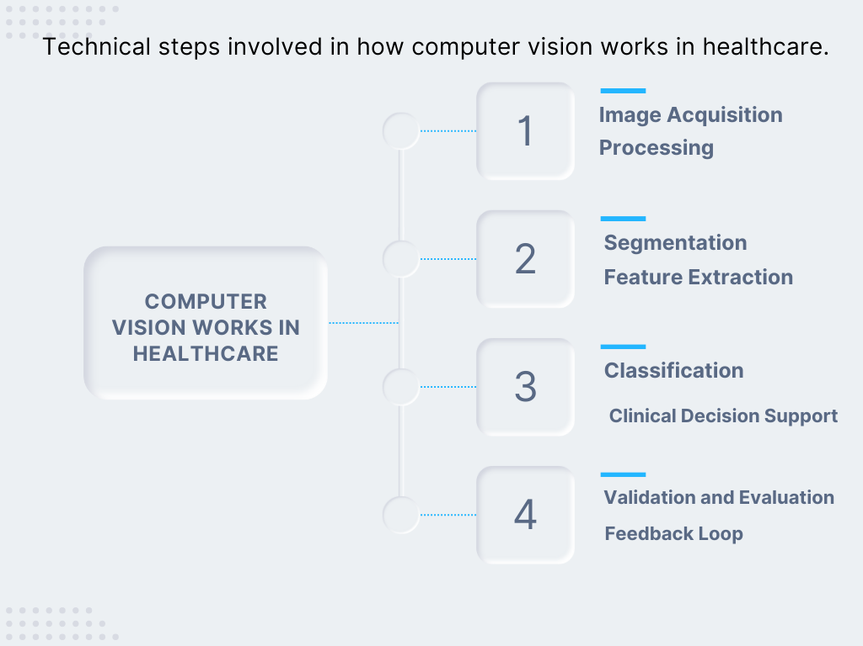
Fig-4: How computer vision works in healthcare

Telemedicine and AI for Remote Consultations:
A. The Role of AI in Remote Healthcare Consultations
In recent years, there has been a notable increase in the importance of remote healthcare consultations, also known as telehealth, which has been further enhanced by the integration of artificial intelligence (AI) technology. Artificial intelligence (AI) plays a diverse and essential role in augmenting the quality and effectiveness of telehealth, thereby establishing itself as an integral component of contemporary healthcare. The emergence of virtual health platforms powered by artificial intelligence has eliminated the limitations imposed by geographical factors, enabling patients and healthcare practitioners to engage in consultations and follow-ups remotely, providing convenience and ease from the confines of one's residence.
Artificial intelligence (AI)-driven chatbots and virtual assistants play a crucial role as the initial interface for individuals seeking medical guidance. AI-driven interfaces have the capability to prioritise symptoms, respond to basic inquiries, and offer first information pertaining to health issues. The implementation of appointment booking systems enhances efficiency by simplifying the procedure, resulting in time savings and alleviating the administrative workload for healthcare personnel.
During telehealth consultations, artificial intelligence (AI) has the potential to assist healthcare clinicians in various capacities. The utilisation of natural language processing (NLP) technology facilitates the transcription and analysis of conversations, so ensuring the correct capture of essential information. Machine learning algorithms have the potential to aid in the diagnosis of medical disorders and provide recommendations for treatment choices. Moreover, the integration of artificial intelligence (AI) into remote monitoring equipment enables the continuous monitoring of vital signs, so enabling healthcare providers to promptly detect any deviations from normal parameters. This early detection capability facilitates timely intervention and appropriate medical attention.
In addition, artificial intelligence has the capability to customise telehealth encounters by adapting the material and suggestions to align with the specific requirements and medical background of each patient. The implementation of personalization in telehealth consultations promotes patient involvement and enhances the informational and effectiveness aspects to a level comparable to in-person visits.

B. Telehealth Applications and Technologies
Telehealth applications and technologies refer to the use of digital platforms and tools in the provision of healthcare services remotely. These applications and technologies enable healthcare professionals to deliver medical care, consultation, and monitoring to patients without the
The field of telehealth has had significant advancements in both applications and technologies, resulting in a transformative impact on the delivery and reception of healthcare services. Telehealth comprises a wide range of services, including virtual consultations with primary care physicians, remote monitoring of chronic illnesses, and teletherapy sessions. The applications of this technology are many, encompassing specialised domains such as telestroke care, teledermatology, and telepsychiatry.
The technological foundation supporting telehealth is also characterised by its dynamic nature. The term "telehealth" refers to a range of technologies, including video conferencing platforms, smartphone apps, wearable devices, and cloud-based solutions. These technologies facilitate seamless connectivity between healthcare providers and patients. These technological advancements provide instantaneous transmission of voice and visual signals, so assuring that consultations closely resemble in-person conversations.
In addition, telehealth technologies integrate robust measures for the secure transfer and storage of patient data, ensuring the protection of sensitive information. Ensuring adherence to healthcare rules, data privacy standards, and encryption methods is crucial in upholding patient trust and safeguarding data security.
The implementation of telehealth has resulted in enhanced accessibility to healthcare services, hence fostering more patient participation, particularly in regions that are geographically remote or lack sufficient medical resources. The implementation of this technology has resulted in a decrease in both travel time and expenses, a reduction in the potential for exposure to communicable diseases, and an enhancement in the overall effectiveness of healthcare provision. The increasing scope of telehealth has led to the emergence of technology, particularly artificial intelligence (AI), as a transformative force in remote healthcare consultations. This development has the potential to revolutionise the healthcare sector by offering a patient-centric and convenient method for getting medical care.

Electronic Health Records (EHR) and AI:
A. EHR Systems and Their Potential for AI Enhancement
Electronic Health Record (EHR) systems have emerged as a crucial tool in modern healthcare, facilitating the storage and exchange of patient health information. With the rapid advancements in artificial intelligence (AI), there is a growing interest in exploring the potential of integrating AI technologies into EHR
The implementation of Electronic Health Records (EHR) has brought about a significant transformation in the manner in which healthcare data is collected, preserved, and retrieved. Digital repositories of patient data have emerged as a fundamental component of contemporary healthcare, providing healthcare providers with complete and well-structured records that enable them to gain a thorough understanding of each patient's medical history. Nevertheless, the genuine potential of Electronic Health Record (EHR) systems resides in their ability to be enhanced by Artificial Intelligence (AI).
The integration of artificial intelligence (AI) into electronic health record (EHR) systems presents healthcare providers with numerous possibilities for enhancing patient care, optimising administrative procedures, and augmenting clinical decision-making. Artificial intelligence (AI) has the capability to analyse extensive quantities of structured and unstructured data contained inside electronic health records (EHRs). This analytical capacity aids in the identification of pertinent clinical insights, patterns, and potential factors that may pose risks. This practise not only facilitates timely identification and intervention but also helps to the field of personalised medicine, enabling the customization of treatment programmes for each unique patient.
Artificial intelligence (AI)-enhanced electronic health records (EHRs) have the potential to aid in the prediction of patient outcomes, the prevention of readmissions, and the timely notification of healthcare providers to crucial occurrences, such as sepsis or bad medication responses. In addition, these technologies have the potential to enhance the efficiency of documentation processes by automating the transcription of clinical notes, hence improving the user-friendliness of electronic health records (EHRs) for healthcare professionals. The integration of artificial intelligence (AI) into electronic health records (EHRs) has the potential to alleviate the administrative workload, allowing healthcare workers to allocate more time towards patient care and engagement. This, in turn, facilitates the adoption of a patient-centric approach within the field of medicine.
B. AI-Assisted Data Extraction and Analysis
The utilisation of artificial intelligence (AI) to facilitate the extraction and analysis of data inside electronic health record (EHR) systems plays a crucial role in enhancing the accessibility and usability of healthcare data. Electronic health records (EHRs) encompass a diverse range of information, including structured data such as vital signs and lab results, as well as unstructured clinical notes and medical photographs. Artificial intelligence (AI)-based algorithms possess the capability to swiftly and precisely extract and analyse this data, thereby offering significant insights that can aid in clinical decision-making.
The utilisation of natural language processing (NLP) methods facilitates the ability of artificial intelligence (AI) systems to analyse and comprehend the unorganised textual content present in electronic health records (EHRs), hence enabling computational accessibility to clinical notes and narratives. This improves the capacity to recognise crucial data, extract diagnostic patterns, and condense patient histories, so aiding healthcare professionals in making educated judgements.
Artificial intelligence (AI) has the capability to consolidate data from several sources, hence facilitating the accessibility of pertinent patient information. The integration of data from several electronic health records (EHRs), wearable devices, and external sources of health data facilitates a more thorough understanding of a patient's overall health status through the utilisation of artificial intelligence (AI) systems. The utilisation of wearable devices to collect real-time data, in conjunction with past electronic health record (EHR) data, holds significant value in the context of managing chronic diseases. This approach enables proactive monitoring of patient health.

Ethical and Regulatory Considerations:

A. Ethical Dilemmas in AI-Driven Healthcare
The incorporation of artificial intelligence (AI) within the healthcare sector has initiated a novel epoch of medical advancement and effectiveness. Nevertheless, the swift progression in technology also gives rise to a plethora of ethical quandaries and intricate inquiries that necessitate resolution. One of the primary quandaries revolves with the equilibrium between advancements in technology and the safeguarding of patient rights, safety, and privacy.
The ethical dilemma of potential bias and fairness is a significant concern for AI-driven healthcare systems, including those engaged in diagnosis, treatment recommendations, and predictive analytics. If the data utilised for the training of artificial intelligence models exhibits bias, there is a possibility that the system will perpetuate and intensify prevailing gaps in healthcare. The primary importance is in guaranteeing the impartiality and fairness of the development and implementation of AI technology.
Privacy and data security are significant ethical considerations that warrant attention. The safeguarding of sensitive patient information from unauthorised access and breaches is of utmost importance as healthcare organisations continue to accumulate and exchange substantial quantities of such data. The ethical quandary of reconciling the sharing of data for research purposes with the imperative of safeguarding patient privacy is a formidable challenge.
Furthermore, there exist inquiries regarding the extent of human supervision in healthcare systems propelled by artificial intelligence. Determining the appropriate circumstances for AI to offer recommendations, as opposed to deferring the final choice to a human healthcare expert, is a crucial consideration. The ethical implications around accountability and culpability arise from the delineation of artificial intelligence's (AI) involvement in the medical decision-making process.
B. Regulatory Frameworks and Guidelines
In order to effectively navigate the ethical quandaries associated with artificial intelligence (AI) implementation in the healthcare sector, regulatory frameworks and guidelines have been developed. The objective of these guidelines is to establish a coherent framework for the advancement, implementation, and assessment of healthcare solutions powered by artificial intelligence.
Regulatory agencies, such as the U.S. Food and Drug Administration (FDA) and the European Medicines Agency (EMA), have issued rules pertaining to medical devices and software that utilise artificial intelligence (AI). These rules establish requirements for the transparency of data, the explainability of algorithms, and the evaluation of performance, thereby guaranteeing that artificial intelligence systems adhere to stringent safety and effectiveness criteria.
Furthermore, the safeguarding of patient data and the lawful utilisation of such data in artificial intelligence (AI) applications are facilitated by privacy legislation such as the Health Insurance Portability and Accountability Act (HIPAA) in the United States and the General Data Protection Regulation (GDPR) in the European Union.
Prominent medical organisations and associations, such as the American Medical Association (AMA) and the World Health Organisation (WHO), have also issued ethical guidelines that underscore the significance of openness, accountability, and patient permission in the context of AI-driven healthcare.

Challenges and Future Directions:
The ongoing transformation of healthcare decision support systems by artificial intelligence (AI) necessitates the recognition and resolution of associated issues. This chapter delves into the challenges and prospective advancements in the domain of artificial intelligence (AI) for supporting health-related decision-making. It encompasses the issues of data privacy and security, the compatibility of AI-driven healthcare systems, and the emerging trends and possible significant developments that lie ahead.
A. Data Privacy and Security Concerns
One of the primary obstacles in the incorporation of artificial intelligence (AI) into the healthcare sector pertains to the issues of data privacy and security. Healthcare decision support systems heavily depend on extensive collections of sensitive patient data, encompassing medical records, diagnostic pictures, and genetic information. The preservation of the confidentiality, integrity, and availability of this data is of utmost importance.
The main worry lies in the risk associated with data breaches, unauthorised access, and the potential misuse of patient information. Ensuring adherence to data protection standards, such as the Health Insurance Portability and Accountability Act (HIPAA) and the General Data Protection Regulation (GDPR), is of utmost importance. Consequently, developers of artificial intelligence (AI) systems must integrate strong encryption mechanisms, authentication protocols, and comprehensive audit trails to effectively secure the privacy of patients.
Furthermore, it is imperative to address concerns pertaining to algorithmic bias and fairness in order to mitigate the risk of inadvertent prejudice. The establishment of ethical principles in the development of artificial intelligence (AI) and the implementation of strategies to address biases in AI models are of utmost importance in upholding trust and promoting fairness in the field of healthcare.
B. Interoperability of AI-Driven Healthcare Systems
One additional obstacle that lies ahead pertains to the interoperability of healthcare systems powered by artificial intelligence. In numerous healthcare settings, the integration of diverse software applications and systems is vital to ensure the provision of comprehensive patient care. The integration of AI systems into the current healthcare infrastructure is crucial, as it enables the sharing of data, insights, and recommendations with electronic health records, clinical information systems, and medical devices.
The process of achieving interoperability entails the standardization of data formats, communication protocols, and integration interfaces. The complexity of this task is exacerbated by the wide range of outdated systems that are now being utilised in various healthcare environments. The resolution of interoperability obstacles holds significant importance in facilitating the extensive integration of artificial intelligence (AI) in the healthcare sector. This is essential for assuring the effective delivery of decision support in a timely manner and in the appropriate context.
C. Future Trends and Potential Breakthroughs
Despite the existence of persistent problems, the future of artificial intelligence (AI) for health decision support exhibits great prospects, characterized by various significant trends and potential breakthroughs that lie ahead. Artificial intelligence (AI)-powered systems are expected to undergo further advancements, leading to the provision of increasingly tailored and contextually sensitive advice for healthcare providers. The potential exists for the development of artificial intelligence (AI) systems that possess the capability to adapt to the unique requirements of individual patients, thereby augmenting care regimens and ultimately enhancing patient outcomes.
The potential of integrating artificial intelligence (AI) with emerging technologies, such as the Internet of Things (IoT) and wearable gadgets, is substantial. The utilization of remote monitoring and the acquisition of real-time patient data have the potential to augment early detection and predictive analytics, hence diminishing the strain on healthcare systems and enhancing the quality of patient care.
Furthermore, the implementation of federated learning and secure data-sharing protocols has the potential to address privacy problems in the healthcare domain. These approaches enable numerous healthcare institutions to collaborate on artificial intelligence (AI) models without compromising the confidentiality of sensitive patient data.

Case Studies:
A. Case Study 1: Early Detection of Tuberculosis Using AI
Location: Apollo Hospitals, Chennai
Apollo Hospitals in Chennai partnered with a healthcare AI firm to successfully implement an artificial intelligence (AI)-driven system aimed at detecting tuberculosis (TB) at an early stage. Through the analysis of chest X-rays, the AI model has a remarkable ability to detect indications of tuberculosis, resulting in expedited diagnosis and prompt initiation of therapy. The aforementioned has shown to be of particular significance in the context of India, where tuberculosis is a pervasive and complex issue within the realm of public health. The utilisation of artificial intelligence technology aids healthcare practitioners in the early detection of cases, hence improving patient outcomes and mitigating the transmission of the disease.
B. Case Study 2: Predictive Analytics for Neonatal Care
Location: Manipal Hospitals, Bengaluru
The implementation of predictive analytics powered by artificial intelligence (AI) has been launched by Manipal Hospitals in Bengaluru with the aim of enhancing newborn care. Through the examination and interpretation of data obtained from neonatal intensive care units (NICUs), the system is capable of forecasting the probability of infections and several other issues that may arise in premature infants. Healthcare professionals have the ability to utilise these forecasts in order to customise treatment plans and actions. The utilisation of an AI-driven methodology has resulted in a substantial decrease in infant mortality rates and enhanced the overall standard of care in the infant Intensive Care Unit (NICU).
C. Case Study 3: AI-Powered Telemedicine for Rural Health Access
Location: Swasthya Slate, Rajasthan
The Swasthya Slate programme operates in rural regions of Rajasthan, employing artificial intelligence (AI) to deliver telemedicine services to marginalised populations. The AI platform enables the provision of remote consultations with healthcare professionals and provides assistance in the diagnostic process. Technology has a crucial role in facilitating the timely identification of health concerns, particularly in the context of mother and child health. The implementation of Swasthya Slate has had a significant effect on enhancing the availability of healthcare services and mitigating health inequalities in rural areas of India.
D. Case Study 4: AI-Enhanced Cancer Diagnosis
Location: Tata Memorial Centre, Mumbai
The integration of artificial intelligence (AI) into cancer diagnosis systems has been implemented at the Tata Memorial Centre in Mumbai. Artificial intelligence (AI) algorithms are utilised for the purpose of examining pathology slides and radiological pictures, hence assisting in the timely identification and categorization of different types of malignancies. The implementation of automated analysis of medical images by the AI system enhances the precision of cancer diagnoses and expedites the reporting procedure. The implementation of this novel methodology has had a substantial influence on the provision of medical attention, resulting in a decrease in the time taken to diagnose patients and guaranteeing prompt administration of therapy.
E. Case Study 5: Remote Monitoring for Chronic Disease Management
Location: Fortis Hospitals, Delhi-NCR
Fortis Hospitals located in the Delhi-NCR region have successfully integrated artificial intelligence (AI)-enabled remote monitoring technologies to cater to patients suffering from chronic illnesses. Patients are provided with wearable devices that continuously gather health data, which is subsequently subjected to analysis by artificial intelligence algorithms. The system has the capability to identify and analyse abnormalities and patterns, hence facilitating healthcare providers to take appropriate actions when deemed essential. The implementation of a proactive approach in managing chronic diseases has resulted in enhanced patient outcomes and a decrease in hospital readmissions.
The presented case studies from India exemplify the varied implementations of artificial intelligence (AI) within the healthcare sector. These applications encompass early identification of diseases, prognostic analytics, remote medical consultations, cancer detection, and the treatment of chronic ailments. The aforementioned instances underscore the capacity of artificial intelligence (AI) to augment healthcare decision support systems, enhance the quality of patient care, and effectively tackle distinct healthcare obstacles within the Indian setting.

Conclusion:
This extensive exploration of the chapters inside "Artificial Intelligence and Intelligent Computing Techniques for Healthcare Decision Support Systems" has provided a thorough examination of the integration of healthcare and advanced technology. The book offers a comprehensive perspective on the significant impact of artificial intelligence (AI) and intelligent computing in reconfiguring the healthcare sector. It explores how these technologies have initiated a revolution centred around data-driven decision support, leading to an enhancement in the overall quality of patient care.
Beginning with the foundational principles of healthcare decision support systems, we emphasize the crucial significance of data-driven decision-making within the healthcare ecosystem and the essential role played by artificial intelligence (AI) and intelligent computing techniques in reshaping the healthcare paradigm.
Machine learning has emerged as a pivotal factor, making significant contributions to the field of healthcare. Supervised learning, which enables accurate diagnosis and prognosis, unsupervised learning for patient clustering and anomaly detection, and reinforcement learning for optimising treatment strategies, exhibit significant potential in the realm of clinical decision support and improving patient outcomes. The provided flowchart effectively demonstrates the diverse range of applications of machine learning within the healthcare industry.
The utilisation of Natural Language Processing (NLP) in the healthcare sector has demonstrated the significant benefits obtained from unstructured data. Natural Language Processing (NLP) enhances healthcare decision support by providing valuable textual insights, such as analysing electronic health data and understanding patient attitudes via comments.
Expert systems play a crucial role in the healthcare industry by simulating the decision-making abilities of medical specialists. They provide valuable assistance to healthcare workers in tasks such as nuanced diagnosis, case-based reasoning, and rule-based clinical decision support. The aforementioned systems are thoroughly examined in a comprehensive comparative analysis, providing a nuanced perspective on their respective uses.
The emergence of predictive analytics has shown to be a powerful tool in the realm of projecting patient outcomes and identifying potential dangers. This technology has the potential to significantly transform the healthcare industry by mitigating undesirable events. Our investigation encompassed a comprehensive exploration of several aspects, ranging from the identification of data sources to the complexities associated with predictive analytics. This endeavour aimed to shed light on the multitude of factors that impact the effectiveness of predictive models in the healthcare domain.
Within the field of medical imaging, there has been significant emphasis placed on the possibilities of AI-driven image processing and computer vision for the purposes of early detection and diagnosis. By examining persuasive case cases, we observed the measurable effects of their contributions in improving the interpretation of radiological images and the overall outcomes for patients.
The integration of artificial intelligence (AI) in telemedicine was investigated as the global healthcare landscape shifts towards distant consultations. The integration described serves to address disparities in healthcare, hence improving the ease of access and providing essential assistance in the context of remote medical encounters.
The potential for AI development in Electronic Health Records (EHRs), which serve as a fundamental component of modern healthcare, has been unveiled. The utilisation of artificial intelligence (AI) to aid in the extraction and analysis of data inside electronic health records (EHRs) holds the potential to enhance the efficiency of documentation and provide support for clinical decision-making.
The proper integration of artificial intelligence (AI) in healthcare necessitates the recognition of ethical considerations and adherence to regulatory frameworks. The primary objective is to guarantee that artificial intelligence (AI) adheres to ethical guidelines and effectively protects patient data.
The concluding chapter directs its attention towards the future, providing insights into the forthcoming problems and potential advancements. Our investigation primarily centred on the aspects of data privacy, security, and the interoperability of AI-driven systems. Through our analysis, we have identified a viable trajectory that holds great potential for advancement and novel developments.
In summary, the exploration within this particular chapter of the book reflects the deep interdependence between the field of health and the discipline of artificial intelligence. The integration of artificial intelligence (AI) and intelligent computing approaches has initiated a significant transformation in healthcare decision support systems, offering a hopeful future with substantial potential for change. As societal advancements unfold, the collaborative endeavors of healthcare practitioners, researchers in the field of artificial intelligence (AI), and policymakers serve as the foundational elements that propel AI's ongoing impact on healthcare. This impact manifests through the enhancement of patient care and the progression of health outcomes for both people and communities on a global scale.
Reference:
1. M.Ahmed, M. Tariq, X. Qiao” Advanced Artificial Intelligence for Computational Healthcare and Bioinformatics” Computational Intelligence and Neuroscience,2023.
2. Adam Bohr, K. Memarzadeh “The rise of artificial intelligence in healthcare applications” , National Library of Medicine ,2020.
3. T. Davenport, R. Kalakota, “The potential for artificial intelligence in healthcare” , Future healthcare Journal, 2019.
4. S. Secinaro, D. Calandra, A. Secinaro, V.Muthurangu & P. Biancone “The role of artificial intelligence in healthcare: a structured literature review” , BMC Medical Informatics and Decision Making, Springer Nature,2021.
5. R. Mamne, S.C. Khantheti, “Application of Artificial Intelligence in Healthcare: Chances and Challenges” , current journal od applied Science and Technology, 2021.
6. G. Rong, A. Mendez, E. Bou Assi, Bo Zhao, M. Sawan “Artificial Intelligence in Healthcare: Review and Prediction Case Studies”, Science Direct – Engineering, Vol 6(3), 2020.
7. J. Bajwa, U. Munir, A. Nori and B. Williams “Artificial intelligence in healthcare: transforming the practice of medicine” , Future healthcare Journal, 2021.
8. Bahiru Legesse Jimma “Artificial intelligence in healthcare: A bibliometric analysis”, Telematics and Informatics Reports: Science Direct, 2023.
9. Al Kuwaiti, K. Nazer, A. Reedy. et al “A Review of the Role of Artificial Intelligence in Healthcare” , Journal of personalized medicine, 2023.
10. O. Ali, W. Abdelbaki, A. Shrestha, E. Elbasi, M.A. Ali , Yogesh K Dwivedi, “A systematic literature review of artificial intelligence in the healthcare sector: Benefits, challenges, methodologies, and functionalities” , Journal of Innovation & Knowledge: Elsevier, 2023.

