FROM PIONEERS TO FUTURE GENERATIONS, A WAY OF LIVING – AYURVEDA
Mohd. Umar Azeem¹, Yashika Saini¹, Sonalika Singh²
1. Assistant Professor, NIMS Institute of Allied Medical Science and Technology, NIMS University, Jaipur, Rajasthan.
1. Ph.D. Scholar, NIMS Institute of Allied Medical Science and Technology, NIMS University, Jaipur, Rajasthan.
2. Associate Professor, NIMS Institute of Allied Medical Science and Technology, NIMS University, Jaipur, Rajasthan.
Abstract:
Ayurveda, often referred to as the "Science of Life," is a traditional holistic medical practice that has its roots in the Indian subcontinent and dates back thousands of years. This chapter examines the development of Ayurveda from its early pioneers to its current relevance and prospective applications in influencing future generations' lifestyles through the adoption of an integrated approach and the fusion of Ayurveda with contemporary sciences. This chapter explores the growing data that supports Ayurvedic practices by drawing comparisons to contemporary science. The concepts underlying Ayurvedic ideas, such as how some herbs affect biological processes and how practising mindfulness reduces stress, are starting to be understood by science. Ayurveda is recognised as a profound "Way of Living" that has endured over the ages. Pioneers and practitioners have kept its ancient wisdom alive, and it continues to offer wisdom and direction for overcoming the challenges of modern life. Ayurveda has the power to create a future that is healthier and more peaceful by encouraging a closer connection between people, their environment, and their inner selves.
Introduction to Ayurveda:
Ayurveda, a 5,000-year-old holistic medical system with its roots in India, still fascinates and has an impact on contemporary health practises. Ayurveda is a scientific tradition of harmonious life, and its roots can be found in Rigvedic and Atharvavedic pearls of knowledge from centuries in the past. Since ancient times, it has been a staple of Indian medicine's traditional healthcare system ^{[1]}, In order to improve health and fight against medical conditions, it places emphasis on the harmony between the body, mind, and spirit and employs a variety of therapies, including yoga, nutrition, and herbs ^{[2]}. In order to preserve this equilibrium, every person possesses a distinct blend of the three doshas. Earth, water, fire, air, and sky are the five elements upon which Ayurveda is based. These constituents unite to generate the three doshas, or bio-energies, called Pitta, Kapha, and Vata, which dictate an individual's mental, emotional, and physical traits. Ayurveda places more focus on developing physical and mental resilience to handle a variety of stressors, such as infection. The Ayurvedic idea of immunity, or strength, is divided into three categories: natural (Sahaja), chronobiologic (Kalaja), and acquired (Yuktikrut), much like innate and acquired immunity ^{[3]}.

Eight branches of Ayurveda dealing with different aspects of medical science.
The goal of current research and modern Ayurvedic validation is to comprehend the scientific underpinnings of Ayurvedic concepts and practises. In recent years, there has been an increasing interest in carrying out scientific investigations to investigate the effectiveness, safety, and mechanisms of action of different Ayurvedic remedies. Key areas of research and validation related to Ayurveda are :
- Clinical Trials: Researchers are conducting clinical trials to evaluate the effectiveness of Ayurvedic treatments for various health conditions. These trials often follow rigorous scientific methodologies to assess the impact of Ayurvedic interventions on patient outcomes. Recently clinical trials for many diseases using herbal formulations are showing positive impacts on patients. Clinical trial using herbal extracts of (mangosteen, Lithospermum officinale, Tribulus terrestris L., Houttuynia cordata Thunb) for the treatment of mild to moderate acne vulgaris was done ^{[7]}. Clinical trials on Capparis spinosa, Rosa canina, Securidaca securigera, Silybum marianum, Urtica dioica, Trigonella foenum-graecum and Vaccinium arctostaphylos were done for treatment of diabetic patients ^{[8]}. As a herbal remedy with antiviral and immunomodulatory properties, Nigella sativa oil (NSO) was evaluated for its effectiveness against Covid-19 by enrolling a total of 173 patients in a randomised controlled trial ^{[9]}. Clinical trials were carried out to assess the impact of Salvia officinalis (S. officinalis) extract on "anthropometric indices" and "insulin resistance markers" in patients with Polycystic Ovary Syndrome (PCOS). The results showed that euglycemic PCOS patients had better insulin resistance markers and lower body mass index (BMI) and systolic blood pressure. ^{[10]}.

- Herbal Formulations: Many Ayurvedic herbal formulations are being studied for their potential therapeutic effects. Researchers are investigating the active compounds in herbs and their mechanisms of action, as well as exploring their safety profiles. In order to treat cerebral ischemia reperfusion injury (CIRI), which is one of the leading causes of stroke-related death worldwide, scientists have recently developed a brain drug delivery system from herbal medicine. This development not only greatly improves human health but also has a significant financial impact on society. [11]. Herbal formulations are being administered to the patients of PCOS, diabetes, hypertension, thyroid, cholesterol, neurodegeneration, fatty liver disease, renal function diseases, rheumatoid arthritis, detoxification, dermatological disorders etc. because of their efficacy and less side effects as compared to conventional chemical drugs.
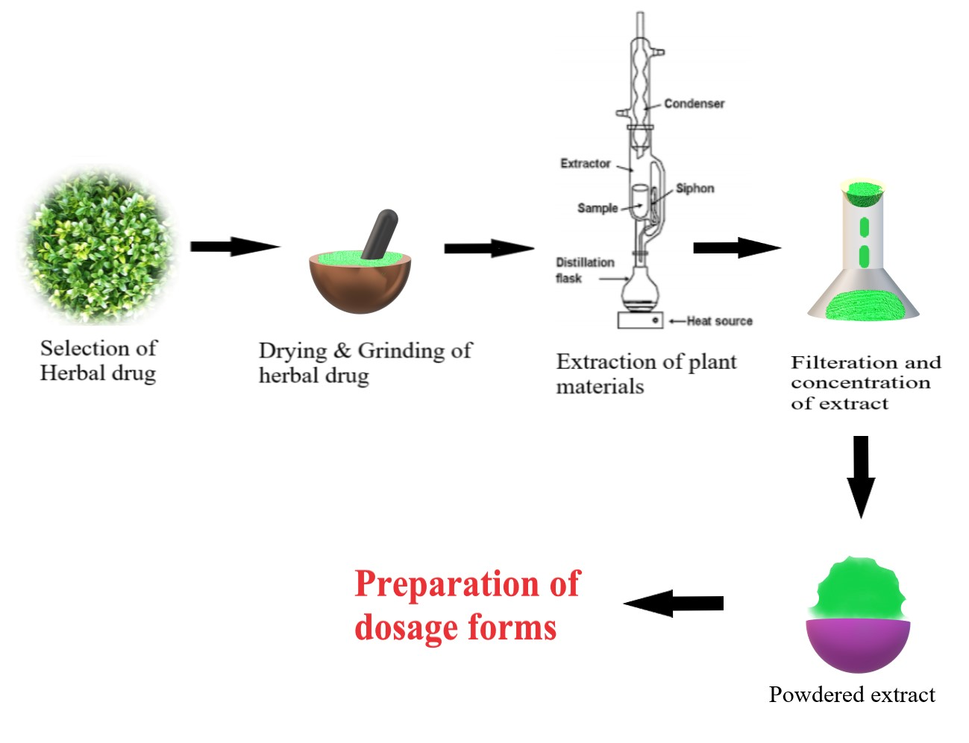
Figure1. Process of preparation of Herbal Dosage

- Diet and Nutrition: Ayurveda places significant emphasis on dietary practices. Research is being conducted to understand how specific dietary recommendations align with modern nutritional science and whether they can contribute to overall health and disease prevention. According to Ayurveda, food has an impact on both the body and the mind. Nutrition can help us heal ourselves if we know how to create foods that are healthy for our bodies and minds. According to Ayurveda, ahara items are made up of five mahabhutas and corresponding bhutagnis, which break down the ingredients on their own during metabolism and digestion—but only when antaragni stimulates them ^{[13]}. Scholars of Ayurveda have proposed theories to explain the mechanism of tissue nutrition: Ek Kala Dhatu Poshan Nyaya (simultaneous supply of nutrients to entire body), KedariKulya Nyaya (transportation of nutrients through channels), Khale Kapota Nyaya (selective uptake of nutrients), and Ksheera Dadhi Nyaya (transformation of nutrients). According to Ayurveda, tissues are dependent on one another for healthy metabolism and sustenance, even though nutrients from Ahara are continuously circulated to nourish and replenish tissues at varying rates according to Agni's functioning state. This idea has significant implications for treating malnutrition and a number of other illnesses. [14].

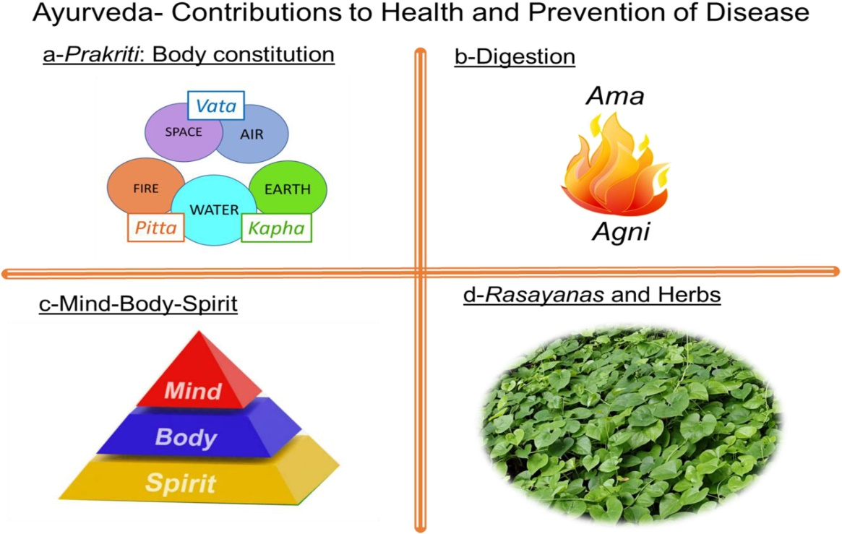
Figure 2. [Source: Arnold, J. T. (2022)]
- Mind-Body Interventions: Ayurvedic techniques including yoga, meditation, and mindfulness are being researched for their potential to improve mental health, reduce stress, and potentially cause cellular-level physiological changes. In recent years, there has been a significant increase in the use of yoga and other alternative therapies in healthcare for patients in both clinical and non-clinical settings. ^{[15]}. Yoga is a mind-body discipline that has its roots in ancient India. It emphasises breathing and mental control in conjunction with the order and fusion of several asanas, or postures. These asanas/postures have an efficient beneficial effect on lifestyle and health, going beyond just practicing physical movements ^{[16]}. Since each of us has a unique energy balance, maintaining the balance of the three doshas—vata, pitta, and kapha—is crucial for one's overall health and well-being ^{[17]}.

- Chronic Disease Management: Ayurvedic interventions are being explored as complementary approaches for managing chronic diseases like diabetes, cardiovascular conditions, and autoimmune disorders. Researchers are investigating how these interventions can support conventional treatments.

- Quality Control and Standardization: As Ayurvedic treatments often involve complex herbal formulations, there is a focus on quality control, standardization, and safety. Researchers are working on developing reliable methods for assessing the quality of Ayurvedic products. Products made from plant resources that are used to treat and improve human health are known as herbal medicines. It is crucial that the quality of herbal remedies be regulated just as much as that of pharmaceuticals made by chemical synthesis ^{[18]}.

- Integration with Modern Medicine: Research is examining how Ayurveda can be integrated into modern healthcare systems in a safe and effective manner. This includes collaborations between Ayurvedic practitioners and conventional medical professional. An accident involving burn injuries was effectively treated using an integrated method that combined modern and Ayurvedic medicine. After receiving therapy, the wound fully healed in 60 days. The combined strategy reduced hospital stays and contractures while promoting faster wound healing with less discolouration ^{[19]}. And many more such integrated treatment approaches using Ayurveda are being administered to treat various diseases.

- Nanotechnology and Ayurveda: As Ayurveda gains traction again, scientists are fusing Ayurveda with nanotechnology. Due to their effectiveness and safety, ayurvedic drugs and treatments are becoming more and more popular. Combining Ayurveda and nanotechnology could result in the creation of the greatest medications to cure a range of serious illnesses ^{[4]}. Although the term "nano" is relatively new, Ayurveda uses nanoparticles of metal and minerals called "Bhasmas" (fig. 3) as effective medicines from long ago ^{[5]}. Typically, Bhasma is administered in the form of animal derivatives such horns, shells, feathers, and metallic and nonmetallic minerals. A Bhasma is an ash that is produced by burning ^{[6]}. The possibility for treating numerous chronic diseases will improve with the use of Ayurvedic medications and formulations in nanocarriers ^{[4]}. Previous research found that a number of natural compounds, including piperine (PIP), resveratrol (RSV), curcumin (Cur), quercetin (QC), Ginkgo biloba, and Nigella sativa, may be nanoformulated to dramatically improve the condition of patients with neurodegenerative illnesses. ^{[12]}.

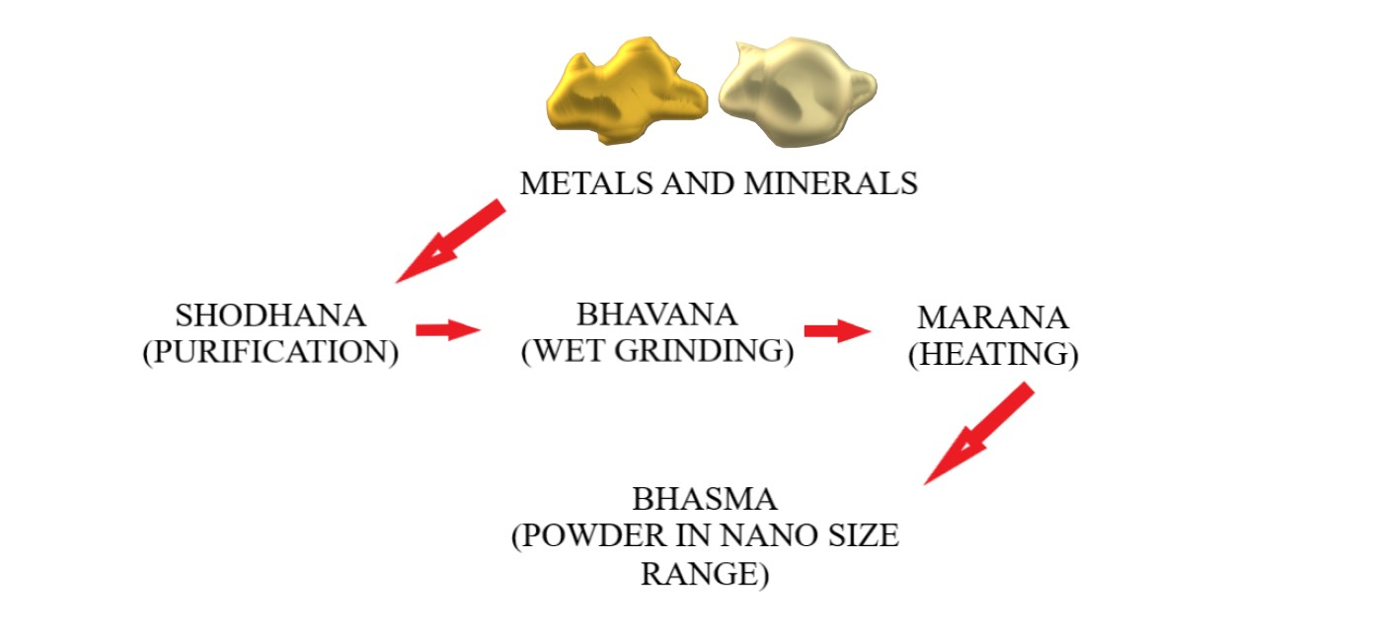
Figure.3 Process of formation of Bhasma – An ancient Nanomedicine

The Growing Inclination of Mankind Towards Indigenous Medicinal Systems
The panorama of global healthcare has changed significantly recently, with a rising preference among people for traditional medical practices. This fad represents a return to age-old healing techniques that have been promoted by many societies for millennia. The holistic approach of Ayurveda, which takes into account the interdependence of the body, mind, and spirit, strikes a deep chord with those seeking total well-being. Ayurveda treats the underlying causes of health problems, in contrast to conventional medicine, which frequently just focuses on symptom management, in order to promote long-term healing and balance. The preference for sustainable and all-natural medical modalities is another factor driving the shift towards Ayurveda. People are turning to the emphasis on herbs, natural cures, and individualised diet found in Ayurveda as a result of worries about synthetic pharmaceuticals and their harmful effects. This fits in with a larger trend towards eco-friendly and natural methods of treating illness. Additionally, the global distribution of Ayurvedic information and practises has been made possible by the digital era. Ayurveda is now more widely available to people all over the world thanks to easily accessible knowledge, online tools, and raised awareness. Stress-reduction practises from Ayurveda, yoga, and meditation have become more popular as people look for alternatives to the fast-paced and frequently stressful modern existence. Its appeal has also been aided by the integration of Ayurveda and contemporary wellness modalities. Ayurvedic and Western medical ideas are combined in integrative health systems, which provide a complete response to the problems of contemporary health.
Conclusion:
Let's sum up by saying that the fusion of Ayurveda with contemporary science is a vibrant and promising area that has the potential to deepen our understanding of health and wellbeing. The progression of Ayurveda from its ancient roots to its current partnership with scientific investigation highlights its adaptability and enduring significance. Personalised treatment, holistic approaches, and mind-body links are just a few examples of things that Ayurveda has embraced while remaining grounded in ancient wisdom. An excellent foundation for incorporating Ayurvedic practises into contemporary healthcare systems is provided by the growing body of scientific research that confirms their effectiveness. This integration does, however, also present difficulties that necessitate cautious manoeuvring. A difficult balance must be struck between the requirements for thorough scientific validation, practise standardisation, and the maintenance of Ayurveda's ancient ethos. In order to ensure that the best of both worlds may be harnessed for the benefit of individuals and society, collaborative activities that engage both Ayurvedic practitioners and scientific researchers are essential. There are several ways that Ayurveda could be used to treat current health issues. Ayurveda provides a complementary approach that is consistent with the shift towards patient-centered treatment and personalised medicine. It addresses conditions ranging from chronic illnesses to mental health issues, from preventive measures to holistic well-being enhancement. The combination of modern science and Ayurveda has the potential to create a healthcare system that is more inclusive and comprehensive as we look to the future. We have the chance to provide holistic care that respects the variety of human experiences, fosters well-being, and fosters a harmonious relationship between people, their environment, and their inner selves by upholding the foundations of Ayurvedic wisdom and embracing scientific advancements. The conversation between tradition and innovation on this voyage paves the path for a truly holistic approach to health that cuts across cultural barriers and improves the lives of future generations.
REFERENCES
- Mukherjee PK, Harwansh RK, Bahadur S, Banerjee S, Kar A, Chanda J, Biswas S, Ahmmed SM, Katiyar CK. Development of Ayurveda–tradition to trend. Journal of ethnopharmacology. 2017 Feb 2;197:10-24.
- Manik RK, Jain D, Joshi A. Effect of Naturopathy and Ayurveda on Cystic Fibrosis: Detailed Review analysis. Journal of Survey in Fisheries Sciences. 2023 Mar 28;10(1S):4214-30.
- Golechha M. Time to realise the true potential of Ayurveda against COVID-19. Brain, behavior, and immunity. 2020 Jul;87:130.
- Valikarimwala M, Gadale S, Waghmode S. Applications of Nanotechnology in Ayurveda: A review.
- Valikarimwala M, Gadale S, Waghmode S. Applications of Nanotechnology in Ayurveda: A review.
- Pal D, Sahu CK, Haldar A. Bhasma: the ancient Indian nanomedicine. Journal of advanced pharmaceutical technology & research. 2014 Jan;5(1):4.
- Yang JH, Hwang EJ, Moon J, Yoon JY, Kim JW, Choi S, Cho SI, Suh DH. Clinical efficacy of herbal extracts in treatment of mild to moderate acne vulgaris: an 8-week, double-blinded, randomized, controlled trial. Journal of Dermatological Treatment. 2021 Apr 3;32(3):297-301.
- Mehrzadi S, Mirzaei R, Heydari M, Sasani M, Yaqoobvand B, Huseini HF. Efficacy and safety of a traditional herbal combination in patients with type II diabetes mellitus: a randomized controlled trial. Journal of dietary supplements. 2021 Jan 2;18(1):31-43.
- Koshak AE, Koshak EA, Mobeireek AF, Badawi MA, Wali SO, Malibary HM, Atwah AF, Alhamdan MM, Almalki RA, Madani TA. Nigella sativa for the treatment of COVID-19: An open-label randomized controlled clinical trial. Complementary Therapies in Medicine. 2021 Sep 1;61:102769.
- Amini L, Mojab F, Jahanfar S, Sepidarkish M, Raoofi Z, Maleki-Hajiagha A. Efficacy of Salvia officinalis extract on the prevention of insulin resistance in euglycemic patients with polycystic ovary syndrome: A double-blinded placebo-controlled clinical trial. Complementary Therapies in Medicine. 2020 Jan 1;48:102245.
- Long Y, Yang Q, Xiang Y, Zhang Y, Wan J, Liu S, Li N, Peng W. Nose to brain drug delivery-a promising strategy for active components from herbal medicine for treating cerebral ischemia reperfusion. Pharmacological Research. 2020 Sep 1;159:104795.
- Moradi SZ, Momtaz S, Bayrami Z, Farzaei MH, Abdollahi M. Nanoformulations of herbal extracts in treatment of neurodegenerative disorders. Frontiers in bioengineering and biotechnology. 2020 Apr 7;8:238.
- NV R, Mishra A. Traditional methods of food habits and dietary preparations in Ayurveda—the Indian system of medicine. Journal of Ethnic foods. 2019 Dec;6:1-9.
- Agrawal S, Verma V, Gehlot S. Explication on tissue nutrition in prenatal and postnatal life: An Ayurveda perspective. Journal of Ayurveda and Integrative Medicine. 2021 Jan 1;12(1):198-205.
- Salmon P, Lush E, Jablonski M, Sephton SE. Yoga and mindfulness: Clinical aspects of an ancient mind/body practice. Cognitive and behavioral practice. 2009 Feb 1;16(1):59-72.
- Sivapuram MS, Srivastava V, Kaur N, Anand A, Nagarathna R, Patil S, Biman S, Chander I, Jyoti S, Nagendra HR. Ayurveda body–mind constitutional types and role of yoga intervention among type 2 diabetes mellitus population of Chandigarh and Panchkula Regions. Annals of Neurosciences. 2020 Jul;27(3-4):214-23.
- Joshi K, Thapliyal A, Singh V. The Tridosha theory according to Ayurveda. International Journal for Modern Trends in Science and Technology. 2021;7(8):120-4.
- Balekundri A, Mannur V. Quality control of the traditional herbs and herbal products: A review. Future Journal of Pharmaceutical Sciences. 2020 Dec;6:1-9.
- Shindhe PS, Priyanka K, Killedar RS, Prasannan D, Kirthi A. An integrated management (Ayurveda and Modern medicine) of accidental burn injury: A case study. Journal of Ayurveda and integrative medicine. 2023 Mar 1;14(2):100691.

