Production of third generation biofuel from oleaginous bacteria- an approach for utilization of lignocellulosic substrates biodiesel production

Authors
1) Rajakumari Pandiyan ⁽¹⁾
School Of Life Sciences
Bharathidasan University
Mail.id: nandhjara2000@gmail.com
2) Snegalatha D ⁽²⁾
School Of Life Sciences
Bharathidasan University
Mail.id: snegalathasls2025@gmail.com
Abstract

Population growth is a serious issue nowadays since it is increasing at an alarming rate while the earth's resources are still being degraded. Resources for conventional fossil fuels are exhausted and unsustainable. Alternatives to fossil fuels include biofuels. They possess qualities such as sustainability, low production costs, great productivity, short incubation times, etc. Oleaginous microorganisms are used in producing third generation biofuels to overcome the drawbacks of the first and second generation. Single cell oil is the name given to the lipid that the microorganisms create. The biofuel production from oleaginous bacteria is the recent interest area in the research field which uses lignocellulosic biomass as their substrate. This review discussed the lipid contents in bacteria and its extraction by bioprocessing technologies and the utilization of lignocellulosic biomass.
Keywords; Oleaginous microbes, lignocelluloses, transesterification, metabolic engineering

Introduction
Rapid population increase, grossly unbalanced provision of food, declining petroleum reserves, and depletion of natural resources have all triggered the emergence of the world's energy threats [1]. Approximately eight times more fossil fuels have been consumed since 1950 than there were in 1950, and this trend has been relatively constant since 1980[2]. Along with the rising petroleum price, the reserves of fossil fuels are exhausted, non-renewable, and exploiting the natural environment. To cope with these issues, we need a novel approach to sustainable utilization of energy. Biodiesel is one such forms of renewable energy. It is made from renewable biomass by transesterifying triacylglycerols, which results in monoalkyl esters of long-chain fatty acids with short-chain alcohols, such as fatty acid methyl esters (FAMEs) and fatty acid ethyl esters (FAEEs). In comparison to petroleum diesel, biodiesel has a higher O2 content, higher combustion efficiency, and a lower sulfur and aromatic component. They are environmentally friendly, have a higher cetane number, as well as a higher flash point. It emits less greenhouse gases than standard diesel and does not increase atmospheric carbon dioxide or sulfur concentrations [3-6]. Four generations of biodiesel were identified based on the feedstock used in manufacturing[7-9]. First-generation biofuel is created using a variety of dietary sources, including animal fat and edible plant oils. The non-edible feedstock used to make second-generation biofuel includes things like non-edible oil, food waste, animal-based waste, and crop residue [9,10]. Microbiologically generated biodiesel is a type of third-generation biofuel. [12-14]. Fourth-generation biofuels are produced via hydro-refining processes similar to those used in the production of petroleum, cutting-edge biochemistry, or novel technologies like Joule's "solar-to-fuel" system, which does not fall under any other biofuel category[15].

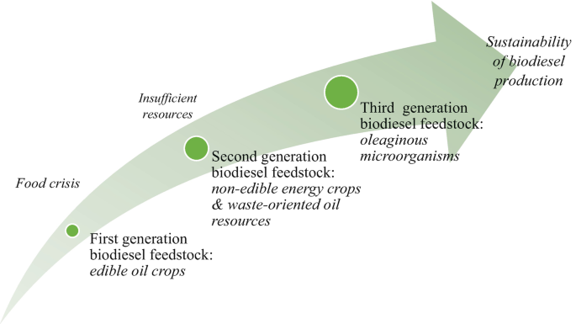

Fig 1: Generations of biofuels ( Ref: Homa Hosseinzadeh-Bandbafha et al., Chapter: Life Cycle Analysis for Biodiesel Production from Oleaginous Fungi)

Table 1 Source, benefits and challenges of different generations biodiesel (Leong et al., 2018; Sigh et al., 2020)

S.No | Biofuels | 1st generation | 2nd generation | 3rd generation | 4th generation
1 | Source | Edible oil feedstock-like palm oil, soybean, rapeseed, sunflower & corn, etc | Non-edible feedstock-like seeds of jatropha, food waste, animal fat waste and agricultural waste, etc | Oleaginous microbes, such as bacteria, fungus, Yeast microalgae etc | Photobiological solar fuels, electro-fuels and synthetic cells
2 | Benefits | Renewable source, environment friendly and their biodiesel conversion process is simple | Renewable, biodegradable, no competition with food crops | Renewable, biodegradable, no competition with food crops, the land is not required, no climate dependency, and a greater growth rate | Renewable, abundant supply, high energy content, inexhaustible
3 | Challenge | Requires land,  manpower for  cultivation and  rising food price | Requires extra land and manpower for  cultivation and production cost is high | Production low for commercialization and difficult to maintenance etc | Research is on infancy level

Oleaginous microorganisms, which historically have been characterized as organisms with a lipid content greater than 20%, offer good prospects for the production of fatty acids as a sustainable biofuel [16,17]. The biological synthesis of lipids using oleaginous microorganisms such microalgae, yeast, fungus, and bacteria has been the subject of numerous investigations [21-26]. They are employed as an alternative feedstock for the production of oil and fat [18]. International interest in single-cell oils, microbial lipids used in the production of biodiesel, has grown significantly [19]. The majority of lipids produced by oleaginous microbes have unbranched carbon chains that range in length from 4 to 28, and these lipids can either be saturated or unsaturated fatty acids depending on the type of carbonated hydro chain and the number of double bonds [20]. As metabolic byproducts of metabolizing fatty acids and triacylglycerol (TAG), various microbes form hydrocarbons. Eukaryotic organisms including yeast, fungus, plants, and animals utilise TAG as an energy reserve. TAG biosynthesis by bacteria groups is accomplished in a significant amount of carbon sources, such as sugars, organic acids, alcohols, n-alkanes, branched alkanes, phenylalkanes, oils, and coal lipids source for biodiesel generation but it is not studied. According to Bharti et al. (2014a) and Kumar et al. (2020), microbial fatty acid and TAG generated by bacteria might be used as a beginning material of microbial lipids source for biodiesel generation. Bio-lipids derived from oleaginous microorganisms offer an advantage over vegetable oil in terms of fatty acid composition, and fatty acid composition can be modified to the required level by modifying the supply of nutrients or substrates, as well as the metabolic engineering method. It was also discovered that oleaginous bacteria utilise high-carbon waste efficiently for lipid synthesis [36,37]. Oleaginous bacteria, including Arthrobacter. Sp [18], Rhodococcus opacus [27], and Acinetobacter calcoaceticus[28], exhibit fast growth rates and can acquire oil content up to 87% of their dry biomass. They also produce significant volumes of biomass in a short amount of time [28-31]. Rhodococcus sp. has recently been examined for its ability to breakdown lignin and eventually assimilate lignin monomeric components into the lipid accumulation pathway [32,33]. Rhodococcus opacus was shown to have a lipid concentration of 26.8% w/w when grown on aromatics derived from organosolv pretreatment of loblolly pine together with lignocellulosic pretreatment effluents containing different sugars in one investigation [34]. This species was also used to transform oxygen-treated Kraft lignin into useful lipids [35]. This review article will focus over the extraction of biofuel from oleaginous bacteria using lignocellulosic substrate (dry matter of plants) and it gives the significance of third generation biofuel and the role of oleaginous bacteria in utilizing the lignocellulosic subtrates.

Lipid content in various oleaginous bacteria
Although bacteria have a rapid rate of cell development, they accumulate less lipid than fungi and microalgae. Under straight forward cultivation techniques, bacterial lipids are created in the cytoplasm of the cells in the form of small droplets with high cell growth rates, and some strains accumulate oil under specific environments [40]. When the carbon supply is high and other nutrients (primarily nitrogen) are running low in the growth media, bacteria proceed to make lipids. To promote favorable lipid accumulation, the carbon-to-nitrogen ratio of the culture medium must be high. Extra carbon in the cell is transformed into the lipid triacylglycerol [38,39]. The most prevalent class of neutral lipids in most bacterial species are poly hydroxyl alkanoic acids, which are used as intracellular carbon and energy storage materials [41]. The lipid synthesis in bacteria is influenced by the various factors such as pH ,temperature, nutrients etc., The highest amounts of triacylglycerols are produced by various bacterial genera, including Rhodococcus, Mycobacterium, Arthrobacter, Streptomyces, Nocardia, Acinetobacter, Clostridium etc,. Among these R.opacus was the most researched oleaginous bacterial strain that went through fermentation and optimization. According to reports, the Arthrobacter and Rhodococcus species may store fatty acids up to 87% of their cellular dry weight and have large biomass [42]. It has yet to be determined that gram negative species have a significant lipid content, in contrast to these gram positive bacterial species [42,43].

Lipid biosynthesis in bacteria

In cells, fatty acid biosynthesis (FAS) is an essential activity. For the construction and metabolism of cells, fatty acids are crucial. The increasing fatty acid chain is stabilized and transported by an acyl carrier protein (ACP) throughout the enzymatic modules of the FAS system for stepwise catalysis [44]. The monoenoic C18 acids contain various double-bond locations and often lack polyunsaturation. Some bacteria produce 3-hydroxy acyl acids, whereas others produce branched-chain fatty acids. In general, there are two different molecular forms of fatty acid synthesis (FAS) routes known as type I and type II. A single, big polypeptide unit with multiple different domains, known as the type I system, which is found in mammals, catalyzes FAS. The acyl carrier protein (ACP) is one of the components of the type II system, which is found in bacteria, plants, and protozoa [45,46]. Since the majority of bacteria have the ability to integrate external fatty acids into their membrane phospholipids, it is crucial to determine whether this ability will enable them to get around FASII inhibitors by obtaining the fatty acids they require from the host [47]. The FAS system carries out fatty acid elongation, which is broken down into two stages: synthesis start and elongation, sequentially using a number of enzyme modules .

Initiation
The terminal sulfhydryl of the 4-phosphopantetheine arm (4′-Pan-arm) on the substrate carrier protein, a holo-acyl carrier protein (holo-ACP), is covalently attached by the initiation stage to a short acetyl (or malonyl) group. In order to process fatty acid extension, ACP then switches between roughly four enzymatic modules in the elongation cycle. Two more carbons are added to the substrate chain with each cycle until the product is released. With the exception of an incomplete enoyl reductase (FabI)-ACP structure and a covalently crosslinked -hydroxyacyl-ACP dehydratase (FabA)-ACP structure, the interactions between ACP and enzyme modules in FASN or individual enzymes in FAS-II have only rarely been studied due to the high flexibility and diffusible characteristics of ACP [48,49]. As a result, it is still unknown what fundamental mechanisms underlie the detection and processing of ACP by enzyme modules for substrate catalysis, particularly during the elongation cycle.

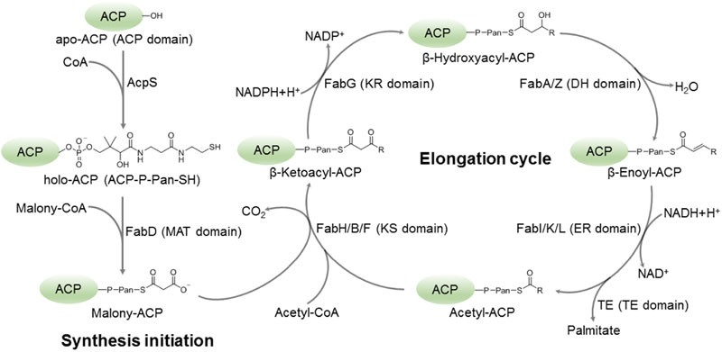

Fig:2 Schematic diagram of fatty acid biosynthesis process [68,69]

  - Elongation
In the cycle of fatty acid synthesis, an acyl-enzyme/acyl thioester (acyl-ACP or, for FabH, acetyl-CoA) was Claisen-condensed with malonyl-ACP to produce a 3-ketoacyl-ACP, CO2, ACP (or CoA), and free enzyme. Three enzymes, previously known as synthases I, II, and III in E. coli but more recently known as FabB, FabF, and FabH, respectively, after their gene names, catalyze 3-ketoacyl-ACP synthase reactions. Saturated and unsaturated fatty acid synthesis processes can be carried out by the enzymes FabB and FabF, which have a dimeric protein structure. The distribution of the products from this route is controlled by 3-ketoacyl-ACP synthases because it is the irreversible step in the elongation cycle of fatty acid synthesis [50].

Reduction
The 3-keto-thioester (3-ketoacy-ACP) is reduced by NADPH-dependent 3-ketoacyl-ACP reductase (Fab G) and forms 3-hydroxy acyl- ACP. In E. coli, only a single NADPH-specific 3-ketoacyl-ACP reductase is present and functional with all acyl chain lengths [51].

Dehydration
3-hydroxy acyl-ACP dehydratase (FabZ) catalyzes the removal of a water molecule from the three hydroxy acyl-ACP, resulting in the formation of enoyl-ACP. Chain 3-hydroxy acyl-ACPs and a lengthy chain of saturated and unsaturated 3-hydroxy acyl-ACP were successfully dehydrated by dehydratase [52]

Reduction
An acyl-ACP is the result of the catalyzed enoyl-ACP reductase (FabI) reduction pathway. The fatty acid cycle's final enzyme was enoyl-ACP reductase. For precise fatty acid production, FabI pulls the other reversible cycle phases by regulating the activity of other enzymes (FabG and FabZ). Acyl-ACP can act as a substrate for further elongation or, if necessary, for the synthesis of long enough chains. It might transfer into sophisticated lipids. The major saturated fatty acid in E. coli is formed by elongating the trans-3-decanoyl-ACP FabI, which is then followed by either FabB or FabF [52].

Lipid extraction from oleaginous bacteria:
To dissolve or degrade the protective cell walls of microorganisms and increase the accessibility of the intracellular lipids in solvent extraction, a type of biomass pretreatment, such as cell disruption, is typically required. In addition to enhancing lipid extraction by reducing cell wall barriers, the optimal biomass disruption technique should be able to improve mass transfer and streamline downstream processing [53]. In order to produce high-quality goods, complex methods for lipid extraction were improved. These techniques included solvent extraction, the Soxhlet method, the Folch method, the Bligh and Dyer method, the use of supercritical fluids, and ultrasonication, etc.,[52]. A novel method called ultrasonication is widely used to increase the generation of bioproducts from diverse organic wastes. It was stated that ultrasonication is applicable to scaling up and has been employed in a variety of processes, including the production of biogas and the recovery of crude oil [54,55]. The new method of producing biodiesel, known as in-situ trans-esterification, allows oil contained in bacteria to convert the fuel directly without altering its composition.[55]. In addition to lipid extraction, a number of pretreatment techniques improve lipid recovery. The series employs enzymatic, chemical, and physical approaches to pretreat isolated lipids [56].

Transesterification

The process of transesterification involves changing one carboxylic acid ester into another. The interaction of an ester and an alcohol in the presence of an acid catalyst is the most typical technique of transesterification. Triacylglycerols (TAGs) and free fatty acids (FFAs) are relevant lipids from microbial oil for the production of biodiesel, and they can be transesterified with an alcohol (methanol or ethanol) to form fatty acid (m)ethyl esters using acid, alkali, or enzymatic catalysis.[56].
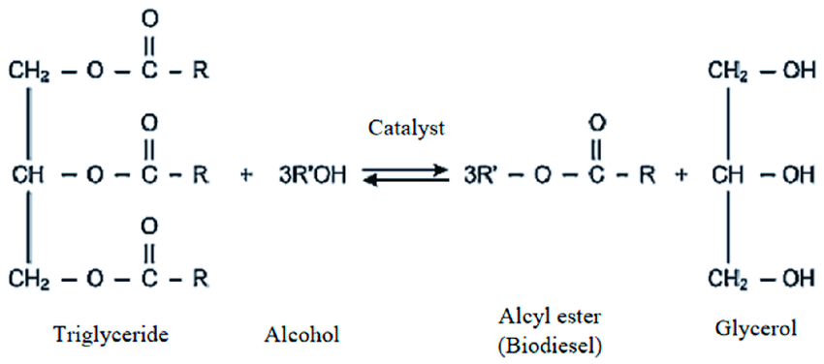

Fig 3: Transesterification process(Linganiso, Ella & Tlhaole et al.,2022)

There are various transesterification methods include homogenous acid–base transesterification, heterogeneous acid–base transesterification, and enzymatic transesterification etc,.

Biodiesel production by oleaginous bacteria from lignocellulosic substrate

The widely available and renewable resource known as lignocellulosic biomass (LB) is mostly made up of the polysaccharides cellulose and hemicellulose as well as the aromatic polymer lignin. Three polymers make up : lignin (10–25%), hemicellulose (20–40%), and cellulose (35–55%). Sugar-rich lignocellulosic biomass can promote the growth of heterotrophic organisms. The production of biofuels, biosourced chemicals, and minerals using LB has a significant potential as a substitute for fossil resources without endangering the world's food supply[57-59]. For instance, lipid made up to 70% of the DCW under nitrogen-deficient conditions. The fermentation of lignocellulosic biomass to biogas or ethanol has been documented by numerous studies Studies have looked into the possibilities of making TAGs for biodiesel synthesis from lignocellulosic biomass [60,61]. Oleaginous microorganisms (OMs) can use cheap feedstocks, such as waste substrates and lignocellulosic substrates (LCSs), to accumulate more lipid [62]. Delignification, saccharification, fermentation with OMs for increased lipid synthesis, and ultimately conversion to transesterification are the four crucial processes in the manufacturing of biodiesel from LCBs [63,64].
.
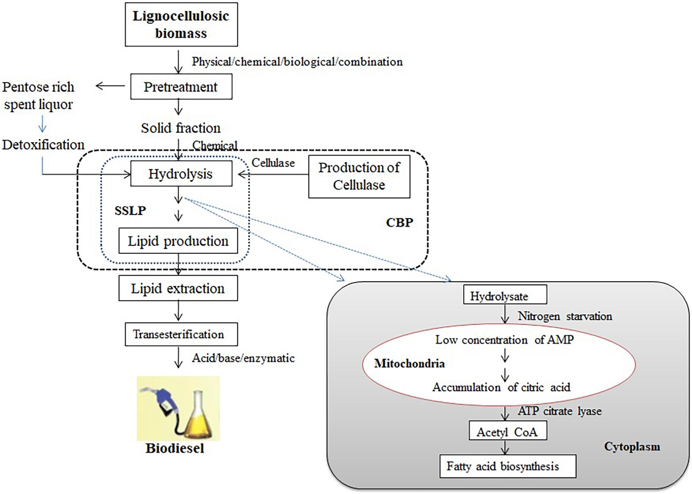
Fig 4: Schematic diagram of lipid biosynthesis from lignocellulosic biomass using oleaginous microorganisms (Anjani Devi Chintagunta et al., Front. Microbiol., 12 August 2021)

Application of metabolic engineering in lipid production by microbial cells:
Significant attention is being paid to microbial sources of lipids that can be employed as nutraceuticals or as sources of energy [65]. More than others, the gene regulatory mechanisms for fatty acid production in bacteria are well understood. The most recent method of altering the metabolism of microorganisms through genetic engineering is known as metabolic engineering. The main tactic used in metabolic engineering is improving current biochemical pathways or adding the necessary components [66,67]. Enhancing lipid production in bacteria involves the application of certain metabolic engineering techniques [52].

Conclusion
The use of fossil fuels, urbanization, and population increase have had a significant impact on the economy and resource depletion of many nations. One of the most notable renewable energy sources for a sustainable environment is biofuel. An developing method for the productive synthesis of third generation biofuels uses oleaginous bacteria and lignocellulosic biomass as a substrate. The impacts from using edible and non edible feedstock is greatly reduced by the usage of oleaginous microbes and lignocellulosic biomass. The modification of these cells at genetic and metabolical level is quite easy. There are many ongoing research projects which implement the efficient utilization of microbial cells in the production of biofuels by metabolic engineering technologies.

REFERENCE:
- Ulucak R., Khan S.U.-D. Determinants of the ecological footprint: Role of renewable energy, natural resources, and urbanization. Sustain. Cities Soc. 2019;54:101996. [Google Scholar]
- Hannah Ritchie, Max Roser and Pablo Rosado (2022) - "Energy". Published online at OurWorldInData.org. Retrieved from: 'https://ourworldindata.org/energy' [Online Resource]
- Jared A. DeMello et al.Biodegradation and environmental behavior of biodiesel mixtures in the sea: an initial study Mar Pollut Bull(2007)
- H.M. Alvarez et al.Triacylglycerols in prokaryotic microorganisms Appl Microbiol Biotechnol (2002)
- Mahlia TMI, Syazmi ZAHS, Mofijur M et al (2020) Patent landscape review on biodiesel production: technology updates. Renew Sust Energ Rev 118:109526. https://doi.org/10.1016/j.rser.2019.109526
- Patel A, Arora N, Antonopoulou I (2020a) Single cell oil and ethanol production by the oleaginous yeast Trichosporonfermentans utilizing dried sweet sorghum stalks. Renew Energ 146:1609–1617. https://doi.org/10.1016/j.renene.2019.07.107
- Alalwana HA, Alminshidb AH, Aljaafari HAS (2019) Promising evolution of biofuel generations. Renew Energy Focus 8:127–139. https://doi.org/10.1016/j.ref.2018.12.006
- Aron NSM, Khoo KS, Chew KW et al (2020) The Hong Phong Nguyen sustainability of the four generations of biofuels—a review. Int J Energy Resources. https://doi.org/10.1002/er.5557
- Singh D, Sharma D, Soni SL et al (2020) A review on feedstocks, production processes, and yield for different generations of biodiesel. Fuel 262:116553. https://doi.org/10.1016/j.fuel.2019.116553
- Ferrero GO, Sanchez Faba EM, Rickert AA et al (2020) Alternatives to rethink tomorrow: biodiesel production from residual and non–edible oils using biocatalyst technology. Renew Energy 150:128–135. https://doi.org/10.1016/j.renene.2019.12.114
- Allen J, Unlu J, Demire Y et al (2018) Integration of biology, ecology and engineering for sustainable algal-based biofuel and bioproduct biorefinery. Bioresour Bioprocess 5:47. https://doi.org/10.1186/s40643-018-0233-5
- Hossain N, Mahlia TMI (2020) Progress in physicochemical parameters of microalgae cultivation for biofuel production. Crit Rev Biotechnol 39:835–859. https://doi.org/10.1080/07388551.2019.1624945
- Zhang J, Gao H, Xue Q (2020a) Potential applications of microbial enhanced oil recovery to heavy oil. Crit Rev Biotechnol 40:459–474. https://doi.org/10.1080/07388551.2020.1739618
- Zeghloulia J, Guendouza A, Duchezb D (2021) Valorization of co-products generated by argan oil extraction process: application to biodiesel production. Biofuels. https://doi.org/10.1080/17597269.2021.1941573.
- Demirbas, M.F., 2011. Biofuels from algae for sustainable development. Appl. Energy 88, 3473–3480. https://doi.org/10.1016/j.apenergy.2011.01.059.
- Chisti Y. Biodiesel from microalgae. Biotechnol Adv 2007;25:294–306
- Clark JH, Deswarte FEI, Farmer TJ. The integration of green chemistry into future biorefineries. Biofuels Bioprod Biorefin 2009;3:72–90.
- Maa X, Gaoa Z, Wang Q et al (2018) Biodiesels from microbial oils: opportunity and challenges. Bioresource Technol 263:631–641. https://doi.org/10.1016/j.biortech.2018.05.028
- Carsanba E, Papanikolaou S, Erten H (2018) Production of oils and fats by oleaginous microorganisms with an emphasis given to the potential of the nonconventional yeast Yarrowialipolytica. Crit Rev Biotechnol 38:1230–1243. https://doi.org/10.1080/07388551.2018.1472065

- Patel A, Karageorgou D, Rova E et al (2020b) An overview of potential oleaginous microorganisms and their role in biodiesel and omega-3 fatty acid-based industries microorganisms. Microorganisms 8:434. https://doi.org/10.3390/microorganisms8030434
- Chen G, Zhao L, Qi Y. Enhancing the productivity of microalgae cultivated in wastewater toward biofuel production: a critical review. Appl Energy 2015;137:282–91
- Meng X, Yang J, Xu X, Zhang L, Nie Q, Xian M. Biodiesel production from oleaginous microorganisms. Renew Energy 2009;34:1–5.
- Jin M, Slininger PJ, Dien BS, Waghmode S, Moser BR, Orjuela A, et al. Microbial lipid-based lignocellulosic biorefinery: feasibility and challenges. Trends Biotechnol 2015;33:43–54.
- Williams PJLB, Laurens LML. Microalgae as biodiesel & biomass feedstocks: review & analysis of the biochemistry, energetics & economics. Energy Environ Sci 2010;3:554–90.
- Sawangkeaw R, Ngamprasertsith S. A review of lipid-based biomasses as feedstocks for biofuels production. Renew Sustain Energy Rev 2013;25:97–108.
- Pienkos PT, Darzins A. The promise and challenges of microalgal-derived biofuels. Biofuels Bioprod Biorefin 2009;3:431–40.
- Alvarez HM, Steinbüchel A. Triacylglycerols in prokaryotic microorganisms. Appl Microbiol Biotechnol 2002;60:367–76.

- Alvarez HM, Pucci OH, Steinbüchel A. Lipid storage compounds in marine bacteria. Appl Microbiol Biotechnol 1997;47:132–9.
- Alvarez HM, Luftmann H, Silva RA, Cesari AC, Viale A, Wältermann M, et al. Identification of phenyldecanoic acid as a constituent of triacylglycerols and wax ester produced by Rhodococcus opacus PD630. Microbiology 2002;148:1407–12.
- Alvarez HM, Kalscheuer R, Steinbüchel A. Accumulation of storage lipids in species of Rhodococcus and Nocardia and effect of inhibitors and polyethylene glycol. Fett/Lipid 1997;99:239–46.
- de Andrés C, Espuny MJ, Robert M, Mercadé ME, Manresa A, Guinea J. Cellular lipid accumulation by Pseudomonas aeruginosa 44T1. Appl Microbiol Biotechnol 1991;35:813–6
- Kosa M., Ragauskas A.J. Bioconversion of lignin model compounds with oleaginous Rhodococci. Appl. Microbiol. Biotechnol. 2012;93:891–900. doi: 10.1007/s00253-011-3743-z. [PubMed] [CrossRef] [Google Scholar]
- Kosa M., Ragauskas A.J. Lignin to lipid bioconversion by oleaginous Rhodococci. Green Chem. 2013;15:2070–2074. doi: 10.1039/c3gc40434j. [CrossRef] [Google Scholar]
- Wells T., Wei Z., Ragauskas A. Bioconversion of lignocellulosic pretreatment effluent via oleaginous Rhodococcus opacus DSM 1069. Biomass Bioenergy. 2015;72:200–205. doi: 10.1016/j.biombioe.2014.11.004. [CrossRef] [Google Scholar]
- Wei Z., Zeng G., Huang F., Kosa M., Huang D., Ragauskas A.J. Bioconversion of oxygen-pretreated Kraft lignin to microbial lipid with oleaginous Rhodococcus opacus DSM 1069. Green Chem. 2015;17:2784–2789. doi: 10.1039/C5GC00422E. [CrossRef] [Google Scholar] [Ref list]
- Kumar S, Gupta N, Pakshirajan K (2015) Simultaneous lipid production and dairy wastewater treatment using Rhodococcusopacus in a batch bioreactor for potential biodiesel application. J Environ Chem Eng 3:1630–1636. https://doi.org/10.1016/j.jece.2015.05.030
- Kot AM, Blazejak S, Kurcz A et al (2017) Effect of initial pH of medium with potato wastewater and glycerol on protein, lipid and carotenoid biosynthesis by Rhodotorulaglutinis. Elect J Biotechnol 27:25–31. https://doi.org/10.1016/j.ejbt.2017.01.007
- Wu, S., Hu, C., Jin, G., Zhao, X., Zhao, Z.K., 2010. Phosphate-limitation mediated lipid production by Rhodosporidium toruloides. Bioresour. Technol. 101, 6124–6129. https://doi.org/10.1016/j.biortech.2010.02.111.
- N.M. Zabermawi, Faten A.S. Alsulaimany, M.T. El-Saadony et al., New eco-friendly trends to produce biofuel and bioenergy from microorganisms: An updated review, Saudi Journal of Biological Sciences, https://doi.org/10.1016/j.sjbs.2022.02.024
- Qadeer S, Khalid A, Mahmood S et al (2017) Utilization oleaginous bacteria and fungi for cleaner energy production. J Clean Product 168:917–928. https://doi.org/10.1016/j.jclepro.2017.09.093
- Carsanba E, Papanikolaou S, Erten H (2018) Production of oils and fats by oleaginous microorganisms with an emphasis given to the potential of the nonconventional yeast Yarrowialipolytica. Crit Rev Biotechnol 38:1230–1243.
- Kumar M, Rathour R, Gupta J et al (2020) Bacterial production of fatty acid and biodiesel: opportunity and challenges. Ref Biomass Resid Sust Energ Bioprod. https://doi.org/10.1016/B978-0-12-818996-2.00002-8Return to ref 2020 in article
- Babu MV, Murthy KM, Rao GAP (2020) Production process optimization of SterculiaFoetida Methyl Esters (Biodiesel) using response surface methodology. Int J Ambient Energy. https://doi.org/10.1080/01430750.2020.1723692
- Zhang, L., Xiao, J., Xu, J. et al. Crystal structure of FabZ-ACP complex reveals a dynamic seesaw-like catalytic mechanism of dehydratase in fatty acid biosynthesis. Cell Res 26, 1330–1344 (2016). https://doi.org/10.1038/cr.2016.136
- Ratledge C (2004) Fatty acid biosynthesis in microorganisms being used for Single cell oil production. Biochimie 86:807–815
- Qadeer S, Khalid A, Mahmood S et al (2017) Utilization oleaginous bacteria and fungi for cleaner energy production. J Clean Product 168:917–928. https://doi.org/10.1016/j.jclepro.2017.09.093
- S. Brinster, G. Lamberet, B. Staels, P. Trieu-Cuot, A. Gruss, C. Poyart ,Type II fatty acid synthesis is not a suitable antibiotic target for Gram-positive pathogens Nature, 458 (2009), pp. 83-86
- Rafi S, Novichenok P, Kolappan S, et al. Structure of acyl carrier protein bound to FabI, the FASII enoyl reductase from Escherichia coli. J Biol Chem 2006; 281:39285–39293.
- Nguyen C, Haushalter RW, Lee DJ, et al. Trapping the dynamic acyl carrier protein in fatty acid biosynthesis. Nature 2014; 505:427–431.
- Janben HJ, Steinbuchel A (2014) Fatty acid synthesis in Escherichia coli and its applications toward the production of fatty acid–based biofuels. Biotechnol Biofuels 7:1–26. https://doi.org/10.1186/1754-6834-7-7
- Javidpour P, Pereira JH, Goh EB et al (2014) Biochemical and structural studies of NADH–dependent FabG used to increase the bacterial production of fatty acids under anaerobic conditions. Appl Environ Microbiol 80:497–505. https://doi.org/10.1128/AEM.03194-13
- Koreti, D., Kosre, A., Jadhav, S.K. et al. A comprehensive review on oleaginous bacteria: an alternative source for biodiesel production. Bioresour. Bioprocess. 9, 47 (2022). https://doi.org/10.1186/s40643-022-00527-1
- Tao Dong, Eric P. Knoshaug, Philip T. Pienkos, Lieve M.L. Laurens, Lipid recovery from wet oleaginous microbial biomass for biofuel production: A critical review, Applied Energy,Volume 177,2016, Pages 879-895,ISSN 0306-2619, https://doi.org/10.1016/j.apenergy.2016.06.002.
- Wang Z, Gu S (2017) State-of-the-art on the development of ultrasonic equipment and key problems of ultrasonic oil production technique for EOR in China. Renew Sustain Energ Review 82:2401–2407. https://doi.org/10.1016/j.ultsonch.2017.03.035
- Chen J, Li J, Zhang X (2018) Ultra-sonication application in biodiesel production from heterotrophic oleaginous microorganisms. Crit Rev Biotechnol 38:902–917. https://doi.org/10.1080/07388551.2017.1418733
- Patel A, Karageorgou D, Rova E et al (2020b) An overview of potential oleaginous microorganisms and their role in biodiesel and omega-3 fatty acid-based industries microorganisms. Microorganisms 8:434. https://doi.org/10.3390/microorganisms8030434
- Menon, V., and Rao, M. (2012). Trends in bioconversion of lignocellulose: biofuels, platform chemicals and biorefinery concept. Prog. Energy Combust. Sci. 38, 522–550. doi: 10.1016/j.pecs.2012.02.002
- Chandel, A. K., Garlapati, V. K., Singh, A. K., Antunes, F. A. F., and da Silva, S. S. (2018). The path forward for lignocellulose biorefineries: bottlenecks, solutions, and perspective on commercialization. Bioresour. Technol. 264, 370–381 doi: 10.1016/j.biortech.2018.06.004
- Cheah WY, Sankaran R, Show PL et al (2020) Pretreatment methods for lignocellulosic biofuels production: current advances, challenges and future prospects. Biofuel Res J 25:1115–1127. https://doi.org/10.18331/BRJ2020.7.1.4
- Kumar D, Singha B, Korstad J (2017a) Utilization of lignocellulosic biomass by oleaginous yeast and bacteria for production of biodiesel and renewable diesel. Ren Sustain Energy Rev 73:654–671. https://doi.org/10.1016/j.rser.2017.01.022
- Sun J, Zhang L, Loh KC (2021) Review and perspectives of enhanced volatile fatty acids production from acidogenic fermentation of lignocellulosic biomass wastes. Bioresour Bioprocess 8:68. https://doi.org/10.1186/s40643-021-00420-3
- Kumar, S. P. J., Kumar, N. S., and Chintagunta, A. D. (2020d). Bioethanol production from cereal crops and lignocelluloses rich agro-residues: prospects and challenges. SN Appl. Sci. 2:1673. doi: 10.1007/s42452-020-03471-x
- Zhao, X., Kong, X. L., Hua, Y. Y., Feng, B., and Zhao, Z. B. (2008). Medium optimization for lipid production through co-fermentation of glucose and xylose by the oleaginous yeast Lipomyces starkeyi. Eur. J. Lipid Sci. Technol. 110, 405–412. doi: 10.1002/ejlt.200700224
- Kumar, S. P. J., Gujjala, L. K. S., Dash, A., Talukdar, B., and Banerjee, R. (2017c). “Biodiesel production from lignocellulosic biomass using oleaginous microbes,” in Lignocellulosic Biomass Production and Industrial Applications, eds A. Kuila and V. Sharma (Hoboken, NJ: Wiley), 65–92. doi: 10.1002/9781119323686.ch4
- Ledesma-Amaro R. Microbial oils: A customizable feedstock through metabolic engineering. Eur. J. Lipid Sci. Technol. 2015;117:141–144. doi: 10.1002/ejlt.201400181. [CrossRef] [Google Scholar] [Ref list]
- Liang MH, Jiang JG (2013) Advancing oleaginous microorganisms to produce lipid via metabolic engineering technology. Prog Lipid Res 52:395–408. https://doi.org/10.1016/j.plipres.2013.05.002
- Nie L, Xu K, Zhong B et al (2022) Enhanced l-ornithine production from glucose and sucrose via manipulation of the fructose metabolic pathway in Corynebacterium glutamicum. Bioresour Bioprocess 9:11. https://doi.org/10.1186/s40643-022-00503-9
- Smith S, Witkowski A, Joshi AK . Structural and functional organization of the animal fatty acid synthase. Prog Lipid Res 2003; 42:289–317.
- White SW, Zheng J, Zhang YM . Rock. The structural biology of type II fatty acid biosynthesis. Annu Rev Biochem 2005; 74:791–831.

